Effect of the parasitoids Phymastichus coffea (LaSalle, 1990) and Cephalonomia stephanoderis (Betrem, 1961) on the coffee berry borer (Hypothenemus hampei) in laboratory

Abstract
Aims: The coffee berry borer (Hypothenemus hampei) is the most important pest of coffee, causing severe damage to the berries. The chemical products commonly used for its control pose risks to human health and the environment. Therefore, this laboratory study was conducted to evaluate the effectiveness of two parasitoids, Phymastichus coffea and Cephalonomia stephanoderis, on coffee berry borer.
Study design: The study was carried out in laboratory conditions to minimize environmental variability.
Place and Duration of Study: This study was carried out at the National Center for Agricultural Research in July and december 2023.
Methodology: parasitoids were reared under laboratory conditions on a natural substrate. The experimental design consisted of 200 parasitoids (100 P. coffea and 100 C. stephanoderis), 200 coffee berry borers, and 200 ripe coffee berries. Each experimental unit comprised 20 ripe berries, 20 borers, and 20 parasitoids. A completely randomized block design with five replications was implemented.
Results: Results showed that the total mortality rates of the borers in the presence of the two parasitoids were 50% when parasitism occurred before fruit perforation and 60% when it occurred 28 days after perforation. Specifically, before fruit perforation, mortality was 30% with P. coffea and 25% with C. stephanoderis. When the parasitoids were introduced 28 days after perforation, mortality reached 20% with P. coffea and 22% with C. stephanoderis. Furthermore, the findings indicate that Phymastichus coffea targets adult borers, whereas Cephalonomia stephanoderis primarily attacks immature stages (larvae, pupae, and pre-adults).
Conclusion:The combined use of both parasitoids proved to be the most effective strategy for controlling the coffee berry borer under laboratory conditions.

Keywords: Coffee, parasitoid, coffee berry borer, Phymastichus coffea, Cephalonomia stephanoderis

1. INTRODUCTION
Coffee cultivation is exposed to several pests that limit its yield. The major insect pest regularly encountered in coffee plantations is the coffee berry borer (Hypothenemus hampei). This pest causes damage throughout all stages of coffee berry development. The drop of young infested fruits is sometimes considerable, reaching up to 30% of the newly formed berries (Ohoueu et al., 2024). The entry galleries of the borer in the cherries also promote infestation by bacteria (Erwinia) and fungi (Aspergillus sp., Fusarium sp., and Penicillium sp.), some of which are harmful to human health. In particular, the presence of mycotoxins is frequent (Taniwaki et al., 1999). The larvae continue to develop inside the cherries from harvest through processing, as long as favorable conditions persist. The breakage of weakened “scolyted” beans during hulling results in product losses. Yield losses can reach up to 60% (Wegbe et al., 2003). Several synthetic insecticides have already been tested but have shown limitations under field conditions (Wegbe et al., 2003). Moreover, the use of synthetic insecticides is increasingly discouraged to avoid pesticide residues in final products. As an alternative, biological control of this major pest is becoming more strongly recommended due to its negligible impact on the environment. In the late 1980s, Cephalonomia stephanoderis was introduced into Togo, Mexico, and Ecuador (Klein-Koch et al., 1988) for the biological control of H. hampei. The developmental cycle of C. stephanoderis is shorter than that of H. hampei, and its oviposition capacity is higher, making it an important natural enemy for biological control of the coffee berry borer. The objective of this study was therefore to evaluate, under laboratory conditions, the effectiveness of parasitoids against the coffee berry borer.
2. MATERIAL AND METHODS
2.1 Study site
The study was conducted in the insectarium of the research station of the National Center for Agronomic Research (CNRA) in Divo. The station is located 17 km from Divo (Côte d’Ivoire), at 5.8373900° N latitude and –5.3572300° W longitude. The climatic conditions in the insectarium were similar to those prevailing in the surrounding environment, with temperatures ranging from 24 to 28 °C. The average relative humidity recorded during the study varied between 60% and 75%.
2.2 Materials
2.2.1 Biological material
The plant material consisted of ripe Coffea canephora (robusta) cherries collected from plantations. The animal material was exclusively composed of the coffee berry borer (Hypothenemus hampei) and the parasitoids (Phymastichus coffea and Cephalonomia stephanoderis), reared under laboratory conditions.
2.2.2 Technical material
The technical equipment used during the experiment included transparent, colorless plastic containers of 1,440 cm³ (length: 15 cm × width: 12 cm × height: 8 cm) for rearing the coffee berry borer and parasitoids (figure 1 et 2) ; a scalpel for dissecting cherries; a brush and a mechanical aspirator for collecting insects; as well as markers and labels for identification purposes.
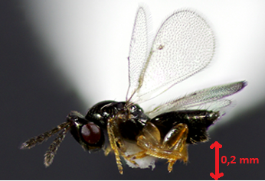
Figure 1. Phymastichus coffea
(Source, Ohoueu)
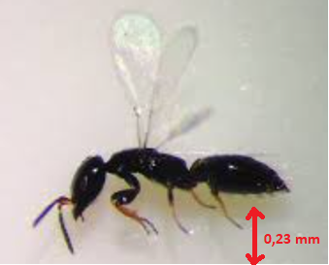
Figure 2. Cephalonomia stephanoderis
(Source, Ohoueu)

2.2 Méthodes
2.2.1 Treatments
Seven (07) treatments were established (Table 1):
P1: Absolute control (No parasitoid);
P2 : P. coffea exposed to coffee berry borer before fruit penetration;
P3 : C. stephanoderis exposed to coffee berry borer before fruit penetration;
P4 : P. coffea + C. stephanoderis exposed to coffee berry borer before fruit penetration;
P5 : P. coffea was exposed to fruits 28 days after coffee berry borer had infested them;
P6 : C. stephanoderis was exposed to fruits 28 days after coffee berry borer had infested them;
P7 : C. stephanoderis + P. coffea were exposed to fruits 28 days after coffee berry borer had infested them.

Table 1. Experimental treatments
Treatment | Parasitoids used | Period of Exposure of Parasitoids to the Beetle | Nomber of parasitoids used
P1 | No parasitoid |  | 20
P2 | P. coffea | Jour 0 | 20
P3 | C. stephanoderis | Jour 0 | 20
P4 | P. coffea + C. stephanoderis | Jour 0 | 20
P5 | P. coffea | 28 days after beetle penetrated cherry | 20
P6 | C. stephanoderis | 28 days after beetle penetrated cherry | 20
P7 | P. coffea + C. stephanoderis | 28 days after beetle penetrated cherry | 20

2.2.2 Experimental design
The experimental design was a randomized complete block with five (5) replications, with the factor studied being the “type of parasitoid” under seven (7) treatments: Absolute control (no parasitoid), Phymastichus coffea introduced to the beetle before fruit penetration, Cephalonomia stephanoderis introduced to the beetle before fruit penetration, Phymastichus coffea + Cephalonomia stephanoderis introduced to the beetle before fruit penetration, Phymastichus coffea introduced to the fruit 28 days after beetle penetration, Cephalonomia stephanoderis introduced to the fruit 28 days after beetle penetration, and Cephalonomia stephanoderis + Phymastichus coffea introduced to the fruit 28 days after beetle penetration.
The experimental unit consisted of two plastic pots connected by two test tubes (figure 3). Each unit contained 20 ripe cherries, 20 fruit beetles, and 20 parasitoids.
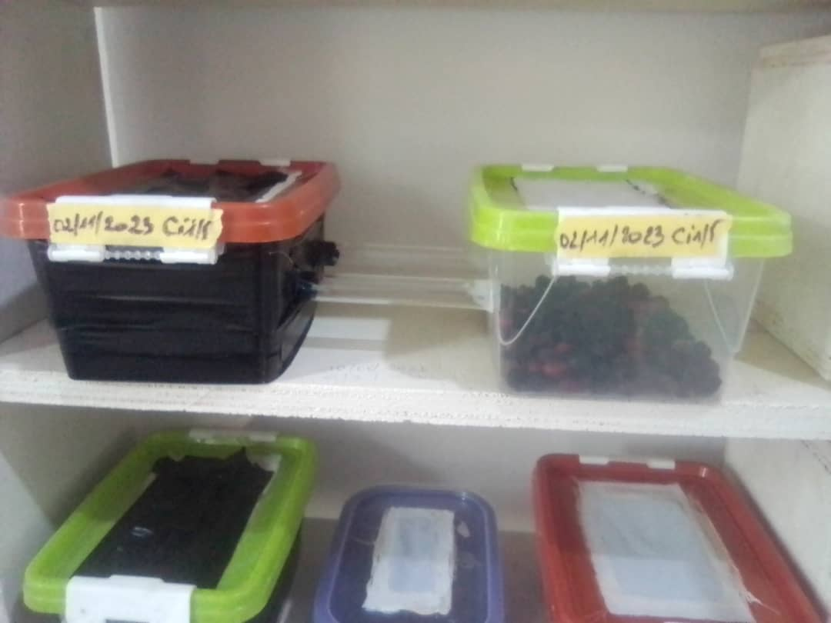
Figure 3. Pots for exposing coffee berry borer to parasitoids

2.2.3 Conduct of the Experiment
The experiment was carried out over two periods. In the first period, twenty parasitoids were introduced to twenty beetles on twenty ripe cherries in a double-compartment pot on day 0 (J0), and daily observations were made until the 28th day (first cycle) to perform cherry dissections. In the second period, the beetles were first allowed to interact with the ripe cherries for 28 days, after which the parasitoids were introduced. Observations were also conducted for 28 days, corresponding to one beetle cycle.

2.2.4 Data Collection
After introducing the parasitoids to the beetles, data on beetle mortality were recorded daily until cherry dissection on the 28th day following the start of treatments. After dissection, the biological parameters of the coffee berry beetle were recorded (beetle developmental stage, parasitized individuals) according to the treatments.
2.2.5 Estimation of coffee berry borer mortality rate
The mortality rate was calculated using Abbott’s formula (1925), as recommended by the FAO and WHO for insecticide tests. The formula is as follows:

où : TMc : Taux de mortalité corrigée (%),
Mo : Observed mortality in treated groups (%)
Me : Mean mortality from the absolute control
2.2.5 Data Analysis
Beetle mortality data were subjected to one-way analysis of variance (ANOVA) using the STATISTICA software. The Least Significant Difference (LSD) test was used for multiple comparisons at a 5% probability level.
3. RESULTS AND DISCUSSION
3.1 Mortality rate of the coffee berry borer
The evaluation of the sublethal effect of different parasitoids on the corrected mortality of the coffee berry beetle revealed significant variations depending on the type of parasitoid used and the timing of their introduction to the host. The control treatment, without parasitoids, showed a minimal corrected mortality of 5%, indicating low natural mortality. Treatments P1 and P2, with Phymastichus coffea and Cephalonomia stephanoderis applied from day 0, induced higher mortality, reaching 30% and 25%, respectively. The combination of these two parasitoids (P3), applied simultaneously from day 0, significantly increased beetle mortality to 50%. This increase was even more pronounced when the combination was applied 28 days after beetle penetration (P6), with corrected mortality reaching 60%, the highest level observed. In comparison, delayed applications of the parasitoids individually (P4 and P5) showed slightly lower mortality rates than early applications. These results suggest that combining the two parasitoids, applied at an advanced stage of beetle development, is the most effective strategy for reducing its population in coffee cherries.
The results obtained in this study highlight the variable effectiveness of the parasitoids Phymastichus coffea and Cephalonomia stephanoderis on the mortality of the coffee berry borer (Hypothenemus hampei), depending on the timing of application and their combination. The control treatment, without biological intervention, showed a very low corrected mortality (5%), confirming the limited impact of abiotic factors on the natural mortality of the pest under experimental conditions.
Individual application of the parasitoids at the onset of infestation (day 0) resulted in significant mortality (30% for P. coffea and 25% for C. stephanoderis), demonstrating their ability to disrupt the borer’s biological cycle at an early stage. However, the simultaneous combination of both species (P3) generated a higher mortality rate (50%), indicating complementarity in their modes of action or a more efficient occupation of the pest’s ecological niches.
Interestingly, delayed application (28 days after borer penetration) did not reduce the effectiveness of the parasitoid association (P6); on the contrary, this strategy led to the highest observed mortality (60%). This may be explained by the fact that, at an advanced developmental stage of the borer inside the seed, parasitoids benefit from greater accessibility to hosts or from an increased concentration of susceptible stages (pre-pupae and pupae). In contrast, when used individually at a delayed stage (P4 and P5), both parasitoids showed slightly lower efficacy compared to their early application, suggesting that their optimal action depends on the timing and physiological stage of the host.
These findings are consistent with those of Bustillo et al. (1998) and Aristizábal et al. (2016), who demonstrated that combining multiple biocontrol agents can enhance regulation of borer populations, provided their ecological niches and attack strategies are complementary. Overall, this study underlines the importance of an integrated strategy, combining compatible parasitoids with a targeted application schedule, to optimize biological control of the coffee berry borer.

Table 2. Coffee berry borer mortality following parasitoid introduction
Treatment | Parasitoids used | Period of Exposure of Parasitoids to the Beetle | Corrected mortality rate of the coffee berry borer (%)
P1 | No parasitoid |  | 5a
P2 | P. coffea | Jour 0 | 30b
P3 | C. stephanoderis | Jour 0 | 25b
P4 | P. coffea + C. stephanoderis | Jour 0 | 50c
P5 | P. coffea | 28 days after beetle penetrated cherry | 20b
P6 | C. stephanoderis | 28 days after beetle penetrated cherry | 22b
P7 | P. coffea + C. stephanoderis | 28 days after beetle penetrated cherry | 60c

Means followed by the same letter within a column do not differ significantly from each other (Fisher’s test, p = 0.01).

3.2 Effect of parasitoids (Prorops coffea and Cephalonomia stephanoderis) on the developmental parameters of the coffee berry borer
Table 3 shows the effect of the parasitoids Phymastichus coffea and Cephalonomia stephanoderis, alone or in combination, on the different developmental stages of the coffee berry borer (Hypothenemus hampei). The control treatment (without parasitoids) exhibits all developmental stages (eggs, larvae, pupae, adults) with no parasitism, confirming the viability of the insect’s life cycle in the absence of biological control. Introduction of P. coffea results only in parasitism of adults, whereas C. stephanoderis primarily targets larvae, pupae, and pre-pupal stages, with no effect on eggs or adults. The combination of both parasitoids provides more comprehensive coverage of the borer’s life cycle, reducing both immature and adult stages. Neither species parasitizes the eggs. These results suggest that the combined use of these two parasitoids offers a complementary and effective strategy within an integrated biological control program against H. hampei.
The results further confirm the complementary potential of P. coffea and C. stephanoderis in the biological control of H. hampei. The control treatment, characterized by the presence of all pest stages in the absence of parasitism, showed that the borer can complete its entire life cycle without significant natural pressure under controlled conditions. Introduction of P. coffea exclusively targeted adults, which is consistent with its known biology as a specialized endoparasitoid that injects its eggs directly into adult borers (Aristizábal et al., 2004). By contrast, C. stephanoderis, an ectoparasitoid, exerted its action on immature stages, particularly larvae and pupae, in agreement with earlier observations by Baker (1999), Bustillo et al. (1998), and Aristizábal et al. (2004), who reported that C. stephanoderis shows a marked preference for larvae, with its efficiency depending on the developmental stage of the borer within the coffee berry (Orozco, 2002; Salazar et al., 2002).
The combination of the two parasitoid species proved more effective by covering all susceptible stages of the borer, except for eggs, for which no parasitism was observed. This biological complementarity is crucial in integrated management systems, as it allows for a broader disruption of the pest’s life cycle, reducing the chances of survival and proliferation of the remaining individuals. These results corroborate those of Benavides et al. (2002), who already emphasized the importance of multi-agent approaches in the sustainable management of H. hampei.
Nevertheless, the absence of any effect on eggs suggests the need to complement these parasitoids with other control methods, such as strict cultural practices (frequent collection of fallen berries, removal of post-harvest residues) or the targeted use of entomopathogenic fungi such as Beauveria bassiana, recognized for its effectiveness against adult stages of the borer (Bustillo, 2005; Irulandi et al., 2008). Moreover, field studies will be necessary to confirm the viability and sustainability of these parasitoids under open-field conditions, particularly in terms of survival, dispersal, and ecological interactions.
In conclusion, the combined use of P. coffea and C. stephanoderis represents a promising and ecologically sound strategy to strengthen biological control programs against H. hampei, provided they are integrated within a broader agroecological management framework.

 |  |  | Developmental stage of coffee berry borer
 | Parasitoids used | Periods | Egg parasitized | Œuf unparasitized | Parasitized larva | Unparasitized larva | Parasitized pupa | Unparasitized pupa | Parasitized pre pupa | Unparasitized pre pupa | Parasitized  beetle | Unparasitized beetle
P1 | No parasitoid | Jour 0 | 0 | 23a ±2 | 10b±2 | 20a ±2 | 0 | 0 | 0 | 100a±4 | 0 | 90a±3
P2 | Phymastichus coffea | Jour 0 | 0 | 30a ±2 | 0 | 30a±2 | 0 | 50a±1 | 0 | 200b±2 | 140a±3 | 10a±2
P3 | Cephalonomia stephanoderis | Jour 0 | 0 | 20a ±1 | 110a±1 | 12a ±2 | 10a±1 | 10b±1 | 20a±1 | 05c±1 | 0 | 80a±3
P4 | P. coffea + C. stephanoderis | Jour 0 | 0 | 25a ±2 | 20b±0.3 | 30a ±2 | 40b±2 | 10b±2 | 20a±3 | 10c±1 | 70a±2 | 10b±1
P5 | Phymastichus coffea | Jour 28 | 0 | 100b ±2 | 0 | 60b ±2 | 0 | 40a± 3 | 0 | 70a±3 | 100a±1 | 60a±3
P6 | Cephalonomia stephanoderis | Jour 28 | 0 | 80b ±1 | 60c±1 | 0 | 40b±3 | 5b±2 | 50b±2 | 10c±2 | 0 | 120a±1
P7 | P. coffea + C. stephanoderis | Jour 28 | 0 | 100b ±3 | 60c±0.2 | 0 | 40b±2 | 10b± 3 | 50b±1 | 20c±1 | 150a±2 | 10b±2
Table 3. Parasitism of the coffee berry borer according to its developmental stage

Means followed by the same letter within a column are not significantly different from each other (Fisher’s test, p =0.02

Conclusion and Perspectives
This study demonstrated the effectiveness of the parasitoids Phymastichus coffea and Cephalonomia stephanoderis in the biological control of the coffee berry borer (Hypothenemus hampei) under laboratory conditions. The results showed that the combined use of these two parasitoids targets both immature and adult stages of the pest, leading to significantly higher mortality rates compared to the use of each parasitoid individually. The synergistic effect observed, particularly when application was delayed by 28 days after infestation, suggests that the biological complementarity between these two species represents a valuable lever to enhance the efficiency of biocontrol strategies.
However, the absence of any effect on borer eggs indicates that these parasitoids, although effective, cannot eradicate the pest on their own. They should therefore be integrated into an integrated pest management program, combining appropriate cultural practices, regular monitoring of pest populations, and, where relevant, the complementary use of entomopathogenic fungi such as Beauveria bassiana.
It is recommended to:
- Conduct field trials to assess the survival, dispersal, and effectiveness of the parasitoids under natural conditions.
- Study the ecological interactions between these parasitoids and other organisms present in the coffee agroecosystem.

References
Abraham , Y.J. , Moore , D. & Godwin , G. (2009). Rearing and aspects of the biology of Cephalonomia stephanoderis and Prorops nasuta (Hymenoptera: Bethylidae) parasitoids of the coffee berry borer, Hypothenemus hampei (Coleoptera: Scolytidae). Bulletin of entomological research.
Aristizabal , L. F. , Bustillo , A. E. , & Arthurs , S. P. (2016). Integrated pest management of coffee berry borer: strategies from Latin America that could be useful for coffee farmers in Hawaii. Insects, 7(1), 6. https://doi.org/10.3390/insects7010006
Baker , P. S. ( 1999 ). The Coffee Berry Borer in Colombia. Final Report of the DFID-Cenicafe-CABI Bioscience IPM Project, DFID.
[Available at : https://www.cabi.org]
Benavides , P. , Bustillo , A. E. , & Montoya , E. C. (2002). Releases of Cephalonomia stephanoderis and Prorops nasuta (Hymenoptera: Bethylidae) in coffee plantations and their establishment. Colombian Journal of Entomology, 28(2), 185–190.
Bustillo , A. E. , Cardenas , R. , Villalba , D. , Benavides , P. , Orozco , J. , & Posada , F. (1998). Integrated management of the coffee drill bit Hypothenemus hampei (Ferrari) in Colombia. Cenicafe, Chinchina, Colombia.
Damon, A. (2000). A review of the biology and control of the coffee berry borer, Hypothenemus hampei (Coleoptera: Scolytidae). Bulletin of Entomological Research, 90(6), 453–465. https://doi.org/10.1017/S0007485300000584
Irulandi , S. , Rajendran , R. , Samuel , SD , ​​Chinniah , C. , Kumar , PK & Sreedharan , K. ( 2008 ). Efficacy of Beauveria bassiana and an exotic parasitoid, Cephalonomia stephanoderis (Betrem) (Hymenoptera : Bethylidae) for the management of scolyte of the coffee bean Hypothenemus hampei (Ferrari) (Coleoptera : Scolytidae) . Journal of Biological Control 22 , 91 – 97
Jaramillo , J. , Borgemeister , C. , & Baker , P. (2006). The coffee berry borer Hypothenemus hampei (Coleoptera: Curculionidae): searching for sustainable control strategies. Bulletin of Entomological Research, 96(3), 223–233.
LaSalle , J. ( 1990 ). Phymastichus coffea n. sp., a parasitoid of the coffee berry borer from Africa (Hymenoptera: Eulophidae). Bulletin of Entomological Research, 80(1), 93–98.
Portilla, M. (1999). Breeding and mass production of coffee drill bit parasitoids. Cenicafé Technical Bulletin, 24(2), 1–19.
Orozco , J. , Aristizabal , L. F. , & Trujillo , H. (2008). Control strategies of coffee drill with entomopathogenic and parasitoid fungi in Colombia. Journal Integrated Pest Management and Agroecology, 89, 66–75.
Perez , L. A. , Montoya , E. C. , & Benavides , P. (2015). Biological control of Hypothenemus hampei with Cephalonomia stephanoderis and Phymastichus coffea in Colombia. International Journal of Tropical Insect Science, 35(2), 109–115.
Orozco, H.J., 2002. Guide to the production of the parasitoid Phymastichus coffea for coffee drill control, CFC-Cenicafé-CABI-Commodities -ICO: Colombia,; 19
Salazar , H.M. , & Baker , P.S. (2002). Impact of Cephalonomia stephanoderis releases on Hypothenemus hampei populations. Rev. Fr. Cenicafe 53, 306–316

