Transforming Teacher Education Through Digital Innovation: A Moodle-based Module for 21st-Century Literacies

.
ABSTRACT

Aims: This study focused on designing and evaluating a Moodle-based instructional module for Building and Enhancing New Literacies Across the Curriculum (BENLAC), a professional education course embedded in the updated higher education curricula. Its purpose was to prepare pre-service teachers with vital 21st-century literacies and skills necessary for effective teaching in the future.
Study design: A mixed-methods approach was employed, integrating qualitative document analysis for module development with quantitative assessment through a descriptive survey to evaluate the instructional module's effectiveness.
Place and Duration of Study: The research was conducted at Central Bicol State University of Agriculture (CBSUA), Philippines.
Methodology: The Moodle-based instructional module was developed through a structured three-phase process: planning, design, and evaluation. Five doctoral experts in fields such as curriculum development, educational leadership, professional education, instructional materials development, and ICT reviewed the module using a modified 36-item checklist. The assessment covered four key areas: content, design/format, technical features, and pedagogical aspects, all rated on a 5-point Likert scale. Data were analyzed with IBM SPSS Statistics 21, calculating the weighted mean and standard deviation.
Results: Expert evaluation results showed that the Moodle-based instructional module received "very good" ratings across all assessment criteria. Content validation scored 4.6, design and format validation reached 4.63, technical and technological aspects earned 4.73, and pedagogical parameters garnered 4.57 on a 5-point scale. The module effectively incorporated essential learning materials, provided user-friendly navigation, supported various learning styles, and aligned well with the Philippine Professional Standards for Teachers and 21st-century literacy skills.
Conclusion: The Moodle-based instructional module, carefully designed and tested, proved to be a highly useful and relevant resource for professional education courses. It is especially appropriate for the shift in delivery modes prompted by the COVID-19 pandemic. The study shows that well-constructed Learning Management System (LMS) modules can effectively maintain high-quality teaching and learning in higher education. Additionally, they help prepare pre-service teachers with vital 21st-century skills and literacies needed in today’s educational environments.

Keywords: Instructional module design and evaluation, Moodle-based instructional module, professional education course, Virtual Learning Portal

1. INTRODUCTION

The COVID-19 pandemic has had an unprecedented impact on education systems worldwide, causing a significant shift in teaching and learning methods. One notable change has been the forced adoption of distance learning to keep education going without risking the health and safety of teachers and students. During the rapid technological advancements of the pandemic, many universities moved from traditional education methods to e-learning (Stecula & Wolniak, 2022). However, implementing e-learning has brought both advantages and challenges for educational institutions. Okagbue et al. (2023) point out several concerns during this period, such as the lack of online learning tools for synchronous classes, financial constraints or poverty, internet connectivity issues, low digital literacy, and a shortage of ICT devices for teaching and learning. Alongside these challenges, the pandemic has pushed the education system to explore new ways to deliver learning content to students (Abumalloh et al., 2021).

E-learning, which combines and utilizes Information and Communication Technology (ICT) to deliver educational content and support remote education (Suzianti & Paramadini, 2021), has long been part of the education system. However, it was fully adopted during the pandemic due to restrictions on in-person classes (Fauzi, 2017). Video teleconferencing tools and learning management systems, such as Microsoft Teams, Zoom, and Google Classroom, have become alternatives for Higher Education Institutions (HEIs), providing more opportunities to enhance teaching and learning (Stecula & Wolniak, 2022). E-learning is defined as various applications and processes accessible through electronic media and resources used to deliver education and training (Alqahtani & Rajikhan, 2020). Additionally, e-learning can offer training and higher education opportunities to students from diverse educational backgrounds and cultures (Aljawarneh, 2020). As e-learning transforms education, many institutions and educators are encouraged to adopt and embrace Internet-based learning resources to provide high-quality teaching and learning.

The study by Bani Hani et al. (2021) shows that Zoom and Skype are the most popular platforms for e-learning. Similarly, Gunawan et al. (2021) state that the Zoom application can be used on various mobile devices, PCs, and laptops, enabling students to participate in learning from any location. Several studies indicate that Zoom has been an effective video teleconferencing app during the COVID-19 pandemic and is widely integrated into Learning Management Systems (LMS). The LMS has become one of the most notable tools for e-learning during the pandemic, driven by technological advances. Lonn, Teasley, and Krumm (2011) define LMS as a web-based platform that allows teachers and students to share learning materials and engage in synchronous or asynchronous online interactions. An LMS is characterized by its ability to incorporate multiple media formats, various resources, alternative technologies, and an organized presentation of information that facilitates learning (Oliveira et al., 2016). A high-quality LMS can be a vital tool for successful online course delivery, offering features such as course management, assessment, progress tracking, gradebook, communication tools, social connectivity, security and privacy, and ubiquitous access (Turnbull et al., 2020).

Oliveira, Cunha, and Nakayama (2016) stated that advances in e-learning have encouraged educational institutions to adopt different learning activities, develop new processes, and address emerging educational challenges. They also noted that integrating Learning Management Systems (LMS) and e-learning management can improve the planning, organization, management, control, and enhancement of e-learning processes. In response to the ongoing development of LMS during the pandemic, the Central Bicol State University of Agriculture (CBSUA) launched the Virtual Learning Portal (VLP) through the Modular Object-Oriented Dynamic Learning Environment (MOODLE) as an innovative solution to support the continuation of teaching and learning (Homillano, 2023). Homillano (2023) described VLP as a smart LMS alternative that provides customized and relevant content, utilizing various pedagogical models to engage students. As an online LMS, MOODLE offers numerous advantages over traditional methods and can improve communication between students and between students and teachers (Goyal et al., 2023). According to Maryati et al. (2023), Moodle-based LMS is one of the popular learning technologies used during the pandemic.

The Virtual Learning Portal (VLP) is primarily used to provide lecture resources and content. Faculty members at CBSUA created instructional modules based on the MOODLE platform for various academic disciplines. During the pandemic, these instructional modules became the most widely used educational materials for delivering learning content across all levels, from high school to college. The shift toward e-learning further encouraged the development of self-instructional modules, allowing teachers to explore and improve their teaching strategies. Dechavez (2023) states that self-instructional modules empower learners to progress at their own pace, anytime and anywhere. Recognizing the sudden move to e-learning, CBSUA took the opportunity to develop instructional modules in different fields via the VLP to enhance the overall teaching and learning process.

In response to the comprehensive revisions made to the Philippine Basic Education Curriculum, the Commission on Higher Education (CHED) has aligned the Higher Education curriculum with the K-12 curricula by implementing new Policies, Standards, and Guidelines for various undergraduate and graduate degree programs. The Higher Education curriculum requires exploring new literacies, concepts, strategies, challenges, and impacts of the 21st century to address current educational trends. Developing a Moodle-based instructional module for the Building and Enhancing New Literacies Across the Curriculum (BENLAC) course is essential for equipping pre-service teachers with new literacies and 21st-century skills needed to become effective educators in the future. De Leon (2020) defined 21st-century skills as comprehensive knowledge, abilities, work habits, and personal attributes required to navigate the modern world and future careers. Alongside these emerging trends, the 21st-century curriculum emphasizes seven new literacies: multicultural literacy, social literacy, media literacy, financial literacy, digital literacy, ecological literacy, and creative literacy. This study aims to design and evaluate an instructional module for the professional education subject of the revised tertiary education curricula, guiding pre-service and in-service teachers to acquire 21st-century literacies and skills. This study advocates for improving the quality of professional education in HEIs by utilizing Moodle-based instructional modules, providing accessible and practical learning within evolving educational environments, especially within the current Philippine educational context. The results of the study contribute to emerging pedagogical strategies with technology to create enriching learning experiences.

2. methodology

- Research Method

The study used a mixed-methods approach to design and evaluate instructional modules delivered through the Moodle platform for a specific professional education course. Qualitative data were collected through document analysis related to the development of the instructional module. A descriptive survey was employed for the quantitative part to assess the Moodle-based modules in terms of content, design/format, technical aspects, and pedagogical dimensions. The evaluation of these online learning modules was based on expert assessments using an evaluation tool modified by the researchers, initially adapted from Basilio & Sigua (2022). To evaluate the Moodle-based instructional modules, a descriptive analysis was conducted based on experts' responses to a Likert-style survey questionnaire. Data analysis was performed using IBM SPSS Statistics 21, utilizing techniques such as weighted mean and standard deviation.

- Instructional Module Evaluators

Five experts, selected for their relevant qualifications and expertise in key areas of module design, evaluated the instructional module. These areas included content, format, design, technical and technological factors, and pedagogical considerations. The expert panel was diverse in professional backgrounds to ensure a thorough assessment. It comprised a curriculum development specialist serving as a Curriculum Director, a Dean from the College of Education, two faculty members specializing in teaching Professional Education courses, a distinguished professor in Instructional Materials Development, and a professor experienced in information and communications technology (ICT). All evaluators held doctoral degrees (Ph.D. or Ed.D.) in fields such as Development Studies, Development Education, Educational Foundations, Human Development and Management, and Educational Leadership and Management.

- Phases of Moodle-based Instructional Module

Fig. 1. Phases of Moodle-based Instructional Module

The instructional module used a modified checklist from a study by Basilio and Sigua (2022), which contains 36 items rated on a 5-point Likert scale from strongly disagree (1) to agree (5) (see Table 1).

Table 1. Scale and Verbal Interpretation of the 5-point Likert Scale
Scale | Likert-Scale Interval | Interpretation
1 | 1.00 – 1.80 | Poor
2 | 1.81 – 2.60 | Fair
3 | 2.61 – 3.40 | Neutral
4 | 3.41 – 4.20 | Good
5 | 4.21 – 5.00 | Very Good

3. results and discussion

- Design of the Moodle-based Instructional Module

Implementing a Moodle-based learning system involves various components such as attendance tracking, synchronous activities using video conferencing tools, asynchronous activities facilitated by third-party applications, assignment creation and submission, and uploading and linking instructional materials like PDFs, PowerPoint presentations, documents, videos, and more (Makruf et al., 2022). In response to the challenges posed by the COVID-19 pandemic, the Central Bicol State University of Agriculture (CBSUA) developed the Virtual Learning Portal (VLP), a Moodle-based Learning Management System (LMS) designed to ensure the delivery of quality education online. The VLP was created to maintain the continuity of online teaching and learning during the pandemic. The Moodle-based learning portal includes several key pages, such as a login page, a dashboard, a site home page, a course section page, a course content page, a discussion board, and an assessment page (Figure 2). Instructional modules and their related content and materials are regularly uploaded according to the course schedule. A wide variety of learning resources and materials, including lecture videos, PowerPoint slides, PDFs, and more, are made available to students through the VLP.

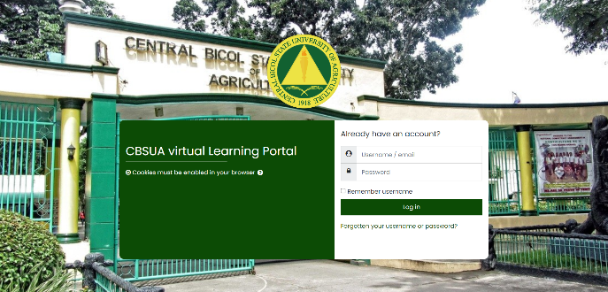  Login Page | 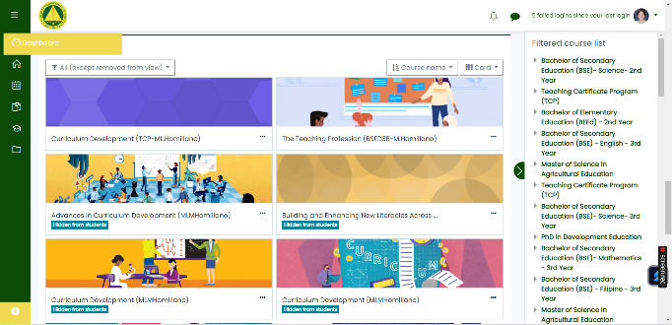  Dashboard Page
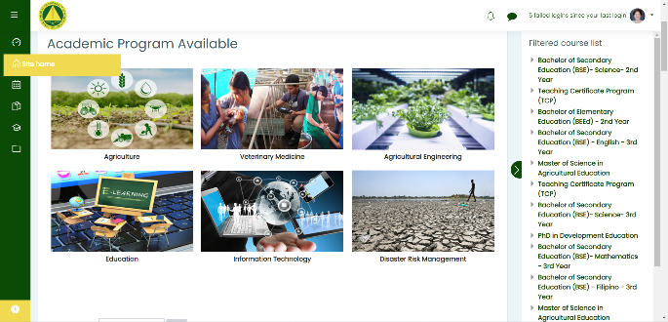  Site Home Page | 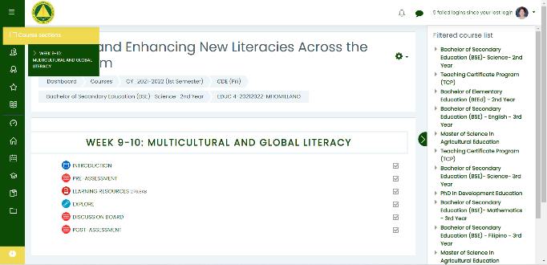  Course Section Page
  Course Content Page | 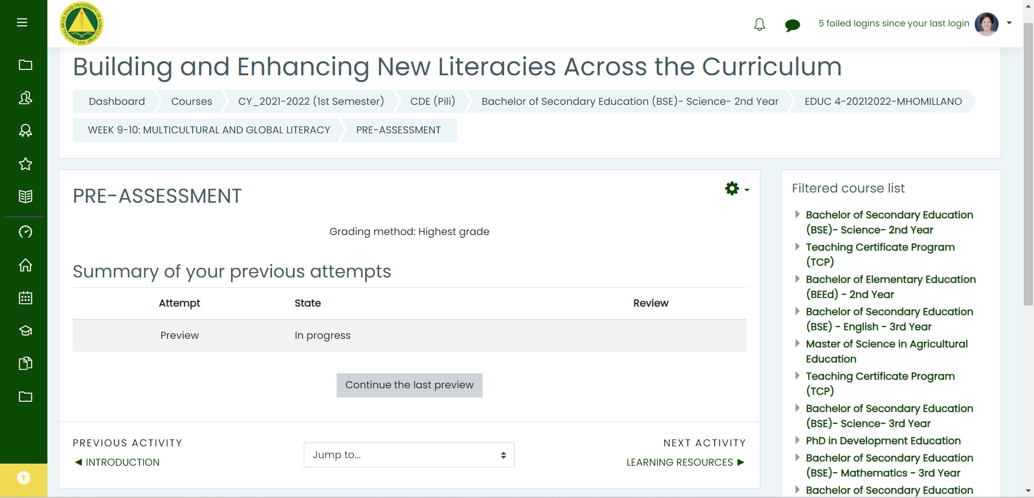  Pre-Assessment Page
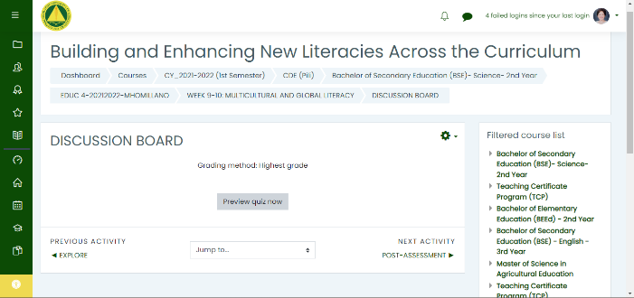 Discussion Board Page | 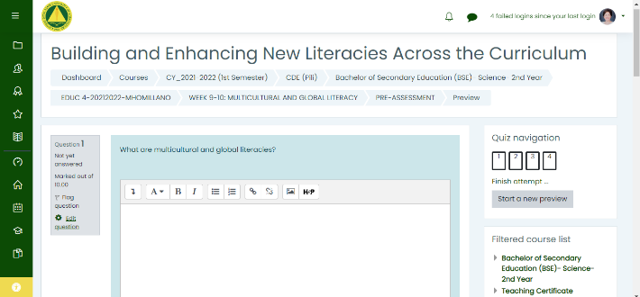  Post Assessment Page
Fig. 2. CBSUA Virtual Learning Portal Workflow

- Evaluation of Experts on the Moodle-based Instructional Module

The study focused on developing Moodle-based Learning modules that served as an alternative solution for higher education institutions during the peak of the COVID-19 pandemic, when online education became widely adopted. Experts in content, design, technology, and pedagogy assessed the modules. Second-year college students enrolled in professional education courses used these modules through the Virtual Learning Portal for 18 weeks, with 15 weeks dedicated to formative assessments and three weeks to summative assessments.

Table 2 shows that the content validation of the Moodle-based instructional module received a "very good" rating with an average score of 4.6. The design and format validation also earned a "very good" rating with an average score of 4.63. The technical and technological aspects achieved a "very good" rating with a weighted mean of 4.73, and the pedagogical parameter received a "very good" rating with a weighted mean of 4.57.

Table 2. Evaluation of Experts on the Content of the Moodle-based Instructional Module
Indicators | Mean | SD | Interpretation
CONTENT
- “The topic/lessons included in the module are very relevant to the main goal of the course and greatly contribute to the achievement of the specific lesson objectives.” | 4.67 | 0.52 | Very Good
- “The module provides information that is very important and useful to the students who will be utilizing it.” | 4.83 | 0.41 | Very Good
- “Adequate information is provided in every lesson with links and references to guide students for further research activities.” | 4.5 | 0.84 | Very Good
- “The content is presented using language that is understandable and suited to the level of the target learners.” | 4.5 | 0.84 | Very Good
- "The knowledge and ideas presented in every lesson are accurate, recent, and free from errors, using terminologies that suit the distinct characteristics of the target learners.” | 4.5 | 0.55 | Very Good
Weighted Mean | 4.6 |  | Very Good

Content of the Module. The evaluation shows that the module effectively organizes topics, making it easier for pre-service teachers to understand the learning materials. The instructional module includes essential, practical, and relevant information presented clearly, accurately, and without errors, as confirmed by experts. This indicates that the designed instructional module offers a variety of activities to help pre-service teachers grasp the subject BENLAC. This aligns with the study by Sirisuthi and Chantarasombat (2021), which states that learning content should promote innovative knowledge and foster creativity during the learning process. The module remains a versatile tool for teaching key skills, especially for students who may have missed specific topics due to challenges faced in their classes (Cramer et al., 2018).

Table 3. Evaluation of Experts on DESIGN/FORMAT of the Moodle-based Instructional Module
DESIGN/FORMAT
- “Textual information is presented with appropriate choice of font size and style, including other formatting features (e.g., italics, boldface, underline, etc.).” | 4.67 | 0.52 | Very Good
- “Proper spacing, margin, and indentation are observed between texts, sentences, and paragraphs to avoid congested pages.” | 4.5 | 0.55 | Very Good
- “The module utilized graphics and other media elements to motivate and engage students in the topics presented.” | 4.5 | 0.84 | Very Good
- “The important parts of the module are properly labeled for easy recognition (e.g., main topics, subtopics, specific discussions, etc.).” | 4.83 | 0.41 | Very Good
- “Each section of the module has clear instructions for students to follow, and it is appropriately packaged and ordered such that each component complements the others.” | 4.67 | 0.52 | Very Good
Weighted Mean | 4.63 |  | Very Good

Design/Format of the Module. The module's design and formatting elements are comprehensive, including a logical order of instructions and activities, appropriate font size and style, adequate spacing, effective use of graphics and multimedia components, and clear section labels. Cruz and Rivera (2022) argue that a well-designed learning module is essential for facilitating teaching and learning processes. Similarly, the study by Lau et al. (2019) highlights that incorporating engaging visuals, captivating designs, illustrations, and color schemes can make learning materials more attractive and appealing to students. When developing an instructional module, it is crucial to include features that promote meaningful learning experiences. Well-designed instructional modules can significantly improve students' understanding and knowledge acquisition in specific subject areas (Lagos, 2020).

Table 4. Evaluation of Experts on the TECHNICAL/TECHNOLOGICAL of the Moodle-based Instructional Module
TECHNICAL/TECHNOLOGICAL
- “Use of the module does not require equipment or applications beyond what is typically available to the students (e.g., operating systems, browsers, application software).” | 4.83 | 0.41 | Very Good
- “The module can be accessed by students either through the internet (online) or offline by providing an electronic copy (from CD, flash drive, and other modes of transferring files).” | 4.83 | 0.41 | Very Good
- “The module can be embedded or fully integrated into a Learning Management System (LMS) for wide dissemination and accessibility.” | 5 | 0.00 | Very Good
- “The module has a user-friendly interface and navigational tools that even novice users can easily follow.” | 4.5 | 0.55 | Very Good
- “The module allows students to interact with the teacher and other students through various communication tools such as email, messenger, videoconferencing, etc.” | 4.5 | 0.55 | Very Good
Weighted Mean | 4.73 |  | Very Good

Technical/Technological aspect of the Module. The results demonstrate that the developed module is highly suitable for easy integration into an LMS, ensuring broad accessibility, especially during the COVID-19 pandemic. Moodle, a popular LMS platform, is one of the most widely used free open-source learning systems. It offers a user-friendly option for educational institutions involved in e-learning at no cost (Cavus, 2015). Adding a module to an LMS enables students to access various resources, including videos, quizzes, and forum discussions, which are essential for supporting the learning process (Chaw & Tang, 2018). For successful integration, it is important to verify that the LMS has the necessary tools and features to support the intended modules, along with key capabilities and specialized tools designed for effective learning (De Smet et al., 2012).

Table 5. Evaluation of Experts on the PEDAGOGICAL aspect of the Moodle-based Instructional Module
PEDAGOGICAL
- “Objectives are well-formulated, giving clear direction and establishing a sense of expectancy among students.” | 5 | 0 | Very Good
- “Prior knowledge of students is properly assessed to bridge the gap between what they already know and what they have to know.” | 4.83 | 0.41 | Very Good
- “Various motivational and cognitive strategies are properly embedded in every lesson/unit to keep students on track.” | 4.33 | 0.52 | Good
- Tasks or activities required in the module are very relevant to the main objectives of the course and lessons. They must be realistic considering the resources available (e.g., time, materials, equipment, etc.).” | 4.5 | 0.55 | Very Good
- “The module provides provision for individual differences by supporting diverse learners with different learning styles, preferences, interests, and experiences.” | 4.17 | 0.41 | Good
- “Assessment tools included ensure the development of higher-order thinking skills such as critical and creative thinking.” | 4.67 | 0.52 | Very Good
- “The module also provides a good feedback mechanism so learners can regularly receive formative feedback on learning (i.e., they can track their performance, monitor their improvement, or test their knowledge).” | 4.5 | 0.55 | Very Good
Weighted Mean | 4.57 |  | Very Good

Pedagogical aspect of the Module. The data highlights well-designed objectives of the instructional module, which effectively guide learners and foster anticipation. When integrated into an LMS, the module enables e-learning objectives to provide learners with comprehensive explanations, examples, interactive elements, questions, feedback, glossaries, and more, helping them become self-reliant in acquiring new concepts and skills (FAO, 2021). In line with these structured objectives, the module also includes various assessment tools to promote higher-order thinking skills. Moodle offers a range of assessment methods, such as essay questions, online audio recordings, multiple-choice assessments, short-answer questions, matching questions, embedded answers, the option to upload PDF files, and interactive video and audio recordings (Thomas et al., 2015). Kotzer & Elran (2012) emphasized that the goal of Moodle-based instruction is to support an inquiry- and discovery-based approach to online learning. To improve different aspects of LMS, further analysis of the implementation and effectiveness of the materials is essential for e-learning success (Gamage et al., 2022). Additionally, Taban (2021) noted that many scholars have proposed that LMS can serve as a technological intervention in current educational reforms, where an e-learning approach is needed.

4. Conclusion

The study reported significant findings in preparing pre-service teachers to meet the changing needs of K-to-12 Basic Education in the 21st century. Through thorough data analysis and literature review, the research offered insights into the design and evaluation of Moodle-based instructional modules for a professional education course, BENLAC. The findings carry important implications for future educators in effectively integrating technology, aligning instruction with standards, using various assessment strategies, promoting active learning within communities, and providing ongoing learning opportunities.

The implementation of the Virtual Learning Portal (VLP) during the COVID-19 pandemic marks a significant advancement in improving the educational landscape. The VLP simplified how course content is delivered and offered an innovative platform for collaboration, assessment, and ongoing learning. The VLP was evaluated to demonstrate its ability to meet the diverse needs of educators and students in an interactive and engaging environment. Despite challenges, the positive results of the study lay a foundation for future educational technologies that promote efficient and effective teaching and learning experiences.

Furthermore, the assessment of the Moodle-based instructional module proved to be a valuable educational resource. Strong evidence of its educational usability was demonstrated through thorough evaluations by experts in content, design/format, technical/technological, and pedagogical fields, with an overall 'very good' rating across all criteria. Positive feedback and constructive suggestions from expert reviewers confirmed its strong applicability and significant potential to improve learning experiences. The results helped refine the instructional module and highlighted that ongoing evaluation and continuous improvement in instructional design are crucial. The findings underscored the importance of well-designed instructional materials in supporting active and meaningful learning.

COMPETING INTERESTS DISCLAIMER:
Authors have declared that they have no known competing financial interests OR non-financial interests OR personal relationships that could have appeared to influence the work reported in this paper.

References

Abumalloh, R.A., Asadi, S., Nilashi, M., Minaei-Bidgoli, B., Nayer, F.K., Samad, S., Mohd, S., Ibrahim, O. (2021). The impact of coronavirus pandemic (COVID-19) on Education: The role of virtual and remote laboratories in Education. Technol. Soc., 67, 101728. https://doi.org/10.1016/j.techsoc.2021.101728
Aljawarneh, S.A. (2020). Reviewing and exploring innovative ubiquitous learning tools in higher Education. J Comput High Educ, 32, 57–73. https://doi.org/10.1007/s12528-019-09207-0
Alqahtani, A.Y., & Rajkhan, A.A. (2020). E-Learning Critical Success Factors during the COVID-19 Pandemic: A Comprehensive Analysis of E-Learning Managerial Perspectives. Education Sciences, 10(9), 216. https://doi.org/10.3390/educsci10090216
Bani Hani, A., Hijazein, Y., Hadadin, H., Jarkas, A.K., Al-Tamimi, Z., Amarin, M., Shatarat, A., Abu Abeeleh, M., Al-Taher, R. (2021). E-Learning during COVID-19 pandemic; Turning a crisis into opportunity: A cross-sectional study at The University of Jordan. Annals of Medicine and Surgery, 70, 102882. https://doi.org/10.1016/j.amsu.2021.102882
Basilio, C. R. & Sigua, E. S. (2022). Development and validation of multimedia-based instructional module in Science 7. International Research Journal of Science, Technology, Education, and Management, 2(1), 152–162. https://doi.org/10.5281/zenodo.6496847
Cavus, N. (2015). Distance Learning and Learning Management Systems. Procedia - Social and Behavioral Sciences, 191, 872–877. https://doi.org/10.1016/j.sbspro.2015.04.611
Chaw, L.Y., & Tang, C.M. (2018). What Makes Learning Management Systems Effective for Learning? Journal of Educational Technology Systems, 47(2), 152–169. https://doi.org/10.1177/0047239518795828
Cramer, K.M., Ross, C., Plant, L., & Pschibul, R. (2018). Efficacy of Learning Modules to Enhance Study Skills. International Journal of Technology and Inclusive Education, 7(1), 1251–1259. https://doi.org/10.20533/ijtie.2047.0533.2018.0153
Cruz, L.I.C., & Rivera, K.C. (2022). Development And Validation Of Project-Based Module For Selected Topics In Biology. International Journal of Educational Research and Social Sciences (IJERSC), 3(3), 1124–1137. https://doi.org/10.51601/ijersc.v3i3.374
De León, E.B. (2020). Building and Enhancing New Literacies Across the Curriculum. Lorimar Publishing.
De Smet, C., Bourgonjon, J., De Wever, B., Schellens, T., Valcke, M. (2012). Researching instructional use and the technology acceptation of learning management systems by secondary school teachers. Computers & Education, 58(2), 688–696. https://doi.org/10.1016/j.compedu.2011.09.013
Dechavez, M. (2023). Peer And Students' Evaluation: An Instructional Module Enhancement. International Journal of Research and Innovation in Social Science (IJRISS), 7(1), 1360–1378. https://philarchive.org/archive/DECPAS
Department of Education. (2017). National Adoption and Implementation of the Philippine Professional Standards for Teachers (DepEd Order 42 s. 2017). [Online]. https://www.deped.gov.ph/wp-content/uploads/2017/08/DO_s2017_042-1.pdf
FAO. (2021). E-learning methodologies and good practices: A guide for designing and delivering e-learning solutions from the FAO e-learning Academy, second edition. Rome.
Fauzi, M.A. (2017). E-learning in higher education institutions during COVID-19 pandemic: current and future trends through bibliometric analysis. Heliyon, 8, e09433. https://doi.org/10.1016/j.heliyon.2022.e09433
Gamage, S., Ayres, J.R. & Behrend, M.B. (2022). A systematic review on trends in using Moodle for teaching and learning. IJ STEM Ed 9, 9. https://doi.org/10.1186/s40594-021-00323-x
Goyal, S., Khaliq, F., & Vaney, N. (2023). Implementation of the online learning management system 'Moodle' as a blended approach to online teaching. Indian Journal of Physiology and Pharmacology, 67(1), 64–72. https://doi.org/10.25259/IJPP_208_2022
Gunawan, G., Kristiawan, M., Risdianto, E., & Monicha, R.E. (2021). Application of the Zoom Meeting Application in Online Learning During the Pandemic. In: Education Quarterly Reviews, 4(2), 26-32. https://doi.org/10.31014/aior.1993.04.02.193
Homillano, L. (2023). Development and Validation of an Instructional Module in Science, Technology, and Society (STS) in the Tertiary Education Curriculum. Asian Journal of Education and Social Studies, 46(3), 41–52. https://doi.org/10.4060/i2516e
Kotzer, S., & Elran, Y. (2012). Learning and teaching with Moodle-based E-learning environments, combining learning skills and content in the fields of Math and Science & Technology. 1st Moodle Research Conference, Heraklion, Crete, Greece, 122–131.
Lagos, J.C. (2020). Validation of module on exponential and logarithmic functions using the understanding by design lesson plan for grade 11 mathematics students. African Educational Research Journal, 8(2), 262–271. https://doi.org/10.30918/AERJ.82.20.006
Lau, X.C., Wong, Y.L., Wong, J.E., Koh, D., Sedek, R., Jamil, A.T., Ng, A.L.O., Hazizi, A.S., Ruzita, A.T., & Poh, B.K. (2019). Development and Validation of a Physical Activity Educational Module for Overweight and Obese Adolescents: CERGAS Programme. International journal of environmental research and public health, 16(9), 1506. https://doi.org/10.3390/ijerph16091506
Lonn S., Teasley S.D., Krumm A.E. (2011). Who needs to do what where?: Using learning management systems on residential vs. commuter campuses. Computers & Education, 56(3), 642–649. https://doi.org/10.1016/j.compedu.2010.10.006
Makruf, I., Rifa'i, A., & Triana, Y. (2022). Moodle-Based Online Learning Management in Higher Education. International Journal of Instruction, 15(1), 135-152. https://doi.org/10.29333/iji.2022.1518a
Maryati, I., Hamdani, N.A., Maolani, G.A.F., Tetep. (2023). Moodle-Based Learning Management System Application in the Development of Interactive Digital Module in Description Statistics Courses. Proceedings of the 3rd International Conference on Education and Technology (ICETECH 2022), 354–366. https://doi.org/10.2991/978-2-38476-056-5_38
Okagbue, E.F., Ezeachikulo, U.P., Nchekwubemchukwu, I.S., Chidiebere, I.E., Kosiso, O., Ouattaraa, C.A.T., Nwigwe, E.O. (2023). The effects of COVID-19 pandemic on the education system in Nigeria: The role of competency-based Education. Int. J. Educ. Res. Open, 4, 100219. https://doi.org/10.1016/j.ijedro.2022.100219
Oliveira, P.C., Cunha, C., & Nakayama, M.K. (2016). Learning management systems(LMS) and e-learning management: an integrative review and research agenda. Journal of Information Systems and Technology Management, 13(2), 157–180. https://doi.org/10.4301/S1807-17752016000200001
Sirisuthi, C. & Chantarasombat, C. (2021). Development on the Learning Module of School-Based Supervision Course for Master Degree Students, Majoring Educational Administration in Thailand. International Journal of Higher Education, 10(4), 21–31. https://doi.org/10.5430/ijhe.v10n4p21
Stecuła, K., & Wolniak, R. (2022). Advantages and Disadvantages of E-Learning Innovations during the COVID-19 Pandemic in Higher Education in Poland. Journal of Open Innovation: Technology, Market, and Complexity, 8(3), 159. https://doi.org/10.3390/joitmc8030159
Suzianti, A., Paramadini, S.A. (2021). Continuance Intention of E-Learning: The Condition and Its Connection with Open Innovation. J. Open Innov. Technol. Mark. Complex, 7, 97. https://doi.org/10.3390/joitmc7010097
Taban, J. (2021). Teaching mathematics in a Moodle-based learning environment. Asia Pacific Journal of Multidisciplinary Research, 9(1), 19–29. https://research.lpubatangas.edu.ph/wp-content/uploads/2022/02/APJMR-2021.9.1.03.pdf
Thomas, N.T., Kumar, A., & Bijlani, K. (2015). Automatic Answer Assessment in LMS Using Latent Semantic Analysis. Procedia Computer Science, 58, 257-264. https://doi.org/10.1016/j.procs.2015.08.019
Turnbull, D., Chugh, R., Luck, J. (2020). Learning Management Systems, An Overview. In: Tatnall, A. (eds) Encyclopedia of Education and Information Technologies. Springer, Cham. https://doi.org/10.1007/978-3-030-10576-1_248

