Phytochemical Screening and TLC Profiling of Leaf Extracts of Catharanthus roseus show presence of biopesticidal secondary metabolites

Abstract
The present study was aimed to evaluate the phytochemical constituents through biochemical tests as well as thin layer chromatography (TLC) of crude and acetone leaf extracts of Catharanthus roseus (Madagascar periwinkle), a medicinally important plant known for its alkaloids with anticancer properties. Crude and solvent (acetone) leaf extracts were prepared. Standard phytochemical screening procedures were employed to detect alkaloids, flavonoids, saponins, tannins, terpenoids, cardiac glycosides, anthraquinones, carbohydrates, and phenols. TLC profiling was carried out using suitable solvent systems and it showed different Rf values that were analyzed. The results obtained in the present investigation indicated the presence of alkaloids, tannins, and phenols, saponins, terpenoids, cardiac glycosides, anthraquinones, carbohydrates were present in both the extracts. Flavonoids were absent in crude extract but they were present in acetonic extract. TLC revealed distinct bands corresponding to secondary metabolites, confirming the chemical diversity of C. roseus. The findings support its traditional medicinal as well as biopesticidal applications and provide a baseline for further bioactivity-guided biopesticides development.
Keywords: Catharanthus roseus, phytochemical screening, TLC profiling, leaf extracts, alkaloids, secondary metabolites
1. Introduction
Leaf extracts of plants are important sources of bioactive compounds with therapeutic and biopesticidal potential. Catharanthus roseus (commonly known as Madagascar periwinkle or rosy periwinkle) is a well-known medicinal plant belonging to the family Apocynaceae (Gupta et al., 2018). The species is native to Madagascar but has been widely cultivated in tropical and subtropical regions, including India, where it grows as an evergreen perennial herb reaching 30–100 cm in height. Traditionally, it has been used as an ornamental plant, valued for its year-round flowering, and is commonly propagated from seeds or stem cuttings (Aslam et al., 2010).
Pharmacologically, C. roseus is cultivated primarily for its alkaloids, which exhibit diverse therapeutic properties including anti-cancer, anti-bacterial, anti-diabetic, anti-fungal, and anti-malarial activities (Gupta et al., 2018). The concentration of alkaloids varies among different plant parts, with the root bark showing the highest levels, ranging from 0.15% to1.34% and occasionally reaching up to 1.79%. The plant contains more than 130 indole alkaloids, of which about 25 are dimeric in nature. Two of these dimeric alkaloids, vinblastine and vincristine, are concentrated in the aerial parts and are widely used as chemotherapeutic agents in the treatment of various cancers. In addition, several monomeric alkaloids, including ajmalicine (raubacine) are present in the roots and are utilized in managing circulatory disorders (Aslam et al., 2010).
Beyond alkaloids, the plant is also a source of other bioactive metabolites such as sterols, flavonoids, sesquiterpenes, lactones, and lupeol acetate, all of which contribute to its medicinal and biopesticidal significance in both traditional and modern pharmacology (Kapoor et al., 2021 and Supradip et al., 2012). Phytochemicals having Insecticidal or biopesticidal potential of leaf extracts are alkaloids, terpenoids, phenolics, tannins and sterols (Fabrick et al., 2020) Morphologically, C. roseus is cultivated in two main varieties distinguished by flower color: the pink-flowered type (rosea) and the white-flowered type (alba) (Paikara et al., 2017).
The aims of the present study are to investigate the presence of qualitative phytochemicals for biopesticidal interest through biochemical tests and thin layer chromatography (TLC) of crude and acetonic leaf extract of C. roseus.
2. Materials and Methods
Plant Collection and Authentication:
During study period fresh leaves of Catharanthus roseus were collected from R.B.S. College Garden, Agra.
Preparation of Plant Extracts:
a) Preparation of Crude Extract: 100g of fresh leaves of Catharanthus roseus were rinsed with running water from 2-3 times and then with distilled water and then macerated in mortar and pestle and then filtered using the muslin cloth and centrifuged at 3000 rpm for 10 minutes, supernatant refiltered using the Whatman's No.1 filter paper and kept in a sterilized glass bottle at 4°C in the outer cabinet of the refrigerator for further analysis (Yadav et al., 2018).
b) Preparation of Solvent Extract: Fresh leaves of Catharanthus roseus were rinsed with running water from 2-3 times and then with distilled water, dried in the shade for 7 days with continuous flipping at room temperature and crushed with electric blender to generate a fine powder. Then, 10g of powder was mixed with 100ml of acetone (solvent). The mixture thus obtained was filtered through muslin cloth and thereafter pass through Whatman’s No. 1 filter paper. The filtrate was concentrated by evaporation of solvent at room temperature, and the extracts were stored at 4°C until further use (Ramya et al., 2008).
Preliminary Phytochemical Screening:
Standard qualitative tests were carried out to detect major phytochemical groups including alkaloids, flavonoids, tannins, saponins, cardiac glycosides, carbohydrates, terpenoids, anthraquinones, and phenols.
Test for Carbohydrates:
1) Fehling’s Test: To 0.5ml of C. roseus extract, 5 ml of Fehling’s solution A and 5 ml of Fehling’s solution B was added. Then the contents were allowed to boil for a few minutes. The formation of a red or brick red precipitate indicated the presence of carbohydrates (Patharajan and Abirami, 2014).
2. Benedict’s Test: To 0.5ml of C. roseus extract, 5 ml of Benedict’s reagent was added and were allowed to boil for 5 minutes. The formation of a bluish green color indicated the presence of carbohydrates (Patharajan and Abirami, 2014).
Test for Phenols:
1ml of plant extract of C. roseus was mixed with 2ml of distilled water, followed by a few drops of 10 percent aqueous FeCl₃ solution. The formation of a blue or green precipitate indicated the presence of phenols (Patharajan and Abirami, 2014).
Test for saponins:
0.5ml of plant extract of C. roseus was treated with a drop of sodium bicarbonate. The mixture was shaken vigorously and kept for 3 minutes. The formation of a honeycomb-like froth indicated the presence of saponins (Patharajan and Abirami, 2014).
Test for Tannins:
Lead acetate Test: 0.5ml of plant extract of C. roseus was treated with a few drops of 1 percent solution of lead acetate. The formation of a yellow or red precipitate indicated the presence of tannins (Patharajan and Abirami, 2014).
Test for Cardiac Glycosides:
0.5ml of plant extract of C. roseus was diluted with 5ml of water and then 2ml of glacial acetic acid was added followed by addition of one drop of FeCl₃. This was under laid with 1ml of concentrated H₂SO₄. The formation of brown ring at the interface and a violet ring below the brown ring, Greenish ring may form just above the brown ring, indicated the presence of cardiac glycosides (Paikara et al., 2017).
Test for Anthraquinones:
0.5ml of plant extract of C. roseus was mixed with 10ml of sulphuric acid (H₂SO₄) and were allowed to boil and filtered while hot. Now the filtrate was treated with 5ml of chloroform and shaken, followed by addition of 1ml of dilute ammonia in the chloroform layer. The formation of rose-pink color in the ammonical layer indicated the presence of anthraquinones (Gotmare and Gade, 2018).
Test for Terpenoids:
0.5ml of plant extract of C. roseus was mixed with 2ml of chloroform, and 3ml of concentrated H₂SO₄ was carefully added to form a layer. The formation of reddish-brown coloration at the interface indicated the presence of terpenoids (Paikara et al., 2017).
Test for Alkaloids:
0.5ml of plant extract of C. roseus was mixed with 1% v/v HCl, warmed and filtered. Now this filtrate was used for the following test.
Hager's Test: The filtrate was treated with Hager's reagent (saturated picric acid solution). The formation of a yellow color precipitate indicated the presence of alkaloids (Yadav et al., 2017).
Test for Flavonoids:
Alkaline Reagent Test: 0.5ml of plant extract of C. roseus was treated with 2-3 drops of sodium hydroxide solution. The formation of an intense yellow color, which becomes colorless in addition of a few drops of sulphuric acid, indicated the presence of flavonoids (Yadav et al., 2017).
Thin Layer Chromatographic Studies (TLC):
Thin- layer chromatography was carried out on the crude and acetone extracts of C. roseus using TLC pre- coated plates (silica gel 60F254) by using one-way ascending technique. The plates were cut with scissors of size 3×10 cm and marked with pencil about 1cm from the bottom of the plate. Then, the capillary tubes were used to spot the sample on the TLC plate on the pencil marked bottom line and allowed to dry and load the sample again until a dark spot is obtained. Then, the plates were developed in different solvent systems (SS) including; (SS1) n-butanol: acetic acid: water (4:1:5), (SS2) chloroform: ethyl acetate: methanol: water (15:8:4:1), (SS3) hexane: ethyl acetate (8:2), (SS4) chloroform: methanol (15:1), (SS5) hexane (100%), ensuring that the solvent front remained below the applied spot to prevent direct immersion of the sample. The plates were dried and visualized under visible light, ultraviolet light (254nm and 365nm).
The retention factor Rf for each active compound was calculated for each fraction using the following formula: (Alebiosu and Yusuf, 2015)
$$Rf=\frac{distance moved by the solute or compund}{distance moved by solvent}$$
Results & Discussion -:
Phytochemical Screening:
The general preliminary phytochemical screening conducted on the crude (Figure 1) and acetonic leaf extracts of C. roseus revealed the presence of various secondary metabolites as shown in Table 1.
Thin Layer Chromatographic Studies:
TLC analysis of crude and acetonic leaf extracts of C. roseus using different solvent systems revealed the presence of promising spots as shown in Table 2.

Table 1: Phytochemical Screening of C. roseus Leaf Extract
Phytochemicals | Crude Extract | Solvent (acetone) Extract
Carbohydrates | + | +
Phenols | + | +
Saponins | + | +
Tannins | + | +
Cardiac Glycosides | + | +
Anthraquinones | + | +
Terpenoids | + | +
Alkaloids | + | +
Flavonoids | - | +
+ = Present; - = Absent
Table 2: Thin-layer chromatographic (TLC) profile of crude and solvent extracts of the plant in different solvent systems, showing the number of bands and corresponding Rf values.
Extract | Solvent  System | No. of Bands | R_{f} Values
Crude extract | SS1 | 4 | 0.37, 0.59, 0.71, 0.83
Crude extract | SS2 | 3 | 0.50, 0.65, 0.73
Crude extract | SS3 | —
Crude extract | SS4 | 4 | 0.20, 0.23, 0.27
Crude extract | SS5 | —
Solvent (acetone)extract | SS1 | 4 | 0.56, 0.65, 0.75, 0.93
Solvent (acetone)extract | SS2 | 3 | 0.48, 0.58, 0.70
Solvent (acetone)extract | SS3 | 6 | 0.09, 0.19, 0.40, 0.50, 0.61, 0.71
Solvent (acetone)extract | SS4 | 3 | 0.07, 0.19, 0.29
Solvent (acetone)extract | SS5 | —
SS= Solvent System
The phytochemical results confirmed that crude and acetone solvent extracts of C. roseus leaves are rich in carbohydrates, phenols, saponins, tannins, cardiac glycosides, anthraquinones, terpenoids, alkaloids, whereas flavonoids were absent in crude extract. Similar findings have been reported by Kabesh et al., (2015), Shaikh et al., (2020) and Ujagar et al., (2021). Phytochemical constituents showed variation in R_{f} values across solvent systems, reflecting differences in polarity and guiding the selection of suitable mobile phases for compound isolation. TLC analysis of the crude extract showed a maximum of four bands in solvent systems SS1 and SS4, with R_{f} values ranging from 0.20 to 0.83, while no separation was observed in SS3 and SS5. In contrast, the solvent extract produced better resolution, yielding up to six bands in SS3 (R_{f} 0.09–0.71). Distinct bands were also observed in SS1, SS2, and SS4, whereas SS5 failed to show any migration. Overall, the solvent extract demonstrated greater compound diversity and separation efficiency compared to the crude extract, particularly in SS3. These bands were identified as phenolics, saponins, glycosides, terpenoids, alkaloids and flavonoids with the help of Rf value, compounds polarity and reference of standards (Das Manosi et at., 2017 and Gurav et al., 2023). Phytochemicals like phenols, alkaloids, saponins and terpenoids having insecticidal or biopesticidal potential were present in leaf extracts of C. roseus (Fabrick et al., 2020)
Conclusion
The phytochemical screening and TLC profiling of Catharanthus roseus leaf extracts confirmed the presence of important secondary metabolites, and these compounds are responsible for its biopesticidal activities and therapeutic potential. Further studies involving HPLC, GC-MS, and bioactivity assays are recommended to isolate and characterize individual bioactive molecules for biopesticidal interest. We will also try the study of insecticidal potential of these extracts on Sitophillus oryzae, a stored grain pest.

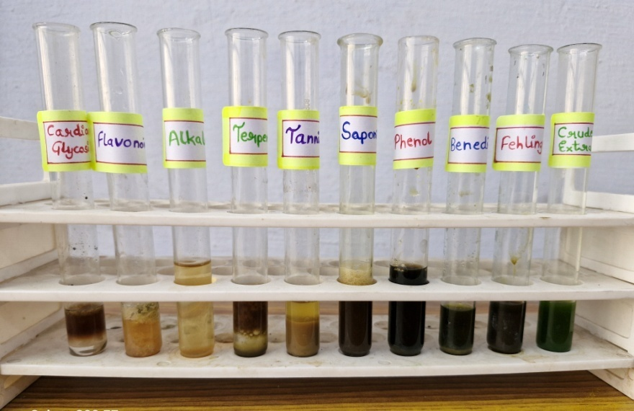
Figure 1 -; results of phytochemical tests of crude extract of C. roseus leaves
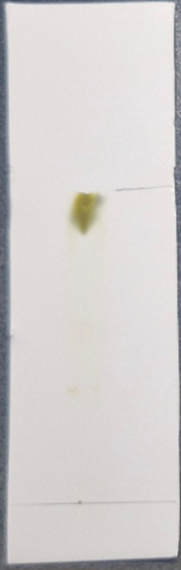
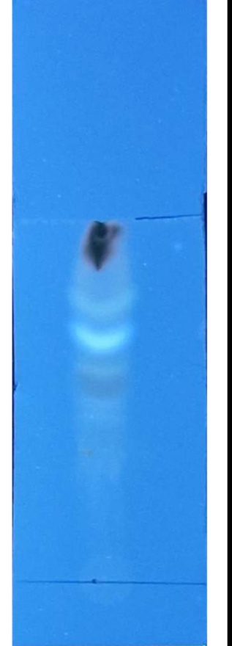
a b c
Figure 2 -: TLC analysis of acetonic leaf extract of C. roseus using SS1 in a.visible light, b. 254nm UV and c. 365nm UV light.

References
- Alebiosu, C. O., and Yusuf, A. J. (2015). Phytochemical screening, thin-layer chromatographic studies and UV analysis of extracts of Citrullus lanatus. J Pharm Chem Biol Sci, 3(2), 214-220.
- Aslam, J., Khan, S.H., Siddiqui, Z.H., Fatima, Z., Maqsood, M., Bhat, M. A., and Sharma, M.P. (2010). Catharanthus roseus (L.) G. Don. An important drug: it’s applications and production. Pharmacie Globale (IJCP), 4(12): 01-16.
- Das Manosi et al. Phyto-pharmacognostical evaluation and HPTLC study on Anantamul (Hemidesmusindicus R.Br.) Root. Int. J. Res. Ayurveda Pharm. 2017;8(3):68-72 http://dx.doi.org/10.7897/2277-4343.083146
- Fabrick JA, Yool AJ, Spurgeon DW (2020) Insecticidal activity of marigold Tagetespatula plants and foliar extracts against the hemipteran pests, Lygushesperus and Bemisiatabaci. PLoS ONE 15(5): e0233511. doi:10.1371/journal.pone.0233511
- Gotmare, S., and Gade, J. (2018). Orange peel: A potential source of phytochemical compounds. Int J ChemTech Res, 11(02): 240-243.
- Gupta, M., Tomar, R.S., Kaushik, S., Mishra, R.K., and Sharma, D. (2018). Effective antimicrobial activity of green ZnO nanoparticles of Catharanthus roseus. Frontiers in microbiology, 9: 01-13.
- Kabesh, K., Senthilkumar, P., Ragunathan, R., and Kumar, R.R. (2015). Phytochemical analysis of Catharanthus roseus plant extract and its antimicrobial activity. Int. J. Pure App. Biosci, 3(2): 162-172.
- Kapoor, M., Rani, J., Kumar, A., and Ghosh, S. (2021). Phytochemical screening for antimicrobial and antioxidant activity of periwinkle. Indian J. Hort., 78(4): 428-435.
- Nitin Vitthal Gurav, Rajendra Marotrao Gade, and Rupesh kumar Jagannath Choudhari. 2023. “Phytochemical and Thin Layer Chromatographic Analysis of Chloroform and Methanol Extracts of AzadirachtaIndica and Eucalyptus Globulus Leaves”. International Journal of Plant & Soil Science 35 (19):502–513. https://doi.org/10.9734/ijpss/2023/v35i193576.
- Paikara, D., Pandey, B., and Singh, S. (2017). Phytochemical analysis and antimicrobial activity of Catharanthus roseus. Indian J. Sci. Res, 12(2): 124-127.
- Patharajan, S., and BalaAbirami, S. (2014). Antioxidant activity and phytochemical analysis of fractionated leaf extracts of Catharanthus roseus. Int J Pharm, 1(2): 138-143.
- Ramya, S. (2008). In Vitro Evaluation of Antibacterial Activity Using Crude Extracts of Catharanthus roseus L. (G.) Don. Ethnobotanical Leaflets, 12(1): 1067-1072.
- Shaikh, S.G., Pathak, H.C., Kumawat, V.S., and Kothule S.R. (2020). Phytochemical analysis of Catharanthusroseus (L) G. Don. International Journal of Scientific Development and Research (IJSDR), 5(5): 314-318.
- Supradip S, Walia S, Kundu A, Kumar B, Joshi D. Antifungal acetylinicthiophenes from Tagetesminuta: potential biopesticide. J Appl Botany Food Qual. 2012;85:207-11.
- Ujagar, A. B., Rathod, M. G., Aasore, S. R., & Pathak, A. P. (2021). Phytochemical screening and antibacterial activity of petroleum ether, methanol and acetone extracts of Catharanthusroseus leaves and flowers. Research and Development in Pharmaceutical Science, 1, 133-141.
- Yadav, A. K., Ambasta, S. K., Prasad, S. K., and Trvedi, M. P. (2018). In-vitro evaluation of antibacterial property of Catharanthus roseus (Linn.) G. Don. Var.“rosea” and “alba”. Int J Pharm Pharm Sci, 10(5): 55-58.
- Yadav, R., Khare, R. K., and Singhal, A. (2017). Qualitative phytochemical screening of some selected medicinal plants of shivpuri district (mp). Int. J. Life. Sci. Scienti. Res, 3(1), 844-847.

