Comparative study between the technique of treating lateritic gravelly soil improved with crushed granite (litho stabilization) and the technique of treating soil with cement: the case of the section of the Saaba road linking the bypass road in the city of Ouagadougou in Burkina Faso.

Abstract
Burkina Faso is a developing country, with most of the transport being done by land. Like all Sahelian countries, Burkina Faso uses lateral gravel as a foundation layer and 60 to 70% of the base layers.
In view of the current high traffic, its use in road construction in its natural state sometimes has low load-bearing capacity causing the rapid degradation of the foundations, which led Burkina Faso to adopt a technique of improving lateritic gravels with cement (cement soil) and crushed granite (litho-stabilization). In our study, we use a sample of recycled lateritic gravelly material taken from borrowed heaps and enhanced with crushed granite and cement at different percentages to achieve the bearing capacity meeting the technical specifications of the CCPT.
After improvement with crushed granite at 20%, 25%, and 30%, we obtained the following result at 25% CBR index 124 at 98% and 82 at 95% and after formulation study, the cement improvement made with 1%, 1.5%, 2% gave a satisfactory result at 1.5% with a CBR of 90 to 95% and 138 to 98%. Cement improvement offers better technical results than litho-stabilization. However, from an economic point of view, cement soil is less expensive than litho-stabilization because of the low percentage of cement addition (1.5%).
Keywords: Lateritic gravelly; Litho-stabilization; Cement floor; Improvement; Index, carbon loan.

- INTRODUCTION
Burkina Faso, a developing country, is located in the heart of West Africa. As a landlocked country, its road network represents an important base for its economy insofar as it allows the transport of goods, the movement of people and contributes to the occupation of the territory as well as the exploitation of resources. Roads classified as asphalt represent 26.69% of Burkinabe road networks in 2022 (2022, transport infrastructure statistics).
Road networks have often experienced problems with good geotechnical quality materials that are becoming increasingly scarce, while the need to build roads for development is continuously increasing. This situation has forced several authors to look for solutions to improve the resistance of existing soils.
It is in this context that our study aims to propose technical, mechanical and economic elements to guide road builders in their choice of materials between lateritic gravel improved with crushed granite and lateritic gravel improved with cement.
- MATERIALS AND METHOD
2.1- Sampling
2.1.1- Equipment used
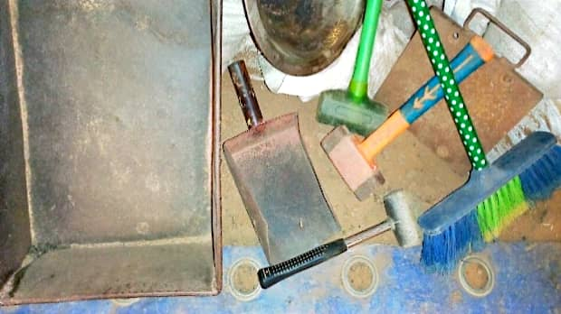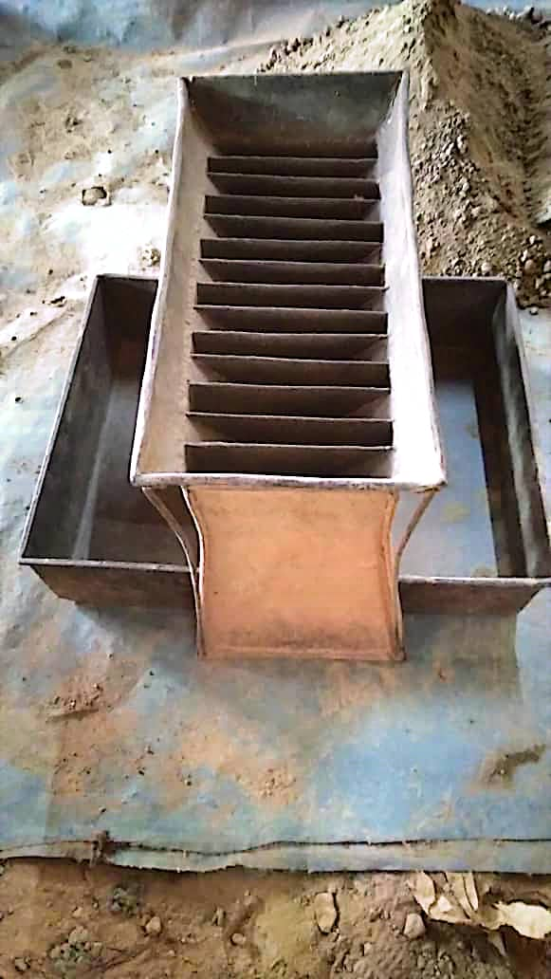
Figure 1: Equipment used for quarting or sampling

- A tarpaulin or lurk to avoid direct contact of the material with the ground.
- A sampler or divider to divide the material into two equal and homogeneous parts.
- Bins to collect materials from the divider.
- Hand shovels for the collection of the material under test
- The 44 sieves with a diameter of 20mm and 38 with a diameter of 5mm, these sieves are used for the sieving of materials such as clay and lateritic gravelly clay (GAL).
- Hammers to crush refusals during sieving.
- Dishes to collect the sample needed to perform the test after sampling.
- A bag to keep the sample reserves.
- A broom and a trowel

2.1.2- OPERATING MODE
Sampling is the operation that involves taking a quantity of material so that the sampled part is representative of the entire material. The sample taken from the site must be spread out on a tarpaulin and dried in the open air if it is too wet; and the larger particles should be crushed to facilitate the drying of the material. Additionally, the material should not be completely dry to prevent the loss of fines during sieving.
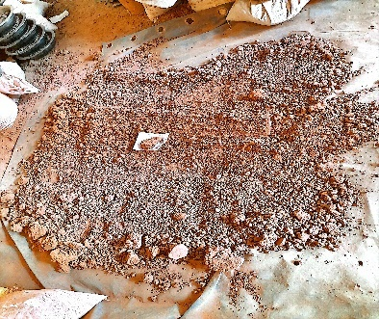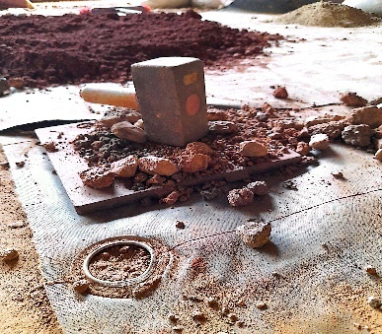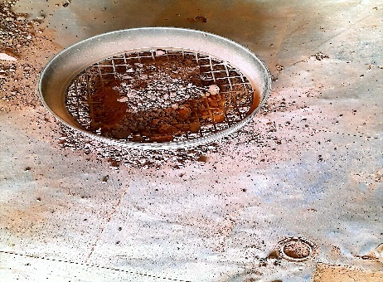
Figure 2: Preparing the material for quarting or using the sampler

Sampling is done by quarting or using the sampler:
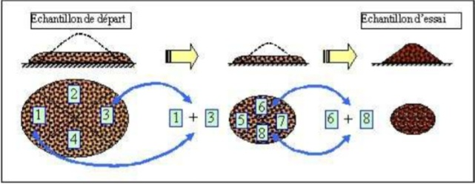
Figure 3: Quarter operation (1)

Quartering: on the tarpaulin the material is divided into 4 roughly equal parts and then grouped in two later, made up of opposite tars of the fourth parts. This selection is homogenized and another quarter is carried out to obtain 8 points, i.e., 8 equal parts of the material, including 5 points for the Proctor and 3 points for the CBR.

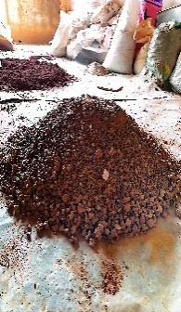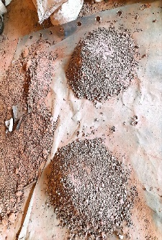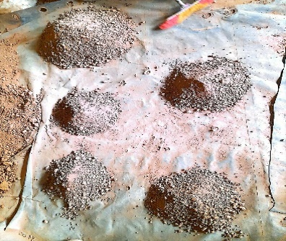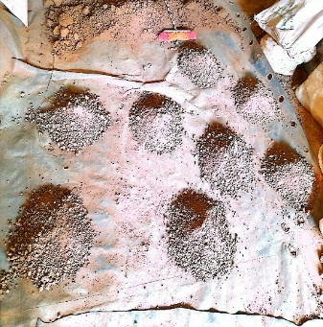
Figure 4: Quarter operation (2)
Sampling: this is a device that divides the material into two equal parts and each half is collected in two separate bins. This operation is repeated 4 times for each tank to obtain the quantity of materials required for the requested test. We thus obtained the 8 points we were looking for, including 5 points for the Proctor test and 3 points for the CBR test.
Both operations allow the same results to be obtained, i.e. the homogeneity of the material under test.
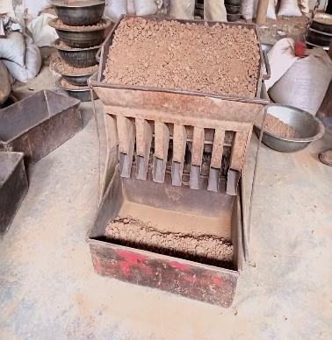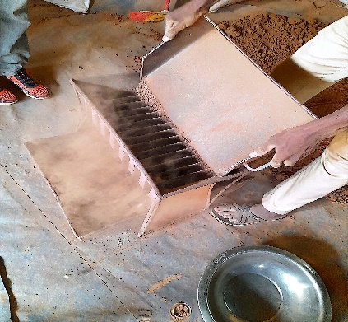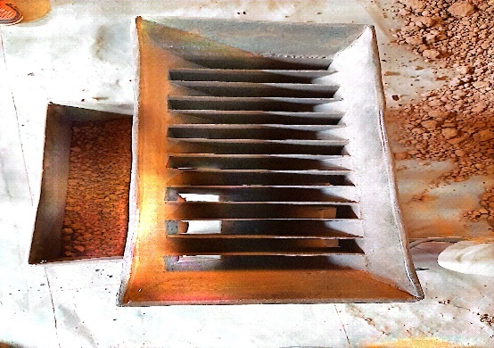
Figure 5: Sampler operation
2.2- CARRYING OUT THE TESTS
2.2.1- ATTERBERG LIMIT TEST
2.2.1.1- EQUIPMENT USED
The equipment used to carry out the limit test are:
- A CASAGRANDE device: this is the device used to carry out the test, it is composed of a wooden base mounted on four rubber feet, a cup in the shape of a portion of a sphere, a metal support carrying a cup and a cane operated by a crank to lift the cup;
- A scale to weigh the material to determine its water content;
- Spatulas to knead the leg to make it homogeneous and capsules to collect the leg to determine the water content;
- A 400 μm sieve (module 27 sieve) with square mesh for washing the material;
- A smooth plate for mixing and rolling the material under test;
- An oven with an adjustable temperature of 150°C allowing the drying of the leg obtained during the test;
- A groove allows the leg spread out in the cup to be divided in two.
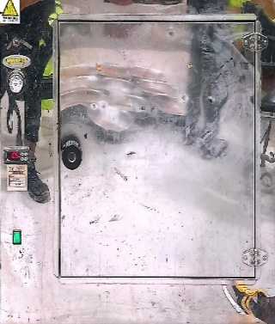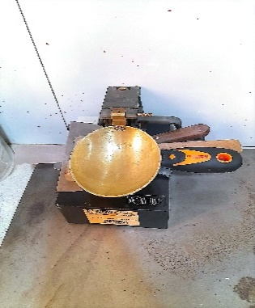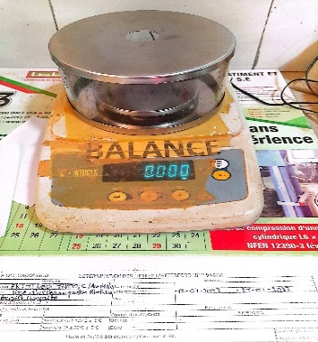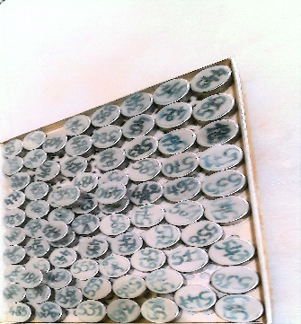
Figure 6: Equipment used for the Atterberg Limit test

2.2.1.2- DETERMINATION OF THE LIQUIDITY LIMIT
- OPERATING MODE
The operations described below are to be carried out successively:
- Make a quarter to obtain a representative soil sample,
- Determine the initial moisture content of the sample if the consistency index (Ic) is to be calculated.
- Pass the representative soil sample through a 0.4 mm sieve. Sieving is preferably doneby washing, to ensure the complete recovery of particles smaller than 0.4 mm.
- After a decanting period of at least 12 hours, the clear water is siphoned off without causing any solid deposit
- Dry the sample at a temperature not exceeding 50°C
- Weigh the weight of the dry refusal, the weight of the dry loop (P), and calculate the weight proportion C of the 0/0.4 mm fraction
C =$\frac{mass passing the 0.4 mm sieve }{sample mass}$
- Place the sample in a porcelain bowl and then saturate it with water (water weight required, sample weight), reworking it completely with a spatula to obtain a homogeneous mixture.
- Let the dough rest in an oven for 4 to 8 hours.
Preparation of the Equipment
- Calibrate the drop height of the cup using the calibration wedge: 1 cm ± 0.5 mm.

Running the test
- After homogenizing the dough, distribute it in the cup symmetrically, the thickness in the center should be 15 to 20 mm. It is at the point of impact (center of the cup) that this maximum thickness must be found.
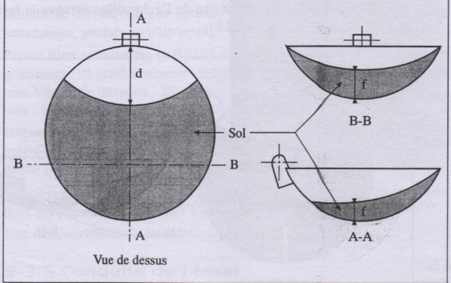
Figure 7 : Sample Setup
- Divide the dough in half using the grooving tool. The groove will be hollowed out in a single movement
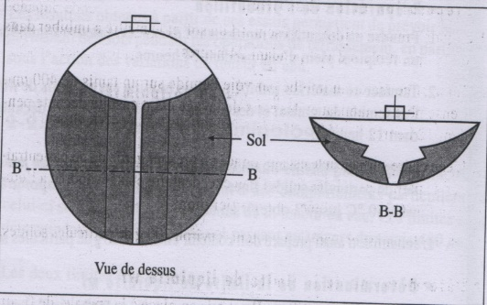
Figure 8: Dough Sharing
- Using the device, subject the cup to a series of regular shocks: two blows per second.
- Stop the series when the two groove lips have closed to a length of 12 to 13 mm appreciated by the eye.

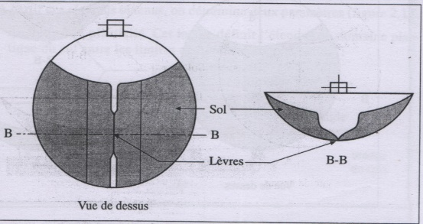
Figure 9 : Closing the groove

- Note the number of strokes.
- Take a sample in the vicinity of the groove (where it has been enclosed) to determine the water content.
The entire test is repeated 3 to 5 times, varying the water content either by drying or by adding water, so as to cover a range of strokes from 15 to 35.
2.2.2- PARTICLE SIZE ANALYSIS
2.2.2.1- Equipment used
The equipment used to carry out the AG test are:
- A series of mm aperture sieves for sieving the material
- An oven for drying the material
- A precision scale to weigh refusals
- A dish for washing the material and collecting the rejects in order to weigh them.
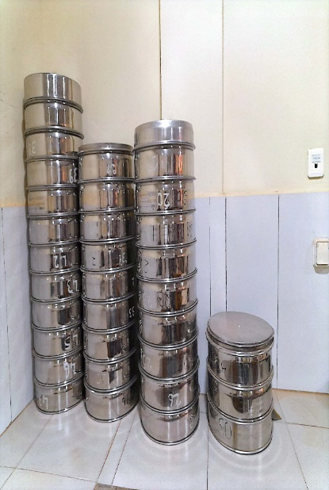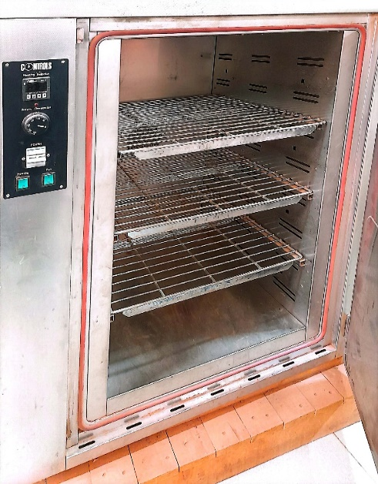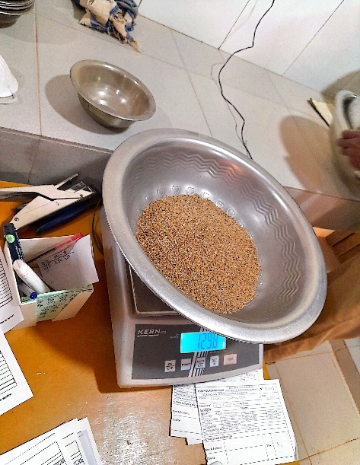
Figure 10: Materials used for the AG test
2.2.2.2- Modus operandi
After sampling, the dry mass of the material subjected to the test is sought by putting it in the oven at 105°C for 24 hours, then soaking it with water to facilitate washing of the material. In particular, the drying operation is carried out at a temperature of 105°C for heat-insensitive floors and 50°C for heat-sensitive floors. But when in doubt, the material is treated as if it were sensitive to heat. After drying, the material is sieved and then the accumulated rejects are weighed.

2.2.3- PROCTOR-CBR TEST
2.2.3.1- Modified Proctor Test:
- Procedure of the test
To perform the test, the mold must be chosen according to the nature of the test to be performed, i.e. the Modified Proctor mold for the Modified Proctor test. Then, the specimens are compacted and moistened by introducing the amount of material so that the height of the first layer after compaction is slightly more than one-fifth of the height of the Proctor Modified mold. Compact this layer with the PM lady by applying 56 strokes per coat (5 coats).

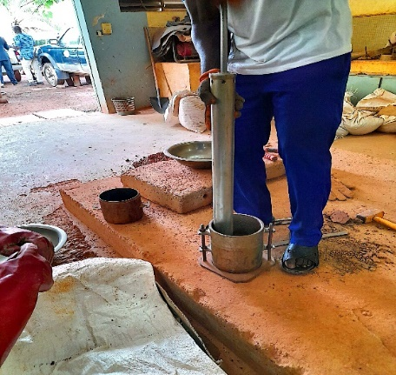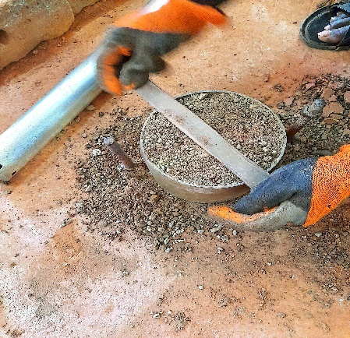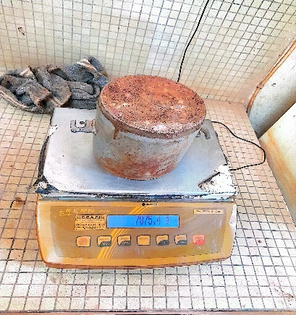
Figure 11: Operation of the Proctor Modified Trial
2.2.3.2- CBR lift test (California Bearing Ratio) : NF P 94-078 (1997)
- Modus operandi
Compaction is carried out at the water content corresponding to 95% of the OPM determined in the Proctor test. When the maximum size of the soil elements to be studied is less than 20 mm, the entire soil is tested. If the soil contains elements greater than 20 mm in a proportion of less than 30%, they are removed by sieving. The test is then carried out on the remaining fraction. All the CBRs of our study are carried out after imbibition (or immersion), The specimen compacted in the CBR mould is immersed in water for four days after which the punching is carried out. The aim of this operation is to place the soil in the worst hydrometric conditions that it is likely to encounter in practice.
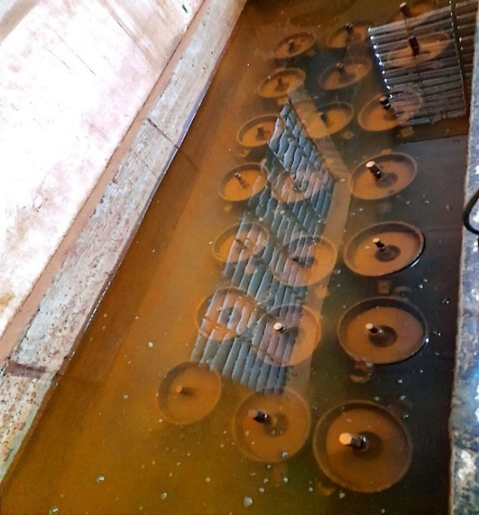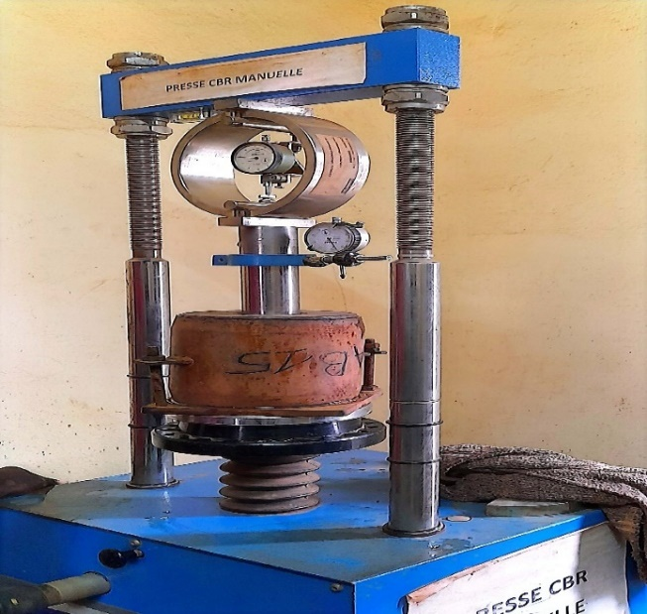
Figure 12: Submerged CBR and punching
- RESULTS AND DISCUSSIONS
3.1- Results, Analysis and Interpretation
3.1.1- Results, analysis and interpretation on the LAG
The material used is a recycled lateritic clay gravel from the old pavement (asphalt, the superficial layer, the foundation layer and the base layer) with a thickness of 80cm commonly called the 0.80.
3.1.1.1- Particle size analysis
These results obtained after the test allowed us to determine the curve below:

Figure 13 : Particle size curve of the Lateritic Clay Gravel
The shape and position of the curve shows that the material is well spread out and varied because it is between two curves, that of the minimum and the maximum.
3.1.1.2- Atterberg limit
The material used for our study was subjected to the test to which we have the result in the figure below. The result obtained in the table below allowed us to draw the Atterberg limit curve of the (Lateritic Clay Gravel) GAL
Table 1 : Summary of the Atterberg limit of the LAG
Nombre de coups | Teneur en eau
17 | 31,4
23 | 31,05
27 | 30,82
32 | 30,53
36 | 30,3

The results of the liquidity limit allow us to show that the condition of our soil according to the description of the soil classification table is I_{P} = 14.5. A low-plastic soil that follows the standards of the control and supervision study of the widening works and the modernization of the RN4.
3.1.1.3- Modified Proctor and CBR Lift
The results of the tests allowed us to have the results recorded in the table below:
Table 2 : the maximum IPI effort of each mold
Number of strokes | Effort max | Density ( t/m3)
10 coups d'état | 9 | 1,96
25 coups | 37 | 2,1
56 coups d'État | 86 | 2,19

According to the results of the modified Proctor; we note that the material could be used as a foundation layer according to the road quality of the RN4, on the other hand the bearing capacity index CBR is not usable as a foundation layer according to GTR and the road road safety system of the RN4.
3.1.2- Results and interpretation of the cement soil
The cement used for the study is the CIMBURKINA brand. The technical sheet of the production of the week of 20 to 26/05/24 of composite portland cement, classic cement CEMII/B-M(PL) 32.5N will allow us to have an idea of its characteristics. The standard used is that of NBF 02-013Rev 2009 (EN 197-1 equivalent)
Table 3 : CPJ 32.5R Data Sheet
Paramètre contrôlés/ set values | Valeurs normatives/standard | Valeurs CIMBURKINA moyenne/average | CIMBURKINA  Minimum
Résistance à 2jours/2 Days strength (MPa) | Néant | 12,4 | 10,75
Résistance à 7jours/7 Days strength (MPa) | $≥$16 MPa | 25,25 | 25,00
Résistance à 28jours/28 Days strength (MPa) | 32,5< fc28 >52,5MP | Pas prêt | Pas prêt
Temps de prise/ Intial setting time (Minutes) | > 75Minutes | 235 | 207
Dilatation/Solidité (mm) | < 10 mm | 0,5 | 0
Surface Spécifique/Blaine (${cm}^{2}$) | Néant/NR | 4166 | 3567
Sulfates/SO3( %) | < 4 % | 2,315 | 2,1
Perte au feu/ Loss on ignotion (%) | Néant/NR | 10,066 | 6,2
Chlorure/ Chloride (%) | < 0,1 % | -- | --
3.1.3- Results, Analysis and Interpretation of Crushed 0/315
The crushed granite used in our study is of class 0/315 warning of the quarry of the Globex construction company in Gonsé.
3.1.3.1- Particle size analysis
The result of the test allowed us to draw the particle size analysis curve of the crushed granite according to the figure below:

Figure 15 : Crushed particle size curve
The analysis of the particle size curve allows us to say that the material intended for the study has a spread or varied particle size according to the coefficient of uniformity (Cu >2) and well graduated according to the coefficient of curvature (1< Cc <3)

3.1.3- Results, analysis and interpretation of the cement soil
The results of the soil cement study are shown in the table below, which shows the evolution of the improvement
Table 4 : Soil cement results
Echantillon |  | Proctor Modifié |  | CBR
 |  | ɣd(t/m) | ω% | 95% | 98%
GAL recyclé(référence) |  | 2,125 | 7,8 | 37 | 60
Sol ciment | 1% | 2,14 | 7,3 | 32 | 63
Sol ciment | 1,50% | 2,1 | 8,1 | 90 | 138
Sol ciment | 2% | 2,095 | 8 | 188 | 227
- Proctor modified
Improving the GAL to cement varies the dry density according to the percentage of cement used. We note that the maximum value of the dry density is reached when there is a 1% improvement, we notice a gradual decrease in density when the percentage of cement is increased. In reality, the decrease in the optimal dry density of the various improvements is due to the fact that the hydraulic binder creates an aggregation of the particles and thus generates a large volume, this and due to the low density of the cement.
- CBR Index
The observation we make is that the bearing index increases gradually according to the rates of improvement. The evolution of the 95% and 98% bearing capacity from GAL to cement as a function of the improvement rate plus compaction characteristics increased considerably compared to GAL. This improvement in bearing capacity is due to the hydration reactions of the cement that produce hydrated calcium silicates that bind the soil particles together.
After the improvement we find that at 1.5% of cement addition we have a CBR index at 95% and 138kN at 98% and a dry density which is 2.1t/m3.
3.1.3- Results, analysis and interpretation of litho-stabilization
The lateritic gravelly studied in the table above in (I.1) has been improved with crushed granite in three different proportions (20%, 25% and 30%) with crushed granite of class 0/315. The objective of the study is to see the influence of the litho-stabilization technique on the properties of the GAL. These tests will allow to study the properties physical and mechanical aspects of the mixture. Each formulation obtained was tested in a full test each (AG, LA, modified Proctor, and CBR assays).

I.5.1 Results of litho-stabilization
The results achieved with the improvement are summarized in the table below:

I.5.2. Particle size analysis
In general, we see a drop in the percentages of fines (from 7% to 25%, 1.1% to 20% and an increase from 2% to 30%) percent. This decrease is due to the addition of crushed material to
the material.
Table 5 : Litho results
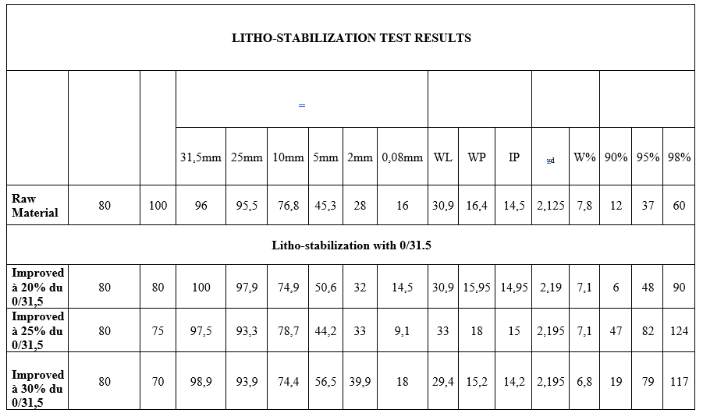

I.5.3. Atterberg limit
$Les results are summarized in the table below. The floor remains low in plastic with the improvements made to it.
Table 6 : Summary of litho results
ECHANTILLON | $$ω_{L}$$ | $$ω_{P}$$ | $$I_{P}$$
GAL | 30,9 | 16,4 | 14,5
GAL + 20 % CONSOMMÉ | 30,9 | 15,95 | 14,95
GAL + 25 % CONCASSÉ | 33% | 18% | 15%
GAL+30 % CONCASSÉ | 29,40% | 15,10% | 14,30%

I.5.4. Modified Proctor
The study of lateritic gravel at the crushed plants slightly varies the value of the optimal dry density.

I.5.5. CBR index
We note that the indices bringing CBR to 95 and 98% have risen considerably after improvement. We see an increase to 25% improvement and a drop to 30% improvement. This fall is due to two causes: The presence of coarse elements or the presence of fine elements plays an important role in the fall of the CBR index. The figure below allows us to better appreciate the evolution of the indices bringing CBR to 98%. Table 7: The evolution of the CBR

Conclusion on litho-stabilization
After improving the lateritic gravel to the crushed stones, we find that after 25% of adding crushed stones with the granular class 0/31.5, we have a better CBR bearing capacity result which is 82kN at 95%, and 124kN at 98% a dry density which is 2.195 t/m3
- CONCLUSION
The comparison between litho-stabilization and cement treatment techniques for the improvement of lateritic gravel in the context of road construction in Burkina Faso highlights significant results both technically and economically. Improving the soil with cement has demonstrated superior performance in terms of load-bearing capacity, especially when the cement content reaches 1.5%. This technique achieves CBR indices from 95% to 138kN at 98%, proving its effectiveness as a soil reinforcement method.
On the other hand, although litho-stabilization (improvement with crushed granite) also produces good results, especially at 25% crushed, it remains more expensive due to the significant addition of materials. However, this method can be considered a viable alternative when resources are available in sufficient quantity and costs need to be controlled.
The study therefore offers valuable avenues for the choice of materials and techniques adapted to different types of soils and economic constraints in road construction in the Sahelian environment. In this regard, it becomes crucial to optimize the use of local materials, while ensuring the sustainability of infrastructure.
5- References
[1] NF P 94-078 CBR test after immersion, immediate and immediate lift index, May 1997
[2] NF P 94-095 Determination of the compaction references of a material, October 1999
[3] NF P 94 -56 particle size analysis; Dry sieving method after washing, March 1996
[4] NF P 94 -068 Measurement of the adsorption capacity of methylene blue in a soil or rocky material, October 1998
[5] NF P 94-051 Determination of the Atterberg limit, March 1993
[6] NF EN 933-8 Test to determine the characteristics of aggregates, August 1999
[7] BAKOUAN, Dominique, Internship report for the diploma of civil engineer, July 2014
[8] Mr. WOLINANG DJOMOU Clotaire, Soil Mechanics Course, 2023
[9] Mr. SAWADOGO Boukary, Construction Materials Course, 2023
[10] DIARRA Mamoudou Professional Bachelor's Degree Report on Construction Specialty, March 2020
[11] KIEMDE Maximilien Sosthène End-of-cycle internship report: Geotechnical tests in the laboratory and in situ, 2013
[12] TRAN Van Duy, Study of Soil Improvement by Lime Treatment, 2013
[13] Maliki Otiéboame DJANDIEME, Characteristic of lateritic gravels improved with cement and stabilized litho for use in road construction, June 22, 2018

