Original Research Article
Effect of Fertilizer Type and Irrigation Method on the Agronomic Parameters of Okra [(Abelmoschus esculentus L. (Malvaceae)]

Abstract
Okra (Abelmoschus esculentus (L.) Moench) is an exceptional and unique crop, as all of its parts are valued for food, medicinal, artisanal, and even industrial purposes. However, despite these advantages, its production remains low, mainly due to soil infertility resulting from land overexploitation. In view of improving okra yield, effects of fertilizers type and irrigation method was studied, aiming at identifying the most suitable practice or technical pathway to promote optimal growth and yield. For this purpose, okra plants were fertilized with one organic (rabbit manure) and two mineral fertilizers (wood ash and NPK), while unfertilized ones constitute control. Water was supplied using two methods: drip irrigation and can watering. Plants were regularly monitored, and growth (plant height and diameter, leaves number and size) and yield parameters (fruits size and weight) were assessed using the analysis of variance test (ANOVA 2). The results revealed that fertilizers (rabbit manure and NPK) promoted plant growth and higher yields, compared to wood ash fertilisation, which itself performed better than the control (unfertilized). The heaviest fruits (40.05 g) were harvested from plants fertilized with rabbit droppings, followed by those from NPK (29.79 g) and wood ash (23.35 g), heavier than those obtained with control (19.34 g). About watering, the best agronomic performances were recorded under the drip irrigation method. The positive interaction indicates that fertilization with rabbit manure combined with drip irrigation promoted the best growth and the highest fruit yield in okra.
Keywords: okra, fertilizers, irrigation, yield

Introduction
Developing countries are confronted with multiple challenges, with food demand being the most pressing due to rapid population growth. As highlighted by Keutgen (2013), vegetable crops play a crucial role in ensuring food security and improving the populations’ well-being. These crops are particularly profitable and constitute a major source of livelihood for numerous households, especially those living below the poverty line (Drabo, 2016). As for other developing nations, ivorians’population diet is largely based on cereals, tubers, fruits, and vegetables. Among these, okra holds a prominent position because it contributes to essential metabolic functions regulation while exhibiting noteworthy protective effects (Mishra et al., 2016). Moreover, okra fruits contain more substantial nutritional value than tomato’s (Hamon and Charrier, 1997).
Unfortunately okra production is hindered by diverse constraints in Côte d’Ivoire. Indeed its production decline is largely attributed to land overexploitation resulting from the disappearance of fallow practices, itself driven by rapid population growth. This consequently led to yield reductions in many regions (Michel, 2006; Idi-Saïdou et al., 2021). In response to land over exploitation, developing countries generally resort to synthetic fertilizers importation, recommended to fullfil mineral elements demands and improve soil fertility in the short term (FAO, 2004). However, their long-term use leads to a decline in soil organic matter content and increased soil acidification, ultimately reducing the yields of cultivated crops (Koulibaly et al., 2010; Traoré et al., 2015).
In this context, the use of organic fertilizers represents a less polluting alternative for the environment and a viable strategy compared to conventional methods relying on chemical fertilizers. The application of organic amendments to provide substantial nutrient inputs, thereby compensating for nutrient depletion caused by crop harvesting and soil losses has been demonstrated in several studies (Citeau et al., 2008; Mulaji, 2011).
Within this framework, the present study aims to contribute to the improvement of okra production through the optimization of fertilizer type and irrigation method. More specifically, this study aimed at assessing the effect of fertilizers type (NPK, wood ash, and rabbit manure) and irrigation methods (drip irrigation and traditional watering can), first individually then combined on okra plant growth and fruit yield in view of identifying the most effective combination for maximizing yield.
- Materials and Methods
  - Study Site
Experiments were conducted from March to June 2023 at the experimental site of Nangui Abrogoua University, located in the Abidjan district (Côte d’Ivoire). Nangui Abrogoua University (UNA) is situated in Abidjan, in the southern part of Côte d’Ivoire. According to Kouakou et al. (2016), the geographical coordinates of the study site are 5°17′–5°31′ N latitude and 3°45′–4°22′ W longitude (Figure 1).
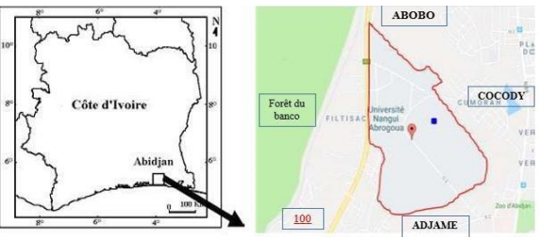
Figure 1. Study site location of the (N’Goran, 2019)
  - Materials
    - Plant material
The plant material consisted of okra (Abelmoschus esculentus L.) variety “Kirikou F1” seeds purchased from Sémivoire (Figure 2).
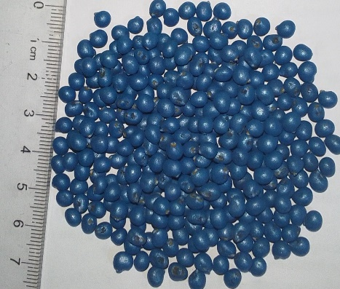
Figure 2. Seeds of okra Kirikou F1variety
    - Substrate and fertilizers
Humus-rich soil collected from the arable layer from Nangui Abrogoua University forest soil was collected an used as substrate. This humus-rich soil was heated in a metal barrel to eliminate potential dangerous bacteria and nematodes against future plants, it contains. This “sterilized” soil was then used as the substrate to fill bags intended to contain plants.Two types of fertilizers were applied in this study. Rabbit manure (CrLa), sorted and ground into powder, then applied to substrate served as the organic fertilizer. Wood ash (CeBo) and NPK (15-15-15) were also used as mineral fertilizers.
    - Experimental design
The experimental design consisted of 16 plots, each measuring 1 m × 1.6 m. Each plot was assigned 10 substrate bags, each containing one okra plant. These perforated nursery bags (30 cm in diameter × 35 cm in height) were filled to two-thirds, either directly with the “sterilized” substrate or with the same substrate supplemented with rabbit manure. For this purpose, 32 kg of rabbit manure were incorporated into the substrate as basal fertilizer. Two weeks after sowing, mineral fertilizers (NPK and wood ash) were applied to plants at rates of 8.5 g per plant for NPK and 10 g per plant for wood ash. All nursery bags, filled to two-thirds, were arranged on a tarpaulin in two rows of five bags each according to the different fertilizer treatments and irrigation regimes. Rows were spaced 0.5 m each other, and bags 0.40 m within row. Sowing consisted in placing 2 to 3 seeds at a depth of 2–3 cm in each bag for all three treatments. After germination, plants were watered using two methods: traditional method using traditional can and drip irrigation using bottles (Figure 3) previously perforated with a needle and calibrated to release their contents (0.6 L) over 24 hours. Globally, 8 treatments: 4 fertilizers (rabbit manure, ash, NPK and control) × 2 watering methods (traditional can and drip) each twice replicated were applied to okra plants in substrate bags and arranged according to Table 1. Two weeks after emergence, the seedlings were thinned, leting only one plant per bag.
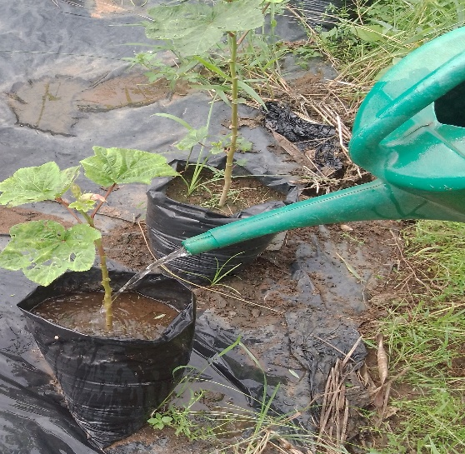  A | 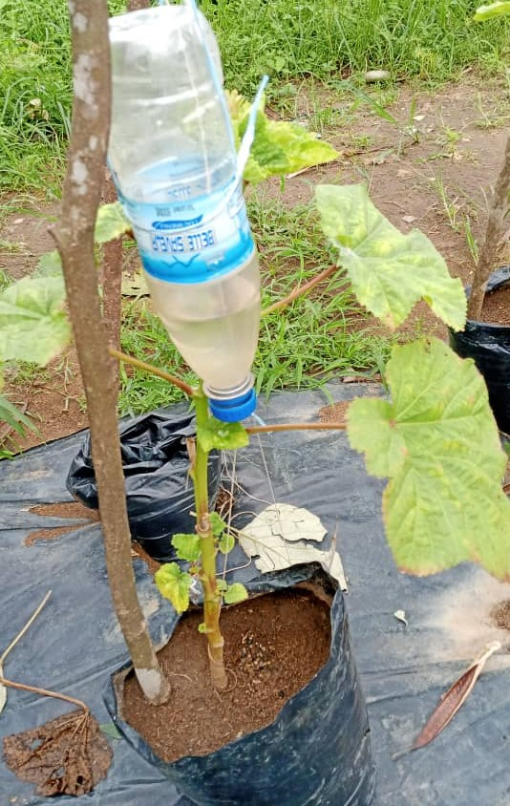  B
Figure 3. Okra plant irrigation methods: traditional can watering (A) and drip irrigation (B).

Table 1. Okra plant treatments following fertilizer type and watering method on sterilized soil substrate in nursery bag
Treatment | Fertilizer | Irrigation method
T1 | NPK | Traditional watering
T2 | NPK | Drip irrigation
T3 | Wood ash | Traditional watering
T4 | Wood ash | Drip irrigation
T5 | Control | Traditional watering
T6 | Control | Drip irrigation
T7 | Rabbit manure | Traditional watering
T8 | Rabbit manure | Drip irrigation

Phytosanitary treatments began 14 days after sowing to protect okra plants then control pest attacks. Okra plants were sprayed with the contact insecticide Cypermax (Cypermethrin) at a rate of 10 ml per 3 L of water against caterpillars, beetles, flies, and bugs."
    - Measured parameters
The okra plants (Abelmoschus esculentus L.) agronomic parameters (growth, phenological, and yield) and their measurement methods are presented in Table 2
Table 2. Recorded agronomic parameters, codes, counts, and measurement methods in okra
Parameters |  | Code | Measurement Method
Growth | Leaf width (cm) | LeWi | Measured across the leaf using a graduated ruler.
Growth | Leaf length (cm) | LeLe | Distance from insertion point on stem to leaf tip, measured with a graduated ruler.
Growth | Plant height (cm) | PlHe | Distance from plant collar to its apex, measured with a measuring tape.
Growth | Number of leaves | NoLe | Count of leaves observed on the plant.
Growth | Stem diameter at colar (mm) | StDi | Measured at 1 cm above the base of the stem using a caliper.
Yield | Fruit length (cm) | FrLe | Measured from fruit base to its pointed tip using a caliper.
Yield | Fruit diameter (cm) | FrDi | Measured on fruits using a caliper.
Yield | Fruit weight (g) | FrWe | Measured using an electronic balance.

    - Statistical Analysis
All values of the agromorphological and yield parameters obtained in this study were subjected to statistical analysis. To this end, a two-way analysis of variance (ANOVA) was performed, considering the three factors (fertilizer type, watering method, and experimental duration) individually as well as their interactions on the mean of each parameter. When a significant difference was observed (P < α, α = 0.05), the Least Significant Difference (LSD) test was applied to identify the treatment(s) responsible for this difference. All calculations were performed using STATISTICA software, version 7.1.
- Results
  - Effect of fertilizer type on the growth of okra plants
Plant height increased under all treatments during growth. This growth was higher with all fertilized plant (rabbit manure, NPK and wood ash) compared to control. In addition, rabbit manure produced the tallest plants, followed by NPK, wood ash, and finally the control (Figure 4).
Leaves number per plant gradually increased during okra plant growing both with rabbit manure and with wood ash fertilizers, as well as in the control. In contrast, plants fertilized with NPK produced only more leaf number during the first six weeks. Nevertheless, leaf formation was markedly higher with rabbit droppings, followed by wood ash.
Trend in stem collar diameter of okra plants shows a slow increase over time. Rabbit manure and NPK fertilizers produced larger stem collar diameters, whereas wood ash and unfertilized ones (control) exhibited similar smaller diameters.
Curves of leaf size indicate that fertilizers type positively influenced okra leaves length. So organic and mineral fertilizations favored longer leafs. Indeed, by the 4th week, plants fertilized with NPK had already reached their growth peak, while those fertilized with rabbit droppings attained their maximum at the fifth, compared to wood ash fertilization and control ones.

Figure 4. Curbes of okra plants growth parameters following fertilizers type: NPK, rabbit manure (CrLa), wood ash (CeBo) and control (Te)
  - Incidence of irrigation method on okra plant growth
Figure 5 presents variation in okra plant height according to irrigation method during cultivation period. Curves analysis indicates that, under both drip irrigation and traditional watering, plant height exponentially increased. This growth was slower from the 1st to 4th week, then accelerated from the 4th to the 10th week after sowing. However, drip irrigation resulted in slightly taller plants compared with the traditional can watering.
Variation in okra plant leaves number continuous increase throughout under both irrigation methods. However, but drip irrigation allowed plants with considerably more leaves than traditional can watering.
Okra plants stem collar diameter progressively increased during growth stage from the first to the tenth week. Under both irrigation methods, plants grown with drip irrigation exhibited the largest stem collar diameters. Analysis of leaf growth curves indicates that, over period cultivation, okra leaf length increased similarly under both irrigation methods.

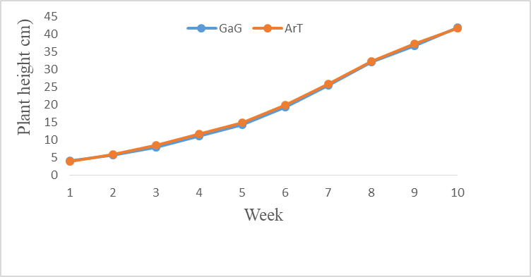 | 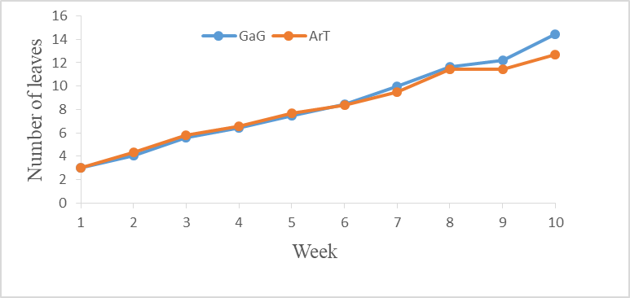
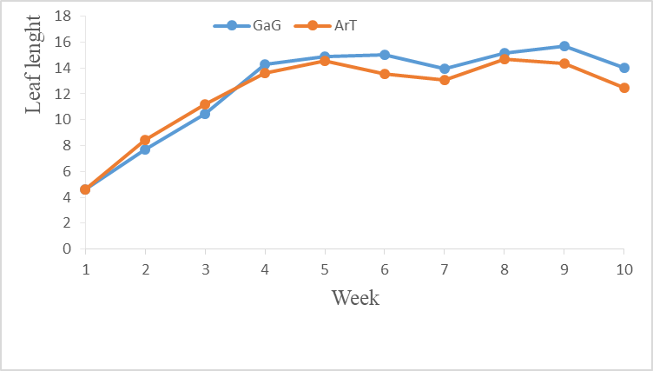 | 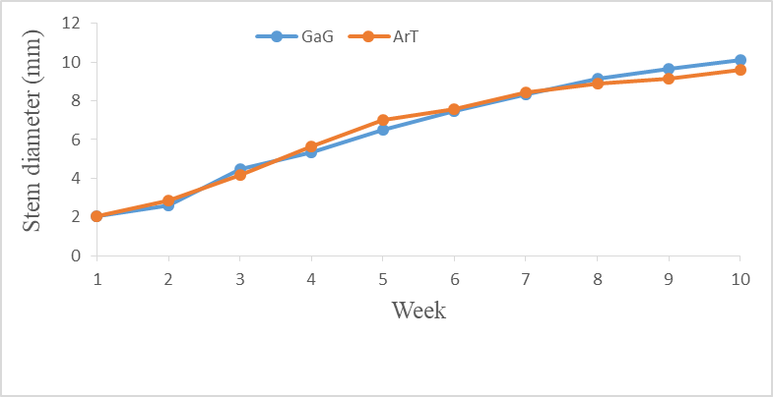
Figure 5. Curbes of okra plants growth parameters following watering methods: drip irriation (GaG) and traditional can watering (ArT).
2.3. Effect of Fertilizer Type on Okra Yield Parameters
Table 3 indicated that fertilizer type significantly (P < 0.01) influenced okra fruits yield parameters [fruit weight and size (diameter and fruit length)]. Indeed, plants fertilized with rabbit manure produced bigger and heavy fruits (24.70 g) followed by NPK fertilization, producing itself more bigger fruits (8.83 g) than wood ash and the control, which produced similar smaller fruits. However, when comparing fruits from wood ash and the control, no significant difference was observed. Regarding fruit weight, values were 24.70 g for rabbit manure, 13.64 g for wood ash, and 13.14 g for the control, while NPK showed the lowest value at 8.83 g. The fruit diameter was almost the same for wood ash (20.43 mm) and the control (21.31 mm), both considerably lower than that of rabbit manure (29.49 mm) and higher than NPK (15.53 mm). Similarly, fruit length was comparable for wood ash (5.75 cm), the control (6.08 cm), and NPK (4.56 cm), whereas rabbit manure produced significantly longer fruits (8.44 cm).
Table 3. Mean values of okra fruit yield parameters according to fertilizer type
Fruit parameters | Fertilizer Type |  |  |  | Statistics
Fruit parameters | Rabbit manure | Wood ash | NPK | Control | F | P
Fruit weight (g) | 24.70 ± 0.50ª | 13.64 ± 0.54^{b} | 13.14 ± 0.44^{b} | 8.83 ± 0.89^{c} | 76.68 | < 0.001
Fruit diameter (mm) | 29.49 ± 0.27ª | 20.43 ± 0.47^{b} | 21.31 ± 0.43^{b} | 15.53 ± 1.14b | 39.90 | < 0.001
Fruit length (cm) | 8.44 ± 0.14ª | 5.75 ± 0.18^{c} | 6.08 ± 0.19^{b} | 4.56 ± 0.33^{b} | 33.70 | < 0.001
On the lines, values bearing the same letters are statistically equal (p ≥ 0.05).F: Fisher’s statistic; P: Probability associated with the test.

2.4. Effect of Watering Method on Okra Yield Parameters
The analysis of the results in Table 4 showed that the irrigation method influenced fruit weight and fruit diameter. For these two parameters, the highest values were recorded in plants under drip irrigation.
Table 4. Variation of yield parameters according to watering method.
Yield parameters | Watering method |  | Statistics
Yield parameters | Drip Irrigation | Traditional can Watering | F | P
Fruit weight (g) | 15.64 ± 0.90ª | 13.49 ± 0.83^{b} | 4.17 | 0.04
Fruit diameter (mm) | 22.24 ± 0.89ª | 19.55 ± 0.94^{b} | 4.36 | 0.03
Fruit length (cm) | 6.37 ± 0.26ª | 5.68 ± 0.27ª | 2.79 | 0.09
Values in the same row bearing different letters are significantly different (p < 0.05). F: Fisher’s statistic; P: probability associated with the test.

2.4. Effect of the Interaction between Fertilizer Type and Watering Method on Okra Plant Growth
The values of growth parameters (plant height, collar diameter, leaf size, and number of leaves per plant) are presented in Table 5. Statistical analysis of this table indicates that plant height, leaf dimensions, and number of leaves per plant were significantly influenced by the interaction between fertilizer type and watering method (P < 0.05). However, collar diameter was not affected. Regardless of the watering method (drip irrigation or traditional watering), fertilizer type influenced the growth parameters. Indeed, under drip irrigation, the best results were obtained with NPK and rabbit manure, whereas under traditional watering, rabbit manure performed best. A comparison of these top results indicates that greater plant height was achieved with drip irrigation. Similar observations were made for all other parameters. Thus, plant growth parameters varied not only with fertilizer type but also with watering method. The best overall performance was obtained with rabbit manure fertilization combined with drip irrigation.
Table 5. Values of growth parameters of okra under different irrigation methods
Cultivation factors |  | Growth parameters
Fertilizers | Irrigation | Plant height (cm) | Collar diameter (cm) | Leaf length (cm) | Leaf width (cm) | Number of leaves per plant
NPK | Drip | 23.14 ± 1.16^{b} | 7.47 ± 0.24^{b} | 13.51 ± 0.42^{c} | 9.80 ± 0.31^{b} | 6.74 ± 0.20^{c}
NPK | Traditional | 24.94 ± 1.14ª | 7.47 ± 0.20^{b} | 13.52 ± 0.37^{c} | 9.50 ± 0.25^{b} | 6.75 ± 0.15^{c}
Rabbit droppings | Drip | 23.76 ± 1.20^{b} | 8.85 ± 0.32ª | 15.92 ± 0.49ª | 10.72 ± 0.33ª | 12.64 ± 0.56ª
Rabbit droppings | Traditional | 23.53 ± 1.13^{b} | 8.82 ± 0.28ª | 14.54 ± 0.43^{b} | 9.95 ± 0.29^{b} | 12.66 ± 0.52ª
Wood ash | Drip | 16.00 ± 0.76^{c} | 4.92 ± 0.15^{d} | 10.63 ± 0.30^{d} | 7.73 ± 0.22^{c} | 6.82 ± 0.20^{c}
Wood ash | Traditional | 16.58 ± 0.83^{c} | 5.07 ± 0.15^{c} | 10.27 ± 0.30^{d} | 7.80 ± 0.23^{c} | 6.41 ± 0.17^{d}
Control (unfertilized) | Drip | 16.72 ± 0.75c | 5.03 ± 0.14^{c} | 10.25 ± 0.26^{d} | 7.67 ± 0.21^{c} | 7.07 ± 0.24^{b}
Control (unfertilized) | Traditional | 15.89 ± 0.74c | 4.76 ± 0.15^{d} | 9.87 ± 0.27^{d} | 7.43 ± 0.21^{c} | 6.51 ± 0.20^{d}
Statistics | F | 6,32 | 3,25 | 2,79 | 2,53 | 3,05
Statistics | P | < 0,001 | 0,008 | 0,04 | 0,03 | 0,02

2.5. Effect of Fertilizer–Watering Interaction on Okra Harvest
The analysis of the results in Table 6 shows that both watering method and fertilizer type significantly (P < 0.05) influenced stem collar diameter and fresh fruit weight of okra. However, fruit length was not affected (P = 0.84). Fertilizer type also influenced these parameters regardless of the watering method. Indeed, under drip irrigation, the best results were obtained with rabbit manure, and the same trend was observed under traditional watering.
Table 6. Yield parameters evaluated in okra
Cultivation factors | Fruit yield parameters | Fruit yield parameters
Fertilizer type | Watering method | Length (cm) | Diameter (cm) | Fresh weight (g)
NPK | Drip irrigation | 5.05 ± 0.48ª | 16.89 ± 1.59^{d} | 9.98 ± 1.37^{f}
NPK | Traditional | 4.07 ± 0.45ª | 14.18 ± 1.62^{d} | 7.70 ± 1.13^{f}
Rabbit manure | Drip irrigation | 8.63 ± 0.27ª | 31.01 ± 0.32ª | 26.05 ± 0.83ª
Rabbit manure | Traditional | 8.25 ± 0.12ª | 28.00 ± 0.29^{b} | 23.39 ± 0.49^{b}
Wood ash | Drip irrigation | 6.13 ± 0.26ª | 21.51 ± 0.59^{c} | 15.39 ± 0.58^{c}
Wood ash | Traditional | 5.20 ± 0.18ª | 18.90 ± 0.52^{d} | 11.16 ± 0.38e
Control (unfertilized) | Drip irrigation | 6.24 ± 0.26ª | 22.47 ± 0.42^{c} | 12.88 ± 0.57^{d}
Control (unfertilized) | Traditional | 5.92 ± 0.28ª | 20.08 ± 0.66^{c} | 13.41 ± 0.70^{d}
Statistics | F | 3.50 | 2.99 | 2.61
Statistics | P | 0.84 | 0.04 | 0.03

Discussion
Productivity of any crop depends not only on the quality sown seeds used but also on the crop management practices applied. In this study, their effects throught fertilizer type and irrigation method, on the okra agronomic parameters were analyzed in view of contributing to a better understanding of this crop’s cultivation. The findings revealed that both factors (fertilizer type and irrigation method) either individually and combine, significantly influence these parameters.
Compared to the control plants (non-fertilized), both organic fertilization (rabbit manure) and mineral fertilization (NPK and wood ash) improved plant height, collar diameter, leaf dimensions, and the number of leaves per okra plant. Moreover, the best growth performance was observed with organic fertilizer (rabbit manure), followed by mineral fertilizers (NPK) and wood ash. The enhanced growth observed in response to organic and mineral fertilizer application may be attributed to their essential minerals contribution to the soil, thereby meeting the okra plants nutritional requirements. Olaniyi et al. (2010) reported similar observations indicating that okra cultivated on soils amended with manure and mineral fertilizers exhibited significant differences in growth depending on fertilizer type applied. Furthermore, the relatively weaker response of okra to mineral fertilizers compared to organic fertilizer could be explained by the fact that mineral fertilizers do not improve the physical properties (such as soil texture), which may have limited the plant’s ability to efficiently absorb the available nutrients.
The superior response obtained with organic fertilizer (rabbit manure) may be attributed to the combined effect of improved physical and chemical properties of the soil, leading to the mineralization of organic matter into plant-available nutrients. Several studies have demonstrated that local resources such as organic wastes, when applied to poor and acidic tropical soils, can supply essential mineral elements required for the nutrition and growth of cultivated plants (Mulaji, 2011; Kimuni, 2014). In the control plots, plant height, collar diameter, leaf dimensions, and the number of leaves per plant showed only limited development. In this regard, Mukalay et al. (2008) and Kasongo (2008) reported that the low performance of plants grown on unfertilized soils could be explained by their acidity and nutrient deficiencies.
Regarding irrigation methods (traditional watering can and drip irrigation), they differently influenced plant performance. The best results, expressed through plant height, number of leaves, and number of flowers, were obtained under drip irrigation compared to traditional watering. This outcome may be explained by the continuous availability of water at the plant base throughout the day, with minimal losses. In contrast, although the same amount of water was applied with the watering can, water losses due to evaporation likely resulted in insufficient water availability at critical growth stages. Our findings are consistent with those of Moshé (2005), who reported that drip irrigation improved vegetative growth and yield of strawberry plants more effectively than motorized irrigation techniques (using a water pump).
At harvest, the superior performance of the three treatments (rabbit manure, wood ash, and NPK) in terms of yield, evaluated through fruit weight and size (length and diameter), appeared to be linked to the quality of the growing substrate. Indeed, according to Pizongo (2014), the use of inputs not only increases fruit production but also promotes the development of vegetative organs. Furthermore, several studies (Togun et al., 2004; Abbasi et al., 2002) have shown that, although these fertilizers stimulate plant growth, the type of nitrogen they contain is a crucial factor, particularly for leaves and stems. These authors also reported an increase in flower and fruit production with fertilizer application.
Although all three types of fertilizers (rabbit manure, NPK, and wood ash) promoted the growth and development of the okra plants studied, their effects were not equally pronounced. Specifically, the mineral NPK fertilizer enhanced plant height more than the organic fertilizer (rabbit manure), which in turn performed better than wood ash and the control. This difference could be attributed to their phosphorus content (Defoer et al., 2000). Moreover, NPK is recognized as an effective resource for maintaining soil fertility by supplying a broad range of macro- and micronutrients (Pulgar et al., 2000). The observed variation in growth may also be explained by the slow mineralization of rabbit manure, which gradually releases nutrients to plants over time. This finding is consistent with that of Kaho et al. (2011), who reported that mineralization is a progressive process, such that cumulative residual effects can enhance soil fertility, thereby increasing fruit yields across successive cropping cycles.

Conclusion
This study aimed at evaluating the effects of three types of fertilizers (NPK, rabbit droppings, and wood ash) combined with two irrigation methods (drip irrigation and traditional watering can) on the growth and yield of okra, compared with an unfertilized control. The results showed that fertilization enhanced plant growth traits (plant height, leaf number, leaf size, and stem diameter), with rabbit manure producing the most pronounced effects. This positive impact extended to yield components (fruit weight, diameter, and length), resulting in larger and heavier fruits. Regarding irrigation, drip irrigation significantly improved both growth and yield compared with the traditional method. The positive interaction (fertilizer × irrigation) indicated that the combined rabbit manure and drip irrigation exhibited the best growth performance and the highest fruit yield. Future studies will assess the effects of organic and mineral fertilizers on the nutritional and organoleptic quality of okra fruits.
DISCLAIMER (ARTIFICIAL INTELLIGENCE)
Author (s) hereby declare that NO generative AI technologies such as Large Language Models (ChatGPT, COPILOT, etc) and text-to-image generators have been used during writing or editing of this manuscript.
COMPETING INTERESTS
Authors have declared that no competing interests exist.
References
Abbasi P.A., Al-Dahmani J., Sahin F., Hoitink H. & Miller S.A. (2002). Effect of compost amendments on disease severity and yield of okra unconventional and organic production systems. Plant Disease, 156-161.
Citeau L., Antonio B., Marion B., & Dominique K. (2008). Sustainable land management; Quae Editions. France, 340 pages.
Defoer T., Budelman A., Toulmin C., & Carter E. (2000). Building common knowledge. Participatory learning and action research (Part 1). Defoer and A. Budelman (Eds.). Managing soil fertility in the tropics p 387.
Drabo A. (2016). Urban and peri-urban market gardening in the city of Bobo-Dioulasso: Introduction and promotion of high-performance hybrid varieties of tomato: Lycopersican esculentum Mill. (Var. Assila F1), cucumber: Cucumis sativus Linné. (Var. Darina F1), and zucchini: Cucurbita pepa Linné. (Var. Clarita F1), pp. 17-18.
FAO (2004). The state of food insecurity in the world. Rome, Italy, p. 43.
Hamon S. & Charrier A. (1997). Okra. In: Tropical Plant Breeding. CIRAD and ORSTOM, pp. 313-333.
Idi-Saidou S., Haougui A., Issaka S. O., Kumar S., Ali M. & Bakasso Y. (2021). Screening of okra (Abelmoschus species) genotype for resistance to root-knot nematodes (Meloidogyne species). African Journal of Agricultural Research, 17(1), 173-188.
Kaho F., Yemefack M., Feujio-Tegwefouet P., and Tchanthaouang J.C. (2011). Combined effect of Tithonia diversifolia leaves and inorganic fertilizers on maize yield and the properties of a ferralitic soil in central Cameroon. Tropicultura, 29, 39-45, 2011.
Kasongo L.M.E. (2008). Multi-scale land assessment system for determining the impact of agricultural management on food security in Katanga, DR Congo. Doctoral thesis, Ghent University, Belgium, p. 336.
Keutgen C. (2013). Urban market gardeners in Lubumbashi: peacemakers. Justice and Peace Commission. 4 p.
Kimuni N.L., Mwali K.M., Mulembo M.T., Wa Lwalaba L.J., Lubobo K.A., Katombe N.B., Michel M.M. & Louis L.B. (2014). Effects of increasing doses of chicken manure compost on the yield of Chinese cabbage (Brassica chinensis Linné) grown on an acidic soil in Lubumbashi. Journal of Applied Biosciences (77), 6509-6522.
Koulibaly B., Traoré O., Dakuo D., & Zombré P.N. (2009). Effects of 8 local amendments on yields, nutrient indices, and crop balances in a cotton-maize rotation system in western Burkina Faso. Biotechnol. Agron. Soc. Environ. 13, 1, 103-111
Michel M (2006). Integrated Development of Tropical Regions, Volume I, Biophysical Basis of the Tropical Environment. P 43-46. Research International, Article ID 735891, p. 8.
Mishra A., Clark J.H. & Pal S. (2016). Modification of Okra Mucilage with Acrylamide: Synthesis, Characterization, and Swelling Behavior. Carbohydr. Poly, (72): 608-615.
Mukalay M.J., Shutcha M.N., Tshomba K.J., Mulowayi Kamb C.F. & Ngongo L.M. (2008). Cause of High Plant Heterogeneity in a Maize Field under the Pedoclimatic Conditions of Lubumbashi. Annals of the Faculty of Agricultural Sciences, (1): 4-11.
Mulaji K.C. (2011). Use of household biowaste composts to improve the fertility of acidic soils in Kinshasa Province (Democratic Republic of Congo). Doctoral thesis, Gembloux Agrobiotechnologie, p. 220.
N’Goran K. (2019). Development and management plan for the Banco National Park 2019-2028. Ivorian Office of Parks and Reserves. Ministry of the Environment and Sustainable Development, 145 pages.
Olaniyi J.O., Akanbi W.B., Olaniran O.A. & Ilupeju O.T. (2010). Effect of organic, inorganic, and organominerals on growth, fruit yield, and nutritional composition of okra (Abelmoscus esculentus). Journal of Animal and Plant Sciences 9 (1): 11135-1140.
Pizongo N. (2014). Response of Okra (Abelmoschus esculentus Linné) Varieties to Chemical Fertilizers and Organic Manure, 9 p.
Pulgar G., Villora G. & Moreno, A. (2000). Effect of Nitrogen and Potassium on the Ionic Balance in Capsicum Plants (Capsicum annuum L.) Soil Science and Plant Analysis 31 (11-14) pp. 2321-28.
Togun A.O., Akanbi W.B., & Adediran, J.A. (2004). Growth, Nutrient Uptake and Yield of Tomato in Response to Different Plant Residue Composts. Food, Agriculture & Environment, WFL Publisher Science and Technology. pp. 310-316.
Traoré O., Somé N.A., Traoré K. & Somda K., (2007). Effect of land use 14. Change on some important soil properties in cotton-based farming system in Burkina Faso. Int. J. Biol. Chemical Science. 1, 7-14

