Germination of “gnangnan” seeds [Solanum anguivi Lam. (Solanaceae)] and changes in certain biochemical compounds during fruit ripening in the south of Ivory Coast

ABSTRACT
Aims : This study aims to evaluate the germination rate of seeds and then to follow the evolution of some biochemical compounds during the different stages of maturation of fresh and dried gnangnan fruits in order to popularize its cultivation.
Place and Duration of Study: Department of Nature sciences (Nangui Abrogoua University-Côte d’Ivoire) and Agricultural Production Improvement Laboratory (University Jean Lorougnon Guédé - Côte d’Ivoire), between August 2024 and February 2025.
Methodology: For this purpose, seeds from fresh and dried fruits were sown to determine the germination rate. Subsequently, fresh and dried fruits were assayed to identify the compounds present during ripening.
Results : At the end of the germination test, the results showed that red fruit seeds had the highest germination rates (91.08 % and 95.58 %). Regarding the evolution of biochemical compounds in Solanum anguivi Lam fruits, the results revealed that green and yellow fruits (fresh or dried) contain high levels of phenolic compounds and proline. Orange and red fruits (fresh or dried), on the other hand, contain higher levels of total sugars and proteins.
Conclusion : These results indicate that red seeds are best for good germination in Solanum anguivi Lam. Furthermore, The high biochemical synthesis in green and yellow fruits (fresh or dried) means improved metabolic activity and stress tolerance in these fruits. This metabolic vigor stimulates good germination of these seeds.
Keywords : biochemical compounds ; germination ; Solanum anguivi Lam.
- INTRODUCTION
The agricultural sector occupies an important place in the economy and development of Côte d'Ivoire.Indeed, these significant natural resources have enabled it to cultivate a wide range of crops, the main ones being cocoa, coffee, oil palm, cotton, rubber, cashew nuts, etc. (Doumbia and Kwdjo, 2009). In addition to these main crops, there are food crops such as tomatoes (Solanum lycopersicum L) and eggplants (S. aethiopicum gilo), whose cultivation methods are well known and which have become major vegetable crops over time (Koffi et al., 2009). Eggplant is one of more than 40 species of vegetable and protein crops grown in Côte d'Ivoire (CNRA, 2013).
In forests and savannas, many vegetables such as tomatoes (S. lycopersicum), chili peppers (Capsicum annuum), okra (Abelmoschus esculentus), and fruits of Solanum anguivi Lam are consumed throughout West Africa, particularly in Côte d'Ivoire. However, the cultivation of Solanum anguivi Lam is little known and remains in the wild. S. anguivi Lam is a species of eggplant with a bitter taste that is highly prized for culinary purposes by the populations of central Côte d'Ivoire, where it is commonly known as “gnangnan” (N'Dri et al., 2010). Its fruits are available at any time of year and are also part of the dietary habits of Ivorians. They are consumed in various forms: fresh or dried and ground to be used in sauces, or chopped and combined with tomatoes and chili peppers to serve as condiments (Rahaanirina, 2009). This species of eggplant occupies an important place in food menus thanks to its nutritional qualities that contribute to the well-being of the human body (Iheanacho et al., 2009). Gnangnan is one of the traditional fruit vegetables that several authors have reported as being important in reducing human health problems due to its high content of phenolic compounds, proteins, minerals, and vitamins (Diouf et al., 2017). In addition, the juice obtained from mixing Solanum anguivi leaves is used to treat leprosy, gonorrhea, and earaches (Burkill, 2000). Crushed fruit also helps heal wounds on fingers and toes (Dan, 2015).
Despite its therapeutic and nutritional importance, S. anguivi Lam is not cultivated like other eggplant species and generally remains in the wild. Our study was initiated with the aim of contributing to scientific knowledge on the germination of S. anguivi Lam seeds. It aims to study the germination of S. anguivi Lam seeds and evaluate changes in the content of certain biochemical compounds during fruit ripening in order to promote its cultivation in Côte d'Ivoire.
- MATERIALS AND METHODS
2.1 Materiels
2.1.1 Plant Materials
The plant material used in this study consisted of dried seeds of Solanum anguivi Lam from several sources. The fruits were pressed to release the seeds, which were washed with tap water and dried for three days in the sun (Figure 1).
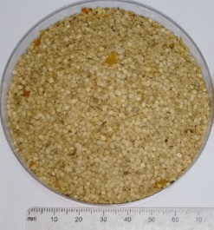

Figure 1 : Dried seeds of S. anguivi
2.1.2 Organic material
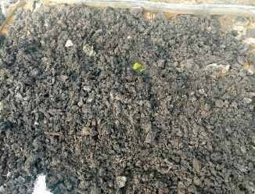
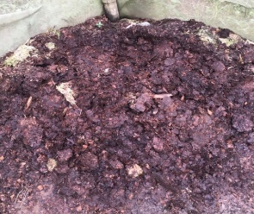
The organic material consisted of poultry manure for the crop and pig manure for the nursery (Figure 2).
10 cm
10 cm

A
B

Figure 2: Fertilizers used
A: Decomposing poultry manure, B: Well-decomposed pig manure
2.2 Setting up the nursery
2.2.1 Preparing the nursery bed, sowing seeds, and maintenance
A raised bed 1 m wide, 1.5 m long, and 20 cm high was created by tilling the soil with a hoe. Three kilograms of well-decomposed pig manure were spread over the entire surface of the board. Then, the ridge was flattened and furrows were made using a wooden stick.
Then, the seeds of S. anguivi Lam were scattered in these furrows and gently covered with soil (Figure 3). Next, the seeds of S. anguivi Lam were scattered in these furrows and gently covered with soil (Figure 3).
After germination, the palm whites were carefully removed. The nursery was regularly maintained by manual weeding to eliminate weeds. The nursery was monitored for 45 days (Figure 4).
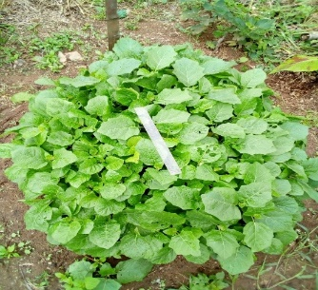
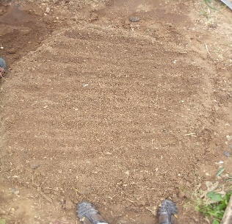
10 cm

B
A
10 cm

Figure 3 : Setting up the nursery.
A: nursery bed, B: nursery ready for transplanting
2.2.2 Setting up the plot and experimental design
2.2.3 Preparing the ground
Using a walking stick and a hoe, a 10 m by 10 m plot was cleared and then cleaned. Holes 20 cm deep and 20 cm in diameter, spaced 60 cm apart between rows and 60 cm apart within rows, were dug on the plot (Figure 5). Each pocket was then filled with 500 g of decomposing poultry manure as a base fertilizer.
2.2.4 Transplanting
Transplanting was carried out by carefully removing the plants with the root ball so as not to damage the root system (Figure 4). Each pocket received one gnangnan plant. One week after transplanting, the dead plants were replaced.
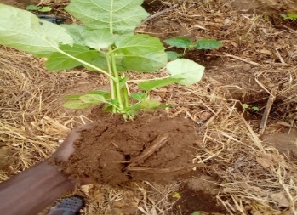
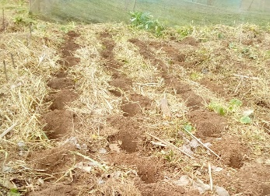
A
B
60 cm
60 cm
60 cm

Figure 4 : Experimental plot and transplanting of seedlings
A: holes, B: seedlings pulled up with clods of earth for transplanting.
2.2.5 Crop maintenance
After transplanting the seedlings, the plot was regularly hoed to remove weeds (Figure 6). A cypermethrin-based insecticide at a dose of 2 ml/2 l was applied every two weeks to the entire plot using a sprayer.
2.2.6 Harvesting ripe clusters
During the fruiting phase, the gnangnan plants bore inflorescences composed of green berries. These berries changed color as they ripened, turning from dark green to light green, yellow, orange, and then red. At each coloring stage, the berries were harvested manually for measurement. The fruits were separated from the bunches, weighed (Figure 5), and then sorted into four batches: green, yellow, orange, and red fruits. These batches of fruits were each divided into two parts.
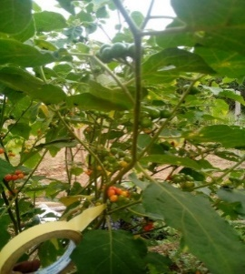
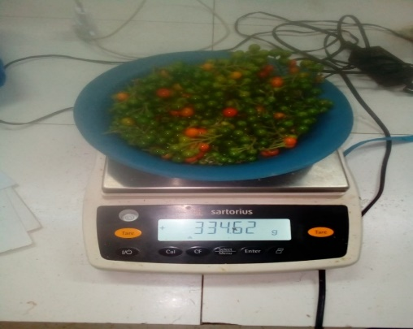
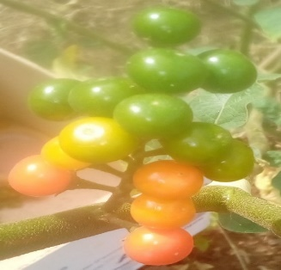
Jaune
B
Rouge
A
C
1 cm
20 cm
Orange
Vert

Figure 5 : Fruit coloring during ripening
A: S. anguivi plant in production ; B : fruit cluster with four different colors; and C: weighing the fruit.
2.2.7 Étude de quelques paramètres liés à la germination
2.2.8 Extraction et traitement des graines
A portion of the seeds from each batch of fruit, previously sorted and classified by stage of ripeness, was used for the germination test (Figure 6).
To this end, 500 g of each batch of fruit was weighed, and the seeds were extracted for viability testing. This test consisted of soaking the seeds in water. Those that floated were discarded, and those that remained at the bottom of the container were considered viable. These seeds were divided into two batches: undried seeds and seeds dried for three days in the sun (Figure 6). This resulted in eight types of seeds (undried and dried seeds from green, yellow, orange, and red fruits).
2.2.9 Sowing the seeds
Thirty seeds from the eight treatments were sown in three jars that had been perforated beforehand and filled with a mixture of soil and well-decomposed pig manure, then placed under a shade cloth. Ten seeds were sown per jar and the jars were labeled. Watering was carried out every two days at a rate of 250 mL per jar for 21 days. Germination parameters were evaluated. A seed was considered germinated when the young shoot emerged approximately 0.5 cm above the substrate.

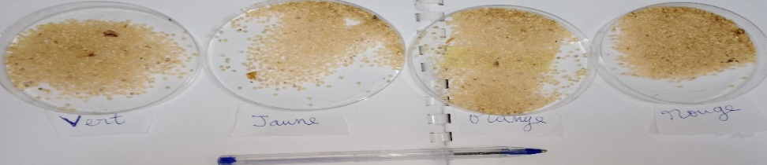
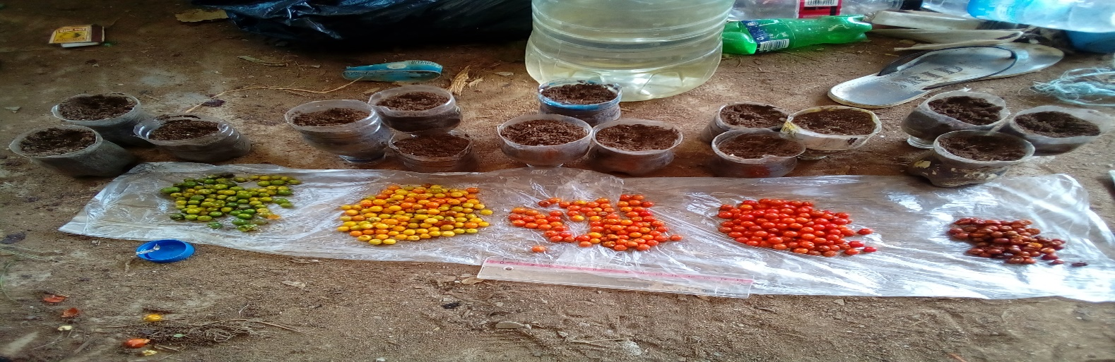
A
B
Red
Orange
Yellow
Green

Figure 6 : Fruits harvested at different stages and their corresponding seeds.
2.2.10 Evaluation of parameters related to germination after cultivation
In order to test the effect of ripeness stage on germination, the following parameters were evaluated: Germination percentage (GP): this is the ratio of the number of germinated seeds to the total number of seeds sown, multiplied by 100.
NGG

NGS

X 100
PG (%) =
PG: Percentage of germination, NGG: Number of seeds that germinated, NGS: Number of seeds sown
Average germination time (AGT), which is used to assess the maturity of the seeds.
TMG = ∑n.Jn/N (j)
Where n is the number of seeds that germinated on day D, Dn is the number of days after sowing required to obtain n germinated seeds, and N is the total number of seeds that germinated.
Seed germination capacity (GC): this is the ratio of the number of seeds that have germinated to the number of seeds that have not germinated.
CG =
NGG

NGNG

NGG: Number of germinated seeds, NGNG: Number of non-germinated seeds
Study of certain biochemical parameters of fruit
For the biochemical compound measurements, part of each batch of fruit was dried for two weeks in the sun, as farmers do for preservation, and the other part was used fresh. This allowed us to have eight modalities (undried and dried seeds from green, yellow, orange, and red fruits).
These eight treatments were used for the extraction and determination of proteins, prolines, total phenolic compounds, and total sugars.
2.2.11 Protein extraction and measurement
Protein extraction and measurement were performed according to the Bradford method (1976).
The proteins were extracted cold (4°C). To this end, 500 mg of fresh fruit and 500 mg of dried gnangnan fruit from each stage of ripeness were ground in the presence of 0.05 g of polyvinylpyrrolidone (PVP) and 5 ml of 0.1 M sodium phosphate buffer (pH 7.9).
The resulting pulp was centrifuged at 5000 rpm for 30 minutes, and the supernatant obtained constituted the crude extract.
For the assay, 5.1 ml of reaction medium was prepared. This medium contains 0.1 ml of crude extract and 5 ml of Coomassie blue solution. This solution was prepared using the following method: 0.2 g of Coomassie Blue was dissolved in 10 ml of 95 % ethanol to which 20 ml of acid was added, then the final volume was adjusted to 200 ml with distilled water. The reaction mixture was placed in an ice bath in the dark for 30 min. Then, the protein content was monitored using a spectrophotometer at 595 nm. In the control tube, the extract was replaced with phosphate buffer. The bovine serum albumin (BSA) solution (250 µg/mL) was used as the reference protein solution. The protein content was determined using a calibration curve (y = 0.41x + 0.0013; R2 = 0.999) and was expressed in milligrams per gram of fresh and dry matter (mg/g FM and mg/g DM). The protein content was calculated using the following equation:
(4)
Protein content (mg/g) =
m
2X. V

Y = 0.0013X – 0.41 where Y is the optical density, m is the mass of the sample, and V is the volume after centrifugation.
2.2.12 Extraction and measurement of proline
Proline extraction and measurement were performed according to the method described by Dreir and Goring (1974). To do this, 100 mg of fresh (FM) and dried (DM) gnangnan fruit at each stage of ripeness was crushed separately in 3 ml of 40% methanol. The mixture was heated in a water bath at 85°C for 30 min. After cooling in melting ice and centrifugation at 5000 rpm for 10 min, 1 ml of the supernatant was collected. Next, 1 mL of glacial acetic acid, 25 mg of ninhydrin, and 1 mL of mixture (I) containing (120 mL of distilled water, 300 mL of acetic acid (CH3COOH), and 80 mL of phosphoric acid (H3PO4)) were added. The mixture was stirred vigorously and then brought to a boil at 100°C for 45 minutes until the color changed. After cooling, 5 ml of toluene was added to the solution. The mixture was stirred and left to stand for 30 minutes. Finally, 3 ml of the supernatant was taken for optical density (OD) reading at 528 nm using a spectrophotometer.
The calculation of proline concentration (C) was performed using the following formula :
C (mM/g) = $\frac{DO}{Ɛ*L}$ (5)
Ɛ = 0.9986 mM/L/cm, L: Length of spectrophotometer tube
2.2.13 Extraction and measurement of total phenolic compounds
The extraction of phenolic compounds was performed according to the method described by Kouakou et al. (2009). Thus, 500 mg of fresh and dried gnangnan fruit was placed in 10 ml of methanol (96%). The mixture was then incubated in the dark for 10 hours at 4°C. This is the time required for the extraction of phenolic compounds. After centrifugation at 5000 rpm for 10 min, the supernatant obtained was filtered and constituted the crude phenolic extract to be analyzed.
The phenolic compounds were measured using the method described by Singh et al. (2000). To do this, 0.5 ml of 5 N Folin-Ciocalteu reagent was added to 0.9 ml of distilled water. 0.1 ml of phenolic extract was added to the mixture. The mixture was stirred at room temperature, then 1.5 ml of 17 % sodium carbonate and 6 ml of distilled water were added to the solution. The solutions obtained were incubated for 30 minutes. The intensity of the coloration (proportional to the concentration of polyphenols) was monitored using a spectrophotometer at 765 nm. During the assay, a control sample was prepared and the phenolic extract was replaced with distilled water. The total phenol content is determined using a calibration curve (y = 0.586x, where x is the concentration of gallic acid) produced with different concentrations of a gallic acid stock solution (200 μg/mL). These concentrations were expressed in milligrams per gram of fresh and dry matter (mg/g FM and DM).
The total phenolic compound content was calculated using the following equation :

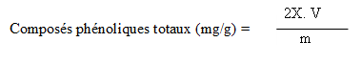
(6)

Y = 0.586 X where Y is the optical density, m is the mass of the sample, and V is the volume after centrifugation.
2.2.14 Extraction and measurement of total sugars
Total sugars were extracted as previously described (extraction of phenolic compounds) and measured using the Dubois method (1956). A concentrated sulfuric acid solution (H₂SO₄) was used to break the glycosidic bonds between D-glucose and D-65 fructose, dissolving all the sugars present, which were then revealed by phenol. For the assay, 0.2 ml of 5 % phenol and 0.2 ml of phenolic extract were taken and placed in a test tube. The reaction mixture was made up to 1 ml with distilled water, to which 1 ml of concentrated sulfuric acid (97 %) was added. The solution was incubated for 5 min in a boiling water bath, then cooled in the dark for 30 min. The intensity of the color produced by the reaction was measured using a spectrophotometer at a wavelength of 490 nm against a control sample that did not contain sugars. The optical density was converted into total sugar content (mg/g of fresh matter (FM) and dry matter (DM)) using a calibration curve (0.01 to 0.1 mg/ml) constructed from a glucose solution (1 mg/ml). Total sugar content was determined using the following equation :
5X.V
m
(8)
Total sugar content (mg/g) =
Teneurs en sucres totaux (µg/g) =

Y = 1.497X + 0.0179 where Y is the optical density, m is the mass of the sample, and V is the volume after centrifugation.

3.3. Statistical analyses
Statistical analyses were performed using STATISTICA software version 7.1. A two-way analysis of variance (ANOVA 2) was performed, taking into account the interaction of the two factors on the means of the biochemical parameters of the fruits. When a significant difference was observed, Fisher's LSD test was used to separate means.
- RESULTS
3.1 Germination rate of seeds from wild fruits
The results showed that out of 1,855 seeds from random fruits planted in the nursery, only 327 seeds germinated. This represents a germination rate of 17.63%.
3.2. Effect of seed condition and ripeness stages on germination
The results relating to the effect of seed condition and fruit ripeness stages are presented in Table 1. The analysis of variance revealed that the interaction between seed condition and fruit ripeness stages influenced all germination parameters. Thus, regardless of the condition of the fruit, the germination rate was higher for seeds from fruit at the red ripeness stage, with a germination percentage of 91.08 to 95.58 %. However, fresh seeds from red fruits had the highest germination rate (95.58 %).
Table 1: Effect of dried and fresh seeds at different stages of ripeness on germination
EG | SM | PG (%) | CG | TMG
Fresh beans  Grains non séchés | Greens | 19,75±0,08d | 0,36±0,01d | 1,69±0,18a
Fresh beans  Grains non séchés | Yellows | 89,50±1,13b | 9,25±0,68b | 0,67±0,17d
Fresh beans  Grains non séchés | Oranges | 88,67±1,77bc | 6,50±0,33c | 0,96±0,05cd
Fresh beans  Grains non séchés | Reds | 95,58±1,33a | 12,75±0,65a | 1,39±0,18ab
Dried grains  Grains séchés | Greens | 16,91±0,09e | 0,24±0,00d | 0,94±0,07cd
Dried grains  Grains séchés | Yellows | 89,75±1,67b | 9,00±1,01b | 1,08±0,08bc
Dried grains  Grains séchés | Oranges | 86,33±2,12c | 6,47±0,17 c | 1,36±0,09ab
Dried grains  Grains séchés | Reds | 91,08±1,97b | 9,37±0,13b | 1,48±0,09b
 | P | P < 0,001 | P < 0,001 | P < 0,002
In each column, means labeled with different letters are significantly different from each other at the 5% level according to Duncan's test.
EG: Grain conditions, SM: Maturity stages, PM: Maturity stages, CG: Germination capacity, TMG: Average germination time
3.3 Changes in the phenolic compound, proline, protein, and total sugar content of fresh and dried fruits of Solanum anguivi Lam
3.4 Protein content of fresh and dried fruits of S. anguivi Lam during ripening
Analysis of variance showed that the stage of ripeness and the condition of the fruit had a combined effect on protein synthesis. Indeed, the protein content of S. anguivi fruits increases significantly with the stage of ripeness (from green to red) in fresh fruits. However, these levels drop dramatically in dried fruits, which showed no differences between them (Figure 7).
Green | Yellow | Orange | Red
Proline content (mM/g)

Fresh fruit

Dried fruit

Figure 7 : Changes in protein content according to seed condition (fresh and dry) and fruit ripeness stage of S. anguivi Lam.
3.5 Proline content of fresh and dried S. anguivi Lam fruit during ripening
The proline content of fresh and dried S. anguivi Lam fruit decreases significantly during ripening. In fact, the proline content decreases not only with ripening but especially with the drying of the fruit (Figure 8).
Green | Yellow | Orange | Red

Proline content (mM/g)
Fresh fruit
Dried fruit
Figure 8 : Changes in proline content according to seed condition and fruit ripeness stage in S. anguivi Lam

3.6 Phenolic compound content in fresh and dried S. anguivi Lam fruit during ripening
The phenolic compound content of fresh and dried S. anguivi Lam fruits decreases significantly during ripening, except for the first two and last two stages of ripening in each state (Figure 9). In fact, the phenolic compound content of the first two stages of ripeness in fresh fruit (0.86 and 0.75 mg/g) and dried fruit (0.67 and 0.72 mg/g) relative to green and yellow coloring does not differ, but has the highest phenolic compound content. These are different from those of fruits at the orange and red stages of ripeness of fresh and dried fruits, which were statistically different. However, fresh green fruits had the highest phenolic compound content.
Green | Yellow | Orange | Red

Fruits frais
Phenolic compound content (mg/g)
Fresh fruit

Figure 9 : Evolution of phenolic compound content according to seed condition and fruit ripeness stage of S. anguivi Lam.
3.7 Total sugar content of fresh and dried S. anguivi Lam fruit during ripening
The total sugar content of fresh and dried S. anguivi Lam fruit increases significantly during ripening (Figure 10). In fact, the total sugar content of fresh and dried red fruits does not differ significantly. However, the best result was recorded for fresh red fruits (0.62 mg/g) and dried red fruits (0.57 mg/g).

Green | Yellow | Orange | Red
Dried fruit
Fresh fruit
Total sugar content (mg/g)
Figure 10 : Changes in total sugar content according to the condition and ripeness stage of S. anguivi Lam fruit
- DISCUSSION
4.1 Effect of seed condition and ripeness stages on germination
The very low germination rate (17.63 %) recorded with seeds from different stages of ripeness could be explained by the fact that these seeds may be physiologically immature and continue to ripen in the digestive tract of these animals. Indeed, the albumen and seed coat appear to be the potential cause of this type of dormancy because they can store inhibitors (Nivot, 2005). So, some plants rely on animals to disperse their seeds. This is called zoochory. This is what happens with “gnangnan” seeds. In fact, birds feed on gnangnan fruits, which attract them with their different colors, and the seeds, which are not digested, pass through the digestive tract and end up in the excrement. It has also been shown that, for plants that spread by endozoochory, seeds from excrement develop more than seeds that have simply fallen from the parent plant (Chasseriaud, 2018). In our case, untreated seeds had a low germination rate (17.63%). Seeds from the first three stages of ripeness (green, yellow, and orange) of fresh and dried fruits showed low germination rates. This could be explained by the fact that these seeds do not fully meet all the conditions, as they are freshly matured. Moreover, Benjamin (2021) reported that the average germination rate of eggplants can drop for seeds from fruits harvested when barely mature. According to this researcher, freshly mature seeds contain more abscisic acid (ABA) than gibberellic acid (GA3). ABA is a potent inhibitor of germination, and one of its roles is to prevent premature germination (Hoareau, 2012). However, the germination rate of fresh seeds (95.58 %) and dry seeds (91.08 %) from red fruits can be explained by the fact that red fruits contain more gibberellic acid and ethylene than ABA. Indeed, the presence of gibberellin and ethylene could have promoted good germination in red fruits.
4.2 Protein content of fresh and dried fruits of S. anguivi Lam during ripening
The study on the condition and stages of ripening of gnangnan fruit during production and post-harvest storage revealed that the ripening of gnangnan results in a successive change in color corresponding to the stages of ripening (green, yellow, and orange). This could be explained by the degradation of phenolic compounds. Our results differ from those reported by N'Dri et al. (2010) on Solanum anguivi Lam, who noted three stages of ripeness: green, orange, and red. However, the phenolic compound content of S. anguivi Lam fruits decreases significantly during ripening. According to Kadam and Salunkhe (1998), the decrease in phenolic compound content in S. anguivi Lam fruits during ripening and post-harvest storage (dry) is due to polymerization and condensation reactions of these compounds, resulting in the formation of insoluble polymers.
4.3 Proline content of fresh and dried S. anguivi Lam fruit during ripening
With regard to the proline content of S. anguivi Lam fruits, the results showed that the proline content decreases in line with that of phenolic compounds. These compounds are much more prevalent in green and yellow fruits. Charaf et al. (2012) showed in their work on marram grass (Ammophila arenaria L.) that proline accumulates abundantly in the main vegetative organs (leaves, stems, and rhizomes).
4.4 Phenolic compound content in fresh and dried S. anguivi Lam fruit during ripening
Unlike phenolic compounds and proline, analysis of protein content showed that proline content increases during ripening. Thus, the increase in protein content would indicate the continuation of metabolic and physiological activities in certain fruits after harvest at maturity. Our results are consistent with those of Assemand et al. (2012), who observed an increase in protein content ranging from 3.27 to 4.27 % from the green stage to the ripe stage.
4.5 Total sugar content of fresh and dried S. anguivi Lam fruit during ripening
The results also showed an increase in total sugar content in the fruits studied. This increase could be explained by the fact that during the ripening process, starch is converted into reducing sugars and then into sucrose. Indeed, ripe green fruit contains more starch than reducing sugars and sucrose. Then, as it ripens, it contains less and less starch and more and more sugar. Our results are consistent with those of Brady (1987), who explains that the increase in sugars in fruits occurs as a result of the breakdown of starch or heteroside under the action of amylases and heterosidases.
- CONCLUSION
At the end of this study, it should be noted that the germination of gnangnan (Solanum anguivi Lam) is optimal when the seeds, whether dried or not, come from red fruits. The high content of phenolic compounds makes it an important food for human health. For good germination, it is therefore preferable to use fresh or dry seeds from red fruits as seeds and to consume the fruits of Solanum anguivi Lam preferably fresh.
REFERENCES
Assemand E., Camara F., Kouame F., Konan V. and Kouame P. (2012). Biochemical characterization of plantain fruits (Musa paradisiaca L.) variety “Agnrin” from Ivory Coast and sensory evaluation of its derived products. Journal of Applied Biosciences, 3 (60): 4438-4447.
Benjamin. (2021). Cultivate Your Street. Simplified cultivation guide - eggplants: www.culturetarue.fr. Accessed July 26, 2024.
Bradford M. M. (1976). A rapid and sensitive method for the quantitation of microgram quantities of protein utilizing the principle of protein-dye binding. Analogy Biochemistry, 72: 248–254.
Brady, C. (1987). Fruit ripening. Annual review. Plant Physiology, 38: 155-178.
Burkill, H. (2000). The useful plants of West Tropical Africa. 2nd Edition. Familiars S-Z, Addendum. Royal Botanic Gardens, United Kingdom, 5: 686-698.
Charaf, M., Hachemi, B., Fatima, Z. B. & Moulay, B. (2012). Seasonal variation in proline and soluble sugar content in beachgrass (Ammophila arenaria (L.) Link) from the natural environment of the west coast of Algeria, Acta Botanica Gallica, 159 (1): 127-135.
Chaseriaud, M. (2018). Chronicle written and presented by Océane Bartholomée for Mag Sciences - Chronicle re-edited for Echosciences, 2 (2): 109-123.
CNRA, (2013). Growing eggplants successfully in Côte d'Ivoire. Fact sheet 23. www.cnra.ci (accessed 25/10/2021).
Dan, C. G. (2015). Evolution of biochemical and physico-functional parameters of Solanum anguivi Lam berries harvested in Ivory Coast during ripening. Doctoral thesis of Nangui Abrogoua University in Food Science and Technology Specialty : Biochemistry and Food Technology, 196p.
Diouf, M.., Hgaza, V., Carsky, R.., Assa, A., Tra, T. B., Tschannen, A.., Girardin, O., Diby, L. N., Gueye, M. & Samb, P. I. (2017). Use of biochemical parameters for determining the optimal harvest date of bissap leaves (Hibiscus sabdariffa L.) in Senegal. International Journal of Biology and Chemistry Sciences, 11 (5): 2306-2314.
Doumbia, K. E. & Kwadjo, M. (2009). Pesticide use and management practices by market gardeners in Côte d’Ivoire : Case of the city of Abidjan and two of its suburbs (Dabou and Anyama). Journal of Applied Bioscience, 18 (1): 992-1002.
Dreir, W. & Goring, M. (1974). The influence of salt concentrations on physiological parameters of maize. Naturwiss, 23 (1) : 641–644.
Dubois, M., Gilles K. A. L., Hamilton, J. K., Rebers, P. A. &Smith F. (1956). Colorimetric method for determination of sugar and related substances analytically. Chemistry, 39 (28): 14–15.
Hoareau (2012). Germination and ion leakage are linked with phase transitions of membrane lipids during imbibition of Typha latifolia pollen. Plants Physiologys, 84: 29-34.
Kadam, S., Salunkbe, D. (1998). Handbook of vegetable Science and Technology, Marcel Incorporation, New York, 232p.
Koffi, E. M., Sangare, A., Akamou, F., & Fall C. (2009). State of plant genetic resources for food and agriculture (Côte d’Ivoire): Second national report, p10.
Kouakou, T. H. (2009). Somatic embryogenesis in cotton (Gossypium hirsutum L.): variation of phenolic compounds during callogenesis and cell suspension culture. State thesis, University of Abobo-Adjamé (Abidjan-Ivory Coast), 137p.
N'Dri, D., Calani, L., Mazzeo T., Scazzina, F., Rinaldi M., Del Rio, D., Pellegrini, N. &Brighenti F. (2010). Effects of different rnaturity stages on antioxidant content of Tvorian gnangnan (Solanum indicum L.) berries. Molecules, 15 (1): 7125-7138.
Nivot, N. (2005). Germination and cutting trials of six native sciaphyte species from Canada. Master's thesis in plant biology. Department of Phytology; University of Laval, Quebec. Oladimeji F. A, Orafidiya O, p32.
Rahajanirina, G. (2009). Development of the sensory profile of the 12 most consumed leafy vegetables in Antananarivo and study of the nutritional value of dishes based on these leafy vegetables. DEA thesis, University of Antananarivo, 117 p.
Singh, A. P., Luthria, D., Wilson, T., Vorsa, N., Singh, V., Banuclos, G. S. & Pasakdec, S. (2009). Polyphenols content and antioxidant capacity of eggplant pulp. Food chemistry, 114 : 955-961.

