COMBINED EFFECTS OF THREE SOIL TYPES AND SOWING DENSITY ON AGRONOMIC PARAMETERS OF DESMODIUM ADSCENDENS (SW.) PLANTS GROWN UNDER AGROECOLOGICAL CONDITIONS IN DALOA (CÔTE D'IVOIRE)

ABSTRACT
This study examined the impact of soil texture and seedling spacing on the germination and growth of Desmodium adscendens, a plant recognised for its medicinal and agroecological uses. Three types of soil were evaluated: sandy, silty and clayey, as well as three spacing between seedlings (0.5 m; 1 m; 1.5 m). The results showed that the sandy and silty soils produced faster and more uniform germination, with germination rates of over 90% by the thirteenth day after sowing. This performance was attributed to their light, well-aerated structure, which facilitated the circulation of oxygen and the lifting of dormancy. In contrast, the clay soil, which is more compact and less permeable, delayed germination and recorded the lowest germination rates. In terms of vegetative growth, plants grown in sandy soil showed the best results in terms of collar diameter, stem length and number of branches, followed by those grown in loamy soil. The clay soil limited the development of the plants, whatever the spacing used. Statistical analysis revealed that spacing had no significant effect on agronomic parameters (P > 0.05), which can be explained by the morphological plasticity of the species and its ability to adapt to different planting densities. These results confirm the potential of Desmodium adscendens to be integrated into sustainable cropping systems in the humid tropics.
Key words: Desmodium adscendens ; soil texture; germination; vegetative growth; sowing density.

- INTRODUCTION
Wild plant domestication is an essential strategy for diversifying agricultural systems, boosting food security and preserving plant biodiversity threatened by deforestation and climate change (Tenaillon et al., 2023). In Africa, this approach is particularly important in forest areas, where many species with agronomic and medicinal potential remain under-exploited (Tchoundjeu & Takoutsing, 2023; Avana-Tientcheu, 2025). Desmodium adscendens (Sw.), a plant in the Fabaceae family, is recognised for its medicinal properties and its role as a cover crop improving soil fertility (Kouame et al., 2024). The domestication of this plant in Côte d'Ivoire, particularly in the Daloa region, is part of an agro-ecological dynamic aimed at making the most of local resources while meeting the challenges of agricultural sustainability (Koffi et al., 2024). However, the success of this domestication is highly dependent on edaphic conditions and cultivation practices. Soil texture directly influences water retention, nutrient availability and root development, thus impacting plant growth and yield (Freschet et al., 2018; Ngom et al., 2024). Similarly, seeding density is a key factor in competition between plants and optimisation of the biomass produced (Kouame et al., 2024). The Daloa region, characterised by a humid tropical climate and ferralitic soils, offers a suitable setting for experimentation with Desmodium adscendens in the domestication phase (Kouadio et al., 2021). The aim of this study is to assess the combined effects of three soil types (sandy, clayey and silty) and different sowing densities on the agronomic parameters of Desmodium adscendens, in order to identify the optimum conditions for its cultivation in this agro-ecological zone.
2. MATERIALS AND METHODS
2.1 STUDY SITE
The study was conducted on the experimental plot of the Jean Lorougnon Guédé University, located in Daloa, capital of the Haut-Sassandra region, in west-central Côte d'Ivoire (Figure 1). Located in a forested area, Daloa lies at 6°53' north latitude and 6°27' west longitude (INS, 2015). The region enjoys a humid tropical climate, with four distinct seasons: two rainy seasons and two dry seasons. The soils, mostly ferralitic, have good agronomic potential for perennial crops, despite the pressures associated with urbanisation (Kacou, 2023; Traoré et al., 2023).
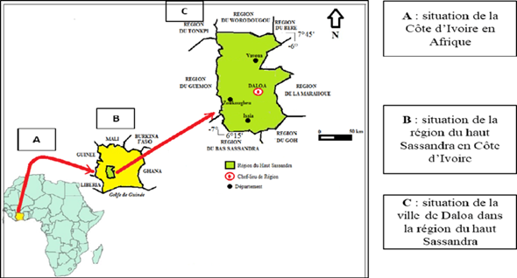
Figure 1 : Geographical location of the study area (INS, 2015)
2.2 Plant material
The plant material used in this study came from Desmodium adscendens grains collected from oil palm, cocoa and rubber plantations located in the locality of Assouba, in Aboisso region (south-east of Côte d'Ivoire). This area stands out as one of the main ecological hotspots where this species grows naturally, notably because of its humid tropical climate and the richness of its forest soils, which are favourable to the development of herbaceous plants such as Desmodium adscendens.

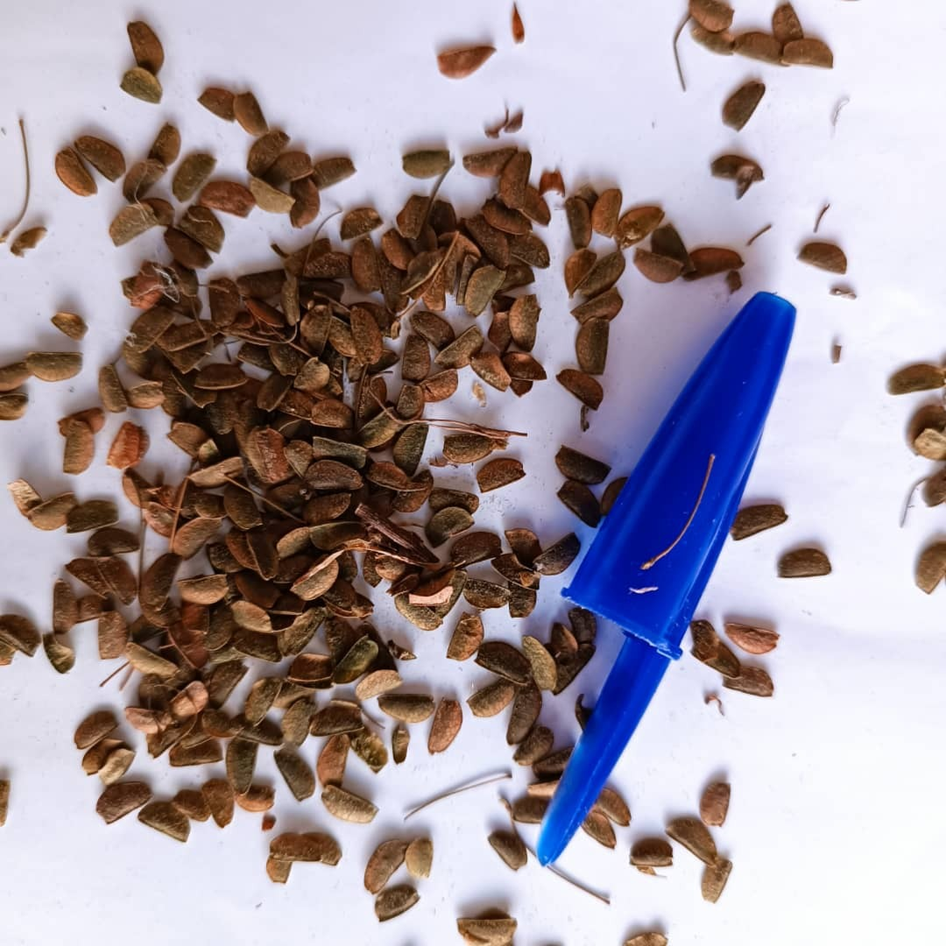

Figure 2: Desmodium adscendens seeds
2.2 Technical equipment
As part of the installation and monitoring of the experimental plots, several tools were used to ensure the precision of the agronomic operations:
-Machete: used for the initial clearing of plots, eliminating existing vegetation and preparing the ground for the experimental blocks.
-Daba: a traditional tool used to level out the ground after clearing, and to make poquets (small holes for seeds or seedlings), to ensure even planting.
-Measuring tape: used to delimit the experimental blocks according to the dimensions specified in the protocol, ensuring the regularity and reproducibility of the trials.
Tape measure: used to measure the length of stems at different stages of development in order to assess vegetative growth.
-Caliper: used to accurately measure the diameter at the collar (base of the stem, at ground level), an important indicator of plant vigour and biomass.

2.3 METHODS
2.3.1 Experimental set-up
The experiment was conducted using a block design applied to three types of soil texture: sandy, silty and clayey (Figure 3). For each texture, three blocks spaced 10 metres apart were set up to limit environmental interference. Within each block, three planting spacings were tested (0.5 m × 0.5 m; 1 m × 1 m; 1.5 m × 1.5 m), and this scheme was repeated three times for each soil type, ensuring the statistical robustness of the protocol (Figure 4). Each replication consisted of fifty seedbeds, each receiving two Desmodium adscendens seeds, i.e. 100 seeds per replication. The seeds were sown at a uniform depth of 2 cm, in accordance with agronomic recommendations for this species, to ensure uniform germination and comparability of results between the different experimental conditions.
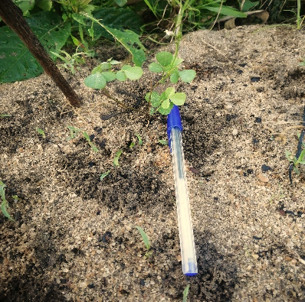
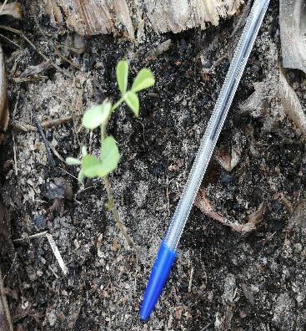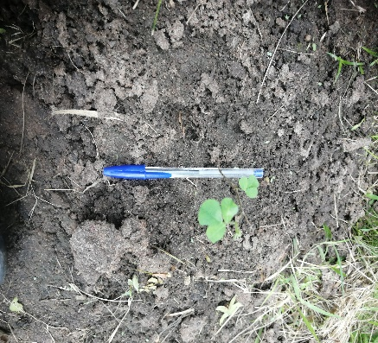
Soil clayey
Silty soil
Sandy soil
Figure 3 : Diffrents types of soil used

x | x | x | x | x
x | x | x | x | x
x | x | x | x | x
x | x | x | x | x
x | x | x | x | x
x | x | x | x | x
x | x | x | x | x
x | x | x | x | x
x | x | x | x | x
x | x | x | x | x

x | x | x | x | x
x | x | x | x | x
x | x | x | x | x
x | x | x | x | x
x | x | x | x | x
x | x | x | x | x
x | x | x | x | x
x | x | x | x | x
x | x | x | x | x
x | x | x | x | x

x | x | x | x | x
x | x | x | x | x
x | x | x | x | x
x | x | x | x | x
x | x | x | x | x
x | x | x | x | x
x | x | x | x | x
x | x | x | x | x
x | x | x | x | x
x | x | x | x | x

0,5 m
10 m
1 m
1,5 m
Figure 4: Experimental set-up
NB : The sub-block in white represents the spacing 0.5m x 0.5m; the sub-block in blue corresponds to the spacing 1m x 1m and the sub-block in green corresponds to the spacing 1.5m x 1.5m. x: seedbed.
2.3.2 Determination of growth and development parameters for marketed parts of Desmodium adscendens
Three months after sowing, i.e. 90 days, several agronomic parameters reflecting the growth and development of the plants were recorded from the experimental set-up, with the exception of the germination rate, which was assessed earlier. This rate was calculated by dividing the number of seeds germinated per day by the total number of seeds sown, then multiplying the result by 100, using the following formula: (number of seeds germinated/total number of seeds sown) × 100. The following characteristics were measured: diameter at the crown, length of the main stem, number of leaves on the stem, spread of the plant, number of internodes, length of the internodes, and length and width of the leaves. These data were used to assess vegetative vigour in relation to growing conditions.
2.4 Analyse Data analysis and statistical processing
The parameters measured were used to assess several aspects of Desmodium adscendens development: Influence of soil texture on germination rate. Effect of soil type on growth parameters: The impact of soil texture on plant growth was assessed by comparing the averages of the various quantitative parameters obtained for plants grown on the three types of soil studied. Effect of sowing density on plant growth: The influence of the spacing between plants (0.5 m × 0.5 m; 1 m × 1 m; 1.5 m × 1.5 m) was analysed by comparing the overall means of the growth parameters. The means of the various parameters, according to soil type, were compared using a one-factor analysis of variance (ANOVA), performed at the 5% significance level. In the event of significant differences, a post-hoc test was applied to distinguish statistically different groups. All statistical analyses were carried out using IBM SPSS version 22.0 software, while the histograms illustrating germination rates were generated using Microsoft Excel 2010.

- RESULTS AND DISCUSSION
3.1 Influence of soil texture on the germination rate of Desmodium adscendens
The evolution of the germination rate of Desmodium adscendens as a function of soil type was monitored over a period of several days after sowing (Figure 4). The first germinations were observed on day 7ᵉ exclusively on sandy soil, which progressed rapidly from day 8ᵉ. At this same date, the silty and clay soils showed significantly lower rates. In addition, the clay soil showed a delay in the start of germination, with the first germinated seeds recorded at 9ᵉ day. This rate gradually increased by day 13ᵉ. In comparison, at the same time, sandy and silty soils showed germination rates above 90 %, reflecting faster and more efficient germination dynamics. Overall, the results indicated that the sandy soil favoured the best germination rates, both in terms of earliness and overall performance.
The study revealed that Desmodium adscendens seeds germinated better on sandy and silty soils. These textures provided good aeration and optimum oxygen circulation, facilitating the lifting of dormancy and the activation of embryonic metabolism. On the other hand, the clay soil, which was too compact and not very porous, limited germination. This behaviour can be explained by the physical structure of the soil: sandy and silty soils, which are lighter and richer in organic matter, allow better infiltration of air and water, essential elements for germination. These results are in line with the work of Muhammad et al. (2024), who observed optimal germination of Luffa acutangula on loamy soil. Pagadjovongo et al. (2017) also showed that Isoberlinia spp. seeds sown on sandy soil gave the best results in the nursery.

Figure 5 : Histogram of Desmodium germination rates by soil type
J : day after sowing ; Sableux : sandy ; Limoneux : silty ; Argileux : clayey
3.2 Influence of soil type on Desmodium adscendens plant growth parameters
The results of the analysis of variance revealed a significant difference (P < 0.05, ANOVA test) in the mean growth parameters of Desmodium Adscendens plants assessed on each soil texture. To this end, the Student Newman-Keuls post-hoc test was used to rank them from smallest to largest. The largest values for: diameter at collar; length of stem; number of leaves on main stem; spread; number of internodes; length of internodes; length and width of leaf were recorded for plants grown on sandy soil. Plants grown on loam also recorded average values overall. However, the lowest values were recorded for plants grown in clay soil. However, Desmodium adscendens plants adapt better on sandy and silty soils compared to clay soil.

3.3 Combined effect of density and soil type on diameter and stem development of Desmodium adscendens seedlings
Desmodium adscendens seedlings showed marked differences in growth depending on the type of soil in which they had been rooted (Figure 6). On sandy soil, the stems grew vigorously, reaching impressive lengths, as did the diameter at the collar. Regardless of the planting density chosen, this soil produced the most developed plants. In contrast, the clay soil produced shorter, frailer stems with small collar diameters. Between these two extremes, the silty soil proved relatively favourable, recording average values overall. However, the lowest values were recorded on the clay soil, regardless of the type of soil tested.
3.4 Combined effect of density and soil type on changes in the number of branches on Desmodium adscendens plants
Changes in the number of branches on Desmodium adscendens plants as a function of soil type were monitored for several days after sowing (Figure 7). The analyses showed that the sandy soil had the highest number of branches for the three sowing densities tested. The silty soil recorded average values overall. On the other hand, the clay soil showed the lowest values, whatever the spacing used. However, the lowest values were recorded on the clay soil, regardless of the type of soil tested.
Observations showed that Desmodium adscendens can grow on different soil types, revealing a certain resilience outside its natural collection zone. However, clay soils hampered the initial growth of seedlings, due to their density and poor aeration. A nursery phase is therefore recommended to optimise seedling establishment on these soils, as suggested by Willan (1992) and Sanou (2014). The best growth was observed on the sandy soil, thanks to its favourable texture and high organic matter content. These observations are in line with the conclusions of Onana (2009) and Pagadjovongo et al. (2021), who stressed the importance of soil texture in vegetative development. Furthermore, Kouamé et al. (2024) evaluated the effect of different levels of shade on the growth of Desmodium adscendens in Côte d'Ivoire. They showed that plants grown under 40% shade on well-drained soil showed the best results in terms of biomass and vegetative development.

Table I: Comparative study of changes in Desmodium adscendens growth parameters by soil type
Soil | DC (cm) | LngTig (cm) | NmbFeuilTp | Enverg (cm) | NmbEntrNd | LngEntrNd (cm) | LngFeuil (cm) | Largfeuill (cm)
Argileux | 0,13±0,04ª | 12,63±3,98ª | 12,42±3,83ª | 21,25±7,81ª | 6,33±1,78ª | 2,733±0,55ª | 2,64±0,5ª | 3,27±0,65ª
Limoneux | 0,18±0,09ª | 33,02±13,94^{b} | 30,06±14,04^{b} | 51,53±20,63^{b} | 11,78±4,18^{b} | 2,5±0,65ª | 2,53±0,45ª | 3,24±0,5ª
Sableux | 1,76±0,37^{b} | 48,2±16,68^{c} | 49,87±4,72^{c} | 82,9±32,27^{c} | 18,8±4,14^{c} | 3,18±1,11ª | 3,5±0,5^{b} | 4,25±0,74^{b}
F | 89,19 | 24,04 | 13,08 | 23,82 | 38,89 | 2,9 | 18,4 | 12,65
P | 0,01 | 0,001 | 0,001 | 0,001 | 0,001 | 0,071 | 0,001 | 0,001
Sableux : sandy ; Limoneux : silty ; Argileux : clayey ; DC: diameter at crown; LngTig: length of stem; NmbFeuilTp: number of leaves on main stem; Enverg: span; NmbEntrNd: number of internodes; LngEntrNd: length of internodes; LngFeuil: length of leaf and Largfeuill: width of leaf; P: probability of significance; F: Fisher's constancy. NB: Values with the same letter are not significant.

Figure 6: Histogram of mean values for diameter and stem length of Desmodium adscendens seedlings as a function of soil type and sowing density
D1 : 0.5m x 0.5 m ; D2 : 1 m x 1m ; D3 : 1.5 m x 1.5 m

Figure 7: Histogram of mean values for diameter and stem length of Desmodium adscendens plants as a function of soil type and sowing density.
3.5 Effect of sowing density on growth parameters of Desmodium adscendens plants grown on the same soil
The results showed that sowing density had no significant effect (P ˃ 0.05, ANOVA test) on all the parameters (collar diameter; stem length; number of leaves on the main stem; span; number of internodes; internode length; leaf length and width) studied. Thus, the density of sowing does not influence the growth and development of this species, so that it is a creeping stem plant.
Statistical analysis of the results showed that sowing spacing (0.5 m ; 1 m; 1.5 m) had no significant effect (P > 0.05) on the agronomic parameters of Desmodium adscendens. This stability can be explained by the creeping, shade-tolerant nature of the plant, as well as its great morphological and physiological plasticity. These characteristics enabled it to adapt to different planting densities without compromising its growth or productivity. These results are consistent with those of Franco et al. (2022), who observed no effect of sowing density on Bromus auleticus. On the other hand, Boubacar et al. (2019) showed that for millet, wider spacing improved yield. François et al. (2022), working on maize, noted that the highest sowing density (0.75 m × 0.2 m) resulted in good yields. These differences underline the importance of considering the physiological and ecological specificities of each species when designing planting schemes. The adaptability of Desmodium adscendens to varying densities could make it an interesting candidate for agroforestry systems or associated crops in the humid tropics.

Table II: Comparative study of the effect of density on the growth parameters of Desmodium Adscendens seedlings
Spacing | DC | LngTig | NmbFeuilTp | Enverg | NmbEntrNd | LngEntrNd | LngFeuil | Largfeuill
0.5 m | 0,72±0,84a | 35,45±20,23a | 22,27±11,71a | 57,37±28,73a | 12,87±5,81a | 2,83±0,84a | 2,93±0,62a | 3,68±0,65a
1 m | 0,66±0,76a | 31,63±21,81a | 22,13±12,05a | 55,27±43,87a | 13,6±7,03a | 2,75±1,02a | 2,79±0,7a | 3,51±0,86a
1.5 m | 0,696±0,83a | 30,85±15,22a | 21,47±25,27a | 49,1±25,27a | 11,53±5,58a | 2,79±0,71a | 2,92±0,67a | 3,57±0,85a
F | 0,022 | 0,244 | 0,019 | 0,245 | 0,433 | 0,032 | 0,204 | 0,182
P | 0,978 | 0,785 | 0,981 | 0,784 | 0,652 | 0,968 | 0,816 | 0,834
DC: diameter at crown; LngTig: length of stem; NmbFeuilTp: number of leaves on main stem; Enverg: span; NmbEntrNd: number of internodes; LngEntrNd: length of internodes; LngFeuil: length of leaf and Largfeuill: width of leaf; P: probability of significance; F: Fisher's constancy. NB: Values with the same letter are not significant.
- Conclusion
The study highlighted the significant influence of soil texture on the germination and growth of Desmodium adscendens. Sandy and silty soils favoured rapid and uniform germination, as well as optimal vegetative development, thanks to their aerated structure and high organic matter content. Clay soils, on the other hand, limited seed emergence and slowed seedling growth, due to their compactness and low porosity. Furthermore, the spacing between sowing points had no significant effect on agronomic parameters, confirming the morphological and physiological plasticity of the species. These results suggest that Desmodium adscendens can be grown effectively outside its natural zone, provided that well-structured soils are chosen and a nursery phase on heavy substrates is favoured. All the data obtained provides a useful basis for agro-ecological intensification strategies and the use of this plant in sustainable cropping systems.

References
Avana-Tientcheu, M.-L. (2025). Domesticating forest and fruit trees in Central Africa. IRD Le Mag, 4.
Baboucar, B., Moustapha, G., Abdoulaye, B., Daouda, N., & Samba, L. K. A. (2019). Effect of sowing date and density on growth and grain yield of late millet [Pennisetum glaucum (L.) R. Br] in the southeastern and southern zones of Senegal. Journal of Applied Biosciences, 138, 14106–14122.
Franco, M., Oliveira, R., & Silva, T. (2022). Effect of sowing density on agronomic traits of Bromus auleticus. Journal of Grassland Science, 38(4), 112–120.
François, T., Koné, A., & Yao, K. (2022). Influence of sowing density on maize (Zea mays L.) yield in Côte d'Ivoire. Tropical Agriculture Papers, 29(3), 61–70.
Freschet, G. T., Violle, C., Roumet, C., & Garnier, E. (2018). Interactions between soil and vegetation. In P. Lemanceau & M. Blouin (Eds.), Soils at the heart of the critical zone: Ecology (pp. 83–104). ISTE Editions.
Institut National de la Statistique (INS). (2015). Directory of localities: Haut-Sassandra Region. Abidjan, Côte d'Ivoire: INS.
Kacou, B. (2023). Potential soil fertility assessment of former coffee and cocoa orchards with a view to revalorization in the Centre-West of Côte d'Ivoire (Daloa) (Doctoral thesis, Université Jean Lorougnon Guédé). DICAMES.
Koffi, T. J. Y., Gnamien, Y. G., Kanga, A.-N., Allouko, J.-R., Koffi, K. M., & Ayolie, K. (2024). Characterisation of the biological cycle of Desmodium adscendens for domestication in Daloa. International Journal of Agricultural and Applied Sciences, 5(2), 77–83.
Kouame, K. D., Yao, K. J.-E., Kassi, K. F. J.-M., Kouadio, Y. H., Kone, K. N., & Kone, D. (2024). Evaluation of the effect of four levels of shade on the growth and development of Desmodium adscendens. Agricultural Sciences, 15(11), 1179–1194.
Muhammad, A., Bello, S., & Usman, M. (2024). Agronomic performance of Luffa acutangula under different soil textures. African Journal of Plant Science, 18(1), 22–30.
Ngom Ngom, E. T., Diatta, M., Ndiaye, M., Mohamed, M. C., & Sy, M. (2024). Effects of different soil substrates on germination emergence and growth of cashew varieties (Anacardium occidentale L.). Ecosystems and Landscapes Magazine, 4(2), 1–15.
Onana, J. M. (2009). Cameroon flora: Desmodium and its traditional uses. Yaoundé: IRAD Press.
Pagadjovongo, A. S., Koffi, A. D., Koffi, A. B., & Kouassi, K. E. (2021). Germination trials and growth performance monitoring of Khaya senegalensis (Desv.) A. Juss. seedlings in the Sudanian zone (Côte d'Ivoire). International Journal of Animal & Plant, 48(2), 8673–8685.
Pagadjovongo, A. S., Kouassi, K. E., Koffi, A. D., & Soro, D. (2017). Seed germination qualities and seedling growth of Isoberlinia spp. in controlled environment (nursery). International Journal of Biological and Chemical Sciences, 11(1), 93–106.
Sanou, H. (2014). Nursery techniques for woody species in the Sudanian zone. Ouagadougou: INERA.
Tchoundjeu, Z., & Takoutsing, B. (2023). Tree domestication in the Congo Basin. In Central African Forests Forever (pp. 142–145). ICRAF.
Traoré, K. M., Kouamé, K. J., & Kouadio, K. J. (2023). Soil artificialisation and water erosion in the city of Daloa, west-central Côte d'Ivoire. Ziglôbitha, 6(2), 599–624.
Willan, R. L. (1992). Guide to forest seed production. Rome: FAO.

