Resistance Level of Sweet Potato Clones to Sweet Potato Weevil (Cylas formicarius Fabricius)

ABSTRACT
In Indonesia, the yield losses of local sweet potato variety due to sweet potato weevil (SPW) caused by the Cylas formicarius insect could reach 100%. The most useful C. formicarius control technology is to use the resistant varieties. This study aims to evaluate the level of resistance of six sweet potato clones to SPW. The field test was conducted in dry season (May - October 2024) in two locations in Lumajang Regency, East Java Province namely Karanganom Village, Pasrujambe District, and Sarikemuning Village, Senduro District. The design used was a Randomized Block Design with four replications. Each sweet potato genotype was planted on a plot of 5 m x 5 m, plant distance of 100 cm x 25 cm (1 steck per hole). The clones were tested in the field and in the laboratory. Observation of tuber borer pest attacks on tested clones Laboratory resistance testing aims to prove and ensure the tolerance level of candidate sweet potato varieties to tuber borer pests. The sweet potato harvest from the field is then cleaned from the soil using water, then healthy tubers (free from C. formicarius) with uniform sizes are selected. Furthermore, the tubers are put into plastic mylar with a height of 20 cm and a diameter of 8 cm. The resistance test method used were choice and without (no)-choice. Results of the trials showed that sweet potato Gatotkoco has a level of resistance to sweet potato weevil equivalent to the check variety Sari which is classified as a resistant, while Bima Pasru has a level of resistance equivalent to the check variety Beta 2 which is classified as an intermediate resistant. These two local varieties of Lumajang (Gatotkoco and Bima Pasru) could be developed to overcome the problem of sweet potato weevil in the field.

Key words: clone, sweet potato, resistance level, weevil, variety

1. INTRODUCTION
Sweet potatoes have several advantages, including the nutrients contained in them and the taste of the tubers. Orange sweet potato tubers contain a lot of beta-carotene which is a pro-vitamin A. Beta-carotene compounds function to provide protection (prevention) against cancer, aging, decreased immunity, heart disease, stroke, cataracts and muscle disorders (Ginting et al., 2012).
In Indonesia, Lumajang Regency of East Java Province, is one of the sweet potato centers with an annual planting area ranging from 600 - 700 ha. Local sweet potatoes planted by farmers generally have a sweet taste which is usually called Ubi Madu (honey yam). In 2023, the harvest area was 363 hectares, with a production of 8,869 tons and a productivity level of 24.4 t / ha (BPS, 2024).
The local sweet potato variety has quite high tuber productivity and has a potential as a functional food ingredient to substitute rice as a staplefood. However, most of the local varieties are not quite resistant to sweet potato weevil (SPW) caused by the Cylas formicarius insect (Reddy et al. 2012; Devi et al. 2014). Yield losses caused by this pest could reach 100%. The sweet potato tubers which are attacked by C. formicarius can not be used for human consumption because they contain furan terpene and coumarin compounds which can cause human cancer disease. This obstacle make farmers could change to other more beneficial crops. These tuber borer insects damage the tubers in the larval phase, develop inside the tubers in the soil causing the chemical insecticidal compounds that are applied are unable to reach the target insects. The most useful C. formicarius control technology is to use resistant varieties (Stevenson et al. 2009).
In order to determine the level of resistance of in controlling the tuber borer insect, it is necessary to evaluate the level of resistance of sweet potato clones to C. formicarius. This study aims to evaluate the level of resistance of sweet potato clones to tuber borer (Cylas formicarius Fabricius) in Lumajang upland, East Java, Indonesia.

2. MATERIALS AND METHODS
2.1. Location Criteria
Sweet potato clone resistance test to tuber borer insect (Cylas formicarius) attack was conducted in two locations in Lumajang Regency namely Karanganom Village, Pasrujambe District, and Sarikemuning Village, Senduro District. The trial was conducted in dry season (May - October 2024). Lumajang Regency is located in the southern part of East Java Province, Indonesia, with an area of ​​approximately 1,790.90 km² and is surrounded by three volcanoes: Mount Semeru, Mount Bromo, and Mount Lemongan, which give its soil high fertility. This area has a tropical climate with two main seasons, the rainy season from November to April and the dry season from May to October, with annual rainfall between 1,500 to 2,500 mm and an average temperature of 22°C to 33°C. According to Schmidt and Ferguson climate classification, most of Lumajang area is included in climate type C, while some other sub-districts have climate type D23. Soil types in Lumajang Regency are very diverse, including andosol, regosol, mediterranean, and alluvial.
Table 1 shows the soil nutrient content sufficient for sweet potato growth, except for the element N. The elements Fe, Zn, Cu, and Mn play a role in determining the nutritional value of sweet potatoes, increasing the growth and development of sweet potato plants (Saha et al. 2022).

Table 1. Soil nutrient content in two Villages in Lumajang Regency, 2024
 |  | Karanganom Village |  | Sarikemuning Village
No. | Nutrient | Nutrient value | Criteria | Nutrient value | Criteria
1 | N | 0.16 | low | 0.29 | low
2 | P | 168 | very high | 149 | very high
3 | K | 1.87 | very high | 2.48 | very high
4 | C organik | 1.52 | rendah | 2.85 | intermediate
5 | PH | 6.9 | neutral | 6.2 | quite acid
6 | Fe (ppm) | 14 | high | 31 | high
7. | Zn (ppm) | 1.3 | intermediate | 1.82 | intermediate
8 | Cu(ppm) | 7.9 | high | 1.30 | intermediate
9 | Mn(ppm) | 6.7 | high | 1.13 | intermediate

2.2. Research Design
The design used was a Randomized Block Design with four replications. The treatments were six sweet potato genotypes, namely three local clones and three check varieties (Table 2). Each genotype was planted on a plot measuring 5 m x 5 m (plot area 25 m²), with a planting distance of 100 cm x 25 cm (1 steck per hole).

Table 2. Genetic material used in adaptation test.
No. | Clone name | Clone origin
1 | Bima Pasru | Lokal Lumajang
2 | Gatotkoco | Lokal Lumajang
3 | Asban Ace | Lokal Lumajang
4 | Sari | Improved released variety (check 1)
5 | Beta 2 | Improved released variety (check 2)
6 | Papua Solossa | Improved released variety (check 3)

2.3. Trial Maintenance
The fertilizer dose used was 300 kg Ponska + 100 kg Urea + 2 tons of manure per ha. Implementation in the field began with the preparation of the land to be used. The soil was processed together with the application of manure, then ridges were made. The distance between the tops of the ridges was 100 cm, the width of the ridges was 50 cm, and the height of the ridges was 40 cm. Sweet potato cuttings measuring 25 cm, before planting were soaked in a solution of red onion extract (Allium cepa) for 1 minute to avoid pathogen infection, especially scab (Sphaceloma batatas). Stem cuttings were planted upright on the top of the ridge with 2-3 segments of the vines submerged in the soil. The planting distance between cuttings in the ridge was 25 cm.
Plant maintenance was carried out by giving the first fertilizer at the age of 10-14 days after planting as much as 1/3 of the fertilizer dose. Fertilizer was given by making a hole with a distance of 10 cm from the plant. Lowering the ridge was done when the plant was one month old along with the first weeding. Repairing the ridge (raising the ridge) was done when the plant was two months old along with the second weeding. The second fertilization was done at the age of two months as much as 2/3 of the fertilizer dose. Turning the stem is done when the plant was 10 and 13 weeks old after planting (adjusting to the type of plant). Water requirements from planting, during the growth period until harvest were given optimally. Harvesting was done at the age of 4.5 months after planting.

2.4. Resistance Test to C. formicarius Insects

Test Insect Propagation

The activity of propagating test insects (rearing) of C. formicarius imago is carried out to obtain insects in abundant numbers at a uniform imago stage as material for infestation. This activity is carried out by maintaining C. formicarius insects on sweet potato tubers or collecting tubers that have been bored by C. formicarius which can be obtained from sweet potato plantations or at sweet potato sellers. Rearing is carried out every day to obtain/take groups of eggs, larvae or imago in the tubers by splitting the tubers then the insects are kept in plastic jars or gauze bags. Insect maintenance is carried out until a uniform population structure (F2) is obtained as a test insect with the amount as expected (Figure 1).

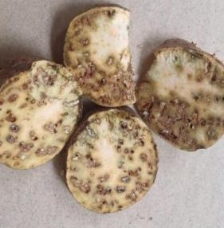 | 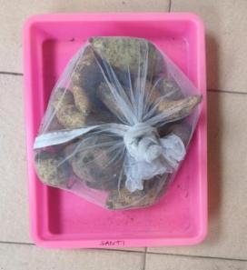 | 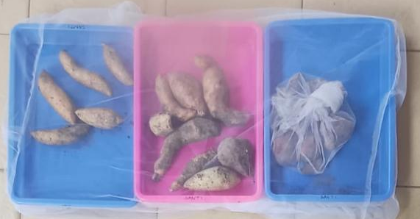
Figure 1. Rearing C. formicarius to obtain imago stages with uniform ages.

Infestation of C. formicarius on Sweet Potato Clones in the Field
Observation of tuber borer pest attacks on tested clones caused by C. formicarius larvae in the field is as follows: before harvesting, observations are made visually by observing the base of the stem, if there are traces of larval droppings with a distinctive aroma, then it can be predicted that the tubers have been attacked by Cylas. Furthermore, observations are carried out destructively in the following manner; all newly harvested tubers from each variety are collected then each tuber that shows wounds from C. formicarius larvae on the tuber skin is split to determine the level of tuber damage (%). Tubers that have been bored by C. formicarius larvae are defective because the tubers already contain toxins, namely furan terpenes and coumarins (terpenoids) from larvae droppings that can trigger liver cancer in consumers. Bulbs that have been eaten will emit a very distinctive and unpleasant aroma so that it is easy to recognize as an indication or sign that the bulbs have been eaten by C. formicarius.
The intensity of tuber damage due to C. formicarius larvae is assessed from the percentage of damaged tubers with the following scores:
1. Score 1: damage level <1%
2. Score 2: damage level 1-5%
3. Score 3: damage level 6-25%
4. Score 4: damage level 26-50%
5. Score 5: damage level 51-100%
Based on the intensity of damage, the criteria for resistance to C. formicarius are determined by referring to the method of Syahnas et al. (2019) as follows:
1. Tolerant with a score of 1- <1.5
2. Somewhat tolerant with a score of 1.5 - 2.5
3. Somewhat susceptible with a score of 2.5 - 3.5
4. Susceptible with a score of 3.5 - 5.

Infestation of C. formicarius on Sweet Potato Clones in the Laboratory
Laboratory resistance testing aims to prove and ensure the tolerance level of candidate sweet potato varieties to tuber borer pests. The sweet potato harvest from the field is then cleaned from the soil using water, then healthy tubers (free from C. formicarius) with uniform sizes are selected. Furthermore, the tubers are put into plastic mylar with a height of 20 cm and a diameter of 8 cm. The resistance test method used were choice and without (no)-choice which refers to the methods developed by Kabi et al. (2003), Dada et al. (2019), and Mau et al. (2021). Infestation of test insects by releasing 20 C. formicarius imago per plastic mylar system without choice (choice test) (Figure 2) or into a container box in the choice method (no-choice test) (Figure 3). The infestation period of test insects in the mylar or box was exposed for three weeks.
The resistance of each candidate variety was assessed based on the level of destructive C. formicarius larvae attack by splitting the tubers if there were traces of burrowing on the skin referring to the method developed by Syahnas et al. (2019), Dada et al. (2020) and Prayogo et al. (2023). Infestation was carried out on tuber samples from all local clones and comparison varieties harvested from Karanganom and Sarikemuning using the choice and no-choice methods (Figures 2 and 3). All candidate varieties and comparisons were tested, in the no-choice method the tubers were put into plastic bottles, each bottle was filled with 1 tuber and infested with a pair of Cylas insects (male and female), while in the choice method each box was filled with five tubers each and then infested with 20 Cylas insects (10 males, 10 females).

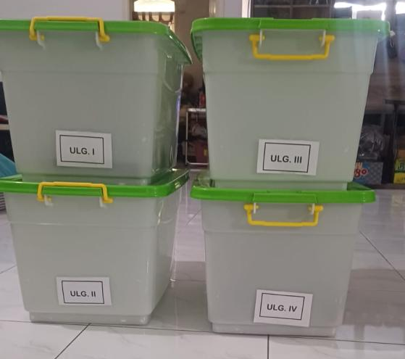 |  | 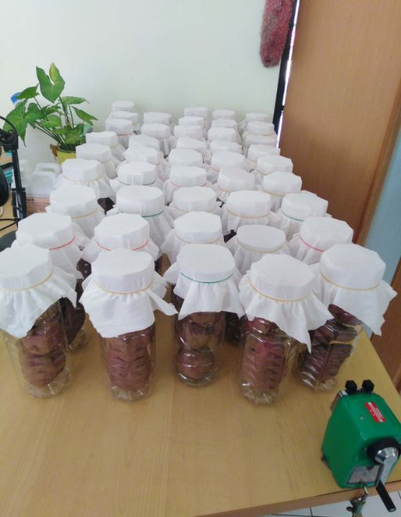
Figure 2. Resistance test of sweet potato varieties using the “choice” test method |  | Figure 3. Resistance test of sweet potato varieties using the “no-choice” test method
The resistance criteria of candidate sweet potato varieties to tuber borer pests were calculated using the formula from the Mau et al. (2021) method and have been modified as follows:
IK = a/(a + B) x 100%
Description: IK (intensity of tuber damage), a (% of damaged tubers), b (undamaged tubers).
The intensity of tuber damage due to C. formicarius larvae was assessed from the percentage of damaged tubers with the following scores:
Score 1: damage level <1%
Score 2: damage level 1-5%
Score 3: damage level 6-25%
Score 4: damage level 26-50%
Score 5: damage level 51-100%
Based on the intensity of damage, the resistance criteria to C. formicarius were determined by referring to the Syahnas et al. method. (2019) as follows:
Tolerant with a score of 1- < 1.5
Somewhat tolerant with a score of 1.5 - 2.5
Somewhat vulnerable with a score of 2.5 - 3.5
Vulnerable with a score of 3.5 - 5.

2.5. Data analysis
All data collected were analyzed using the Minitab 16 program. If there is a significant difference between treatments, then proceed with LSD test at the significance level of 0.05.

3. RESULTS AND DISCUSSION
3.1. Intensity of C. formicarius Pest Attacks in Field Test
The intensity of tuber borer attacks in Karanganom village ranges from 1-25% with the highest level of tuber damage occurring in the Asban Ace variety. The percentage of tubers bored in the candidate local variety Bima Pasru was much smaller because only 10.38% of the tubers were damaged, making it more tolerant to borer pests compared to the Papua Solossa check variety with a tuber damage level of 25.14%. The candidate local sweet potato variety Lumajang Gatotkoco also appears to be more tolerant to C. formicarius larvae attacks because only 1.05% of the tubers were bored, while the Beta 2 check variety still had tuber damage reaching 5.65% (Figure 4).
The test results indicate that all types of sweet potatoes that are exposed will eventually be eaten by C. formicarius larvae because sweet potatoes are the main host of tuber borer insects. Prayogo et al. (2023) emphasized that tuber borers caused by C. formicarius insects were the main pests of sweet potatoes and do not have host plants, so technological innovations in controlling these pests can be carried out by applying biopesticides from the entomopathogenic fungus Beauveria bassiana. This statement is supported by research results that convince us that B. bassiana is a more effective biopesticide in suppressing tuber borer pests when compared to synthetic insecticides (Su 1991; Yasuda 1999; Ali et al. 2009; Prayogo et al. 2023).

Figure 4. Average attack of tuber borer C. formicarius from field test in Karanganom Village, 2024.

Observation results during harvest time in Sarikemuning Village showed that the highest intensity occurred in the Papua Solossa variety, reaching 29.05%. The intensity of C. formicarius attacks on the Asban Ace variety was also relatively high, at 26.16%, approaching the level of attack that occurred in the Papua Solossa variety. Meanwhile, the intensity of tuber borer attacks that occurred in the three varieties, namely Beta 2, Bima Pasru and Sari, showed that tuber damage due to C. formicarius larvae was relatively the same, ranging from 10-11% (Figure 5). When viewed from the level of tuber borer attacks in the field, the candidate local variety Bima Pasru appeared significantly lower when compared to Papua Solossa with tuber damage of 10.01% and 29.55% respectively. Meanwhile, the level of tuber damage due to C. formicarius in the candidate local variety Gatotkoco also appeared superior when compared to the Beta 2 variety with tuber damage levels of 3.12% and 10.16% respectively. The consistency of the level of resistance of candidate local varieties from field tests needs to be further confirmed through laboratory resistance tests. This activity must be carried out because in order to obtain accurate data on the character of the resistance of candidate local varieties to attacks

Figure 5. Average attack of tuber borer C. formicarius from field test in Sarikemuning Village, 2024.

3.2. Intensity of C. formicarius Pest Attacks in Laboratory Tests
Laboratory tests were conducted to determine the validation of the candidate variety's resistance to tuber borer pests for Bima Pasru, which is more tolerant compared to the Papua Solossa variety as a resistance check.
The results of samples derived from Karanganom village of the Bima Pasru resistance test against borer pests showed that tuber damage was only around 10.38%. Meanwhile, the borer pest insect on the Papua Solossa variety as a check with a level of tuber damage reached 25.14% (Figure 6). The intensity of tuber borer attacks on the Gatotkoco variety tested in the laboratory showed higher tuber damage of around 0.39% when compared to the Beta 2 variety check which 4.46% tuber damage while Gatotkoco 4.85%. However, the results of the statistical test did not show a significant difference between Gatotkoco and the superior Beta 2 variety.

Figure 6. Average attack of tuber borer C. formicarius from laboratory test (tuber samples from Karanganom village).

Sample data from Sarikemuning village, laboratory test results showed that the intensity of tuber borer attacks was almost the same as the level of tuber damage that occurred in the field. The level of tuber damage that occurred in the candidate local variety Bima Pasru was significantly lower when compared to the damage to Papua Solossa tubers, which reached 28.98% while Bima Pasru was only 12.05%. Gatotkoco also has a more tolerant character to tuber borer attacks when compared to the resistance of the superior variety Beta 2 in laboratory tests. This fact is shown from the results of the test using the choice method carried out in a box in a 30-day infestation test. The tubers of the candidate variety Gatotkoco in the test were only bored by 3.57%, while the comparison variety Beta 2 with tuber damage reached 13.87% (Figure 7).

Figure 7. Average attack of tuber borer C. formicarius from laboratory test (tuber samples from Sarikemuning village).

The resistance of local sweet potato genotypes of Lumajang to tuber borer C formicarius in two locations (Karanganom and Sarikemuning) showed differences between clones and between locations. Bima Pasru, Gatotkoco and Beta 2 were classified as intermediate resistant, resistant, and intermediate resistant, respectively. The Sari variety was classified as resistant level among the three check varites. Meanwhile, Asban Ace and Papua Solossa were classified as susceptible varieties (Table 3).
Table 3. Results of laboratory tests of the resistance level of sweet potato varieties to tuber borer C. formicarius

No. | Sweet potato varieties | Intensity of drilled sweet potato tubers in village |  | Intensity average | Resistance level
No. | Sweet potato varieties | Karanganom | Sarikemuning | Intensity average | Resistance level
1. | Bima Pasru | 10.01 cd | 12.05 bc | 11.03 | IR
2. | Gatotkoco | 3.12 e | 3.57 d | 3.34 | R
3. | Asban Ace | 26.15 ab | 27.57 a | 26.86 | S
4. | Sari | 1.15 ef | 3.55 de | 2.35 | R
5. | Beta 2 | 10.16 c | 13.87 b | 12.01 | IR
6. | Papua Solossa | 29.55 a | 28.98 a | 29.26 | S
Remarks: R = resistant; IR = intermediate resistant; S = susceptible

4. CONCLUSION

Sweet potato Gatotkoco has a level of resistance to sweet potato weevil (C. formicarius) equivalent to the check variety Sari which is classified as resistant, while Bima Pasru has a level of resistance equivalent to the check variety Beta 2 which is classified as an intermediate resistant. These two local varieties of Lumajang (Gatotkoco and Bima Pasru) could be developed to overcome the problem of sweet potato weevil in the field.

COMPETING INTERESTS DISCLAIMER:
Authors have declared that they have no known competing financial interests OR non-financial interests OR personal relationships that could have appeared to influence the work reported in this paper.

REFERENCES
AOAC. 2016. Microchemical determination of nitrogen using the microKjeldhal method (12.1.07). In: Latimer GWJr (ed.). Official Methods of Analysis of AOAC International. 20th Edition. AOAC International. Rockyville, Maryland, USA.
Antarlina, S.S. 1997. Characteristics of sweet potato as a flour ingredient in cake making. pp. 188-204. In Budijanto, S., F. Zakaria, R. Dewanti-Hariyadi, B. Satiawiharja (Ed.). Proceedings of the National Seminar on Food Technology in Denpasar, July 16-17, 1997. PATPI-Ministry of Food, Republic of Indonesia.
Ali A, Sermann H, Lerche S, Buttner C. 2009. Soil application of Beauveria bassiana to control Ceratitis captitata in semi-field conditions. Commun Agric Appl Biol Sci 74:357-361.
BPS, 2024. Lumajang in Figures. Central Statistics Agency, Lumajang Regency. Volume 45. 408p.
BSN. 1992. Food and Beverage Testing Methods. SNI 01-2891-1992. National Standardization Agency. Jakarta. 36 pp.
Ginting, E, Y. Widodo, S.A. Rahayuningsih, and M. Jusuf. 2005. Starch Characteristics of Several Sweet Potato Varieties. Journal of Food Crop Agricultural Research Vol. 24(1): 9-18.
Ginting, E., Sri S.A., Joko S.U., and Ratnaningsih. 2006. Sweet Potato Post-Harvest Technology Supports Food Diversification and Agro-Industry Development. Palawija Bulletin No. 11:15-28.
Ginting, E, Utomo, J.S., Yulifianti, R., Jusuf, M. 2011. Potential of Purple Sweet Potato as a Functional Food. Food Crop Science and Technology 6(1):116-138.
Ginting, E, Rahmi Y., M. Yusuf, and Made J. M. 2015. Identification of Physical, Chemical, and Sensory Properties of Promising Anthocyanin-Rich Sweet Potato Clones. Food Crop Agricultural Research Vol. 34(1):69-78.
Ginting, E., Yulifianti, R., & Elisabeth, D. A. A. 2018. Physical and Chemical Properties of Sweet Potato Under Various N Fertilization Applications in Tidal Lands of South Kalimantan. Palawija Bulletin, 16(1), 36-45.
Juliano, B.O. 1979. A simplified assumy for milled rice amylose. Cereal Sci. Today 16:334-340.
Jumanah, J., Maryanto M., and Wiwik S. W. 2017. Characterization of Physical, Chemical, and Sensory Properties of Rice Noodles Made from Composite Flour of Canna edulis and Mung Beans (Vigna radiata). Journal of Agrotechnology Vol. 11(2).
Kwarteng EA, Dawson EOS, Ayernor GS, Truong VD, Shih FF, Daigle K. 2014. Variability of sugars in staple-type sweet potato (Ipomoea batatas) cultivars: The effects of harvest time and storage. International Journal of Food Properties 17(2): 410-420.
Misganaw, CD and Bayou, WD. 2020. Tuber yield and yield component performance of cassava (Manihot esculenta) varieties in Fafen District, Ethiopia. International Journal of Agronomy (1), 5836452.
Martanto EA. 1997. Sweet potato resistance to scab disease. Indonesian Journal of Plant Protection 3(2):72-76.
Owusu-Mensah E, Oduro I, Ellis WO, Carey EE. 2016. Cooking Treatment Effects on Sugar Profile and Sweetness of Eleven-Released Sweet Potato Varieties. J Food Process Technol 7:580.
Prayogo Y, MSYI Bayu, Indiati SW, Sumartini, Susanto GWA, Harnowo D, Baliadi Y, Widiarta IN, Harsono A, Budiono R, Mejaya MJ, Supriyadi K. 2023. Control measure of sweet potato weevil (Cylas formicarius Fab.) (Coleoptera: Curculionidae) in endemic land of entisol type using mulch and entomopathogenic fungus Beauveria bassiana. Open Agriculture (8): 20220237. https://doi.org/10.1515/opag-2022-0237
Saha, H.R., Most. Lutfunnahar, Manoshi Sana, Samiron Sana, Md Shajedul Haque, Badhan Rani Dey, Bidhan Chandra Sarkar, Niranjan Kumar Sana. 2022. Nutritional Value of Sweet Potato (Ipomoea batatas) Cultivated in the Northern Part of Bangladesh. International Journal of Science and Healthcare Research Vol. 7; Issue: 3; July-Sept. 2022. Website: ijshr.com. Original Research Article ISSN: 2455-7587. International Journal of Science and Healthcare Research (www.ijshr.com) 258 Vol. 7; Issue: 3; July-September 2022.
Setyaningsih, D, Apriyantono, A, and Sari, MP. Sensory Analysis for the Food and Agro Industry. IPB Press. Bogor.
Sudarmadji, S, Haryono, B, and Suhardi. 1997. Analytical Procedures for Food and Agricultural Materials. Liberty. Yogyakarta.
Stevenson PC, Hall DR, Porter EA, Munyinza H. 2009. Chemical basis for resistance.
Su CY. 1991. Field application of Beauveria bassiana for control of sweet potato weevil Cylas formicarius. Chin J Entomol 11:162-168.
Widiantini F, Yulia E, Roosda AA, Karuniawan A. 2015. Resistance selection of sweet potato genotypes F1 against scab disease (Sphaceloma batatas). Journal of Agriculture 26 (1): 23-29.
Yao, Y., Zhang, R., Jia, R., Deng, Y., & Wang, Z. 2023. Impact of different cooking methods on the chemical profile of orange-fleshed sweet potato (Ipomoea batatas L.). Lwt, 173, 114288.
Yasuda K. 1999. Auto-infection system for the sweet potato weevil Cylas formicarius (Fabricius) (Coleoptera: Curculionidae) with the entomopathogenic fungus Beauveria bassiana using a modified sex pheromone trap in the field. Appl Entomol Zool 34:501–505.
Zhang, L., Zhao, L., Bian, X., Guo, K., Zhou, L., Wei, C.. 2018. Characterization and Comparative Study of Starches from Seven Purple Sweet Potatoes. Food Hydrocolloids 80:168-176.

