Original Research Article
Phytoplankton Community Responses to Anthropogenic Pressures and Physico-chemical Gradients in the Azagny Canal, a Tropical Coastal Ecosystem (Côte d'Ivoire)

ABSTRACT:
Background: The Azagny Canal is a major artificial waterway in southern Côte d'Ivoire, playing a crucial role in the region's water management and economy. It connects the Ebrié Lagoon to the Bandama River and, thus indirectly, to the Atlantic Ocean. However, this transitional ecosystem is under increasing anthropogenic pressure.
Aims: This study aims to characterize the phytoplankton communities in the Azagny Canal to assess the impact of human activities and environmental gradients, thereby providing biological indicators and essential scientific data for the sustainable management of this ecological corridor.
Methodology: Micro-algae were sampled using a 20 µm mesh plankton net from February to August 2022. The sampling combined physico-chemical and biological analyses across five stations.
Results: A total of 90 taxa were identified, revealing a dominance of Chlorophyta (43%) and Heterokontophyta (24%), with a heterogeneous spatial distribution. Station ST5 exhibited the highest taxonomic richness (45 taxa). Multivariate analyses demonstrated that water temperature, transparency, dissolved oxygen, conductivity, salinity, and nutrient levels (nitrite, nitrate, phosphate, and ammonium) significantly shaped the phytoplankton assemblages. The abundance of Chlorophyta and the presence of indicator species for nutrient enrichment confirm an ongoing process of eutrophication.
Conclusion: This study validates the use of phytoplankton as a diagnostic tool for water quality monitoring and highlights the urgent need for management measures to protect this vital ecological corridor
Keywords: Phytoplankton, physico-chemical parameters, eutrophication, Azagny Canal, Côte d’Ivoire.

1. INDRODUCTION
The Grand-Lahou lagoon system, which includes the Niouzounou, Tagba, Mackey, and Tadio water bodies, is connected to the Ebrié Lagoon through the 17 km-long Azagny Canal. This canal, of major ecological and socio-economic importance, is subject to intense anthropogenic pressures such as fishing, farming along its banks, transport, and domestic discharges (Konan et al., 2008; Kouadio et al., 2010). These activities, combined with natural variations, strongly affect the ecological balance of the system (Amanieu, 1994; Kouamé et al., 2011). Phytoplankton, defined as the assemblage of free-floating microscopic plants (Feldmann, 1963), plays a central role in aquatic food webs and is widely recognized as a reliable indicator of water quality (Iltis, 1980; Karr, 1991). In Côte d’Ivoire, several studies have highlighted the usefulness of phytoplankton in assessing the ecological status of aquatic ecosystems (Iltis et Lévêque, 1982; N’Douba et al., 2007; Kouassi et al., 2015; N’Guessan et al., 2019). This study therefore aims to contribute to a better understanding of the phytoplankton communities of the Azagny Canal and to provide relevant insights for the sustainable management of this strategic lagoon system.
2. MATERIAL AND METHODS
2.1 Study environment
Located in the Grands Ponts region, more specifically in the sub-prefecture of Grand-Lahou, the Azagny Canal was dug in 1923 to facilitate hydraulic exchange and navigation between the various water bodies in the area (Konan et al., 2008; Kouadio et al., 2010). Situated at the western end of the Ebrié Lagoon (5°09'16" N and 4°57'00" W), it connects this lagoon to the Bandama River, the Grand-Lahou Lagoon, and, more broadly, to the Atlantic Ocean. Due to its strategic position, it forms a major hydraulic corridor that runs through the Azagny National Park, a 19,400-hectare protected area renowned for its ecological richness (Aké-Assi, 2002; Kouamé et al., 2011). Thus, the canal plays a major ecological, hydrological, and socio-economic role, but it is also subject to multiple pressures from human activities, including fishing, riverbank agriculture, transportation, and domestic waste discharge (Kouadio et al., 2010; Kouassi et al., 2015). The sampling stations are distributed as follows: station (ST1) Canal Entrance, station (ST2) N’guessan Amessandon, station (ST3) Djakétê, station (ST4) Noumouzou, and station (ST5) Canal End (Figure 1).

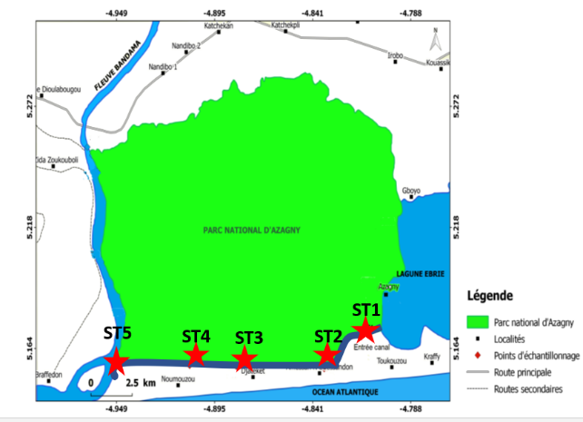
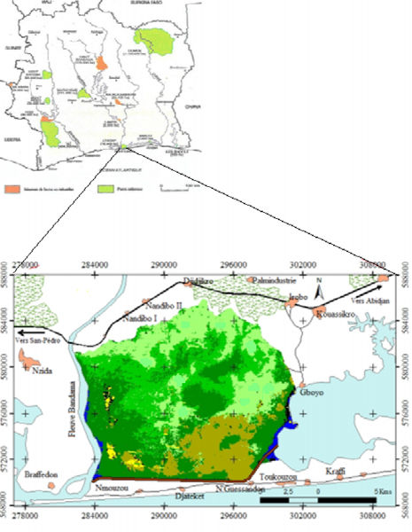

Map. 1. Map of the Azagny National Park showing the sampling stations
2.2 Physicochemical parameters
During our sampling, we used a GPS receiver to record the geographical coordinates of the sampling stations. Measurements of physicochemical parameters (temperature, pH, conductivity, dissolved oxygen, and salinity) were carried out in situ within the top fifty centimeters of the water column using a portable HANNA HI 9828 multi-parameter probe. A Secchi disk was used to measure water transparency. Portable HANNA mini-photometers were used to analyze the concentration of nutrient salts (nitrite, nitrate, phosphate, and ammonium) in the water.
2.3 Phytoplankton Sampling and Analysis Methodology
Samples intended for the study of phytoplankton communities were collected using a 20 µm mesh plankton net and 30 ml vials at the various stations in the canal. Surface water samples were collected with a 10-liter bucket and poured into the plankton net. The microalgae were concentrated by filtration through the net. The net's collector was then opened over a 30 ml vial to drain the contents. The samples were fixed with formaldehyde at a final concentration of 5%. Observations were carried out in the laboratory. A drop of the vial's content was collected using a pipette and mounted between a slide and a coverslip. The resulting preparation was placed on the stage of a light microscope (Olympus CKX41) and examined. The observed specimens were measured using an objective micrometer and photographed. Identification of the various phytoplankton species was based on taxonomic keys and various reference works: Ouattara (2000), Komoé (2010), Seu-Anoï (2012), Adon (2013), Kouassi (2013), Konan (2014), Salla (2015), Lozo (2016), Ouattara (2017), and Kamagaté (2017). Species descriptions followed the classification established by (Van den Hoek et al., 1995). The scale bar on each figure represents 10 μm.
3. RESULTS AND DISCUSSION
3.1 Physicochemical parameters
The study reveals a typically tropical aquatic environment, characterized by a consistently high and uniform temperature (30.85 °C) (Table 1). However, water quality is heterogeneous, showing signs of localized anthropogenic degradation and high hydrological variability.
Table 1. Physicochemical characteristics of the water from the Azagny Canal
Stations | Temp. (°C) | Oxygen (mg/L) | pH | Salinity (‰) | Conductivity (µS/cm) | Phosphate (mg/L) | Nitrate (mg/L) | Nitrite (mg/L) | Ammonium ( mg/L)
St1 | 30,67 | 4,12 | 6,83 | 1,76 | 3,39 | 0,9 | 0,42 | 0,14 | 0,5
St2 | 30,74 | 4,70 | 6,99 | 1,27 | 2,49 | 0,04 | 0 | 0,14 | 0,1
St3 | 30,83 | 4,80 | 6,84 | 3,53 | 6,528 | 0,41 | 1 | 0,8 | 0,1
St4 | 30,58 | 5,54 | 7,31 | 0,80 | 1,57 | 0,9 | 0 | 0,01 | 0,1
St5 | 31,44 | 12,4 | 7,02 | 0,11 | 0 ,24 | 0,36 | 2 | 1 | 0,4
Val mo | 30,85 | 6,31 | 7,02 | 1,49 | 2,84 | 0,52 | 0,68 | 0,42 | 0,24

The recorded temperatures were consistently high (mean: 30.85 °C), which is characteristic of surface waters in West African tropical environments. This finding aligns with previous studies in the Ebrié and Aby lagoons in Côte d'Ivoire (Bamba et al., 2013; Adingra et al., 2012) and in similar systems such as the Lagos Lagoon in Nigeria (Onuoha et al., 2017). This thermal regime directly influences evaporation rates, biochemical reaction kinetics, and the solubility of oxygen.
The observed high variability in salinity (0.11 to 3.53 ‰) and conductivity is a classic indicator of a freshwater-saltwater transition zone. This dynamic is primarily governed by the interplay of riverine inputs, tidal incursion, and seasonal precipitation. The very low salinity at St5 suggests a strong influence from a freshwater source (Bandama River), whereas the elevated salinity at St3 indicates significant marine intrusion. This phenomenon is well-documented along the Ivorian coast, where it is exacerbated by coastal erosion and altered current patterns (Kouassi et al., 2015).
A critical dissolved oxygen concentration was recorded at St1 (4.12 mg/L), falling below the 5 mg/L threshold considered critical for tropical aquatic life (USEPA, 1986). This localized hypoxia likely results from the decomposition of organic matter, hydrological confinement, or pollutant discharges, all of which reduce oxygen availability for aquatic organisms a phenomenon previously observed in urbanized sections of the Ebrié Lagoon (Bombo-Béré et al., 2020). The proximity of St1 to the densely populated Azagny Village supports this hypothesis. In contrast, the supersaturated DO level at St5 (12.4 mg/L) is likely attributable to intense phytoplankton photosynthesis, fueled by available nutrients, or to mechanical water turbulence.
Elevated nutrient concentrations, particularly phosphates (max: 0.9 mg/L) and nitrogen species (Nitrites: max 1 mg/L at St5), are indicative of anthropogenic inputs. These levels frequently exceed natural baselines established for less-impacted Ivorian lagoons (Eblin et al., 2014) and are comparable to those found in urban and agricultural zones near Abidjan. Probable sources include agricultural runoff laden with fertilizers (nitrates) and organic effluents (ammonium, nitrites). This nutrient profile is a strong signal of incipient eutrophication, similar to the process documented in Cocody Bay (Adingra et Kouassi, 2012). If sustained, this trend may lead to algal blooms, ecological imbalances, and an accelerated degradation of water quality.
3.2 Phytoplankton diversity
The algal flora of the Azagny Canal waters comprised 89 taxa distributed across 5 divisions, 9 classes, 15 orders, 22 families, and 45 genera (Table 2). The Chlorophyta division was the most diverse, with 39 taxa (43%), followed by Heterokontophyta with 20 taxa (24%), Euglenophyta with 14 taxa (16%), Cyanoprokaryota with 12 taxa (13%), and finally, the Dinophyta division, which was poorly represented with only 5 taxa (6%) (Figure 1).
Regarding the spatial distribution of taxa (Figure 2), the highest number was recorded at station ST5 with 45 taxa, followed by station ST3 with 34 taxa. Stations ST1 and ST2 each hosted 29 taxa, while station ST4 had the lowest count with 27 taxa.

Table 2. List of taxa recorded in the different stations of the Azagny Canal (Côte d'Ivoire)
Taxa | ST1 | ST2 | ST3 | ST4 | ST5
Cyanoprokaryota Anagnostidis et Komárek
Cyanophyceae Sachs
Chroococcales Wettstein et Westerheim
Chroococcaceae Nägeli
Aphanocapsa elachista G.S. West | X | X | X | X | X
Aphanocapsa incerta Lemmermann | X | X |  | X | X
Chroococcus dispersus (Keissler) Lemmermann |  | X | X | X
Chroococcus limneticus Lemmermann |  | X | X
Mycrocystis aeruginosa (Kützing) Kützing | X | X | X | X
Mycrocystis wesembergii Komárek |  | X
Merismopedia glauca (Ehrenberg) Nägeli |  |  |  |  | X
Nostocales (Borzi) Gétler
Nostocaceae Dumortier
anabaena affinis Lemmermann | X | X | X
Anabaena mucosa Komarkov-Legnerova et Eloranta |  |  |  |  | X
Oscillatoriales Elenkin
Phormidiaceae Anagnostidis et Komárek
Phormidium cf. simplicissimum (Gomont) Anagnostidis & Komárek |  |  |  |  | X
Spirulinales
Spirulinaceae
Spirulina okensis (C. Meyer) Geitler |  |  | X | X
Pseudanabaenaceae Anagnostidis et Komárek
Pseudanabaena papillaterminata (Kiselev) Kukk |  |  | X
Heterokontophyta Van Den Hoek et al.
Bacillariophyceae Haeckel
Centrales Schütt
Aulacoseiraceae Crawford
Aulacoseira granulata var. angustissima (O. Müller) Simonsen | X | X | X | X | X
Aulacoseira granulata (Ehrenberg) Simonsen | X | X | X | X | X
Aulacoseira italica (Ehrenberg) Simonsen |  |  |  |  | X
Melosira lineata (Dillwyn) Agard+A103 |  |  |  |  | X
Fragilariaceae Hustedt
Ulnaria biceps (Kützing) Compère | X | X | X | X
Ulnaria ulna (Nitzsch) Compère | X | X | X | X
Ulnaria sp | X | X | X | X | X
Naviculaceae Kützing
Diploneis smithii (Brébisson in W. Smith) Cleve | X
Diploneis weissflogi (Schmidt) Cleve |  | X
Caloneis crassa (Gregory) Ross in Hartley |  | X
Pinnulariaceae Mann in Round et al.
Pinnularia legumen Ehrenberg |  |  |  |  | X
Pinnularia sp. 1 |  | X
Cymbellales D.G. Mann
Cymbellaceae Greville
Encyonema silesiacum (Bleisch) D.G. Mann |  |  |  |  | X
Pleurosigmataceae Mereschkowsky
Pleurosigma angulatum (Quekett) Wm.Smith |  |  |  |  | X
Pleurosigma sp. |  |  |  |  | X
Surirellales Mann
Surirellaceae Kützing
Petrodictyon gemma (Ehrenberg) Mann | X | X | X
Surirella sp. 1 | X
Surirella sp. 2 | X
Surirella sp.3 | X
Xanthophyceae Allorge ex Fritsch
Mischococcales Fritsch
Sciadiaceae Borzi
Centritractus belonophorus Lemmermann | X | X | X | X | X
Chlorophyta Cavalier-Smith
Chlorophyceae Wille in Warming
Sphaeropleales Luerssen
Ankistrodesmaceae Korshikov
Ankistrodesmus nannoselene Skuyja |  |  | X
Chlorococcales Pascher
Hydrodictyaceae (Gray) Dumortier
Pediastrum duplex var. gracillimum West et G.S. West |  | X |  | X
Pediastrum simplex Meyen |  |  | X
Sorastrum americanum (Bohlin) Schmidle | X
Radiococcaceae Walton
Eutetramorus planctonica (Korshikov) Bourrelly |  |  |  |  | X
Scenedesmaceae Oltmanns
Coelastrum pulchrum Schmidle |  |  |  |  | X
Coelastrum astroideum De Notaris |  |  | X
Coelastrum indicum Terner |  |  | X |  | X
Actinastrum hantzschii Lagerheim | X |  |  |  | X
Actinastrum gracillimum G. M. Smith | X |  |  | X
Desmodesmus quadricaudatus (Turpin) Hegewald |  |  |  |  | X
Desmodesmus opoliensis (Richter) Hegewald |  |  |  |  | X
Scenedesmus acuminatus (Lagerheim) Chodat |  |  | X
Scenedesmus bernardii Chodat |  |  | X
Scenedesmus bicaudatus Dedussenko |  |  |  | X
Scenedesmus quadricauda var. longispina (Chodat) G.M. Smith | X
Scenedesmus tropicus Crow | X
Oocystis borgei J. Snow |  |  | X | X
Oocystis submarina Lagerheim |  |  | X | X | X
Treubaria triappendiculata Bernard | X
Volvocales Ehrenberg
Volvocaceae Ehrenberg
Pandorina morum (Müller) Bory |  |  | X |  | X
Conjugatophyceae Engler
Desmidiales Bessey
Closteriaceae Bessey
Closterium gracile Brébisson ex Ralfs |  |  |  | X
Closterium kuetzingii Brébisson | X |  | X
Closteririum limniticum Lemm | X | X | X
Closterium macilentum Brébisson |  |  | X
Desmidiaceae kützing ex Ralfs
Micrasterias foliacea Bailey |  |  |  |  | X
Cosmarium connatum Brébisson ex Ralfs |  |  |  |  | X
Cosmarium depressum var. achondrum (Boldt) West et G.S. West |  |  |  |  | X
Cosmarium contractum Kirchner var. minutum (delp.) West et West |  |  |  |  | X
Hyalotheca dissiliens Brébisson ex Ralfs |  |  |  | X
Staurastrum volans West & G.S.West |  | X | X | X | X
Staurastrum boreale W. & G.S. West |  |  | X | X | X
Staurastrum forficulatum Lundell var. minus Fritsch & Rich |  |  | X
Staurastrum polymorphum Brébisson ex Ralfs |  |  |  |  | X
Staurastrum subradians Rich |  |  |  | X
Staurastrum sp. |  | X
Staurodesmus convergens (Ralfs) Lillier |  |  |  | X
Staurodesmus triangularis (Lagerheim) Teiling |  |  |  |  | X
Euglenophyta Pascher
Euglenophyceae Schoenichen
Euglenales Engler
Euglenaceae Stein
Lepocinclis ovum Ehrenberg |  | X
Lepocinclis salina Fritsch |  | X | X
Phacus lefevrei Bourrelly |  |  | X
Phacus ephippion Pochm. |  |  |  |  | X
Phacus longicauda var. longicauda (Ehrenberg) Dujardin |  |  |  |  | X
Phacus onyx Pochmann |  | X |  |  | X
Phacus sp. | X
Strombomonas acuminata (Schmarda) Deflandre |  |  |  |  | X
Strombomonas fluviatilis (Lemmerm.) Deflandre |  |  |  |  | X
Strombomonas verrucosa (E.Daday) Deflandre |  |  |  |  | X
Trachelomonas hispida var. hispida (Perty) Stein |  |  |  |  | X
Trachelomonas oblonga Lemmermann |  |  |  | X | X
Trachelomonas volvocinopsis Swirenko |  |  |  |  | X
Trachelomonas sp. |  |  |  |  | X
Dinophyta Auct.
Dinophyceae Pascher
Peridiniales Haeckel
Peridiniaceae Ehrenberg
Peridinium cunninglonii (O. Müller) Ehrenberg |  |  |  |  | X
Karenia sp.1 | X | X | X | X | X
Karenia sp.2 | X | X | X | X | X
Desmophyceae Smith
Gonyaulacales F.J.R. Taylor
Goniodomataceae Lindemann
Pyrodinium sp. | X | X | X | X | X
Peridiniales Haeckel
Protoperidiniaceae F.J.R. Taylor
Protoperidinium conicoides (Paulsen) Balech |  |  |  | X
Total = 90 | 29 | 29 | 34 | 27 | 45

Fig. 1: Variation in taxa across the sampling stations on the Azagny Canal (Côte d'Ivoire)

Fig. 2 Variation in taxa across the sampling stations of the Azagny Canal (Côte d'Ivoire)

The sampling campaign identified a rich phytoplankton community within the Azagny canal, comprising 90 taxa. This remarkable diversity can be attributed to the canal's strategic position as a transitional ecosystem at the interface of several distinct water masses. Specifically, the canal's waters represent a confluence point, influenced by: freshwater and nutrient inputs (nitrates, phosphates) from the Bandama River, which drains agricultural lands upstream; brackish waters and biological communities from the Grand-Lahou lagoon system and inflows of saline water and tidal movements from the Atlantic Ocean. This convergence of nutrient sources and environmental heterogeneity creates a range of ecological niches that fosters the establishment and maintenance of species with varied ecological requirements. As highlighted by Gonzales and Descamps-Julien (2004), ecosystem stability and complexity are key determinants of community development. By acting as a hydrological crossroads, the Azagny canal provides a degree of functional stability that allows for the completion of biological cycles for a wide range of taxa. However, the high species richness may mask an ecological dynamic typical of disturbed or eutrophic environments, where high nutrient availability simultaneously promotes numerous opportunistic species. Thus, this richness could reflect not only ecosystem stability but also anthropogenic pressures (agricultural activities, discharges) that enrich the system with organic and mineral matter. This leads to eutrophication, which can initially stimulate algal diversity. The co-dominance of Chlorophytes and Heterokontophyta is a classic bio-indicator of nutrient-rich environments, particularly in nitrogen and phosphorus, often associated with anthropogenic inputs (Bellinger & Sigee, 2015; Reynolds, 2006). Station 5, with 45 identified taxa, exhibited the highest species richness. The significant algal development at this station is strongly correlated with two main factors: temperature and nutrient salt concentration. In tropical environments, high water temperatures (>25°C) accelerate microbial metabolism and the rate of organic matter mineralization (Paerl & Huisman, 2009). This process rapidly transforms organic matter into bioavailable mineral salts (nitrates, phosphates), creating eutrophic conditions conducive to algal proliferation. The strong dominance of Chlorophytes and Heterokontophyta observed here is a characteristic ecological signature of aquatic ecosystems subject to nutrient enrichment (eutrophication). More precisely, it strongly suggests sustained inputs of untreated domestic wastewater, which is rich in organic matter and nutrients (Smith et al., 1999).
4. CONCLUSION
The study of the phytoplankton communities in the Azagny canal highlights the importance of this transitional ecosystem for both hydraulic management and the local economy. The results reveal a notable phytoplankton diversity, dominated by Chlorophyta and Heterokontophyta, which reflects the specific environmental conditions of the canal. The impact of human activities, particularly through eutrophication, is clearly demonstrated by the proliferation of certain indicator species, as well as by the effect of the observed physicochemical gradients. These data confirm the usefulness of phytoplankton as an indicator of water quality, thus providing a valuable tool for the ecological monitoring of the Azagny canal. However, the study underscores the necessity to implement integrated and sustainable management actions, particularly to limit nutrient inputs and preserve this crucial space. Proactive management is essential to ensure the long-term viability of this ecological corridor in the face of increasing pressures from human activities.

5. References
Konan, K. J., Aka, K., & Koffi, K. J. (2008). Physicochemical and Biological Quality of the Waters of the Ébrié Lagoon in the Abidjan Region (Côte d’Ivoire). European Journal of Scientific Research, 24(2), 235–248.
Kouadio, K. N., N’Douba, V., Konan, K. J., & Kouamé, K. I. (2010). Impact of Human Activities on the Water Quality of the Grand-Lahou Lagoon System (Côte d’Ivoire). Journal of Applied Biosciences, 32, 1964–1975.
Amanieu M. (1994). Preface to the book “Environment and Aquatic Resources of Côte d’Ivoire”. Volume II. Lagoon Environments. Durand J.R., Dufour P., Guiral D., and Zabi S.G.F. (editors). Éditions de l’ORSTOM., Paris, pp. 335–363.
Kouamé, K. I., N’Douba, V., Konan, K. J., & Kouassi, K. P. (2011). Ecological status of the Grand-Lahou lagoon system: Physicochemical quality and biological diversity. International Journal of Biological and Chemical Sciences, 5(2), 530–546. (Feldmann, 1963)
Feldmann, J. (1963). Marine cyanophyceae and chlorophyceae of the French Mediterranean coast and the Algerian coast. Bulletin of the Botanical Society of France, 110(5–6), 249–262.
Iltis A. (1980). Algae. In: Durand J.R. and Lévêque C. (Eds). Aquatic Flora and Fauna of Sahel-Sudanese Africa. Volume I. Éditions O.R.S.T.O.M. Initiation Collection
Technical Documents No. 44, Paris, pp. 9-61.
Karr J. R. (1991). Biological Integrity: A Long-Neglected Aspect of Water Resource
Management. Ecological Applications, 1(1): 66-84.
Iltis, A., & Lévêque, C. (1982). Physicochemical and Biological Characteristics of Ivorian Lagoons. Paris: ORSTOM.
N’Douba, V., Kouamé, K. I., & Konan, K. J. (2007). Dynamics of Primary Productivity and Phytoplankton in the Bia River (Côte d’Ivoire). Tropicultura, 25(1), 45–51.
Kouassi, A. M., Aka, K., & Yapo, O. B. (2015). Diversity and distribution of phytoplankton in the Ébrié lagoon (Côte d’Ivoire). Ivorian Journal of Science and Technology, 26, 115–129.
N’Guessan, K. R., Kouamé, K. I., & Aka, K. (2019). Phytoplankton diversity and bioindication of water quality in the Fresco lagoon (Côte d’Ivoire). Journal of Applied Biosciences, 137, 13916–13927.
Konan, K. J., Aka, K., & Koffi, K. J. (2008). Physicochemical and Biological Quality of the Waters of the Ébrié Lagoon in the Abidjan Region (Côte d’Ivoire). European Journal of Scientific Research, 24(2), 235–248.
Kouadio, K. N., N’Douba, V., Konan, K. J., & Kouamé, K. I. (2010). Impact of Human Activities on the Water Quality of the Grand-Lahou Lagoon System (Côte d’Ivoire). Journal of Applied Biosciences, 32, 1964–1975.
Aké-Assi, L. (2002). Flora of Côte d’Ivoire 1 and 2: Catalogue, Systematics, Biogeography and Ecology. Conservatory and Botanical Gardens, Geneva.
Kouame, K. I., N’Douba, V., Konan, K. J., & Kouassi, K. P. (2011). Ecological state of the Grand-Lahou lagoon system: physicochemical quality and biological diversity. International Journal of Biological and Chemical Sciences, 5(2), 530–546.
Kouadio, K. N., N’Douba, V., Konan, K. J., & Kouamé, K. I. (2010). Impact of Human Activities on the Water Quality of the Grand-Lahou Lagoon System (Côte d’Ivoire). Journal of Applied Biosciences, 32, 1964–1975.
Kouassi, A. M., Aka, K., & Yapo, O. B. (2015). Diversity and Distribution of Phytoplankton in the Ébrié Lagoon (Côte d’Ivoire). Ivorian Journal of Science and Technology, 26, 115–129.
Ouattara A. (2000). First Systematic and Ecological Data on Phytoplankton in Lake Ayamé (Côte d’Ivoire). Doctoral Thesis, Faculty of Wetlands, Institute for Plant Sciences, Catholic University of Leuven, Belgium, 207 p.
Komoé K. (2010). Phytoplankton Diversity in the Grand-Lahou Lagoon Complex in
Côte d'Ivoire. Doctoral Thesis. Félix Houphouët-Boigny University of Cocody, Abidjan, Côte d'Ivoire, 305 p.
Seu-Anoï N. M. (2012). Spatial and Seasonal Structuring of Phytoplankton Communities and Variability of Abiotic Factors in Three Lagoon Complexes in Côte d'Ivoire (Aby, Ébrié, and Grand-Lahou). Doctoral Thesis, Nangui Abrogoua University (Côte d'Ivoire), 137 p.
Adon M. P. (2013). Spatial and Seasonal Variations in Phytoplankton in the Adzopé Reservoir (Côte d'Ivoire): Composition, Structure, Biomass, and Primary Production. Doctoral Thesis, Nangui Abrogoua University, Abidjan, Côte d'Ivoire, 89 p.
Kouassi B. A. (2013). Taxonomy, Floristic Composition, and Spatio-Seasonal Dynamics of Periphytic Algae in the Adzopé Reservoir (Côte d'Ivoire). Doctoral Thesis. Felix Houphouët-Boigny University of Cocody. Abidjan, Côte d'Ivoire, 177 p.
Konan E. S. (2014). Spatio-temporal distribution of phytoplankton populations in relation to abiotic factors in the Fresco lagoon (Ivory Coast), Doctoral thesis, Félix Houphouët-Boigny University of Cocody, Abidjan, Ivory Coast, 197p.
Salla M. (2015). Taxonomy, composition and spatio-seasonal distribution of phytoplankton in the tropical coastal rivers Boubo and Mé (Ivory Coast). Doctoral thesis. Felix Houphouët-Boigny University of Cocody. Abidjan, Ivory Coast, 215p.
Lozo R. N. (2016). Floristic composition and distribution of the microalgal population in the Bandama River (Ivory Coast). Doctoral thesis, University of Cocody, Abidjan (Ivory Coast), 188p.
Van den Hoek C., Mann D. G. & Jahns H. M. (1995). Algae. An introduction to phycology. Cambridge University Press, Cambridge, UK, 623 p.
Bamba, S.B., Ouattara, A.F., Kaba, K., Koné, N., & Ouattara, A. (2013). Nutrient dynamics (N, P, Si) in the Aby Lagoon (Ivory Coast). International Journal of Biological and Chemical Sciences, 7(2), 664-679.
Adingra, A. A., & Kouassi, A. M. (2012). Hydrological and pollution study in Ebrie Lagoon (Abidjan, Ivory Coast). Journal of Environmental Protection, *3*(11), 1507-1514.
Onuoha, G. C., Okoro, B. C., & Ogunlade, O. J. (2017). Seasonal variations in physicochemical characteristics of Lagos Lagoon, Nigeria. Journal of Fisheries and Aquatic Science, 12, 1-8.
Kouassi, A. M., Adingra, A. A., Eblin, S. G., & Soro, N. (2015). Vulnerability of the Ivorian coastal zone to erosion and marine submersion: The case of Grand-Bassam. Géo-Eco-Trop, 39(2), 207-218.
United States Environmental Protection Agency (USEPA) (1986). Ambient Water Quality Criteria for Dissolved Oxygen. EPA 440/5-86-003.
Bombo-Béré, S., Koffi, K. M., Dibi, N., Kouassi, K. L., & Savané, I. (2020). Spatial and seasonal variation of the water quality of the urban lagoon of Grand-Lahou (Ivory Coast). Journal of Water Resources and Protection, 12(5), 427-449.
Eblin, S. G., Koffi, P. B., Soro, G., Soro, N., & Aka, N. (2014). Physico-chemical characteristics of the waters of the coastal rivers of South-Eastern of Côte d’Ivoire. Journal of Environmental Protection, 5(13), 1272-1285.
Adingra, A. A., & Kouassi, A. M. (2012). Hydrological and pollution study in Ebrie Lagoon (Abidjan, Ivory Coast). Journal of Environmental Protection, *3*(11), 1507-1514.
Gonzalez, A., & Descamps-Julien, B. (2004). Population and community variability in randomly fluctuating environments. Oikos, *106*(1), 105–116.
Bellinger, E. G., & Sigee, D. C. (2015). Freshwater Algae: Identification, Enumeration and Use as Bioindicators. Wiley-Blackwell.
Reynolds C.S. 2006, “The ecology of phytoplankton.” Cambridge University Press, p.524.
Paerl, H. W., & Huisman, J. (2009). Climate change: a catalyst for global expansion of harmful cyanobacterial blooms. Environmental Microbiology Reports, 1(1), 27-37.
Smith, V. H., Tilman, G. D., & Nekola, J. C. (1999). Eutrophication: impacts of excess nutrient inputs on freshwater, marine, and terrestrial ecosystems. Environmental Pollution, 100(1-3), 179-196.

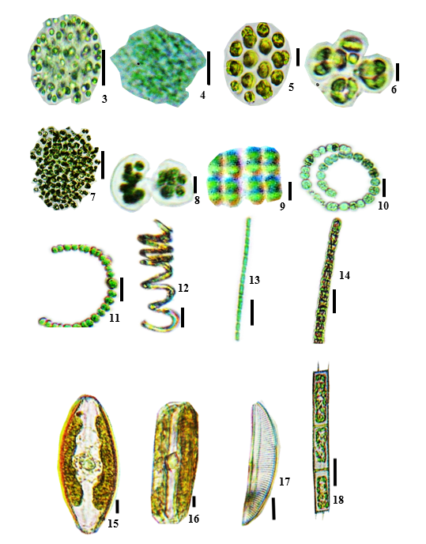
ANNEXE

(Fig. 3-18) 3: Aphanocapsa elachista, 4: Aphanocapsa incerta, 5: Chroococcus dispersus, 6: Chroococcus limneticus, 7: Microcystis aeruginosa, 8: Mycrocistis wesembergii, 9: Merismopedia glauca, 10: Anabaena spiroides, 11 : Anabaena mucosa, 12 : Spirulina okensis, 13 : Pseudanabaena papillaterminata, 14 : Phormidium cf. simplicissimum 15: Navicula cryptocephala, 16: Pinnularia sp, 17: Encyonema silesiacum, 18: Aulacoseira granulata

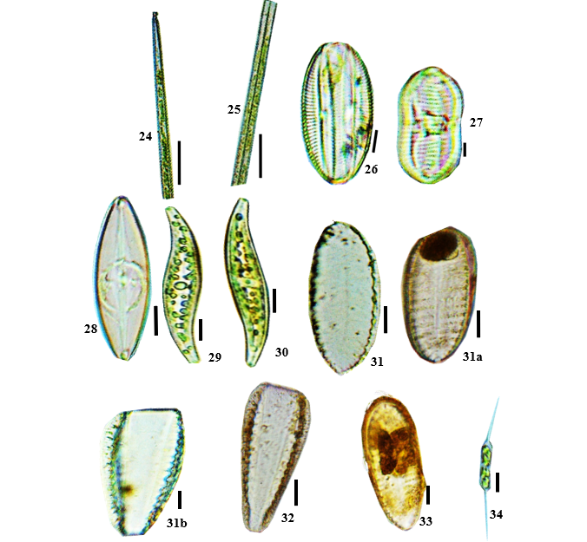
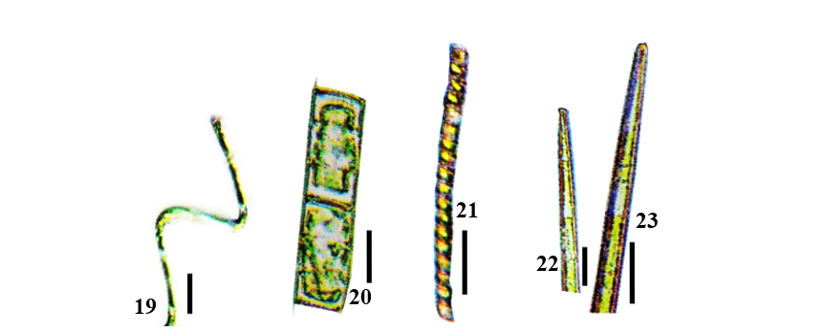

(Fig. 19-34) : 19: Aulacoseira granulata var. angustissima fo. Spiralis, 20 : Aulacoseira italica, 21 : Melosira lineata, 22: Ulnaria biceps, 23: Ulnaria ulna, 24: Ulnaria sp., 25 : Diploneis smithii, 26 : Diploneis weissflogi, 27: Caloneis crassa, 28: Pleurosigma angulatum, 29: Pleurosigma sp., 30: Petrodictyon gemma, 31a et b : Surirella sp.1, 32: Surirella sp.2, 33: Surirella sp.3, 34 : Centritractus belonophorus
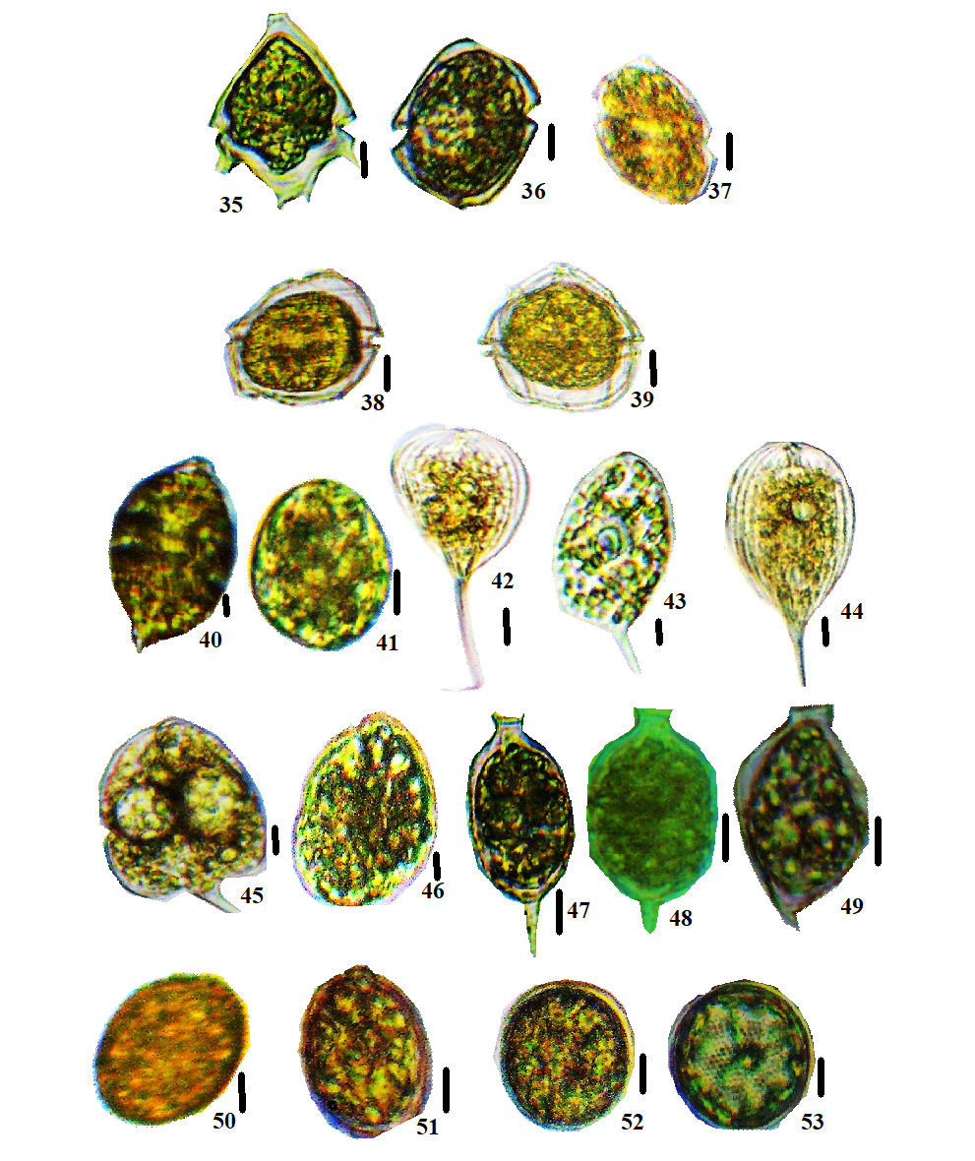

(Fig. 35-53) 35: Peridinium cunninglonii, 36: Karenia sp.1, 37: Karenia sp.2, 38: Pyrodinium sp., 39: Protoperidinium conicoides 40: Lepocinclis fusiformis 41: Lepocinclis salina, 42: Phacus ephippion 43: Phacus lefevrei, 44: Phacus longicauda, 45: Phacus onyx, 46: Phacus sp., 47: Strombomonas acuminata var. deflandreana, 48: Strombomonas fluviatilis, 49: Strombomonas verrucosa, 50: Trachelomonas hispida var. hispida, 51: Trachelomonas oblonga, 52 : Trachelomonas volvocinopsis, 53 : Trachelomonas sp.
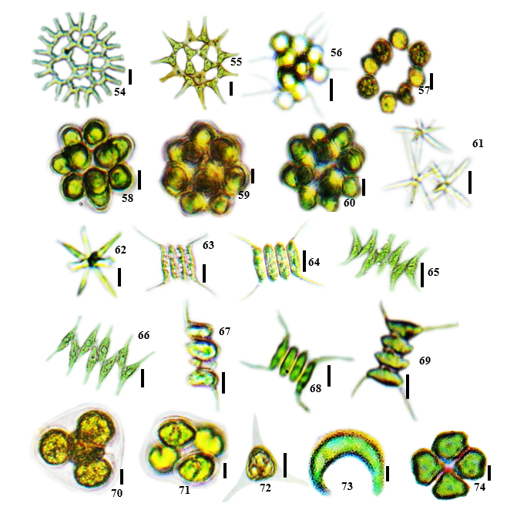

(Fig. 54-74) 54: Pediastrum duplex var. gracillimum, 55: Pediastrum simplex var. duodenarium, 56: Sorastrum americanum, 57: Eutetramorus planctonica 58: Coelastrum astroideum, 59: Coelastrum indicum 60: Coelastrum pulchrum, 61: Actinastrum gracillimum, 62: Actinastrum hantzschii, 63: Desmodesmus opoliensis, 64: Desmodesmus quadricaudata, 65: Scenedesmus acuminatus, 66: Scenedesmus bernardii, 67: Scenedesmus bicaudatus, 68: Scenedesmus quadricauda var. longispina, 69: Scenedesmus tropicus, 70: Oocystis borgei, 71: Oocystis submarina, 72: Treubaria triappendiculata, 73: Ankistrodesmus nannoselene, 74: Pandorina morum

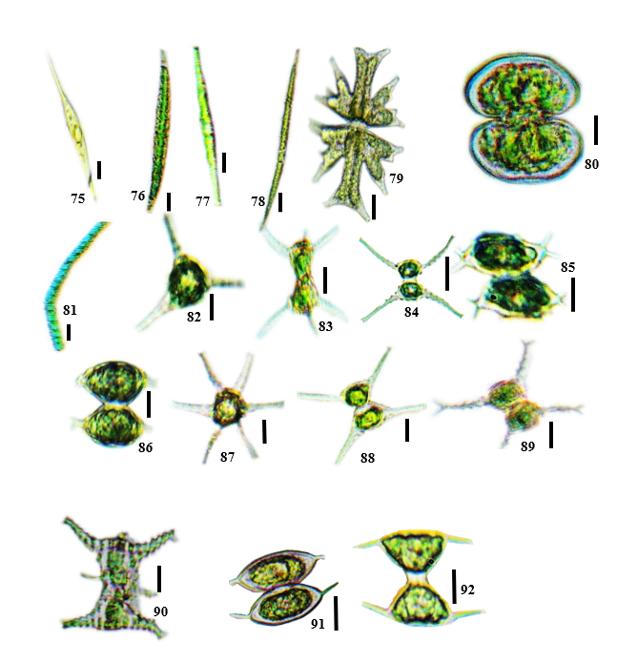

(Fig. 75-92) 75: Closterium gracile, 76: Closterium kuetzingii, 77: Closterium, 78: Closterium macilentum, 79: Micrasterias foliacea, 80: Cosmarium depressum var. achondrum, 81: Hyalotheca dissiliens, 82: Staurastrum asperatum, 83: Staurastrum boreale, 84: Staurastrum brachioprominens var. archerianum, 85: Staurastrum forficulatum var. minus 86: Staurastrum polymorphum, 87: Staurastrum subradians, 88: .Staurastrum tetracerum, 89: Staurastrum volans, 90: Staurastrum sp., 91: Staurodesmus convergens , 92: Staurodesmus triangularis

