Original Research Article
On Sum Cordialness of Some Fractal Graph

Abstract:
For a graph G with vertex set V is a function $f:V(G)→\{0,1\}$ with induced edge labeling such that $f^{\#}:E(G)→\{0,1\}$ such that $f^{\#}\left(pq\right)=(f(p)+f(q))(mod 2)$ for all $pq∈E(G)$is called a sum cordial labeling, If $\left|v\left(0\right)-v\left(1\right)\right|≤1$and $\left|e\left(0\right)-e\left(1\right)\right|≤1$. A graph that follows sum cordial labeling is called a sum cordial graph. We have shown that various types of fractal graphs are sum cordial graphs.
Keywords: Vicsek fractal, Box fractal, Ladder Fractal Graph of Type – 1 to Type – 4, Sum Cordial Labeling, Sum Cordial Graph.
AMS Subject classification: 05C78, 05C15

- Introduction
Fractals [8] are complex geometric shapes that exhibit self-similarity, meaning their structure looks similar at different levels of magnification. They are often created by repeating a simple process over and over in an ongoing feedback loop. Its main key properties are infinite complexity, self-similarity and fractal dimension.
While the sum cordial labeling is investigated firstly by Visavaliya [10] and et.al.
- Some Terminologies
Definition 2.1: Sum Cordial Labling [10]
For a graph G with vertex set V is a function $f:V(G)→\{0,1\}$ with induced edge labeling such that $f^{\#}:E(G)→\{0,1\}$ such that $f^{\#}\left(pq\right)=(f(p)+f(q))(mod 2)$ for all $pq∈E(G)$is called a sum cordial labeling, If $\left|v\left(0\right)-v\left(1\right)\right|≤1$and $\left|e\left(0\right)-e\left(1\right)\right|≤1$. Its abbreviation is SCL.
Definition 2.2: Sum Cordial Graph [1]
A graph that follows SCL is called sum cordial graph. Its abbreviation is SCG.
Definition 2.3: Construction of Vicsek fractals (saltire form) [8]
In mathematics, the Vicsek fractal—also known as the Vicsek snowflake or box fractal—is a well-known example of a recursive pattern. It is generated using the cluster fractal method, also called generator iteration. The process begins by dividing a square into a 3-by-3 grid, forming nine equal smaller squares. The four corner squares and the central square are retained, while the remaining four edge-centre squares are removed. This same procedure is then applied recursively to each of the five remaining squares. The Vicsek fractal is the limiting set that emerges from repeating this process infinitely.

In nth iteration of vicsek fractals (saltire form), there are $5^{n-1}$ squares, $3\left(5^{n-1}\right)+1$vertices and $4\left(5^{n-1}\right)$ edges.
Fig 1 : Construction of Vicsek fractals (saltire form)
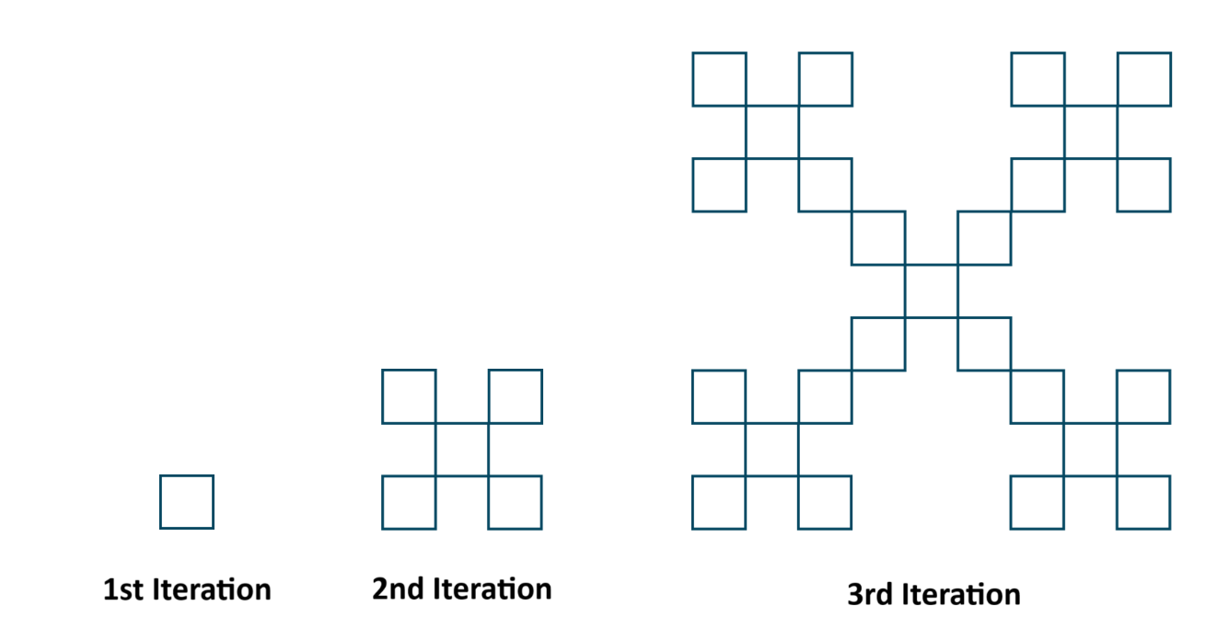
Definition 2.4: Construction of Vicsek fractals (cross form) [8]
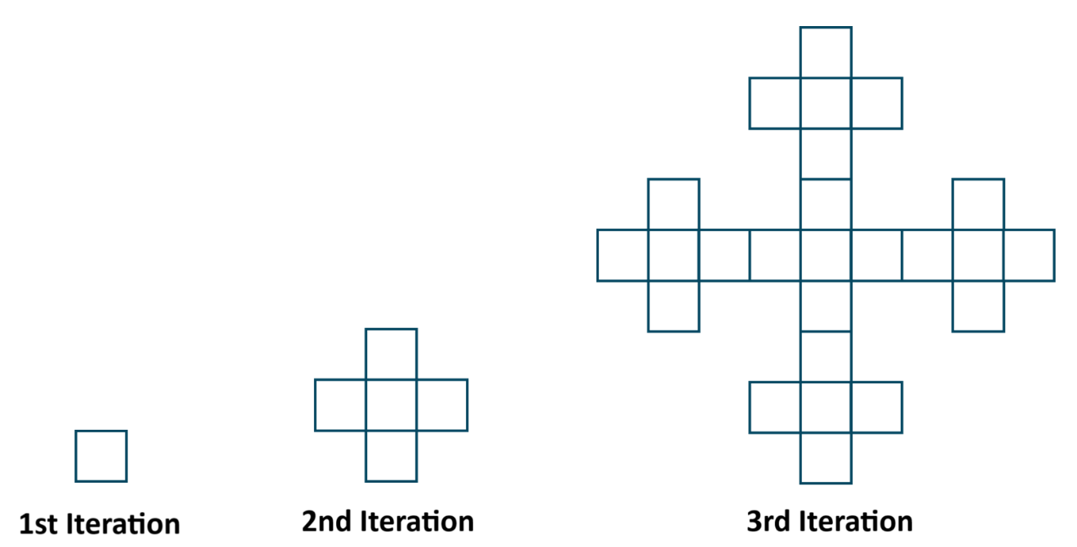
The construction of the Vicsek fractal in its cross form begins similarly to the saltire form, starting with a single square and using the cluster fractal generation method. The initial square is divided into a 3-by-3 grid, resulting in nine smaller squares. The four corner squares are removed, while the central square and the four edge-center squares are retained. This recursive process is then applied to each of the five remaining squares. The Vicsek fractal is the limit set formed through infinite repetition of this procedure.
Fig 2 : Construction of Vicsek fractals (cross form)

In nth iteration of vicsek fractals (cross form), there are $5^{n-1}$ squares, $2\left(5^{n-1}+1\right)$vertices and $3\left(5^{n-1}\right)+1$ edges.

Definition 2.5: Construction of Box Fractal (Type-2) [8]
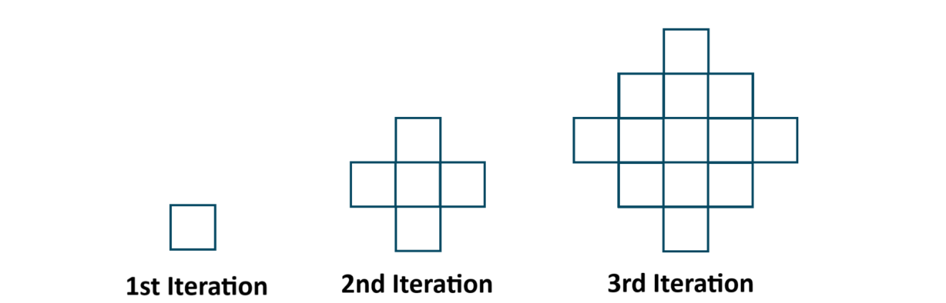
The construction of the Box Fractal also begins with a single square in the 1st iteration. In the next step, one square is added to each side of the original, forming a plus-shaped arrangement of five squares. This pattern is then repeated—adding new squares to each side of the existing ones—continuing the design in the same manner. Alternatively, this structure can be generated using the cluster fractal method, where certain squares are systematically removed at each stage to create the same overall pattern.
Fig 3 : Construction of Box Fractal (Type-2)

In nth iteration of box fractals (type-2), there are $n^{2}+{\left(n-1\right)}^{2}$ squares, $2\left(n+1\right)$vertices and $4n^{2}$ edges.
Definition 2.6: Construction of Ladder Fractal Graph (Type - 1) [9]
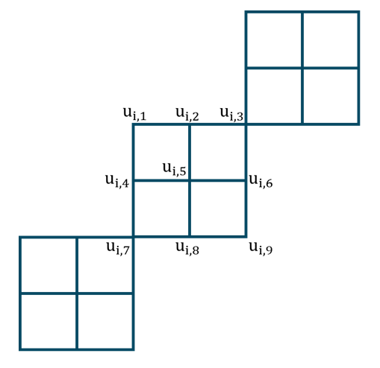
For Type-1 construction, we start by considering four squares in the 1st step. In the 2nd step, four additional squares are attached at the top-right vertex of the existing structure. This combined result from the first and second steps is regarded as the first iteration. In each subsequent iteration, four new squares are similarly attached at the top-right vertices of the existing squares, forming a ladder-like fractal pattern. This fractal structure can also be represented and studied as a graph. It is denoted by $LF_{1}.$
Fig 4 : Construction of Ladder Fractal Graph (Type - 1)
From figure it is very clear that, vertex $u_{i, 3}=u_{i+1, 7}$. i.e. one vertex is shared in next iteration. In nth iteration of ladder fractals (type-1), there are $4n$ squares, $8n+1$vertices and $12n$ edges.
Definition 2.7: Construction of Ladder Fractal Graph (Type - 2) [9]
For Type-2, the construction begins by considering four squares in the 1st step. In the 2nd step, another set of four squares is attached along the top-right edge of the existing structure. The combination of these steps forms the first iteration. In each following iteration, four new squares are added in the same way, progressively creating a ladder-like fractal pattern. This structure can also be modelled and analysed as a graph. It is denoted by $LF_{2}.$
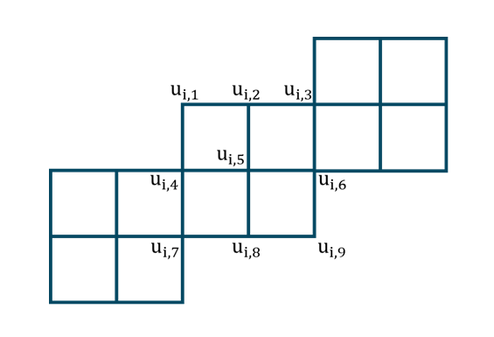
From figure it is very clear that, vertex $u_{i, 4}=u_{i+1, 3}$and $u_{i, 7}=u_{i+1, 6}$. i.e. two vertices and one edge is shared in next iteration. In nth iteration of ladder fractals (type-2), there are $4n$ squares, $7n+2$vertices and $11n+1$ edges.
Fig 5 : Construction of Ladder Fractal Graph (Type - 2)
Definition 2.8: Construction of Ladder Fractal Graph (Type - 3) [9]
For Type-3, the construction starts by considering four squares in the 1st step. In the 2nd step, four additional squares are attached along the upper edge at the top-right corner of the existing structure. This combined configuration marks the completion of the first iteration. In each subsequent iteration, four new squares are added in the same manner, gradually forming a ladder-like fractal pat tern. This fractal can also be represented and studied as a graph. It is denoted by $LF_{3}.$
Observe that, Ladder fractal of Type - 2 and Type – 3 are symmetrically same.
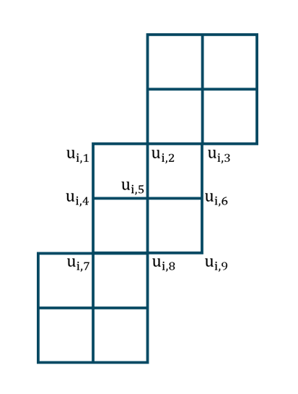
Definition 2.9: Construction of Ladder Fractal Graph (Type - 4) [9]
Fig 6 : Construction of Ladder Fractal Graph (Type - 4)
In Type-4, the construction begins similarly to Type-1, with four squares considered in the initial step. However, in the 2nd step, only three additional squares are attached to the top-rightmost square, resulting in a total of seven squares after this step. The addition of these three squares is considered the completion of the first iteration. In each subsequent iteration, three more squares are attached in the same manner to the top-rightmost square, gradually forming a ladder-like fractal graph. It is denoted by $LF_{4}.$
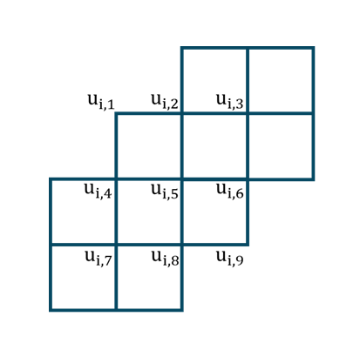
From figure it is very clear that, vertex $u_{i, 2}=u_{i+1, 4}, u_{i, 3}=u_{i+1, 5}, u_{i, 5}=u_{i+1, 7}$and $u_{i, 6}=u_{i+1, 8}$. i.e. four vertices and four edges are shared in next iteration. In nth iteration of ladder fractals (type-2), there are $4n$ squares, $5n+4$vertices and $8n+4$ edges.
Fig 7 : Construction of Ladder Fractal Graph
- Main Results

Theorem 3.1: The vicsek fractals (saltire form) admits sum cordial labeling (SCL).
Proof: For vertex labeling, allot 0 label all vertices of 1st column and allot 1 label to 2nd column and repeat it alternatively for all columns. i.e. If any column is labelled with 0 then next column is labelled with 1.
For such vertex labeling, it is clearly visible that in each box 2 edges are labelled with 1(an edge with small thick vertical line in between the edge) and remaining 2 edges are labelled with 0.
Table 1 : Vertex and edge counts grow exponentially with each iteration
Iteration | Vertex count | Edge count
$1$^{st} | $$\left|v_{f}\left(0\right)\right|=\left|v_{f}\left(1\right)\right|=2$$ | $$\left|e_{f}\left(0\right)\right|=\left|e_{f}\left(1\right)\right|=2$$
$2$^{nd} | $$\left|v_{f}\left(0\right)\right|=\left|v_{f}\left(1\right)\right|=8$$ | $$\left|e_{f}\left(0\right)\right|=\left|e_{f}\left(1\right)\right|=10$$
$3$^{rd} | $$\left|v_{f}\left(0\right)\right|=\left|v_{f}\left(1\right)\right|=38$$ | $$\left|e_{f}\left(0\right)\right|=\left|e_{f}\left(1\right)\right|=50$$
$4$^{th} | $$\left|v_{f}\left(0\right)\right|=\left|v_{f}\left(1\right)\right|=188$$ | $$\left|e_{f}\left(0\right)\right|=\left|e_{f}\left(1\right)\right|=250$$
$n^{th}$ | $$\left|v_{f}\left(0\right)\right|=\left|v_{f}\left(1\right)\right|=\frac{ 3\left(5^{n-1}\right)+1 }{2}$$ | $$\left|e_{f}\left(0\right)\right|=\left|e_{f}\left(1\right)\right|=2\left(5^{n-1}\right)$$

So, it is clearly visible that $\left|v_{f}\left(0\right)-v_{f}\left(1\right)\right|=0 and \left|e_{f}\left(0\right)-e_{f}\left(1\right)\right|=0.$ Hence, the vicsek fractal (saltire form) admits SDCL.
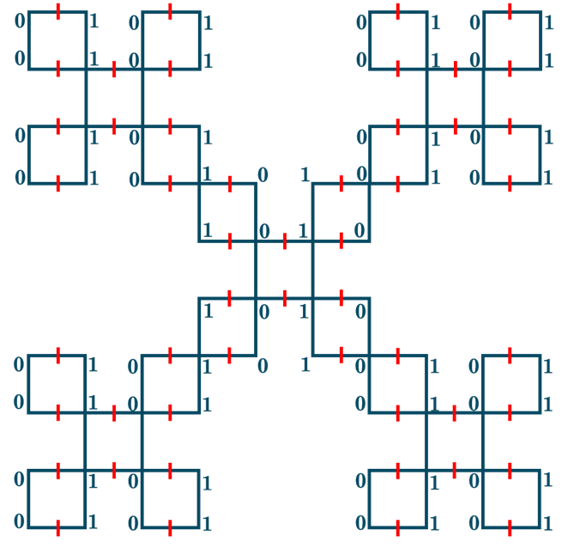
In below figure, sum labeling is applied on 3rd iteration of vicsek fractal (saltire form). In this figure, a small thick red coloured line denote edge with label 1.
Fig 8 : Sum labeling on 3rd iteration of vicsek fractal (saltire form)

Theorem 3.2: The vicsek fractals (cross form) admits sum cordial labeling (SCL).
Proof: For vertex labeling, allot 0 label all vertices of 1st column and allot 1 label to 2nd column and repeat it alternatively for all columns. i.e. If any column is labelled with 0 then next column is labelled with 1.
For such vertex labeling, it is clearly visible that in each box 2 edges are labelled with 1(an edge with small thick vertical line in between the edge) and remaining 2 edges are labelled with 0.
Table 2 : Vertex and edge counts increase with each iteration
Iteration | Vertex count | Edge count
$1$^{st} | $$\left|v_{f}\left(0\right)\right|=\left|v_{f}\left(1\right)\right|=2$$ | $$\left|e_{f}\left(0\right)\right|=\left|e_{f}\left(1\right)\right|=2$$
$2$^{nd} | $$\left|v_{f}\left(0\right)\right|=\left|v_{f}\left(1\right)\right|=6$$ | $$\left|e_{f}\left(0\right)\right|=\left|e_{f}\left(1\right)\right|=8$$
$3$^{rd} | $$\left|v_{f}\left(0\right)\right|=\left|v_{f}\left(1\right)\right|=26$$ | $$\left|e_{f}\left(0\right)\right|=\left|e_{f}\left(1\right)\right|=38$$
$4$^{th} | $$\left|v_{f}\left(0\right)\right|=\left|v_{f}\left(1\right)\right|=126$$ | $$\left|e_{f}\left(0\right)\right|=\left|e_{f}\left(1\right)\right|=188$$
$n^{th}$ | $$\left|v_{f}\left(0\right)\right|=\left|v_{f}\left(1\right)\right|=5^{n-1}+1$$ | $$\left|e_{f}\left(0\right)\right|=\left|e_{f}\left(1\right)\right|=\frac{3\left(5^{n-1}\right)+1}{2}$$

So, it is clearly visible that $\left|v_{f}\left(0\right)-v_{f}\left(1\right)\right|=0 and \left|e_{f}\left(0\right)-e_{f}\left(1\right)\right|=0.$ Hence, the vicsek fractal (cross form) admits SDCL.
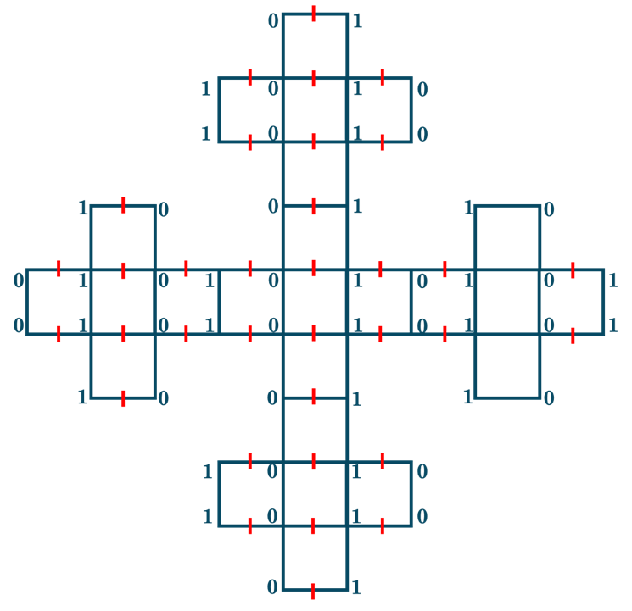
In below figure, sum labeling is applied on 3rd iteration of vicsek fractal (cross form). In this figure, a small thick red coloured line denote edge with label 1.
Fig 9 : Sum labelling on the 3rd iteration of the Vicsek fractal (cross form)

Theorem 3.3: The box fractal (type-2) admits sum cordial labeling (SCL).
Proof: For vertex labeling, allot 0 label all vertices of 1st column and allot 1 label to 2nd column and repeat it alternatively for all columns. i.e. If any column is labelled with 0 then next column is labelled with 1.
For such vertex labeling, it is clearly visible that in each box 2 edges are labelled with 1(an edge with small thick vertical line in between the edge) and remaining 2 edges are labelled with 0.
Table 3 : Vertex and edge counts grow quadratically with each iteration
Iteration | Vertex count | Edge count
$1$^{st} | $$\left|v_{f}\left(0\right)\right|=\left|v_{f}\left(1\right)\right|=2$$ | $$\left|e_{f}\left(0\right)\right|=\left|e_{f}\left(1\right)\right|=2$$
$2$^{nd} | $$\left|v_{f}\left(0\right)\right|=\left|v_{f}\left(1\right)\right|=6$$ | $$\left|e_{f}\left(0\right)\right|=\left|e_{f}\left(1\right)\right|=8$$
$3$^{rd} | $$\left|v_{f}\left(0\right)\right|=\left|v_{f}\left(1\right)\right|=12$$ | $$\left|e_{f}\left(0\right)\right|=\left|e_{f}\left(1\right)\right|=18$$
$4$^{th} | $$\left|v_{f}\left(0\right)\right|=\left|v_{f}\left(1\right)\right|=20$$ | $$\left|e_{f}\left(0\right)\right|=\left|e_{f}\left(1\right)\right|=32$$
$n^{th}$ | $$\left|v_{f}\left(0\right)\right|=\left|v_{f}\left(1\right)\right|=n\left(n+1\right)$$ | $$\left|e_{f}\left(0\right)\right|=\left|e_{f}\left(1\right)\right|=2n^{2}$$

Fig 10 : Sum labelling on the 3rd iteration of box fractal (type-2).
So, it is clearly visible that $\left|v_{f}\left(0\right)-v_{f}\left(1\right)\right|=0 and \left|e_{f}\left(0\right)-e_{f}\left(1\right)\right|=0.$ Hence, the box fractal (type-2) admits SDCL.
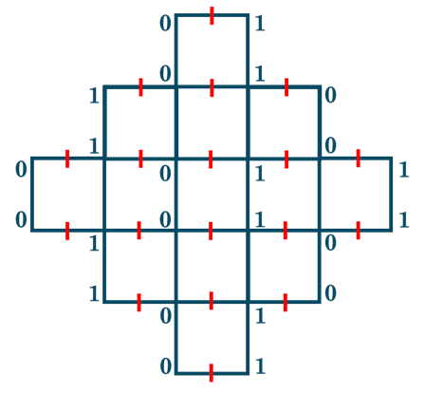
In below figure, sum labeling is applied on 3rd iteration of box fractal (type-2). In this figure, a small thick red coloured line denote edge with label 1.
Theorem 3.4: The ladder fractal (type-1) admits sum cordial labeling (SCL).
Proof: Let us define vertex labelling $f_{{LF}_{1}} :V\left({LF}_{1}\right)→\left\{0, 1\right\}$as
$$f_{{LF}_{1}}\left(u_{i, 1}\right)=f_{{LF}_{1}}\left(u_{i, 3}\right)=f_{{LF}_{1}}\left(u_{i, 4}\right)=f_{{LF}_{1}}\left(u_{i, 6}\right)=f_{{LF}_{1}}\left(u_{i, 7}\right)=f_{{LF}_{1}}\left(u_{i+1, 7}\right)=0$$
$$f_{{LF}_{1}}\left(u_{i, 2}\right)=f_{{LF}_{1}}\left(u_{i, 5}\right)=f_{{LF}_{1}}\left(u_{i, 8}\right)=f_{{LF}_{1}}\left(u_{i, 9}\right)=1$$
Now the induced edge labeling is defined as ${f_{{LF}_{1}}}^{\#} :E\left({LF}_{1}\right)→\left\{0, 1\right\}$ as ${f_{{LF}_{1}}}^{\#}\left(pq\right)=\left[f_{{LF}_{1}}\left(p\right)+f_{{LF}_{1}}\left(q\right)\right]\left(mod 2\right)$.
As per vertex labeling,
$${f_{{LF}_{1}}}^{\#}\left(u_{i, 1} u_{i, 4}\right)={f_{{LF}_{1}}}^{\#}\left(u_{i, 4} u_{i, 7}\right)={f_{{LF}_{1}}}^{\#}\left(u_{i, 2} u_{i, 5}\right)={f_{{LF}_{1}}}^{\#}\left(u_{i, 5} u_{i, 8}\right)={f_{{LF}_{1}}}^{\#}\left(u_{i, 3} u_{i, 6}\right)={f_{{LF}_{1}}}^{\#}\left(u_{i,8} u_{i, 9}\right)=0$$
$${f_{{LF}_{1}}}^{\#}\left(u_{i, 1} u_{i, 2}\right)={f_{{LF}_{1}}}^{\#}\left(u_{i, 2} u_{i, 3}\right)={f_{{LF}_{1}}}^{\#}\left(u_{i, 4} u_{i, 5}\right)={f_{{LF}_{1}}}^{\#}\left(u_{i, 5} u_{i, 6}\right)={f_{{LF}_{1}}}^{\#}\left(u_{i, 7} u_{i, 8}\right)={f_{{LF}_{1}}}^{\#}\left(u_{i,6} u_{i, 9}\right)=1$$
Table 4 : Vertex and edge counts in each iteration follow linear growth
Iteration | Vertex count | Edge count
$1$^{st} | $$\left|v_{f_{{LF}_{1}}}\left(0\right)\right|=5 ; \left|v_{f_{{LF}_{1}}}\left(1\right)\right|=4$$ | $$\left|e_{{f_{{LF}_{1}}}^{\#}}\left(0\right)\right|=\left|e_{{f_{{LF}_{1}}}^{\#}}\left(1\right)\right|=6$$
$2$^{nd} | $$\left|v_{f_{{LF}_{1}}}\left(0\right)\right|=9; \left|v_{f_{{LF}_{1}}}\left(1\right)\right|=8$$ | $$\left|e_{{f_{{LF}_{1}}}^{\#}}\left(0\right)\right|=\left|e_{{f_{{LF}_{1}}}^{\#}}\left(1\right)\right|=12$$
$3$^{rd} | $$\left|v_{f_{{LF}_{1}}}\left(0\right)\right|=13; \left|v_{f_{{LF}_{1}}}\left(1\right)\right|=12$$ | $$\left|e_{{f_{{LF}_{1}}}^{\#}}\left(0\right)\right|=\left|e_{{f_{{LF}_{1}}}^{\#}}\left(1\right)\right|=18$$
$4$^{th} | $$\left|v_{f_{{LF}_{1}}}\left(0\right)\right|=17; \left|v_{f_{{LF}_{1}}}\left(1\right)\right|=16$$ | $$\left|e_{{f_{{LF}_{1}}}^{\#}}\left(0\right)\right|=\left|e_{{f_{{LF}_{1}}}^{\#}}\left(1\right)\right|=24$$
$n^{th}$ | $$\left|v_{f_{{LF}_{1}}}\left(0\right)\right|=\left\lceil \frac{ 8n+1 }{2} \right\rceil ;$$  $$\left|v_{f_{{LF}_{1}}}\left(1\right)\right|=\left\lfloor \frac{ 8n+1 }{2} \right\rfloor$$ | $$\left|e_{{f_{{LF}_{1}}}^{\#}}\left(0\right)\right|=\left|e_{{f_{{LF}_{1}}}^{\#}}\left(1\right)\right|=6n$$

So, it is clearly visible that $\left|v_{f_{{LF}_{1}}}\left(0\right)-v_{f_{{LF}_{1}}}\left(1\right)\right|=1 and \left|e_{{f_{{LF}_{1}}}^{\#}}\left(0\right)-e_{{f_{{LF}_{1}}}^{\#}}\left(1\right)\right|=0.$ Hence, the ladder fractal (type-1) admits SCL.
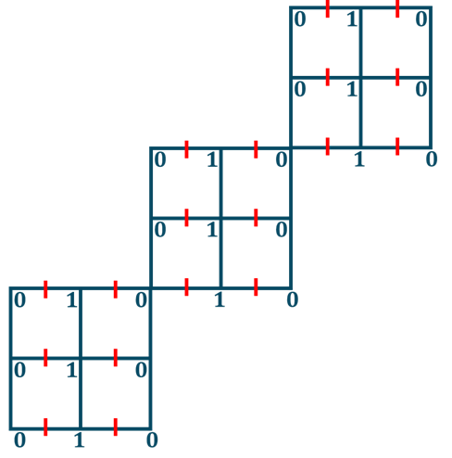
In below figure, sum labeling is applied on 3rd iteration of ladder fractal (type-1). In this figure, a small thick red coloured line denote edge with label 1.
Fig 11 : Sum labeling is applied on 3rd iteration of ladder fractal (type-1)
Theorem 3.5: The ladder fractal (type-2) admits sum cordial labeling (SCL).
Proof: Let us define vertex labelling $f_{{LF}_{2}} :V\left({LF}_{2}\right)→\left\{0, 1\right\}$as
Case – 1: $i∈N$
$f_{{LF}_{2}}\left(u_{i, 3}\right)=f_{{LF}_{2}}\left(u_{i, 4}\right)=f_{{LF}_{2}}\left(u_{i, 6}\right)=f_{{LF}_{2}}\left(u_{i, 7}\right)=0$ and $f_{{LF}_{2}}\left(u_{i, 5}\right)=1$
Case – 2: $i≡0\left(mod 2\right)$
$f_{{LF}_{2}}\left(u_{i, 1}\right)=f_{{LF}_{2}}\left(u_{i, 2}\right)=1$ and $f_{{LF}_{2}}\left(u_{i, 8}\right)=f_{{LF}_{2}}\left(u_{i, 9}\right)=0$
Case – 3: $i≡1\left(mod 2\right);i≠1$
$f_{{LF}_{2}}\left(u_{i, 1}\right)=f_{{LF}_{2}}\left(u_{i, 2}\right)=0$ and $f_{{LF}_{2}}\left(u_{i, 8}\right)=f_{{LF}_{2}}\left(u_{i, 9}\right)=1$
Now the induced edge labeling is defined as ${f_{{LF}_{2}}}^{\#} :E\left({LF}_{1}\right)→\left\{0, 1\right\}$ as ${f_{{LF}_{2}}}^{\#}\left(pq\right)=\left[f_{{LF}_{2}}\left(p\right)+f_{{LF}_{2}}\left(q\right)\right]\left(mod 2\right)$.
As per vertex labeling,
Case – 1: $i∈N$
${f_{{LF}_{2}}}^{\#}\left(u_{i, 3} u_{i, 6}\right)={f_{{LF}_{2}}}^{\#}\left(u_{i, 4} u_{i, 7}\right)=0$ and
$${f_{{LF}_{2}}}^{\#}\left(u_{i, 4} u_{i, 5}\right)={f_{{LF}_{2}}}^{\#}\left(u_{i, 5} u_{i, 6}\right)={f_{{LF}_{2}}}^{\#}\left(u_{i, 7} u_{i, 8}\right)=1$$
Case – 2: $i≡0\left(mod 2\right)$
${f_{{LF}_{2}}}^{\#}\left(u_{i, 1} u_{i, 4}\right)={f_{{LF}_{2}}}^{\#}\left(u_{i, 2} u_{i, 3}\right)={f_{{LF}_{2}}}^{\#}\left(u_{i, 8} u_{i,9}\right)=1$ and
$${f_{{LF}_{2}}}^{\#}\left(u_{i, 1} u_{i, 2}\right)={f_{{LF}_{2}}}^{\#}\left(u_{i, 2} u_{i, 5}\right)={f_{{LF}_{2}}}^{\#}\left(u_{i, 5} u_{i, 8}\right)={f_{{LF}_{2}}}^{\#}\left(u_{i, 6} u_{i,9}\right)=1$$
Case – 3: $i≡1\left(mod 2\right);i≠1$
${f_{{LF}_{2}}}^{\#}\left(u_{i, 1} u_{i, 2}\right)={f_{{LF}_{2}}}^{\#}\left(u_{i, 2} u_{i, 3}\right)={f_{{LF}_{2}}}^{\#}\left(u_{i, 1} u_{i, 4}\right)={f_{{LF}_{2}}}^{\#}\left(u_{i, 5} u_{i, 8}\right)={f_{{LF}_{2}}}^{\#}\left(u_{i, 8} u_{i,9}\right)=0$ and
$${f_{{LF}_{2}}}^{\#}\left(u_{i, 2} u_{i, 5}\right)={f_{{LF}_{2}}}^{\#}\left(u_{i, 6} u_{i,9}\right)=1$$
Table 5 : Vertex and edge counts​​ grow linearly with iteration, showing slight differences between even and odd steps
Iterations | Vertex count | Edge count
$1$^{st} | $$\left|v_{f_{{LF}_{2}}}\left(0\right)\right|=5 ; \left|v_{f_{{LF}_{2}}}\left(1\right)\right|=4$$ | $$\left|e_{{f_{{LF}_{2}}}^{\#}}\left(0\right)\right|=\left|e_{{f_{{LF}_{2}}}^{\#}}\left(1\right)\right|=6$$
$$i=2n ;n∈N$$ | $$\left|v_{f_{{LF}_{2}}}\left(0\right)\right|=\left|v_{f_{{LF}_{2}}}\left(1\right)\right|=\frac{ 7i+2 }{2}$$ | $$\left|e_{{f_{{LF}_{2}}}^{\#}}\left(0\right)\right|=\left\lceil \frac{ 11i+1 }{2} \right\rceil ;$$  $$\left|e_{{f_{{LF}_{2}}}^{\#}}\left(1\right)\right|=\left\lfloor \frac{ 11i+1 }{2} \right\rfloor$$
$$i=2n+1$$  $$;n∈N$$ | $$\left|v_{f_{{LF}_{2}}}\left(0\right)\right|=\left\lceil \frac{ 7i+2 }{2} \right\rceil ;$$  $$\left|v_{f_{{LF}_{2}}}\left(1\right)\right|=\left\lfloor \frac{ 7i+2 }{2} \right\rfloor$$ | $$\left|e_{{f_{{LF}_{2}}}^{\#}}\left(0\right)\right|=\left|e_{{f_{{LF}_{2}}}^{\#}}\left(1\right)\right|=\frac{11i+1}{2}$$

So, it is clearly visible that $\left|v_{f_{{LF}_{2}}}\left(0\right)-v_{f_{{LF}_{2}}}\left(1\right)\right|≤1 and \left|e_{{f_{{LF}_{2}}}^{\#}}\left(0\right)-e_{{f_{{LF}_{2}}}^{\#}}\left(1\right)\right|≤1.$ Hence, the ladder fractal (type-2) admits SCL.
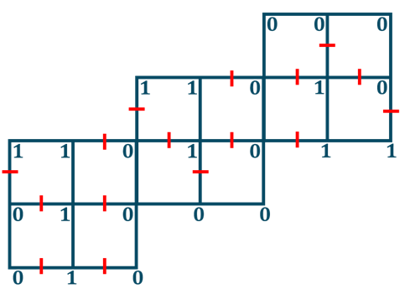
In below figure, sum cordial labeling is applied on 3rd iteration of ladder fractal (type-2). In this figure, a small thick red coloured line denote edge with label 1.
Fig 12: Sum cordial labeling is applied on 3rd iteration of ladder fractal (type-2)

Theorem 3.6: The ladder fractal (type-4) admits sum cordial labeling (SCL).
Proof: Let us define vertex labelling $f_{{LF}_{4}} :V\left({LF}_{4}\right)→\left\{0, 1\right\}$such that
Case – 1: $i=1$
$f_{{LF}_{4}}\left(u_{i, 1}\right)=f_{{LF}_{4}}\left(u_{i, 4}\right)=f_{{LF}_{4}}\left(u_{i, 6}\right)=f_{{LF}_{4}}\left(u_{i, 7}\right)=0$ and
$$f_{{LF}_{4}}\left(u_{i, 2}\right)=f_{{LF}_{4}}\left(u_{i, 3}\right)=f_{{LF}_{4}}\left(u_{i, 5}\right)=f_{{LF}_{4}}\left(u_{i, 8}\right)=f_{{LF}_{4}}\left(u_{i, 9}\right)=1$$
Case – 2: $i≡0\left(mod 2\right)$
$f_{{LF}_{4}}\left(u_{i, 1}\right)=f_{{LF}_{4}}\left(u_{i, 6}\right)=f_{{LF}_{4}}\left(u_{i, 9}\right)=0$ and $f_{{LF}_{4}}\left(u_{i, 2}\right)=f_{{LF}_{4}}\left(u_{i, 3}\right)=1$
Case – 3: $i≡1\left(mod 2\right);i≠1$
$f_{{LF}_{4}}\left(u_{i, 1}\right)=f_{{LF}_{4}}\left(u_{i, 6}\right)=f_{{LF}_{4}}\left(u_{i, 9}\right)=1$ and $f_{{LF}_{4}}\left(u_{i, 2}\right)=f_{{LF}_{4}}\left(u_{i, 3}\right)=0$
Now the induced edge labeling is defined as ${f_{{LF}_{4}}}^{\#} :E\left({LF}_{4}\right)→\left\{0, 1\right\}$ as ${f_{{LF}_{4}}}^{\#}\left(pq\right)=\left[f_{{LF}_{4}}\left(p\right)+f_{{LF}_{4}}\left(q\right)\right]\left(mod 2\right)$.
As per vertex labeling,
Case – 1: $i=1$
${f_{{LF}_{4}}}^{\#}\left(u_{i, 1} u_{i,4}\right)={f_{{LF}_{4}}}^{\#}\left(u_{i, 4} u_{i, 7}\right)={f_{{LF}_{4}}}^{\#}\left(u_{i, 2} u_{i, 3}\right)={f_{{LF}_{4}}}^{\#}\left(u_{i, 2} u_{i, 5}\right)={f_{{LF}_{4}}}^{\#}\left(u_{i, 5} u_{i, 8}\right)={f_{{LF}_{4}}}^{\#}\left(u_{i, 8} u_{i, 9}\right)=0$ and
$${f_{{LF}_{4}}}^{\#}\left(u_{i, 1} u_{i,2}\right)={f_{{LF}_{4}}}^{\#}\left(u_{i, 3} u_{i, 6}\right)={f_{{LF}_{4}}}^{\#}\left(u_{i, 4} u_{i, 5}\right)={f_{{LF}_{4}}}^{\#}\left(u_{i, 5} u_{i, 6}\right)={f_{{LF}_{4}}}^{\#}\left(u_{i, 7} u_{i, 8}\right)={f_{{LF}_{4}}}^{\#}\left(u_{i, 6} u_{i, 9}\right)=1$$
Case – 2: $i≡0\left(mod 2\right)$
${f_{{LF}_{4}}}^{\#}\left(u_{i, 2} u_{i, 3}\right)={f_{{LF}_{4}}}^{\#}\left(u_{i, 2} u_{i, 5}\right)={f_{{LF}_{4}}}^{\#}\left(u_{i, 8} u_{i, 9}\right)={f_{{LF}_{4}}}^{\#}\left(u_{i, 6} u_{i,9}\right)=0$ and
${f_{{LF}_{4}}}^{\#}\left(u_{i, 1} u_{i, 2}\right)={f_{{LF}_{4}}}^{\#}\left(u_{i, 1} u_{i, 4}\right)={f_{{LF}_{4}}}^{\#}\left(u_{i, 3} u_{i,6}\right)={f_{{LF}_{4}}}^{\#}\left(u_{i, 5} u_{i,6}\right)=1$
Case – 3: $i≡1\left(mod 2\right);i≠1$
${f_{{LF}_{4}}}^{\#}\left(u_{i, 1} u_{i, 4}\right)={f_{{LF}_{4}}}^{\#}\left(u_{i, 2} u_{i, 3}\right)={f_{{LF}_{4}}}^{\#}\left(u_{i, 5} u_{i, 6}\right)={f_{{LF}_{4}}}^{\#}\left(u_{i, 6} u_{i,9}\right)=0$ and
$${f_{{LF}_{4}}}^{\#}\left(u_{i, 1} u_{i, 2}\right)={f_{{LF}_{4}}}^{\#}\left(u_{i, 2} u_{i,5}\right)={f_{{LF}_{4}}}^{\#}\left(u_{i, 3} u_{i,6}\right)={f_{{LF}_{4}}}^{\#}\left(u_{i, 8} u_{i,9}\right)=1$$

Table 6: Vertices grow linearly with slight even-odd variation; edges increase steadily
Iterations | Vertex count | Edge count
$1$^{st} | $$\left|v_{f_{{LF}_{4}}}\left(0\right)\right|=5 ; \left|v_{f_{{LF}_{4}}}\left(1\right)\right|=4$$ | $$\left|e_{{f_{{LF}_{4}}}^{\#}}\left(0\right)\right|=\left|e_{{f_{{LF}_{4}}}^{\#}}\left(1\right)\right|=6$$
$$i=2n ;n∈N$$ | $$\left|v_{f_{{LF}_{4}}}\left(0\right)\right|=\left|v_{f_{{LF}_{4}}}\left(1\right)\right|=\frac{ 5i+4 }{2}$$ | $$\left|e_{{f_{{LF}_{4}}}^{\#}}\left(0\right)\right|=\left|e_{{f_{{LF}_{4}}}^{\#}}\left(1\right)\right|= 4i+2$$
$$i=2n+1 ;n∈N$$ | $$\left|v_{f_{{LF}_{4}}}\left(0\right)\right|=\left\lfloor \frac{ 5i+4 }{2} \right\rfloor ;$$  $$\left|v_{f_{{LF}_{4}}}\left(1\right)\right|=\left\lceil \frac{ 5i+4 }{2} \right\rceil$$ | $$\left|e_{{f_{{LF}_{4}}}^{\#}}\left(0\right)\right|=\left|e_{{f_{{LF}_{4}}}^{\#}}\left(1\right)\right|= 4i+2$$
So, it is clearly visible that $\left|v_{f_{{LF}_{4}}}\left(0\right)-v_{f_{{LF}_{4}}}\left(1\right)\right|≤1 and \left|e_{{f_{{LF}_{4}}}^{\#}}\left(0\right)-e_{{f_{{LF}_{4}}}^{\#}}\left(1\right)\right|≤1.$ Hence, the ladder fractal (type-4) admits SCL.
In below figure, sum labeling is applied on 3rd iteration of ladder fractal (type-4). In this figure, a small thick red coloured line denote edge with label 1.
Fig 13 : Sum labeling is applied on 3rd iteration of ladder fractal (type-4).
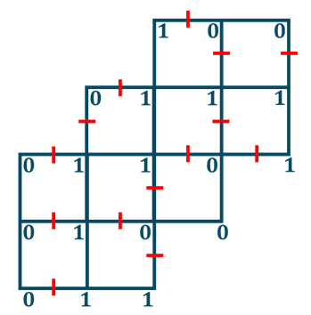

Conclusion:
The vicsek fractals (saltire form), the vicsek fractals (cross form), the box fractal (type- 2), the ladder fractal (type-1) , the ladder fractal (type-2) , the ladder fractal (type-4) admits sum cordial labeling (SCL).

References
- Bloom G. S. and Golomb S. W. (1977). Applications of numbered undirected graphs, Proc of IEEE, 65(4),562-570.
- Cahit I., “On Cordial and 3-Equitable Labellings of Graphs”, Utilitas Mathematica 37(1990), pp. 189-190.
- Gallian J.A., “A Dynamic Survey of Graph Labeling,” The electronic journal of combinatorics, 27th Edition, Nov. 2024.
- K. K. Raval and M. Prajapati, Signed product cordial labelings ofsome fractal graphs, Gradiva Review J. 8(11) 2022 537-546.
- M. Barnsley, Fractals Everywhere, Academic Press Inc., 1988
- M.I. Bosmia, V.R.Visavaliya and B.M. Patel, “Further results on Sum cordial graphs”, Malaya Journal of Mathematik: An International Journal of Mathematical Science with Computer Application.3 (2) (2015) 175-181.
- R. Devaney and L. Keen, eds., Chaos and Fractals: The Mathematics Behind the Computer Graphics, American Mathematical Society, Providence, RI, 1989
- Sathakathullaa, A. A., Akrama, M. and Rajeswari, P. G., (2012), Cordial, Total Cordial, Edge Cordial, Total Edge Cordial Labeling of Some Box Type Fractal Graphs, International Journal of Algebra and Statistics, 1(2), 99–106.
- Sathakathulla, A. A. and Rajeswari, P. G., (2012), Edge Cordial, Total Edge Cordial Labeling of Some Ladder Type Fractal Graphs, International Journal of Applied Sciences and Engineering Research, 1(6), 793–801.
- V.R.Visavaliya, M.I. Bosmia, B.M.Patel: “Sum Cordial Labelling of Graphs” Journal of Mathematics and Computer Science. 4(2014), No. 5,879-891.

