Metagenomic Identification of Bacillus thuringiensis within the Bacterial Microflora of Soils under Rice and Wheat Cultivation in Diré, Mali

.
ABSTRACT

Aims: This study aimed to identify and characterize the presence of Bacillus thuringiensis (Bt) within the soil bacterial microflora under rice and wheat cultivation in Diré, northern Mali, where pest pressure is notably low.
Study Design: A cross-sectional metagenomic survey of agricultural soils.
Place and Duration of Study: Agricultural fields in Diré, Mali, sampled during the 2024 dry season.
Methodology: Thirty surface soil samples were collected from five plots. DNA was extracted and sequenced using Illumina MiSeq. Taxonomic classification was performed using DADA2 and OneCodex.
Results: Firmicutes dominated the bacterial community (61%), followed by Proteobacteria (14%) and Actinobacteria (13%). Bacillus thuringiensis represented 0.48% of Bacillus reads, including insecticidal serovars kurstaki, morrisoni, and indiana.
Conclusion: The natural presence of Bt strains in Diré soils may contribute to reduced pest incidence. These findings support the potential of indigenous Bt strains as biocontrol agents adapted to Sahelian agroecosystems.

Keywords: Bacillus thuringiensis, metagenomics, rice, wheat, soil microbiome, biocontrol, Mali

1. INTRODUCTION

In Mali, crop losses caused by insect pests represent a major constraint to agricultural productivity. Farmers frequently lose up to 80% of their yields due to pest infestations, with additional post-harvest losses estimated at 15–22%. Chemical pesticides remain the primary control strategy, but their cost, environmental risks, and impact on soil biodiversity make them unsustainable for smallholder systems (Matyjaszczyk, 2018)..
Among microbial biocontrol agents, Bacillus thuringiensis (Bt) is widely recognized for its production of Cry toxins—δ-endotoxins with potent insecticidal activity (Bravo et al., 2011). These proteins are highly specific to target insect species, making Bt one of the safest and most effective biopesticides globally (Chakrabarty et al., 2022). However, resistance to Bt toxins has been reported in several insect populations, raising concerns about long-term efficacy (Soberón et al., 2016)
Interestingly, in the Diré region of northern Mali, pest infestations in rice and wheat fields are less frequent compared to irrigated areas such as the Office du Niger. This suggests that native soil microbial communities may contribute to natural pest suppression, possibly through the presence of indigenous Bt strains. Recent metagenomic studies in Mali and other African agroecosystems have highlighted the dominance of Bacillus spp. in Sahelian soils (Kassogué et al.2024; Kassogué et al., ).

High-throughput sequencing now enables comprehensive profiling of soil microbial communities, including non-cultivable taxa (Yang et al., 2024). This study therefore aimed to characterize the bacterial community structure of Diré soils, identify the presence and diversity of Bt strains, and explore their potential contribution to reduced pest incidence.

2. material and methods

2.1 Study area and soil sampling

The study was conducted in Diré, a Sahelian zone of northern Mali characterized by low annual rainfall, high evapotranspiration, and sandy loam soils with limited organic matter. These environmental conditions are known to strongly shape microbial community composition in arid agroecosystems (Wang et al., 2016). Five representative agricultural plots were selected: two under continuous rice cultivation (SNI21 and SNI22), two under wheat cultivation (SNI23 and SNI24), and one under a rice–wheat rotation system (SNI25). Within each plot, six surface soil subsamples (0–15 cm depth) were collected along an “X” transect using sterile corers, yielding a total of 30 subsamples. Subsamples were homogenized to form one composite sample per plot, sieved through a 2 mm mesh to remove plant debris, and stored at –20 °C until DNA extraction. Field blanks and sterile controls were included to monitor potential contamination during sampling and handling.

2.2 Soil physicochemical characterization

To provide context for microbial community structure, basic soil properties were measured following standard protocols. Soil pH was determined in a 1:2.5 soil–water suspension using a glass electrode pH meter, while electrical conductivity was measured in the same extract. Gravimetric moisture content was assessed by oven drying at 105 °C for 24 h. Organic carbon was quantified using the Walkley–Black method, and total nitrogen was determined by the modified Kjeldahl procedure (Nelson & Sommers, 1996). Soil texture was analyzed by the hydrometer method to estimate sand, silt, and clay fractions. These parameters were measured in duplicate for each composite sample to ensure reproducibility.

2.3 DNA extraction and quality assessment

Total community DNA was extracted from 0.25 g of soil using the DNeasy PowerSoil Pro Kit (Qiagen, Germany), which has been widely applied in metagenomic studies of agricultural soils (Quince et al., 2017). Mechanical lysis was enhanced by bead beating to ensure efficient disruption of Gram-positive bacteria such as Bacillus. DNA concentration was quantified using a Qubit dsDNA HS assay (Thermo Fisher Scientific), while purity was assessed by NanoDrop spectrophotometry, with acceptable ratios defined as A260/280 between 1.8–2.0 and A260/230 above 1.8. Integrity was verified by 1% agarose gel electrophoresis. Extraction blanks were processed in parallel to detect potential contamination.
2.4 PCR amplification of the 16S rRNA gene

The bacterial 16S rRNA gene was amplified using universal primers targeting the V3–V4 hypervariable region: 341F (5′-CCTACGGGNGGCWGCAG-3′) and 806R (5′-GGACTACHVGGGTWTCTAAT-3′). PCR reactions were performed in 25 µL volumes containing 12.5 µL of KAPA HiFi HotStart ReadyMix, 0.2 µM of each primer, and approximately 10 ng of template DNA. The thermal cycling program consisted of an initial denaturation at 95 °C for 3 min, followed by 25 cycles of 98 °C for 20 s, 55 °C for 30 s, and 72 °C for 30 s, with a final extension at 72 °C for 5 min. Each sample was amplified in triplicate to minimize stochastic amplification bias, and the products were pooled prior to purification with AMPure XP beads (Beckman Coulter). Negative controls without template DNA were included in each PCR run.

2.5 Library preparation and sequencing

Purified amplicons were indexed using the Nextera XT dual-index system (Illumina, USA), quantified by Qubit, and normalized to equimolar concentrations. Sequencing was performed on an Illumina MiSeq platform using the 2 × 300 bp paired-end chemistry (MiSeq v3 kit). A 10% PhiX spike-in was included to improve base diversity. The sequencing run targeted a minimum of 50,000 paired reads per sample, which is considered sufficient for capturing the dominant bacterial taxa in agricultural soils (Caporaso et al., 2012).

2.6 Bioinformatics and taxonomic classification

Raw reads were demultiplexed and processed using the DADA2 pipeline (Callahan et al., 2016) implemented in R v4.3. Primer sequences were trimmed with Cutadapt, and reads were filtered based on quality scores (truncLen = 280 for forward and 220 for reverse reads, maxEE = 2–3). Error models were learned per run, paired reads were merged with a minimum overlap of 12 bp, and chimeras were removed by consensus. Amplicon sequence variants (ASVs) were assigned taxonomy against the SILVA v138.1 database. In parallel, reads were uploaded to the OneCodex platform for k-mer–based classification against curated microbial reference genomes, providing an independent validation of taxonomic assignments. Special attention was given to the Bacillus cereus group, within which B. thuringiensis was identified at the species level when supported by both pipelines.

2.7 Data visualization and reproducibility

Results were presented as relative abundance plots (phylum, class, order, family, genus, and species levels). Figures and tables were generated in R and summarized to highlight differences between rice and wheat soils.

3. results and discussion

3.1 Results

3.1.1 Soil physicochemical properties
The physicochemical characteristics of the soils are summarized in Table 1. All soils were slightly acidic (pH 6.1–6.5), with low organic carbon content typical of Sahelian soils. The rice–wheat rotation soil (SNI25) exhibited slightly higher organic carbon and nitrogen levels compared to monoculture soils, suggesting improved fertility under rotational management.

Table 1. Physicochemical properties of soils collected from rice, wheat, and rice–wheat rotation fields in Diré, Mali

Sample ID | Crop type | pH (1/2.5 H₂O) | Organic carbon (g/Kg) | Total N (%) | Texture | Moisture (%)
SNI21 | Rice | 6.1 | 3.2 | 0.05 | 62/21/17 | 8.5
SNI22 | Rice | 6.3 | 2.9 | 0.04 | 60/22/18 | 9.1
SNI23 | Wheat | 6.4 | 3.5 | 0.06 | 59/23/18 | 7.8
SNI24 | Wheat | 6.5 | 3.1 | 0.06 | 61/21/18 | 8.2
SNI25 | Rice-Wheat | 6.2 | 3.8 | 0.07 | 58/24/18 | 9.8
SNI26 | Rice-Wheat | 6.2 | 3.7 | 0.07 | 57/24/18 | 9.4

Legend:
Soil physicochemical properties measured in five agricultural plots from Diré, Mali. pH was determined in a 1:2.5 soil–water suspension using a glass electrode pH meter. Organic carbon was quantified by the Walkley–Black method, and total nitrogen was determined by the modified Kjeldahl method (Nelson & Sommers, 1996). Soil texture was analyzed by the hydrometer method, while bulk density was measured using the core sampler technique. Moisture content was calculated on an oven‑dry weight basis. Values represent means of duplicate measurements per composite sample.

3.1.1 Overall bacterial community structure

The global metagenomic analysis of all samples revealed a total of 18 phyla, of which six were dominant (each > 1% of classified reads). The most abundant phylum was Firmicutes (61%), followed by Proteobacteria (14%), Actinobacteria (13%), Chloroflexi (3%), Planctomycetes (2.7%), and Bacteroidetes (1.2%). These six phyla accounted for over 95% of the total classified sequences.
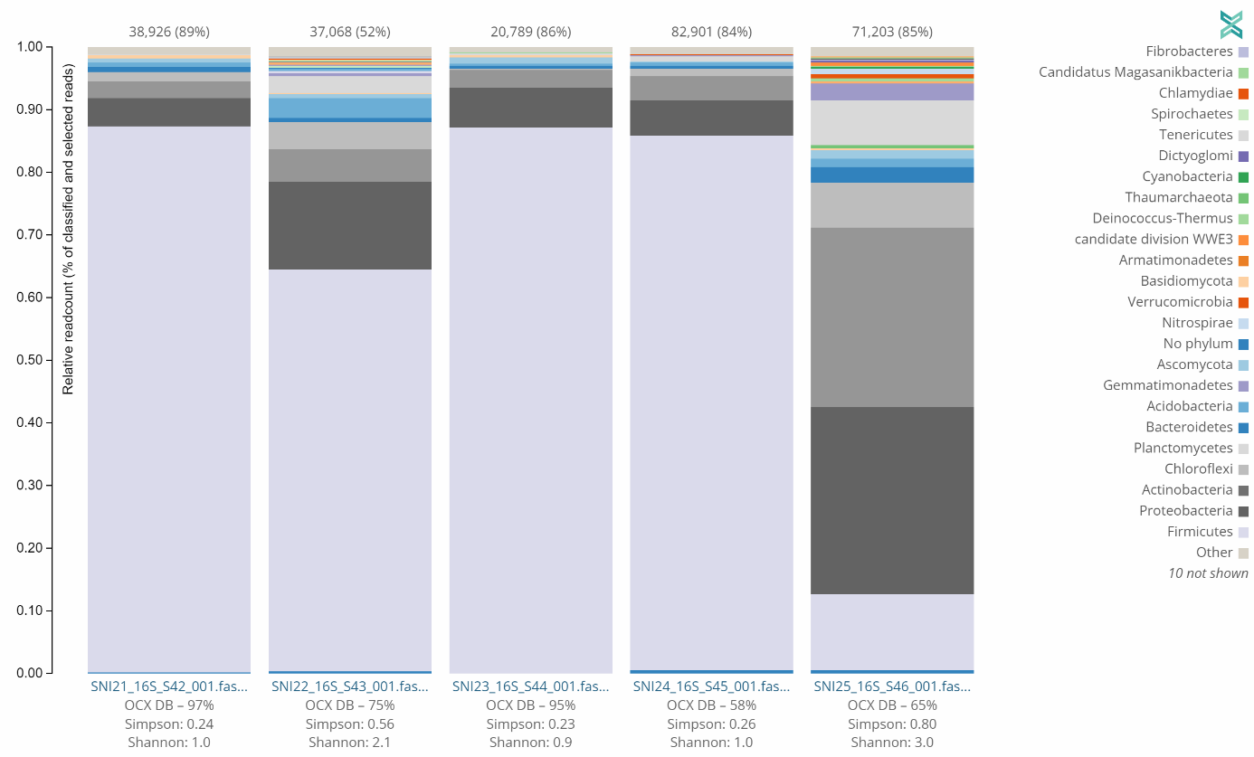
Figure 1. Stacked bar plots showing the relative abundance of dominant bacterial phyla in soils collected from rice (SNI21, SNI22), wheat (SNI23, SNI24), and rice–wheat rotation (SNI25) fields in Diré, Mali.

At the sample level, the four soils SNI21, SNI22, SNI23, and SNI24 were dominated by Firmicutes (87%, 64%, 87%, and 85%, respectively), while the mixed rice–wheat soil (SNI25) exhibited a higher proportion of Proteobacteria (30%) and Actinobacteria (29%). Wheat soils (SNI23, SNI24) contained more Firmicutes on average than rice soils (SNI21, SNI22).

3.1.2 Community composition at the class and order levels

Across all samples, 34 bacterial classes were identified, with Bacilli (56%) and Actinomycetia (11%) being the most abundant. Sample-wise, the four main soils (SNI21–SNI24) contained between 56–87% Bacilli, whereas SNI25 was dominated by Actinomycetia (21%).

At the order level, Bacillales were predominant, followed by Streptomycetales, Hyphomicrobiales, Eubacteriales, Isosphaerales, Solirubrobacterales, and Burkholderiales. A total of 110 bacterial orders were detected above the 0.1% abundance threshold.

3.1.3 Composition at the family and genus levels

A total of 108 bacterial families were identified, with Paenibacillaceae (23%) and Bacillaceae (15%) being the most abundant. Sample SNI21 contained 36% Bacillaceae and 13% Paenibacillaceae; SNI22 had 41% Bacillaceae and 4.1% Paenibacillaceae; SNI23 showed 30% Bacillaceae and 24% Paenibacillaceae; SNI24 had 10% Bacillaceae and 60% Paenibacillaceae; while SNI25 contained 5.8% Bacillaceae.
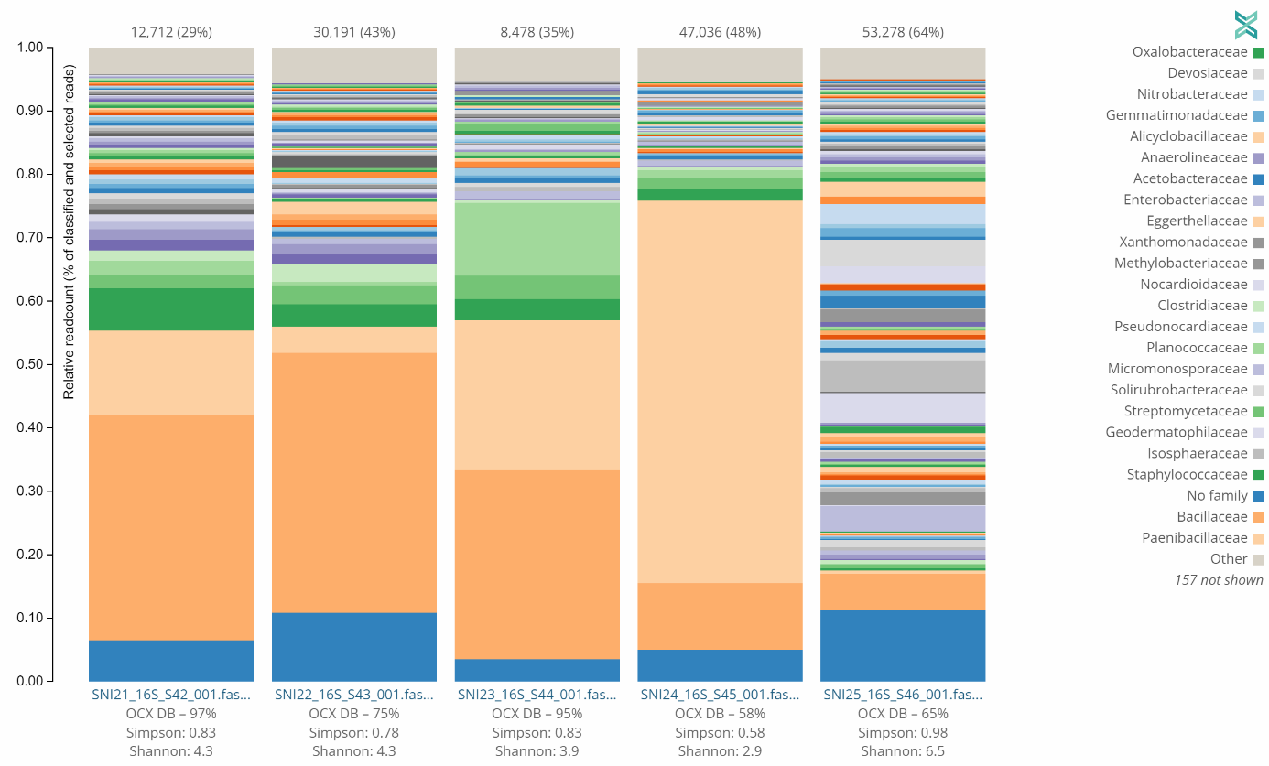

Figure 2. Stacked bar plots showing Composition at the family and genus levels in soils collected from rice (SNI21, SNI22), wheat (SNI23, SNI24), and rice–wheat rotation (SNI25) fields in Diré, Mali..

At the genus level, eight major bacterial genera dominated the samples: Bacillus (23%), Cohnella (23%), Lysinibacillus (11%), Paenibacillus (9.4%), Sporosarcina (2.4%), Fictibacillus (2%), Longilinea (1.7%), and Solirubrobacter (1.2%). The relative abundance of Bacillus varied from 1.4% (SNI24) to 25% (SNI23) across samples.

3.1.4 Detection and diversity of Bacillus thuringiensis

Within the Bacillus genus, B. thuringiensis accounted for 0.48% of reads. Among the 61,256 classified Bacillus reads, 291 were assigned to B. thuringiensis with multiple insecticidal serovars detected, including kurstaki, morrisoni, and Indiana:
- B. thuringiensis (species-level, 0.05% of classified reads),
- B. thuringiensis MC28 (0.02%),
- B. thuringiensis serovar indiana (0.01%),
- B. thuringiensis serovar morrisoni (0.01%),
- B. thuringiensis YBT-1518 (0.01%),
- B. thuringiensis serovar kurstaki (0.0013%),
- B. thuringiensis DB27 and Bt18247 strains (trace amounts).

Although present at low abundance, the consistent detection of diverse Bt serovars suggests an ecologically meaningful role in natural pest suppression. The kurstaki serovar is known for its activity against lepidopteran pests such as Lymantria dispar, while morrisoni targets coleopteran pests such as the cotton boll weevil (Anthonomus grandis) (Das et al., 2021; Fiuza et al., 2017). The indiana serovar has been previously isolated from wheat soils (DeLucca et al., 1979), which aligns with its detection in our wheat samples. These results support the hypothesis that the low pest pressure observed in Diré may be partly explained by the natural presence of insecticidal Bt strains.

3.2 Discussion

3.2.1 Soil bacterial diversity

The predominance of Firmicutes in all samples, except SNI25, indicates that these bacteria play a central role in the microbiome of Diré soils. Similar findings were reported by Prasannakumar et al. (2021) in metagenomic studies of rice soils, where Firmicutes accounted for ~36% of bacterial reads [6]. In our study, the proportion (61%) was notably higher, possibly due to soil type, temperature, and lower organic content typical of Sahelian environments.
The high relative abundance of Bacilli (56–87%) agrees with findings from Nivedita Rawat et al. (2019), who recorded 63% Firmicutes in hot-spring soils (Wang et al., 2016). Likewise, Youseif et al. (2021) observed that Bacilli dominate wheat rhizospheres across various soil textures, ranging from 40–100% in clay, sandy, and calcareous soils (Nelson et al.,1996). Our results are thus consistent with these global trends.

3.2.1 Presence of Bacillus thuringiensis in Diré soils

Although B. thuringiensis represented only 0.48% of Bacillus reads, its detection across several serovars (notably kurstaki, morrisoni, and indiana) suggests an ecologically meaningful presence.
The kurstaki serovar is known for its insecticidal activity against Lymantria dispar (gypsy moth), while morrisoni targets Anthonomus grandis (cotton boll weevil) (Quince et al., 2017). The indiana serovar has been previously isolated from wheat fields (DeLucca et al., 1979), which aligns with its detection in our wheat soil samples (SNI23, SNI24).

These observations support the hypothesis that the low pest pressure in Diré’s agricultural systems may be linked to the natural occurrence of insecticidal B. thuringiensis. Even at low abundance, Bt can exert significant ecological effects through toxin persistence and soil bioactivity.

4. Conclusion

This study provides the first metagenomic evidence of Bacillus thuringiensis within the soil bacterial communities of rice and wheat fields in Diré, Mali. The bacterial microbiome was dominated by Firmicutes, while Bt was consistently detected across multiple insecticidal serovars.

These findings suggest that native Bacillus thuringiensis strains may contribute to the naturally low pest incidence observed in the region, through the presence of insecticidal B. thuringiensis species.

Ethical approval

This study did not involve human or animal subjects. Soil sampling was conducted with the consent of local farmers and in accordance with national agricultural research guidelines.

References

- Matyjaszczyk, E. (2018). Products containing microorganisms as a tool in integrated pest management and the rules of their market placement in the European Union. Pest Management Science, 74(3), 521–527. https://doi.org/10.1002/ps.4742
- Bravo, A., Likitvivatanavong, S., Gill, S. S., & Soberón, M. (2011). Bacillus thuringiensis: A story of a successful bioinsecticide. Insect Biochemistry and Molecular Biology, 41(7), 423–431. https://doi.org/10.1016/j.ibmb.2011.02.006
- Chakrabarty, S., Chakraborty, P., Islam, T., Aminul Islam, A. K. M., Datta, J., Bhattacharjee, T., Minghui, J., & Xiao, Y. (2022). Bacillus thuringiensis proteins: Structure, mechanism and biological control of insect pests. In S. S. Ghosh, S. K. Das, & A. K. Mandal (Eds.), Bacilli in Agrobiotechnology (pp. 581–608). Springer. https://doi.org/10.1007/978-3-030-85465-2_25
- Soberón, M., Monnerat, R., & Bravo, A. (2016). Mode of action of Cry toxins from Bacillus thuringiensis and resistance mechanisms. In S. S. Ghosh (Ed.), Microbial Toxins (pp. 1–13). Springer. https://doi.org/10.1007/978-94-007-6725-6_28-1
- Kassogué, A., Traore, S., Dao, S., Dara, A., Sissoko, S., Cissé, C., Diallo, K. A., Fané, R., Traoré, A., Wélé, M., & Babana, A. H. (2024). Assessment of the diversity of endophytic, rhizospheric and soil bacteria in Mali using a targeted metagenomic approach. Annual Research & Review in Biology, 39(12), 1–15. https://doi.org/10.9734/arrb/2024/v39i1232179
- Yang, Y., Wang, N., Wang, J., Zhang, Y., & Li, Y. (2024). Advances in metagenomic approaches for soil microbial ecology. Frontiers in Microbiology, 15, 1127641. https://doi.org/10.3389/fmicb.2024.1127641
- Wang, J., Song, Y., Ma, T., Raza, W., Li, J., Howland, J. G., Huang, Q., & Shen, Q. (2016). Impacts of soil and plant factors on bacterial communities in a wheat–rice rotation system. Applied Soil Ecology, 107, 140–147. https://doi.org/10.1016/j.apsoil.2016.06.006
- Nelson, D. W., & Sommers, L. E. (1996). Total carbon, organic carbon, and organic matter. In D. L. Sparks (Ed.), Methods of Soil Analysis: Part 3 Chemical Methods (pp. 961–1010). Soil Science Society of America.
- Quince, C., Walker, A. W., Simpson, J. T., Loman, N. J., & Segata, N. (2017). Shotgun metagenomics, from sampling to analysis. Nature Biotechnology, 35(9), 833–844. https://doi.org/10.1038/nbt.3935
- Caporaso, J. G., Lauber, C. L., Walters, W. A., Berg-Lyons, D., Lozupone, C. A., Turnbaugh, P. J., Fierer, N., & Knight, R. (2012). Ultra-high-throughput microbial community analysis on the Illumina HiSeq and MiSeq platforms. ISME Journal, 6(8), 1621–1624. https://doi.org/10.1038/ismej.2012.8
- Callahan, B. J., McMurdie, P. J., Rosen, M. J., Han, A. W., Johnson, A. J. A., & Holmes, S. P. (2016). DADA2: High-resolution sample inference from Illumina amplicon data. Nature Methods, 13(7), 581–583. https://doi.org/10.1038/nmeth.3869
- Prasannakumar, V., Somashekaraiah, R., & Pradeep, C. (2021). Comparative metagenomic analysis of bacterial communities in rice field soils. Microbial Ecology, 81(4), 1013–1026. https://doi.org/10.1007/s00248-020-01590-2
- Rawat, N., Sharma, R., & Singh, A. (2019). Microbial diversity in hot spring soils revealed by 16S rRNA sequencing. Extremophiles, 23(5), 623–635. https://doi.org/10.1007/s00792-019-01130-1
- Youseif, S. H., Abd El-Megeed, A., & Abd El-Hady, M. (2021). Soil texture shapes the wheat rhizosphere microbiome. Frontiers in Microbiology, 12, 659165. https://doi.org/10.3389/fmicb.2021.659165
- Das, S. K., Pradhan, S. K., Samal, K. C., & Singh, N. R. (2021). Structural and functional analysis of Cry toxins of Bacillus thuringiensis. Egyptian Journal of Biological Pest Control, 31, 44. https://doi.org/10.1186/s41938-021-00394-6
- Fiuza, L. M., Berlitz, D. L., de Oliveira, J. V., & Knaak, N. (2017). Bacillus thuringiensis: Different targets and interactions. In L. M. Fiuza, D. L. Berlitz, J. V. de Oliveira, & N. Knaak (Eds.), Bacillus thuringiensis and Lysinibacillus sphaericus (pp. 111–130). Springer. https://doi.org/10.1007/978-3-319-56678-8_9
- DeLucca, A. J., Simonson, J. G., & Larson, A. D. (1979). Isolation of Bacillus thuringiensis from wheat field soils. Applied and Environmental Microbiology, 37(2), 339–342. https://doi.org/10.1128/aem.37.2.339-342.1979

