CAPACITY ASSESSMENT OF THE SANTO NIÑO–PALMA GIL RICE FARMERS’ ASSOCIATION (SPRFA) IN TALAINGOD, DAVAO DEL NORTE, PHILIPPINES

Abstract
Rice farming continues to be a critical livelihood for smallholder farmers in the Philippines, yet farmer associations face persistent challenges related to technical capacity, collaboration, strategic engagement, and enabling environments. This study assessed the organizational capacities of the Santo Niño–Palma Gil Rice Farmers’ Association (SPRFA) in Talaingod, Davao del Norte, to identify strengths and areas for improvement. Using a quantitative research design, data were collected from 70 rice farmers through a structured and validated survey questionnaire. The instrument measured respondents’ demographic characteristics and their perceived capacities across six domains: navigating complexity, collaboration, reflection and learning, engagement in strategic and political processes, technical skills, and enabling environment. Findings reveal that while the association demonstrates strengths in mobilizing resources, problem-solving, leadership, and openness to training, it is constrained by weak technical foundations, limited external linkages, and underdeveloped long-term planning capacities. Technical skills scored the lowest overall (2.77), highlighting a pressing need for training in crop management, pest control, and postharvest handling. External engagement also showed modest results, with low scores in communication channels and policy influence. Furthermore, the enabling environment posed systemic barriers, particularly in market access, registration, and certification processes. The synthesis suggests that the partnership is functional internally but remains externally constrained. To enhance resilience and competitiveness, interventions should focus on technical training, stronger institutional linkages, improved communication and advocacy, and supportive policies that reduce systemic barriers. The results provide evidence-based insights to guide policymakers, development practitioners, and local institutions in strengthening farmer organizations for sustainable agricultural development.
Keywords: Capacity assessment, Farmer organizations, Rice farming, Organizational development, Technical skills, Collaboration, Reflection and learning, Strategic engagement, Enabling environment, Davao del Norte, Philippines
- INTRODUCTION
Rice farming remains a cornerstone of rural livelihoods in the Philippines, significantly contributing to both food security and household income among smallholder farmers. Despite its importance, rice farmers continue to face persistent challenges such as fluctuating market prices, climate-related shocks, limited access to high-quality inputs, and gaps in institutional support services (Ituriaga, Mariñas, & Saflor, 2024). In addressing these challenges, farmer associations are expected not only to strengthen their members’ technical skills but also to build capacities in collaboration, reflection and learning, navigating complex socio-political environments, and engaging strategically with institutional and policy processes.
Recent literature underscores the multidimensional nature of these capacities. For instance, Ituriaga et al. (2024), in their evaluation of government service delivery to rice farmers using a SERVQUAL-based framework, highlighted how service quality dimensions such as reliability, responsiveness, and security influence farmers’ trust and satisfaction, which directly affect their productive performance. Similarly, Bueno and Padawil (2025) emphasized that training needs, attitudes, and operational constraints identified through multi-stakeholder analyses play a critical role in farmers’ adoption of innovations, collaborative practices, and sustained productivity.
In Davao del Norte, the Impact Assessment of the Rice Competitiveness Enhancement Fund (RCEF) Mechanization Program conducted by Arbes et al. (2024) revealed that institutional support in the form of mechanization and improved access to agricultural machinery enhanced productivity. However, the outcomes varied depending on farmers’ readiness to adopt new technologies, their ability to navigate policy and institutional frameworks, and the effectiveness of their engagement with support services. These findings highlight the interconnectedness of technical competencies with other capacities, particularly collaboration, reflection, and strategic engagement.
The Sto. Niño–Palma Gil Rice Farmers Association was founded on May 31, 2018 with an initial membership of 27 dedicated rice farmers. Since its establishment, the association has steadily grown and now proudly consists of 70 active members. The organization serves as a platform for collaboration, knowledge-sharing, and collective action among its members. Every week, the association holds regular meetings at their demonstration farm, which has become a hub for learning and cooperative decision-making. Beyond farming practices, the group has also ventured into machinery rental services, providing affordable access to essential equipment that supports members in improving their productivity and efficiency.
Through these initiatives, the Sto. Niño–Palma Gil Rice Farmers Association continues to strengthen its role in uplifting local farmers, fostering unity, and advancing sustainable agricultural development in their community. Examining dimensions such as navigating complexity, collaborating, reflecting and learning, engaging in strategic and political processes, and technical skills will help identify both strengths and areas for improvement. The results of this assessment are expected to inform capacity-building interventions, strengthen organizational governance, and enable the association to foster resilience and productivity among its members.

Statement Of The Problem
Farmer organizations in the Philippines are essential drivers of agricultural productivity, market access, and resilience for smallholder farmers. However, many associations continue to struggle with limited technical competencies, weak collaborative mechanisms, insufficient opportunities for reflection and learning, and inadequate engagement in strategic and political processes. These constraints can weaken their ability to respond effectively to climate variability, shifting market conditions, and policy reforms, particularly in the competitive field of rice production.
The Santo Niño–Palma Gil Rice Farmers’ Association (SPRFA) in Talaingod, Davao del Norte, is a rural-based organization whose members depend primarily on rice farming for their livelihood. Yet, there is limited knowledge of how well its members are equipped with the essential capacities required for organizational effectiveness and sustainability. Identifying these capacity levels is critical to designing appropriate interventions, strengthening institutional support, and ensuring that the association remains responsive to the developmental needs of its members.
Thus, this study seeks to assess the capacities of SPRFA members across five key dimensions: (1) capacity to navigate complexity, (2) capacity to collaborate, (3) capacity to reflect and learn, (4) capacity to engage in strategic and political processes, (5) technical skills, and (6) enabling environment. Specifically, it aims to determine: What are the mean responses of the respondents in each of these five capacity dimensions? The findings of this study will provide evidence-based insights to guide policymakers, development practitioners, and the association itself in creating targeted capacity-building programs that enhance resilience, productivity, and inclusivity among rice farmers in Talaingod.
- REVIEW OF RELATED LITERATURE
Farmer associations are widely acknowledged as central to improving smallholder productivity, resilience, and market participation. In the Philippines, their effectiveness relies on a combination of technical competence, collaboration, learning, strategic engagement, and the ability to navigate institutional and political complexity. These capacities align directly with the objectives of the present assessment of the Santo Niño–Palma Gil Rice Farmers’ Association (SPRFA) in Talaingod, Davao del Norte.
Service quality and institutional support
Ituriaga, Mariñas, and Saflor (2024) examined the quality of government services provided to rice farmers in the Philippines and concluded that reliability, responsiveness, and perceived security strongly influence farmers’ satisfaction and trust, which in turn affect productive capacity. Similarly, Arbes, Villaremo, Cabañog, Escobar, Mindal, and Amilbahar (2024) conducted an impact assessment of the Rice Competitiveness Enhancement Fund (RCEF) mechanization program in Davao del Norte. They reported that institutional support through mechanization improved productivity, though farmers’ responses depended on their readiness to adopt new technologies and engage with support systems. These findings highlight how both technical skills and strategic engagement capacities shape outcomes.
Collaboration and collective action
Dorvlo, Baffoe, Jew, Mkandawire, and Dougill (2025) demonstrated in Ghana that sustainable agricultural mechanization requires strong collaboration among stakeholders, reinforcing the global importance of organizational collaboration capacity. Within Southeast Asia, Methamontri, Mughwai, Nanseki, and Chomei (2022) analyzed participation in collective marketing among organic rice farmer groups in Thailand. Their results show that social capital, training, and group structures are key predictors of participation, emphasizing that collective outcomes depend heavily on collaboration and organizational health.
Learning, innovation, and reflective capacity
Jalotjot and Tokuda (2024) investigated the open-innovation capability of smallholder farmers in the Philippines and found that even resource-constrained farmers are capable of absorbing external knowledge and co-developing solutions when embedded in supportive networks. This underscores the importance of reflection and continuous learning within associations. Complementing this, Lamm and Lamm (2022) cautioned that capacity assessments must include diverse respondent groups to avoid blind spots and to ensure inclusive learning processes that reflect the perspectives of all members.
Adaptive and technical capacities
Ali, Liu, Ishaq, Shah, Ilyas, and Din (2021) studied adaptation strategies of rice farmers in Pakistan and found that skills, information, and risk management strategies reduce production risks in the face of climate variability. This aligns with the need for strong technical and adaptive skills in rice farming communities. In the Philippine context, Hosonuma and colleagues (2024) evaluated rice cultivation changes in the Candaba Swamp using remote-sensing data, demonstrating how access to technical information and analysis is increasingly critical for farmer organizations in managing production risks.
Policy environment in Mindanao
The Department of Agriculture (2021) through the Mindanao Inclusive Agriculture Development Project (MIADP) emphasized organizational strengthening and inclusive value chains, particularly for Indigenous Peoples’ communities in Mindanao. This framework is highly relevant for associations in Talaingod, where many farmers belong to upland and IP-majority populations. Further, the University of the Philippines Center for Integrative and Development Studies (UP CIDS, 2025) argued that local governments can play the role of “lead firms” in agricultural value chains, underscoring the importance of associations’ capacity to strategically engage with local institutions.
Ituriaga et al. (2024), Arbes et al. (2024), Jalotjot and Tokuda (2024), and Methamontri et al. (2022) have shown that farmer capacity is multifaceted and strongly linked to productivity, resilience, and collaboration. Yet, there remains a gap in localized assessments that systematically measure these capacities within a sp
ecific association using descriptive statistics. This study addresses that gap by quantifying SPRFA members’ mean responses across five dimensions, providing an evidence base for capacity-building and policy support.
- METHODOLOGY
This chapter presents the research methods that are employed to attain the research objectives. It explained the sources of data, the data gathering instrument, and the sampling technique. Additionally, it discussed the procedure of the study and the statistical treatment of the gathered data.
This chapter presents the research methods that are working to attain the study objects. It explained the sources of data, the data gathering tool, and the sample method. Moreover, it discussed the way of the study and the statistical treatment of the met data.
Research Design
This study employs quantitative research design, utilizing survey questionnaires as the primary tool for data collection. A quantitative approach is deemed appropriate because it allows for the systematic measurement and analysis of variables, enabling the researcher to determine the mean responses of the Santo Niño–Palma Gil Rice Farmers’ Association (SPRFA) members across different capacity dimensions. This design is particularly effective for capturing and analyzing the knowledge, perceptions, and outlooks of rice growers in Talaingod, Davao del Norte. By quantifying responses, the study ensures objectivity, comparability, and the ability to generalize findings to the broader association membership (Creswell & Creswell, 2018).
Ethical Considerations
The investigator strictly adhered to recognized ethical standards and protocols throughout the study. All procedures were guided by institutional guidelines, particularly in relation to data handling and respondent confidentiality. Prior to data collection, the survey questionnaire—along with proper citations and supporting documentation—was presented for thorough review and evaluation. The study design was carefully examined to ensure that no harm would come to participants, and that informed consent would be observed. Only after receiving formal approval from the Ethics Committee did the researcher proceed with the distribution of the instrument and continuation of the research process.
Informed Consent
Before data collection, the researcher secured written informed consent from all qualified participants. They were clearly informed about the study’s purpose, relevance, and their role in identifying factors affecting farming practices. Explanations were given in simple, understandable terms to ensure full comprehension. Participation was entirely voluntary, and respondents had the right to decline or withdraw at any time without consequence. No pressure or influence was applied. The confidentiality of all responses was strictly maintained, with no identifying information disclosed. The investigator also prioritized members' emotional comfort, concerning their time, limits, and inclination to contribute through the research procedure.
Vulnerability of Research Participants.
The contributors involved in this study were Rice growers in Talaingod, Davao del Norte. All respondents were of legal age and mentally accomplished delivering informed consent, and therefore, were not confidential as part of a vulnerable population. None of the participants were exposed to physical, emotional, or psychological risks during the conduct of the research. The researcher safeguarded that the data collection process was carried out respectfully and at a time convenient to the respondents to avoid any undue burden or stress. Additionally, contribution was entirely voluntary, with the freedom to decline or withdraw at any stage without consequence. The researcher took appropriate measures to protect the privacy and privacy of all information shared by the participants. No identifying details were included in the final report to ensure anonymity. Ethical standards were carefully observed to safeguard the dignity, rights, and well-being of every individual involved in the study.
Sources of Data
The main data sources were the survey questionnaires assumed among the Rice growers in Talaingod, Davao del Norte. Furthermore, the investigator obtained secondary data sources from books, journals, articles and online resources that produce various views, outcomes, and data from the authors to support the study findings.
Respondents of the Study
This study involved 70 active rice farmers in Talaingod, Davao del Norte. Respondents were selected through stratified random sampling, which ensured proportional representation from each district (Wiley, 2017). The sample size was determined using the Raosoft Sample Size Calculator, resulting in a recommended 59 respondents at a 90% confidence level and 5% margin of error (Raosoft, 2020). This sampling method provided a diverse and representative picture of the farming population, thereby enhancing the validity and reliability of the study’s findings.

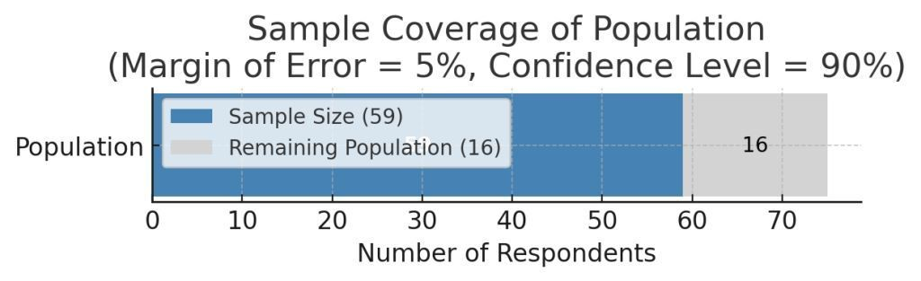
Figure 1. Active Rice Farmer Population and Recommended Sample Size for Survey Using Raosoft Sample Siza Calculator (Margin of Error = 5%, Confidence Level = 90%) in Talaingod, Davao del Norte.

Research Instrument

This study employed an organized survey questionnaire as the primary tool for collecting quantitative data from the members of the Santo Niño–Palma Gil Rice Farmers’ Association (SPRFA) in Talaingod, Davao del Norte. The questionnaire was designed to gather information on the respondents’ demographic profile as well as their perceived capacities across five domains: (1) Capacity to Navigate Complexity, (2) Capacity to Collaborate, (3) Capacity to Reflect and Learn, (4) Capacity to Engage in Strategic and Political Processes, (5) Technical Skills, and Enabling Environment (6).
The instrument was divided into two parts:
- Part I: Demographic Profile – This section included items on age, sex, educational attainment, household size, years of farming experience, farm size, and access to support services. These variables provided background information to contextualize the capacity assessment.
- Part II: Capacity Assessment – This section consisted of structured statements aligned with the five capacity domains. Respondents rated each statement using a four-point Likert scale ranging from 1 = Very little or none to 4 = Very much or fully. The Likert scale was selected for its ability to capture the intensity of perceptions, attitudes, and practices in a standardized and quantifiable manner.
The questionnaire items were adapted and contextualized from existing frameworks and studies on capacity assessment and farmer organizations (e.g., Lamm & Lamm, 2022; Ituriaga, Mariñas, & Saflor, 2024).

Data Gathering Procedure
The researcher followed systematic steps in conducting the study after the research questionnaire had undergone validation. Prior to data collection, an endorsement letter from the Professor was secured and presented to the Local Chief Executive of Talaingod, Davao del Norte, through the Municipal Agriculture Office. This served as a formal request for permission to conduct the study within the community. Once approval was granted, coordination was established with the officers of the Santo Niño–Palma Gil Rice Farmers’ Association (SPRFA) to obtain a list of active members, which was used as the basis for identifying respondents.
The researcher-made survey questionnaire, validated by experts—including faculty members, agricultural extension workers, and farmer leaders—served as the primary tool for data collection. Courtesy visits were conducted with association officers and members to explain the objectives of the study, ensure informed consent, and guarantee voluntary participation. Data were then gathered through the administration of survey questionnaires, complemented by clarifications and follow-up discussions when necessary to ensure accuracy and completeness of responses.

Procedure of the Study

The procedure of the study began with securing permission from the academic authorities and the Municipal Agriculture Office of Talaingod. Following this, coordination was made with SPRFA leaders to validate the respondents’ list and to facilitate access to participants. The research instrument underwent expert validation to ensure clarity, reliability, and appropriateness to the study objectives. The survey was then administered directly to the rice farmer respondents, with assistance provided to those who requested help in completing the questionnaire. After collection, all accomplished questionnaires were checked for completeness, systematically organized, and prepared for statistical analysis.

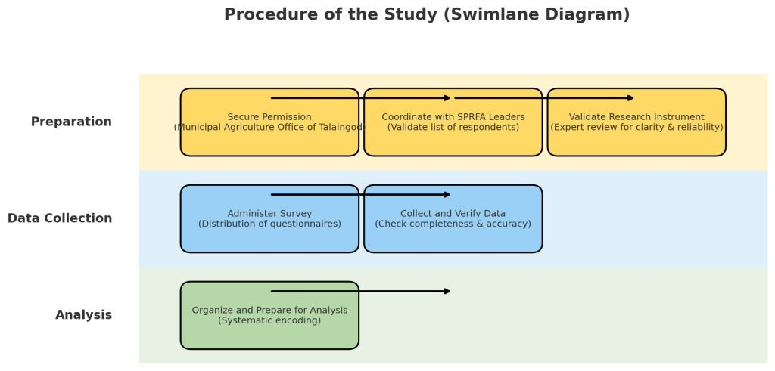

Figure 2. Research procedure showing the phases of preparation, data collection, and analysis in the capacity assessment of the Santo Niño–Palma Gil Rice Farmers’ Association (SPRFA).

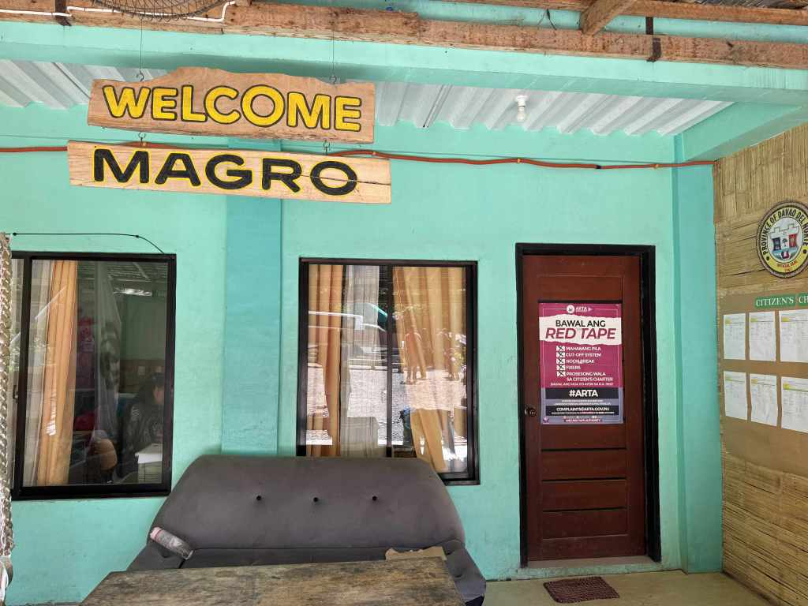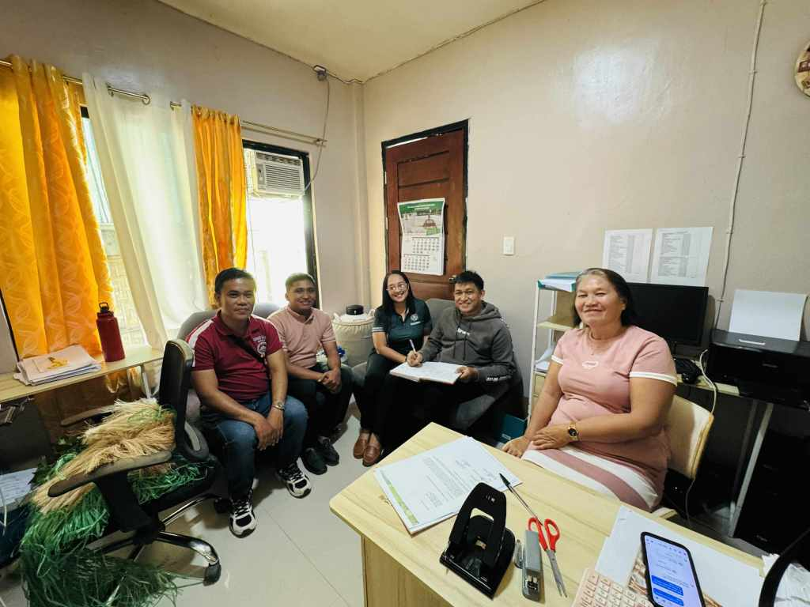
Figure 3. Courtesy call of the researcher at the Municipal Agriculture Office (MAGRO) in Talaingod, Davao del Norte, with Ms. Harren Rose T. Rosas, discussing the objectives of the study and seeking guidance to connect with the target rice farmers’ association in the rural area of Talaingod, Davao del Norte.
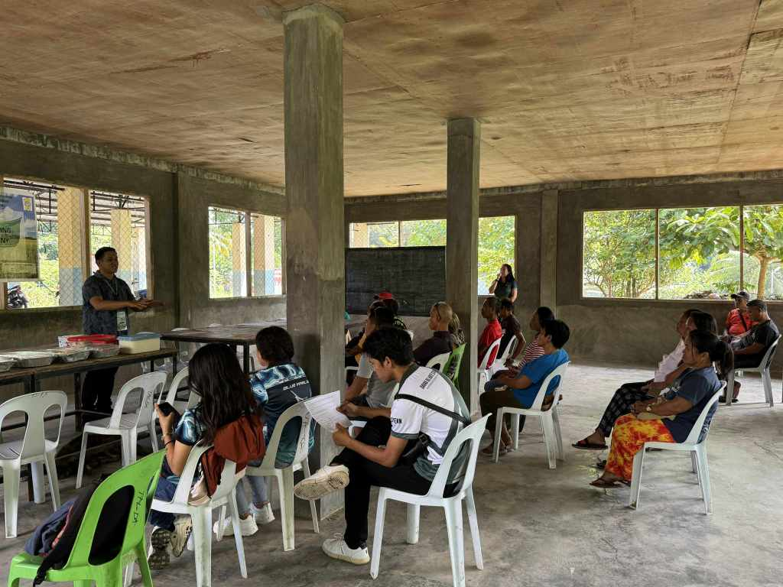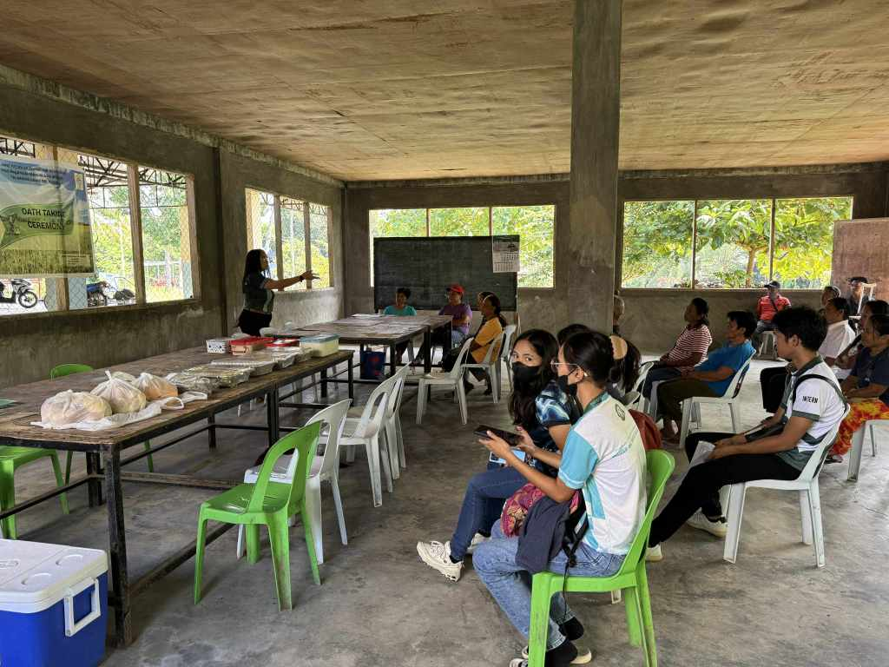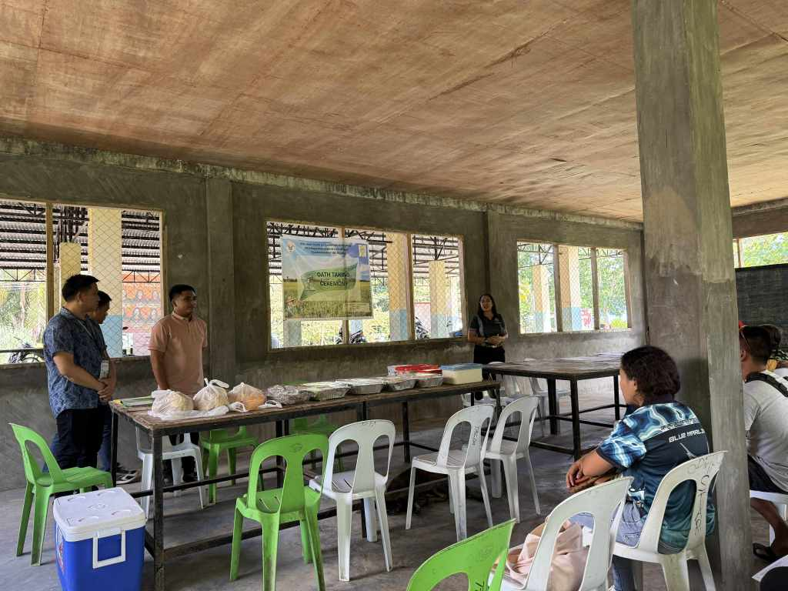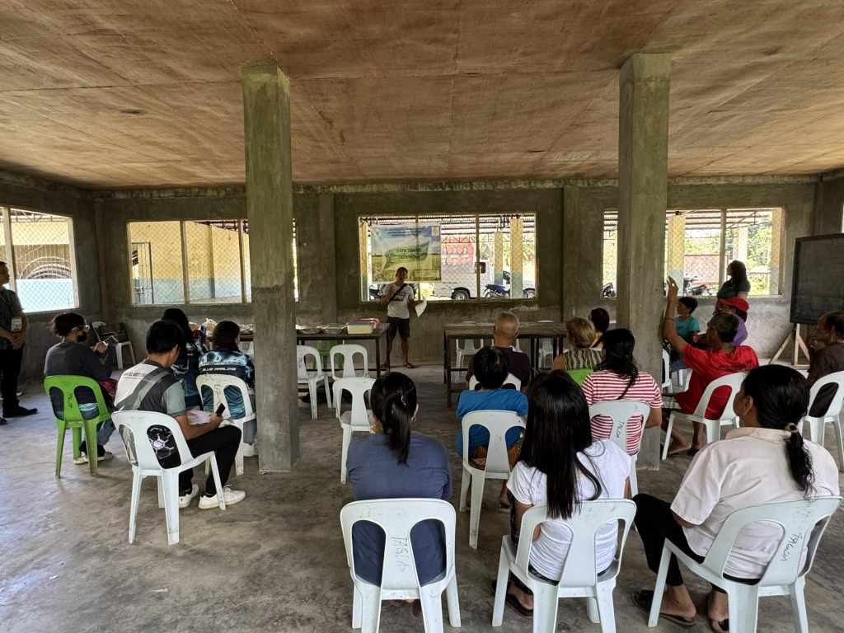
d
c
b
a
Figure 4. Orientation of the members of the SANTO NIÑO–PALMA GIL Rice Farmers’ Association (SPRFA) in Talaingod, Davao del Norte, Philippines; (a–c) researchers discussing the purpose of the study and its possible implications, and (d) a message delivered by the association president, Mr.Jyvee Nangan.
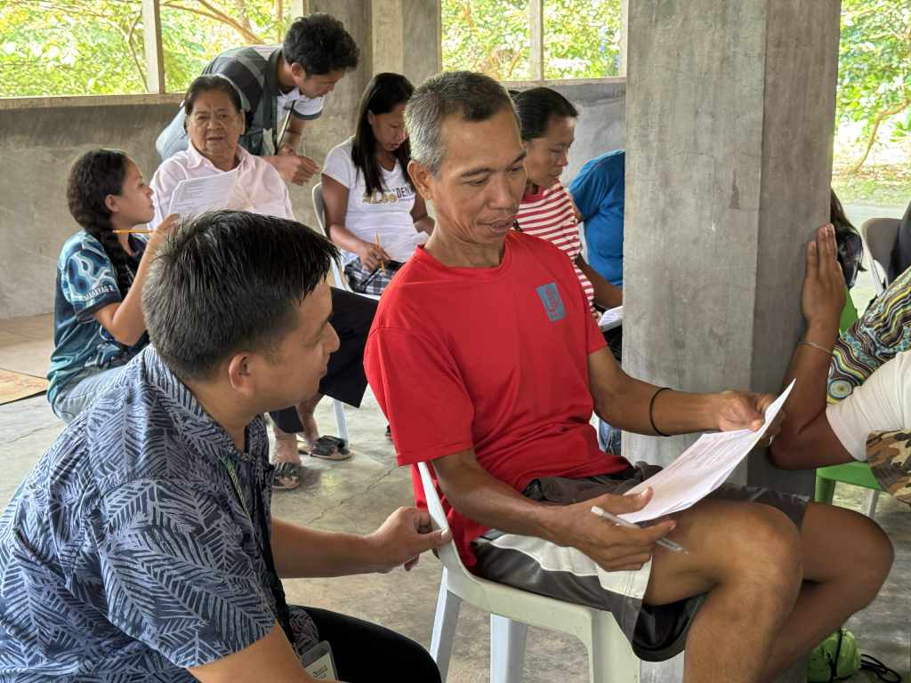
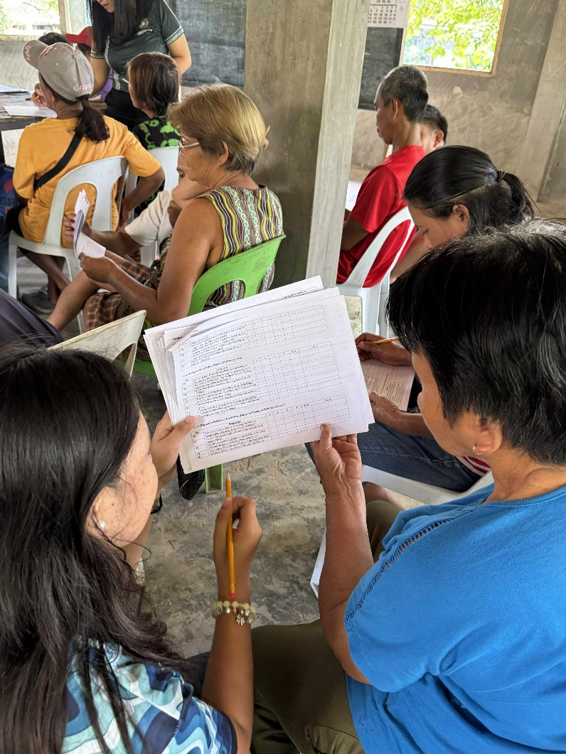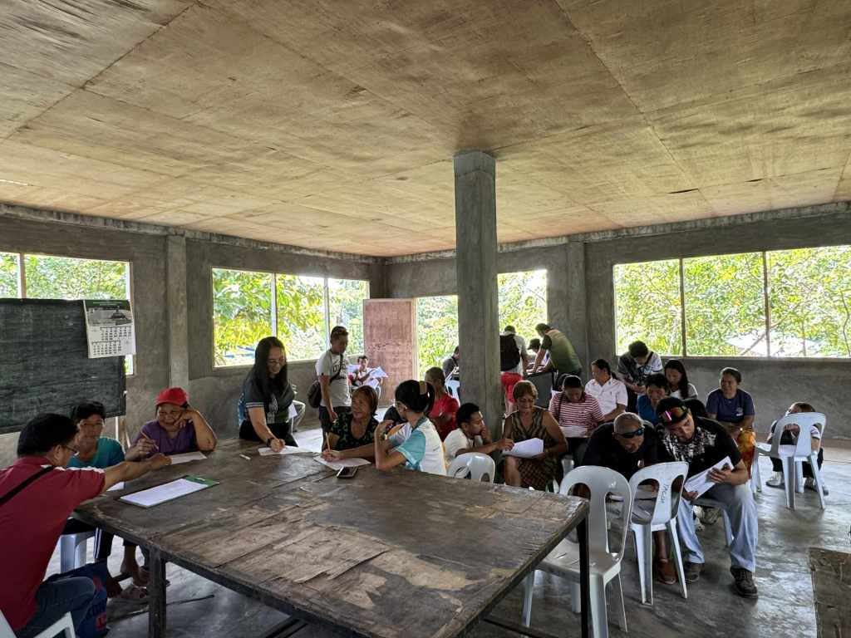
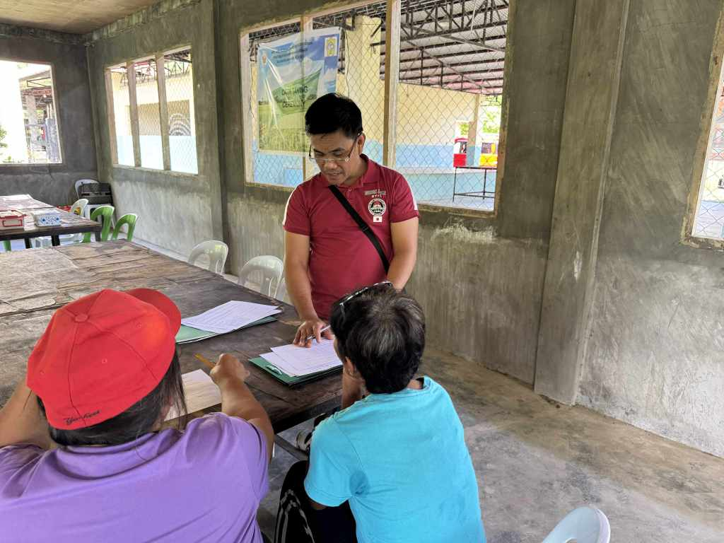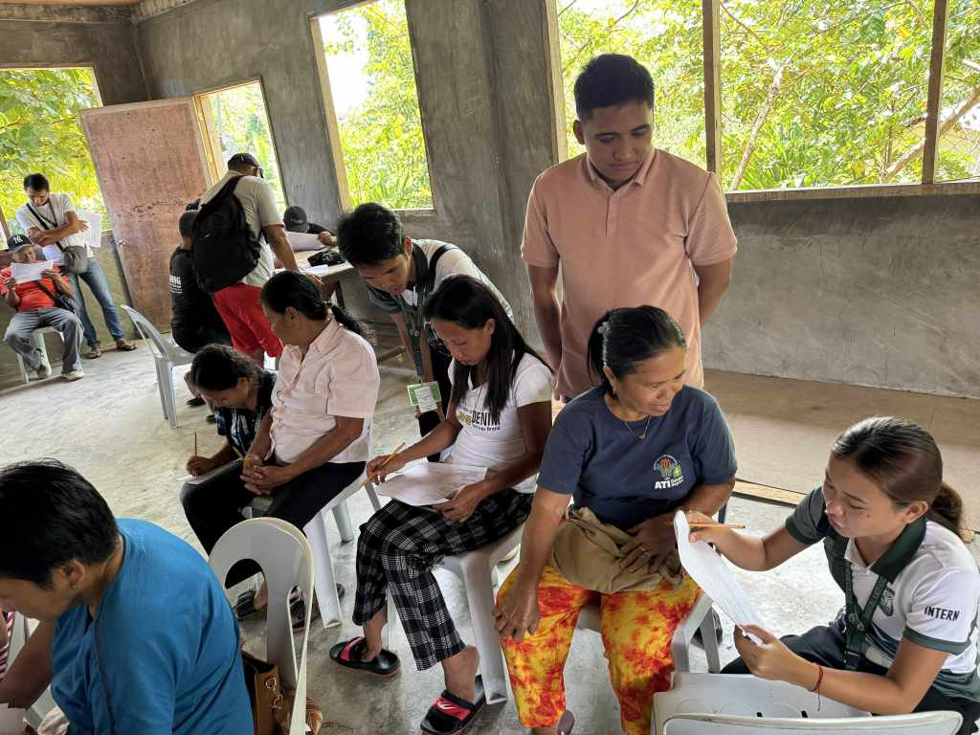
Figure 5. Farmer survey conducted among rice growers of the SANTO NIÑO–PALMA GIL Rice Farmers’ Association (SPRFA) in Talaingod, Davao del Norte, Philippines

2. RESULTS AND DISCUSSIONS
Demographic Profile (Figure 6)
The demographic profile of the Santo Niño–Palma Gil Rice Farmers’ Association (SPRFA) in Talaingod, Davao del Norte shows that farming is largely managed by older farmers, with 57% aged 61 years and above and only 2% belonging to the younger age group (18–30 years). This indicates limited youth involvement and raises concerns about generational continuity in rice farming.

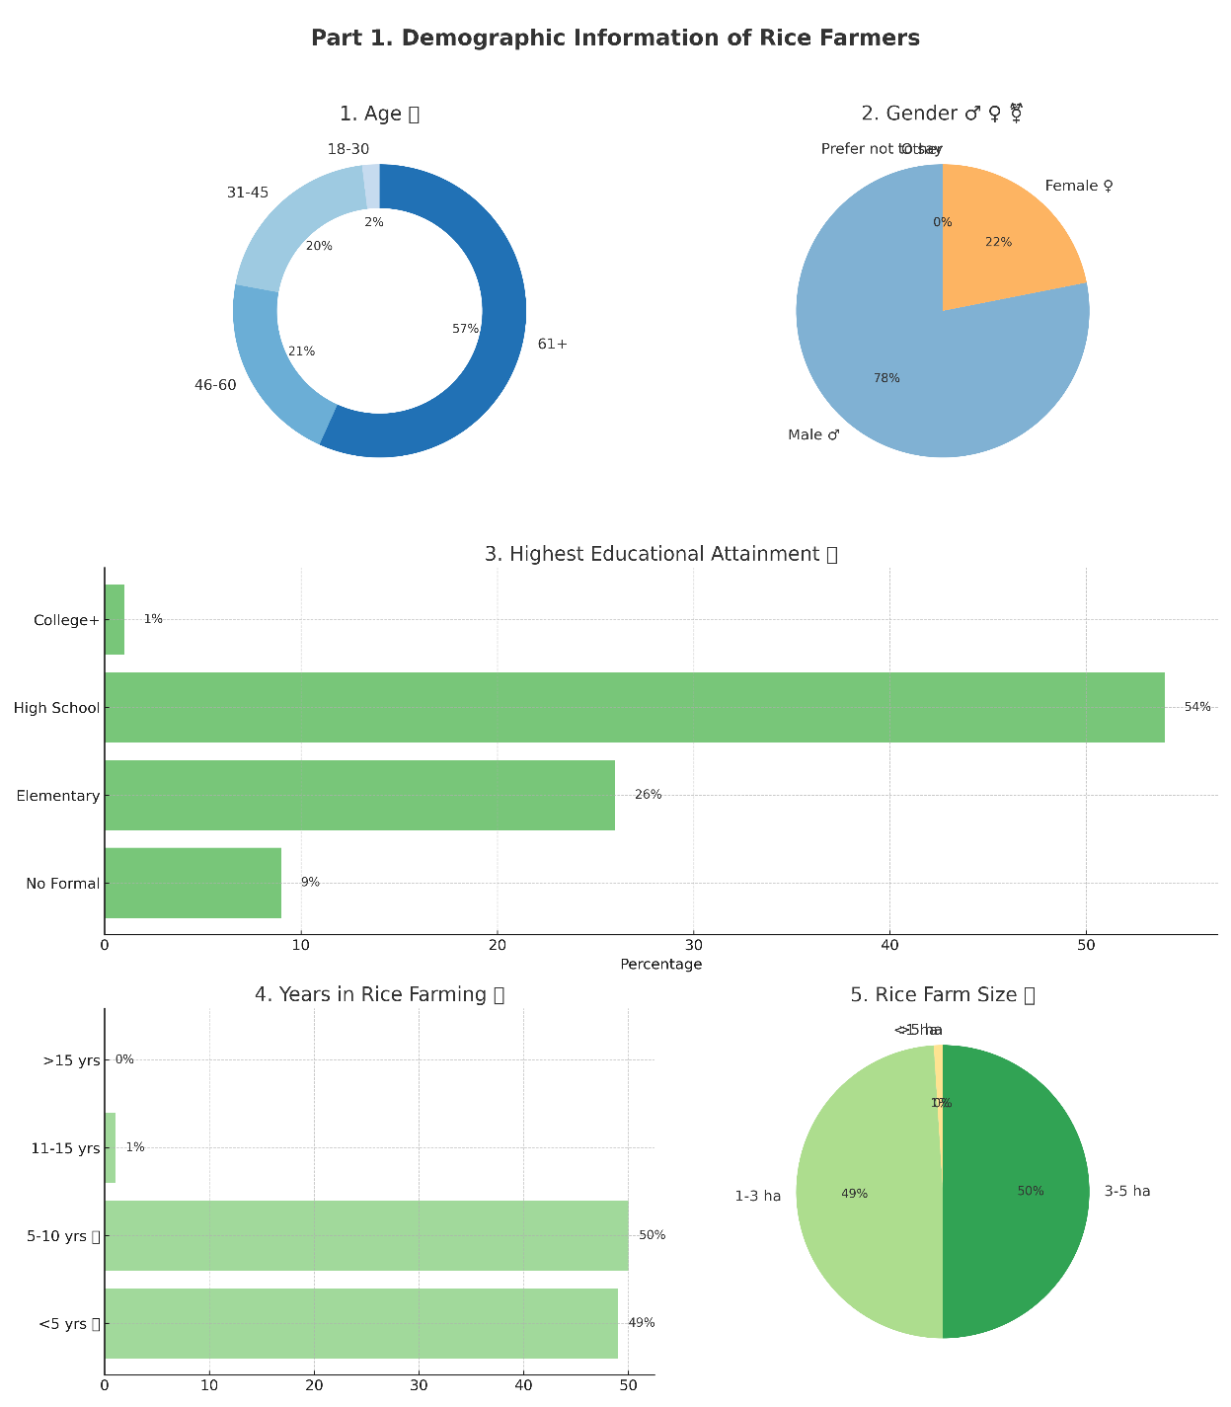

Figure 6. Demographic Information of Rice Farmers showing the age distribution, gender, highest educational attainment, years engaged in rice farming, and rice farm size (hectares) among members of the SANTO NIÑO–PALMA GIL Rice Farmers’ Association (SPRFA) in Talaingod, Davao del Norte, Philippines.
The sector is male-dominated, with 78% of members being men, while women represent only 22%, reflecting traditional gender roles in rural agriculture. Educational attainment is also limited, as more than half (54%) of members reached only high school and just 1% completed college, which may hinder their ability to adopt modern technologies. Farming experience reveals that nearly all members are relatively new in rice cultivation, with 49% engaged for less than five years and 50% for 5–10 years. Farm size is generally small, with 49% cultivating 1–3 hectares and 50% managing 3–5 hectares, leaving little room for economies of scale or mechanization.
Likewise, Cobrado and Fernandez (2025) reported similar trends among 372 small-scale banana farmers in Davao del Norte. More than half (55%) were 51 years old and above, showing that banana production is also dominated by older farmers with minimal youth participation. Men accounted for 84% of respondents, underscoring the male-dominated nature of farming in the region. Educational attainment was modest, with 52% completing secondary school and only 5% finishing college. Land tenure revealed vulnerability, as only half of the farmers owned their land while 47% were lessees, discouraging long-term investment. Farm sizes were likewise small, with 78% cultivating only 1–5 hectares, making them more exposed to income and yield losses from Panama disease (Fusarium oxysporum f. sp. cubense TR4).
Taken together, the demographic profiles of both rice and banana farmers in Davao del Norte highlight common challenges—aging farmer populations, low youth involvement, small farm sizes, and modest educational attainment. These factors limit innovation, disease management, and productivity. Addressing them requires stronger government support, training, and youth engagement programs to ensure long-term sustainability in the province’s agriculture.
Capacity Assessment (Figure 7)
The assessment of the partnership highlights varied strengths and weaknesses across six domains: navigating complexity, collaboration, reflection and learning, engagement in political processes, technical skills, and the enabling environment. These dimensions shed light on how the group manages its internal functions while interacting with broader agricultural systems.
Capacity to Navigate Complexity
Among the areas, this area received the highest ratings. Members demonstrated strong ability to mobilize resources (3.73) and to recognize and solve problems (3.72). These findings suggest that the group is able to coordinate effectively and respond to challenges that arise in daily operations. The relatively good score for management skills (3.54) further indicates that organizational structures are functioning.
Yet, weaknesses are evident in areas that involve forward-looking activities. For instance, sharing of information with outside actors such as businesses and officials was rated low (2.87). Similarly, vision building (2.92) and strategy formulation (2.90) show that long-term planning is underdeveloped. Decision-making is not yet fully inclusive, as reflected in modest scores for recognition of local knowledge (3.29) and informed participation (3.13). These results imply that while the group manages short-term issues competently, its ability to prepare for future challenges remains fragile.
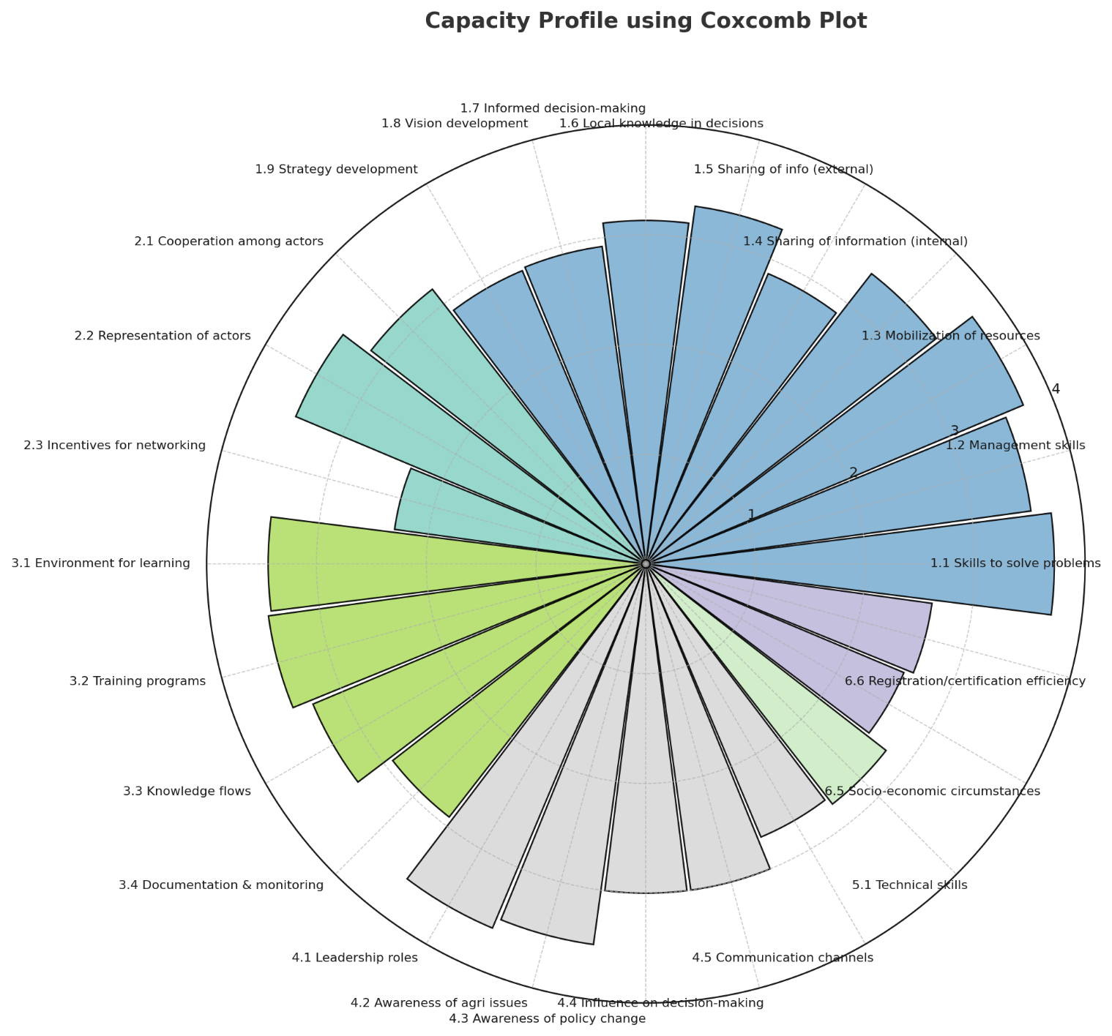Figure 7. Coxcomb Plot Illustrating the Capacity Profile of the Partnership in Navigating Complexity, Collaboration, Reflection and Learning, Strategic Engagement, Technical Skills, and Enabling Environment among members of the SANTO NIÑO–PALMA GIL Rice Farmers’ Association (SPRFA) in Talaingod, Davao del Norte, Philippines.

Capacity to Collaborate
Collaboration is moderately established. Representation of different actors in coordination (3.46) and general cooperation among members (3.17) are fairly strong. However, the lack of incentives for networking and partnership building (2.31) stands out as a barrier. Without tangible benefits for collective action, enthusiasm to collaborate is likely to remain limited. This situation risks reducing innovation and discouraging stronger ties within and outside the group.

Capacity to Reflect and Learn
This dimension shows promise. Participation in training (3.47) and the presence of an environment that fosters reflection and experimentation (3.44) indicate that the group is open to new knowledge and adaptive learning. Still, weaknesses appear in documentation and monitoring (2.92), which are essential for sustaining lessons and tracking progress. Understanding of knowledge flows (3.29) is only moderate, pointing to a need for better systems that allow knowledge to circulate and be applied effectively.

Capacity to Engage in Strategic and Political Processes
The results reveal strong internal leadership (3.6) and good awareness of agricultural development concerns (3.5). However, external engagement is limited. Scores for awareness of policy opportunities (3.0), influence in decision-making (3.0), and communication channels (2.7) highlight difficulties in making the group’s voice heard at higher levels. This lack of influence reduces opportunities to shape or benefit from policy changes and government programs. Weak communication also risks creating gaps in transparency and collective decision-making within the group.

Technical Skills
This domain scored lowest overall (2.77). Limited technical know-how hinders the adoption of improved farming practices and innovation. Without stronger technical foundations, the group will continue to face challenges in productivity and competitiveness, even if organizational capacities improve. Technical training in crop management, pest control, and postharvest handling is necessary to close this gap.

Enabling Environment
External conditions are also weak. Scores for favorable socio-economic conditions for linking producers to markets (2.55) and efficiency of agricultural registration and certification (2.63) reflect systemic obstacles that the group cannot easily control. High transaction costs, bureaucratic processes, and limited access to markets continue to constrain growth. These findings underscore the need for supportive policies and collaboration with government and private institutions to create a more enabling environment.
Synthesis
The results portray a partnership that is functional internally but constrained externally. Strengths include resource mobilization, leadership, training participation, and problem-solving, while the most pressing weaknesses lie in technical capacity, external linkages, strategic foresight, and enabling conditions.
For the group to move from “mainly” to “very much or fully,” several interventions are needed:
- Strengthening technical skills through targeted training.
- Building stronger linkages with government, private sector, and research bodies.
- Institutionalizing monitoring and documentation to secure organizational learning.
- Developing better communication and advocacy to improve representation and influence.
- Creating incentives for collaboration so members see clear benefits from working together.
- Addressing systemic barriers by engaging policymakers to simplify certification and enhance market access.

Implications
The findings point to both opportunity and risk. The group’s commitment to learning and leadership provides a solid base for growth. However, unless external linkages and technical competencies are strengthened, the partnership may remain limited to subsistence-level operations. Building both internal and external capacities is crucial if the group is to play a meaningful role in advancing agricultural sustainability, improving livelihoods, and ensuring resilience in the face of socio-economic and environmental pressures.

COMPETING INTERESTS DISCLAIMER:
Authors have declared that they have no known competing financial interests OR non-financial interests OR personal relationships that could have appeared to influence the work reported in this paper.

References
Ali, S., Liu, Y., Ishaq, M., Shah, T., Ilyas, A., & Din, I. U. (2021). Farmers’ climate change adaptation strategies for sustainable rice production: A case from Pakistan. Agronomy, 11(3), 600. https://doi.org/10.3390/agronomy11030600
Arbes, J. L., Villaremo, M. A., Cabañog, R. A., Escobar, L. A., Mindal, M. G., & Amilbahar, G. V. (2024). Impact assessment of the Rice Competitiveness Enhancement Fund (RCEF) mechanization program on the agricultural productivity among rice farmers in a selected barangay in Davao del Norte. Business Fora: Business and Allied Industries International Journal. https://doi.org/10.62718/vmca.bf-baiij.3.1.SC-1124-001
Boone, H. N., & Boone, D. A. (2021). Analyzing Likert data. Journal of Extension, 59(2). https://tigerprints.clemson.edu/joe/vol59/iss2/16
Bueno, D. C., & Padawil, A. T. (2025). Multi-stakeholder analysis of rice farming attitudes, practices, training needs and constraints in sustaining local agriculture program in the province of Zambales. IMRaD Journal, 7(1). https://doi.org/10.13140/RG.2.2.12346.50889
Creswell, J. W., & Creswell, J. D. (2018). Research design: Qualitative, quantitative, and mixed methods approaches (5th ed.). SAGE Publications. https://edge.sagepub.com/creswellrd5e
Cobrado, J. S., & Fernandez, A. M. (2025). Impact of Panama disease of banana caused by Fusarium oxysporum f. sp. cubense TR4 on banana growers. Asian Research Journal of Agriculture, 18(3), 412–423. https://doi.org/10.9734/arja/2025/v18i3750
Department of Agriculture. (2021). Mindanao Inclusive Agriculture Development Project (MIADP) – Environmental and Social Management Framework. Department of Agriculture & World Bank. https://www.da.gov.ph/wp-content/uploads/2021/10/MIADP-P173866-ESMF-10-2021.pdf
Dorvlo, S. Y., Baffoe, G., Jew, E. K. K., Mkandawire, E., & Dougill, A. J. (2025). Improving stakeholder collaboration for sustainable agricultural mechanisation in rice production: A case study from Asutsuare, Ghana. SN Applied Sciences, 7, 532. https://doi.org/10.1007/s42452-025-07542-9
Hosonuma, K., et al. (2024). Evaluation of geographical and annual changes in rice cultivation using MODIS LAI data in the Candaba Swamp, Philippines. Remote Sensing, 16(3), 499. https://doi.org/10.3390/rs16030499
Ituriaga, J., Mariñas, K. A., & Saflor, C. S. (2024). Enhancing government services to rice farmers in the Philippines: A service quality–sustainability-focused approach for long-term agricultural resilience. Sustainability, 16(18), 8108. https://doi.org/10.3390/su16188108
Jalotjot, H. C., & Tokuda, H. (2024). Exploring smallholder farmers’ open innovation capability: A structural equation modeling approach. Journal of Open Innovation: Technology, Market, and Complexity, 10(3), 99. https://doi.org/10.1016/j.joitmc.2024.100099
Lamm, K. W., & Lamm, A. J. (2022). Identifying respondent group representation in extension capacity assessments. Journal of International Agricultural and Extension Education, 29(4), 63–77. https://newprairiepress.org/jiaee/vol29/iss4/6
Methamontri, Y., Mughwai, H., Nanseki, T., & Chomei, Y. (2022). Factors influencing participation in collective marketing among organic rice farmer groups. Organic Agriculture, 12(3), 329–343. https://doi.org/10.1007/s13165-021-00391-5
Panpakdee, C., Sooksa-nguan, T., & Krey, R. (2025). Definitions of resilience in organic rice farming: A systematic review. Discover Sustainability, 6, 68. https://doi.org/10.1007/s43621-025-01200-1
Sullivan, G. M., & Artino, A. R. (2020). Analyzing and interpreting data from Likert-type scales. Journal of Graduate Medical Education, 5(4), 541–542. https://doi.org/10.4300/JGME-5-4-18
Taherdoost, H. (2022). Validity and reliability of the research instrument: How to test the validation of a questionnaire/survey in research. SSRN Electronic Journal. https://doi.org/10.2139/ssrn.4126401
University of the Philippines Center for Integrative and Development Studies (UP CIDS). (2025). How do local governments in the Philippines lead inclusive and competitive agriculture value chains? https://cids.up.edu.ph/discussion_paper/how-do-local-governments-in-the-philippines-lead-inclusive-and-competitive-agriculture-value-chains/

