Beyond The Bed and Walls: Boarding Houses Living Conditions of Apayao State College- Conner Campus

.
ABSTRACT

Student housing plays a vital role in shaping the academic success and personal well-being of college students, especially in rural and semi-urban settings. At Apayao State College – Conner Campus, boarding houses serve as long-term residences for many students, making their living conditions a key factor in their educational journey. This study explores the living conditions of students residing in boarding houses near Apayao State College – Conner Campus. Mixed-method approach using an adapted survey questionnaire was used to gather the research data. Frequency and percentage, weighted mean, and thematic analysis was used to interpret data. Findings show that students are generally satisfied with their boarding environments, particularly in terms of hygiene, proximity to campus, and basic utilities. However, areas such as surveillance, emergency water access, and weather-related infrastructure require improvement. Based on student feedback, the study proposes practical recommendations to enhance boarding house conditions, including improved safety measures, better transport coordination, and access to essential services. These findings underscore the critical role of student housing in supporting academic performance, health, and overall well-being.

Keywords: Boarding house, living condition, students

1. INTRODUCTION

The increasing number of students residing in boarding houses near Apayao State College – Conner Campus highlights the critical need to examine the quality of these living environments and their impact on student well-being. As many students come from remote areas, boarding houses become their primary residence during the academic year. These accommodations vary widely in terms of safety, sanitation, space, and access to basic amenities, which can significantly influence students’ physical and mental health, academic performance, and overall college experience. According to Reyes II (2016), the kind of boarding house a student lives in can either support or hinder their academic success, depending on the comfort, safety, and conduciveness of the environment.

Living away from family and familiar support systems can lead to feelings of isolation, stress, and anxiety among students. Boarding houses that lack proper facilities, privacy, or security may exacerbate these challenges. A study by Gbadegesin (2021) emphasized that improvements in boarding house regulations and living conditions are essential to support students’ well-being and academic success. Furthermore, Cubero et. al, (2024) emphasized that the absence of standardized policies and contracts between landlords and boarders, as observed in similar studies, can lead to misunderstandings and neglect of student welfare. This research seeks to investigate how these environmental factors affect students’ emotional, social, and academic dimensions of well-being.

The rationale for this study is also grounded in Maslow’s Hierarchy of Needs, which posits that individuals must satisfy basic physiological and safety needs before achieving higher levels of motivation and self-actualization (Sowmya, & Anokha, 2025). Boarding houses that fail to meet these foundational needs such as clean water, secure premises, and adequate space can hinder students’ ability to focus, engage, and thrive academically (Brilliantes et. al, 2012). Studies conducted in other Philippine universities have shown that students living in poorly maintained boarding houses often experience stress, poor sleep quality, and reduced academic performance4. By applying this theoretical framework, the study aims to highlight the importance of holistic support systems in student housing.

Moreover, this research addresses a gap in localized data specific to Apayao State College – Conner Campus. While national and regional studies have explored boarding house conditions, few have focused on the unique challenges faced by students in this institution. The findings will provide evidence-based insights that can inform policy development, institutional interventions, and community partnerships aimed at improving student accommodations. As highlighted by Arroyo (2023), understanding the relationship between housing conditions and academic outcomes is vital for educational planning and support services.

Aligned with global development efforts, this study contributes to the realization of several Sustainable Development Goals (SDGs). Specifically, it responds to SDG 3 (Good Health and Well-being) by promoting healthier living environments; SDG 4 (Quality Education) through improved housing that supports academic success; and SDG 11 (Sustainable Cities and Communities) by advocating safe and inclusive student accommodations.

Ultimately, this study aspires to go “beyond the bed and walls” by recognizing that student well-being is shaped not only by academic instruction but also by the environments in which students live and grow. By examining both student and boarding house owner perspectives, the research will offer a comprehensive view of current conditions and propose actionable recommendations to enhance the quality of student life. The results will be valuable to school administrators, local government units, and boarding house operators committed to fostering safe, supportive, and student-cantered living spaces.

2. methodology

2.1. Research Design
This study was utilized through mixed-method approach using an adapted survey questionnaire (Reyes, 2016) to gather the research data.

2.2. Locale of the Study
This study was conducted at Apayao State College - Conner Campus and the nearby barangays with boarding houses.

2.3. Respondents of the Study
The respondents of this study are the students who were residing in boarding houses near Apayao State College-Conner Campus. Stratified random sampling was used.

2.4. Research Instrumentation
An adapted survey questionnaire (Reyes, 2016) was used to gather the research data. It was composed of 3 parts: Part I elicited the profile of the respondents; Part II measured the condition of the boarding houses based on students’ assessment, and Part III was for the recommendations.

2.5. Data Gathering Procedures
Survey questionnaires were distributed in person and, where necessary, via digital platforms (e.g., email or Google Forms) to accommodate students with limited physical access. Respondents were given clear instructions and assured of confidentiality and voluntary participation. Data were tallied, tabulated and interpreted.

2.6. Statistical Analysis

Frequency and percentage were used to compute for the demographic profile of the respondents.

Weighted mean was used to measure the level condition of the boarding houses based on students’ assessment using 5 Point-Likert scale:

Table 1. 5 Point-Likert scale
SCALE | MEAN RANGE | DESCRIPTIVE INTERPRETATION
5 | 4.20 – 5.00 | Very Satisfied
4 | 3.40 – 4.19 | Satisfied
3 | 2.80 – 3.39 | Neutral
2 | 1.80 - 2.79 | Dissatisfied
1 | 1.00 – 1.79 | Very Dissatisfied

Thematic analysis was used for the recommendations of the respondents.

3. results and discussion

  - Profile of the respondents

Table 2. Profile of the respondents
 | Frequency | Percentage
Sex
Male | 91 | 55%
Female | 74 | 45%
 | 165 | 100
Age
20 years and below | 78 | 47.27%
21 years old | 31 | 18.79%
22 years old | 31 | 18.79%
23 years old | 12 | 7.27%
24 years old | 8 | 4.85%
26 years and above | 5 | 3.03%
 | 165 | 100
Year Level
1st year | 20 | 12.12%
2nd year | 50 | 30.30%
3rd year | 83 | 50.30%
4th year | 8 | 4.85%
5th year | 4 | 2.42%
 | 165 | 100
Department
BSC | 50 | 30.30%
BSE | 20 | 12.12%
BEED | 15 | 9.09%
BSCE | 10 | 6.06%
BSBA | 25 | 15.15%
BSA | 8 | 4.85%
BSIT | 12 | 7.27%
BSICT | 5 | 3.03%
BSHM | 10 | 6.06%
BSTM | 10 | 6.06%
 | 165 | 100

Table 2 presents a demographic profile of 165 student respondents, revealing that the majority are male (55%), aged 20 and below (47.27%), and predominantly third-year students (50.30%) enrolled in the Bachelor of Science in Criminology program (30.30%). This data provides a foundational understanding of the students’ backgrounds, which is crucial when assessing how boarding house conditions may affect their academic and personal well-being.
A related study by Arroyo (2023) at Central Mindanao University found that students’ academic performance is significantly influenced by the quality of their boarding house environment including factors like sanitation, safety, and accessibility which aligns with the need to evaluate and improve student housing conditions at Apayao State College. These findings suggest that institutional support and regulation of boarding facilities can play a vital role in enhancing student success and well-being.

Graph 1. Duration of stay in the boarding house
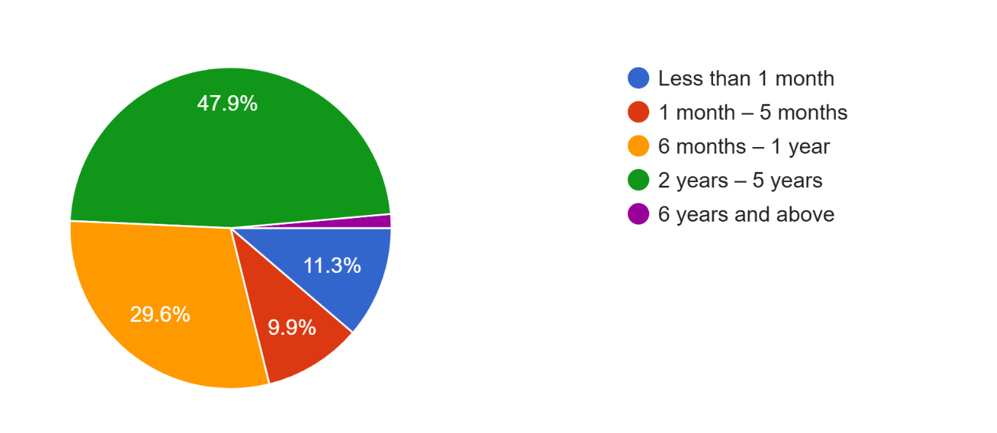
1.8%

Graph 1 reveals that nearly half of the student respondents (47.9%) have stayed in boarding houses for 2 to 5 years, indicating a long-term reliance on these accommodations throughout their college journey. This suggests that boarding houses are not just transitional spaces but integral to students’ academic lives. The extended duration of stay may reflect both necessity and comfort, as students adapt to independent living while pursuing their education.
According to Lovitos, 2019, prolonged residence in boarding houses fosters greater self-sufficiency and maturity among students, contributing positively to their college preparedness and personal development. This aligns with the findings from Apayao State College, where long-term boarding appears to be a norm rather than an exception.

Graph 2. Type of accommodation
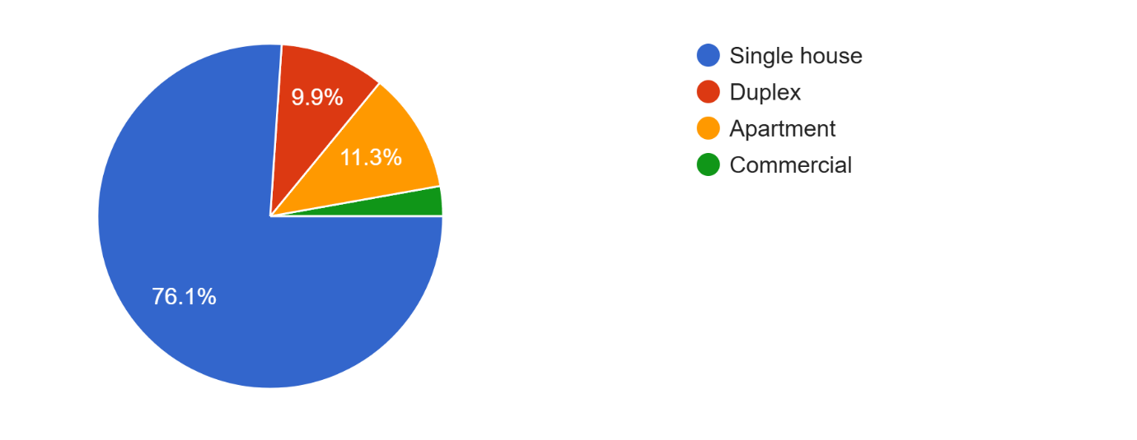
2.8%

Graph 2 indicates that 76.1% of students reside in single houses, making it the most common accommodation type among Apayao State College students. This preference reflects the cultural and economic realities of student life in rural and semi-urban areas, where single-house boarding setups are often family-run and more affordable are more accessible than apartments or commercial lodgings. Duplexes and apartments are less common, likely due to higher rental costs or limited availability. Commercial accommodation, used by only 2.8% of respondents, may offer more amenities but are likely out of reach for most students financially.
According to Nobis, 2022 students often prioritize proximity to school, affordability, and basic amenities when choosing housing, making single-house boarding a practical and popular choice for those on a budget.

  - Assessment of the Condition of the Boarding Houses

Table 3. Cleanliness And Sanitation
Statement | Mean | Interpretation
- The common areas (e.g., kitchen, hallway, living space) are cleaned regularly and kept tidy. | 4.15 | Satisfied
- The bathroom and toilet facilities are hygienic and properly maintained. | 3.84 | Satisfied
- Trash bins are available, emptied regularly, and waste disposal is properly managed. | 3.94 | Satisfied
- The boarding house has adequate ventilation that helps maintain air cleanliness. | 4.08 | Satisfied
- Cleaning supplies and disinfectants are accessible for personal and shared use. | 3.92 | Satisfied
- There are no unpleasant odors in the boarding house due to poor sanitation. | 3.91 | Satisfied
- The boarding house management enforces cleanliness rules among tenants. | 4.35 | Very Satisfied
Overall Mean | 4.02 | Satisfied

The data in Table 3 shows that students residing in boarding houses at Apayao State College – Conner Campus are generally satisfied with the cleanliness and sanitation of their living spaces, with an overall mean score of 4.02. The highest-rated aspect was the enforcement of cleanliness rules by management (4.35, “Very Satisfied”), indicating strong institutional efforts to maintain hygiene standards. Other areas such as ventilation, waste disposal, and bathroom maintenance also received favorable ratings, suggesting that the boarding houses provide a clean and health-conscious environment.
This aligns with the findings of Arroyo (2023), which concluded that satisfactory living conditions including sanitation, safety, and cleanliness, positively influence students’ academic performance and well-being. The connection between a clean-living space and academic success underscores the importance of maintaining high standards in student accommodation to foster both comfort and productivity.

Table 4. Water Supply
Statement | Mean | Interpretation
- The boarding house provides a consistent and uninterrupted water supply throughout the day. | 4.12 | Satisfied
- Water pressure in the bathroom, laundry and kitchen is sufficient for daily use. | 4.00 | Satisfied
- Drinking water is clean, safe, and readily available. | 3.77 | Satisfied
- The water supply system is well-maintained and free from leaks or damage. | 3.95 | Satisfied
- Water used for bathing and washing is clean and free from foul odor or discoloration. | 4.00 | Satisfied
- The boarding house provides alternative water sources (e.g., storage tanks) during supply interruptions. | 3.70 | Satisfied
Overall Mean | 3.92 | Satisfied

Table 4 reveals that students at Apayao State College – Conner Campus are generally satisfied with the water supply conditions in their boarding houses, with an overall mean score of 3.92. The highest-rated item was the consistency of water availability throughout the day (4.12), while the lowest was the provision of alternative water sources during interruptions (3.70), suggesting room for improvement in contingency planning. Clean and safe water for drinking, bathing, and daily use was rated positively, indicating that basic water needs are being met.
This aligns with the findings of Nobis (2022) which highlighted that while students were generally satisfied with their boarding conditions, inadequate and unsafe water supply was a recurring issue that negatively impacted their comfort and academic focus. The connection between reliable water access and student well-being underscores the importance of maintaining efficient water systems in boarding houses to support both health and learning outcomes.

Table 5. Safety And Security
Statement | Mean | Interpretation
- The boarding house has secure locks on doors and windows. | 4.28 | Very Satisfied
- Emergency exits and safety procedures are clearly communicated and accessible. | 3.85 | Satisfied
- The boarding house is equipped with basic safety features (e.g., fire extinguisher, first aid kit). | 3.47 | Satisfied
- Visitors and outsiders are properly monitored or restricted by the management. | 4.14 | Satisfied
- There are CCTVs, lighting in hallways, entrances, and outdoor | 2.97 | Neutral
- Curfew hours are properly observed | 3.83 | Satisfied
- Liquor and cigarette use are strictly prohibited in the boarding house. | 3.84 | Satisfied
- Presence of landlady/landlord is always assured | 4.02 | Satisfied
Overall Mean | 3.80 | Satisfied

Table 5 indicates that students at Apayao State College – Conner Campus are satisfied with the safety and security measures in their boarding houses, with an overall mean score of 3.80. The highest-rated item was the presence of secure locks on doors and windows (4.28, “Very Satisfied”), while the lowest was the availability of CCTVs and lighting in key areas (2.97, “Neutral”), suggesting a need for improvement in surveillance and visibility. Other aspects such as curfew enforcement, visitor monitoring, and landlord presence were rated positively, reflecting a generally safe environment.
This supports the findings of Mubita et al. (2022), the study found that while some safety measures were in place, many boarding houses lacked essential features such as proper ventilation, fire safety equipment, and adequate lighting, which posed risks to student health and security. The researchers emphasized that a safe and healthy living environment is crucial for meaningful learning, echoing UNICEF’s assertion that academic attainment is closely tied to the quality of educational spaces.

Table 6. Accessibility
Statement | Mean | Interpretation
- The boarding house is within reasonable walking distance from the campus. | 4.09 | Satisfied
- Public transportation options near the boarding house are convenient and reliable. | 3.73 | Satisfied
- Nearby access to essential services (e.g., stores, clinics, eateries) is convenient. | 4.00 | Satisfied
- The entrance and pathways inside the boarding house are easy to move through, even with belongings. | 4.01 | Satisfied
- The boarding house is accessible during all weather conditions (e.g., rain, flooding). | 3.92 | Satisfied
- The boarding house has clear signage or directions for first-time visitors. | 3.92 | Satisfied
Overall Mean | 3.94 | Satisfied

Table 6 shows that students at Apayao State College – Conner Campus are generally satisfied with the accessibility of their boarding houses, with an overall mean score of 3.94. The highest-rated item was proximity to campus (4.09), indicating that most students live within reasonable walking distance, which likely contributes to reduced transportation costs and improved punctuality. Accessibility to essential services and ease of movement within the boarding house also received favorable ratings, while public transportation and weather-related access scored slightly lower, suggesting areas for improvement.
These findings align with the international study by Ying et al. (2023), which found that accessibility, especially to school, food, and health services was a key factor in students’ academic focus and independence. The study emphasized that accessible housing not only supports logistical convenience but also enhances students’ motivation and time management. This connection reinforces the importance of strategically located and well-connected boarding houses in promoting academic success and student well-being.

Table 7. Recommendations of the students to improve the conditions of boarding houses
Themes | Student Recommendations
Proximity & Location | Encourage campus partnerships with nearby landlords to prioritize student housing and develop a map of verified boarding houses within walking distance
Transportation Access | Improve coordination with local transport providers for student-friendly schedules and advocate for shuttle services during peak hours
Essential Services | Promote development of mini-marts, clinics, and eateries near boarding zones
Mobility Inside Boarding House | Require landlords to maintain clear, unobstructed pathways
Weather Resilience | Install elevated walkways or drainage systems to prevent flooding and encourage roofing and pathway improvements for rainy conditions
Signage & Wayfinding | Add visible signage and room labels for easier navigation and include digital maps or QR codes for first-time visitors

Table 7 proposed several practical recommendations to improve boarding house conditions, focusing on proximity, transportation, essential services, mobility, weather resilience, and signage. These suggestions aim to enhance comfort, safety, and accessibility, which are crucial for academic success.
These insights are supported by Arroyo (2023), whose study at Central Mindanao University found that satisfactory living conditions including accessibility, safety, and sanitation significantly influenced students’ academic performance and well-being.

4. Conclusion

The findings of this study reveal that boarding houses play a vital role in the academic and personal lives of students at Apayao State College – Conner Campus, with most respondents relying on these accommodations for multiple years. Overall, students expressed satisfaction with key aspects of their living conditions, including cleanliness, water supply, safety, and accessibility, though areas such as surveillance, contingency water sources, and weather-related access require improvement. The demographic profile highlights a predominantly young, male, and third-year student population, primarily enrolled in the Criminology program, residing in single-house setups due to cultural and economic factors. Student recommendations emphasize the need for enhanced infrastructure, better transport coordination, and improved access to essential services, underscoring the importance of responsive and student-centered housing policies. These insights affirm that well-maintained and accessible boarding houses contribute significantly to students’ academic performance, health, and overall well-being.

DISCLAIMER (ARTIFICIAL INTELLIGENCE)

I acknowledge that I have not used ChatGPT or Copilot for refining some of the sections in the document.

Consent (WHEREVER applicable)

I affirm that the respondents voluntarily agreed to participate after being fully informed about the purpose, nature, and potential implications of the study. Their responses have been collected with utmost respect for their privacy and confidentiality, in accordance with ethical research guidelines.

Ethical approval (WHEREVER applicable)

The study was conducted with approval and in accordance with the standards of the college. No ethical approval was required, as the research followed all applicable ethical guidelines, ensuring respect for the respondents' privacy and confidentiality

COMPETING INTERESTS DISCLAIMER:
Authors have declared that they have no known competing financial interests OR non-financial interests OR personal relationships that could have appeared to influence the work reported in this paper.

References

- Abagon, B. S. (2022). Teacher Education Students Living in Boarding House/Dormitories. American Journal of Humanities and Social Sciences Research, (5).
- Andren, Z. S., Gabio, O. F. M., Garzon, C. D., Lacbayan, F. V. G., Liboon, D. M., & Pabalinas, G. H. A. (2024). THE COPING SELF-EFFICACY OF STUDENTS LIVING IN BOARDING HOUSES. Ignatian International Journal for Multidisciplinary Research, 2(4), 643-654.
- Araña, R. V. E (2015). Living Conditions of Iligan Capitol College Students in their Boarding Houses.
- Arroyo, R. A. (2023). Living Conditions and Academic Performance of Students Occupying Boarding Houses in Northern Mindanao. CMU Journal of Science, 27(1), 5-14.

- Brilliantes, R. A., Aga, N. B., Tipace, F. C., Adegue, C. A., Perez, M. P., Aya-ay, A. M., & Sagarino, E. V. (2012). The living conditions of university students in boarding houses and dormitories in Davao City, Philippines. Int Peer Rev J, 1, 66-85

- Cubero, G. D., Bayo, R., Wales, W. D., & Ladesma, R. (2024). Living condition of off-campus housing accommodation: Students' qualitative perceptions. Psychology and Education: A Multidisciplinary Journal, 27(9), 1002–1014. https://doi.org/10.5281/zenodo.14061470

- Decena, R. J. S. (2015). The influence of living conditions of boarding houses and dormitories on the well-being of the state university students. IAMURE International Journal of Education, 15(1), 1-1.

- Gbadegesin, J. T., Komolafe, M. O., Gbadegesin, T. F., & Omotoso, K. O. (2021). Off-campus student housing satisfaction indicators and the drivers: From student perspectives to policy re-awakening in governance. Journal of Human Behavior in the Social Environment, 31(7), 889-915.

- Lovitos, A. H. R. (2019). Quality living conditions and the boarding preferences of UM college students. International Journal of Humanities, Arts and Social Sciences, 5(2), 54.
- Mubita, K., Milupi, I., Daka, I., Nalwamba, M., Lungu, V., Luwi, P., ... & Mundende, K. (2022). An Assessment of Safety and Health Issues in Selected Students’ Boarding Houses of Lusaka City. International Journal of Social Science and Education, 2(8), 323-329.
- Nobis Jr, M. L. (2022). Status of Students’ Boarding Houses in the University of Eastern Philippines, Laoang Campus. Asian Journal of Research in Education and Social Sciences, 4(1), 113-126.
- Reyes, P. P. (2016). Profile of boarding houses of students of the Kalinga-Apayao state college. International Journal of Advanced Research in Management and Social Sciences, 5(6), 1-14.
- Sowmya, D. S., & Anokha, V. (2025). Maslow's Hierarchy of Needs. In Coaching in Communication Research (pp. 117-140). IGI Global Scientific Publishing.

- Waheed, S. A., Gilani, N., Raza, M., & Sharif, S. (2022). Understanding Students' Experiences of Lived Space in Schools: A Phenomenological Perspective. Journal of Research and Reviews in Social Sciences Pakistan, 5(2), 1764-1776.

- Ying, B. O. N. G., Kamarazaly, M. A., Ibrahim, F. I., & Harun, H. (2023). Living in off-campus student housing: Analysis on the satisfaction level related to environmental and physical aspects. Journal of Engineering Science and Technology S, 4, 156-164.

