Original Research Article

The Role of Chemical Teaching Aids and Learning Resources in Building Students' Knowledge Construction

.
ABSTRACT

Student knowledge development can be influenced by many factors, one of which is the use of teaching aids and the availability of learning resources. The purpose of this study was to measure the relationship between the use of teaching aids and learning resources on students' ability to construct knowledge on atomic structure material. The method used in this study was a quasi-experimental method with a correlation approach. The results of this study show that the correlation value between the use of teaching aids and learning resources is 0.52. The correlation value between the use of teaching aids and the ability to construct knowledge is 0.452. Meanwhile, the significance value (p<0.05) indicates that there is a relationship between the use of teaching aids and learning resources and the ability to construct knowledge. The conclusion of this study is that there is a relationship between the use of teaching aids and learning resources and the ability to construct knowledge.

Keywords: [Using Teaching Aids, Learning Resources, Ability to Construct Knowledge, Chemistry Learning, Atoms Subject}

1. INTRODUCTION
The ability to construct knowledge is an individual's ability to actively build or form new knowledge based on previous experiences, interactions, and understanding (Zabolotna et al., 2023). This means that knowledge is not something that is passively received from outside, but rather the result of an active cognitive process in which individuals interpret, organise, and compile information into a complete and meaningful understanding for themselves. This process involves several abilities such as remembering experiences, comparing information to find similarities and differences, and evaluating these experiences in order to form new understanding or knowledge, as well as motor activities such as practical work or project-based learning that can build students' knowledge (Pratami, 2024).
In other words, the ability to construct knowledge is the mental ability to take separate pieces of information and combine them into a comprehensive understanding (Azzahra, 2025). The level of Indonesian students' ability to construct knowledge is still relatively low, as reflected in the 2022 PISA results, which ranked Indonesia 68th out of 80 countries. The average score of Indonesian students has decreased compared to PISA 2018. The reading literacy score decreased to around 359 points from 371 points in 2018, the mathematics score dropped to 366 from 379, and the science score dropped to 359 from 396 in 2018. These scores are still far below the OECD average and the 2024 RPJMN target (OECD 2023, 2022). The PISA results provide an overview of the low level of knowledge among students, including their ability to construct their own knowledge from available information. Low PISA scores are closely related to students' low conceptual knowledge mastery, science literacy skills, and critical thinking capacity, which are the foundations of knowledge construction. The low conceptual knowledge, science literacy skills, and critical thinking capacity of students as measured by PISA parameters illustrate that Indonesian students are unable to connect knowledge and understand existing knowledge stimuli to complement knowledge development (Azzahra, 2025). Students' conceptual knowledge mastery, science literacy skills, and critical thinking capacity can be developed by fulfilling the factors of curriculum, learning methods, learning resources, and socio-economic conditions, also known as learning environment capacity (Pulkkinen & Rautopuro, 2022).
The learning environment support is all efforts that support students in learning, including curriculum factors, learning methods, learning resources, teaching styles, learning facilities, learning resources, and comfort in learning (Fitria et al., 2020). Factors such as cleanliness, completeness of facilities/infrastructure, physical condition of the learning space, and social support from teachers and peers affect motivation and learning effectiveness, which will have an impact on students' ability to utilise their brains for thinking (Samodro et al., 2020). A good environment will have a positive impact on student learning (Jannah et al., 2024). The use of various learning resources such as textbooks, learning media, learning environments, teaching aids, and information technology significantly supports the process of knowledge construction in students. By utilising many learning resources, students have greater opportunities to actively learn and build their own knowledge more effectively. Students who have the ability to construct knowledge at school will have the ability to solve problems in life (Etzel et al., 2025). Based on the results of research, the use of environmental support such as learning resources affects students' knowledge with scores ranging from 26.9% to 73.8%. This also depends on the context, subject matter, and management of learning resources at school. Good school facilities will have an effectiveness in learning of 11.6% (Susilawati et al., 2020).
Students' knowledge construction can be built through a meaningful learning process, which is learning that utilises learning resources and students' skills and abilities. Not only cognitive abilities, but psychomotor and affective skills must also be optimised by teachers so that students can obtain a holistic learning experience. The learning process integrates the development of students' physical and motor skills in an active and relevant manner with real experiences, so that students not only understand concepts but are also able to apply them directly. This approach emphasises active participation and the use of practical methods to improve psychomotor skills while deepening conceptual understanding so that learning outcomes are more effective (Marcelina et al., 2024). The maximum use of cognitive, affective, and psychomotor skills can improve students' conceptual knowledge, science literacy skills, and critical thinking capacity, which will have an impact on students' constructivism abilities (Shobihah et al., 2024).
One approach to honing students' psychomotor skills is the use of teaching aids. The use of teaching aids (psychomotor skills) helps students construct knowledge by connecting new ideas with concrete experiences, so that the knowledge they build becomes more meaningful and lasting (Purba, 2016). Learning that integrates psychomotor skills and the constructivist approach increases learning activities, creativity, and student involvement directly in the learning process (Sari et al., 2019). Constructivist learning provides space for students to experiment, reflect, and revise their knowledge, where psychomotor skills facilitate these activities effectively. Learning using teaching aids not only hones students' psychomotor skills but also hones their cognitive abilities and affective skills (Jasumayanti, 2019). Therefore, the improvement of constructivism skills can be optimally developed through learning using teaching aids during practical work and maximising the use of learning resources.
2. material and methods

Time and Place of Research
This research was conducted in July-August 2025 at the Chemistry Education Laboratory, Indonesian Christian University and Ketapang 3 Private Junior High School, Jakarta. The research began with the development of chemistry teaching aids in July 2025 at the Chemistry Education Laboratory, Indonesian Christian University. The aids developed were teaching aids on the subject of atomic and molecular structure, using recycled paper materials. The teaching aids developed were then used in science lessons at junior high school level. Learning activities using the teaching aids were conducted in August at SMPS Ketapang 3 Jakarta..

Population and Sample
The teaching aids were used by 40 students, who were given the teaching aids and then tested. The test assessed knowledge about atomic and molecular structures (constructivist learning ability). Atomic and molecular structures are part of the Natural Sciences (IPA) curriculum at the junior high school level.
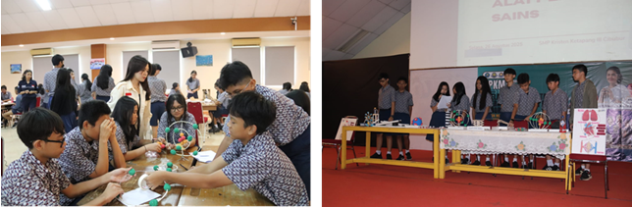
Figure 1. Learning Activities with Teaching Aids

Research Methodology
This study utilised a quasi-experimental method with a correlational research approach, in which psychomotor skills in using teaching aids and environmental support were independent variables. Meanwhile, students' constructivist learning abilities were dependent variables. Data was obtained by distributing (surveying) test instruments in the form of knowledge tests and non-test instruments in the form of questionnaires regarding the environmental support of students and psychomotor skills in using teaching aids. The data obtained was then tested for normality, homogeneity, and regression and correlation to measure the relationship and influence of each variable.

Research Design
The design of this study is as follows:

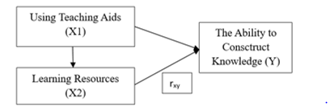

FIG 2. Diagram correlation between variable

Research Instruments
This study uses test instruments and non-test instruments to answer the research questions, including:
- Test instruments to assess students' academic performance or their ability to understand atomic and molucle structure subject
- Non-test instruments, namely observational instrument of using teaching aids and instrument learning resources

3. results and discussion
This study aims to measure the relationship between the ability to use teaching aids and students' learning support capacity on their ability to construct knowledge. The research was conducted at SMPS Ketapang 3 Jakarta, involving 40 respondents in the second grade of junior high school. The respondents, who were students, were assessed on their ability to use teaching aids in the form of recycled molimod, which was used to construct students' knowledge in understanding the material on atomic and molecular structures. In addition, this study also observed the support provided by the school environment in supporting learning. The variables in this study were the skill in using teaching aids (variable X1) and the support provided by the environment (variable X2), as well as the ability to construct knowledge as variable Y. The data for the variables in this study can be seen in the following graph:
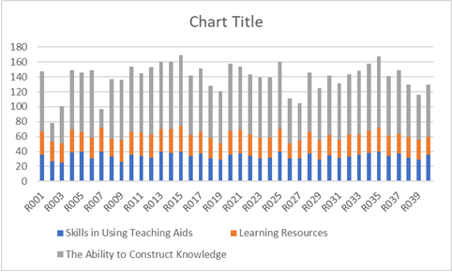
Figure 3. Data on Skills in Using Teaching Aids, Learning Support Capacity, and Knowledge Construction Ability

This report summarizes data collected from 40 respondents regarding their skills in using teaching aids, access to learning resources, and ability to construct knowledge. The dataset includes four columns: Responden, Skills in Using Teaching Aids, Learning Resources, and The Ability to Construct Knowledge. The 'Skills in Using Teaching Aids' column reflects the respondents' proficiency in utilizing teaching aids, with scores ranging from 25 to 40, averaging around 34.20. The 'Learning Resources' column indicates the availability and utilization of learning resources, with scores ranging from 20 to 34, averaging around 28.18. The 'The Ability to Construct Knowledge' column represents the respondents' capacity to build and synthesize knowledge, with scores ranging from 25 to 95, averaging around 76.58. Based on the first five sample data entries, there's variability in all three skill areas. For instance, 'R005' has the highest skill in using teaching aids (40), while 'R002' and 'R003' have relatively lower scores (27 and 25 respectively). The ability to construct knowledge also varies significantly, with scores ranging from 25 to 80 within the first five respondents. The standard deviation of 'The Ability to Construct Knowledge' is relatively high (15.83), suggesting a wide distribution of scores in this category across the entire dataset.
Correlation between skills in using aids and learning resources
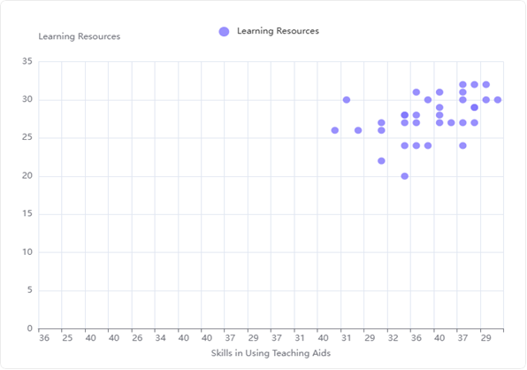
Figure 4. Graph showing the relationship between skills in using aids and learning resources
The scatter plot shows a general upward trend, indicating that as the 'Skills in Using Teaching Aids' increase, 'Learning Resources' also tend to increase. The points are somewhat spread out but generally follow a positive slope. The Pearson correlation coefficient between 'Skills in Using Teaching Aids' and 'Learning Resources' is 0.526. Strength of Correlation: The Pearson correlation coefficient of 0.526 indicates a moderate positive correlation between 'Skills in Using Teaching Aids' and 'Learning Resources'. This means that there is a noticeable, but not extremely strong, linear relationship between the two variables. The positive sign of the correlation coefficient, supported by the upward trend in the scatter plot, suggests that as an individual's skills in using teaching aids improve, their access to or utilization of learning resources also tends to increase. Conversely, lower skills in using teaching aids are generally associated with fewer learning resources. This relationship implies that proficiency in using teaching aids might be linked to, or perhaps even influence, the availability or effective use of learning resources. It could suggest that individuals more adept at using teaching aids are also more likely to leverage or be provided with more learning resources.
There is a strong correlation between the skills in using teaching aids and the effectiveness of learning resources. Research shows that the frequency and proper use of teaching aids significantly enhance students' understanding and retention of scientific concepts. In one study, the use of teaching aids accounted for 58% of the variance in students' science concept understanding, with better post-test scores among groups using these aids compared to traditional teaching methods. The alignment between teaching aids and lesson objectives also strengthens student engagement and knowledge construction. Students demonstrated significant improvement in conceptual understanding and confidence when lessons integrated physical models and interactive demonstrations (Souza et al., 2025).
The correlation between skills in using teaching aids and the effectiveness of learning resources is strongly supported by research from a study conducted in public senior secondary schools in Kano metropolis, Nigeria. The study utilized an experimental research design with 306 students, testing the effects of audio-visual and print media teaching aids on academic performance in English language (Mera, 2023).
Correlation between skills in using aids and the ability to contsruct knowledge
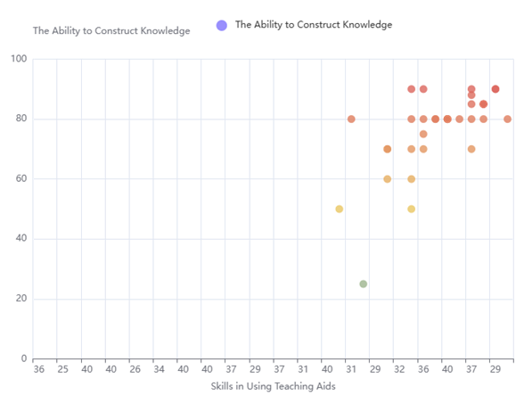
Figure 5. Graph showing the relationship between skills in using aids and the ability to construct knowledge
The scatter plot visually supports a positive trend, where higher values on the x-axis ('Skills in Using Teaching Aids') generally correspond to higher values on the y-axis ('The Ability to Construct Knowledge'). The data points are spread across the plot, but there's a noticeable clustering towards the upper right, indicating that individuals with higher skills in using teaching aids also tend to have a higher ability to construct knowledge. The Pearson correlation coefficient between 'Skills in Using Teaching Aids' and 'The Ability to Construct Knowledge' is 0.452. The correlation indicates a moderate relationship, there is a moderate positive linear relationship between 'Skills in Using Teaching Aids' and 'The Ability to Construct Knowledge', with a Pearson correlation coefficient of 0.452. The relationship is positive, this suggests that better skills in using teaching aids are associated with a greater ability to construct knowledge.. A moderate positive linear relationship implies that as 'Skills in Using Teaching Aids' increase, 'The Ability to Construct Knowledge' tends to increase as well. The findings imply that enhancing educators' skills in utilizing teaching aids could potentially contribute to an improvement in students' ability to construct knowledge. This finding implies that improving educators' skills in using teaching aids could potentially contribute to enhancing students' ability to construct knowledge. Further investigation might explore the causality and the specific mechanisms through which this relationship operates.
There is a significant positive correlation between skills in using teaching aids and students' ability to construct knowledge. Research focusing on elementary science education revealed that classrooms using teaching aids such as physical models and interactive tools showed higher engagement, comprehension, and retention of scientific concepts. Students exposed to these aids demonstrated better conceptual understanding and meaningful learning outcomes compared to traditional teaching methods (Ariani & Marleni, 2023). The studies indicate that effective use of teaching aids facilitates active learning, which enhances students' ability to visualize and internalize abstract concepts, supporting stronger knowledge construction processes. Teachers' careful selection and integration of teaching aids aligned with lesson objectives also play a crucial role in maximizing their impact on knowledge acquisition (Emidar & Indriyani, 2023).
Research in Nigerian secondary schools revealed that both audio-visual and print teaching aids significantly improved academic performance compared to traditional teaching methods. The study emphasized the importance of teachers' skillful use of instructional materials in facilitating better teaching and learning processes (Mera, 2023). A qualitative study on natural science learners found that teaching aids such as charts, models, and laboratory equipment boost comprehension, engagement, critical thinking, and collaborative learning, which are key components in knowledge construction (Nghitoolwa et al., 2024)

Correlation between Learning Resources and the ability to contsruct knowledge
Figure 6. Graph showing the relationship between skills in using aids and the ability to construct knowledge

The scatter plot visually supports the moderate positive correlation. While there is some dispersion, a general upward trend can be observed, indicating that higher values of 'Learning Resources' are often associated with higher values of 'The Ability to Construct Knowledge'. The calculated p-value for this correlation is 0.0089. With a p-value of 0.0089, which is less than the conventional significance level of 0.05, the correlation is considered statistically significant. The correlation is statistically significant (p = 0.0089), meaning that this observed relationship is unlikely to be due to random chance and suggests a genuine association between the two variables. This suggests that the observed positive relationship is unlikely to have occurred by random chance. The Pearson correlation coefficient between 'Learning Resources' and 'The Ability to Construct Knowledge' is 0.408. There is a moderate positive correlation (r = 0.408) between 'Learning Resources' and 'The Ability to Construct Knowledge'. This implies that an increase in learning resources is associated with an increase in the ability to construct knowledge. This value indicates a moderate positive linear relationship. A positive correlation means that as 'Learning Resources' tend to increase, 'The Ability to Construct Knowledge' also tends to increase. The strength is considered moderate, suggesting that while there is a discernible trend, it is not extremely strong or perfect. The findings suggest that investing in or improving learning resources could potentially contribute to enhancing individuals' ability to construct knowledge. However, since the correlation is moderate, other factors also play a significant role in knowledge construction.
Research shows a positive correlation between learning resources and the ability to construct knowledge. Studies emphasize that well-designed learning resources support active engagement, collaboration, and critical thinking, which are essential for meaningful knowledge construction. One qualitative study on blended learning highlighted that accessible, flexible multimedia and online resources increase students' motivation and enhance their learning outcomes by facilitating better understanding and thinking skills. The interactive nature of these resources allows learners to go beyond simple content consumption to actively constructing and applying knowledge (Younas et al., 2025).
Constructivist learning research explains that knowledge construction occurs through social interaction and the transformation of prior knowledge. Learning resources that support collaboration and provide scaffolding enable learners to negotiate meaning and co-construct knowledge, moving from individual to collective understanding. Technologies and web tools play a crucial role in fostering such environments (Jaleel & Verghis, 2015). Furthermore, collaborative learning research shows that groups working with shared learning resources to create knowledge artifacts engage in deeper epistemic interactions, resulting in more complex and elaborated knowledge. This joint engagement is essential for addressing complex problems and enhancing learning processes (Revista, 2019).

Skills in Using Teaching Aids
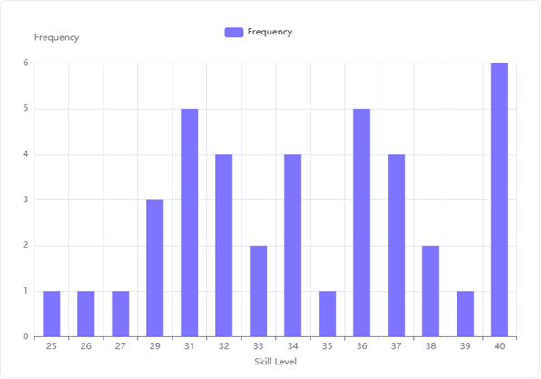
Figure 7. Distribution of Data on Skills in Using Teaching Aids
The skill levels observed range from a minimum of 25 to a maximum of 40. The mean skill level is 33.00. Standard Deviation of Skill Levels: The standard deviation of skill levels is 4.88, indicating a moderate spread in the data. The frequency of each skill level ranges from a minimum of 1 to a maximum of 6. The average frequency across all observed skill levels is approximately 2.86. The skill level of 40 is the most frequently observed, with 6 occurrences, indicating a significant number of individuals possess the highest reported skill in using teaching aids. Skill levels 31 and 36 are also highly frequent, each appearing 5 times, suggesting a strong presence of individuals with good proficiency. Skill levels 25, 26, 27, 35, and 39 are the least frequent, each occurring only 1 time, which might indicate fewer individuals at these specific proficiency points. The distribution shows a varied pattern, with several peaks (e.g., at 31, 36, and 40) and valleys (e.g., at 25-27, 35, 39), suggesting that skill in using teaching aids is not uniformly distributed but rather concentrated at certain proficiency levels, particularly towards the higher end of the scale.
\

Learning Resources
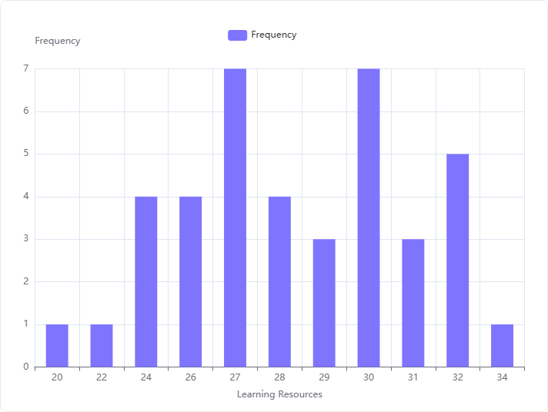
Figure 8. Distribution of Data on Skills in Using Teaching Aids
The bar chart visually confirms the frequency distribution, with the height of each bar corresponding to the frequency of the respective 'Learning Resources' level. The highest frequencies are observed for 'Learning Resources' levels 27 and 30, both occurring 7 times. The lowest frequencies are observed for 'Learning Resources' levels 20, 22, and 34, each occurring only 1 time. The distribution of 'Learning Resources' is not uniform, showing varying levels of frequency across different resource levels. for students who take science lessons in class, using the same or different learning resources. The experiences between one class and another differ. In addition, the teachers who teach one class and another differ. As a result, one class gains learning experience through practical work, while another class does not gain the same experience. The most common 'Learning Resources' levels are 27 and 30, indicating these might be the most utilized or preferred resources. Conversely, 'Learning Resources' levels 20, 22, and 34 are the least common, suggesting lower engagement or availability for these specific resources. The distribution shows a peak around the mid-to-high range (27-32), with frequencies generally higher in this range compared to the lower and highest ends of the spectrum.

The Ability Construct Knowledge
Figure 9. Distribution of Data on Skills in Using Teaching Aids
The ability score of 80 is the most frequent, appearing 14 times. The score of 90 is the second most frequent, with 7 occurrences. The score of 70 follows with 5 occurrences. An ability score of 85 appears 4 times. Scores of 25, 50, 95, and 60 each appear 2 times. Scores of 88 and 75 are the least frequent, each appearing only 1 time. The bar chart visually confirms the frequency distribution, with the tallest bar corresponding to an ability score of 80 (frequency of 14), followed by 90 (frequency of 7), and 70 (frequency of 5). The shorter bars represent the less frequent scores. The ability score of 80 is the most prevalent among the observed data, indicating a significant concentration at this knowledge level. A substantial portion of the data points fall within the higher ability scores (80, 90, 70, 85), suggesting a general tendency towards good or strong ability to construct knowledge. Lower ability scores (e.g., 25, 50, 60) and some specific higher scores (e.g., 88, 75) are much less common, indicating fewer individuals at these particular knowledge construction levels.

Outliers in 'Skills in Using Teaching Aids' based on the boxplot method (1.5*IQR)
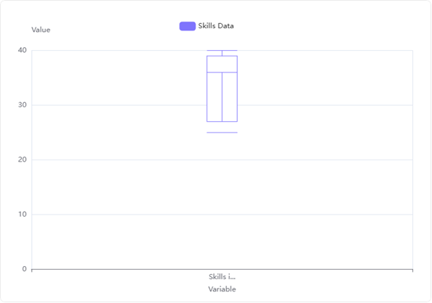
Figure 10. Data Skills Using Teaching Aids in the Bloxpot Method

The analysis of the 'Skills in Using Teaching Aids' column using the 1.5*IQR method revealed no data points falling outside the calculated lower and upper bounds. All 40 respondents' scores were within the expected range. The column in the Data Frame consistently shows for all entries, confirming the absence of outliers. The boxplot for 'Skills in Using Teaching Aids' visually supports the analytical findings. The plot does not display any individual data points beyond the whiskers, which would typically represent outliers. This indicates that all data points are contained within the interquartile range and its 1.5*IQR extensions. Based on both the statistical calculation using the 1.5*IQR rule and the visual representation in the boxplot, there are no outliers present in the 'Skills in Using Teaching Aids' data. The lack of outliers suggests that the scores for 'Skills in Using Teaching Aids' are relatively consistent across the respondents, without any unusually low or high values that would deviate significantly from the main distribution. This indicates a homogeneous group concerning this specific skill.

Outliers in 'Learning Resources' based on the boxplot method (1.5*IQR)
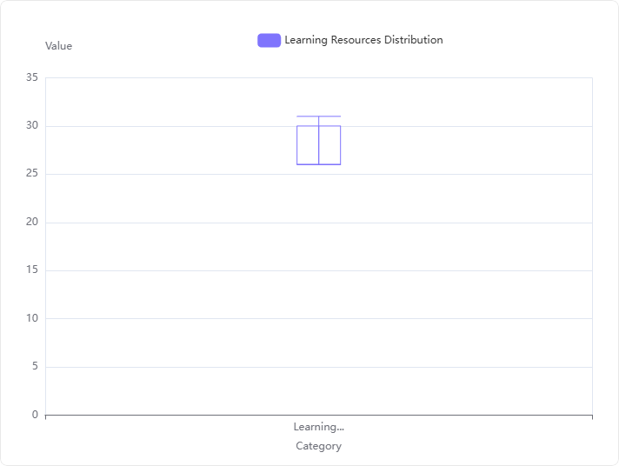
Figure 11. Data Learning Resources in the Bloxpot Method
The first quartile (Q1) for 'Learning Resources' is 26.75, and the third quartile (Q3) is 30.0. The IQR, calculated as Q3 - Q1, is 3.25. Based on the 1.5*IQR method, the lower bound is 21.875 (Q1 - 1.5 * IQR) and the upper bound is 34.875 (Q3 + 1.5 * IQR). A value of 20 in 'Learning Resources' was identified as an outlier because it falls below the calculated lower bound of 21.875. The boxplot for 'Learning Resources' visually represents its distribution. While the provided image does not explicitly show individual outlier points, the compact nature of the boxplot indicates a relatively tight distribution for the majority of the data. The numerical analysis confirms the presence of an outlier. The value 20 is identified as an outlier, as it falls below the calculated lower bound of 21.875.
Outliers in 'The Ability Construct Knowledge' based on the boxplot method (1.5*IQR)
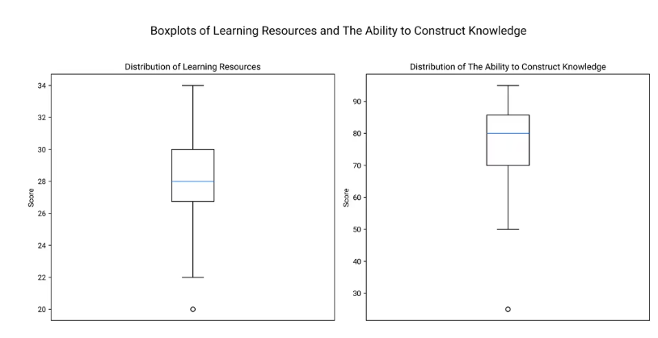
Figure 12. Data The Ability to Construct Knowledge in the Bloxpot Method

The analysis identified two outliers in 'The Ability to Construct Knowledge' column, both with a value of 25. The boxplot for 'Distribution of The Ability to Construct Knowledge' visually confirms the presence of outliers, represented by two points below the lower whisker, corresponding to the value of 25. The lower bound for outlier detection was calculated as 46.375, and the upper bound was 109.375. Any value below 46.375 or above 109.375 is considered an outlier.

4. Conclusion

The conclusion of this study is that there is a relationship between using teaching aids and learning resources with the ability to consctruct knowledge. The results of this study show that the correlation value between the use of teaching aids and learning resources is 0.52. The correlation value between the use of teaching aids and the ability to construct knowledge is 0.452. Meanwhile, the significance value (p<0.05).

Disclaimer (Artificial intelligence)
Author(s) hereby declare that generative AI technologies such as Large Language Models, etc. have been used during the writing or editing of manuscripts. This explanation will include the name, version, model, and source of the generative AI technology and as well as all input prompts provided to the generative AI technology
Details of the AI usage are given below:
1. Consensus for literature
2. Preplexity for literature
3. Powerdrill for analysis
4. Deepl for translate Indonesia Language to English Language

COMPETING INTERESTS DISCLAIMER:
Authors have declared that they have no known competing financial interests OR non-financial interests OR personal relationships that could have appeared to influence the work reported in this paper.

References

Ariani, K., & Marleni, M. (2023). the Effectiveness of Using Teaching Aids on Student Learning Outcomes in Increasing Interaction in Learning. Esteem Journal of English Education Study Programme, 6(2), 346–355. https://doi.org/10.31851/esteem.v6i2.12337
Emidar, E., & Indriyani, V. (2023). The effect of learning planning skills and teaching material development skill on teacher teaching skills. JPPI (Jurnal Penelitian Pendidikan Indonesia), 9(3), 1804. https://doi.org/10.29210/020232814
Jaleel, S., & Verghis, A. M. (2015). Knowledge Creation in Constructivist Learning. Universal Journal of Educational Research, 3(1), 8–12. https://doi.org/10.13189/ujer.2015.030102
Mera, M. S. (2023). Effect of Teaching Aids on Students’ Academic Performance in English Language in Selected Public Senior Secondary Schools in Kano Metropolis: Implication for Policy Making. Tahdzib Al-Akhlaq: Jurnal Pendidikan Islam, 6(2), 263–273. https://doi.org/10.34005/tahdzib.v6i2.3174
Nghitoolwa, H. T. S., Chirimbana, M., & Medusalem, M. (2024). The Impact of Teaching Aids on The Academic Performance of Learners in Natural Science. Journal of Education For Sustainable Innovation, 2(1), 74–83. https://doi.org/10.56916/jesi.v2i1.835
Souza, F., Lima, R., & Mustofa, I. (2025). View of The Relationship Between the Use of Teaching Aids and Science Concept Understanding in Elementary School Students.pdf. 2(2), 91–101.
Younas, M., El-Dakhs, D. A. S., & Jiang, Y. (2025). Knowledge construction in blended learning and its impact on students’ academic motivation and learning outcomes. Frontiers in Education, 10(August), 1–14. https://doi.org/10.3389/feduc.2025.1626609
Azzahra, N. T. (2025). Constructivism theory offers a strong philosophical foundation for educational transformation, emphasising the central role of students in constructing knowledge through experience and social interaction. 2(2), 64–75.
Etzel, J. M., Heinze, A., Neumann, K., Bernholt, S., Retelsdorf, J., Köller, O., & Nagy, G. (2025). What we learn in school, we learn for life: Learning opportunities as moderators of the relationship between prior knowledge and learning in post-school contexts. Contemporary Educational Psychology, 80(January). https://doi.org/10.1016/j.cedpsych.2025.102336
Fitria, E., Muslim, S., Solihatin, E., Program, D., & Jakarta, U. N. (2020). The Use Resources Education of in Learning Based Early Childhood. International Journal of Innovation, Creativity and Change, 12(1), 583–590.
Jannah, R., Muhammad Yaumi, & Herdah. (2024). Utilization of Learning Space as a Learning Resource Center. Al-Iftah: Journal of Islamic Studies and Society, 4(1), 63–77. https://doi.org/10.35905/aliftah.v4i1.9334
Jasumayanti, E. (2019). Correlation between Constructivism Approach and Student Learning Outcomes in Primary School Education. Journal of Education and Learning, 1–13.
Marcelina, S., Cahaya, S., Triana, Y., Normala, Yulinae, & Hartanto, T. J. (2024). Improving Psychomotor Skills and Student Learning Outcomes through a Direct Instruction Model Assisted by Practicum in Measurement Material. PENDIPA Journal of Science Education, 8(3), 386–396. https://doi.org/10.33369/pendipa.8.3.386-396
OECD 2023. (2022). PISA PISA 2022 Results Malaysia. Journal Pendidikan, 10. https://www.oecd.org/publication/pisa-2022-results/country-notes/malaysia-1dbe2061/
Pratami, R. (2024). The Constructivist Approach in Project-Based Learning Policy: Educational Transformation Towards Creativity and Collaboration. Public Administration Network, 16(2), 76–87. https://doi.org/10.20473/jap.v16i2.60539
Pulkkinen, J., & Rautopuro, J. (2022). The correspondence between PISA performance and school achievement in Finland. International Journal of Educational Research, 114(May), 102000. https://doi.org/10.1016/j.ijer.2022.102000
Purba, R. (2016). Improving Student Activity and Learning Outcomes in Science Lessons by Applying the Constructivism Learning Model at Gracia Sustain Elementary School in Medan. Indonesian Education Pearl Journal, 1(1), 78–91. https://doi.org/10.51544/mutiarFdidik.v1i1.388
Samodro, P., Rahmatunnisa, M., & Endyana, C. (2020). Environmental Carrying Capacity Study in Spatial Utilisation in the North Bandung Area. Jurnal Wilayah Dan Lingkungan, 8(3), 214–229. https://doi.org/10.14710/jwl.8.3.214-229
Sari, R. T., Angreni, S., & Fortuna, R. A. (2019). Development Of IPA-Based Learning Module Constructivism Approach For Grade V Students. Jurnal Pembelajaran Biologi, 8(2), 89–93.
Revista, A. (2019). Knowledge construction and regulation of learning in asynchronous collaborative tasks. Apertura, 11(1), 6–23. https://doi.org/10.32870/AP.V11N1.1465
Shobihah, S. S., Fakhruddin, A., & Iman Firmansyah, M. (2024). Implementation of Meaningful Learning in Islamic Education and Ethics Subjects at Mutiara Bunda High School. Allama: Jurnal Pendidikan Islam Indonesia, 00(01), 57–74.
Susilawati, D. E., Okianna, & Bambang Budi Utomo. (2020). The Influence of Learning Resources on the Effectiveness of the Learning Process in Economics at Wisuda High School. Jurnal Pendidikan Dan Pembelajaran Khatulistiwa, 4(6), 1–12.
Zabolotna, K., Malmberg, J., & Järvenoja, H. (2023). Examining the interplay of knowledge construction and group-level regulation in a computer-supported collaborative learning physics task. Computers in Human Behavior, 138(August 2022). https://doi.org/10.1016/j.chb.2022.107494

