Nutrient uptake and efficiency in maize: Response to organic-inorganic phosphorus substitutions in western Kenya

.
ABSTRACT

Aims: The degrading soil fertility and inefficient application of fertilizers limit the production of sustainable maize in sub-Saharan Africa. The objective of the study was to determine the effects of substituting organic and inorganic phosphorus sources (P) on nutrient uptake and the effectiveness of their use in maize production in western Kenya under varying Agro-ecological conditions.
Study design: The experimental layout was a randomized complete block design with 14 treatments: triple superphosphate (TSP), pressmud, and cattle manure, all at equal P rates. The treatments were replicated three times.
Place and Duration of Study: Field experiments were conducted at Kibos and Bumula in western Kenya, during long rain season of 2021
Methodology: Soils were sampled to determine pH, C, N, P, and K contents. Composted pressmud and cattle manure was also analysed to establish nutrient. Agronomic data, including plant growth, grain and stover yield, were recorded and data analyzed using ANOVA.
Results: Findings showed that the 50% substitution of TSP by both PM and CM, i.e., TSP15 + PM15 and TSP15 + CM15, was superior in terms of nitrogen and phosphorus uptake, agronomic efficiency indices (AEN, REN, AEP, REP), and grain yield compared to either organic or inorganic application alone.
Conclusion: The gains in efficiency were site-specific, which depended on soil fertility and climatic variation. Results highlight the potential benefits of using Integrated Soil Fertility Management (ISFM) to improve nutrient use efficiency, minimize input inefficiencies, and enhance climate-resilient maize systems. The research paper gives new evidence on the P source integration approaches to sustainable intensification.

Keywords: Nutrient use efficiency, Agronomic efficiency, Pressmud, Integrated Soil Management, Sab Sahara Africa

1. INTRODUCTION

Global maize production has increased significantly over the past few decades, driven by rising demand and enhanced soil fertility (Erenstein et al., 2022). It is a versatile, multi-purpose crop, primarily used as a feed globally, but also essential as a food crop, especially in sub-Saharan Africa (SSA), as well as for non-food uses (Tenge et al., 2024). Traditionally, maize production in SSA depends primarily on soil nutrient mining (Ten Berge et al., 2019), since fertilizer use in the region is considerably low. Given the accumulating evidence of climate change in SSA coupled with declining soil fertility, there is an urgent need to develop more climate-resilient maize production systems for sustainability (Alamu, 2025; Mmbando, 2025). Maize crop production must increase threefold in SSA to meet the demand of the growing population. Improving the nutritional density of maize fields would curb the uncertainties associated with maize production (Cairns et al., 2021). Nitrogen (N) and phosphorus (P) are two of the most essential macronutrients for maize growth, playing crucial roles in processes such as protein synthesis, photosynthesis, and energy transfer (Coetzee et al., 2017).
In most instances, farmers believe that increased inorganic fertilizer use should boost maize yields, but growing evidence shows variable returns on investment due to limited nutrient uptake and inefficiencies in fertilizer use. However, improving the efficient use of key nutrients, such as nitrogen and phosphorus fertilizers, involves various strategies, including optimizing fertilizer application rates, sources, and the use of soil amendments, as well as applying fertilizers at the correct times (Beegle et al., 2000). Ultimately, increasing fertiliser use efficiency (FUE) for nitrogen and phosphorus not only promotes agricultural sustainability but also helps reduce negative environmental impacts (Anas et al., 2020; Jarvie et al., 2015). Therefore, the integrated soil fertility management (ISFM) approach provides the opportunity to intensify maize production by maximizing the agronomic efficiency (AE) of the applied nutrients (Adem et al., 2023).
Improved soil fertility management practices, which combine organic and mineral fertilizer inputs, can enable the efficient use of applied inputs and increase the overall system's productivity. Technologies that combine mineral fertilizers with organic nutrient sources can be considered better options for improving fertilizer use efficiency, as they provide a more balanced supply of nutrients and offer multiple agronomic and ecological benefits (Srinivasarao et al., 2013). Fertilizer use can increase crop yields and additionally produce enough residues for soil fertility management, while organic sources can rehabilitate less responsive soils and make them responsive to fertilizers (Shah & Wu, 2019).
Maize nutrients, particularly phosphorus uptake, use efficiency, and yields in western Kenya, have been declining (Kihara & Njoroge, 2013). This may be associated with the inefficiency of the fertilizers and manure currently applied/or nutrient depletion. Appropriate fertilizer use leads to increased crop yields and high nutrient recovery rates (Roberts & Johnston, 2015). The effectiveness of phosphorus fertilizers, therefore, depends on their chemical and physical properties, the rate and method of application, soil and climatic conditions, and the crop species grown (Blackwell et al., 2019).
The substitution of inorganic P source (TSP) by different sources of organic manure (OM) would lead to a refined focus on nutrient use efficiency in maize production in western Kenya soils. Similarly, due to the high cost of these imported inorganic fertilizers, focus is now shifting to solutions that utilize the local resources for sustainability in maize production. Therefore, this study aims to determine the effects of substituting organic and inorganic phosphorus sources (P) on nutrient uptake and the effectiveness of their use in maize production in western Kenya under varying agro-ecological conditions.

2. materialS and methods

2.1 Experimental Sites
The experiments were conducted at two sites with contrasting soil properties in western Kenya: Kibos and Bumula (Table 1). The Kibos site was located in the Kenya Agricultural and Livestock Research Centre (KALRO), Kisumu County at (0.0393°N, 34.8162°E) at an altitude of 1224 m above sea level. The site lies in the lower midland semi-humid zones (LM3) with orthic Acrisol soils. The area receives an average annual rainfall of between 450 and 600 mm, while the average temperature ranges from 21 to 22.7°C (Jaetzold, Schmidt, Hornetz, & Shisanya, 2010). The Bumula is located in the mid-altitude areas of western Kenya (0.5742°N, 34.4420°E and 1493 m above sea level). It lies within the LM2 agroecologicl zone (AEZ) and receives an annual rainfall and average temperature of 1500 mm and 21-25 °C, respectively. The soil is classified as Acrisols (Jaetzold et al., 2010).

Table 1: Initial soil characterisation at Kibos and Bumula sites (0 - 20 cm)
Chemical parameter | Field site |  | critical level
 | Bumula | Kibos
pH (H₂O) | 6.06 | 5.59 | > 5.5
%C | 1.18 | 1.02 | > 2.7
%N | 0.06 | 0.08 | > 0.2
P mgkg⁻¹ | 2.71 | 12.52 | 30
K mgkg⁻¹ | 238 | 634 | > 350
*Water extraction- pH, *Walkley Black- organic carbon, *kjeldahl- Total nitrogen, *Olsen- Available phosphorus and *ammonium acetate extraction- Exchangeable K (Okalebo et al. 2002, Wogi et al 2021). Critical levels

2.2 Composting of Pressmud and Cattle Manure
Pressmud (PM) was obtained from a local sugarcane processing factory, while cattle manure (CM) was from a large-scale dairy farm. Before composting, both PM and CM were segregated into two portions: sun-dried and fresh portions, to adjust the carbon-to-nitrogen (C:N) ratio to about 25-30:1 for optimal bacterial activity. The Berkeley hot composting method (Atchley, K. 2013) was used to prepare organic fertilizers from PM and CM. A compost heap measuring 2 m wide was raised to a height of 1.3 m and after four days of initial heating, the heap was turned at intervals of two days for aeration. Turning helps to maintain oxygen levels, promote aerobic decomposition, and prevent foul odours. Temperature was monitored and kept between 40°C and 65°C throughout the process to ensure efficient composting, with excess heat managed by turning and spreading the piles. Moisture levels were maintained between 45% and 60%, while monitoring pH levels and when the pH dropped below 7.5, the composting was terminated to avoid nutrient loss. Detailed PM and CM properties are presented in (Table 2).
Table 2: Selected chemical attributes of composted pressmud (PM) and cattle manure (CM)
Chemical parameter | Organic Amendment
 | Pressmud (PM) | Cattle manure (CM)
% Organic Carbon | 24.4 | 25
% Total Nitrogen | 0.6 | 1.5
% Total Phosphorus | 0.7 | 0.5
% Total Potassium | 0.4 | 0.8
*All parameters were analyzed according to Okalebo et al. 2002

2.3 Treatments, experimental design and crop husbandry
The plots were established in a randomised complete block design with 14 P fertilizer treatments of sole and/or combinations of PM, CM and Triple Super Phosphate (TSP), replicated thrice (see Modeste et al., in preparation). Each treatment received 30 kg P ha-1 at different ratios of organic and inorganic as shown in Table 3. A blanket application of Nitrogen (100 kg ha-1 as Urea) and potassium (60 kg ha-1 as muriate of potash) was applied to all experimental units except the control. The experiments were laid out in a randomized complete block design and replicated three times. Before planting, the land was prepared to a fine tilth and planting was done at the beginning of the long rains season in 2021, as per the farmers’ practice. Hybrid maize variety H520 from Kenya Seed Company Limited was planted at 25 cm within row spacing and 75 cm between row spacing in plots measuring 5 m x 4.5m at both Kibos and Bumula sites. Two maize seeds were sown per hill, and later thinned to one a week after emergence. N was applied in two equal splits of 50 kg ha-1 at planting and after 8 weeks, whereas K and P were applied in bunds at planting. Standard agronomic procedures for maize cultivation, including weeding and pest control, were appropriately followed after crop emergence.
Table 3: Substitution of triple super phosphate (TSP) fertilizer by pressmud (PM) and cattle manure (CM) at 0%, 25%, 50%, and 100% of the 30 kg P ha-1 rate
Soil amendments |  | Description | Ratios of P amendments
Control | No nutrients applied
TSP | 30 kg P/ha⁻¹, Sole inorganic P |  |  | 1:0
Press Mud (PM) | 30 kg P/ha⁻¹, sole organic P |  |  | 0:1
Cattle Manure (CM) | 30 kg P/ha, Sole organic P |  |  | 0:1
TSP 15 + PM 15 | 15 kg P/ha⁻¹ TSP + 15 kg P/ha PM |  |  | 0.5:.0.5
TSP 22.5 + PM 7.5 | 22.5 kg P/ha⁻¹ TSP + 7.5 kg P/ha PM |  |  | 0.25:0.75
TSP 7.5 + PM 22.5 | 7.5 kg P/ha⁻¹ TSP + 22.5 kg P/ha PM |  |  | 0.75:0.25
TSP 15 + CM 15 | 15 kg P/ha⁻¹ TSP + 15 kg P/ha CM |  |  | 0.5:.0.5
TSP 22.5 + CM 7.5 | 22.5 kg P/ha⁻¹ TSP + 7.5 kg P/ha |  |  | 0.75:0.25
TSP 7.5 + CM 22.5 | 7.5 kg P/ha⁻¹ TSP + 22.5 kg P/ha CM |  |  | 0.25:0.75
PM 15 + CM 15 | 15 kg P/ha⁻¹ PM + 15 kg P/ha CM |  |  | 0.5:.0.5
PM 22.5 + CM 7.5 | 22.5 kg P/ha⁻¹ PM + 7.5 kg P/ha CM |  |  | 0.75:0.25
PM 7.5 + CM 22.5 | 7.5 kg P/ha⁻¹ PM + 22.5 kg P/ha CM |  |  | 0.25:0.75
TSP 10 + PM 10 + CM 10 | 10 kg P/ha⁻¹ TSP + 10 kg P/ha PM + 10 kg P/ha CM |  |  | 0.33:0.33:0.33

2.4 Data collection and Analysis
2.4.1 Forage yield
Sampling and determination of forage yield followed the protocols described by Katoch (2023). Nine randomly selected plants from the four centre rows of each plot were harvested at the milk stage (R3-kernels with milky fluid). The weight of fresh forage biomass was obtained, then chopped into small pieces and oven-dried at 65°C to a constant weight for the dry weight.
2.4.2 Grain yield
Cobs were harvested at physiological maturity from four inner rows at an effective plot area of 18 m². The total fresh weight of the cobs was recorded, and a sub-sample of nine cobs was then randomly taken from each plot, dried, weighed, and shelled to estimate grain yield
2.4.3 Plant tissue analysis
To determine both forage and grain quality, dried samples of forage and grain were ground separately to pass through a 0.25 mm sieve, followed by N and P content analysis using the principles of oxidation and digestion as described by Okalebo et al. (2002). The tissue samples were digested at 360 °C for 2 hours using a block digester in concentrated sulphuric acid in the presence of lithium sulfate, selenium powder and hydrogen peroxide. This was followed by a colorimetric determination using a UV spectrophotometer at wavelengths of 650 nm and 880 nm for total N and P contents, respectively.
The tissue P and N contents were then used to calculate grain and forage uptake, as illustrated in equations 1 to 5.
$GNU=Y ×N (\%)$ (1)
$FNU=DM (kg) ×N(\%)$ (2)
$GPU=Y ×P (\%)$ (3)
$FPU=DM (kg) ×P(\%)$ (4)
$TU=GU+FU$ (5)
Where, GNU = Grain N uptake (kg ha-1), Y = Grain yield (kg ha-1), N = Nitrogen content (%), FNU = Forage plant N uptake (kg ha-1), GPU = Grain P uptake, P = Phosphorus content (%), FPU = Forage P uptake (kg ha-1), TU = Total nutrient uptake, N or P.
The nutrient use efficiency indices were calculated according to equations 6 and 7. The agronomic efficiency (AE) is the relative yield (grain) increase per unit of N applied
$AE= \frac{Y_{N}-Y_{O} }{ {N }_{app}}$ (6)
The recovery efficiency (RE) is the relative increase in N uptake by the plant (grain + forage) per unit of N applied.
$RE=\frac{{TU}_{N}-{TU}_{o}}{N_{app}}$ (7)
Where, YN = yield in the fertilised plots (kg ha-1), YO = Yield in the non-fertilised plot, Napp = Amount of nutrient (N/P) applied

2.4.4 Statistical analysis
All statistical analyses were performed using R statistical software version 4.5.1 (R Core Team, 2025). To understand how the different P source substitutions influenced AEN, REN, AEP, REP, N and P uptake across the two sites, a two-way analysis of variance (ANOVA) was adopted using an lme model from the nlme package. In the analysis, treatment effects were evaluated using either organic P and inorganic sources or their combinations, along with site, as fixed factors, while replicates were used as random factors. Furthermore, a one-way ANOVA was also used to determine the effect of organic P, inorganic P source, and their combination at each site. The means were separated at a 5% level of significance using the Tukey HSD test.

3. results

3.1 Nutrient use efficiency indices as affected by different P source substitutions
The agronomic N efficiency (AEN) was significantly (p < 0.05) influenced by the different P sources and their combinations (Table 4). Overall, the AEN ranged from 17.27 to 44.96 kg kg-1 and from 26.40 to 46.96 kg kg-1 in Kibos and Bumula sites, respectively. The sole application of TSP (TSP30) resulted in peak AEN, which was consistent at both Kibos and Bumula sites, 44.56 and 46.96 kg kg-1, respectively. Whereas, the applying CM at 30 kg P ha-1 (CM30) resulted in markedly lower (p < 0.05) AEN, 17.27 and 26.40 kg kg-1 in Kibos and Bumula, respectively.
In Kibos, the highest N recovery efficiency (REN) was observed from 50% substitution of TSP by CM, i.e., TSP15 + CM15 (0.42 kg kg-1; Table 4). Whereas, in Bumula, the sole application of TSP (TSP30), exhibited a peak N recovery of 0.49 kg kg-1. At both sites, REN from the sole application of P from CM30 was consistently lower (0.13 and 0.12 kg kg-1 in Kibos and Bumula, respectively) and differed significantly (p < 0.05) from the other treatments (Table 4).
At both sites, the different P sources and combinations affected agronomic P efficiency (AEP) (p < 0.05), with values ranging from 57.58 to 148.54 kg kg-1 in Kibos and from 88.00 to 159.31 kg kg-1 in Bumula (Table 4). Treatment CM30 showed the least AEP in Kibos (57.58 kg kg-1), and this was also consistent in Bumula (88.00 kg kg-1). The highest AEP was observed in TSP30 in Kibos and 50% substitution of TSP by CM in Bumula (Table 4).
Across the two sites, there were contrasting effects of the different P sources and combinations on P recovery efficiency (REP) (see Table 4). In Kibos, no significant effect was observed (p > 0.09), with values ranging between 0.07 and 0.12 kg kg-1. Meanwhile, in Bumula, the treatments had a significant effect on the REP (p < 0.05), with values ranging from 0.09 to 0.25 kg kg-1.

Table 4: Nutrient use efficiency indices of N and P as influenced substitution of TSP by PM and CM at Kibos and Bumula sites. Similar lowercase letters indicate no significant difference at 5% level of significance
 | AE_{N} |  |  | RE_{N} |  |  | AE_{P} |  |  | RE_{P}
 | (kg grain kg N⁻¹) |  |  | (kg N uptake kg N⁻¹) |  |  | (kg grain kg P⁻¹) |  |  | (kg P uptake kg P⁻¹)
Treatment | Kibos | Bumula | Mean | Kibos | Bumula | Mean | Kibos | Bumula | Mean | Kibos | Bumula | Mean
Control | - | - |  | - | - |  | - | - |  | - | -
CM30 | 17.27^{c} | 26.40e | 21.84 | 0.13^{f} | 0.12^{f} | 0.13 | 57.58^{f} | 88.00^{g} | 72.79 | 0.08ª | 0.09^{d} | 0.09
PM10+CM10+TSP10 | 41.46^{ab} | 43.26^{ab} | 42.36 | 0.32^{bcde} | 0.35^{bc} | 0.34 | 138.16^{abc} | 149.73^{ab} | 143.95 | 0.07ª | 0.23^{ab} | 0.15
PM15+CM15 | 34.61^{b} | 30.62de | 32.62 | 0.30^{cde} | 0.23e | 0.27 | 98.17e | 106.86^{ef} | 102.52 | 0.09ª | 0.22^{ab} | 0.16
PM22.5+CM7.5 | 39.97^{ab} | 41.48^{abc} | 40.73 | 0.35^{bcd} | 0.36^{bc} | 0.36 | 133.23^{abcd} | 131.95^{cd} | 132.59 | 0.10ª | 0.21^{abc} | 0.16
PM30 | 23.7^{c} | 29.11e | 26.41 | 0.29de | 0.25de | 0.27 | 73.48^{f} | 92.44^{fg} | 82.96 | 0.10ª | 0.14^{cd} | 0.12
PM7.5+CM22.5 | 39.09^{ab} | 35.69^{bcde} | 37.39 | 0.36^{abc} | 0.24e | 0.30 | 133.83^{abcd} | 110.72e | 122.28 | 0.10ª | 0.18^{bc} | 0.14
TSP15+CM15 | 40.97^{ab} | 40.53^{abc} | 40.75 | 0.35^{bcd} | 0.32^{bc} | 0.34 | 144.29^{ab} | 142.72^{bc} | 143.51 | 0.09ª | 0.22^{ab} | 0.16
TSP15+PM15 | 43.58ª | 46.03ª | 44.81 | 0.42ª | 0.33^{bc} | 0.38 | 139.16^{abc} | 159.31ª | 146.24 | 0.08ª | 0.23^{ab} | 0.16
TSP22.5+CM7.5 | 37.53^{ab} | 39.96^{abcd} | 38.75 | 0.34^{bcd} | 0.30^{cde} | 0.32 | 120.3^{d} | 138.17^{bcd} | 129.24 | 0.09ª | 0.20^{abc} | 0.15
TSP22.5+PM7.5 | 41.22^{ab} | 43.10^{ab} | 42.16 | 0.37^{ab} | 0.37^{b} | 0.37 | 131.95^{bcd} | 149.43^{ab} | 140.69 | 0.08ª | 0.25^{ab} | 0.17
TSP30 | 44.56ª | 46.96ª | 45.76 | 0.39^{ab} | 0.49ª | 0.44 | 148.54ª | 140.84^{bcd} | 144.69 | 0.12ª | 0.24^{ab} | 0.18
TSP7.5+CM22.5 | 33.4^{b} | 33.01^{cde} | 33.21 | 0.26e | 0.24e | 0.25 | 118.02^{d} | 105.38^{ef} | 111.70 | 0.08ª | 0.20^{abc} | 0.14
TSP7.5+PM22.5 | 37.51^{ab} | 39.17^{abcd} | 38.34 | 0.26e | 0.31^{bcd} | 0.29 | 125.04^{cd} | 126.42^{d} | 125.73 | 0.08ª | 0.25ª | 0.17
MSD | 8.44 | 9.58 |  | 0.07 | 0.068 |  | 16.45 | 14.99 |  | 0.05 | 0.075
S.E.D (±) | 0.45 | 0.51 |  | 0.004 | 0.0036 |  | 0.88 | 0.80 |  | 0.00 | 0.004
P'value | <0.05 | <0.05 |  | <0.05 | <0.05 |  | <0.05 | <0.005 |  | 0.09 | <0.05
Grand mean | 36.53 | 38.10 |  | 0.32 | 0.30 |  | 120.14 | 126.31 |  | 0.09 | 0.20
AE_{N} = grain increase per N input; AE_{P} = grain increase per P input; RE_{N} = N uptake gain per N input; RE_{P} = P uptake gain per P input Table 4: N Similar lowercase letters indicate no significant difference at 5% level of significance.

3.2 Effect of P sources and combinations on N uptake
The effect of different P sources and their combinations is shown in Figure 1. An apparent site effect (p < 0.05) on N uptake by plants was observed, irrespective of the P source and combinations. The overall mean in Kibos was 31.70 kg ha-1, compared to 29.91 kg ha-1 in Bumula, which was approximately 6% less. However, across the two sites, the peak total N uptake was observed at the Bumula site (49.03 kg ha-1, TSP30), which was 6.82 kg ha-1 higher than the highest N uptake at Kibos (42.21 kg ha-1, TSP15 + PM15). At both sites, the control plots consistently exhibited the least N uptake, 10.38 and 12.05 kg ha-1 in Bumula and Kibos, respectively. With regards to P source and combinations, N uptake in Kibos increased in the order of Control > CM30 > TSP7.7 + PM22.5 > PM15 + CM15 > TSP7.5 + CM22.5 > PM30 > PM22.5 + CM7.5 > P10 + CM10 + TSP10 > PM7.5 + CM22.5 > TSP15 + CM15 > TSP22.5 + PM7.5 > TSP22.5 + CM7.5 > TSP30 >TSP15 + PM15 (Ref. Figure). Meanwhile, in Bumula, the treatments were in the order of Control > CM30 > PM15 + CM15 > PM7.5 + CM22.5 > TSP7.5 + CM22.5 > PM30 > TSP15 + CM15 > TSP7.5 + PM22.5 > TSP15 + PM15 + TSP22.5 + CM7.5 > P10 + CM10 + TSP10 > PM22.5 + CM7.5 > TSP22.5 + PM7.5 > TSP30 (Figure 1
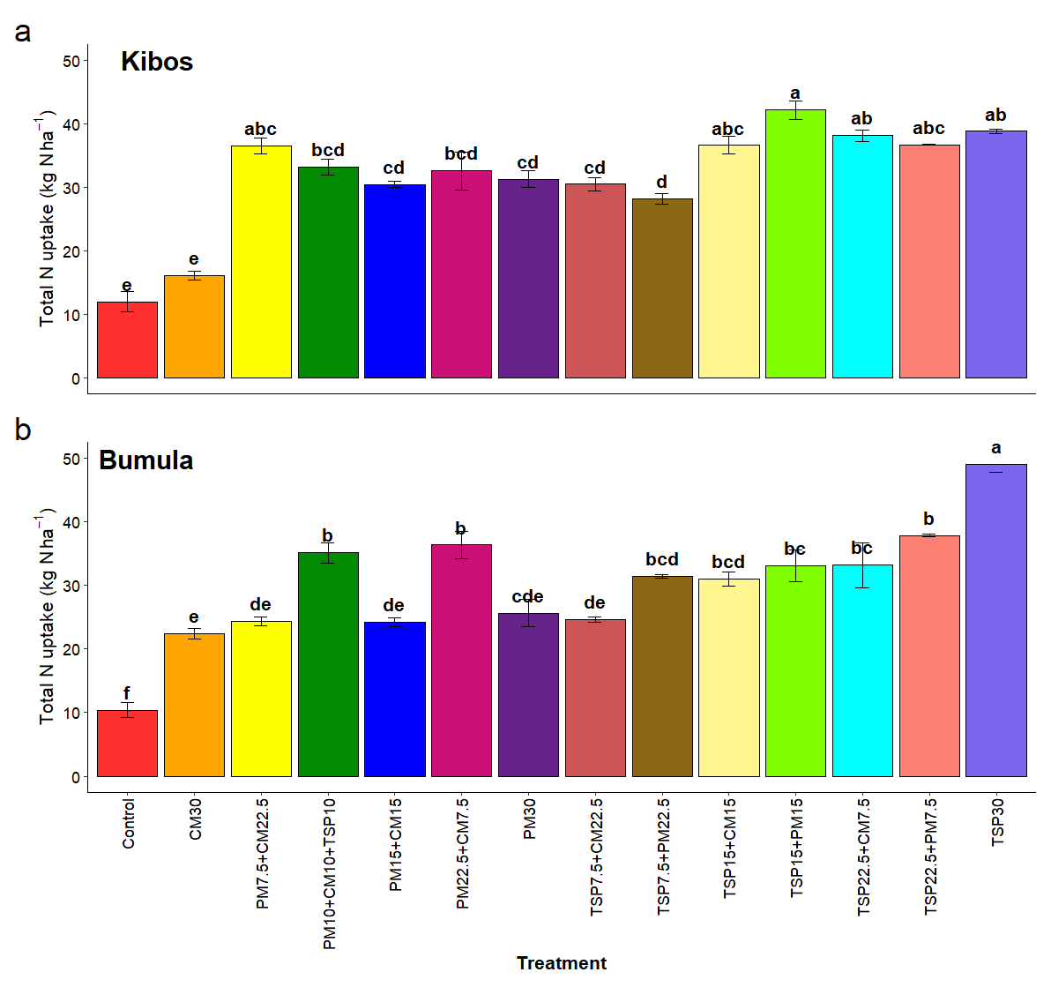

Figure 1: Plant N uptake (Grain + Stover) as influenced by different P sources and their combinations
The response of grain yield to the total N uptake was similar across both sites (Figure 2). A linear pattern was observed in Kibos and Bumula, with R² values of 0.84 and 0.8, respectively, indicating that grain yield increased with increasing plant N uptake.

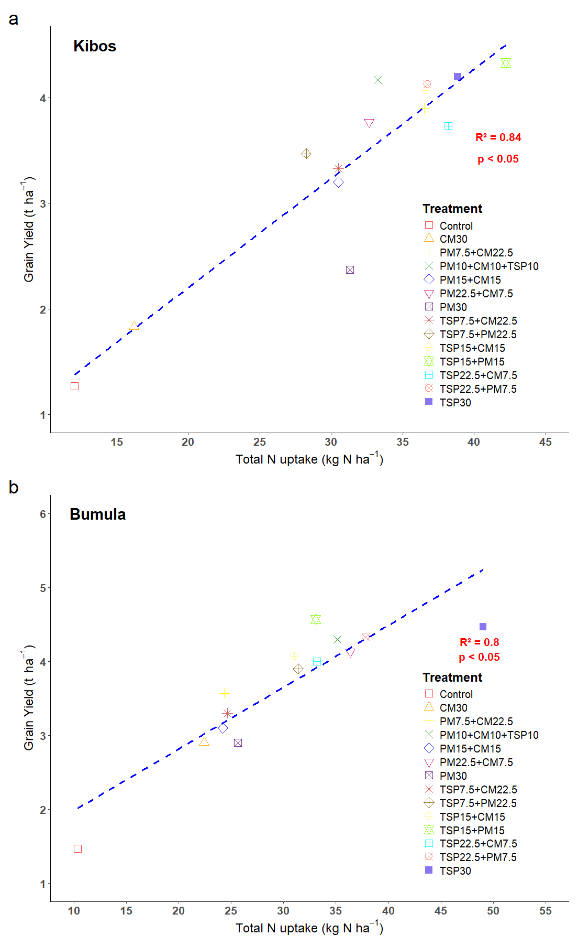

Figure 2: Relationship between total N uptake and maize grain yield as influenced by the substitution of TSP by PM and CM at (a) Kibos and (b) Bumula sites
3.3 Effect of P sources and combinations on P uptake
There was a considerable individual effect (p < 0.05) of site and the substitution of the different P sources, as well as the site x treatment on phosphorus (P) uptake (Figure 3). Varying observations were recorded at each site, where P uptake ranged from 4.88 to 11.56 kg ha ¹ and from 2.77 to 7.58 kg ha ¹ in Kibos and Bumula, respectively. On average, the different P substitutions performed considerably better (p < 0.05) irrespective of the P sources and their combinations in Kibos (8.72 kg P ha-1), in contrast to Bumula (5.95 kg P ha-1).

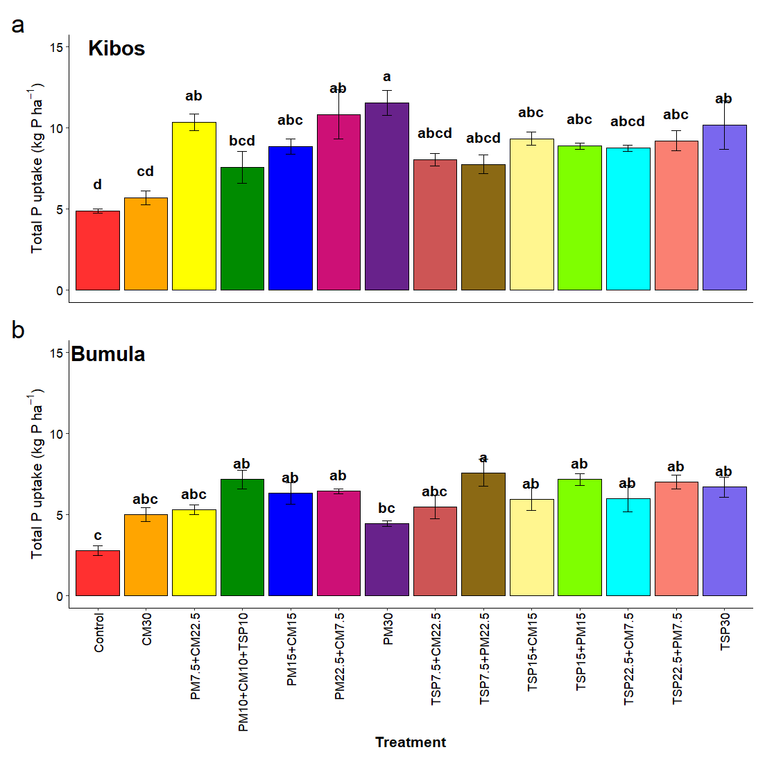
Figure 3: Plant P uptake (Grain + Stover) as influenced by substituting TSP by PM and CM at (a) Kibos and (b) Bumula sites. Similar lowercase letters indicate no significant differences at 5% level of significance

4.0 Discussion

The integrated phosphorus (P) management, which involves substituting inorganic with organic sources, has a significant positive effect on nutrient uptake and use efficiency indices in maize compared to individual applications of these sources, as demonstrated by this study. This is in accordance with the integrated soil fertility management (ISFM) paradigm, which additionally argues that the interaction between organic and inorganic nutrient sources is synergistic, which increases the availability of nutrients, synchronizes the nutrient release and crop demand, and improves soil biological functioning (Adem et al., 2023; Srinivasarao et al., 2013). The hypothesis that nutrient sources have complementary effects that maximize crop response based on enhanced nutrient uptake and retention in the rhizosphere is verified by superior agronomic nitrogen efficiency (AEN) and agronomic phosphorus efficiency (AEP) with combined treatments of TSP15 + PM15 and TSP15 + CM15 (Beegle et al., 2000; Blackwell et al., 2019).
4.1 Supporting ISFM Theory and Nutrient Dynamics
The elevated grain increases to P observed in the integrated regimes relative to the sole organic sources suggest the biochemical synergy of the ISFM systems. Although inorganic fertilizers, such as TSP, provide P in a readily available form for plant uptake, organic amendments enhance the exchange capacity of cations, microbial activity, and soil structure, which contribute to the improvement of nutrient diffusion and uptake (Srinivasarao et al., 2013; Shah and Wu, 2019). On the other hand, the low efficacy of only the sole cattle manure (CM30) and pressmud (PM30) treatments implies that organic sources only have a slow release of nutrients that are not sufficient to address the rapid demand of maize at the onset of the season, which causes a temporary nutrient deficiency (Kihara and Njoroge, 2013). These findings are consistent with those in Ethiopia and India, where integrated P management has been shown to increase nutrient use efficiency compared to either exclusive organic or exclusive inorganic fertilization (Adem et al., 2023; Srinivasarao et al., 2013).
Furthermore, the higher efficiency of nitrogen recovery (REN) in the cases of TSP15 + CM15 and TSP30 supports the fact that a sufficient supply of P promotes root growth and N assimilation, a well-reported physiological reaction in maize (Coetzee et al., 2017). The linear relation (R2 > 0.8) between grain yield and N uptake also validates the fact that nutrient uptake efficiency is the key factor behind the productivity to be achieved under these fertility regimes, as was observed by Roberts and Johnston (2015), who noted that crop yield is highly related to nutrient recovery when the fertilizer application is even and timely.
4.2 Describing Local Processes
The responses of the REN and REP indices, which are site-specific, reflect the effects of edaphic and climatic conditions on nutrient changes. Bumula, with increased rainfall and a slightly higher pH, had a higher nutrient recovery (REN = 0.49; REP = 0.25) compared to Kibos, potentially due to increased microbial mineralization and decreased phosphorus (P) fixation under sub-humid conditions (Jaetzold et al., 2010). Conversely, reduced organic carbon (1.02 percent) and P (12.52 mg kg-1) in Kibos likely inhibited the activity of microbes, which restrained the decomposition and liberation of organic nutrient sources. This spatial heterogeneity confirms the study by Ten Berge et al. (2019) and Kihara and Njoroge (2013), who reported the existence of heterogeneous fertilizer responses in Western Kenya due to natural soil fertility increases and agro-ecological variability.
It is interesting to note that P recovery efficiency (REP) did not differ significantly at Kibos; however, treatments at Bumula reacted differently, indicating that P uptake is more site-specific and moisture-sensitive than N uptake. This deviation is consistent with Blackwell et al. (2019), who stated that P-use efficiency is highly mediated by soil pH, P sorption capacity, and precipitation patterns, which vary significantly across agro-ecological zones.
4.3 Substitution vs. Single Inorganic Sources
Immediate mineral P availability, characterized by the high AEN and AEP of sole TSP (TSP30) treatments, promotes the direct impact of this mineral on root activity and photosynthetic capacity (Coetzee et al., 2017). The slightly increased or similar efficiencies realised under integrated treatments (TSP15 + PM15; TSP15 + CM15), however, suggest that partial replacement by organic matter can maintain yield and enhance soil nutrient retention and long-term fertility. This confirms the findings of Adem et al. (2023) and Srinivasarao et al. (2013), who suggest that under resource-limited smallholder systems, nutrient-use efficiency and system resilience are most effective when a blend of organic and inorganic sources is used.
4.4 Low Efficiency under Sole Organics
The poor AEN, REN, and AEP of CM30 and PM30 treatments can be attributed to the low speed of mineralization, low nutrient density, and the potential fixation of N and P by microbes during the decomposition process (Shah & Wu, 2019). The relatively low ratio of N and K in Pressmud (Table 2) and the high C: N ratio could also have reduced the release of nutrients, thereby postponing nutrient availability beyond critical growth periods (Okalebo et al., 2002). The low REP values in these treatments indicate low P solubility and competition at adsorption sites, as observed by Blackwell et al. (2019) and Roberts and Johnston (2015), who note that the chemical form and application rate of P are the strongest determinants of uptake efficiency.
4.5 Maize Production Consistency with Climate-Resilience
The resulting increase in nutrient uptake and efficiency across ISFM regimes supports the argument for the climate resilience of integrated approaches to fertility. These practices ensure alignment with the long-term sustainability recommendations of Alamu (2025) and Mmbando (2025), who advocate for resilient maize systems in the face of shifting climatic conditions by combining fast-acting mineral fertilizers with organic matter that enhances soil health. Improved efficiencies of N and P uptake not only increase yield but also reduce environmental hazards related to nutrient leaching and evaporation (Anas et al., 2020; Jarvie et al., 2015).
Overall, the study's findings are essentially in line with the global and regional literature that promotes the use of integrated nutrient management as a practical approach to enhance fertilizer efficiency, crop productivity, and sustainability. Minor site-specific differences emphasize the context-specificity of nutrient interactions and highlight the need to provide localized advice. TSP combined with organics (PM, CM) maximizes AEN, AEP, and nutrient uptake, supporting the view that integration, rather than substitution, is the key to efficient and climate-resilient maize production systems in Sub-Saharan Africa.

5. Conclusion

This research revealed that combining organic and inorganic sources of phosphorus, especially application of TSP15 + PM15 and TSP15 + CM15, showed significant improvement of nutrient uptake, agronomic efficiency indices, and yield of maize as compared to a single application. The findings confirm the Integrated Soil Fertility Management (ISFM) strategy as a potential channel for enhancing nutrient use efficiency, restoring soil fertility, and improving climate-resilient maize production systems in Western Kenya. The results also show that the site-specific efficacy of integrated nutrient regimes depends on the chemical properties of soil, rainfall, and the content of organic matter. It has therefore been proposed that instead of relying on either organic or inorganic fertilizers, balanced nutrient substitution principles should be used to achieve sustainability in productivity and environmental stewardship.
Limitations, Policy Implications and Future Research Directions
Although the current research provides strong empirical evidence on the success of combining organic and inorganic sources of phosphorus to enhance nutrient utilization efficiency in maize, certain limitations must be acknowledged. The study was conducted in two locations within a single growing cycle, which may limit the extrapolation of the results to larger agro-ecological zones and time frames. The research also utilised a uniform maize cultivar and nutrition application program, thus failing to reflect the genotypic variability or multi-nutrient interactions with anything other than phosphorus-based management. Lack of economic and environmental evaluations also constrains communication of agronomic benefits into farmer-level decision-making and policy development.
Policy-wise, the findings confirm the strategic importance of integrated soil fertility management (ISFM) in enhancing nutrient efficiency, productivity, and sustainability. The policymakers and extension agencies ought to thus encourage the use of blended nutrient regimes (mixing of mineral fertilizer with locally sourced organic resources). By integrating ISFM into national fertilizer subsidy policies, soil health, resource-use efficiency, and the resiliency of smallholders can be improved, as well as progress towards the Sustainable Development Goals (SDGs) on food security, sustainable land management, and climate action.
Multi-season, multi-site experiments should be the future research methodology to record the long-term nutrient dynamics and residual effects of multi-component P management. Further study of economic returns, soil biological responses, and adoption behavior among farmers is necessary to ensure it is scalable and effective. The combination of biogeochemical modeling and climatic-resilience evaluations will also deliver more information regarding the role of ISFM practices in maintaining maize production under the altered environmental conditions.

Ethical approval (where ever applicable)
“All authors hereby declare that all experiments have been examined and approved by the appropriate ethics committee and have therefore been performed in accordance with the ethical standards laid down in the 1964 Declaration of Helsinki.”

References

Adem, M., Azadi, H., Spalevic, V., Pietrzykowski, M., & Scheffran, J. (2023). Impact of integrated soil fertility management practices on maize yield in Ethiopia. Soil and Tillage Research, 227, 105595. https://doi.org/10.1016/j.still.2022.105595
Alamu, S. A. (2025). Climate change-resilience farming model for enhanced food security and sustainable development in Sub-Saharan Africa. Science World Journal, 19(4), 1068–1076. https://doi.org/10.4314/swj.v19i4.23
Anas, M., Liao, F., Verma, K. K., Sarwar, M. A., Mahmood, A., Chen, Z.-L., Li, Q., Zeng, X.-P., Liu, Y., & Li, Y.-R. (2020). Fate of nitrogen in agriculture and environment: Agronomic, eco-physiological and molecular approaches to improve nitrogen use efficiency. Biological Research, 53(1), 47. https://doi.org/10.1186/s40659-020-00312-4
Beegle, D. B., Carton, O. T., & Bailey, J. S. (2000). Nutrient Management Planning: Justification, Theory, Practice. Journal of Environmental Quality, 29(1), 72–79. https://doi.org/10.2134/jeq2000.00472425002900010009x
Blackwell, M., Darch, T., & Haslam, R. (2019). Phosphorus use efficiency and fertilizers: Future opportunities for improvements. Frontiers of Agricultural Science and Engineering, 6(4), 332. https://doi.org/10.15302/J-FASE-2019274
Cairns, J. E., Chamberlin, J., Rutsaert, P., Voss, R. C., Ndhlela, T., & Magorokosho, C. (2021). Challenges for sustainable maize production of smallholder farmers in sub-Saharan Africa. Journal of Cereal Science, 101, 103274. https://doi.org/10.1016/j.jcs.2021.103274
Coetzee, P.-E., Ceronio, G. M., & Du Preez, C. C. (2017). Effect of phosphorus and nitrogen sources on essential nutrient concentration and uptake by maize ( Zea mays L.) during early growth and development. South African Journal of Plant and Soil, 34(1), 55–64. https://doi.org/10.1080/02571862.2016.1180714
Erenstein, O., Jaleta, M., Sonder, K., Mottaleb, K., & Prasanna, B. M. (2022). Global maize production, consumption and trade: Trends and R&D implications. Food Security, 14(5), 1295–1319. https://doi.org/10.1007/s12571-022-01288-7
Jaetzold, R. (2010). Farm Management Handbook of Kenya: Volume II: Natural Conditions and Farm Management Information; Annex: Atlas of Agro-Ecological Zones, Soils and Fertilising by Group of Districts; Subpart A2: Nyanza Province Homa Bay and Migori County.
Jarvie, H. P., Sharpley, A. N., Flaten, D., Kleinman, P. J. A., Jenkins, A., & Simmons, T. (2015). The Pivotal Role of Phosphorus in a Resilient Water-Energy-Food Security Nexus. Journal of Environmental Quality, 44(4), 1049–1062. https://doi.org/10.2134/jeq2015.01.0030
Katoch, R. (2023). Techniques in forage quality analysis. Springer.
Kihara, J., & Njoroge, S. (2013). Phosphorus agronomic efficiency in maize-based cropping systems: A focus on western Kenya. Field Crops Research, 150, 1–8. https://doi.org/10.1016/j.fcr.2013.05.025
Mmbando, G. S. (2025). Recent possible agriculture techniques for supporting climate resilient crops in Africa. Cogent Food & Agriculture, 11(1), 2557341. https://doi.org/10.1080/23311932.2025.2557341
Okalebo, J. R., Gathua, K. W., & Woomer, P. L. (2002). Laboratory methods of soil and plant analysis: a working manual second edition. Sacred Africa, Nairobi, 21, 25-26.
R Core Team. (2025). R: A Language and Environment for Statistical Computing [Computer software]. R Foundation for Statistical Computing. https://www.R-project.org/
Roberts, T. L., & Johnston, A. E. (2015). Phosphorus use efficiency and management in agriculture. Resources, Conservation and Recycling, 105, 275–281. https://doi.org/10.1016/j.resconrec.2015.09.013
Shah, F., & Wu, W. (2019). Soil and Crop Management Strategies to Ensure Higher Crop Productivity within Sustainable Environments. Sustainability, 11(5), 1485. https://doi.org/10.3390/su11051485
Srinivasarao, C., Venkateswarlu, B., Hegde, D. M., Venkateswara Rao, K., & Kundu, S. (2013). Use of Organic Fertilizers Alone or in Combination with Inorganic Ones: Effects on Water‐ and Nutrient‐Use Efficiency in Indian Farming Systems. In Z. Rengel (Ed.), Improving Water and Nutrient‐Use Efficiency in Food Production Systems (1st ed., pp. 235–261). Wiley. https://doi.org/10.1002/9781118517994.ch14
Ten Berge, H. F. M., Hijbeek, R., Van Loon, M. P., Rurinda, J., Tesfaye, K., Zingore, S., Craufurd, P., Van Heerwaarden, J., Brentrup, F., Schröder, J. J., Boogaard, H. L., De Groot, H. L. E., & Van Ittersum, M. K. (2019). Maize crop nutrient input requirements for food security in sub-Saharan Africa. Global Food Security, 23, 9–21. https://doi.org/10.1016/j.gfs.2019.02.001
Tenge, B., Muiru, W., Linguya, S., Schwake- Anduschus, C., Kimenju, J. W., & Amata, R. L. (2024). Management of aflatoxins in maize during storage using plant products and diatomaceous earth. Cogent Food & Agriculture, 10(1), 2423245. https://doi.org/10.1080/23311932.2024.2423245

