Original Research Article
The effect of preoperative clinical variables on morbidity and mortality after radical cystectomy

ABSTRACT

Introduction: Bladder cancer, the 10th most common cancer globally, often requires radical cystectomy (RC) for localized muscle-invasive cases. RC is associated with significant morbidity and mortality, influenced by various preoperative clinical factors. Understanding these factors is crucial to optimizing patient outcomes.

This study aimed to determine preoperative clinical variables affecting postoperative outcomes, assess the morbidity and mortality following RC, and categorize postoperative events using the Clavien-Dindo system.

Methods: A prospective and retrospective observational study was conducted on 40 patients undergoing open radical cystectomy with ileal conduit at the Department of Urology, Nizams Institute of Medical Sciences, Hyderabad, from July 2023 to July 2024. Data on demographic, clinical, and preoperative factors were analyzed for associations with perioperative outcomes. Statistical analyses included chi-square tests and correlation analyses, with significance set at p < 0.05.

Results: The mean age was 62.18 years, with a male predominance (90%). Significant predictors of postoperative morbidity included higher BMI, ASA grade, Charlson Comorbidity Index (CCI), intraoperative time, and blood loss (p < 0.05). Smoking was significantly associated with higher morbidity and severe complications. Postoperative complications occurred in 50% of patients, predominantly mild to moderate (40%), while severe complications were observed in 10%. Early mortality was 5%, with long-term mortality at 16%, associated with advanced age, higher BMI, ASA grade, and CCI. Length of hospital stay correlated positively with age, BMI, ASA grade, and CCI.

Conclusion: Preoperative factors, including ASA grade, CCI, BMI, and smoking, are critical predictors of RC outcomes. Optimizing modifiable risk factors and implementing targeted perioperative strategies can improve morbidity, mortality, and recovery outcomes.

KEYWORDS: Bladder cancer, Radical cystectomy, Morbidity, Mortality, Preoperative risk factors, Clavien-Dindo grading, BMI, ASA grading, Smoking

INTRODUCTION:
Bladder cancer is the 10th most common cancer worldwide. It is the 6th most common cancer in men and the 17th most common cancer in women. Greece had the highest overall rate of bladder cancer in 2020, followed by the Netherlands. (1)

The most common type of bladder cancer is urothelial carcinoma (UC), previously known as transitional cell carcinoma (TCC) (2). Of all the bladder cancers diagnosed, approximately 70% are not muscle- invasive. The majority of these can be managed endoscopically. The risk of progression in 5 years varies from 0.8%-45%, depending on the risk profile of the patient and tumour (3). In patients with superficial high-grade tumours, the risk of progression at 5 years is 54% without BCG instillation, and 10-20% with BCG instillation (induction and maintenance therapy) (3).

Thirty percent of patients require more radical therapy from the time of diagnosis for muscle-invasive disease (3). This includes radical surgery, or multimodality treatment and/or bladder- preserving protocols (3,4). Radical cystectomy with extended lymph node dissection and urinary diversion is the standard of care for treatment of localized muscle- invasive bladder cancer (BC) (3,4). Radical cystectomy has traditionally been performed through open surgery. However, since the advent of laparoscopy and robotic-assisted laparoscopic RC, there has been a worldwide shift towards minimally invasive surgical procedures.
In the present Institute, average of 10 cases per year were operated and with Introduction of Robotics, a new journey was began. Open radical cystectomy (ORC) is associated with high rates of perioperative morbidity and mortality, owing to its extensive surgical nature and the high frequency of multiple co-morbidities among patients. As an alternative, robot-assisted radical cystectomy (RARC) has been increasingly adopted worldwide, being a reliable treatment option that utilizes minimally invasive surgery.

OBJECTIVES:

To determine different pre-operative variables affecting postoperative outcome and to determine the morbidity and mortality after radical cystectomy. To grade post operative events according to Clavien-Dindo system.

MATERIAL AND METHODS:

The study was conducted on patients planned for open radical cystectomy with ileal conduit at the Department of Urology, Nizams Institute of Medical Sciences, Hyderabad, from July 2023 to July 2024. A total of 40 subjects were included in this ambispective observational study, carried out over a one-year period following Institutional Ethics Committee approval. The inclusion criteria encompassed patients admitted to the urology department who either underwent or were planned for open radical cystectomy with ileal conduit, including those with recurrent or large tumors and those who received neoadjuvant chemotherapy and were deemed amenable to radical cystectomy. Patients who had received radiotherapy, those with inoperable tumors, and individuals lost to follow-up were excluded from the study. Data were collected from medical records and direct patient assessments, including demographic details, preoperative clinical parameters, and perioperative outcomes. Preoperative variables such as patient comorbidities, tumor characteristics, and history of neoadjuvant therapy were evaluated for their influence on morbidity and mortality outcomes. Outcomes of interest included intraoperative complications, postoperative recovery, and survival metrics, analyzed to identify associations with preoperative factors. The study adhered to ethical standards and ensured informed consent from participants while maintaining data. Statistical analysis: Data was entered into Microsoft excel data sheet and was analyzed using SPSS 22 version software (IBM SPSS Statistics, Somers NY, USA) and Epi-info version 7.2.1 (CDC Atlanta) software. Categorical data was represented in the form of Frequencies and proportions. Chi-square test was used as test of significance for qualitative data. Continuous data was represented as mean and standard deviation. Pearson or Spearman’s correlation was done to find the correlation between two non-parametric data. Graphical representation of data by bar diagram. P value (Probability that the result is true) of <0.05 was considered as statistically significant after assuming all the rules of statistical tests.

RESULTS:
In the present study, the majority of subjects (58%) were in the age group of 61-70 years, followed by 29% in the 51-60 years group, 10% below 50 years, and 3% above 70 years. The male predominance was evident, with 90% of the subjects being male and only 10% female. Regarding the mode of presentation, hematuria was the most common (72%), followed by a combination of hematuria and dysuria (15%), and dysuria alone (13%). The operative time varied, with 42% of cases lasting 7 hours, 34% lasting 8 hours, 18% lasting 9 hours, 8% lasting 6.5 hours, and 3% extending to 11 hours. Post-cystectomy histopathology revealed high-grade transitional cell carcinoma (TCC) in 75% of cases, low-grade TCC in 7.5%, squamous cell and sarcomatoid carcinoma in 7.5%, and adenocarcinoma with micropapillary features in 2.5%. Majority T2 (organ-confined); 1 case nodal metastasis; extravesical + nodal metastasis also noted. In the present study mean of length of hospital stay was 10.75 ± 4.33 days. [Table 1].

Table 1: General profile of subjects
 |  | Count | Frequency
Age | <50 years | 4 | 10%
Age | 51-60 years | 12 | 29%
Age | 61-70 years | 23 | 58%
Age | >70 years | 1 | 3%
Sex | Male | 36 | 90%
Sex | Female | 4 | 10%
Mode Of Presentation | Hematuria | 29 | 72%
Mode Of Presentation | Hematuria + Dysuria | 6 | 15%
Mode Of Presentation | Dysuria | 5 | 13%
Operative Time (In Hours) | 6.5 hrs | 3 | 8%
Operative Time (In Hours) | 7 hrs | 17 | 42%
Operative Time (In Hours) | 8 hrs | 14 | 34%
Operative Time (In Hours) | 9 hrs | 7 | 18%
Operative Time (In Hours) | 11 hrs | 1 | 3%
Post Cystectomy Histopathology Type | High-Grade TCC | 30 | 75%
Post Cystectomy Histopathology Type | Low-Grade TCC | 3 | 7.5%
Post Cystectomy Histopathology Type | Squamous Cell & Sarcomatoid | 3 | 7.5%
Post Cystectomy Histopathology Type | Adenocarcinoma & Micropapillary | 1 | 2.5%

In the present study, 50% of subjects experienced no post-operative complications, while 40% had minor complications (Clavien Dindo grades 1-2) and 10% had major complications (Clavien Dindo grades 3-5). Specific post-operative complications included ileus and infection in 37.5%, acute kidney injury (AKI) in 10%, wound dehiscence in 7.5%, re-exploration in 7.5%, and anastomotic leak in 2.5%. The post-operative mortality rate was 5%, with 95% of patients discharged successfully. Long-term follow-up revealed an 84% survival rate at 3 years, while 16% experienced mortality during this period. Pelvic nodal recurrence was observed in 8% of cases post-radical cystectomy, while 92% had no recurrence.

Table 2: Complications among subjects

 |  | Count | Frequency
Post Op Complication Rate | Minor (Clavien Dindo 1-2) | 16 | 40%
Post Op Complication Rate | Major (Clavien Dindo 3-5) | 4 | 10%
Post Op Complication Rate | No Complications | 20 | 50%
Specific Post Operative Complications | Ileus & infection | 15 | 37.5%
Specific Post Operative Complications | AKI | 4 | 10%
Specific Post Operative Complications | Wound Dehiscence | 3 | 7.5%
Specific Post Operative Complications | Anastomotic Leak | 1 | 2.5%
Specific Post Operative Complications | Re-Exploration | 3 | 7.5%
Post Operative Mortality Rate | Deaths | 2 | 5%
Post Operative Mortality Rate | Discharged | 38 | 95%
Long Term Mortality Rate (>3 months) [n =38] | Alive | 32 | 84%
Long Term Mortality Rate (>3 months) [n =38] | Mortality at 3 years | 6 | 16%
Nodal Recurrence after Radical Cystectomy [n=38] | Pelvic nodal recurrence | 3 | 8%
Nodal Recurrence after Radical Cystectomy [n=38] | Nil | 35 | 92%

In the present study, factors associated with post-operative complications were analyzed with respect to Clavien Dindo grading. Age distribution showed no significant association with complications (p = 0.758), with the majority of patients in the 61-70 years age group (50%). ASA grading revealed a significant association (p = 0.0074), with a higher proportion of Grade I (25%) and Grade III (25%) patients experiencing low-grade complications, while all Grade IV patients (10%) experienced high-grade complications. The Charlson Comorbidity Index showed a significant correlation (p = 0.033), with 35% of patients having a score of 3, and high-grade complications observed in those with higher scores. Serum albumin levels were not significantly associated (p = 0.37); however, patients with levels <3.5 g/dL accounted for 55% of cases, predominantly with high-grade complications.
BMI demonstrated a significant association (p = 0.045), with 55% of patients classified as obese, among whom 20% experienced high-grade complications. Intra-operative blood loss was significantly associated with complications (p = 0.016), with 55% of patients losing <500 mL of blood, none of whom had high-grade complications, whereas all patients with >1500 mL blood loss had high-grade complications. Operative time was also significantly associated (p = 0.009), with 30% of cases extending beyond 8 hours, among which 20% experienced high-grade complications. These findings highlight the importance of ASA grading, Charlson Comorbidity Index, BMI, intra-operative blood loss, and operative time as significant predictors of post-operative complications.

Table 3: Factors associated with Post Operative Complication with respect to Clavien Dindo grading
 | Categories | Number  of  patients  (n =20) | Clavien Dindo grading 1-  2  (Low  grade) | Clavien Dindo grading 3-5  (High  grade) | Chi square | P-  value
Age | <50 | 1 | 1 | 0 | 11.79 | 0.758
Age | 51-60 | 4 | 3 | 1 | 11.79 | 0.758
Age | 61-70 | 10 | 9 | 1 | 11.79 | 0.758
Age | >70 | 5 | 3 | 2 | 11.79 | 0.758
ASA  grading | Grade I | 6 | 5 | 1 | 27.11 | 0.0074
ASA  grading | Grade II | 6 | 6 | 0 | 27.11 | 0.0074
ASA  grading | Grade III | 6 | 5 | 1 | 27.11 | 0.0074
ASA  grading | Grade IV | 2 | 0 | 2 | 27.11 | 0.0074
Charlson comorbidity index | 0 | 0 | 0 | 0 | 43.25 | 0.033*
Charlson comorbidity index | 1 | 1 | 1 | 0 | 43.25 | 0.033*
Charlson comorbidity index | 2 | 2 | 2 | 0 | 43.25 | 0.033*
Charlson comorbidity index | 3 | 8 | 7 | 1 | 43.25 | 0.033*
Charlson comorbidity index | 4 | 2 | 2 | 0 | 43.25 | 0.033*
Charlson comorbidity index | 5 | 4 | 3 | 1 | 43.25 | 0.033*
Charlson comorbidity index | 6 | 1 | 0 | 1 | 43.25 | 0.033*
Charlson comorbidity index | 7 | 1 | 1 | 0 | 43.25 | 0.033*
Serum Albumin | <3.5 | 11 | 4 | 7 | 6.51 | 0.37
Serum Albumin | 3.5-4.0 | 5 | 0 | 5 | 6.51 | 0.37
Serum Albumin | 4.0-4.5 | 4 | 0 | 4 | 6.51 | 0.37
Serum Albumin | >4.5 | 0 | 0 | 0 | 6.51 | 0.37
BMI | Normal (18.5-24.9kg/m2) | 1 | 1 | 0 | 9.74 | 0.045*
BMI | Overweight (25-  29.9kg/m2) | 8 | 8 | 0 | 9.74 | 0.045*
BMI | Obese (>30kg/m2) | 11 | 7 | 4 | 9.74 | 0.045*
Intra operative blood loss ( ml) | < 500ml | 11 | 11 | 0 | 15.66 | 0.016*
Intra operative blood loss ( ml) | 500-1000 ml | 5 | 4 | 1 | 15.66 | 0.016*
Intra operative blood loss ( ml) | 1000-1500 ml | 3 | 1 | 2 | 15.66 | 0.016*
Intra operative blood loss ( ml) | >1500 ml | 1 | 0 | 1 | 15.66 | 0.016*
Intra operative time (hrs) | 5-6 hrs | 2 | 2 | 0 | 17.15 | 0.009*
Intra operative time (hrs) | 6-7 hrs | 6 | 6 | 0 | 17.15 | 0.009*
Intra operative time (hrs) | 7-8 hrs | 6 | 6 | 0 | 17.15 | 0.009*
Intra operative time (hrs) | >8 hrs | 6 | 2 | 4 | 17.15 | 0.009*

In the present study, the association of smoking status with post-operative morbidity and complication grades was analyzed. Post-operative morbidity was significantly higher among smokers compared to non-smokers (p = 0.000036), with 80% of smokers experiencing morbidity compared to only 10% of non-smokers. Similarly, post-operative complication grades showed a significant association with smoking status (p = 0.000034). Among smokers, 60% had low-grade complications (Clavien Dindo grades 1-2), 20% had high-grade complications (Clavien Dindo grades 3-5), and only 10% experienced no complications. In contrast, 90% of non-smokers had no complications, 20% had low-grade complications, and none experienced high-grade complications. These findings strongly indicate that smoking is significantly associated with increased post-operative morbidity and a higher grade of complications.

Table 4:Association of smoking with Post Operative Morbidity and Complication grade
 |  | Smoking Status |  | Chi square | P-value
 |  | Smoker | Non-Smoker | Chi square | P-value
Post operative Morbidity | Present | 16 | 2 | 17.07 | 0.000036*
Post operative Morbidity | Absent | 4 | 18 | 17.07 | 0.000036*
Post operative Complication grade | Low grade Clavien Dindo grade (CD1-2) | 12 | 4 | 20.6 | 0.000034*
Post operative Complication grade | High grade Clavien Dindo grade (CD3-5) | 4 | 0 | 20.6 | 0.000034*
Post operative Complication grade | No complication | 2 | 18 | 20.6 | 0.000034*

In the present study, the correlation between various factors and the length of hospital stay was analyzed. Age demonstrated a moderate positive correlation (r = 0.49), indicating that older patients tended to have longer hospital stays. Serum albumin levels showed a significant negative correlation (r = -0.6), suggesting that higher serum albumin levels were associated with shorter hospital stays. BMI exhibited a moderate positive correlation (r = 0.43), indicating that patients with higher BMI tended to have longer hospital stays. ASA grading also showed a moderate positive correlation (r = 0.55), with higher ASA grades, reflecting more severe preoperative health conditions, associated with longer hospital stays. Similarly, the Charlson Comorbidity Index (CCI) displayed a moderate positive correlation (r = 0.54), suggesting that patients with a greater burden of comorbidities tended to have extended hospital stays. These findings highlight the influence of demographic, nutritional, and clinical factors on the length of hospitalization.

Figure 1 : correlation between length of hospital stay and preoperative factors
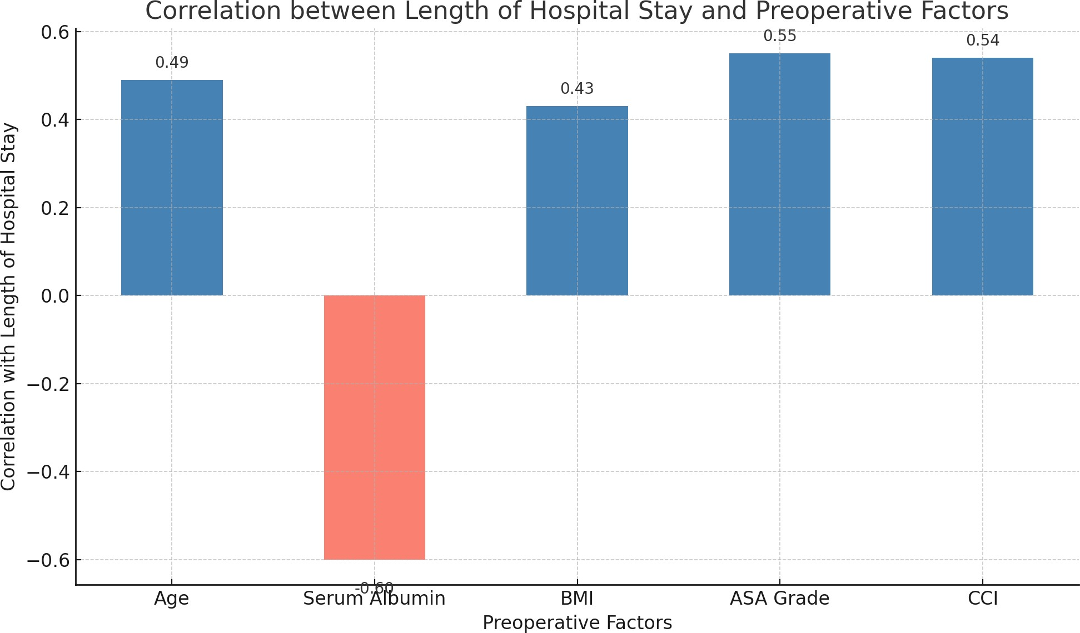

Pre operative factors and Mortality: In the present study, early perioperative mortality occurred in 2 out of 40 patients and was associated with older age (mean >69.5 years), low serum albumin levels (<3.5 g/dL), higher BMI (mean >33.6 kg/m²), higher ASA grade (>4), and higher Charlson Comorbidity Index (CCI, mean 6.5). While these factors appear linked to early mortality, the small sample size precludes definitive correlation. Long-term follow-up revealed mortality in 6 out of 38 patients. Analysis using box plots demonstrated a statistically significant association between long-term mortality and age (p = 0.0022, χ² = 24.15), BMI (p = 0.0280, χ² = 10.87), and ASA grading (p < 0.0001, χ² = 45.11), with ASA grading showing the strongest correlation. The association with CCI was marginally significant (p = 0.058, χ² = 15.06), suggesting a trend towards higher mortality with increased comorbidity burden. Among these, ASA grading and CCI were most strongly related to long-term mortality, while age and BMI showed weaker relationships. Serum albumin was not strongly correlated with long-term mortality in this dataset. These findings underscore the importance of preoperative health status, as reflected by ASA and CCI, in predicting long-term outcomes.

Figure 2: Bar diagram showing association between Pre operative factors and Mortality

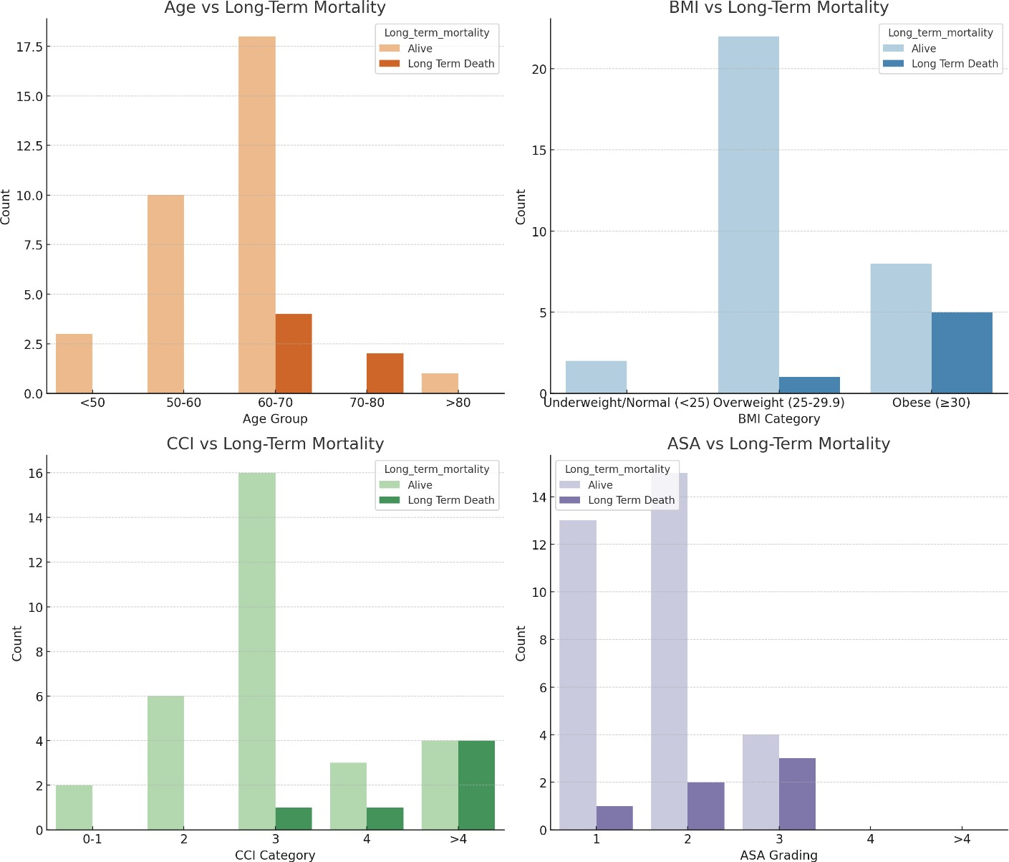

DISCUSSION:
The standard treatment for localized muscle-invasive bladder cancer (MIBC) and recurrent high-grade non-muscle-invasive bladder cancer (NMIBC) is radical cystectomy (RC) with bilateral pelvic lymph node dissection and urinary diversion (UD) (5). However, RC is a complex surgical procedure with significant perioperative risks, including complications and adverse outcomes, despite advancements in care. Malnutrition, encompassing both undernutrition and overnutrition, has been shown to exacerbate postoperative complications, increasing mortality, morbidity, length of hospital stay (LOS), readmission rates, and hospital costs (6). Preoperative nutritional status has emerged as a crucial predictor of postoperative outcomes in colorectal surgery (7) and major urological surgeries (8), though data specific to RC remains sparse. Indicators of nutritional status include BMI, unintended preoperative weight loss, comprehensive nutritional scores (e.g., NRS score, PNI), and markers such as low serum albumin levels (9).
This study analyzed preoperative factors affecting postoperative morbidity and long-term mortality in 40 RC patients. Statistically significant associations were identified, emphasizing modifiable factors for improved outcomes. The mean age was 62.18 ± 8.95 years, consistent with Gierth et al. (10) and Allaire et al. (11), which reported mean ages of 70 and 68.9 years, respectively. Males constituted 90% of the cohort, aligning with similar male predominance observed by Gierth et al. (80%) and Allaire et al. (78%). (10,11) Hematuria was the most common presentation, followed by dysuria. Histopathological findings post-cystectomy primarily included high-grade transitional cell carcinoma (TCC, 75%), with fewer cases of other variants.
Postoperative complications were influenced by various preoperative factors. Age >70 years was linked to poorer survival (12), with studies by Huang et al. (13) and Gondoputro et al. (14) highlighting higher American Society of Anesthesiologists (ASA) scores as predictors of severe complications (p < 0.05). Similarly, Charlson Comorbidity Index (CCI) was a strong predictor of high-grade complications (15, 16). While preoperative hemoglobin levels did not significantly correlate with complications, anemia was associated with higher Clavien-Dindo grades, likely reflecting a small sample size (17, 18). Serum albumin <3.5 g/dL was associated with higher complication rates, although statistical significance was not observed in this study, paralleling findings by Lambert et al. (19) and Patidar et al. (20). BMI exhibited a significant relationship with severe complications (10, 21).
Longer operative times and greater blood loss were significantly associated with high-grade complications, consistent with Adamczyk et al. (22) and Patidar et al. (20). Specific complications such as surgical site infections (SSI), paralytic ileus, acute kidney injury (AKI), and wound dehiscence were linked to factors including anemia, low serum albumin, higher BMI, longer operative times, and higher CCI. Smoking was a notable contributor to wound complications, likely due to impaired collagen synthesis, as supported by studies by Sathianathen et al. (23) and Fan Chiang et al. (24).
Preoperative hypoalbuminemia and high BMI were predictors of 30-day mortality, emphasizing the importance of nutritional optimization (25, 26). Higher BMI was linked to worse cancer-specific survival, while underweight patients exhibited better outcomes, reflecting differential metabolic and immunological responses (27, 28). A higher CCI predicted overall survival, reinforcing its value in preoperative assessments (29).
The findings underscore the critical role of comprehensive preoperative evaluation, emphasizing modifiable risk factors such as nutritional status and comorbidity management to improve RC outcomes. The results align with existing literature, highlighting the need for targeted interventions.

CONCLUSION:
From the study it can be concluded the Our study revealed that higher BMI, Comorbidity Index (CCI), American Society of Anaesthesiologists (ASA) grade, and prolonged intraoperative time were significantly associated with postoperative morbidity. While advanced age, low preoperative haemoglobin, and serum albumin levels did not exhibit statistical significance in predicting morbidity, specific complications demonstrated associations with particular risk factors. Smoking also emerged as a significant factor, with higher postoperative morbidity and complications of greater severity among smokers. Length of hospital stay was markedly affected by advanced age, higher BMI, CCI, and ASA grades. Early mortality was associated with factors such as advanced age, low serum albumin, and higher BMI, while long-term mortality was associated with factors such as advanced age, elevated CCI, BMI, and ASA grades. These findings underscore the importance of comprehensive preoperative assessments and risk stratification to optimize outcomes following radical cystectomy.

RECOMMENDATIONS AND LIMITATIONS:
To improve outcomes in patients undergoing radical cystectomy, we recommend targeted preoperative optimization focusing on modifiable risk factors such as BMI management, smoking cessation, and improvement of comorbid conditions where feasible. Comprehensive preoperative evaluations, including ASA grading and CCI assessments, should guide surgical planning and perioperative care. Intraoperative strategies to minimize surgical duration and blood loss may further reduce morbidity. Enhanced postoperative protocols, including vigilant monitoring of at-risk patients for complications like surgical site infections, paralytic ileus, and acute kidney injury, are essential. Additionally, smoking cessation programs should be prioritized to mitigate postoperative risks and improve recovery. Despite these insights, our study's limitations, particularly the small sample size, constrain the ability to generalize findings. Larger, multicentre studies are warranted to validate these results and establish stronger correlations between preoperative factors and perioperative outcomes. Future research should also explore the role of novel predictive models incorporating these factors to enable personalized risk stratification and management for patients undergoing radical cystectomy.
CONSENT
All authors declare that written informed consent was obtained from the patients for publication of this article. A copy of written consent is available for review by Chief Editor.
ETHICAL APPROVAL
All authors hereby declare that above research was approved by Institutional Ethics Committee (ethics approval number 1567/2023)and have therefore been performed in accordance with ethical standards laid down in the 1964 Declaration of Helsinki.

COMPETING INTERESTS DISCLAIMER:
Authors have declared that they have no known competing financial interests OR non-financial interests OR personal relationships that could have appeared to influence the work reported in this paper.
REFERENCES:

- Global Cancer Observatory, owned by the World Health Organization/International Agency for Research on Cancer [Internet]. https://www.wcrf.org/cancer-trends/bladder-cancer-statistics/.
- Wood Jr. DP: Urothelial Tumours of the Bladder. Campbell-Walsh Urology; 10th Edition; Kavoussi LR, Novick AC, Partin AW, et al; Elsevier Saunders 2012; Vol. 3; 80: pp. 2311-2332.
- Grabe-Heyne K, Henne C, Mariappan P, Geiges G, Pöhlmann J, Pollock RF. Intermediate and high-risk non-muscle-invasive bladder cancer: an overview of epidemiology, burden, and unmet needs. Front Oncol. 2023; 13:1170124.
- Aminoltejari K, Black PC. Radical cystectomy: a review of techniques, developments and controversies. Transl Androl Urol. 2020;9(6):3073- 3081.
- EAU Guidelines. Edn. presented at the EAU Annual Congress Amsterdam 2020. Arnhem, The Netherlands: EAU Guidelines Office; 2020. ISBN 978-94- 92671-07-3. Available from: https://uroweb.org/guidelines/compilations-of-all- guidelines/
- Williams DGA, Molinger J, Wischmeyer PE. The malnourished surgery patient: a silent epidemic in perioperative outcomes? Curr Opin Anaesthesiol. 2019;32(4):405–411.
- Hu WH, Cajas-Monson LC, Eisenstein S, Parry L, Cosman B, Ramamoorthy S. Preoperative malnutrition assessments as predictors of postoperative mortality and morbidity in colorectal cancer: an analysis of ACS-NSQIP. Nutr J. 2015;14:91.

- Cerantola Y, Valerio M, Hubner M, Iglesias K, Vaucher L, Jichlinski P. Are patients at nutritional risk more prone to complications after major urological surgery? J Urol. 2013;190(6):2126–2132.

- Li J, Cheng Y, Liu G, Ji Z. The association of pre-treatment serum albumin with outcomes in bladder cancer: a meta-analysis. Onco Targets Ther. 2018;11:3449–3459.

- Gierth M, Zeman F, Denzinger S, Vetterlein MW, Fisch M, Bastian PJ, et al. Influence of body mass index on clinical outcome parameters, complication rate and survival after radical cystectomy: evidence from a prospective European multicentre study. Urol Int. 2018;101(1):16–24.
- Allaire J, Léger C, Ben-Zvi T, Nguilé-Makao M, Fradet Y, Lacombe L, et al. Prospective evaluation of nutritional factors to predict the risk of complications for patients undergoing radical cystectomy: a cohort study. Nutr Cancer. 2017;69(8):1196–1204.
- Liu YL, Wu CT, Hsu YC, Chen MF, Chen CS, Shi CS, et al. Perioperative complications and oncologic outcomes after radical cystectomy in end-stage renal disease patients with bladder cancer obtained using a standardized reporting system. Cancers (Basel). 2022;14(14):3512.
- Huang H, Zhang Z, Hao H, Wang H, Shang M, Xi Z. The comprehensive complication index is more sensitive than the Clavien-Dindo classification for grading complications in elderly patients after radical cystectomy and pelvic lymph node dissection: Implementing the European Association of Urology guideline. Front Oncol. 2022;12:1002110.
- Gondoputro W, Riechelmann RP, Trinh QD, Aydin AM, Shariat SF, Lotan Y, et al. Surgical high-risk patients with ASA ≥ 3 undergoing radical cystectomy: Morbidity, mortality, and predictors for major complications in a high-volume tertiary center. Urol Oncol. 2018;36(9):365.e9–365.e16.
- von Deimling M, Rink M, Klemm J, Koelker M, Schuettfort V, König F, et al. Comprehensive evaluation of the ability of comorbidity and health status indices to improve the prediction of perioperative morbidity and long-term survival outcomes after radical cystectomy. Urol Oncol. 2023;41(3):239.e1– 239.e9.
- Yilmaz H, Cinar NB, Avci IE, et al. Evaluation of comprehensive complication index versus Clavien-Dindo classification in prediction of overall survival after radical cystectomy. Int Urol Nephrol. 2023;55(8):1459–1465.
- Weiss J, Goossen K, Haese A, Fritsche HM, Horstmann M, Wiesner C, et al. Preoperative anemia is associated with adverse outcomes in patients with urothelial carcinoma of the bladder following radical cystectomy. J Cancer Res Clin Oncol. 2015;141(9):1511–1522.
- van Ginkel N, Witjes JA, van de Velde RJ, et al. Predictors of major complications and the association with oncological outcomes after radical cystectomy for bladder cancer: a nationwide registry study. Eur Urol. 2021;79(6):839–847.
- Lambert JW, Ingham M, Gibbs BB, Given RW, Lance RS, Riggs SB. Using preoperative albumin levels as a surrogate marker for outcomes after radical cystectomy for bladder cancer. Urology. 2013;81(3):587–592.
- Patidar N, Yadav P, Sureka SK, Mittal V, Kapoor R, Mandhani A. An audit of early complications of radical cystectomy using Clavien-Dindo classification. Indian J Urol. 2016;32(4):282–287.
- Bi H, Huang Y, Wang G, Ma L, Lu M. Impact of body mass index and pretreatment hemoglobin level on prognosis following radical cystectomy for bladder cancer in males and females. Urol Int. 2020;104(1-2):28–35.
- Adamczyk P, Poblocki P, Michalik C, Kadlubowski M, Adamowicz J, Mikolajczak W, Drewa T, Juszczak K. A Personalized Approach to Radical Cystectomy Can Decrease Its Complication Rates. J Pers Med. 2022 Feb 14;12(2):281. doi: 10.3390/jpm12020281. PMID: 35207768; PMCID: PMC8878982.
- Sathianathen NJ, Weight CJ, Jarosek SL, Konety BR. Increased Surgical Complications in Smokers Undergoing Radical Cystectomy. Bladder Cancer. 2018 Oct 29;4(4):403-409. doi: 10.3233/BLC-180185. PMID: 30417051; PMCID: PMC6218107.
- Fan Chiang YH, Lee YW, Lam F, Liao CC, Chang CC, Lin CS. Smoking increases the risk of postoperative wound complications: A propensity score- matched cohort study. Int Wound J. 2023 Feb;20(2):391-402. doi: 10.1111/iwj.13887. Epub 2022 Jul 9. PMID: 35808947; PMCID: PMC9885463.
- Arora K, Hanson KT, Habermann EB, Tollefson MK, Psutka SP (2018) Early complications and mortality following radical cystectomy: associations with malnutrition and obesity. Bladder Cancer 4:377–388
- Osawa T, Lee CT, Abe T, Takada N, Hafez KS, Montgomery JS et al (2016) A multi-center international study assessing the impact of differences in baseline characteristics and perioperative care following radical cystectomy. Bladder Cancer 2:251–261
- Chromecki TF, Cha EK, Fajkovic H, Rink M, Ehdaie B, Svatek RS et al (2013) Obesity is associated with worse oncological outcomes in patients treated with radical cystectomy. BJU Intm111:249–255
- Murakami Y, Matsumoto K, Ikeda M, Utsunomiya T, Hirayama T, Koguchi D et al (2018) Impact of body mass index on the oncological outcomes of patients with upper and lower urinary tract cancers treated with radical surgery: a multi-institutional retrospective study. Asia Pac J Clin Oncol 14:310–317.
- Mayr R, May M, Martini T, Lodde M, Comploj E, Pycha A, et al. The Charlson Comorbidity Index Predicts Survival after Disease Recurrence in Patients following Radical Cystectomy for Urothelial Carcinoma of the Bladder. J Urol. 2014;192(2):494-501. doi: 10.1016/j.juro.2014.02.016.

