Vogt–Koyanagi–Harada Syndrome: A Case Report and Updated Literature Review

Abstract
Vogt–Koyanagi–Harada (VKH) syndrome is a rare multisystemic autoimmune inflammatory disorder affecting melanocyte-containing tissues, including the eyes, meninges, skin, and inner ear. We report the case of a 19-year-old Afro-Caucasian female presenting with sudden unilateral vision loss that rapidly progressed to bilateral involvement. Ophthalmic imaging demonstrated serous retinal detachments with characteristic angiographic findings. Ancillary investigations revealed cerebrospinal fluid pleocytosis with no evidence of infection. A diagnosis of incomplete VKH syndrome was established, and the patient was treated with high-dose intravenous corticosteroids followed by oral tapering, leading to a favorable anatomical and functional outcome. This report highlights the importance of multimodal imaging and early aggressive corticosteroid therapy in improving visual prognosis. We also provide an updated review of current literature on the immunopathogenesis, diagnostic criteria, and management strategies for VKH syndrome.
Keywords: Vogt–Koyanagi–Harada syndrome, bilateral uveitis, serous retinal detachment, corticosteroid therapy, autoimmune inflammation.

Introduction
Vogt–Koyanagi–Harada (VKH) syndrome is a systemic autoimmune disorder characterized by bilateral granulomatous panuveitis, meningitis, and variable integumentary and auditory manifestations. It primarily affects individuals with pigmented skin, particularly those of Asian, Middle Eastern, Hispanic, and Native American descent, with an incidence estimated at 1–2 per million population annually. The disease results from a T-cell–mediated immune reaction targeting antigens associated with melanocytes, leading to inflammation of the uveal tract, meninges, and skin. Clinically, VKH progresses through four distinct phases: the prodromal phase with meningitic symptoms, the acute uveitic phase marked by bilateral serous retinal detachments and optic disc swelling, the convalescent phase with depigmentation phenomena (sunset glow fundus, vitiligo, poliosis), and the chronic recurrent phase, characterized by relapsing anterior uveitis. Diagnostic criteria, first proposed by the American Uveitis Society and later revised by Read et al. in 2001, classify VKH into complete, incomplete, and probable forms. Early diagnosis and prompt corticosteroid therapy are essential to prevent progression to chronic disease and irreversible visual loss.

Case Report
A 19-year-old Afro-Caucasian female with no significant medical history presented with sudden, painless vision loss in the left eye (LE) for three days, accompanied by mild intermittent headaches. She reported exposure to tuberculosis six months prior but had not received treatment. There was no history of ocular trauma, infection, or systemic autoimmune disease. Ophthalmic examination revealed a best-corrected visual acuity (BCVA) of 10/10 in the right eye (RE) and 1/10 in the LE. The anterior segment examination was unremarkable bilaterally. Fundus examination of the LE demonstrated serous retinal elevation and paramacular folds (Figure 1). Optical coherence tomography (OCT) confirmed a serous retinal detachment involving the macula (Figure 2). Fluorescein angiography (FA) showed multiple pinpoint hyperfluorescent leaks with progressive pooling of dye (Figure 3). Systemic evaluation was normal. Laboratory investigations showed leukocytosis (13,000/mm³), negative autoimmune and infectious serologies, and a positive Quantiferon-TB Gold test, though chest X-ray was unremarkable. The patient was admitted for observation and hypotensive therapy. After five days, partial improvement was noted with reduced subretinal fluid (Figure 4). Seven days later, she developed sudden visual loss in the right eye with severe headaches. Slit-lamp examination revealed fine keratic precipitates and a 3+ aqueous flare bilaterally. Fundus examination showed bilateral serous detachments and optic disc edema. OCT revealed a large macular detachment in the RE with residual atrophy in the LE (Figure 5–6). Fluorescein angiography confirmed multiple leakage points and optic disc hyperfluorescence. MRI was normal. Lumbar puncture revealed pleocytosis (130 cells/mm³) with sterile culture. A diagnosis of incomplete VKH syndrome was made. The patient received intravenous methylprednisolone (1 g/day for five days) followed by oral prednisone taper (1 mg/kg/day), topical corticosteroids (Maxidrol®), and antiviral prophylaxis (Valex®). Within one week, headaches resolved and OCT showed near-complete resorption of subretinal fluid (Figure 7). One month later, BCVA improved to 9/10 bilaterally.

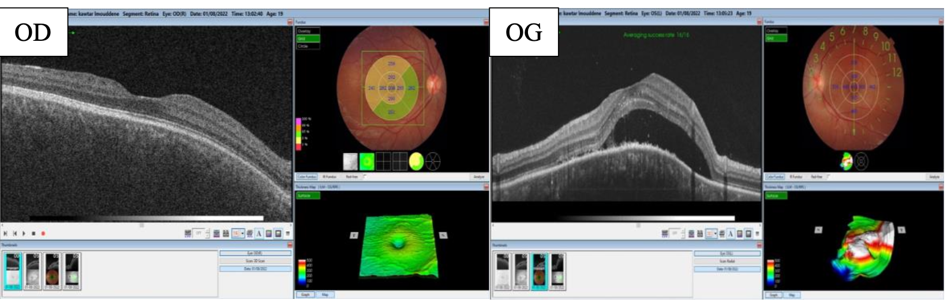
Figure 1: Initial macular OCT showing serous retinal detachment in the left eye.

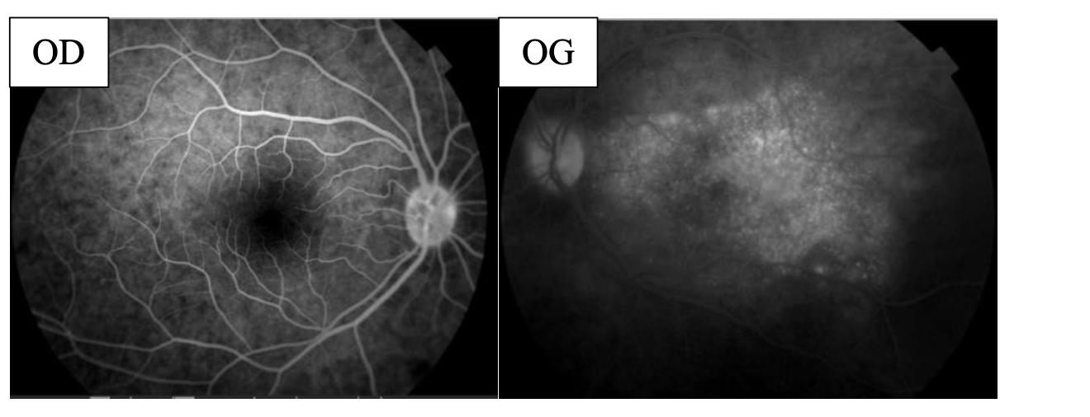
Figure 2: Early fluorescein angiography showing multiple leakage points and a bilobed pattern of serous detachment

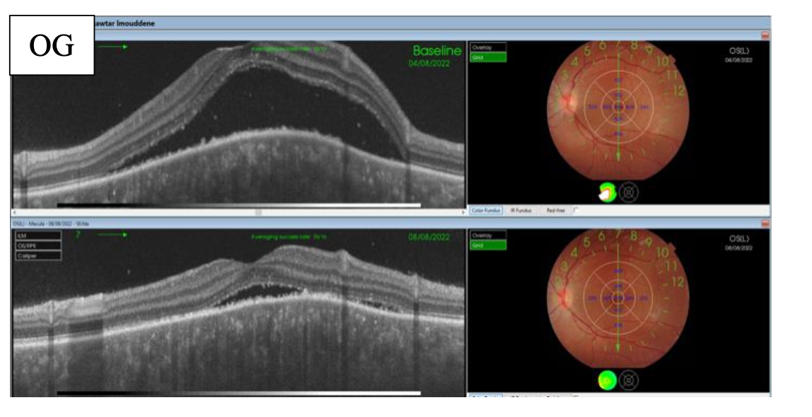Figure 3: OCT under Diamox® showing regression of subretinal fluid

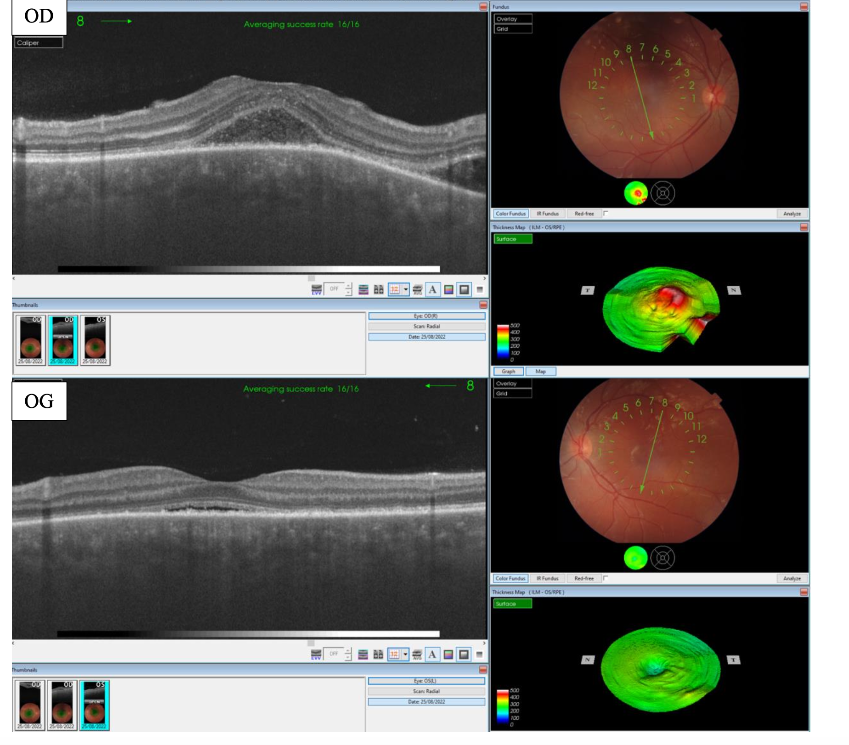
Figure 4: Late-phase angiography showing confluence of leakage points and optic disc hyperfluorescence.
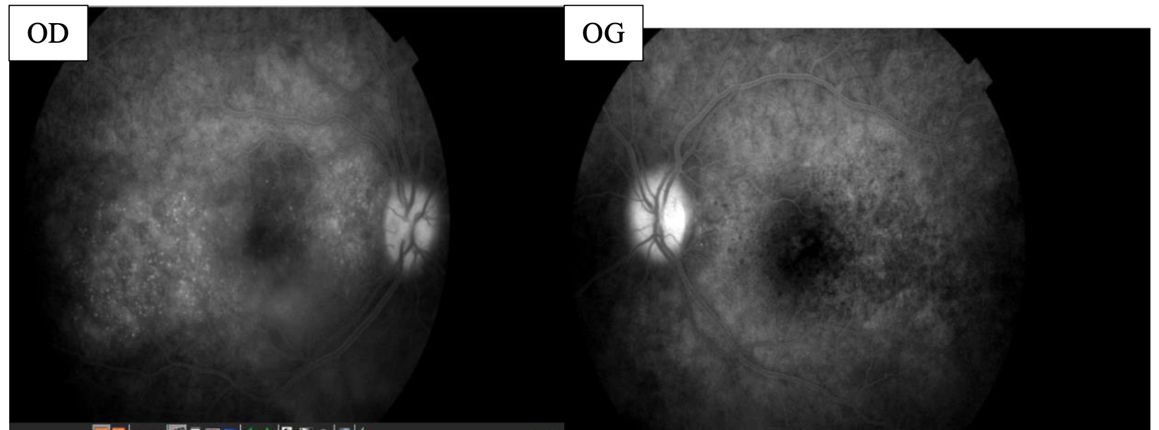
Figure 5: Bilateral OCT showing persistent serous detachment before corticosteroid therapy.

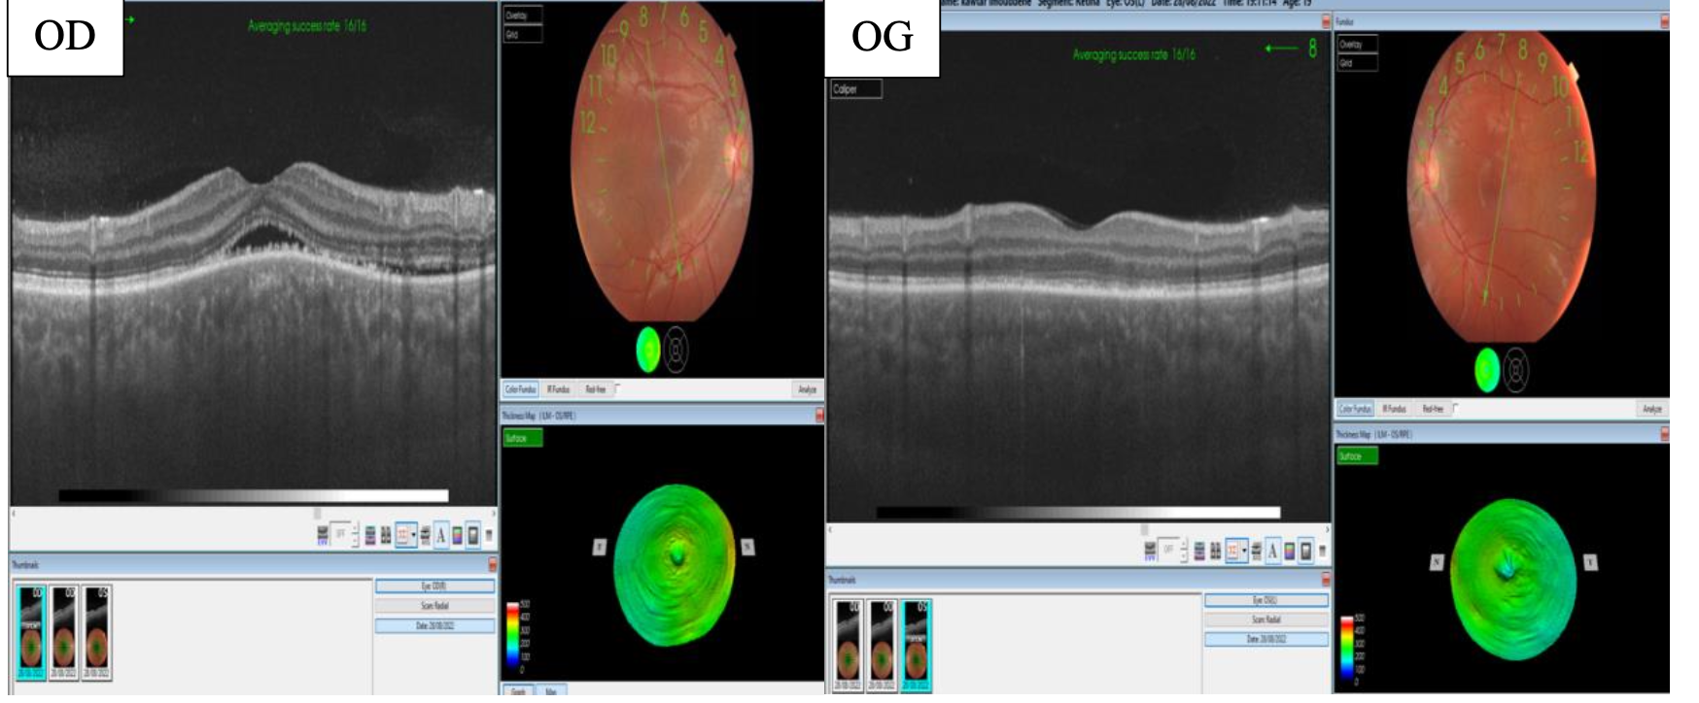
Figure 6: OCT at day 3 after intravenous methylprednisolone showing regression of serous detachment.

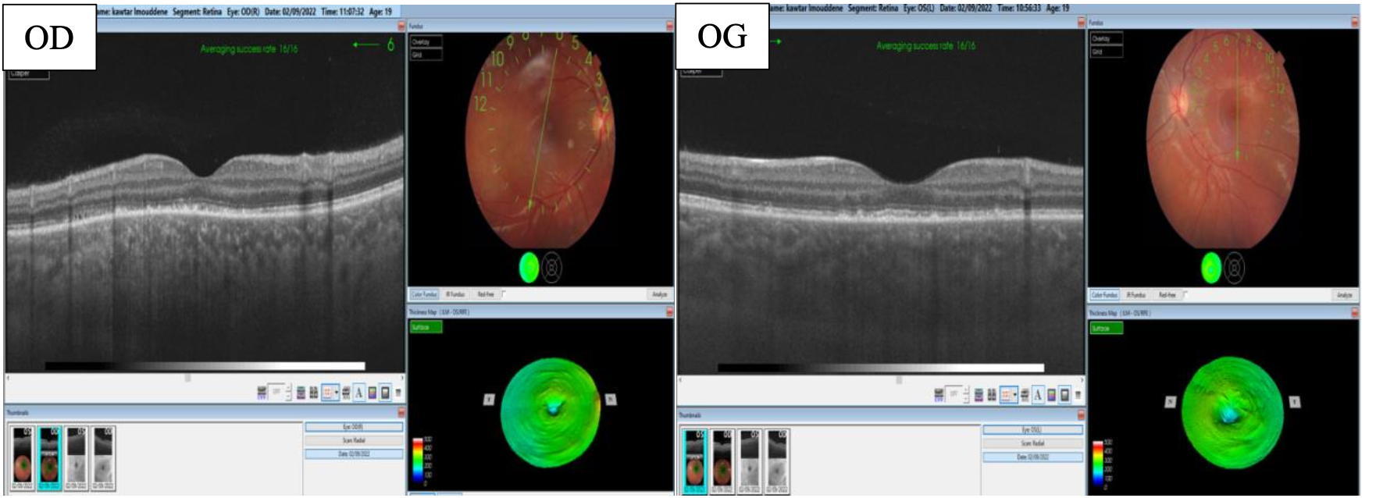
Figure 7: OCT at day 6 showing near-complete resolution of serous retinal detachment.

Discussion
Vogt–Koyanagi–Harada (VKH) syndrome is a T-cell–mediated autoimmune disease directed against melanocyte-associated antigens. Cytotoxic CD4+ and CD8+ lymphocytes initiate choroidal inflammation, while elevated cytokines such as IL-6, IL-17, and interferon-γ contribute to disease progression. Genetic studies have identified associations with HLA-DR4 and HLA-DQw3, particularly in Asian populations. Diagnosis relies on clinical features supported by imaging. OCT shows serous detachments and subretinal septa, FA reveals pinpoint leaks, and ICGA is sensitive for choroidal inflammation. OCT angiography (OCT-A) is emerging as a non-invasive method to assess choroidal perfusion deficits. Treatment requires prompt corticosteroid therapy—typically high-dose intravenous methylprednisolone followed by a slow taper over 6–12 months. In refractory or relapsing cases, immunosuppressive drugs (azathioprine, cyclosporine, mycophenolate mofetil) and biologics (adalimumab, infliximab) are recommended. Prognosis is generally good if treated early, though delayed therapy increases the risk of chronic depigmentation and fibrosis. Differential diagnoses include sympathetic ophthalmia, posterior scleritis, sarcoidosis, and APMPPE. Our case illustrates an incomplete VKH initially unilateral and later bilateral, emphasizing the need for early recognition.

Conclusion
Vogt–Koyanagi–Harada syndrome is a rare, sight-threatening autoimmune disease. Early recognition based on multimodal imaging and prompt corticosteroid therapy are crucial to preserve vision. Long-term monitoring and appropriate immunosuppression reduce recurrence and chronic complications. Advances in OCT-A and biologic therapies offer promising avenues for improved management.

Patient Consent
The patient provided informed consent for the publication of this case report and accompanying images.

References
- 1. Read RW, Holland GN, Rao NA, et al. Revised diagnostic criteria for Vogt–Koyanagi–Harada disease. Am J Ophthalmol. 2001;131(5):647–652.
- 2. Moorthy RS, Inomata H, Rao NA. Vogt–Koyanagi–Harada syndrome. Surv Ophthalmol. 1995;39(4):265–292.
- 3. Damico FM, Kiss S, Young LH. Vogt–Koyanagi–Harada disease. Semin Ophthalmol. 2005;20(3):183–190.
- 4. Hou S, Kijlstra A, Yang P. Immunopathogenesis of Vogt–Koyanagi–Harada disease. Prog Retin Eye Res. 2022;87:100999.
- 5. Yang P, Zhong Y, Du L, et al. Diagnostic criteria for Vogt–Koyanagi–Harada disease. JAMA Ophthalmol. 2021;139(9):1016–1024.
- 6. Herbort CP, Abu El Asrar AM, Yamamoto JH, et al. Vogt–Koyanagi–Harada disease: Review. Surv Ophthalmol. 2022;67(5):1049–1073.
- 7. Maruyama K, et al. Cytokine profile in Vogt–Koyanagi–Harada disease. Ocul Immunol Inflamm. 2020;28(5):821–828.
- 8. Chee SP, Jap A. The enigma of VKH and sympathetic ophthalmia: Overlaps and differences. Ocul Immunol Inflamm. 2018;26(2):167–172.
- 9. Zhang X, et al. Optical coherence tomography angiography findings in acute VKH. Retina. 2019;39(7):1389–1396.
- 10. Agarwal A, et al. Long-term outcomes of biologic therapy in refractory VKH. Br J Ophthalmol. 2020;104(8):1064–1069.
- 11. Lai TY, et al. Advances in the management of uveitis: biologics and targeted therapies. Eye (Lond). 2021;35(9):2342–2354.
- 12. Pavesio C, et al. Multimodal imaging in VKH: a comprehensive approach. Front Med (Lausanne). 2023;10:112345.

