Predictive Factors of Biliary Cannulation Failure

Abstract:
Introduction: Endoscopic biliary drainage continues to evolve and now plays a central role in the management of biliary tract strictures of lithiasic, tumoral, or other origins.
The aim of our study is to report our outcomes with endoscopic biliary drainage via endoscopic retrograde cholangiopancreatography (ERCP) and to identify factors associated with cannulation failure.
Materials and Methods: This is a retrospective, descriptive, and analytical study conducted in the Hepato-Gastroenterology Department at Ibn Rochd University Hospital in Casablanca. It covers an eight-year period, from January 2017 to January 2024, and includes all patients who underwent therapeutic ERCP.
Results: During the study period, 407 therapeutic ERCP procedures were performed. Cannulation failure occurred in 7% of cases, representing 30 patients.
The predictive factors of biliary cannulation failure identified in our study were: an impacted stone in the distal common bile duct, the appearance of the duodenal papilla, and an intradiverticular location of the papilla.
Conclusion: Our study demonstrated that the location and appearance of the duodenal papilla, as well as the presence of an impacted stone in the distal common bile duct, are significant factors influencing the risk of biliary cannulation failure.
Keywords : Failure-ERCP- Biliary cannulation

Introduction :
Selective cannulation of the main bile duct is a crucial step during endoscopic retrograde cholangiopancreatography (ERCP).
Biliary cannulation can be difficult or even impossible to achieve, leading to repeated procedures due to factors related either to the anatomy of the biliary system [1], the presence of bile duct stones [2], or tumoral infiltration of the papilla.
Understanding the predictive factors of biliary cannulation failure could provide endoscopists with the opportunity to consider alternative management strategies, such as laparoscopic cholecystectomy combined with intraoperative bile duct clearance.
The objective of our study is to analyze the predictive factors of biliary cannulation failure.

Materials and Methods:
This is a retrospective, descriptive, and analytical study conducted in the Hepato-Gastroenterology Department of Ibn Rochd University Hospital in Casablanca over an 8-year period (January 2017 – January 2024).
The initial diagnosis of a biliary tract obstruction was based on clinical and biological findings, such as the presence of jaundice, right upper quadrant pain, fever, elevated liver enzymes (cytolysis), and a biological cholestasis syndrome with or without jaundice.
Radiologically, all patients underwent abdominal imaging — either computed tomography (CT) or magnetic resonance imaging (MRI), specifically magnetic resonance cholangiopancreatography (MRCP), prior to undergoing ERCP.
All patients who underwent an ERCP procedure during which biliary cannulation was documented as failed were included.
All patients with a history of complex gastrointestinal surgeries that could make access to the papilla difficult were excluded from the study.
We analyzed the patients’ epidemiological data, the factors implicated in cannulation failure, and the various therapeutic alternatives considered.
Descriptive statistics were calculated for continuous variables, including means, standard deviations, minimum and maximum values, as well as 95% confidence intervals (CIs).

Frequencies were calculated for categorical variables. When hypothesis testing was performed, Pearson’s Chi-square test and, when appropriate, Fisher’s exact test were applied [3].

Statistical analysis was performed using Jamovi software, which utilizes the R statistical language [4]. A statistical significance threshold of P = 0.05 was adopted.

Results:
A total of 407 therapeutic ERCP sessions were performed during the study period.
Biliary cannulation failure was reported in 30 patients, representing 7%.
The mean age of patients who experienced biliary cannulation failure was 58.5 ± 18.8 years, with a female predominance of 63% (n = 19), corresponding to a male-to-female sex ratio of 0.6 (Figure 2).Among the patients, 76% (n = 23) had no prior medical history.
A history of cholecystectomy was reported in 13% of cases (n = 4), 6% (n = 2) had a history of lithiasic pancreatitis, and alcohol and tobacco use was reported in 3% (n = 1) (Figure 1).Among the 30 patients, the indication for ERCP was common bile duct (CBD) stones in 70% of cases (n = 21), angiocholitis in 13% (n = 4), acute lithiasic pancreatitis in 13% (n = 4), and distal choledochal stricture in 4% (n = 1).
Significant factors associated with biliary cannulation failure were: impacted stone in the distal common bile duct (p<0.001), type I duodenal papilla morphology according to the Novel classification (p<0.001), intradiverticular papilla (p<0.001), and papilla infiltrated by a tumoral lesion (p<0.001) (Table 1). Conversely, age (p=0.472), sex (p=0.639), and indication for ERCP (p=0.479) were not significantly associated with cannulation failure (Table 1).
As therapeutic alternatives, surgical bypass was indicated in the majority of patients (67%, n=20), sphincterotomy alone in 25% (n=6), septotomy in 12.5% (n=3), and precut sphincterotomy in 4.2% (n=1).

Predictive Factors of Biliary Cannulation Failure | p-value
-Age (58.5 ans +/- 18.8) | 0.472
-Sex (ratio (H/F) de 0.6) | 0.639
Indication for ERCP:  - Choledocholithiasis (n=21)  - Cholangitis (n=4)  - Biliary pancreatitis (n=4)  - Distal common bile duct stricture (n=1) | 0.479
-Impacted stone in the distal common bile duct (n=8) | <0.001
-Type I duodenal papilla morphology according to the Novel classification (n=5) | <0.001
-Intradiverticular papilla (n=5) | <0.001
- Papilla infiltrated by a tumoral lesion (n=12) <0.001
Table 1: Predictive Factors of Biliary Cannulation Failure

Figure 1 : medical history figure 2 : sex

Figure 3 : indication of ERCP
Discussion:
Interventional endoscopy has revolutionized the management of biliary tract diseases by reducing the risk of complications and shortening hospital stays. However, perioperative risks have been reported, including perforations, hemorrhages, post-ERCP acute pancreatitis, and notably, failure of biliary cannulation during the procedure.

According to the European Society of Gastrointestinal Endoscopy (ESGE), failure of biliary cannulation is a notable complication, occurring in approximately 5 to 20% of procedures, even in specialized centers [5].
Compared to our study, the biliary cannulation failure rate was 7%, which is consistent with data reported in the literature.
In a prospective multicenter study conducted in the United States, the failure rate was 19.5% [6].
According to the literature, several factors are significantly associated with biliary cannulation failure. These include a small-sized papilla, dysfunction of the sphincter of Oddi, an intra- or para-diverticular papilla, a tortuous papilla, malignant tumor infiltration of the duodenum or papilla, as well as the presence of edema or distortion of the duodenum caused by acute pancreatitis [7-10].

Other factors identified as potentially compromising biliary cannulation success include a history of Billroth II gastric surgery, an initially elevated bilirubin level, an INR ≥ 1.5, and atypical biliary strictures (multifocal or located outside the main bile duct) [11, 12].
The papilla morphology has been classified into seven types according to the Novel classification (Figure 2): type I, flat type without oral protrusion; type IIA, tubular non-pleated prominent type with oral protrusion and fewer than one transverse fold on the protrusion; type IIB, pleated tubular prominent type with oral protrusion and more than two transverse folds on the protrusion; type IIC, prominent bulging type with a widened and bulging oral protrusion; type IIIA, diverticular-intradiverticular type with the papillary orifice located inside the diverticulum; type IIIB, diverticular-border diverticular type with the papillary orifice less than 2 cm from the diverticular edge; and type IV, unclassified papilla without morphology fitting the other categories.
It has been demonstrated that types I and II are significantly associated with biliary cannulation failure according to prospective multicenter studies conducted in Scandinavia, which align with the findings of our study [13, 14].
In our study, other factors significantly associated with cannulation failure included impacted stones in the distal common bile duct (p<0.001) and intradiverticular papilla (p<0.001), consistent with results reported in the literature [15-18].
However, a concentric study conducted in Greece identified advanced age as a risk factor for failure, which does not correspond to our findings [19].
In addition to the factors mentioned above, the experience of the endoscopist or operator was significantly associated with cannulation failure, according to a study conducted in Japan in 2022 [20].
In 2024, a study conducted in Sweden comparing the precut technique using a needle-knife versus transpancreatic sphincterotomy for difficult biliary cannulation demonstrated greater success with transpancreatic sphincterotomy, but with higher rates of adverse events such as pancreatitis and perforation [21].
Performing a second ERCP after initial biliary cannulation failure has been considered a therapeutic option, with a success rate of approximately 83.9%, according to a study conducted in China in 2022 [22].
In our study, as therapeutic alternatives, the majority of patients underwent surgical bypass and radiological drainage.
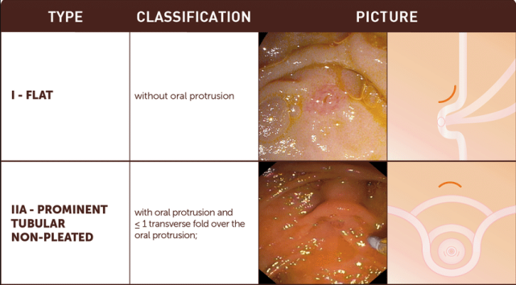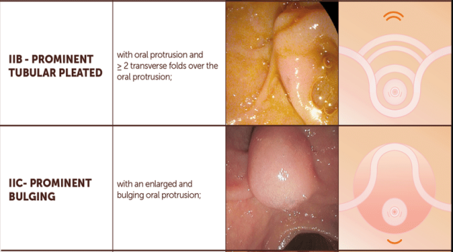
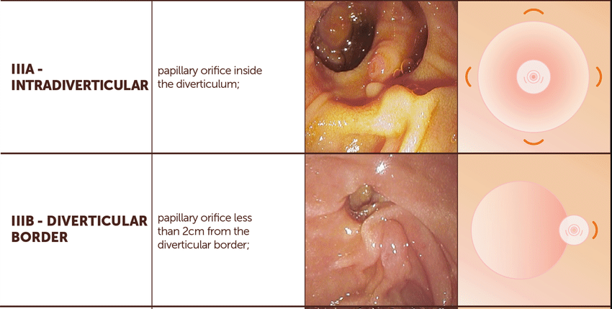
Figure 4: Novel Classification of the Duodenal Papilla.

Conclusion:
The position and morphology of the duodenal papilla, as well as the presence of an impacted stone in the distal common bile duct, determine the risk of biliary cannulation failure.
The use of sphincterotomy alone, septotomy, and precut sphincterotomy can help reduce this risk.

Reference :
1. Cheng CL, Tsou YK, Lin CH, Tang JH, Hung CF, Sung KF, et al. Poorly expandable common bile duct with stones on endoscopic retrograde cholangiography. World J Gastroenterol 2012;18:2396 401.
2. Aljebreen AM, Alharbi OR, Azzam N, Almadi MA. Efficacy of spyglass guided electrohydraulic lithotripsy in difficult bile duct stones. Saudi J Gastroenterol 2014;20:366 70.
3. Warnes GR, Bolker B, Lumley T, Johnson RC. Contributions from Randall C. Johnson are copyright. SAIC Frederick, Inc. Funded by the Intramural Research Program, of the NIH, National Cancer Institute and Center for Cancer Research under NCI Contract NO1 CO 12400. (2015). gmodels: Various R Programming Tools for Model Fitting. R package version 2.16.2. Available from: https://CRAN.R project.org/package=gmodels. [Last accessed on 2018 Jul 02].
4. R Core Team. A: A language and environment for statistical computing. Vienna, Austria: R Foundation for Statistical Computing; 2017. Available from: https://www.R project.org/. [Last accessed on 2018 Jul 02].
5. Testoni PA, Mariani A, Aabakken L, et al. Papillary cannulation and sphincterotomy techniques at ERCP: European Society of Gastrointestinal Endoscopy (ESGE) Clinical Guideline. Endoscopy. 2016;48(7):657-683. doi:10.1055/s-0042-100456.
6. Failed biliary ERCP: A Prospective Multicenter Study of Risk Factors, Complications, and Resource Utilization. Gastrointestinal Endoscopy. 2004;60(6):1035-1041.
7. Bakman, Y.G., Freeman, M.L. Difficult biliary access at ERCP. Gastrointest. Endosc. Clin. N Am. 2013;23(2):219–236. DOI: 10.1016/j.giec.2012.12.012.
8. Rajnakova A., Goh P.M., Ngoi S.S., Lim S.G. ERCP in patients with periampullary diverticulum. Hepato-gastroenterology. 2003; 50(51):625–628.
9. Baillie, J. Difficult biliary access for ERCP. Curr. Gastroenterol. Rep. 2012;14(6):542–547. DOI: 10.1007/S11894-012-0297-X.].
10. Saito H, Kadono Y, Shono T, Kamikawa K, Urata A, Nasu J, Imamura H, Matsushita I, Kakuma T, Tada S. Factors Predicting Difficult Biliary Cannulation During Endoscopic Retrograde Cholangiopancreatography for Common Bile Duct Stones. Clinical Endoscopy. 2022;55(2):263–269.
11. Dumonceau JM, Tringali A, Blero D, et al. Biliary stenting: indications, choice of stents and results: European Society of GastrointestinalEndoscopy (ESGE) clinical guideline. Endoscopy. 2012; 44:277-98.
12. Rey JF, Dumas R, Canard JM, et al., Recommendation of the French Society of Digestive Endoscopy: Biliary Prostheses. Endoscopy. 2002; 34: 181–185.
13. Haraldsson E., Lundell L., Swahn F., Enochsson L., Löhr J., Arnelo U. Endoscopic classification of the papilla of Vater. Results of an inter- and intra-observer agreement study. Unit. Eur. Gastroenterol. J. 2017; 5(4):504–510. DOI: 10.1177/2050640616674837].
14. Haraldsson E., Kylänpää L., Grönroos J.M., Saarela A., Toth E., Qvigstad G. Macroscopic appearance of the major duodenal papilla influences bile duct cannulation: a prospective multicenter study by the Scandinavian Association for Gastrointestinal Endoscopy for ERCP Study Group. Gastrointest. Endosc. 2019;90(6):957–963. DOI: 10.1016/j.gie.2019.07.014.].
15. Almadi M., Eltayeb M., Thaniah S., Alrashed F., Aljebreen M., Alharbi O. Predictors of failure of endoscopic retrograde cholangiography in gallstone removal during the initial procedure. Saudi J. Gastroenterol. 2019; 25(2):132. DOI: 10.4103/SJG. SJG_304_18.
16. Üsküdar O., Parlak E., Dışıbeyaz S., Köksal A.S., Cıçek B., Kılıç Z.M.Y. Main predictors of difficult bile duct stones. Turk. J. Gastroenterol. 2013; 24(5):423–429. DOI: 10.4318/TJG.2013.0511.
17. Kim H.J., Choi H.S., Park J.H., Park D.I., Cho Y.K., Sohn C.I. Factors influencing the technical difficulty of endoscopic gallstone removal. Gastrointest. Endosc. 2007; 66(6):1154–1160. DOI: 10.1016/j.gie.2007.04.033.
18. Ramírez García, J. Factors associated with treatment failure in gallstone removal by endoscopic retrograde colangiopancreatography, ERCP. Rev. Gastroenterol. Peru. 2011; 31(4):330–334.
19. Christoforidis E., Vasiliadis K., Tsalis K., Patridas D., Blouhos K., Pramateftakis M.G. Factors significantly contributing to the failure of conventional endoscopic stone removal in patients with “difficult” choledocholithiasis: a single-center experience. Diagn. Ther. Endosc. 2014; 2014:1–7. DOI: 10.1155/2014/861689.
20. Saito H, Kadono Y, Shono T, Kamikawa K, Urata A, Nasu J, Imamura H, Matsushita I, Kakuma T, Tada S. Factors Predicting Difficult Biliary Cannulation during Endoscopic Retrograde Cholangiopancreatography for Common Bile Duct Stones. Clinical Endoscopy.
21. Difficult cannulation during endoscopic retrograde cholangiopancreatography — needle knife precut versus transpancreatic sphincterotomy on the basis of successful cannulation and adverse events. Surgical Endoscopy. 2024 Dec 29;39(2):1200 1206.
22. Second endoscopic retrograde cholangiopancreatography after failure of initial biliary cannulation: A single institution retrospective experience.” Translational Medicine Studies. 2022.

