Case Report
Plummer-Vinson Syndrome Associated with Celiac Disease: A Case Report

Abstract
Plummer-Vinson Syndrome (PVS), also known as Paterson-Kelly syndrome, is a rare condition characterized by cervical dysphagia associated with iron-deficiency anemia and the presence of a web in the upper esophagus. The association of this syndrome with celiac disease is not well known.
Aim : We report a case of a patient with PVS associated with celiac disease.
Case report : A 48-year-old woman was hospitalized for the management of high dysphagia accompanied by an anemic syndrome. The diagnosis of PVS associated with celiac disease was established. The patient was treated with iron supplementation and endoscopic dilation of the esophageal web, along with a gluten-free diet.
Conclusion : Celiac disease is a classic cause of iron-deficiency anemia and should be considered an etiological factor in sideropenic dysphagia. Since both Plummer-Vinson syndrome (PVS) and celiac disease are each associated with an increased risk of pharyngeal and esophageal cancer, regular follow-up of these patients is essential.
Keywords : Plummer-Vinson syndrome, Celiac disease, Endoscopic dilation, Iron supplementation, Gluten-free diet

Introduction
Plummer-Vinson syndrome (PVS), also known as Paterson-Kelly syndrome, is a rare condition characterized by cervical dysphagia associated with iron deficiency anemia and the presence of an upper esophageal web. The association between this syndrome and celiac disease is not well known and was first reported by Dickey and McConnell in 1999. The aim of our report is to highlight the importance of considering a diagnosis of celiac disease whenever we encounter a case of iron deficiency anemia, especially when it is associated with Plummer-Vinson syndrome.

Case Report
We report the case of a 48-year-old woman, followed for unexplored iron deficiency anemia, who was admitted for progressive, selective high dysphagia to solids evolving over a period of two years, without other associated symptoms. Clinical examination revealed mucocutaneous pallor. Laboratory tests showed hypochromic microcytic anemia, with a hemoglobin level of 7.3 g/dL and low ferritin at 3.85 ng/L, without other signs of malabsorption. Esophagogastroduodenoscopy (EGD) revealed a regular, stenotic narrowing located 15 cm from the dental arches, which was impassable by the endoscope. A complementary barium swallow (esophagogastroduodenal transit) showed a constant, short, and regular stenosis of the cervical esophagus, suggestive of Plummer-Vinson syndrome. The patient subsequently underwent endoscopic dilation using Savary-Gilliard bougies. Endoscopic examination downstream of the stenosis revealed a serrated duodenal mucosa. Celiac serology, specifically IgA and IgG anti-transglutaminase antibodies, was positive at 110.70 IU/mL and 25.90 IU/mL, respectively. Duodenal biopsies showed subtotal villous atrophy classified as grade IIIb according to the Marsh classification. Thus, the diagnosis of PVS associated with celiac disease was confirmed. The patient was started on a gluten-free diet combined with iron supplementation. The follow-up showed resolution of the deficiency syndrome and no recurrence of dysphagia after six months.

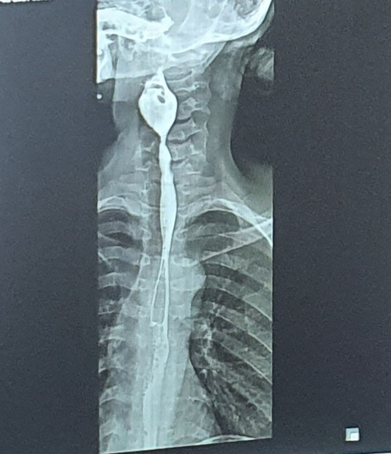
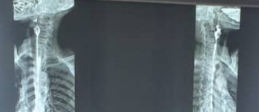
Figure 1: A consistent, short, and regular stenosis of the cervical esophagus, seen on frontal and lateral viewsTOGD
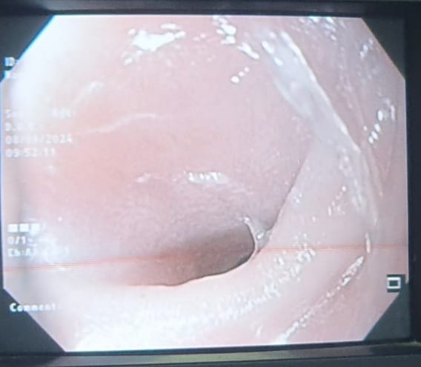

Figure 2: Endoscopic view of a thin, stenosing semi-lunar membrane in the cervical esophagus
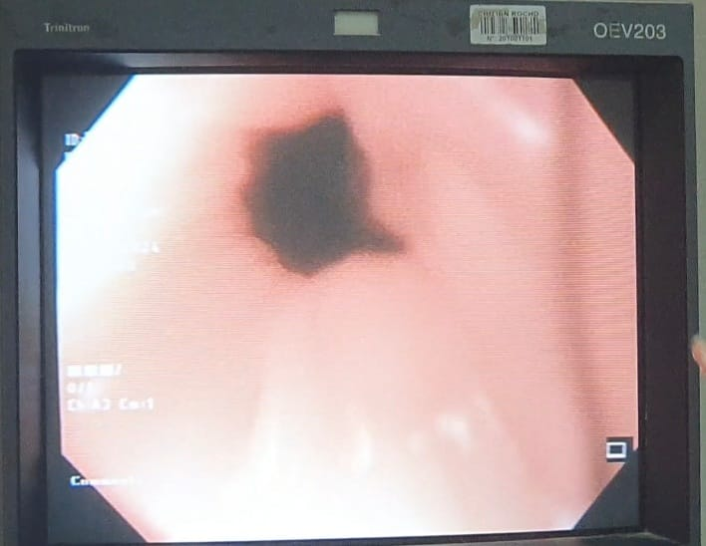
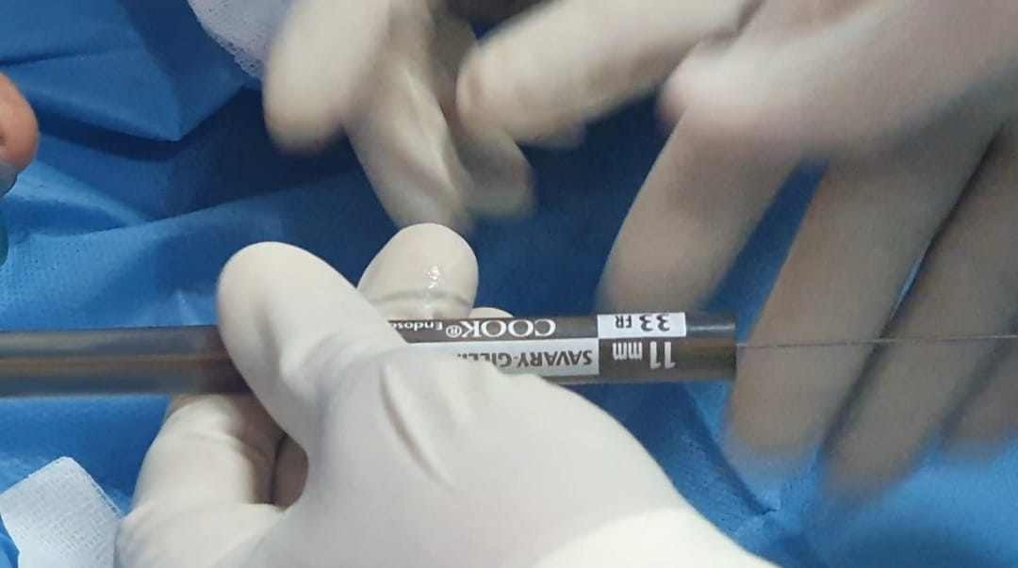
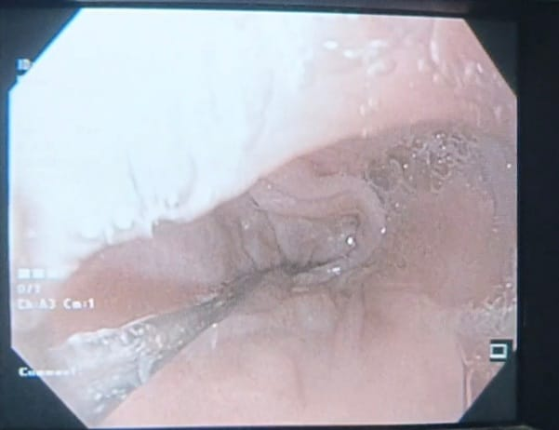
Figure 4: Appearance of the stenosis after dilation with bougies
Figure 3: Endoscopic dilation using Savary-Gilliard bougies

Discussion
Plummer-Vinson syndrome (PVS), also known as Paterson-Kelly syndrome, is a rare clinical entity characterized by the triad of cervical dysphagia, iron-deficiency anemia, and an esophageal web in the upper esophagus [1]. Dysphagia is the main symptom that often leads to its diagnosis. However, some atypical presentations without dysphagia can result in delayed diagnosis [2]. This syndrome was first described by Henry Plummer in 1912 and then by Vinson in 1919 [3,4]. Its incidence is declining, which may be attributed to improved nutrition and/or iron intake. It predominantly affects women (85%), between the third and seventh decades of life, which is consistent with our patient's case [5]. Cases of VPS have also been reported in men, children and adolescents [6]. This entity is described in northern European countries, notably in rural Sweden [7]. In Africa, PVS is a more recent description despite the prevalence of malnutrition and iron deficiency [1,8,9,10].
The pathogenesis of the syndrome remains uncertain, but among the most cited etiopathogenic mechanisms is iron deficiency [1,11]. Several studies suggest an important etiological role for anemia in the formation of the esophageal diaphragm [12,13]. It has been described that iron deficiency induces dysfunction of iron-dependent enzymes, leading to oxidative stress and DNA damage. This dysfunction is responsible for mucosal atrophy and pharyngeal muscle degradation, leading to the development of esophageal membranes [7, 14].
Some studies have even shown that correction of this anemia alone in some patients can lead to improvement in dysphagia [7]. For example, a study by Lee et al reported that the patient's swallowing difficulties were resolved after 8 months of CD management using a gluten-free diet [15,].
Furthermore, it has also been suggested that genetic, environmental and autoimmune causes could play a role in this condition [5,9,10] explaining its association with several autoimmune diseases such as Biermer's disease, celiac disease as shown by our observation [11,16,17].
Clinically, PVS is characterized by high cervical dysphagia that is painless, intermittent or slowly progressive, and predominantly affects solids. It is associated with an anemic syndrome, including mucocutaneous pallor, fatigue, palpitations, nail and hair abnormalities, cheilitis, and glossitis. These clinical manifestations correspond with those observed in our patient. Endoscopically, the presence of a thin, semi-lunar web in the cervical esophagus may be missed or accidentally ruptured during rapid insertion of the endoscope [1,3,18]. A barium swallow typically shows a short, web-like or ring-like stenosis at the level of the cervical vertebrae (C5–C6) [19].
Management of PVS begins with identifying the underlying cause of the iron-deficiency anemia. This investigation includes ruling out dietary deficiency, bleeding (particularly gastrointestinal), neoplasia, and celiac disease or gluten intolerance [20]. Although the association of PVS with celiac disease is uncommon, celiac disease is a well-recognized cause of iron-deficiency anemia in patients with PVS, as in our case, hence the necessity of performing a systematic duodenal biopsy, as recommended in several studies.
The association between PVS and celiac disease is not well known and was first described by Dickey and McConnell in 1999 [21]. Diagnosis of celiac disease relies on clinical, biological, and histological findings. It is traditionally recognized in children and young adults; however, detection in the elderly has increased in recent years [22]. The clinical presentation is highly variable, ranging from the typical form (fatty, foul-smelling diarrhea, malabsorption, weight loss) to atypical forms (abdominal pain, growth delays, bone pain, etc.). Biologically, iron-deficiency anemia whether or not accompanied by other signs of malabsorption is one of the most common extra-intestinal manifestations of celiac disease [23,24], as observed in our patient. Serologic testing usually reveals the presence of anti-tissue transglutaminase IgA antibodies. Duodenal biopsies confirm the diagnosis by showing villous atrophy and increased intraepithelial lymphocytes on histopathological examination.
In patients with PVS associated with celiac disease, treatment should include both iron supplementation and the initiation of a gluten-free diet. In most cases, dysphagia improves with iron supplementation even before biological normalization, despite the persistence of the esophageal web [7,25]. However, when the esophageal ring is tight, mechanical dilatation with Savary-Gilliard bougies may be necessary [10,26]. In our case, the patient received iron supplementation (intravenous) and underwent a dilatation session, with good clinical and biological improvement. Given the high long-term risk of progression to esophageal cancer in these patients as described by Neil and Ben Dhaou [27,28] regular endoscopic and histological surveillance is indicated [29,30].

Conclusion
PVS is a rare condition with an underestimated prevalence. Its association with celiac disease is uncommon but increasingly reported. In any patient with PVS, celiac disease should be considered and investigated, especially in women and when the cause of anemia is not obvious. Management involves correcting the iron deficiency, performing esophageal dilatation in symptomatic cases, and adhering strictly to a gluten-free diet. In patients with PVS and celiac disease, the increased risk of malignant transformation justifies close endoscopic monitoring.

Consent (where ever applicable)

As per international standards or university standards written ethical approval has been collected and preserved by the author(s).

Ethical approval (where ever applicable)
As per international standards or university standards written ethical approval has been collected and preserved by the author(s).

COMPETING INTERESTS DISCLAIMER:
Authors have declared that they have no known competing financial interests OR non-financial interests OR personal relationships that could have appeared to influence the work reported in this paper.
Reference
- 1. Novacek G (2006) Plummer-Vinson syndrome. Orphanet J Rare Dis 1:36
- 2. Elwood PC, Jacobs A, Pitmann RG, et al. Epidemiology of the Patterson Kelly syndrome. Lancet. 1964 Oct 3;2(7362):716–20.
- 3. Plummer S (1912) Diffuse dilatation of the esophagus without anatomic stenosis (cardiospasm). A report of ninety-one cases. J Am Med Assoc 58:2013–5
- 4. Vinson PP (1919) A case of cardiospasm with dilatation and angulation of the esophagus. Med Clinics North Am 3:623–7
- 5. Chisholm M. The association between webs, iron, and post-cricoid carcinoma. Postgrad Med J 1974;50:215–9.
- 6. Lopez Rodrigez MJ, Robledo Andres P, Amarilla Jimenez A, et al. Sideropenic dysphagia in an adolescent. J Pediatr Gastroenterol Nutr 2002;34:87–90
- 7. Hofmann RM, Jaffe PE (1995) Plummer-Vinson syndrome: a case report and literature review. Arch Inter Med 155:2008–11
- 8. Dia D, Diouf ML, Mbengue M, et al (2010) Plummer-Vinson syndrome: clinical, paraclinical, and therapeutic aspects of 19 cases in Dakar. Med Afr Noire 57:189–92
- 9. Berthé A, Diop MM, Touré PS, et al (2014) Unusual presentations of Plummer-Vinson syndrome in Black Africans: report of two cases. Pan Afr Med J 19:145
- 10. Fall F, Gning SB, N’diaye AR, et al (2011) Plummer-Vinson syndrome: retrospective study of 50 cases. J Afr Hepatol Gastroenterol 5:259–63
- 11. Park JM, Kim KO, Park CS, Jang BI (2014) A case of Plummer Vinson syndrome associated with Crohn’s disease. Korean J Gastroenterol 63:244–7
- 12. . Chisholm M, Ardran GM, Callender ST, et al. A follow-up study of patients with postcricoid webs. Q J Med 1971;159:409–20
- 13. Jacobs A, Kilpatrick GS. The Paterson-Kelly syndrome. Br Med J 1964;2:79–82.
- 14. Changela K, Haeri NS, Krishnaiah M, Reddy M. Plummer-Vinson Syndrome with Proximal Esophageal Web. J Gastrointest Surg. 2016 May;20(5):1074-5. [PubMed]
- 15. Lee A, Tobin M, Cherian J, Chawla A. Dysphagia as a presentation of celiac disease. ACG Case Reports J. 2020;7(4):e00359. doi: 10.14309/.
- 16. Diop MM, Lèye MY, Touré PS, et al (2012) Plummer-Vinson syndrome discovered incidentally in Biermer's disease: case report and literature review. Rev Int Sc Med 14:165–8
- 17. Jacobs A, Kilpatrick GS (1964) The Paterson-Kelly syndrome. Br Med J 2:79–82
- 18. Park JM, Kim KO, Park CS, Jang BI (2014) A case of Plummer Vinson syndrome associated with Crohn’s disease. Korean J Gastroenterol 63:244–7
- 19. Jacobs A, Kilpatrick GS (1964) The Paterson-Kelly syndrome. Br Med J 2:79–82
- 20. Novacek G (2006) Plummer-Vinson syndrome. Orphanet J Rare Dis 1:36
- 21. Dickey W, McConnell B (1999) Celiac disease presenting as the Paterson-Brown Kelly (Plummer-Vinson) syndrome. Am J Gastroenterol 94:527–9
- 22. Freeman H, Lemoyne M, Pare P. Celiac disease. Best Pract Res Clin Gastroenterol 2002;16:37–49.
- 23. Bottaro G, Cataldo F, Rotolo N, et al. The clinical pattern of sub clinical/silent celiac disease: an analysis on 1026 consecutive cases. Am J Gastroenterol 1999;94:691–6.
- 24. Halfdanarson TR, Litzow MR, Murray JA. Hematologic manifestations of celiac disease. Blood 2007;109:412–21
- 25. Bakshi SS (2015) Plummer Vinson syndrome: is it common in males? Arq Gastroenterol 52:250–2
- 26. Sreenivas DV, Kumar A, Mannar R, Babu GR (2002) Results of Savary-Gilliard dilation in the management of cervical web of esophagus. Hepatogastroenterology 49:188–90
- 27. Neil Floch R. Plummer-Vinson syndrome. Netter Gastroenterologia. 2006:42–43
- 28. Ben Dhaou B, Ketari S, Derbali F, et al. Plummer-Vinson syndrome: about 3 observations and review of the literature. Rev Med Int. 2009;30(2):110.
- 29. Chisholm M (1974) The association between webs, iron and post-cricoid carcinoma. Postgrad Med J 50:215–9
- 30. Messmann H (2001) Squamous cell cancer of the esophagus. Best Pract Res Clin Gastroenterol 15:249–65

