Case Report
Hepatic and Cerebral Metastases from a Melanoma of Unknown Primary Origin: A Case Report

Abstract :
Malignant melanoma is a highly metastatic tumor that develops from melanocytes.
The most common sites of metastases are the liver, brain, and lungs, and in most cases, the primary origin can be identified.
We report the case of a patient presenting with hepatic and cerebral metastases revealing a melanoma with no identifiable cutaneous, mucosal, or ocular lesion.
The diagnosis was established based on immunohistochemistry following a liver biopsy.
Clinical, dermatological, and ophthalmological investigations failed to identify the primary tumor.
This case highlights the diagnostic and therapeutic challenges posed by this atypical presentation, as well as the importance of a multidisciplinary approach.
Keywords : Malignant melanoma, hepatic metastases, cerebral metastases, unknown primary origin.
Introduction :
Melanoma is one of the types of skin cancer and originates in melanocytes, the cells responsible for producing melanin, the pigment that gives skin its color.
In addition to the skin, melanoma can also develop in other parts of the body where melanocytes are found, such as the mucous membranes, the eyes (particularly in the ciliary body, iris, and choroid), as well as in the central nervous system, especially the meninges.
Hepatic metastases are diagnosed in 10% to 20% of patients with melanoma and are associated with poor prognosis and short survival rates [1].
Primary malignant melanoma of the liver, as well as secondary hepatic or cerebral localizations of melanoma with an unknown primary origin, are extremely rare cases.
Few cases have been reported, and their pathogenesis remains poorly understood [2–3].
In this case, we present a patient with hepatic and cerebral metastases from a melanoma of unknown primary origin in order to provide useful insights for clinical diagnosis and treatment.
CASE PRESENTATION
Patient and Clinical Observation :
Patient Information:
We report the case of a 72-year-old male patient with a medical history including type II diabetes, arterial hypertension, dyslipidemia, and peripheral artery disease of the lower limbs. He underwent right femoral tripod endarterectomy in 2021 and left in 2022, with placement of a Y-shaped bovine pericardial patch. Additional medical history includes a previous cholecystectomy and an episode of intestinal obstruction due to adhesions.
He is also followed in urology for kidney stones with episodes of hematuria.
There is no history of toxic habits and no family history of cancer.
Diagnostic Process:
The patient was referred to our hepatogastroenterology unit due to abnormal liver function tests. Abdominal and pelvic CT performed as part of a workup for a 4 kg weight loss revealed small hepatic nodules showing arterial-phase contrast enhancement, on a non-cirrhotic liver.
No abnormalities were observed in the pancreas, stomach, ileocolon, and there were no peritoneal nodules.
Clinically, the patient was in good general condition, with no signs of malnutrition, hepatic insufficiency, or portal hypertension. On abdominal examination, there was tenderness in the right hypochondrium, without guarding or rigidity.
Biologically, his hemoglobin level was 13.4 g/dL, white blood cell count and coagulation, renal, and electrolyte panels were all within normal limits.
He presented with cytolysis predominantly involving AST = 64 U/L and ALT = 45 U/L, and anicteric cholestasis with GGT = 569 U/L, ALP = 155 U/L, and a normal total bilirubin level of 14 µmol/L.
Hepatitis B and C viral serologies were negative and tumour markers were correct, with Alpha-feto-protein at 2 kUI/L and CA 19-9 at 15.8 Kui/l.
In view of the disturbance of the liver balance and the hepatic nodules with no obvious etiologies, a scanno-guided liver biopsy (Figure 1) was performed with anatomopathological examination.
Histopathological examination revealed:
An infiltration by a poorly differentiated tumor composed of epithelioid cells arranged in clusters or nodules within a sparsely fibrous stroma.
Numerous cells contained melanin pigment (positive Fontana staining).
Immunohistochemical analysis showed negativity for AE1/AE3, CD45, CK7, CK20, and CK19, and strong nuclear positivity for SOX10 and PRAME, as well as strong cytoplasmic positivity for HMB45 and Melan A in all tumor cells.
Molecular analysis of the biopsy specimens showed no detectable mutation in the BRAF gene but revealed an oncogenic Q61R mutation in the NRAS gene, suggesting a potential benefit from targeted therapy with MEK inhibitors.
To search for a primary tumor and complete the staging workup, a PET scan and brain MRI were performed. The PET scan showed no detectable primary cutaneous or subcutaneous lesion, but revealed hypermetabolic celiac and inter-portocaval lymphadenopathies, diffuse hepatic metastases, and multiple secondary bone lesions throughout the skeleton.
Brain MRI identified a right paramedian 8 mm lesion in contact with the midsection of the corpus callosum, with T1 hyperintensity, central FLAIR and T2 hypointensity, and restricted diffusion—features suggestive of a hemorrhagic cerebral metastasis of melanoma (Figures 2, 3, and 4).
Management and Follow-Up:
The case was discussed in a multidisciplinary tumor board meeting, and the decision was made to initiate treatment with Ipilimumab–Nivolumab.
After two cycles of Ipilimumab–Nivolumab, the patient's condition worsened, marked by a 6 kg weight loss over three weeks, increased fatigue, episodes of falls, and altered consciousness.
Biological and radiological assessments were consistent with disease progression. As a result, palliative care was proposed.
Unfortunately, the patient died after 3 months of positive diagnosis.
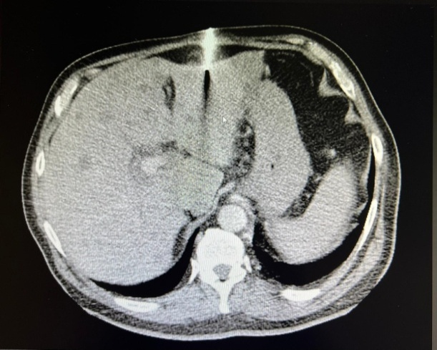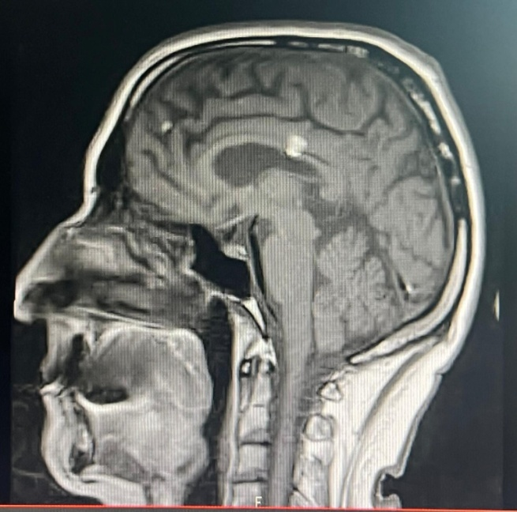
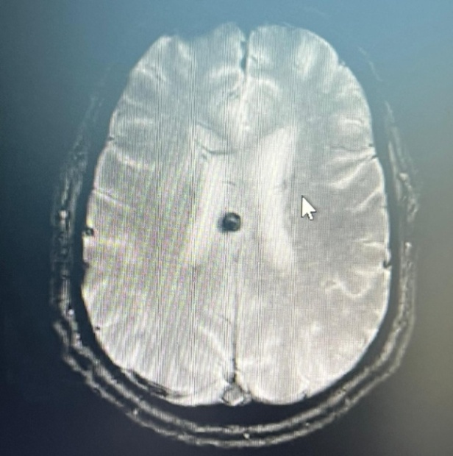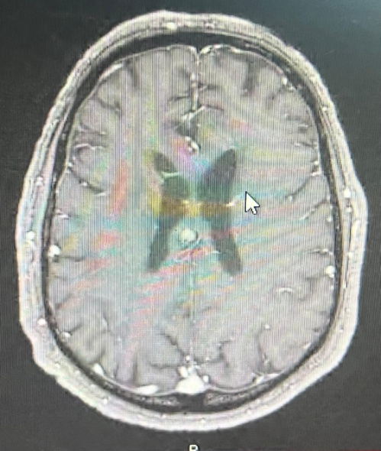
Figure 1-4 PET scan showed primary cutaneous or subcutaneous lesion
Discussion :
Melanomas account for between 1% and 3% of all cancers [4].
They primarily appear on the skin or develop in the choroid of the eye.
Malignant melanomas carry a high risk of recurrence and metastasis, and the prognosis is often poor [5].
According to the literature, the primary origin of metastatic melanoma is generally identified, but remains unknown in approximately 3.2% of cases [6, 7].
The liver does not contain melanocytes. However, two hypotheses have been mentioned in the literature: the first states that these neoplasms could arise from ectopic melanocytes that have undergone malignant transformation [8, 9], or from malignant transformation of melanoblastic cells derived from the neural crest during embryogenesis [6].
According to scientific reviews, the diagnosis of primary hepatic melanoma or secondary melanoma of unknown primary origin is currently based on three essential criteria:
- Histological and immunohistochemical confirmation of hepatic melanoma,
- Exclusion of other primary malignant melanomas, and
- Absence of a prior cutaneous tumor (which may have been destroyed or excised without undergoing histological examination) [10].
Clinical symptoms are varied and non-specific, with predominant signs including abdominal pain, presence of an abdominal mass, general deterioration, or abnormal liver function tests [11].
Due to the rarity of reported cases, no standardized treatment exists for hepatic melanoma of unknown primary origin.
When the lesion is localized, surgical resection is the first-line treatment and remains the gold standard.
Some studies suggest that surgery combined with lymph node dissection in the hepatoduodenal ligament may be the best option for patients with resectable tumors [10].
According to a European Cancer Review, immunotherapy is a potential treatment pathway, with interferon showing possible effects on recurrence-free survival [12].
High doses of IL-2 have been proposed by the National Comprehensive Cancer Network as a treatment option for advanced melanomas.
In a study by Algazi et al., chemotherapy with dacarbazine demonstrated limited efficacy [13].
On the other hand, several targeted therapies, such as nivolumab and ipilimumab, have shown promising results [14, 15], as was attempted in our patient. Unfortunately, his condition deteriorated after two cycles.
Given the current lack of well-established treatment protocols, metastatic melanoma remains a tumor with poor prognosis.
Conclusion :
Primary hepatic melanomas are rare, and it is often difficult to establish their primary nature.
Diagnosis requires histological and immunohistochemical confirmation of melanocytic origin, exclusion of any extra-hepatic primary site through thorough examination of the skin and mucous membranes, and confirmation that no prior excision of skin lesions occurred without histological analysis.
There is no standardized therapeutic approach. The prognosis is poor, with a high rate of recurrence and generally short survival.
CONSENT (WHERE EVER APPLICABLE)
As per international standards or university standards written ethical approval has been collected and preserved by the author(s).
ETHICAL APPROVAL (WHERE EVER APPLICABLE)
As per international standards or university standards written ethical approval has been collected and preserved by the author(s).

COMPETING INTERESTS DISCLAIMER:
Authors have declared that they have no known competing financial interests OR non-financial interests OR personal relationships that could have appeared to influence the work reported in this paper.

References :
1. Rose DM, Essner R, Hughes TD, et al. Surgical resection for me tastatic melanoma to the liver. The John Wayne Cancer Institute and Sydney Melanoma Unit Experience. Arch Surg 136: 950-955, 2001.
2. Gong L, Li YH, Zhao JY, Wang XX, Zhu SJ and Zhang W. Primary malignant melanoma of the liver: a case report. World J Gastroenterol 2008; 14: 4968.
3. Huang H, Yu Y and Zheng Z. Primary malignant melanoma of liver: a case report and literature review. Chinsese Journal of Clinical and Experimental Pathology 2011; 27: 193-195.
4. Wang J, Yang F, Ao WQ, Liu C, Zhang WM, Xu FY. Primary gastric melanoma: acase report with imaging findings and 5-year follow-up. World J Gastroenterol. 2019;25(44): 6571-6578.

5. Houghton A, Coit D, Bloomer W, Buzaid A, Chu D, Eisenburgh B et al. NCCN melanoma practice guidelines. National Comprehensive Cancer Network. Oncology (Williston Park). 1998 Jul;12(7A): 153-77.

6. Wright JP, Geevarghese SK. Primary Heptaic Melanoma or Melanoma of Unknown Primary? Am Surg. 2021 Apr;87(4): 511-513.

7. Scott JF, Gerstenblith MR. Melanoma of unknown primary. Codon Publications, Brisbane, Australia. 2018. 1: 99-116.

8. Baab GH, McBride CM: Malignant melanoma: the patient with anunknown site of primary
origin. Arch Surg. 1975;110: 896-900.

9. Song EJ, Scolyer RA, Damian DL, Thompson JF. Primary oesophageal melanoma - a case report. World J Surg Onc. 2014;12: 77.

10. 1. Zhang Y, Hu Z, Wu W, Liu J, Hong D, Zhang C. Partial hepatectomy for primary hepatic melanoma: a report of two cases and review of the literature. World J Surg Oncol 2014;12: 362.
11. Ao W, Wang J, Mao G, Yang G, Han X, Jia Y, Cheng Y. Primary hepatic melanoma: a case report of computed tomography and magnetic resonance imaging findings. Medicine (Baltimore). 2019 Jun;98(25): e16165.
12. Eggermont AM. The role interferon-alpha in malignant melanoma remains to be defined. Eur J Cancer. 2001 Nov;37(17): 2147-53.
13. Algazi AP, Soon CW, Daud AI. Treatment of cutaneous melanoma: current approaches and future prospects. Cancer Manag Res. 2010 Aug 17;2: 197-211.

14. Hodi FS, O'Day SJ, McDermott DF, Weber RW, Sosman JA, Haanen JB et al. Improved survival with ipilimumab in patients with metastatic melanoma. N Engl J Med. 2010;363(8): 711-23.
15. Wolchok JD, Kluger H, Callahan MK, Postow MA, Rizvi NA, Lesokhin AM et al. Nivolumab plus ipilimumab in advanced melanoma. N Engl J Med. 2013;369(2): 122-33.

