Malignant hypertension induced thrombotic microangiopathy: A case report

Abstract
Malignant hypertension (MH) is a medical emergency characterized by severe blood pressure elevation and end-organ damage. We present the case of a 34-year-old male with MH leading to microangiopathic hemolytic anemia (MAHA) and acute kidney injury (AKI), a rare and life-threatening combination. The patient exhibited severe hypertensive retinopathy, thrombocytopenia, and hemolysis, complicated by renal dysfunction. Diagnosis was confirmed through clinical, laboratory, and imaging findings. Multidisciplinary management, including antihypertensive therapy and supportive care, was crucial in stabilizing the patient. This case underscores the importance of early recognition and a coordinated approach to managing MH and its complications to prevent irreversible outcomes.
Keywords: hemolytic anemia, hypertension, acute kidney injury, microangiopathic hemolytic anemia
Introduction
Malignant hypertension can cause thrombotic microangiopathy (TMA) and the overall presentation may mimic thrombotic thrombocytopenic purpura (TTP). This presents a dilemma of whether or not to initiate plasma exchange. Hypertensive urgencies may affect as many as 1% of all hypertensive patients and account for 3% of all emergency room visits, and a quarter of all medical emergencies. Given its high incidence, malignant hypertension, although uncommonly associated with TMA, is an important etiology. In malignant hypertension, the autoregulatory mechanism fails, resulting in damage to the vascular wall. Disruption of the vascular endothelium causes plasma constituents (Allinovi et al., 2025; Ikeda et al., 2024). In clinical practice, it is often a diagnostic challenge to differentiate hypertension-associated TMA from complement-mediated disease. This is particularly the case in patients presenting without profound hemolysis and/or thrombocytopenia. If one refrains from a complete diagnostic work-up, including a comprehensive search for complement abnormalities, a subset of patients may progress to end-stage renal disease without receiving optimal treatment. Moreover, the correct diagnosis is of utmost importance to adopt suitable prophylactic measures prior to kidney transplantation (Timmermans et al., 2017).

Case Presentation
A 34-year-old male, known hypertensive but non-compliant with medications for one year, presented to the emergency department with a two-day history of worsening dyspnea, cough, hemoptysis, severe headache, chest pain, and blurred vision. On admission, his blood pressure was 230/162 mmHg. Initial workup revealed significant end-organ damage.
Troponin T was elevated at 183 ng/L. ACS protocol was initiated with IV urapidil 12.5 mg stat, and the patient was shifted to ICU due to hypoxia (SpO₂ 92% requiring oxygen).
Clinical Findings:
- BP: 230/162 mmHg, Pulse: 91 bpm, RR: 21/min, SpO₂: 92% (room air)
- ECG: Severe LVH with ST changes; Echocardiography: LVH (21 mm), left atrial dilation, diastolic dysfunction, mild pericardial effusion, EF 50%.

Laboratory Investigations:
Test | Value | Reference Range
Creatinine (mg/dL) | 6.21↑ | 0.6–1.2
Urea (mg/dL) | 131.5↑ | 7–20
eGFR (mL/min/1.73m²) | 10.4↓ | >90
Sodium (mmol/L) | 128.9↓ | 135–145
Potassium (mmol/L) | 3.1↓ | 3.5–5.0
Chloride (mmol/L) | 93↓ | 98–107
LDH (U/L) | 715↑ | 140–280
Platelets (×10³/μL) | 72↓ | 150–450
Hemoglobin (g/dL) | 11↓ | 13.8–17.2
Ferritin (ng/mL) | 1001↑ | 24–336
Reticulocyte (%) | 4.21↑ | 0.5–2.5
D-Dimer (ng/mL) | 2451↑ | <500
Troponin-T (ng/L) | 183↑ | <14
proBNP (pg/mL) | >9000↑ | <125
Management:
- IV urapidil 12.5 mg stat followed by infusion.
- Oral antihypertensives: moxonidine, amlodipine, doxazosin.
- ICU admission with fluid restriction and renal-friendly diet.
Nephrology Evaluation:
- Urinalysis: 2+ blood, 3+ urobilinogen, 20–25 RBCs, microalbumin 2768.9 mg/dL, protein-creatinine ratio 4259.8 mg/g.
- ANA speckled positive, C3/C4 normal.
- USG KUB: Bilaterally reduced renal size, increased echogenicity, loss of cortico-medullary differentiation.
- Diagnosis: AKI secondary to MH.
Ophthalmology Evaluation:
- Grade IV hypertensive retinopathy with macular edema, cotton wool spots, flame-shaped hemorrhages, macular star formation. (Figure 1).
- Topical Bromfenac initiated, blood pressure control emphasized.
Hematology Workup:
- Peripheral smear: Normocytic normochromic RBCs, schistocytes >1%, microspherocytes, polychromatic cells. (Figure 2)
- Platelets: 80 ×10³/μL.
- Diagnosis: MAHA secondary to malignant hypertension.
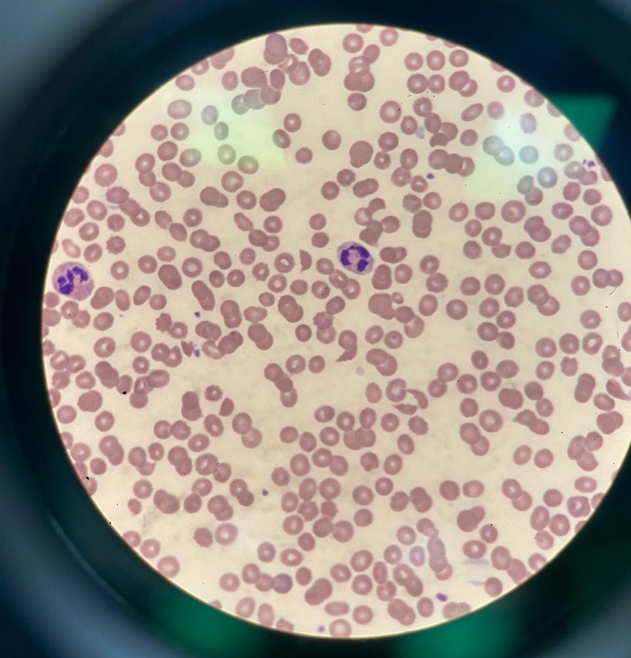
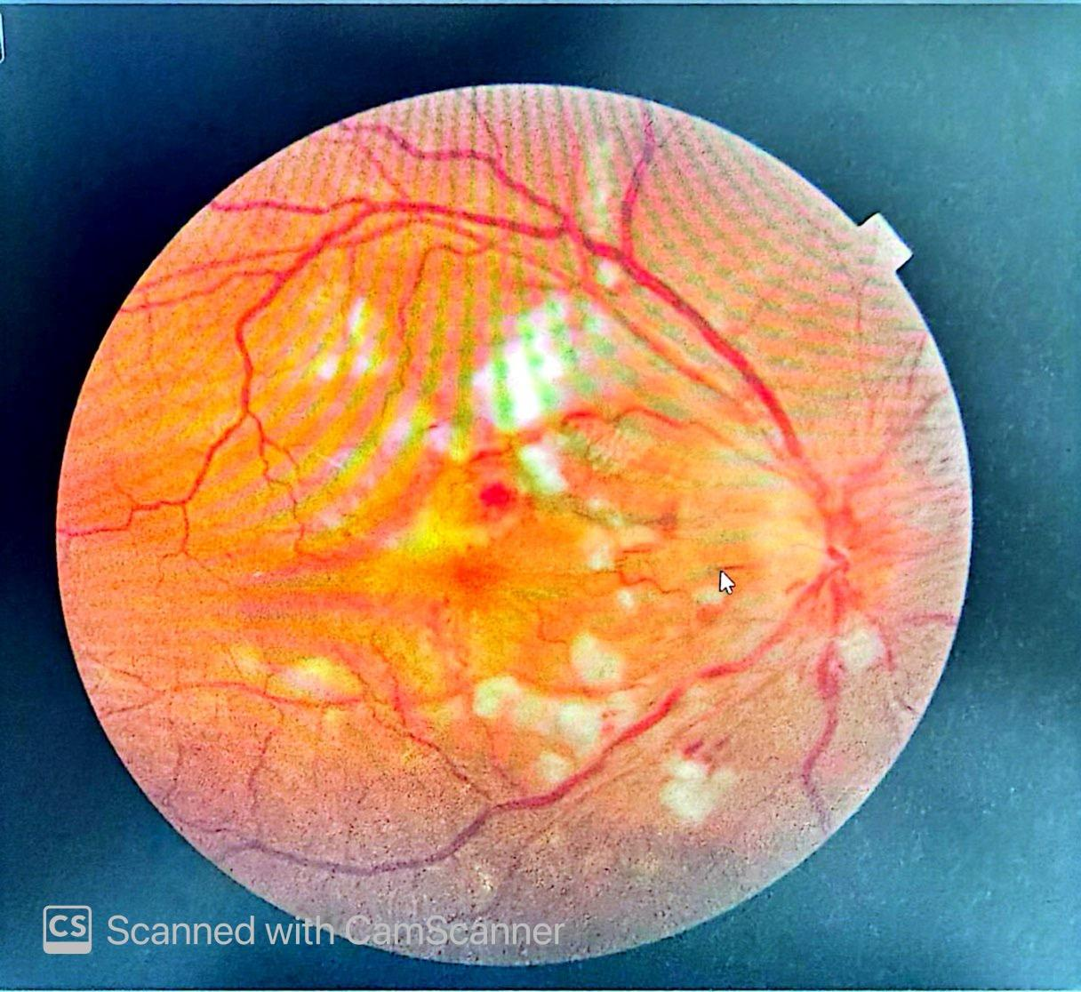

Figure 1. Grade IV hypertensive retinopathy with macular edema

Figure 2. Normocytic normochromic RBCs

Outcome:
After 7 days, BP stabilized at 151/99 mmHg, creatinine 6.94 mg/dL, eGFR 9.1 mL/min/1.73m², platelets normalized to 163 ×10³/μL, LDH decreased to 594 U/L. Symptoms improved, and the patient was discharged on oral antihypertensives with follow-up.

Discussion
This case highlights a classic presentation of thrombotic microangiopathy (TMA) secondary to MH, defined by systolic BP ≥180 mmHg and diastolic ≥120 mmHg.¹ TMA is characterized by thrombocytopenia, MAHA, and organ injury, commonly involving the kidneys.² Severe hypertension can precipitate endothelial damage, leading to mechanical stress on red blood cells and platelet aggregation.³
Malignant hypertension often presents with hypertensive retinopathy, including flame-shaped retinal hemorrhages, cotton wool spots, and papilledema.⁴ Grade IV retinopathy, as seen in our patient, correlates with high-risk vascular complications.⁵ MAHA in MH results from fibrinoid necrosis of arterioles and capillaries, causing red cell fragmentation and microvascular thrombosis.⁶ Activation of the renin-angiotensin-aldosterone system (RAAS) and endothelial dysfunction play central roles in this process.⁷
Differentiating hypertensive TMA from thrombotic thrombocytopenic purpura (TTP) is critical, as management strategies differ.⁸ TTP typically requires urgent plasma exchange, whereas hypertensive TMA responds to aggressive blood pressure control.⁹ Our patient’s hematologic parameters improved with antihypertensives alone, without plasma exchange, confirming hypertensive TMA.^{4,10}
Renal involvement is a key determinant of prognosis.² Elevated creatinine, proteinuria, and reduced eGFR indicate significant microvascular injury. MAHA may exacerbate renal dysfunction through arteriolar occlusion and endothelial injury.¹¹ Early recognition of MAHA using LDH, schistocytes, and platelet trends helps predict AKI progression.¹² Recent studies show that high BNP/NT-proBNP levels correlate with thrombotic risk and adverse cardiovascular outcomes in hypertensive crises.¹³
Multidisciplinary management—including nephrology, cardiology, and ophthalmology—was crucial in stabilizing this patient.^{14,15} Timely fundoscopic evaluation facilitated early detection of severe retinopathy.⁵ The choice of antihypertensives (urapidil, amlodipine, doxazosin, moxonidine) aligns with current hypertensive emergency guidelines.^{16,17} Nutrition and fluid management also contributed to renal protection.¹⁸
Literature supports that long-term outcomes in malignant hypertension improve with early diagnosis, blood pressure control, and monitoring for TMA-related complications.^{19,20} This case emphasizes vigilance for MAHA and renal impairment in patients presenting with extreme BP elevations.

Conclusion
In conclusion, malignant hypertension can induce TMA and MAHA, complicating AKI and end-organ injury. Early recognition through clinical examination, laboratory findings, and fundoscopic evaluation is crucial. Effective multidisciplinary management, focused on blood pressure control and supportive care, can prevent irreversible organ damage. This case underscores the importance of differentiating hypertensive TMA from TTP, guiding appropriate therapy, and monitoring for renal and retinal complications.

References
- National Institute for Health and Care Excellence. Recommendations: Measuring blood pressure. NICE guidance NG136. Available at: https://www.nice.org.uk/guidance/ng136/chapter/Recommendations#measuring-blood-pressure. Accessed February 11, 2025.
- Brocklebank V, Wood KM, Kavanagh D. Thrombotic microangiopathy and the kidney. Clin J Am Soc Nephrol. 2018;13(2):300–317. doi:10.2215/CJN.00620117
- Asano T, Mori H. Thrombotic microangiopathy due to malignant hypertension treated exclusively with antihypertensive therapy. Cureus. 2022;14(2):e21835. doi:10.7759/cureus.21835
- Bandaru SS, Anaji SC, Stowe IT. A case of thrombotic microangiopathy secondary to hypertensive emergency. Cureus. 2022;14(4):e24237. doi:10.7759/cureus.24237
- Wong TY, Mitchell P. Hypertensive retinopathy. N Engl J Med. 2004;351:2310–2317. doi:10.1056/NEJMra041234
- van den Born BJ, Honnebier UP, Koopmans RP, van Montfrans GA. Microangiopathic hemolysis and renal failure in malignant hypertension. Hypertension. 2005;45(2):246–251. doi:10.1161/01.HYP.0000151620.17905.ee
- Vaziri ND. Mechanisms of endothelial dysfunction in hypertension. Circ Res. 2001;88:608–616. doi:10.1161/01.RES.88.6.608
- George JN. Clinical practice. Thrombotic thrombocytopenic purpura. N Engl J Med. 2006;354:1927–1935. doi:10.1056/NEJMcp055912
- Aydin S, Aydin C, et al. Hypertensive emergencies: Etiology, treatment, and outcomes. Am J Emerg Med. 2018;36:833–838. doi:10.1016/j.ajem.2017.12.063
- Coppo P, Froissart A, Veyradier A. Thrombotic microangiopathies: Diagnosis and management. Haematologica. 2014;99:177–188. doi:10.3324/haematol.2013.088848
- Timmermans S, et al. Kidney outcomes in patients with TMA: A systematic review. Kidney Int Rep. 2021;6:204–216. doi:10.1016/j.ekir.2020.10.009
- Aoudia H, et al. MAHA as a marker of renal prognosis in malignant hypertension. Clin Nephrol. 2020;93:107–115. doi:10.5414/CN109735
- Rossi R, Jabrah D, Douglas A, et al. Investigating the role of BNP and NT-proBNP in thrombosis and acute ischemic stroke etiology. Int J Mol Sci. 2024;25(5):2999. doi:10.3390/ijms25052999
- KDIGO Clinical Practice Guideline for Acute Kidney Injury. Kidney Int Suppl. 2012;2:1–138. doi:10.1038/kisup.2012.1
- AHA Scientific Statement. Management of hypertensive emergencies. Circulation. 2022;145:e123–e139. doi:10.1161/CIR.0000000000001082
- ESC Council on Hypertension. 2023 ESC/ESH Guidelines for the management of arterial hypertension. Eur Heart J. 2023;44:3222–3320. doi:10.1093/eurheartj/ehad075
- Legendre C, Licht C, et al. Thrombotic microangiopathy: Pathophysiology, diagnosis, and management. Nephrol Dial Transplant. 2019;34:2020–2032. doi:10.1093/ndt/gfz148
- Wijnsma KL, et al. Nutritional management in patients with malignant hypertension and AKI. Clin Kidney J. 2019;12:505–514. doi:10.1093/ckj/sfz056
- Pavlakis M, et al. Long-term outcomes of malignant hypertension: A systematic review. Hypertension. 2020;76:109–118. doi:10.1161/HYPERTENSIONAHA.120.15065
- Bendapudi PK, et al. Guidelines for thrombotic microangiopathies: Diagnosis and management. Haematologica. 2021;106:1019–1031. doi:10.3324/haematol.2020.260003
- Allinovi, M., Menale, S., Querin, V., Caroti, L., Antognoli, G., Cirami, C. L., ... & Scheggi, V. (2025). Potentially reversible severe cardiac involvement in thrombotic microangiopathies with malignant hypertension. Journal of Nephrology, 38(6), 1655-1661.
- Ikeda, S., Inoue, Y., Suzuyama, K., Ide, T., & Eriguchi, M. (2024). Haemorrhagic and ischemic stroke following posterior reversible encephalopathy syndrome and thrombotic microangiopathy in a patient with malignant hypertension. Acta Neurologica Belgica, 124(1), 339-341.
- Timmermans, S. A., Abdul-Hamid, M. A., Vanderlocht, J., Damoiseaux, J. G., Reutelingsperger, C. P., van Paassen, P., ... & van Duijnhoven, E. (2017). Patients with hypertension-associated thrombotic microangiopathy may present with complement abnormalities. Kidney international, 91(6), 1420-1425.

