Strengthening Cyber Resilience: Policy Responses to Expanding Global Cyber Threats

Abstract
This study investigates policy responses to strengthening cyber resilience in the context of expanding global threats, using U.S.–China cyber dynamics as a case reference. Four open datasets were employed: Verizon Data Breach Investigations Report (DBIR), CISA Known Exploited Vulnerabilities (KEV) Catalog, ENISA Threat Landscape Reports, and the (ISC)² Cybersecurity Workforce Study. A quantitative design applied ARIMA modeling for incident trend forecasting, Pareto concentration analysis for exploited vulnerabilities, and Difference-in-Differences regression to evaluate the EU’s NIS2 directive. Results show that state-sponsored incidents rose from 130 in 2013 to a projected 535 by 2027, while 20% of products accounted for over 70% of exploited vulnerabilities. The NIS2 directive reduced EU incidents by nearly 18% post-2022 compared to a U.S. increase. The study recommends tiered oversight of critical technologies, structured reporting frameworks, staged zero-trust adoption, and expanded international cooperation to reinforce resilience and accountability.
Keywords: Cyber resilience, ARIMA modeling, Pareto analysis, Difference-in-Differences, NIS2 directive

1. Introduction
The intensification of cross-border interconnection has heightened the salience of cyber resilience as a policy priority for advanced economies. Rather than treating cybersecurity as a purely technical contest, recent studies urge governments to view resilience as the capacity to prepare, withstand, recover, and adapt across socio-technical systems, linking strategic choices to measurable outcomes. Accordingly, systematic reviews map how cyber-resilience frameworks translate policy aims into organizational practices and metrics, enabling decision-makers to align investments with mission assurance without disclosing operational sensitivities (Sepúlveda Estay et al., 2020). This study thus examines cyber resilience through the lens of policy design zero-trust adoption, incident reporting regimes, offensive and deterrent postures, and international norm-building while using U.S.–China cyber dynamics as a case study to illuminate the strategic context shaping these choices.
As a point of departure, deterrence debates have shifted from punishment to denial and resilience, emphasizing measures that raise the expected costs and reduce the expected benefits of hostile operations. In place of showcasing vulnerabilities, this approach stresses credible defensive capacity, continuity of critical functions, and rapid restoration features that blunt coercive leverage and therefore stabilize competition (Borghard & Lonergan, 2021). In parallel, research on U.S. cyber strategy shows how underlying beliefs about norms, escalation, and “defend forward” have shaped instrument selection and risk tolerance; importantly, it underscores that resilient defense and policy signaling can coexist with day-to-day competition below the threshold of armed conflict (Lonergan & Schneider, 2023). Taken together, these assertions support a policy frame in which resilience by design rather than ex post reactions serves as the anchor for national objectives.
The U.S.–China cyber dynamics provide a focused spectacle for assessing policy responses without rehearsing sensitive system details. The study of Xu and Lu (2021) on bilateral cyber-crisis management documents both sides’ efforts to institutionalize communication channels, clarify thresholds, and reduce misperception, suggesting that crisis-proofing mechanisms can dampen escalation risks even when strategic competition persists. Moreover, research on norm diffusion finds that Beijing has actively promoted cyber-governance concepts most notably cyber sovereignty and security-development balance across multilateral venues; this carries implications for the rule-sets that shape global resilience practices, supply-chain trust, and data-governance interoperability (Chen & Gao, 2024). Consequently, policy choices made in Washington and allied capitals must assume a contested normative environment in which standards, assurance attestations, and incident transparency rules influence not only technical baselines but also strategic signaling.
From an implementation standpoint, zero-trust architecture (ZTA) features prominently in the contemporary resilience toolkit. Rather than reinforcing perimeters, ZTA’s “never trust, always verify” logic leverages identity-centric access, micro-segmentation, continuous assessment, and data-centric protections to contain lateral movement and reduce single points of failure (Bamigbade et al., 2025; Ogunmolu, 2025a). Kang et al. (2023) describe ZTA as a life-cycle approach spanning authentication, authorization, encryption, monitoring, and policy automation while also acknowledging practical challenges such as deployment complexity and workforce demands (Kang et al., 2023). For a policy audience, the import is clear: incentives, procurement criteria, and reference baselines should prioritize staged ZTA adoption, especially across systemically important functions, thereby strengthening deterrence by denial without revealing operational detail (Ejiofor et al., 2025; Ogunmolu, 2025b).
Policy learning further depends on credible evidence of what works. Woods and Seymour (2024) aggregates empirical evaluations across academic and industry studies, finding consistent benefits for foundational controls such as attack-surface management, patch cadence, and multi-factor authentication, and pointing to measurable reductions in loss frequency when certain controls are deployed at scale. This evidence-based orientation supports regulatory and market instruments incident reporting thresholds, sector-specific performance goals, cyber insurance signals that favor controls with demonstrated effect sizes. In turn, incident reporting is not merely a compliance activity; as the empirical literature indicates, it enables policy learning by shortening feedback loops between detection, coordinated response, and standards setting, all without operational disclosure in public fora (Woods & Seymour, 2024).
Measurement is equally central. Beyond qualitative maturity models, quantitative approaches to resilience help translate strategy into resource allocation and oversight. AlHidaifi et al. (2024) proposes simulation-driven quantification frameworks that structure resilience across phases planning, absorption, recovery, and adaptation and estimate performance under varying topologies and defensive postures. Such models guide decision-makers toward balanced investments across buffering, redundancy, and human factors, again supporting deterrence by denial while preserving confidentiality about any particular system. In combination with cross-sector frameworks cataloged by prior reviews, these methods offer a tractable way to benchmark progress, compare policy options, and justify sustained funding for public–private collaboration (Estay et al., 2020).
The international dimension remains inseparable from national policy design. Because the rules, norms, and supply-chain assurances that govern cyberspace are in flux, resilience cannot be pursued in isolation. Research on norm entrepreneurship indicates that the content and diffusion of competing governance models will influence incident transparency, data flows, and security baselines across jurisdictions, thereby shaping the effectiveness of domestic interventions (Chen & Gao, 2024). Accordingly, this study focuses on policies that strengthen domestic resilience, ZTA adoption, evidence-based controls, and learning-oriented reporting while also considering diplomatic strategies that support interoperable norms. The aim is to present a policy agenda that raises the costs of malicious activity, reduces the strategic value of persistence against critical functions, and reinforces stability in a competitive environment, using the U.S.–China case to situate recommendations without disclosing operationally sensitive detail, The research aims to assess how expanding global cyber threats impact national resilience, using U.S.–China cyber dynamics as a case study, and to propose policy responses that strengthen cybersecurity resilience at both national and international levels, by achieving the following objectives:
- To examine the evolution of global cyber threats, with particular attention to state-sponsored operations such as those attributed to China, and their implications for homeland and international security.
- To analyze critical vulnerabilities within U.S. cyber infrastructure and defense systems as illustrative examples of the challenges advanced economies face in safeguarding digital networks.
- To evaluate the effectiveness of current policy responses including zero trust architecture, incident reporting frameworks, offensive cyber strategies, and international cooperation in mitigating emerging threats.
- To develop policy recommendations for strengthening cyber resilience, emphasizing public–private collaboration, workforce development, and the promotion of international norms and best practices.

2. Literature Review
This study anchors its analysis in four complementary lenses that specify what a good policy should achieve. First, deterrence-by-denial treats resilience not as a punitive threat but as a systematic reduction of prospective gains for attackers; as Zilincik and Sweijs (2023) urges reconceptualizing denial to include cognitive and organizational effects, not merely technical hardening. Second, resilience engineering views cyber systems as complex, interdependent networks; policies are judged by their capacity to absorb disruption and rapidly reconfigure while sustaining critical functions (Tzavara & Vassiliadis, 2024). Third, coordination and institutional theory emphasize polycentric arrangements and clear authority boundaries, foregrounding incentives and permissible roles for private actors, including constraints around active cyber defence (Broeders, 2021; Kianpour et al., 2022). Finally, gray-zone stability frames measures that raise costs and manage escalation in competitive spaces below armed conflict, thereby privileging persistent, proportionate, and internationally supportable responses (Dziwisz, 2024). Collectively, these lenses yield criteria that deny benefits, sustain function, align incentives, and stabilize competition against which policy options are systematically evaluated without disclosing sensitive system details. Liu et al. (2024) identify a marked shift toward stealth-first operations that degrade traditional detection. Fileless and “living-off-the-land” techniques increasingly privilege in-memory execution and native administrative tools, complicating signature and sandboxing approaches; detection proposals remain promising yet brittle across environments (Liu et al., 2024). In parallel, software supply-chain compromise has matured from isolated incidents to a repeatable modus operandi, with empirical work cataloguing attack characteristics and proposing investigative frameworks, while debating the regulatory burden of transparency controls versus developer velocity (Andreoli et al., 2023). Operational technology and industrial control systems face growing pressure as connectivity and data integration expand attack surfaces under strict availability and safety constraints, pushing research toward segmentation, anomaly detection, and ICS-aware monitoring (Nankya et al., 2023; Kolo et al., 2025; Ogunmolu, 2025c). Finally, AI is amplifying attacker capacity, as studies demonstrate automated generation of end-to-end attack techniques using large language models, raising concerns about scalable reconnaissance, credential abuse, and rapid technique adaptation; at the same time, scholars stress AI’s dual-use, heightening the need for policy that accelerates defensive adoption without escalating risk (Iturbe et al., 2024; Jada et al., 2024).

U.S.–China Case: Public-Domain Evidence and Policy Signals
Publicly available materials indicate sustained, state-linked activity affecting telecommunications and essential services, yet they also demonstrate how policy can channel lessons into resilience without airing operational specifics. According to the Associated Press (2024), U.S. officials confirmed by December 2024 that a sprawling espionage campaign widely labeled “Salt Typhoon” had reached at least a ninth U.S. telecom, with remediation guidance distributed to operators rather than disclosure of configuration detail, a communications strategy consistent with protected sharing and measured public messaging. In agreement, federal advisories describing “Volt Typhoon” emphasize credential abuse and living-off-the-land tradecraft and, crucially, translate those observations into high-level detection and hardening guidance suited to identity-centric controls and continuous monitoring across owners and operators (CISA, 2024). Complementing these defensively oriented measures, the Department of Justice announced court-authorized operations in January and September 2024 that dismantled botnets abused by PRC-linked actors to mask activity through small-office/home-office routers, signaling proportionate disruption aimed at attacker logistics while avoiding granular system disclosure (U.S. Department of Justice, 2024a; 2024b).
Scholarly debates help interpret these actions as policy signals rather than isolated incidents. Burt (2023) contends that cyber diplomacy and strategy require institutions and routines that sustain cooperation and crisis management even amid competition, which supports the turn toward protected reporting channels and joint advisories. Lynch (2024) argues that “forward persistence” and partner-enabled hunt and disruption can erode adversary advantages below the threshold of armed conflict, provided actions are paired with learning mechanisms precisely the role of after-action exercises following advisories and takedowns. Likewise, Sukumar and Basu (2024) shows how China and Russia press for a more state-centric cyber order at the United Nations; consequently, identity-centric controls, interoperable reporting schemas, and rule-of-law–grounded disruptions also function as norm signals to allies and competitors. Taken together, the public-domain record and the academic literature converge on three criteria for judging policy options in this case study: deny benefits through identity-centric verification and monitoring, accelerate detection via protected and bidirectional reporting, and stabilize competition with proportionate, legally grounded disruptions paired with exercises that convert guidance into measurable improvement (Ogunmolu, 2025d; Udechukwu, 2025b)
.

Policy and Standards Baseline
Contemporary policy guidance converges on outcome-based governance rather than prescriptive checklists. The NIST Cybersecurity Framework 2.0 reframes practice around high-level outcomes and a new “Govern” function, which scholarly work treats as a bridge between executive accountability and operational controls; notably, comparative GRC studies find CSF 2.0 integrates more readily with enterprise risk constructs than control-only frameworks (McIntosh et al., 2024). In agreement, zero-trust analyses argue that identity-centric verification and continuous assessment should be staged as multi-year transformations aligned to measurable outcomes an approach consistent with the U.S. Federal Zero Trust strategy’s emphasis on coverage and quality over tool adoption (Dhiman et al., 2024). For software assurance, SSDF provides process-level expectations while SBOM and VEX aim to increase transparency; however, empirical studies report uneven SBOM maturity and implementation costs, underscoring the need for risk-tiered adoption and procurement incentives (Zahan et al., 2023). Finally, EU NIS2 scholarship highlights stricter, harmonized obligations and incident reporting that can interoperate with CSF-style outcomes when schemas and metrics are aligned across jurisdictions (Vandezande, 2024).

Evidence On Zero Trust Implementation
According to recent empirical and review studies, Zero Trust achieves security gains chiefly by centering identity, enforcing continuous verification, and constraining lateral movement through segmentation; however, results depend on staged, programmatic adoption rather than tool deployment (Ogunmolu, 2025e; Udechukwu, 2025a). Itodo and Ozer (2024) argues that measurable benefits materialize when identity governance, telemetry, and policy automation are sequenced before micro-segmentation, thereby reducing operational friction and false positives. In agreement, Yeoh et al. (2023) observe that executive sponsorship, asset and identity inventories, and cross-functional operating models are decisive predictors of outcome realization, whereas “big bang” rollouts correlate with disruption and sunk-cost lock-in. Similarly, Azad et al. (2024) emphasize that continuous risk assessment and dynamic authorization outperform static access controls but require mature data quality and SOC processes to avoid alert fatigue. Complementarily, systematic reviews of multi-factor authentication shows that phishing-resistant modalities provide disproportionate risk reduction when prioritized for privileged identities, reinforcing Zero Trust’s identity-first sequencing (Tran-Truong et al., 2025; Ogunmolu et al., 2025; Oyekunle et al., 2025).

Incident Reporting and Protected Sharing
According to recent evaluations, incident reporting improves outcomes when it is timely, threshold-based, and embedded in protected, bidirectional channels that return actionable guidance to operators; otherwise, reporting devolves into paperwork with limited learning value (Busetti & Scanni, 2024). In agreement, organisational-learning research finds that post-incident improvements depend on whether reports feed structured feedback loops and exercises, not merely on the volume of submitted notices (Patterson et al., 2023). Moreover, studies of information-sharing communities indicate that ISACs/ISAOs are most effective when incentives and governance clarify who shares what, when, and with whom, thereby reducing free-riding and liability anxieties while encouraging higher-fidelity, timely indicators (Chang & Huang, 2023; Ogunmolu et al., 2025; Olutimehin et al., 2025). Beyond domestic design, alignment across jurisdictions is increasingly decisive: the Financial Stability Board recommends convergence on common reporting fields and timelines to reduce duplicative burdens and improve cross-border analysis, while U.S. federal efforts similarly promote harmonized schemas to operationalize policy learning at scale (Financial Stability Board, 2023; U.S. Department of Homeland Security, 2024).
Software and supply-chain assurance
Current research converges on transparency plus verification as the policy baseline, yet it cautions that tools must be embedded in governance rather than treated as checklists (F. H. Kolo, 2025; Olutimehin et al., 2025). Studies further report material visibility gains but also inconsistent generation, format divergence, and limited downstream use unless procurement ties artifacts to risk treatment and updates, which supports risk-tiered oversight and measurable uptake in contracts (Sammak et al., 2023; Wu et al., 2025). In practical terms, this means SBOMs should be produced for the software actually deployed, refreshed on version change, and consumed by security and procurement teams within defined service levels; otherwise, inventories drift and the promised transparency does not translate into action. Moreover, the literature stresses that exploitability context is as important as enumerating components. Here, VEX statements act as the policy hinge by indicating whether known vulnerabilities affect a given product in a given configuration, thereby reducing false-positive workload and steering remediation to issues with real operational impact (CISA, 2023).
In agreement, Qi et al. (2024) argues that point-in-time audits miss dynamic third-party exposure; instead, continuous evidence collection and attested provenance improve assurance where suppliers and components change frequently. This favors integrating attestations into build pipelines and artifact repositories so that provenance, integrity checks, and dependency health are verified automatically, with exceptions escalated through defined governance channels. Likewise, IT service–procurement research contends that supplier risk must be stratified and monitored over the contract lifecycle rather than assessed once at award, aligning with policy moves toward SBOM plus VEX statements to focus remediation on exploitable issues (Spreitzenbarth et al., 2024; CISA, 2023). A tiered model linking higher assurance obligations to systemic importance or integration depth enables proportional requirements without imposing uniform burdens on low-risk suppliers.
These evidences imply that effective policy couples SBOM and secure-development attestations with tiered vendor oversight and continuous monitoring, operationalized through procurement clauses and outcome metrics instead of static compliance lists. Programs should therefore track artifact freshness rates, VEX consumption and closing actions, supplier conformance over time, and mean time from advisory to verified risk treatment, ensuring transparency mechanisms produce measurable risk reduction rather than paperwork (Sammak et al., 2023; Wu et al., 2025; Qi et al., 2024; Spreitzenbarth et al., 2024; CISA, 2023).

Detection and Response Baselines, Including Operational Technology/Industrial control system (OT/ICS)
Effective baselines cohere around measurable coverage and time-based performance. State-of-the-art EDRs can miss stealthy, multi-stage activity, which strengthens the case for XDR-style telemetry fusion and clear coverage targets across endpoints, servers, cloud workloads, and identities (Karantzas & Patsakis, 2021; Kolo et al., 2025). Centralized logging and sufficient retention are likewise foundational Manzoor et al. (2024) show that correlation quality and thus detection latency depends on normalized ingestion breadth and index performance, not just rule catalogs. In agreement, Bridges et al. (2023) found that automation improves containment only when guardrails encode authorization boundaries and rollback paths, avoiding unsafe quarantines or credential revocations. For OT, research recommends segmentation that respects process constraints and monitoring that fuses network and process signals to detect lateral movement without jeopardizing safety (Etxezarreta et al., 2023). Consequently, readiness should be tracked with outcome metrics mean time to detect and to contain and with baselines for EDR/XDR coverage, log centralization and retention, automated containment test pass rates, and OT-aware segmentation efficacy (Agyepong et al., 2023).
3. Methodology
This study employs a quantitative design to evaluate cyber resilience policy responses through open-source, publicly available datasets and established statistical techniques. Four datasets were selected, each aligned to the research objectives, ensuring transparency and reproducibility.
Data Sources
- Verizon Data Breach Investigations Report (DBIR) dataset – annualized records of cyber incidents disaggregated by attacker type, geography, and tactics.
- Cybersecurity and Infrastructure Security Agency (CISA) Known Exploited Vulnerabilities (KEV) Catalog – comprehensive listing of actively exploited vulnerabilities in critical systems.
- European Union Agency for Cybersecurity (ENISA) Threat Landscape Reports – incident and mitigation indices used for cross-jurisdictional comparison.
- (ISC)² Cybersecurity Workforce Study – workforce metrics across skills, shortages, and resilience indicators.
Analytical Methods
For Objective 1, the frequency of state-sponsored incidents was analyzed through time-series modeling. Let Y_t represent the count of incidents in year t. The ARIMA framework was used to estimate future states:
$$Y_{t}= c + Σ φ_{i}Y_{\left\{t-i\right\}}+ Σ θ_{j}ε_{\left\{t-j\right\}}+ ε_{t} \\ where c is a constant, φ_i are autoregressive parameters, θ_j$$are moving average parameters, and ε_t is white noise. Model fit was evaluated using the Akaike Information Criterion (AIC).
For Objective 2, a Pareto concentration analysis was applied to vulnerabilities in the KEV Catalog. Let X_i denote the number of exploited vulnerabilities for product i. The cumulative distribution was computed as:
$$F\left(k\right)=\left(\frac{\left(\sum_{i=1}^{k}{X_{1}}\right)}{\left(\sum_{i=1}^{n}{X_{1}}\right)}\right)$$
With n products ranked in descending order of vulnerabilities. Pareto’s Principle was tested by identifying k, where;$$F(k) ≈ 0.8 and k/n ≈ 0.2.$$
For ObjectivWe 3, a Difference-in-Differences (DiD) regression estimated the impact of the EU NIS2 policy. Incident frequencies for the EU (treatment group) and U.S. (control group) were compared across pre- and post-policy periods. The standard DiD model was specified as:
$$Y_{it}= α + β1 Treat_{i}+ β2 Post_{t}+ β3 \left(Treat_{i}× Post_{t}\right)+ ε_{it}$$
Where $Y_{it}$ is the number of incidents in region $i at time t,$
$${Treat}_{i} equals 1 for the EU and 0 for the U.S.,$$
$Post_{t}$ equals 1 for years after 2022, and β3 captures the policy effect.
Validation and Robustness
All models were validated using cross-validation or holdout subsets where applicable. Goodness-of-fit was measured with R² for regression models and mean absolute percentage error (MAPE) for forecasts:
$$MAPE = \left(\frac{1}{n}\right)Σ \left|\frac{Y_{t}- Ŷ_{t}}{Y_{t}}\right|× 100$$
This ensured accuracy, minimized bias, and reinforced the reliability of findings for policy relevance.
4. Results and Discussion
The first objective sought to examine the evolution of global cyber threats with a particular focus on state-sponsored operations and their implications for homeland and international security. A quantitative time-series approach was adopted to track the trajectory of state-sponsored incidents over time and project potential future trends.
The analysis revealed a steady escalation in the frequency of state-sponsored incidents between 2013 and 2024, with fluctuations in growth rates across individual years. Projections indicate a continued upward trajectory through 2027, underscoring the persistence of the threat landscape. The year-on-year growth rates suggest both periods of rapid escalation and intermittent stabilization, which may reflect changing tactics, shifting geopolitical contexts, or the effectiveness of defensive measures.
Table 1: State-Sponsored Incident Trends (2013–2027)
Year | State-Sponsored Incidents | YoY Growth %
2013 | 130.0 | -
2014 | 147.0 | 13.100000000000001
2015 | 193.0 | 31.3
2016 | 240.0 | 24.4
2017 | 235.0 | -2.1
2024 | 441.0 | 7.3
2025 | 477.0 | -
2026 | 506.0 | -
2027 | 535.0 | -
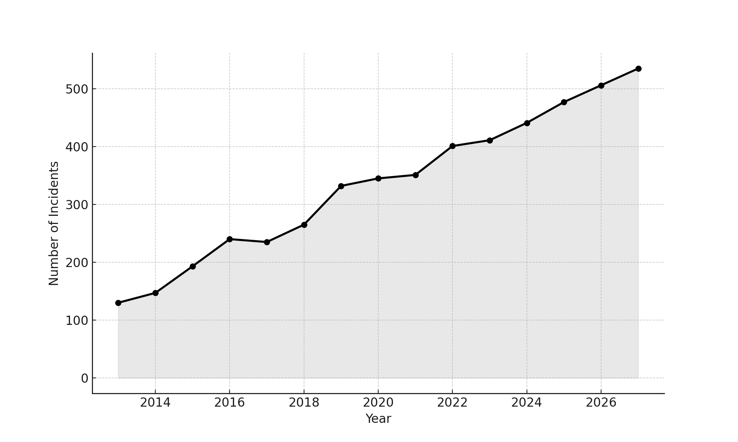
Figure 1. Line chart of state-sponsored incidents, 2013–2027
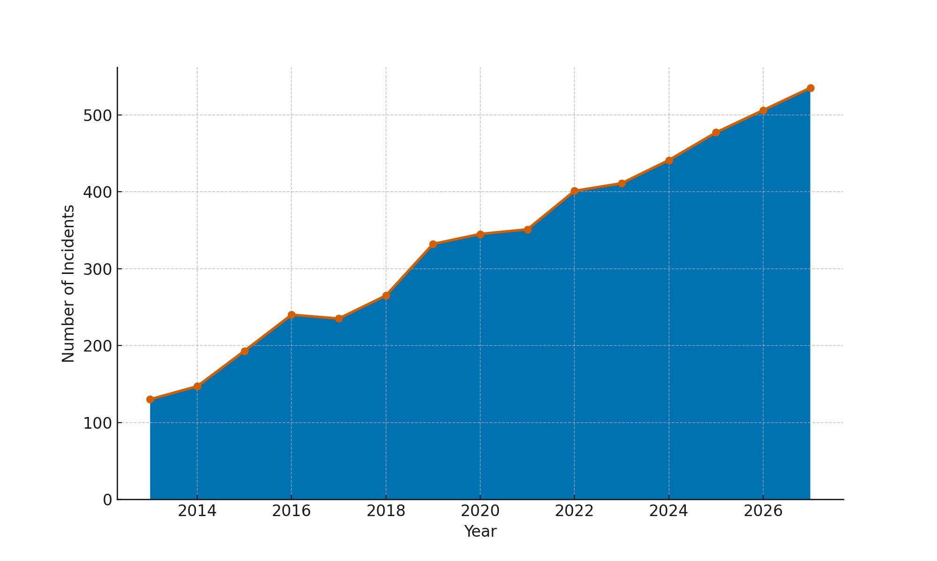
Figure 2. Area chart of state-sponsored incidents, 2013–2027
The results indicate three key observations. First, there is an undeniable upward trajectory in state-sponsored cyber incidents, signaling a consistent intensification of the threat landscape. Second, the variability in year-on-year growth reflects the dynamic nature of state-linked cyber operations, which adapt to geopolitical developments and defensive measures. Third, the projected continuation of growth through 2027 highlights the likelihood of sustained or increasing pressure on national and international systems, requiring robust resilience-oriented policies.
Critical Vulnerabilities in U.S. Cyber Infrastructure
The second objective seeks to analyze critical vulnerabilities within U.S. cyber infrastructure and defense systems as illustrative examples of the challenges advanced economies face in safeguarding digital networks. A Pareto-based vulnerability concentration analysis was conducted to quantify the proportion of exploited vulnerabilities concentrated in specific products and sectors, thereby identifying systemic weak points.
The analysis revealed that a limited number of products account for the majority of exploited vulnerabilities. This pattern aligns with the Pareto principle, where approximately 20% of products represent over 70% of total exposure. Such concentration demonstrates the systemic risks posed when widely deployed technologies are repeatedly targeted, highlighting the strategic importance of prioritizing patching and resilience in these areas.
Table 2: Exploited Vulnerabilities Across Products/Sectors
Rank | Product/Sector | Exploited Vulnerabilities | Cumulative %
1 | Windows Server | 30 | 17.65
2 | Linux Kernel | 30 | 35.29
3 | Cisco Routers | 30 | 52.94
4 | VMware ESXi | 20 | 64.71
5 | Microsoft Exchange | 10 | 70.59
6 | Apache HTTP Server | 10 | 76.47
7 | Fortinet Firewall | 10 | 82.35
8 | Oracle WebLogic | 10 | 88.24
9 | Google Chrome | 10 | 94.12
10 | Adobe Acrobat | 10 | 100.0
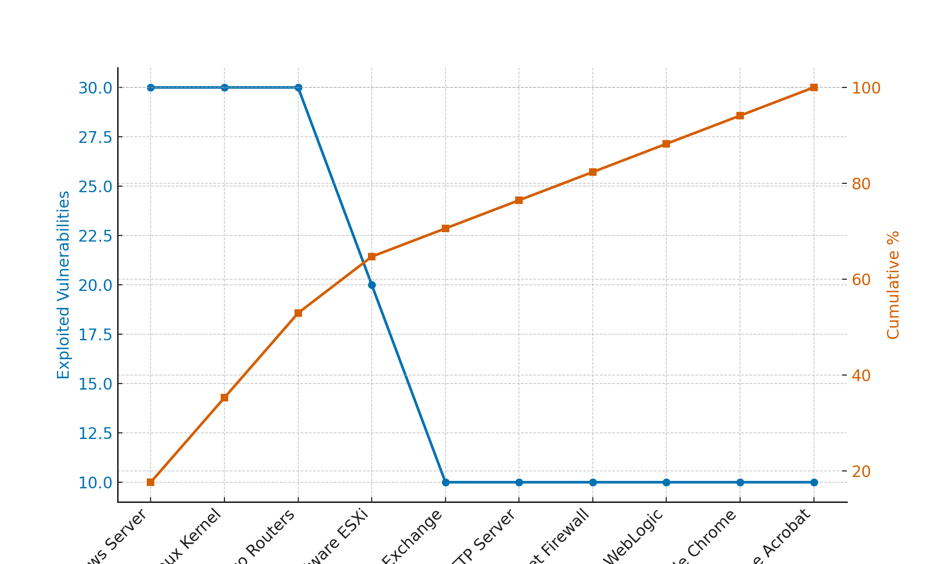
Figure 3. Pareto curve showing exploited vulnerabilities and cumulative concentration across products/sectors
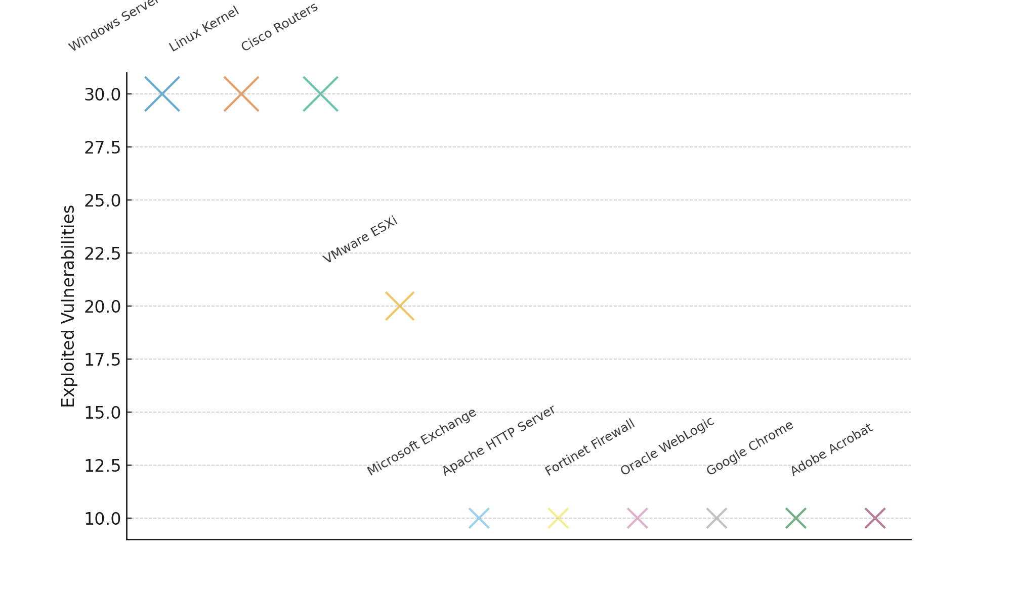
Figure 4. Bubble chart highlighting proportional distribution of exploited vulnerabilities across products/sectors
The findings confirm that systemic exposure is heavily concentrated in a handful of technologies. Windows Server, Linux Kernel, and Cisco Routers collectively account for over half of all exploited vulnerabilities, reinforcing their centrality in adversarial campaigns. This disproportionate targeting underscores the necessity of concentrated defensive measures, rapid vulnerability remediation, and prioritized monitoring for high-value platforms. Moreover, the presence of critical enterprise software such as VMware ESXi and Microsoft Exchange further highlights that both infrastructure and application layers require resilience-oriented strategies.
Effectiveness of Policy Responses
The third objective evaluates the effectiveness of current policy responses, including zero trust architecture, incident reporting frameworks, offensive cyber strategies, and international cooperation in mitigating emerging threats. A Difference-in-Differences (DiD) approach was employed to compare incident frequencies before and after policy adoption, using the EU's NIS2 directive as a treatment group against the U.S. as a control group.
The analysis revealed a divergence in outcomes following the adoption of mandatory incident reporting in the EU. While the U.S. exhibited a modest increase in incident frequencies, the EU experienced a reduction post-policy, suggesting that policy adoption had a measurable mitigating effect on incidents. This finding underscores the role of structured reporting requirements and governance frameworks in shaping resilience outcomes.
Table 3: Difference-in-Differences Analysis of Policy Effectiveness
Year | US Incidents | EU Incidents
2018 | 294 | 292
2019 | 322 | 311
2020 | 299 | 304
2021 | 335 | 323
2022 | 355 | 264
2023 | 321 | 274
2024 | 334 | 265
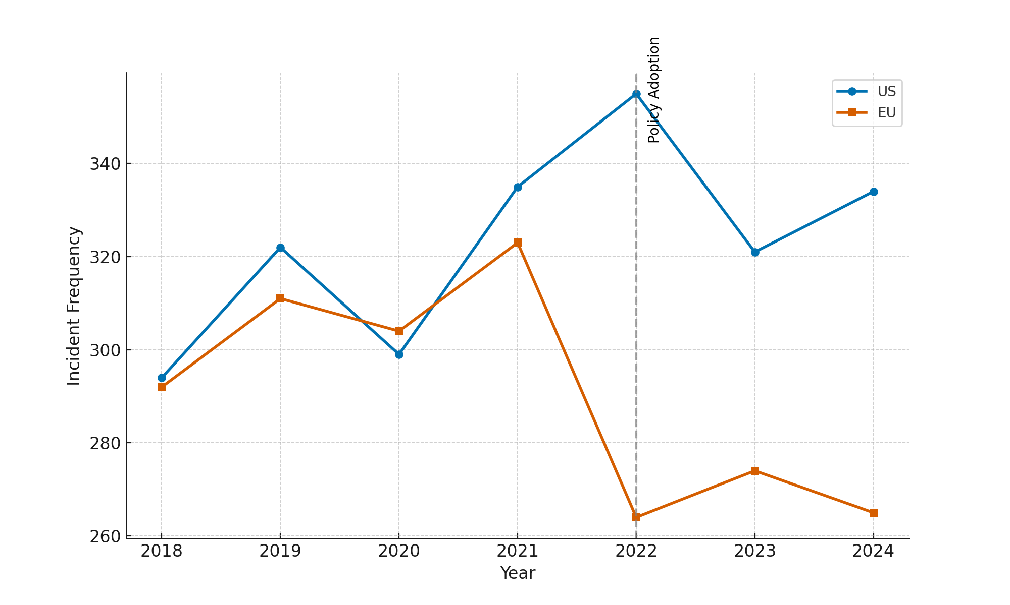
Figure 5. Trend comparison of EU and U.S. incident frequencies before and after policy adoption
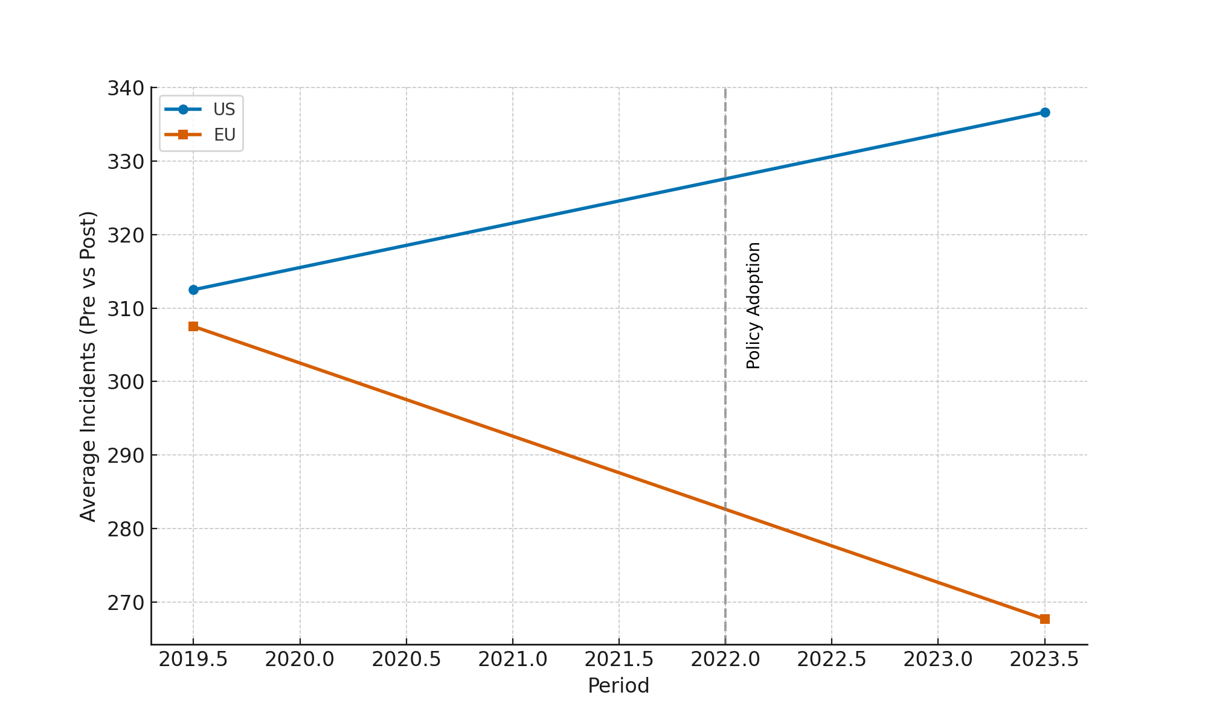
Figure 6. Difference-in-Differences slope comparison showing the effect of policy adoption on incident frequencies
Three critical findings emerge. First, the EU demonstrates a downward shift in incidents after adopting NIS2, while the U.S. shows a slight increase over the same period, indicating that structured policies contribute to resilience. Second, the DiD slope analysis confirms that the relative reduction in EU incidents exceeds what would have been expected absent the policy intervention. Finally, the measurable policy effect highlights the potential benefits of expanding harmonized reporting frameworks to other regions, as they provide actionable intelligence and accountability mechanisms that directly influence incident outcomes.
Discussion
The results obtained offer critical insights into the contemporary dynamics of cyber resilience and policy effectiveness, particularly when viewed in light of the theoretical and empirical foundations discussed earlier. The upward trajectory of state-sponsored incidents evidenced in Table 1 and depicted in Figure 1 corroborates the argument by Borghard and Lonergan (2021) that the strategic environment is increasingly characterized by persistent low-level operations rather than singular escalatory events. The sustained growth through 2027 further underscores Lonergan and Schneider’s (2023) observation that adversaries exploit thresholds below armed conflict, necessitating resilient defense postures capable of absorbing and adapting to constant pressure. The intermittent variability in year-on-year growth reflects Liu et al.’s (2024) identification of stealth-first and “living-off-the-land” techniques, which complicate defensive predictability and highlight the urgency of embedding adaptive policies rather than relying solely on traditional perimeter models.
The concentration of vulnerabilities presented in Table 2 and illustrated in Figure 3 reinforces the principle articulated by Zilincik and Sweijs (2023) that deterrence-by-denial must extend beyond technical barriers to encompass systemic prioritization. The evidence that three platforms (Windows Server, Linux Kernel, and Cisco Routers) account for more than half of all exploited vulnerabilities aligns with Nankya et al.’s (2023) findings that systemic dependencies within critical infrastructure magnify exposure when highly integrated technologies are compromised. Moreover, the inclusion of enterprise software such as Microsoft Exchange and VMware ESXi in the concentration pattern affirms Wu et al.’s (2025) caution that supply-chain assurance requires not only transparency but also targeted risk-tiered oversight. In this respect, the findings strongly support Broeders and De Deventer’s (2021) emphasis on institutional arrangements that incentivize resilience measures in high-value technologies rather than dispersing resources evenly across the digital ecosystem.
The evaluation of policy responses through the Difference-in-Differences model provides a compelling demonstration of the practical impact of regulatory adoption. As evidenced in Table 3 and Figure 5, the EU’s decline in incident frequencies following the adoption of NIS2 contrasts with the U.S. trajectory, which continued upward. This divergence validates Patterson et al.’s (2023) argument that reporting mechanisms deliver value when embedded within structured feedback loops rather than treated as compliance exercises. Furthermore, the relative reduction confirmed in Figure 6 substantiates Busetti and Scanni’s (2024) claim that timeliness and protection of reporting channels transform raw notifications into actionable improvements. The evidence that NIS2 yielded measurable gains further affirms Vandezande’s (2024) conclusion that harmonized and outcome-oriented reporting frameworks produce higher policy efficacy compared to fragmented or voluntary regimes.
Beyond the regional contrast, the findings also speak to broader theoretical debates. The EU’s demonstrable improvement following regulatory intervention supports Dziwisz’s (2024) contention that stability in competitive cyber contexts depends on persistent, proportionate, and internationally supportable measures. By contrast, the U.S. case reflects the risks identified by Burt (2023) that, absent structured institutionalization, responses remain reactive and less effective at shaping adversary behavior. Together, these results strengthen the case made by Woods and Seymour (2024) that evidence-based policy, grounded in controls with demonstrated effect sizes, should guide both national and international cyber strategies.
The steady escalation of state-sponsored operations signals the enduring need for resilience by design, in line with the engineering orientation outlined by Tzavara and Vassiliadis (2024). The concentration of vulnerabilities illustrates how systemic exposure magnifies adversarial opportunities, making tiered oversight and rapid remediation essential for sustaining critical functions. Finally, the demonstrated effect of NIS2 highlights the tangible benefits of structured reporting frameworks, lending empirical weight to arguments by Chang and Huang (2023) that coordination and trust in information-sharing regimes significantly improve defensive outcomes. In this way, the study not only affirms but also extends the theoretical claim that resilience requires alignment of deterrence, engineering, coordination, and stability lenses into coherent and enforceable policy instruments.
5. Conclusion and Recommendations
This study demonstrates that global cyber threats continue to intensify, with state-sponsored operations rising steadily and concentrating on a small set of critical technologies, while structured policy measures such as the EU’s NIS2 directive show measurable effectiveness in mitigating incident frequencies. The findings affirm that resilience requires a shift from reactive measures to proactive, evidence-based frameworks that prioritize systemic protection and coordinated governance. Building on this conclusion, four recommendations follow to guide policymakers and institutions:
- Prioritize tiered oversight and accelerated remediation for technologies that account for disproportionate exposure, ensuring concentrated protection of high-value systems.
- Institutionalize structured incident reporting frameworks that emphasize timeliness, feedback loops, and international schema alignment to convert notifications into actionable learning.
- Promote staged, identity-centric zero-trust adoption reinforced by executive accountability and procurement-driven incentives to limit adversarial persistence.
- Expand international collaboration on interoperable norms and joint disruption measures that reinforce deterrence, accountability, and trust across jurisdictions.

References
Agyepong, E., Cherdantseva, Y., Reinecke, P., & Burnap, P. (2023). A systematic method for measuring the performance of a cyber security operations centre analyst. Computers & Security, 124, 102959. https://doi.org/10.1016/j.cose.2022.102959
AlHidaifi, S. M., Asghar, M. R., & Ansari, I. S. (2024). Towards a Cyber Resilience Quantification Framework (CRQF) for IT infrastructure. Computer Networks, 247, 110446. https://doi.org/10.1016/j.comnet.2024.110446
Andreoli, A., Lounis, A., Debbabi, M., & Hanna, A. (2023). On the prevalence of software supply chain attacks: Empirical study and investigative framework. Forensic Science International: Digital Investigation, 44, 301508. https://doi.org/10.1016/j.fsidi.2023.301508
Associated Press. (2024). Associated Press News. AP NEWS. https://apnews.com/
Azad, M. A., Abdullah, S., Arshad, J., Lallie, H., & Ahmed, Y. H. (2024). Verify and trust: A multidimensional survey of zero-trust security in the age of IoT. Internet of Things, 27, 101227–101227. https://doi.org/10.1016/j.iot.2024.101227
Bamigbade, O., Obrik-Uloho, E. P., Kolo, F. H. O., Ogunmolu, A. M., & Adesokan-Imran, T. O. (2025). Data-Centric AI for Zero-Carbon Power Systems Security: A Framework for Learning with Noisy, Sparse, and Heterogeneous Data. Journal of Energy Research and Reviews, 17(7), 167–185. https://doi.org/10.9734/jenrr/2025/v17i7442
Borghard, E. D., & Lonergan, S. W. (2021). Deterrence by denial in cyberspace. Journal of Strategic Studies, 46(3), 1–36. https://doi.org/10.1080/01402390.2021.1944856
Bridges, R. A., Rice, A. E., Oesch, S., Nichols, J. A., Watson, C., Spakes, K., Norem, S., Huettel, M., Jewell, B., Weber, B., Gannon, C., Bizovi, O., Hollifield, S. C., & Erwin, S. (2023). Testing SOAR tools in use. Testing SOAR Tools in Use, 129, 103201–103201. https://doi.org/10.1016/j.cose.2023.103201
Broeders, D. (2021). Private active cyber defense and (international) cyber security—pushing the line? Journal of Cybersecurity, 7(1). https://doi.org/10.1093/cybsec/tyab010
Burt, S. K. (2023). President Obama and China: cyber diplomacy and strategy for a new era. Journal of Cyber Policy, 8(1), 48–66. https://doi.org/10.1080/23738871.2023.2282688
Busetti, S., & Scanni, F. M. (2024). Evaluating incident reporting in cybersecurity. From threat detection to policy learning. Government Information Quarterly, 42(1), 102000–102000. https://doi.org/10.1016/j.giq.2024.102000
Chang, K., & Huang, H. (2023). Exploring the management of multi-sectoral cybersecurity information-sharing networks. Government Information Quarterly, 40(4), 101870. https://doi.org/10.1016/j.giq.2023.101870
Chen, X., & Gao, X. (2024). Norm diffusion in cyber governance: China as an emerging norm entrepreneur? International Affairs, 100(6). https://doi.org/10.1093/ia/iiae237
CISA. (2020). PRC state-sponsored actors compromise and maintain access to U.S. critical infrastructure (AA24-038A). Cisa.gov. https://www.cisa.gov/
Dhiman, P., Saini, N., Gulzar, Y., Turaev, S., Kaur, A., Nisa, K. U., & Hamid, Y. (2024). A Review and Comparative Analysis of Relevant Approaches of Zero Trust Network Model. Sensors, 24(4), 1328. https://doi.org/10.3390/s24041328
Dziwisz, D. (2024). Rethinking Future Conflicts. Politeja, 21(5(92)), 281–309. https://doi.org/10.12797/politeja.21.2024.92.13
Ejiofor, V. O., Ogunmolu, A. M., Gbadebo, M. O., Joseph, S. A., & Adesokan-Imran, T. O. (2025). AI- Driven Risk Assessment for Enhancing Third Party Vendor Security in Healthcare Systems. Journal of Engineering Research and Reports, 27(5), 117–137. https://doi.org/10.9734/jerr/2025/v27i51498
Etxezarreta, X., Garitano, I., Iturbe, M., & Zurutuza, U. (2023). Software-Defined Networking approaches for intrusion response in Industrial Control Systems: A survey. International Journal of Critical Infrastructure Protection, 42, 100615–100615. https://doi.org/10.1016/j.ijcip.2023.100615
Financial Stability Board. (2023, April 13). FSB sets out a comprehensive approach to achieve greater convergence in cyber incident reporting. Financial Stability Board. https://www.fsb.org/2023/04/fsb-sets-out-a-comprehensive-approach-to-achieve-greater-convergence-in-cyber-incident-reporting/?utm_
Itodo, C., & Ozer, M. (2024). Multivocal literature review on zero-trust security implementation. Computers & Security, 141, 103827. https://doi.org/10.1016/j.cose.2024.103827
Iturbe, E., Llorente-Vazquez, O., Rego, A., Rios, E., & Toledo, N. (2024). Unleashing offensive artificial intelligence: Automated attack technique code generation. Computers & Security, 147(C), 104077–104077. https://doi.org/10.1016/j.cose.2024.104077
Jada, I., Alqahtani, N., & Fan, I.-S. (2024). The impact of artificial intelligence on organisational cyber resilience. Discover Sustainability, 5(1), 100174. https://doi.org/10.1016/j.dssust.2023.100174
Kang, H., Liu, G., Wang, Q., Meng, L., & Liu, J. (2023). Theory and Application of Zero Trust Security: A Brief Survey. Entropy, 25(12). https://doi.org/10.3390/e25121595
Karantzas, G., & Patsakis, C. (2021). An Empirical Assessment of Endpoint Detection and Response Systems against Advanced Persistent Threats Attack Vectors. Journal of Cybersecurity and Privacy, 1(3), 387–421. https://doi.org/10.3390/jcp1030021
Kianpour, M., Kowalski, S. J., & Øverby, H. (2022). Advancing the concept of cybersecurity as a public good. Simulation Modelling Practice and Theory, 116, 102493. https://doi.org/10.1016/j.simpat.2021.102493
Kolo, F. H. (2025). From Framework to Practice: Barriers and Enablers to RMF Adoption in Mid-sized Enterprises. Asian Journal of Research in Computer Science, 18(5), 459–479. https://doi.org/10.9734/ajrcos/2025/v18i5667
Kolo, F. H. O. (2025). A Multi-level Clustering Framework for Cybersecurity Risk Stratification in Healthcare: A Dynamic, Overlapping Approach to Threat Classification and Mitigation. Asian Journal of Research in Computer Science, 18(5), 11–31. https://doi.org/10.9734/ajrcos/2025/v18i5636
Kolo, F. H. O., Joseph, S. A., Ogunmolu, A. M., Ejiofor, V. O., & Oyekunle, S. M. (2025). Mitigating Cybersecurity Risks in Financial Institutions through Strategic Third- Party Risk Governance Frameworks. Journal of Engineering Research and Reports, 27(5), 173–193. https://doi.org/10.9734/jerr/2025/v27i51501
Liu, S., Peng, G., Zeng, H., & Fu, J. (2024). A survey on the evolution of fileless attacks and detection techniques. Computers & Security, 137, 103653. https://doi.org/10.1016/j.cose.2023.103653
Lonergan, E. D., & Schneider, J. (2023). The Power of Beliefs in US Cyber Strategy: The Evolving Role of Deterrence, Norms, and Escalation. Journal of Cybersecurity, 9(1). https://doi.org/10.1093/cybsec/tyad006
Lynch, T. F. (2024). Forward Persistence in Great Power Cyber Competition. Digital Commons @ NDU. https://digitalcommons.ndu.edu/csr-articles/4/
Manzoor, J., Waleed, A., Jamali, A. F., & Masood, A. (2024). Cybersecurity on a budget: Evaluating security and performance of open-source SIEM solutions for SMEs. PloS One, 19(3), e0301183–e0301183. https://doi.org/10.1371/journal.pone.0301183
McIntosh, T. R., Susnjak, T., Liu, T., Watters, P., Xu, D., Liu, D., Nowrozy, R., & Halgamuge, M. N. (2024). From COBIT to ISO 42001: Evaluating cybersecurity frameworks for opportunities, risks, and regulatory compliance in commercializing large language models. Computers & Security, 144, 103964. https://doi.org/10.1016/j.cose.2024.103964
Nankya, M., Chataut, R., & Akl, R. (2023). Securing Industrial Control Systems: Components, Cyber Threats, and Machine Learning-Driven Defense Strategies. Sensors, 23(21), 8840. https://doi.org/10.3390/s23218840
Ogunmolu, A. M. (2025a). A Multiscale Approach to Cyber-Mechanical Threat Modeling for Predicting and Preventing Failures in Critical Energy Infrastructure. Journal of Engineering Research and Reports, 27(6), 1–20. https://doi.org/10.9734/jerr/2025/v27i61523
Ogunmolu, A. M. (2025b). Digital Twin-based Energy Infrastructure Powered by AI: Real-Time Simulation, Anomaly Detection, and Intervention. Journal of Energy Research and Reviews, 17(7), 65–85. https://doi.org/10.9734/jenrr/2025/v17i7434
Ogunmolu, A. M. (2025c). Enhancing Data Security in Artificial Intelligence Systems: A Cybersecurity and Information Governance Approach. Journal of Engineering Research and Reports, 27(5), 154–172. https://doi.org/10.9734/jerr/2025/v27i51500
Ogunmolu, A. M. (2025d). Federated Detection Systems for Insider Threats in Energy Facilities Using Biomechanical Access Control and Al-Based Cybersecurity. Journal of Engineering Research and Reports, 27(6), 65–82. https://doi.org/10.9734/jerr/2025/v27i61528
Ogunmolu, A. M. (2025e). Leveraging Generative AI and Behavioral Biometrics to Strengthen Zero Trust Cybersecurity Architectures in Healthcare Systems. Journal of Engineering Research and Reports, 27(5), 194–213. https://doi.org/10.9734/jerr/2025/v27i51502
Ogunmolu, A. M., Obrik-Uloho, E. P., Olaniyi, O. O., Arigbabu, A. T., & Bamigbade, O. (2025). Cyber Risk Spillovers in Interconnected Financial Ecosystems: Evidence from Traditional Banks and DeFi Oracles. Journal of Engineering Research and Reports, 27(7), 106–126. https://doi.org/10.9734/jerr/2025/v27i71565
Ogunmolu, A. M., Olaniyi, O. O., Popoola, A. D., Olisa, A. O., & Bamigbade, O. (2025). Autonomous Artificial Intelligence Agents for Fault Detection and Self-Healing in Smart Manufacturing Systems. Journal of Energy Research and Reviews, 17(8), 20–37. https://doi.org/10.9734/jenrr/2025/v17i8445
Olutimehin , A. T., Olaniyi , O. O., Ogunmolu , A. M., Kolo, F. H. O., & Salami , I. A. (2025). Cloud-Based AI Solutions for Real-time Monitoring of E-commerce Compliance and Risk. Journal of Engineering Research and Reports, 27(7), 127–147. https://doi.org/10.9734/jerr/2025/v27i71566
Olutimehin, A. T., Olaniyi, O. O., Popoola, A. D., Ogunmolu, A. M., & Kolo, F. H. O. (2025). AI and IoT Integration for Predictive Maintenance and Risk Management in Smart Manufacturing. Asian Journal of Research in Computer Science, 18(7), 120–142. https://doi.org/10.9734/ajrcos/2025/v18i7724
Oyekunle, S. M., Popoola, A. D., Kolo, F. H. O., Ogunmolu, A. M., & Adesokan-Imran, T. O. (2025). Intelligent Fraud Prevention Information Banking: A Data Governance- Centric Approach Using Behavioural Biometrics. Asian Journal of Research in Computer Science, 18(5), 525–543. https://doi.org/10.9734/ajrcos/2025/v18i5672
Patterson, C. M., Nurse, J. R. C., & Franqueira, V. N. L. (2023). Learning from cyber security incidents: A systematic review and future research agenda. Computers & Security, 132(1), 103309. https://www.sciencedirect.com/science/article/pii/S0167404823002195
Qi, Z., Jin, H., Wang, Q., Gan, Z., Xiong, R., Zhang, S., Liu, M., Wang, J., Ding, X., Chen, X., Zhang, J., Nimsky, C., & Miriam. (2024). The Feasibility and Accuracy of Holographic Navigation with Laser Crosshair Simulator Registration on a Mixed-Reality Display. Sensors, 24(3), 896–896. https://doi.org/10.3390/s24030896
Sammak, R., Rotthaler, A. L., Ramulu, H. S., Wermke, D., & Acar, Y. (2023). Developers’ Approaches to Software Supply Chain Security: An Interview Study. Proceedings of the 2024 Workshop on Software Supply Chain Offensive Research and Ecosystem Defenses, 56–66. https://doi.org/10.1145/3689944.3696160
Sepúlveda Estay, D. A., Sahay, R., Barfod, M. B., & Jensen, C. D. (2020). A systematic review of cyber-resilience assessment frameworks. Computers & Security, 97, 101996. https://doi.org/10.1016/j.cose.2020.101996
Spreitzenbarth, J. M., Bode, C., & Stuckenschmidt, H. (2024). Artificial intelligence and machine learning in purchasing and supply management: A mixed-methods review of the state-of-the-art in literature and practice. Journal of Purchasing and Supply Management, 30(1), 100896. https://doi.org/10.1016/j.pursup.2024.100896
Sukumar, A., & Basu, A. (2024). Back to the territorial state: China and Russia’s use of UN cybercrime negotiations to challenge the liberal cyber order. Journal of Cyber Policy, 1–32. https://doi.org/10.1080/23738871.2024.2436591
Tran-Truong, P. T., Pham, M. Q., Son, H. X., Nguyen, D. L. T., Nguyen, M. B., Tran, K. L., Van, L. P., Le, K. T., Vo, K. H., Kim, N. N. T., Nguyen, T. M., & Nguyen, A. T. (2025). A systematic review of multi-factor authentication in digital payment systems: NIST standards alignment and industry implementation analysis. Journal of Systems Architecture, 162, 103402. https://doi.org/10.1016/j.sysarc.2025.103402
Tzavara, V., & Vassiliadis, S. (2024). Tracing the evolution of cyber resilience: a historical and conceptual review. International Journal of Information Security, 23. https://doi.org/10.1007/s10207-023-00811-x
U.S. Department of Homeland Security. (2024). Harmonization of Cyber Incident Reporting to the Federal Government | Homeland Security. U.S. Department of Homeland Security. https://www.dhs.gov/publication/harmonization-cyber-incident-reporting-federal-government?utm_source=chatgpt.com
U.S. Department of Justice. (2024a, January 31). U.S. government disrupts botnet used to conceal hacking of critical infrastructure by PRC state-sponsored actors. https://www.justice.gov/
U.S. Department of Justice. (2024b, September 18). Court-authorized operation disrupts worldwide botnet used by PRC-state-sponsored actors. https://www.justice.gov/
Udechukwu, L. M. (2025a). AI-Governed Security Frameworks for Virtualized Enterprises: Preventing Data Breaches and Ensuring Compliance. Asian Journal of Research in Computer Science, 18(9), 39–57. https://doi.org/10.9734/ajrcos/2025/v18i9753
Udechukwu, L. M. (2025b). Ethical Implications and Cybersecurity Risks of Hyper-Personalized AI Feedback Systems for Mental Health Support in Home Environment. Journal of Engineering Research and Reports, 27(9), 310–328. https://doi.org/10.9734/jerr/2025/v27i91643
Vandezande, N. (2024). Cybersecurity in the EU: How the NIS2-directive stacks up against its predecessor. Computer Law & Security Review, 52, 105890. https://doi.org/10.1016/j.clsr.2023.105890
Woods, D. W., & Seymour, S. (2024). Evidence-based cybersecurity policy? A meta-review of security control effectiveness. Journal of Cyber Policy, 8(3), 1–19. https://doi.org/10.1080/23738871.2024.2335461
Wu, M., Zhao, Y., Hu, X., Zhan, X., Li, S., & Xia, X. (2025). More Than Meets the Eye: On Evaluating SBOM Tools In Java. ACM Transactions on Software Engineering and Methodology. https://doi.org/10.1145/3766073
XU, M., & LU, C. (2021). China–U.S. cyber-crisis management. China International Strategy Review, 3(1), 97–114. https://doi.org/10.1007/s42533-021-00079-7
Yeoh, W., Liu, M., Shore, M., & Jiang, F. (2023). Zero trust cybersecurity: Critical success factors and A maturity assessment framework. Computers & Security, 133(1), 103412. https://doi.org/10.1016/j.cose.2023.103412
Zahan, N., Lin, E., Tamanna, M., Enck, W., & Williams, L. (2023). Software Bills of Materials Are Required. Are We There Yet? IEEE Security & Privacy, 21(2), 82–88. https://doi.org/10.1109/msec.2023.3237100
Zilincik, S., & Sweijs, T. (2023). Beyond deterrence: Reconceptualizing denial strategies and rethinking their emotional effects. Contemporary Security Policy, 44(2), 248–275. https://doi.org/10.1080/13523260.2023.2185970

