Original Research Article
DESIGN AND IMPLEMENTATION OF A HOMOMORPHIC CRYPTOSYSTEM MODEL IN THE CLOUD, SPECIFICALLY ADAPTED TO THE NEEDS OF ELECTRONIC VOTING IN THE DRC

ABSTRACT
This article focuses on the design and implementation of a homomorphic cryptosystem model, specifically designed for a private cloud , to protect sensitive data in the context of electronic voting in the Democratic Republic of the Congo (DRC). The main objective is to develop a system capable of performing calculations on encrypted data without compromising its confidentiality , thereby ensuring the security of the information.

The study addresses several crucial issues, including ensuring the security and confidentiality of sensitive data, the integrity and transparency of electoral processes , and the adaptation of advanced technologies to the local realities of the DRC.

The proposed model adopts a multi- layered architecture, encompassing physical infrastructure, virtualization to create isolated environments , and orchestration and automation tools to enhance efficiency .

The results demonstrate the technical feasibility of this model, capable of ensuring the confidentiality , integrity , and verifiability of electoral processes . However , challenges remain , such as algorithmic complexity and system interoperability . increased awareness among political actors and civil society is essential to promote the adoption of this innovative technology .

Keywords : Homomorphic cryptosystem, Private cloud, Electronic voting, DRC
INTRODUCTION
The Democratic Republic of Congo, like many countries, is seeking to modernize its electoral processes while ensuring the integrity and confidentiality of votes (TSIBASU , S. 2017). This article proposes to explore the design and implementation of a homomorphic cryptosystem model in the cloud, specifically adapted to the needs of electronic voting in the DRC.

The goal is to develop a system capable of performing calculations on encrypted data without compromising their confidentiality. The homomorphic cryptosystem represents a promising solution for combining data security and functionality. It allows mathematical operations to be performed on encrypted data without requiring their prior decryption, thus ensuring the protection of sensitive information. (GENTRY, C.2009)

01. PROBLEM

The problem of this study focuses on the implementation of a homomorphic cryptosystem for electronic voting in the Democratic Republic of Congo, addressing several major issues.

A) Fundamental issues:
- How can we ensure the security and confidentiality of sensitive data, such as personal information and political choices, in an increasingly complex digital environment?
- How can we ensure the integrity and transparency of electoral processes, especially in a context where trust in institutions is sometimes fragile? (NGINDU, K. 2019)
- How can advanced technologies, such as homomorphic cryptosystems , be adapted to the specific realities of the DRC, marked by technical, socio-economic and political constraints?

B) Issues specific to our research:
- Which homomorphic cryptosystem should be chosen among existing algorithms, taking into account performance, security and complexity?
- How can the theoretical model of a homomorphic cryptosystem be adapted to the particularities of the Congolese electoral system, to the available digital infrastructures and to local technical skills?
- How can we find a balance between a high level of security and a simple and intuitive user experience for voters?
- How can we guarantee the social acceptability of an electronic voting system based on complex technology, in the face of potential public reluctance? (MERCURI , RT . 2001)

So , the problem of this research boils down to the following question : How to design and implement an electronic voting system secure and transparent, based on a cryptosystem homomorphic , which is adapted to the context specific to the Republic Democratic Republic of Congo, while ensuring the confidentiality of votes and promoting acceptance social impact of this new technology ? (TSHIBASU, S.2017)

02. Hypotheses
Based on the elements previously discussed concerning the use of cryptosystems homomorphic for electronic voting in the DRC, we propose the hypotheses following :

2.1. Main hypothesis
- Hypothesis 1 : The implementation of an electronic voting system based on a homomorphic cryptosystem can significantly improve the security and confidentiality of elections in the DRC.
- Hypothesis 2 : Such a system can strengthen citizens' confidence in the electoral process by guaranteeing the integrity and transparency of the results.
- Hypothesis 3 : The technical and socio-economic constraints of the Congolese context can be overcome to implement a secure and efficient electronic voting system.

2.2.. Specific hypotheses
- Hypothesis 4 : The choice of a specific homomorphic cryptosystem (such as BFV or CKKS) will have a direct impact on the performance and security of the electronic voting system.
- Hypothesis 5 : The implementation of an electronic voting system will require specific training for the actors involved in the electoral process.
- Hypothesis 6 : Social acceptance of such a system will depend on the transparency of decisions, communication on security issues and the active participation of citizens.

3. INTEREST OF THE STUDY
The interest of this study is multiple, responding to issues of data security and electoral integrity at the national and international level.

3.1. Theoretical and Practical Interests
Contribution to cryptography, including the application of homomorphic cryptosystems to electronic voting. Evaluation of the feasibility and effectiveness of cryptosystems in a private cloud .

3.2. Societal and Political Interests
Guaranteeing the confidentiality of votes, reducing the risk of electoral fraud. Tools to secure sensitive data and increase transparency.

3.3. Specific Interests in the Congolese Context
Adjusting technologies to the technical and socio-economic constraints of the DRC. Strengthening capacities in cryptography and computer security. (CHAUM, D. 2005) Proposals for innovations to secure public data.

4. RESEARCH METHODOLOGY

a. Literature review
There are many works available on the application of homomorphic encryption to electronic voting. For example, let us cite (Electronic Voting: The Challenges of Secrecy and Transparency, Véronique Cortier and Pierrick Gaudry, May 2022, Éditions Odile Jacob) or the master's report by Jean-Christophe Deneuville :
Homomorphic Cryptography ”, University of Limoges, 2012, which describes the state of the art of homomorphic cryptography and possible applications, such as electronic voting.

b. Analysis of specific needs:
A analysis in-depth needs assessment East necessary to design a system robust .

homomorphic cryptosystem model .
4. RESULTS
  - MODEL DESIGN
The development of a homomorphic cryptosystem (CHE) model suitable for a private cloud of sensitive data is a complex but essential technical challenge to guarantee the security and confidentiality of information . ( COPPERSMITH,D.1994)

SYSTEM ARCHITECTURE
To ensure safety​ and the reliability of the CENI DRC data center, a system architecture robust and multi-layered East essential .

Layer 1: Physical Infrastructure
This layer includes the physical components of the data center, such as than servers , storage systems , networks​​ and safety devices . (WANG , C.2010 )

- Servers : Use of high-performance, scalable servers for data processing.
- Storage : Redundant and secure storage systems for sensitive data.
- Network : Implementation of a secure network with firewalls, intrusion detection systems and encryption solutions to prevent cyber attacks.
- Physical security : Strict measures, such as biometric access controls, video surveillance systems and security fencing, to protect the data center against physical intrusion.
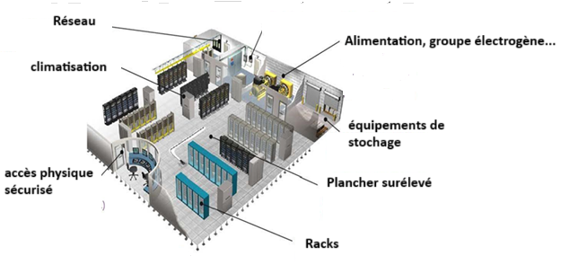

Figure 1: Data Center (Model inspired by the RDC Data Center, 7 of 7.cd/2024)
Layer 2: Virtualization
Virtualization technology allows the creation of isolated virtual environments on a single physical server, which improves resource utilization, flexibility, and scalability . Virtualization also allows applications and data to be isolated from each other, which increases system security and reliability . ( BONNET L 2007)

Layer 3: Defining the perimeter
Establishing network zones with distinct security levels helps segment the network and limit access to sensitive data. A secure network zone should be created to host CENI's critical systems, while a less secure network zone can be used for non-critical systems.

Layer 4: Orchestration and Automation

Orchestration and automation tools can be used to automate data center management tasks, such as server provisioning, configuration management, and software updates. Automation helps improve efficiency, reduce human error, and ensure consistent system configurations.

Layer 5: Monitoring and Security
Monitoring solutions must be implemented to continuously monitor system performance, detect anomalies, and alert administrators in the event of problems. Sophisticated security systems, such as next-generation firewalls, intrusion detection systems, and intrusion prevention solutions, must be deployed to protect the data center from advanced cyberattacks.

Layer 6: Access and Authentication
A robust authentication and authorization system must be in place to control access to data center systems and data. Multi-factor authentication should be used to add an extra layer of security and protect accounts from unauthorized access.

Layer 7: Backup and Restore
A comprehensive backup and recovery solution should be in place to protect data from accidental or malicious loss. Regular data backups should be performed and stored offsite in a secure location.

Recovery procedures must be tested regularly to ensure that data can be restored quickly in the event of a disaster. This multi-layered system architecture provides a robust and secure approach to designing a data center for the CENI DRC. By implementing this architecture, the CENI can protect its sensitive data, ensure system availability, and ensure the integrity of electoral processes.

System components and interactions
A secure data center for the CENI DRC consists of several key components that interact to ensure the storage, processing, and protection of sensitive data. Here is a description of the main components and their interactions:

1. Servers:
Servers are the heart of the data center, responsible for processing data and running applications. Different types of servers can be used, such as rack servers, blade servers, and high-performance computing (HPC) servers, depending on the specific needs of the CENI.

Servers interact with storage systems to access data, with networks to communicate with users and other devices, and with management systems to receive instructions and updates.

2. Storage systems:
Storage systems are used to store CENI data, including voter ID information, election results, and other sensitive data. Different types of storage systems can be used, such as traditional hard disk drives (HDDs), solid-state drives (SSDs), and cloud storage, depending on capacity, performance, and security requirements.

Storage systems interact with servers to provide the data needed for processing, and with backup systems to create backup copies of the data.

3. Networks:
Networks allow servers, storage systems, and other devices in the data center to communicate with each other and with external users. A secure network with firewalls, intrusion detection systems, and encryption solutions is crucial to protect data from cyberattacks.

Networks interact with servers to transmit user requests and responses, with storage systems to transfer data, and with security systems to monitor network traffic and detect suspicious activity.

4. Management systems:
Management systems provide control and monitoring of the entire data center, including servers, storage systems, networks, and security devices. They allow administrators to provision new resources, configure systems, deploy software, monitor performance, and troubleshoot issues.
Management systems interact with all other components in the data center to collect data, send commands, and ensure proper system operation.

5. Safety devices:
Security systems protect the data center from physical intrusions and cyberattacks. They include firewalls, intrusion detection systems (IDS), intrusion prevention systems (IPS), biometric access controls, surveillance cameras, and security fences.

Security devices interact with management systems to report security incidents and take corrective action.

Interactions between components
Servers send requests to storage systems to retrieve the data needed for processing, which respond by providing the requested information. The servers then process this data and send the results to users or other systems.

Networks transport requests, responses, and data between servers, storage systems, and users. Management systems monitor performance, configure systems, deploy software, and troubleshoot problems.

Finally, security devices protect the data center against physical intrusions and cyberattacks, while reporting security incidents to management systems.

4.2. IMPLEMENTATION

4.2.1. CHOICE OF MODELING OF THE MODEL
We opted for the UML language, which is a standard systems modeling language, using diagrams to represent each aspect of a system. The use case diagram identifies the main functionalities of a system and the users (called actors) who interact with it. It breaks down the functionalities into use cases, thus reflecting the needs of the users . ( Michel PLASSE, 2013)

List of actors:
- Administrator : Registers political parties, candidates, sets up elections, creates polling stations and publishes results, while having access to the operations of a voting user.
- Voting user : Registers for an election, votes, consults the candidates' statements of faith, the list of parties and the election statistics.
- Candidate : Submits their application, enters their profession of faith and can perform all the actions of a voting user.

The use case diagram illustrates the interactions between these actors and the system, as well as the relationships between them and the use cases.
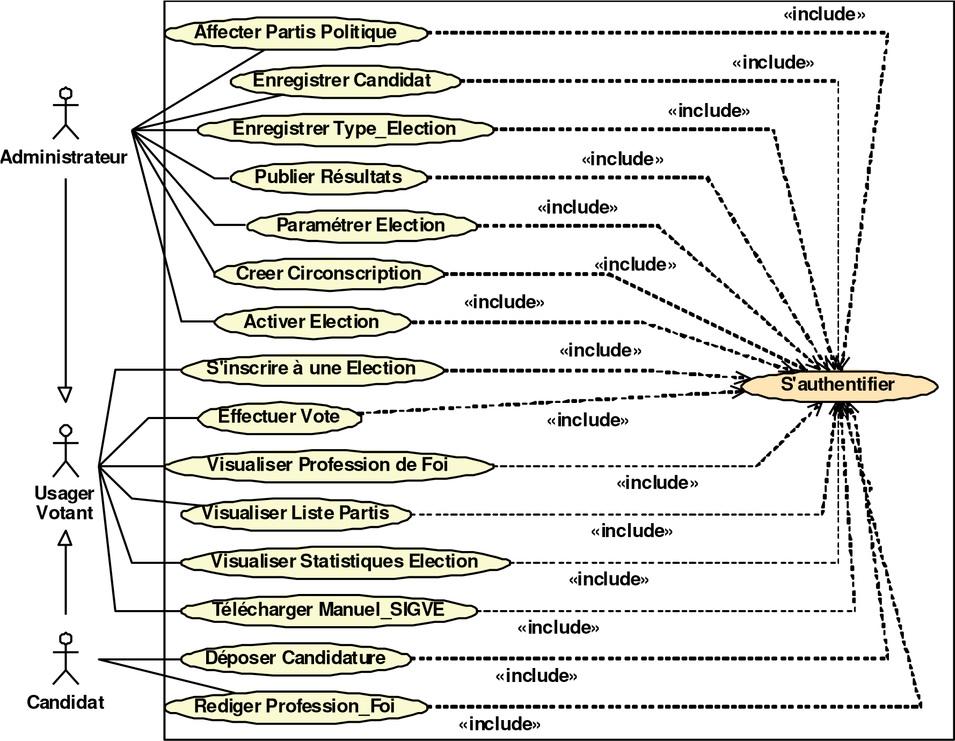
Figure 2. Use case diagram of the voting system

Textual Description of Some Use Cases

A use case is a collection of success or failure scenarios describing how an actor uses a system to achieve a goal. To detail it, it is essential to verbatim record all interactions between actors and the system, clearly identifying the beginning and end of the use case. It is also important to specify possible variations while organizing the descriptions sequentially to improve readability.

Sequence diagrams, part of UML's interaction diagrams, describe system dynamics by illustrating the interactions between objects needed to realize a use case. Each object is represented by a vertical lifeline, and the messages exchanged are indicated by horizontal arrows. Time flows from top to bottom, reflecting the sequence of message sending and receiving (SEUMO NTSIEPDJAP 2014)
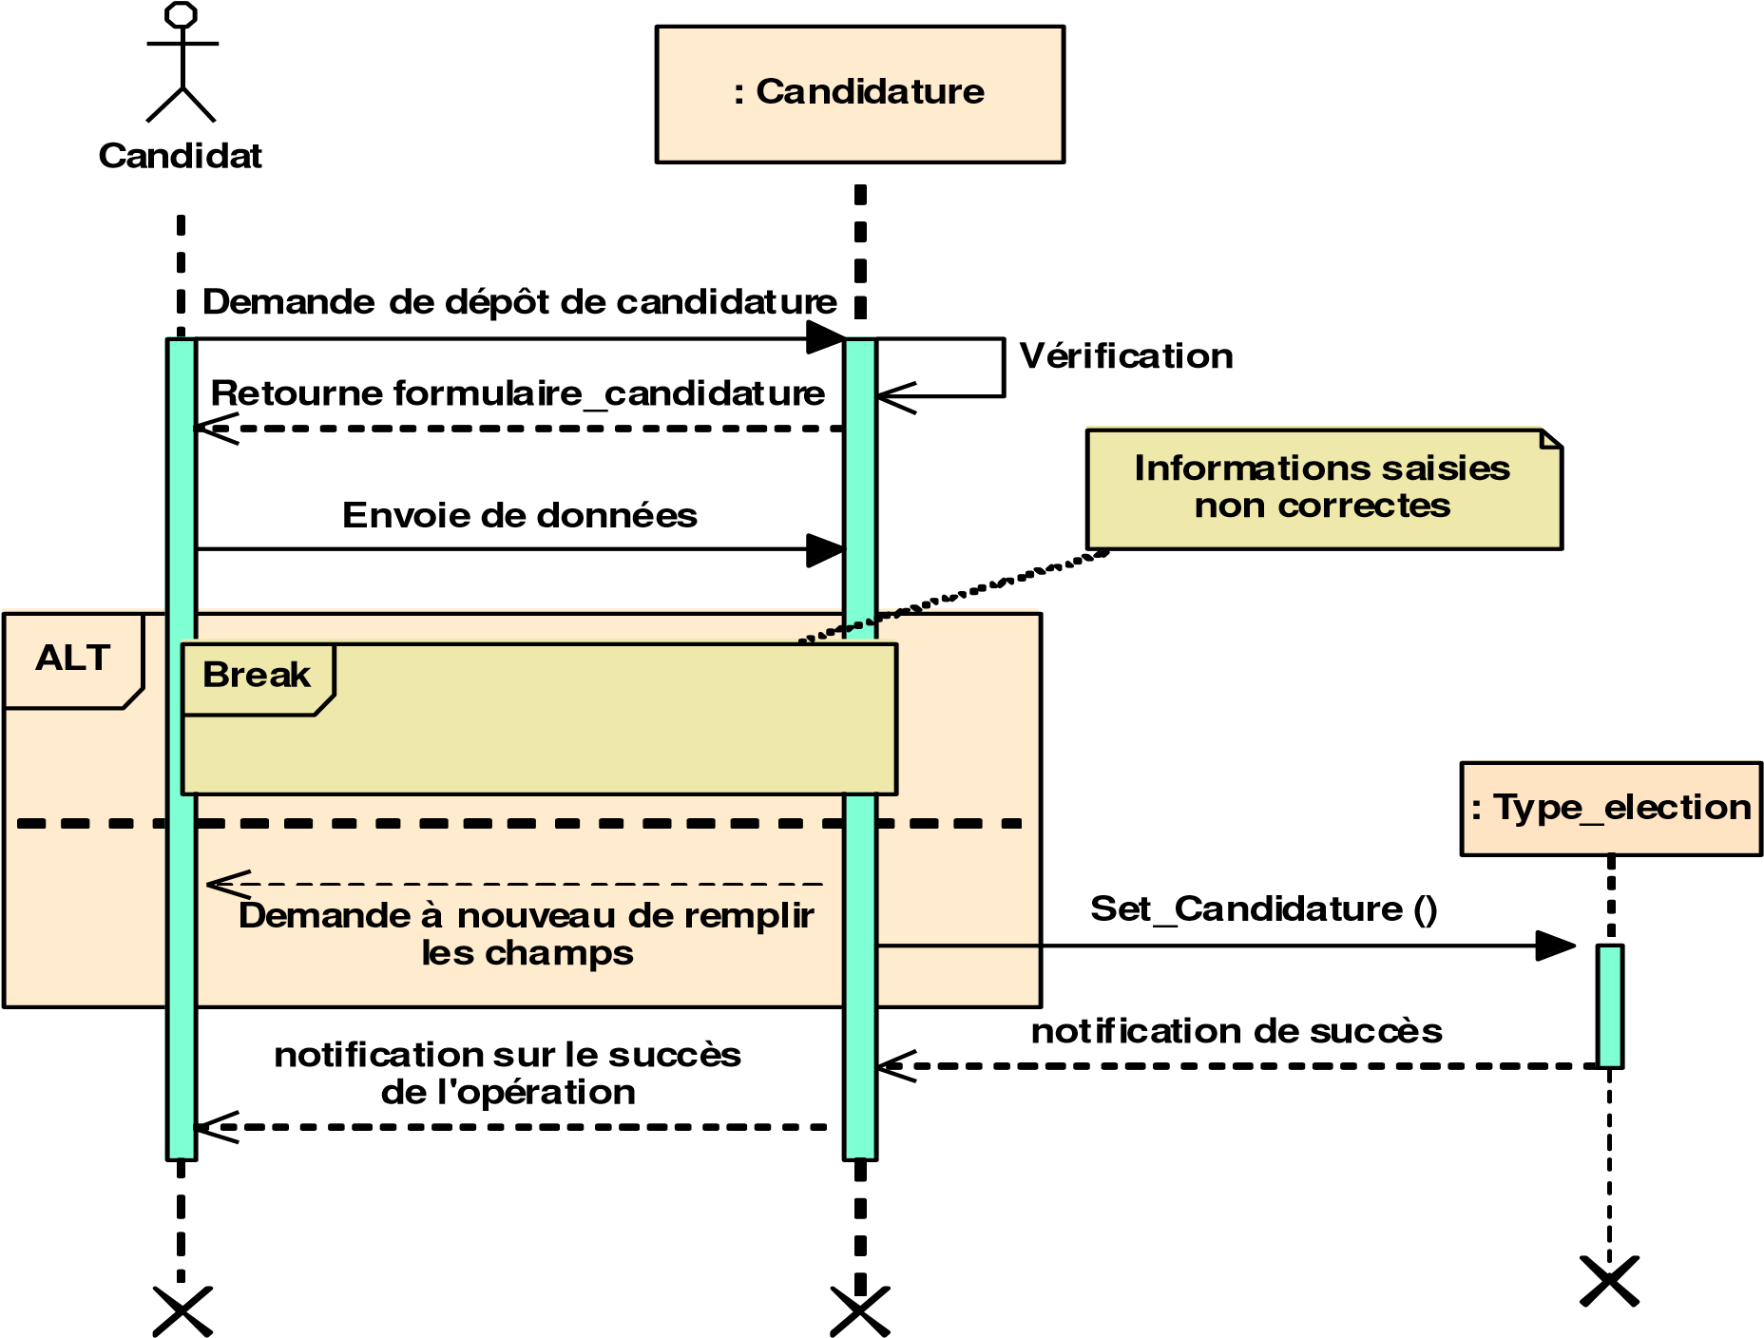
Figure 3. Sequence diagram of the “Submit Application” use case

The figure describes the exchanges between a candidate and the system when submitting their application. The candidate requests to submit an application via its interface, receives a form to fill out, and then submits it. If there is an error, they receive an error message and must correct the form. Once the form is correctly completed and validated, their application is assigned to the requested position, and they receive a notification confirming that their application has been taken into account . ( Pierre –Alain Muller 2003)

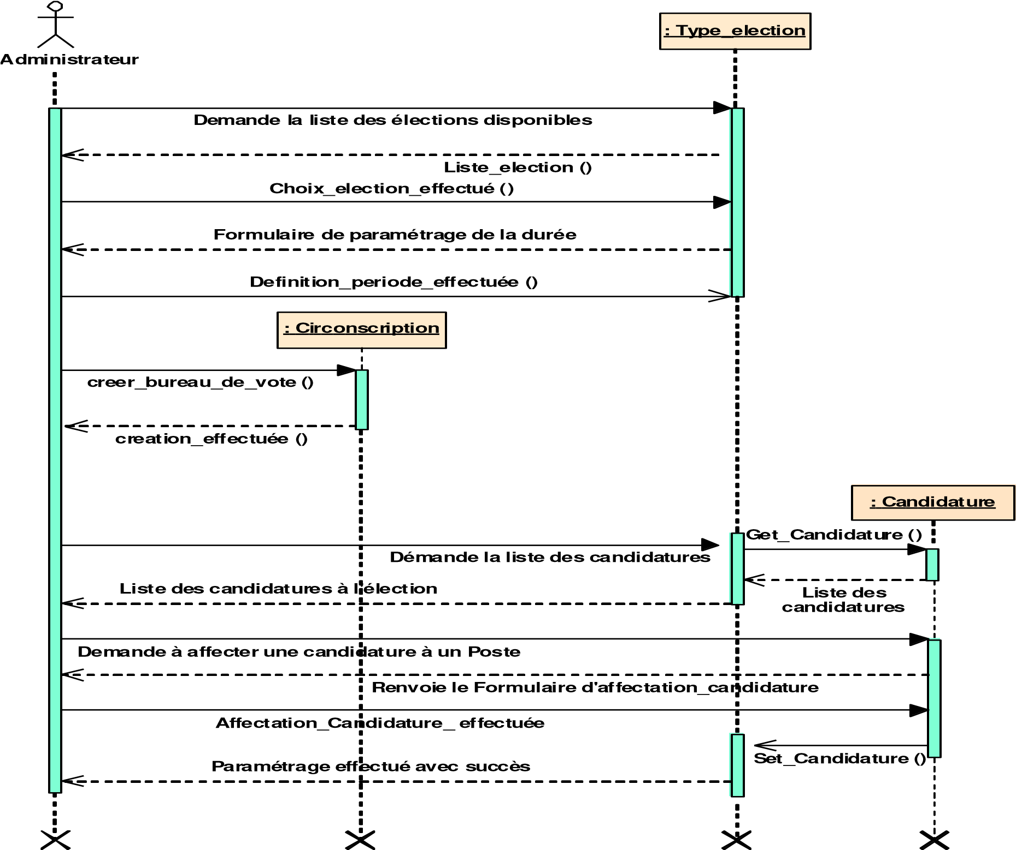
Figure 4. Sequence diagram of the “Configure Election” use case
This figure above shows the different messages exchanged between the administrator and the program to allow the configuration of an election. The administrator, through his interface, requests to configure an election, then he will have to create an election, this after having created at least one polling station and a political party. The form containing the list of political parties that have been previously registered is returned to him, from then on, all that remains is to request the assignment of a political party to an election. Finally, he will receive a notification of the success of the operation.

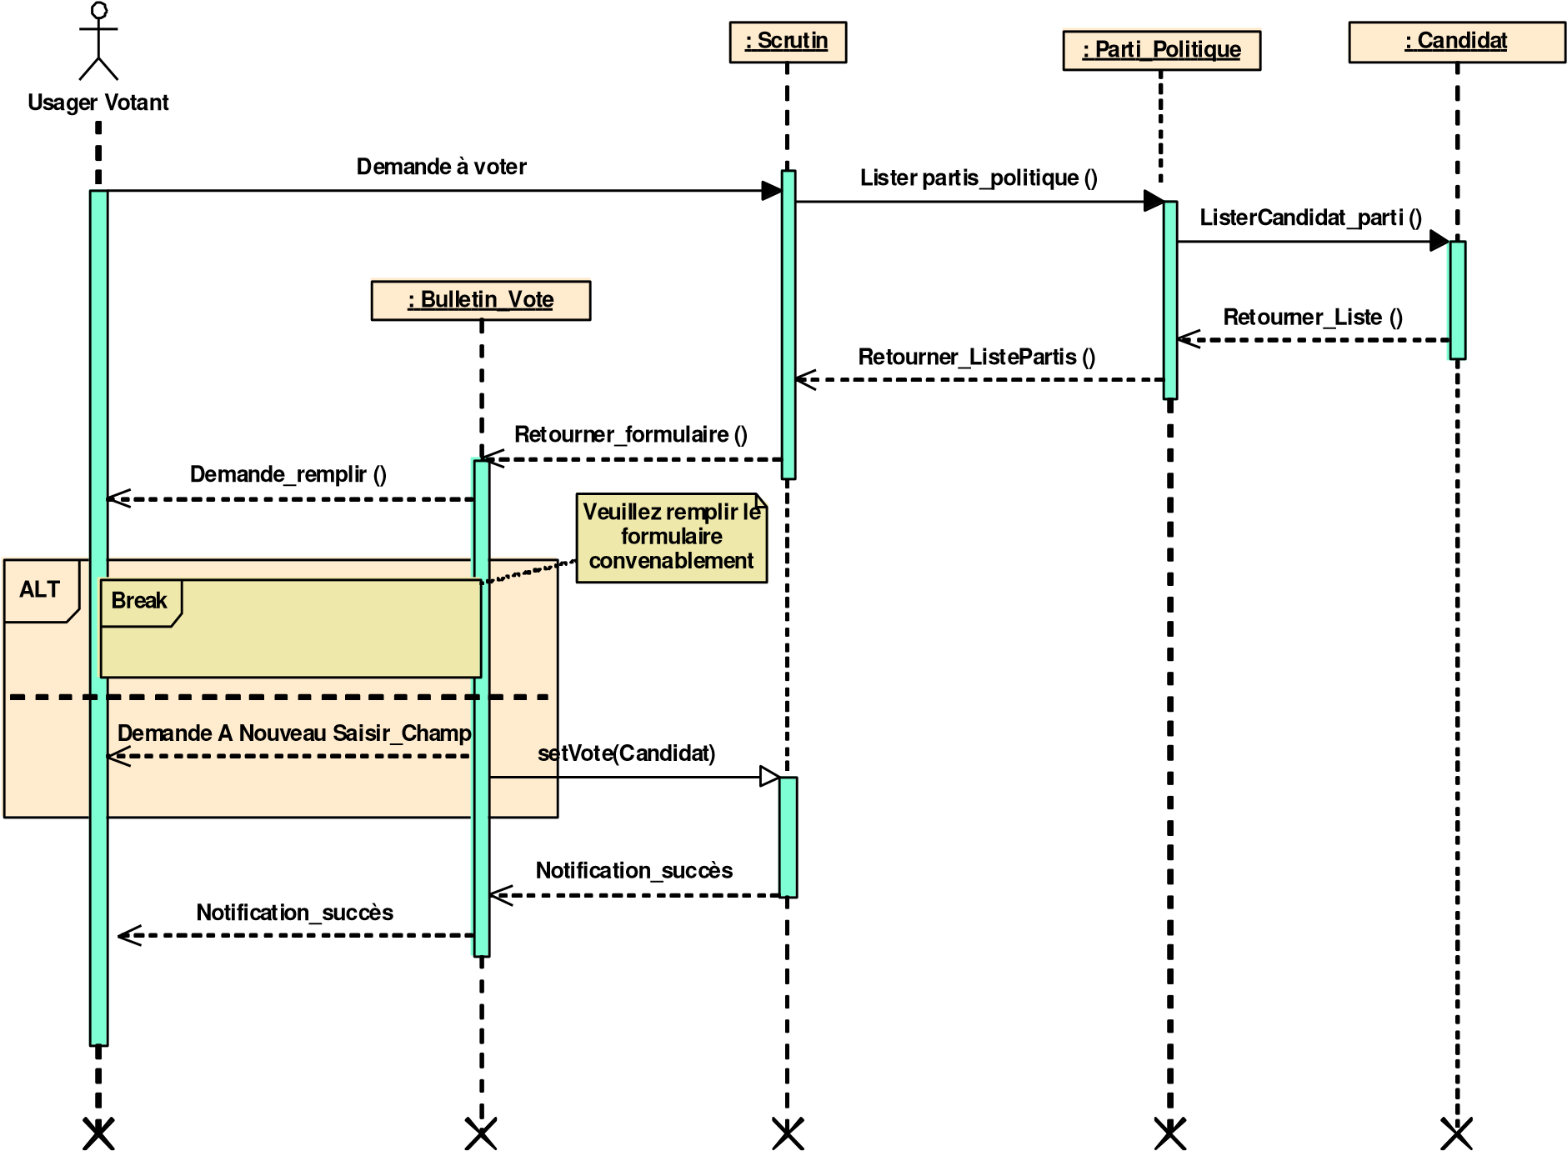
Perform Vote” use case
Figure 5 : Exchanges between a voting user and the system when voting for a candidate

The figure illustrates the exchanges between a voting user and the system when voting for a candidate. The user requests to vote and receives a ballot containing the list of candidates. He fills out the ballot and submits it; in case of error, a message invites him to correct his vote. Once his choice is validated, his vote is recorded, and he receives a notification confirming the success of the operation. Representation of the sequence diagram: case " Register for an election "

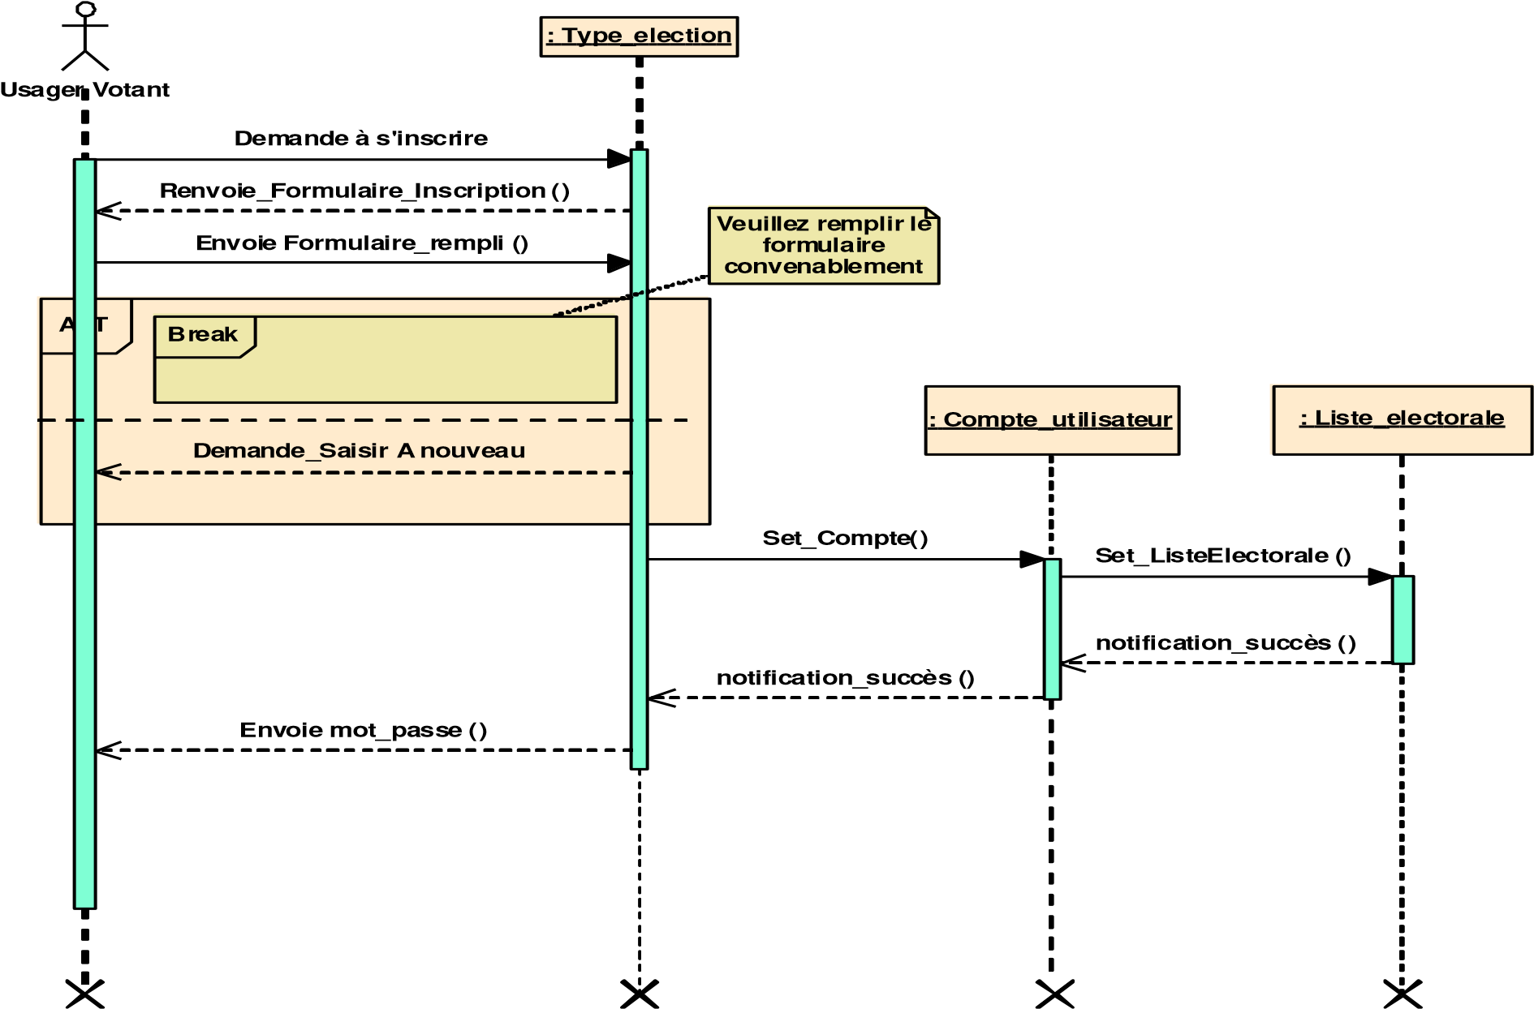
Figure 6. Sequence diagram of the “Register for an election” use case
The figure describes the exchanges between a voting user and the system when registering for an election. The user requests to register and receives a registration form to fill out. If an error occurs, they receive a message inviting them to correct the form. Once the form is correctly completed, their account is created, and they are registered on the chosen electoral list. Finally, they receive their password by message, confirming the success of the operation.

4.2.3. General system behavior (activity diagram)
An activity diagram represents the behavior of an operation, use case, or process involving multiple elements. It illustrates how activities are coordinated to perform voting operations. This diagram, consisting of actions and transitions, models the essential dependencies between the different stages of an operation. It functions like an automaton, where transitions between states do not occur based on triggering events.

Figure 6 below depicts the activity diagram of the voting process.
Refuser Vote
Effectuer Vote
Confirmer
Message
D'envoie
Identification
Vérification
vote
Retour
identification
Oui
Non
Déconnexion
Confirmer Vote
Indexer
Election
Figure 7. Activity diagram representing the voting process

According to Figure 6, when a citizen successfully logs in, a voting page appears. After making their choice, they receive a message confirming that their vote has been counted. However, if they have not voted, they will be informed that their vote has not been recorded. In addition, if the citizen has already voted, their session will be closed, preventing them from logging in again as a voter for the current election session.

CONCLUSION
This article presents a model of a cryptosystem homomorphic suitable for a private cloud to protect data sensitive during electronic voting in the DRC. The results show the technical feasibility of this approach , capable of guaranteeing confidentiality , integrity and process verifiability​​ electoral .

We have developed A electronic voting protocol secured and evaluated its performance, while analyzing its implications for confidentiality and integrity . However , challenges​ remain for a large - scale implementation​ scale , including complexity​ algorithmic schemes​ homomorphic And interoperability between systems . A increased awareness among stakeholders policies and society​ civil security issues​​ digital East also necessary to promote the adoption of this technology .

References

- Bonnet L.; State of the art of free virtualization solutions for a small business. Bearstech , 7th ed., December 2007.
- Michel Plasse ; Why use a particular tool or language? Course material. Eyrolles Publishing, 2013
- Pierre-Alain Muller and Natalie Gaetner ; Object Modeling with UML, ed. Eyrolles 2003
- Chaum , D., Ryan, PYA, &Schneider, S. 2005. A Practical , Voter- Verifiable Election Scheme.ESORICS .
- Mercuri , R. T. (2001). Electronic Vote Tabulation Checks and Balances.Ph.D Dissertation, University of Pennsylvania .
- Tshibasu , S. (2017). Electronic Governance in the DRC: Challenges and Opportunities. European University Ed.
- Ngandu , K. (2019). ICT issues and solutions in the context of the DRC.
- Coppersmith , D. (1994). The Data Encryption Standard (DES) and Its Strength Against Attacks . IBM Journal of Research and Development , 38(3), 243-250.
- Seumo Ntsiepdjap ; Design and Implementation of an electronic voting system, Technology and Computer Science and Network license, IUT-FV University of Dschang; 2014.
- http://fr.wikipedia.org/wiki/vote electronic
- http://www.openmairie.org/catalogue/openelec

