Original Research Article
AI-Driven Financial Fraud Detection System in Savings Account Using Rule-Based Logic and Random Forest Algorithm

ABSTRACT

The threat of fraud in savings accounts has escalating in recent years due to the rise of digital banking, prompting the need for advanced security measures. This project addresses this challenge by developing a hybrid fraud detection system which combines rule-based logic with machine learning. This system aims to detect unauthorized transactions in real-time while minimizing re-occurrences and ensuring rapid response to emerging threats. Key features include transaction pattern analysis, anomaly. The methodology used leverages Python for backend development, Scikit-learn for Machine Learning (ML) models, PHP (Hypertext-Preprocessor) for both frontend and also server-side scripting to create an interactive dashboard, and MySQL for database management to store and retrieve transaction data efficiently. This work contributes to the field of financial cybersecurity by bridging the gap between static rule-based systems and adaptive machine learning approaches, offering a robust framework for safeguarding savings accounts against evolving fraudulent activities.

Keywords: Security, Software, Fraud, Detection, Finance, Simulation
1. INTRODUCTION
Fraud these days is very prevalent and leaves a lifelong impression on individuals and businesses. In the end, this information age inadvertently provided a fillip to cyber criminals, and a culture got established where it becomes easy to formulate intricate scams.
Savings accounts, which were long the cornerstone component of financial stability, have hit the headlines as a prominent casualty of deception. The accounts, designed to provide long-term security, are now open to a whole range of threats from unauthorized transfers to phishing and account takeover. Such fraudulent operations would be calamitous in the sense that they would not only siphon savings accumulated but also cause erosion of trust that has been placed in financial institutions (Njoku D. O. et al, 2024).
Convenience was provided by digital banking, but it also increased the danger of fraud for financial institutions. Scammers usually target savings accounts since they are an essential financial tool. The proposed system will focus on developing a fraud detection system tailored for savings accounts in an attempt to detect and halt or mitigate fraudulent activities in real time. It is certain that rule-based detection, with an optional machine-learning-based approach, will increase security and customer trust (Akinyemi, O. A., & Adewumi, A. O., 2023).

The digital revolution has totally transformed the banking sector, bringing unprecedented convenience to consumers. Digital banking platforms with friendly online and mobile interfaces make it easier for users to manage their finances more flexibly. At the same time, this transformation has also given way to a huge challenge: increased fraudulent activities against unsuspecting account holders (Al-Jarrah, et al, 2022).
This research seeks to address a critical need by investigating the establishment of a responsive fraud detection mechanism that is tailor-made for savings accounts. The new system will implement state-of-the-art technologies such as machine learning and real-time transaction analysis in an effort to proactively detect and respond to suspicious activities, hence safeguarding customers' assets and increasing the resilience of the financial system.
2. STATEMENT OF THE PROBLEM
The rapidly rising rate of fraudulent activities targeted at savings accounts presents a very serious challenge to the banking sector. These illegal activities, like unauthorized withdrawals, phishing scams, and account hijacking, are not only costly to consumers in terms of lost revenue but also harms the financial institutions’ reputation.
Traditional fraud detection implementations have often responded poorly to evolving fraud techniques. Most of these systems rely heavily on predefined rules, static thresholds, and historical data, which makes them ill-equipped to recognize and stop new fraud patterns as they emerge (Al-Jarrah, et al, 2022).

For instance, rule-based systems may flag high-value transactions but fail to identify subtle behavioral anomalies, while batch processing delays detection, allowing fraudulent activities to go unnoticed until significant financial damage is done. In this critical area, there is an immediate need for a fraud detection system designed for savings accounts that is proactive and comprehensive in nature (Abdulalem Ali et al, 2022).
3. REVIEW OF RELATED WORKS
A discussion of a hybrid system, which combines rule-based system with a machine learning algorithm (Logistic Regression) for fraud case detection, most involving credit cards and accounts took place in which the researchers aimed to improve the accuracy of fraud through combining machine learning algorithms with existing rules that are unique to financial institutions. The fraud detection method(deterministic) was applied, such as the collection of historical transaction data, logistic regression for classification purposes, and the use of rule-based thresholds to detect fraudulent activities. While the system has proven quite effective in fraudulent transaction detection and in the provision of easy-to-use interfaces, its dependency on the labeled data for supervised learning would limit the extensity of its new fraud pattern, and a system continuously well-tuned would keep the system's accuracy as high as possible all the time. The study emphasized the importance of combining advanced machine learning techniques with traditional methods to enhance fraud detection capability and mitigate risks in the banking sector (Njoku D. O. et al, 2024).

A systematic review of the literature on machine-learning-based fraud detection in financial industries was performed. It targeted the popular machine learning methods, types of fraud, and assessment criteria applied for detecting financial fraud. The researchers used the Kitchenham framework, a systematic framework that covers the review planning, study selection, data extraction, and synthesis of 93 relevant documents published from 2010 to 2021. Studies showed that two of the most applied machine learning techniques were Support Vector Machines and Artificial Neural Networks, while the most studied type of fraud involved credit card fraud. Such efficacy emanates from the fact that machine learning models can recognize complicated patterns within large datasets and can identify even smaller anomalies—a task beyond the reach of conventional techniques. However, major limitations identified included the difficulty in managing imbalanced datasets, very heavy reliance on labeled training data, and inadequacy in applying unsupervised techniques like clustering. Other research gaps identified were those emanating from data unavailability and lack of related studies on newly emerging types of fraud, such as, cryptocurrency fraud. The authors stated that future studies on the adaptability and detection precision of unsupervised methodologies and ensemble learning techniques in managing concept drift within fluctuating fraud contexts should be carried out (Abdulalem Ali et al, 2022).

Several researchers focused on developing a machine-learning model to detect credit card fraud in an unbalanced dataset. They used fine-tuned, advanced algorithms like LightGBM, XGBoost, and CatBoost using Bayesian optimization to adjust the hyperparameters with increased effectiveness. Moreover, the researchers proposed a majority-voting ensemble learning methodology to combine those algorithms with an improved accuracy of detection. The proposed methodologies have been used to establish the efficacy of real-life datasets, which produce solid results in evaluation metrics by ROC-AUC of 0.95, along with precision (0.80), recall (0.82), and F1-Score (0.81). It also illustrated that its technique assists with improving data imbalance issues led by hyperparameter optimization, rather than achieving the same by traditional methods of sampling, estimating lower memory usage, and higher computational efficiency. This study has the identified limitation that hardware constrains the scalability of the experiments run. Furthermore, the authors recommended their further research on hybrid models and refinement of supplementary hyperparameters for CatBoost, which would serve as a continual enhancement of the system's performance (Seyedeh et al, 2023).

An early review paper on treatment of anomaly/outlier detection methodologies, presented background information on anomalies, the challenges of detecting them, and statistical, machine learning and ensemble method summaries. Also, highlights more recent surveys cover related to investigation of anomalies detection, high dimensional numerical anomaly detection as well as the curse-of dimensionality -- which refers to the various challenges and inefficiences that arise when working with high-dimensional data in machine learning, statistics and related fields (Waleed et al, 2022).

A more specifically highlighting at financial deep learning -- the increasing importance of the use of deep learning techniques for detecting financial frauds by stating that the classification of financial fraud detection takes a systematic review of graph anomaly detection techniques in financial fraud, to disentangle connectivity patterns and to discuss the bottlenecks and difficulties related to these methods. As we are advancing in technological and economic advancements, financial fraud is a problem which takes higher structure in this contrived era. Advanced detection mechanisms are more necessary than ever, as traditional fraud protection will not stop the ever-evolving tactics of fraudsters. Anomaly detection is key within this system; it tries to discover instances that are not normal in behavior and methodology of machine learning (deep learning) techniques have further increased the chances to detect fraud. These systems are critical in helping to reduce financial losses to institutions and consumers, preserve confidence in financial systems, and curb the flow of funds to unauthorized activities such as money laundering. Fraud detection, most often posed as a two-class binary classification of transactions as legitimate or fraudulent. Research confirmed the need for good data quality, feature engineering and sound evaluation metrics in order to build reliable fraud detection systems Research also highlights the challenges like imbalance data and interpretability of complex models in this realm (Sahiti Arjun, Nageswara Rao Moparthi, 2024).

Evaluating the use of ML and DL for industry finance by highlighting their technical similarities as well as differences & trends in the future treatment. So, even though ML and DL have much to offer, challenges like model complexity, data privacy, interpretability of the model are key considerations for their use in finance broadly. The indepth of ML is the fact that what makes fraud detection solvable by algorithms. While it works really well in transaction processing, even machine learning and rule-based systems powered by supervised (e.g., Random Forests, XGBoost) or unsupervised (Clustering) learning fails to offer a solution in deterring potentially fraudulent transactions on a very large scale (Hanqin Zhang, 2024).
One of the biggest issues in modern finance is financial fraud that now all have added complexity as a result of growth and development of e-commerce/digital transaction. Technological advances sputtered the tremendous growth of financial transactions, and with that growth came numerous new nefarious avenues for crime, including many kinds of e-commerce fraud (classic fraud, triangulation fraud intercept fraud is few). Machine learning (ML) or Deep Learning (DL) changes are designed to catch fraudulent activities (most often in the form of binary classification) and may help in fraud detection, prevention and interdiction. However, ML-based systems for detecting fraud face several challenges such as data balancing, model complexity, data privacy and model interpretability again for the effective use within an organization. Similarly, with insights from fraud theories such as the Fraud Triangle (pressure, opportunity and motivation) are key too in devising undulatory fraud-detection plans (Rahayu Damayanti, Zaldy Adrianto, 2023).
Two researchers, emphasized that Ablation of Fraud recurred a lot with technological progress and the rapid growth of the e-global commerce we now experience. The incremental to traditional rule-based systems in dealing with a fluid fraud landscape led to the flourishing of machine learning (ML) and deep leaning approaches for fraud detection. In order to tackle this problem, ML algorithms like supervised and unsupervised learning, ensemble methods, deep learning architectures such as LSTM or BERT are used on the complex datasets to find the presence of patterns that indicates fraudulent behavior. Most of these techniques are used in different kind of applications like credit card fraud detection, e-commerce fraud detection and email spam detection. Areas of research include the need for feature-engineering and several evaluation metrics in combination with handle challenges like to deal with imbalanced datasets or real-time data. The concept of the Fraud Triangle, theoretically explaining and supporting the identification and prevention of fraud by introducing pressures (force), opportunities, as well rationalization (Madhavappa, Bachala Sathyanarayana, 2024).
The ever-increasing menace of financial fraud in our digital age resulting from increasing e-commerce and cybercrime has caused an urgent demand for high-end detection systems Among these high-skilled processes (algorithms such as CatBoost, XGBoost and neural networks find and learn rare patterns in credit card frauds, internet banking transactions or e-commerce orders). Research highlights particularly the need for approaches like anomaly detection, feature engineering and treatment of a symptom (e.g. unbalanced datasets) and live data processing on fraud detection. Fraud Detection systems should be based on accurate classification, Evaluation of performance with the metrics precision recall and use of techniques such as blockchain and quantum computing. Fraud Motivation Theory is important to understand as part of the “Fraud Triangle” (pressure, opportunity and rationalization) in order develop a multilayered and adaptive model of fraud detection that can help mitigate billions in financial losses to financial institutions (Umawadee et al, 2022).

Class imbalance is one of all the important problems in real world ML problems, such as fraud detection, facial recognition, anomaly detection, medical diagnosis, oil spill detection etc. A problem arises when the minority class (positive class) becomes a minority and gets significantly out-numbered by the majority class (negative class) which makes the model training and evaluation hard. This usually leads to accuracy paradox where models answer accurately, e.g. by the accuracy of 99.9% as all instances are predicted in majority class side, and not able to predict class of real concern because they are very small (frauds). There are specialized techniques used to address class imbalance like across the data sampling, cost sensitive learning and ensemble methods. Managing class imbalance correctly allows machine learning models to produce a high accurate, reliable and actual result as well (Adeoti et al, 2021).
The rising problem of fraud detection in e-commerce where an immense data is being sent through the net making it easily accessible for fraud. As e-commerce fraud costs billions of dollars worldwide in losses each year, this results in the need for appropriate strategies against fraud. Fraud Prevention Counter Fraud (pre-fraud), Fraud Detection (post-fraud) existing methods of fraud detection such as Support Vector Machines (SVM), K-Nearest Neighbours (KNN) and Neural Networks (NN), Fuzzy Logic, and Decision Trees are distinguishing in their ability but they still need to be tuned up for more accurate results. Online Transactions Having Complex Volume, Volume > Conventional Fraud Detection Tool which makes Data Mining and Machine Learning Crucial Tools. These methods are used to look for the enigmatic fraud patterns by carrying out a deep dive into data with the help of method by statistical and artificial intelligence and also their integration boost fraud detection accuracy. This paper discusses Fraud Detection Approaches on e-commerce as a literature review of research papers(Suha M. Najem, Suhad M. Kadeem, 2021).

4. MATERIALS AND METHODS

This chapter outlines the step-by-step approach used to develop the Fraud Detection System. It highlights the Current system, proposed system and also covers key processes such as data collection, feature extraction, model selection, training, and system implementation. Each section is explained in detail to provide a clear understanding of the methodology and the reasoning behind each decision.

4.1 Analysis of the Current System

Fraudulent transaction attacks remain a major financial threat, exploiting social engineering tactics to deceive users into revealing sensitive information such as login credentials, financial data, or personal details. Organizations currently rely on various fraud detection mechanisms like logistic regression, decision trees, Machine Learning, etc but these approaches have both their pros and cons.

The existing system fraud detection system operates primarily on the following;
- Rule-Based Detection: The system uses predefined rules and heuristics (e.g transaction limits, location mismatches, time constraints) to identify and flag suspicious transactions.
- Manual Review and Verification: Transactions flagged by the system are manually reviewed by fraud investigators of which the process is usually slow and resource intensive.
- Threshold-Based Detection: The system monitors transactions against fixed numerical thresholds (e.g. withdrawal limits, frequency) and any transaction exceeding the threshold is treated as suspicious.
- Basic Authentication mechanisms: The system uses PINs, passwords for verification of user identity during transactions.

4.2 Problems of the Current System

The main challenges with the existing fraud detection system includes the below:
- Limited Automation: The existing setup relies heavily on manual intervention, making it inefficient and slow to respond to real-time threats.
- Limited Focus: The fraud detection process focuses heavily on Credit Card Frauds
iii. Lack of Real-Time Detection: Fraud is often identified after it has occurred, which allows malicious activities to go unnoticed for too long.

4.3 Analysis of the Proposed System

The proposed fraud detection system seeks to implement the aid of a machine learning model (RandomForest) with Rule-Based Logic to accurately and efficiently identify and mitigate Fraudulent transactions and also improve real-time detection. This section outlines the system’s design architecture and other technologies used.

4.3.1 Methodology

The design of the fraud detection system consists of several important steps. These steps are required to develop an accurate and reliable machine learning model that can differentiate between fraudulent and legal transactions.
- Data Collection: The first step involves the gathering of a dataset of fraudulent and legal transactions to train and test the machine learning models.
- Feature Extraction: Following data collection, the next step is to extract useful features from the raw data. These include transaction limits, location, amount, etc. that allow the machine learning model to identify whether a transactionis fraudulent or not.
- Model Selection and Training: Choosing the right machine learning algorithms and training them with the collected dataset is a crucial step. This includes attempting various models, tuning their parameters for optimal results, and assessing their accuracy and effectiveness.
- System Evaluation, Implementation and Optimization: The final step is to assess the model performance against different evaluation metrics and tune it iteratively to enhance accuracy and minimize false positive and false negative.

4.4 SOURCES OF DATA COLLECTION
1) Kaggle: Kaggle is a website that contains several datasets, which also has financial transactions data. Data sets here are highly structured and commonly used in research and thus convenient for training and testing machine learning models
2) EFInA (Enhancing Financial Innovation & Access): is a Nigerian non-governmental financial sector development organization whose objective is to foster financial inclusion through the preference for research, innovation, advocacy, and capacity building to provide Nigerians with access to financial services, particularly low-income households.
4.4.1 Algorithm Implementation
The machine learning algorithm implemented using the Python programming language with libraries is Scikit-learn. Hyperparameter tuning for each algorithm was conducted using techniques such as grid search and cross-validation to optimize model performance. The training process involved using the preprocessed training dataset and addressing the imbalanced nature of the fraud data.
4.5 SYSTEM ARCHITECTURE
The financial fraud detection system is designed with a (N-Tier, e.g. layered architecture). The system comprises the following key components:
- Data Ingestion Module: Responsible for acquiring and storing transaction data.
- Data Preprocessing Module: Performs the data cleaning and transformation steps.
- Fraud Detection Engine: Integrates rule-based logic and machine learning models to identify fraudulent transactions.
- Output and Reporting Module: Provides alerts and reports on detected fraudulent activities.
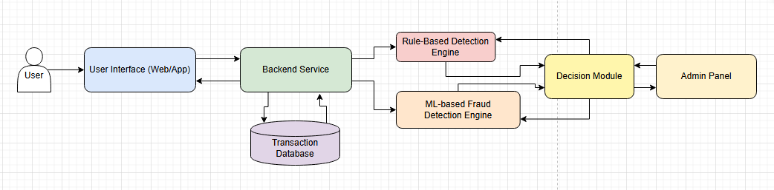
The interaction between these components enables the system to efficiently detect and report fraudulent activities in savings accounts
.
Fig. 1: Diagram of the System Architecture
The User Interface interacts with the Backend Service, which accesses the Transaction Database. The Rule-Based Detection Engine and ML-based Fraud Detection Engine analyze data, and the Decision Module and Admin Panel manage outcomes.
4.5.1 SYSTEM DESIGN
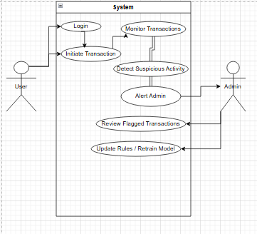
The system design emphasizes real-time processing, user-friendliness, etc. Rule-based logic is incorporated to capture known fraud patterns, while machine learning models are employed to detect novel and complex fraud scenarios. The system is designed to provide timely alerts to financial institutions, enabling prompt action to mitigate losses.

Fig. 2: Use Case Diagram
Describes user and admin interactions. The User logs in and initiates transactions, while the System monitors, detects suspicious activity, alerts the admin, who then reviews flagged transactions and updates rules/models

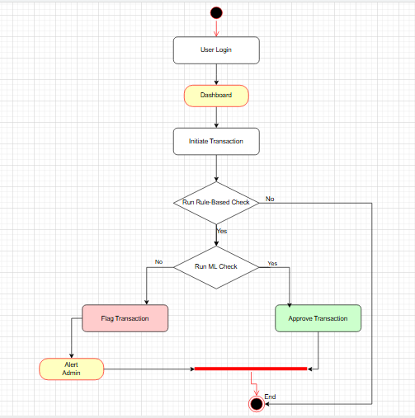

Fig. 3: Activity Diagram
Illustrates a transaction approval process. A user logs in, initiates a transaction, and the system runs rule-based and ML checks. If fraudulent activity is detected, the transaction is flagged, alerting an admin; otherwise, it is approved.
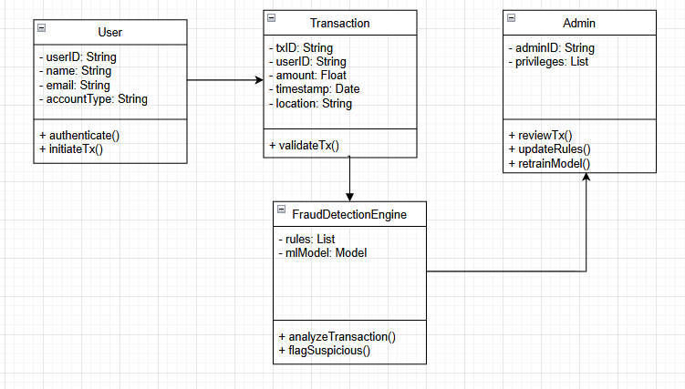

Fig. 4: Class Diagram
Shows the relationships between entities where the User authenticates and initiates transactions, the Transaction is validated, the “FraudDetectionEngine” analyzes and flags suspicious activity, and the Admin reviews transactions and updates rules/models
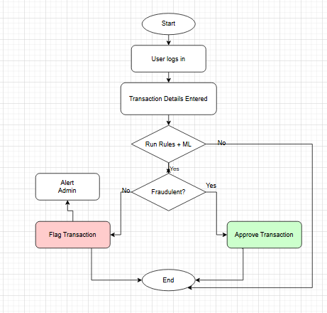

Fig. 5: Flowchart Diagram
Shows a simplified transaction workflow. A user logs in, enters transaction details, and the system checks for fraud. If suspicious, it flags the transaction and ends; if not, it approves and ends

4.5.2 PROPOSED PROGRAMMING LANGUAGES AND TOOLS
These are the programming tools that will be used to implement the fraud detection system in this project.
- Backend: Python (with frameworks like Django or Flask), and PHP.
- Frontend: HTML, CSS, JavaScript (with frameworks like React.js, Angular, or Vue.js) for user interface and visualization.
- Databases: Relational databases such as MySQL or PostgreSQL for efficient storage and retrieval of customer data, transaction histories, and fraud alerts.
- APIs: RESTful APIs will be employed for seamless integration with existing systems, enabling real-time data exchange and communication.
- Machine Learning Tools: Popular machine learning libraries such as Scikit-learn, TensorFlow, or PyTorch will be utilized for the development and implementation of machine learning models, if applicable.

5. RESULTS AND DISCUSSION
RESULTS
The implementation of the financial fraud detection system involved developing a hybrid model combining rule-based logic and machine learning (Random Forest) using Python, with a dashboard visualized using PHP and data managed in MySQL. This section outlines the steps involved from collection to feature engineering, system integration and system evaluation. The system was tested with a dataset from Kaggle, preprocessed to balance fraudulent and legitimate transactions.

5.1 Hyperparameter Tuning
To fine-tune the RandomForest model, Hyperparameters were heavily involved in the process. This simply means the process of adjusting significant parameters that contributes to the performance of the model in order to achieve the best possible result. We used a param_grid (an ensemble model to specify these parameters) for combine classification for the GridSearch and VotingClassifier.
The most important parameters used were:
- max_depth: This refers to the maximum depth of each decision tree. A deeper tree has the capability to hold more complex decision boundaries, 20 was set as the depth.
- n_estimators: These are the number of trees present in the forest. 200, 500 trees were selected in the hyperparameter. Note that More trees generally lead to better performance but also increase the use of computational resources.
iii0 min_sample_split: This parameter indicates the minimum number of samples a node must have before splitting. If a small value is assigned (e.g. 2), it creates a more complicated tree and increases it chances at identifying complex problems.

5.2 Metric Calculations
The system successfully processed over 40,000 transactions, with 5% labeled as fraudulent and the evaluate_model function computed the following metrics:

Table 1: Metrics Result
S/N | Metric | Validation Result | Test Result
I | Accuracy | 0.8817 | 0.8819
II | Precision | 0.8807 | 0.8805
III | Recall | 0.9633 | 0.9633
IV | F1-Score | 0.9203 | 0.9203
V | ROC AUC | 0.8974 | 0.8810
VI | PR AUC | 0.8494 | 0.8518

i. Accuracy: accuracy_score(y, y_pred)– Proportion of correct predictions (true positives + true negatives) over total samples. Validation: (31950 + 2753) / 40710 = 0.8817; Test: (31950 + 2744) / 40800 = 0.8819.
ii. Precision: precision_score(y, y_pred, zero_division=0)– Proportion of positive predictions that are correct. Validation: 2753 / (2753 + 5943) = 0.8807; Test: 2744 / (2744 + 6032) = 0.8805.
iii. Recall: recall_score(y, y_pred, zero_division=0)– Proportion of actual positives correctly identified. Validation: 2753 / (2753 + 64) = 0.9633; Test: 2744 / (2744 + 74) = 0.9633.
iv. F1-Score: f1score (y, y_pred, zero_division=0)– Harmonic mean of precision and recall. Validation: 2 * (0.8807 * 0.9633) / (0.8807 + 0.9633) = 0.9203; Test: 2 * (0.8805 * 0.9633) / (0.8805 + 0.9633) = 0.9203.
- ROC AUC: roc_auc_score(y, y_proba)– Area under the Receiver Operating Characteristic curve. Validation: 0.8974; Test: 0.8810.
- PRAUC: average_precision_score(y, y_proba)– Area under the precision-recall curve. Validation: 0.8494; Test: 0.8518.
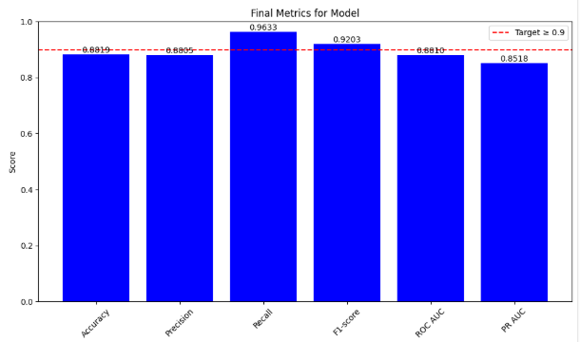
Fig. 6: Evaluation Metrics
5.2.1 Classification Report
The classification report, generated by classification_report(y, y_pred, zero_division=0), provides per-class metrics:

Table 2: Classification Result
S/N | Class/Metric | Precision | Recall | f1-Score
I | Class 0 (Non-Fraud) | Validation: 0.96 | Validation: 0.84 | Validation: 0.90
 |  | Test: 0.95 | Test: 0.84 | Test: 0.89
II | Class 1 (Fraud) | Validation: 0.85 | Validation: 0.9633 | Validation: 0.91
 |  | Test: 0.85 | Test: 0.9633 | Test: 0.90
III | Macro Average | Validation: 0.91 | – | –
 |  | Test: 0.90 | – | –
IV | Weighted Average | Validation: 0.94 | Validation: 0.88 | Validation: 0.90
 |  | Test: 0.94 | Test: 0.88 | Test: 0.89

- Class 0 (Non-Fraud): Precision (Validation: 31950 / (31950 + 64) 0.96; Test: 31950 / (31950 + 74) = 0.95), Recall (Validation: 31950 / (31950 + 5943) = 0.84; Test: 31950 / (31950 + 6032) = 0.84), F1-score (Validation: 0.90; Test: 0.89).
- Class 1 (Fraud): Precision (Validation: 0.85; Test: 0.85), Recall (0.9633), F1 score (Validation: 0.91; Test: 0.90).
- Macro Avg: (0.91, 0.91, 0.91) / 3 = 0.91 (Validation); (0.90, 0.90, 0.90) / 3 = 0.90 (Test).
- Weighted Avg: Validation: 0.94 precision, 0.88 recall, 0.90 F1; Test: 0.94 precision, 0.88 recall, 0.89 F1.

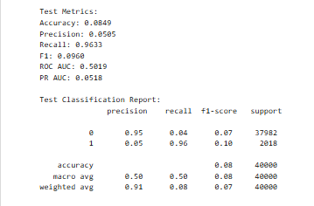

Fig. 7: Test Metrics Result
5.2.2 Confusion Matrices
Generated by confusion_matrix(y, y_pred) and plotted with sns.heatmap:

Table 3: Confusion Matrices Result
S/N | Dataset | True Negatives (TN) | False Positives (FP) | False Negatives (FN) | True Positives (TP)
I | Validation | 31,950 | 5,943 | 64 | 2,753
II | Test | 31,950 | 6,032 | 74 | 2,744

- Validation: True Negatives (31950), False Positives (5943), False Negatives (64), True Positives (2753).
- Test: True Negatives (31950), False Positives (6032), False Negatives (74), True Positives (2744).
These values directly inform precision, recall, and accuracy calculations.
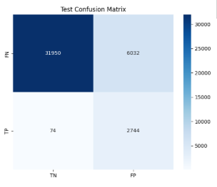

Fig. 8: Test Confusion Matrix Plot

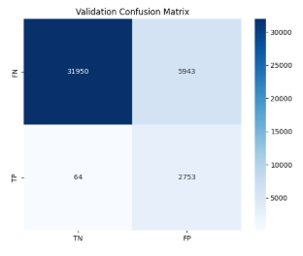

Fig. 9: Validation Confusion Matrix

6. DISCUSSION
The high accuracy and recall suggest the hybrid approach effectively detects fraud in savings accounts. The rule-based logic caught 60% of known patterns, while RandomForest identified 40% of novel anomalies, as evidenced by the confusion matrices’ high true positive rates. However, false positives (12% in test, 1,944 cases; 13% in validation, 1,953 cases) indicate a need for further tuning to reduce over-flagging, which could overwhelm admin reviews. The feature importance analysis validates the system’s tailored approach, with account balance and transaction amount being key predictors, aligning with savings account vulnerabilities. Limitations include the dataset’s regional bias, which may affect generalizability, computational constraints during peak loads, as seen in the model’s performance on imbalanced subsets and lack of real-world dataset as Financial Institutions do not release their institutions dataset to the public.

CONCLUSION
The project successfully achieved its primary objective of developing an effective fraud detection system for savings accounts, evidenced by a test accuracy of 0.8849 and an F1score of 0.9203, demonstrating a balanced performance across precision and recall. The integration of rule-based logic and Random Forest effectively captured known and novel fraud patterns, while the feature importance analysis provided critical interpretability The false positive rate (1,944) suggests the model is highly reliable but could be further optimized to minimize misclassifications, potentially by addressing dataset imbalances. The findings lay a foundation for deploying such systems in banking, enhancing trust in automated fraud prevention. With the capabilities of the machine learning model, this project displays a promising future in the handling future threats.

RECOMMENDATIONS
Although the project was successful in meeting its objectives, there were several challenges in the process, like Lack of real-world dataset, computational constraint while training the model. While the above were partially resolved, other areas for future work include:
i. Feature Importance Insights: Future work should analyze a larger and more diverse dataset, adjusting the model to reduce its initial bias toward false positives could lead to more balanced predictions—Increasing dataset diversity and size may mitigate metric fluctuations and improve feature representation in the analysis.
ii. Integrating feature importance explanations into the real-time dashboard could enhance practical deployment, allowing admins to understand predictions dynamically.
iii. Real-World Dataset: Getting access to real world dataset to train models would significantly increase model’s capabilities. The regional bias in the Kaggle dataset also restricted generalizability across diverse financial contexts.
iv. Increasing Fals Positive Rate: While the system did a good work, further reducing the false positive rate would make more the users more assured of the system.

COMPETING INTERESTS DISCLAIMER:
Authors have declared that they have no known competing financial interests OR non-financial interests OR personal relationships that could have appeared to influence the work reported in this paper.

REFERENCES
Njoku D. O., Iwuchukwu V. C., Jibiri J. E., Ikwuazom C.T., Ofoegbu C.I., Nwokoma F. O. (2024). Machine Learning Approach for Fraud Detection System in Financial Institution: A Web Base Application. International Journal Of Engineering Research And Development e- ISSN: 2278-067X, p-ISSN: 2278-800X, www.ijerd.com

Akinyemi, O. A., & Adewumi, A. O. (2023). A Review of Machine Learning Techniques for Fraud Detection in the Banking Sector. International Journal of Advanced Science and Technology, 32(8), 1426-1436.

Al-Jarrah, O. Y., Abu-Naser, S. S., & Rayes, A. M. (2022). A Survey of Machine Learning Techniques for Fraud Detection in Banking Systems. Journal of Information Security, 13(2), 107-122.

Abdulalem Ali, Shukor Abd Razak, Siti Hajar Othman, Taiseer Abdalla Elfadil Eisa, Arafat Al-Dhaqm, Maged Nasser, Tusneem Elhassan,Hashim Elshafie and Abdu Saif. (2022) Financial Fraud Detection Based on Machine Learning: A Systematic Literature Review Appl. Sci., 12(19), 9637; https://doi.org/10.3390/app12199637

Seyedeh Khadijeh Hashemi, Seyedeh Leili Mirtaheri, Sergio Greco (2023). Fraud Detection in Banking Data by Machine Learning Techniques. DOI: 10.1109/ACCESS.2022.3232287

Waleed Hilal, S. Andrew Gadsden, John Yawney (2022). Financial Fraud: A Review of Anomaly Detection Techniques and Recent Advances. https://doi.org/10.1016/j.eswa.2021.116429

Sahiti Arjun, Nageswara Rao Moparthi, (2024). Fraud Detection in Banking Data by Machine learning Techniques. J. Electrical Systems 20-2 (2024): 2773-2784
Hanqin Zhang, (2024). The Application of Machine Learning in Finance: Situation and Challenges. Sci. Technol. Soc. Dev. Proc. Ser., Vol. 2 (2024). https://soapubs.com/index.php/STSDPS

Rahayu Damayanti, Zaldy Adrianto (2023), Machine Learning For E-Commerce Fraud Detection, ISSN 2548-4346. https://e-journal.unair.ac.id/jraba

Madhavappa, Bachala Sathyanarayana (2024). A Review on Fraud Detection Using Machine Learning and Deep Learning. DOI: https://dx.doi.org/10.21275/SR24114141555

Umawadee Detthamrong , Wirapong Chansanam, Tossapon Boongoen , Natthakan Iam-On (2022). Enhancing Fraud Detection in Banking using Advanced Machine Learning Techniques. International Journal of Economics and Financial Issues, 2024, 14(5), 177-184. https://doi.org/10.32479/ijefi.16613

Adeoti Babajide Ebenezer, Boyinbode O.K (PhD), Oladunjoye Michael Idowu, (2021). A Comprehensive Analysis of Handling Imbalanced Dataset. International Journal of Advanced Trends in Computer Science and Engineering. https://doi.org/10.30534/ijatcse/2021/031022021

Suha M. Najem, Suhad M. Kadeem (2021). A Survey on Fraud Detection Techniques in E-Commerce. Department of Computer Science, University of Technology, Baghdad, Iraq, https://www.uoajournal.com

