Case report
Palpitations revealing myxoid bi-leaflet mitral prolapse associated with type b aortic dissection with anevrysmal dilation: Case report

Abstract
Background Mitral valve prolapse is defined as the abnormal bulging of the mitral valve leaflets into the left atrium during ventricular systole. This relatively common condition is associated with several complications, notably mitral regurgitation.
Case presentation We present the case of a 48-year-old male with no significant medical history who presented with exertional dyspnea and palpitations. Physical examination revealed a systolic murmur at the apex. Transthoracic echocardiography (TTE) and transesophageal echocardiography (TEE) confirmed the diagnosis of a bi-leaflet mitral valve prolapse with myxomatous degeneration, consistent with Barlow's disease, and significant mitral regurgitation (MR). Additionally, the imaging studies revealed dissection of the descending thoracic aorta, associated with aortic dilation. The patient underwent mitral valve replacement and medical treatment for aortic dissection.
Conclusion The association between bi-leaflet prolapse with myxomatous changes and type B aortic dissection is quite rare underscoring the relevance of presenting our case to highlight the importance of considering this diagnosis, even in the absence of thoracic or abdominal pain.
Keywords mitral prolapse, Type B aortic dissection, anevrysmal dilation, association, myxoid, palpitations, case report.

Introduction
The prevalence of mitral valve prolapse in the general population has traditionally been estimated between 5% and 15% [1]. However, recent research applying stricter diagnostic criteria suggests a lower prevalence, estimated at around 2–3% [2]. In Western populations, mitral valve prolapse resulting from myxomatous degeneration is the leading cause of mitral regurgitation that necessitates surgical intervention.
At the same time, type B aortic dissection (TBAD), which typically involves the descending aorta, accounts for approximately 25–40% of all aortic dissections. It is a life-threatening condition associated with a 5-year survival rate ranging from 60% to 80% [3].
We report a case of myxoid bi-leaflet mitral prolapse associated with type B aortic dissection and aneurysmal aortic dilation.
Case presentation
48-year-old male patient with no significant past medical history, was referred to our department due to exertional dyspnea classified as NYHA class II, as well as episodes of palpitations occurring at rest, characterized by sudden onset and resolution. These symptoms were accompanied by neurovegetative signs that have been progressing for one month.
The clinical examination identified a patient with a height of 170 cm and symmetric blood pressure measurements in both upper and lower limbs, Additionally, a systolic murmur was auscultated at the apex, described as a 'blowing' murmur, radiating to the axilla and graded at 4/6, with no evidence of heart failure. The electrocardiogram showed a regular sinus rhythm accompanied by left atrial enlargement
Transthoracic echocardiography revealed moderate dilation of the left cardiac chambers, accompanied by bi-leaflet mitral prolapse secondary to myxomatous degeneration, resulting in severe eccentric mitral regurgitation while preserving systolic function. Additionally, the imaging indicated dilation of the ascending aorta measuring 44mm, associated with aneurysmal dilation of the descending thoracic aorta (58mm), consistent with the presence of aortic dissection. [Figure 1, Figure 3]
Transoesophageal echocardiography (TOE) confirmed the initial echocardiographic findings and identified a dissection of the descending thoracic aorta, characterized by a pre-thrombotic appearance of the false lumen. [Figure 3, Figure2]
CT angiography of the aorta showed type B Aortic dissection associated with anevrysmal dilation of the descending aorta with a maximal diameter of 50mm.
Holter EKG showed Ventricular hyperexcitability stage 4B of Lown classification.
The patient underwent cardiac surgery for mitral valve replacement using the 'BICARBON N°31' mechanical prosthesis, with uncomplicated postoperative course. In the case of type B aortic dissection, it was decided to initiate medical treatment with statins and antiplatelet therapy, along with monitoring of cardiovascular risk factors. Additionally, A beta-blocker treatment was initiated for the excitability disturbances.
At the one-month follow-up, transthoracic echocardiography revealed a well-functioning prosthesis and preserved left ventricular function. Concurrently, Holter EKG showed an important decrease in ventricular ectopic burden.
A 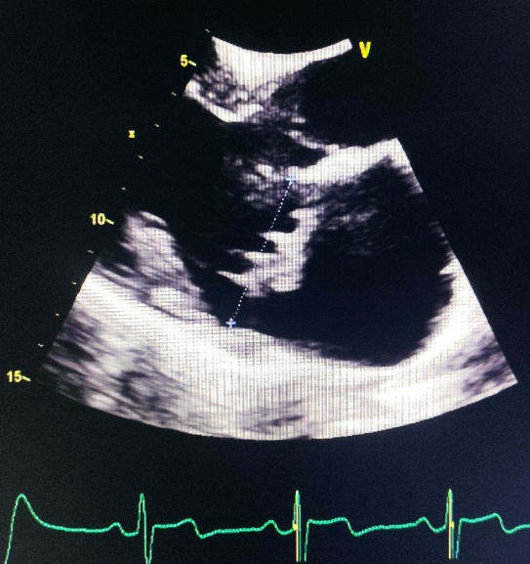 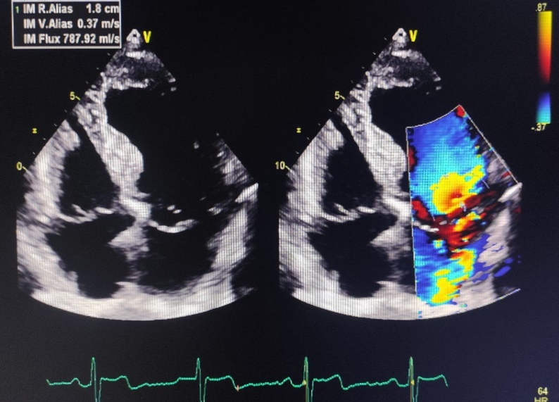 B
Figure 1. A. Parasternal long axis view showing the bi-leaflet mitral prolapse with thickened and bulky leaflets, B. Apical 4 chambers view showing the bi-leaflet prolapse with a severe mitral regurgitation

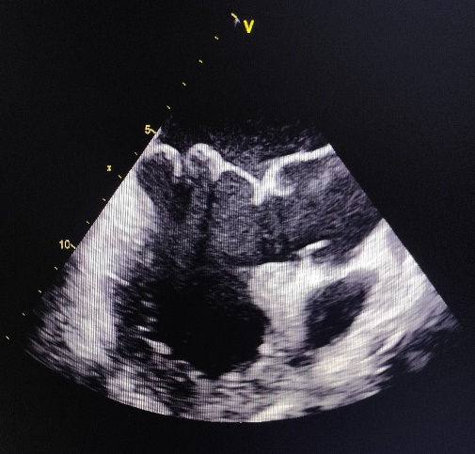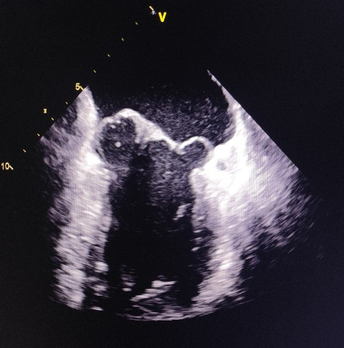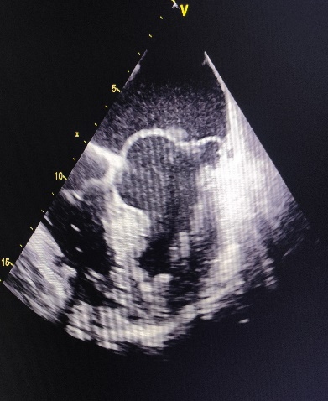
Figure 2. Transoesophageal echocardiography views (120°, 45°,0°) showing bi-leaflet mitral prolapse

A 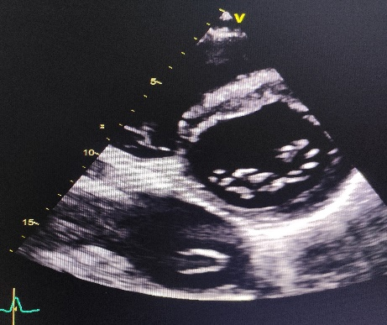 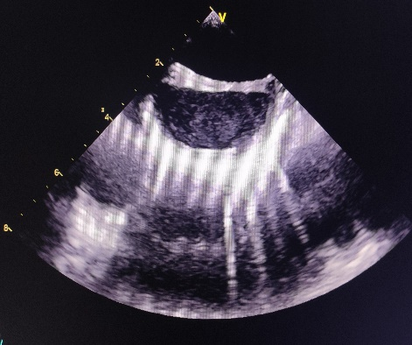 B
Figure 3. A. Short axis view showing dissection of the descending thoracic aorta, associated with aneurysmal dilatation of false lumen, B. Transoesophageal echocardiography view showing dissection of the descending thoracic aorta

Discussion
Mitral valve prolapse is characterized by the abnormal displacement of one or both mitral valve leaflets into the left atrium during ventricular systole. This condition is relatively common and can predispose individuals to a range of complications, such as mitral regurgitation, congestive heart failure, arrhythmias, and endocarditis [4].
Myxomatous degeneration is the most common cause of mitral valve prolapse in the United States and Europe [5]. It is characterized by thickened, elongated, and distended mitral leaflets, as well as thickened and elongated chordae tendineae and an enlarged, dilated annulus. Prolapse is frequently multisegmental, involving both leaflets in up to 40% of cases [6]. These features align with the echocardiographic findings observed in our case.
The progression of myxomatous mitral prolapse is the leading cause of mitral regurgitation that ultimately necessitates surgical intervention.
Myxomatous degeneration is thought to have a genetic basis, although the exact genetic mechanisms remain incompletely understood. The condition exhibits genetic heterogeneity, involving multiple genes and chromosomal contributions. It is typically inherited in an autosomal dominant manner, though it demonstrates incomplete penetrance [7].
Ventricular arrhythmias are frequently observed in patients with myxomatous mitral valve prolapse and arise from various underlying mechanisms. These include tension exerted on the chordae, mechanical injury to the ventricular endocardium caused by excessive leaflet tissue during diastole, and, in older individuals, the presence of established myocardial fibrosis, particularly affecting the papillary muscles. Most patients with arrhythmias linked to degenerative mitral valve disease can be effectively managed with either medical therapy or catheter ablation. However, a seminal case report by Barlow's research group, published over three decades ago, was among the first to highlight the potential advantages of mitral valve repair surgery in these cases [8]. In the present case, combining medical therapy with mitral valve repair was the selected treatment strategy, leading to a marked improvement within one month of initiation.
Aortic dissection is a life-threatening condition characterized by the development of a tear in the intimal layer of the aorta, allowing blood to enter the aortic wall and create a false lumen between its layers. Although the incidence of aortic dissection is relatively low compared to other cardiovascular emergencies, it is associated with high rates of morbidity and mortality.
Risk factors for aortic dissection include a wide array of clinical conditions and behaviors, such as advanced age, atherosclerosis, blunt trauma, and cocaine use. Structural abnormalities, including coarctation of the aorta and aortopathy (e.g., Marfan syndrome and Ehlers-Danlos syndrome), are significant contributors to risk. Metabolic conditions, such as homocystinuria, the presence of a bicuspid aortic valve, and various connective tissue disorders, are also implicated. Furthermore, infectious and inflammatory conditions such as vasculitis and tertiary syphilis as well as a history of prior cardiac surgery and the physiological changes associated with pregnancy, can predispose individuals to this life-threatening event [9]. In our case, the patient’s young age, ascending aorta dilation, and mitral valve prolapse with redundant leaflets raise the possibility of an underlying connective tissue disorder, such as Marfan syndrome, despite the absence of musculoskeletal, ocular, or pulmonary features. Unfortunately, genetic testing could not be performed because of resource constraints.
Mitral valve prolapse may be associated with aneurysmal dilation of the ascending aorta; however, the concurrent presence of type B aortic dissection and severe mitral regurgitation secondary to myxomatous degeneration is exceedingly rare. This underscores the importance of presenting our case to emphasize the need to consider this diagnosis, even in the absence of thoracic or abdominal pain.
Chronic type B aortic dissections are associated with high rates of morbidity and mortality. While they are generally managed with medical therapy, surgical intervention may become necessary during the acute, subacute, or chronic phases if significant complications arise. The most common complication is aneurysmal dilation of the affected aorta, often at the aortic isthmus. This is defined as a maximum aortic diameter exceeding 55 mm (or 60 mm in the descending thoracic aorta) or a progressive increase in diameter of more than 4 mm per year [3]. In our case, the patient's descending aorta measures 50 mm, approaching the threshold at which surgical intervention is considered. The vascular surgeon's management approach includes medical therapy focused on controlling blood pressure and heart rate to reduce the hemodynamic stress on the aortic wall. Additionally, regular imaging follow-up, typically every 6 months, is recommended to monitor for any changes in aortic diameter or the emergence of new complications.
Mitral valve repair in Barlow's disease presents significant challenges due to the extensive bileaflet billowing, which makes it difficult to identify a clear "reference point" for the valve, complicating both its evaluation and the planning of surgical repair. Nonetheless, numerous well-established surgical techniques are available to effectively address this complex condition. Mitral valve repair offers multiple advantages compared to mitral valve replacement, including a reduced risk of reoperation, improved durability, better preservation of left ventricular function, and a lower likelihood of complications associated with prosthetic valves, such as thromboembolism, anticoagulation-related bleeding, and infective endocarditis [10]. In this case, due to the presence of an aortic dissection, mitral valve repair with annuloplasty was considered the most appropriate approach to minimize the need for long-term anticoagulation, particularly given the associated risk of hemorrhage. Unfortunately, this procedure could not be performed, and the patient ultimately underwent valve replacement.
Conclusion
The association between mitral valve prolapse and type B aortic dissection represents a complex and intriguing intersection of two distinct cardiovascular conditions. A deeper understanding of this relationship can improve diagnostic accuracy, inform management strategies, and enhance patient counseling. As ongoing research continues to uncover the genetic and developmental mechanisms connecting these conditions, clinicians may be better equipped to adopt more targeted and personalized approaches to cardiovascular care
Abbreviations
MVP Mitral valve prolapse
TBAD Type B aortic dissection
MR Mitral regurgitation
TTE Transthoracic echocardiography
TTE Transesophageal echocardiography (TEE)
MR Mitral regurgitation
EKG Electrocardiogram
CTA Computed tomography angiography

Declarations
Ethics approval and consent to participate
Not applicable.
Consent for publication
Written informed consent was obtained from the patient for publication of this case report and accompanying images.

References
- Savage DD, Garrison RJ, Devereux RB, et al. Mitral valve prolapse in the general population. 1. Epidemiologic features: the framingham study. Am Heart J. 1983;(106):571–576.
- Freed LA, Levy D, Levine RA, et al. Prevalence and clinical outcome of mitral-valve prolapse. N Engl J Med. 1999;341:1–7.
- Ohana, M. (2016). Imagerie de la dissection aortique de type B : ce que veut savoir le chirurgien avant et après l’intervention. Journal des Maladies Vasculaires, 41(5), 260-271.
- Althunayyan, A. (2019). Mitral valve prolapse. Expert Review of Cardiovascular Therapy, 17(1), 43–51. https://doi.org/10.1080/14779072.2019.1553619
- Guy, T. S., & Hill, A. C. (2012). Mitral valve prolapse. Annual Review of Medicine, 63, 277–292. https://doi.org/10.1146/annurev-med-022811-091602
- Criley JM, Lewis KB, Humphries JO, Ross RS. Prolapse of the mitral valve: clinical and cine-angiocardiographic findings. Br Heart J 1966; 28:488-496.
- Mahmood F, Gorman JH 3rd, Subramaniam B, et al. 2010. Changes in mitral valve annular geometry after repair: saddle-shaped versus flat annuloplasty rings. Ann. Thorac. Surg. 90:1212–20.
- Pocock WA, Bosman CK, Chesler E, Barlow JB, Edwards JE. Sudden death in primary mitral valve prolapse. Am Heart J. 1984;107(2):378-382.
- Aortic dissection and other acute aortic syndromes: diagnostic imaging findings from acute to chronic longitudinal progression. Murillo H, Molvin L, Chin AS, Fleischmann D. Radiographics. 2021;41:425–446.
- Enriquez-Sarano M, Schaff HV, Orszulak TA, et al. Valve repair improves the outcome of surgery for mitral regurgitation. A multivariate analysis. Circulation 1995;91:1022-8.

