Original Research Article
Antimicrobial Activity of Biosynthesized Silver Nanoparticles from Mentha arvensis and Syzygium aromaticum and their Combinations with Levofloxacin and Cefotaxime

.
ABSTRACT

Aims: This study is aimed at evaluating the antimicrobial activity of biosynthesized silver-nanoparticles (AgNPs) from Mentha arvensis and Syzygium aromaticum and its combinations with cefotaxime and levofloxacin.
Study design: Cross sectional study.
Place and Duration of Study: Biological Science Department of National Institute for Pharmaceutical Research and Development Idu Abuja, between January 2025 and August 2025.
Methodology: The AgNPs were biosynthesized from Mentha arvensis (M. arvensis) and Syzygium aromaticum (S. aromaticum) extracts and characterized with Fourier transform infrared (FTIR) spectroscopy and scanning electron microscopy. The antimicrobial activity of AgNPs, cefotaxime and levofloxacin against the Pseudomonas aeruginosa (P. aeruginosa) isolates (B1, B2 and B3) from surgical wound were evaluated using the microbroth dilution method. The effect of combination of the AgNPs and cefotaxime or levofloxacin was evaluated using the checkerboard method.
Results: The size of S. aromaticum and M. arvensis were 50-179nm with an average of 114.5nm and 80-268nm with an average of 174nm respectively. The AgNPs biosynthesized from S. aromaticum and M. arvensis had activity against the isolates with minimum inhibitory concentrations (MICs) ranges from 6.25-0.0078 mg/mL while for cefotaxime and levofloxacin, the MICs ranges from 64.0-2.0 µg/mL. The combination of S. aromaticum/cefotaxime, S. aromaticum/levofloxacin and M. arvensis/levofloxacin had synergistic effect against only B1 with FICs ranges from 0.125-0.5 but had indifference effect on isolate B2 and B3 with FICs of 2.0. Finally, the combination of M. arvensis/cefotaxime had additive effect on B1 and B2 with FICs of 1.0.
Conclusion: The biosynthesized AgNPs from S. aromaticum and M. arvensis had antipseudomonal activity with inconsistent effect in its combination with cefotaxime and levofloxacin against the P. aeruginosa isolates.
Keywords: Pseudomonas aeruginosa, Antimicrobial, Synthesized Silver-Nanoparticles

1. INTRODUCTION

Pseudomonas aeruginosa (P. aeruginosa) is a Gram-negative rod shaped, aerobic facultative anaerobic bacterium belonging to the family γ-proteobacteria (1). This bacterium is a common and widespread organism that can adapt to many different environments, and it can be isolated from many sources within hospitals and community settings (3).
Pseudomonas aeruginosa is a major cause of life-threatening acute infections and chronic, lifelong persistent infections. It is responsible for 7% and 12% of all healthcare-associated infections, respectively (4, 5, 6). The excessive use of antimicrobials during treatment accelerates the development of multidrug-resistant (MDR) strains, rendering antibiotic therapies ineffective (7). A recent study by Alam et al. (3) reported that P. aeruginosa exhibits resistance to a diverse range of antimicrobials, including aminoglycosides, quinolones, and β-lactams. Consequently, antimicrobial resistance (AMR) remains a serious global health issue for both humans and animals, a problem that is compounded by the challenges in developing new antimicrobials (7). In response, the World Health Organization (WHO) has listed P. aeruginosa, particularly its carbapenem-resistant strains, as one of three critical-priority bacterial species requiring the urgent development of new therapeutic agents (3). Previous research has explored the efficacy of crude plant extracts and their solvent fractions against P. aeruginosa isolates (2, 8, 9), as well as the activity of biosynthesized silver nanoparticles (AgNPs) against both planktonic and biofilm forms of the bacterium (10, 11). Among these alternatives, AgNPs are notably effective against pathogenic MDR bacterial isolates (10).
However, the combined effect of biosynthesized AgNPs, specifically those derived from M. arvensis and S. aromaticum, with antimicrobials such as levofloxacin and cefotaxime on MDR P. aeruginosa isolates from surgical wounds has not been investigated. Therefore, this study aims to evaluate the antimicrobial activity of AgNPs biosynthesized from M. arvensis and S. aromaticum, both alone and in combination with levofloxacin or cefotaxime, against such isolates.

2. material and methods
2.1 Plants Collection and Identification.
The fresh two plants such as (Mint leaves) Mentha arvensis, and (Cloves) Syzygium aromaticum were collected from Jos, Plateau State, Nigeria, and identified in the Botanical Garden of the National Institute for Pharmaceutical Research and Development (NIPRD), Idu, Abuja, for proper identification.
2.2 Biosynthesis of Silver-Nanoparticles (AgNPs)
The biosynthesis of AgNPs from S. aromaticum and M. arvensis was performed using a slightly modified version of the method previously described by Asif et al. (12). Briefly, 20.0 g of leaf powder from each plant was separately dissolved in 200 mL of sterile distilled water. The solutions were filtered through Whatman No. 1 filter paper. Subsequently, 100 mL of each filtrate was added to 900 mL of a 2 mM aqueous AgNO₃ solution. The mixtures were heated at 60 °C for 1 hour and then incubated in a dark cupboard at room temperature for 24 hours. A color change from dark brown to reddish-brown indicated the formation of AgNPs. The nanoparticles were recovered by centrifuging the solutions at 3,500 rpm for 15 minutes, washed twice with sterile distilled water, and dried at 35 °C in a water bath.

2.3 Characterization of Silver Nanoparticles.
The synthesized Ag-NPs were characterized using Fourier-Transform Infrared Spectroscopy (FTIR). The spectra of silver nanoparticles were measured using proper instrument calibration and validation to ensure precision and accuracy in the measurements. The samples were properly prepared to be homogeneous with consistent thickness for accurate quantitative measurements, was to determine the chemical composition or specific components of the nanoparticles. Scanning Electron Microscope (FEI Nova NanoSEM 450, USA) was used for the morphological analysis. The shape, size, and crystalline nature of silver nanoparticles were confirmed by the SEM.
2.4 Test Organisms.
The multidrug-resistant clinical Pseudomonas aeruginosa wound isolates (B1, B2, B3), were sourced from Bingham University Teaching Hospital (BUTH) Jos, Plateau State, Nigeria.

2.5 Evaluation of Minimum Inhibitory Concentrations of Silver-Nanoparticles and some Antimicrobials
The MICs of biosynthesis of AgNps from S. aromaticum and M. arvensis; and antimicrobials such as cefotaxime and levofloxacin were determined using microbroth dilution method as follows; 100 µL of Mueller-Hinton broth (MHB: Oxoid Ltd, UK) containing different concentrations (50.0-0.78 mg/mL) of the AgNPs and 512-0.078 µg/mL of cefotaxime and levofloxacin were each prepared in 96-well microtiter plate and 5 µL (105 CFU) of the standardized test organism were inoculated into each well and incubated at 37 °C for 24 h. The minimum concentration of the AgNPs that inhibit the growth of the test organism without turbidity was read as the MICs.

2.6 Evaluation of the Effect of Combinations of Silver-Nanoparticles and some Antimicrobials
The effect of the combination of biosynthesis of AgNPs from S. aromaticum and M. arvensis and cefotaxime and levofloxacin were carried out using checkerboard method as follows; different concentrations of the AgNPs in combinations with either cefotaxime and levofloxacin (2×mics to 1/128×mics) were prepared in 100 µl of double strength MHB in 96-well microtiter plate and 5 µl (10⁵ cfu) of the standardized test organism were inoculated into each well and incubated at 37 °c for 24 h. The minimum concentration of the combination of the AgNPs and known antimicrobials that inhibit the growth of the test organism without turbidity was read as the combined mics. The fractional inhibitory concentrations of the combination of the AgNPs and known antimicrobials were calculated using the following formula:
$FICI=\frac{MICA in combination}{MICA alone}+\frac{MICB in combination}{MICB alone}$
The synergistic, additive, indifference and antagonistic effect of combination were interpreted as follows; synergistic effect: fic ≤ 0.5, additive effect: fic≥ 0.5 and ≤ 1.0, indifference effect fic≥ 1.0 and < 4.0, antagonistic effect: ≥ 4.
3. results and discussion
3.1 Characteristics of Biosynthesized Silver-Nanoparticles
The functional groups and sizes of the silver nanoparticles (AgNPs) biosynthesized from S. aromaticum and M. arvensis were analyzed using FTIR and SEM, as shown in Figures 1-2 and Plates 1-2, respectively.
The FTIR analysis of AgNPs from S. aromaticum (Figure 1) showed prominent peaks at 3900.2 cm⁻¹, 3749.7 cm⁻¹, and 3363.9 cm⁻¹, corresponding to O-H stretching vibrations characteristic of alcohol groups. Peaks at 2926.1 cm⁻¹ and 2362.8 cm⁻¹ were assigned to C-H stretching vibrations of alkyl and methylene groups. A strong peak at 1732.1 cm⁻¹ indicated the presence of C=O stretching, typical of esters and phospholipids. For the AgNPs from M. arvensis (Figure 2), a broad peak at 3363.9 cm⁻¹ revealed the presence of O-H stretching vibrations from alcohols and phenols. The size of the synthesized AgNPs, as determined by SEM (Plates 1a, 1b, 2a, and 2b), was within the range of 50–179 nm for S. aromaticum, with an average size of 114.5 nm. In contrast, the AgNPs from M. arvensis ranged from 80–268 nm, with an average size of 174 nm.
3.2 Antimicrobial Activity of Silver-Nanoparticles, Cefotaxime and Levofloxacin
The antimicrobial activity of AgNPs biosynthesized from S. aromaticum and M. arvensis, as well as the known antimicrobials cefotaxime and levofloxacin, against P. aeruginosa isolates B1, B2, and B3 was determined using the microbroth dilution method; the results are presented in Table 1. The biosynthesized AgNPs from both plant species demonstrated activity against all three P. aeruginosa isolates. The AgNPs from M. arvensis exhibited greater potency, with a MIC of 0.078 mg/mL against all isolates. In contrast, the AgNPs from S. aromaticum were less potent, with MICs of 6.25 mg/mL against isolates B1 and B2.
The conventional antibiotics also showed activity. The MIC range for cefotaxime was 2.0–8.0 µg/mL, while that for levofloxacin was 8.0–64.0 µg/mL across the three isolates.

3.3 Effect of Combination of Biosynthesized Silver-Nanoparticles with Known Antimicrobials
The combined effect of biosynthesized AgNPs from S. aromaticum and M. arvensis with levofloxacin and cefotaxime against multidrug-resistant P. aeruginosa isolates B1, B2, and B3 was determined by calculating the Fractional Inhibitory Concentration (FIC) indices of the combinations, as shown in Table 2.
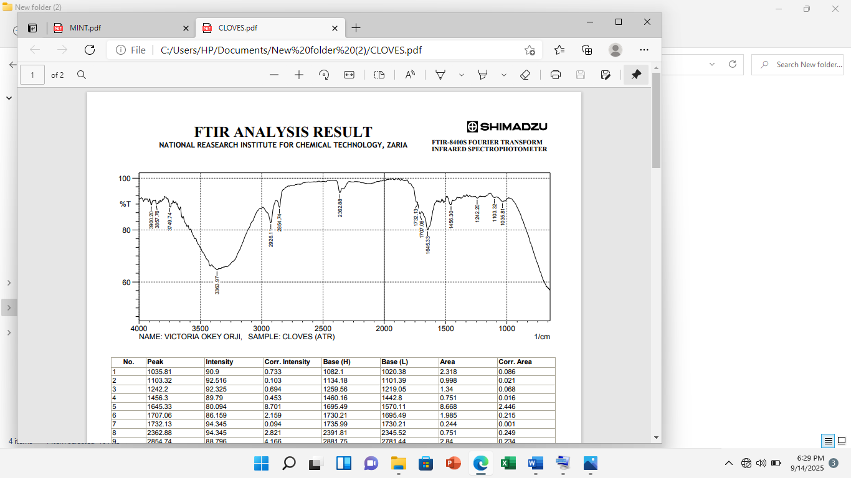
Notably, the combination of AgNPs from S. aromaticum with levofloxacin and cefotaxime demonstrated a synergistic effect against isolate B1, with FIC indices ranging from 0.125 to 0.5. However, these same combinations showed an indifferent effect against isolates B2 and B3, with FIC indices of 2.0. Furthermore, the combination of AgNPs from M. arvensis with cefotaxime exhibited an additive effect against isolates B1 and B2, with an FIC index of 1.0.

Figure 1: Fourier Transmission Infra-Red Spectra of the Silver nanoparticles biosynthesized from crude S. aromaticum extract.

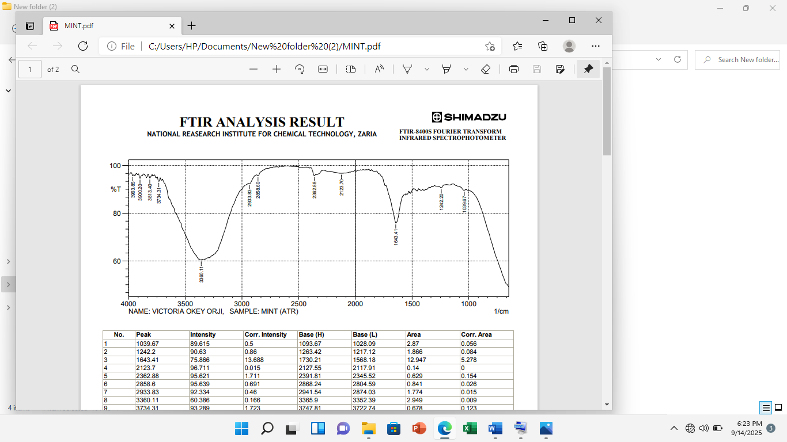

Figure 2: Fourier Transmission Infra-Red Spectra of the Silver nanoparticles biosynthesized from crude M. arvensis extract

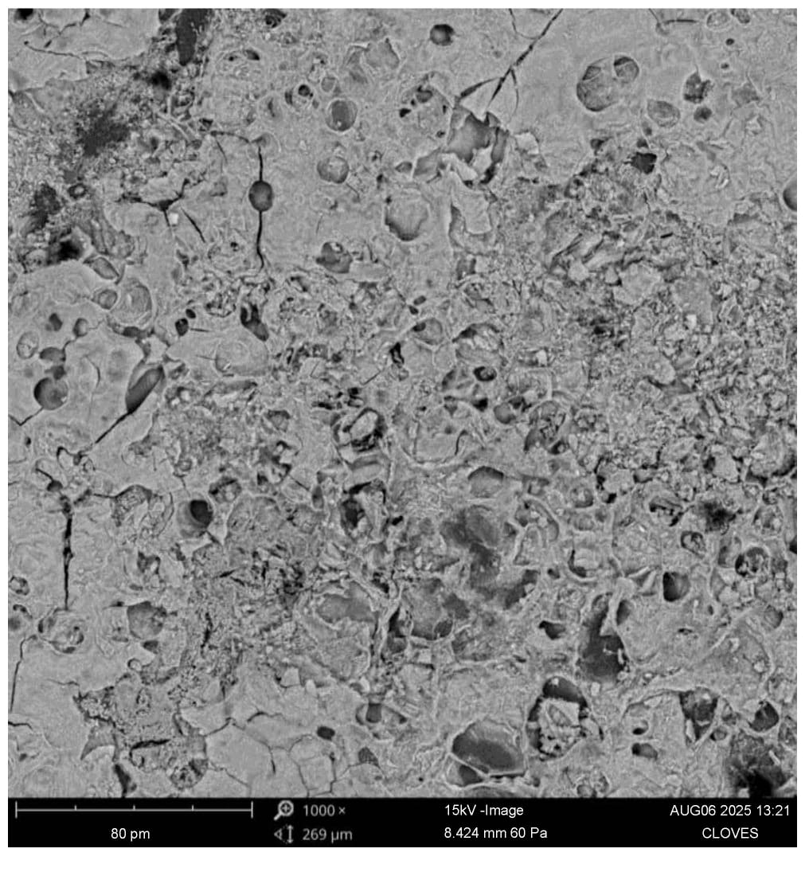
Plate 1a: Scanning Electron Microscopy characteristics showing the size of the Silver Nanoparticles synthesized from the seed extract of S. aromaticum using 1000x magnification Lens.

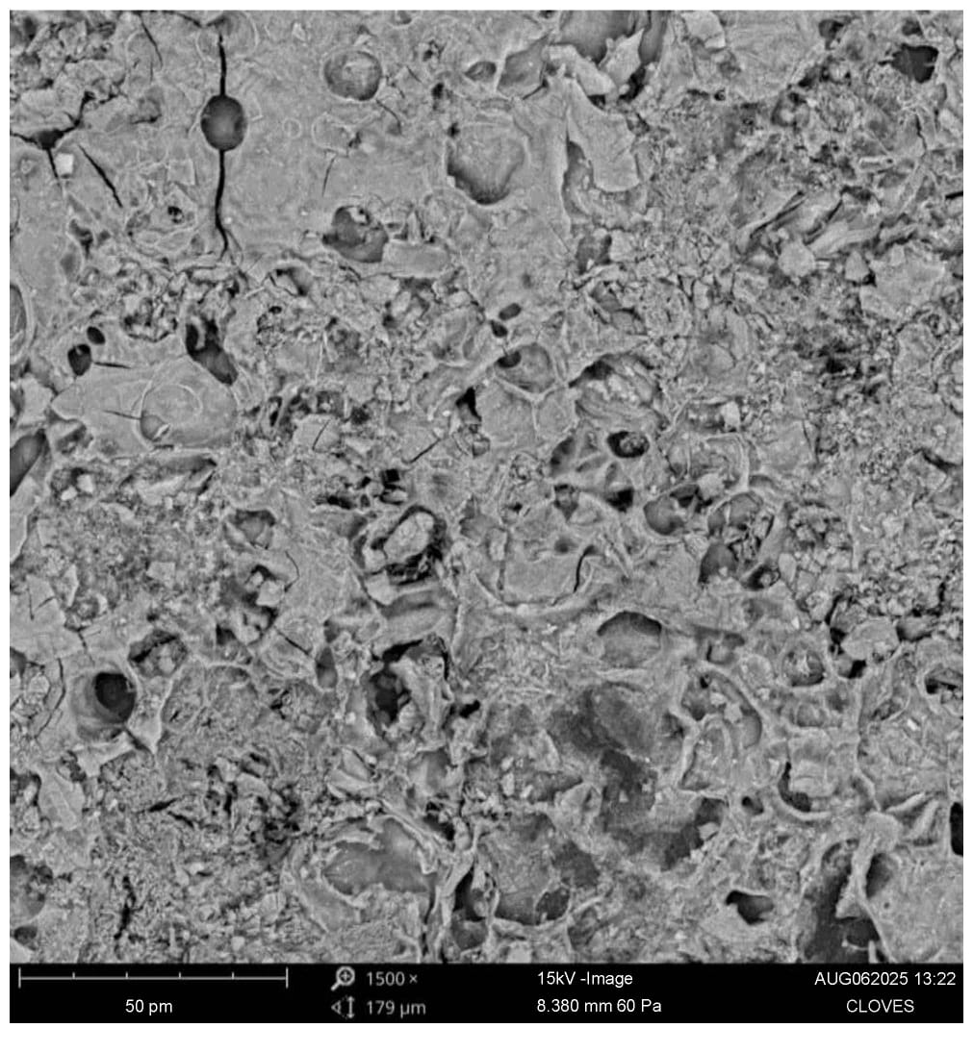
Plate 1b: Scanning Electron Microscopy characteristics showing the size of the Silver Nanoparticles synthesized from the seed extract of S. aromaticum using 1500x magnification Lens.

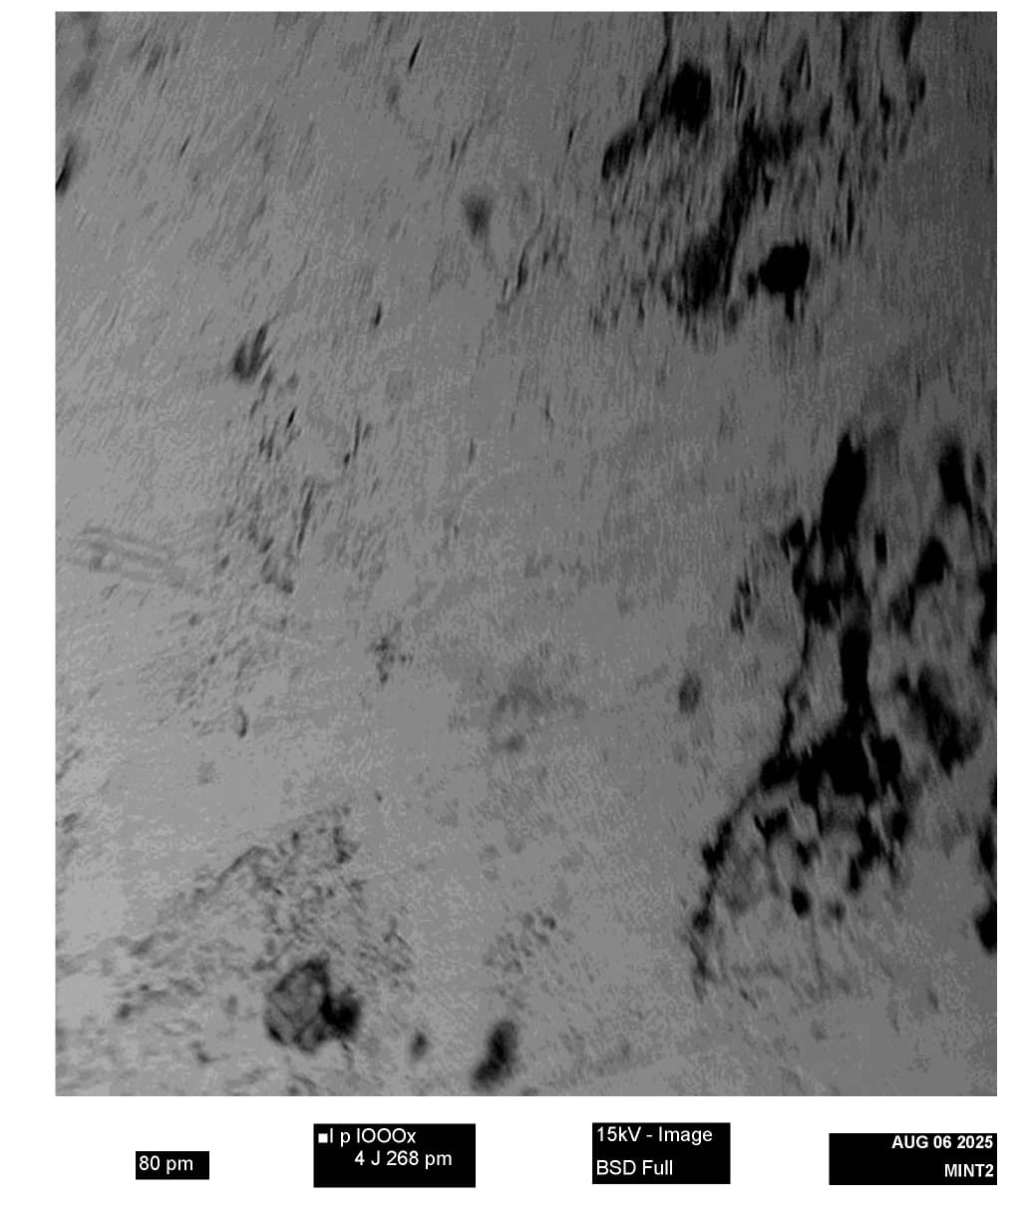

Plate 2a: Scanning Electron Microscopy characteristics showing the size of the Silver Nanoparticles synthesized from the leaf extract of M. arvensis using 100x magnification Lens.

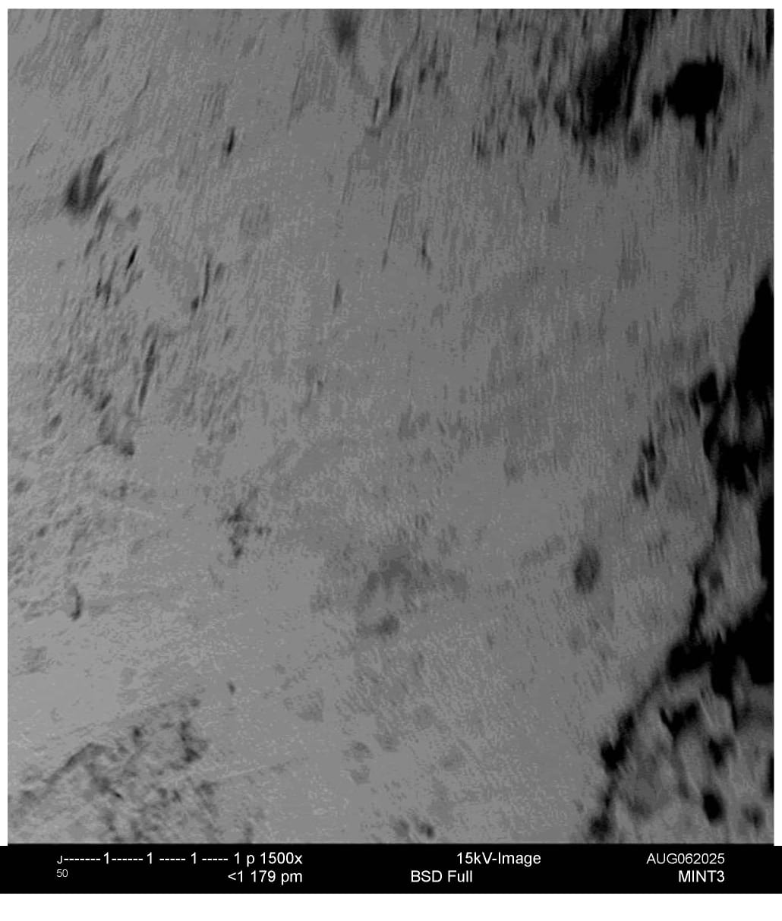

Plate 2b: Scanning Electron Microscopy characteristics showing the size of the Silver Nanoparticles synthesized from the leaf extract of M. arvensis using 1500x magnification Lens.

Table 1:Antipseudomona Activity of Biosynthesized Silver Nanoparticles (Ag-NPs)
 | MICs
Isolates | S. aromaticum  (mg/mL) | M. arvensis  (mg/mL) | Levofloxacin  (µg/mL) | Cefotaxime (µg/mL)
B1 | 6.25 | 0.078 | 8.0 | 2.0
B2 | 6.25 | 0.078 | 64.0 | 2.0
B3 | 0.078 | 0.078 | 64.0 | 8.0
B1=P. aeruginosa B1; B2=P. aeruginosa B2; B3=P. aeruginosa B3.

Table 2: Fractional Inhibitory Concentration of Synthesized Silver Nanoparticles in Combination with Antimicrobial Agents and P.aeruginosa isolates.
Isolates | FICs
Isolates | Ag-NPs_Sa + Lev | Ag-NPs_Sa + CTX | Ag-NPs_Ma + Lev | Ag-NPs_Ma + CTX
B1 | 0.125 | 0.5 | 0.25 | 1.0
B2 | 2.0 | 2.0 | 2.0 | 1.0
B3 | 2.0 | 2.0 | 2.0 | 2.0
FICs=Fractional Inhibitory concentrations; Ag-NPs=Silver-Nanoparticles; Ag-NPs_Sa=Silver-Nanoparticles derived from S. aromaticum; Ag-NPs_Ma= Silver-Nanoparticles derived from M. arvensis; Lev=Levofloxacin; CTX=Cefotaxime; B1=P. aeruginosa B1; B2=P. aeruginosa B2; B3= P. aeruginosa B3.

The results of this study demonstrate that the AgNPs synthesized from S. aromaticum and M. arvensis possess antipseudomonal activity, suggesting their potential utility in treating wound infections caused by multidrug-resistant P. aeruginosa. To the best of our knowledge, the antipseudomonal activity of AgNPs derived from these specific plants is a novel finding, although the inhibitory effects of their crude extracts have been previously reported (13, 14). The observed antimicrobial activity is likely attributable to the nanoparticles' size. While the precise mechanism of interaction between the AgNPs and the MDR P. aeruginosa isolates was not evaluated in this study, previous research has established that the efficacy of plant-synthesized AgNPs is often size-dependent (15). We therefore hypothesize that the activity of the biosynthesized AgNPs is related to their size and the functional groups present on their surface.
The efficacy of these plant-based AgNPs against P. aeruginosa from surgical wounds indicates their promising potential for developing new treatments for such infections. The combinations of biosynthesized AgNPs from S. aromaticum with cefotaxime or levofloxacin, and from M. arvensis with cefotaxime, exhibited a synergistic effect only against P. aeruginosa isolate B1, while demonstrating an indifferent effect against isolates B2 and B3. This suggests an inconsistency in the isolates' responses to the combinations. The factor underlying this inconsistent response remains unclear from our present study. We speculate that the efficacy of the antimicrobial combinations may vary depending on the specific resistance mechanisms of each strain, although the genetic diversity of the multidrug-resistant isolates was not evaluated. This variability in response to combination therapy could influence the selection of an appropriate treatment for infections caused by different strains of multidrug-resistant bacteria.
4. Conclusion
While the biosynthesized AgNPs from S. aromaticum and M. arvensis demonstrated inherent antipseudomonal activity, the response of the P. aeruginosa isolates to their combination with antibiotics was variable. Therefore, further investigation is necessary to elucidate the factors responsible for this inconsistent response.

References

1. Al-Tawalbeh DM, Alawneh JM, Momani W and Mayyas A (2025). Comparative antibacterial activity of clove extract against Pseudomonas aeruginosa. BMC Complementary Medicine and Therapies, 25:7.
2. Alam, K. D. A. A. Farraj, S. Mah-e-Fatima, M.A. Yameen, M. S. Elshralqufaid, R. M. Alkufeidy, A. E.-Z. M. A. Mustafa, P. Bhasme, M. K. Alshammari, N. A. Alkubaisi, A. M. Abbasi, T. A. Naqvi, (2020). Anti-Biofilm Activity of Plant Derived Extracts against Infectious Pathogen-Pseudomonas aeruginosa PAO1. Journal of Infection and Public Health. https://doi.org/10.1016/j.jiph.2020.07.007.

3. Aman, S., Mittal, D., Shriwastav, S. Tuli, H. S. Chauhan, S., Singh, P. Sharma, S. Saini, R.V. Kaur, N. Saini, A.K, (2022). Prevalence of Multidrug-Resistant Strains in Device Associated Nosocomial Infection and the In Vitro Killing by Nanocomposites. Ann. Surg. 78, 103687.
4. Farajolah, F. Farajallah, Maleki, Saeed Hemati, Zahra Madhavi, (2020). Pseudomonas aeruginosa Biofilm and Antimicrobial Resistance. Egyptian Journal of Veterinary Science. 51(1):105-110.
5. Orfa Inés, Contreras-Martínez, Daniela Sierra-Quiroz, Alberto Angulo-Ortíz (2024). Antibacteria and Antibiofilm Potential of Ethanolic Extracts of Duguetia. Vallicola (Annonaceae) against in-Hospital Isolates of Pseudomonas aeruginosa Plant, 13(10), 1412.
6. Zeng, B. Wang, C. Zhang, P. Guo, Z. Chen, L Duan, K (2020). Heat Shock Protein in Pseudomonas aeruginosa Affects Biofilm Formation via Pyocyanin Production. Microorganisms 8, 395.
7. Mombeshora M and Mukanganyama S. (2019). Antibacterial activities, proposed mode of action and cytotoxicity of leaf extracts from Triumfetta welwitschii against Pseudomonas aeruginosa. BMC Complementary and Alternative Medicine, 19:315.
8. Mouozong R, Fankam A G, Difo VL, Matieta VY, Megaptche FJ and Kuete V. (2024). Phytochemical Composition, Antibacterial, and Antibiotic-Resistance Modulatory Activity of Extracts of Lippia multiflora Moldenke, Terminalia mollis M. A. Lawson, and Cinchona officinalis L. Against Multidrug-Resistant Pseudomonas aeruginosa. Scientifica Volume 2024, 3403280, 9 pages.
9. Al‑Momani H, Almasri M, Balawi DA, Hamed S, Albiss BA, Aldabaibeh N, Ibrahim L, Albalawi H, HaMahmoud SA, Khasawneh AI, Kilani M, Aldhafeeri M, Bani‑Hani M, Wilcox M, Pearson J and Ward C (2023). The efficacy of biosynthesized silver nanoparticles against Pseudomonas aeruginosa isolates from cystic fibrosis patients. Scientific Reports, 13:8876.
10. Kamer AMA, El Maghraby GM, Shafik MM and Al-Madboly LA (2024). Silver nanoparticle with potential antimicrobial and antibiofilm efficiency against multiple drug resistant, extensive drug-resistant Pseudomonas aeruginosa clinical isolates. BMC Microbiology (2024) 24:277
11. Asif M, Yasmin R, Asif R, Ambreen A, Mustafa M and Umbreen S. (2022). Green Synthesis of Silver Nanoparticles (AgNPs), Structural Characterization, and their Antibacterial Potential. Dose-Response: An International Journal, 1–11
12 Li, Y., Roberts, J. A., Walker, M. M., Aslan, A. T., Harris, P. N. A., and Sime, F. B. (2024). The Global Epidemiology of Ventilator-Associated Pneumonia caused by Multidrug Resistant Pseudomonas aeruginosa: A Systematic Review and Meta-Analysis International Journal of Infectious Disease 139, 78–85.
13. Subramaniam G.1, Khan G. Z.1, Sivasamugham L.A.1, Wong L.S.1, Kidd S., Yap C. K (2023Antimicrobial and Anti-biofilm Activities of Plant Extracts against Pseudomonas. aeruginosa. A Review. Journal of Experimental Biology and Agricultural Sciences,11(5) :780 – 790.
14. Nguyen Hoang Nam1,2 & Nguyen Hoang Luong; 2, (2019). Nanoparticles: Synthesis and Applications Review. Materials for Biomedical Engineering: Inorganic Micro and Nanostructures. 978-0-08-102814-8.0000.

