Original Research Article

PREVALENCE OF GASTROINTESTINAL PARASITES IN CATTLE AT KERANIGANJ UPAZILA, DHAKA

.
ABSTRACT

Background: Cattle play a crucial role in the agricultural economy of Bangladesh, serving as a primary source of livestock for both farming and dairy production. Gastrointestinal parasitism is a world-wide concern in cattle. The objective of this study was to investigate the gastrointestinal parasite of cattle at Keraniganj upazila in Dhaka.
Methods: A total of 184 samples were collected randomly from the household’s farm of Keraniganj Upazila and examined through simple sedimentation technique.
Results: Faecal sedimentation revealed 141 positive samples out of 184 (76.63%) were infected, where seven species of helminths, namely Fasciola spp. (6.52%), Paramphistomum spp. (16.30%), Nematodius spp. (1.63%), Trichuris spp. (11.41%), Strongyloides spp. (26.63%), Dictyocaulus spp. (3.80%), Moniezia spp. (2.72%) and three species of protozoa Eimeria spp. (8.69%), Balantidium spp. (19.02%), Cryptosporidium spp. (23.91%) were identified, respectively. In case of gender-wise prevalence, a little difference was observed where females (84.47%) were infected more than males (64.19%). Moreover, the highest prevalence (86.27%) was seen in the younger groups of age, followed by 72.93% in adult of more than 6 months. In addition to this, the prevalence of gastrointestinal parasites in non-deworming animals was found 97.29% which was higher than deworming animals (44.59%).
Conclusions: The increased prevalence observed in the study area can be linked to geo-climatic factors and the presence of water-logged regions. Additionally, inadequate management practices, poor nutrition, limited awareness, and infrequent de-worming contributed to the higher occurrence of gastrointestinal parasites.

Keywords: Cattle, Parasites, Risk factors, Prevalence, Bangladesh

Introduction
Bangladesh has the largest livestock population in Asia, with an estimated population of 23.4 million cattle. With 43% of the population being employed and 13.31% of the country's GDP being generated by agriculture, it continues to be the most significant sector of the Bangladeshi economy. (BBS, 2024). The contribution of livestock in GDP is 2.5% and GDP growth rate of livestock is 3.23% (DLS, 2024). Particularly in low- and middle-income nations, the livestock industry is vital to a nation's social and economic advancement. In the developing world, it directly helps 600 million impoverished small-holder farmers make a living (Thornton et al., 2006; HLPE, 2016). Both rural and urban households rely on livestock as a direct and indirect source of food. Animal-source foods (ASF), or foods sourced from cattle, are thought to account for 34% of the world's protein consumption and 18% of its food energy consumption (FAOSTAT, 2024). In Bangladesh, cattle are a significant domestic animal. Zebu cattle make up the majority of Bangladesh's native cattle population. Red Chittagong Cattle (RCC), Munshingonj cattle, Pabna cattle, Manikgonj cattle, and North Bengal Grey cattle are among the improved cattle varieties that have the ability to provide both meat and milk (Azizunnesa et al., 2008).
Gastrointestinal parasitism (GP) is a world-wide concern in cattle. It is regarded to be one of the key restrictions that hinder the expansion of cattle population (Kakar et al., 2008) and also has a negative impact on animals' productivity and health (Radostits et al., 1994). The losses brought on by parasitic infections include poorer overall health, slower growth, reduced productivity, less production of milk and meat, abortion, the expense of preventive care, and a diminished capacity to withstand disease, all of which can eventually result in increased mortality. (Silvestre et al., 2000; Radostits et al., 1994).
Approximately 50% of calves die from GP before they turn one year old. Furthermore, parasitism with parasites has a significant negative impact on adult cattle (Raza et al., 2010; Alim et al., 2011), causing Bangladesh to suffer massive economic losses (Sardar et al., 2006). Unfortunately, the animals in Bangladesh exhibit little to no clinical symptoms after contracting parasites, these issues are occasionally disregarded or ignored. (Raza et al., 2010; Alim et al., 2011). Numerous host-related risk factors and nutritional status have a significant impact on the development of gastrointestinal parasite infections (Badran et al., 2012). The development of gastrointestinal parasitic diseases is influenced by several risk factors, including the host, species, sex of the animal, age, bodily condition, breed/genotype, parasite species, and worm population frequency (Tariq et al., 2010).
Despite significant changes throughout the years, livestock has always been an essential component of Keraniganj Upazila's agricultural system. The environmental conditions such as humidity, environmental temperature of Keraniganj Upazila is suitable for growth and survivable of parasites and their intermediate hosts. Therefore, the present study was conducted to investigate the prevalence of gastrointestinal parasite in cattle at Keraniganj Upazila of Dhaka district as well as to identify the associated factors such as age, breed, feeding and rearing system, health condition, vaccination and nutritional condition.
Materials and Methods
Study Area
The study was carried out in Keraniganj Upazila, which is situated in the southern region of the country's capital, Dhaka (Figure 1). This upazila is located at latitude 23°41′N and longitude 90°20′E. There are hectares of grazing lands, with rivers of various sizes crossing them. Although the Buriganga and its intertwining tributaries and offshoots make up the river system, the climatic conditions of the chosen research regions were largely comparable to the county's average. The coldest recorded temperature is 12.7°C in December and the highest is 36°C in April. The average humidity is 44%, and the average precipitation is 101.7 mm.
Figure 1: The map of the Study area, Keraniganj (left) which is under Dhaka district (middle), Bangladesh (right).

Study period
The study was conducted between 10 October, 2024 to 7 November, 2024 which covers late autumn seasons of Bangladesh. The samples were collected randomly from the household’s farm of Keraniganj upazila. During the collection, the data on age, sex, breed and deworming history were gathered from the owners through a structured interview.
Fecal sample collection and Preservation
The feces of 184 cattle were randomly selected, and each sample was taken directly from the rectum. Feces weighing 10–15 grams were collected from each animal and placed in a zipper bag. After being transferred to the lab using a cool chain, the fecal samples were stored at 4°C until they were prepared for further analysis.
Sedimentation Technique
Fecal samples weighing 5–10 grams were placed in a beaker with 50 milliliters of water. A tea strainer was used to filter the sample after it had been thoroughly combined. After filtering, the sample was transferred to a plastic test tube and allowed to settle for five minutes. The supernatant was removed, and a dropper was used for extracting the sediments. After placing a drop of the sediment onto the slide, it was observed with a 10x or 40x microscope.
Statistical Analysis
The data on individual cattle were entered into Microsoft Excel spread sheet program to create a database. Then the data were transferred to SPSS version 20 for further analysis. Prevalence of the gastrointestinal parasites in relation to sex, age, breed, and deworming status were analyzed using Chi-square statistical test, where P<0.05 was considered to be lest limit of significance. Comparative prevalence of various gastrointestinal (GI) parasites group or species was calculated by following formula:
Prevalence (%) = (Number of positive samples / Total number of samples examined) x 100

Results and discussion
Morphological observation

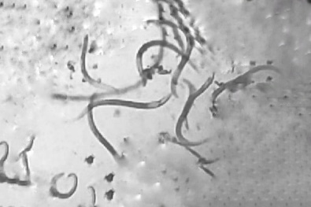 |  | 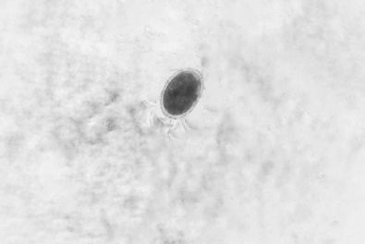 |  | 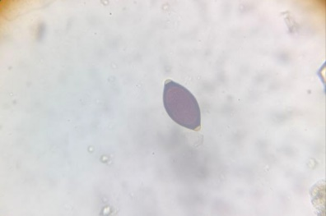
A |  | B |  | C
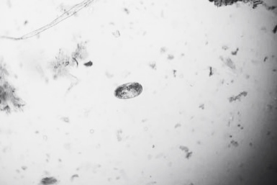 |  | 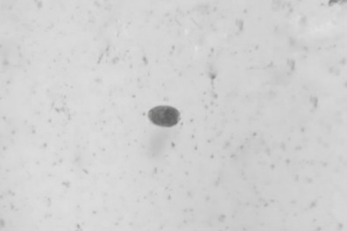 |  | 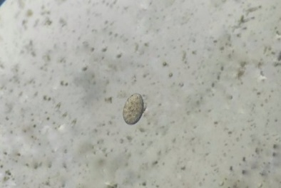
D |  | E |  | F
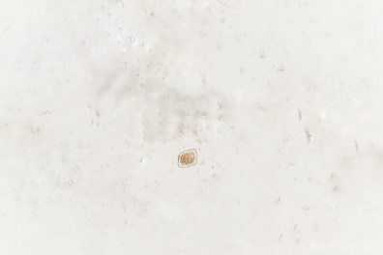 |  | 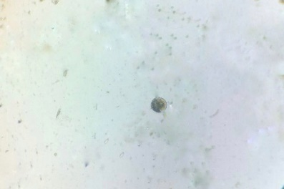 |  | 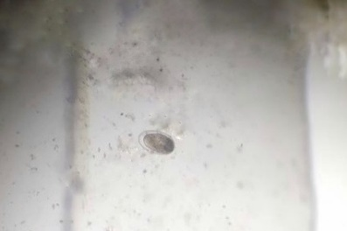
G |  | H |  | I
 |  | A: Dictyocaulus spp. (larval stage), B: Strongyloides spp., C: Trichuris spp., D: Nematodius spp., E: Fasciola spp., F: Paramphistomum spp., G: Moniezia spp., H: Balantidium spp., I: Eimeria spp., and J: Cryptosporidium spp.
J
Figure 2: Identified gastrointestinal parasites in cattle

Through the examination of all 184 samples, seven helminths and three protozoa were confirmed by observing them under microscope (Figure 2). These include 2 species of trematode (Fasciola spp. and Paramphistomum spp.), 4 species of nematode (Nematodius spp., Trichuris spp., Strongyloides spp. and Dictyocaulus spp.), 1 species of cestode (Moniezia spp.) and 3 species of protozoa (Eimeria spp., Balantidium spp. and Cryptosporidium spp). All the parasite was identified according to the keys and descriptions of various authors (Soulsby 1982, Taylor et al., 2016, Hendrix & Robinson, 2020, Bowman, 2021).
Overall prevalence of gastrointestinal parasites
The study was conducted between 10 October, 2024 to 7 November, 2024, where faecal sedimentation revealed 141 positive samples out of 184 (76.63%) were infected with any of those ten species of helminth. These findings complement those of other authors who previously found a prevalence range of 51.1% to 63.41%. (Hassan et al., 2011; Dhara et al., 2015; Das et al., 2017; Yasin et al., 2018; Dappawar et al., 2018; Dey et al., 2020). However, other countries also recorded comparatively higher prevalence, with 94.67% reporting in Bangladesh (Nath et al., 2011), 89.33% in Egypt (Hassan et al., 2019), 87.2% in Northern Thailand (Wuthijaree et al., 2022), 95.9% in Slovakia (Babja´ket al. 2017), and 98% in West Indies (Chikweto et al., 2018). However, other parts of Bangladesh have reported lower rates of gastrointestinal parasite infection than our study (Akther et al., 2017; Hossain et al. 2021). The ecology and host-parasite interaction, sample size, experimental design variation, and diagnostic methods are some of the variables that may have contributed to the discrepancies in the results of various researchers. Furthermore, the true prevalence may be higher than the rate determined by copro-microscopic inspection of this study because of the high likelihood of missing larval stages or low-grade infections during such diagnostic procedures. (Chakrabortty et al., 2023).
Species wise prevalence of gastrointestinal parasites
Table 1: Species-wise prevalence of gastrointestinal parasites
Types of Parasite | Species | No of infected  (N=184) | Prevalence (%) | P-value
Helminths | Fasciola spp. | 12 | 6.52 | <0.0001*
Helminths | Paramphistomum spp. | 30 | 16.30 | <0.0001*
Helminths | Trichuris spp. | 21 | 11.41 | <0.0001*
Helminths | Strongyloides spp. | 49 | 26.63 | <0.0001*
Helminths | Dictyocaulus spp. | 7 | 3.80 | <0.0001*
Helminths | Nematodius spp. | 3 | 1.63 | <0.0001*
Helminths | Moniezia spp. | 5 | 2.72 | <0.0001*
Protozoa | Eimeria spp. | 16 | 8.69 | <0.0001*
Protozoa | Balantidium spp. | 35 | 19.02 | <0.0001*
Protozoa | Cryptosporidium spp. | 44 | 23.91 | <0.0001*

*-indicates significant at p<0.05

A total of the ten species of parasites, where seven species of helminths, namely, Fasciola spp., Paramphistomum spp., Nematodius spp., Trichuris spp., Strongyloides spp., Dictyocaulus spp. Moniezia spp. and three species of protozoa, namely, Eimeria spp., Balantidium spp., and Cryptosporidium spp. were detected at a prevalence of 6.52%, 16.30%, 1.63%, 11.41%, 26.63%, 3.80%, 2.72%, and 8.69%, 19.02% and 23.91%, respectively. The species-wise prevalence of gastrointestinal parasites is illustrated in Table 1. In our study, nematodes may be more common than other helminths because of their direct life cycle and extended environmental survival period. Compared to other helminths, some nematodes can infect hosts more readily and last in the environment for up to ten years. (Zulfikar et al., 2019). Furthermore, for trematodes to finish their life cycle, they require an intermediary host, which makes comparable lower prevalence during our study (Chakrabortty et al., 2023). In addition to this, the research population's shared housing with other domestic animals, inadequate bedding materials, and excessive stocking density were all clearly indicated by protozoan infection (Chartier and Paraud et al., 2012).
Single and Mixed infections of gastrointestinal parasites
Table 2: Single and Mixed infections of gastrointestinal parasites
Types of infection | No of infected  (n=141) | Prevalence  (%) | P-value
Single infection | 94 | 66.66 | <0.0001*
Two species | 28 | 19.86
More than 2 species | 19 | 13.47

*-indicates significant at p<0.05

Among the 141 positive samples, the single parasitic infection was calculated at 66.67%, and the rest 33.33% of the studied samples were infected with more than one species. In case of the mixed infection, 28 were infected with two species of parasites (19.86%) and 19 samples were contaminated with more than two species of parasites (13.47%). These co-infections of gastrointestinal parasites are exhibited in Table 2.
Gender-wise prevalence of gastrointestinal parasites
Table 3: Gender-wise prevalence of gastrointestinal parasites
Variables | No. of examined | No. of infected | Prevalence  (%) | P-value
Male | 81 | 52 | 64.19 | < 0.001*
Female | 103 | 87 | 84.47 | < 0.001*

*-indicates significant at p<0.05

The proportion of gender was mentioned before where 103 were females and the rest 81 were males. In case of gender-wise prevalence, a little difference was observed where females (84.47%) were infected more than males (64.19%). The gender-wise prevalence is given in Table 3. Females had a higher parasitic abundance than males in our study which is supported by Sharma et al. (2009), Owusu et al. (2016), and Kabir et al. (2019). Stress and weakened immune systems during pregnancy, cyclic parturition, and healthcare may be the cause of this increased occurrence in females, which lowers the body's inherent defenses against parasites (Dabasa et al., 2017; Verma et al., 2018).
Age-wise prevalence of gastrointestinal parasites
Table 4: Age-wise prevalence of gastrointestinal parasite
Variables | No. of examined | No. of infected | Prevalence  (%) | P-value
Young (<6 months) | 51 | 44 | 86.27 | 0.057
Adult (>6 months) | 133 | 97 | 72.93 | 0.057

During sampling, all cattle were categorized into two groups, i.e., young (<6 months) and adult (>6 months). The highest prevalence (86.27%) was seen in the younger groups of age, followed by 72.93% in adult of more than 6 months. These results indicated more helminth infections in calf than in adults. Age-wise prevalence is shown in Table 4. According to earlier research, young calves in our study population had more parasite infections than adults (Zvinorova et al., 2016; Islam et al., 2017; Mpofu et al., 2020). Through repeated challenges, adult animals can develop parasite immunity, which allows them to eliminate the parasite before infection happens. (Sorobetea et al., 2018; Mpofu et al., 2020). Furthermore, young animals are susceptible to infections because of immunological immaturity and unresponsiveness, overgrazing of infected pastures, and failure to remove young animals from adult stock during pre-weaning age. (Morris, 2002).
Breed wise prevalence of Gastrointestinal Parasite
Table 5: Breed related prevalence of gastrointestinal parasites
Name of the  breeds | No. of examined | No. of infected | Prevalence  (%) | P value
Local | 53 | 44 | 83.02 | 0.204
Cross (LxHF) | 131 | 97 | 74.05 | 0.204

A total of 184 cattle were analyzed in this study under two breed categories: 53 were local cattle from the Pabna, Munshigonj, and RCC breeds, which produce less milk, and the remaining 131 were crossbred (LocalxHF) cattle, whose produce more milk. Following a comprehensive analysis, the local breed had the highest incidence rate (83.02%), followed by the HF crossbreed (74.05%). The lack of anthelmintic treatment and communal grazing by indigenous livestock may be the cause of these variances. However, in addition to irregular or sometimes strategic anthelmintic medication, improved management practices resulted in fewer parasite infections in crossbred cattle (Alim et al.2012 and Rahman et al.2009).
Prevalence of gastrointestinal parasites depending on their deworming status
Table 6: Prevalence of gastrointestinal parasites on their deworming status
Variables | No. of examined | No. of infected | Prevalence  (%) | P-value
Dewormed | 74 | 33 | 44.59 | <0.0001*
Non-dewormed | 111 | 108 | 97.29 | <0.0001*

*-indicates significant at p<0.05

We had a history of deworming in 74 cattle among the study samples, where the rest 111 cattle were not dewormed recently. On the basis of deworming status, better results were observed in the group of dewormed animals (44.59%), which indicates a good anthelmintic management among the study area. However, the prevalence of gastrointestinal parasites in non-deworming animals was found 97.29%. This prevalence of gastrointestinal parasites depending on deworming status is shown in Table 5. The higher prevalence in non-dewormed cattle is supported by Dey et al. (2020) and Pervin et al. (2022). In order to effectively control gastrointestinal parasites and reduce the development of anthelmintic resistance, frequent anthelmintic deworming is commonly used as endoparasite control in study areas (Belina et al., 2017).

Conclusions
One of the main factors influencing the production and well-being of cattle is parasitism. According to this study, 76.63% of the cattle in Keraniganj Upazila had gastrointestinal parasitic infections. In this investigation, only the prevalence rate and severity of parasite infections in cattle were examined. However, it would be more beneficial for farmers to research the impact of parasites on cattle production performance. Furthermore, the study's examined data will provide a broad understanding of the spread of gastrointestinal parasitic contaminations across the study areas.

REFERENCES
Akther S, Hossain MA, Karim MR, Begum N. Prevalence of gastrointestinal parasitism of cattle in Banskhali Upazilla, Chittagong. Journal of Bangladesh Agricultural University. 2017; 15(1): 79-86.
Alim MA, Das S, Roy K, Sikder S, Mohiuddin MM, Hossain MA. Prevalence of gastrointestinal parasites in cattle of Chittagong division, Bangladesh. Wayamba Journal of Animal Science. 2012; 4: 1-8.
Azizunnesa M, Islam MA, Rahman MM. Genetic improvement of cattle in Bangladesh. Bangladesh Journal of Animal Science. 2008; 37(1): 12-18.
Babják M, Sárközi R, Tóth A. Prevalence of gastrointestinal parasites in cattle from Slovakia: A retrospective study. Veterinary Parasitology. 2017; 244: 58-64.
Badran AI, Zaki AF, El-Sheikh MH. Risk factors for gastrointestinal parasitic infections in cattle: A study in Egypt. Veterinary Parasitology. 2012; 187(3-4): 342-348.
Belina D, Demissie T, Abdela N. Anthelmintic resistance: a potential threat to sustainable small ruminant production in Ethiopia. Journal of Veterinary Medicine and Animal Health. 2017; 9(5): 63-72.
Bowman DD. Georgis' parasitology for veterinarians. 11th edn. Elsevier; 2021.
Chakrabortty A, Sarker S, Rahman M. Prevalence and seasonal variation of gastrointestinal parasites in cattle of Bangladesh. Internatinal Journal of Veterinary Science Research. 2023; 23(1): 72-80.
Chartier C, Paraud C. Coccidiosis due to Eimeria in sheep and goats, a review. Small Ruminant Research. 2012; 103(1): 84-92.
Chikweto A, Thamsborg SM, Thorsen BO. Gastrointestinal parasitism in livestock in the West Indies: Prevalence and species identification. Veteinary Parasitology. 2018; 246: 67-74.
Dabasa G, Tegegne D, Taye M. Influence of pregnancy on gastrointestinal parasitism in dairy cattle. Jounal of Animal Science. 2017; 45(2): 234-239.
Das AK, Das S, Roy PS. A study on gastrointestinal parasitism in dairy cattle in West Bengal, India. Veterinary Research Communications. 2017; 41(5): 443-450.
Dey A, Hossain MA, Rahman MM. Prevalence of gastrointestinal parasitic infections in dairy cattle in northern Bangladesh. International Journal of Veterinary Parasitology. 2020; 43(2): 179-186.
Hassan MA, Hossain MZ, Rahman MM. Prevalence and impact of gastrointestinal nematodes in livestock. Livestock Science. 2019; 56(2): 215-223.
Hassan SR, Ziad MM, Alawi AK. Gastrointestinal parasitism in cattle in Egypt: A study on prevalence and species identification. Journal of Parasitology Research. 2011; 90(1): 29-33.
Hendrix CM, Robinson E. Diagnostic parasitology for veterinary technicians. 5th edn. Elsevier; 2020.
Hossain MM, Islam MT, Aktaruzzaman M, Sarker R. Prevalence and risk factors of gastrointestinal parasitism in cattle in the Barisal division of Bangladesh. Veterinary Parasitology Regional Studies and Reports. 2021; 24: 100546.
Islam MK, Miyaji S, Yokoyama N, Yoshihara Y, Wakabayashi T. Seasonal prevalence of gastrointestinal parasites in cattle in Mymensingh district of Bangladesh. Journal of Veterinary Medical Science. 2017; 79(7): 1100-1105.
Islam MS, Islam MN, Hossain MA. Risk factors of gastrointestinal parasites in cattle in rural Bangladesh. Bangladesh Veterinary Journal. 2017; 15(3): 180-186.
Kabir MHB, Islam KBMS, Islam K, Islam M, Karim SJ, Abdullah SM, Mahmud MS. Epidemiological survey on gastrointestinal parasitic zoonosis in cattle of Sirajganj District, Bangladesh. Internatinal Journal of Pathogen Research. 2019; 2(2): 1-10.
Kakar MN, Shah RB, Khan MM. Prevalence of gastrointestinal parasites in cattle and buffaloes of Pakistan. Veterinary Parasitology. 2008; 156(2): 105-113.
Morris DE. Age-related susceptibility to parasitic infections in cattle. Jounal of Veterinary Parasitology. 2002; 12(3): 249-256.
Nath SS, Roy PS, Sultana F. Epidemiology of gastrointestinal parasites in cattle in Bangladesh. Veterinary Parasitology. 2011; 179(2): 201-207.
Owusu EW, Horne P, Alam M. Gender-related differences in susceptibility to gastrointestinal parasites in livestock: A study from Ghana. Journal of Veterinary Science. 2016; 25(4): 271-275.
Pervin M, Sarker S, Shahin M. The role of deworming in controlling gastrointestinal parasites in dairy cattle in Bangladesh. Veterinary Parasitology. 2022; 202(1): 143-149.
Rahman AKMA, Begum N, Nooruddin M, Rahman MS, Hossain MA, Song HJ. Prevalence and risk factors of helminth infections in cattle of Bangladesh. Korean Journal of Veterinary Service. 2009; 32(3): 265-273.
Raza MA, Ashraf M, Ahmad M. Effect of gastrointestinal parasitic infections on growth rate of cattle. Livestock Science. 2010; 36(1): 51-58.
Sardar SA, Ehsan MA, Anower AKMM, Rahman MM, Islam MA. Epidemiological factors and financial losses associated with bovine fascioliasis in Bangladesh. Journal of the Bangladesh Society for Agricultural Science and Technology. 2006; 3(3-4): 167-170.
Sharma R, Yadav S, Goyal A. Prevalence of gastrointestinal parasites in dairy cattle in the Indian subcontinent. Veterinary Parasitology. 2009; 163(1-2): 89-95.
Silvestre A, Mandonnet N, Le Gal P. Impact of gastrointestinal parasitism on cattle productivity: A review. Veterinary Parasitology. 2000; 91(1): 1-14.
Sorobetea D, Pica I, Popescu C. Development of immunity to gastrointestinal parasites in cattle. Animal Health Research Review. 2018; 27(5): 463-470.
Soulsby EJL. Helminths, arthropods and protozoa of domesticated animals. 7th edn. Baillière Tindall; 1982.
Tariq KA, Chishti MZ, Ahmad F, Shawl AS. Epidemiology of gastrointestinal nematodes of sheep managed under traditional husbandry system in Kashmir valley. Veterinary Parasitology. 2010; 170(1-2): 138-143.
Taylor MA, Coop RL, Wall RL. Veterinary parasitology. 4th edn. Wiley-Blackwell; 2016.
Thornton PK, Kruska RL, Henninger N, Kristjanson PM, Reid RS, Atieno, Ndegwa T. Mapping poverty and livestock in the developing world. International Livestock Research Institute (ILRI); 2006.
Wuthijaree M, Kunpichai W, Wisetsri S. Prevalence and control of gastrointestinal nematodes in cattle in Northern Thailand. Asian Journal of Veterinay Parasitology. 2022; 28(4): 302-310.
Zulfikar M, Akter N, Zaman M. Nematode infection in cattle in Bangladesh: Prevalence and management strategies. Journal of Veterinary Medicine. 2019; 58(1): 21-29.
Zvinorova PI, Halimani TE, Muchadeyi FC, Matika O, Riggio V, Dzama K. Prevalence and risk factors of gastrointestinal parasitic infections in goats in low-input farming systems in Zimbabwe. Small Ruminant Research. 2016; 143: 75-83.

