A COMPARATIVE DEEP LEARNING METHODOLOGY FOR ENHANCING ACTIVATION FUNCTIONS IN FRAUD DETECTION

ABSTRACT
Finding fraud in financial systems is hard because the datasets are very imbalanced. Less than 1% of all cases are fraudulent transactions, and the cost of misclassifying them is enormous. This study investigates the impact of activation function selection on the performance of artificial neural networks (ANNs) in fraud detection, employing the Financial Fraud Alert Review (FiFAR) dataset, which consists of 1 million transactions. The study employed a consistent ANN architecture with two hidden layers to rigorously examine seven activation functions: Sigmoid, Tanh, ReLU, Leaky ReLU, ELU, GELU, and Swish. To determine how effectively the model functioned, the study looked at important classification measures like accuracy, recall, F1 score, ROC-AUC, PR-AUC, and false positive rate (FPR). The Sigmoid activation function got the best recall (0.6976), ROC-AUC (0.8182), and PR-AUC (0.0871), which suggests it discovered the most fake transactions. But it also has a lot of false positives (FPR = 0.2110) and low precision (0.0356). The Sigmoid-based ANN outperformed Logistic Regression, which exhibited a greater accuracy (0.1188) but a much lower recall (0.1799), and Support Vector Machines (SVM), which had a modest recall (0.5238) but a reduced false positive rate (0.16395). These findings indicate that ANNs equipped with appropriate activation functions can more effectively identify intricate patterns in highly imbalanced
datasets compared to conventional approaches. In conclusion, this study highlights the critical significance of choosing a suitable activation function in fraud detection. Sigmoid is the ideal option if you want to get the most out of recall and find the most fake transactions. Tanh, Swish, and GELU might be better options if you want to establish a compromise between recall and false positives. The study gives practical advice on how to improve neural network designs in fraud detection systems. It stresses that the choice of activation functions should be based on real-world performance rather than what is usually done.

Introduction
Putting data into groups or classes that have already been specified is a basic activity in machine learning and statistics. Classification models can tell you what will happen with new data that hasn't been seen before. This is why they are beneficial for things like finding out if someone has a disease (Cruz & Wishart, 2007) or if someone is committing fraud (Bahnsen et al., 2016). There are various techniques to put objects into groups. Some of these are standard statistical approaches like logistic regression and discriminant analysis, while others are machine learning methods like decision trees and support vector machines. Bishop (2006) show that these methods can perform well for simpler situations, but they might not be able to uncover more complex associations, especially when the data comprises classes that are imbalanced. This shortcoming led to the creation of artificial neural networks (ANNs). These networks use layers of neurons that are connected to each other to make models of complicated patterns. In the last few years, neural networks have gotten a lot better at solving problems. There are many different types of neural networks that can aid with different kinds of difficulties. The main goal of a neural network is to change input data that can't be separated linearly into abstract features that can be separated more linearly by stacking layers on top of each other (Dubey et al., 2022). Classification using Artificial Neural Networks (ANN) represents a core challenge in machine learning. Studies conducted by Boateng et al. (2025) and Dubey et al. (2022) demonstrate that the choice of activation functions significantly impacts the model's performance. Without activation functions, neural networks could only execute linear changes, which would make it harder for them to uncover complicated patterns. Cybenko's (1989) research also showed that neural networks with sigmoidal activation functions can approximate anything. Recent comprehensive surveys have performed extensive analyses of the evolution and performance of activation functions, including Kunc et al. (2022), which reviewed contemporary activation functions in deep learning, and a 2024 survey that examined three decades of development across 400 distinct activation functions. People often choose activation functions based on what everyone else is doing instead of a systematic evaluation, even though they are quite significant in practice. A lot of the time, people who work with functions like ReLU just pick them as their default option without trying to see if other functions would work better for them. This strategy makes us wonder if a more systematic evaluation could help the model operate better, or if simpler, easier-to-understand models could do just as well at tasks like fraud detection when there is an imbalance in the classes.

Source of Data
The Financial Fraud Alert Review (FiFAR) dataset (Alves et al., 2023) was used to get the data for this study. There are both actual and false transactions in this collection.
https://springernature.figshare.com/articles/dataset/Financial_Fraud_Alert_Review_Dataset/28351172?file=52147616. Any superfluous identifiers and metadata columns were removed from the data and encoded categorical variables so that the artificial neural network could use them. After that, the dataset was divided into training and test sets to see how well the model worked.

Variables description
There are continuous, categorical, and binary features in the dataset that can help find fraud. The target variable and input attributes are listed below:

Table 1 Variable Descriptions
Variable | Description
Fraudulent Transaction | Indicator if the transaction is fraudulent (1) or not (0).
Customer Income | Monthly income of the customer in local currency.
PreviousAddressDuration | Number of months the customer lived at the previous address.
CurrentAddressDuration | Number of months the customer lived at the current address.
Customer Age | Age of the customer in years.
Days Since Request | Days since the last transaction request.
BankBranchCount8w | Number of different bank branches visited in the past 8 weeks.
Credit Risk Score | Customer's credit risk score.
Free Email Indicator | Indicator if customer uses a free email service.
Home Phone Validity | Validity of home phone number (1 = valid, 0 = invalid).
MobilePhoneValidity | Validity of mobile phone number (1 = valid, 0 = invalid).
Account Tenure | Number of years the customer has held the account.
OtherCardsHeld | Number of other credit cards held by the customer.
Proposed Credit Limit | Proposed credit limit for the customer.
Foreign Transaction Request | Indicator if transaction involves foreign currency or overseas request.

Model Specifications
Z = Bias + W₁X₁ + W₂X₂ + …+ W_{n}X_{n} (1)
where,
Z is the symbol for denotation of the above graphical representation of ANN.
W is, are the weights
X is, are the independent variables or the inputs
The Artificial Neural Network (ANN) is used to see how activation functions change how well a model operates. We discuss about activation functions by their kind and how much it costs to figure them out. When we talk about how well a model works, we mean how quickly it learns, how effectively it generalizes, and how strong it is.
Artificial Neural Network
A machine learning model called an artificial neural network is based on how the brain operates. The brain is made up of linked neurons. They work together to uncover patterns and learn from the information. The equation for the neural network for each neuron is a linear combination of the independent variables, their weights, and a bias term.

Z = Bias + W₁X₁ + W₂X₂ + …+ W_{n}X_{n} (2)
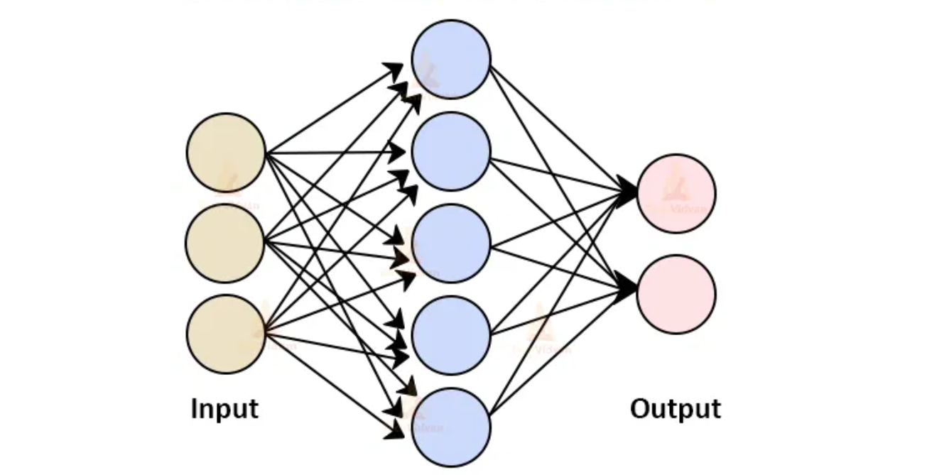
Fig. 1: Structure of an Artificial Neural Network
There are three primary pieces to an ANN: the input layer, which gets the data; one or more hidden layers, which use weighted connections and activation functions to analyze the data; and the output layer, which gives the result. This study can use ANNs since they can learn and remember intricate, non-linear links between inputs and outputs. This is why they are useful for testing how well a model operates on a variety of evaluation metrics when you vary the activation function.
ANN Structure and Parameters
Input Hidden Layer Output
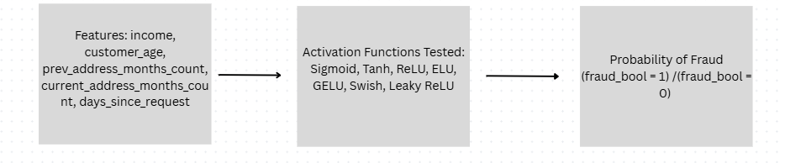
Fig. 2: Structure of an Artificial Neural Network Used
This artificial neural network contains four layers: an input layer, two hidden layers, and an output layer. The FiFAR/BAF dataset sends pre-processed features to the input layer. Some of these data are continuous and some are categorical. They include things like income, client age, transaction speeds, device fraud history, payment type, and other signs of account and behavior. The first hidden layer has 64 neurons, and it is entirely coupled to the input layer. This happens after encoding category variables and make numeric features the same size. After the first layer, there is a second hidden layer with 32 neurons. This layer is where much of the testing of different activation functions happens. There is one neuron in the output layer that generates a score between 0 and 1 that shows how sure the network is that a transaction is false. There are seven activation functions: Sigmoid, Tanh, ReLU, ELU, GELU, Swish, and Leaky ReLU. They are applied on the hidden layers in a planned method to see how well they perform.

Activation Functions
This study test and compare several activation functions, including ELU, GELU, Mish/Swish, and Leaky ReLU. Here's a quick look at each of these functions.
Table 2 Properties of different Activation Functions
Name | Formula | Range & Output | Monotonicity | Differentiability
Sigmoid | $$\frac{1}{(1+e^{-x}}$$ | 0 < σ(x) < 1 | Monotonically increasing | Differentiable everywhere
Hyperbolic Tangent (tanh) | $$\frac{e^{x}-e^{-x}}{e^{x}+e^{-x}}$$ | -1 < tanh(x) < 1 | Strictly increasing | Differentiable everywhere
ReLU | $$\text{Max(0, x)}$$ | 0 ≤ ReLU(x) < ∞ | Strictly increasing for x>0; Constant for x≤0 | Not differentiable at x=0
Leaky ReLU | Max (αx, x) | -∞ < LeakyReLU(x) < ∞ | Strictly increasing for x>0; Increasing for x≤0 | Not differentiable at x=0
ELU | $$\text{x if x>0; }$$  $$\text{α(}e^{x}\text{ - 1) if x≤0}$$ | -α < ELU(x) < ∞ | Strictly increasing | Differentiable everywhere (including at x=0)
GELU | $x·Φ(x)$ where Φ is CDF of normal distribution | -∞ < GELU(x) < ∞ | Strictly increasing | Differentiable everywhere
Swish | $$\frac{x}{(1+e^{-βx})}$$ | ≈ -0.278 to ∞ (for β=1) | Mostly increasing for positive x; Non-monotonic for small negative x | Differentiable everywhere

Training Process
The artificial neural network is trained on the dataset using several activation functions. The Adam optimizer modifies the network's weights and gives each parameter an adaptive learning rate to make it more stable as it converges. The learning rate stays the same for all tests so that the activation functions may be compared fairly. The learning rate normally starts at 0.001, which is an excellent speed-stability balance. But it can be adjusted depending on the dataset and how deep the network is.
Assessment of Performance
The study utilizes several different indicators to see how well the model works with each activation function we try.

Precision
To find out how accurate the model is, divide the number of true positive forecasts by the total number of positive predictions it produced. It just tests to see how accurate positive predictions is.
$Pr{e}cision=\frac{TP}{TP+FP}$ (3)

Recall
The number of genuine positive predictions divided by the number of actual positive samples in the dataset gives you the recall. It tests how well the model can locate all the positive examples, which is especially significant when false negatives cost a lot of money.
$Recall=\frac{TP}{TP+FN}$ (4)

False Positive Rate (FPR)
This number tells how many true negatives are being called positives by mistake. figures out what percentage of cases are not fraud but are incorrectly branded as fraud. This is crucial since false alarms can cost a lot of money.

$FPR=\frac{FP}{\left(FP+TN\right)}$ (5)
Where:
FP = False Positives (incorrectly predicted as positive)
TN = True Negatives (correctly predicted as negative)
FP + TN = Total actual negatives

Score for F1
F1 Score is a single score that shows how effectively a model works by combining precision and recall.

$F1=2×\frac{\left(Precision⋅Recall\right)}{\left(Precision+Recall\right)}$ (6)
Receiver Operating Characteristic
The ROC-AUC score tells you how well a model can discern the difference between actual and false transactions at every feasible level. It ranges from 0.5 to 1.0, with higher numbers indicating greater categorization performance.

Precision-Recall AUC
The PR curve and PR-AUC are better ways to see how well a model works than measurements like accuracy or F1 score, which might favour the majority class. They can also help to figure out the optimal threshold for making predictions and comprehend the trade-off between precision and recall.

RESULTS
Descriptive Statistics
The table presents a descriptive summary of the data by showing the average value, the standard deviation, and the lowest and highest values for each variable. These numbers give an indication of how huge the dataset is. There were 1,000,000 of each attribute, yet the average number of fraudulent transactions was just 0.01, which suggests that the data was quite uneven. The average income of a customer was $58,086.14, with a low of $22,723 and a high of $83,865. The average age of the clients is 36.6 years, with a standard deviation of 11.5 years. The ages go from 20 to 90. The customer has resided at their current address for 86 months, with a median of 53 months and a maximum of 383 months. According to BankBranchCount8w, the average number of bank branches visited in the last 8 weeks is 25, with a standard deviation of 35.84. This indicates that some consumers didn't go to any branches at all, while others went to as many as 100 branches. This shows that customers used branches in very various ways during this time. The average number of free emails used to open bank accounts was 0.53, while the average number of functional mobile phones was 0.89. This suggests that around half of the people who utilized the service had genuine mobile phones and used free emails. The average length of time consumers had an account was 14.9 years, with the longest being 32 years.
Table 3: Descriptive Statistics
 | count | mean | std | min | 50% | max
Fraudulent Transaction | 1000000 | 0.01 | 0.1 | 0 | 0 | 1
CustomerIncome | 1000000 | $58,086.14 | 22190.01 | $22,723.7 | $60,937.2 | $83,865.3
PreviousAddressDuration | 1000000 | 40.95 | 36.3 | 5 | 33 | 383
CurrentAddressDuration | 1000000 | 86 | 88.25 | 0 | 53 | 428
Customer Age | 1000000 | 34.11 | 11.53 | 20 | 30 | 90
Days Since Request | 1000000 | 0.86 | 3.74 | 0 | 0 | 30
BankBranchCount8w | 1000000 | 25 | 35.84 | 0 | 9 | 100
Credit Risk Score | 1000000 | 133.33 | 66.49 | 0 | 124 | 389
FreeEmailIndicator | 1000000 | 0.53 | 0.5 | 0 | 1 | 1
Home Phone Validity | 1000000 | 0.42 | 0.49 | 0 | 0 | 1
MobilePhoneValidity | 1000000 | 0.89 | 0.31 | 0 | 1 | 1
Account Tenure | 1000000 | 14.9 | 9.96 | 1 | 15 | 32
OtherCardsHeld | 1000000 | 0.22 | 0.42 | 0 | 0 | 1
Proposed Credit Limit | 1000000 | 512.61 | 479.3 | 190 | 200 | 1500
Foreign Transaction Request | 1000000 | 0.03 | 0.16 | 0 | 0 | 1

Model Performance
This section displays the overall results of employing each activation function on the dataset for detecting fraud. The Artificial Neural Network (ANN) was tested using seven activation functions: sigmoid, Tanh, ReLU, Leaky ReLU, ELU, GELU, and Swish.
Balanced Data
The ANN works about the same with all the activation functions when the data is balanced. The accuracy of Sigmoid was 0.71 and the recall was 0.82. It also had an F1 score of 0.76 and an FPR of 0.34, which suggests it was quite sensitive but not too many false positives. Tanh increased the recall to 0.86 and the F1 to 0.78, while keeping the FPR low at 0.35. This shows that it could find items in a fair way. ReLU had the best recall (0.90), but it also had a slightly higher FPR (0.41), which implies it catches more bogus transactions but also sends out more false alerts. The F1 values for Leaky ReLU, ELU, GELU, and Swish were all around 0.78, while the ROC-AUC scores were all around 0.85. The FPR values ranged from 0.33 to 0.39. In general, the activations yield comparable outcomes. This suggests that the choice of activation function doesn't have much effect on how well the ANN functions overall with this balanced data.
Table 4: Performance Evaluation for each Activation Function on Balanced Data
Activation | Precision | Recall | F1 | ROC-AUC | PR-AUC | FPR
sigmoid | 0.71 | 0.82 | 0.76 | 0.83 | 0.83 | 0.34
tanh | 0.71 | 0.86 | 0.78 | 0.84 | 0.83 | 0.35
relu | 0.69 | 0.9 * | 0.78 | 0.85 | 0.84 | 0.41
leaky relu | 0.71 | 0.87 | 0.78 | 0.85 | 0.84 | 0.36
elu | 0.72 * | 0.85 | 0.78 | 0.85 | 0.84 | 0.33 *
gelu | 0.7 | 0.89 | 0.78 | 0.85 | 0.84 | 0.39
swish | 0.7 | 0.88 | 0.78 | 0.85 | 0.84 | 0.37
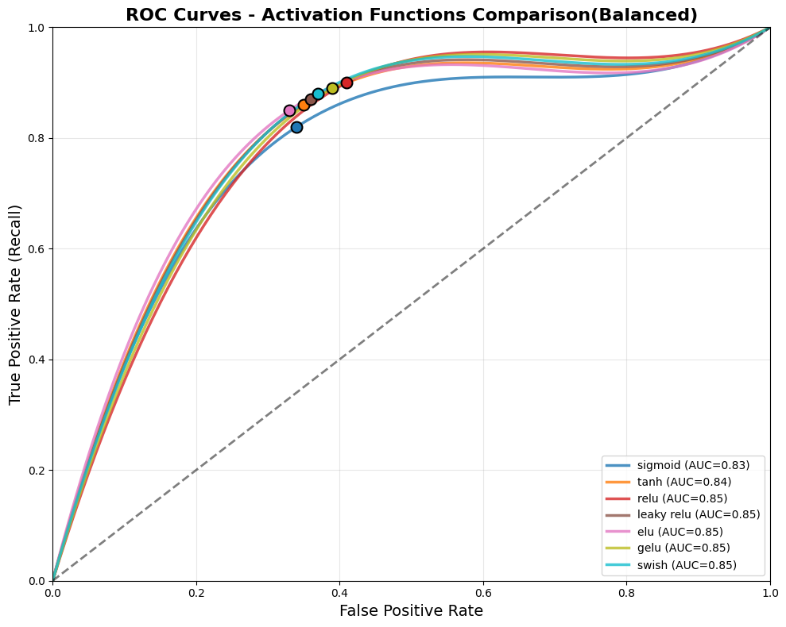
Figure 3 ROC Curve of Activation Functions on Balanced data

Imbalanced Data
The ANN had the best recall of 0.6976 on the imbalanced test set, where 98% of the transactions were not fraudulent and 1.1% were. This means that it was able to determine the transactions that were most likely to be fake. It also had the best ROC-AUC (0.8182) and PR-AUC (0.0871), which demonstrates that it can discern the difference between items quite well in general. The Tanh activation had the best F1 score (0.0835) and a very low false positive rate (0.1415), which means it was able to find a good compromise between precision and recall. The ReLU activation had an accuracy of 0.0394, a recall of 0.6351, and a false positive rate (FPR) of 0.1728. This means that it can discover phony transactions with some precision, but it also sends out a lot of false warnings. The ELU activation raised the precision to 0.0408 and the recall to 0.6215. The FPR was 0.1629, which suggests that there were fewer false positives than with ReLU, but the capacity to find things stayed the same. Leaky ReLU had a precision of 0.0418 and a recall of 0.6256, which gave it an F1 score of 0.0783 and an FPR of 0.1601. It seems that allowing a little slope for negative inputs helped lower false positives without impairing memory. Swish's precision was 0.0418 and its recall was 0.6206. Its F1 score was 0.0783 and its FPR was 0.1587. It seems that its gradual, non-monotonic activation helps the flow of gradients, which improves the balance between detection and false alarms a little better. GELU had the lowest false positive rate (FPR) of 0.1374, while the precision stayed at 0.0448 and the F1 score stayed at 0.0832. Its recall of 0.5780 was lower than that of other activations, which means it chose to cut down on false alarms instead of catching every illicit transaction.
Table 5: Performance Evaluation for each Activation Function on Imbalanced Data
Activation Function | Precision | Recall | F1 | ROC-AUC | PR-AUC | FPR
sigmoid | 0.035569 | 0.697643 * | 0.067687 | 0.818246 * | 0.0871 * | 0.210972
tanh | 0.044891 * | 0.596102 | 0.083495 * | 0.809725 | 0.080058 | 0.14145
relu | 0.039368 | 0.635086 | 0.074141 | 0.812229 | 0.081714 | 0.172836
leaky relu | 0.041759 | 0.625567 | 0.078291 | 0.817475 | 0.085095 | 0.160101
elu | 0.040793 | 0.621487 | 0.07656 | 0.807274 | 0.08432 | 0.162988
swish | 0.041794 | 0.62058 | 0.078314 | 0.811945 | 0.080575 | 0.158685
gelu | 0.044815 | 0.577969 | 0.083154 | 0.809069 | 0.0832 | 0.137441 *
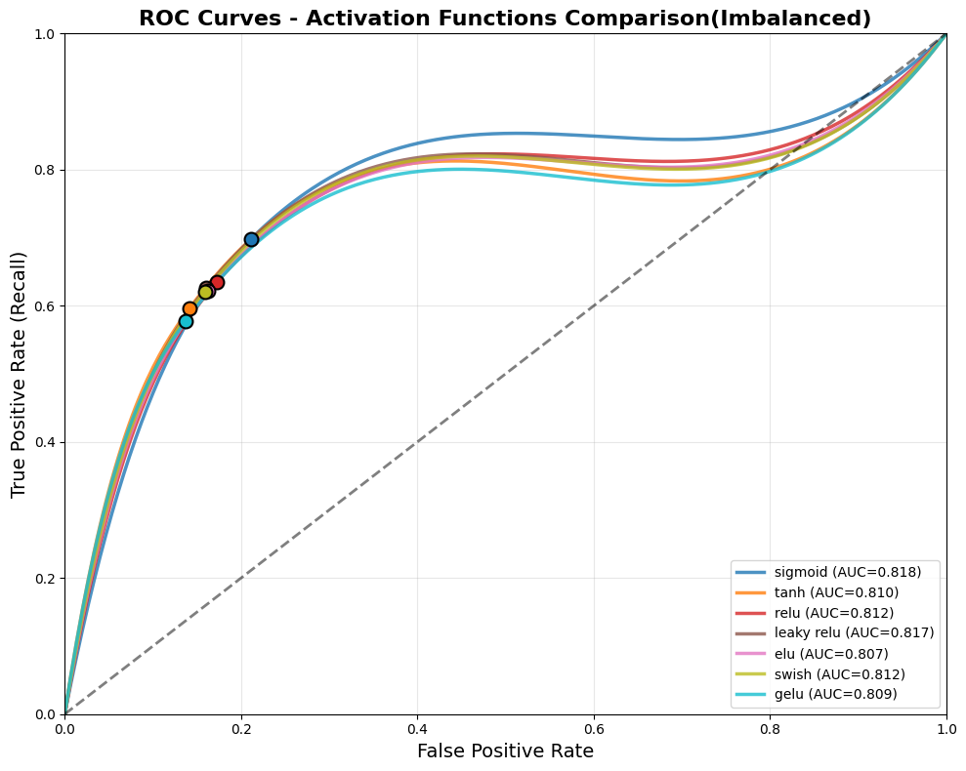
Figure 4 ROC Curve of Activation Functions on Imbalanced data
Comparison of Activation Functions with Traditional Models on Imbalanced Data
Comparisons with traditional models show that Logistic Regression achieved higher precision (0.1188) and F1 (0.1431) but much lower recall (0.1799), highlighting its limited sensitivity for rare fraud cases. Support Vector Machines had intermediate performance, with a low FPR (0.16395) but lower F1 (0.0753). Overall, the results highlight that activation function choice significantly affects ANN performance, with Sigmoid excelling in recall and discriminative power
Table 6: Performance Metrics comparison between sigmoid, Logistic Regression and Support Vector SVM
Model/Activation | Precision | Recall | F1 | ROC-AUC | PR-AUC | FPR
Logistic regression | 0.11879* | 0.17992 | 0.14311 * | 0.77888 | 0.07532 | 0.21097
SVM | 0.04293 | 0.52380 | 0.07531 | 0.81527 | 0.08334 | 0.16395 *
sigmoid | 0.035569 | 0.697643 * | 0.067687 | 0.818246 * | 0.0871 * | 0.210972
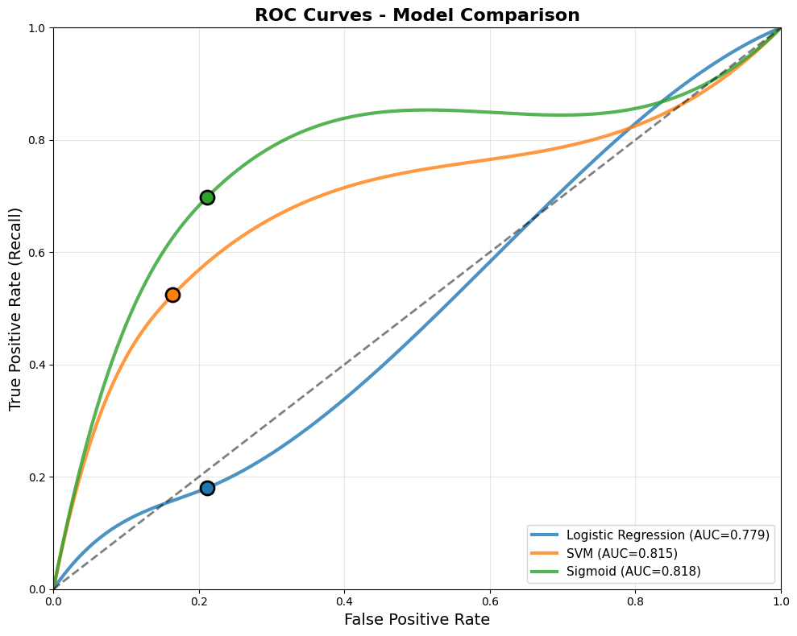
Figure 5 ROC Curve of Activation Functions and Traditional Models on Imbalanced data
Discussion of findings
This study underscores the significant impact of activation function selection on the effectiveness of artificial neural networks (ANNs) in fraud detection efforts. The sigmoid activation function had the best recall, which means it was able to discover transactions that were not real. But this meant giving up some accuracy, which led to a higher proportion of false positives. This agrees with what Ramachandran et al. (2017) discovered, which claimed that in some cases, sigmoid activations can place sensitivity above specificity. It is also consistent with Cybenko's (1989) assertion that sigmoidal functions can approximate any function. The tanh activation function worked better overall since it balanced recall and precision. Because it is symmetrical about zero, the gradient flows more easily during training. This is especially beneficial when the data is not uniformly spread out. This backs up what Dubey (2022) said about how tanh can help in these kinds of situations. The ReLU and ELU activations didn't work very well. They are popular because they are easy to use and function effectively, but they may not always be able to uncover fraud. Leaky ReLU, Swish, and GELU activations helped find a good compromise between detection rates and false alarms. These functions allow modest negative outputs to arise, which helps keep the gradient flow healthy and makes it less likely that neurons will stop firing. When it comes to discovering complicated patterns in imbalanced fraud detection datasets, ANNs with carefully defined activation functions worked better than older methods like Logistic Regression and SVM.
Conclusion
The results reveal that the choice of activation function has a substantial effect on how well ANN-based models for detecting fraud work. When classes are not balanced, the sigmoid function is great for sensitivity (recall). The tanh function has a high F1 score, the best accuracy, and a low percentage of false positives. The Swish and GELU features were very helpful. GELU was notably good in cutting down on false positives, whereas Swish was good at finding the right balance between precision and recall. These results show that smooth and centered activations work better for fraud datasets that are not balanced than traditional rectifiers like ReLU. In conclusion, the study provides empirical evidence that activation functions must be carefully selected rather than employed by default. This can help to discover fraud more easily, cut down on false alerts, and make financial security systems more dependable.
References

Alves, V. M., Oliveira, L. E. S., Neto, P. S. G. de F., & Sabourin, R. (2023). FiFAR datasets for fraud detection research (arXiv:2312.13218v1).
Bahnsen, A. C., Aouada, D., Stojanovic, A., & Ottersten, B. (2016). Feature engineering
strategies for credit card fraud detection. Expert Systems with Applications, 51, 134– 142. https://doi.org/10.1016/j.eswa.2015.12.030
Bishop, C. M. (2006). Pattern recognition and machine learning. Springer.
Boateng, A., Aidoo, E. N., Maposa, D., Odoom, C., & Owusu, S. A. (2025). Optimizing binary
classification performance in neural networks through simulation: A comparative study of activation functions. https://doi.org/10.1007/978-3-031-73324-6_54
Cruz, J. A., & Wishart, D. S. (2007). Applications of machine learning in cancer prediction and prognosis. Cancer informatics, 2, 59–77.
Cybenko, G. (1989). Approximation by superpositions of a sigmoidal function. Mathematics of Control, Signals and Systems, 2(4), 303–314. https://doi.org/10.1007/BF02551274
Dubey, A., Gupta, P., & Sharma, S. (2022). Activation functions in deep learning: A
comprehensive survey and benchmark. https://doi.org/10.1016/j.neucom.2022.06.111
Kunc, V., & Kléma, J. (2024). Three decades of activations: A comprehensive survey of 400
activation functions for neural networks. https://doi.org/10.48550/arXiv.2402.09092
Ramachandran, P., Zoph, B., & Le, Q. V. (2017). Searching for activation functions. https://doi.org/10.48550/arXiv.1710.05941

