Volatility and Risk Analysis of Sectoral NIFTY Index: An Empirical Analysis of Geometric Brownian Motion and Monte Carlo Simulation

Abstract: The global economy and markets face geopolitical uncertainty and trade challenges. Ongoing conflicts between Russia and Ukraine, as well as between Israel and Gaza, along with tensions between Israel and the US over Iran, have created uncertainties about economic growth. Increasing political tensions worldwide, tariff fluctuations, energy risks, and climate change have prompted the central bank, which remains cautious, to shift its policy approach from structural to tactical responses to shield the economy from geopolitical turmoil. In June 2025, the National Stock Exchange reported that India faces a lack of macroeconomic stability. The stock market is highly susceptible to fluctuations in economic conditions. The paper attempts to analyze the risks and volatility of NIFTY sectoral indices in India. This paper employs geometric Brownian motion to forecast seven sectoral indices using daily returns of sectoral index close prices from January 1, 2018, to July 8, 2025. The results showed that volatility exists in nearly all sectoral indices over the next 100 trading days. The maximum potential loss for investors across different sectors is relatively lower in the pharma, PSU Bank, and Metal sectors, as indicated by VaR and CVaR values.
Key Words: Financial forecasting, Investment decisions, Geometric Brownian Motion, Sectoral Index, Forecasting and Simulation
JEL Codes: F47, G11, G17
- Introduction
India’s capital markets are booming, and the confidence is visible. They have become a powerful engine for economic growth by turning household savings into investments. Despite global tensions and domestic uncertainties, the stock market maintained strong performance by December 2024. It outperformed many other emerging economies, showing how investors, both local and global, trust India’s growth story. Press Information Bureau, July 6, 2025
Indian equity markets experienced fluctuations before closing with minimal changes as caution prevailed due to geopolitical concerns. The escalating tensions between India and Pakistan raised fears of potential armed conflict. Global market signals were mixed, influenced by worries over tariffs and a possible economic slowdown in the U.S. However, continuous inflows from foreign institutional investors supported market sentiment and limited further pessimism. Aditya Birla April 30, 2025
The global economy and markets face geopolitical uncertainty and trade challenges. Ongoing conflicts between Russia and Ukraine, as well as between Israel and Gaza, along with tensions between Israel and the US over Iran, have created uncertainties about economic growth. The financial and political rivalry among the US, China, and the EU has led to higher tariffs and disruptions in the global supply chain, increasing production costs. This rise in costs has contributed to inflation risks, prompting the IMF to lower its growth forecasts, fearing the situation could worsen more than during the pandemic. All these global events have impacted the Indian economy. Although India has seen declining inflation rates, with a healthy CPI of 2.8% YoY growth as of May and strong forex reserves of $691 billion, disruptions in the global supply chain caused by tense trade relations among the superpowers have affected India's performance, leading to a contraction in the manufacturing sector. Increasing political tensions worldwide, tariff fluctuations, energy risks, and climate change have prompted the central bank, which remains cautious, to shift its policy approach from structural to tactical responses to shield the economy from geopolitical turmoil. In June 2025, the National Stock Exchange reported that India faces a lack of macroeconomic stability due to external factors such as global policy divergence, supply chain shocks, and geopolitical unpredictability. The adverse effects of these factors worldwide have impacted the Indian stock market. Although a relatively low inflation rate and cautious moves by the Reserve Bank of India regarding CRR and SLR rate cuts have encouraged investors to participate in the stock market, the ongoing geopolitical tensions have made them wary. Despite a series of relief measures, such as low inflation and ample foreign exchange reserves, stock market volatility remains a concern for policymakers and investors. The capital market, often referred to as the stock market, is highly susceptible to fluctuations in economic conditions. The link between the overall economy and the stock market is clear in events such as the severe recession caused by the COVID-19 pandemic, which significantly impacted global stock markets, and the adverse effects of the 2008 global financial crisis on stock markets. Recently, investors have focused on the studies of sectoral volatility, risks, and returns in the capital market because the movement of sectoral indices is directly correlated with the economic conditions of the real sectors. The flow of information to a sector influences the sectoral index volatility, which in turn influences investors’ decision-making.
Similarly, the goal of this paper is to analyze the risks and volatility of NIFTY sectoral indices in India. The paper is organized as follows: Section 2 reviews relevant literature. In Section 3, we introduce the data and methods used for analysis. Section 4 presents the results, and finally, Section 5 concludes.
- Literature Review

Previous research has analyzed the performance of sectoral indices and how the stock market reacts to different events, such as the COVID-19 pandemic. Ashri et al. (2021), Serrasqueiro (2022), Fernandes et al. (2021), and Shahzad et al. (2021) studied the pandemic's impact on sectoral indices.
Trabelsi et al. (2021) argued that the sectoral index performance on the Bombay Stock Exchange influences gold prices. This study uses daily data to explore the relationship between gold returns and seven BSE sectoral indices from January 2000 to May 2018. Considering gold's significance in India, portfolio selection there involves essential challenges. The research addresses hedged robust portfolio problems, focusing on three classic portfolio types: maximizing returns, minimizing global variance, and Markowitz allocation, using various generalized autoregressive conditional heteroskedasticity (GARCH) models. Results show gold returns are mainly independent of BSE sectoral index returns. Moreover, gold can help forecast future returns of the Consumer Durables, Fast-Moving Consumer Goods, and Oil & Gas indices. Additionally, gold acts as a hedge against the information technology index and offers a robust diversification tool. These insights provide valuable implications for investors and risk management strategies.
Tiwari et al. (2021) studied the relationship between oil prices and sectoral index returns on the Bombay Stock Exchange. They analyzed dependence, risk spillovers, and systemic risk among BSE sectoral indices and oil prices using advanced empirical methods. The study used conditional value-at-risk and marginal expected shortfall to evaluate systemic risk. Results indicated that the dependence between oil prices and other sectors varies over time, especially increasing during turbulent periods while remaining relatively stable during calmer times. The sectors- metals, materials, and industrials have shown the highest short-term marginal expected shortfall. Conversely, fast-moving consumer goods, auto, and carbon sectors have the lowest marginal expected shortfall. The risk analysis demonstrates that Indian stock sectors are vulnerable to oil shocks and exhibit significant systemic risk linked to the crude oil market. Notably, the power and energy sectors are more heavily and durably impacted by oil price fluctuations than others.
Hamdi et al. (2019) use quantile regression analysis (QRA) to examine the volatility spill over between oil prices and sectoral indices in the Gulf Cooperation Council countries. This study investigates the extent of volatility between oil prices and sectoral indices in the GCC by applying QRA to both the return series and denoised series over 2006–2017. Four sectors are identified as offering diversification opportunities during high market conditions (i.e., at the 90th quantile). All sectors are found to be interconnected with oil price volatility; however, the bank and insurance sectors are less affected by oil price fluctuations during the 10th, 25th, and 75th quantiles. Furthermore, QRA results show that although all sectors are affected by oil price volatility, the overall market index is less responsive to oil price fluctuations. This underscores the significance of filtering noise from financial return series when conducting regression analysis.
Choi et al. (2021) analyze the dynamic volatility spillovers and relationships among 11 sector indices in the Australian capital markets. The study uses the DCC model to estimate conditional correlations among European, UK, and US stock markets and their industry sectors. It measures the changing volatility spillovers and maps the interconnectedness network across the 11 Australian Securities Exchange (ASX) sector indices using Diebold and Yilmaz's spillover index methodology. Additionally, they depict volatility relationships as links in a complex network to show how volatility spreads among sectors. The findings indicate that recent financial crises have increased the level of volatility connectedness across these sectors, supporting the contagion hypothesis. They emphasize that the financial sector mainly drives volatility connectivity.
Mensi et al. (2017) investigated spillover effects among ten Dow Jones Islamic and conventional sector indices. This study analyzes the dynamic spillovers between these 10 sector index pairs using various multivariate GARCH models. The results show significant time-varying conditional correlations for all pairs. Additionally, Islamic sector risk exposure can be effectively hedged over time within diversified portfolios that include conventional sector stocks. These findings have practical implications for portfolio managers and policymakers regarding asset allocation, risk management, and diversification across these markets.
Costa et al. (2022) analyzed the interconnectedness among US sectoral indices by examining the volatility connectedness of 11 sectors using daily data from January 01, 2013, to December 31, 2020. They applied the connectedness measures developed by Diebold and Yilmaz (2009, 2012, 2014), revealing shifts in sectoral relationships and notable patterns during the COVID-19 pandemic. They observed a significant rise in total connectedness from the early stages of the global spread through July 2020, along with remarkable changes in pairwise sector connections, especially among the initially stronger sectors. Despite these adjustments, there is little evidence of substantial structural changes in overall net connectedness.
Antoniou et al. (2007) analyze correlations and conditional volatility spillovers across international stock markets and industrial sectors from the UK investor's perspective. Using the DCC model, the paper identifies the time-varying conditional correlations among the UK, US, and European stock markets and sectors. It also employs the multivariate generalized autoregressive conditional heteroscedasticity (MVGARCH) to study how volatility transmits from the US and European markets to the UK. The results show that the UK equity market is more closely linked with Europe, both overall and in specific sectors. Correlations tend to be stronger during bear markets and weaken during recovery periods. The sectoral analysis provides valuable insights into how volatility transmits across different sectors.
Forecasting future price conditions is a key research area because anticipated prices help investors decide when to buy or sell stocks to maximize profits. In predicting future stock market price conditions, Suganthi et al. (2019) applied the geometric Brownian model to forecast stock prices in the Indian stock market. They analyzed stock prices using Geometric Brownian Motion based on the Random Walk theory. The study compares stock data from 2013-2014 and from June to November 2017.
Trimono et al. (2021) combined the GBM model with Value at Risk to estimate losses on Ciputra Development Ltd.'s stock. Using the Monte Carlo Simulation method, the results show that the risk estimation is very accurate, with a ratio value of 5%. The GBM model was used, and the MAPE value for the stock BSDE.JK was found to be 5.17%. The prediction of potential loss at the 95% confidence level was -0.0597 using the value at risk method.
This study argues that stock prices can change at any moment, creating uncertainty in the opening and closing prices of stock indexes. Fluctuations in index close prices, which may increase or decrease unexpectedly, generate uncertainty about returns, making it difficult for investors to determine if they will gain or lose. Past performance of the stock index plays a crucial role in forecasting future close prices. To address price movement uncertainty, the study employs a mathematical model called geometric Brownian motion to predict future index close prices based on current data. The analysis will focus on forecasting sectoral index closing prices on the national stock exchange using this model. Additionally, risk of loss will be assessed by calculating value at risk and average value at risk for sectoral index close prices.
3. Materials and Methods
This paper employs geometric Brownian motion to forecast sectoral indices of the National Stock Exchange, as the movement of stock indices is unpredictable due to the volatility of global economic and political conditions. The sectors included in the analysis are NIFTY Auto, NIFTY Energy, NIFTY FMCG, NIFTY Pharma, NIFTY PSU Bank, NIFTY Private Bank, and NIFTY IT. The daily returns of sectoral index close prices are examined from January 1, 2018, to July 8, 2025. The paper assumes that the sectoral indices' closing prices follow a Brownian motion process. Brownian motion is a Wiener stochastic process W(t), which is a specific type of stochastic process.
The values of W(t) are real numbers, with t belonging to [0, ∞), satisfying the following conditions:
(1)W (0) = 0 (2) If 0 < s < t, then W(t)-W(s) follows a normal distribution with mean 0 and variance (3) If 0 ≤ s ≤ t ≤ u ≤ v, then W(t)-W(s) and W(v)-W(u) are independent. (4) The probability density function of W(t) follows an exponential distribution.
In the present paper, Geometric Brownian motion was applied as a method to simulate index prices based on index returns. It has two parameters: the expected value of stock returns () and the volatility of stock prices (). The Geometric Brownian motion was applied because the model considered the randomness in the movement of the sectoral indices in the National Stock Exchange.
Geometric Brownian Motion is the solution of a stochastic differential equation of the form with initial value and where is the index close price.
This model relies on the simulation of prices based on returns. The method assumes constant volatility and a log-normal distribution. By simulating future close prices, the value at risk and the Monte Carlo average value at risk were estimated for each sectoral index close price.
In geometric Brownian motion, sectoral index close price returns are calculated using the formula , where and represent the index close price at period t and . The natural logarithm of is used to perform a Monte Carlo simulation for price prediction for the next 100 days. The mean and standard deviation of log returns were first calculated. Then, 10000 simulations were generated for 100 days into the future, starting with the last available index close price.
Besides volatility, risk also encompasses the unpredictability of financial returns. When investors choose to invest in the stock market, they consider both potential gains and possible risks. To evaluate risks, one can examine the loss associated with the returns from the closing price of the sectoral index.
In this study, Value-at-Risk (VaR) and Conditional Value-at-Risk (CVaR) are used as measures of risk for various sectoral NIFTY indices. VaR and CVaR are defined as follows: for any α in (0, 1), the α-VaR of a random loss L is the α-quantile of L, while the α-CVaR is the average of all β-VaR for β in (α, 1). This study employs Value-at-Risk (VaR) and Conditional Value-at-Risk (CVaR) as risk measurement tools for different sectoral NIFTY indices. VaR and CVaR are defined such that, for any α between 0 and 1, the α-VaR of a random loss L is the α-quantile of L, and the α-CVaR is the mean of all β-VaR for β in (α, 1).
Suppose that , , …, are n independent and identically distributed observations of the random variable L denoting loss. Then, the α-VaR of L can be estimated by where denotes the smallest integer larger than or equal to , and n is the number of observations.
and α-CVaR of L is calculated using the estimator .

Then the Value-at-Risk (VaR) represents the maximum potential loss given a certain confidence level, and Conditional Value-at-Risk (CVaR) is the mean of the maximum potential loss. The estimations for different sectors were made using Python software.
Results and Discussions

This paper evaluates sectoral index close price prediction using geometric Brownian motion based on daily closing prices for various sectors. The stochastic model simulates the trajectory of the NIFTY index close prices across different sectors.
Table 1 reports the descriptive statistics of the index close price, rates of returns and the log rates of returns for different sectors.

Table 1: Descriptive Statistics
Sector |  | Obs. | Mean | Std. Dev. | Min | Max | Skewness | Kurtosis
Energy | Close | 1860 | 23096.69 | 8928.162 | 9850.5 | 44954.5 | 0.735345 | -0.5792
 | ROR | 1860 | 0.000611 | 0.014083 | -0.12465 | 0.08634 | -0.76989 | 8.456624
 | logROR | 1860 | 0.000511 | 0.014166 | -0.13313 | 0.08282 | -0.98885 | 9.67204
Auto | Close | 1859 | 13043.79 | 5645.736 | 4517.75 | 27610.8 | 0.985941 | -0.21833
 | ROR | 1859 | 0.000482 | 0.014504 | -0.13848 | 0.10406 | -0.28738 | 9.80872
 | logROR | 1859 | 0.000377 | 0.014545 | -0.14906 | 0.099 | -0.55155 | 10.79695
Pharma | Close | 1862 | 13279.78 | 4471.432 | 6432.3 | 23783.8 | 0.765021 | -0.40018
 | ROR | 1862 | 0.000525 | 0.012356 | -0.08927 | 0.10368 | 0.148259 | 6.015246
 | logROR | 1862 | 0.000448 | 0.012345 | -0.09351 | 0.09865 | 0.001366 | 5.936966
PSU Bank | Close | 1863 | 3655.336 | 1787.804 | 8006.15 | 8006.15 | 0.814007 | -0.56866
 | ROR | 1863 | 0.0563 | 0.02048 | 0.107416 | 0.10742 | -0.35636 | 4.554102
 | logROR | 1863 | 0.000352 | 0.020573 | 0.102029 | 0.10203 | -0.56657 | 5.469007
Private Bank | Close | 1863 | 19058.18 | 4336.72 | 8974.3 | 28506.1 | 0.129312 | -0.81826
 | ROR | 1863 | 0.000489 | 0.014982 | -0.17877 | 0.11055 | -0.90046 | 17.79622
 | logROR | 1863 | 0.000376 | 0.015109 | -0.19695 | 0.10485 | -1.36954 | 22.07687
FMCG | Close | 1862 | 40146.31 | 11074.17 | 23184.05 | 66305.2 | 0.529768 | -1.12573
 | ROR | 1862 | 0.000445 | 0.010152 | -0.10595 | 0.08319 | -0.12197 | 13.94324
 | logROR | 1862 | 0.000393 | 0.010162 | -0.112 | 0.07991 | -0.3716 | 14.95241
Metal | Close | 1862 | 5239.298 | 2385.604 | 1496.45 | 10223 | 0.376363 | -1.02262
 | ROR | 1862 | 0.000648 | 0.01848 | -0.11602 | 0.07895 | -0.52066 | 3.451933
 | logROR | 1862 | 0.000476 | 0.018575 | -0.12332 | 0.07599 | -0.66928 | 3.920927
IT | Close | 1862 | 26228.68 | 9652.929 | 11179.6 | 45995.8 | 0.039364 | -1.32217
 | ROR | 1862 | 0.000751 | 0.014008 | -0.09575 | 0.09025 | -0.21049 | 5.350463
 | logROR | 1862 | 0.000653 | 0.014028 | -0.10065 | 0.0864 | -0.36607 | 5.630472

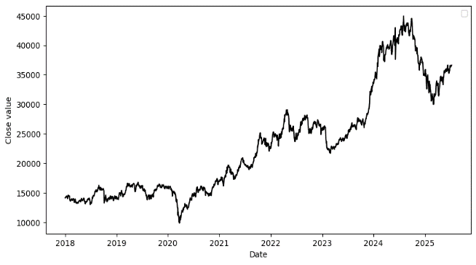
Figure 1(a): Nifty Energy Close
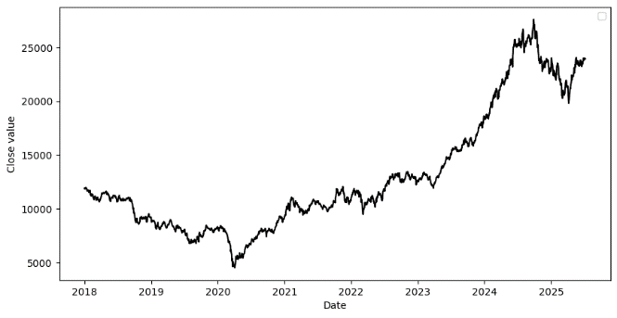
Figure 1(b) : Nifty Auto Close

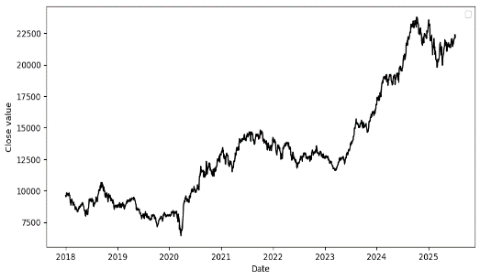
Figure 1(c): Nifty Pharma Close
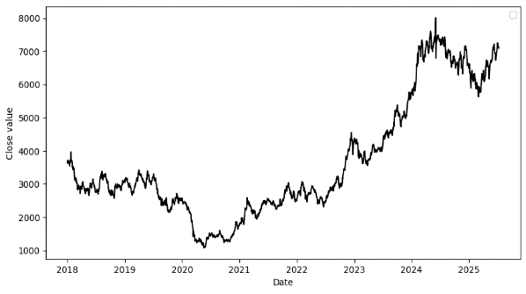 Figure 1(d): Nifty PSU Bank Close
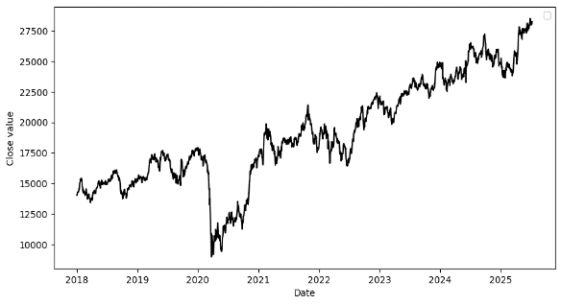
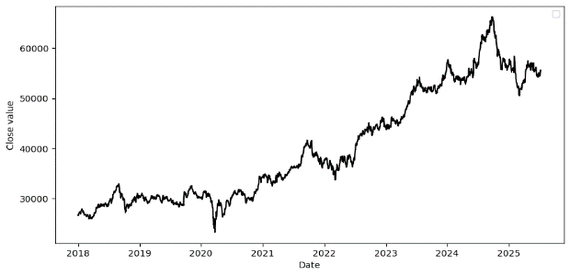
Figure 1(f): Nifty FMCG Close
Figure 1(e): Nifty Private Bank Close
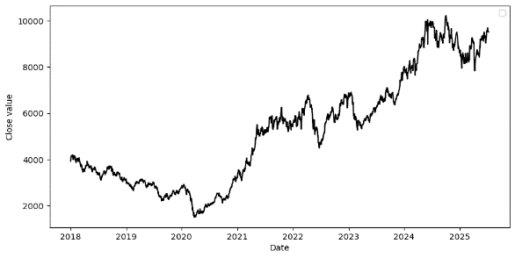
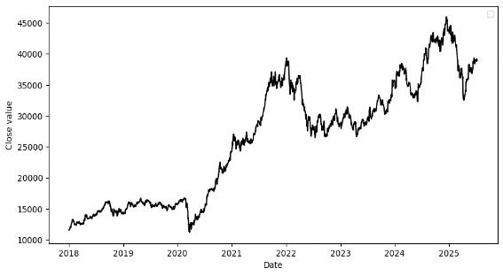
Figure 1(g): Nifty Metal Close Figure 1(h): Nifty IT Close

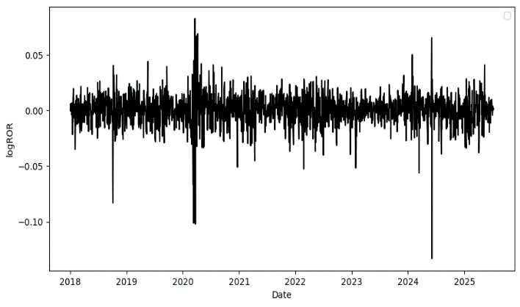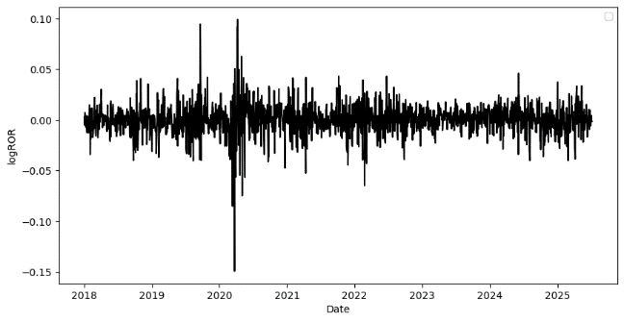
Figure 2(a): Energy Log Rate of Return Figure 2(b): Auto Log Rate of Return
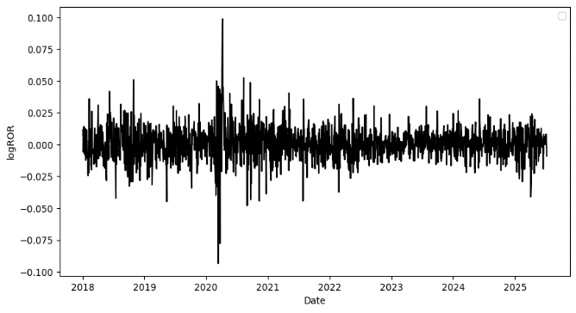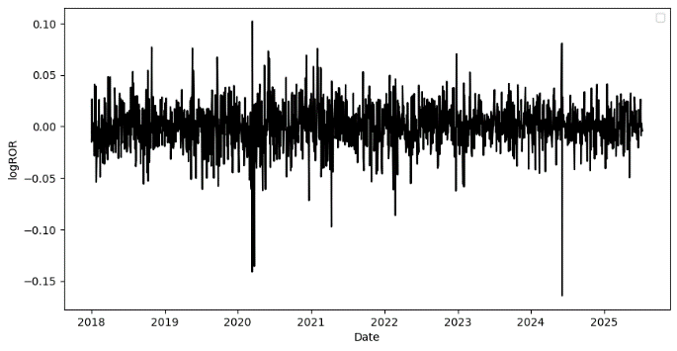

Figure 2( c): Pharma Log Rate of Return Figure 2(d): PSU Bank Log Rate of Return

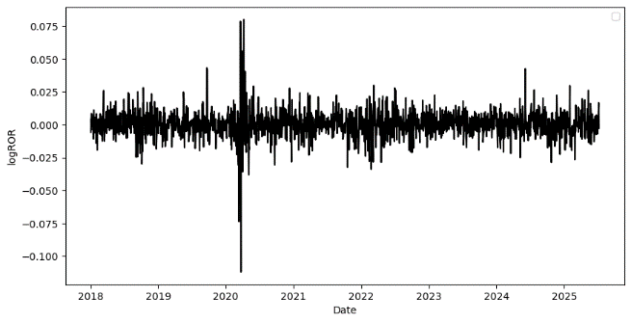

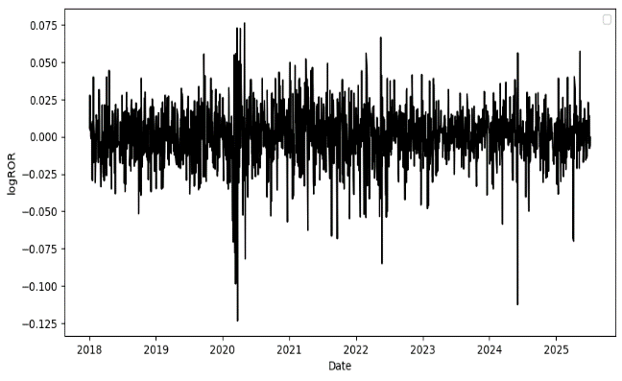

Figure 2(e): FMCG Log Rate of Return Figure 2(f): Metal Log Rate of Return

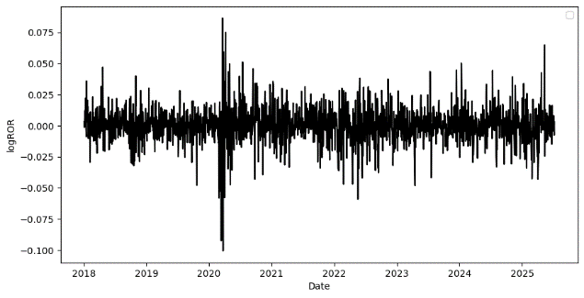
Figure 2(g): IT Log Rate of Return

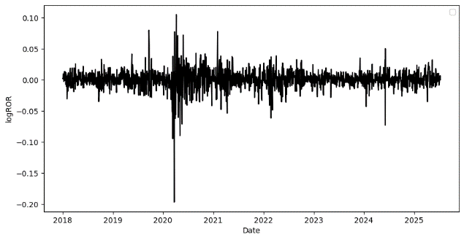
Figure 2(h): Private Bank Log Rate of Return

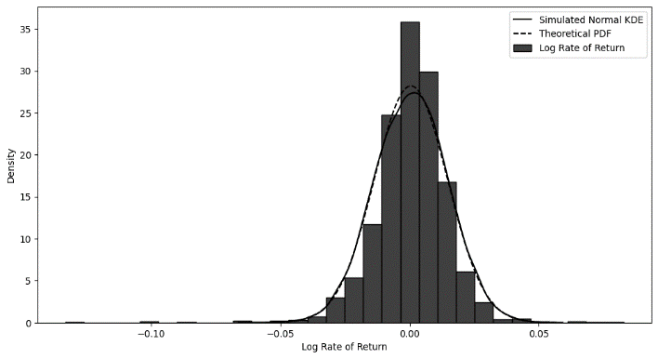
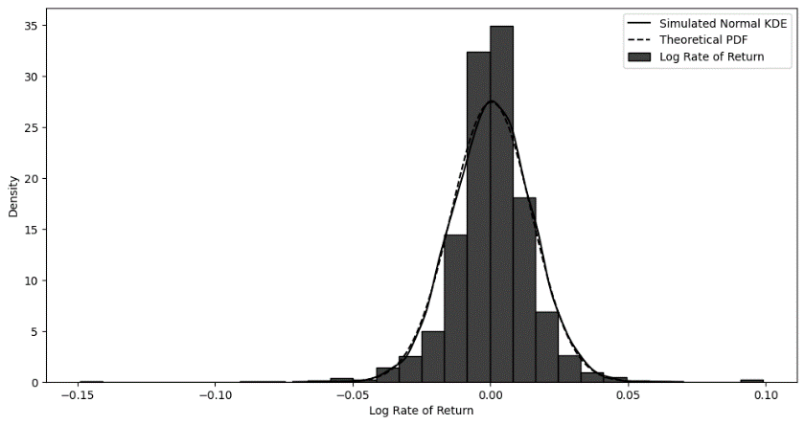

Figure 3(a): Energy KDE Plot and Theoretical PDF Figure 3(b): Auto KDE Plot and Theoretical PDF

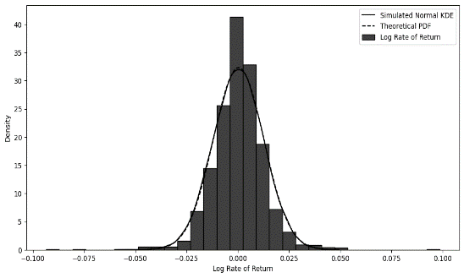
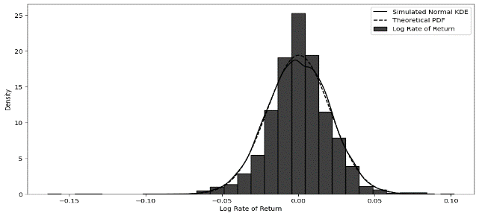
Figure 3(c): Pharma KDE Plot and Theoretical PDF Figure 3(d): PSU Bank KDE Plot and Theoretical PDF

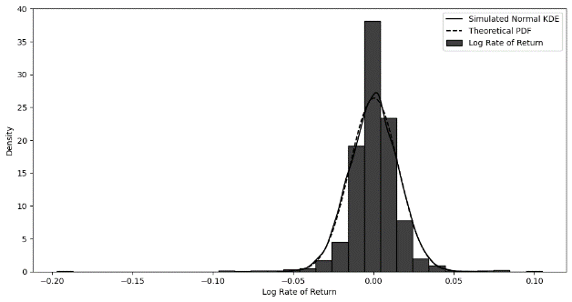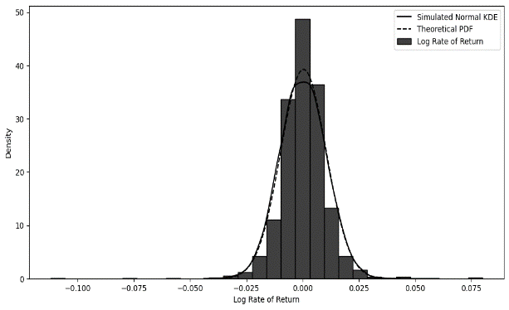
Figure 3( e): Private Bank KDE Plot and Theoretical PDF Figure 3(f): FMCG KDE Plot and Theoretical PDF

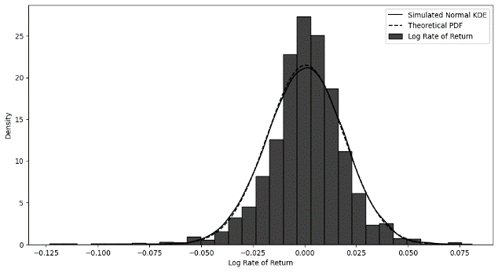
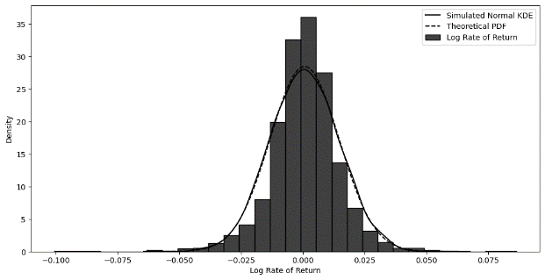

Figure 3(g): Metal KDE Plot and Theoretical PDF Figure 3(h): IT KDE Plot and Theoretical PDF

The line plots of the return rates for the NIFTY closing prices are shown in Figures 1(a) to 1(i). All panels in Figure 1 display overall upward trends with fluctuations, especially between 2020 and 2021, when all the sectoral indices dropped sharply due to high uncertainty during the pandemic years, during which a downward trend in the return rates was observed.
Furthermore, prices in the energy, auto, PSU bank, and IT sectors experienced a sharp decline during the middle of FY 2024 through the beginning of FY 2025, although there has been a recent improvement in prices in the early months of FY 2025. The performance of private banks, FMCG, and metals is relatively better on the NSE in terms of closing prices during the same periods.
The logs of the rate of returns shown in Figures 2(a) to 2(i) illustrate volatility clustering during the period analyzed. The clustering is especially apparent during the pandemic years across all sectors, as depicted in the figures. Returns vary significantly in the sectors, PSU banks, and metals.
In the figures below from 3(a) to 3(i), the actual log return values are shown by histograms, and the bold black line depicts the theoretical normal PDF distribution. The KDE plot indicated by the dashed lines for the sample shows that the theoretical PDF and the KDE plots have similar means and standard deviations for all the sectoral index log returns.
The following table reports the last actual closing prices of the index, along with the mean and standard deviation of the log returns for different sectors.
Table 2: Sector-Wise Log Return Mean and Standard Deviation for Monte Carlo
Simulations

Sector | Last Real Index  Close Price | mu | sigma
Energy | 36605.85 | 0.000611 | 0.014083
Auto | 23943.90 | 0.000482 | 0.014504
Pharma | 22165.90 | 0.000525 | 0.012356
PSU Bank | 7092.35 | 0.0563 | 0.02048
Private Bank | 28236 | 0.000489 | 0.014982
FMCG | 55504 | 0.000445 | 0.010152
Metal | 9517.4 | 0.000648 | 0.01848
IT | 38983.25 | 0.000751 | 0.014008

The mean and standard deviation values were used along with the last real index close price for analyzing the geometric Brownian motion using Monte Carlo simulations.

For each sectoral index examined, 10,000 potential paths were simulated. In other words, using GBM models with Monte Carlo simulation, 10,000 alternative scenarios of the index were generated for each trading day from 8th June 2025. These figures include a graphic representation of the 10,000 possible paths generated by the GBM models.

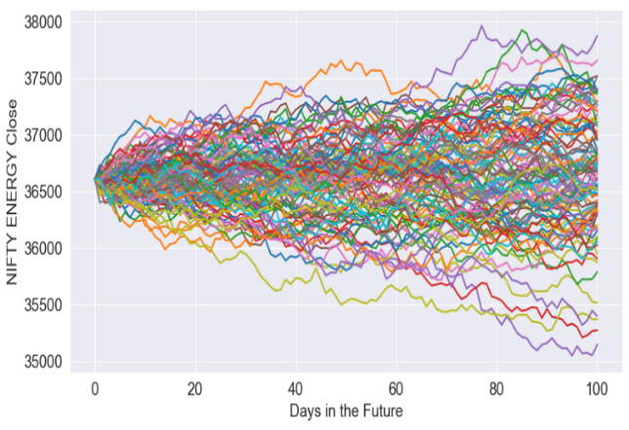
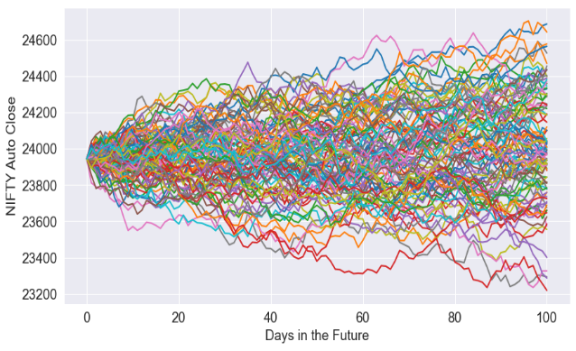

Figure 4(a): GBM Energy in the Next 100 Days Figure 4(b): GBM Auto in the Next 100 Days

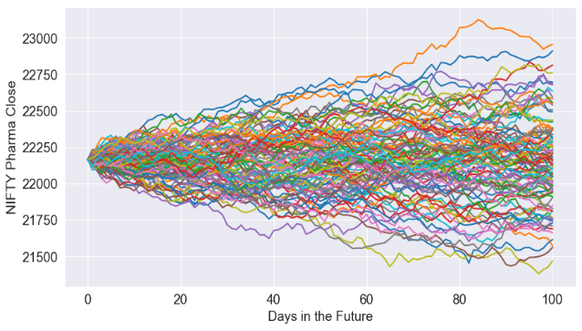
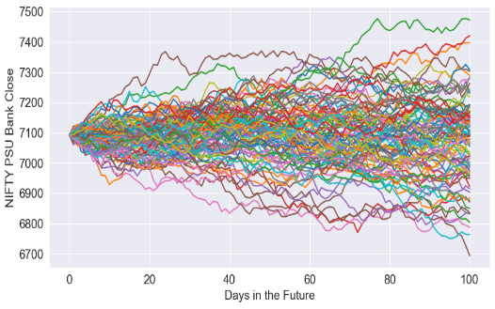

Figure 4( c): GBM Pharma in the Next 100 Days Figure 4(d): GBM PSU Bank in the Next 100 Days
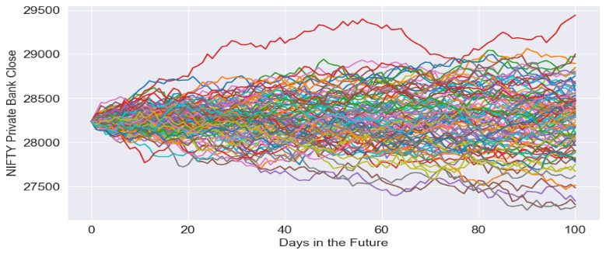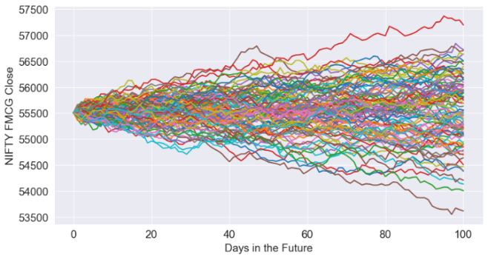
Figure 4(e): GBM Private Bank in the Next 100 Days Figure 4(f): GBM FMCG in the Next 100 Days
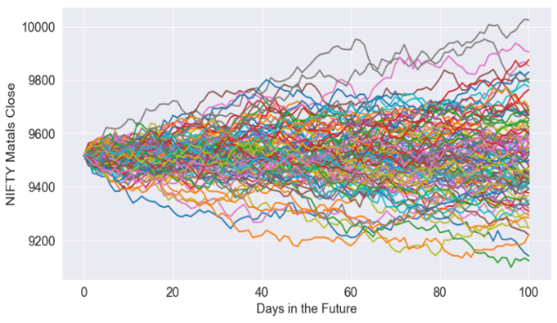

Figure 4(g): GBM Metal in the Next 100 Days
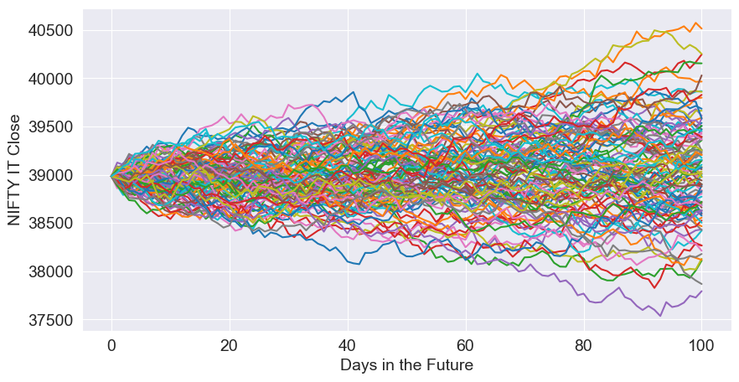
Figure 4(h): GBM IT in the Next 100 Days
The figures from 4(a) to 4(i), display simulation results of the geometric Brownian motion model applied to index closing prices for various sectors. The graphs illustrate potential future index closing prices over the next 100 days. Multiple simulations (10,000 in total) for each sector produce possible future paths of the NIFTY sectoral index, based on historical log returns.
The trajectories illustrate the uncertainty and volatility in the future performance of the sectoral index. The spread of the simulated future paths of the index close price shows the extent of volatility, and the potential loss from the mean returns defines the amount of risk.
Figures 4(e) and 4(f) show that the spread of the trajectories for private banks and FMCG, respectively, is slightly narrower than that of the other trajectories in the remaining diagrams. The highest expected future price for the private bank is 29500, but this value applies to only one trajectory. Otherwise, the potential future paths mainly range from 27500 to 29000. For the FMCG sector, most trajectories are confined between 54000 and 56500. Only two trajectories, one ascending and the other descending from the last actual value, extend beyond these upper and lower limits.

Table 3: Sector-Wise Values of VaR and CVaR
Sector | VaR (Rs.) | CVaR (Rs.)
Energy | 823.44 | 1045.45
Auto | 547.34 | 698.82
Pharma | 283.81 | 355.36
PSU Bank | 229.58 | 290.86
Private Bank | 678.19 | 854.28
FMCG | 896.53 | 1130.81
Metal | 283.81 | 355.36
IT | 877.33 | 1097.69

In Table 3, the sector-wise VaR and CVaR values are reported. The maximum amount of risk is observed in FMCG as the values are Rs. 896.53 and Rs. 1130.81, respectively. At the 100th day, the FMCG index might close down Rs. 896 from its initial value of Rs. 55504, representing the maximum potential loss. The CVaR value of Rs. 1130.81 represents the average of the maximum potential loss.
Conclusion
The current study examined volatility and risk in the Indian stock market using data from selected sectoral indices listed on the NSE. This paper analyzed the price dynamics of eight sectors traded on the national stock exchange, and the GBM proved to be a suitable model for forecasting stock market index values, as it effectively predicts their future development through Monte Carlo simulations. The results showed that volatility exists in nearly all sectoral indices, with a wide range of projected stock prices over the next 100 trading days. The maximum potential loss for investors across different sectors is relatively lower in the pharma, PSU Bank, and Metal sectors, as indicated by the VaR and CVaR values.
Reference
Antoniou, A., Pescetto, G. M., & Stevens, I. (2007). Market-wide and sectoral integration Evidence from the UK, USA and Europe. Managerial Finance, 33(3), 173–194. https://doi.org/10.1108/03074350710718266
Choi, K. H., McIver, R. P., Ferraro, S., Xu, L., & Kang, S. H. (2021). Dynamic volatility spillover and network connectedness across ASX sector markets. Journal of Economics and Finance, 45(4), 677–691. https://doi.org/10.1007/s12197-021-09544-w
Costa, A., Matos, P., & da Silva, C. (2022). Sectoral connectedness: New evidence from US stock market during COVID-19 pandemic. Finance Research Letters, 45(May), 102124. https://doi.org/10.1016/j.frl.2021.102124
Hamdi, B., Aloui, M., Alqahtani, F., & Tiwari, A. (2019). Relationship between the oil price volatility and sectoral stock markets in oil-exporting economies: Evidence from wavelet nonlinear denoised based quantile and Granger-causality analysis. Energy Economics, 80, 536–552. https://doi.org/10.1016/j.eneco.2018.12.021
Mensi, W., Hammoudeh, S., Sensoy, A., & Yoon, S. M. (2017). Analysing dynamic linkages and hedging strategies between Islamic and conventional sector equity indexes. Applied Economics, 49(25), 2456–2479. https://doi.org/10.1080/00036846.2016.1240349
Tiwari, A. K., Pathak, R., DasGupta, R., & Sadorsky, P. (2021). Modelling dependence and systemic risk between oil prices and BSE sectoral indices using stochastic copula and CoVar, ΔCoVar and MES approaches. Applied Economics, 53(58), 6770–6788. https://doi.org/10.1080/00036846.2021.1949430
Trabelsi, N., Gozgor, G., Tiwari, A. K., & Hammoudeh, S. (2021). Effects of price of gold on Bombay stock exchange sectoral indices: New evidence for portfolio risk management. Research in International Business and Finance, 55 (August 2020) 101316. https://doi.org/10.1016/j.ribaf.2020.101316
Trimono, Trimono & Maruddani, Di & Riyantoko, Prisma & Susrama, Gede. (2021). Geometric Brownian Motion and Value at Risk for Analysis Stock Price of Bumi Serpong Damai Ltd., International Journal of Data Science, Engineering, and Analytics, 1, 11-21.
L. Jeff Hong, Zhaolin Hu, and Guangwu Liu. 2014. Monte Carlo methods for value-at-risk and conditional value-at-risk: A review. ACM Transactions on Modeling and Computer Simulation 24(4), Article 22 (November 2014), 1-37. DOI: http://dx.doi.org/10.1145/2661631

