A COMPARISON OF CLASSICAL NON-PARAMETRIC AND BAYESIAN NON-PARAMETRIC APPROACHES IN GRADE COMPARISONS BETWEEN TWO MATHEMATICALLY-BASED FACULTIES IN A TERTIARY INSTITUTION

Abstract
In this study, two statistical methods, the Mann Whitney U test and the Bayesian non-parametric (BNP). Mann Whitney U test were employed to investigate if there exist a significant statistical difference in performances (recorded as grades) of students in two faculties of a university. While the classical test yielded no statistically significant difference (p = 0.229), the Bayesian analysis provided moderate evidence favoring the null hypothesis (BF₁₀ = 0.284), though posterior estimates suggested a slight performance edge for Computing students. These findings underscore the value of Bayesian methods in educational research, especially when classical results are inconclusive.
Keywords: Non-parametric Statistics, Bayesian inference, Mann-Whitney U test, Students performances, Comparison.
- Introduction
Mathematics is a cornerstone of analytical thinking and problem-solving across disciplines, particularly in science and technology-oriented faculties. Performance in foundational mathematics courses often reflects students’ preparedness, cognitive styles, and institutional support structures. Performances of students from different departments or different faculties can be compared in a particular course in order to discover the department/faculty that performs better in the course, especially when the participants are taught by different instructors/methods or when it is desired to test and compare the cognitive knowledge of the participants. This comparison could be done using diverse statistical techniques. However, when the performances are given only in letter grades which are ordinal and not normally distributed, the traditional parametric tests such as the independent samples’ t-test are unsuitable and hence one quickly thinks of non-parametric statistical approaches, one of which is the Mann Whitney U test, for example, McKnight & Najab (2010). In the recent time, it has been observed that Bayesian approaches could also be used to do such comparison by converting the letter grades into ordinal numerical data, for example, Almond et al. (2015), Rouder et al. (2009), among others.
Therefore, the problem in this study is to compare the non-parametric approach and the Bayesian approach in comparing performances/ratings of two or more groups that appear in grades. This study investigates whether there is a statistically significant difference in grade distributions between two faculties. Specifically, the Mann-Whitney U test, a non-parametric alternative, is employed to compare the central tendencies of the two groups. To complement this, a Bayesian Mann-Whitney U test is conducted, offering a probabilistic interpretation of the evidence and allowing for nuanced insights beyond the binary decision framework of classical hypothesis testing. The results of the methods were then compared and inference drawn.
- Literature Review
Non-Parametric Approaches in Educational Assessment
Non-parametric methods are widely used in educational research when data violate assumptions of normality or homogeneity of variance. The Mann-Whitney U test is particularly effective for comparing ordinal outcomes, such as letter grades converted to numerical scores. Studies such as McKnight & Najab (2010) emphasize its robustness in detecting differences in central tendency without assuming normal distribution. For example, Zamkcova, Prokop and Stolin (2020) used the Mann Whitney U test, Kruskal-Wallis test as well as post hoc analysis to compare the overall grades of students between men and women on one hand and between Finance and Management students and Travel and Tourism students on the other hand in a basic statistics course in a polytechnic. Their results show that women tend to achieve better grades than men while Finance and Management students tend to achieve better grades than Travel and Tourism students.
Non-parametric methods remain essential in educational research, particularly when data violate assumptions of normality or equal variance. These methods are distribution-free and often more robust in handling ordinal data, skewed distributions, and small sample sizes.
According to McKnight & Najab (2010), the Mann-Whitney U Test is widely used for comparing two independent groups when the outcome is ordinal or not normally distributed. Its simplicity and robustness make it a staple in educational studies, especially when evaluating interventions or comparing student performances across groups .
Wasserstein et al. (2019), observed that non-parametric tests are limited by their reliance on p-values, which are sensitive to sample size and do not quantify the strength of evidence. According to them, p-values alone can be misleading, especially when results hover near conventional thresholds (e.g., p = 0.05). Sen et al. (2023), also noted that non-parametric tests often lack the ability to estimate effect sizes directly and rely heavily on p-values, which can be misleading in small or large samples.
It has been adduced that Bayesian approaches offer a paradigm shift by allowing researchers to incorporate prior knowledge and interpret results probabilistically. This is particularly valuable in educational settings where historical data or expert judgment can inform analysis. For example, Uglanova (2021) conducted a systematic review showing how BNs enhance flexibility in modeling educational data and support real-time updating of students’ profiles. Almond et al. (2015) integrated Bayesian networks into Evidence-Centered Design (ECD) frameworks, enabling assessments that adapt to student responses and provide richer diagnostic feedback. This design-forward approach supports modularity and nuanced interpretation of students’ performances. Rouder et al. (2009) demonstrated that Bayesian Mann-Whitney tests yield more informative conclusions, especially in borderline cases. According to them, Bayes Factors quantify evidence strength, while credible intervals offer intuitive estimates of uncertainty. Yurtcu, Kelecioglu and Boone (2021) compared the equated scores obtained from Bayesian non-parametric (BNP) model with the outcomes of classical test theory equating method. They discussed two different (mean and linear) equating methods for the classical theory and analysed the distance between the equated scores obtained from mean, linear equating methods and the BNP model to the target test score. Considering the equated scores obtained from the three different methods, it was found out that the equated scores with the BNP model produced a distribution closer to the target test.
Hai Q. and Ma Zhuan, Z. (2025) introduced Bayesian testing procedures based on Bayes factor to compare the means across multiple population in classical non-parametric contexts. Their method was designed to maximize the probability of rejecting the null hypothesis when the Bayes factor exceeds a specified evidence threshold. They demonstrated that the method effectively control Type I error and enable researchers to make consistent decisions aligned with both frequentist and Bayesian approaches provided that the evidence threshold for the Bayesian methods is set according to the significance level of the frequentist tests.
3. Methods
Two hundred students each was taken from Faculty of Science and Faculty of Computing of a university. The students’ performances for the same academic session in Elementary Mathematics I (Algebra and Trigonometry) in letter grades in the two faculties were compared using the Mann Whitney U Test and the Bayesian method. For the purpose of the analysis, the letter grades were converted to ordinal data: A = 5, B = 4, C = 3, D = 2, E = 1, F = 0.
3.1 Mann-Whitney U Test
The Mann-Whitney U test is a distribution free test in which the data in each group are first ordered from lowest to highest. Values in the entire data set, from both faculties, are then ranked, with the average rank being assigned as tied values as it is for the Wilcoxon rank-sum test. The ranks are then summed for each group, and U is determined:
$U_{1}$= $n_{1}n_{2}$ + $\frac{n_{1}\left(n_{1}+1\right)}{2}$ – $R_{1}$
$U_{2}$=$n_{1}n_{2}$ + $\frac{n_{2}\left(n_{2}+1\right)}{2}$ – $R_{1}$,
where
$n_{1 }$ and $n_{2}$ are the sample sizes for Group 1 and Group 2 respectively with $R_{1}$ and $R_{2}$
as the sum of ranks for each group in that order.
$U_{1}$ is the Mann-Whitney statistic for Group 1 and $U_{2}$ is the Mann-Whitney statistic for Group 2.
For the level of significance for a comparison of the two groups, the larger value of $U_{1}$ or $U_{2}$ is used. This is compared to critical values as found in the Mann-Whitney U table.
3.2 Bayesian Methods
Bayesian statistics offer a compelling alternative by quantifying the strength of evidence through Bayes Factors and providing credible intervals for parameter estimates. Unlike frequentist methods, Bayesian inference allows researchers to incorporate prior knowledge and interpret results in terms of probability. Rouder et al. (2009) demonstrated the utility of Bayesian Mann-Whitney tests in psychological and educational studies, showing that they often yield more informative conclusions, especially in borderline cases.
In this study, the Bayesian Mann-Whitney U test provides a Bayes Factor (BF₁₀), indicating the likelihood of the alternative hypothesis relative to the null. A BF₁₀ below 1 suggests support for the null, while values above 1 indicate evidence for a difference. The posterior distribution and credible intervals further enrich the interpretation by estimating the magnitude and uncertainty of the difference.
3.3 Hypothesis
H₀: There is no significant difference between the grades from both Faculties
H:₁ There is a significant difference between the grades from both Faculties
- Results and Discussions
In this section, the classical Mann Whitney U test and the Bayesian non-parametric Mann Whitney U test were applied to data collected on the performances of students in MTH 111- Elementary Mathematics 1 (Algebra and Trigonometry) from Faculty of Science and Faculty of Computing in Dennis Osadebay University, Asaba . Some descriptive statistics were also obtained. The Data were analyzed using JASP (Version 0.19.2.0). The results are as presented in this section.
4.1 Results
 |  | Group |  | N |  | Mean |  | SD |  | SE |  | Coefficient of variation |  | Mean Rank |  | Sum Rank
Grade |  | Computing |  | 200 |  | 3.225 |  | 1.358 |  | 0.096 |  | 0.421 |  | 207.305 |  | 41461.000
 |  | Science |  | 200 |  | 3.010 |  | 1.524 |  | 0.108 |  | 0.506 |  | 193.695 |  | 38739.000
Table 1: Results of Descriptive Statistics Analysis
The results in Table.1 show that students in the Faculty of Computing have a slightly higher mean grade (3.225 vs. 3.010). The lower coefficient of variation suggests more consistent performance in Computing compared to Science.
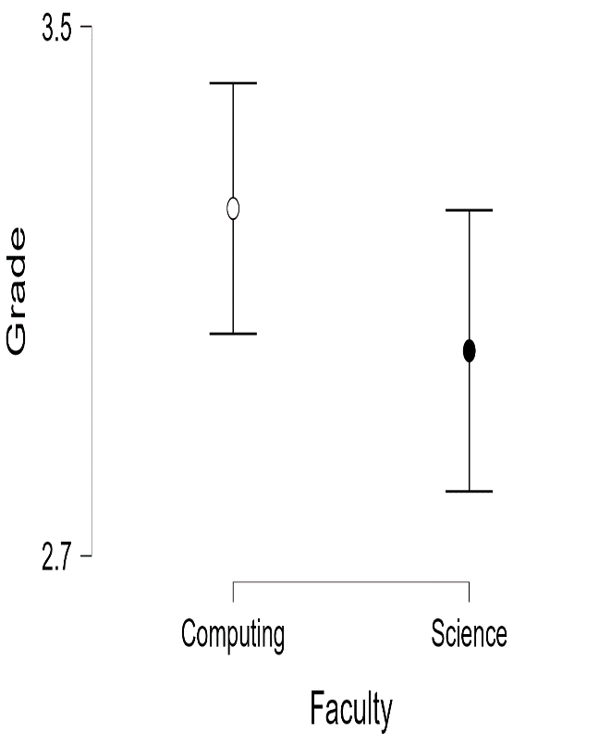
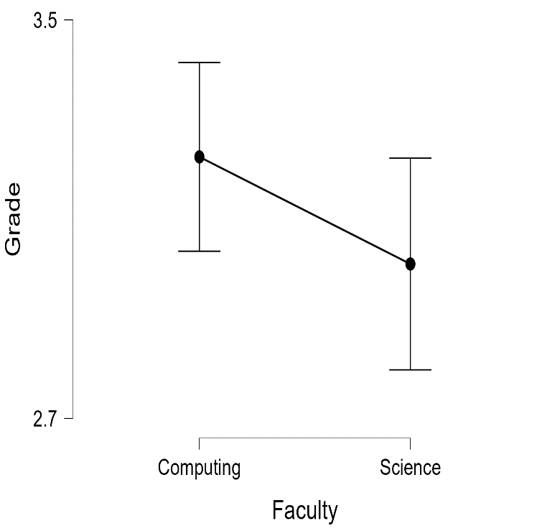

Figure 1a : Mann Whitney U Test Figure 1b: Bayesian Mann Whitney Test
Table 2 : Results of the Mann Whitney U Test
 |  |  |  |  |  |  |  |  |  |  |  | 95% CI for Hodges-Lehmann Estimate
 |  | U |  | df |  | p |  | VS-MPR* |  | Hodges-Lehmann Estimate |  | Lower |  | Upper |  | Rank-Biserial Correlation |  | SE Rank-Biserial Correlation
Grade |  | 21361.000 |  |  |  | 0.229 |  | 1.089 |  | 2.543×10⁻⁵ |  | -2.024×10⁻⁵ |  | 1.928×10⁻⁵ |  | 0.068 |  | 0.058
Note. For the Mann-Whitney test, effect size is given by the rank biserial correlation.
Note. Mann-Whitney U test.
* Vovk-Sellke Maximum p -Ratio: Based on a two-sided p -value, the maximum possible odds in favor of H₁ over H₀ equals
1/(-e p log(p )) for p ≤ .37 (Sellke, Bayarri, & Berger, 2001).
U = 21361, p = 0.229,
Rank-Biserial Correlation = 0.068
TFrom the results of the Mann Whitney U test, the p-value > 0.05 indicates no statistically significant difference in grade distributions. The small effect size (r = 0.068) suggests a weak association between faculty and grade performance.
Table 3: Results of the Bayesian Mann-Whitney U Test
 |  | BF₁₀ |  | W |  | Rhat
Grade |  | 0.284 |  | 21361.000 |  | 1.000
Note. Result based on data augmentation algorithm with 5 chains of 400 iterations.

BF₁₀ = 0.284, Posterior Median Difference = +0.137
95% Credible Interval = [-0.049, 0.343]
The Bayes Factor (BF₁₀ = 0.284) provides moderate evidence in favor of the null hypothesis, meaning the data are about 3.4 times more likely under the null than the alternative. However, the posterior median difference suggests a small positive shift favoring Computing, though the credible interval includes zero, indicating uncertainty.
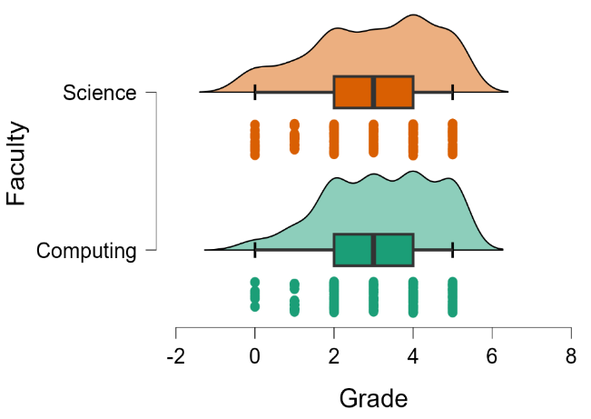
Fig 2 Raincloud Plots:
Fig 2 combines boxplots, density plots, and raw data points. It shows overlapping distributions with slightly higher density around grade 3–4 for Computing.
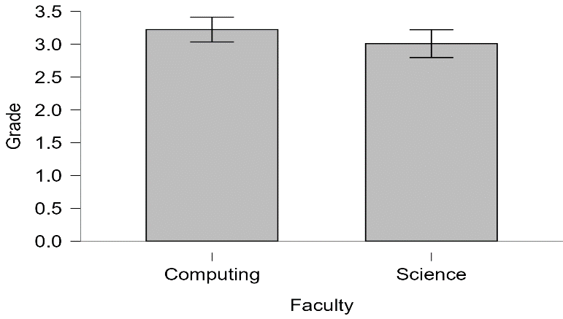
Fig 3: Bar Plot for Computing and Science

Fig 3 revealed that Faculty of Computing shows more students with A and B grades, while Faculty of Science shows more C and D grades

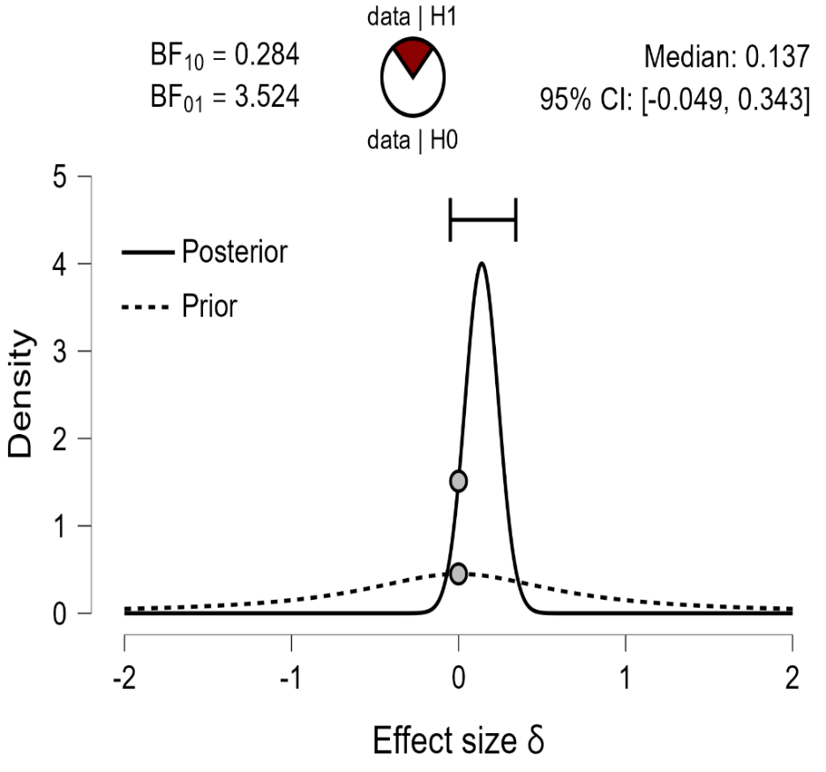

Figure 4: Prior and Posterior Distributions for the two Faculties

Posterior distributions for Computing are slightly shifted right compared to Science.
Credible intervals suggest overlap but lean toward higher performance in Computing.
Prior and posterior: Displays the prior (dashed line) and posterior (solid line) distribution of
the effect size under the alternative hypothesis; the gray circles represent the height of the
prior and the posterior density at effect size delta = 0. The horizontal solid line represents
the width of the 95% credible interval of the posterior distribution.

4.2 Discussion of Results
While the Mann-Whitney U test failed to reject the null hypothesis, the Bayesian analysis provided a more detailed result. The Bayes Factor suggests moderate support for the null, but the posterior distribution hints at a small performance advantage for computing students. This discrepancy highlights the limitations of p-values and the strength of Bayesian inference in educational research. These results agree with the results obtained in Yurtcu, Kelecioglu and Boone (2021). Studies such as Dienes (2014) also argue that Bayesian methods are superior in cases where p-values are non-significant but the effect size is non-trivial. Bayesian analysis allows researchers to quantify uncertainty and avoid binary conclusions, making it a valuable complement to classical tests.
The posterior median difference of +0.137 and the credible interval [-0.049, 0.343] from the BNP suggest a small advantage for Computing students, albeit with uncertainty. This divergence between classical and Bayesian results reflects broader debates in statistical methodology. Classical tests rely heavily on p-values, which can obscure meaningful trends when sample sizes are moderate and effect sizes are small. In contrast, Bayesian inference allows for probabilistic reasoning and the incorporation of prior knowledge, making it particularly useful in educational contexts where data often violate parametric assumptions.
The raincloud and bar plots visually reinforce the numerical findings, showing slightly higher grade densities and frequencies of A/B grades in Computing. These patterns may be influenced by factors such as student motivation, faculty culture, or pedagogical alignment with computing curriculum.
4.3 Conclusion
This study demonstrates that while traditional non-parametric tests may fail to detect significant differences in grade distributions, Bayesian methods can uncover subtle trends and quantify uncertainty. The moderate evidence supporting the null hypothesis suggests that performance in MTH 111 Elementary Mathematics 1 (Algebra and Trigonometry) is broadly comparable across faculties, though computing students may exhibit slightly stronger outcomes. These insights advocate for a dual-method approach in educational assessment, combining robustness with interpretive depth.

- References
- Almond, R. G., Mislevy, R. J., Steinberg, L. S., & Yan, D. (2015). Bayesian networks in educational assessment. Springer.
- McKnight, P. E., & Najab, J. (2010). Mann-Whitney U Test. In The Corsini Encyclopedia of Psychology (4th ed.). Wiley. https://doi.org/10.1002/9780470479216.corpsy0524
- Rouder, J. N., Speckman, P. L., Sun, D., Morey, R. D., & Iverson, G. (2009). Bayesian t tests for accepting and rejecting the null hypothesis. Psychonomic Bulletin & Review, 16(2), 225–237. https://doi.org/10.3758/PBR.16.2.225
- Sellke T., Bayarri, M. & Berger J. ((2001). Calibration of p-values for testing precise Null Hypothesis, The American Statistician, 55, 62-71.
- Sen, S., Roy, S., & Das, S. (2023). A review on parametric and non-parametric test in education. International Journal of Research and Analytical Reviews, 10(1), 45–52.
- Wasserstein, R. L., Schirm, A. L., & Lazar, N. A. (2019). Moving to a world beyond “p < 0.05”. The American Statistician, 73(sup1), 1–19. https://doi.org/10.1080/00031305.2019.1583913
- Yurtcu, M. Kelecioglu H. and Boone E. L. (2021). The Comparison of the Scores obtained by Bayesian nonparametric model and Cassical Test Theory Methods, National Libraryof Medicine, PMC 104 (3)
- Zamkova M., Prokop, M. and Stolin R. (2020). Non-parametric ANOVA Method applied on Students’ Performance Development in Course of Statistics, Acta Universitatis Agriculture Et Silviculturae Mendelianae Beunensis, Vol. 68(1).
- Hai Q. and Ma Zhuan, Z. (2025). Bayesian Nonparametric Hypothesis testingg Methods on Multiple Comparisons, Computational Statistics, Vol. 40

