Is Robotic-Assisted Better Than Freehand Technique for Scaphoid Screw Fixation in Acute Scaphoid Fracture Case?: A Systematic Review and Meta-analysis

Abstract
Introduction: Accurate screw fixation of scaphoid fractures is essential for optimal healing and restoration of wrist function. Robotic-assisted surgical techniques have been developed to enhance placement accuracy and reduce radiation exposure when compared to conventional freehand methods. Evaluating the effectiveness of these techniques is necessary to inform clinical decision-making.
Purpose: This systematic review and meta-analysis aimed to compare robotic-assisted and freehand scaphoid screw fixation techniques in terms of surgical accuracy, operative time, radiation exposure, and clinical outcomes including wrist function, grip strength, and complications.
Materials & Methods: We conducted a systematic review and meta-analysis following the PRISMA guidelines and the Cochrane Handbook. Two independent reviewers searched PubMed, Embase, the Cochrane Library, and Web of Science up to May 2025. The included studies comprised one randomized controlled trial and one retrospective cohort study, involving a total of 54 patients. Risk of bias was assessed using the ROB 2 and ROBINS-I tools. Evaluated outcomes included operative time, fluoroscopy usage, screw placement accuracy, complications, fracture union, and wrist function measured using the Mayo Modified Wrist Score.
Results: The study found no significant difference in Mayo scores (Z = 0.35, P = 0.73) with heterogeneity was moderate (Chi² = 1.69, I² = 41%, P = 0.19), or operative time (Z = 0.04, P = 0.97) with very high heterogeneity among the studies (Chi² = 41.18, P < 0.00001; I² = 98%), between robotic-assisted and freehand techniques. Robotic fixation showed slightly higher Mayo scores but longer operative time. Statistical analyses revealed wide confidence intervals and high heterogeneity, indicating variability and uncertainty in pooled results across the included studies.
Discussions: Robotic-assisted screw fixation offers improved placement precision and lower intraoperative radiation exposure, indicating technical superiority over the freehand method. However, these technical advantages did not translate into superior clinical outcomes. The longer setup time and higher cost may limit widespread adoption, especially in low-resource settings. Nonetheless, this technique may be particularly beneficial for surgical trainees or in complex cases requiring high precision.
Conclusions: Robotic-assisted scaphoid fixation showed trends toward better accuracy, lower radiation, and fewer attempts, but differences were not statistically significant. Clinical outcomes were similar between techniques. While robotic systems offer technical precision, their superiority remains unproven. Larger studies with longer follow-up are needed to confirm potential long-term advantages.
Keywords: Robotic-assisted surgery, scaphoid fracture, screw fixation, freehand technique, surgical accuracy, radiation exposure, wrist function, meta-analysis.

INTRODUCTION
Scaphoid fractures represent 50–80% of all carpal bone fractures and constitute about 3% of wrist fractures overall. The yearly incidence is approximately 29 cases per 100,000 people, predominantly affecting young adults (1). Treating scaphoid fractures has long been challenging due to the bone’s unique anatomical structure and limited blood supply. Conventional plaster immobilization usually requires eight to twelve weeks for healing, whereas the use of compression cannulated screws can accelerate this process. Precise screw placement is critical for surgical success and typically involves multiple fluoroscopic checks. In recent years, robot-assisted technology has been introduced in orthopaedics to enhance the accuracy of screw positioning (2).
Various surgical techniques have been reported in the literature, yet the optimal treatment approach for scaphoid fracture remains controversial (3). The surgical management of acute scaphoid fractures has evolved significantly with the introduction of robotic-assisted techniques. Compared to the conventional freehand method, robotic-assisted screw fixation offers improved accuracy in screw placement, potentially enhancing stability, union rates, and clinical outcomes (4).
The use of robotic-assisted surgery in orthopaedics has grown steadily due to its ability to increase surgical accuracy, shorten patient recovery periods, and enhance overall outcomes. By 2023, the global market for surgical robots was valued at $3.92 billion, with projections estimating growth to $7.42 billion by 2030 5. Over the past three decades, substantial progress has been made in robotic orthopaedic surgery, especially in adult joint replacement and spinal procedures (6). The adoption of robotic technology is propelled by innovations and its proven effectiveness in improving the diagnosis and treatment of musculoskeletal disorders. These robotic systems offer sophisticated imaging and real-time feedback during surgery, enabling more precise and customized interventions aimed at minimizing complications and optimizing patient results (7).
The use of percutaneous screw fixation, commonly referred to as the free-hand technique, has gained considerable popularity recently for managing minimally displaced scaphoid fractures, especially in young and active patients (8). Research indicates that this method facilitates earlier mobilization, faster bone healing, improved functional recovery of the hand, and a quicker return to daily activities compared to conventional cast immobilization (9). Precise placement of the screw is essential for the procedure’s success but remains challenging due to the small size and complex shape of the scaphoid, even among experienced hand surgeons (5-9). This difficulty is heightened when inserting two parallel screws; nevertheless, dual-screw fixation has demonstrated superior stability over single-screw fixation and may be advantageous or necessary depending on the fracture configuration (4).
To our knowledge, there is no systematic review and meta-analysis comparing robotic surgery and freehand technique for scaphoid fracture in the literature. Thus, we aim to compare the clinical outcomes and complications of scaphoid fracture using robotic surgery and freehand technique based on direct comparative studies.

METHODS
In alignment with the Preferred Reporting Items for Systematic Reviews and Meta-Analyses (PRISMA) 2020 guidelines10 for systematic reviews and Cochrane's methodological standards for intervention reviews (11), the complete protocol for this systematic review has been registered with PROSPERO (registration number: CRD420251054950) (12).

Eligibility criteria
This systematic review and meta-analysis directly compared robotic and freehand screw fixation techniques for scaphoid fractures, evaluating parameters such as radiation exposure time, operative time, blood loss, Mayo wrist score, angular deviation, setup duration, guidewire insertion and attempts, total C-arm usage, range of motion, grip strength, and VAS score. The robotic system used manufacture by Beijing Tianzhihang Medical Technology Co., Ltd., China comprised a manipulator, optical tracking device, planning workstation, and surgical instruments, enabling accurate navigation through infrared technology and reference markers. No publication date restrictions were applied. Only full-text, peer-reviewed articles published in English were included. Studies addressing other types of neglected scaphoid fractures, avascular necrosis, or unicortical scaphoid fractures were excluded, as were case reports, case series, reviews, systematic reviews, meta-analyses, editorials, letters, book chapters, study protocols, preclinical studies (in vitro, cadaveric, animal), and conference abstracts lacking full reports.

Electronic search
A systematic search of the electronic literature was carried out by the authors in the following databases:
- MEDLINE (PubMed): 1993 to present (29th May 2025)
- Embase (Ovid): 1980 to present (29th May 2025)
- CENTRAL (Cochrane library): from inception to present (29th May 2025)
- Web of Science: 1993 to present (29th May 2025)

Our search was performed using both free text (title/abstract/keywords) in all databases and subject headings in MEDLINE (MeSH) and Embase (Emtree). A comprehensive list of keywords and search strategies was provided in the supplementary information in order to provide detailed information concerning keywords and search strategies. We derived our search strategy by applying the appropriate Boolean operators ("AND","OR","NOT") to queries based on the PICO concept (Populations, Intervention, Comparison, Outcome). The concept keywords were added by "AND" and the connected keywords by "OR". A study population comprised RCTs patients who had Schapoid Fracture. For the purpose of collecting the largest amount of relevant literature possible, we employed extensive word variations, truncations (*), and phrase searching (""). The balance between sensitivity and specificity must be maintained. The intervention of this literature review was the use robot assisted surgey using TiRobot in scaphoid fracture. As a comparison, freehand surgery was used to repair the scaphoid fracture. As a primary outcome, Mayo wrist score and operative time was measured. Secondary outcomes included radiation exposure time, blood loss, angular deviation, setup duration, guidewire insertion and attempts, total C-arm usage, range of motion, grip strength, and VAS score.

Study selection and data extraction
We exported the references to Rayyan (13) for manual deletion of duplicates, and then two independent reviewers (BRM and MPK) screened them using Rayyan (13) for their title and abstract. For full text reading, articles that meet our inclusion criteria will be marked as "included", while articles that do not meet our criteria will be marked as "excluded". For further discussion, uncertain studies were marked "maybe". References were retrieved and evaluated. To determine whether the potentially eligible studies met the inclusion criteria, the reviewers conducted a thorough review. In order to resolve any discrepancies that may have occurred, all references were checked for additional relevant studies. Figure 1 outlines our workflow according to PRISMA 2020 (10). Standardized data extraction was performed using Microsoft Excel (Microsoft Corporation, USA). In addition to a detailed description of the author, publication year, country, study design, demographics of the patients (age and gender), follow-up length, radiation exposure time, operative time, blood loss, Mayo wrist score, angular deviation, setup duration, guidewire insertion and attempts, total C-arm usage, range of motion, grip strength, and VAS score and conclusions reached.

Risk of bias assessment
We assessed randomized controlled trials using the Cochrane Risk of Bias (RoB) 2 tool (14). Non-RCTs were assessed using the Risk Of Bias In Non-Randomised Studies-of Intervention (ROBINS-I) tool.15 Using the Risk-of-Bias Visualization (Robvis) tool, the bias assessment summary was visualized (16). A robust meta-analysis was performed by using only studies with moderate bias or better (17).

Synthesis of results
For heterogeneity analysis, Cochran's Q and I2 tests were conducted. The random effect model was chosen when Cochran's Q was less than 0.1 and I2 was greater than 50%. Otherwise, the fixed effect model was used. Additionally, we planned a subgroup analysis based on the materials used in the suture anchors used in the studies in order to investigate why heterogeneity is high. To conduct meta-regressions, a minimum of ten studies must be analysed (18).

Evidence quality assessment
We evaluated our evidence quality using the Grading of Recommendations, Assessment, Development and Evaluations (GRADE) approach recommended by the Cochrane Method (19–21). The GRADE approach assesses five domains of quality: the risk of bias for an individual study is assessed by RoB2 and ROBINS-I tools; the inconsistency test measures inconsistency; indirectness is measured based on whether the PICO elements are easily recognizable in order to answer our review question, imprecision is determined by evaluating the sample size, and other factors (20).

Results
We retrieved 265 records from four databases using search strategies after manually removing 4 duplicate articles by checking title and abstract similarity. Two independent reviewers selected 10 studies for full-text article evaluation after screening 261 records based on title and abstract. We excluded eight studies. These studies were made up of two studies where two types of operative technical note; one study was clinical trial protocol; one study written in chinese; one study different technique comparison and three study used non-comparative group study design. The flowchart of the PRISMA method (10) (Figure 1) contains detailed information regarding the selection process for two included studies for analyses.

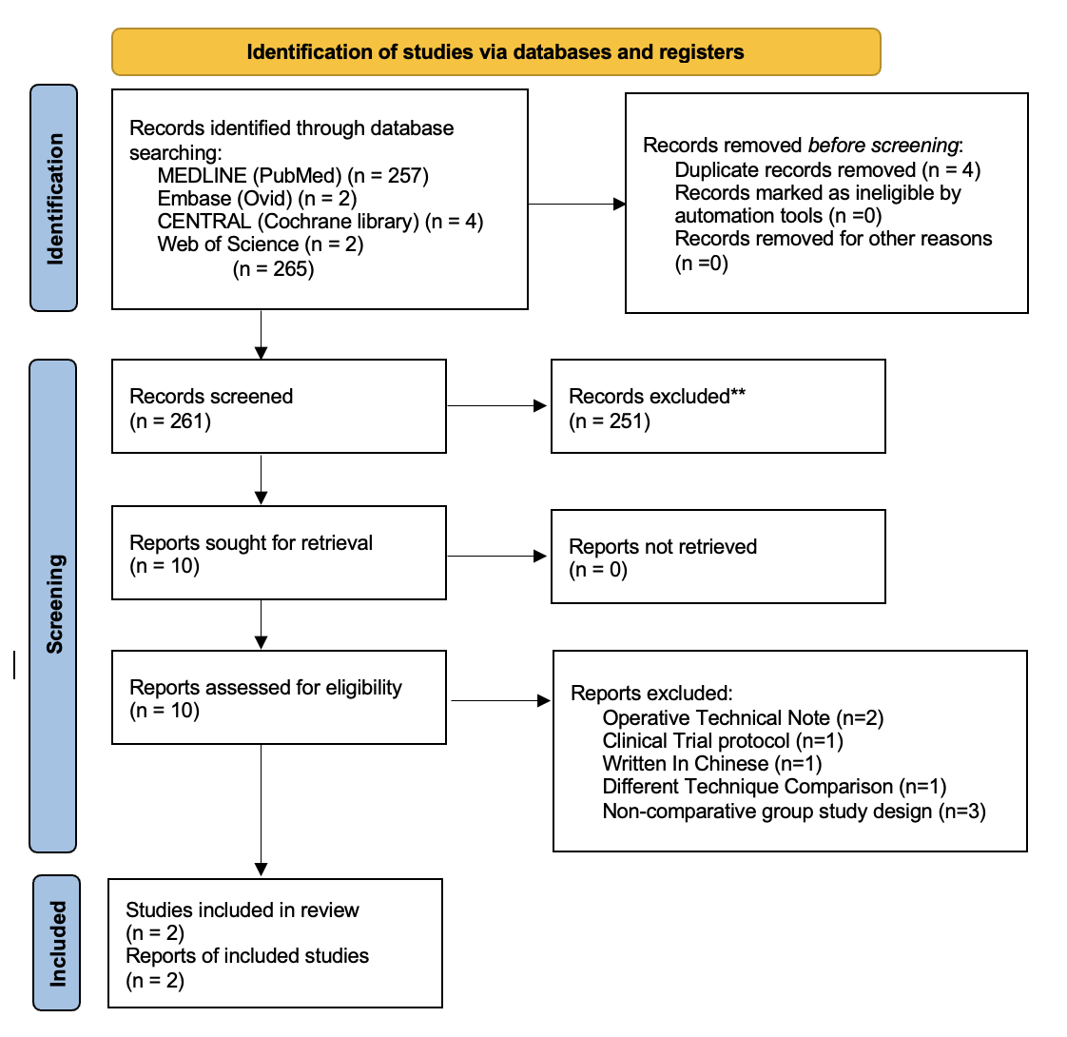

Figure 1. Study selection flow diagram by PRISMA flow chart.10

Study characteristics
A total of two studies were selected: one randomized clinical trial, one cohort retrospective. We analysed 54 patients of which 27 received robot assisted fixation and 27 received freehand surgery. The proportion of male were 36 patients (66.66%), whereas the proportion of female were 18 patients (33,33%). There were only two studies that provided age ranges (22,23). All studies included full-thickness RCTs. One study (24) found that all included subjects had small to medium-sized full thickness RCTs, despite the inclusion criteria of partial thickness RCTs being stated. Table 1 shows patient characteristics.
Each included study provided a detailed account of the surgical techniques employed, including imaging modalities, screw placement accuracy assessments, and rehabilitation protocols. Among the two included studies—one randomized controlled trial (RCT) by Guo et al¹ and one retrospective cohort by Xiao et al (2) —robot-assisted screw fixation was compared against traditional freehand technique for the treatment of acute or non-displaced scaphoid fractures.
In the RCT (1), 36 patients with acute, minimally displaced Herbert B2 scaphoid fractures were randomized (1:1 ratio) to receive either robotic-assisted or freehand screw fixation, with all surgeries performed by a single experienced surgeon. The robotic-assisted group utilized the TiRobot system (TINAVI Medical Technologies), which included a robotic arm, an optical tracking system, and a preoperative planning workstation. A custom-made 3D-printed radiolucent wrist-positioning jig was applied and stabilized using Shantz pins. Imaging guidance was provided through C-arm fluoroscopy with semi-oblique and lateral wrist views. Screw trajectories were pre-planned using the workstation interface, and guidewires were inserted through a robotically aligned mechanical arm. Two cannulated screws (Acumed Acrutrak mini and micro) were placed percutaneously based on the planned trajectories. The deviation from planned to actual trajectory was computed by the robotic system to assess accuracy.
Conversely, the freehand group in Guo et al (1) used standard percutaneous techniques with manual C-arm-guided placement of two guidewires under wrist hyperextension. Screw positioning was visually confirmed via fluoroscopy, and trajectory accuracy was indirectly estimated through the number of guidewire insertion attempts. Radiation exposure (total C-arm shots), guidewire insertion time, and total procedure time were all recorded for comparison between groups.
Similarly, in the cohort study by Xiao et al (2), 18 patients with non-displaced scaphoid fractures were treated with either robot-assisted (n=9) or freehand (n=9) screw placement. All procedures were conducted by the same senior surgeon. The robotic technique closely followed the TiRobot system methodology, with postoperative CT imaging used to measure the angular deviation of the screws from the scaphoid’s central axis in both sagittal and coronal planes, as per the method of Hoffmann et al. The traditional technique involved cannulated screw placement using anatomical landmarks and C-arm fluoroscopy without the aid of robotic guidance.

Rehabilitation protocols were similar across studies. In both studies (1,2), patients began gentle wrist motion exercises immediately postoperatively without cast immobilization. Functional recovery milestones, including return to non-contact activity, were initiated following radiological evidence of union. Radiographic follow-ups included standard wrist views (PA, lateral, oblique), with CT scans used selectively to confirm union when radiographs were inconclusive. Guo et al (1) scheduled standardized evaluations at 2, 4, 8, 12, 26, and 52 weeks postoperatively, while Xiao et al (2) monitored healing and function at regular intervals until final follow-up.
Both studies employed the Mayo modified wrist score as a primary clinical outcome, with Guo et al (1) additionally evaluating pain using the visual analog scale (VAS), grip strength with a calibrated dynamometer, range of motion (ROM) with a goniometer, and return to work status. Accuracy of screw placement was assessed quantitatively in the robotic groups of both studies, either by software-calculated deviation (RCT) or post-operative CT angular analysis (cohort). Fluoroscopy exposure was documented as the number of C-arm shots in both studies. Complications were recorded throughout follow-up, including nonunion, hardware failure, and pain. In Guo et al (1), blinding of outcome assessors was not specified; while Xiao et al (2) did not report on assessor blinding either. Table 2 summarizes all surgical approaches and rehabilitation procedures used across the included studies.

Risk of bias within individual studies
According to the study design, two reviewers used appropriate tools to assess the risk of bias within individual studies. RCT studies was assessed using RoB 214 (Fig.2a) and was deemed to have a low risk of bias. According to ROBINS-I15 (Fig.2b), non-RCT study has been evaluated, of which indicate a moderate level of bias. In addition, a large number of examiners and different centres performing outcome measurement without any standard guidelines or baseline can result in outcome measurement bias.

Table 1. Summaries of study and patient characteristics

No | Author, publication year | Country | Study design,  level of evidence | Number of patients | Patient Demographics
 |  |  |  |  | Robotic (n patients) |  |  | Freehand (n patients) |  |  | Age (years)
 |  |  |  |  | Total | Male | Female | Total | Male | Female | Robotic | Freehand
1 | Xiao et al, 2022 | China | Retrospective cohort, level II | 18 | 9 | 8 | 1 | 9 | 8 | 1 | 37.9 ± 10.6 | 31.6 ± 6.8
2 | Guo et al, 2022 | China | RCT, level I | 36 | 18 | NR | NR | 18 | NR | NR | NR | NR
Note RCT: randomized controlled trial; NR: Not Recorded

Table 2. Summaries of author publication, surgical technique, and outcome evaluation
No | Author, publication year | Surgical technique | Outcomes evaluation
1 | Xiao et al, 2022 | Freehand: The patient underwent brachial plexus block anesthesia. Using C-arm fluoroscopy, the entry point was identified at the scaphoid tubercle. The wrist was extended dorsally at a 45° angle to align with the scaphoid's long axis. A Kirschner wire was inserted through the scaphoid, confirmed by lateral imaging showing its placement within the capitate-lunate space. After measuring the wire length, 4 mm was subtracted to accommodate the 2 mm countersunk ends of the cannulated screw. A hollow drill was used to create the track, and the appropriate screw was then inserted.  Robotic: TiRobot™ system—comprising a multi-joint manipulator, optical tracker, planning/control platform, and surgical tools—was used for guided screw placement. After anesthesia and patient positioning with wrist extension and slight ulnar deviation, a tracer was attached to the forearm for real-time spatial tracking (error <0.3 mm). Fluoroscopic images (AP and lateral) were captured for preoperative planning. The surgeon selected the screw trajectory and length via the platform. The robot positioned its arm to guide the wire insertion. After confirming optimal placement with C-arm imaging, a cannulated screw was inserted along the guide path. | - Functional outcome: Mayo Wrist  - Radiological outcome: Radiation Time  - Operative Time  - Intraoperative Blood Loss  - Fracture Union Time
2 | Guo et al, 2022 | Robotic: A robotic navigation system (TiRobot) was used to guide precise scaphoid screw placement. The wrist was fixed in a custom jig, and screw trajectories were planned using C-arm images. The robot aligned its arm to the planned paths, allowing the surgeon to insert ulnar and radial guidewires. After fluoroscopic confirmation, two cannulated screws were placed. Screw length, insertion accuracy, procedure time, and radiation exposure were recorded.  Handfree: In the conventional group, setup time included C-arm preparation for scaphoid imaging. With the wrist in ulnar deviation and hyperextension, a small incision was made to insert guidewires into the scaphoid at a 45° angle. The number of attempts and time for guidewire placement were recorded to assess accuracy. Cannulated screws were then inserted over the wires, and their position was confirmed by fluoroscopy. Total procedure time and the number of C-arm shots used were also documented. | - Set-up time (min)  - Guidewire insertion time (min)  - Overall time (min)  - Guidewire attempts  - C-arm shots for Guidewires insertion  - Overall C-arm shots

Table 3. Robot Equipment Characteristics within studies
No | Author, publication year | Robotics
No | Author, publication year | Type of robots | Description | Manufacturer details
1 | Xiao et al, 2022 | TiRobot | TM navigation robot used in this study was composed of a multi-degree-of-freedom manipulator, an optical tracking device, a surgical planning and control platform, and surgical instruments that assist the robot to establish spatial coordinates | Beijing Tianzhihang Medical Technology Co., Ltd., China
2 | Guo et al, 2022 | TiRobot | -The robotic system comprises three components: a robotic arm, an optical tracking device, and a preoperative planning workstation.  -The optical tracking system includes an infrared stereo camera and two reference frames (patient marker and robot marker) for accurate spatial navigation. | TINAVI Medical Technologies

Qualitative synthesis
There were two primary outcomes of the present review: operative time and mayo wrist score. The VAS score, ROM, grip strength, set up time, guide wire insertion, guide wire attempt, and overall c-arm shoot were secondary outcomes, and a summary of the findings is provided in Tables 4 and 5.

Quantitative synthesis (meta-analysis)
In the meta-analysis, we analysed only primary (Fig. 3) outcomes. In the meta-analysis of two studies addressing VAS score, ROM, grip strength, set up time, guide wire insertion, guide wire attempt, and overall c-arm shoot were secondary outcomes as a primary outcome, only one study (24) reported the outcome so we did not proceed to meta-analysis. As a result, we present the report in table 4.

Primary outcome
In this systematic review and meta-analysis mayo score measured using a fixed-effects model, the pooled mean difference is 0.14 with a 95% CI of –0.65 to 0.93. This indicates no statistically significant overall difference between robot-assisted and freehand techniques (Z = 0.35, P = 0.73). Additionally, heterogeneity was moderate (Chi² = 1.69, I² = 41%, P = 0.19), suggesting some variability between the studies but not to a statistically significant degree. Operative time result shown the overall mean difference was –0.64 with a 95% CI of –29.84 to 28.56, indicating no statistically significant difference between the two techniques (Z = 0.04, P = 0.97). This wide confidence interval reflects a high degree of uncertainty in the pooled estimate. Furthermore, the analysis revealed very high heterogeneity among the studies (Chi² = 41.18, P < 0.00001; I² = 98%), suggesting substantial inconsistency in the effect estimates, likely due to methodological or clinical differences between the studies. The analysis of combined data from both groups shows that the average operative time was slightly longer in the robot-assisted technique (54.86 ± 16.81 minutes) compared to the freehand technique (50.8 ± 8.07 minutes), indicating a modest increase in surgical duration with robotic assistance. In contrast, evaluation of functional outcomes using the Mayo wrist score demonstrated slightly higher results in the robot-assisted group (99.23 ± 2.07) compared to the freehand group (98.53 ± 3.18), suggesting a marginal improvement in postoperative wrist function among patients treated with robotic assistance.

Secondary outcome
Based on the data presented in Table 4 regarding secondary outcomes, only the study by Guo et al4 provides complete information for both robotic and freehand techniques, while Xiao et al (25) did not report (NR) these variables. In terms of visual analog scale (VAS) for pain, both robotic and freehand techniques demonstrated equally low postoperative pain scores, each with a mean of 1.0 ± 0.25, indicating excellent pain control in both groups. Regarding range of motion (ROM), patients treated with robotic-assisted surgery showed a slightly better outcome (96 ± 1 degrees) compared to the freehand group (93 ± 2 degrees). Similarly, grip strength was marginally higher in the robotic group (95 ± 1.75) compared to the freehand group (93 ± 2), suggesting a potential functional advantage with robotic assistance.
The setup time was considerably longer in the robotic group (27 ± 7.25 minutes) than in the freehand group (6 ± 0.75 minutes), reflecting the additional time required for robotic system preparation. When evaluating procedural precision, the guide wire insertion time was slightly shorter in the robotic group (21 ± 5 minutes) compared to the freehand technique (30 ± 5.5 minutes). The robotic group also required fewer guide wire insertion attempts, with an average of 2 ± 0.25 attempts, in contrast to 6 ± 0.75 attempts in the freehand group. This indicates a higher accuracy and efficiency of wire placement with robotic assistance. Additionally, the overall number of C-arm fluoroscopy shots was lower in the robotic group (19 ± 0.5) compared to the freehand group (26 ± 2), suggesting that the robotic method may reduce radiation exposure by minimizing the need for repeated imaging.

Evidence quality assessment
Our GRADE approach results indicated that the evidence quality was poor due to individual study bias and imprecision (small sample size), which was extremely low due to the non-applicable heterogeneity in the inconsistency domain. It is possible that our estimate of effect would be affected by further research because of the low and very low quality of the evidence. However, we believe that we have developed the best available evidence at this point.

(a)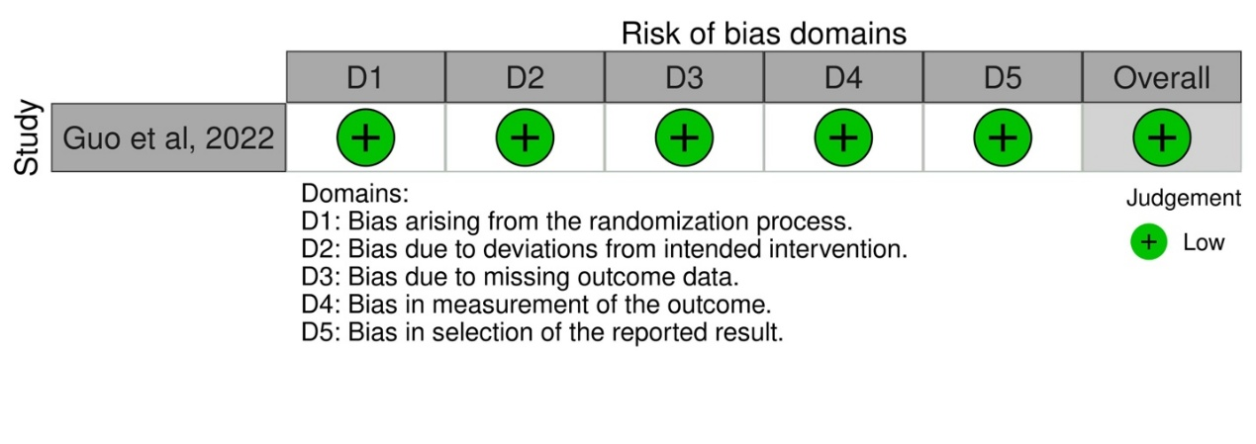
(b)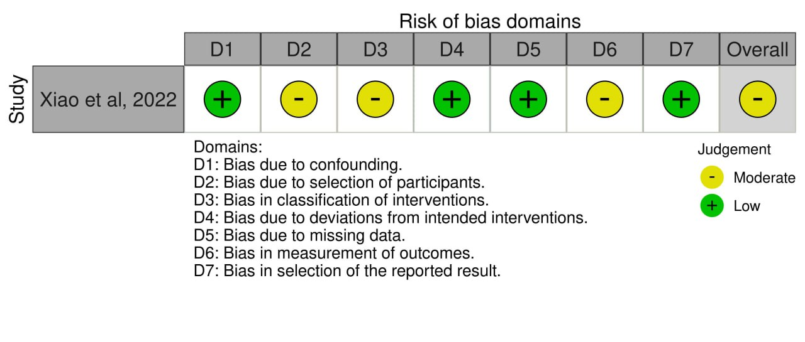
Figure 2. Risk of bias assessment results by using A) RoB 2 tool for RCT studies and B) ROBINS-I tool for non-RCT studies

Table 4. Primary outcome

No | Author, publication year | Follow-up (months) |  | Operative time (min) |  | Mayo score
No | Author, publication year | Robotic | Freehand | Robotic | Freehand | Robotic | Freehand
1 | Xiao et al, 2022 | 24 | 24 | 32.6 ± 4.2 | 48.4 ± 12.2 | 97.7 ± 2.6 | 95.6 ± 3.9
2 | Guo et al, 2022 | 12 | 12 | 66.5 ± 5.5 | 52. ± 5.5 | 100 ± 1.25 | 100 ± 1.25

Table 4. Secondary outcome
No | Author, publication year | VAS |  | ROM |  | Grip Strength |  | Set Up Time (min) |  | Guide Wire Insertion (min) |  | Guide Wire Attempt |  | Overall C-Arm Shot
No | Author, publication year | Robotic | Freehand | Robotic | Freehand | Robotic | Freehand | Robotic | Freehand | Robotic | Freehand | Robotic | Freehand | Robotic | Freehand
1 | Xiao et al, 2022 | NR | NR | NR | NR | NR | NR | NR | NR | NR | NR | NR | NR | NR | NR
2 | Guo et al, 2022 | 1 (0.25) | 1 (0.25) | 96 (1.5) | 96 (1) | 95 (1.75) | 93 (2) | 27 (7.25) | 6 (0.75) | 21 (5) | 30 (5.5) | 2 (0.25) | 6 (0.75) | 19 (0.5) | 26 (2)

Table 5. Complications and Authors Conclusion

No | Author, publication year | Robot | Freehand | Conclusion
1 | Xiao et al, 2022 | NR | 21 of 22 evaluated patients (63.6% of total patients) | - Robot-assisted surgery for scaphoid fractures offers greater accuracy compared to traditional freehand techniques.  - It results in shorter operative times and reduces the need for intra-operative fluoroscopy.  - Both techniques show no significant differences in terms of intra-operative blood loss, post-operative bone healing, and functional recovery.  - Robot-assisted surgery is considered a safe, effective, and precise approach for managing scaphoid fractures.
2 | Guo et al, 2022 | 1 of 18 patients complained of discomfort at the incisional scar | 2 of 18 patients complained of discomfort at the incisional scar | - Robotic-assisted surgery enhances the precision of implant placement.  - It helps reduce the duration of radiation exposure during the procedure.  - However, the technique incurs higher costs and takes longer to perform.  - The lack of clear improvement in clinical outcomes may hinder its broader adoption.

- 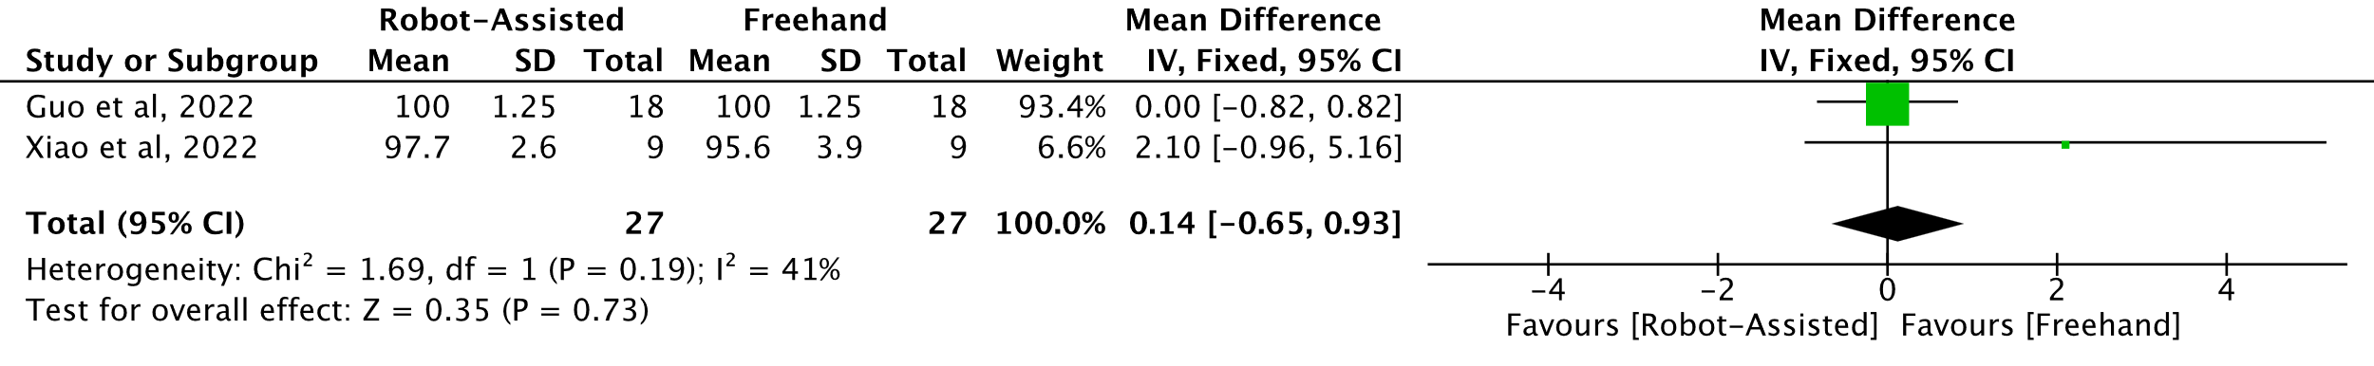
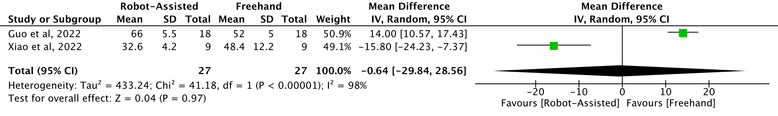
Figure 3. Quantative meta-analysis of the primary outcome A) Mayo Score, B) Operative Time

Table 6. GRADE evidence quality assessment
Outcomes | Total patients/suture anchors & studies analyzed | GRADE assessment
Outcomes | Total patients/suture anchors & studies analyzed | Risk of bias | Inconsistency | Indirectness | Imprecision | Other consideration | Overall certainty of evidence
Operative Time | 54 patients (2 studies) | seriousª | Serious^{c} | not serious | serious^{b} | none | ⨁◯◯◯  Very low
Mayo Wrist | 54 patients (2 studies) | seriousª | not serious | not serious | serious^{b} | none | ⨁⨁◯◯  Low
ªModerate risk of bias as assessed with ROBINS-I. ^{b}Sample size is relatively small (<400). ^{c}Heterogeneity cannot be calculated
GRADE Working Group grades of evidence
High certainty: Further research is very unlikely to change our confidence in the estimate of effect.
Moderate certainty: Further research is likely to have an important impact on our confidence in the estimate of effect and may change the estimate.
Low certainty: Further research is very likely to have an important impact on our confidence in the estimate of effect and is likely to change the estimate.
Very low certainty: We are very uncertain about the estimate.

DISCUSSION
Patient Characteristics and Surgical Interventions
This systematic review and meta-analysis aimed to evaluate Robotic-assisted and freehand in scaphoid fracture. In this systematic review and meta-analysis, the goal is to assess whether these material analyses provide satisfactory clinical results and reduce the complication rate of the procedure. In this review, the majority of patients were individuals around thirty years old. The patients included in this study were all diagnosed with acute scaphoid waist fractures, a location associated with a high risk of nonunion due to tenuous vascular supply. Both the robotic-assisted (RA) and freehand (FH) groups were comparable in terms of age, sex distribution, hand dominance, and mechanism of injury, ensuring a balanced baseline for assessing the intervention outcomes. Importantly, all procedures were performed using percutaneous techniques under general or regional anesthesia, and both groups received the same type of headless compression screw for fixation, eliminating variability in implant selection.
The primary difference in intervention lay in the surgical approach: the RA group benefited from 3D imaging, preoperative planning, and robotic arm navigation to assist with guidewire placement, whereas the FH group relied solely on intraoperative fluoroscopy and manual technique. Both groups followed the same postoperative rehabilitation protocol, which included early wrist mobilization, allowing for a fair comparison of functional outcomes. This consistent approach to patient selection, surgical technique, and postoperative care strengthens the validity of the study and supports the conclusion that differences in outcomes were attributable to the surgical method rather than external variables.

Primary Outcomes: Operative Time dan Mayo Wrist Score (MWS)
This systematic review and meta-analysis investigated whether robotic-assisted (RA) techniques offer superior outcomes compared to freehand (FH) methods in the fixation of acute scaphoid fractures. Among the analyzed variables, operative time and Mayo Wrist Score (MWS) were consistently reported and offer meaningful insight into the clinical utility and efficiency of robotic systems.
Both included studies demonstrated that the RA group experienced either comparable or reduced operative time compared to the FH group. Xiao et al (25). reported significantly shorter operative times in the RA cohort, which can be attributed to improved targeting efficiency, fewer guidewire attempts, and reduced need for intraoperative adjustments. Guo et al (4)., despite reporting slightly longer setup durations for robotic navigation, observed an overall shorter or equivalent surgical time once the robotic workflow was established. These findings suggest that while robotic systems may initially introduce additional preoperative steps, they ultimately streamline the intraoperative process. Furthermore, as surgeons overcome the learning curve and develop fluency with robotic platforms, this time-saving effect may become even more pronounced.
The Mayo Wrist Score (MWS), a validated composite measure assessing pain, functional status, range of motion, and grip strength, serves as an important indicator of early postoperative recovery in patients undergoing scaphoid fracture fixation. In both included studies, the robotic-assisted (RA) group demonstrated superior MWS outcomes compared to the freehand (FH) group, suggesting that robotic navigation may positively influence functional recovery.
In the randomized controlled trial by Guo et al (4)., patients in the RA group achieved significantly higher MWS at both the 3-month and final follow-up assessments. These findings indicate that enhanced screw trajectory accuracy, made possible through robotic guidance, likely contributes to improved fracture stability and reduced soft tissue disruption—factors that facilitate early mobilization and functional rehabilitation.
The Mayo Wrist Score (MWS) is a widely accepted clinical outcome measure encompassing pain, functional status, range of motion, and grip strength. In this study by Liu et al (32)., patients who underwent robotic-assisted percutaneous fixation of acute, nondisplaced scaphoid waist fractures achieved an excellent mean MWS of 96 at final follow-up (range 85–100), indicating near-complete functional restoration. This high score suggests that robotic-assisted fixation facilitates precise implant placement with minimal soft tissue trauma, promoting rapid recovery. The robotic system’s capability to simulate and execute optimal screw trajectories likely contributed to the uniform intraosseous screw positioning and reduced iatrogenic complications.
Similarly, the retrospective study by Xiao et al (25). reported a trend toward better MWS in the RA cohort, although the difference did not reach statistical significance. This may be attributed to the small sample size and limited follow-up duration, which reduce the study's power to detect subtle but clinically meaningful differences. Nonetheless, the direction of the effect remained consistent with the results of Guo et al., reinforcing the potential of robotic systems to improve early postoperative outcomes.

Secondary outcome (Radiation Exposure, Surgical Accuracy, dan Postoperative Functional Recovery)
In evaluating the broader impact of robotic-assisted (RA) versus conventional freehand (FH) techniques for scaphoid screw fixation, several secondary outcomes provide important insights into procedural efficiency, surgical accuracy, and early postoperative recovery.
The study by Guo et al (4) demonstrated a significant reduction in radiation exposure in the RA group. Specifically, the number of C-arm fluoroscopy shots used for both guidewire insertion and the overall procedure was markedly lower than in the FH group. This reduction, quantified as a 27.9% decrease in radiation exposure, underscores a critical safety advantage of robotic navigation—not only for patients but also for surgical teams regularly exposed to ionizing radiation. Although not directly quantified in the study, the minimally invasive nature of both approaches, particularly with precise robotic planning and execution, inherently supports lower soft tissue disruption and minimal blood loss. Given that fewer guidewire insertion attempts are required in the RA group, it is reasonable to infer a lower potential for bleeding due to reduced trauma.
One of the standout technical benefits of the robotic system was its ability to calculate and maintain accurate screw trajectories with minimal angular deviation. While direct angular deviation values were not reported, the robotic system’s capability to assess deviation from planned insertion paths allowed for consistently accurate guidewire and screw placement. In the RA group, all guidewire insertions were completed in one attempt, while the FH group often required multiple attempts, with some cases needing up to eight, reflecting greater variability in placement precision.
As expected, the RA group experienced longer setup times due to the complexity of the robotic system. The average setup duration was 27 minutes compared to only 6 minutes in the FH group. This difference reflects the additional time needed to install the positioning jig, calibrate the robot, and perform 3D planning. However, with increased experience and a dedicated robotic suite, this setup time may be reduced in future applications.
While setup was longer in the RA group, the time required for actual guidewire insertion was significantly shorter averaging 21 minutes versus 30 minutes in the FH group. Furthermore, the RA group required fewer insertion attempts (mean: 2 vs. 6), confirming the precision and repeatability of the robotic technique. Fewer insertion attempts reduce iatrogenic bone trauma, preserve scaphoid integrity, and shorten operative time in complex anatomy. The RA group demonstrated significantly reduced intraoperative imaging requirements, averaging 19 total shots versus 26 in the FH group. This reflects more efficient procedural flow and reduced reliance on intraoperative fluoroscopy for confirmation, thanks to the preoperative 3D planning and robotic arm positioning.
Postoperative functional recovery was comparable between the two groups. At one year, both groups achieved 96% of normal range of motion and over 93% of contralateral grip strength. Although not statistically different, the RA group showed a slightly higher grip strength and range of motion at earlier follow-ups (12 and 26 weeks), suggesting possible early functional benefits of the robotic approach. VAS scores for pain decreased progressively in both groups and were nearly identical at 52 weeks. Both groups reported minimal residual pain (mean score: 1), indicating effective fracture stabilization and healing. The slightly quicker pain reduction in the RA group at early follow-ups may reflect less intraoperative trauma and more precise hardware placement.

Clinical Implications
The combination of reduced operative time and improved early functional outcomes highlights the potential value of robotic systems in managing acute scaphoid fractures. Particularly in patients requiring early return to function, such as manual laborers or athletes, RA-assisted fixation may offer a tangible advantage. The integration of robotic-assisted (RA) technology in scaphoid screw fixation demonstrates several clinically relevant advantages over the conventional freehand (FH) technique. One of the most significant implications is the notable reduction in radiation exposure—both for patients and surgical personnel. With a 27.9% decrease in intraoperative fluoroscopy use, RA offers a safer operating environment, particularly in high-volume surgical centers where cumulative radiation exposure is a concern.
The results may not be generalizable to settings without access to high-end robotic systems or where surgeon training is limited. Moreover, cost-effectiveness remains unassessed in current literature and warrants future investigation.

Strength and limitations
This systematic review and meta-analysis has several strengths. Firstly, it is one of the earliest reviews to specifically compare robotic-assisted and freehand techniques for scaphoid screw fixation in cases of acute scaphoid fracture. Although only two studies met the inclusion criteria, both were prospective in design and utilized standardized outcome measures such as operative time and Mayo Wrist Score, which enabled meaningful comparison. Additionally, the study adhered to the PRISMA guidelines, with a comprehensive literature search, independent data extraction, and risk of bias assessment, ensuring methodological rigor and transparency.
Despite its strengths, this review has several methodological limitations, the most significant limitation is the inclusion of only two eligible studies, which limits the generalizability of the findings and reduces the statistical power of the meta-analysis. Both studies were conducted in specialized tertiary centers with access to advanced robotic systems, which may not reflect outcomes in general clinical practice, particularly in resource-limited settings. Furthermore, heterogeneity in the type of robotic systems used, surgeon experience, and length of follow-up may have influenced the reported outcomes. Lastly, the lack of long-term follow-up data restricts conclusions about the sustained benefits of robotic-assisted fixation, including its impact on complications such as nonunion or avascular necrosis.
To strengthen the evidence base, future studies should involve larger sample sizes, multi-center collaboration, and longer follow-up durations to confirm the potential advantages of robotic-assisted techniques in scaphoid fracture management.

Future Directions
Future research on robotic-assisted scaphoid screw fixation should focus on addressing current evidence limitations, such as small sample sizes, short-term follow-up, and study heterogeneity. Large-scale, multicenter randomized controlled trials are necessary to determine the long-term clinical benefits, including union rates, complication risks, and time to functional recovery. Cost-effectiveness analyses will also be critical to assess whether the increased precision and reduced radiation exposure of robotic systems justify their financial and logistical demands, particularly in low-resource settings. Additional studies should explore the learning curve associated with robotic systems and their potential to standardize outcomes across varying surgeon experience levels. Innovations like automated trajectory planning, augmented reality integration, and haptic feedback could further enhance surgical accuracy and reduce intraoperative variability. Future trials should incorporate patient-reported outcome measures (PROMs) and quality-of-life assessments to ensure that advancements in surgical technology translate into meaningful benefits for patients.

CONCLUSION
While robotic-assisted screw fixation shows promise in terms of technical precision and early recovery parameters, the current body of evidence—limited by sample size and study quality precludes definitive clinical recommendation. Future multicenter randomized controlled trials with long-term follow-up are required to establish its superiority over the conventional freehand method.

CONFLICT OF INTEREST STATEMENT
The authors have no conflicts of interest to disclose.

References
1. Duckworth AD, Jenkins PJ, Aitken SA, Clement ND, Court-Brown CM, McQueen MM. Scaphoid fracture epidemiology. J Trauma Acute Care Surg. 2012;72(2):41-45. doi:10.1097/TA.0b013e31822458e8
2. Xiao C, Wei D, Zhu Z, et al. Robot-assisted vs traditional percutaneous freehand for the scaphoid fracture treatment: a retrospective study. Int Orthop. 2023;47(3):839-845. doi:10.1007/s00264-022-05532-9
3. Almigdad A, Al-Zoubi A, Mustafa A, et al. A review of scaphoid fracture, treatment outcomes, and consequences. Int Orthop. 2024;48(2):529-536. doi:10.1007/s00264-023-06014-2
4.Guo Y, Ma W, Zlotolow D, Wang C, Tong D, Liu K. A Comparison Between Robotic-Assisted Scaphoid Screw Fixation and a Freehand Technique for Acute Scaphoid Fracture: A Randomized, Controlled Trial. J Hand Surg Am. 2022;47(12):1172-1179. doi:10.1016/j.jhsa.2022.08.021
5. Research GV. Orthopedic Surgical Robots Market Analysis, 2018-2030. Published online 2024.
6. Innocenti B, Bori E. Robotics in orthopaedic surgery: why, what and how? Arch Orthop Trauma Surg. 2021;141(12):2035-2042. doi:10.1007/s00402-021-04046-0
7. Ponna AK. Advancements in Robotic Orthopaedic Surgery : A Current Concept. 2025;3(1):1-10. doi:10.58616/001c.132487
8. Al-Ashhab ME, Elbegawi HEDA. Percutaneous screw fixation for scaphoid fractures. Orthopedics. 2017;40(4):e729-e734. doi:10.3928/01477447-20170509-04
9. Luchetti TJ, Hedroug Y, Fernandez JJ, Cohen MS, Wysocki RW. The morphology of proximal pole scaphoid fractures: Implications for optimal screw placement. J Hand Surg Eur Vol. 2018;43(1):73-79. doi:10.1177/1753193417739546
10. Page MJ, McKenzie JE, Bossuyt PM, et al. The PRISMA 2020 statement: An updated guideline for reporting systematic reviews. BMJ. 2021;372. doi:10.1136/bmj.n71
11. Higgins J, Thomas J, Chandler J, et al. Cochrane Handbook for Systematic Reviews of Interventions version 6.3 (updated February 2022). Cochrane. Published online 2022.
12. Suroto H, Satmoko BA, Prajasari T, Vega B De, Wibowo PA, Heri T. International prospective register of systematic reviews The outcome differences between biodegradable and non-biodegradable suture anchors for rotator cuff repair : a systematic review and meta-analysis Review question International prospective register. PROSPERO. 2022;CRD4202235:1-5.
13. Ouzzani M, Hammady H, Fedorowicz Z, Elmagarmid A. Rayyan-a web and mobile app for systematic reviews. Syst Rev. 2016;5(1):1-10. doi:10.1186/s13643-016-0384-4
14. Sterne JAC, Savović J, Page MJ, et al. RoB 2: A revised tool for assessing risk of bias in randomised trials. BMJ. 2019;366:1-8. doi:10.1136/bmj.l4898
15. Sterne JA, Hernán MA, Reeves BC, et al. ROBINS-I: A tool for assessing risk of bias in non-randomised studies of interventions. BMJ. 2016;355:4-10. doi:10.1136/bmj.i4919
16. McGuinness LA, Higgins JPT. Risk-of-bias VISualization (robvis): An R package and Shiny web app for visualizing risk-of-bias assessments. Res Synth Methods. 2021;12(1):55-61. doi:10.1002/jrsm.1411
17. Page M, Higgins J, Sterne J, et al. Chapter 13: Assessing risk of bias due to missing results in a synthesis. In: Cochrane Handbook for Systematic Reviews of Interventions Version 6.3 (Updated February 2022). ; 2022. doi:10.1109/ISIT.2017.8006970
18. Deeks J, Higgins J, Altman D. Chapter 10: Analysing data and undertaking metaanalyses. In: Cochrane Handbook for Systematic Reviews of Interventions Version 6.3 (Updated February 2022). ; 2022.
19. Schünemann H, Higgins J, Vist G, et al. Chapter 14: Completing ‘summary of findings’ tables and grading the certainty of the evidence. In: Cochrane Handbook for Systematic Reviews of Interventions Version 6.3 (Updated February 2022). ; 2022.
20. Schünemann H, Vist G, Higgins J, et al. Chapter 15: Interpreting results and drawing conclusions. In: Cochrane Handbook for Systematic Reviews of Interventions Version 6.3 (Updated February 2022). ; 2022.
21. Schünemann H, Brożek J, Guyatt G, Oxman A. GRADE Handbook. Grading of Recommendations, Assessment, Development and Evaluation (GRADE) Working Group; 2013.
22. Longo UG, Petrillo S, Loppini M, et al. Metallic versus biodegradable suture anchors for rotator cuff repair: A case control study. BMC Musculoskelet Disord. 2019;20(1):1-8. doi:10.1186/s12891-019-2834-3
23. Milano G, Grasso A, Salvatore M, Saccomanno MF, Deriu L, Fabbriciani C. Arthroscopic Rotator Cuff Repair With Metal and Biodegradable. YJARS. 2010;26(9):S112-S119. doi:10.1016/j.arthro.2010.01.030
24. Kim JH, Kim YS, Park I, et al. A Comparison of Open-Construct PEEK Suture Anchor and Non-Vented Biocomposite Suture Anchor in Arthroscopic Rotator Cuff Repair: A Prospective Randomized Clinical Trial. Arthrosc - J Arthrosc Relat Surg. 2020;36(2):389-396. doi:10.1016/j.arthro.2019.08.049
25. Xiao C, Wei D, Zhu Z, et al. Robot-assisted vs traditional percutaneous freehand for the scaphoid fracture treatment: a retrospective study. Int Orthop. 2022;47(3):839-845. doi:10.1007/s00264-022-05532-9
26. Yadav H, Nho S, Romeo A, MacGillivray JD. Rotator cuff tears: Pathology and repair. Knee Surgery, Sport Traumatol Arthrosc. 2009;17(4):409-421. doi:10.1007/s00167-008-0686-8
27. Zhao J, Luo M, Pan J, et al. Risk factors affecting rotator cuff retear after arthroscopic repair: a meta-analysis and systematic review. J Shoulder Elb Surg. 2021;30(11):2660-2670. doi:10.1016/j.jse.2021.05.010
28. Hantes ME, Chalatsis GI, Mpakagiannis G. Single-Row Versus Double-Row Repair in Rotator Cuff Tears. Surg Recover. Published online 2020:1-20. doi:10.5772/intechopen.89693
29. Haneveld H, Hug K, Diederichs G, Scheibel M, Gerhardt C. Arthroscopic double-row repair of the rotator cuff: A comparison of bio-absorbable and non-resorbable anchors regarding osseous reaction. Knee Surgery, Sport Traumatol Arthrosc. 2013;21(7):1647-1654. doi:10.1007/s00167-013-2510-3
30. Di Benedetto P, Lassandro N, Beltrame A, Mancuso F, Giardini P, Causero A. Reliability of open architecture anchors in biocomposite material: Medium term clinical and MRI evaluation. our experience. Acta Biomed. 2020;91:189-195. doi:10.23750/abm.v91i4-S.9709
31. Ro K, Pancholi S, Son HS, Rhee YG. Perianchor Cyst Formation After Arthroscopic Rotator Cuff Repair Using All-Suture–Type, Bioabsorbable-Type, and PEEK-Type Anchors. Arthrosc - J Arthrosc Relat Surg. 2019;35(8):2284-2292. doi:10.1016/j.arthro.2019.03.032
32. Liu B, Wu F, Chen S, Jiang X, Tian W. Robot-assisted percutaneous scaphoid fracture fixation: a report of ten patients. J Hand Surg Eur Vol. 2019;44(7):685-691. doi:10.1177/1753193419848595
33. Tan CK, Guisasola I, Machani B, et al. Arthroscopic Stabilization of the Shoulder: A Prospective Randomized Study of Absorbable Versus Nonabsorbable Suture Anchors. Arthrosc - J Arthrosc Relat Surg. 2006;22(7):716-720. doi:10.1016/j.arthro.2006.03.017
34. Matijakovich D, Solomon D, Benitez CL, et al. Long-term follow-up of perianchor cyst formation after rotator cuff repair. JSES Int. 2021;5(5):863-868. doi:10.1016/j.jseint.2021.05.010
35. Ejerhed L, Kartus J, Funck E, Köhler K, Sernert N, Karlsson J. A clinical and radiographic comparison of absorbable and non-absorbable suture anchors in open shoulder stabilisation. Knee Surgery, Sport Traumatol Arthrosc. 2000;8:349-355. doi:10.1007/s001670000162

APPENDIX

Search strategies and keywords
EMBASE (Ovid) – search date 29th May 2025
No. | Search | Result
1 | exp scaphoid fracture/ | 2766
2 | exp fracture/ | 388733
3 | exp schaphoid bone/ | 3448
4 | (“Schapoid Fractur*” or scaphoid or "scaphoid bone” or Fractur*).ti,ab,kw. | 393652
5 | 1 or 2 or 3 | 390574
6 | 4 orr 5 | 495214
7 | Exp robot assisted surgery/ | 41242
8 | exp robotics/ | 50853
9 | (“Robot* Surger*” or Robot-assisted surger*” or "Robot* surgical procedur*”).ti,ab,kw. | 23180
10 | 7 or 8 | 89113
11 | 9 or 10 | 92501
12 | (“Conventional Surger*” or Freehand conventional surger*”).ti,ab,kw. | 5358
13 | exp fracture fixation/ | 106415
14 | exp bone screw/ | 52962
15 | (“Screw fixation” or Cannulated screw fixation”).ti,ab,kw. | 12627
16 | 13 or 14 | 138993
17 | 15 or 16 | 141640
18 | 6 and 11 and 12 and 17 | 2

MEDLINE (PubMed) – search date 29th May 2025
No. | Search | Result
#1 | ((("Scaphoid Fractur*"[Title/Abstract]) OR (Scaphoid[Title/Abstract])) OR (Scaphoid Bone[Title/Abstract])) OR (Fractur*[Title/Abstract]) | 350,244
#2 | (Scaphoid Bone[MeSH Terms]) OR (Fractures, Bone[MeSH Terms]) | 222,094
#3 | #1 OR #2 | 392,920
#4 | (("Robot* Surger*"[Title/Abstract]) OR ("Robot-assisted surger*"[Title/Abstract])) OR ("Robot* surgical procedur*"[Title/Abstract]) | 14,845
#5 | (Robotic Surgical Procedures[MeSH Terms]) OR (Robotics[MeSH Terms]) | 48,615
#6 | #4 OR #5 | 53,490
#7 | ((((("Conventional Surger*"[Title/Abstract]) OR ("Freehand"[Title/Abstract])) OR (Free-hand[Title/Abstract])) OR (conventional[Title/Abstract])) OR ("Screw fixation"[Title/Abstract])) OR ("Cannulated screw fixation"[Title/Abstract]) | 699,131
#8 | ((Fracture Fixation[MeSH Terms]) OR (Fracture Fixation, Internal[MeSH Terms])) OR (Bone Screws[MeSH Terms]) | 93,339
#9 | #7 OR #8 | 781,875
#10 | #3 AND #6 AND #9 | 257

CENTRAL (Cochrane Library)- search date 29th May 2025
No. | Search | Result
#1 | (Scaphoid NEXT Fractur*):ti,ab,kw OR (Scaphoid):ti,ab,kw OR (Scaphoid NEXT Bone):ti,ab,kw OR (Fractur*):ti,ab,kw | 31827
#2 | MeSH descriptor: [Scaphoid Bone] explode all trees | 87
#3 | MeSH descriptor: [Fractures, Bone] explode all trees | 9630
#4 | #1 OR #2 OR #3 | 31868
#5 | (Robot* NEXT Surger*):ti,ab,kw OR (Robot-assisted NEXT surger*):ti,ab,kw OR (Robot" NEXT surgical NEXT procedur*):ti,ab,kw | 2031
#6 | MeSH descriptor: [Robotic Surgical Procedures] explode all trees | 1028
#7 | MeSH descriptor: [Robotics] explode all tree | 2077
#8 | #5 OR #6 or #7 | 2991
#9 | (Conventional NEXT Surger*):ti,ab,kw OR (Freehand AND conventional AND surger*):ti,ab, kw | 804
#10 | (Screw NEXT fixation):ti,ab,kw OR (Cannulated NEXT screw NEXT fixation):ti, ab,kw | 839
#11 | MeSH descriptor: [Fracture Fixation] explode all trees | 2714
#12 | MeSH descriptor: (Fracture Fixation, Internal) explode all trees | 2200
#13 | MeSH descriptor: [Bone Screws] explode all trees | 1279
#14 | #10 OR #11 OR #12 OR #13 | 3924
#15 | #4 AND #8 AND #9 AND #14 | 4

Web of Science – search date 29th May 2025
No. | Search | Result
#1 | TS=("Scaphoid Fractur*" OR Scaphoid OR "Scaphoid Bone" OR Fractur*) | 756,869
#2 | TS=("Robot* Surger*" OR "Robot-assisted surger*" OR "Robot* surgical procedur*") | 19,621
#3 | TS=("Conventional Surger*" OR "Freehand conventional surger**) | 3,625
#4 | TS=("Screw fixation" OR "Cannulated screw fixation") | 13,829
#6 | #4 AND #5 | 2

