Case Report

Evidence-Informed Pediatric Physiotherapy in Hallervorden-Spatz Disease – A Case Report

.
ABSTRACT

Background: Hallervorden-Spatz Disease (HSD), an aggressive and rare form of NBIA, has specific rehabilitation issues in its rapid neurodegenerative course and early loss of motor milestones. Physiotherapy literature still lacks the entire clinical and therapeutic profile of such patients.
Case summary: This article reports the lengthy, birth-end-of-life clinical history of an 11-year-old female patient with genetically established HSD. She had severe dystonia, fixed postures, scoliosis, compromised respiration, and total dependence on all ADLs. Standardized outcome measures—WeeFIM, GMFM-88, PKAN-ADL, MACS and CFCS—were documented systematically.
Intervention: A structured, evidence-based physiotherapy plan was initiated with task-based training in sitting, chest expansion, postural re-education, and caregiver-supervised home programs specific to her degenerating state.
Conclusion: This is the first physiotherapy case report to comprehensively use longitudinal history, validated outcome measures, and evidence-based therapy in HSD, demonstrating the vital role of neurorehabilitation in the course of the disease.

Keywords: Hallervorden-Spatz Disease, NBIA, pediatric neurorehabilitation, evidence-informed physiotherapy, dystonia, outcome measures, task-oriented training, birth-to-death trajectory

1. INTRODUCTION

Hallervorden-Spatz disease, now more commonly referred to as pantothenate kinase-associated neurodegeneration (PKAN), is a rare neurologic disorder that is a member of the neurodegeneration with brain iron accumulation (NBIA) diseases. The diseases previously belonged to a classification based on post-mortem findings of iron accumulation in specific brain locations, specifically the globus pallidus and substantia nigra, as indicated by several staining techniques like Perl's stain and ferritin immunostaining ^{[1,2]}.

The onset of PKAN typically occurs between the ages of 5 to 15 years, with a rapid progression of symptoms leading to death within a decade of diagnosis ^{[3]}. The hallmark symptoms of NBIA, including dystonia, dysarthria, and movement disorders, reflect the progressive nature of the disease, often necessitating adjustments in treatment and the use of assistive devices as the condition advances ^{[3,2]}. Pathological examinations reveal significant neuronal loss, particularly in the substantia nigra, along with widespread Lewy bodies and neurites, while iron deposition is notably localized to specific brain areas, including the globus pallidus ^{[1,2]}.

Discovery of the PANK2 gene in 2001 was a breakthrough in understanding PKAN since this gene causes most cases of PKAN ^{[2,4]}. As research has progressed, other NBIA disorders due to other genetic mutations have been defined, and the categorization of these disorders has been growing, giving a better picture of their mechanism ^{[2]}. Due to the intricate interaction of genetic factors and the process of neurodegeneration, ongoing research continues to study the different aspects of PKAN and its treatment ^{[5]}.

CASE PRESENTATION

2. PATIENT INFORMATION:

An 11-year-old girl with Hallervorden-Spatz Disease (HSD), an uncommon neurodegenerative disorder belonging to neurodegeneration with brain iron accumulation (NBIA), was referred to our pediatric neurorehabilitation unit. She was completely dependent on all activities of daily living (ADLs) on presentation and had marked global impairment of motor function with loss of postural control and motor coordination. Written informed consent was taken from the patient's parents to publish clinical features of the patient.
She had a history of feeding difficulties and delayed motor milestones in childhood. Toe-walking at 11 months was later recognized as an early feature of extrapyramidal dysfunction. Dystonic posturing, motor regression, and sparse language development were seen by the age of 2 years. Spasticity worsened, choreoathetoid movements, scoliosis, and fixed foot deformities ensued with inexorable decline. MRI at 5 years (Figure 1) revealed the typical 'eye-of-the-tiger' sign, and genetic analysis revealed HSD with a homozygous mutation and both parents were heterozygous carriers.

.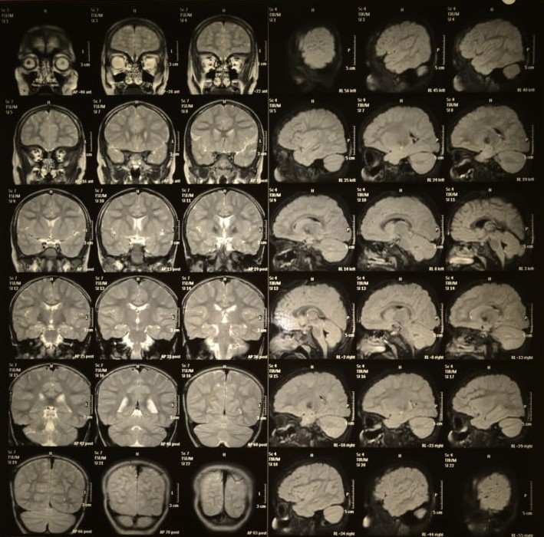
(Figure 1: The "eye of the tiger" sign, a characteristic feature of HSD as seen on T2-weighted magnetic resonance imaging (MRI) of the brain, particularly in the globus pallidus.)
She had received repeated treatment prior to referral: pharmacological treatment consisted of baclofen (twice daily), tetrabenazine (25 mg per day), and mazetol (200 mg), besides Ayurvedic treatment like nasya, panchakarma, shirodhara, and rice therapy. Physiotherapy was irregular and haphazard.

At our facility, thorough assessment with standardized outcome measures determined her baseline functioning (see Table 1). Evidence-based interventions including task-oriented training, breathing, joint range maintenance, and orthotic support were instituted (see Table 2). In spite of intense multidisciplinary treatment, she worsened.

Table 1: Outcome measures
Outcome measure: Function specific | Components: | Scoring: | Interpretation:
Functional Independence Measure for Children (WeeFIM) | Selfcare | 8/56 | The patient required maximal to total assistance in all domains, including feeding, grooming, bathing, toileting, and mobility.
Functional Independence Measure for Children (WeeFIM) | Mobility | 5/35
Functional Independence Measure for Children (WeeFIM) | Cognition | 31/35
Gross Motor Function Measure (GMFM - 88) | Lying and rolling | 52% | Limited movements were seen in dimension A (lying and rolling) and B (sitting), suggesting retained reflexive but not purposeful control. Dimensions D (standing) and E (walking, running, and jumping) showed near-zero scores, indicating total functional immobility.
Gross Motor Function Measure (GMFM - 88) | Sitting | 26%
Gross Motor Function Measure (GMFM - 88) | Crawling, Kneeling | 7%
Gross Motor Function Measure (GMFM - 88) | Total | 28%
Manual Ability Classification System Level | Level IV |  | Handles a limited selection of easily managed objects in adapted situations – Performs parts of activities with effort and with limited success. Requires continuous support and assistance and/or adapted equipment, for even partial achievement of the activity.
Communication Function Classification System Level | Level V |  | A person is seldom able to communicate effectively even with familiar people.
Outcome measures: Disease Specific
Pantothenate Kinase associated Neurodegeneration – Activity of Daily Living Scale (PKAN-ADL) |  | Scoring: | Interpretation:
 |  | 38/48 | Key impairments were noted in eating (requiring assisted feeding), dressing (inability to manipulate fasteners), toileting (incontinence and dependency), and hygiene (complete assistance required).

Table 2: Evidence informed rehabilitation protocol:
Domain | Specific Intervention
Postural Control & Sitting | Task-Oriented Sitting Training on therapy ball with trunk support- Dynamic Reaching in Sitting with therapist facilitation (2x/day)- Sidelying transitions
Chest Expansion & Breathing | Segmental Breathing Exercises (apical, lateral, basal)- Manual Chest Compression & Expansion with hold-relax- Bubble Positive expiratory pressure PEP therapy
Tone & Contracture Prevention | Prolonged Passive Stretching (hamstrings, pectorals, gastroc) for 60 seconds x 3- Rhythmic Inhibition & Neurodevelopmental Technique (NDT) Handling- Positioning in long sitting or prone
Trunk & Core Strength | Bridging with Pelvic Assistance in supine- Facilitated Rolling & Segmental Trunk Rotation with reach cues
Upper Limb Functional Use | Weight Bearing Through Upper Extremities in prone-on-elbows- Bilateral Reaching with Visual Cueing- Hand-over-hand feeding simulation
Sensory-Motor Stimulation | Thermal Tactile Stimulation prior to feeding- Auditory & Proprioceptive Input during tasks- Deep Pressure for calming dystonia
Mobility & Weight Bearing | Tilt Table Standing 20 min/day with abdominal binder- Side-lying to sit task practice- Sit-to-stand with max assist + cues
Oromotor & Swallowing | Jaw Support During Swallowing- Textured Bolus Trials with SLP- Lips and Cheek Tactile Stimulation before feeding
Orthotic Support | Night Resting Splints for elbows & wrists- Soft Cervical Collar for torticollis- Discontinued KAFOs due to skin breakdown
Caregiver Empowerment | Caregiver-Delivered Home Stretching Protocol (2x/day)- Feeding & Positioning Checklist- Training in seizure response & safe transfers
Quality of Life & Expression | Music Therapy Sessions (familiar songs, rhythmic entrainment)- Facial Cue Interpretation & Interaction Coaching for family

She had severe dystonia, fixed postures, advanced scoliosis, compromised respiratory function, and limited communication at age 11. Complications included swallowing dysfunction and recurrent infections. She had developed signs of gastrointestinal obstruction, refractory seizures, and aspiration-related cardiorespiratory arrest within 72 hours, resulting in death in late 2024.

This case highlights the rare and innovative nature of HSD and offers a longitudinal case study, objective outcome measures, and an evidence-informed physiotherapy approach to advanced pediatric neurodegenerative cases.

3. DISCUSSION:

Hallerverden Spatz Disease (HSD) is an uncommon autosomal recessive neurodegenerative disorder belonging to the NBIA spectrum. It is associated with iron accumulation in the basal ganglia, with most of them being in the globus pallidus. The most frequent underlying genetic etiology is mutation of the PANK2 gene, but others are present. Our patient presented a homozygous 215-216ins A* mutation, which is typical of classical types of HSD ^{[6]}.

The classical expression of PKAN usually occurs in early childhood with dystonia, dysarthria, and rigidity between 7 and 15 years of age ^{[4]}. Survival is variable, but median survival after diagnosis is about 10 to 12 years, with a few patients experiencing a quick deterioration and death within one to two years from the onset of symptoms ^{[7,3]}.

Early signs of abnormal gait at 11 months progressed rapidly into postural collapse, fixed deformities, and near total functional dependence at 11 years. In spite of early use of physiotherapy, the relentless pace of motor deterioration highlights the limited success of symptomatic treatment with which we are armed.

While most patients have relentless progression, there is considerable heterogeneity in the disease course. Some patients have a slow rate of progression or, indeed, a plateau for many years, maintaining functional capacity well into the third decade ^{[3,8]}. There are others who experience catastrophic disability and deterioration, wheelchair dependency by mid-teens, and premature death from such complications as dysphagia and aspiration pneumonia ^{[3,7]}.

In the rare forms of the disease, onset is later in life, and the course of the disease is slower, with an uncertain prognosis ^{[4,8]}. Genetic evaluation and counseling of the affected patients and families are indicated, as understanding of the underlying genetics of the disease can be used to inform clinical course and direct management strategies ^{[9]}. In rare cases, while symptomatic treatment can be provided, to date there is no absolute cure for Hallervorden-Spatz disease, and supportive treatment is still useful to improve quality of life in affected patients ^{[7,5]}.

4. CONCLUSION:

This case demonstrates the natural history of untreated and treatment-resistant NBIA. Our case is one of the few, detailed longitudinal descriptions of pediatric HSD, from developmental concern to terminal complications. It highlights the importance of multidisciplinary management, early genetic counseling, and the necessity for research into disease-modifying therapy. The case also further convinces the case for the use of validated outcome measures in follow-up of pediatric neurodegenerative disease, to improve monitoring of progression, and the targeting of interventions.

Consent AND Ethical approval (where ever applicable)

Ethical approval was not required for this single case report as per institutional guidelines; however, written informed consent for participation and publication was obtained from the patient’s legal guardian.

COMPETING INTERESTS DISCLAIMER:
Authors have declared that they have no known competing financial interests OR non-financial interests OR personal relationships that could have appeared to influence the work reported in this paper.

5. REFERENCES:

1. Kurian MA, Spaull RV V, Soo AKS, Hogarth P, Hayflick SJ. Towards Precision Therapies for Inherited Disorders of Neurodegeneration with Brain Iron Accumulation. 2021;11(1):1-20. doi:10.5334/tohm.661
2. Overview of NBIA Disorders - NBIA Disorders Association. Accessed May 15, 2025. https://www.nbiadisorders.org/about-nbia/overview-of-nbia-disorders
3. Hallervorden-Spatz Disease | Syndromes: Rapid Recognition and Perioperative Implications, 2e | AccessPediatrics | McGraw Hill Medical. Accessed May 18, 2025. https://accesspediatrics.mhmedical.com/content.aspx?bookid=2674&sectionid=220531686
4. Hallervorden-Spatz syndrome, PANK2, and the tiger’s eyes. Arch Dis Child. 2003;88(6):487-487. doi:10.1136/ADC.88.6.487
5. Pohane MR, Dafre R, Sontakke NG. Diagnosis and Treatment of Pantothenate Kinase-Associated Neurodegeneration (PKAN): A Systematic Review. Cureus. 2023;15(9). doi:10.7759/CUREUS.46135
6. Tao Y, Zhao C, Han D, et al. Typical pantothenate kinase-associated neurodegeneration caused by compound heterozygous mutations in PANK2 gene in a Chinese patient: a case report and literature review. Front Neurol. 2023;14:1170557. doi:10.3389/FNEUR.2023.1170557/BIBTEX
7. Neurodegeneration with brain iron accumulation | MedLink Neurology. Accessed May 18, 2025. https://www.medlink.com/articles/neurodegeneration-with-brain-iron-accumulation
8. Reddy N, Sharma J, Sharma A. Case of Hallervorden–Spatz Syndrome: A Tale of Twin Sisters. Neurol India. 2024;72(2):411-413. doi:10.4103/NI.NI_1135_22
9. Hogarth P, Kurian MA, Gregory A, et al. Consensus clinical management guideline for pantothenate kinase-associated neurodegeneration (PKAN). Mol Genet Metab. 2017;120(3):278-287. doi:10.1016/J.YMGME.2016.11.004

