The Role of Chemical Engineering in Advancing Circular Economy: Strategies for Waste Valorization and Resource Recover

Abstract
The Circular Economy (CE) offers a radical solution to resource depletion, waste accumulation, and environmental degradation. This study investigates how chemical engineering advances circular economy through waste valorization and resource recovery. Biomass conversion, plastic and electronic waste recycling, and food waste recovery are examined for their ability to reduce resource use and environmental impact. Circular process design, eco-industrial parks, and AI/machine learning are discussed to increase resource efficiency and waste-to-resource conversion. Circular Economy (CE) has great potential, but technological, financial, legal, and social barriers prevent its widespread implementation. To overcome these hurdles and accelerate circular practises, industry, academics, and politicians must work together, according to the document. Chemical engineering's role in supporting sustainable industrial practices and a resource-efficient and resilient global economy is discussed in CE's future. This article discusses sophisticated technology and research needed to alter the circular economy.

1. Introduction

Global Sustainability Challenges
Resource depletion, climate change, and industrial waste are global challenges. Due to rising populations and industrial activity, fossil fuels, minerals, and metals are in high demand. Industrial waste's greenhouse gas emissions and hazardous byproducts are becoming unsustainable. A "take–make–dispose" linear economic model promotes waste generation and resource exploitation without regard for long-term sustainability, compounding these issues. These challenges require a sustainable and environmentally friendly approach[1].

Circular Economy (CE) Paradigm
Circular Economy (CE) is a revolutionary alternative to linearity. Instead of "take–make–dispose," the Circular Economy promotes material reuse, recycling, and regeneration. Closed-loop technology reduces waste, resource use, and environmental effect. To create a sustainable, regenerative system, economic growth should not be tied to resource use. Circular Economy (CE) principles include designing durable products, repairing and refurbishing them, and recovering valuable materials from waste streams for reuse in manufacturing[2].

Role of Chemical Engineering
Chemical engineering helps circular economy by enabling waste valorization and resource recovery. Chemical engineers intensify processes to increase efficiency, reduce energy use, and waste. They advocate catalysis for cleaner and more sustainable chemical transformations, separation technologies for material recovery, and systems engineering for circular economy industrial processes. Transforming garbage into valuable items and maximizing resource use require these improvements[3].

Objectives
Chemical engineering is highlighted in this circular economy paper on novel waste valorization and resource recovery methods. The goals are to highlight waste-to-resource technology advances, identify knowledge gaps in current practices, and suggest strategies to increase chemical engineering's role in circular economy projects. This study examines circular economy and sustainable industrial practices initiatives.

2. Circular Economy Framework

Principles of Circular Economy (CE)
The circular economy (CE) paradigm replaces the linear model of resource extraction, use, and disposal with a closed-loop system that promotes waste minimization, product longevity, and material reutilization. The three Circular Economy (CE) principles are:
1. Reduce garbage: Circular Economy designs processes and products that use fewer resources and are more energy efficient to reduce rubbish. Improve production and reduce packing to reduce waste at the source[4].
2. Increase Product Durability: Superior materials, modular design, and improved repairability lengthen product life. Making products that are easily repaired, upgraded, or refurbished extends their lives and reduces the need for new ones. This includes remanufacturing used products to perfection[5].
3. Promote Material Reuse: The Circular Economy (CE) encourages recycling and upcycling to recover valuable materials from waste streams. Circular economy (CE) reduces demand for virgin materials and environmental impact by recovering and reintegrating commodities into production[6].
These concepts help industries reduce resource use and environmental harm by promoting sustainable production and consumption.

Economic and Environmental Drivers
Economic and environmental needs drive circular economy implementation. Circular economy (CE) reduces pollution, greenhouse gas emissions, and resource depletion, supporting global sustainability goals like the UN Sustainable Development Goals (SDGs), especially Goal 12 (Responsible Consumption and Production). For circular practises to succeed, climate change and biodiversity must be addressed, especially in chemical engineering[7].
Circular economy reduces waste and maximizes resource use, saving money. Reclaiming waste resources reduces material costs and boosts profits. A circular economy can also improve supply chain resilience, reduce raw material cost volatility, and promote long-term sustainability. The Circular Economy is gaining support from governments through resource efficiency and eco-design policies and incentives[8].

Integration with Chemical Engineering
A circular economy requires chemical engineering to improve waste-to-resource conversion. Chemical engineering has made major contributions:
1. Process Optimization: Chemical engineers increase energy efficiency, product quality, and waste reduction. To achieve these goals, process intensification optimises and lowers inefficiencies[9].
2. System Integration: Large industrial systems must operate closed-loop for Circular Economy. Chemical engineers optimize these interrelated processes using systems engineering to efficiently turn waste into useful products[10].
3. Waste-to-Resource Conversion: Catalysis, biorefining, and membrane separations make chemicals, fuels, and materials. Businesses can limit their environmental effect and use of virgin resources while encouraging sustainability[11].
Chemical engineers use these concepts to industrial operations to construct circular economy-relevant, efficient, and sustainable systems. Chemical recycling is part of the Circular Economy (Figure 1). This image depicts how chemical recycling can solve waste streams and minimize dependence on virgin resources from raw material extraction to recycling and reuse. For sustainability and resource efficiency, chemical recycling must follow Circular Economy principles[12].
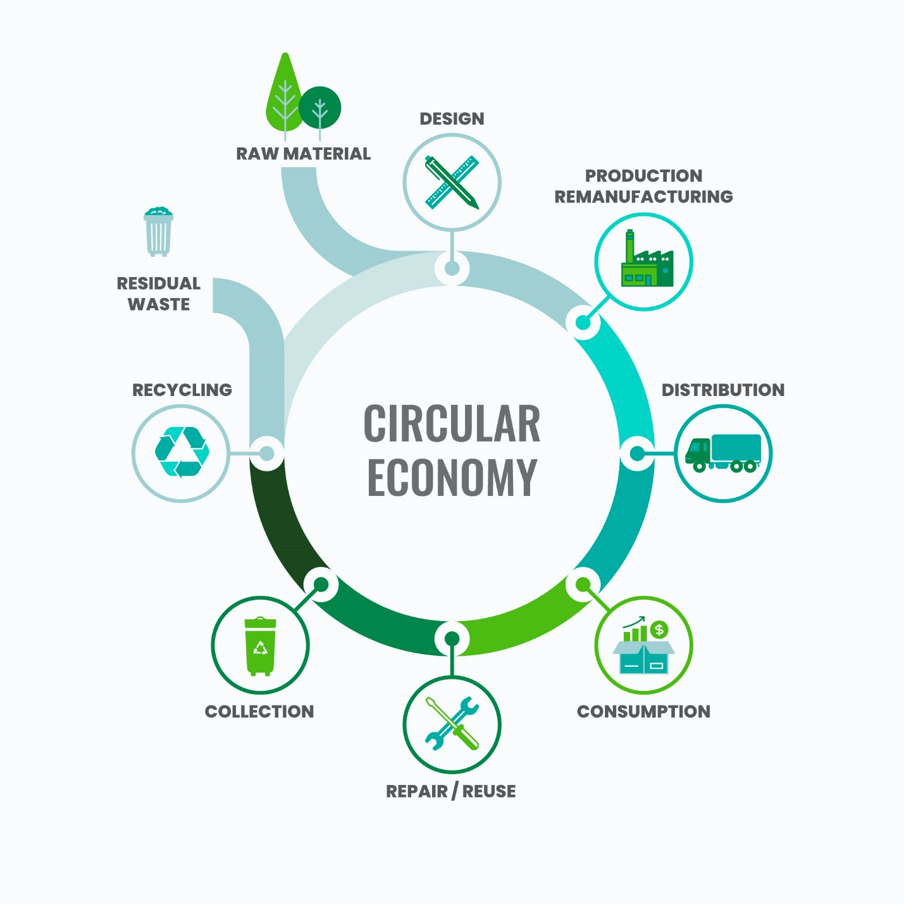
Figure 1: Circular Economy Framework in Chemical Engineering. A diagram illustrating the integration of chemical recycling within the Circular Economy framework, highlighting the stages from raw material extraction to recycling and reuse. Rekart Innovations Pvt Ltd. (2023). Balancing Chemical Recycling within the Framework of a Circular Economy. Retrieved from http://rekart.co.in/blog/Balancing-Chemical-Recycling-within-the-Framework-of-a-Circular-Economy

3. Waste Valorization Strategies

Biomass and Agricultural Waste
Lignocellulosic biomass and crop leftovers and food waste are plentiful and renewable sources for bio-based chemicals, biofuels, and biopolymers. Lignocellulosic materials like cellulose, hemicellulose, and lignin can be used to valorize waste. These complex polymers can be hydrolyzed, pyrolyzed, and fermented into sugars, alcohols, and acids for bioplastic manufacture.
Biorefineries, like petroleum refineries, turn biomass into biofuels, chemicals, and materials. Modern microbial fermentation and synthetic biology can make succinic acid and furan-based compounds from agricultural waste. This method profits from agricultural waste and provides a sustainable chemical source[13].

Plastic and E-waste Recycling
Due to their large volumes and complex compositions, plastics and e-waste are environmental hazards. Conventional plastic recycling methods often lack efficacy and purity. Chemical depolymerization and solvolysis are advanced technologies for decomposing polymers into monomers or useful intermediates. The depolymerization of polyethylene terephthalate (PET) into its monomers, terephthalic acid and ethylene glycol, allows closed-loop recycling to make new PET products[14].
Acid leaching and pyrometallurgy can recover gold, silver, and palladium from electronic garbage. Microwave-assisted and supercritical fluid extraction technologies for energy-efficient metal removal from complicated waste streams are also prevalent. Microorganisms are a more sustainable and environmentally beneficial way to remove metals from electrical waste[15].
Food and Organic Waste

Food and organic garbage represent a large portion of municipal solid waste, offering resource recovery. Anaerobic digestion, composting, and fermentation can recover energy, nutrients, and organic matter from food waste. Organic waste is decomposed by bacteria without oxygen in anaerobic digestion, producing biogas (mostly methane) for energy production. This method reduces trash and generates renewable energy.
Besides biogas production, food waste can be composted to create nutrient-rich organic matter for soil health. Fermenting food waste into bio-based molecules like lactic acid, acetic acid, or alcohols is a sustainable way to recover energy and chemicals from organic sources[16].

Key Technologies in Waste Valorization
Waste valorization requires many advanced technologies. Efficiency in chemical reactions that turn waste into useful items requires catalysis. Heterogeneous catalysis turns waste oils and plastics into biofuels and fine chemicals. Complex biomass is decomposed into fermentable sugars for biofuel generation using enzyme catalysis.
Waste valorization relies on biorefinery, which integrates biomass into multiple products. Biological-thermochemical hybrid systems are becoming common. Pyrolysis (thermochemical) followed by fermentation (biological) allows biofuel and bio-based compound production. Due to their efficiency and versatility, hybrid systems may convert food waste, agricultural waste, and plastics[17].

Industrial Case Studies
Many industries have successfully employed waste valorization processes, proving circular economy theories work. Novozymes advance biorefinery by microbially fermenting agricultural waste into citric acid and enzymes. E-waste recycling technology from Veolia, a major waste management company, extracts valuable metals and rare earth elements from old electronics using hydrometallurgical and mechanical methods[18].
Chemical recycling of plastics by Covestro turns waste plastics into feedstocks for new plastics and chemicals. This effort seeks to reduce plastic waste and promote circular chemical solutions.
These case studies show how waste valorization technologies can help businesses adopt circular economy principles for waste recovery and resource reutilization.

4. Resource Recovery Technologies

Water and Wastewater Treatment
Global water shortages are growing, and wastewater is a valuable resource for water reclamation, fertilizer extraction, and energy production. Water recovery technologies like membrane filtration and reverse osmosis treat and reuse wastewater for industrial and municipal use, reducing the need for new water. These approaches enable wastewater stream water extraction for sustainable water use.
Struvite precipitation and ion exchange can extract nitrogen, phosphorus, and potassium from wastewater, along with water. Reclaimed nutrients can be utilized in agriculture to complete the nutrient cycle and reduce energy-intensive manufactured fertilizers.
Energy recovery from wastewater is crucial to resource recovery. Wastewater organic matter is often processed by anaerobic digestion into methane-rich biogas. Biogas can generate electricity from wastewater treatment, reducing fossil fuel use[19].

Critical Metals Recovery
Electronics, batteries, and renewable energy technology require rare earth elements (REEs), lithium, cobalt, and nickel. Demand for these metals increases the need for sustainable recovery technologies. E-waste and exhausted batteries are plentiful in these precious metals, and recent metallurgical advances have made their recovery efficient.
Acid or ionic liquid leaching can selectively extract metals from waste streams, enabling resource recovery. Cyanide-free gold extraction from electronic waste is being developed, whereas acid leaching removes lithium from spent lithium-ion batteries. Bioleaching, which uses microorganisms to extract metals, is an eco-friendly alternative to conventional methods that may recover rare metals from complex waste streams[20].
Extracting critical metals from electronic garbage and depleted batteries reduces mining's environmental impact and provides a sustainable supply of resources for electronics and electric car manufacturers[15]. Figure 2 shows chemical engineering used to recycle polyurethane foam from old mattresses. The foam is deconstructed to extract polyether polyol and toluene diisocyanate (TDI), which are essential to polyurethane product production. These materials can be recycled to reduce waste and sustain the chemical industry by providing renewable chemicals[21].
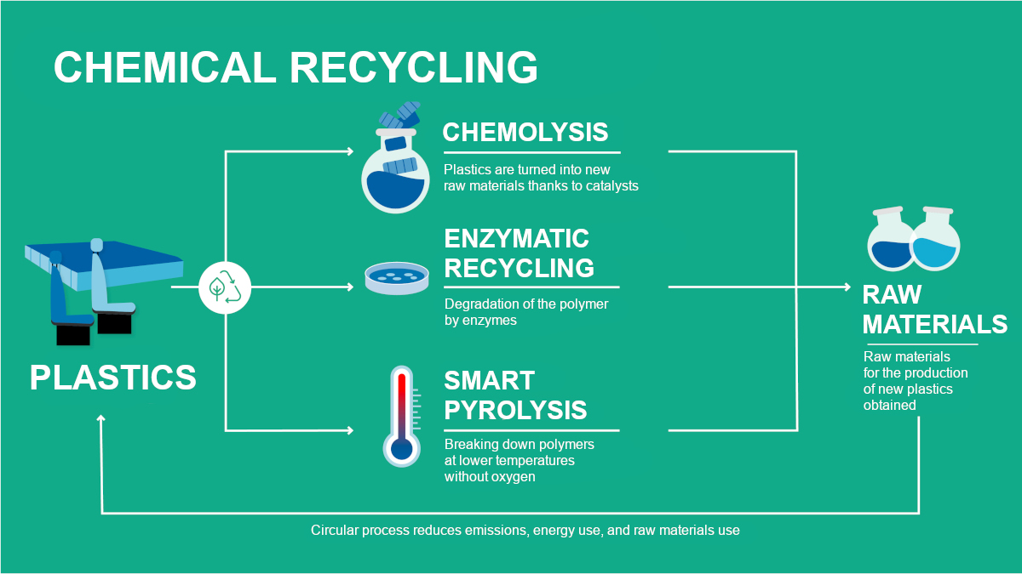
Figure 2: Polyurethane Foam Chemical Recycling. A schematic showing the chemical recycling of polyurethane (PU) foam from worn mattresses, focusing on polyether polyol and toluene diisocyanate (TDI). T. Heinemann (2024). Key Circular Economy Technology: Chemical Recycling. ChemistryViews. Chemical recycling is a critical technology for the circular economy as cited in https://www.chemistryviews.org/.

Carbon Capture and Utilization (CCU)
Carbon capture and utilization (CCU) systems convert CO₂ emissions from industrial processes into valuable products including chemicals, fuels, and construction materials. Transforming CO₂ into valued items reduces greenhouse gas emissions and provides a sustainable carbon source for synthesis of fossil fuel chemicals.
Catalytic techniques are widely used for CO₂ conversion, enabling the production of crucial chemicals such methanol, urea, and formic acid. Electrochemical reduction of CO₂ using renewable electricity is a promising technology for producing ethanol and ethylene glycol. Engineered bacteria are being used in microbial electrosynthesis to produce sustainable biofuels directly from CO₂[22].
These technologies are essential for lowering CO₂ levels and establishing a circular carbon economy by converting CO₂ into valuable products.

Energy Recovery
Minimizing waste and providing sustainable energy need energy recovery from rubbish. Incineration, anaerobic digestion, and thermochemical conversion convert waste into energy.
1. Incineration: Municipal solid waste (MSW) can be burned at high temperatures to generate power or district heating. Waste-to-energy facilities use advanced flue gas purification technologies to reduce emissions, making them greener than landfilling[23].
2. Anaerobic Digestion: This technique turns organic waste into biogas. Biogas can be processed into biomethane to replace natural gas for electricity, transportation, and heating[24].
3. Thermochemical Conversion: Pyrolysis, gasification, and hydrothermal liquefaction turn solid waste like plastics, biomass, and waste oils into syngas or bio-oil, which may be converted into biofuels or chemicals. These systems are efficient and can handle several waste products.
These energy recovery methods divert trash and generate renewable energy while reducing fossil fuel use[25].
In Table 1, the most common resource recovery technologies are cost-benefit analyzed for economic viability and environmental impact. This table displays each technology's initial investments, operational costs, resource recovery efficiency, environmental impact reductions, and profitability potential. These factors demonstrate which industrial waste management and resource recovery solutions are most cost-effective and sustainable[26].
Table 1: Cost-Benefit Analysis of Circular Economy Technologies
Technology Type | Initial Investment (USD) | Operational Cost (USD/year) | Resource Recovery Efficiency (%) | Environmental Impact Reduction (%) | Potential Revenue/Cost Savings (USD/year)
Waste-to-Energy | $5,000,000 | $500,000 | 85% | 60% | $2,000,000[24]
Catalytic Recycling | $3,500,000 | $350,000 | 90% | 80% | $1,500,000[26]
Anaerobic Digestion | $2,000,000 | $150,000 | 75% | 70% | $800,000[24]
Chemical Recycling of Plastics | $6,000,000 | $800,000 | 95% | 85% | $3,500,000[14]
E-Waste Recovery | $4,000,000 | $600,000 | 80% | 65% | $2,200,000[23]

Techno-Economic Feasibility
Resource recovery technology needs a techno-economic feasibility study to spread. Assess resource recovery technology installation CAPEX, OPEX, and ROI. Materials, energy, and regulatory incentives greatly impact these technologies' feasibility.
Financially viable resource recovery projects require cost-benefit analysis. When metal prices rise, e-waste metal extraction is profitable. When prices fall, it is not. Waste-to-energy projects must include infrastructure, technology, maintenance, energy sales, and disposal fees.
Balance cost efficiency and environmental effect for resource recovery technology to flourish. Policymakers, investors, and businesses must collaborate to develop subsidies, tax incentives, and transparent regulatory frameworks to expand these technologies[27].
Enterprises can design and test resource recovery technologies to create circular, sustainable systems that reduce waste, recover resources, and generate renewable energy.

5. Systems Integration and Industrial Symbiosis

Circular Process Design
Chemical process system design must follow Circular Economy (CE) concepts for industrial sustainability. To reduce liquid waste, zero-liquid discharge (ZLD) reuses all industrial water. Water-intensive sectors like chemicals and textiles benefit from Zero Liquid Discharge (ZLD) wastewater treatment systems. These systems recycle effluent water to reduce fresh water use and wastewater pollution.
Chemical process resource-efficient production maximizes raw material consumption, energy efficiency, and waste minimization. Lean manufacturing, process intensification, and closed-loop materials flow boost sustainability. Reusing solvents, catalysts, and other substances from waste streams creates a closed-loop system that decreases virgin resource use. These design innovations improve manufacturing efficiency and assist circular economy goals like resource conservation and waste reduction[28].

Eco-Industrial Parks
Eco-industrial parks (EIPs) are cooperative networks of industries that share energy, water, and materials to reduce waste and promote sustainability. Industrial symbiosis uses one industry's waste as inputs for another, reducing resource consumption and environmental impact. An neighboring facility can use industrial plant heat for district heating, reducing energy use.
EIPs help businesses use communal infrastructure like wastewater treatment plants, waste-to-energy systems, and solar and wind energy. Waste valorization projects in these parks recycle plastics, metals, and chemicals. EIPs improve operational efficiency and encourage cross-industry collaboration and innovation, making industries more sustainable. By turning garbage into resources, this strategy promotes circular economy principles and reduces energy and material dependence[29].
Industries in eco-industrial parks (EIPs) share heat, water, and materials, as shown in Figure 3. Waste and byproducts from one industry are used by another in an EIP, decreasing waste and enhancing resource efficiency. Figure 3 depicts sustainable production using industry links and closed-loop technologies. This joint approach saves money and the environment by utilizing fewer raw materials and energy.
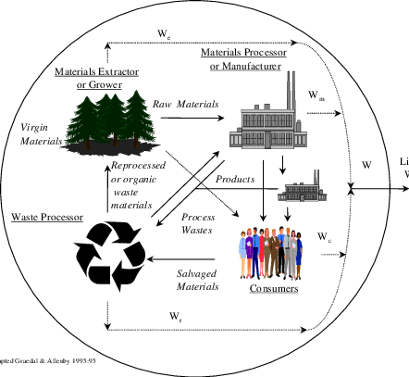

Figure 3: Eco-Industrial Park Industrial Symbiosis. Diagram of eco-industrial parks (EIPs), showing how materials, energy, and trash flow across enterprises to promote resource sharing and sustainable practices. N.d. ResearchGate. Industrial Ecology Fundamentals. Retrieved from https://www.researchgate.net/figure/Basic-Concepts-of-Industrial-Ecology_fig1_223004844

Digital Tools and AI
Industrial AI and digital technology are transforming circular economy planning and operations. Material flows, resource needs, and waste reduction can be optimized by ML algorithms. AI can analyze vast datasets to find manufacturing process inefficiencies and offer resource recovery, energy conservation, and waste reduction improvements[30].
Digital twins enable real-time industrial monitoring and simulation. This technology helps companies examine and enhance circular economy projects before deployment, ensuring sustainability. A wastewater treatment system's digital twin can model water and nutrient recovery, enhancing efficiency[30].
Organizations schedule production and control waste with predictive optimization systems that estimate resource needs and waste generation. These methods promote waste minimization, resource reclamation, and a circular economy by improving environmental and economic efficiency. Circular design, eco-industrial parks, and AI can boost business efficiency and sustainability. The circular economy created by these methods conserves resources, valorizes waste, and decreases environmental effect.

6. Barriers to Circular Economy Implementation

Technological Barriers
Technology is a major hurdle to Circular Economy (CE) implementation. garbage segregation is difficult, especially for mixed plastics and electronic garbage. Advanced sorting technologies like automated separation and robotic systems are still being developed, and large-scale operations with high efficiency and low cost are difficult. Many circular economy operations, such as waste-to-chemicals and biofuel synthesis, require inefficient and scalable catalyst development. Many catalysts deactivate, reducing their lifespan and process viability. Integrating activities inside circular systems often requires a complete infrastructure overhaul, making it difficult to adapt traditional systems to circular economy concepts. Combining biological, thermochemical, and mechanical processes into a circular system is difficult and requires constant innovation[31].

Economic Barriers
Circular economy faces significant economic challenges. Circular processes demand significant initial capital, which is a hurdle. It may be too expensive for most companies, especially SMEs, to build advanced recycling or waste-to-resource operations. Additionally, cheap raw material rivalry threatens circular alternatives' economic viability. Traditional materials, made from abundant natural resources, are cheaper to make than recycled or repurposed ones. This price gap may dissuade organizations from adopting circular processes, especially if cost-effectiveness is a key factor. Additionally, scaling solutions for widespread circular economy adoption is difficult. Technologies that work well in labs or pilots may not be cost-effective in industry[32].

Regulatory and Policy Gaps
Regulations and regulatory flaws accelerate circular economy transition. Industries cannot implement standardized waste management, recycling, and sustainability reporting procedures internationally due to the lack of standardization. Lack of a worldwide framework for extended producer responsibility (EPR) and waste management deters firms from adopting circular practices. Businesses trying to comply with varied local laws face ambiguities and practical issues in many nations and regions due to conflicting legislation. Lack of incentives (such as tax credits, subsidies, or refunds for recycling and trash reduction) deters businesses from investing in circular economy technology and practices, preventing widespread implementation of circular solutions[33].

Social and Behavioral Challenges
Alongside technological, economic, and legal impediments, social and behavioral barriers slow circular economy development. Change resistance in traditional production is a major hurdle. Due of familiarity, many organizations use linear models, and switching to circular methods may seem daunting. Circular economy strategies are often underappreciated, especially in developing economies with entrenched linear processes. Consumer behavior affects the situation because many consumers prefer throwaway products and are hesitant to separate or recycle waste. Changing these behaviors requires education, incentives, and a shift in society's sustainability and resource conservation ideas.
Governments, industry, and consumers must work together to overcome technological, economic, regulatory, and behavioral impediments. Many of these constraints can be overcome as innovation and the worldwide push for sustainability increase, enabling circular economy adoption[34].

7. Future Directions and Research Needs

Next-Generation Technologies
For widespread Circular Economy adoption, next-generation technology must evolve. Sustainable catalysts must be developed. Modern catalytic technologies, essential to chemical recycling and bio-based processing, are inefficient, short-lived, and hazardous. The scalability and sustainability of waste-to-resource systems could be improved by studying non-toxic, reusable, and more efficient catalysts, notably biocatalysts or biomimetic catalysts. Innovation in separation processes improves the extraction of valuable materials from complex waste streams. Membrane filtering, solvent extraction, and electrochemical separation require refining to improve recovery rates and reduce energy and cost. Bio-based processing of waste into chemicals, fuels, and materials offers a sustainable alternative to fossil fuel-based activities. Synthetic biology can help make bio-based products from trash, making manufacturing more sustainable[10].

AI and Digitalization
AI and digitization are becoming increasingly important in circular economy systems. By anticipating material flows and recognizing waste management inefficiencies, machine learning (ML) can improve resource recovery. Artificial intelligence can predict equipment faults using sensors and machine learning models, improving system reliability and reducing downtime. Digital twins and smart sensors enable real-time simulation, monitoring, and optimization of cyclic processes. These technologies use data to identify process inefficiencies, monitor resource use, and optimize circular systems. Blockchain allows transparent and secure waste and material flow monitoring, improving recycling and supply chain responsibility[35].

Policy and Governance
The circular economy needs stronger regulations to reach its full potential. To help enterprises embrace circular models, policymakers must set clear and uniform waste management, recycling, and material recovery standards. EPR systems, which hold manufacturers responsible for their goods' whole lifecycle, will encourage companies to design for recyclability and waste reduction. Global standards are essential for waste management uniformity, secondary raw material trading, and resource recovery. Governments should encourage circular economy technology adoption with subsidies, tax incentives, and research money[36].

Interdisciplinary Research
Interdisciplinary research is needed to accelerate circular economy transition. Chemical engineering, materials science, and environmental economics must collaborate to solve resource recovery, waste management, and sustainability problems. Interdisciplinary collaboration will optimize process design, increase recyclable materials, and evaluate circular practices' economic viability. To understand adoption barriers and improve sustainability, Circular Economy social elements including consumer behavior and public policy must be studied. Joint study will provide a holistic view of Circular Economy (CE) implementation across numerous industries and regions, accelerating the transition to a sustainable, circular future.
Investing in next-generation technology, AI, policy frameworks, and interdisciplinary collaboration may help the global community overcome challenges and execute the circular economy. This strategy will create more sustainable, strong, and efficient systems that meet long-term resource conservation and environmental protection goals.

8. Conclusion
Chemical engineering is crucial to the Circular Economy (CE), a novel concept that links economic practices with environmental goals. Chemical engineers develop waste valorization, resource recovery, process optimization, and systems integration solutions to close material loops and reduce environmental impact. Catalysis, separation, and biological processing innovations by chemical engineers reduce waste and conserve resources.
Industry, academia, and policymakers must collaborate to implement Circular Economy. Industry leaders must invest in new technology, while academia provides the knowledge and expertise to improve it. Governments must encourage circular processes with supportive laws. Collaboration between these industries is the only way to propagate circular economy principles.
Chemical engineering may restructure industry to address global concerns including resource depletion, climate change, and waste management. Chemical engineers can promote the circular economy and sustainable global development through innovation and interdisciplinary collaboration, creating a more resilient and resource-efficient future.

COMPETING INTERESTS DISCLAIMER:
Authors have declared that they have no known competing financial interests OR non-financial interests OR personal relationships that could have appeared to influence the work reported in this paper.

REFRENCES
1. Goel A, Masurkar S, Pathade GR. An Overview of Digital Transformation and Environmental Sustainability: Threats, Opportunities, and Solutions. Sustainability. 2024 Jan;16(24):11079.
2. Desrochers P. Lost Institutional Memory and Policy Advice: The Royal Society of Arts on the Circular Economy Through the Centuries. Recycling. 2025 Apr;10(2):49.
3. Wattanakit C, Fan X, Mukti RR, Yip ACK. Green Chemistry, Catalysis, and Waste Valorization for a Circular Economy. Chempluschem. 2024 Sep;89(9):e202400389.
4. Yang M, Chen L, Wang J, Msigwa G, Osman AI, Fawzy S, et al. Circular economy strategies for combating climate change and other environmental issues. Environ Chem Lett. 2023 Feb 1;21(1):55–80.
5. Mesa JA, Gonzalez-Quiroga A, Aguiar MF, Jugend D. Linking product design and durability: A review and research agenda. Heliyon. 2022 Sep 22;8(9):e10734.
6. Lingaitiene O, Burinskiene A. Development of Trade in Recyclable Raw Materials: Transition to a Circular Economy. Economies. 2024 Feb;12(2):48.
7. Fallah Shayan N, Mohabbati-Kalejahi N, Alavi S, Zahed MA. Sustainable Development Goals (SDGs) as a Framework for Corporate Social Responsibility (CSR). Sustainability. 2022 Jan;14(3):1222.
8. Oyebamiji HO, Adewuyi AY, Halidu A, Togo B, Alebiosu YT, Atilola MO, et al. Integrating Circular Economy in Retrofit: Global Practices in Sustainable Construction. Journal of Management, and Development Research. 2025 Dec 31;2(2):10–8.
9. Cravotto G. Reshaping Chemical Manufacturing Towards Green Process Intensification: Recent Findings and Perspectives. Processes. 2025 Feb;13(2):459.
10. Islam T, Islam SAM, Sarkar A, Khan AJMOR, Paul R, Bari MS. Artificial Intelligence in Fraud Detection and Financial Risk Mitigation: Future Directions and Business Applications. IJFMR - International Journal For Multidisciplinary Research [Internet]. 2024 Oct 5 [cited 2025 Jun 8];6(5). Available from: https://www.ijfmr.com/research-paper.php?id=28496
11. Dennison MS, Paramasivam SK, Wanazusi T, Sundarrajan KJ, Erheyovwe BP, Marshal Williams AM. Addressing Plastic Waste Challenges in Africa: The Potential of Pyrolysis for Waste-to-Energy Conversion. Clean Technologies. 2025 Mar;7(1):20.
12. Balancing Chemical Recycling within the Framework of a Circular Economy [Internet]. [cited 2025 Sep 22]. Available from: http://rekart.co.in/blog/Balancing-Chemical-Recycling-within-the-Framework-of-a-Circular-Economy
13. Ojo AO. An Overview of Lignocellulose and Its Biotechnological Importance in High-Value Product Production. Fermentation. 2023 Nov;9(11):990.
14. Vanaraj R, Suresh Kumar SM, Kim SC, Santhamoorthy M. A Review on Sustainable Upcycling of Plastic Waste Through Depolymerization into High-Value Monomer. Processes. 2025 Aug;13(8):2431.
15. Seif R, Salem FZ, Allam NK. E-waste recycled materials as efficient catalysts for renewable energy technologies and better environmental sustainability. Environ Dev Sustain. 2023 Jan 18;1–36.
16. Sharma A, Badea M, Tiwari S, Marty JL. Wearable Biosensors: An Alternative and Practical Approach in Healthcare and Disease Monitoring. Molecules. 2021 Feb 1;26(3):748.
17. Ghosh J, Repon MdR, Rupanty NS, Asif TR, Tamjid MI, Reukov V. Chemical Valorization of Textile Waste: Advancing Sustainable Recycling for a Circular Economy. ACS Omega. 2025 Mar 19;10(12):11697–722.
18. Carmona Marques P, Fernandes PCB, Sampaio P, Silva J. Advances in Biotechnology in the Circular Economy: A Path to the Sustainable Use of Resources. Sustainability. 2025 Jan;17(14):6391.
19. Silva JA. Advanced Oxidation Process in the Sustainable Treatment of Refractory Wastewater: A Systematic Literature Review. Sustainability. 2025 Jan;17(8):3439.
20. Mohamed D, Fayad A, Mohamed AMO, Al Nahyan MT. The Role of E-Waste in Sustainable Mineral Resource Management. Waste. 2025 Sep;3(3):27.
21. Castillo SR, Winkle CR, Krauss S, Turkewitz A, Silva C, Heinemann ES. Regulatory and Other Barriers to Urban and Peri-urban Agriculture: A Case Study of Urban Planners and Urban Farmers from the Greater Chicago Metropolitan Area. Journal of Agriculture, Food Systems, and Community Development. 2013 May 8;3(3):155–66.
22. Acampora L, Grilletta S, Costa G. The Integration of Carbon Capture, Utilization, and Storage (CCUS) in Waste-to-Energy Plants: A Review. Energies. 2025 Jan;18(8):1883.
23. Abedin T, Pasupuleti J, Paw JKS, Tak YC, Islam MR, Basher MK, et al. From waste to worth: advances in energy recovery technologies for solid waste management. Clean Techn Environ Policy [Internet]. 2025 May 28 [cited 2025 Sep 22]; Available from: https://doi.org/10.1007/s10098-025-03204-x
24. Alengebawy A, Ran Y, Osman AI, Jin K, Samer M, Ai P. Anaerobic digestion of agricultural waste for biogas production and sustainable bioenergy recovery: a review. Environ Chem Lett. 2024 Dec 1;22(6):2641–68.
25. Sarker TR, Khatun MstL, Ethen DZ, Ali MdR, Islam MdS, Chowdhury S, et al. Recent evolution in thermochemical transformation of municipal solid wastes to alternate fuels. Heliyon. 2024 Aug 30;10(17):e37105.
26. Lorenzo López AM, Expósito A. A Comprehensive Environmental Cost–Benefit Analysis of Using Reclaimed Water for Irrigation in Southern Spain. Environments. 2025 Apr;12(4):130.
27. Armoo EA, Mohammed M, Narra S, Beguedou E, Agyenim FB, Kemausuor F. Achieving Techno-Economic Feasibility for Hybrid Renewable Energy Systems through the Production of Energy and Alternative Fuels. Energies. 2024 Jan;17(3):735.
28. Butturi MA, Neri A, Mercalli F, Gamberini R. Sustainability-Oriented Innovation in the Textile Manufacturing Industry: Pre-Consumer Waste Recovery and Circular Patterns. Environments. 2025 Mar;12(3):82.
29. Kowalski Z, Kulczycka J, Makara A, Mondello G, Salomone R. Industrial Symbiosis for Sustainable Management of Meat Waste: The Case of Śmiłowo Eco-Industrial Park, Poland. Int J Environ Res Public Health. 2023 Mar 15;20(6):5162.
30. Olaitan OF, Akatakpo ON, Victor CO, Emejulu CJ, Ayoola TM, Olayiwola DE, et al. Secure and Resilient Industrial IoT Architectures for Smart Manufacturing: A Comprehensive Review. Journal of Engineering Research and Reports. 2025 Jun 21;27(6):331–44.
31. Rezania S, Oryani B, Nasrollahi VR, Darajeh N, Lotfi Ghahroud M, Mehranzamir K. Review on Waste-to-Energy Approaches toward a Circular Economy in Developed and Developing Countries. Processes. 2023 Sep;11(9):2566.
32. Chakraborty A, De D, Dey PK. Circular Economy in Small and Medium-Sized Enterprises—Current Trends, Practical Challenges and Future Research Agenda. Systems. 2025 Mar;13(3):200.
33. Onungwe I, Hunt DVL, Jefferson I. Transition and Implementation of Circular Economy in Municipal Solid Waste Management System in Nigeria: A Systematic Review of the Literature. Sustainability. 2023 Jan;15(16):12602.
34. AlJaber A, Martinez-Vazquez P, Baniotopoulos C. Barriers and Enablers to the Adoption of Circular Economy Concept in the Building Sector: A Systematic Literature Review. Buildings. 2023 Nov;13(11):2778.
35. Snoun A, Mufida MK, El-Cadi AA, Delot T. AI-Driven Innovations in Waste Management: Catalyzing the Circular Economy. Engineering Proceedings. 2025;97(1):12.
36. Alaghemandi M. Sustainable Solutions Through Innovative Plastic Waste Recycling Technologies. Sustainability. 2024 Jan;16(23):10401.

