Conductometric studies of complexation of Benzo-15-crown-5 Ether with some transition metal ions in pure and binary non-aqueous solvent mixtures

ABSTRACT:
The complexation reaction between Benzo-15-crown-5 Ether [B15C5] with Fe³⁺, Co²⁺, Ni²⁺ and Cu²⁺ cation was studied in pure acetonitrile (ACN), pure dimethyl-sulfoxide (DMSO) and in the binary solvent mixtures of ACN-DMSO at various temperatures by conductometric method. The conductance data showed that the stoichiometry of the complexes formed in pure as well as in the binary solvent mixtures was 1:1 ([M^{n+}]: [B15C5]). In binary solvent mixtures, the values of log K_{f} decrease with increase in temperature and with increase in the percentage of ACN. The negative values of ΔGº show the spontaneous reaction, the positive values of ΔHº indicate that the complexation reactions are enthalpy destabilized. Besides this, the positive values of ΔSº indicate that entropy is a driving force for the complexation reaction. The values of ΔHº and ΔSº for formation of the complexes were obtained from temperature dependence of the stability constants.

Keywords: Conductometry, Stability constants, Thermodynamic parameters, Complexation.

INTRODUCTION:
The discovery of macrocyclic polyether (crown ether) in the mid-1960 by Pedersen have played a leading role in the development of host-guest chemistry due to its complexing properties. ^{[1]} These macrocyclic compounds are capable of forming complexes with alkali and alkaline earth metal ions via electrostatic attraction and encapsulation it into the cavity of the host. ^{[2,3]} As per literature till date, there are plenty of examples on the complexation behaviour of alkali, alkaline earth metals and lanthanides ions with crown ethers in various solvent. But very few data are available with the transition metal ions.
Transition metal ions are essential micronutrition/minerals to human, animals and plants and this macrocyclic compounds by accepting the metal ions in a more or less ‘lock and key’ (host & guest) fashion, forms a selectively uncomplicated complex similar as complicated functions of biological materials such as enzymes. The study of various macrocyclic compounds in different solvent or binary solvent may indicate new approach for various fields due to their unique property and ability to form stable complexes with metal cations. The crown ethers are of practical interest for number of reasons, they have found applications in such areas as separation of metal ions, phase transfer catalysis, selective transport of metal ions, recognition of isomers. ^{[4-7]} In this process crown cavity holds the metal cation by providing full or partial inner coordination sphere due to ligating donor atoms from the crown ring to form a stable complex.
The aim of the present work is to evaluate the thermodynamic studies of complex formation between B15C5 and Fe³⁺, Co²⁺, Ni²⁺ and Cu²⁺cations in pure ACN and their binary solvent mixtures at 293.15 K, 303.15 K and 313.15 K temperatures and to study the effect of solvent and temperature on the selectivity and stoichiometry of the complexes formed and also to understand the thermodynamic parameters of the complexation reactions. The advantage of conductometry is that it can be used at very low concentration of solution with very high sensitivity using a simple experimental set-up as well as an inexpensive technique and gives reliable results. ^{[8,9]}

METHODLOGY

EXPERIMENTAL:

Reagents and Solvents:
Analytical grade metal nitrates salts of ferric nitrate (Fe (NO₃)₃.6H₂O), cobalt nitrate (Co (NO₃)₃.6H₂O), nickel nitrate (Ni (NO₃)₃.6H₂O) and copper nitrate (Cu (NO₃)₃⸳6H₂O) (Finar) and the crown ethers, Benzo-15-crown-5 ether (B15C5) (Finar) was of reagent grade (purity ≥98%) used as received. Acetonitrile (ACN) and Dimethyl-sulfoxide (DMSO) (Finar Chemicals) with the highest purity (HPLC grade) was used to prepare the solution mixtures. Glassware used were thoroughly cleaned with freshly prepared aqua-regia and rinsed thoroughly with deionized water. Stock solutions of metal ions and ligands (crown ethers) were prepared by dissolving the appropriate amount of metal ions and ligand in all pure solvents and their binary solvent mixtures.

Apparatus:
The conductance measurements were carried out using Model 856 a digital conductivity apparatus with the touch control from Metrohm (Herisau, Switzerland) and a dip type 5-ring of conductivity cell with a cell constant of 0.59 cm⁻¹ was used. The cell constant of the conductivity cell was determined by measuring the conductance of aqueous potassium chloride solutions of different concentrations.^{[10]} Sartorius GD503 (Bradford, MA, USA) analytical balance having a readability of 0.0001 g was employed for weighing of samples.

RESULTS AND DISCUSSION:

The changes of molar conductivity (Λ_{m}) versus the ligand to metal cation mole ratio [L]_{t}/[M]_{t} for the complexation of B15C5 with M^{n+} (Fe³⁺, Co²⁺, Ni²⁺ and Cu²⁺) metal cations in pure acetonitrile, pure dimethyl-sulfoxide and in the binary solvent mixtures of acetonitrile-dimethylsulfoxide were studied at 293.15K, 303.15K and 313.15K temperatures. The typical series of molar conductance values as a function of [L]_{t}/[M]_{t} for B15C5-M^{n+} complex in pure ACN and in the binary solvent mixtures of ACN-DMSO (v/v% = 80/40/20) are shown in Fig:1–5.

Figure 1: Molar conductance (Λm) versus mole ratio [L]/[Fe³⁺] plots for B15C5-Fe³⁺ complex in pure ACN at: A=293.15 K, B=303.15 K & C=313.15 K temperatures. | Figure 2: Molar conductance (Λm) versus mole ratio [L]/[Fe³⁺] plots for B15C5-Fe³⁺ complex in 80% ACN + 20% DMSO at: A=293.15 K, B=303.15 K & C=313.15 K temperatures.
Figure3: Molar conductance (Λm) versus mole ratio [L]/[Fe³⁺] plots for B15C5-Fe³⁺ complex in 40% ACN + 60% DMSO at: A=293.15 K, B=303.15 K & C=313.15 K temperatures. | Figure 4: Molar conductance (Λm) versus mole ratio [L]/[Fe³⁺] plots for B15C5-Fe³⁺ complex in 20% ACN + 80% DMSO at: A=293.15 K, B=303.15 K & C=313.15 K temperatures.
  Figure 5: Molar conductance (Λm) versus mole ratio [L]/[Fe³⁺] plots for B15C5-Fe³⁺ complex in pure DMSO at: A=293.15 K, B=303.15 K & C=313.15 K temperatures.
The stability constants of B15C5 crown ether complexes with M^{n+} (Fe³⁺, Co²⁺, Ni²⁺ and Cu²⁺) metal cations at each temperature were calculated from variation of molar conductance as a function of [L]_{t}/[M]_{t} molar ratio using a Genplot computer program. ^{[11–15]} The values of the stability constant (log K_{f}) for the B15C5-M^{n+} complex in various binary solvent mixtures are listed in Table 1. Plots of Log K_{f} versus 1000/T in all cases were linear and a typical example of these plots is shown in Figure 6(1000/T graph). The changes in standard enthalpy (ΔH°) for complexation reaction were determined from the slope of the Van’t Hoff plots assuming that ΔCp is equal to zero over the entire temperature range investigated. The changes of standard entropy (ΔS°) were calculated from the relationship: ΔG° = ΔH° - TΔS° and the results are summarized in Table 2.

Table 1: Log K_{f} values of B15C5-M^{n+} complex in pure ACN, pure DMSO and ACN-DMSO binary solvent mixtures at different temperatures.
Complex | Solvent medium | Log Kf±SDª
Complex | Solvent medium | 293.15 K | 303.15 K | 313.15K
B15C5-Fe³⁺ | Pure ACN | 4.682±0.09 | 4.652±0.07 | 4.577±0.06
 | 80% ACN -20%DMSO | 4.635±0.06 | 4.597±0.06 | 4.559±0.08
 | 40% ACN -60%DMSO | 4.676±0.08 | 4.644±0.08 | 4.607±0.05
 | 20% ACN -80%DMSO | 4.497±0.09 | 4.471±0.09 | 4.443±0.07
 | Pure DMSO | 4.358±0.03 | 4.330±0.08 | 4.313±0.07
B15C5-Ni²⁺ | Pure ACN | 4.665±0.07 | 4.632±0.07 | 4.557±0.06
 | 80% ACN -20%DMSO | 4.612±0.06 | 4.580±0.07 | 4.539±0.05
 | 40% ACN -60%DMSO | 4.630±0.07 | 4.603±0.05 | 4.580±0.06
 | 20% ACN -80%DMSO | 4.479±0.08 | 4.459±0.06 | 4.411±0.04
 | Pure DMSO | 4.348±0.06 | 4.328±0.07 | 4.303±0.05
B15C5-Cu²⁺ | Pure ACN | 4.644±0.07 | 4.600±0.08 | 4.539±0.06
 | 80% ACN -20%DMSO | 4.598±0.06 | 4.565±0.06 | 4.520±0.05
 | 40% ACN -60%DMSO | 4.627±0.05 | 4.581±0.06 | 4.549±0.07
 | 20% ACN -80%DMSO | 4.455±0.06 | 4.427±0.07 | 4.387±0.08
 | Pure DMSO | 4.323±0.04 | 4.301±0.06 | 4.282±0.04
B15C5-Co²⁺ | Pure ACN | 4.620±0.06 | 4.576±0.06 | 4.513±0.08
 | 80% ACN -20%DMSO | 4.585±0.04 | 4.552±0.07 | 4.500±0.04
 | 40% ACN -60%DMSO | 4.603±0.03 | 4.579±0.04 | 4.530±0.05
 | 20% ACN -80%DMSO | 4.438±0.05 | 4.399±0.05 | 4.358±0.06
 | Pure DMSO | 4.305±0.06 | 4.289±0.04 | 4.262±0.04
ªSD= standard deviation

Table 2: Thermodynamic parameters for B15C5-M^{n+} complexes in pure ACN, pure DMSO and ACN-DMSO binary solvent mixtures at 293.15K

Complex | Solvent medium | ΔGº± SDª  (kJ.mol⁻¹) | ΔHº ± SDª  (kJ.mol⁻¹) | ΔSº ± SDª  (J.mol⁻¹K⁻¹)
B15C5-Fe³⁺ | Pure ACN | -26.28±0.06 | -9.18±0.07 | 58.47±5
 | 80% ACN -20%DMSO | -26.01±0.04 | -6.67±0.06 | 65.97±3
 | 40% ACN -60%DMSO | -26.24±0.05 | -6.23±0.05 | 68.30±5
 | 20% ACN -80%DMSO | -25.24±0.03 | -4.74±0.04 | 69.93±2
 | Pure DMSO | -24.46±0.1 | -3.96±0.08 | 69.89±4
B15C5-Ni²⁺ | Pure ACN | -26.18±0.06 | -9.44±0.05 | 57.23±5
 | 80% ACN -20%DMSO | -25.88±0.03 | -6.40±0.05 | 66.49±3
 | 40% ACN -60%DMSO | -25.98±0.05 | -4.39±0.04 | 73.64±4
 | 20% ACN -80%DMSO | -25.14±0.04 | -5.94±0.03 | 65.56±5
 | Pure DMSO | -24.40±0.1 | -3.94±0.15 | 69.80±4
B15C5-Cu²⁺ | Pure ACN | -26.06±0.08 | -9.20±0.07 | 57.59±6
 | 80% ACN -20%DMSO | -25.80±0.06 | -6.84±0.04 | 64.74±5
 | 40% ACN -60%DMSO | -25.97±0.04 | -6.86±0.06 | 65.13±3
 | 20% ACN -80%DMSO | -25.00±0.03 | -5.96±0.05 | 65.00±4
 | Pure DMSO | -24.26±0.06 | -3.60±0.1 | 70.47±4
B15C5-Co²⁺ | Pure ACN | -25.93±0.06 | -9.38±0.04 | 56.52±8
 | 80% ACN -20%DMSO | -25.73±0.04 | -7.44±0.04 | 62.44±5
 | 40% ACN -60%DMSO | -25.83±0.05 | -6.38±0.07 | 66.42±4
 | 20% ACN -80%DMSO | -24.91±0.03 | -7.02±0.04 | 61.02±6
 | Pure DMSO | -24.16±0.07 | -3.76±0.1 | 69.61±4
ªSD= standard deviation

It is observed from Figure 1-5 that the molar conductivity of B15C5 with M^{n+} (Fe³⁺, Co²⁺, Ni²⁺ and Cu²⁺) metal cations in pure ACN, pure DMSO as well as in the binary solvent mixtures of ACN-DMSO decrease with increase in the temperature. The decrease in the molar conductivity of B15C5-M^{n+} complexes in pure as well as in the binary solvent mixtures of ACN- DMSO indicates that complex formed is less mobile than the free solvated corresponding cations. The slope of the corresponding Λ_{m} versus [L]_{t}/[M]_{t} plot changes sharply at the point where [L]_{t}/[M]_{t} is 1, which shows the formation of relatively stable 1:1 complex.
It is observed from Table 1, that the stability constants values decrease with increase in temperature for pure ACN, pure DMSO and ACN-DMSO (v/v% =80/40/20) binary solvent mixtures which reveals that the results of complexation reaction between B15C5 and metal cations (Fe³⁺, Co²⁺, Ni²⁺ and Cu²⁺) in these binary solvent mixtures are exothermic. This behavior indicates that formed complexes were weaker at higher temperature. The stability constant (log K_{f}) of (B15C5-Fe³⁺) complexes increases with increasing the concentration of acetonitrile in ACN-DMSO binary solvent mixtures. Similar trends were observed in all other metal ions.

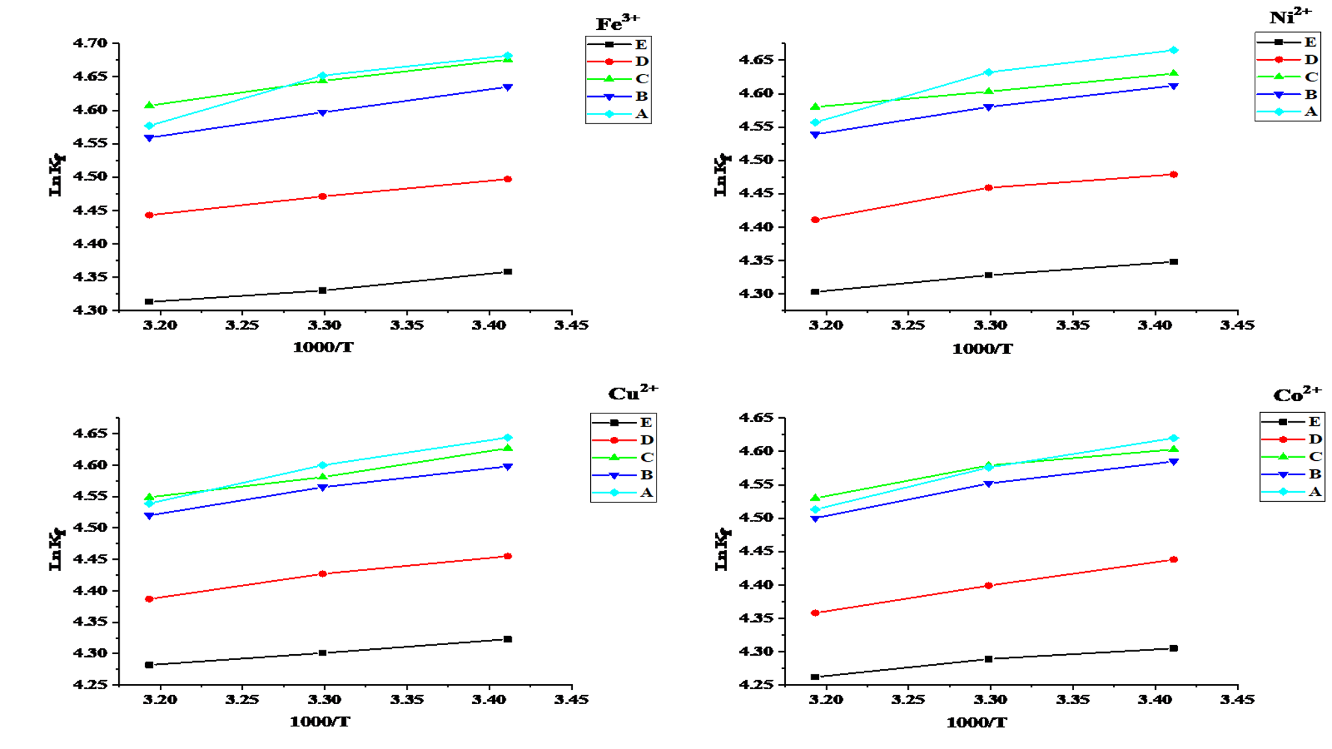

Figure 6: Change of the stability constant Log K_{f} of (B15C5-M^{n+}) complexes with the composition of ACN-DMSO (A=pure ACN, B=80% ACN, C=40%ACN, D=20%ACN, E=pure DMSO) binary solvent mixtures at different temperatures: 293.15 K, 303.15 K and 313.15 K.
To have a better understanding about the thermodynamics of complexation reaction, the enthalpic (∆Hº), and entropic (∆Sº) contribution towards complex formation was evaluated in pure as well as binary solvent mixtures. As shown in the Table-2, the values of thermodynamic parameters for complexation reactions vary with the nature and composition of the mixed solvents, but they vary non-monotonically with the solvent composition. The negative values for free energy (ΔGº) indicate that the complexation process is spontaneous. The experimental values of ∆Hº and ∆Sº show that in all the cases, the complexation reaction is entropy stabilized while enthalpy destabilized, therefore, the entropy of complexation reaction are the principal driving forces for formation of the formed complexes in pure ACN and in the mixtures of ACN-DMSO. It seems reasonable to assume that the increase in entropy on complexation is due to the solvation of the cation and the ligand upon complexation.

In the process of complexation, the solvent and crown ether molecules compete to bind with the metal cations. The cation is poorly solvated and readily complexed by the crown ether when the solvent's donor properties are low, leading to the development of a strong complex in that solvent.^{[16]}The formation of complexes is weakened as the concentration of DMSO increases in the ACN-DMSO binary mixtures because the solvation of the metal cations and possibly the ligand should be stronger in a strong solvating solvent like DMSO having (Gutman Donor Number (DN=29.8) than in solvents with lower solvating abilities like ACN (DN=14.1) therefore, the stability constant (log K_{f}) of (B15C5-M^{n+}) complexes decreases with increasing the temperature in pure ACN and in ACN-DMSO binary solvent mixtures, it indicates that process is exothermic process, and the formation of the complexes is weakened as the concentration of DMSO increases in ACN-DMSO binary solvent mixtures.

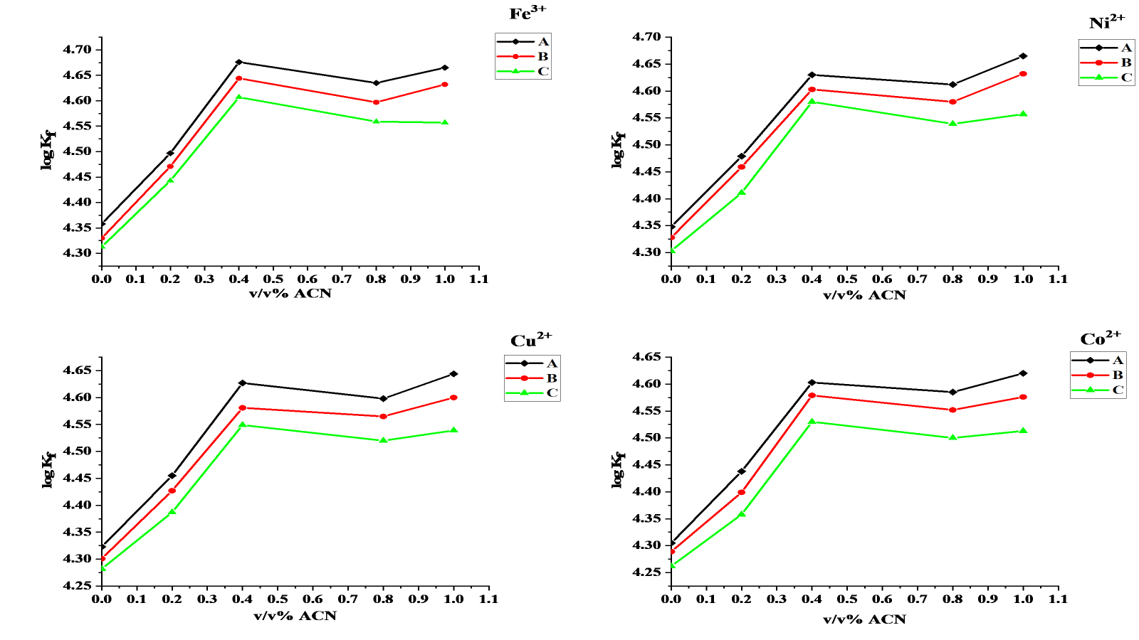

Figure 7: Change of the stability constant Log K_{f} of (B15C5-M^{n+}) complexes with the composition of pure ACN, pure DMSO and ACN-DMSO binary solvent mixtures at various temperatures: A (♦) = 293.15 K, B (●) = 303.15 K and C (▲) = 313.15 K.

Along with the donor number other property like dielectric constant also play the major role. It should be noted that somewhat lower dielectric constant of ACN (38.0) in comparison with that of DMSO (45.0) would cause the electrostatic contribution to the bond formation to increase with increasing percentage of ACN in the binary solvent mixtures. Further, the stability and the selectivity of the formed complexes are affected by several factors like, (1) cavity size of the ligand, (2) the charge density and the polarizability of the cation, (3) nature of donor atoms (4) substituents existing in the macrocycle and (5) the type of anion associated with the cation. ^{[17,18]}

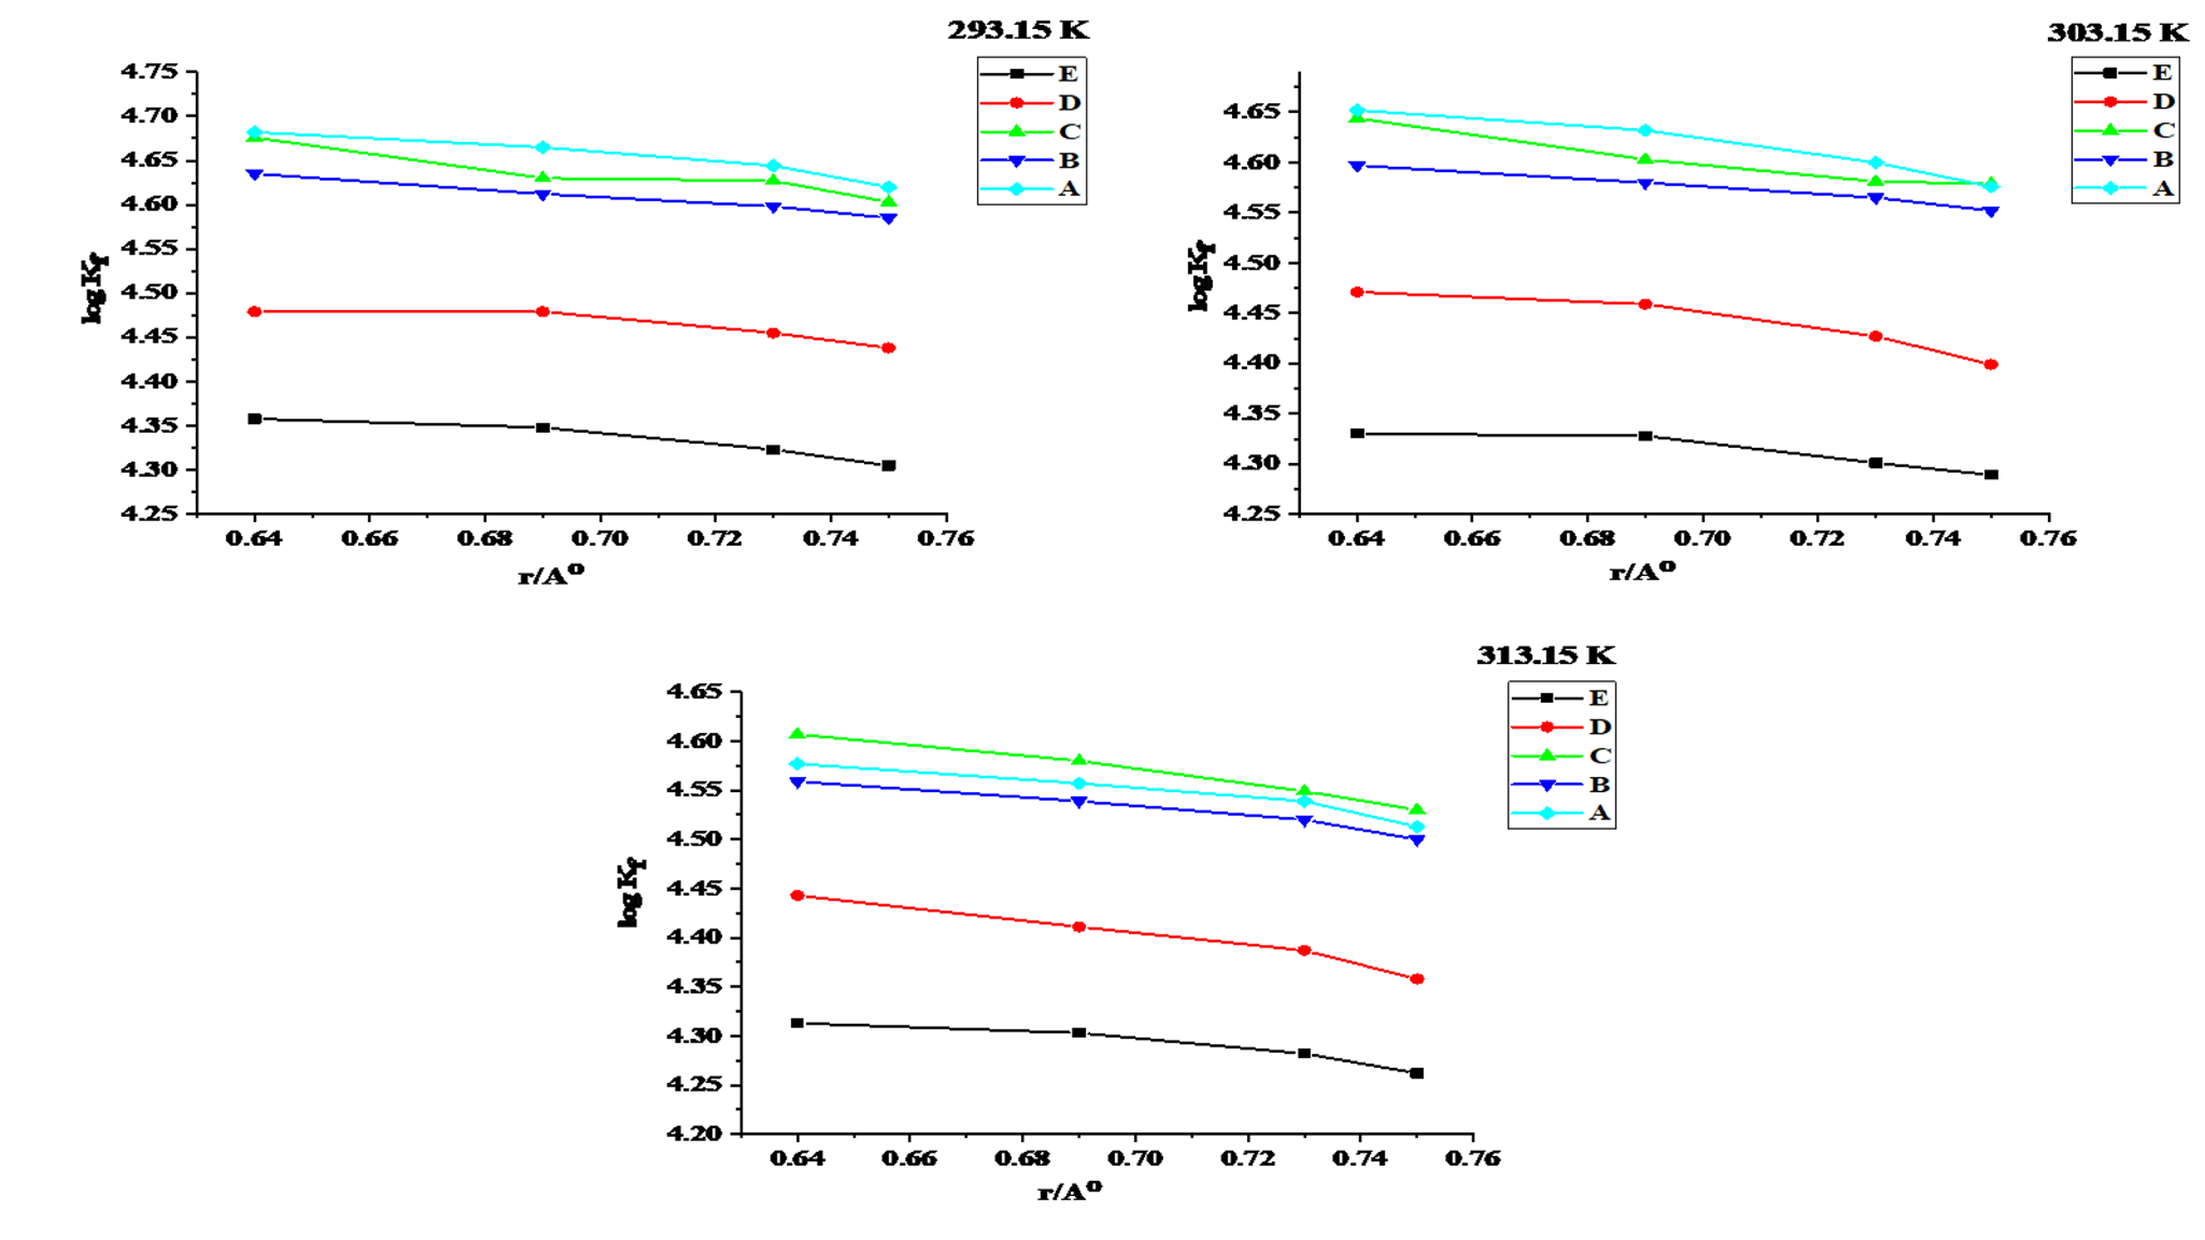
Figure 8: Variation of log K_{f} for L-M^{n+} complexes versus cationic radius in pure ACN, pure DMSO and ACN- DMSO binary solvent mixtures at different temperatures:(A= pure ACN, B =80% ACN, C = 40% ACN, D = 20% ACN, E = pure DMSO)

It is observed from Figure 8 that the stability of the complexes increases with the decrease in the ionic size. The variation of log K_{f} of (B15C5-Fe³⁺), (B15C5-Co²⁺), (B15C5-Ni²⁺) and (B15C5-Cu²⁺) complexes vs. the ionic radii in pure ACN, pure DMSO, and various ACN-DMSO binary solvent mixtures is shown in above figures. As it is seen, that the order of stability of complexes formed between B15C5 and these metal cations vary with the variation of volume of ACN. To explain the crown ether complexes selectivity, the fitness of the metal cation to the cavity of a macrocyclic ligand is an important factor. As is obvious in these figures, the order of selectivity of these complexes at various temperatures is B15C5-Fe³⁺ > B15C5-Ni²⁺ > B15C5-Cu²⁺ > B15C5-Co²⁺.^{[19]}

CONCLUSION:
In the present work complexation reaction between M^{n+} (Fe³⁺, Co²⁺, Ni²⁺ and Cu²⁺) cation and B15C5 has been studied in pure ACN and the mixtures of ACN-DMSO by conductometry. The results obtained indicate that the nature and composition of solvent systems play a vital role in the thermodynamic stability and selectivity of the M^{n+} cations complexes formed. The stoichiometry of the B15C5-M^{n+} in pure as well as binary solvent mixtures was 1:1. Further, the negative values of ΔGº show the spontaneous reaction and positive value of ΔHº which indicates that the complexation reaction is enthalpy destabilized. Furthermore, the positive value of ΔSº indicates that entropy is a driving force for the complexation reaction. The results show that the values and also the sign of these parameters are influenced by the nature and composition of the mixed solvents. In most of all the cases, a non-monotonic behavior was observed for variation of Log K_{f} of the complex versus the composition of the binary solvent system. The results show that the values and also the sign of these parameters are influenced by the nature and composition of the mixed solvents.

COMPETING INTERESTS DISCLAIMER:
Authors have declared that they have no known competing financial interests OR non-financial interests OR personal relationships that could have appeared to influence the work reported in this paper.

REFRENCES:

- C. J. Pedersen: J. Am. Chem. Soc. 89, 7017 (1967).
- C.J. Pedersen, J. Am. Chem. Soc. 92 (1970) 386.
- C.J. Pedersen, J. Am. Chem. Soc. 92 (1970) 391.
- I.M. Kolthoff, Anal. Chem., 51(1979)1R.
- D.A. Laidler and J.F. Stoddart, in S. Patai (Ed.)., Wiley, Chichester, 1980, Chapter-1.
- F. Vogtle and E. Weber, in S. Patai (Ed.)., Wiley, Chichester, 1980, Chapter-2.
- F. Vogtle, Topics in Current Chemistry, Springer, New York,1982.
- A.N. Sonar, European Journal of Biomedical and Pharmaceutical Sciences, Vol. 3, No. 6, Pp. 400-403, 2016.
- E. A. Gomaa, K.M. Ibrahim and N.M. Hassan, Research and Review: Journal of Chemistry, Vol. 3, No. 1, Pp. 47-55, 2014.
- Wu YC and Koch WF., Journal of Solution Chemistry, Vol. 20, Pp. 391-401, 1991.
- GENPLOT, Computer Graphic Service, USA, 1989.
- G. Rounaghi, Z. Eshagi, E. Ghiamati, (1996) Talanta, 43: 1043-1048.
- G. Rounaghi, Z. Eshaghi, E. Ghimati, (1997) Talanta, 47: 275-282.
- Genplot, Data Analysis and Graphical Plotting Program for Scientist and Engineers. Computer Graphic Service, Ltd., Ithaca, NY, USA,1989.
- G. Rounaghi, Z. Eshaghi and E. Ghiamati, Talanta,1997, vol. 44 no.2, pp. 275.
- M. Shamsipur, G. Rounaghi, A. I. Popov, J. Sol. Chem., 1980, 9, 701-714.
- S. Ahmadzadeh, A. Kassim, M. Rezayil, Y. Abdollahi, G.H. Rounaghi, Int. J of Elec Sci., 2011,6,4749-4759.
- G. Rounaghi, M. A. Zawar, K. Badiee, F. Boosaidi, M. Kazemi, J. Inc. Phen. Macrocyclic. Chem., 2007, 59, 363-369.
- F. Christry, P. Shrivastav, (2011) Critical Reviews in Analytical Chemistry, 41: 236-269.

.

