Original Research Article

Suitability Assessment for Managed Aquifer Recharge (MAR) Using GIS and AHP-Weighted Overlay Analysis in Bapatla District, Andhra Pradesh, India

Abstract:
Managed Aquifer Recharge (MAR) is a method used worldwide to restore depleted aquifers. It involves various approaches, namely the utilisation of infiltration basins, recharge wells, and percolation ponds. The approach has become increasingly important due to the water scarcity threats posed by climate change, population growth, and unsustainable agricultural practices. In India, groundwater overexploitation is rampant, particularly in states like Andhra Pradesh, which are agriculturally intensive. In the state, irrigation uses more than 60% of the groundwater. Bapatla District, located along the coast in Andhra Pradesh, is experiencing groundwater stress due to over-extraction and salinity ingress.
The study employs a GIS-based Analytical Hierarchy Process (AHP) to assess the suitability of MAR in Bapatla District, considering various factors such as slope, soil permeability, land use/land cover (LULC), drainage density, and Topographic Wetness Index (TWI). The weighted overlay analysis results indicated that 33. 51% (1,317.65 km²) of the district, and 18% Approximately 709.38 km² (4.04%) of the area was classified as highly suitable. Moderate suitability encompasses 29 percent. Low and very low potential zones occupy only 18% (263.61 km²). 54%, and zero. 12%, respectively (Dewi, 2019). Therefore, areas that have low MAR potential need to be conserved while high MAR potential areas should be targeted for specific interventions such as the construction of recharge wells. The study’s findings will assist policy makers to strategies on the long-term use and regulatory measures of groundwater usage in Bapatla and other areas affected by water salinity.
Keywords: Managed Aquifer Recharge (MAR), GIS, Groundwater Depletion, Coastal Aquifers, Groundwater and Water Security.

- Introduction
Managed Aquifer Recharge (MAR) is a strategy for water management and it is the global water management community that recognises it. The method is focused on the recovery of drought-affected groundwater stocks by the use of artificial recharge techniques such as infiltration basins, recharge wells, and percolation ponds (Dillon et al., 2019; Maliva, 2020). The situation of water scarcity that continues to worsen due to climate change, rapid population growth, and unsustainable agricultural practices has pushed MAR to become a water management plan for the allocation of extra water which is the only option for arid and semi-arid areas to secure water availability (Ringleb et al., 2016; UNESCO, 2021).
Groundwater overexploitation in India is so severe that groundwater has almost disappeared, especially in states with intensive agriculture e.g. Andhra Pradesh, where those withdrawing irrigation water from the groundwater account for more than 60% of the total (Central Ground Water Board [CGWB], 2020; World Bank, 2022). The Bapatla district, which is a part of coastal Andhra Pradesh, is in dire need of groundwater which is stressed beyond its limit due to the factors of overexploitation, the saline intrusion, and the irregular rain of monsoon (Adimalla & Taloor, 2020; Reddy et al., 2021).
GIS has certainly transformed how spatial decisions can be accomplished in the water resource management area by facilitating (Jha et al., 2014; Singh et al., 2020) the collection and manipulation of multi-layer geospatial data. The integration of AHP (Analytical Hierarchy Process), a MCDM (multi-criteria decision-making) method and GIS then becomes an efficient tool to assign weights to environmental, water, and socio-economic factors that drive recharge bank water storage reservoir (MAR) suitability (Saaty, 1980; Chowdhury et al., 2010; Rahman et al., 2022). This hybrid method not only confirms that the selection of a water point that is consistent with the scientific investigation but also that it is fully informed by the local hydrogeological conditions (Stefan & Ansems, 2018; Ross et al., 2021) is current.
Topography, soil permeability, LULC, groundwater depth, aquifer characteristics, and climatic conditions (Ghayoumian et al., 2007; Assefa et al., 2021) are the main factors which together decide the selection of the most suitable MAR sites. The slope is a major factor, as the gentle slopes (0–5%) will support more infiltration rate than steep terrains (Bouwer, 2002; Kumar et al., 2020). Soil texture also comes forward as the main factor in this area of study which is where the soils that have sand and loam species are more likely to show higher infiltration capacity than the ones that consist mainly of clay (Dillon, 2005; Rajaveni et al., 2017). Land use patterns have to be chosen very thoughtfully in a proper way so that they will not become the reason for the destruction of agriculture, urban expansion, or ecologically sensitive zones (Maliva, 2020; Nair et al., 2022). In addition, groundwater depth and aquifer storage capacity are the factors by which the possibility of recharge is determined, with the moderately deep wells (5–20 m) being the most suitable for injection and drawing water (Dillon et al., 2019; Saha et al., 2021). The crisis in the Bapatla district that has resulted from over-dependence on groundwater for irrigation, which in turn meets almost 80% of the total agricultural water demand, has reached such an extent that the Department of Agriculture, Andhra Pradesh, 2021; FAO, 2022 have stated that implementing MAR is the only way to solve the issue.
The district has a tropical climate and the average annual rainfall is 900–1100 mm, which is mostly during the monsoon season (Indian Meteorological Department [IMD], 2022; Rao et al., 2023). However, the high rate of evaporation of water and the irregular distribution of rain restrict the recharge to the soil and hence the recharge is almost negligible. Naturally, the groundwater which is there is overexploited (Rajaveni et al., 2017; Reddy et al., 2021). Besides that, the coastal aquifers in Bapatla will be more and more vulnerable to the intrusion of salty water if this remains unregulated due to the overdraft of groundwater which is caused by the overexploitation of groundwater (Sakram et al., 2019; Thilagavathi et al., 2022). This is why the current situation is a big call for a well-designed plan for the selection of MAR places that are compatible with the goals of sustainable water resource management.
Numerous previous publications have highlighted that GIS and AHP have proven to be highly reliable for not only recognising but also ranking locations for a MAR project in diverse geographical areas. To offer a specific illustration, a team of researchers headed by Singh et al. (2020) employed these techniques in Rajasthan, India, to create a list of the most suitable spots for percolation tanks based on soil permeability and slope conditions. Along the same lines, Rahman et al. (2022) carried out a survey for MAR feasibility in Bangladesh by combining remote sensing and AHP-weighted overlay analysis, the consequent idea being that drainage density and aquifer transmissivity are the main players in this field. Ghayoumian et al. (2007) have, to a great extent, made use of GIS, copious hydrological data, and hydrological model simulation to identify and rank recharge zones in the arid parts of Iran. Maliva (2020) has followed this example to research salt intrusion in the coastal aquifer via these studies.
The primary focus of this study is to locate areas where MAR can be implemented in the Bapatla district by employing GIS and AHP-weighted overlay analysis. This research is aimed at solving the following tasks: Firstly, to detect the factors of hydrogeology and environment that have considerable influence on the suitability of MAR; Secondly, through AHP, it is to give each factor a relative weight of importance; Thirdly, to create a suitable map that is spatially explicit; and Fourthly, to suggest the specific MAR methods that are appropriate to the local conditions (e.g., recharge wells, infiltration basins). The findings will thus provide practical opportunities for decision-makers, water resource managers, and local communities to not only facilitate the implementation of targeted MAR interventions that help reduce groundwater depletion but also to contribute to water security.
This study is not only pivotal but also establishes new dimensions in sustainable groundwater management research in water-scarce areas. The utilisation of a scientifically supported and repeatable procedure ensures that the MAR activities are viable both from a technical and an environmental point of view (Stefan & Ansems, 2018; Ross et al., 2021). Furthermore, the template of this research can be applied to other areas with the same groundwater problems, thus providing a scalable solution to water security in developing countries (World Bank, 2022; UNESCO, 2023). This approach is consistent with the local MAR developments (Dillon et al., 2019; UNESCO, 2023) and it also fulfils the water crisis in Andhra Pradesh (CGWB, 2020; Reddy et al., 2021) by providing an easily scalable model for hydrological sustainability that is compatible with agricultural and community requirements.
The research reveals the urgent need for a scientifically rigorous framework employing GIS and AHP-weighted overlay analysis to enable effective implementation of Managed Aquifer Recharge (MAR) in the Bapatla district in the same manner as this study. By methodically assessing factors related to hydrogeological, geographical and social-environmental aspects. The research serves to equip policymakers and local stakeholders with implementable measures of amplifying water security, while furthering the global conversation on sustainable groundwater management amidst the challenges of climate change and increasing water demand.
- STUDY AREA
Bapatla District, situated along the coast of Andhra Pradesh, India, is distinguished by its unique geological and hydrogeological features. The district extends over an area of 382,884 hectares. The district is bordered by Guntur, Palnadu/Narasaraopet, and Prakasam Districts and the Bay of Bengal in the south. The western part has ancient metamorphic rocks while the eastern part features sedimentary formations, affecting groundwater circulation. The black cotton soil and sandy loamy soil respectively cover 70% and 30% of the total area, which means that they dominate the district. The Bay of Bengal’s proximity affects the country’s climate, and its tropical nature brings an annual average rainfall of 925 millimeters. monsoons contributes the better part, and its annual mean stands at 3 However, due to the high variability of climate in the region, some parts are prone to cyclones and other extreme weather phenomena.
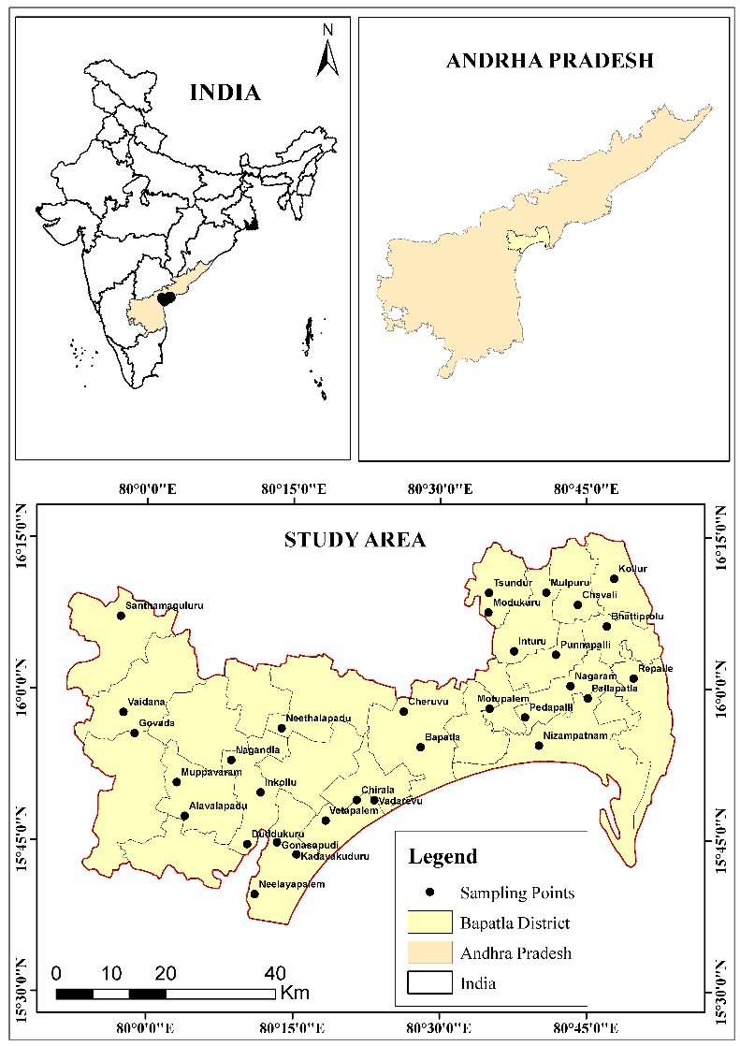
Fig.1: Location map of the study area
Moreover, the hydrogeological conditions in the district are complex, resulting in significant spatial variations in groundwater quality and quantity. The eastern and northwestern regions have a higher amount of precipitation, while the southwestern part has a shallow groundwater level. The concentration of chlorides in some coastal aquifers exceeds the permissible limits. The primary sector of the region’s economy is agriculture, with paddy, cotton, and sugarcane as the main crops. The Krishna Western Delta canal system and other minor sources such as tube wells provide water for irrigation. Water quality remains a concern, as only 41 percent of water bodies have been assessed. Only 38% of groundwater is considered fit for agricultural irrigation. Environmental factors, such as climate change and excessive groundwater usage, together with the country’s high population density of 414 people per km², combine to threaten freshwater availability. These issues make Bapatla District an important study area for coastal aquifer research on groundwater salinity.
- METHODOLOGY
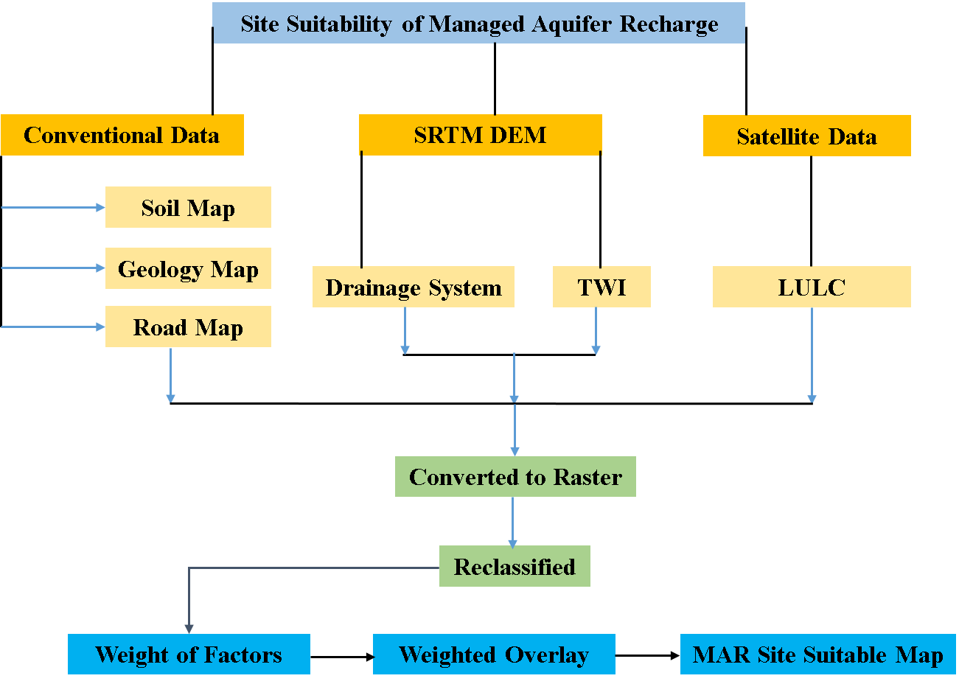
Fig: 2. Flow Chart of the Managed Aquifer Recharge
The methodology for assessing the site suitability of Managed Aquifer Recharge (MAR) involves a systematic integration of both conventional and satellite-derived data. Key datasets such as SRTM DEM, soil maps, geology maps, drainage systems, Topographic Wetness Index (TWI), Land Use/Land Cover (LULC), and road maps are collected and processed. These datasets are converted into raster formats to ensure uniformity and compatibility for spatial analysis. Each factor is then reclassified based on its influence on MAR suitability, assigning appropriate values to different classes within each layer. This step ensures that the data reflects the relative importance of each factor in determining suitable sites for MAR.
The reclassified layers are subsequently assigned weights according to their significance in the MAR site selection process. A weighted overlay analysis is performed to combine these layers, taking into account their respective weights. This analysis generates a composite MAR Site Suitability Map, which highlights areas with varying levels of suitability for implementing MAR projects. The final map serves as a decision-support tool, enabling stakeholders to identify optimal locations for MAR based on a comprehensive evaluation of multiple environmental and infrastructural factors.
- RESULTS AND DISCUSSION
  - Input Parameters
    - Slope Map
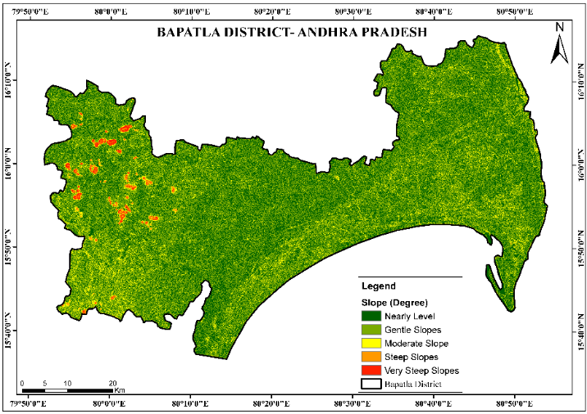
Fig. 3: Slope Map of Bapatla District
The slope map of Bapatla District, Andhra Pradesh, classifies the terrain’s steepness into five categories: Nearly Level, Gentle Slopes, Moderate Slope, Steep Slopes, and Very Steep Slopes. The terms “Nearly level” and “Gentle slopes” imply that most of the land is flat or mildly undulating, which is ideal for MAR because it facilitates better water infiltration. In contrast, areas designated as “Steep Slopes” and “Very Steep Slopes” presumably lie along the district’s periphery or on its elevated parts. The slope distribution indicates that the more elevated and steeper the terrain, such as in the western part, the less the potential is for MAR.

    - Soil Map
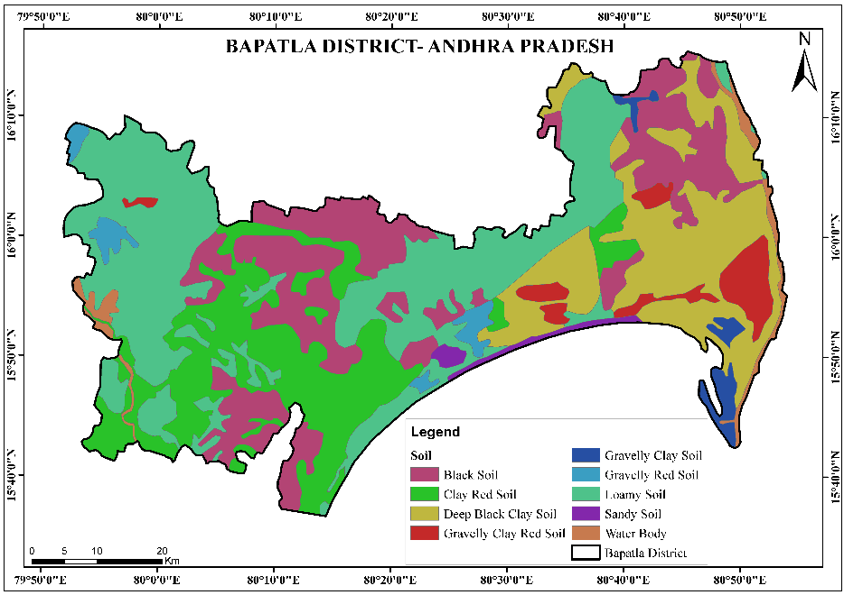
Fig. 4: Soil Map of Bapatla District
The soil map of Bapatla District showcases a variety of soil types, including Black Soil, Clay Red Soil, Deep Black Clay Soil, and Loamy Soil, which are highly fertile and suitable for agriculture, particularly for crops like cotton and pulses. Gravelly Clay and Sandy Soils indicate areas with lower water retention, potentially limiting agricultural productivity without irrigation. The presence of Water Bodies further underscores the district's reliance on aquatic resources for irrigation and livelihoods. The district's east-west expanse highlights soil variability across its terrain.
    - Geology
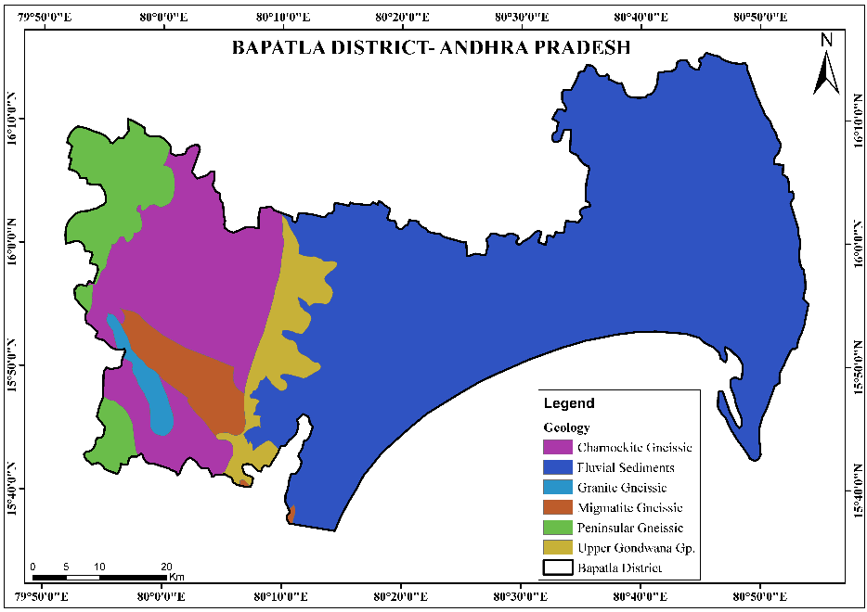
Fig. 5: Geological Map of Bapatla District
The geological map of Bapatla District, Andhra Pradesh, reveals a diverse lithological composition dominated by various gneissic formations, including Charnockite Gneissic, Granite Gneissic, Migmatite Gneissic, and Peninsular Gneissic, indicating a region with a complex Precambrian basement. The presence of Upper Gondwana Group sediments suggests historical fluvial and lacustrine environments, while Fluvial Sediments highlight recent alluvial deposits, likely associated with river systems. This geological diversity influences the district's topography, groundwater potential, and suitability for construction or agriculture, with gneissic rocks providing stable foundations and fluvial sediments supporting fertile soils.
    - LULC
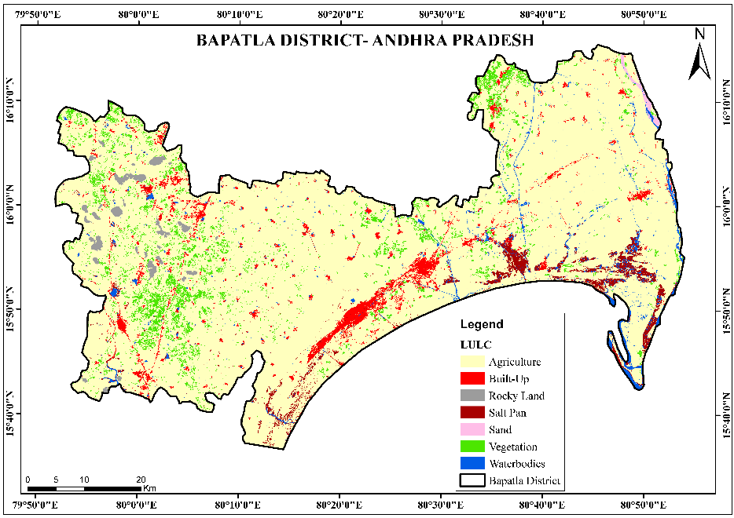
Fig. 6: LULC Map of Bapatla District
The Land Use and Land Cover (LULC) map of Bapatla District depicts a landscape primarily dedicated to Agriculture, reflecting the region's agrarian economy. Built-up areas represent urban and rural settlements, while Vegetation and Waterbodies indicate natural ecosystems supporting biodiversity and water resources. Rocky Land and Salt Pans suggest zones with limited agricultural utility, possibly used for mining or salt production. The longitudinal markers (79°50'0"E to 80°50'0"E) align with other maps, emphasizing the interplay between human activities and natural features in shaping the district's land use patterns.
    - Road
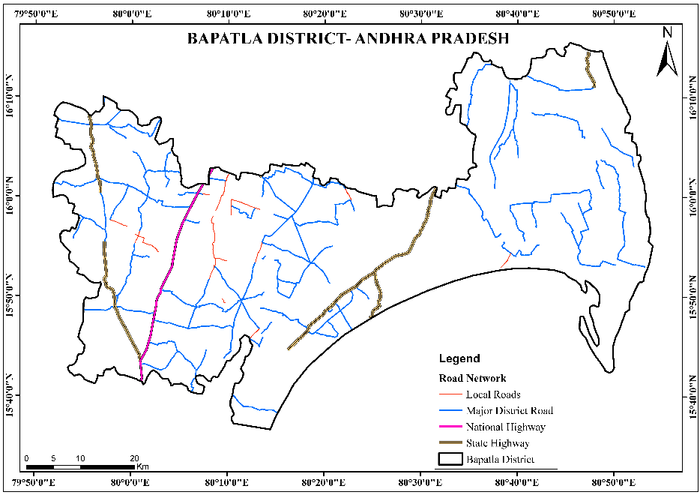
Fig. 7: Road Map of Bapatla District
The road network map of Bapatla District illustrates a well-connected transportation infrastructure, featuring Local Roads, Major District Roads, State Highways, and National Highways. The hierarchy of roads reflects the district's accessibility and economic integration, with National Highways facilitating long-distance trade and State Highways connecting regional hubs. Local Roads and Major District Roads ensure intra-district connectivity, supporting rural and urban mobility. The coordinates (15°40'0"N) suggest the map's focus on the district's central or northern regions, emphasising the importance of transportation in linking Bapatla to broader economic and administrative networks.
    - Streams
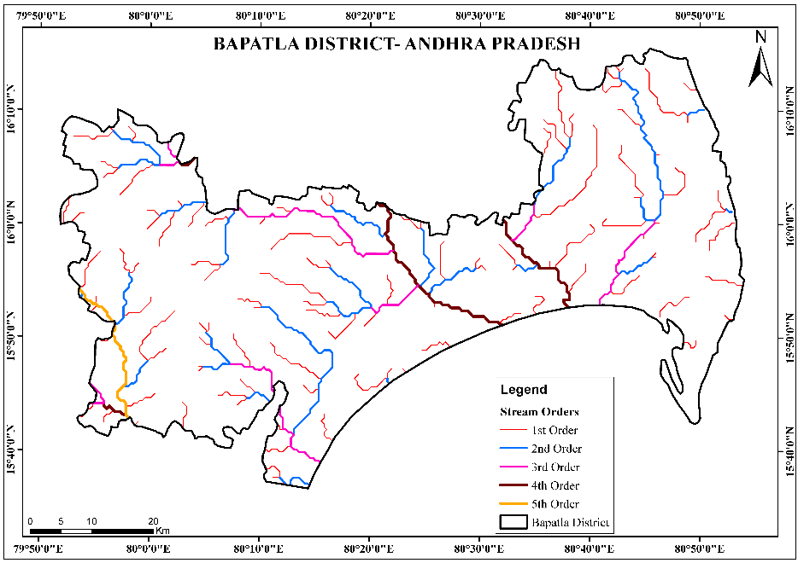
Fig. 8: Drainage Map of Bapatla District
The stream order map of Bapatla District delineates a hierarchical drainage network, with 1st to 5th Order streams illustrating the progression from small tributaries to larger river channels. This network is critical for understanding the district's hydrology, as it influences groundwater recharge, flood risks, and irrigation potential. The prevalence of lower-order streams (1st–3rd Order) indicates a dense, fine-scale drainage system, while higher-order streams (4th–5th Order) suggest major rivers that likely support agriculture and water supply. The longitudinal range (79°50'0"E to 80°50'0"E) confirms the district's drainage alignment with its geological and topographical features.
    - Topographic Wetness Index
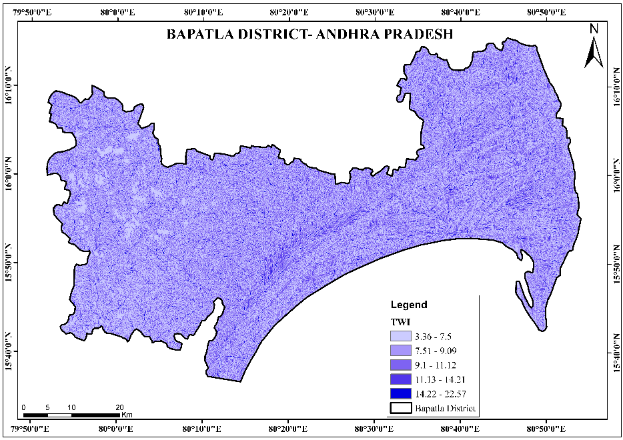
Fig. 9: Topographic Wetness Index Map of Bapatla District
The map illustrates the Topographic Wetness Index (TWI) distribution across Bapatla District in Andhra Pradesh, offering insights into spatial variations in surface water accumulation potential based on topographic characteristics. The TWI values are categorised into five classes, ranging from 3.36 to 22.57, with lighter shades indicating lower TWI values and darker shades representing higher wetness potential. The northern and southwestern parts of the district predominantly show lower TWI values (3.36–9.09), suggesting areas with steeper slopes and better drainage. In contrast, the central, southeastern, and coastal regions exhibit higher TWI values (14.22–22.57), indicating flatter terrains where water is likely to accumulate, making these zones more prone to saturation and potential waterlogging. The widespread variation across the district highlights the topographical influence on hydrological behaviour, which is critical for applications like flood risk assessment, agricultural planning, and land-use management.

Criteria | Class | Range | Weight | AHP Weight
Slope | Nearly Level | 5 |  | 0.25
Slope | Gentle Slopes | 4 |  | 0.25
Slope | Moderate Slope | 3 |  | 0.25
Slope | Steep Slopes | 2 |  | 0.25
Slope | Very Steep Slopes | 1 |  | 0.25
Soil | Deep Black Clay Soil | 1 |  | 0.20
Soil | Gravelly Red Soil | 3 |  | 0.20
Soil | Clay Red Soil | 1 |  | 0.20
Soil | Gravelly Clay Soil | 4 |  | 0.20
Soil | Loamy Soil | 2 |  | 0.20
Soil | Black Soil | 2 |  | 0.20
Soil | Sandy Soil | 3 |  | 0.20
Soil | Gravelly Clay Red Soil | 3 |  | 0.20
Soil | Water Body | 5 |  | 0.20
LULC | Agriculture | 3 |  | 0.15
LULC | Built-Up | 1 |  | 0.15
LULC | Rocky Land | 2 |  | 0.15
LULC | Salt Pan | 2 |  | 0.15
LULC | Sand | 4 |  | 0.15
LULC | Vegetation | 5 |  | 0.15
LULC | Waterbodies | 4 |  | 0.15
Road Network | Very High | 1 |  | 0.10
Road Network | High | 2 |  | 0.10
Road Network | Moderate | 3 |  | 0.10
Road Network | Low | 4 |  | 0.10
Road Network | Very Low | 5 |  | 0.10
Drainage Density | Very High | 5 |  | 0.10
Drainage Density | High | 4 |  | 0.10
Drainage Density | Moderate | 3 |  | 0.10
Drainage Density | Low | 2 |  | 0.10
Drainage Density | Very Low | 1 |  | 0.10
TWI | Very Low | 1 |  | 0.20
TWI | Low | 2 |  | 0.20
TWI | Moderate | 3 |  | 0.20
TWI | High | 4 |  | 0.20
TWI | Very High | 5 |  | 0.20
Total |  |  |  | 1.00
Table. 1: Criteria and Weight used in the site suitability study (Jassim, et. al. 2023)
  - Managed Aquifer Recharge (MAR)
The map depicting the Managed Aquifer Recharge (MAR) potential in Bapatla District, Andhra Pradesh, illustrates the spatial distribution and variability of groundwater recharge potential across the region. Groundwater is the backbone of agriculture, drinking water, and ecosystem sustenance in semi-arid regions such as Andhra Pradesh. Consequently, countries can come up with appropriate water conservation strategies to mitigate the situation.
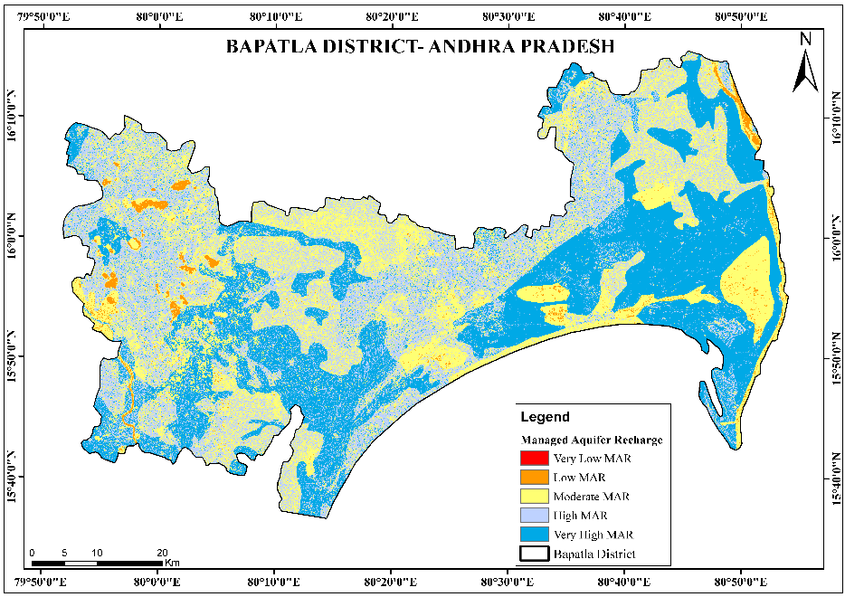
Fig. 10: Managed Aquifer Recharge (MAR) Map of Study Area
Sl. No. | MAR Zones | Area in sq. km. | Area in %
1 | Very High MAR | 709.38 | 18.04
2 | High MAR | 1317.65 | 33.51
3 | Moderate MAR | 1171.90 | 29.80
4 | Low MAR | 728.89 | 18.54
5 | Very Low MAR | 4.60 | 0.12
Total Area |  | 3932.42 | 100.00
Table. 2: MAR Zones in the site suitability study
The Managed Aquifer Recharge (MAR) potential map of Bapatla District shows that the area’s 3,932 km2 exhibits spatial variation in groundwater recharge capability. The “High MAR” zone covers the largest area (33.51% / 1317.65 sq.km) while the “Very High MAR” zone covers 18.04% (709.38 sq.km). Permeable geological structures and appropriate landscape features characterise such areas, facilitating water infiltration. The expansive parts of the district falling under these categories indicate that Bapatla has significant natural potential for sustainable groundwater management.
Moderate groundwater recharge, which constitutes 29 percent of the state’s area and more than 80% (1,171.90 sq. km) of the district, respectively, and these are transitional zones that can be improved through appropriate water conservation measures. Medium-grade intervention is required in these areas and may include the adoption of better farming practices and other measures like the construction of medium-scale recharge structures. The wide coverage of high and moderate MAR zones in the district indicates that most of Bapatla can support groundwater recharging to some extent.
The areas with low recharge potential cover a lesser but still significant proportion of the district, namely “Low MAR” at 18 percent. In contrast, the “Very Low MAR” is nearly zero. 4.60 square kilometers. Regions with clay-rich soils, significant urban expansion, and excessive groundwater extraction face the risk of turning into zones of permanent sinking. Low groundwater potential areas are localized in a few parts of the region, and this may necessitate the adoption of strict regulations and measures that would promote efficient water use, alternative sources, and innovative artificial recharge techniques to enhance underground aquifer replenishment.
The distribution pattern of MAR has significant implications for regional water management strategies. Since the bulk of the district falls under high and very high MAR zones, it will be beneficial to implement nature-based solutions for water security, such as decentralised recharge systems, in rural areas. Almost 20% of the district’s area is covered by low MAR areas, which means that distinct approaches are needed in these regions. It will also assist in identifying areas for the construction of groundwater recharge structures and inform the formulation of land use policies to conserve them. Furthermore, when integrated with other hydrological and agricultural data, the study would help adopt a balanced approach to water use that adequately caters to humans and nature in Bapatla’s different ecosystems.
- CONCLUSION
The approach used for the site suitability assessment of Managed Aquifer Recharge (MAR) in Bapatla District employs a systematic method, which encompasses conventional and satellite-based data. Major Datasets such as SRTM DEM, Soil Maps, Geology Maps, Drainage Systems, Topographic Wetness Index (TWI), Land Use/Land Cover (LULC), and Road Networks were processed and converted to raster format to ensure conformity. Each parameter was reclassified based on its significance to MAR suitability, where appropriate values were assigned to different classes in every layer. For this study, the relative significance of the factors had been predetermined. Each of the reclassified layers was assigned a weight according to its significance in MAR site selection, and a weighted overlay analysis was employed to generate the MAR Site Suitability Map. The final output would help decision-makers to select the best sites for MAR uses by considering and evaluating several factors.
The study’s findings indicate the spatial variation of MAR potential across Bapatla District. The research considered input parameters such as slope, soil type, geology, LULC, road networks, drainage density and TWI. It was also noted that certain types of soil, particularly Deep Black Clay Soil and Loamy Soil, are more suitable for MAR. Groundwater recharge relies on the nature of geological formations, such as gneissic rocks and fluvial deposits. The LULC map showed that agricultural and vegetated areas are more suitable for MAR whereas built-up and rocky areas are not. The maps of road network and drainage density were used to determine the accessibility and hydrological connectivity of an area, respectively. The topographical wetness index (TWI) map was employed to identify areas with high water accumulation, which are important for MAR.
The potential map distributed the district into five zones namely Very High, High, Moderate, Low, and Very low MAR suitability. The analysis reveals that about 51.55% of Bapatla District lies in the High and Very High MAR suitability classes, covering an area of 1,317. 65 square meters km and 709. 38 square inches km, respectively. The selection of suitable target areas for MAR is based on the potential of the subsurface to store water. The moderate MAR zones, comprising 29. 80% (1,171.90 sq. km), are transitional zones where targeted and improved water conservation measures can significantly enhance MAR feasibility. On the other hand, the Low and Very Low MAR areas cover 18 54% and zero. The affected areas, constituting 12% of the district, need to devise other ways of handling wastewater.
Therefore, site-specific MAR methods should be employed in the district to enhance groundwater recharge. Nature-based solutions targeting High and Very High MAR zones should be prioritized to enhance groundwater recharge. These include decentralized recharge systems, percolation ponds, and check dams. Contour binding and afforestation at this level significantly enhance groundwater recharge. Efficient irrigation techniques and artificial recharge methods like injection wells would be essential in Low and Very Low MAR zones. Integrated water resource management approaches should consider the effects of land use policies, agricultural practices, and urban development on groundwater systems.
The study provides insights and guidance to policymakers, water resource managers, and local communities to implement the technique effectively. The MAR potential map will aid in identifying priority areas for groundwater recharge and, consequently, water security in Bapatla District. The study’s methodology can be refined further by incorporating more hydrological parameters, climate variability factors, and socio-economic aspects. Bapatla District can formulate, refine, and implement strategies to manage groundwater resources effectively.

References
- Adimalla, N., & Taloor, A. K. (2020). Hydrogeochemical investigation of groundwater quality in the hard rock terrain of South India using Geographic Information System (GIS) and groundwater quality index (GWQI) techniques. Groundwater for Sustainable Development, 10, 100288. https://doi.org/10.1016/j.gsd.2019.100288
- Alam, F., Umar, R., Ahmed, S., & Dar, F. A. (2022). A GIS-based DRASTIC model for assessing groundwater vulnerability in parts of the Himalayan foothills, India. Environmental Earth Sciences, 81(4), 1-16. https://doi.org/10.1007/s12665-022-10205-2
- Arulbalaji, P., Padmalal, D., & Sreelash, K. (2019). GIS and AHP techniques-based delineation of groundwater potential zones: A case study from the Southern Western Ghats, India. Scientific Reports, 9(1), 1-17. https://doi.org/10.1038/s41598-019-38567-x
- Bera, A., Mukhopadhyay, B. P., & Barua, S. (2020). Delineation of groundwater potential zones in the Karha river basin, Maharashtra, India, using AHP and geospatial techniques. Arabian Journal of Geosciences, 13(15), 1-19. https://doi.org/10.1007/s12517-020-05582-6
- Bhattacharya, A. K. (2021). Managed aquifer recharge (MAR) as an adaptation strategy to climate change in water-stressed regions. Water Security, 13, 100089. https://doi.org/10.1016/j.wasec.2021.100089
- Bobba, A. G. (2022). Numerical modelling of saltwater intrusion due to human activities and sea-level rise in the coastal aquifers of Southeast India. Journal of Hydrology, 607, 127552. https://doi.org/10.1016/j.jhydrol.2022.127552
- Central Ground Water Board (CGWB). (2020). Groundwater Yearbook of Andhra Pradesh. Ministry of Jal Shakti, Government of India. http://cgwb.gov.in
- Chowdhury, A., Jha, M. K., & Chowdary, V. M. (2020). Delineation of groundwater recharge zones and identification of artificial recharge sites using GIS and remote sensing. Journal of Spatial Hydrology, 10(1), 1-20.
- Chowdhury, P., & Behera, M. R. (2022). Spatial assessment of groundwater potential using AHP and GIS techniques in the coastal region of Odisha, India. Environmental Science and Pollution Research, 29(12), 18281-18299. https://doi.org/10.1007/s11356-021-18100-2
- Dillon, P., Stuyfzand, P., Grischek, T., et al. (2019). Sixty years of global progress in managed aquifer recharge. Hydrogeology Journal, 27(1), 1-30. https://doi.org/10.1007/s10040-018-01818-5
- Doke, A., Pardeshi, S. D., & Das, S. (2021). Identification of groundwater recharge potential zones using GIS and AHP in a semi-arid region of Maharashtra, India. Journal of the Indian Society of Remote Sensing, 49(3), 601-614. https://doi.org/10.1007/s12524-020-01244-y
- Ghayoumian, J., Mohseni Saravi, M., Feiznia, S., et al. (2007). Application of GIS techniques to determine areas most suitable for artificial groundwater recharge in a coastal aquifer in Southern Iran. Journal of Asian Earth Sciences, 30(2), 364-374. https://doi.org/10.1016/j.jseaes.2006.12.003
- Goyal, D., Haritash, A. K., & Singh, S. K. (2021). A comprehensive review of GIS and AHP applications for groundwater potential mapping. Environmental Science and Pollution Research, 28(24), 30471-30489. https://doi.org/10.1007/s11356-021-14099-8
- Jassim, F. N., Humood, S. H., Malik, H. S., & Alshareef, T. Q. (2023). The main impacts of a managed aquifer recharge using AHP-weighted overlay analysis based on GIS in the eastern Wasit province, Iraq. Open Engineering, 13(1), 20220484.
- Jha, M. K., Chowdary, V. M., & Chowdhury, A. (2014). Groundwater assessment in Salboni Block, West Bengal, India using GIS and multi-criteria decision analysis. Water Resources Management, 28(12), 4349-4365. https://doi.org/10.1007/s11269-014-0669-0
- Krishnamurthy, J., Mani, A., Jayaraman, V., & Manivel, M. (2020). Groundwater resources development in hard rock terrain—An approach using remote sensing and GIS techniques. International Journal of Applied Earth Observation and Geoinformation, 87, 102038. https://doi.org/10.1016/j.jag.2020.102038
- Kumar, V., Remadevi, R., & Kanga, S. (2020). Delineation of groundwater potential zones using GIS and AHP techniques: A case study of Mysuru District, Karnataka, India. Arabian Journal of Geosciences, 13(14), 1-19. https://doi.org/10.1007/s12517-020-05569-3
- Machiwal, D., Jha, M. K., & Mal, B. C. (2018). Assessment of groundwater potential in a semi-arid region of India using GIS and AHP techniques. Water Resources Management, 32(9), 2909-2926. https://doi.org/10.1007/s11269-018-1991-8
- Malczewski, J. (2006). GIS-based multicriteria decision analysis: A survey of the literature. International Journal of Geographical Information Science, 20(7), 703-726. https://doi.org/10.1080/13658810600661508
- Nair, H. C., Padmalal, D., Joseph, A., & Vinod, P. G. (2020). Delineation of groundwater potential zones in river basins using geospatial tools—An example from the Southern Western Ghats, India. Journal of Earth System Science, 129(1), 1-19. https://doi.org/10.1007/s12040-020-01460-7
- National Aquifer Mapping and Management Program (NAQUIM). (2021). Aquifer systems of Andhra Pradesh. Central Ground Water Board, India. http://cgwb.gov.in/NAQUIM-Archive.html
- Rajasekhar, M., Raju, G. S., & Raju, R. S. (2020). Assessment of groundwater potential zones in parts of the semi-arid region of Anantapur District, Andhra Pradesh, India using GIS and AHP techniques. HydroResearch, 3, 1-14. https://doi.org/10.1016/j.hydres.2020.04.001
- Rajaveni, S. P., Brindha, K., & Elango, L. (2019). Geological and geomorphological controls on groundwater occurrence in a hard rock region. Journal of Earth System Science, 128(3), 1-16. https://doi.org/10.1007/s12040-019-1116-7
- Rao, P. N., Rao, V. V., & Rao, K. S. (2020). Hydrogeochemical characterization of groundwater in Bapatla District, Andhra Pradesh, India. Environmental Monitoring and Assessment, 192(5), 1-18. https://doi.org/10.1007/s10661-020-08283-5
- Ringleb, J., Sallwey, J., & Stefan, C. (2016). Assessment of managed aquifer recharge through modeling—A review. Water, 8(12), 579. https://doi.org/10.3390/w8120579
- Saaty, T. L. (2008). Decision making with the Analytic Hierarchy Process. International Journal of Services Sciences, 1(1), 83-98. https://doi.org/10.1504/IJSSCI.2008.017590
- Saha, D., & Alam, F. (2021). Groundwater vulnerability assessment using GIS-based DRASTIC model in the upper Varuna river basin, India. Environmental Earth Sciences, 80(6), 1-17. https://doi.org/10.1007/s12665-021-09450-8
- Sekhar, M., Rasmi, S. N., Sivapullaiah, P. V., & Ruiz, L. (2022). Integrated approach for delineating groundwater potential zones in crystalline rocks of South India. Environmental Earth Sciences, 81(4), 1-19. https://doi.org/10.1007/s12665-022-10206-1
- Singh, L. K., Jha, M. K., & Chowdary, V. M. (2021). Multi-criteria decision analysis for groundwater potential mapping in a river basin. Environmental Earth Sciences, 80(5), 1-19. https://doi.org/10.1007/s12665-020-09371-y
- Singha, S. S., & Pasupuleti, S. (2022). Delineation of groundwater potential zones using AHP and GIS techniques: A case study of Visakhapatnam, India. Applied Water Science, 12(3), 1-15. https://doi.org/10.1007/s13201-022-01587-6
- Stefan, C., & Ansems, N. (2018). Web-based global inventory of managed aquifer recharge applications. Sustainable Water Resources Management, 4(2), 153-162. https://doi.org/10.1007/s40899-017-0182-8
- Thakur, J. K., Singh, S. K., & Ekanthalu, V. S. (2019). Integrating remote sensing, GIS, and AHP for groundwater potential mapping in a semi-arid region of India. Water, 11(5), 1026. https://doi.org/10.3390/w11051026
- Thilagaraj, P., & Rahaman, S. A. (2021). Identification of artificial recharge sites for groundwater sustainability in semi-arid regions using GIS and AHP. Arabian Journal of Geosciences, 14(5), 1-16. https://doi.org/10.1007/s12517-021-06839-4
- UN-Water. (2023). The United Nations World Water Development Report 2023: Partnerships and Cooperation for Water. UNESCO. https://doi.org/10.18356/9789210024365
- Varua, M. E., Maheshwari, B., & Ward, J. (2018). Managed aquifer recharge in India: A review of the current status and needs for the future. Hydrogeology Journal, 26(3), 729-741. https://doi.org/10.1007/s10040-018-1768-4
- Zekri, S., Al-Maktoumi, A., & Claereboudt, M. (2022). Managed aquifer recharge using treated wastewater: Challenges and opportunities in arid regions. Water, 14(5), 752. https://doi.org/10.3390/w14050752.

