Original Research Article

Integrated Geological Airborne Aeromagnetic and Remote Sensing Datasets in Litho-structural Mapping of Basement Rocks in Otan-Ayegbaju and Environs, Southwestern Nigeria

Abstract
This study presents an innovative approach to litho-structural mapping of basement rocks in Otan-Ayegbaju area of Southwestern Nigeria by integrating advanced satellite technology and geophysical methods. The primary objective is to enhance the understanding of geological formations and identify potential mineralized zones. High-resolution data from Landsat 8 OLI, Shuttle Radar Topographic Mission and aeromagnetic surveys were analyzed using advanced techniques including Principal Component Analysis (PCA), First Vertical Derivative, and Euler deconvolution to delineate lineaments with structural trends and potential mineralize zones. Ground truthing shows that the area is dominated by porphyritic granite, quartz-schist and other rock types such as amphibole schist, talc schist, pegmatite and diorite. Lineament studies reveal that NE-SW, NS-EW and NEE-SWW structural orientation dominate the area. Total magnetic intensity value ranges from 46.6nT to 119.5nT, suggesting contrast magnetic susceptibilities and variation in structural extends of the lithology in the area. Mineralization in Otan-Ayegbaju area is structurally controlled as zones where lineaments and strong magnetic anomalies coincide at the Northeast, central and Southwest are the most promising targets for mineral exploration. Euler deconvolution analysis indicate shallow and deep seated linear structures which range from < 200m to > 1600m. This is peculiar to epithermal ore processes which can result to the formation of vein hosted epithermal deposits like gold, electrum, argentite, and chalcopyrite. The integration of geophysical and remote sensing methods proves to be a highly effective approach to enhance geological mapping of structurally altered zones especially in rugged terrains, and lays the foundation for future exploration efforts in the area.

Keywords: Integrated, litho-lineament, lithology, Basement

Introduction
Recent advancements in satellite technology and geophysical methods have revolutionized the field of geological exploration, providing more efficient, cost-effective, and non-invasive techniques for studying lithological units and mineral resources. Among these advancements, the integration of airborne aeromagnetic data, remote sensing, and traditional geological mapping has emerged as a powerful tool in the exploration of Basement rocks. The application of satellite datasets in mineral exploration has significantly advanced the field of geosciences, offering an efficient and non-invasive approach to the identification and assessment of lithological units and mineral resources. These encompass a variety of technologies, such as satellite imaging, airborne sensors, and geophysical surveys, which enable the collection of detailed information about the Earth’s surface and subsurface. These techniques are pivotal in mineral exploration, as they provide valuable insights into geological formations, mineralization patterns, and potential areas for further investigation (Abdallah et. al. 2022).
The integration of other mapping methods such as geophysical methods has given synergy in the application of these techniques and has led to a reduction in error that may result from using a single technique. The airborne geophysics and remote sensing in mapping, apart from complimenting each other, are very effective especially when an area is inaccessible, saves time, reduces risk and cost-effective compared to other traditional mapping techniques (Abdulmalik et al. 2021). Magnetic map enables graphic visualization of the geology and structures of the upper crust of the Earth. This is particularly helpful where bedrock is obscured by surface vegetation, sand, soil, or water. Magnetic data is especially useful in structural and lithological mapping as it provides information such as structural trends in an area, lineaments direction, lithological boundary. The subsurface geological signature obtained in the magnetic method is therefore aimed at complimenting the surface mappings results obtained from remote sensing results. The challenges and constraints involved in geological field mapping and mineral exploration are potentially solved with the use of remote sensing satellite imageries. Several studies have demonstrated the tremendous applications of remote sensing data in geological studies, to cite the examples provided in (Kruse et.al.1992, Ali and Pour, 2014, Abdulmalik, et. al., 2021).
Lineaments are distinct, mappable linear or curvilinear features on the Earth's surface. These features, which can be simple or composite, often correspond to geologic structures like fractures, faults, and shear zones, as well as lines of crustal weaknesses. They can also be a result of geomorphologic variations due to contrasts in tone or relief (Adiri et. al. 2017). The importance of lineaments, especially those linked to fractures are frequently association with mineralization. They often serve as key indicators for localizing mineral deposits, oil, geothermal, and water reservoirs (Shandini et. al. 2020). Moreover, studying lineaments offers a crucial foundation for understanding regional tectonic history. This analysis helps to decipher the orientation of tectonic stress and the kinematics of fractures, which are essential for reconstructing the tectonic events that have shaped a region (Mhamdi et. al. 2017).
In Otan-Ayegbaju, the rugged terrain makes traditional fieldwork difficult. This study overcame this challenge by combining remote sensing and aeromagnetic data with geological mapping. This approach is especially useful for geological research in areas that are hard to access due to terrain and other logistical issues.

Location and Description of the Study Area
The study area lies in the Northeastern part of the Ilesha schist belt at Boluwaduro Local Government area, Southwestern Nigeria. It falls within latitudes 7°54'N and 8°01'N and longitudes 4°45'E and 4°53'E, which spread across parts of Ilesha NE sheet number 243 and Ilorin SE sheet number 223 (fig. 1) (NGSA 2006). The area is a gateway to both Ekiti and Kwara States at the South and North respectively, it shares boundaries with Oke-Ila at North East; Ire to the west; Ada to the southwest, Imesi Ile and Otan-Ile in Ekiti State to the South. Otan-Ayegbaju area comprises of communities including Igbajo, Iresi, Oyan, Ila, Eripa, Kajola and Araro (figure 2). The area can be reached through a major road from Dagbolu junction at Osogbo to Igbajo. The study area is accessible through network of all seasonal roads and motorable tracks which links it with neighboring states like Ekiti and Kwara States.
The topography of the study area depicts presence of granitic inselbergs and domes which are isolated hills heavily eroded at the slope and are usually seen to rise above the plain, standing out due to their resistance to weathering. The terrain is relatively rugged due to the characteristic cluster of dome shaped hills of varying sizes and orientation. The study area consists of well exposed outcrops ranging from massive hills, ridges, high mountain to low lying outcrops. These massive hills were observed to dominate the entire study area making the field mission difficult to execute because of the rugged nature of the terrain (figure 1). The Northeastern part of the area exhibit scanty outcrops as the rock exposures are generally low lying with less hills forming ridges. Elevation in the study area ranges from 257m to 601m above sea level. Otan-Ayegbaju area is well drained by river and stream channels like Oshun river, Olorogun river, Akekeke river, Otin river and Olin-Alaro river which are mostly structurally controlled as the streams are found along the valleys between ridges which suggests that the drainage type is trellis (figure 3).
The vegetation is generally depicted by moist deciduous forest. Due to the relatively high rainfall experienced annually the vegetation is thicker and more luxuriant. The forests are made up of different species of trees typical of the semi deciduous forest. The Southeastern and Northwestern parts of the study area are characterized by savannah tree vegetation such as the bamboo, other wet species of trees are also found along streams and rivers banks. Other parts of the study area are characterized by shrubs vegetation which are used as grazing by grazers (NIMET, 2022). Otan-Ayegbaju area falls within the tropical rain forest and has a humid tropical climate characterized by alternate wet and dry seasons. The wet season extends mostly from March to November while the dry season lasts between December and February. This area has an average temperature of about 29⁰C (NIMET, 2022).
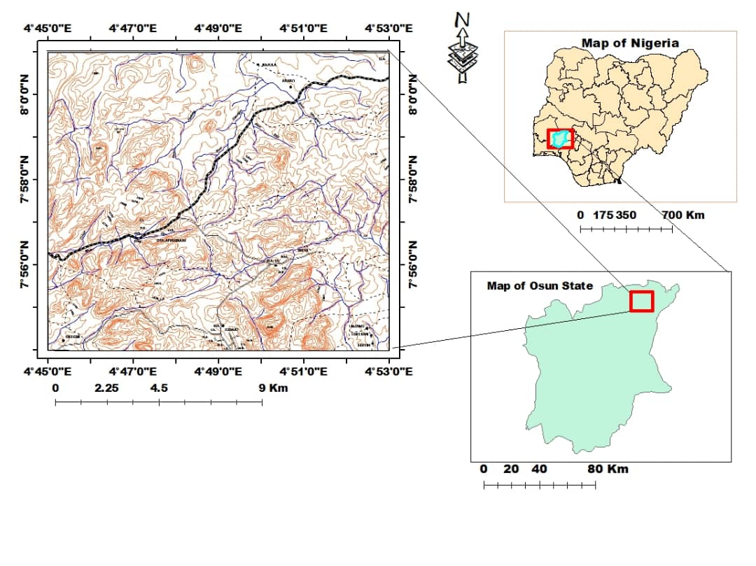
Figure 1: Topographical Map of the Study Area on a scale of 1:25,000 (Federal Survey of Nigeria 1966, Sheet No. 243 & 223 merged)
Figure 2: Map showing the Location of Study Area in Osun State (NGSA, 2006)
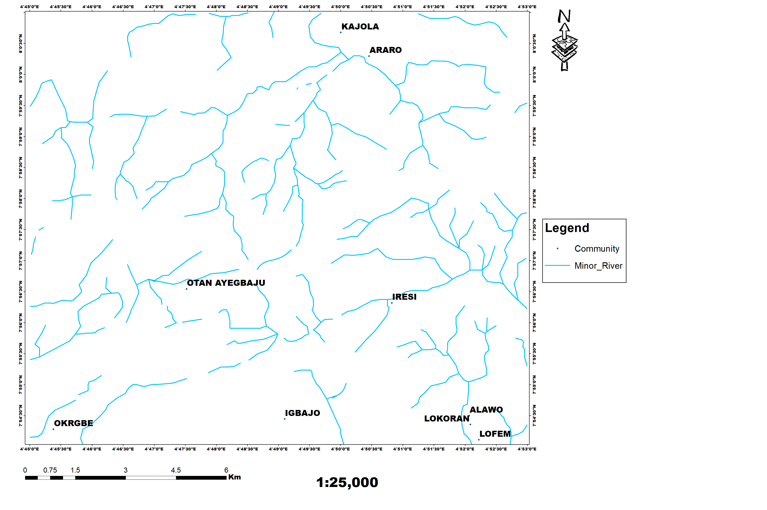
Figure 3: Drainage Map of the Study Area (Inset: Map of Nigeria)

Geological Setting and Local Geology of the Study Area
The Nigerian Basement Complex, a significant part of the country's geology, consists of Precambrian rocks and the schist belts folded within them. It covers roughly half of Nigeria's landmass and is a segment of the Pan-African mobile belt, situated between the West African and Congo cratons (figure 4) (NGSA, 2009). This complex was heavily influenced by the Pan-African Orogeny around 600 million years ago, a period of mountain-building resulting from the collision between the passive West African craton and the active Pharusian continental margin (Dada, 2006). Dada (2006) and Obaje (2009) classified the Basement Complex into four major lithological units: (1). Migmatite-Gneiss Complex (MGC): This is the most widespread lithological unit and includes highly metamorphosed rocks such as gneisses and migmatites. These rocks represent the oldest component of the Nigerian Basement Complex. The migmatites are typically composed of a mixture of granitic material and partially melted rocks, signifying an early phase of the Earth's crust formation. Gneisses, characterized by their banded structure, are common in this complex and are believed to have been affected by multiple cycles of deformation. (2). Schist Belts: These are extensive areas of metasedimentary rocks that have been subjected to regional metamorphism. The schist belts are particularly significant for the exploration of gold and other minerals due to the tectonic activity in these regions. These rocks include a variety of schists such as mica-schist, amphibole-schist, and biotite-schist, and are typically intercalated with metavolcanic rocks. The schist belts are typically located in the Northwest, central and Southwestern part of Nigeria. They are considered important for understanding the tectonic processes that occurred during the Pan-African orogeny. (3). Older Granites: These granitoid rocks are typically found in the Southern part of Nigeria. These rocks are considered to be of Pan African age (Neoproterozoic to early Paleozoic) during which orogeny involved continental collision resulting in the formation of mountain ranges. The older granites are associated with granitization that affected the region during the Pan African orogeny, a process in which the original rock underwent partial melting and recrystallization to form granitic rocks. These granites are often found in association with high-grade metamorphic rocks and have been important in mineral exploration. (4). Undeformed Acid and Basic Dykes: These are younger intrusions that cut across the older lithologies of the Basement Complex. The acid and basic dykes include granite, dolerite and basalt which intruded into the existing rock during later stages of tectonic activity. These dykes are important for understanding the tectonic history of the region.
Geological evolution of the Basement Complex of Nigeria is marked by several phases of deformation which occurred the orogenic cycles. Geologists believe that these rocks are the result of at least four major orogenic cycles of deformation, metamorphism, and remobilization which include:
- Liberian Orogeny (2.7 billion years ago): The earliest phase of deformation that resulted in the formation of the migmatite-gneiss complex.
- Eburnean Orogeny (2.0 billion years ago): This orogeny is responsible for significant tectonic events that led to the formation of the schist belts and metamorphism of the existing rocks.
- Kibaran Orogeny (1.1 billion years ago): This phase involved the remobilization and reworking of the Basement Complex rocks and the formation of additional granite bodies.
- Pan-African Orogeny (600 million years ago): This is the final and most recent tectonic event which is significant in shaping the current structure of the Basement Complex. It was characterized by intense tectonic deformation, metamorphism, and the emplacement of granitic intrusions. The orogeny concluded with significant faulting and fracturing events. (Odeyemi, 1981, Rahaman, 1988, Okonkwo, 1992, Oyinloye, 2011).
The Basement Complex of Nigeria generally has significant mineralization potential, with various studies indicating the presence of economic deposits of rare-metal, gold, Tin-Niobium-Tantalum (Sn-Nb-Ta) and gemstones mineralization (Akinlalu, et. al. 2018, 2021, Afolabi, et. al. 2024, Bwamba, et. al. 2024, Lawal, et. al. 2025, Ifeanyi, et. al. 2022).
Locally, Otan-Ayegbaju and its neighborhoods lie within the Ilesha schist belt and composed of eight lithologic units (Figure 5). These are include, Banded gneiss this medium grain lithology is located in the Northeastern part of the mapped area at Orangun settlement. Its alternating dark and light mineral bands appearance is a signature of deep tectonic processes at high temperature resulting to alignment of minerals during intense foliation. This rock is formed under high grade metamorphism. Since banded gneiss formed at depth than schists, this indicates that area around Orangun may have experienced deep burial during orogenesis. Low laying melanocratic rock composing of quartz, feldspar and biotite, trending in SE-SW direction. It is slightly weathered with augen eyes and solution hallow indicating tectonic deformation and differential weathering respectively. Quartz-schist is located in the central and Northeastern parts of study area, with major exposures at Iresi settlements such as Idi-Agba, Arewu Okedi, Aragba and Aba Ikirun. A fine grain highly foliated in boulder form leucocratic metamorphic rock trending in the NE-SW, SE-NW directions. The rock composed primarily of quartz with minor amounts of mica and feldspar. Amphibole-schist strongly foliated, fine grained and slightly weathered melanocratic rock was encountered mainly in the Northeastern area, with large exposures near Arewu Okedi and Oke-olokuta. Massive outcrop with orientation in the NE-SW direction. Photomicrograph studies of samples indicated mineral alignment of hornblende, pyroxene, quartz and plagioclase feldspar orentated in a preffered direction showing foliation of minerals. Talc schist was found in narrow bands along the Eastern section of the mapped area, particularly around Orangun settlement. It is a fine grained, leucocratic, soft, soapy metamorphic rock, primarily composed of talc and mica. Quartzite medium grained, leucocratic, hard and dense metamorphic rock composed primarily of quartz, occurs in isolated patches ridges particularly around Iresi, Arewu Okedi, Idiagbo at igbajo and Araro. The outcrop trend in NE-SE direction. Massive strained quartz with specks of muscovite were observed in photomacrograph. Porphyritic Granite is the most widespread rock type in the study area, occupying the majority of the map area. It is characterized by coarse grained textures of large feldspar and quartz crystals within fine-grained matrix. This lithology appeared as steepy ridges and domes with conspicuous ex-foliations which are results of differential temperature and erosion. Discordant pinch and swell veinlets, quartz veins, quartzo-feldspartic veins, joints and normal faults are some of the structures observed in most of the outcrops (figure 6). Photomicrograph of samples revealed large grains of quartz, microcline feldspar and deformed biotite. Pegmatite bodies are encountered at the East and Northeast of the study area particularly at Iresi with extension at Idi-Agbo and Kajola to Araromi close to Ila Orangun. Coarse grained rock with large crystals of feldspar, quartz, and mica. The outcrops are mostly weathered, low laying and majorly oriented in the SE-NW direction. Diorite a medium grained low laying isolated intrusive body located at Kajola. Buried but slightly exposed as pillow structures, gray in colour with speckled appearance. Photomicrograph of rock samples showed desuccate texture of horblende, quartz, and plagioclase feldspar.
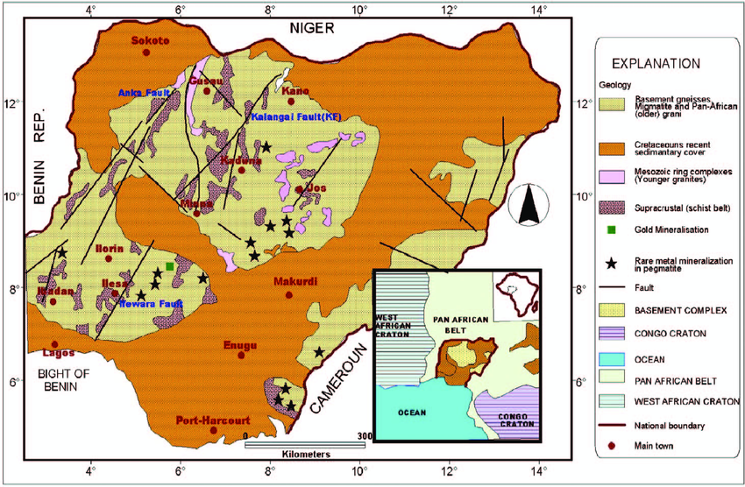
Figure 4: Map of Nigeria Showing the location within Pan African Province and Geology (modified after NGSA, 2009)
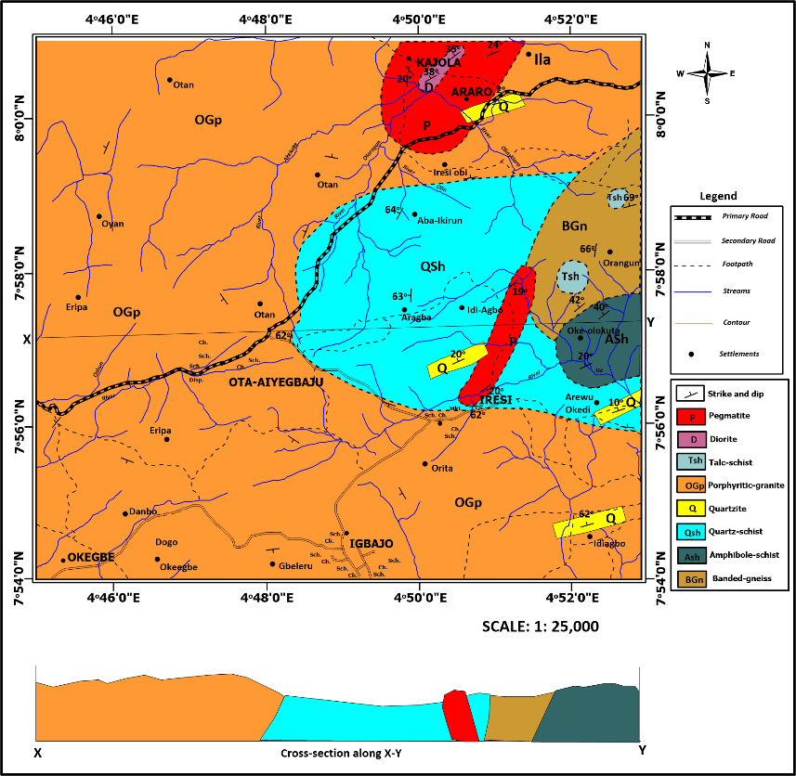
Figure 5: Geological Map of The Study Area

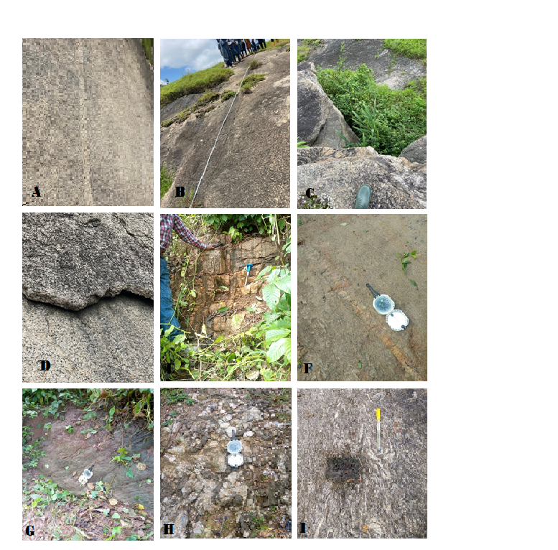

Figure 6: Rocks of the Study Area. (A). N-S trending quartzo-feldspartic vein in porphyritic granite at Igbajo (B). N-S trending fracture in porphyritic granite around Gbeleru Igbajo (C). E-W trending joints in porphyritic granite at Eripa, (D). N-S trending exfoliated porphyritic granite at Orita Iresi, (E). N-S trending joints and fractures in quartzite at Araro (F). N-E trending pegmatite vein in quartz schist along at Iresi (G). Inclined body of amphibole schist around Arewu, (H). Expose surface of pegmatite at Idi-Agbon (I). Multiple folds (chevron, plunge) on banded gneiss at Orangun.

Materials and Methods
Topographical map of Ilesha N.E. sheet 243 and Ilorin S.E sheet 223 sourced from Osun and Kwara State Government respectively were used in addition to existing geological map of the area and other geological mapping tools such as handy GPS for detailed geological field mapping conducted to identify the various rock units, fault lines, and other structural features visible at the surface. Landsat 8 OLI and Shuttle Radar Topographic Mission (SRTM) scenes of the study area sourced from usgs.gov. High resolution Airborne magnetic data Map (1:100,000) of sheet 265 in excel format acquired from Nigerian Geological Survey Agency. The acquisition parameters of the aeromagnetic data are- Flight line spacing (500m), tie line separation (1.5km), Terrain clearance (50m), Flight direction is NW-SE, while the Tie line direction NE-SW. The aeromagnetic data were later produced as a total magnetic intensity (TMI) map in a grid cell size of the 5000 m interval using Geosoft software Oasis Montaj™ 8.4.0. ArcGIS 10.8 software was utilized to digitize maps while ENVI 5.1 software was employed for Landsat 8 image processing, Aeromagnetic data were processed using Oasis Montaj software (8.4) while PCI Geomatica (2015) and Rockworks 17 software were deployed for extraction and plotting of the orientation of extracted lineaments respectively.
Detailed litho-lineament mapping was digitalized in two forms. 1. Surface lineaments were extracted from a processed Landsat 8 data of the area of study using an automatic lineament extraction tool in PCI Geomatica. 2. Subsurface lineaments were extracted from SRTM (DEM) using Geomatica software, the lines were later exported to ArcGIS where it was converted into CAD format for further processing in Rockworks. Digital Elevation Model map was superimposed over geology map of the area for a clearer perspective of the lithology. Landsat 8 data were processed further using ENVI 5.3. Atmospheric correction was carried out by rescaling raw radiance data from imaging spectrometer to reflectance data. Aeromagnetic data of the study area were processed with Oasis Montaj software to generate Total Magnetic Intensity (TMI) map, from where the study area was clipped out. Total Magnetic Intensity map of the area was reduced to equator and processed further to generate residual map while the first vertical derivative filter was used for lineament mapping.

Image Pre-Processing, Processing and Enhancement
In aeromagnetic and remote sensing mapping, particularly for geological exploration, image pre-processing, image processing, and image enhancement are crucial steps that are used to transform raw data into understandable maps. These techniques are essential for delineating subsurface structures, identifying mineralization zones, and understanding geological formations. Incorporating these techniques is vital for effective aeromagnetic and remote sensing mapping. These methodologies enable geologists to extract precise information, leading to better understanding and exploration of geological formations and mineral resources.
Image Pre-Processing
Geo-Referencing aims to correct the inconsistency between the actual coordinates of the location on the ground or on the base image and the coordinates of the location of the raw image data. It is used to remove geometric distortions and to pre-process remote sensing data (Adili et. al.2017). This correction is used to extract accurate information on the area of polygons, distance, and direction (Baboo and Devi, 2011).
Stack layering is applied on Landsat 8 using ArcGIS (10.8) to combine the six bands together to acquire one band before further image processing procedures.
Image Processing and Enhancement
Techniques adopted include Principal Component Analysis (PCA), which allows redundant data to be compacted into fewer bands so that the dimensionality of the data is reduced. It was used to reduce the redundancy between the spectral reflectance of the spectral bands. Therefore, PCA uses such correlation to suppress the redundant information and enhance specific spectral information in specific PCA bands. PCA is applied to the fused image, the resulting image has high spatial resolution and a wide range of colours that make the different lithological units easily discriminated. Structural interpretation, filtering and edge detection techniques were applied to SRTM (DEM) to pick structural features in the form of lineaments in the study area.
Enhancement of the TMI involved removal of unwanted high-amplitude short- wavelength features using non-linear filtering. Enhanced TMI reveals faults and fracture corridors that control fluid flow and rock mass behavior (Kazeem et al. 2022). The Total Magnetic Intensity (TMI) grid (Figure 17) was processed, filtered and transformed to First Vertical Derivative (FVD) using Oasis Montaj for identification of structural trends (Figure 22). Enhancement of the images using Reduced to Equator (RTE) was applied to obtain a clear image of the structures and the regional structural lineaments were extracted and presented in (Figure 18). Using derivative procedures, the edges of anomalies were sharpened and shallow features were enhanced. The resulting vertical derivative map provides a sharper image than the total magnetic intensity map because it is more responsive to local influences than to regional effects.

Results and Discussions
Geological Mapping
Ground truthing exercise carried out shows that the study area is mostly dominated by porphyritic granite and metamorphic rocks such as schists, banded gneiss, quartzite and intrusions such as pegmatite and diorite. Some rocks and observed structures are shown in Figure 6.
Lineament Mapping with Landsat-8 OLI
Lineaments were interpreted, their lengths and orientations were measured separately for different locations within the study area. The Landsat-8 OLI lineament map shows that 105 lineaments were captured and distributed across the entire study area. The lineaments were observed occurring parallel to each other, in most cases crossing or intersecting, which reveals the intensity and density of structures in the rock types that form the underlying lithology of the area. From the lineament maps, areas where porphyritic granite is the most dominant rock type are more fractured, thus displaying a greater number of lineaments due to the brittle nature of the rock. The lineaments were observed to be distributed across the entire study area showcasing various lengths described as short, medium and long lineaments (Figures 7). Some were found crossing each other either depicting a T-crossing, X-crossing and in some cases running parallel to each other. The orientation of majority of the lineaments were observed to trend in the N-E & S-W while other subsidiary lineaments were seen trending in the N-S & E-W (Figure 8).

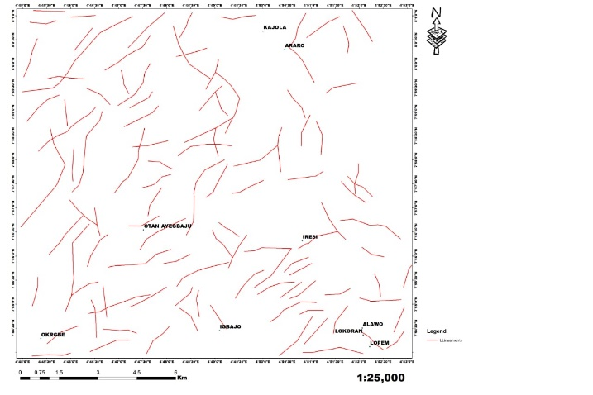

Figure 7: Landsat 8 OLI lineament map of the study area

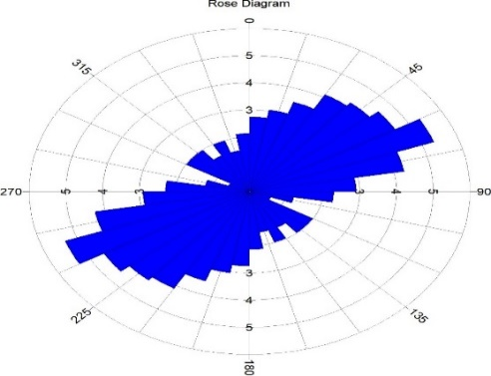

Figure 8: Landsat 8 (OLI) Rose Diagram of the study area

Lineament Mapping with SRTM (DEM)
Lineament mapping with Shuttle Radar Topographic Mission (SRTM) data shows that a total of 38 lineaments have been captured, compared to 105 lineaments in Landsat-8 OLI. Lineaments delineated as seen on the map are concentrated around Southwest, Northwest and Southern sections of the study area. Lengths of these lineaments varied from short to medium, no long lineament except it intercept each other at an angle (figure 9). The orientation of the predominant portion of the lineaments were observed to trend in the N-E and S-W while subsidiary lineaments were seen trending in the E-W direction (figure 10). Observation from SRTM lineament map implies the presence of lineaments in the South, central and Northwestern section of the study area was possible because of the brittle nature of the underlying lithology of the area identified from ground truthing as porphyritic granite. Heavy presence of lineaments in this area is a pointer to obvious effect of deformation and shearing with the cluster being an indicator for the possibility of mineralization zone.

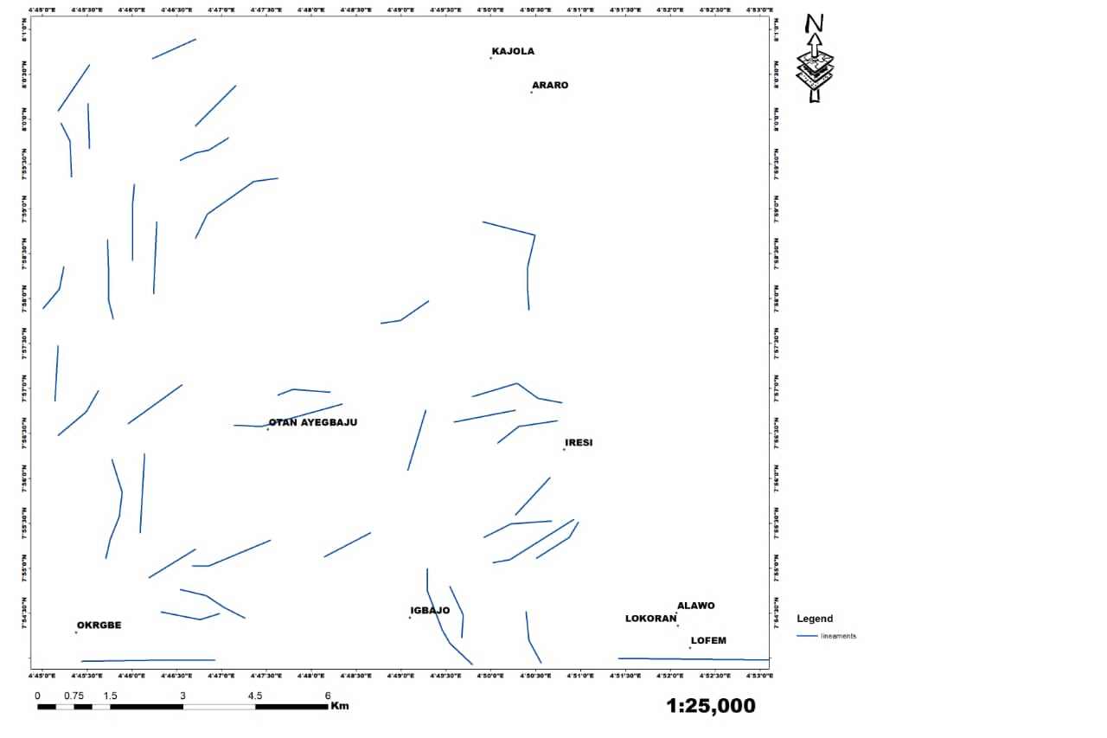
Figure 9: SRTM (DEM) lineament map of the study area

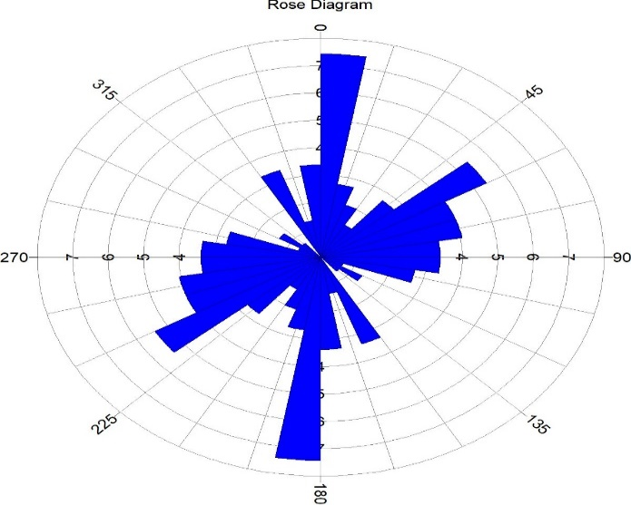
Figure 10: SRTM (DEM) Rose Diagram of the study area
Lineament Density
The analysis of lineament density can be used to understand the tectonic evolution, structural complexity, and mineralization potential of a region. The area with high lineament density is associated with high mineralization and groundwater potential (Fagbohun, 2018, Olatunji, 2022, Afolabi et. al., 2024). Based on the lineament density maps generated using Landsat-8 OLI and SRTM (DEM) imagery, areas with very high lineament density are shown in reddish colour, while areas with moderate lineament density are shown in yellow. These lineaments are located at the Northwest, central and Southwest area. Thus, are identified as the mineralization zones within the study area. Porphyritic granite and quartz schist are the most fractured lithology as shown by the population and density of lineaments captured using Landsat 8 and SRTM (figures 11 and 12).

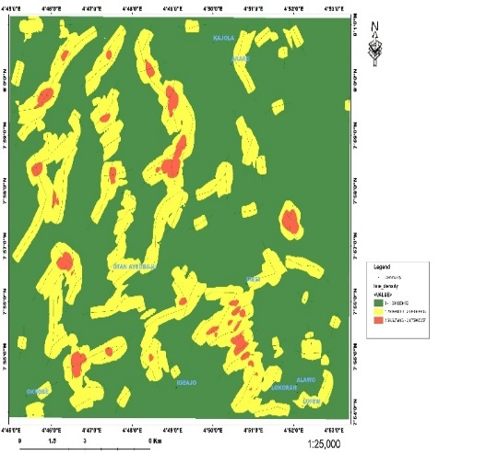
Figure 11: Landsat 8 OLI lineament density map of the study area

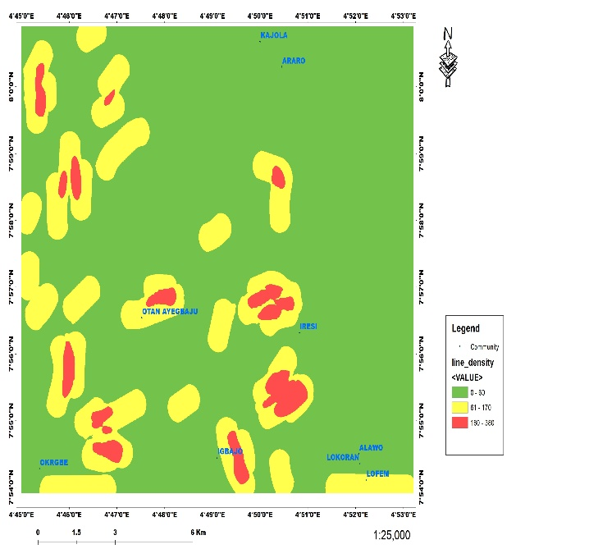
Figure 12: SRTM (DEM) lineament density map of the study area

Lineament Mapping with Aeromagnetic Data
The airborne aeromagnetic data is used to generate maps that show major lithology, structural features (lineaments) as well as depth and geometry of minerals present in the study area. The use of geophysical study approach is to delineate litho-structures since mineralization can be structurally controlled in an area.

Aeromagnetic Lineament
Processing of TMI satellite imagery shows that about 18 lineaments were captured. Lineaments delineated as seen on the map are concentrated at the Northeaster part of the area, with a major lineament cutting across the study area in the Southwest to Northeast (figure 13). The orientation of the predominant portion of the lineaments were observed to trend in the NE-SWW direction (figure 14). The application of image enhancement and filtering was useful in the elaboration of weak and low anomalies as well as production of several magnetic maps including Total Magnetic Intensity (TMI), Reduction to Equator, Reduction to pole, Residual Magnetic Anomaly, First Vertical Derivative, Analytical Signal, and other relevant maps required for the structural interpretation of the magnetic results.

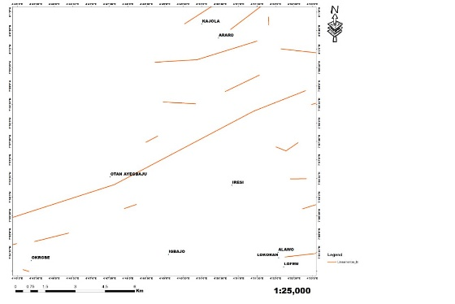

Figure 13: Aeromagnetic lineament map of the study area

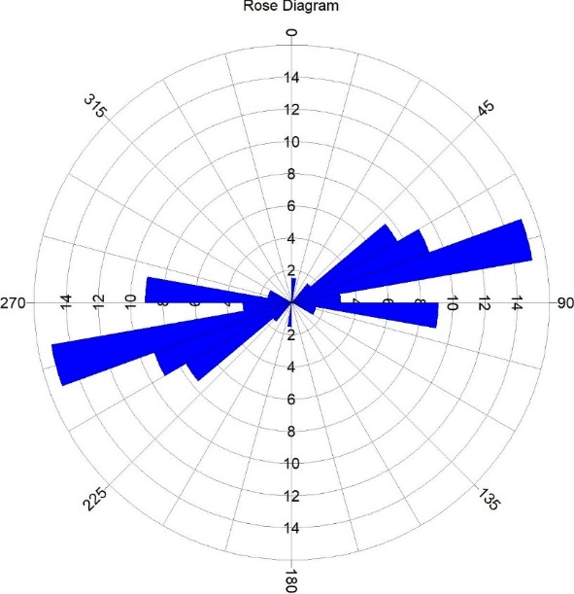
Figure 14: Aeromagnetic Rose Diagram of the Study Area
Total Magnetic Intensity (TMI)
Total magnetic intensity value in the study area ranges from 46.6nT to 119.5nT, which suggests contrasting magnetic susceptibilities and variation in structural extends of the rock types in the study area. Area with high magnetic intensity values ranging from 119.5nT to 99.9nT, which are represented in pink and red colours (figure 15). These are zones with high magnetic susceptibility which implies that the rocks in there are very easily magnetized by the Earth's magnetic field, which is the characteristic of ferromagnetic minerals like magnetite and others like biotite and hornblende. Structurally, these pink to red areas often represent the presence of intrusions like dikes, sills, and volcanic plugs, or uplifted basement rocks that have high concentrations of magnetic minerals.
Low magnetic intensity values with blue to green colours range from 46.6nT to 86.8nT which connotes deviation in the magnetic field pattern in the area. This area suggests low magnetic susceptibility which means that the rocks are not easily magnetized. This is characteristic of non-magnetic or weakly magnetic materials, such as quartz-rich sedimentary rocks such as sandstones and shales, felsic igneous rocks like granites or deeply weathered rock. These magnetic lows are highly significant for mineral exploration because this process of demagnetization is often associated with the deposition of valuable metals like gold, copper, and silver, which are carried by the same fluids. The low magnetic signature essentially acts as a "footprint" of the hydrothermal system. Phyllic and argillic hydrothermal alterations are peculiar to this transport. Structurally, low magnetic intensity areas tend to coincide with fault intersections, shear zones, and intrusive contacts, which act as pathways for hydrothermal fluids (Sharma,1987). The prominent fault zone, a major structural feature cutting through the study area and other minor structures, significantly influences the tectonic framework and mineralization processes of the region.
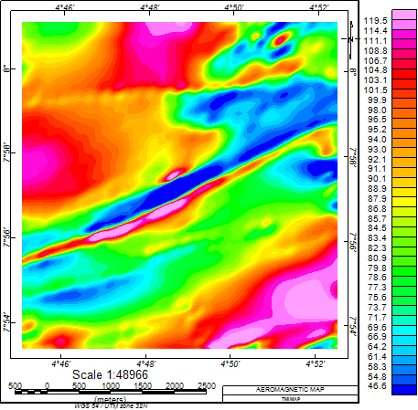
Figure 15: Aeromagnetic Total Intensity map of the study area
Reduction to the Equator (RTE)
RTE is a technique used to transform magnetic or gravitational field data measured at a specific latitude to what could be expected if the measurements were made at the equator. RTE is helpful for the interpretation and comparison of data from different latitudes particularly in low latitude regions where the Earth’s magnetic field inclination is small (Rusman et al., 2023). Areas with magnetic susceptibility are identified around the Northeastern, central and minor cases spotted around the Southwestern parts of the area. These locations show high amplitude magnetic anomalies values that range between 52.35nT and 64.10nT. While the area characterized by moderately low amplitude magnetic intensity values between 73.12nT and 91.46nT marked with greenish to yellow colours suggesting regions characterized by geological structures (fracture/fault) with low magnetic contents (figure 16).
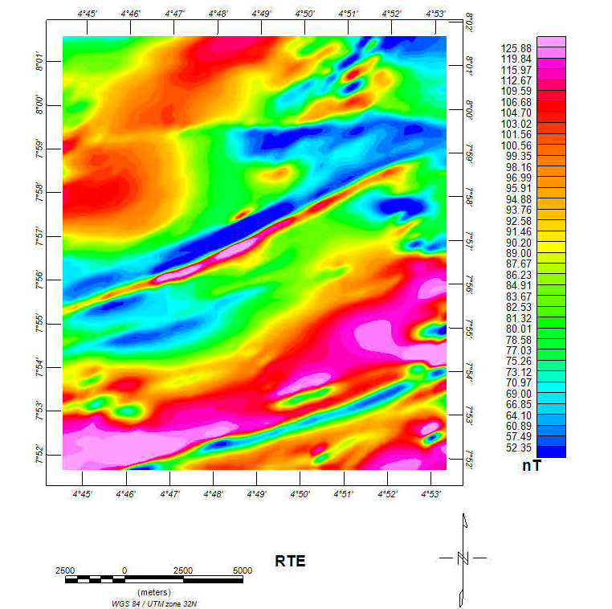
Figure 16: Aeromagnetic Reduction to the Equator of the study area
Residual Magnetic Anomaly Map (RMI)
The regional fields were removed by upward continuing the Total magnetic intensity data (TMI) grid to a height of 2000m and subtracting the resulting grid (figure 17) from the TMI grid in order to obtain the residual grid (figure 18 & 19).
The residual magnetic intensity (RMI) was reduced to the magnetic equator using magnetic inclination of -4.68° and declination of - 2.01° (IGRF of 2005) of the center point of the study area, so that anomalies observed would be directly positioned on their respective causative source bodies. The RMI was reduced to the magnetic equator so that observed anomalies were vertically positioned directly on their respective source bodies. The residual magnetic anomaly map of the study area illustrated that the dominant magnetic anomaly trends in the study are predominantly in the NE-SW direction (Fig. 20). Reduction was made possible so as to eliminate the anomalies distortion caused by inclination of the earth's magnetic field (El Gout et al., 2009).

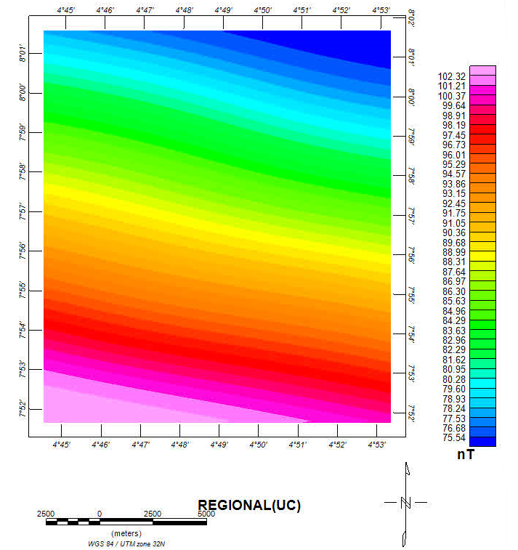
Figure 17: Regional Magnetic Anomaly Map of the study area

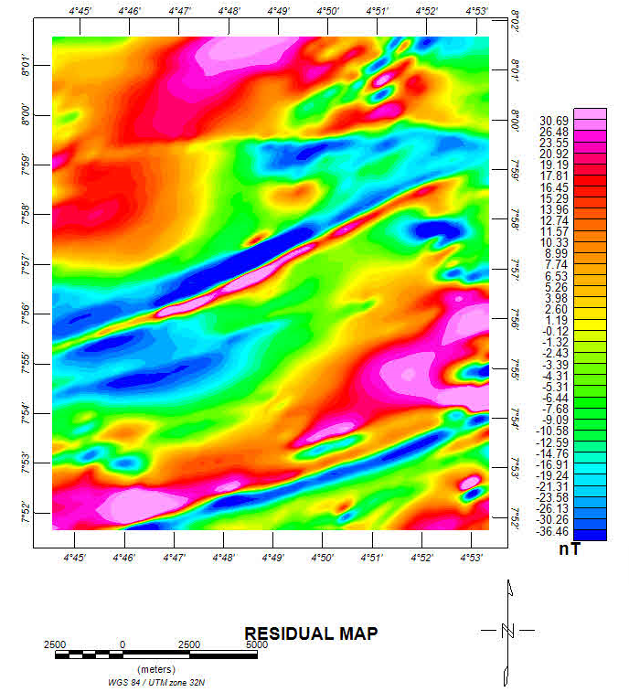
Figure 18: Residual Magnetic Anomaly of the study area
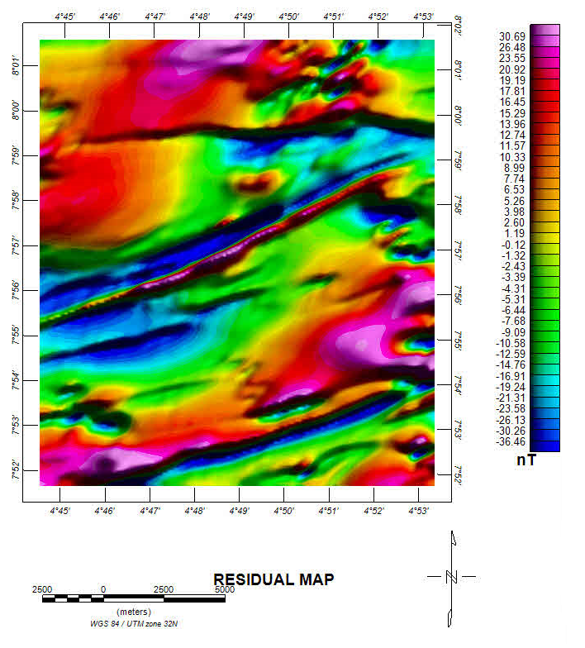

Figure 19: Residual Magnetic Anomaly Map in 3D of the study area
First Vertical Derivative (FVD)
This technique accentuates short wavelength and is relatively insensitive to noise. Mostly used for delineating near surface lineaments and contacts (Tarlowski, 1997). The First vertical derivative has shown to be a useful technique in the processing of magnetic data; it is a filtering technique that is equivalent to enhancing shallow sources and suppressing deeper sources (Reeves, 2005). The transform is a useful interpretation tool in the determination of shallow seated fractures and faults by making the edges of shallow seated anomalies become sharper or clearer. The First Vertical Derivative (FVD) filter does the removal of the long wavelength properties of magnetic responses and most importantly enhances the quality of adjacent and superposed responses (Keating,1995). Consequently, structural features and boundaries of causative shallow sources are enhanced. Magnetic intensity value for the total vertical derivative ranges from -0.11nT/m to 0.11nT/m. Prominent structure trends in the SW- NE direction while minor structures occupy Southeast and Northeast with scanty lineaments at the Southwest of the map (Figure 20).

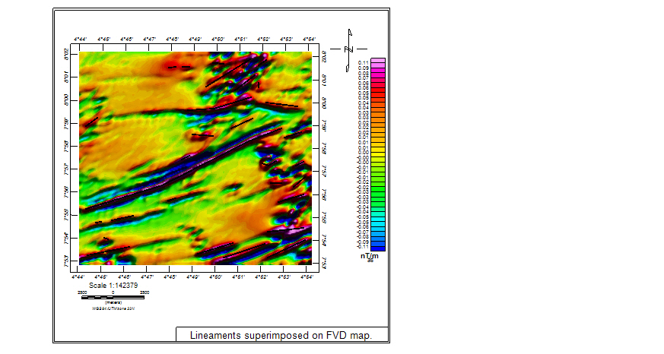
Figure 20: Lineament on first vertical derivative map of the study area
Analytical Signal Technique (AST)
The amplitude of analytic signal within the study area was achieved by calculating the square root of sun of squares of magnetic gradient in x, y and z directions using grid expression of Oasis Montaj. Analytical signal amplitude ranges between -0.055nT/m to 0.137nT/m. Geologic bodies with high magnetic susceptibility appears in pink and red, these records the peak of its signals ranging from 0.119nT/m to 0.060nT/m. Geologic bodies with low magnetic susceptibility appearing in green signals with their peaks ranging between 0.002nT/m to 0.035nT/m (figure 21).
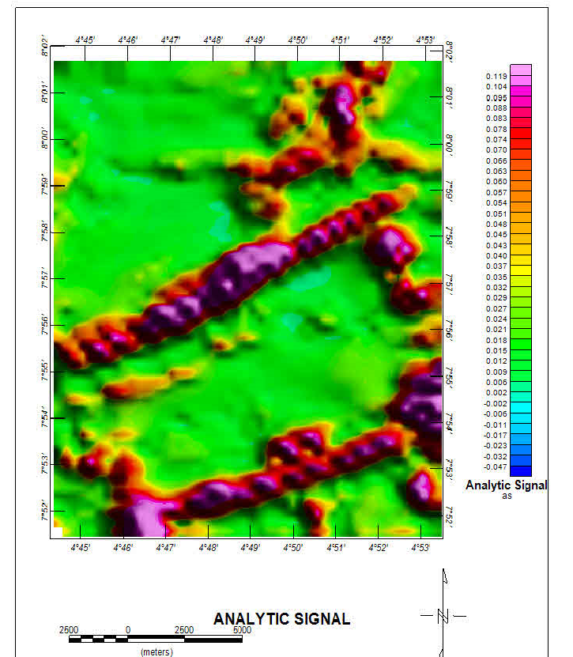
Figure 21: Lineament on Analytic Signal of the study area

Euler Deconvolution
Euler deconvolution is both a border and a depth estimator. It extracts data from grids using the homogeneity relationship shown by (Wahab & Adepoju, 2019). From the Euler deconvolution map, the depths at which the linear structures are encountered are shallow and deep seated which range from < 200m to > 1600m. This range of depth is peculiar to epithermal ore processes which resulted to the formation of vein hosted Epithermal Vein Deposits at shallow depths of <1500m with temperatures ranging from 100°C to 300°C. This mineralization is often associated with hydrothermal fluids releasing minerals such as native gold (Au), electrum (Au-Ag alloy), Argentite (Ag₂S), acanthite (Ag₂S), stephanite (Ag₃SbS₃), Chalcopyrite (CuFeS₂) and bornite (Cu₅FeS₄) (Simmons, & Brown, 2006, Zhong, et. al.2017).
The extracted lineaments reflect the position of features such as fault, deep fractures and geologic contacts within the study area as revealed from aeromagnetic Euler Deconvolution maps (figure 22). The areas where lineaments and strong magnetic anomalies coincide are the most promising targets for mineral exploration (figure 23). This implies that Otan-Ayegbaju area’s mineralization is structurally controlled, where high grade veins deposits of orogenic gold, (Au), Quartz, Arsenopyrite (FeAsS) and Pyrite (FeS₂) at 150⁰C to 300⁰C and >2000m.

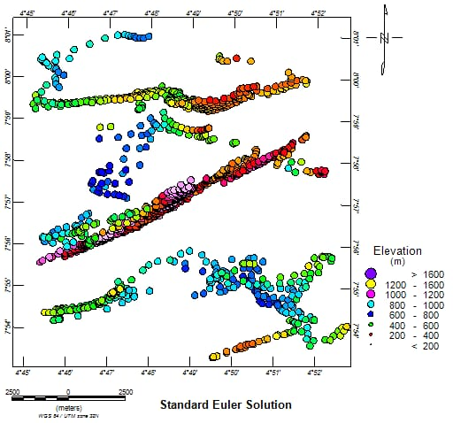

Figure 22: Euler Deconvolution Map of the study area

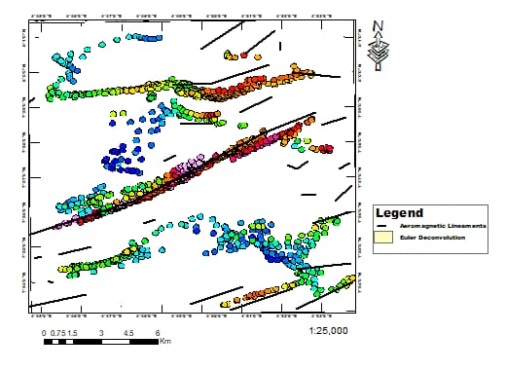
Figure 23: Lineament on Euler Deconvolution Map of the study area
Superimposing Lineaments Maps on Geology Map
Lineaments often correspond to fractures, faults, and shear zones that can serve as pathways for mineralizing fluids. By overlaying lineaments map on geology map of an area, delineating areas where structural features intersect with lithologies indicating potential zones of mineralization is uncomplicated. The integration of lineament maps with geological maps enhances the accuracy of geological interpretations by providing additional structural information. This integrated approach provides better understanding of subsurface structures, which can lead to better geological mapping and resource assessment (Hamann, 2024).

Landsat 8 (OLI) and SRTM Lineament Extraction Map on Geology Map
The lineament analysis derived from Landsat-8 OLI and SRTM imagery reveals clear structural patterns when superimposed on the updated geological map. The analysis enables the identification of lithological deformation. It particularly highlights the porphyritic granite and quartz schist lithologies which exhibit significant brittle characteristics. The inherent brittleness leads to pronounce deformation under tectonic stress making it susceptible to fracturing, jointing and faulting processes. As a result, the distribution and density of lineaments are notably concentrated in the porphyritic granite and quartz schist formations which indicate a region of multiple tectonic activities. Lineament extraction using Landsat 8 (OLI) appears to be densely populated and concentrated across the entire study area, which indicate areas of active tectonic deformation. The orientation of the lineaments shows a general trend towards N-E and S-W which characterize Pan African orogenic events while subsidiary lineaments were seen trending in the N-S and E-W direction, indicative of secondary structural alteration. Landsat 8 satellite imagery coupled with geological map reveals that 78% of the captured lineaments are associated with porphyritic granite lithology, 19% are found on quartz schist while 3% are located on other rock types which include pegmatite, banded gneiss, diorite, talc schist and amphibolite schist (figure 24).
SRTM (DEM) imagery show that Southwest, Central and Northwest sections of the study area demonstrate the highest degree of tectonic deformation which is attributed to its susceptibility to orogenic events due to high concentration of lineament. These deformations create conducive environment for mineralization. Thus, the Western zone, Northwest, Central and Southwest are delineated as a prospective mineralization domain in the study area. The orientation of the predominant portion of the lineaments were observed to trend in the N-E and S-W while subsidiary lineaments were seen trending in the E-W direction. The results of the amalgamation of SRTM lineament extraction and geological map of the area shows that 84% of the lineaments are associated with porphyritic granite rock while 16% are found on quartz schist (figure 25).
Aeromagnetic Lineament Extraction Map on Geology Map
Aeromagnetic lineament extraction superimpose on geological map of the area depicts a major lineament which transverse through the area in the N-E and N-W direction, cutting across lithologies including porphyritic granite, quartz schist and banded gneiss (figure 26). This lineament is suspected to be Ifewara fault which create shear zone that traverses the Ilesha Schist Belt in southwestern Nigeria. It plays a significant role in the tectonic framework of the region, influencing both structural geology and mineralization processes. (Adekoya, 1988, Oyinloye, 2006). Lineaments are seen to be populated at the Northeastern part of the area on quartz schist, quartzite and pegmatite rocks. These rocks are host to mineralization, therefore have implications for mineral exploration in the area.
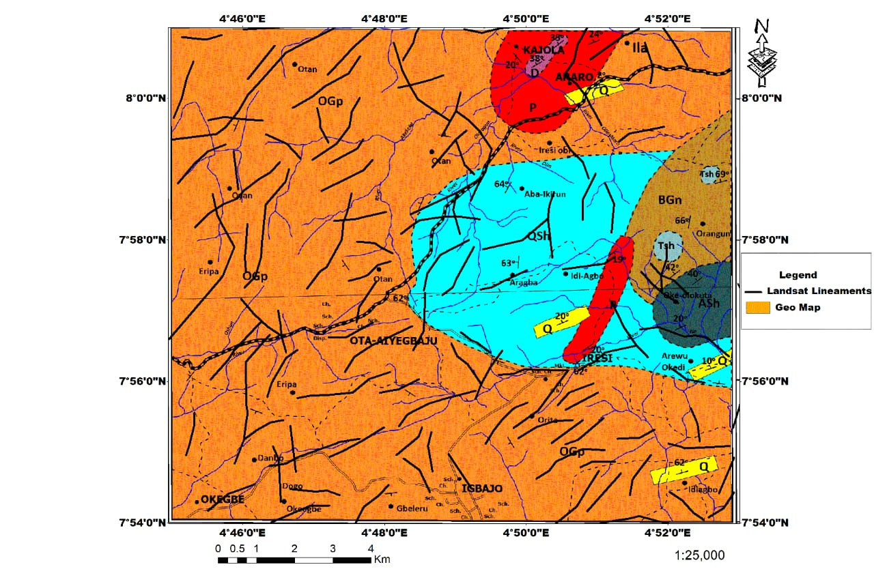
Figure 24: Landsat 8 (OLI) Lineament Extraction Map Superimposed on Geological Map of the study area
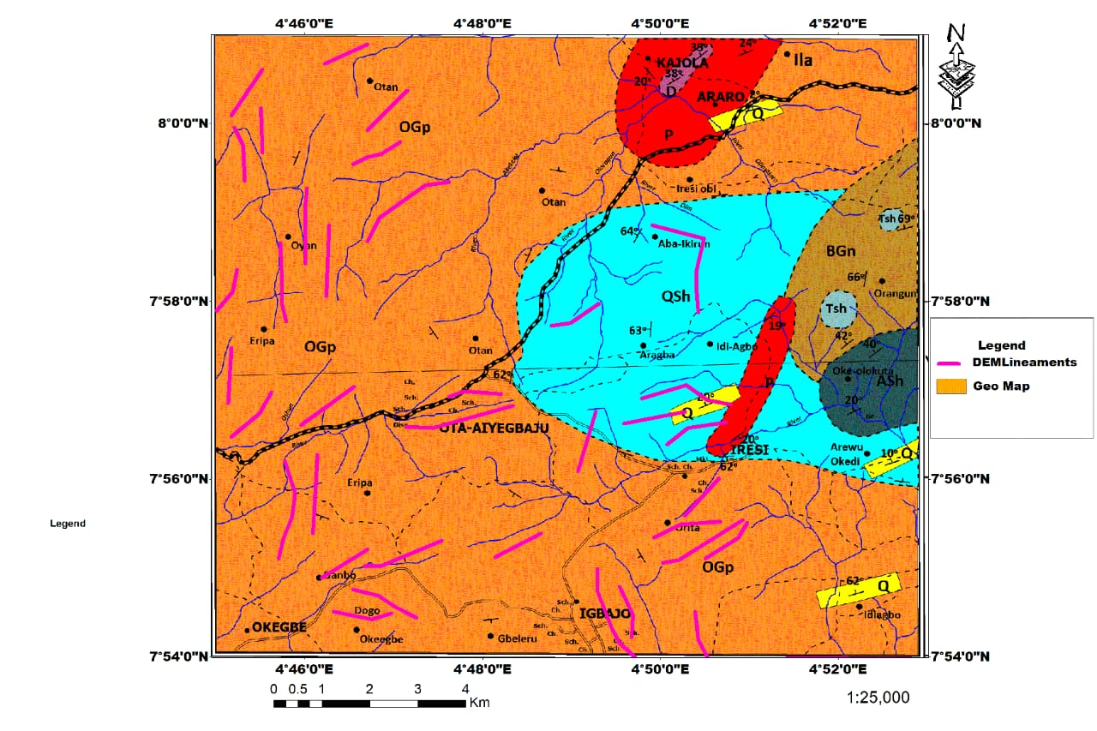
Figure 25: SRTM Lineament Extraction Map Superimpose on Geological Map of the study area
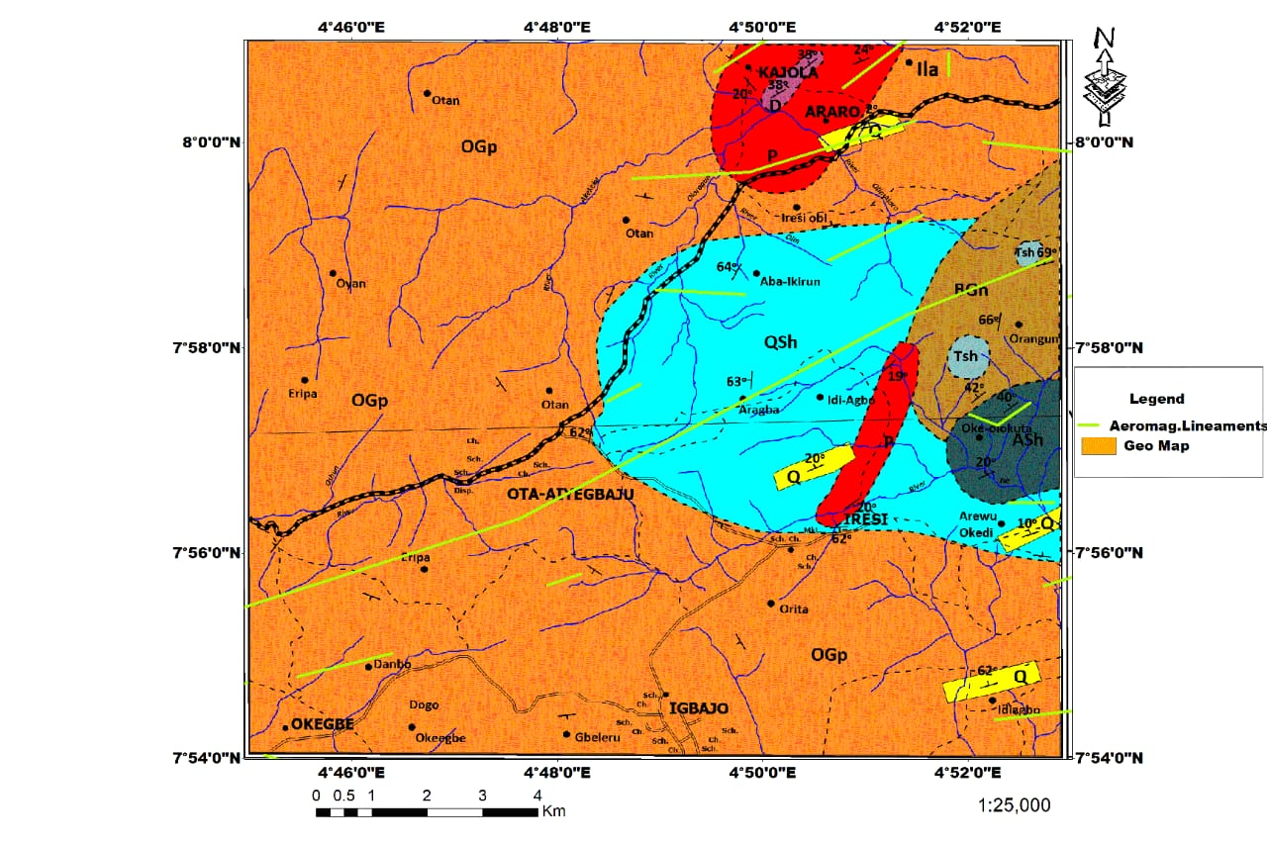
Figure 26: Aeromagnetic Lineament Extraction Map Superimpose on Geological Map of the study area
Conclusion
This study successfully integrated multiple data sources and applied advanced image processing techniques to overcome challenging terrain, resulting in a more comprehensive and accurate understanding of the geology, structural trend and mineral potential of the study area. The geological mapping revealed eight (8) lithology in the area including porphyritic granite, quartz-schist, amphibole schist, talc schist, quartzite, banded gneiss, pegmatite and diorite with porphyritic granite being the most extensive in the area. Lineament studies reveal that NE-SW, NS-EW and NEE-SWW structural orientation dominate the area. Total magnetic intensity value ranges from 46.6nT to 119.5nT, suggesting contrast magnetic susceptibilities and variation in structural extends of the lithology in the area. Zones with high magnetic susceptibility ranging from 119.5nT to 99.9nT, implies the rocks in this area are very easily magnetized by the Earth's magnetic field, which is the characteristic of ferromagnetic minerals like magnetite and other iron-rich minerals. Low magnetic intensity values ranging from 46.6nT to 86.8nT connotes deviation in the magnetic field pattern in the area. This zone suggests low magnetic susceptibility which means that the rocks are not easily magnetized. These magnetic lows are highly significant for mineral exploration because this process of demagnetization is often associated with the deposition of valuable metals like gold, copper, and silver, which are carried by the same hydrothermal fluid. The low magnetic signature essentially acts as a "footprint" of the hydrothermal system. Phyllic and argillic hydrothermal alterations are peculiar to this transport. Structurally, low magnetic intensity areas tend to coincide with fault intersections, shear zones, and intrusive contacts, which act as pathways for hydrothermal fluids. A prominent major structural feature cutting through the study area in the NE-SW direction suspected to be Ifewara fault zone, coincide with strong magnetic anomalies at the Northeast, central and Southwest. These are the most promising target zones for mineral exploration in the study area. Results of Euler deconvolution analysis indicate that linear structures encountered are shallow and deep seated which range from < 200m to > 1600m. This is peculiar to epithermal ore processes which can result to the formation of vein hosted Epithermal Deposits like gold, electrum, argentite, and chalcopyrite. Ultimately, this study contributes to the ongoing efforts to improve geological mapping and resource assessment in Nigeria, paving the way for sustainable mineral exploration and development.

COMPETING INTERESTS DISCLAIMER:
Authors have declared that they have no known competing financial interests OR non-financial interests OR personal relationships that could have appeared to influence the work reported in this paper.

References
- Adekoya, J.A. (1988). Graphite-schist in the Ilesha Schist Belt, southwestern Nigeria. Journal of African Earth Sciences, 7(4), 453-460. https://doi.org/10.1016/0899-5362(88)90036-0
- Abdelouhed, F., et. al., (2021). Lineament mapping in the Ikniouen area (Eastern Anti-Atlas, Morocco) using Landsat-8 OLI and SRTM data. Remote Sensing Applications: Society and Environment, 23, 100606. https://doi.org/10.1016/j.rsase.2021.100606
- Abdulmalik, N., et. al., (2021). Application of Landsat-8 operational land imager and shuttle radar topography mission-digital elevation model in the study of Ikara and its environs, northwestern Nigeria. Fudma Journal of Science, 5, 259–273.
- Adiri, Z., et. al., (2016). Comparison of Landsat-8, ASTER and Sentinel 1 Satellite Remote Sensing Data in Automatic Lineaments Extraction: A Case Study of Sidi Flah-Bouskour Inlier, Moroccan Anti Atlas.” Advances in Space Research 60 (11): 2355–67.
- Ali, A.S., & Pour, A.B. (2014). Lithological mapping and hydrothermal alteration using Landsat 8 data: A case study in Ariab Mining District, Red Sea Hills, Sudan. International Journal of Basic and Applied Sciences, 3, 199.
- Alabi, A.B., et. al., (2020). Structural, mineralogical, and quantitative characterizations of compositions of products linked to explosive volcanic eruption at Haleakala, USA. Tanzania Journal of Science, 46(2), 205-215. https://www.ajol.info/index.php/tjs/article/view/196276
- Bachri, I., et. al., (2019). Machine learning algorithms for automatic lithological mapping using remote sensing data: A case study from Souk Arbaa Sahel, Sidi Ifni Inlier, Western Anti-Atlas, Morocco. ISPRS International Journal of Geo-Information, 8, 248.
- Baboo, S.S., & Devi, M.R. (2011). Geometric correction in recent high resolution satellite imagery: A case study in Coimbatore, Tamil Nadu. International Journal of Computer Applications, 14, 32-37.
- Cardoso-Fernandes, J., Teodoro, A.C., & Lima, A. (2019). Remote sensing data in lithium (Li) exploration: A new approach for the detection of Li-bearing pegmatites. International Journal of Applied Earth Observation and Geoinformation, 76, 10–25.
- Cooley, T., Anderson, G.P., Felde, G.W., Hoke, M.L., Ratkowski, A.J., Chetwynd, J.H., Gardner, J.A., Adler-Golden, S.M., Matthew, M.W., Berk, A., Bernstein, L.S., Acharya, P.K., Miller, D., & Lewis, P.F. (2002). FLAASH, a MODTRAN4-based atmospheric correction algorithm, its applications, and validation. In International Geoscience and Remote Sensing Symposium (IGARSS), pp. 1414–1418. IEEE. https://doi.org/10.1109/IGARSS.2002.1026134
- Dada, S.S., (2006): Proterozoic evolution of Nigeria. In: Oshi O (ed) The basement complex of Nigeria and its mineral resources (A Tribute to Prof. M. A. O. Rahaman). Akin Jinad & Co. Ibadan, pp 29–44.
- Fagbohun B.J. et al., 2017. Lithostructural Analysis of Eastern Part of Ilesha Schist Belt, Southwestern Nigeria. Published in Journal of African Earth Sciences. Volume 133, pp.123-137.
- Federal Survey of Nigeria (1966). Topographic maps Sheet No. 243 and 223.
- Hamann, J. S. (2024). Digital topographic analysis and lineament interpretation using GIS: Applications in structural geology. Computers & Geosciences, 160, 104-112. DOI: 10.1016/j.cageo.2022.104112
- Haruna, I.V., Ahmed, H.A., & Ahmed, A.S., (2012). Geology and tectono-sedimentary disposition of the Bima sandstone of the upper Benue trough Nigeria: implications for sandstone-hosted uranium deposits. J. Geol. Min. Res. 4 (7), 168–173.
- Ijeh, B.I., Ohaegbuchu, H.E., & Okpetue, P.C. (2018). Integration of aeromagnetic data and Landsat imagery for structural analysis: A case study of Awgu in Enugu State, South-Eastern Nigeria. WNOFNS, 18(2), 79-105. EISSN. 2543-5426.
- Jayeola, A.O., et. al., (2023). Litho-lineament mapping of rocks in Ila Orangun area Southwestern Nigeria using remote sensing and aeromagnetic data: Implications for mineral exploration. British Journal of Earth Sciences Research, 12(1), 1341. https://doi.org/10.37745/bjesr.2013/vol12n11341
- Kazeem, O. O. et. al. (2022). Aeromagnetic Mapping and Radioelement Influence on Mineralogical Composition of Mesothermal Gold Deposit in Part of Ilesha Schist Belt, Southwestern Nigeria. Nriag Journal of Astronomy and Geophysics vol.11, no1,177-192
- Keating P.B.1995. A simple technique to identify magnetic anomalies due to Kimberlite
pipes. Exploration and Mining Geology. 1995;4(2):121–125.
- Kruse, F.A., et. al., (1992). The Spectral Image Processing System (SIPS): Software for integrated analysis of AVIRIS data. In JPL, Summaries of the Third Annual JPL Airborne Geoscience Workshop, AVIRIS Workshop: Pasadena, CA, USA, Volume 1.
- Luo, Y., Xue, D.J., & Wang, M. (2010). Reduction to the pole at the geomagnetic equator. Chinese Journal of Geophysics, 53(6), 1082-1089.
- Mhamdi, Hicham Si, Mohammed Raji, Soufiane Maimouni, and Mostafa Oukassou (2017). “Fractures Network Mapping Using Remote Sensing in the Paleozoic Massif of Tichka (Western High Atlas, Morocco).” Arabian Journal of Geosciences 10 (5): 125.
- Milligan, P.R., & Gunn, P.J. (1997). Enhancement and presentation of airborne geophysical data. AGSO Journal of Australian Geology and Geophysics, 17(2), 64–74.
- Nedjraoui, K., et. al., (2021). Structural mapping and interpretation of lineaments related to the Interia Volcanism (Southeastern Algeria) using Landsat 8 OLI TIRS images and aeromagnetic data. Journal of African Earth Sciences, 184, 104348. https://doi.org/10.1016/j.jafrearsci.2021.104348
- Nigerian Geological Survey Agency (2006). Geological and Mineral Resources Map of Osun and Kwara State, Nigeria. https://ngsa.gov.ng
- Nigerian Meteorological Agency (2022). State of climate in Nigeria. NiMet 91p., 28.
- Obaje, N.G. (2009): Geology and Mineral Resources of Nigeria. ISSN 0930-0317, ISBN 978-3-540-92684-9 e-ISBN 978-3-540-92685-6. DOI 10.1007/978-3-540-92685-6. Springer Dordrecht Heidelberg London New York
- Odeyemi, I. (1981). A Review of the Orogenic Events in the Precambrian Basement of Nigeria, West Africa. Geologische Rundschau, 70 (3), pp. 897 909.
- Okonkwo, C.T. (1992). Structural geology of basement rocks of Jebba area, Nigeria Journal of Mining and Geology, 28 (2):203-209.
- Olatunj,i S. (2022). Integration of remote sensing and geophysical methods for structural and lithological mapping in a part of Precambrian basement rocks, northern Nigeria. J. Fundam. Appl. Sci., 14(1), 161-180.
- Oyinloye, A.O. (2006). Metallogenesis of the Lode Gold Deposit in Ilesha Area of Southwestern Nigeria. Pakistan Journal of Scientific and Industrial Research, 49(1), 1-11.
- Oyinloye, A.O., 2011. Geology and Geotectonic Setting of the Basement Complex Rocks in Southwestern Nigeria: Implications on Provenance and Evolution. Earth and Environmental Sciences, 98-117.
- Rahaman, M. A. (1988): Recent advances in the study of the Basement Complex of Nigeria. Precambrian Geology of Nigeria. Pp 11 - 39.
- Reeves, C. (2005). Aeromagnetic surveys, Principle practice and interpretation. Geosoft E-Publication: www.geosoft.com/media/uploads/resources/technical/aeromagnetic survey
- Reid, A.B., et. al., (1990). Magnetic interpretation in three dimensions using Euler deconvolution. Geophysics, 55, 80-91.
- Rusman, M.N., Alawiyah, S., & Gunawan, I. (2023). Study on the significance of reduction to the equator (RTE), reduction to pole (RTP), and pseudogravity in magnetic data interpretation. Journal Penelitian Pendidikan IPA, 9(8), 6197-6205. https://doi.org/10.29303/jppipa.v9i8.4705
- Sharma P.V. (1987). Magnetic method applied to mineral exploration. Journal of Applied Geophysics, DOI: 10.1016/0169-1368(87)90010-2
- Shandini, Y., et. al., (2020). “Automatic Extraction and Geospatial Analysis of Lineaments and Their Tectonic Significance in South Cameroon Area Using Remote Sensing Techniques and GIS.” Anuário Do Instituto de Geociências 43 (4): 319–29.
- Simmons, S.F.; Brown, K. L.(2006). Gold in Magmatic Hydrothermal Solutions and the Rapid Formation of a Giant Ore Deposit. Science. 314, 288–291.
- Tarlowski, C., Gunn, P.J., & Mackey, T. (1997). Enhancements of the magnetic map of Australia. AGSO Journal of Australian Geology and Geophysics, 17(2), 77-82.
- Traore, M., et. al., (2020). Lithological and alteration mineral mapping for alluvial gold exploration in the south-east of Birao area, Central African Republic using Landsat-8 Operational Land Imager (OLI) data. Journal of African Earth Sciences, 170, 103933.
- Wahab S. S. A.& Adepoju M. I. (2019). Introduction to Geophysical Exploration for Mineral Resources. Wiley-Blackwell. DOI: 10.1016/j.jgeop.2019.03.010
- Zhong, J.; Pirajno, F.; Chen, Y.J. (2017). Epithermal Deposits in South China: Geology, Geochemistry, Geochronology and Tectonic Setting. Gondwana Res. 42, 193–219.

