Original Research Article

RUSLE-Based Estimation of Annual Soil Loss and Its Environmental Geoscience Implications in the Mansiri River Basin, Assam

ABSTARCT
Soil loss is a significant environmental issue that removes fertile top soil, reduces agricultural output, and causes significant sedimentation in the river systems. This study evaluates the yearly soil loss in the Mansiri River Basin of Assam, using a Geographic Information System (GIS) and the Revised Universal Soil Loss Equation (RUSLE) method. The Mansiri basin is vulnerable to erosion due to intense monsoon rains, fragile terrain, and rapid land use changes. Findings show that soil loss varies from 0 to 1038 t/ha/yr. While most of the area (63.75%) is characterized as a low erosion area (0–2 t/ha/yr), about 2% of the area, mainly in downstream zones, faces a high to very high erosion risk (>5 t/ha/yr). Rainfall intensity, soil characteristics, and limited vegetation cover emerged as the main drivers of erosion. These results highlight the urgent need for site-specific soil conservation and watershed management to safeguard agriculture and ecological sustainability in the Brahmaputra valley.
Keywords: RUSLE, GIS, Soil loss, Mansiri River Basin, Assam
Introduction
Soil loss is defined as a natural geomorphic process in which topsoil on the surface is eroded away. Soil loss due to erosion is a global problem, especially affecting natural resources and agricultural production (Littleboy et al, 1992; Bakker et al., 2005; Pimentel, 2006; Parveen & Kumar, 2012; Ighodaro et al., 2013). Soil erosion leads to the loss of fertile topsoil, reduces soil productivity, and has detrimental effects on water resources and biodiversity. It is a serious and continuous environmental problem all over the world, especially in developing countries (Amsalu & Mengaw, 2014). As per Global Soil Partnership reports of the Food and Agriculture Organization (FAO), about 75 billion tons of soil are at high risk of erosion every year from productive agricultural lands across the globe, which may result in an estimated financial loss of 400 billion US dollars per year (Kayet et al., 2018). According to ICAR-Indian Institute of Soil & Water Conservation, every year, in India, it is estimated that almost 5.3 billion tons of soil loss with an average of 16.4 tons per hectare (ICAR-IISWC, 2010). Soil loss is impacted by parameters such as rainfall, runoff, related factors, soil features, terrain, plantation, and land use-land cover (Kayet et al., 2018). In monsoon-dominated regions such as North Eastern India, the combination of intense seasonal precipitation, steep slopes in the upstream reaches, and rapid land use and land cover change elevates erosion risk (Bakker et al., 2005).
There are several models used to estimate or predict soil loss. The popular among them are Universal Soil Loss Equation/ Revised Universal Soil Loss Equation (USLE/RUSLE), Water Erosion Prediction Project (WEPP), Soil and Water Assessment Tool (SWAT), and European Soil Erosion Model (EUROSEM), etc. The Revised Universal Soil Loss Equation (RUSLE) was developed by Wischmeier and Smith in the late 1970s as an improvement over the original Universal Soil Loss Equation (USLE). The Geographical Information System (GIS) is a modern tool that provides information on all geographical variables and has been frequently used in soil erosion studies and research (Khanam & Patnaik, 2025). Remotely sensed satellite images are also helpful for generating up-to-date land use or land cover of the Earth's surface, facilitating the identification of erosion-prone areas.
RUSLE strikes a balance between physical realism and manageable data needs, and it fits naturally into GIS-based workflows to map where soil loss is highest (Parveen & Kumar, 2012; Amsalu & Mengaw, 2014). In simple terms, RUSLE multiplies factors for rainfall erosivity (R), soil erodibility (K), slope length and steepness (LS), vegetation and management (C), and conservation practices (P) to estimate average annual soil loss.
Soil loss is a major environmental concern in river basins, leading to the loss of fertile topsoil, degradation of agricultural productivity, and increased sedimentation in water bodies and the Mansiri River Basin in the Sonitpur district, Assam, is no exception; here, erosional processes exacerbated by rainfall intensity and patterns associated with climate variability threaten soil fertility, crop yields, infrastructure, and community well-being. This study uses the widely adopted RUSLE model together with GIS to measure and map average annual soil loss across the basin by calculating the key RUSLE components: rainfall erosivity (R), soil erodibility (K), slope length and steepness (LS), cover management (C), and support practices (P). The resulting erosion maps identify where soil loss is worst so planners and communities can prioritize practical conservation measures to curb sediment runoff, protect crop production, reduce landslide and flood risk, and support more resilient, sustainable land use in the watershed.
Study Area
The Mansiri River is a northern sub-tributary of the Brahmaputra River that empties into the Jia Bharali River. It flows from the West Kameng district of Arunachal Pradesh to the Sonitpur district of Assam in a southern direction across the plain region of Assam. It lies in the eastern plain of the Indian sub-continent. The Mansiri river basin is located between 92˚36ˊ E to 92˚55ˊ E longitude and 26˚38ˊ N to 26˚59ˊ N latitude, covering a large part of the Sonitpur district of Assam (Fig.1). The total geographical area of the basin is 448 sq. km. About 443.5 sq. km. out of the total area of the basin is located in the Sonitpur district of Assam. The northern part of the basin, which is about 4.5 sq. km., is located in Arunachal Pradesh. Elevation ranges from about 48 m above sea level in the southern floodplains to 446 m in the northern foothills. Climatically, the region is dominated by the South Asian monsoon. Because of its location within the fragile Brahmaputra valley system, the Mansiri Basin provides an excellent setting for applying the RUSLE framework.
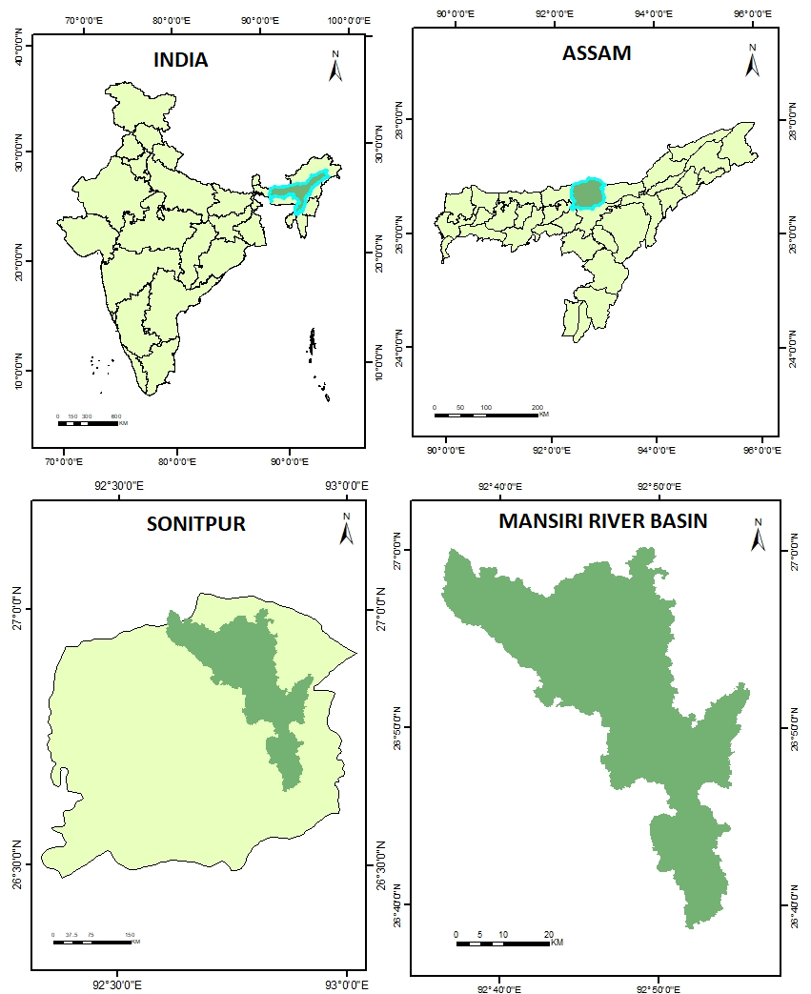
Fig. 1: Location of the study area
Materials and Methods
To calculate the average annual soil loss, various data have been collected from different sources (Table 1). The watershed boundary was delineated using the ALOS PALSAR Digital Elevation Model (DEM) downloaded on 12th March 2024, in the ArcGIS 10.2 software. The rainfall data for the year (2011-2020) was downloaded from the Climatic Research Unit (CRU) on 15th March 2024. The information about soil and soil map was collected from the National Bureau of Soil Survey and Land Use Planning (NBSS&LUP), acquired on 17th March 2024. A cloud-free Landsat 8 OLI satellite image was downloaded from the United States Geological Survey (USGS) on 12th March 2024 to derive land cover and management details. Fig.2 shows the adopted methodology of the research.
Table 1: Description of data sources for estimating the soil loss
Data | Description | Source | Date of acquisition
Satellite data | Landsat 8 OLI | https://earthexplorer.usgs.gov/ | 12/03/2024
DEM | ALOSPALSAR (30M) | htpps://asf.alaska.edu/ | 12/03/2024
Rainfall | Average annual rainfall data from 2011-2020 | https://crudata.uea.ac.uk/cru/data/hrg/ | 15/03/2024
Soil Map | Digitized from ICAR 1:50000 Soil Map | National Bureau of Soil Survey and Land Use Planning (NBSS&LUP), Nagpur, Regional Centre, Jorhat | 15/03/2024

Rainfall data
R factor
Eq. 2
IDW
Average Annual
Soil data
RUSLE Modelling
A=R*K*LS*C*P
K factor
Table 2
Soil Class
Soil Map

LS factor factor
Eq. 3
Flow Accumulation
Flow Direction
Fill
DEM

Soil Loss Estimation
NDVI
Eq. 4
C factor
Satellite image
LULC
Table 3
P factor

Fig. 2: Flow chart for creating a RUSLE-based soil loss map

RUSLE BASED SOIL LOSS ESTIMATION
The Revised Universal Soil Loss Equation (RUSLE) calculates long-term average annual soil loss as the multiplicative product of five factors (Guduru & Jilo, 2023):
A=R×K×LS×C×P Eq. 1
Where A is average annual soil loss per unit area, R is rainfall erosivity, K is soil erodibility, LS represents slope length, C is the cover management factor, and P is the support practice factor (Renard et al., 1997). Each factor was calculated or assigned based on empirical equations and geospatial datasets, resampled to a common 30 m grid, and integrated in ArcGIS 10.2.
Rainfall erosivity factor (R)
Rainfall erosivity is one of the major soil erosion factors in a watershed as it reflects the effect of rainfall intensity on soil erosion (Wischmeier and Smith, 1978). Here, the rainfall erosivity was determined from the annual mean rainfall (2011-2020). By using the Inverse Distance Weighting (IDW), an interpolation tool in ArcGIS, the spatial variability of rainfall was determined. For measuring smooth rainfall distribution of a watershed, IDW is considered the best method (Bakis et al, 2021). The rainfall erosivity was generated using a raster calculator with the help of Eq. 2 (Ram et al, 2004).
R = 81.5 + 0.38P Eq. 2
Where R denotes the rainfall erosivity factor and P is the mean precipitation for the area (mm).
Soil erodibility factor (K)
The soil erodibility factor represents the characteristics of soil. It is a measure of the susceptibility of soil to be eroded and washed away by rainfall, which is determined by the original content, drainage potential, grain size, texture of the soil, cohesiveness, and structural integrity (Prasanna Kumar et al, 2011). The K-factor map was generated using the standard value from the following table:

Table 2: Standard range values of the K factor as per the taxonomy of soil (Wischmeier & Smith, 1978; Renard et al., 1997)
Textural Class | Average OMC* | Less than 2% OMC | More than 2% OMC
Clay | 0.49 | 0.54 | 0.47
Clay loam | 0.67 | 0.74 | 0.63
Coarse loam | 0.16 | - | 0.16
Fine sand | 0.18 | 0.20 | 0.13
Fine sandy loam | 0.40 | 0.49 | 0.38
Loam | 0.67 | 0.76 | 0.58
Loamy fine sand | 0.25 | 0.34 | 0.20
Loamy sand | 0.09 | 0.11 | 0.09
Loamy very fine sand | 0.87 | 0.99 | 0.56
Sandy clay loam | 0.45 | - | 0.45
Sandy loam | 0.29 | 0.31 | 0.27
Silt loam | 0.85 | 0.92 | 0.83
Silty clay loam | 0.72 | 0.79 | 0.67
Very fine sand | 0.96 | 1.03 | 0.83
Very fine sandy loam | 0.79 | 0.92 | 0.74

Slope length and steepness factor (LS)
The characteristics of slope strongly influence soil loss in an area and are represented by the LS factor in the RUSLE model. In this study, the LS factor was calculated using a raster calculator based on the Eq. 3 developed by Moore and Burch (1986).
LS = ${\left(flow accumulation × \frac{cell size}{22.13}\right)}^{0.4}$ $×$ ${\left(\frac{\sin{slope}}{0.0896}\right)}^{1.3}$ Eq. 3
Where LS denotes the slope length and slope steepness factor, flow accumulation is the accumulated upslope contributing area for a given cell, cell size is the area covered by each grid, and sin slope is the sin value of slope degree. The flow accumulation and slope map were generated from the ALOS PALSAR DEM of 30 meters.
Cover management factor (C)
The cover management factor denotes the soil cover that influenced the rate of erosion. Soil loss decreases when there is more vegetation cover, as ground cover reduces the erosive power of raindrops before they hit the soil surface. Vegetation cover, subsurface biomass, and cropping patterns can help reduce soil erosion after precipitation and runoff. Wischmeier and Smith defined the C factor as the ratio of soil loss from land use under specific conditions to that loss from continuously fallow and tilled land. By using the Normalized Different Vegetation Index (NDVI), the C factor can be easily generated. It is a dimensionless index that can determine vegetation strength and describes the difference between visible and near-infrared reflectance of vegetation cover (Weier & Herring, 2000). C factor was calculated by using Eq. 4 (Zhou et al, 2008)
C= exp 𝛼$\left[\frac{NDVI}{β NDVI}\right]$ Eq. 4
Where, 𝛼 = 2 𝑎𝑛𝑑 𝛽 = 1
Support practice factor (P)
Conservation practice factor (P) is a dimensionless ratio applied in soil loss estimation. The P factor explains the control practice of the area that decreases the erosive capacity of rainfall and runoff. The value of the P factor varies from 0 to 1, where the lowest value denotes good support practice and the highest value indicates poor support practice. Here, the P factor map was generated by using LULC map of the study area. The study area was categorized into seven main landcover classes namely, forest, cultivation, barren land, grassland, water body, built up and river. The P factor value for each LULC types were added to the attribute table of LULC vector and then converted to the raster in the ArcGIS software. P factor map was generated using the standard value from the following table:
Table 3: Standard range values of P factor (Wischmeier & Smith, 1978; Renard et al., 1997)
Land Use Class | P Factor
Alpine vegetation | 0.12
Barren land | 1
Bushland | 0.12
Cultivation | 0.12
Forest | 0.8
Grassland | 0.12
Shrub land | 0.12
Waterbody | 1
Woodland | 0.8
Built-up | 1
River | 1

Result and Discussion
In this research, the RUSLE model integrated with GIS techniques was used to estimate the soil loss rate (tons per hectare per year) in the Mansiri River basin and to identify the erosion-prone areas. The estimation was based on the five erosion factors of the RUSLE model: rainfall erosivity factor (R), soil erodibility factor (K), Slope length and steepness factor (LS), cover management (C), and support practice factor (P).
Rainfall Erosivity Factor (R)
The rainfall data showed that the mean annual rainfall over the basin ranges from 1647.90 mm to 1718.79 mm (Fig. 3). The R factor map indicated that R factor varies from 707.701 MJ mm/ha/h/y to 734.642 MJ mm/ha/h/y in the Mnasiri River basin (Fig. 4). R factor follows the variation in average annual rainfall. The higher R value depicts the rainfall's greater influence on soil erosion. Since the southeastern part of the study area receives more rainfall, it is more susceptible to soil erosion. More than 70% of the total rainfall occurs during the monsoon season (May to September); such a massive volume of rainfall within a few months to a large extent causes high surface runoff, resulting in more soil loss.
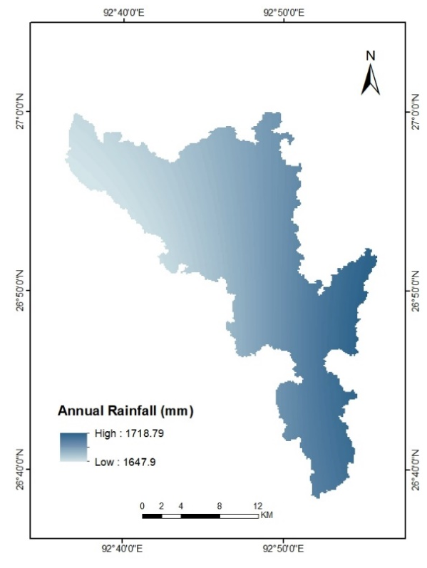
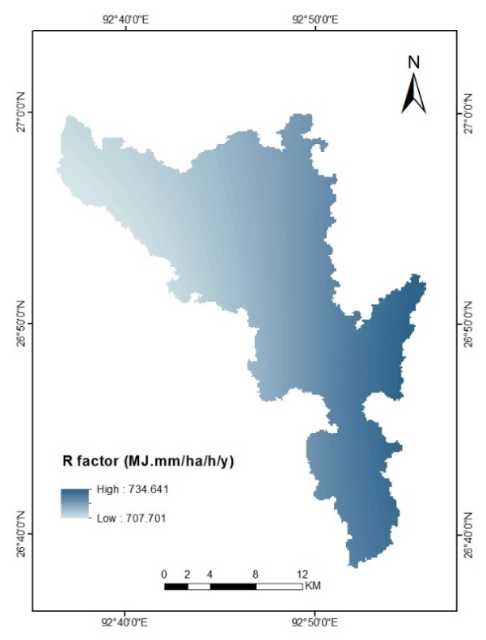
Fig. 3: Mean Annual Rainfall Map Fig. 4: Rainfall Erosivity Factor (R) Map

Soil Erodibility Factor (K):
Soil erodibility factor (K) represents the rate of soil loss per erosion index unit from a unit plot size (Wischemier and Smith, 1978). The Mansiri river basin, soil texture has been divided into two categories - coarse loamy and silty loam soil. The soil which are loose or less compact, like silt or sand, tends to have a higher K value, which is more susceptible to soil erosion than the lower K value of clay and loamy soil. Fig. 5 represents the soil erodibility (K) map of the Mansiri River basin. The erodibility value of 0.16 t h/MJ/mm represents the northern region (covered with coarse loamy soil), and 0.85 t h/MJ/mm represents the southern region (covered with silty loam soil). The soil erodibility factor determines how resistant soils and soil profiles are to erosion K (Uludağ & Fiçici, 2018).
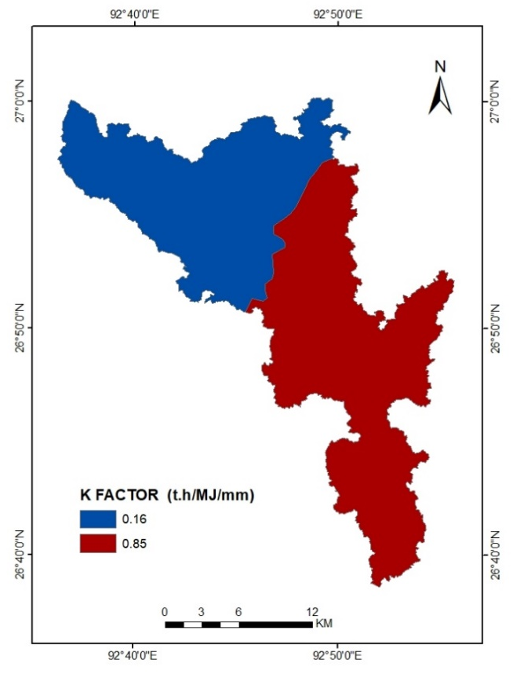
Fig. 5: Soil Erodibility Factor (K) Map

Slope Length and Steepness Factor (LS):
Two topographic parameters, flow accumulation and slope in degrees, were used to determine the LS factor map of the Mansiri River basin. The basin slope varies from 0 to 49.99° (Fig. 6), reflecting the region’s diverse terrain from flat alluvial plains to steep hill slopes. Both these two parameters together determined the LS factor of the area, which ranges from 0 to 0.143209 (Fig. 8). Higher the value of LS factor tends to cause more soil loss. The higher LS value were is dominant from south to north along the river. The higher LS values also recorded in areas near the river due to the higher slope length and steepness (Das et al., 2020).

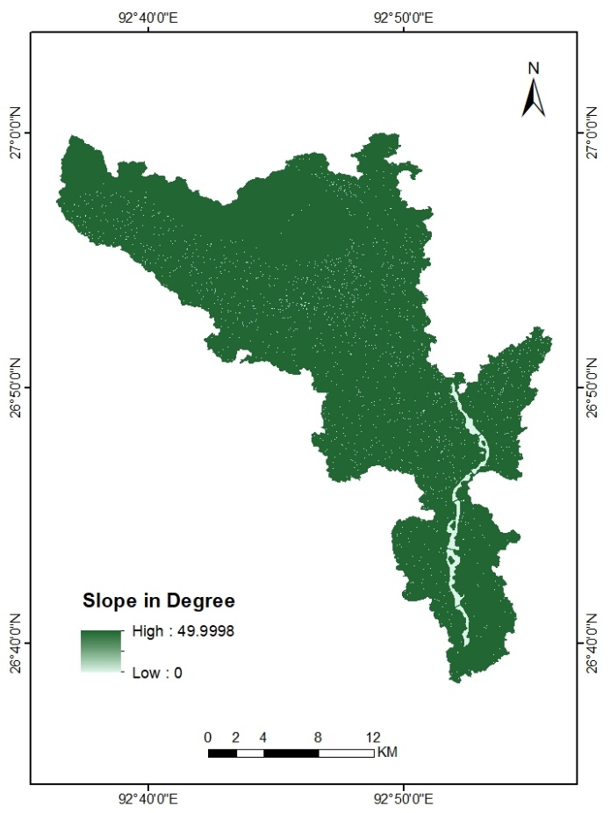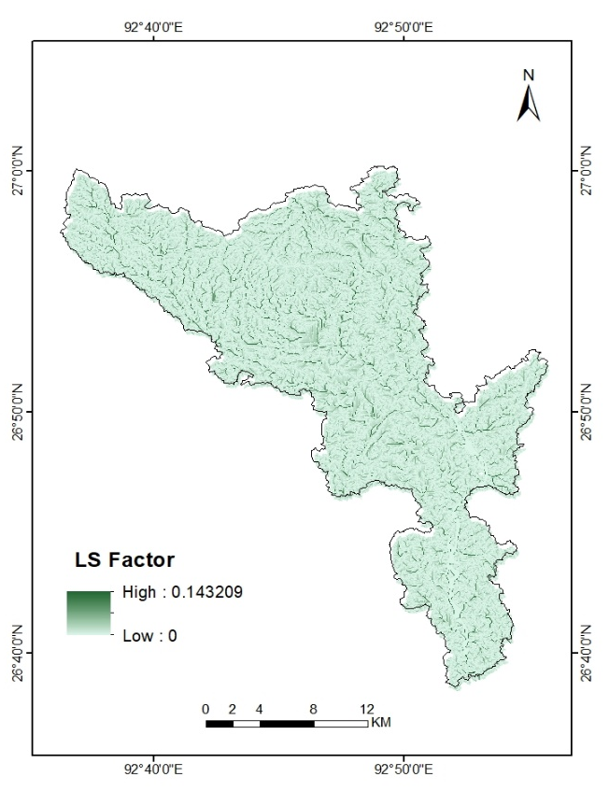
Fig. 6 Slop Map Fig. 7 Slope Length and Steepness Factor (LS) Map

Cover Management Factor (C):
The cover management factor was calculated from the NDVI map by using the Landsat 8 imagery in the Mansiri watershed. NDVI is used to measure the vegetation cover or vegetation density. It ranges from -0.02 to 0.35 (Fig. 9). The Higher the value of NDVI, the denser the vegetation cover and the more resistant it is to soil loss. The C factor increases with lower NDVI values, posing a larger danger for soil erosion (Ghosh, 2025). The C factor varies from 0.30 to 1.09 in the Mansiri river basin (Fig. 10). The Higher the value of the C factor, the greater susceptibility to soil loss, while the value nearer to zero indicates a vegetated area with cover management practices.
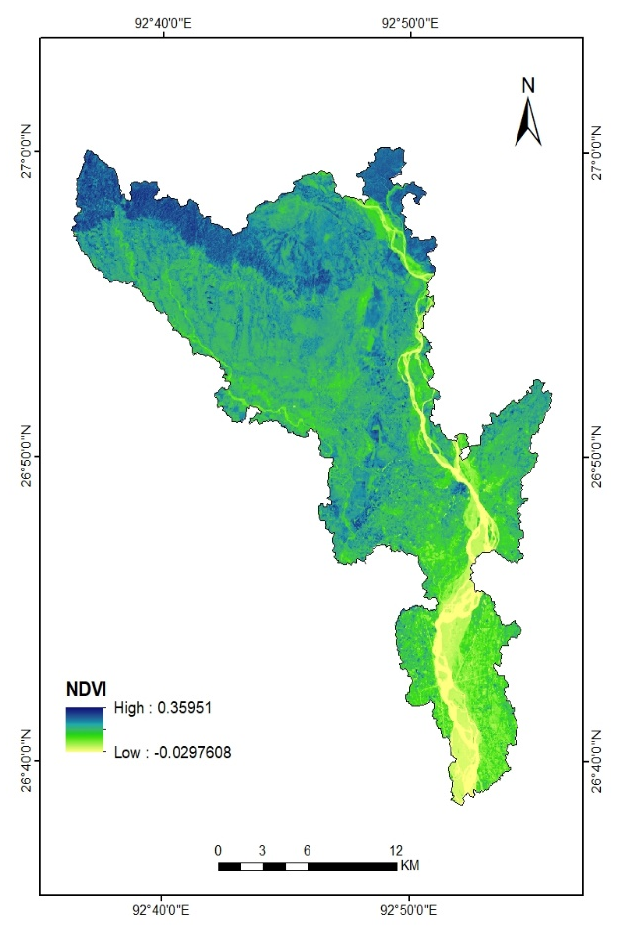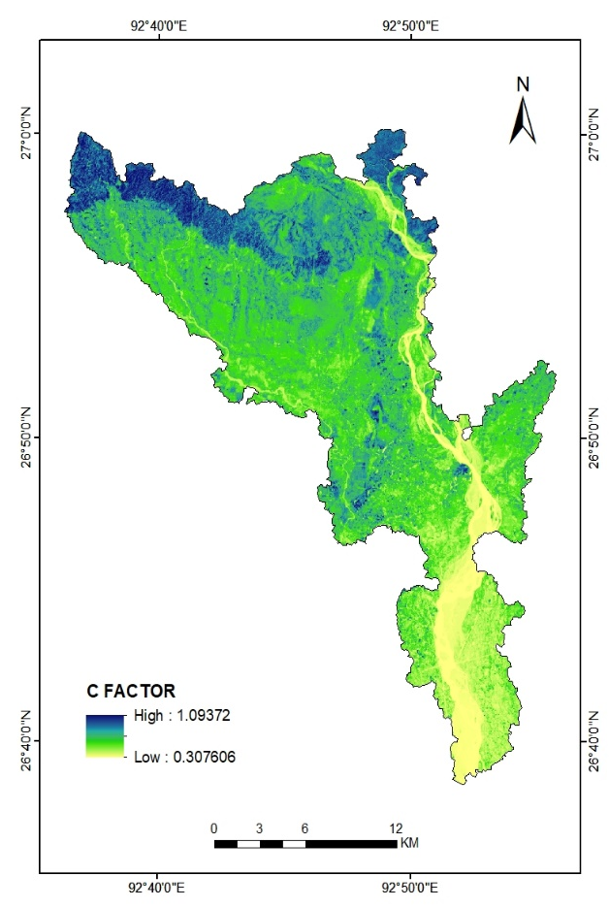
Fig. 9: NDVI Map Fig. 10: Cover Management Factor (C) Map

Conservation Practice Factor (P):
The conservation factor was determined based on land use and land cover of the Mansiri River basin. The value of the P factor lies between 0 and 1, where 0 displays more efficient conservation practices and 1 represents less efficient conservation practices. The study area was classified into seven land use and land cover classes: forest, cultivation, barren land, grassland, waterbody, built-up area, and river (Fig. 11). For barren land and built-up area, which were more susceptible to soil erosion, a higher P value was assigned. While a lower P value was assigned to the crop land, forests, which were more protective against soil erosion as the vegetation cover resists excessive runoff, increase the infiltration rate, and protect the soil from the direct action of falling raindrops. Fig. 12 shows the P factor map of the study area.
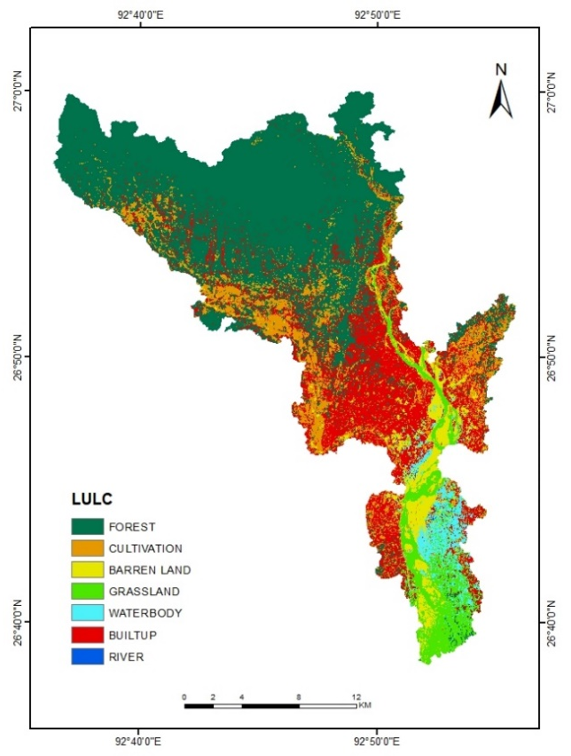
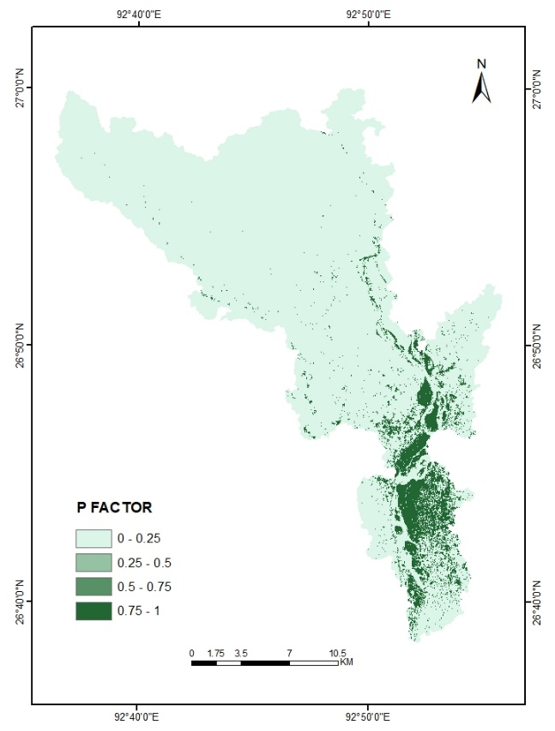
Fig. 11: LULC Map Fig. 12: Conservation Practice Factor (P) Map
Soil Loss Estimation (A):
The mean soil loss of the Mansiri River basin was estimated by integrating all RUSLE factors in the raster calculation of the ArcGIS environment. It was estimated that the annual soil loss of the Mansiri River basin varies between 0 to 1038 tons/hectare/year (Fig. 13). Table 4 shows that the mean annual soil loss rate of the Mansiri River basin were categorized into four classes namely low (0-2 t/ha/y), moderate (2-5 t/ha/y), high (5-10 t/ha/y), and very high (above 10t/ha/y). A large area of the basin was classified as a low rate of soil loss (0-2 t/ha/y), which covered an area of 285.6 sq. km, moderate rate of soil loss (2-5 t/ha/y) covered an area of 153.13 sq km, high rate of soil loss (5-10 t/ha/y) covers 6 sq. km, and a very high rate of soil loss (above 10t/ha/y) covered 3.27 sq. km. The downstream area of the Mansiri River basin recorded a higher rate of soil loss compared to the upstream area of the basin.
Rate of Soil Loss (t/ha/y) | Soil Loss sensitivity class | Area (in sq. km.) | Percentage (%) of total area
0 - 2 | Low | 285.6 | 63.75
2 - 5 | Moderate | 153.13 | 34.18
5 – 10 | High | 6 | 1.34
Above 10 | Very High | 3.27 | 0.73
Table 4: Magnitude of Soil Loss Sensitivity in the Mansiri River Basin
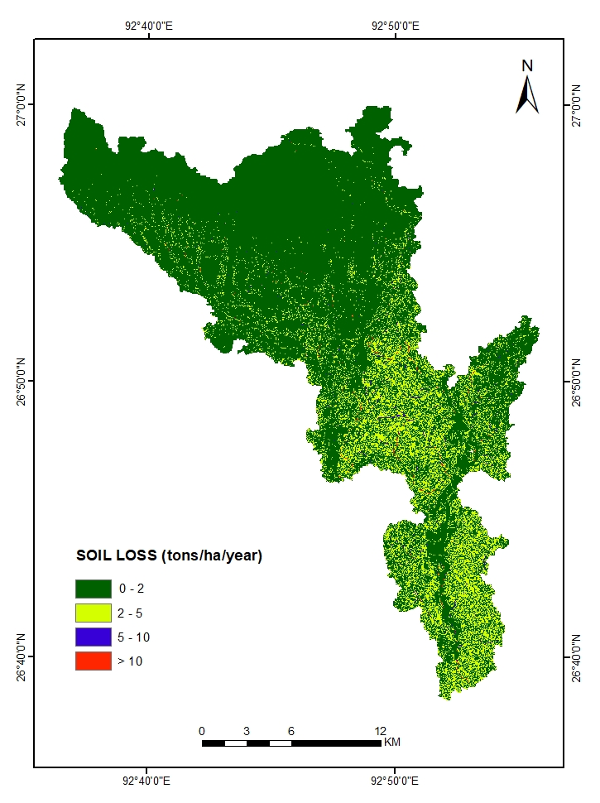
Fig. 13: Average Annual Soil Loss Estimation of the Mansiri River Basin
Conclusion
The study shows Rainfall erosivity factor (R), Soil erodibility factor (K), and Cover management factor (C) were the leading factors that contribute to soil loss in the Mansiri River basin. Besides these, the Topographic factor (LS) and the Conservation practices factor (P) also play an important role in soil loss. About 1.34% of the basin area (out of 448 sq. km) was identified as a high soil loss zone. In this area, the estimated rate of soil loss was above 5 t/ha/y. This area included barren land, grassland, and waterbodies, which have a very low soil holding capacity. Due to high rainfall in the southern part compared to the northern part, the rate of soil loss was high in the southern part. The quantitative estimation of soil loss in the Mansiri river basin can be used in conservation practices and to address the issue of soil loss across the basin. The process of erosion affects the fertility rate of soil, soil quality, and the quality of drinking water. Therefore, the spatial variation of soil loss intensity can help in determining soil conditions across the region. Mapping soil loss with RUSLE shows where fertile topsoil is being washed away, which directly cuts crop production and harms the agricultural lands. Eroded soil also blocks drains, descends water quality, increasing flood risk, and drives up the repair costs in the towns, because of the effects of flood supply, water regulation and flood control. The findings of this study are therefore significant not only for sustaining agricultural productivity but also for improving watershed health. Consequently, the results can support watershed management, land-use planning, and sustainable development strategies.
References
Alaska Satellite Facility. (n.d.). Advanced Land Observation Satellite PALSAR. Retrieved from https://asf.alaska.edu/datasets/daac/alos-palsar/
Amsalu, T., & Mengaw, A. (2014). GIS based soil loss estimation using RUSLE model: The case of Jabi Tehinan woreda ANRS, Ethiopia. Natural Resources, 5(6), 616–626. https://doi.org/10.4236/nr.2014.510055
Bakker, M. M., Govers, G., Kosmas, C., Vanacker, V., Van Oost, K., & Rounsevell, M. (2005). Soil erosion as a driver of land-use change. Agriculture, Ecosystems & Environment, 105(3), 467–481. https://doi.org/10.1016/j.agee.2004.07.009
Bakis, R., Bayajit, Y., Ahmady, D. M., & Cabuk, S. N. (2021). Analysis and comparison of spatial rainfall distribution applying different interpolation methods in Porsuk River Basin, Turkey. Eskisehir Technical University Journal of Science and Technology B – Theoretical Sciences, 9(1), 1–14.
Das, R., Gogoi B., & Jaiswal MK (2020). Soil loss assessment in Sadiya Region, Assam, India using remote sensing and GIS. Indian Journal of Science and Technology 13(23): 2319-2327. https://doi.org/10.17485/IJST/v13i23.588
Foster, G.R., McCool, D.K., Renard, K.G., and Moldenhauer, W.C. 1981. Conversion of the Universal Soil Loss Equation to SI metric units. Journal of Soil and Water Conservation, 36(6), pp. 355-359.
Ghosh, J., Das, S., Ghosh, S., Midya, K., Das, S., & Mishra, V. N. (2025). Soil erosion vulnerability analysis of Damodar River Basin, India using Revised Universal Soil Loss Equation (RUSLE) in Google Earth Engine (GEE). Discover Geoscience, 3(1), 1-31. https://doi.org/10.1007/s44288-025-00191-w
Guduru, J. U., & Jilo, N. B. (2023). Assessment of rainfall-induced soil erosion rate and severity analysis for prioritization of conservation measures using RUSLE and Multi-Criteria Evaluations Technique at Gidabo watershed, Rift Valley Basin, Ethiopia. Ecohydrology & Hydrobiology, 23(1), 30–47. https://doi.org/10.1016/j.ecohyd.2022.07.004
Haile, S., Pathan, S.A. & Ronghang, M. Assessment of soil erosion in the Brahmaputra river basin in Assam using the RUSLE model. Int J Energ Water Res (2025). https://doi.org/10.1007/s42108-025-00381-9
ICAR–IISWC. (2010). Annual report 2009–2010. Indian Council of Agricultural Research – Indian Institute of Soil and Water Conservation, Dehradun, India.
Khanam, L. & Patnaik, S. (2025). Identification of Groundwater Potential Zones Using GIS Techniques in East Karbi Anglong District, Assam, India. Asian Journal of Geographical Research. 8. 472-487. https://doi.org/10.9734/ajgr/2025/v8i3312
Ighodaro, I. D., Lategan, F. S., & Yusuf, S. F. (2013). The impact of soil erosion on agricultural potential and performance of Sheshegu community farmers in the Eastern Cape of South Africa. Journal of Agricultural Science, 5(5), 140–147. https://doi.org/10.5539/jas.v5n5p140
Kayet, N., Pathak, K., Chakrabarty, A., & Sahoo, S. (2018). Evaluation of soil loss estimation using the RUSLE model and SCS-CN method in hillslope mining areas. International Soil and Water Conservation Research, 6(1), 31–42. https://doi.org/10.1016/j.iswcr.2017.11.002
Littleboy, M., Freebairn, D. M., Hammer, G. L., & Silburn, D. M. (1992). Impact of soil erosion on production in cropping systems. II. Simulation of production and erosion risks for a wheat cropping system. Soil Research, 30(5), 775–788. https://doi.org/10.1071/SR9920775
Moore, I. D., & Burch, G. J. (1986). Physical basis of the length slope factor in the universal soil loss equation. Soil Science Society of America Journal, 50(5), 1294–1298. https://doi.org/10.2136/sssaj1986.03615995005000050042x
Parveen, R., & Kumar, U. (2012). Integrated approach of universal soil loss equation (USLE) and geographical information system (GIS) for soil loss risk assessment in Upper South Koel Basin, Jharkhand. Journal of Geographic Information System, 4(6), 588–596. https://doi.org/10.4236/jgis.2012.46062
Pimentel, D. (2006). Soil erosion: A food and environmental threat. Environment, Development and Sustainability, 8(1), 119–137. https://doi.org/10.1007/s10668-005-1262-8
Prasanna Kumar, V., Shiny, R., Geetha, N., & Vijith, H. (2011). Spatial prediction of soil erosion risk by remote sensing, GIS and RUSLE approach: A case study of Siruvani river watershed in Attapady valley, Kerala, India. Environmental Earth Sciences, 64, 965–972. https://doi.org/10.1007/s12665-011-0913-3
Ram, B., Dhyani, B. L., & Kumar, N. (2004). Assessment of erodibility status and refined iso-erodent map of India. Indian Journal of Soil Conservation, 32(2), 171–177.
Renard, K. G., Foster, G., Weesies, G., McCool, D. K., & Yoder, D. (1997). Predicting soil erosion by water: A guide to conservation planning with the Revised Universal Soil Loss Equation (RUSLE) (Agricultural Handbook No. 703). United States Department of Agriculture.
Uludağ, M., & Fiçici, M. (2018). Saray ilçesinde (Tekirdağ) toprak erozyonunun RUSLE yöntemiyle değerlendirilmesi. Türk Coğrafya Dergisi, 70, 29–36. https://doi.org/10.17211/tcd.356669
United States Department of Agriculture Soil Conservation Service (USDA–SCS). (1972). Hydrology (Section 4). In SCS National Engineering Handbook. U.S. Department of Agriculture.
United States Geological Survey (USGS). (n.d.). EarthExplorer. Retrieved from https://earthexplorer.usgs.gov/
Weier, J., & Herring, D. (2000). Measuring vegetation (NDVI & EVI). NASA Earth Observatory. Washington, DC. Retrieved from https://earthobservatory.nasa.gov/features/MeasuringVegetation
Wischmeier, W. H., & Smith, D. D. (1978). Predicting rainfall erosion losses: A guide to conservation planning (Agricultural Handbook No. 537). U.S. Department of Agriculture, Science and Education Administration.
Zhou, P., Luukkanen, O., Tokola, T., & Nieminen, J. (2008). Effect of vegetation cover on soil erosion in a mountainous watershed. Catena, 75(3), 319–325. https://doi.org/10.1016/j.catena.2008.07.010

