EVALUATION OF ANTIOXIDANT CONTENTS AND STRUCTURAL IDENTIFICATION BY HPTLC AND HPLC-MS/MS OF CAROTENOIDS IN THE BF59XCIP1 VARIETY OF IPOMOEA BATATAS L.

Abstract:
Objective: Orange-fleshed sweet potatoes are an important source of nutrients for consumers thanks to the carotenoids they contain. Carotenoids are bioactive compounds which, thanks to their anti-radical properties, can protect the human body against oxidative stress. Oxidative stress is the cause of many degenerative diseases, such as cancer, blindness, and aging. This study aims to evaluate the antioxidant content of the orange-fleshed variety BF59XCIP1, obtained by crossing varieties adapted to local agroecological conditions, and to identify the main carotenoids in this variety.
Study design: The work combined cutting, tuber harvesting, and various laboratory analyses. This work was carried out as part of my doctoral thesis.
Methodology: Two types of extracts were prepared. Extracts using an acetone-water-acetic acid solvent system (70:29.5:0.5 v/v/v) for the evaluation of antioxidant content and hexane extracts for structural identification. Antioxidant content was evaluated using the DPPH and FRAP methods. HPTLC-MS and HPLC-MS/MS analyses were used for carotenoid identification.
Results: antioxidant content assessed using the DPPH and FRAP methods was estimated at 0.082 mg ET/g and 0.183 mg ET/g of fresh plant material, respectively. For the structural identification of carotenoids, analysis of the two major spots by HPTLC-MS identified β-cryptoxanthin, zeaxanthin, and β-carotene. HPLC-MS/MS analysis identified capsanthin, echinenone, α-tocopherol, and β-carotene.
Conclusion: The BF59XCIP1 variety of orange-fleshed sweet potato is a source of vitamin A. Therefore, its consumption can compensate for vitamin A deficiency in malnourished children.

Keywords: carotenoids; antioxidant; HPLC-MS/MS, HPTLC-MS.

1. Introduction
Carotenoids are secondary metabolites, i.e., compounds synthesized by plants. They belong to the terpenoid family and comprise two major classes of compounds: carotenes and xanthophylls. Carotenoids are found in many fruits and vegetables (oranges, tomatoes, carrots, spinach, sweet potatoes, pumpkins) and are often responsible for the bright colors of these fruits and vegetables [1]. Due to their coloring properties, carotenoids play an important role in plant physiology. Some carotenoids are precursors to vitamin A, which is one of their most important physiological functions [2]. A correlation has been established between the consumption of vegetables and fruits rich in carotenoids and the prevention of several chronic degenerative diseases, such as cancer, inflammatory diseases, cardiovascular diseases, cataracts, and degeneration, among others [3], thanks to their antioxidant properties. Given the importance of these carotenoids, their qualitative and quantitative analysis in PDCO is necessary in order to promote their consumption as part of the fight against vitamin A deficiency. The objective of this study is to identify the major carotenoids and evaluate the antioxidant content of extracts from the BF59XCIP1 variety of Ipomoea batatas L.
2. Materials and methods
2.1. Plant material
The plant material consisted of the BF59XCIP1 variety of orange-fleshed sweet potato. This variety, whose cuttings were provided by INERA, was grown in the LCOPA experimental garden at Joseph KI-ZERBO University.
2.2. Methods
2.2.1. Extraction
For qualitative analysis, 30 g of fresh crushed plant material was extracted successively with 100 mL, 50 mL, and 50 mL of hexane by maceration. The filtrates obtained were collected for saponification. In fact, 30% KOH in methanol was added to the crude extract. The mixture was left to stand at room temperature for 3 hours away from light. After liquid-liquid partitioning in a separating funnel using hexane, the organic phase obtained was concentrated to dryness and used for the various analyses.
To evaluate the antioxidant content, extracts were prepared using a solvent system of acetone-water-acetic acid (70:29.5:0.5 v/v/v). Five grams of crushed tubers were macerated using a sonicator for 1 hour in 10 mL of the solvent system. After filtration, two further extractions were carried out with 5 mL of the same solvent system for 30 min. The filtrates were combined for analysis.
2.2.2. Evaluation of antioxidant content
The total antioxidant content was determined by spectrophotometry using two of the three commonly used methods: the 2,2-diphenyl-1-picrylhydrazyl (DPPH) method and the Ferric Reducing Antioxidant Power (FRAP) method. These methods are based on different chemical mechanisms. The DPPH method measures the ability of an antioxidant to trap the radical [4] by transferring electrons from the sample to the antioxidant. The FRAP method evaluates the reducing power of a sample.
DPPH method: This method measures the absorbance of the discolored DPPH° radical solution by the activity of a quantity of the sample being studied. Fifty µL of each extract is added to 200 µL of the DPPH reagent. After 10 minutes of incubation, the absorbances are read at 515 nm using a microplate reader (MP96 spectrophotometer, SAFAS). The absorbances of the samples studied are plotted on a standard curve (y = -14.194x + 0.6017; R² = 0.9997) previously established using Trolox as a reference antioxidant. The contents are thus expressed in mg of Trolox equivalents per gram of fresh plant material. All measurements are repeated three times.
FRAP method: in this method, a ferric salt, Fe(III)(TPTZ)2Cl3 (TPTZ = 2,4,6-tripyridyl-s-triazine) is used as an oxidant [4][5]. The absorbance of the intense blue discoloration at 595 nm is measured with a microplate reader (MP96 spectrophotometer, SAFAS). To a mixture of 30 μL of distilled water and 20 μL of each of the appropriately diluted samples, 200 μL of the FRAP reagent is added. A standard curve is established using Trolox as the reference antioxidant. The results, determined from the calibration curve equation (y = 18.957x + 0.2917; R2= 0.9985), were expressed in mg of Trolox Equivalents (TE) per gram of plant material. All measurements were repeated three times.
2.2.3. HPTLC-MS analysis
Chromatography was performed on a 20 cm x 10 cm silica gel 60 F254 HPTLC plate (Merck, Germany). The mobile phase was a petroleum ether-acetone-ethyl acetate system (85:15:5 v/v/v). Five µL and 6 µL of saponified extracts were applied in 5 mm bands using a CAMAG Vision CAT automatic thin-layer chromatography (TLC) sampler. The mass spectrometer used to identify carotenoids in PDCO extracts was a Quadrupole Time of Flight (QTOF, 6520 series) equipped with an Electro-Spray ionization source in positive mode (ESI+). Mass spectra were obtained in a mass range of m/z 400-600. The MS parameters were as follows: collision gas was helium; capillary temperature was 250°C.
2.2.4. HPLC-MS/MS analysis
HPLC coupled with tandem mass spectrometry using positive mode electrospray ionization (HPLC-ESI-MS/MS) was used in this study to identify and characterize carotenoids. An Agilent Technology Infinitely Better 1290 HPLC system was used for chromatographic separation. It is equipped with a 100 mm long, 2.1 mm diameter, 5 µm particle size, water X-terra reverse phase C18 column. Elution was performed with mobile phase A (acetonitrile; methanol 85:15 v/v + 0.1% formic acid) and mobile phase B (water + 0.1% formic acid) as described by Jeevan Kumar Prasain et al [6]. The elution gradient over time, expressed as a percentage of the volume of mobile phase A and mobile phase B, was programmed as follows: 0 to 7 min, 95% A; 8 to 15 min, 100% A. The flow rate was maintained at 1 mL/min and the column temperature at 25°C.
3. Results and discussion
3.1. Antioxidant content
The antioxidant content of the local PDCO variety BF59XCIP1 is expressed in mg ET/g of plant material. These contents are 0.082±0.002 and 0.183±0.001 respectively by the DPPH and FRAP methods. These values are significantly different. This difference could be explained by their reaction mechanisms. The DPPH method measures the ability of an antioxidant to trap the DPPH° radical [4] by transferring electrons from the antioxidant sample. However, the FRAP method evaluates the reducing power of the sample. The relatively low antioxidant content assessed by the DPPH method could also be explained by the structure of the DPPH° radical.
3.2. Identification of the main carotenoids by HPTLC-MS
The identity of the bands in the extract chromatogram was further confirmed by mass spectrometry, i.e., using the Camag TLC-MS interface, which allows direct coupling of TLC to MS.
Two major spots were analyzed. Spots 1 and 2 with respective Rf values of 0.3 and 0.87 (Figure 1).
MS analysis of spot 1 (Rf= 0.3) shows two peaks corresponding to two molecular ions at m/z 537.4 and 569.4, named A and B respectively (Figure 2). The molecular ion at m/z 537.4 (≃537) corresponds to the mass calculated from the formula C40H56. Compounds such as β, α-carotene, and lycopene have the same molecular formula. Compound A can be either β or α-carotene, or lycopene. The molecular ion at m/z 569.4 (569) corresponds to the mass calculated from the formula C40H56O2. This is either lutein or zeaxanthin. Lutein and zeaxanthin differ only in the position of a double bond on the rings (Figure 3). Compound B could therefore be either lutein or zeaxanthin.
Analysis of the mass spectrum (HPTLC-MS) of spot 2 (Rf= 0.87) reveals three peaks corresponding to molecular ions at m/z 537.4, 553.7, and 568.5, labeled C, D, and E, respectively (Figure 2). As in the case of spot 1, the molecular ion at m/z 537.4 (≃537) corresponds to the mass calculated from the formula C40H56. The masses of carotenoids such as lycopene, β, γ, and α-carotene correspond to this molecular formula. Compound C could be either lycopene or one of its isomers. However, several studies have shown that β-carotene (Figure 5) is the major component in PDCOs [8][9]. Compound C could correspond to β-carotene. The molecular ion at m/z 553.7 could correspond to one of the isomers of cryptoxanthin (β-cryptoxanthin and α-cryptoxanthin) with the formula C40H56O (Figure 4). Compound D could be identified as one of these isomers. The molecular ion at m/z 568.5 (≃569) corresponds to the mass calculated from the formula C40H56O2. Lutein and zeaxanthin (Figure 3) are two carotenoids corresponding to this molecular formula. Furthermore, previous studies have already shown the presence of these carotenoids in PDCOs [7]. Compound E can be identified as one of these two carotenoids.
Figure 1: HPTLC spectrum of the BF59XCIP1 variety
Figure 2: HPTLC spectrum of spots 1 and 2 of variety BF59XCIP1
Figure 3: Structures of zeaxanthin and lutein
α-cryptoxanthin
β-cryptoxanthin
Figure 4: Structures of β-cryptoxanthin and α-cryptoxanthin
Figure 5: Structures of β-carotene

3.3 Identification of compounds in the BF59XCIP1 variety by HPLC-MS/MS
The LC-MS/MS method can be used to characterize carotenoids present as minor components in several fruits, as demonstrated by the analysis of extracts from pineapple (Physalis peruviana), kiwano (Cucumis metuliferus), mango (Mangifera indica), and pumpkin (Cucurbita pepo) [9]. The identification of the different carotenoid isomers is based on the characteristic fragmentation pattern. Chromatographic analysis identified four peaks labeled 1, 2, 3, and 4 with retention times of 0.788, 0.94, 3.33, and 9.652 min, respectively, corresponding to four compounds (Figure 6). These peaks correspond in LC-MS to molecular ions at m/z: 585, 551, 431, and 537, respectively. The observed sequence of chromatographic peaks reflects the decreasing polarity of the eluted compounds, with the more polar xanthophylls being eluted first. This is related to the polarity of the mobile phase used in our case. The intensities of the peaks corresponding to the molecular ions are greater than those of the fragment ions. This could be explained by the collision energy used during their fragmentation. It could even explain the absence of certain fragments of these molecular ions.
The molecular ion at m/z 585 corresponds to the mass calculated from the formula C40H56O3. It corresponds to the most polar compound. The presence of three oxygen atoms could explain this polarity. LC-MS/MS analysis of this molecular ion gives a fragment ion at m/z 249 corresponding to [M+H-C24H32O]+ (Figure 7). This compound 1 is thought to be capsanthin (Figure 8).
The molecular ion at m/z 551.200 corresponds to the mass calculated from the formula C40H54O. Carotenoids (xanthophylls) have the same chromophore. The difference in retention times between the molecular ions at m/z 551 and 585 can be explained by the difference in the number of oxygen atoms. Thus, the molecular ion at m/z 551 would have fewer oxygen atoms than the one at 585. In addition, the MS/MS spectrum of this molecular ion gives a fragment ion at m/z 459. This fragment ion corresponds to the loss of toluene C7H8 [M+H-C7H8]+ (Figure 9). This compound 2 can be identified as echinenone (Figure 10).
From the analysis of the general and individual chromatograms, the peaks corresponding to masses 413 and 431 have the same retention times (Figure 11). The peak corresponding to m/z 413 could therefore correspond to the fragment ion of the molecular ion at m/z 431. This fragment ion corresponds to the loss of a water molecule [M+H-H2O]+. In addition, the fragment ion at m/z 301 corresponds to the loss of a water molecule and a C8H17 molecule [M+H-H2O-C8H17]+ (Figure 11). This compound 3 can be identified as α-tocopherol (5,7,8-trimethyltocol), also known as vitamin E (Figure 11).
The retention time tR=9.65 min corresponding to peak 4 of the chromatogram shows that the corresponding molecular ion is less polar than the other three ions. This molecular ion could belong to the carotenes subgroup. In mass spectrometry, this molecular ion gives a mass at m/z 537 corresponding to the mass calculated from the formula C40H56 and two fragment ions at m/z 415 [M+H-C9H15]+ and 282 [M+H-C19H27]+ (Figure 12). The masses of lycopene, β, γ, and α-carotene correspond to this molecular formula. Compound 4 is either lycopene or one of its isomers. The presence of these compounds has already been reported in PDCOs in the literature. However, these studies show that β-carotene is the major compound [7]. Compound 4 can be identified as β-carotene (Figure 13).

Figure 6: Chromatogram of the extract from variety BF59XCIP1
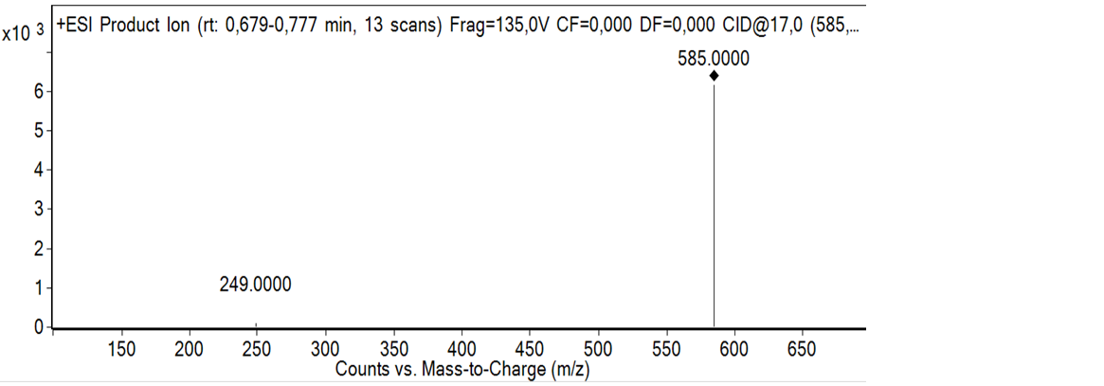
Figure 7: SM/SM spectrum of capsanthin
Figure 8: Structure of capsanthin
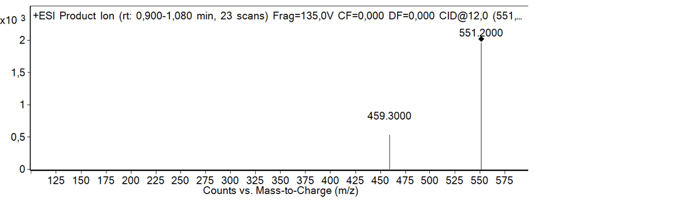
Figure 9: SM/SM spectrum of echinenone
Figure 10: Structure of echinenone

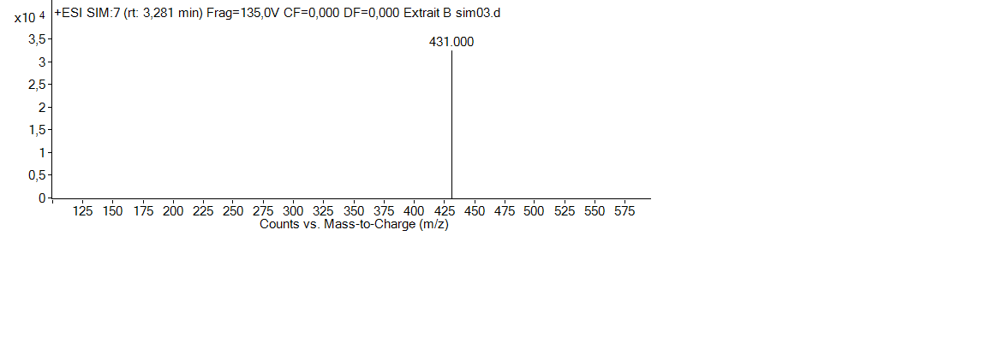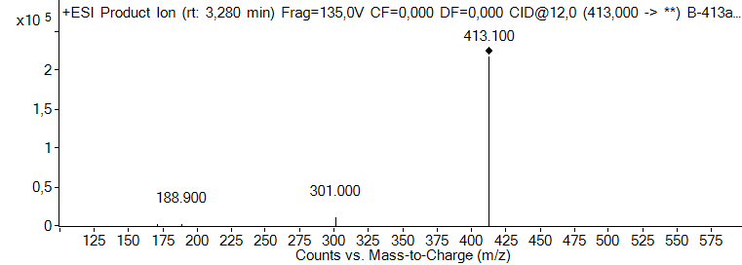
Figure 11: Mass spectrum of compound 3

Figure 12: Structure of α-tocopherol

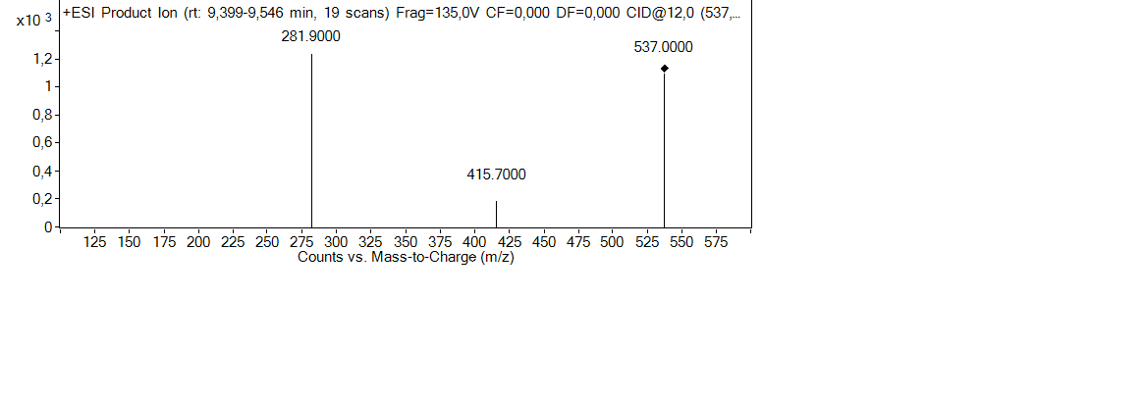
Figure 13: SM/SM spectrum of β-carotene

Figure 14: Structure of β-carotene
4. Conclusion
Quantitative analysis of antioxidant content was performed using two of the three commonly used methods: DPPH and FRAP. Antioxidant content was found to be 0.082 and 0.183 mg ET/g of plant material using the DPPH and FRAP methods, respectively. From the qualitative analysis, four carotenoid molecules were identified: zeaxanthin, α-cryptoxanthin, α-tocopherol, and β-carotene. It appears that this variety contains vitamin E, a powerful antioxidant, and β-carotene, a molecule with provitamin A activity.
DISCLAIMER (ARTIFICIAL INTELLIGENCE)
The authors hereby declare that NO generative AI technology such as large language models (ChatGPT, COPILOT, etc.) and text-to-image generators were used in the writing or revision of this manuscript.

References
[1] R. Sol, M, C. Paul, and C.-G. and Ramon, “identification of carotenoids using massspectrometry,” Wiley Online Libr., pp. 33(5):353-372, 2013.
[2] C. Vílchez, F. Eduardo, C. María, B. Francisco, G. Inés, and V. and José, M, “Marine Carotenoids: Biological Functions and Commercial Applications,” Mar. Drugs, pp. 9(3): 319–333, 2011.
[3] M. Guerin, M. Huntley, and M. Olaizola, “Haematococcus astaxanthin: Applications for human health and nutrition,” Trends Biotech, pp. 21;210–216, 2003.
[4] H. Tapiero, D. Tew K, G. Nguyen, Ba, and G. Mathe, “Polyphenols: do they play a role in the prevention of human pathologies.,” Biomed. Pharmacother, pp. 56, 200–207, 2002.
[5] J. Strain and B. IF, “The ferric reducing ability of plasma as a measure of ‘antioxidant power’: the FRAP assay.,” Anal. Biochem, pp. 239, 70–76, 1996.
[6] Jeevan Kumar Prasain, «Electrospray tandem mass spectrometric analysis,» JOURNAL OF MASS SPECTROMETRY, vol. 40, n° %12005, p. 916–923, 2 June 2005.
[7] T. Somé, Issa et al., “Validation d’une méthode de dosage des caroténoïdes par CLHP : application à la détermination de teneur en caroténoïdes dans dix variétés de patates douces (Ipomea batata),” C. R. Chim. 7, pp. 1063–1071, 2004.
[8] M. Kimura, C. N. Kobori, R.-A. Delia B, and N. Penelope, “Screening and HPLC methods for carotenoids in sweetpotato, cassava and maize for plant breeding trials,” Food Chem., vol. 100 (2007), 2007.
[9] I. Pott, D. Breithaupt, and R. Carle, “Detection of unusual carotenoid esters in fresh mango (Mangifera indica L. cv. ‘Kent’).,” Phytochemistry, pp. 64; 8–25, 2003.

