Exploring the beneficial effect and therapeutic mechanism of phytochemicals present in Coccinia indica against Parkinson's Disease based on Molecular docking studies
ABSTRACT
Aim: Parkinson's Disease (PD) is a neurodegenerative disorder that affects movement. its major causes Genetic Factors, Family history, Environmental Factors, Toxins and pesticides etc. Parkinson's disease pathophysiology involves: Dopamine depletion in the substantia nigra, Alpha-synuclein aggregation and Lewy body formation. Coccinia indica exhibits promising therapeutic potential against Parkinson's disease, attributed to its rich phytochemical profile including flavonoids, flavonoid glycosides , fatty acids, Phytosterols, Polyphenol and Triterpenoid . These compounds demonstrate antioxidative and neuroprotective properties which mitigate oxidative stress.
Materials and Methods : In this study 3 targets i.e. Dopamine receptor, Muscarinic acetylcholine receptor and NMDA receptor were selected on the basis of their mechanism of action in Parkinson's disease. The docking analysis was carried out by utilising PyRx 0.8 virtual screening and the visualization of protein-ligand interaction was investigated by utilising the BIOVIA Discovery Studio Visualizer.
Result: Docking simulation of active compounds from Coccinia indica against the Dopamine receptor shows that Quercetin (-9.8 kcal/mole), Stigmasterol (-9.7 kcal/mole) and Apigenin (-9.5 kcal/mole) have the highest binding affinity. In the characteristic binding to the Muscarinic acetylcholine receptor, Rutin (-8.5 kcal/mole), Stigmasterol (-8.3 kcal/mole) showed highest binding affinity. Docking analysis of NMDA receptor showed impressive binding affinities of Apigenin (-9.1 kcal/mole) and Quercetin (-9.0 kcal/mole).
Conclusion: On the basis of binding affinity and pharmacokinetic parameters our findings strongly support the potential use of phytoconstituents from Coccinia indica as a medicinal herb that might be taken in daily life to manage the parkinsonism. Further, additional research, i.e. in vitro and in vivo trials on the same constituents, is required to confirm our results and the clear picture of the mechanism of action by which the medicinal plant demonstrated their anti Parkinson's effects.
Keywords: Parkinson's Disease, Coccinia indica, Quercetin, Stigmasterol, Apigenin, Naringenin

1. INTRODUCTION:
Parkinson's disease (PD) is a common idiopathic, neurodegenerative disorder that produces slow bodily movements, muscular rigidity, frequent tremor of resting limbs, and loss of postural balance (Zhang and Roman, 1993). The etiology of PD is largely unknown, although there is growing body of evidence implicating environmental risk factors, including rural living, consumption of well water, and pesticide exposure. (Tanner and Langston, 1990; Tanner and Goldman, 1996) (1). Parkinson's disease (PD) is a common neurodegenerative disorder- alpha synucleinopathy-with a prevalence of 160/100,000 in Western Europe rising to ~4% of the population over 80 (2). With a prevalence of approximately 1% at age 65, which rises to nearly 5% by age 85, PD is the second most common neurodegenerative disorder after Alzheimer's disease (3,4). The mean age of PD diagnosis is in the seventh decade of life, but due to PD's insidious nature, the onset of symptoms may precede clinical recognition by many years . The exact causes are not fully understood, but several factors contribute to its development like Genetic Factors ( Mutations in genes like SNCA, PARK2, PINK1, DJ-1, and LRRK2 can increase the risk of developing PD and environmental Factors (Pesticide Exposure, heavy Metal Exposure etc), Traumatic brain injury may also increase the risk of developing PD and Age and Neurodegeneration contributes to PD symptoms. Other Potential Factors also Mitochondrial Dysfunction, Chronic inflammation in the brain, Alterations in the gut microbiome may influence PD development and progression (5). The pathophysiology of Parkinson's disease (PD) is complex and multifactorial, involving various cellular, molecular, and systems-level changes that ultimately lead to the degeneration of dopaminergic neurons in the substantia nigra pars compacta (SNpc) and other brain regions (6). Alpha-synuclein (α-syn) is a protein that plays a crucial role in the pathophysiology of Parkinson's disease (PD). In normal functioning α-Syn is involved in regulating synaptic vesicle trafficking and neurotransmitter release. But in Parkinson's α-Syn can misfold and aggregate, forming insoluble fibrils that accumulate in neurons and α-Syn is the primary component of Lewy bodies and Lewy neurites. So α-Syn aggregation can lead to neuronal dysfunction and lead Parkinsonism (7). There are some synthetic drug which used for Parkinson's disease like Levodopa, Carbidopa, Amantadine, Benztropine, Selegiline etc (8). In this study Coccinia indica plant used for Parkinson's treatment and which is commonly referred to as ivy gourd and belongs to the cucurbitaceae family and genus is coccinia. It is abunded with phytoconstituents viz. Arachidonic acid, Oleic acid, Linoleic acid, Palmitic acid, Quercetin, Naringenin, Kaempferol, Beta sitosterol, Cucurbitacin B, Stigmasterol, Rutin, Resveratrol, Quercetin, Apigenin etc (9, 10,11,12,13 ) Additionally, there are numerous therapeutic activities such as Antioxidant activity, Anti-inflammatory activity, Anticancer activity, Anti-diabetic activity, Anti depressant activity, Anti ulcer activity and hepato protectivity etc and many more properties have been reported from this plant but there are no scientific evidence available for anti Parkinson's activity using coccinia indica (14).
Molecular docking is a computer-aided approach which serves to identify specific molecules in accordance with their free binding energy and demonstrates structural hypotheses concerning the assessment of protein ligand interactions which plays a key role in determining molecular targets or receptors for various ligands. This approach has benefits in terms of decreasing errors in laboratory research, leads to lower costs and faster responses.
2.METHODOLOGY
2.1 Software And Tools: Protein Data Bank (PDB), PubChem, PyRx, Molegro Molecular Viewer, Discovery Studio Visualizer.
2.2 Ligand Structure Preparation: The phytoconstituents viz. Palmitic acid, Oleic acid, Linoleic acid, Arachidonic acid, Quercetin, Naringenin, Stigmasterol, Rutin, Kaempferol, Beta sitosterol, Resveratrol, Apigenin, Cucurbitacin B have been diagnosed from the chosen medicinal plant Coccinia indica and the 2D structures of the ligands were obtained from PubChem chemical libraries and saved as SDF format.
2.3 Target Prediction: In order to identify the various possible targets based on the fit score, the Swiss Target Prediction tool was implemented. The canonical SMILES of chemical compounds have been presented on the website. The species was selected as homo sapiens, and all additional parameters have been retained as the default.
2.4 Protein Structure Preparation: The 3D structures of targeted receptor proteins related to metabolism of lipids were recognized by Target Prediction and obtained from the Protein data hank (PDB). The three-dimensional (3D) coordinates of the crystal structure of Dopamine receptor D1 subtype in complex with levodopa, PDB id-6CM4(with a Resolution: 2.87 A°), NMDA GLUN 1/GLUN 2B in complex with Amantadine, PDB id-5EWJ (with a Resolution: 2.77 A°), Muscarinic acetylcholine receptor in complex with Benztropine, PDB id- 6WJC(with a Resolution: 2.55A°). In order to perform docking analysis the target was initially determined and afterwards 3D structure of the above receptors were obtained. It is commonly accepted that the PDB file format is unable to store bond order information and thus explicit hydrogen assignments are frequently incomplete or incorrect. Consequently, the Molegro Molecular Viewer was used to assign bond orders, correct bonds, hybridization and charges. During the protein preparation procedure, water molecules that were present in the crystal structure were removed.
2.5 Molecular Docking: The docking analysis was carried out by utilising Python Prescription (PyRx) 0.8 virtual screening tool along with BIOVIA Discovery Studio Visualizer (DS 2021). It is necessary to initially convert the updated receptor file from PDB to PDBQT file format before proceeding. All the converted receptor and ligands were uploaded to the workspace of PyRx and minimization was done using the Open Babel program. All the receptors were closed in the grid box and all the grid points (i.e. X, Y, and Z axis) were assigned accordingly for docking. Grid box arrangement was carried out at a distance of 1 A in order to enable the ligand to move freely and find the most suitable location to attach to the amino acid at the most convenient spot of the enzyme. For every single protein-ligand combination, a separate docking study was carried out. The analysis of the molecular docking simulation was acquired from parameter scoring of the affinity energy values. The outcomes were arranged in ascending order of docking energies. Each cluster's lowest binding energy was chosen as representative. The binding affinity in between the receptor and ligand is determined for all. binding regions and the result is reported as affinity (kcal/mol).
2.6 Protein-ligand Interactions: The visualization of protein-ligand interaction was investigated by utilising the BIOVIA Discovery Studio Visualizer. 3D and 2D arrangement of the interaction was also displayed for the final docking output. Further details from the interaction of protein-ligand can be utilised to understand the nature of hydrophobics and other forms of hydrogen bonds, as well as which amino acids are crucial for bond formation.
2.7 Lipophilicity of the ligands : Lipophilicity is a vital physical property of chemical compound which affects drug uptake , potency , distribution and metabolism . It can also defined as the partition coefficient ( log Po / w ) between water and n- octanol . The lipophilicity attribute of a chemical compound plays a significant role by dictating the success and failure rate in drug discovery . Higher lipophilicity is correlated with larger log P values . SwissADME provides admittance to five freely accessible predictive models , namely iLOGP , XLOGP , MLOGP , WLOGP and SILICOS - IT to determine the lipophilicity property of a molecule .
2.8 Water solubility : A compound's solubility entirely depends on the solvent employed , the surrounding air temperature , and atmospheric pressure . When a medicine can dissolve at its maximum dose strength in 250 millilitres or less of aqueous medium with a pH range of 1 to 7.5 , it is said to be very easily soluble . The estimated volume of 250 ml comes from standard bioequivalence study procedures in which the drug is administered to the participants on an empty stomach along with a glass of water . Each drug substance has been categorised into 4 classes ; class I. refers to high solubility and high permeability ; class II , indicates lower solubility and higher permeability ; class III , which is poorly soluble and highly permeable ; lastly , class IV signifies lower solubility and lower permeability , Swiss ADME utilises three topological approaches for water solubility estimation , the first model is ESOL , the second one is based on Ali et al , 2012 and the third one designed by SILICOS - IT . The molar solubility in water ( log S ) is expressed by the decimal logarithm for all anticipated values.
2.9 In silico Pharmacokinetic Studies: Pharmacokinetic study is essential to evaluate ADME properties of chemical compounds. The pharmacokinetic properties of chemical constituents were assessed by using the Swiss ADME tool. The molecular configurations of the compounds were uploaded in the form of canonical SMILES in order to predict various pharmacokinetic parameters. The measured parameters include, passive gastrointestinal absorption (HIA) and penetration of blood-brain barrier (BBB), which are comprised within the Cytochromes P450 (CYP450), prediction of skin permeability coefficient (Kp), P-glycoprotein (P-gp), and bioavailability (F) score.
2.10 Drug - likeness of the ligands : The phytochemicals viz . were selected as ligands Arachidonic acid, Oleic acid, Linoleic acid, Palmitic acid, Quercetin, Naringenin, Kaempferol, Beta sitosterol, Cucurbitacin B, Stigmasterol, Rutin, Resveratrol, Quercetin, Apigenin, Levodopa, Benztropin, Amantadin.
2.11 Prediction of Toxicity: ProTox-II webserver has been utilised to estimate the ligand's organ toxicities, toxicological endpoints, and LD50. The structure of the active compounds were found by using the compound names in the PubChem. The server analysed the toxicity and selected the toxicity of the targets after choosing the models to be utilised. It was also assessed whether the chemical compounds possess any potentially harmful side effects. Drug induced hepatotoxicity is a type of acute or chronic liver injury and drug withdrawal is a primary reason for hepatotoxicity. The term "Carcinogenicity" describes the induction of tumours in cells by chemicals or we can say a carcinogenic compound has the ability or tendency to cause cancer. Data analysis is done by using two databases: and the CEBS database and the Carcinogenic Potency Database (CPDB).
3. RESULTS AND DISCUSSION
3.1 Ligand structure preparation: The phytoconstituents Viz. Quercetin, Apigenin, Naringenin, Kaempferol, Rutin, Resveratrol, Beta sitosterol , Stigmasterol, Cucurbitacin B, Linoleic acid, OLeic acid, Palmitic acid, Arachidonic acid, Levodopa, Amantadine, Benztropine were selected as ligands and the structures of compounds.
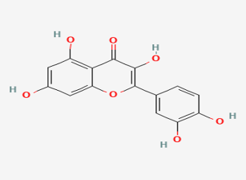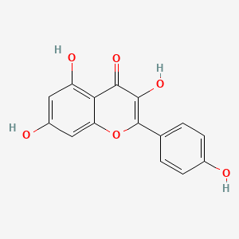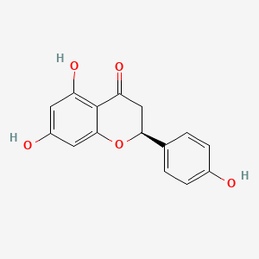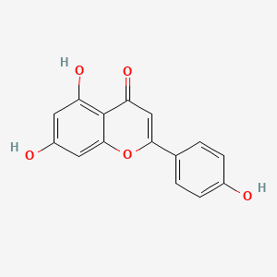
Quercetin Kaempferol Naringenin Apigenin

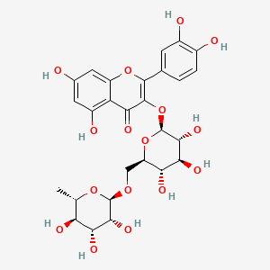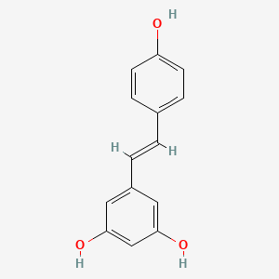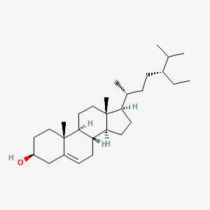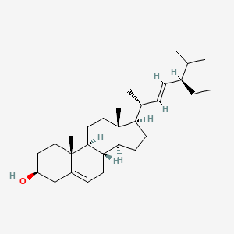
Rutin Resveratrol Beta sitosterol Stigmasterol

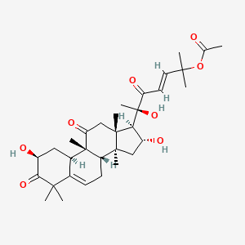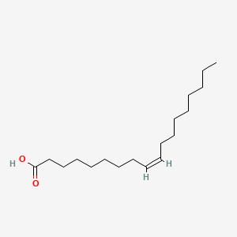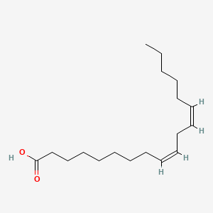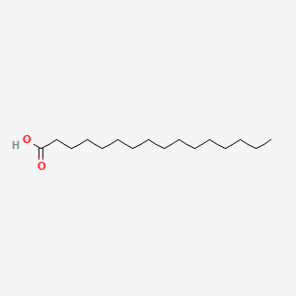
Cucurbitacin B Oleic acid Linoleic acid Palmittic acid

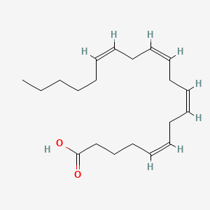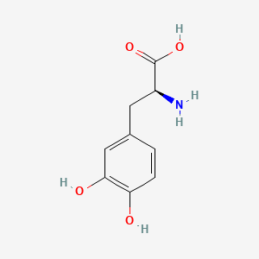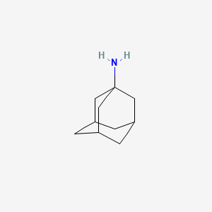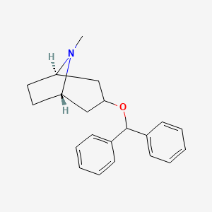
Arachidonic acid Levodopa Amantadin Benztropin
Figure 1. Chemical structure of ligands
Table 1. Displays the canonical SMILES (Simplified molecular input line entry specification) of ligands along with PubChem CID and Molecular formula
ligand | SMILES | PubChem CID | Molecular formula
Quercetin | C1=CC(=C(C=C1C2=C(C(=O)C3=C(C=C(C=C3O2)O)O)O)O)O | 5280343 | C₁₅H₁₀O₇
Kaempferol | C1=CC(=CC=C1C2=C(C(=O)C3=C(C=C(C=C3O2)O)O)O)O | 5280863 | C₁₅H₁₀O₆
Naringenin | C1[C@H](OC2=CC(=CC(=C2C1=O)O)O)C3=CC=C(C=C3)O | 439246 | C₁₅H₁₂O₅
Apigenin | C1=CC(=CC=C1C2=CC(=O)C3=C(C=C(C=C3O2)O)O)O | 5280443 | C₁₅H₁₀O₅
Rutin | C[C@H]1[C@@H]([C@H]([C@H]([C@@H](O1)OC[C@@H]2[C@H]([C@@H]([C@H]([C@@H](O2)OC3=C(OC4=CC(=CC(=C4C3=O)O)O)C5=CC(=C(C=C5)O)O)O)O)O)O)O)O | 5280805 | C₂₇H₃₀O₁₆
Resveratrol | C1=CC(=CC=C1/C=C/C2=CC(=CC(=C2)O)O)O | 445154 | C₁₄H₁₂O₃
Beta-Sitosterol | CC[C@H](CC[C@@H](C)[C@H]1CC[C@@H]2[C@@]1(CC[C@H]3[C@H]2CC=C4[C@@]3(CC[C@@H](C4)O)C)C)C(C)C | 222284 | C₂₉H₅₀O
Stigmasterol | CC[C@H](/C=C/[C@@H](C)[C@H]1CC[C@@H]2[C@@]1(CC[C@H]3[C@H]2CC=C4[C@@]3(CC[C@@H](C4)O)C)C)C(C)C | 5280794 | C₂₉H₄₈O
Cucurbitacin B | CC(=O)OC(C)(C)/C=C/C(=O)[C@@](C)([C@H]1[C@@H](C[C@@]2([C@@]1(CC(=O)[C@@]3([C@H]2CC=C4[C@H]3C[C@@H](C(=O)C4(C)C)O)C)C)C)O)O | 5281316 | C₃₂H₄₆O₈
Linoleic Acid | CCCCC/C=C\C/C=C\CCCCCCCC(=O)O | 5280450 | C₁₈H₃₂O₂
Oleic Acid | CCCCCCCC/C=C\CCCCCCCC(=O)O | 445639 | C₁₈H₃₄O₂
Palmitic Acid | CCCCCCCCCCCCCCCC(=O)O | 985 | C₁₆H₃₂O₂
Arachidonic Acid | CCCCC/C=C\C/C=C\C/C=C\C/C=C\CCCC(=O)O | 444899 | C₂₀H₃₂O₂
Levodopa | C1=CC(=C(C=C1C[C@@H](C(=O)O)N)O)O | 6047 | C₉H₁₁NO₄
Amantadine | C1C2CC3CC1CC(C2)(C3)N | 2130 | C₁₀H₁₇N
Benztropine | CN1[C@@H]2CC[C@H]1CC(C2)OC(C3=CC=CC=C3)C4=CC=CC=C4 | 1201549 | C₂₁H₂₅NO

3.2 Protein structure Preparation: The three-dimensional structures of the targeted receptor proteins associated with lipid metabolism were obtained from protein data bank. In this study 3 selected molecular targets related to Parkinson’s Disease, explained below
3.2.1 Dopamine D2 receptor: The most frequently employed drug for treatment of Parkinson’s disease is Dopaminergic agents, also known as synthethic dopamine (i.e, Levodopa ). These drugs mostly increases the Dopamin levels , converting to dopamine. The protein, PDB ID 6CM4 (with the resolution of 2.87Å) was downloaded from protein data bank. This protein is mutation free.

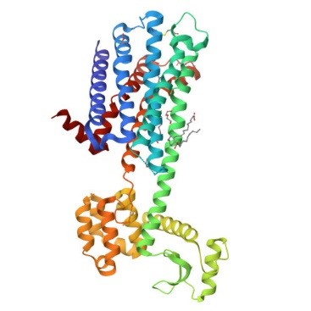
Figure 2. 3D structure of Dopamine receptor

3.2.2. Muscarinic acetylcholine receptor : Benztropine is an anticholinergic medication that acts as a muscarinic acetylcholine receptor antagonist. It's primarily used to Treat Parkinson's disease symptoms, Benztropine helps manage tremors, rigidity, and bradykinesia. By blocking muscarinic acetylcholine receptor. PDB ID- 6WJC (with the resolution of 2.55Å) was retrieved. This protein is mutation free.
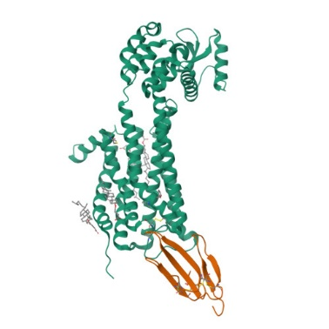
Figure 3 : 3D structure of of muscarinic acetylcholine receptor
3.2.3 . NMDA Receptor : Amantadine is indeed a synthetic drug that acts as an NMDA receptor antagonist. It's used in Parkinson's disease treatment, Amantadine can help manage symptoms like dyskinesia and motor fluctuations, act as Neuroprotective. Amantadine's mechanism involves blocking NMDA receptors, which can modulate glutamate activity and influence various physiological processes. PDB ID- 5EWJ (with the resolution of 2.57Å) was retrieved . This protein can mutant.

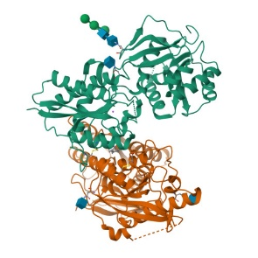
Figure 4:3D structure of NMDA receptor

3.3 Molecular Docking
3.3.1. Docking Analysis of dopamine receptor : Docking simulation of active compounds from Coccinia indica against 6CM4 receptor shows that quercetin has the highest binding affinity of (-9.8 kcal/mole) which is not similar to standard drug Levodopa and palmitic acid shows the lowest binding affinity with a docking score of (-5.4 kcal/mole). Furthermore apigenin (-5.4kcal /mole), kaempferol (-7.9 kcal/mole), naringenin (-9.1kcal / mole), rutin (-8.9 kcal/mole), resveratrol (-8.8 kcal / mole), oleic acid (-5.9 kcal / mole), linoleic acid (-5.6 kcal/mole), arachidonic acid (-7.5 kcal/mole).

Table 2 : Represents docking interaction of 6CM4 protein with active compounds of coccinia indica and synthetic ligands
Ligands | Binding affinity | Interaction with amino acids
Quercetin | -9.8 | SER-193, SER-197, ASP-114, TYR- 416, PHE-389, CYS-118, TRP-386, PHE-390
Kaempferol | -7.9 | THR-412, LEU-94, GLU-95
Naringenin | -9.1 | ASP-114,CYS-118, HIS-393, PHE-390, PHE-389, TRP-386
Apigenin | -9.5 | SER-197,CYS-118,ASP-114, TRP-386, SER-193, PHE-390, PHE-389, TYR-416
Rutin | -8.9 | TYR-408,GLU-95,ASP-114, SER-409, THR-412, HIS-393 LEU-94
Resveratrol | -8.8 | SER-197, CYS-118, PHE-198, PHE-389, PHE-390, PHE-189,TRP-386
Beta sitosterol | -9.4 | TYR-408, HIS-393, PHE-189, ILE-184, VAL-115, PHE-389,TRP-386
Stigmasterol | -9.7 | TYR-408, PHE-389, PHE-189
Cucurbitacin B | -8.8 | TRP-100, TYR-408, ILE-184, THR-412, SER-409
Linoleic acid | -5.6 | TYR-408,PHE-389, TRP-413,TRP-100
Oleic acid | -5.9 | PHE-390, PHE-389, TYR-408, PHE-382, TRP-386, CYS-118, HIS-393, ILE-184, PHE-198, PHE-189
Palmitic acid | -5.4 | ASP- 114 ,VAL-115,TRP-100, LEU-94, VAL-91, PHE-189, ILE-184, TYR-408, PHE-110, PHE-389
Arachidonic acid | -7.5 | VAL-91, CYS-118, TRP-386, TRP-100, TRP-413, PHE-198, PHE-382, VAL-115, PHE-389,PHE-390
Levodopa | -5.4 | TYR-213, LEU-216,ALA-376

Table 3: 3D and 2D structure of the two higher binding affinities of active constituents and binding ligand on Dopamine Receptor
Structures | Chemical constituents | Chemical constituents | Standard
 | Quercetin | Stigmasterol | Levodopa
3D | 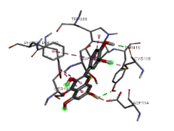 | 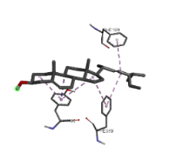 | 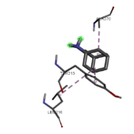
2D | 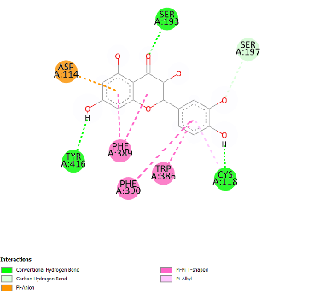 | 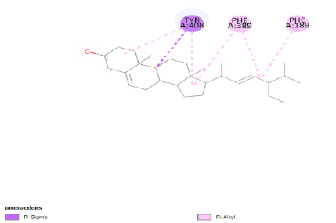 | 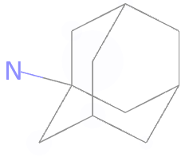

3.3.2 Docking analysis of muscarinic acetylcholine receptor : Docking simulation of active compounds from Coccinia indica against receptor shows that rutin( -8.5 ) has the highest binding affinity which is not similar to standard drug Benztropin and Oleic acid shows the lowest binding affinity with a docking score of (-4.2 kcal/mole). Furthermore apigenin (-7.1 kcal /mole), kaempferol (-7.3 kcal/mole), naringenin (-6.7 kcal / mole), quercetin (-6.9 kcal/mole), resveratrol (-6.0 kcal / mole), palmitic acid (-5.9 kcal / mole), linoleic acid (-5.1 kcal/mole), arachidonic acid (-5.2 kcal/mole).

Table 4 : Represents docking interaction of 6WJC protein with active compounds of coccinia indica and synthetic ligands
Ligands | Binding affinity | Interaction with amino acids
Quercetin | -6.9 | ASP-1019, THR-1025, GLU-1010, LEU-1031
Kaempferol | -7.3 | GLY-89,TYR-36,PRO-33, TYR-85, GLN-177, ARG-52, ARG-34, GLU-397
Naringenin | -6.7 | GLU-1010, TYR-1017
Apigenin | -7.1 | ASP -53,ARG-52,GLN-177,TYR-85
Rutin | -8.5 | GLY-89,ARG-52, TYR- 51, TYR-36, LEU-86, GLU-397, PRO-22, ARG-34, PRO-33,
Resveratrol | -6.0 | ARG-137, ALA-142, ARG-141, TYR-133, LYS-136,ASP-122, THR-138, MET-145
Beta sitosterol | -7.5 | ALA-195,TRP-157,TRP-164, PHE-182, ALA-195, LFU- 156
Stigmasterol | -8.3 | ALA-143.TRP-150, ILE-146, LEU-65
Cucurbitacin b | -7.5 | GLN-29
Linoleic acid | -5.1 | LYS-136,TYR-133,PHE-125 , PHE-121
Oleic acid | -4.2 | ASP-1019, ALA-1072, LEU-1031, PHE-1103
Palmittic acid | -4.4 | MET-145, LYS-136,PHE-125, ARG-141, THR-138,
Arachidonic acid | -5.2 | VAL-203,VAL-152,MET-114, ALA-149, LEU-117, PHE-121, LEU-118, LEU-148
Benztropin | -7.1 | VAL-203, MET-114, ALA-149, LEU-117, PHE-121, LEU-118,

Table 5 : 3D and 2D structure of the two higher binding affinities of active constituents and binding ligand on Muscarinic acetylcholine Receptor
Structures | Chemical constituents | Chemical constituents | Standard
 | Rutin | Stigmasterol | Benztropin
3D | 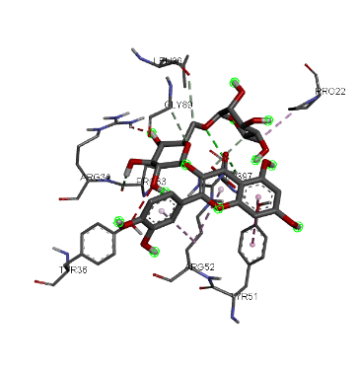 | 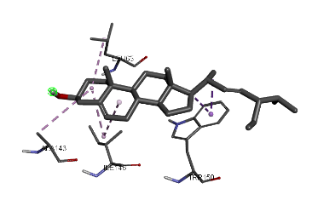 | 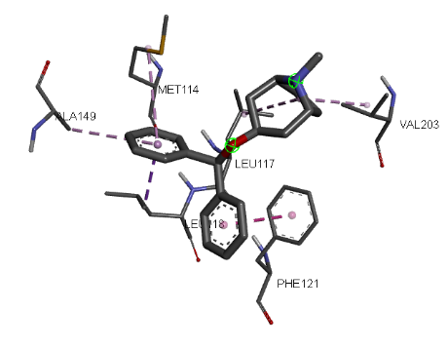
2D | 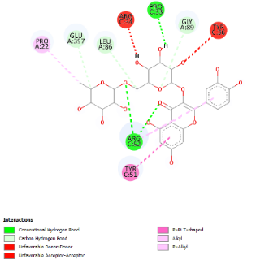 | 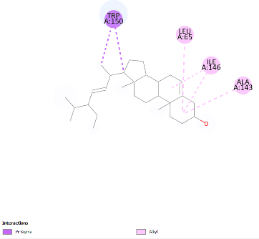 | 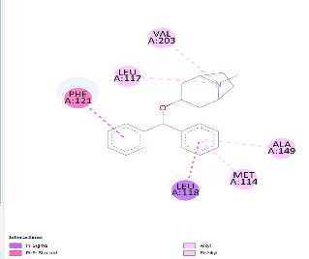

3.3.3. Docking analysis of NMDA receptor : Docking simulation of active compounds from Coccinia indica against receptor shows that apigenin (9.1), quercetin (9.0) has the highest binding affinity which is not similar to standard drug palmitic acid and Oleic acid shows the lowest binding affinity with a docking score of (-4.4 kcal/mole). Furthermore cucurbitacin b ( -8.9 ), kaempferol (-7.2 kcal/mole), naringenin (-7.8 kcal / mole), stigmasterol ( -8.9 ) , resveratrol (-8.7 kcal / mole), amantadine (-5.3 kcal / mole), linoleic acid (-5.1 kcal/mole), arachidonic acid (-5.6 kcal/mole).

Table 6 : Represents docking interaction of 5EWJ protein with active compounds of coccinia indica and synthetic ligands
Ligands | Binding affinity | Interaction with amino acids
Quercetin | -9.0 | THR - 333, GLU- 106, ILE-335, MET – 207
kaempferol | -7.2 | LEU-324,PHE-312
naringenin | -7.8 | GLN-400, GLY -326
apigenin | -9.1 | ASN -336, PHE-143, SER-141, ASP-138, LYS -137
Rutin | -8.6 | VAL-328
Reserveratrol | -8.7 | ASP-474, LYS -403
Beta sitosterol | -7.0 | ASN-448
Stigmasterol | -8.9 | TYR-401
Cucurbitacin B | -8.9 | ILE-472, ASP-472
Linoleic acid | -5.1 | VAL-329
Oleic acid | -4.4 | ASN-448, LYS-325
Palmittic acid | -4.4 | ARG-399, GLN-400
Arachidonic acid | -5.6 | LYS-325
Amantadin | -5.3 | TYR-401, ALA-322,

Table 7: 3D and 2D structure of the two higher binding affinities of active constituents and binding ligand on NMDA Receptor
Structures | Chemical constituents | Chemical constituents | Standard
 | Apigenin | Quercetin | Amantadin
3D | 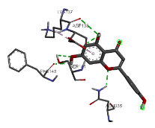 | 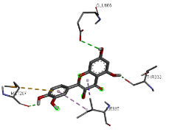 | 
2D | 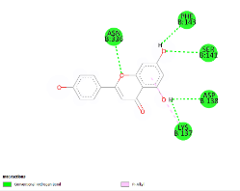 | 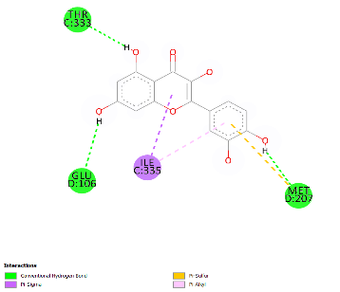

3.4. Lipophilicity:
Lipophilicity is measured by using a combined set of Log P values, that is average of all Log P values and also known consensus Log P. For iLOGP, stigmasterol (5.05 ) revealed as most lipophilic whereasRUTIN (0.46) as least lipophilic.
For XLOGP3, BETA SITOSTEROL (9.34) observed highest followed by rutin (-0.33), showed lowest value.
In case of WLOGP, beta sitosterol (8.02 ) showed higher value while standard drug ( 0.05 ), lowest value or MLOGP, beta sitosterol (6.73) observed highest value followed by kaempferol (-0.03) showed lower value.
For SILCOS-IT, beta sitosterol (7.04 ) showed higher value while levodopa (-0.0 7 ) showed lower value.
Table 8: Lipophilicity Ligand characteristics LOGP of proposed XLOGP3 chemical WLOGP constituents in MLOGP relation with the synthetic ligand
Ligand | iLOGP | XLOGP | WLOGP | MLOGP | SILICOS-IT | Consensus  Log P
Quercetin | 1.63 | 1.54 | 1.99 | -0.56 | 1.54 | 1.23
Kaempferol | 1.70 | 1.90 | 2.28 | -0.03 | 2.03 | 1.58
Naringenin | 1,75 | 2.52 | 2.19 | 0.71 | 2.05 | 1.89
Apigenin | 1.89 | 3.02 | 2.58 | 0.52 | 2.52 | 2.11
Rutin | 0.46 | -0.33 | -1.69 | -3.89 | -2.11 | -1.51
Resveratrol | 1.71 | 3,13 | 2.76 | 2.26 | 2.57 | 2.48
Beta sitosterol | 5.05 | 9.34 | 8.02 | 6.73 | 7.04 | 7.24
Stigmasterol | 5.08 | 8.56 | 7.80 | 6.62 | 6.86 | 6.98
Cucurbitacin B | 3.77 | 2.64 | 3.50 | 1.76 | 4.50 | 3.23
Linoleic acid | - | - | 5.88 | -0.7 | - | -
Oleic acid | 4.01 | 7.64 | 6.11 | 4.57 | 5.95 | 5.65
Palmittic acid | 3.85 | 7.17 | 5.55 | 4.19 | 5.25 | 5.20
Arachidonic acid | - | - | 6.22 | - | - | -
Levodopa | 0.72 | -2.74 | 0.05 | -2.26 | -0.07 | -0.86
Benztropin | 3.53 | 4.48 | 3.71 | 3.69 | 3.84 | 3.85
Amantadin | 2.18 | 2.44 | 1.91 | 2.45 | 1.91 | 2.18

3.5 Solubility:
According to ESOL model and Ali et al. all the 13 phytochemicals predicted as soluble compounds viz. quercetin, apigenin, kaempferol, naringenin, rutin, resveratrol, oleic acid, linoleic acid, palmitic acid, arachidonic acid, beta, sitosterol, cucurbitacin B. stigmasterol .
According to SILICOS-IT 3- quercetin, apigenin, kaempferol, naringenin, rutin, resveratrol, predicted as soluble and remaining showed moderate water solubility and only beta sitosterol showed poor solubility. Comparing the solubility results of chemical constituents with the synthetic drug, all compound exhibits superior performance, as indicated by Table-
Table 9: . solubility Ligand characteristics according to ESOL , Ali, SILICOS II, relation with the synthetic ligand
Ligands |  | ESOL |  |  |  | Ali |  |  |  | SILICOS-IT
 | Log s | Solubility |  | class | Logs | solubility |  | Class | Log S | Solubility |  | class
 |  | mg/ml | mol/L |  |  | mg/ml | mol/L |  |  | mg/ml | mol/L
Quercetin | -3.16 | 2.11e-01 | 6.98e-04 | s | -3.91 | 3.74e-02 | 1.24e-04 | s | -3.24 | 1.73e-01 | 5.73e-04 | s
Kaempferol | -3.31 | 1.40e-01 | 4.90e-04 | S | -3.86 | 3.98e-02 | 1.39e-04 | S | -3.82 | 4.29e-02 | 1.50e-04 | S
Naringenin | -3.94 | 8.74e-02 | 3.21e04 | S | -3.99 | 2.77e-02 | 1.02e-04 | S | -3.42 | 1.04e-01 | 3.82e-04 | S
Apigenin | -3.94 | 3.07e-02 | 1.14e-04 | s | -4.59 | 6.88e-03 | 2.55e-05 | s | -4.40 | 1.07e-02 | 3.94e-05 | MS
Rutin | -3.30 | 3.08e-01 | 5.05e-04 | S | -4.87 | 8.30e-03 | 1.36e-05 | S | -0.29 | 3.15e+02 | 5.15e-01 | S
Resveratrol | -3.62 | 5.51e-02 | 2.41e-04 | S | -4.07 | 1.93e-02 | 8.44e-05 | MS | -3.29 | 1.18e-01 | 5.16e-04 | S
Beta sitosterol | -7.90 | 5.23e-06 | 1.26e-08 | PS | -9.67 | 8.90e-08 | 2.15e-10 | PS | -6.19 | 2.69e-04 | 6.49e-07 | PS
Stigmasterol | -7.46 | 1.43e-05 | 3.46e-08 | PS | -8.86 | 5.71e-07 | 1.38e-09 | PS | -5.47 | 1.40e-03 | 3.39e-06 | MS
Cucurbitacin B | -4.57 | 1.50e-02 | 2.68e-05 | MS | -5.19 | 3.58e-03 | 6.41e-06 | MS | -4.26 | 3.05e-02 | 5.46e-05 | MS
Linoleic acid | - | - | - | - | - | - | - | - | - | - | - | -
Oleic acid | -5.41 | 1.09e-03 | 3.85e-06 | MS | -8.26 | 1.54e-06 | 5.46-09 | PS | -5.39 | 1.14e-03 | 4.04e-06 | MS
Palmittic acid | -5.02 | 2.43e-03 | 9.49e-06 | MS | -7.77 | 4.31e-06 | 1.68e-08 | PS | -5.31 | 1.25e-03 | 4.88e-06 | MS
Arachidonic acid | - | - | - | - | - | - | - | - | - | - | - | -
Levodopa | 0.54 | 6.91e+02 | 3.50e+00 | HS | 1.11 | 2.56e+03 | 1.30e+01 | HS | -0.72 | 3.76e+01 | 1.91e-01 | S
Benztropin | -4.69 | 6.27e-03 | 2.04e-05 | MS | -4.46 | 1.O6e-02 | 3.45e-05 | MS | -5.66 | 6.74e-04 | 2.19e-06 | MS
Amantadin | -2.31 | 7.32e-01 | 4.84e--03 | S | -2.63 | 3.55e-01 | 2.35e-03 | S | -1.57 | 4.08e+00 | 2.70e-02 | S
Note : HS- Highly soluble, S – Soluble, MS – Moderately soluble, PS – Poorly soluble

3.6. In silico Pharmacokinetic Studies:
The overall in silico pharmacokinetics predictions. showed high level of Gl absorption for all the ligands except the stigmasterol, cucurbitacin b, rutin, sitosterol, arachidonic acid. The blood-brain permeability was observed for resveratrol, benztropine, palmitic acid.
Quercetin, apigenin, naringenin, kaempferol, linoleic acid oleic acid, and synthetic drug levodopa were observed negative permeability. In this study, it has been found that active chemical constituents are not impermeable with skin because of their higher negative log Kp value.
The phytoconstituents Quercetin, apigenin, naringenin, kaempferol, linoleic acid oleic acid, cucurbitacin b, stigmasterol, sitosterol, and synthetic drug levodopa did not show p-glycoprotein substrate activity.
Palmitic acid, resveratrol, and synthetic drug benztropine shows showed p-glycoprotein substrate activity .
For CYP2C19 all phytoconstituents showed non-inhibitors. in case of CYP2C9, all ligands showed non-inhibitors except the resveratrol, stigmasterol,oleic acid.
for CYP2D6 all ligands were showed non inhibitors except kaempferol, quercetin, apigenin, and marketed drug benztropine.
for CYP3A4 all ligands were observed non-inhibitors except quercetin,kaempferol, naringenin, apigenin, resveratrol, cucurbitacin b.
The estimated bioavailability disclose that all the chemical constituents have same bioavailability (ie. 0.55) except rutin (0.17) and arachidonic acid (0.17), palmitic acid (0.85) , oleic acid (0.85).

Table 10 : ADME analysis of thirteen selected ligands along with four selected
ligand | GI absorption | BBB Permeant | p-gp substrate | CYP1A2  inhibitor | CYP2C19 inhibitor | CYP2C9 inhibitor | CYP2D6 inhibitor | CYP3A4 inhibitor | log KP  (Skin permeation ) | Bioavailability
Quercetin | high | - | - | + | - | - | + | + | -7.05 cm/s | 0.55
kaempferol | high | - | - | + | - | - | + | + | -6.70 cm/s | 0.55
naringenin | high | - | + | + | - | - | - | + | -6.17 cm/s | 0.55
Apigenin | high | - | - | + | - | - | + | + | -5.80 cm/s | 0.55
Rutin | low | - | + | - | - | - | - | - | -10.26 cm/s | 0.17
Resveratrol | high | + | - | + | - | + | - | + | -5.47 cm/s | 0.55
Beta sitosterol | low | - | + | - | - | - | - | - | -2.20 cm/s | 0.55
Stigmasterol | Low | - | - | - | - | + | - | - | -2.74 cm/s | 0.55
Cucurbitacin b | Low | - | + | - | - | - | - | + | -7.83 cm/s | 0.55
Palmitic acid | High | + | - | + | - | + | - | - | -2.70 cm/s | 0.85
0leic acid | High | - | - | + | - | + | - | - | -2.60 cm/s | 0.85
Linoleic acid | - | - | - | - | - | - | - | - | - | -
Arachidonic acid | low | - | + | - | - | - | - | - | -10.26 cm/s | 0.17
Levodopa | high | - | - | - | - | - | - | - | -9.45 cm/s | 0.55
Benztropine | high | + | - | - | - | - | + | - | -4.99 cm/s | 0.55
Amantadin | high | + | - | - | - | - | - | - | -5.49 cm/s | 0.55
(Yes = + ),( no = -)
3.7 Drug-likeness of the ligands:
According to the Lipinski's rule of 5, an orally active drug cannot have more than one infraction of the following specifications.: MW ≤ 500 DA, H-bond acceptors 10. H-bond donors ≤ 5, and log P≤ 5. Additional significant variables were also estimated. including polar surface area (TPSA), molar refractivity and rotatable bonds. A compound should have a TPSA of less than 140A and less than 10 rotatable bonds. All the ligands have molecular weight less than 500 and less than 10 rotatable bonds. Drug molecules carrying a molecular weight of <500 are easier to transport and exhibit better absorption than those with a higher molecular weight.
Table 11 : The drug likeness of the phytoconstituents of Coccinia indica along with two synthetic ligands :
Ligand | Molecular weight | TPSA | Molar refractivity | Fraction csp3 | Rotable bonds | Num. of H- bond donars | Num. of H- bond acceptors
Quercetin | 302.24 | 131.36 | 78.03 | 0.00 | 1 | 5 | 7
Kaempferol | 286.24 | 111.13 | 76.01 | 0.00 | 1 | 4 | 6
Naringenin | 272.25 | 86.99 | 71.57 | 0.13 | 1 | 3 | 5
Apigenin | 270.24 | 90.90 | 73.99 |  | 1 | 3 | 5
Rutin | 610.52 | 269.43 | 141.38 | 0.44 | 6 | 10 | 16
Resveratrol | 228.24 | 60.69 | 67.88 | 0.00 | 2 | 3 | 3
Beta sitosterol | 414.71 | 20.23 | 133.23 | 0.93 | 6 | 1 | 1
Stigmasterol | 412.69 | 20.23 | 132.75 | 0.86 | 5 | 1 | 1
Cucurbitacin B | 558.70 | 138.20 | 150.94 | 0.75 | 6 | 3 | 8
Palmittic acid | 256.42 | 37.30 | 80.80 | 0.94 | 14 | 1 | 2
Oleic acid | 282.46 | 37.30 | 89.94 | 0.83 | 15 | 1 | 2
Linoleic acid | 280.45 | 37.30 | 89.46 | 0.72 | 14 | 1 | 2
Arachidonic acid | 304.47 | 37.30 | 98.13 | 0.00 | 14 | 1 | 2
Levodopa | 197.19 | 103.78 | 49.55 | 0.22 | 3 | 4 | 5
Benztropin | 307.43 | 12.47 | 98.02 | 0.43 | 4 | 0 | 2
Amantadin | 151.25 | 26.02 | 46.59 | 1.00 | 0 | 1 | 1

3.8 Prediction of Toxicity :
The toxicity was estimated on the basis of several targets that are connected to unfavourable drug-reactions. 3-koajmalicine, Akuammigine, Isomitraphylline, Kopteropodine, Isorhynchophylline, Mitraphylline. Rhynchophylline. Pteropodine, Speciophylline, Tetrahydroalstonine, and Uncarine Fhas claimed to be carcinogenic, 3-soajmalicine, Akuammigine and Tetrahydroalstonine, are found to have Immunotoxicity with a toxicity class of 3. All the phytoconstituents has shown negative Mutagenicity, Cytotoxicity and hepatotoxicity where Atorvastatin and Ezetimibe showed hepatotoxicity with LD50 of 5000 mg/kg and 1350 mg/kg, has class 5 and class 4 toxicity respectively. Table 14 displays the evaluated toxicity for all the igands.
Table 12 : Toxicity analysis of thirteen selected ligands along with two synthetic drug using Pro Tox II
Ligand | HT | NT (neuro toxicity) | NT(nephro) | RG | CT(cardio) | CT(carcino) | Mutagen | PPAR gamma | BBB | MMP | ER-LBD | CYP1A2 | CYP2C19 | CYP2C9 | NMDAR | GABAR | Nutritional toxicity | LD50 12  Mg/kg | TC 13
Quercetin | - | - | + | + | _- | + | + | - | + | + | + | + | + | + | - | - | ₊ | 159 | 3
kaempferol | - | - | + | + | - | - | - | - | + | + | + | + | + | + | - | - | + | 3519 | 5
naringenin | - | - | + | + | - | - | - | + | + | + | + | + | + | + | - | - | + | 2000 | 4
apigenin | - | - | + | + | - | - | - | + | - | + | - | + | + | + | - | - | - | 2500 | 5
rutin | - | - | + | + | - | - | - | - | - | - | - | - | - | - | - | - | + | 5000 | 5
Resveratrol | - | - | + | - | + | - | - | - | - | + | + | + | - | + | - | - | - | 1560 | 4
Beta sitosterol | - | + | - | + | - | - | - | - | + | - | - | - | - | - | - | - | + | 890 | 4
stigmasterol | - | + | - | + | - | - | - | - | + | - | - | - | - | + | - | - | + | 890 | 4
Cucurbitacin b | - | - | + | + | - | + | - | - | + | - | - | - | - | - | - | - | + | 14 | 2
Palmitic acid | - | - | - | - | - | - | - | - | + | - | - | - | - | - | - | - | - | 900 | 4
Linoleic acid | - | - | - | - | - | - | - | + | + | - | - | - | - | - | - | - | - | 10000 | 6
Oleic acid | - | - | - | - | - | - | - | + | + | - | - | - | - | - | - | - | - | 48 | 2
Arachidonic acid | - | - | - | - | - | - | - | + | + | - | - | - | - | - | - | - | - | 10000 | 6
Levodopa | - | - | + | + | - | - | + | - | - | - | - | - | - | - | - | - | - | 1460 | 4
Benztropin
Amantadin
Active= +, inactive = -
3. 9 DISCUSSION:
Modern drug discovery requires evaluating the efficacy of dynamic molecules and their ability to effectively reach the desired target site in a reactive state. This process involves conducting cellular. animal, and human clinical trials, which are both expensive and perhaps potentially hazardous. The estimation of a drug's pharmacokinetic properties i.e. absorption, distribution, metabolism, and excretion (ADME) is currently supported by computer-aided drug discovery; they provide fast, reliable, and predictive data and support experimental methods. In this work, we assessed the ADME and toxicity characteristics of the bioactive phytoconstituents that found in Coccinia Indica, using the Swiss ADME and Pro tox-II online tool. This programme is easily accessible and allows for simplified result analysis, even for those who are not experts in CADD. Using the Swiss ADME and Protox-II online tool, a total of 13 active phytoconstituents of were examined Coccinia Indica .To investigate various charecteristics like lipophilicity (Table 8), water solubility (Table 9), pharmacokinetic parameters (Table 10), drug likeness (Table 11) and toxicity study (Table 12) respectively. The possible interactions between the small active phytocompounds and proteins could lead to the creation of novel treatments for a wide range of pathologies. These concepts, supported by long experience of traditional wisdom and the use of indigenous resources to address health issues, are widely used in Ayurveda, Traditional Chinese Medicines, Yunani medicines as well as other indigenous centres which focus on local medicinal products. Therefore, based on its peculiar characteristics of exhibiting strong functional groups,. is a Coccinia Indica used in several medical treatments. The present study revealed a similar type of observation about the interaction with the 3 different target protein like (a) Dopamine receptor, (b) NMDA receptor, (c) muscarinic acetyl choline receptor by displaying a notable binding energy difference in comparison with the synthetic drug Levodopa, Benztropin, Amantadin which are the most commonly used anti parkinsons disease that inhibit on tremors, damage nerve cells and manage parkinsons symptomps.
According to this in silico investigation, the active phytochemicals derived from the formulation of Coccinia Indica, may have the ability to treatment the parkinson’s disease. However, to learn more about these phytochemicals' ability to reduce tremors, further laboratory studies are needed (i.e. in vitro as well as in vivo). With 6CM4 protein, as we found in the results.
The in silico docking study revealed that their higher binding affinity with 6CM4 receptor, the phytoconstituents of Coccinia Indica may be used to regulate and mitigate parkinson’s disease. In the docking study it has been revealed that quercetin showed the highest binding affinity and also shared three common amino acid residues with the synthetic drug Levodopa (). The virtual screening's findings are consistent with the hypothesis that the active chemical compounds may bind to the same enzyme target as standard drug. Overall, these results suggest that the phytoconstituents in. Coccinia Indica may be able to treatment the parkinsons disease.
4. CONCLUSION :
The present study successfully demonstrates the potential of phytochemicals present in Coccinia indica (ivy gourd) as promising therapeutic agents against Parkinson’s disease through molecular docking analysis. The in silico docking results revealed that several bioactive compounds from coccinia indica exhibit significant binding affinities toward key Parkinson;s -related targets, such dopaminergic neuron, and muscarinic acetylcholine receptor, indicating their potential roles in tremors regulation, anti-parkinson’s activity, and inhibit neurodegenerative effects, respectively. Among the compounds analyzed, quercetin showed particularly strong interactions, suggesting their involvement in protective and healing mechanisms of the parkinson’s trearment. These findings support traditional claims of coccinia indica as a anti parkinson’s remedy and provide a scientific basis for its further development as a natural therapeutic alternative. Coccinia indica’ Future studies, including in vitro and in vivo validations, pharmacokinetic profiling, and toxicity assessments, are recommended to confirm the efficacy and safety of these phytochemicals. Overall, this research opens promising avenues for the development of plant-based anti-parkinson’s agents derived from coccinia indica ,
5. REFERENCES :
1.Environmental Risk Factors and Parkinson's Disease: A Metaanalysis. Anumeet Priyadarshi, Sadik A. Khuder, Eric A. Schaub,t and Snigdha S. Priyadarshit. Department of Public Health, Medical College of Ohio, Toledo, Ohio, and Department of Medicine, Medical College of Ohin, Toledo. https://doi.org/10.1006/enrs.2001.4264
2. Mutch WJ, Dingwall-Fordyce 1, Downie AW et al (1986) Parkinson's disease in a Scottish City, BMJ, 292, 534-536.https://doi.org/10.1136/bmj.292.6519.534
3. De Lau LML, Breteler MMB. Epidemiology of Parkinson's disease. Lancet Neurol. 2006;5(6):525-535.https://doi.org/10.1016/S1474-4422(06)70471-9
4. Van Den Eeden SK, Tanner CM, Bernstein AL, Fross RD, Leimpeter A, et al. 2003. Incidence of Parkinson's disease: variation by age, gender, and race/ethnicity. Am. J. Epidemiol. 157:1015-22. https://doi.org/10.1093/aje/kwg068
5. Stack E, Ashburn A. Fall events described by people with Parkinson's disease: implications for clinical interviewing and the research agenda. Physiotherapy Research International. 1999;4(3):190-200.https://doi.org/10.1002/pri.165
6. Caviness JN. Pathophysiology of Parkinson's disease behavior-a view from the network. Parkinsonism Relat Disord. 2014;20 Suppl 1:S39-43. https://doi.org/10.1016/S1353-8020(13)70012-9
7. Moore DJ , West AB , Dawson VL , Dawson TM . Molecular pathophysiology of Parkinson's disease.Annu Rev Neurosci . 2005; 28: 57-87. https://doi.org/10.1146/annurev.neuro.28.061604.135718
8. Calne DB. Treatment of Parkinson's disease. N Engl J Med. 1993;329(14):1021-7. https://doi.org/10.1056/NEJM199309303291408
9. Kondhare D , Lade H. Phytochemical profile , aldose reductase inhibitory , and antioxidant activities of Indian traditional medicinal Coccinia grandis ( L. ) fruit extract . 3 Biotech . 2017 ; 7 ( 6 ) : 378 .https://doi.org/10.1007/s13205-017-1013-1
10. Hussain A , Wahab S , Rizvi A , Hussain MS . Macroscopical , anatomical and physico - chemical studies on leaves of Coccinia indica Wight & Arn . , growing wildly in eastern Uttar Pradesh region of India . Indian J Nat Prod Resour . 2011 ; 2 ( 1 ) : 74-80 .
11. Prabhakar P , Mukherjee S , Kumar A Rout RK , Kumar S , Verma DK , Dhara S , Rao PS , Maiti MK , Banerjee M. In Silico In Vitro and Ex Vivo Evaluation of the Antihyperglycaemic , Antioxidant and Cytotoxic Properties of Coccinia grandis L. Leaf Extract . Food Technol Biotechnol 2024 62 ( 2 ) : 188-204.https://doi.org/10.17113/ftb.62.02.24.8162
12. Sharma A , Mazumdar B , Keshav A. Ultrasound assisted extraction of phytochemicals from Coccinia indica fruits and its characterization . J Food Meas Charact . 2021 ; 15 ( 1 ) : 466-477.https://doi.org/10.1007/s11694-020-00633-8
13. Kumari R , Agrawal A , Tiwari M , Shukla SH , Dubey GP . Role of Coccinia indica in the prevention and management of breast cancer : A review . J Ayu Herb Med . 2016 ; 2 ( 2 ) : 56-60 .
14. Gautam S , Meshram A , Srivastava N. A brief study on phytochemical compounds present in Coccinia cordifolia for their medicinal , pharmacological and industrial applications . World J Pharm Pharm Sci . 2014 ; 3 : 1995-2016

