Vitamins and Antinutrients in commonly Consumed Diets in North Central Region of Nigeria

ABSTRACT
Vitamins play important roles in scavenging free radicals or reactive oxidants, thereby protecting humans and animals against oxidative stress or DNA damage. Antinutrients are substances that antagonize good nutrition, either by causing toxicity leading to secondary nutritional deficiencies. The aim of this study was to determine the vitamins and antinutrient contents in commonly consumed diets within the North-central region of Nigeria. The region comprise of six states namely; Benue, Nasarawa, Kogi, Kwara, Plataeu, Niger and the Federal capital territory, Abuja. A survey was first conducted to obtain the commonly consumed foods within the region using structured questionnaire. From the outcomes of the questionnaire, the various food samples were collected from each state and analyzed for vitamin and antinutrient contents following standard laboratory methods. The findings revealed the presence of vitamins B1, B2, B3, B5, B6, B7, B9, B12, A, C, and E in the processed foods, including Beans Porridge, Jollof Rice, Pounded Yam with Fish Soup, Pounded Yam with Egusi, Roasted Yam with Red Oil, Okpa, Moi-moi, Yam Porridge, Tuwo Masara, Dried Okra, Cassava, and Kuli-kuli. It also showed the presence of vitamins B1, B2, B3, B5, B6, B7, B9, B12, A, C, and E. raw foods, including Ginger, Bambara Nut, Beans, Cassava, Corn Flour, Salt, Sugar, Egusi, Tomatoes, Pepper, Locust Beans, Yam, Rice, Seasoning Cubes, Fish, Crayfish, Dried Okra, Ugwu, Meat, Moringa, Onions, and Kuli-kuli. The results also showed the presence of anti-nutrients, including Oxalate, Phytate, HCN, Tannin, Saponins, and Phenol. Processed and raw foods, such as Beans Porridge, Jollof Rice, Pounded Yam with Fish Soup, Pounded Yam with Egusi, Roasted Yam with Red Oil, Okpa, Moi-moi, Yam Porridge, Tuwo Masara, Dried Okra, Cassava, and Kuli-kuli. These findings indicate that both raw and processed foods consumed within the region contain vitamins and antinutrients.
Keywords: Vitamins, Antinutrients, oxidative stress, processed foods raw foods.

1.0 INTRODUCTION
Vitamins with antioxidant activities namely; vitamins A, C and E are available in some plants abundantly. These vitamins play important roles in scavenging free radicals or reactive oxidants, thereby protecting humans and animals against oxidative stress or DNA damage (Ponnan et al.,2006). In addition to their importance in protecting the cell membranes from oxidative stress/damage caused by the free radicals, antioxidant vitamins promote many aspects of cellular and noncellular immunity (Damon, 2009). Their antioxidant function could, at least in part, promote immunity by maintaining the functional and structural integrity of the immune cells. Generally, the chemical constituents in plants are responsible for many aspects of their properties associated with nutrition, health, toxicity or safety, as well as stability to physical, chemical or microbial changes (Akubugwo et al., 2007).
Many chemical constituents occur naturally in plants that are non-nutritive but required by the plants for specific functions like resistance against pests, pathogens and herbivores, attraction of pollinators, or survival in adverse growing conditions (Panda et al., 2009). These compounds are called phytochemicals, and include alkaloids, flavonoids, glycosides, steroids, tannins, and phenol compounds. They are mostly secondary metabolites synthesized by the plants and deposited in specific or all their parts (Bishnu et al., 2009). Most of these phytochemicals however, have biological and pharmacological properties that provide therapeutic benefits to humans. Some phytochemicals either reduce the bioavailability of a nutrient or cause acceptability problems, these are known as antinutrients antinutritional factors (Panda et al., 2009). Antinutrients antagonize good nutrition, either by causing toxicity leading to secondary nutritional deficiencies. They are present in almost all foods at some levels, but their levels can be reduced in modern crops, probably due to domestication processes (Welch and Graham, 2004).
High-quality food composition data are needed and should be publicly available to users. Such data should be in a user-friendly format and covered user’s need with regards to food and component coverage. Many users of food composition databases and tables are not aware that food composition data can vary significantly either because of real differences in the nutrient content or because of artificial differences. Real differences in nutrient content of foods can arise due to environmental and processing influences, recipe formulation, cooking methods, biodiversity or differences among products from different producers. Artificial differences may be introduced to data due to dataquality, sampling, analytical methods, calculation methods or data expression (Charrondiere et al.,2013).

2.0 MATERIALS AND METHODS

2.1 Materials
2.1.1 Instrument/Equipment
Various instruments were used during the course of this research. They are as follows: Drying Oven, Muffle Furnace (Gallon Kamp, Model-S90 NC/NA), Desiccator (Gilson Inc, Model-MA-204), Crucibles, Kjeldahl Apparatus, Soxhlet Extractor (Heating Mantel, KDM-250), Weighing balance (OHAUS; Pioneer, PA214), Glucometer (Blood Glucose Meter), Atomic absorption spectroscopy (AAS), UV- Spectrophotometer (Jenway,7305 Spectrophotometer), Water Bath(Digital water bath DK-420,WOM), Centrifuge(80-1,Techrnel&Technel USA), Heating mantle , Test Strips, Lancet, Cotton wool and Glasswares
2.1.2 Chemicals/Reagents
All the chemicals and reagents used in the study were of analyrical grade and include; Sulfuric acid, Methyl red (indicator), Sodium Hydroxide, Petroleum ether, Boric acid, Nitric acid (HNO₃), Hydrochloric acid (HCl), Standard solutions of heavy metals (e.g., Pb, Cd, Cu, Ni, Co, Cr, Fe), Deionized water, Vitamin B1-Thiamine hydrochloric acid, metol solution, liquor Ammonia (AR grade),Chloroform (AR grade),Vitamin B2-stock solution Riboflavin, phosphate-Saline buffer, Methanol, Vitamin B5-Anhydrous sodium sulphate, sodium hydroxide, sulphuric acid, distilled water, pathenol standard, Pathenol standard stock solution, Mclivare buffer, Duquenous reagent, Acetate buffer, Ninhydrin, acetaladehyde, Vitamin B6-Pyridoxine hydrochloride standard solution, papsone, Sulfamilamide, sodium nutrient, sodium carbonate solution, Potassium iodate, Sulfuric Acid, cyclohexane spectrophotometric grade, Standard biotin, Vitamin B9-1,2-Nathoquinone-4-sulphonic acid,sodium salt, zinc dust, potassium hydrogen phthalate solution, buffer solution, Tri-sodium phosphate solution, lactate-Phosphate buffer solution, B12-Nitric acid, Concentration hydrochloric acid Nitroso-R-salt, cobaltrous Nitrate, sodium acetate trihydrate, Standard vitamin B12.

2.2 Methods

2.2.1 Experimental Design
This study employed experimental design to analyze the vitamins and antinutrient compositions in the sampled foods. For sample size determination, a stratified sampling technique was utilized, applying the Cochran formula, to determine sample sizes. The survey primarily focused on women aged 18 years and older, particularly mothers and caregivers, within each local government area of the state. In each region, approximately 200 to 250 questionnaires were randomly distributed to achieve a representative sample.

2.2.2 Data Collection Methods
Questionnaires were used for survey on the commonly consumed foods within the North-central region of Nigeria and the food materials were obtained from local markets to prepare foods as per traditional recipes. These questionnaires were developed and used for documenting the most commonly consumed foods, drinks and snacks, as well as their constituting ingredients and mode of preparations. The outcomes provided important background information on the food composition, dietary factors and nutritional status of a population.

2.3 Determination of Vitamins

2.3.1 Determination of Retinol (Vitamin A)
Vitamin A was determined by the AOAC (1990) method. Exactly 4 g of sample was weighed, and then 5 ml of 50% potassium hydroxide solution and 50 ml of ethyl alcohol were added and refluxed in a water condenser for 1 hr. The solution was then cooled and transferred to a 500 ml separator, to which 50 ml of hexane was added and shaken vigorously for 5 minutes resulting in the formation of two separate layers. The organic layer was passed through sodium sulphate anhydrous into a 200 ml volumetric flask while the aqueous layer was shaken 3 times by taking 30 ml hexane each time. All the organic layers were pooled together and diluted to 200 ml with the required amount of hexane. The absorbance in UV spectrophotometer at 325 nm was recorded.
Vitamin A = absorbance - intercept
Slope

2.3.2 Determination of Ascorbic Acid (vitamin C)
1 mg/ml of the sample was prepared by dissolving in acetone. The working standard (vitamin C) solutions (1.0, 0.8, 0.6, 0.4 and 0.2) was prepared by dissolving in acetone. The absorbance was taken at 265 nm.
Vitamin C = absorbance – intercept
Slope

2.3.3 Determination of Alpha Tocopherol (vitamin E)
The estimation of tocopherols was done according to (Ugwu et al., 2019). The extract 2.5 g was homogenized in a small volume of 0.1N sulphuric acid and the volume was finally made up to 50 ml by adding 0.1N sulphuric acid slowly, without shaking and the content was allowed to stand overnight. The content of the flask was shaken vigorously on the next day and filtered through Whatman No.1 filter paper. 1.5ml of the filtrate was pipette out into centrifuge and 1.5ml each of ethanol and xylene were added and centrifuged. After centrifugation, the xylene layer was transferred into another tube and 1.0 ml of 2,2′-dipyridyl reagent was added and the absorbance was taken in the spectrophotometer at 460 nm.
Vitamin E = absorbance - intercept
Slope
2.3.4 Determination of Vitamin B1 (Thiamine)
Reagents: (a) Thiamine HCl standard solution—Dissolve 100 mg accurately weighed thiamine HCl in 100 mL water in a volumetric flask. Dilute 10 mL of this solution to 100 mL with water. 0.25-2.0 mL portions of thiamine HCI standard solution was pipetted into a series of 10 mL graduated test tubes and to each was added 0.5 mL Metol solution and 1.0 mL liquor ammonia. Reagent blank was simultaneously prepared. The test tubes were frequently shaken for 7 min, each solution was diluted to 10 mL, and absorbance measure at 420 nm against reagent blank. Concentration in assay solution was determined from the standard curve using the same procedure detailed earlier.
2.3.5 Determination of Vitamin B2 (Riboflavin)
A stock solution of riboflavin was prepared by dissolving 0.0528 grams into one liter of distilled water making a concentration of 1.403 × 10−4 molar. This container was wrapped in aluminum foil to protect the riboflavin stock solution from light exposure. Stock solution of sodium borate buffer of 0.010 molar was prepared in distilled water at pH value of 7.52. A stock solution pH 7.36 utilizing phosphate-saline buffer (phosphate 6.6 millimolar and saline 0.154 molar) was prepared for evaluation of an absorbance spectrum at 440nm. In the case of tablets or capsules, (1) the tablet was weighed, (2) then ground in mortar and pestle, (3) the dry amount of solid to be dissolved in volumetric flasks was weighed again (a separate aliquot of ground powder can be captured for other assays and the amount of the vitamin pill preparation that was dissolved for riboflavin assay was thus known), (4) the desired amount of solid is carefully placed in volumetric container and dissolved in distilled water, (5) further use requires the filtering out of insoluble solids through Whatman #1 filter paper, and (6) the filtered liquid is ready for assay or further dilution in the desired buffer. In all cases of test specimens to be assayed in this study, the material was dissolved in a known volume of pH 7.52 borate buffer (all assays were carried out at pH 7.52).
2.3.6 Determination of Vitamin B3 (Niacin)
General procedure: Serial volumes of 0.02, 0.06 to 0.56 mL were transferred in 0.04 step of the standard niacin (0.001 g/mL) solution equivalent to ranges of concentration (5.0-130 µg/ mL) into different test tubes. 0.2 mL of buffer 8 was added into the set up and 2 mL of methanol was added. Equal volumes of 2,3-Dichloro-5,6-dicyano-1,4-benzoquinone (98 % purity) (DDQ) (0.001 g/mL) solution was added in methanol according to the stoichiometric ratio of the drug and reagent. The content was mixed and allowed to stand for 70 min at 60 °C before analysis at 464 nm against a methanol blank.
2.3.5 Determination of Vitamin B5
500 mg of panthenol was dissolved in 5 ml of distilled water. 2 ml of 0.5 N sodium hydroxide and 30 ml of distilled water were added. The solution was placed on a boiling water bath for 1 h then neutralized to pH 7 with 2 ml of 0.5 N sulphuric acid and completed to 50 ml with distilled water. 10 ml of the solution was diluted with distilled water to 100 ml. 3. Standard panthenol stock solution (10 µg/ml) for fluorimetry: dissolve 5 mg of panthenol in few ml of distilled water and determined spectrometrically.
2.3.7 Determination of Vitamin B6 (Pyridoxine)
Reagents: (a) Pyridoxine hydrochloride standard solution. 25 mg accurately of PyHCl was dissolved in 100 mL water in volumetric flask, with shaking. (b) Dapsone and sulfanilamide working solutions. (1) Dapsone.—Dissolve 100 mg dapsone in 100mL95% ethanol. (2) Sulfanilamide.—Dissolve 100 mg sulfanilamide in 20 mL 95% ethanol, and dilute solution to 100 mL with water. (c) Acid mixture. —15% trichloroacetic acid-H₂SO₄-water (86 + 20 + 94). (d) Sodium nitrite solution. 0.1 % aqueous. (e) Sodium carbonate solution. 4.0% aqueous.
2.3.8 Determination of Vitamin B7 (Biotin)
A sample of the preparation, equivalent was weighed and added to approximately 10 mg. of biotin, into a 50-ml. glass-stoppered centrifuge tube. Add 3.0 ml. of 1% potassium iodate reagent, mix well, then add 2.0 ml. of 30% sulfuric acid reagent. Pipet 20.0 ml. of cyclohexane into the tube and place the tube and contents into a 60ºc water bath, adjusting the water level in the bath to coincide with the aqueous phase in the centrifuge tube. Stopper each tube loosely in order to permit pressure release. Allow the centrifuge tube to remain in the bath for 30-40 min, then remove and immerse in an ice bath for several minutes. Shake the tube vigorously for 5 min, allow the contents to settle, and centrifuge at moderate speed for 5 min. quantitatively transfer the cyclohexane layer into a 100-ml. volumetric flask. The biotin present in the preparation was calculated from the equation:
Biotin (mg/g) = Ap x Cs
As x sample weight (g)
2.3.9 Determination of Vitamin B9 (Folic Acid)
For iron tablets folic acid, 50ml of the prepared filtrate was reduced as described in the SOP. 20 ml of the reduced solution was incubated for colour development, so that the final concentration of folic acid was within the experimental range. The concentration was determined from the formula;
Calculations
The amount of folic acid (mg) in the sample taken = At x S x D
As
Where At is the average absorbance of the test solution,
As, the average absorbance of the standard solution,
S the amount of folic acid (mg) present in 1 ml of standard solution, and
D the dilution factor.
2.3.10 Determination of vitamins B12
Nitric acid was obtained from Merck, Germany as were the conc. Hydrochloric acid, Nitroso•
Rosalt and cobaltous Nitrate. sodium acetate trinyorate was ourchased from BOH. Us. Standardvitamin B12 (88%) was obtained from bAST, Germany.

2.4 Determination of Anti-Nutrients

2.4.1 Determination of Hydrogen Cyanide
This was determined according to the method of El-Olemyl, (1994). A quantity, 1 g of the extract was macerated with 50 ml of distilled water and filter. The filtrate (1 ml) was pipette inside the test tube. The alkaline picrate solution (4 ml) was boil for 5 min and was cool at room temperature. Measure the absorbance at 490 nm.
$$Hydrogen Cyanide \left(HCN\right)=\frac{absorbance of sample - intercept}{slope}$$

2.4.2 Determination of Phytates
This analysis measures the amount of phytate within a given sample which involves the decoloration of a ferric – sulfosalicylic acid complex as the phytate in the sample replaces the sulfosalicylic acid according to Darambazar, (2018). 0.5 g of the extract and 0.5 g of NaCl were placed into separate test tubes. 10 mL of 2.4% (0.64N) HCl was added to the test tube containing the sample and vortex vigorously for 10 s to mix. The test tube was placed on a platform shaker at 300 rpm for 16 h (overnight) at room temperature. The tube was centrifuged at 3000 rpm for 20 min. The supernatant was filtered through Whatman No. 1 filter paper into the tube with the previously weighed NaCl. Mixture is mixed thoroughly on vortex for the salt to dissolve on a shaker at 300 rpm for 20 min and allow to settle the sample at 4°C for 60 min. 1 mL of supernatant was taken into 25 mL volumetric flask and dilute to the level with deionized water and place 3 mL of the diluted sample and combine with 1 mL of Wade Reagent and the absorbance of colour reaction was taken in a spectrophotometer at 500 nm.
$$Phytate =\frac{absorbance - intercept}{Slope}$$

2.4.3 Determination of Oxalates
Sample extraction for OA determination using UV-Vis Spectrophotometer method 1 g dried sample was weighed and boil in 150 ml water containing 27.5 ml 6 M HCl plus 2 drops of octanol for 25 min in beaker. The mixture was cooled, transferred to a 250 ml volumetric flask and made up to mark. The mixture was then filtered through Whatman 1 filter paper. A volume of 10 ml of this filtrate was evaporated at 40-45ºC in a vacuum oven and re-dissolved in 10 ml of 0.01 M H₂SO₄. Then 0.5 mM K₂Cr₂O₇ and 0.25 mM MnCl₂ was prepared in 250 ml volumetric flask; this solution was the background (blank) solution during OA standard solution. 1 ml from each extracted sample and 9 ml from the blank solution, a total of 10 ml was taken for each sample and incubated for 60 min. Finally, the total OA in the sample was analyzed using a UV–Vis Spectrophotometer at 590 nm
Calibration curve of change in absorbance against standard concentrations of OA was constructed using 0.01, 0.25, 0.5, 1 and 2 mM.

2.4.4 Determination of Tannins
Determination of total tannin content was evaluated for total phenolic content by using Folin-Ciocalteu’s reagent (Rajeev et al., 2012). Plant extract (10 mg) was dissolved in 10 ml distilled water to make final concentration of 1 mg/1 ml. Different aliquots of garlic acid (0.5, 0.4, 0.3, 0.2 and 0.1 mg) were dissolved in 1 ml of distilled water to make the final concentrations 100, 80, 60, 40 and 20 μg/ml. After preparing 3.5% v/v sodium carbonate solution, 0.1 ml garlic acid solution of every concentration (100-20 mg/l) was taken into different volumetric flask. Then 7.5 ml of distilled water and 0.5 ml FC reagent were added to it. After 5 min, 1 ml 3.5% sodium carbonate solution and 10 ml distilled water were added to that flask. After 30 min, UV absorbance was determined at 725 nm. Total tannin content of the extract was measured using garlic acid standard calibration curve and stated as mg garlic acid equivalent, GAE/100 g of dried plant extract.

2.4.5 Determination of Saponins
Saponin was determine according to Sim, (2011). Standard saponin solution was prepared by dissolving 10 mg of diosgenin and add (16 ml) methanol and distilled water (4 ml). To the aliquots for each tube, vanillin reagent (8%, 0.25 ml) was added and sulphuric acid (72% v/v, 2.5 ml) added slowly on the inner side of the wall. The solutions were mixed well and the tubes were transferred to a 60 ⁰C water bath. After 10 mins incubation, the tubes were cooled in ice cold water bath for 3 – 4 min. The absorbance was measured at 544 nm against the reagent blank. 0.1 g of freeze dried sample was dissolved in aqueous methanol (80%, 0.1 ml). 0.25 ml of aliquot was taken for spectrophotometric determination for total saponins at 544 nm.

2.4.6 Determination of Phenols
The total phenolic content was determined according to the method described by Maurya and Singh (2010). This is basically a colour reaction that produces a blue colour which is measured spectrophotometrically. Folin Ciocalteu Reagent was used to evaluate the amount of total phenolic content and garlic acid was used as standard expressed as mg/g garlic acid equivalent (GAE). The concentration of 0.01, 0.02, 0.03, 0.04, and 0.05 mg/ml were prepared in methanol. The concentration of 1 mg/ml of plant extract was prepared in methanol and 0.5ml of the sample was placed in a test tube, and it was mixed with 2.5ml of 10-fold diluted Folin Ciocalteu Reagent. The mixture was added to 2ml of 7.5% of sodium carbonate. The tubes were allowed to stand for 30 minutes covered with parafilm at room temperature before taking the absorbance at 760 nm. Reading was taken in triplicates.

2.5 Statistical Analysiss
Statistical analysis was performed using SPSS version 25 (statistical packages for social sciences). The food samples were gotten using frequency analysis of food gotten via questionnaires and Google forms. The data expressed as mean ± standard deviation, were analyzed by frequency distribution and one-way analysis of variance (ANOVA) using Statistical packages for social sciences (SPSS) version 25.0 software and p < 0.05 was taken to be significant.
3.0 RESULTS AND DISCUSSION
3.1 Results
3.1.1 Vitamin content of processed, locally sourced foods consumed in the North Central states of Nigeria
The results presented in Figure 1 illustrate the vitamin content of processed, locally sourced foods consumed in the North Central states of Nigeria. The analysis of various food items from this region reveals significant findings regarding the levels of vitamins B1, B2, B3, B5, B6, B7, B9, B12, A, C, and E. This figure highlights a diverse selection of processed foods, including Beans Porridge, Jollof Rice, Pounded Yam with Fish Soup, Pounded Yam with Egusi, Roasted Yam with Red Oil, Okpa, Moi-moi, Yam Porridge, Tuwo Masara, Dried Okra, Cassava, and Kuli-kuli.

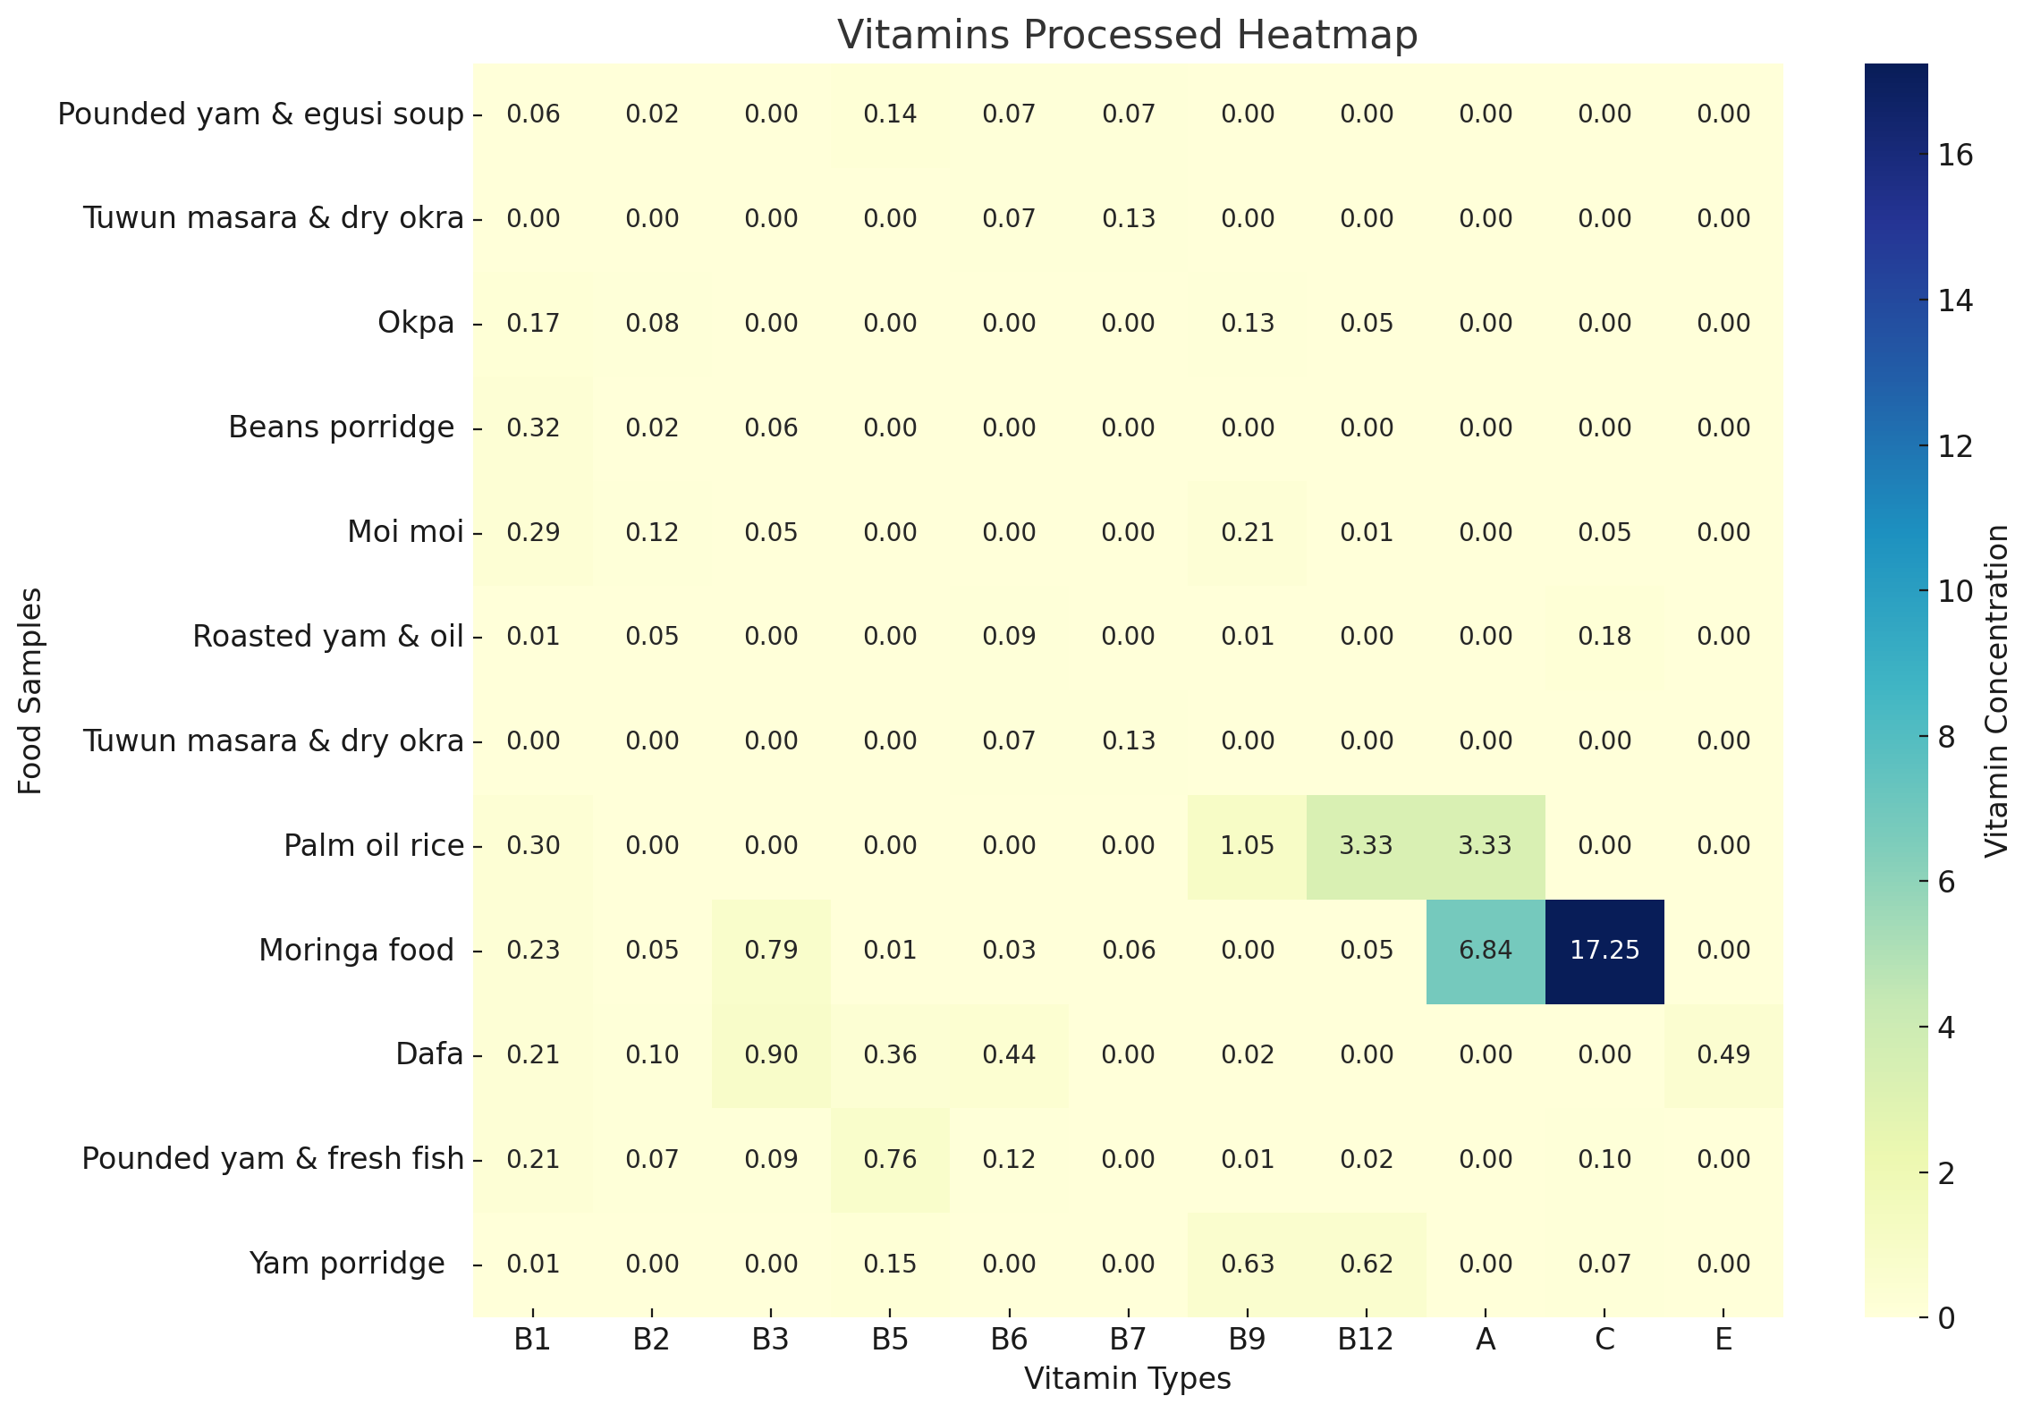
Figure 1. Vitamin constituent for processed locally sourced food consumed in the north central states, Nigeria

3.1.2 Vitamin constituent for raw locally sourced food consumed in the north central states, Nigeria
The results presented in Figure 2 illustrate the vitamin content of raw, locally sourced foods consumed in the North Central states of Nigeria. The analysis of various food items from this region reveals significant findings regarding the levels of vitamins B1, B2, B3, B5, B6, B7, B9, B12, A, C, and E. This figure highlights a diverse array of raw foods, including Ginger, Bambara Nut, Beans, Cassava, Corn Flour, Salt, Sugar, Egusi, Tomatoes, Pepper, Locust Beans, Yam, Rice, Seasoning Cubes, Fish, Crayfish, Dried Okra, Ugwu, Meat, Moringa, Onions, and Kuli-kuli.

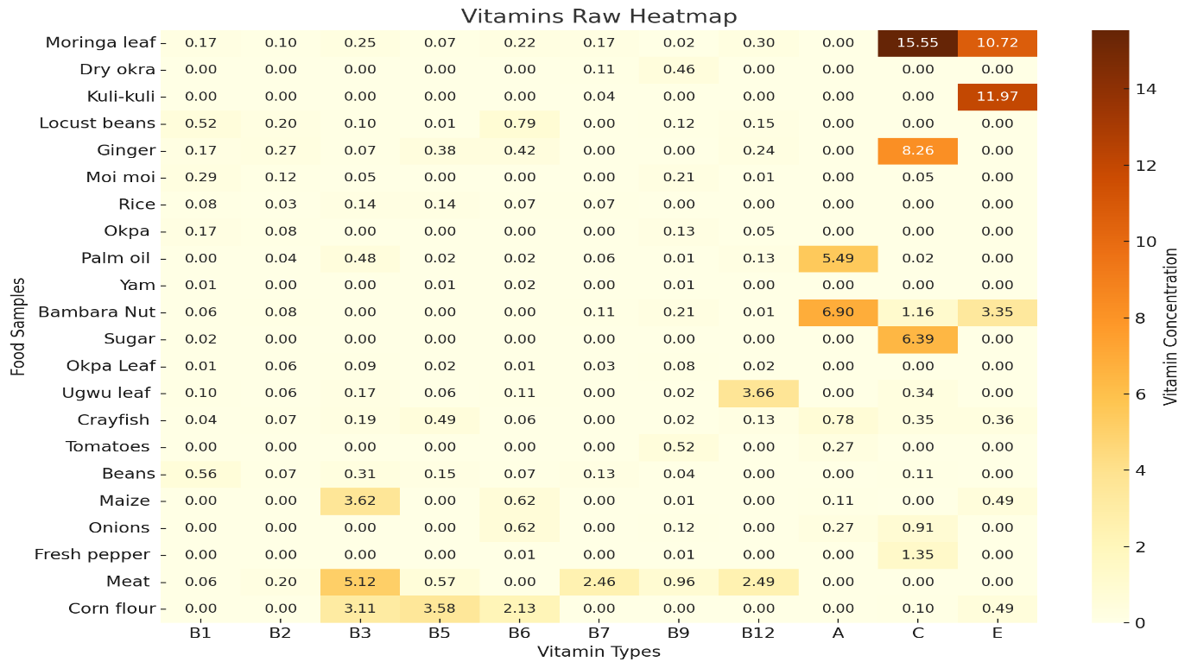
Figure 2. Vitamin constituent for raw locally sourced food consumed in the north central states, Nigeria.

3.1.3 Ant-nutrient constituent for processed locally sourced food consumed in the north central states, Nigeria.
The results presented in Figure 3 illustrate the anti-nutrient content of processed, locally sourced foods consumed in the North Central states of Nigeria. The analysis of various food items from this region reveals significant findings regarding the levels of anti-nutrients, including Oxalate, Phytate, HCN, Tannin, Saponins, and Phenol. This figure highlights a diverse selection of processed foods, such as Beans Porridge, Jollof Rice, Pounded Yam with Fish Soup, Pounded Yam with Egusi, Roasted Yam with Red Oil, Okpa, Moi-moi, Yam Porridge, Tuwo Masara, Dried Okra, Cassava, and Kuli-kuli..
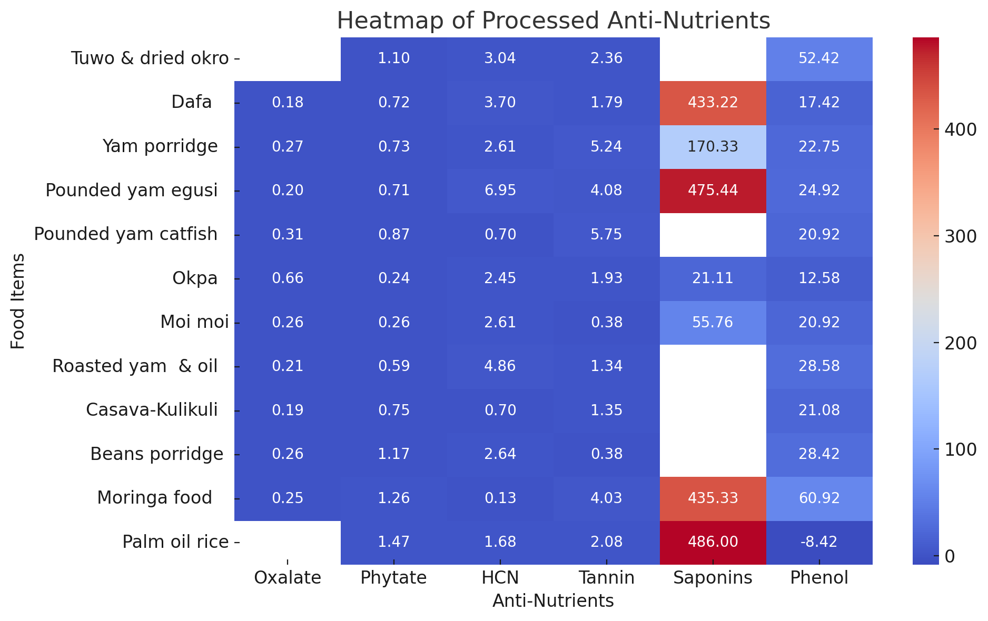
Figure 3. Ant-nutrient constituent for processed locally sourced food consumed in the north central states, Nigeria.

3.1.4 Ant-nutrient constituent for raw made foods and ingredients consumed in the north central states, Nigeria
The results presented in Figure 4 illustrate the anti-nutrient content of raw foods and ingredients consumed in the North Central states of Nigeria. The analysis of various food items from this region reveals significant findings regarding the levels of anti-nutrients, including Oxalate, Phytate, HCN, Tannin, Saponins, and Phenol. This figure highlights a diverse selection of raw foods, such as Ginger, Bambara Nut, Beans, Cassava, Corn Flour, Salt, Sugar, Egusi, Tomatoes, Pepper, Locust Beans, Yam, Rice, Seasoning Cubes, Fish, Crayfish, Dried Okra, Ugwu, Meat, Moringa, Onions, and Kuli-kuli.
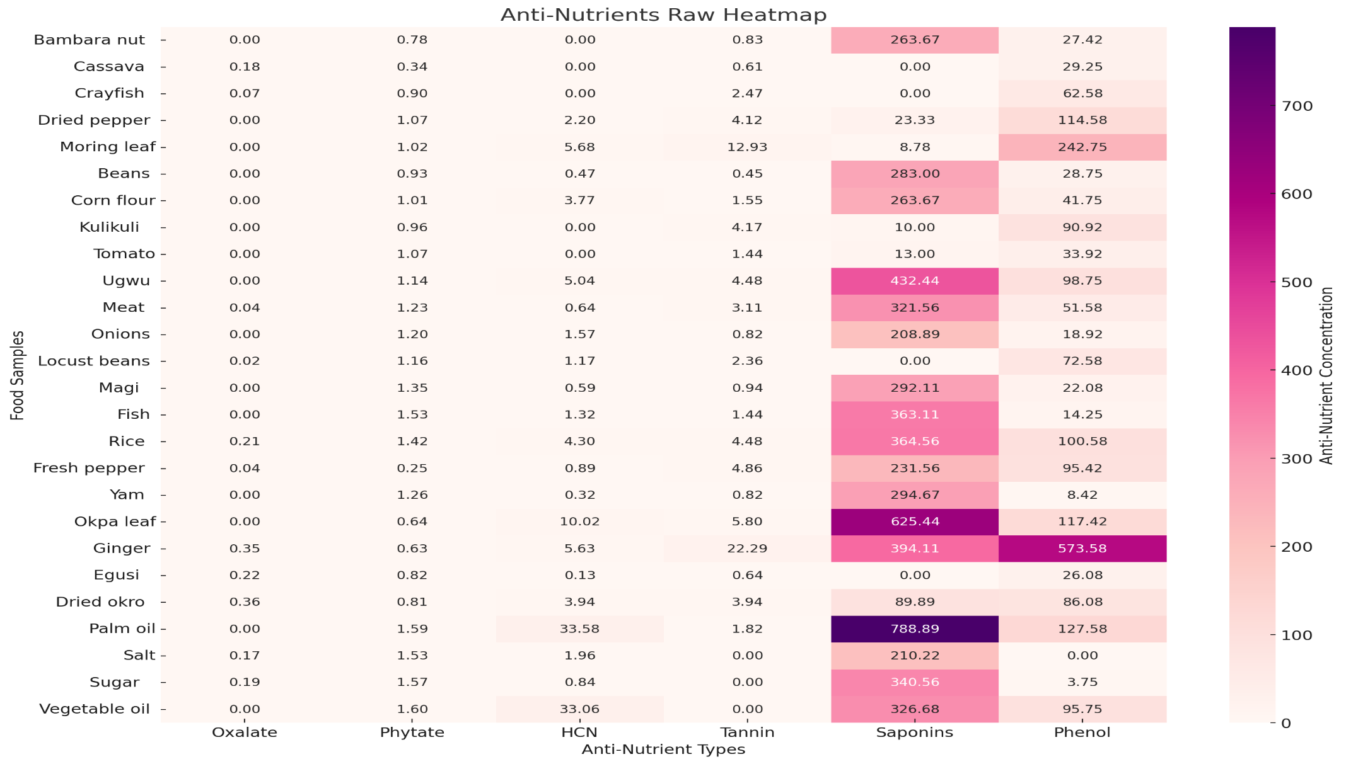
Figure 4. Ant-nutrient constituent for raw made foods and ingredients consumed in the north central states, Nigeria.

3.2 Discussion
The analysis of various traditional food items from North-Central Nigeria revealed significant differences in vitamins and anti-nutrient contents in the processed and raw foods. Thiamine is crucial for carbohydrate metabolism and energy production, acting as a coenzyme in the conversion of pyruvate to acetyl-CoA, which is vital for the Krebs cycle (Mallat et al., 2016). The higher levels of thiamine in processed foods like Beans Porridge and Moi Moi suggest their potential to support energy metabolism effectively. Conversely, the low levels of thiamine in staples like Roasted Yam may lead to deficiencies, such as beriberi, particularly in populations that rely heavily on these foods. Similarly, riboflavin plays a critical role in energy production and the metabolism of fats, drugs, and steroids. The presence of riboflavin in processed foods like Moi Moi and Okpa indicates that these dishes can contribute positively to dietary intake (Office of Dietary Supplements., 2022). However, the undetectable levels in many raw foods emphasize the need for a varied diet to ensure adequate intake of essential vitamins. Research by (Ukom et al., 2023) reinforces these findings, highlighting the impact of cooking methods on nutrient retention and the necessity for dietary diversity to prevent deficiencies.
The analysis reveals significant differences in the niacin (Vitamin B3) and pantothenic acid (Vitamin B5) content between processed and raw foods. This disparity highlights the importance of dietary diversity and the potential nutritional benefits of incorporating both processed and raw foods into the diet. Niacin is essential for energy metabolism, serving as a precursor to nicotinamide adenine dinucleotide (NAD) and nicotinamide adenine dinucleotide phosphate (NADP), which are critical coenzymes in various metabolic pathways, including glycolysis and the Krebs cycle. The presence of niacin in foods like Moringa and Dafa suggests that these dishes can effectively support energy production and overall metabolic health. Conversely, the absence of niacin in many staple foods may pose a risk for individuals who rely heavily on these items, potentially leading to deficiencies that manifest as fatigue, digestive issues, and skin problems. This is particularly concerning in populations that may not have access to a variety of food sources, as niacin deficiency can lead to conditions such as pellagra, characterized by dermatitis, diarrhea, and dementia (Freese & Lysne, 2023).
Pantothenic acid is vital for numerous biochemical processes, including the synthesis of coenzyme A, which is essential for fatty acid metabolism and steroid hormone synthesis (Sanvictores & Chauhan, 2024). The presence of B5 in foods like Pounded Yam & Fresh Fish and Dafa indicates their contribution to dietary intake, while the undetectable levels in many other foods highlight a potential gap in nutrient intake.
The data reveals significant differences in the levels of Vitamins B6 (pyridoxine) and B7 (biotin) between processed and raw foods. This disparity highlights the importance of dietary diversity and the potential nutritional benefits of incorporating both processed and raw foods into the diet. Vitamin B6 plays a crucial role in amino acid metabolism, neurotransmitter synthesis, and hemoglobin production. It is also involved in converting tryptophan to serotonin, a neurotransmitter that regulates mood. The presence of B6 in foods like Dafa and Pounded Yam & Fresh Fish suggests that these dishes can effectively support metabolic functions and overall health. Conversely, the absence of B6 in many staple foods may pose a risk for individuals who rely heavily on these items, potentially leading to deficiencies that manifest as irritability, depression, and anemia. This is particularly concerning for populations that may not have access to a variety of food sources, as Vitamin B6 deficiency can lead to significant health issues (Parra et al., 2018).
Vitamin B7, or biotin, is essential for fatty acid synthesis, amino acid metabolism, and gluconeogenesis. It acts as a coenzyme for carboxylase enzymes, which are critical for various metabolic pathways. The presence of biotin in Tuwun Masara & Dry Okra indicates that this dish can contribute positively to dietary intake. However, the undetectable levels of B7 in many other foods highlight a potential gap in the dietary intake of this essential nutrient, which could affect metabolic functions and overall health. For instance, while Moringa Leaf and Ginger provide some B6 and B7, many other raw foods, such as Tomatoes and Sugar, lack these vitamins entirely.
The results indicate significant differences in the levels of folate (Vitamin B9) and cobalamin (Vitamin B12) between processed and raw foods. This disparity underscores the importance of dietary diversity and the potential nutritional benefits of incorporating both processed and raw foods into the diet. Folate is essential for DNA synthesis, repair, and methylation, as well as for red blood cell production. The presence of folate in foods like Palm Oil Rice and Yam Porridge suggests that these dishes can effectively support cellular functions and overall health. Conversely, the absence of B9 in many staple foods may pose a risk for individuals who rely heavily on these items, potentially leading to deficiencies that can result in anemia, neural tube defects in developing fetuses, and other health issues. This is particularly concerning for populations that may not have access to a variety of food sources, as folate deficiency can have serious implications for maternal and child health (Fenech, 2012).
Vitamin B12 is crucial for neurological function, DNA synthesis, and red blood cell formation. It is primarily found in animal products, which may explain the low levels detected in many plant-based foods in this analysis. The presence of B12 in Okpa and Moi Moi, albeit at low levels, indicates that these dishes can contribute to dietary intake. However, the undetectable levels of B12 in many other foods highlight a potential gap in the dietary intake of this essential nutrient, which could lead to deficiencies characterized by fatigue, weakness, and neurological issues. This is particularly relevant for individuals following vegetarian or plant-based diets, as they may be at a higher risk for B12 deficiency (Fenech, 2012).
The results indicate a significant disparity in Vitamin A content between processed foods and raw ingredients. The presence of Vitamin A in some of the foods analyzed. Conversely, the absence of Vitamin A in many staple foods may pose a risk for individuals who rely heavily on these items, potentially leading to deficiencies that can result in vision problems and increased susceptibility to infections. This is particularly concerning for populations that may not have access to a variety of food sources, as Vitamin A deficiency can lead to serious health issues, including night blindness and a weakened immune response (Huang et al., 2018).
The analysis reveals significant differences in Vitamin C content between processed foods and raw ingredients. This disparity highlights the importance of dietary diversity and the potential nutritional benefits of incorporating both processed foods and raw ingredients into the diet. Vitamin C is essential for several physiological functions, including collagen synthesis, antioxidant protection, and immune function (Carr & Maggini, 2017). As a powerful antioxidant, it helps protect cells from oxidative stress and is vital for the health and integrity of skin, blood vessels, and connective tissues. The high levels of Vitamin C in Moringa Food suggest that this dish can effectively support these critical functions, making it a valuable addition to the diet. Moringa leaves are known for their nutrient density, and their high Vitamin C content can significantly contribute to daily nutritional requirements. Conversely, the absence of Vitamin C in many staple foods may lead to deficiencies that can result in symptoms such as scurvy, characterized by fatigue and impaired wound healing (Chambial et al., 2013).
The analysis reveals a significant disparity in Vitamin E content between processed foods and raw ingredients. Ingredients such as Moringa Leaf (10.72 mg), Kuli-kuli (11.97 mg), and Bambara Nut (3.35 mg) provide significant amounts of this essential nutrient. Vitamin E is a crucial fat-soluble antioxidant that protects cell membranes from oxidative damage and plays a vital role in immune function and skin health. The high levels of Vitamin E found in Moringa Leaf and Kuli-kuli suggest that these foods can effectively contribute to the dietary intake of this important vitamin. Vitamin E deficiency can result in neurological problems and weakened immune function, which are particularly concerning for vulnerable populations, including children and the elderly (Rizvi et al., 2014).
Anti-nutrients like oxalate, phytate, HCN, tannin, saponins, and phenol provides valuable information about the risks associated with some foods. The analysis of oxalate content in various food samples, both processed and raw, reveals significant biochemical implications for dietary health, particularly concerning mineral absorption and kidney health. Among the processed foods tested, Okpa exhibits the highest oxalate concentration at 0.66 ± 0.01 mg/g. This level is notably elevated compared to other samples and raises concerns regarding its potential impact on calcium bioavailability. Oxalate is known to bind with calcium in the gastrointestinal tract, forming insoluble calcium oxalate complexes that can hinder the absorption of this essential mineral (Holmes & Kennedy, 2000). The high oxalate content in Okpa suggests that regular consumption could lead to calcium deficiencies, particularly in populations that rely heavily on this food as a staple. In comparison, the raw ingredients such as Cassava (0.18 ± 0.00 mg/g) and Rice (0.21 ± 0.07 mg/g) exhibit lower oxalate levels. These values are within a safer range for regular consumption, as foods with oxalate content below 0.2 mg/g are generally considered safe, while levels above 0.5 mg/g may warrant caution, particularly for individuals susceptible to kidney stones (Bayata, 2019; Kolawole & Obueh, 2013). The lower oxalate levels in these raw ingredients suggest that they may be better options for individuals concerned about oxalate intake, especially when consumed in their unprocessed forms.
High dietary oxalate is associated with an increased risk of kidney stone formation, particularly calcium oxalate stones, which are the most prevalent type of kidney stones (Holmes & Kennedy, 2000). The data indicates that individuals consuming high-oxalate foods like Okpa and Moi Moi (0.26 ± 0.05 mg/g) may be at a greater risk for developing kidney stones, especially if they have a predisposition to renal issues. In contrast, the raw ingredients listed, such as Ginger (0.35 ± 0.01 mg/g) and Dried Okro (0.36 ± 0.06 mg/g), while higher than some other raw foods, still present lower risks compared to processed foods like Okpa. The presence of oxalate in both processed and raw foods indicate a potential risk for reduced calcium absorption, which is particularly concerning in regions where dietary diversity is limited. According to the World Health Organization (Bayata, 2019), the recommended daily intake of calcium for adults is approximately 1000 mg, and diets high in oxalate can compromise the ability to meet this requirement.
The analysis of phytate content in various food samples, both processed and raw, reveals significant biochemical implications for nutrient absorption and overall dietary health. Among the processed foods tested, Palm Oil Rice exhibits the highest phytate concentration at 1.47 ± 0.01 mg/g. This elevated level of phytate is particularly concerning, as phytate is known to act as an anti-nutrient by binding to essential minerals such as iron, zinc, and calcium, thereby reducing their bioavailability (Kolawole & Obueh, 2013). The high phytate content in Palm Oil Rice suggests that regular consumption could hinder the absorption of these critical minerals, especially in populations that rely heavily on this dish as a staple. In comparison, several raw ingredients also show significant phytate levels. For instance, Fish has a phytate concentration of 1.53 ± 0.00 mg/g, while Rice (1.42 ± 0.00 mg/g) and Salt (1.53 ± 0.03 mg/g) also contain notable amounts. These raw ingredients, while providing essential nutrients, may similarly pose risks for mineral absorption due to their phytate content. The presence of phytate in both processed and raw foods indicates a potential risk for reduced mineral absorption, which is particularly concerning in regions where dietary diversity is limited. According to the World Health Organization (Norhaizan, & Nor Faizadatul Ain, 2009), adequate intake of minerals like iron and zinc is crucial for preventing deficiencies that can lead to anemia and impaired immune function.
Interestingly, some raw ingredients, such as Bambara Nut (0.78 ± 0.00 mg/g) and Cassava (0.34 ± 0.00 mg/g), exhibited lower phytate levels compared to processed foods. These lower levels suggest that they may be better options for individuals concerned about phytate intake, particularly when consumed in their unprocessed forms. Foods with phytate content below 0.5 mg/g are generally considered to be within a safe range for regular consumption, while levels above 1.0 mg/g may warrant caution, particularly for individuals at risk of mineral deficiencies (Norhaizan, & Nor Faizadatul Ain, 2009). The findings from this analysis suggest that while some of the tested raw ingredients fall within a moderate range, processed foods like Palm Oil Rice exceed this threshold, indicating a need for careful consumption. The biochemical implications of phytate consumption extend beyond mineral absorption. While phytate is often viewed negatively due to its anti-nutrient properties, it also possesses antioxidant properties and may have health benefits, such as reducing the risk of certain chronic diseases. This dual role of phytate complicates its classification as merely an anti-nutrient, as it can contribute positively to health when consumed as part of a balanced diet.
The analysis of hydrogen cyanide (HCN) content in various food samples reveals significant biochemical implications for dietary safety and health. Among the processed foods tested, Pounded Yam Egusi exhibits the highest concentration of HCN at 6.95 ± 1.44 mg/kg. This elevated level raises concerns regarding the potential toxicity associated with HCN, which is a well-known anti-nutrient that can interfere with cellular respiration and lead to cyanide poisoning if consumed in excessive amounts (Kolawole & Obueh, 2013). According to the Ndubuisi & Chidiebere, (2018), the acceptable daily intake of cyanide is approximately 0.5 mg/kg body weight, which means that individuals consuming high-HCN foods may exceed this limit, particularly if they have a low body weight or consume these foods in large quantities. This highlights the need for awareness regarding the HCN content in traditional diets and the potential health risks associated with excessive consumption.
The analysis of saponin content in various food samples reveals significant biochemical implications for health, particularly concerning their potential benefits and anti-nutritional effects. These elevated levels of saponins are noteworthy, as saponins are known for their ability to form complexes with cholesterol and other lipids, which can influence lipid metabolism and may have both beneficial and detrimental effects on health (Timilsen, et al., 2023). Saponins are often recognized for their potential health benefits, including cholesterol-lowering properties, immune system enhancement, and anti-cancer effects (Sharma et al., 2023). The high saponin content in Pounded Yam Egusi and Palm Oil Rice suggests that these foods may contribute positively to cardiovascular health and overall well-being when consumed as part of a balanced diet.
In terms of normal dietary ranges, saponin levels in foods can vary widely. Generally, foods with saponin content below 100 mg/g are considered to be within a safe range for regular consumption, while levels above 400 mg/g may warrant caution, particularly for individuals with sensitive digestive systems (Timilsen, et al., 2023). The findings from this analysis suggest that while some of the tested foods fall within a moderate range, Pounded Yam Egusi and Palm Oil Rice exceed this threshold, indicating a need for careful consumption, especially in populations with limited
The analysis of phenolic content in various food samples reveals significant biochemical implications for health, particularly concerning antioxidant properties and potential anti-nutritional effects. Among the foods tested, Moringa Food exhibits the highest concentration of phenols at 60.92 ± 5.01 mg/g. This elevated level is noteworthy, as phenolic compounds are known for their antioxidant properties, which can help combat oxidative stress and reduce the risk of chronic diseases such as cardiovascular disease and cancer (Islam, et al., 2021). The high phenol content in Moringa Food suggests that it may offer substantial health benefits when included in the diet. Moringa leaves, in particular, have been recognized for their rich nutrient profile and bioactive compounds, making them a valuable addition to dietary regimens aimed at improving health outcomes. The moderate phenolic content in these foods aligns with findings by Nardini (2022), who noted that certain traditional foods can serve as significant sources of antioxidants, thereby contributing to the overall health of populations that consume them regularly.
However, it is essential to consider the potential anti-nutritional effects of phenolic compounds. While they are beneficial in moderate amounts, excessive consumption of phenols can interfere with the absorption of certain minerals, such as iron and zinc, by forming complexes that inhibit their bioavailability (Reddy & Pierson, 1994). Generally, foods with phenol content below 20 mg/g are considered to be within a safe range for regular consumption, while levels above 50 mg/g may be associated with both beneficial and potentially adverse effects (Islam, et al., 2021).
3.3 Conclusion
This study which was aimed at determining the vitamin and anti-nutrient contents in commonly consumed foods within the North- central region of Nigeria revealed diverse and high vitamins and anti-nutrients contents in some of the processed and raw foods commonly consumed within the region.
References
Adepoju, O. T., & Etukumoh, A. U. (2014). Nutrient composition and suitability of four commonly used local complementary foods in Akwa Ibom State, Nigeria. African Journal of Food, Agriculture, Nutrition and Development, 14(6), 13925-13939. https://doi.org/10.18697/ajfand.67.13925
Akubugwo, I.E., Chinyere, G.C. and Ugbogu, A.E. (2007). Nutritional and Chemical value of Amaranthus hybridus leaves from Afikpo, Nigeria. African journal of Biotechnology. 6:2833-2839.
Bayata, A. (2019). Review on nutritional value of cassava for use as a staple food. Science Journal of Analytical Chemistry, 7(4), 83-91. http://doi.org/10.11648/j.sjac.20190704.12
Bishnu, J.U.; Sunil, L. and Anuja, S. (2009). Antimicrobial Property of different Medicinal Plants; Ocimum sanctum, Cinnamommum zeylanicum, xanthoxylim arimatum and Origanum masorana. Journal of Science, Engineering and Technology. 5:143-150.
Carr, A. C., & Maggini, S. (2017). Vitamin C and immune function. Nutrients, 9(11), 1211. https://doi.org/10.3390/nu9111211
Chambial, S., Dwivedi, S., Shukla, K. K., John, P. J., & Sharma, P. (2013). Vitamin C in disease prevention and cure: An overview. Indian Journal of Clinical Biochemistry, 28(4), 314–328. https://doi.org/10.1007/s12291-013-0375-3
Fenech, M. (2012). Folate (vitamin B9) and vitamin B12 and their function in the maintenance of nuclear and mitochondrial genome integrity. Mutation Research, 733(1), 21–33. https://doi.org/10.1016/j.mrfmmm.2011.11.003
Freese, R., & Lysne, V. (2023). Niacin – A scoping review for Nordic Nutrition Recommendations 2023. Food & Nutrition Research, 67. https://doi.org/10.29219/fnr.v67.10299
Holmes, R. P., & Kennedy, M. (2000). Estimation of the oxalate content of foods and daily oxalate intake. Kidney International, 57(4), 1662–1667. https://doi.org/10.1046/j.1523-1755.2000.05704.x
Huang, Z., Liu, Y., Qi, G., Brand, D., & Zheng, S. G. (2018). Role of vitamin A in the immune system. Journal of Clinical Medicine, 7(9), 258. https://doi.org/10.3390/jcm7090258
Kolawole, S. E., & Obueh, H. O. (2013). A study of the oxalate, phytate and cyanide contents of selected Nigerian foods and diet in Akwa Ibom and Cross River states of Nigeria. African Journal of Food Science and Technology, 4(4), 44-47. http://www.interesjournals.org/AJFST
Mallat, J., Lemyze, M., & Thevenin, D. (2016). Do not forget to give thiamine to your septic shock patient! Journal of Thoracic Disease, 8(5), 1006-1008. https://doi.org/10.21037/jtd.2016.04.32
Nardini, M. (2022). Phenolic compounds in food: Characterization and health benefits. Molecules, 27(3), 783. https://doi.org/10.3390/molecules27030783
Ndubuisi, N. D., & Chidiebere, A. C. U. (2018). Cyanide in cassava: A review. International Journal of Genomics and Data Mining, 2, 118. https://doi.org/10.29011/2577-0616.000118
Norhaizan, M. E., & Nor Faizadatul Ain, A. W. (2009). Determination of phytate, iron, zinc, calcium contents and their molar ratios in commonly consumed raw and prepared food in Malaysia. Malaysian Journal of Nutrition, 15(2), 213-222.
Office of Dietary Supplements. (2022). Riboflavin - Health professional fact sheet. National Institutes of Health. https://ods.od.nih.gov/factsheets/Riboflavin-HealthProfessional/
Panda, S.K., Thatoi, H.N. and Dutta, S.K. (2009). Antibacterial Activity and Phytochemical Screening of Leaf and Bark Extracts of Vitex negundo from Similipal Biosphere Reserve Orissa. J. Med Plant Res. 3(4): 294-300.
Parra, M., Stahl, S., & Hellmann, H. (2018). Vitamin B6 and its role in cell metabolism and physiology. Cells, 7(7), 84. https://doi.org/10.3390/cells7070084
Ponnan, A., Perumal, R., Sathiyavedu, T.S. and Arabandi, R. (2006). Antioxidant Activity Measured in Different Solvent Fractions Obtained from Mentha spicata Linn.: An Analysis by ABTS Decolorization Assay. Asia Pac J. Clin. Nutr. 119 – 124.
Rizvi, S., Raza, S. T., Ahmed, F., Ahmad, A., Abbas, S., & Mahdi, F. (2014). The role of vitamin E in human health and some diseases. Sultan Qaboos University Medical Journal, 14(2), e157–e165. https://doi.org/10.18295/squmj.2014.14.2.006
Sanvictores, T., & Chauhan, S. (2024). Vitamin B5 (pantothenic acid). In StatPearls. StatPearls Publishing. https://www.ncbi.nlm.nih.gov/books/NBK563233/
Sharma, K., Kaur, R., Kumar, S., Saini, R. K., Sharma, S., Pawde, S. V., & Kumar, V. (2023). Saponins: A concise review on food related aspects, applications and health implications. Food Chemistry Advances, 2, 100191. https://doi.org/10.1016/j.focha.2023.100191
Timilsena, Y. P., Phosanam, A., & Stockmann, R. (2023). Perspectives on saponins: Food functionality and applications. International Journal of Molecular Sciences, 24, 13538. https://doi.org/10.3390/ijms241713538
Ukom, A., Albert, M., Ojimelukwe, P., Ofa-Olua, B., & Nwanagba, L. (2023). Impact of cooking methods on the chemical and antioxidant composition of some indigenous
Welch, R.M. and Graham, R.D. (2004). Breeding for Micronutrients in Staple Food Crops from a Human Nutrition Perspective. J. Exp Bot. 55(396): 353 – 64.

