Authentication of Six Medicinal Plants Collected from Al-Madinah Al-Munawwarah- Saudi Arabia

Abstract
Accurate identification of herbal medical plants is highly necessary to ensure their safety and efficacy. This study aims to authenticate six medicinal plants belong to legume family (fabaceae). Pollen morphology marker is used as tool to authenticate the studied species a light microscope (LM) at magnifications ranging from 10x to 40x is used to analyze the detailed morphology. The studied species; C. plicatum, L. leucocephala, S. italic and T. apollinea possess monad pollen grains, typically suboblate to triangular convex. In contrast, P. dulce and V. flava exhibit polyad grains that is oblate and circular. The polar axis ranges from 19–22 µm in C. plicatum to 53.0–56.97 µm in L. leucocephala, while the equatorial diameter reaches up to 100 µm in P. dulce. These findings reinforce the critical role of palynological analysis in authentication medicinal plants. Moreover, this work contributes to filling a documented research gap by linking traditional medicinal knowledge with micro-morphological evidence.
Keywords: Authentication; pollen grain morphology; medicinal plants; palynology; Saudi Arabia.

1. Introduction
Plants are widely used in many indigenous systems of medicine for therapeutic purposes. Herbal medicine, also called botanical medicine or phytomedicine are generally cheaper, accessible or readily available and more culturally acceptable to many because of the belief that they cause less side effects than some synthetic drugs (Roopashree et al., 2022; Mensah et al., 2019; Abdel-Aziz et al.,2016; Chanda, 2014; Lynch and Berry, 2007; Pal and Shukla, 2003). According to WHO (2002) around 80% of the global population still relies on botanical drugs. Moreover, the increased demand for botanical products is met by an expanding industry (Seukep et al., 2025; Dzoyem et al., 2013; Mafimisebi et al., 2013; Sucher and Carles, 2008).
The use of medicinal plants for treatments of various ailments in Saudi Arabia is ancient and still available among the tribal and medicinal healers (Al-Robai et al., 2022; Qari et al., 2021; Ullah et al., 2020; Tounekti et al., 2019; Syed, 2017; Rahman et al., 2004 ). According to Dailah, (2022), In the Middle East, Saudi Arabia is regarded as the origin of herbal medicine. Its flora is considered the richest biodiversity areas in the Arabian Peninsula and comprises very important genetic resources of crop and medicinal plants (Rahman et al., 2004). The safe use of herbal medicines is critical issue and requires prior authentication of the raw herbal materials used to make them. Thus, the rapid and accurate identification of herbal medical plants is highly necessary to ensure their safety and efficacy (Ghadage et al., 2025; Indrayanto, 2022). Moreover, adulteration and use of spurious materials as substitutes have become a major concern for users and industry for reasons of safety and efficacy (Kshirsagar et al.,2017 Ganie et al., 2015; Techen et al., 2004).
The authentication methods for herbal products include macro- microscopy, spectroscopy, chromatography, chemometry, immunoassays, DNA fingerprinting etc. Pollen morphology is considered as a significant tool for modern taxonomist for identification plant species (Qayyum et al., 2025; Tripathi et al., 2025; Alotaibi et al., 2020; Ramzan et al., 2019; Fazal et al., 2013). Moreover, Pollen characters are useful in solving complicated problems of interrelationships between various taxa and assessment of their status in the classification, particularly with reference to the families, subfamilies, tribes, genera, species, and subspecies. Mature pollen grain size, exine sculpturing, and number of pores are the most distinctive features for plant species identification (Faegri and Iversen, 1975; Klimko et al., 2000).
This study aims to authenticate six medicinal plants belong to legume family (fabaceae). The study well offer valuable insights for identification of the selected medicinal plants and contribute to bridging traditional medicinal knowledge with microscopic plant analysis.

2. Materials and Methods
2.1. Plant Collection
Six medicinal plants; Cullen plicatum (C.plicatum), Leucaena leucocephala (L. leucocephala), Pithecellobium dulce( P.dulce), Senna italic(S. italica ), Tephrosia apollinea(T. apollinea), and Vachellia flava (V. flava) belonging to legume family were collected from various regions in Al-Madinah Al-Munawwarah ncluding Wadi Qanat, Wadi Al-Aqiq, Southern Wadi Malal, and Mountain Uhud between February and March 2025 .
Initial identification was carried out in the field and later confirmed using regional flora and botanical guides, including Flora of Saudi Arabia (Migahid, 1996 ) and the online database Plants of the World Online (https://powo.science.kew.org).

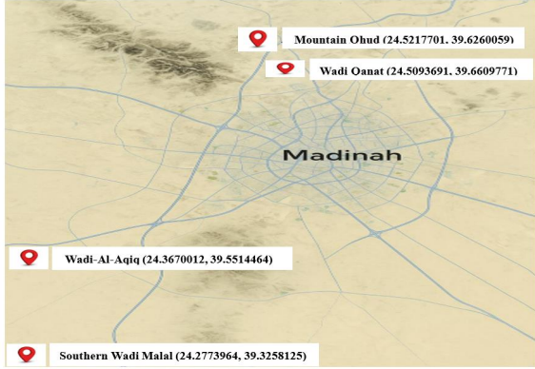
Figure 1. Geographical Coordinates of Plant Collection Sites in Al-Madinah AlMunawarah Based on Google Maps.
2.2. Herbarium Preparation
Plant specimens were preserved using a flower press kit, the Aboofx Wooden Flower Press, which features seven layers and measures 15.7 × 11.8 inches. This press ensures even pressure and efficient drying using multiple ventilated wooden boards. Once fully dried, the specimens were mounted on standard herbarium sheets and labeled with the following information: • Scientific name • Collection location • Date of collection • Habitat details Herbarium specimens of the six plant species were preserved in the Herbarium of the Department of Biology, College of Science, Taibah University, and labeled with the accession codes TUH001 to TUH006.
2.3. Pollen Sample Preparation
Pollen grains were isolated by removing anthers from mature floral buds and gently crushing them to release the pollen. The grains were then transferred to a slide, stained with diluted safranin (1:5 ratio of 1% safranin to distilled water), and covered with a cover slip for observation. The sample size consisted of five pollen slides prepared for each species.
2.4. Microscopic Examination
Prepared slides were observed under a light microscope (LM) at magnifications ranging from 10x to 40x to analyze the detailed morphology of the pollen grains. Observations focused on:
1. Pollen shape
2. Aperture type and number
3. Surface ornamentation Photomicrographs for documentation and interspecies comparison were captured using a compound light microscope (Novex, The Netherlands).
2.5. Measurement of Pollen Grains
Pollen grain dimensions were measured from calibrated photomicrographs using image analysis software ImageJ. Lines were drawn across specific polar and equatorial views to obtain measurements in micrometers using the Analyze > Measure tool. Multiple grains per species were measured to calculate average sizes. The results were saved for statistical analysis, and scale bars were optionally added to the images for publication purposes.
3. Results
3.1. The pollen grains morphology of the selected medicinal plants
Among the plants studied, C. plicatum, L. leucocephala, S. italic and T. apollinea possess monad pollen grains, typically suboblate to triangular convex. In contrast, P. dulce and V. flava exhibit polyad grains that is oblate and circular. These traits aid in identifying and classifying medicinal plants (see Table 2 and Figures 2-7).

Table 1: Scientific Names and Local Names with Growth Habitats, Chorotype, and Collection Sites of the selected medicinal plants.
Collection Site  and Date | Chorotype | Growth  Habit | Local Name | Medicinal Plant
Southern Wadi Malal, March 7, 2025 | Saharo-Arabian | Perennial, shrub or subshrub | Hama | Cullen plicatum
Wadi-Al-Aqiq, March 1, 2025. | Mesoamerican | Perennial, shrub or tree | Leucaena | Leucaena leucocephala
Mountain Ohud, February 12, 2025. | Neotropical | Perennial shrub or tree | Luz hendi | Pithecellobium dulce
Wadi-Al-Aqiq, March 1, 2025 | Afro-Asian | Perennial, subshrub | Eshrek | Senna italica
Mountain Ohud, February 12, 2025. | Afro-Tropical to South Asian | Perennial,subshrub | Teqtaq | Tephrosia apollinea
Southern Wadi Malal, March 7, 2025. | Saharo-Sindian | Perennial shrubs or tree | Salam | Vachellia flava

Table 2: Pollen Morphology of the selected medicinal plants .

Surface Ornamentation | Aperture Type and Number | Pollen Shape | Medicinal Plant
Coarsely reticulate | Tricolpate | Suboblate to triangular convex | Cullen plicatum
psilate to scabrate | Tricolpate | Subprolate | Leucaena leucocephala
Psilate | Colpate (no pores observed) | Oblate, circular | Pithecellobium dulce
Scabrate | Tricolpate | Subprolate to triangular convex | Senna italica
Reticulate | Tricolpate | Subprolate to triangular convex | Tephrosia apollinea
Microreticulate to finely rugulate | Inaperturate | Polyad grain, oblate, circular | Vachellia flava

3.2. The dimension of pollen grains of the selected medicinal plants

The dimensions of pollen grains show significant variation among the studied species. The polar axis ranges from 19–22 µm in C. plicatum to 53.0–56.97 µm in L. leucocephala, while the equatorial diameter reaches up to 100 µm in P. dulce, indicating notable differences in pollen size and shape. The P/E ratio also varies, with the lowest value being 0.35 in P. dulce and the highest 1.54 in T. apollinea, reflecting differences in the elongation or flattening of the grains (see Table 3 and Figures 2-7).

Table 3: Pollen Grain Dimensions (in Micrometers) of the selected medicinal plants.
P/E Ratio (μm) | Equatorial diameter (µm) | Polar Axis (µm) | Medicinal Plant
0.872μm | 22–25 μm | 19–22 μm | Cullen plicatum
1.132μm | 50–50.53μm | 53–56.97 μm | Leucaena leucocephala
0.35μm | 85–100 μm | 30–35 μm | Pithecellobium dulce
0.716 μm | 32–35 μ m | 23–25 μ m | Senna italica
1.54μm | 16.59–19.83μm | 26.29–30.14 μm | Tephrosia apollinea
0.652 μm | 32–37 μ m | 20–25 μ m | Vachellia flava

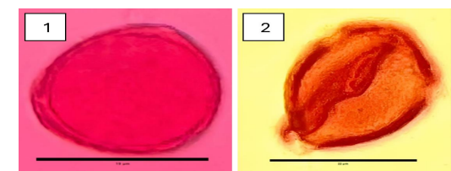

Figure 2: Pollen Grain Morphology and Dimensions of the C. plicatum; (1) polar view (2) equatorial view.
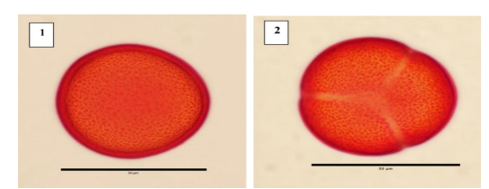
Figure 3: Pollen Grain Morphology and Dimensions of the L. leucocephala ; (1) polar view (2) equatorial view.

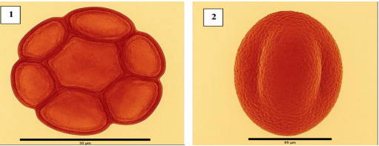

Figure 4: Pollen Grain Morphology and Dimensions of the P. dulce ; (1) polar view (2) equatorial view.

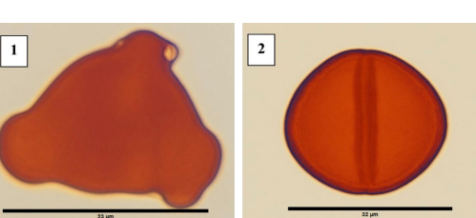

Figure 5: Pollen Grain Morphology and Dimensions of the S. italica ; (1) polar view (2) equatorial view.

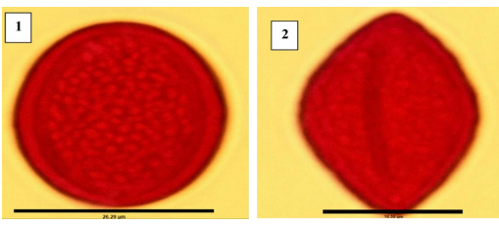
Figure 6: Pollen Grain Morphology and Dimensions of the T. apollinea. ; (1) polar view (2) equatorial view.

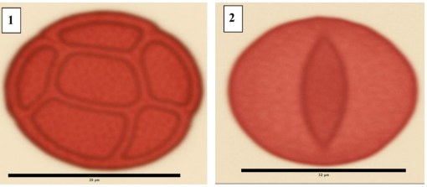
Figure 7:Pollen Grain Morphology and Dimensions of the V. flava ; (1) polar view (2) equatorial view.

4. Discussion
Although literature sources describe the pollen grains of several studied species as tricolporate (Elkordy et al., 2022; Khan et al., 2020; Unkelbach and Reinhardt, 2024), light microscopy observations in this study consistently revealed colpate apertures without clearly visible pores (pori). For example, the pollen grains of C. plicatum, L. leucocephala, S. italica, and T. apollinea all exhibited three distinct colpi, yet no definitive pori were observed under the light microscope, suggesting a tricolpate condition rather than tricolporate.
This discrepancy may be due to limitations in staining techniques and the magnification power used. In this study, observations were made under 40x magnification, which may not be sufficient to resolve minute pore structures, particularly if they are small or partially obscured by stain deposits. The visibility of apertures can also be influenced by the type and intensity of the stain, which may enhance the colpi while masking the finer details of the pori.
Previous palynological studies, such as those by Unkelbach and Reinhardt (2024), have confirmed the presence of pori using scanning electron microscopy (SEM), supporting the tricolporate classification. Similarly, Elkordy et al., (2022) described T. apollinea as tricolporate based on SEM evidence, while Khan et al., (2020) characterized L. leucocephala as tricolporate with psilate to scabrate ornamentation. However, under light microscopy, especially with the standard 40x objective, these features may appear absent or indistinct, leading to a different morphological interpretation. These findings emphasize the importance of integrating multiple microscopy techniques for accurate pollen identification and the cautious interpretation of aperture types based solely on light microscopy.
The pollen grain dimensions reveal clear differences in pollen grain size and shape among the six studied Fabaceae species, which reflect both taxonomic and ecological adaptations. C. plicatum showed relatively small, nearly round pollen grains (P/E = 0.872 um), which is typical for insect-pollinated plants. Its coarse surface ornamentation helps pollen stick to pollinators (Unkelbach and Reinhardt, 2024). L. leucocephala had the largest pollen grains, with a slightly elongated shape (P/E = 1.132 um), which may support efficient pollen transfer in trees and shrubs that depend on large pollinators or wind (Khan et al., 2020).
This study answers the original research question regarding the taxonomic and ecological value of pollen morphology in medicinal legumes of Al-Madinah AlMunawwarah. In interpreting the results, multiple explanations should be considered. Differences in pollen features may stem from evolutionary lineage, environmental stressors, and pollination syndromes. For example, the structural robustness of certain grains may reflect adaptation to arid environments or selective pressures from specific pollinators (Singh, 2010; Smýkal et al., 2015). Rather than attributing pollen variations solely to phylogenetic divergence, this study acknowledges the multifactorial nature of palynological diversity, including ecological, evolutionary, and functional influences, avoiding overreliance on currently dominant evolutionary theories unless directly supported by data.
5. Conclusion
This study has demonstrated that the pollen morphology of medicinal plants within the Fabaceae family offers valuable taxonomic insights that can aid in the identification, classification, and conservation of these species in Al-Madinah AlMunawwarah. By comparing six species C. plicatum, L. leucocephala, P. dulce, S.italica, T. apollinea, and V. flava we observed differences in pollen shape, aperture type, and surface ornamentation. These findings reinforce the critical role of palynological analysis in distinguishing between morphologically similar taxa, particularly in arid environments where floral traits may converge due to climatic pressures.
Importantly, this work contributes to filling a documented research gap by linking traditional medicinal knowledge with micro-morphological evidence. The integration of ethnobotanical data with pollen traits broadens our understanding of the region’s medicinal flora and underscores the importance of preserving native plant diversity. On a larger scale, these results highlight how palynology can support environmental monitoring and historical vegetation analysis in regions sensitive to climate change.

COMPETING INTERESTS DISCLAIMER:
Authors have declared that they have no known competing financial interests OR non-financial interests OR personal relationships that could have appeared to influence the work reported in this paper.

6. References
Abdel-Aziz, S. M., Aeron, A., & Kahil, T. A. (2016). Health benefits and possible risks of herbal medicine. In Microbes in food and health (pp. 97-116). Cham: Springer International Publishing.
Alotaibi, S. S., Sayed, S. M., Alosaimi, M., Alharthi, R., Banjar, A., Abdulqader, N., & Alhamed, R. (2020). Pollen molecular biology: Applications in the forensic palynology and future prospects: A review. Saudi journal of biological sciences, 27(5), 1185-1190.
Al-Robai, S. A., Ahmed, A. A., Mohamed, H. A., Ahmed, A. A., Zabin, S. A., & Alghamdi, A. A. (2022). Qualitative and quantitative ethnobotanical survey in Al Baha province, southwestern Saudi Arabia. Diversity, 14(10), 867.
Chanda, S. (2014). Importance of pharmacognostic study of medicinal plants: An overview. Journal of pharmacognosy and phytochemistry, 2(5).
Dailah, H. G. (2022). The ethnomedicinal evidences pertaining to traditional medicinal herbs used in the treatment of respiratory illnesses and disorders in Saudi Arabia: A review. Saudi Journal of Biological Sciences, 29(9), 103386.
Dzoyem, J. P., Tshikalange, E., & Kuete, V. (2013). Medicinal plants market and industry in Africa. In Medicinal plant research in Africa (pp. 859-890). Elsevier.
Elkordy, A., Osman, A.K. i Badry, & M.O. (2022). Seed and pollen morphology and numerical analysis of Tephrosia Pers. (Fabaceae) and their taxonomic.
Faegri, K., & Iversen, J. (1975). Textbook of pollen analysis.
Fazal, H., Ahmad, N., & Haider Abbasi, B. (2013). Identification, characterization, and palynology of high‐valued medicinal plants. The Scientific World Journal, 2013(1), 283484.
Ganie, S. H., Upadhyay, P., Das, S., & Sharma, M. P. (2015). Authentication of medicinal plants by DNA markers. Plant gene, 4, 83-99.
Ghadage, D., Chavan, Y., Jadhav, P., Kengar, M., Aiwale, P., & Patil, A. (2025). Advanced Herbal Technology: A Review of Plant Identification, Authentication, and Advanced Extraction Techniques. Journal of Advancement in Pharmacognosy, 5(1), 1-10.
Indrayanto, G. (2022). The importance of method validation in herbal drug research. Journal of Pharmaceutical and Biomedical Analysis, 214, 114735.
Khan, S. U., Zafar, M., Ullah, R., Shahat, A. A., Ahmad, M., Sultana, S., & Malik, K. (2020). Pollen diversity and its implications to the systematics of mimosaceous species by LM and SEM. Microscopy Research and Technique, 83(10), 1–14.
Klimko, M., Kluza, M., & Kreft, A. (2000). Morphology of pollen grains in three varieties of Helianthus annuus L. Roczniki Akademii Rolniczej w Poznaniu. Botanika, 3.
Kshirsagar, P., Umdale, S., Chavan, J., & Gaikwad, N. (2017). Molecular authentication of medicinal plant, Swertia chirayita and its adulterant species. Proceedings of the National Academy of Sciences, India Section B: Biological Sciences, 87(1), 101-107.
Lynch, N., & Berry, D. (2007). Differences in perceived risks and benefits of herbal, over-the-counter conventional, and prescribed conventional, medicines, and the implications of this for the safe and effective use of herbal products. Complementary therapies in medicine, 15(2), 84-91.
Mafimisebi, T. E., Oguntade, A. E., Ajibefun, I. A., Mafimisebi, O. E., & Ikuemonisan, E. S. (2013). The expanding market for herbal, medicinal and aromatic plants in Nigeria and the international scene. Med Aromat Plants, 2(144), 2167-0412.
Mensah, M. L., Komlaga, G., Forkuo, A. D., Firempong, C., Anning, A. K., & Dickson, R. A. (2019). Toxicity and Safety Implications of Herbal Medicines. Herb. Med, 63.
Migahid, A. M. (1996). Flora of Saudi Arabia (4th ed., Vols. 1–3). Riyadh, Saudi Arabia: King Saud University.
Pal, S. K., & Shukla, Y. (2003). Herbal medicine: current status and the future. Asian pacific journal of cancer prevention, 4(4), 281-288.
Plants of the World Online. (n.d.). Royal Botanic Gardens, Kew. Retrieved April 20, 2025, from https://powo.science.kew.org
Qari, S. H., Alrefaei, A. F., Filfilan, W., & Qumsani, A. (2021). Exploration of the medicinal flora of the Aljumum region in Saudi Arabia. Applied Sciences, 11(16), 7620.
Qayyum, I., Ahmad, M., Shinwari, Z. K., MAKSUDA, N., USMANKULOVNA, M. H., Khawaja, S., ... & Idrees, M. (2025). Palynological investigation for taxonomic authentication of medicinal flora from the Hindukush range of northern Pakistan. Pak. J. Bot, 57(2), 685-700.
Rahman, M. A., Mossa, J. S., Al-Said, M. S., & Al-Yahya, M. A. (2004). Medicinal plant diversity in the flora of Saudi Arabia 1: a report on seven plant families. Fitoterapia, 75(2), 149-161.
Rahman, M. A., Mossa, J. S., Al-Said, M. S., & Al-Yahya, M. A. (2004). Medicinal plant diversity in the flora of Saudi Arabia 1: a report on seven plant families. Fitoterapia, 75(2), 149-161.
Ramzan, S., Shaheen, S., Hussain, K., Sharifi‐Rad, J., Khan, M. A., Harun, N., ... & Khan, F. (2019). Implication of palynological techniques for the authentication of adulterated drugs traded with the same name in different herbal markets of district Lahore, Pakistan. Microscopy research and technique, 82(6), 931-940.
Roopashree, S., Anitha, J., Mahesh, T. R., Kumar, V. V., Viriyasitavat, W., & Kaur, A. (2022). An IoT based authentication system for therapeutic herbs measured by local descriptors using machine learning approach. Measurement, 200, 111484.
Seukep, A. J., Mbuntcha, H. G., & Kuete, V. (2025). Progress in the medicinal plants market and industry in Africa from 2013. In Medicinal Plant Research in Africa (pp. 805-821). Elsevier.
Singh, G. (2010). Plant systematics: An integrated approach (3rd ed.). Science Publishers.
Smýkal, P., Coyne, C. J., Ambrose, M. J., Maxted, N., Schaefer, H., Blair, M. W., Berger, J., Greene, S. L., Nelson, M. N., Besharat, N., Vymyslický, T., Toker, C., Saxena, R. K., Roorkiwal, M., Pandey, M. K., Hu, J., Li, Y. H., Wang, L. X., Guo, Y., Qiu, L. J., Redden, R. J., & Varshney, R. K. (2015). Legume crops phylogeny and genetic diversity for science and breeding. Critical Reviews in Plant Sciences, 34(1–3), 43–104.
Sucher, N. J., & Carles, M. C. (2008). Genome-based approaches to the authentication of medicinal plants. Planta medica, 74(06), 603-623.
Syed, A. H. (2017). SHPIS: A database of medicinal plants from Saudi Arabia. International Journal of Advanced Computer Science and Applications, 8(5).
Techen, N., Crockett, S. L., Khan, I. A., & Scheffler, B. E. (2004). Authentication of medicinal plants using molecular biology techniques to compliment conventional methods. Current medicinal chemistry, 11(11), 1391-1401.
Tounekti, T., Mahdhi, M., & Khemira, H. (2019). Ethnobotanical study of indigenous medicinal plants of Jazan region, Saudi Arabia. Evidence‐Based Complementary and Alternative Medicine, 2019(1), 3190670.
Tripathi, S., Anis, N., Vaish, S., Kumar, A., Singh, K., & ARYA, A. K. (2025). Potential in Palaeoecological Reconstruction from Modern Pollen Calibrations along the Kukrail Reserve Forest, Central Ganga Plain, India. Journal of the Palaeontological Society of India, 05529360251320221.
Ullah, R., Alqahtani, A. S., Noman, O. M., Alqahtani, A. M., Ibenmoussa, S., & Bourhia, M. (2020). A review on ethno-medicinal plants used in traditional medicine in the Kingdom of Saudi Arabia. Saudi journal of biological sciences, 27(10), 2706-2718.
Unkelbach, J., & Reinhardt, A. L. (2024). Atlas of the Oman pollen flora – Pollen morphology of the arid Arabian Peninsula vegetation. Review of Palaeobotany and Palynology, 331, Article 105204.

