Physico-chemical Characterization of the Waters of Lake Dogodogo located in Bujumbura province, Burundi.

Abstract
Water pollution is an environmental problem caused by various discharges. Therefore, a study on Lake Dogodogo was conducted in 2022. The objective was to assess the physico-chemical quality of its waters in order to protect this fishery resource for the surrounding population. To achieve this, six sites were identified based on different characteristics. Sampling was carried out twice a month between 10 A.M. and 12 P.M. Parameters such as temperature, pH, electrical conductivity, and total dissolved solids were measured in situ using a multimeter device with several specific probes. Dissolved oxygen, ammonium, nitrates, nitrites, phosphates, chemical oxygen demand, and biochemical oxygen demand over 5 days were analyzed in the laboratory following APHA and AFNOR methods. The results showed that the studied parameters varied spatially and temporally. Electrical conductivity values were high and varied in the same way as total dissolved solids. These two were positively correlated. The spatio-temporal analysis of these parameters indicated pollution fluctuations associated with increased levels of BOD₅ and COD. Nutrient concentrations were very low during the study period due to their absorption by aquatic plants. Principal component analysis linked the parameters and sites to identify those with similar environmental conditions. Understanding these abiotic conditions helped assess the ecological balance of this vital aquatic ecosystem. The Organic Pollution Index indicated that the waters fall into the "high organic pollution" category. Overall, the lake’s degradation is not alarming, but it is subject to pollution from agricultural sources. Hence, there is a need to protect this lake and its organisms for the benefit of the surrounding population.
Keywords: Ecosystem, Population, Physico-chemical Parameters, OPI

1. INTRODUCTION
Water is essential for the proper functioning of any aquatic ecosystem. It is a vital resource and therefore deserves special attention, as it is highly altered and threatened by human activities (Makhoukh et al., 2011). Indeed, population growth, accompanied by rapid urbanization and technological progress, causes numerous disturbances to natural environments (Michael & Kinney, 2002). This results in the release of pollutants that can affect the physico-chemical and biological quality of aquatic receiving environments (Mullis et al., 1997), and consequently impact water uses (drinking water supply, swimming, etc.) (Burton & Pitt, 2001).
Pollution sources can lead to the deterioration of water quality when the protection of the receiving environment is not ensured. Additionally, wastewater from communities enriched in organic matter (Ibrahim & Al-Fifi, 2010; Ngounouno et al., 2021) also contributes.
In rural areas, water is subject to pollution from agricultural sources due to the use of pesticides, fertilizers, and livestock waste. As a result, biodiversity decreases and water bodies may disappear (Fofana et al., 2019). These changes significantly affect trophic networks (Lacroix & Danger, 2008).
In recent years, optical methods (UV-visible spectroscopy, fluorescence) have been proposed to better understand the composition of the dissolved fraction of certain substances and link them to the quality of water bodies and the pressures they face (Assaad, 2019). These methods are now used to assess water pollution. Pollution is an environmental issue due to various discharges into lakes. Untreated domestic wastewater, as well as household waste, whether liquid or solid, represents the main source of organic water pollution. These lead to the degradation of both surface and groundwater quality (Mullis et al., 1997). Agricultural activities and the organic and dissolved substance loads from domestic effluents contribute to changes in the composition of water in aquatic environments (Côté et al., 2002).
Burundi, through its commitments and water code, has established legislation to protect the environment and biodiversity in general, and to limit water pollution in particular, especially in Lake Tanganyika (Burundi Nature Action, 2014). Burundi has many lakes under anthropogenic pressure. Lake Dogodogo is one of the aquatic ecosystems located in the northwest of the country in Cibitoke Province. It is shallow and subject to pressure for goods and services. It is mainly bordered by rice, maize, sorghum, cassava cultivation, and phragmites are visible along its edges. Its waters receive various types of agricultural fertilizers from soil amendments and pesticides used to control plant pests (Bigumandondera et al., 2021). These substances discharged into the lake alter the physico-chemical composition of the water and impact the lake’s biodiversity, particularly microorganisms and fish. Moreover, it may also affect its use for drinking water supply to the surrounding population (WHO, 2004). To our knowledge, no study has yet been conducted on the physico-chemistry of its waters to predict the impact on its biodiversity. The present study was initiated to provide a preliminary assessment of the physico-chemical composition of its waters and draw conclusions for better decision-making.The objective was to evaluate the physico-chemical quality of its waters with a view to protecting this fishery resource, a source of protein for the surrounding population.

2. MATERIALS AND METHODS

2.1. Description of the Study Area
Lake Dogodogo is located in the northwest of Burundi, in Cibitoke Province, within the Imbo plain. It lies at 2°50′23.00″ South latitude and 29°05′52.00″ East longitude, at an altitude of 910 meters. It is a recent reservoir lake located 67 km from Bujumbura, the economic capital of Burundi, and 4 km south of the administrative center of Rugombo commune, along the right side of National Road 5. This is the westernmost and lowest-altitude region in Burundi (Allison et al., 2000).
Lake Dogodogo covers an area of 80 hectares. In fact, it is a large pond whose surrounding wetlands are marshy and cover nearly 450 hectares. The soil is clay-sandy. It is characterized by aquatic vegetation composed of water lilies and nymphaeas. It has a remarkable algal flora and a few fish species. The lake shores are invaded by Phragmites mauritianus, Typha domingensis, and tall grasses floating on the water. Its biodiversity also includes aquatic birds such as ducks (INECN, 2013).

Location of Sampling Stations
To properly conduct the study, six (06) stations were selected based on their characteristics (Figure 1). Four stations (St1, St2, St3, and St4) were chosen in the littoral zone, and two others (St5 and St6) in the pelagic zone.
- The first station, St1 (coordinates: S 2.84191; E 29.09506; altitude: 912 m), is located just before the lake’s water flows out into the drainage canal toward the Rusizi River. It was selected to assess the condition of the lake at its outlet.
- The second station, St2 (coordinates: S 2.84312; E 29.09919; altitude: 913 m), lies to the right of station St1, near rice fields. It was chosen to evaluate the impact of agricultural activities on the lake’s waters.
- Stations St3 and St4, with coordinates (St3: S 2.83797; E 29.09956; altitude: 914 m) and (St4: S 2.83543; E 29.09529; altitude: 910 m), are located a few meters downstream of irrigation canals feeding water from rice fields. Station St4 is to the left of St3 and was selected near the docking zone for small fishing boats. Stations St3 and St4 were chosen to assess the influence of water inputs on nutrient levels.
- Station St5 (S 2.83949; E 29.09763; altitude: 913 m) and St6 (S 2.83689; E 29.09626; altitude: 912 m) are located in the middle of the lake, in the pelagic zone. These two stations were chosen to assess the distribution of nutrient concentrations potentially responsible for pollution.
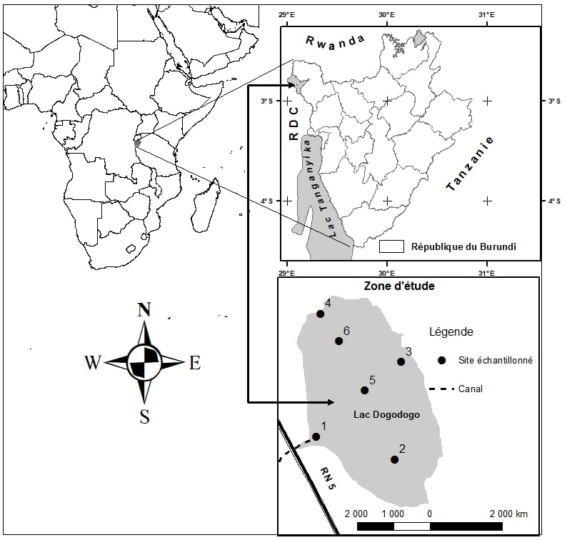
Figure 1: Location of Lake Dogodogo and the Sampling Stations

2.2. Sampling
Sampling was carried out twice a month over a four-month period, from March 23 to August 9, 2022. Each sampling was done between 8:00 and 11:00 a.m. Water was collected vertically and samples were placed in 1.5-liter bottles at all six sampling sites. These bottles were pre-rinsed with lake water and then filled completely to avoid air bubbles. The collected samples were immediately stored in black plastic bags and transported to the laboratory to prevent possible reactions before analysis. They were then refrigerated at 4°C for the analysis of physico-chemical parameters that were not measured in situ. A total of eight sampling rounds were conducted during the period, resulting in 48 samples.
In situ parameters measured included pH, temperature, transparency, electrical conductivity (EC), and total dissolved solids (TDS). Other parameters such as dissolved oxygen, ammonium, nitrates, nitrites, phosphates, chemical oxygen demand (COD), and biochemical oxygen demand over 5 days (BOD₅) were analyzed at the Laboratory of Chemistry and Environmental Analyses (LCAE).

2.3. In Situ Measurement of Physico-chemical Parameters
Transparency was measured using a Secchi disk attached to a rope. The exact depth at which the disk disappears from sight was measured using a graduated measuring tape in centimeters. Three readings were taken and their average was considered. Temperature, pH, electrical conductivity, and TDS were measured using a Consort C6010 electrochemical multiparameter analyzer, equipped with specific probes for each parameter. These probes were directly immersed in the water and readings were recorded once the values stabilized on the screen.

2.4. Laboratory Analysis of Physico-chemical Parameters
Dissolved oxygen, ammonium ions, nitrite ions, nitrate ions, phosphate ions, chemical oxygen demand (COD), and biochemical oxygen demand (BOD₅) were determined according to APHA and AFNOR methods (Rodier, 2005) at the Laboratory of Chemistry and Environmental Analyses (LCAE) of the University of Burundi.

2.5. Determination of the Organic Pollution Index
The Organic Pollution Index (OPI) by Leclercq (2001) was used to evaluate the organic load in the lake. The principle of the OPI is to classify pollutant element values into five classes (Table 1). This index is obtained using the values of ammonium, nitrites, BOD₅, and phosphates. Each parameter's values are categorized into five pollution classes based on the average values from the study, and the final OPI is the average of these four class numbers.
Table 1: Class Limits for the Organic Pollution Index (Leclercq, 2001)
Parameters | Class 5 | Class 4 | Class 3 | Class 2 | Class 1
BOD₅ (mg O₂/L) | < 2 | 2.1 – 5 | 5.1 – 10 | 10.1 – 15 | > 15
Ammonium (mg/L) | < 0.1 | 0.1 – 0.9 | 1.0 – 2.4 | 2.5 – 6.0 | > 6.0
Nitrites (µg/L) | < 5 | 6 – 10 | 11 – 50 | 50 – 150 | > 150
Orthophosphates (µg/L) | < 15 | 16 – 75 | 76 – 250 | 251 – 900 | > 900
OPI = Average of the pollution class numbers for the 4 parameters:
- 5.0 – 4.6 : No organic pollution
- 4.5 – 4.0 : Low organic pollution
- 3.9 – 3.0 : Moderate organic pollution
- 2.9 – 2.0 : High organic pollution
- 1.9 – 1.0 : Very high organic pollution

2.6. Statistical Analysis
Analysis of variance at a significance threshold of p < 0.05 was performed using SPSS software. The averages of the physico-chemical parameters across different stations and dates were also calculated. A Principal Component Analysis (PCA) was applied to all abiotic parameters to establish relationships between parameters and sampling sites and to better assess water quality. For this, XLSTAT software was used. The objective was to analyze correlations between the studied variables and the sampling stations to understand their spatial distribution.

3. RESULTS

3.1. Spatial Variation of Some Physico-chemical Parameters

A spatial variation of some physico-chemical parameters is presented (Table 2). The highest average temperature was recorded at station 4, and the lowest at station 2. For pH, the highest average was noted at station 3, and the lowest at station 1. Dissolved oxygen was highest at station 2 and lowest at station 1. Electrical conductivity was highest at station 2 and lowest at station 5. TDS values followed the same pattern. The highest average transparency was observed at station 2 and the lowest at station 3.

Ammonium ions had the highest mean at station 3 and the lowest at station 5. Similarly, nitrite ions peaked at station 3 and were lowest at station 2. Nitrate ions were highest at station 2 and lowest at station 4. Phosphates were consistently low and equal across all stations. The highest averages for COD and BOD₅ were recorded at station 6, and the lowest at station 3. Transparency and BOD₅ varied significantly (P < 0.05), while the other parameters did not show significant differences (P > 0.05).

Table 2: Spatial Variation of Some Physico-chemical Parameters
Parameters | St1 | St2 | St3 | St4 | St5 | St6 | Mean | Sig.
T° | 25,98±0,62 | 25,94±1,07 | 26,24±0,85 | 26,76±1,80 | 26,17±1,05 | 26,13±1,28 | 26,23±1,14 | NS
pH | 7,66±0,51 | 7,81±0,46 | 7,92±0,47 | 7,78±0,50 | 7,86±0,58 | 7,9±0,43 | 7,82±0,47 | NS
DO (mgO₂/l) | 4,49±1,70 | 5,24±2,46 | 5,07±1,54 | 5,06±2,25 | 4,87±1,89 | 5,18±1,19 | 4,98±1,80 | NS
EC (µS/cm) | 279,34±105,76 | 288,58±87,67 | 274,09±106,06 | 274,62±104,58 | 271,27±103,64 | 272,92±104,06 | 276,8±96,76 | NS
TDS (mg/l) | 143,65±57,83 | 152,47±46,74 | 146,41±57,08 | 146,81±56,89 | 147,94±54,19 | 145,72±56,78 | 147,17±52,11 | NS
Trans. (cm) | 62,84±11,80 | 91,35±12,03 | 62±14,70 | 75,01±18,46 | 65,49±13,11 | 64,76±18,22 | 70,57±17,53 | S
NH₄⁺ (mg/l) | 0,52±0,22 | 0,47±0,22 | 0,59±0,28 | 0,43±0,14 | 0,38±0,8 | 0,54±0,15 | 0,49±0,20 | NS
NO₂⁻ (mg/l) | 0,17±0,06 | 0,16±0,07 | 0,32±0,25 | 0,24±0,19 | 0,25±0,21 | 0,24±0,24 | 0,24±0,20 | NS
NO₃⁻ (mg/l) | 0,13±0,13 | 0,22±0,32 | 0,09±0,09 | 0,08±0,09 | 0,1±0,11 | 0,14±0,17 | 0,13±0,25 | NS
PO₄³⁻ (mg/l) | 0,0013±0,003 | 0,0013±0,003 | 0,0013±0,003 | 0,0013±0,003 | 0,0013±0,003 | 0,0013±0,003 | 0,0013±0,003 | NS
COD (mgO₂/l) | 60,27±38,33 | 59,26±42,83 | 48,59±38,89 | 74,87±41,61 | 58,76±35,57 | 90,15±96,65 | 65,32±52,46 | NS
BOD5 (mgO₂/l) | 40,16±3,8 | 39,36±1,42 | 30,82±1,81 | 51,84±1,16 | 38,75±2,12 | 64,08±3,23 | 44,17±11,17 | S
Legend: Sig. = Significance, NS = Not significant at P < 0.05, S = Significant at p < 0.05, T° = Temperature, EC = Electrical Conductivity, Trans.=Transparency, TDS = Total Dissolved Solids, COD = Chemical Oxygen Demand, BOD₅ = Biochemical Oxygen Demand after 5 days

3.2. Temporal Variation of Some Physico-chemical Parameters
Temporal variation in environmental variables is shown (Table 3). The highest average temperature was recorded on May 5, and the lowest on July 5. The highest pH was noted on August 9, and the lowest on June 14. Dissolved oxygen peaked on May 25 and was lowest on March 23. Electrical conductivity was highest on August 9 and lowest on April 14. TDS followed the same pattern. Transparency was highest on July 21 and lowest on May 5.
Ammonium ions peaked on May 25 and were lowest on March 23. No nitrate values were recorded on June 14 and July 21, but the highest mean occurred on March 23. Nitrites peaked on March 23 and were lowest on July 21. Phosphates were only detected on March 23 and July 5. COD was highest on March 23 and lowest on July 21. BOD₅ peaked on April 14 and was lowest on May 25. All parameters varied significantly over time (p < 0.05), except BOD₅ which did not show significant variation (p > 0.05).

Table 3: Temporal Variation of Some Physico-chemical Parameters
Parameters | 23/03/2022 | 14/04/2022 | 05/05/2022 | 25/05/2022 | 14/06/2022 | 05/07/2022 | 21/07/2022 | 09/08/2022 | Mean | Sig.
T° | 26,57±0,24 | 26,35±0,29 | 27,92±1,55 | 27,23±0,69 | 25,87±0,57 | 24,88±0,23 | 25,82±0,29 | 25,18±0,35 | 26,23±1,14 | NS
pH | 7,73±0,19 | 7,50±0,26 | 7,80±0,20 | 7,74±0,14 | 7,04±0,23 | 8,29±0,19 | 8,18±0,12 | 8,45±0,18 | 7,84±0,47 | NS
DO (mgO₂/l) | 1,71±1,06 | 6,37±0,91 | 6,50±0,52 | 6,55±0,53 | 3,37±0,56 | 5,26±1,43 | 5,5±0,64 | 4,62±0,81 | 4,98±1,80 | S
EC (µS/cm) | 190,5±13,75 | 188,26±11,89 | 192,99±13,6 | 192,9±15,24 | 264,5±9,01 | 368,97±10,19 | 403,65±2,71 | 412,67±2,48 | 276,8±96,76 | S
TDS (mg/l) | 101,45±6,25 | 101,87±8,18 | 101,80±6,67 | 102,55±6,96 | 135,83±6,91 | 195,97±4,71 | 214,8±1,17 | 223,07±4,09 | 147,17±52,1 | S
Trans.(cm) | 71,38±12,11 | 73,12±12,44 | 50,63±17,59 | 51,45±17,48 | 82,5±10,41 | 84,07±11,22 | 84,91±11,05 | 66,54±5,92 | 70,57±17,53 | S
NH₄⁺ (mg/l) | 0,26±0,20 | 0,65±0,20 | 0,66±0,2 | 0,67±0,2 | 0,41±0,05 | 0,37±0,06 | 0,43±0,06 | 0,46±0,05 | 0,49±0,2 | S
NO₃⁻ (mg/l) | 0,32±0,29 | 0,11±0,07 | 0,20±0,09 | 0,2±0,08 | 0,00±0,00 | 0,04±0,08 | 0,00±0,00 | 0,02±0,04 | 0,11±0,16 | S
NO₂⁻ (mg/l) | 0,70±0,11 | 0,21±0,11 | 0,22±0,11 | 0,22±0,11 | 0,16±0,06 | 0,16±0,6 | 0,1±0,01 | 0,17±0,17 | 0,24±0,2 | S
PO₄³⁻ (mg/l) | 0,007±0,002 | 0,00±0,000 | 0,00±0,000 | 0,00±0,000 | 0,00±0,00 | 0,001±0,002 | 0,00±0,00 | 0,00±0,00 | 0,001±0,002 | S
COD (mgO₂/l) | 170,10±69,4 | 75,75±26,66 | 76,27±22,19 | 75,53±21,91 | 45,05±12,47 | 44,6±12,4 | 44±13,68 | 45±11,08 | 72,03±52,46 | S
BOD₅ (mgO₂/l) | 45,00±12,18 | 45,44±8,07 | 45±11,92 | 41,44±12,02 | 32,69±3,39 | 32,06±5,29 | 29,14±9,07 | 31±9,34 | 37,07±10,97 | S

Sig: significance, NS: not significant at (p<0.05); S: significant at p<0.05

3.3. Relationship Between Physico-chemical Parameters and Sampling Sites
To establish a relationship between physico-chemical parameters and sampling sites, a Principal Component Analysis (PCA) was performed on all abiotic parameters. The correlation circle (Figure 2) represents the projection of the initial variables on a two-dimensional plane formed by the first and third factors (F1 and F3). These two factorial axes explain 99.55% and 0.09% of the total variability respectively, providing a cumulative 99.64% of the total variance. For better interpretability, a projection on axes 1 and 3 is recommended.
The sites are distant from the center of the graph and close to each other. The analysis grouped sites 2 and 4, which share almost the same environmental conditions. Similarly, sites 1, 3, 5, and 6 also appear to have similar environmental characteristics (Figure 2).
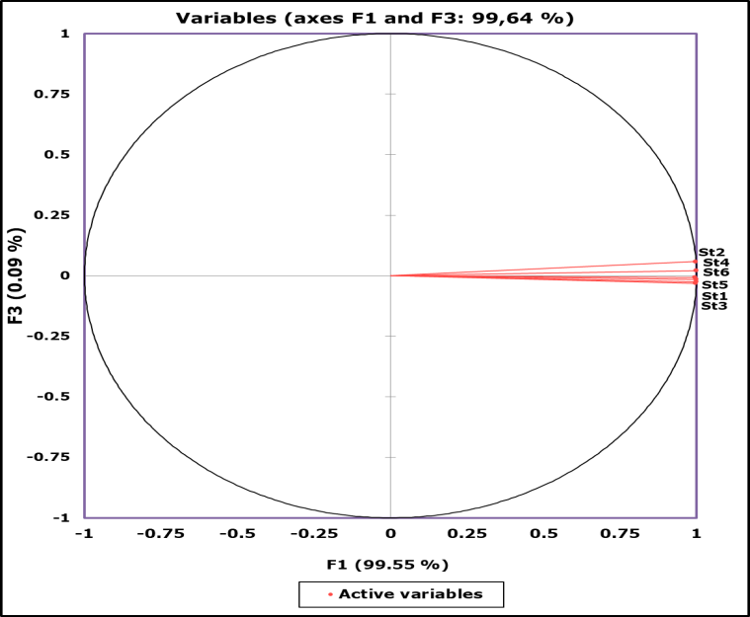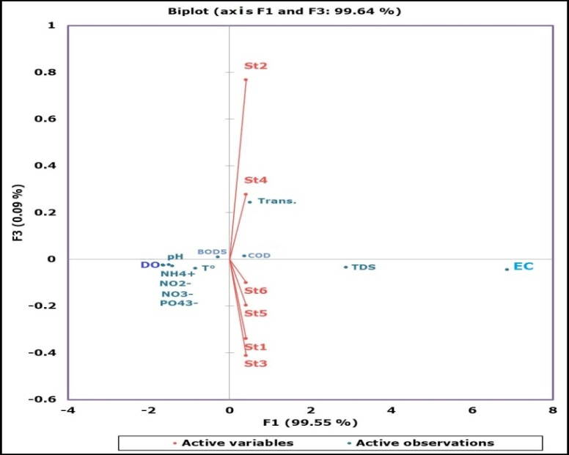
Figure 2: Similarity between the Sampling Sites
Figure 3: Biplot Diagram Showing the Relationship Between Sampling Sites and Parameter Intensities

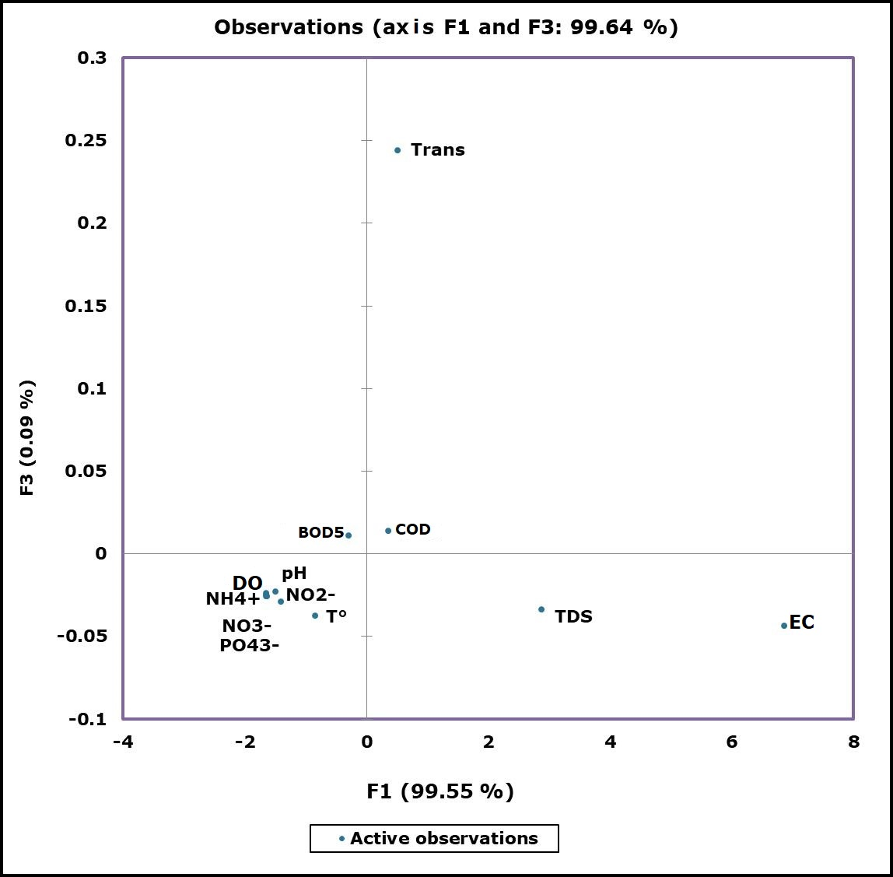
Figure 4: Correlation between the physico-chemical variables
Figure 4 shows the correlation between the physico-chemical variables. Considering the distance between the origin of the axes (F1 × F3) and the position of each physico-chemical parameter, we observe that the parameters may form:
- Acute angles (α < 90°), indicating a positive correlation between the variables (e.g., TDS and EC, COD and transparency);
- Right angles (α = 90°), indicating no correlation between the variables (e.g., BOD₅ and temperature);
- Obtuse angles (90° < α < 180°), indicating a negative correlation between the variables (e.g., BOD₅ and TDS, dissolved oxygen and transparency).
- The smaller the angle between two variables, the stronger the correlation between them.
Figure 3 shows the relationships between the physico-chemical variables and how the sampling stations are described by these variables. The closer a variable is to a station, the higher its concentration at that site. For example, the highest value of transparency was recorded at station 2, while the lowest value was recorded at station 3.
3.4. Spatio-temporal Variation of Organic Pollution
Analysis of Table 4 shows that the calculated Organic Pollution Index (OPI) varied both spatially and temporally. The highest OPI values were recorded on July 5 and July 21 at all sampling stations. The value remained high at Station 2 for almost the entire analysis period, except on March 23. The calculated average OPI values ranged from 2.81 to 2.97, recorded at Station 3 and Station 2, respectively. This indicates that the waters fall within the same pollution class, corresponding to high organic pollution, within the range of 2–2.9 (based on Table 1).
Table 4: Spatio-temporal Variation of the Organic Pollution Index (OPI)
 | 23/3 | 14/4 | 5/5 | 25/5 | 14/6 | 5/7 | 21/7 | 9/8 | Avg. | SD
St1 | 2.75 | 2.75 | 2.75 | 2.75 | 2.69 | 3 | 3 | 3 | 2.84 | 0.13
St2 | 2.75 | 3 | 3 | 3 | 3 | 3 | 3 | 3 | 2.97 | 0.08
St3 | 2.75 | 2.75 | 2.75 | 2.75 | 2.75 | 3 | 3 | 2.75 | 2.81 | 0.11
St4 | 3 | 2.75 | 2.75 | 2.75 | 2.75 | 3 | 3 | 2.75 | 2.84 | 0.12
St5 | 2.75 | 2.75 | 2.75 | 2.75 | 3 | 3 | 3 | 2.75 | 2.84 | 0.12
St6 | 2.75 | 3 | 3 | 3 | 2.75 | 2.75 | 3 | 3 | 2.91 | 0.12
Avg.: Average, SD: Standard Deviation
4. DISCUSSION OF RESULTS
The quality of Lake Dogodogo's water was assessed using several physicochemical parameters. Anthropogenic activities affect surface water, leading to environmental and health issues (Antoinette et al., 2016). Most measured parameters showed relatively stable values, except for transparency and BOD₅, which varied significantly across stations. This variation is linked to the rock type, as the lake is fed by groundwater. Temporal variation was significant for all parameters except BOD₅, likely due to human activities during rainy and dry seasons that alter the chemical composition of water.
Temperature varied over time but remained stable across stations due to their proximity. Similar results were reported in other ecosystems (Buhungu et al., 2018). This is explained by the lake's location in a hot region and the sampling periods. Such temperature variations are normal and do not harm aquatic organisms. Temperature influences gas solubility (like dissolved oxygen) and salt dissociation (Villeneuve et al., 2006; Rodier et al., 2005). It also promotes chemical and biochemical reactions and the growth of aquatic organisms, especially microorganisms (Chapman, 2021). Sudden temperature changes can disrupt aquatic ecosystem balance (Haddad & Ghoualem, 2014). Water temperature influences aquatic biological processes (WHO, 1987; Kadlec & Reddy, 2001; FAO, 2006). Temperatures between 25°C and 30°C are favorable for fish growth (Tfeil et al., 2018). The observed values fall within this range.
The water had an alkaline pH that increased from the rainy to the dry season. During rains, acidic gases lower pH, making water more acidic (Jia et al., 2019). In this study, pH remained basic and stable due to station proximity. The basic nature in the dry season may result from evaporation increasing dissolved salt concentration (Kouassi & Adingra, 2005), and from bicarbonate dissolution during photosynthesis. Recorded pH values are within WHO acceptable limits (6.5–9.5), allowing for optimal life development.
Dissolved oxygen (DO) decreased as temperature increased a well-known correlation (Villeneuve et al., 2006). DO was lower during the dry season, likely due to microbial respiration and organic matter degradation. Buhungu et al. (2018) reported similar observations in the Kinyankonge River. Organic matter oxidation depletes oxygen. Climate also affects DO levels (De Villers et al., 2005).
Electrical Conductivity (EC) didn’t vary significantly across stations but was higher in the dry season. EC reflects overall mineralization and indicates salinity. Lower EC during the rainy season results from dilution by rainwater (N’Diaye et al., 2014). This trend aligns with the study results.
Total Dissolved Solids (TDS) represent total mineralization (Kambiré et al., 2014). EC and TDS are positively correlated, both increase together. Similar results were found by Buhungu et al. (2018). TDS remained below 500 mg/L, favorable for fish farming (Charkhabi & Sakizadeh, 2006).
Transparency was low in most stations, indicating the presence of colloidal compounds (clay, rock debris, decomposing microorganisms) increasing turbidity and limiting photosynthesis. High suspended solids reduce water clarity (Viaho et al., 2020). Clearer water enhances light penetration and photosynthesis (Buhungu et al., 2018). Transparency increased in the dry season and decreased during rains.
Ammonium ions remained low due to reduced activities producing them. They originate naturally from incomplete decomposition of organic matter. Ammonium levels were slightly above standards, possibly due to fish farming using organic feeds. Decomposition of aquatic plants and animal matter also contributes. Tremblay (1995), Mouly et al. (2009), and Rodier (2005) state ammonium arises from anaerobic decomposition of nitrogenous organic matter, typically between 0.1 and 0.2 mg/L.
Nitrites result from incomplete oxidation of ammonium or reduction of nitrates by denitrifying bacteria (Dib, 2010). Water containing nitrites is considered microbiologically suspect (Rodier, 2005). Observed levels were potentially lethal, especially to young fish.
Nitrates are the final oxidation product of nitrogenous organic matter. Natural water typically has 1–10 mg/L. In this study, nitrate levels were very low, likely absorbed by aquatic plants. In low oxygen conditions, nitrates serve as oxygen donors for aquatic microbes (Makhoukh et al., 2011). Recorded levels are below international standards (50 mg/L), indicating low nitrate pollution risk.
Phosphates are easily fixed by soils and originate from the terrain and decomposition of organic matter or bedrock (Soro et al., 2021). Recorded phosphate levels were low, likely due to plant uptake. This supports the theory by Stone & Thomforde (2004), which recommends ≤0.06 mg/L for aquaculture. Nitrogen and phosphorus are key nutrients for primary production (Ravindra et al., 2003). Their high concentrations in the rainy season come from anthropogenic inputs and natural processes (Soro et al., 2021). Excess nutrients can cause lake eutrophication, though the current study shows no such risk.
COD (Chemical Oxygen Demand) reflects all oxidizable substances in water, including minerals and organics. High values indicate high concentrations of such materials, as observed in Lake Nokoué by Dovonou et al. (2011).
BOD₅ (Biochemical Oxygen Demand) measures the oxygen consumed in 5 days at 20°C in the dark by aquatic microorganisms. It indicates the level of organic pollution (McCarty et al., 2003). COD and BOD₅ are closely related. The COD/BOD₅ ratio reveals the biodegradability of organic matter. In this study, the ratio ranged from 0.66 to 1.82, all below 2, indicating the lake’s pollutants are biodegradable. COD and BOD₅ were positively correlated (Yapo et al., 2009), except on March 23, when non-biodegradable substances, likely from fertilized rice fields, entered the lake.
Regarding the organic pollution index, values remained within acceptable limits, indicating high organic pollution. This reflects an enrichment of the lake in organic matter, suggesting low agricultural degradation based on the observed physicochemical values.
CONCLUSION
This study assessed the physicochemical quality of Lake Dogodogo’s water to propose protective measures for this ecologically important fishery resource. Most parameter concentrations remained within international surface water discharge standards. Nutrient levels were low throughout the sampling period due to plant uptake. The organic pollution index indicated high organic pollution, reflecting enrichment in organic matter. Thus, the lake is undergoing slight agricultural degradation. For sustainable management, protecting this resource from harmful impacts is essential, especially given its role in supporting fish populations and providing protein to nearby communities.
DISCLAIMER (ARTIFICIAL INTELLIGENCE)
Author(s) hereby declare that NO generative AI technologies such as Large Language Models (ChatGPT, COPILOT, etc) and text-to-image generators have been used during writing or editing of this manuscript.

REFERENCES
Allison, E.H., Paley, R.G.T., Ntakimazi, G., Cowan, V.J., & West, K. (2000). Evaluation and conservation of biodiversity in Lake Tanganyika: Final technical report of BIOSS. Pollution control and other measures to protect biodiversity in Lake Tanganyika (RAF/92/G32), GEF, NRI, MRAC, IFE, 205 p.
Antoinette, A., Micheline, A.D.T., Nelly, C.K., & Rébecca, L. (2016). Pollutant fluxes related to anthropogenic activities, risks to surface water resources and the food chain worldwide: a literature review. International Journal of Biological and Chemical Sciences, 10(3), 1459–1472.
Assaad, A. (2019). Anthropogenic pollution of watercourses: spatial-temporal characterization and flow estimation. PhD thesis, University of Lorraine, 227 p.
Bigumandondera, P., Ndikuryayo, F., & Nineza, C. (2021). Pollution in the city of Bujumbura: extent, harmful impacts and remediation strategies. Scientific Bulletin on Environment and Biodiversity, 4, 35–47.
Buhungu, S., Montchowui, E., Barankanira, E., Sibomana, C., Ntakimazi, G., & Bonou, C.A. (2018). Spatial and temporal characterization of the water quality of the Kinyankonge River, a tributary of Lake Tanganyika, Burundi. International Journal of Biological and Chemical Sciences, 12(1), 576–595.
Burton, Jr G.A., & Pitt, R. (2001). Stormwater Effects Handbook: A Toolbox for Watershed Managers, Scientists, and Engineers. CRC Press.
Burundi Nature Action. (2014). Strategy to limit pollution in Lake Tanganyika. Critical Ecosystem Partnership Fund, Bujumbura, Burundi, 40 p.
Chapman, D.V. (2021). Water Quality Assessments: A Guide to the Use of Biota, Sediments and Water in Environmental Monitoring. CRC Press.
Charkhabi, A.H., & Sakizadeh, M. (2006). Assessment of spatial variation of water quality parameters in the most polluted branch of the Anzali Wetland, Northern Iran. Polish Journal of Environmental Studies, 15(3) ,395–403.
Côté, R., Bussières, D., & Desgagnés, P. (2002). Spatial-temporal distribution of phytoplankton and zooplankton in Lake Saint-Jean (Quebec), a hydroelectric reservoir. Journal of Water Science, 15(3), 597–614.
De Villers, J., Squilbin, M., & Yourassowsky, C. (2005). Physicochemical and chemical quality of surface waters: general framework. IBGE Data: “Water in Brussels”, v228, 11KB, p.2.
Dib, I. (2010). Impact of agricultural and urban activity on the quality of groundwater in the Gadaine-Ain Yaghout plain (Eastern Algeria). PhD dissertation, University of Batna 2.
Dovonou, F., Aïna, M., Boukari, M., & Alassane, A. (2011). Physico-chemical and bacteriological pollution of an aquatic ecosystem and its ecotoxicological risks: the case of Lake Nokoué in Southern Benin. International Journal of Biological and Chemical Sciences, 5(4), 1590–1602.
FAO. (2006). State of World Aquaculture. Food and Agriculture Organization of the United Nations, Fisheries Technical, Rome.
Fofana, N.M., Etile, R.N., & Gooe, Bi G. (2019). Seasonal distribution of zooplankton in relation to environmental characteristics in Lake Kaby (Bongouanou, Côte d’Ivoire). Journal of Applied Biosciences, 140, 14256–14267.
Haddad, H., & Ghoualem, H. (2014). Physico-chemical characterization of water in the coastal watershed of Algiers. Larhyss Journal, 18, 155–167.
Ibrahim M., & Al-Fifi, Z. (2010). Mechanism of pollution control by the aquatic plant water hyacinth. The Open Spectroscopy Journal, 4(1).
INECN. (2013). Regional Implementation Plan of the National Strategy and Action Plan on Biodiversity in the Imbo Plain. Bujumbura, Burundi.
Jia, X., Tang, J., & Zhang, Y. (2019). Precipitation chemistry and acidity over China during 2018. In: E3S Web of Conferences, (136):06020. EDP Sciences.
Kadlec, R., & Reddy, K. (2001). Temperature effects in treatment wetlands. Water Environment Research, 73,543–557.
Kambiré, O., Adingra, A.A., Eblin, S.G., Aka, N., Kakou, A.C., & Koffi-Nevry, R. (2014). Characterization of waters from an estuarine lagoon in Côte d'Ivoire: Aby Lagoon. Larhyss Journal, 20.
Kouassi, A.M., & Adingra, A.A. (2005). Hydrological monitoring of the Ebrié Lagoon at Abidjan, Technical sheets and popularization documents, Abidjan, CRO, 1–18.
Lacroix, G., & Danger, M. (2008). From trophic networks to the functioning of lake ecosystems: towards integrating heterogeneity and complexity. Revue des Sciences de l’Eau, 21(2), 155–172.
Leclercq, L. (2001). Running waters: characteristics and study methods in wetlands. Proceedings of colloquiums organized in 1996 by the Walloon Region Ministry for the World Wetlands Year, Jambes, Walloon Region, DGRNE, pp. 67–82.
Makhoukh, M., Sbaa, M., Berrahou, A., & Van Clooster, M. (2011). Contribution to the physicochemical study of surface waters of the Oued Moulouya (Eastern Morocco). Larhyss Journal, 9.
Ngounouno, M.A., Ngueyep, L.L.M., Kingni, S.T., Nforsoh, S.N., & Ngounouno, I. (2021). Evaluation of the impact of gold mining activities on the waters and sediments of Lom River, Wakaso, Cameroon and the restorative effect of Moringa Oleifera seeds. Applied Water Science, 11(7), 113.
McCarty, P.L., Sawyer, C.N., & Parkin, G.F. (2003). Chemistry for Environmental Engineering and Science. McGraw-Hill Higher Education.
Michael, L., & McKinney. (2002). Urbanization, biodiversity and conservation. Bioscience, 52(10), 883–890.
Mouly, D., Joulin, E., Roosin, C., Beauudeau, P., Zeghnoun ,A., Olszewski-Ortar, A., & Munoz, J.F. (2008). Study report. By-products of chlorination in drinking water in France. Analysis campaign in four distribution systems and modeling of trihalomethanes evolution. Saint-Maurice (France): Institute for Public Health Surveillance.
Mulliss, R., Revitt, D.M., & Shutes, R.B.E. (1997). The impacts of discharges from two combined sewer overflows on the water quality of an urban watercourse. Water Science and Technology, 36(8–9), 195–199.
N’Diaye, A.D., Mint Mohamed Salem, K., El Kory, M.B., Ould Kankou, M.O.S.A., & Baudu, M. (2014). Contribution to the spatial and temporal study of the physicochemical quality of water from the right bank of the Senegal River. Journal of Materials and Environmental Science, 5(1), 320–329.
WHO. (2004). Guidelines for Drinking-water Quality. Geneva, Volume 1, 3rd Edition.
Ravindra, K., & Kaushik, A. (2003). Seasonal variations in physico-chemical characteristics of the Yamuna River in Haryana and its ecological best-designated use. Journal of Environmental Monitoring, 5(3), 419–426.
Rodier, J. (2005). Water Analysis: Natural Waters, Wastewater, Seawater. 8th Edition, Dunod, Paris.
Rodier, J., Bazin, C., Broutin, J.P., Chambon, P., Champsaur, H., & Rodi, L. (2005). Water Analysis: Natural Waters, Wastewater, Seawater. Ed. Dunod, Paris.
Soro, T.A., Silué, K.D., Gogbé, Z.M., Coulibaly, L., & Bi G.G. (2021). Physico-chemical parameters of the waters of the Upper Bandama basin (Côte d’Ivoire). Synthesis: Review of Science and Technology, 27(1), 33–48.
Stone, N.M., & Thomforde, H.K. (2004). Understanding Your Fish Pond Water Analysis Report. Cooperative Extension Program, University of Arkansas at Pine Bluff, US Department of Agriculture and County Governments Cooperating, pp.1–4.
Tfeil, H., Mahfoudh, M., Moulay Mhamed, B.A., Aliyen, A., Yarba, L., & Vall Hmeyada, A.M. (2018). Physico-chemical characterization of surface waters and ichthyological diversity study of some continental wetlands in Mauritania. European Scientific Journal, 14(6), 83–101.
Tremblay, L. (1995). Trihalomethane production in drinking water distribution systems in Quebec: Master’s thesis presented to the University of Quebec at Chicoutimi as a partial requirement for a master’s degree in renewable resources.
Viaho, C.C., Ahouansou-Montcho, S., Agblonon Houelome, T.M., Adandedjan, D., Agadjihouede, H., & Laleye, P.A. (2020). Physico-chemical characterization of Lake Ahémé and its channels in southwestern Benin. Afrique Science, 17(4), 72–92.
Villeneuve, V., Légaré, S., Painchaud, J., & Vincent, W. (2006). Dynamics and modeling of dissolved oxygen in rivers. Journal of Water Science, 19(4), 259–274.
WHO. (1987). Global Pollution and Health: Results of Related Environmental Monitoring. Global Environment Monitoring System, WHO, UNEP.
Yapo, B.O., Mambo, V., Séka, A., Yapi, A.D., & Houenou, P. (2009). Characterization by gravimetric fractionation of the organic matter contained in wastewater: application to the study of biodegradability. Journal of the West African Society of Chemistry, 27, 21–37.

