Optimizing Computer-Aided Detection for Tuberculosis Thresholds for Community TB Screening in Nigeria: Integrating Patient Profiles and Symptomatology

Abstract
Background: Computer-aided detection (CAD) is a promising tool for tuberculosis (TB) screening, but its performance, particularly the optimal abnormality score thresholds, is highly context-specific. This study aimed to optimise the use of computer-aided detection (CAD4TB) software in tuberculosis (TB) screening by customising its threshold settings based on individual patient characteristics and reported symptoms.
Method: The study was a retrospective observational study using secondary data from community-based TB screening with portable digital X-ray with AI. All Adults screened using PDX with CAD4TB AI in multiple field locations were studied. Validation involved CAD AI findings compared to molecular confirmation (GeneXpert, etc) to calculate diagnostic accuracy. Statistical Analysis included sensitivity, specificity, PPV and NPV of CAD-AI. The ROC curves for AI scoring thresholds were generated and compared to the case detection yield by age and settings.
Findings: The study found a high TB prevalence of 10.9%. The performance of CAD was significantly different for individuals with a history of previous TB. The optimal threshold for this subgroup was a score of 48 (sensitivity 91.0%, specificity 41.9%, AUC 0.76), compared to a score of 36 for those without prior TB (sensitivity 90.6%, specificity 39.0%, AUC 0.81). This confirms that CAD accuracy is reduced among people previously treated for TB, likely due to post-TB radiological sequelae. While no single threshold met the WHO Target Product Profile (≥90% sensitivity and ≥70% specificity) for the entire population, the study demonstrated CAD's good overall accuracy (AUC >0.80) and its value as a high-sensitivity screening tool.

Conclusion: CAD is an effective tool for community-based TB screening in Nigeria. However, its implementation requires locally validated, context-specific thresholds rather than universal cut-offs. Programmes must adopt different thresholds for key subgroups, such as those with a history of TB, to balance case detection with cost-effectiveness. Continuous re-evaluation of thresholds with each software update is essential to maintain optimal performance and impact.

Keywords: Computer-Aided Detection (CAD), Tuberculosis Screening, TB Thresholds, Patient Profiles.

Introduction
There has been a continuous effort to prevent and control TB, with progress chalked in the development of therapeutic regimes. However, despite the long historical and continuous effort, M. tuberculosis infections remain a dogged health concern globally. It is of great concern due to the emergence of antibiotic-resistant MDR and XDR strains and the co-prevalence of diabetes and the HIV epidemics, which increase TB risk 4-5 (Olaleye et al., 2023). Chest radiography (CXR) plays a key role in the screening and triage of pulmonary tuberculosis (TB) and can guide the effective use of diagnostic testing to improve case detection and cost-efficiency. Computer-aided interpretation of chest radiography offers the opportunity for cost- and labour-efficient population-based TB-screening by preselecting individuals with abnormal lung fields for microbiological sputum examination. In resource-limited settings with high TB burden, community-based screening programmes have been established to increase case-finding. (Creswell et al, 2014) However, these programmes are challenged by high costs for medical staff and diagnostics, including molecular tests such as Xpert MTB/RIF® and microbiological culture. (Van’t Hoog et al, 2012). To reduce the cost and staffing requirements associated with diagnostic testing, digital chest radiography (CXR) has become an important tool to identify individuals with lung field abnormalities who require sputum testing according to WHO guidelines for TB screening (WHO, 2011).
CAD4TB produce an abnormality score that can be used to signal probable TB and trigger further TB diagnostic evaluation relative to a selected threshold (Frascella et al, 2021). Previous retrospective studies have highlighted that CAD4TB can identify CXRs with abnormal lung fields and TB-related abnormalities (Onozaki et al, 2015; Pande et al, 2015) and reduce the cost for diagnostics (Qin et al, 2019). Effective integration of CAD4TB into routine programming requires the calibration of CAD products based on the local context and intended use, as well as decision-making around the goals for screening and acceptable costs (World Health Organisation, 2021).
Currently, no official guidelines exist for selecting a decision threshold. Also, most CAD software products do not come with a pre-set manufacturer-recommended threshold that defines a cut-off to be referred for diagnostic evaluation for TB. Even when some manufacturers recommend thresholds for defining images as abnormal, evaluations by the WHO Guideline development group demonstrated substantial variation in the diagnostic accuracy (sensitivity and specificity) of CAD programmes across settings, even within the same technology set to the same threshold. This calls for calibration of CAD thresholds for a given software based on the settings and population in which it will be used (WHO, 2021).
Several studies also suggested the importance of obtaining a study-specific decision threshold adjusted to the underlying TB prevalence and demographic parameters. (Zaidi et al, 2018) This study, therefore, seeks to calibrate CAD4TB to local settings and population groups by comparing the diagnostic accuracy of CAD compared to a reference standard, as this has the potential to increase active TB case finding and advance the goal of eradicating TB by 2030.
Aim and Objectives of the Study
The main aim of this study was to optimise the use of computer-aided detection (CAD4TB) software in tuberculosis (TB) screening by customising its threshold settings based on individual patient characteristics and reported symptoms. The specific objectives of the study were:
1. To set the CAD4TB threshold for targeted community Tuberculosis Active Case Finding (TBACF) in Nigeria
2. To use varied patient characteristics, clinical symptoms and CAD4TB score to set a threshold score for presumptive TB identification.
Research Questions
The following research questions guided this study:
1. What is the CAD4TB threshold for targeted community Tuberculosis Active Case Finding (TBACF) in Nigeria?
2. How can varied patient characteristics, clinical symptoms and CAD4TB score be used to set a threshold score for presumptive TB identification in Nigeria?
Methods and Materials
This study was conducted using data from mixed population settings generated during active case finding in hard-to-reach remote villages, prisons, internally displaced people’s camps (IDPs), urban slums and general population settings across six states in Nigeria, including Benue, Cross River, Delta, Katsina, Kano and Nasarawa states under the KNCV intervention. The selection of these states and sites for screening programs was purposive, based on the ease of the organisational operations. These states fall under three geopolitical regions of North-Central, North-West and South-South parts of Nigeria. This study adopted a retrospective case-control which was conducted under standard programmatic settings among individuals presenting for TB screening and those participating in a community-based active case finding activities study. Cases are individuals aged 15 years and above for whom a CXR and a bacteriological confirmatory diagnosis of pulmonary TB exists. Controls are individuals aged 15 years and above for whom a CXR was conducted and a TB diagnosis ruled out based on the negative bacteriological test results. It involved a review of routinely collected data on PDX implementation across six states in Nigeria, implementing active TB case finding using portable digital x-ray with CAD4TB artificial intelligence. Participants were drawn from previously conducted mixed screening activities for TB active case findings across the states, as reviewed in the electronic presumptive register. The study population included all patients in the selected states who were screened, regardless of whether they presented with respiratory or constitutional symptoms for TB, as documented in the electronic presumptive registers. Pregnant women, individuals who did not get screened with CXR but had a sputum sample collected and tested and all confirmed TB clients who were on treatment before the screening were excluded. All study samples were retrospectively identified using data from the electronic presumptive register generated by the seven PDX across the six states and the web-based application for x-ray and clinical symptom evaluation platform (XMAP). A data collection tool (Proforma) was developed for data extraction from the e-presumptive register and the XMAP portal. Trained Data clerks extracted data from the PDX e-presumptive registers from the six states. The Researcher had controlled access to the XMAP platform, which has accurate storage of all the uploaded CXR and clinical outcomes of the patients. The researcher segregated the data according to local government and states of implementation in Nigeria. Data on all the bacteriologically positive and negative TB cases were extracted, as well as tracking of the CAD4TB scores by the researcher. Demographic, clinical, and microbiological data were obtained from each study. The GeneXpert MTB/RIF Ultra (Xpert Ultra, Cepheid) nucleic acid amplification test was used in the study. Chest x-ray images were anonymized and collected in DICOM format. CAD analysis was subsequently performed using CAD4TB version 7 software (Delft Imaging, Hertogenbosch, Netherlands). Chest x-rays were additionally reviewed by expert human readers in the original studies (including PG) to detect lung abnormalities, including cavitary disease as a marker for active disease and probable infectiousness. In this study, cases were defined as participants who were tuberculosis positive, i.e, individuals diagnosed with pulmonary tuberculosis by Xpert Ultra or sputum culture positivity, or both (microbiological reference standard). The controls were defined as participants who were tuberculosis negative, i.e, individuals with both a negative Xpert Ultra and sputum culture result.
Data entry into the e-presumptive registers was done by data clerks who are already working under the KNCV Tuberculosis Local Organizations Network (TB LON) projects; as such, they are already experienced in entering the required data variables. These data are usually vetted by the State Programme Officers (SPO) or State Programme Managers (SPM) before it was submitted to the Monitoring and Evaluation (M&E) Officer in the central office, where they undergo further scrutiny. The Active Case Finding (ACF) coordinators, SPO, and SPM of the respective states were readily available to answer questions or provide clarifications to gray areas.
The data collected were entered into a standardized CSV spreadsheet and uploaded to the online CAD for TB detection calibration tool developed by WHO to facilitate the analysis of data needed for CAD calibration studies. Further analysis was undertaken. Categorical variables were summarized using frequency and percentages and compared using the Pearson χ² test (χ² test) or Fisher’s exact test. Continuous variables were summarized using Mean and standard deviation for normally distributed data or Median and Interquartile Range (IQR). Also, continuous variables like mean CAD score were compared using Student’s t-test (parametric data) for two (2) groups or Analysis of Variance (ANOVA) for more than two (2) groups. The level of significance was at p < 0.05.
The ethical approval was sought from the National Health Research Committee (NHREC) before the commencement of this study. There is no invasive procedure as the study will be done with secondary data. All necessary steps were taken to ensure the confidentiality of patients’ personal information; all the results from CAD4TB and bacteriological tests in the E. presumptive register were de-identified and coded with unique identifiers and were securely protected in a password-protected file in a secure computer, which was accessible only to authorized persons.
Results and Findings

Table 1: Distribution of AUC, sensitivity, specificity and CAD4 score of participants based on Gender
Variables | Sensitivity % | Specificity % | CAD4 Score | AUC (95% CI)
Female
Sen (approx. 90%) ‖ Spec | 90.00 | 35.40 | 32 | 0.799(0.686 – 0.842)
Sen ‖ Spec (approx. 70%) | 78.60 | 68.60 | 46 | 0.799(0.686 – 0.842)
Male
Sen (approx. 90%) ‖ Spec | 90.20 | 44.70 | 40 | 0.830 (0.788 – 0.857)
Sen ‖ Spec (approx. 70%) | 84.50 | 69.40 | 50
*Sen – Sensitivity *Spec - Specificity

Table 1 shows the distribution of AUC of participants based on Gender of participants. The AUC for males was higher than females (0.830 versus 0.799). Similarly, the CAD4 Threshold cut off for Males 40 (Sen 90.20%, Spec 44.70%) is greater than Females 32 (Sen 90.00%, Spec 35.40%). For males the missed cases were 13, True Positive (TP) 116 for sensitivity of approximately 90% and missed cases 22; TP 107 for specificity of approximately 70%. For females the missed cases were 13, True Positive (TP) 116 for sensitivity of approximately 90% and missed cases 30; TP 99 for specificity of approximately 70%.
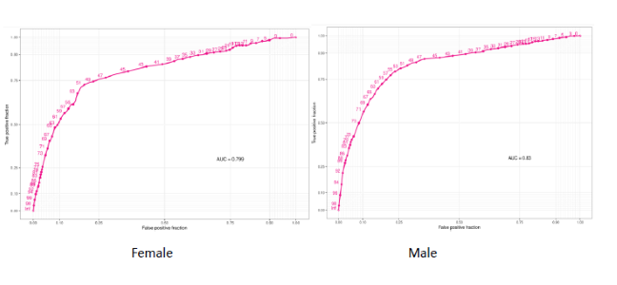

Figure 1a: Plot showing AUC for participants based on age categories

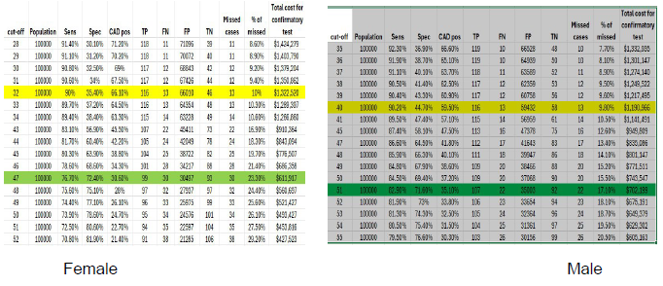

Figure 1b: Picture of CAD4 cut off for participants based on gender

The figure shows that at the suggested CAD4 Threshold cut Off scores of 32 for females (missed TB cases was 13, True Positive (TP) 116 and attracted about 1,322,528 dollars for confirmatory test) and 40 for males (missed TB cases was 13, True Positive (TP) 116 and attracted about 1,190,966 dollars for confirmatory test) corresponding respectively to sensitivity of approximately 90%.

Table 2: Distribution of AUC, sensitivity, specificity and CAD4 score of participants based on Location/setting
Variables | Sensitivity % | Specificity % | CAD4 Score | AUC (95% CI)
Health Facility
Sen (approx. 90%) ‖ Spec | 90.50 | 53.10 | 47 | 0.813 (0.771 – 0.855)
Sen ‖ Spec (approx. 70%) | 81.00 | 70.30 | 57 | 0.813 (0.771 – 0.855)
Slum
Sen (approx. 90%) ‖ Spec | 90.90 | 40.40 | 43 | 0.781(0.763 – 0.799)
Sen ‖ Spec (approx. 70%) | 75.00 | 70.00 | 55 | 0.781(0.763 – 0.799)
General population
Sen (approx. 90%) ‖ Spec | 90.80 | 23.30 | 11 | 0.756(0.724 – 0.788)
Sen ‖ Spec (approx. 70%) | 67.80 | 69.70 | 45 | 0.756(0.724 – 0.788)
Camp
Sen (approx. 90%) ‖ Spec | 87.00 | 18.80 | 38 | 0.724(0.571 – 0.877)
Sen ‖ Spec (approx. 70%) | 73.90 | 50.20 | 41 | 0.724(0.571 – 0.877)
Hard to Reach
Sen (approx. 90%) ‖ Spec | 90.30 | 65.20 | 48 | 0.854(0.834 – 0.874)
Sen ‖ Spec (approx. 70%) | 87.40 | 70.80 | 51 | 0.854(0.834 – 0.874)
Correctional centre
Sen (approx. 90%) ‖ Spec | 90.20 | 37.50 | 37 | 0.795(0.762 – 0.827)
Sen ‖ Spec (approx. 70%) | 77.30 | 70.80 | 49 | 0.795(0.762 – 0.827)
*Sen – Sensitivity *Spec - Specificity

Table 2 shows the distribution of AUC of participants based on location/settings of participants. The AUC was high for all location/settings. The AUC ranged from 0.724 for those in Camp to 0.854 for those in Hard-to-reach areas. 0.830 versus 0.799). The CAD4 Threshold cut off scores were; Camp 38 (Sen 87.00%, Spec 18.80%), Correctional Centre 37 (Sen 92.20%, Spec 37.50%), Hard to Reach 48 (Sen 90.30%, Spec 65.20%), Slum 43 (Sen 90.90%, Spec 40.40%) and Health Facility 47 (Sen 90.50%, Spec 53.10%).
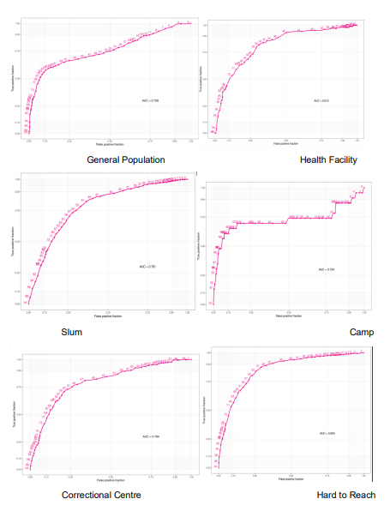

Figure 2a: Plot showing AUC for participants based on settings/location

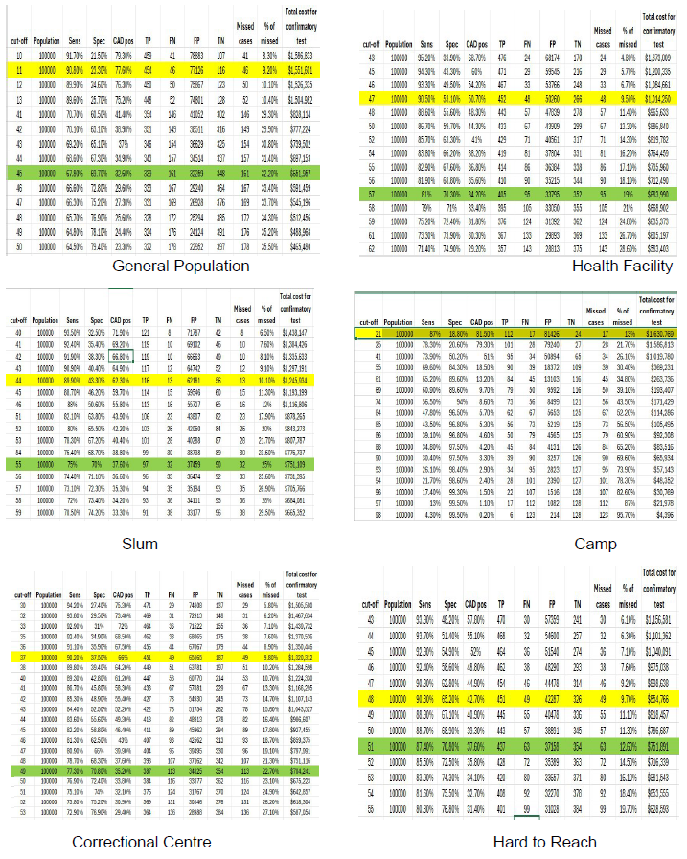

Figure 2b: Picture of CAD4 cut off for participants based on settings/location

The figure shows that at the suggested CAD4 Threshold cut Off scores of 38 for Camp (missed TB cases was 17, True Positive (TP) 112 and attracted about 1,630,769 dollars for confirmatory test), 37 for Correctional centre (missed TB cases was 49, True Positive (TP) 451 and attracted about 1,300,312 dollars for confirmatory test), 48 for Hard to Reach (missed TB cases was 49, True Positive (TP) 451 and attracted about 854,766 dollars for confirmatory test), 43 for Slum (missed TB cases was 13, True Positive (TP) 116 and attracted about 1,245,934 dollars for confirmatory test), and 47 for Health Facility (missed TB cases was 43, True Positive (TP) 452 and attracted about 18,380 dollars for confirmatory test), corresponding respectively to sensitivity of approximately 90%.

Table 3: Distribution of AUC, sensitivity, specificity and CAD4 score of participants based on previous treatment for TB
Variables | Sensitivity % | Specificity % | CAD4 Score | AUC (95% CI)
Yes
Sen (approx. 90%) ‖ Spec | 91.00 | 41.90 | 48 | 0.758(0.694- 0.812)
Sen ‖ Spec (approx. 70%) | 69.70 | 70.20 | 69 | 0.758(0.694- 0.812)
No
Sen (approx. 90%) ‖ Spec | 90.60 | 39.00 | 36 | 0.812(0.765 – 0.867)
Sen ‖ Spec (approx. 70%) | 80.10 | 71.00 | 49 | 0.812(0.765 – 0.867)
*Sen – Sensitivity *Spec - Specificity
Table 3 shows the distribution of AUC of participants based on previous treatment for TB. The AUC for those who previously had TB was lower than those who never had TB before (0.758 versus 0.812). However, the CAD4 Threshold cut off for those that previously had TB 48 (Sen 91.00%, Spec 41.90%) is greater than those that never had TB before 36 (Sen 90.60%, Spec 39.00%). For those that previously had TB the missed cases were 0, True Positive (TP) 1 for sensitivity of approximately 90% and missed cases also of 0; TP 1 for specificity of approximately 70%. For those that never had TB before the missed cases were 2, True Positive (TP) 18 for sensitivity of approximately 90% and missed cases 4; TP 16 for specificity of approximately 70%.
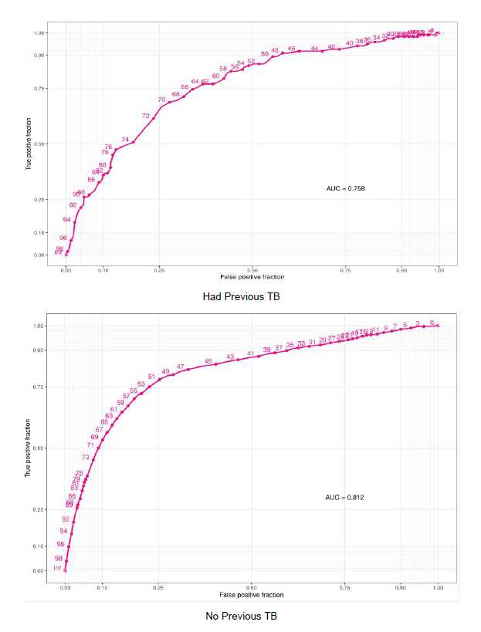

Figure 3a: Plot showing AUC for participants based on history of TB

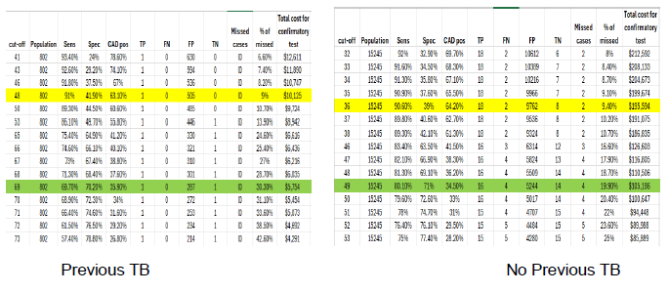

Figure 3b: Picture of CAD4 cut off for participants based on history of TB

The figure shows that at the suggested CAD4 Threshold cut Off scores of 48 for those that previously had TB (missed TB cases was <1 , True Positive (TP) 1 and attracted about 10,125 dollars for confirmatory test) and 36 for those that never had TB before (missed TB cases was 2, True Positive (TP) 18 and attracted about 195,594 dollars for confirmatory test), corresponding respectively to sensitivity of approximately 90%.
Discussion of Findings
Findings from current study show that in all, 10.9% have TB disease and 5.0% previously treated for TB. A similar study in Zambia had a similar prevalence of microbiologically confirmed TB among those with and without history of previous TB as 12.4% and 16.9%, respectively.(Kagujje et al., 2023) The mean CAD4 score was significantly higher for those previously treated for TB compared to those not previously treated (48.38 versus 45.32). The CAD threshold cut off score were for previous treatment 48 (sensitivity of 91.0%, specificity 41.9%) with AUC of 0.76 and no previous treatment for TB CAD4 cut off of 36 (sensitivity 90.60%, specificity 39%) with AUC of 0.81. The finding is in agreement with WHO which documented that patients with previous TB due to scarring in the lungs is less accurate compared to new cases. (World Health Organization, 2021a).
In contrast to current study, a retrospective analysis of data from a cross-sectional active TB. in Zambia CAD4TB, sensitivity and specificity were 89.3% (95% CI: 78.1–96.0%) and 24.0% (19.9–28.5%) and 90.5% (86.1–93.3%) and 60.3% (57.4–63.0%) among those with and without previous TB, respectively. In line with current study, the performance of CAD systems as a TB triage tool is decreased among people previously treated for TB. (Kagujje et al., 2023) A study on accuracy of computer-aided chest X-ray screening in the Kenya, Sensitivity and sensitivity were lower in smear-negative pulmonary tuberculosis.(Khan et al., 2020) The same study documented that positive predictive value was significantly lower among those with previous history of tuberculosis. A study that investigated the parameters affecting the performance accuracy of versions 6 and 7 CAD4TB in TB screening programmes in South Africa and Lesotho stated that individuals with a previous history of TB showed lower performance. Both versions showed significantly worse performance in people with a prior history of TB. For version 6, the AUC is 0.68 for those with previous TB and 0.87 for the rest (p < 0.01). For version 7, the corresponding figures are 0.76 and 0.89 (p < 0.01).
Among persons with previous TB, the optimum thresholds for achieving at least 90% sensitivity differed substantially by sex. Substantial differences in specificity between men and women (irrespective of previous TB history) were observed for both CAD software systems when a fixed threshold that approximated 90% sensitivity in the overall study population was applied. This likely, in large part, reflects the tradeoffs between the sensitivity and specificity at a fixed abnormality threshold as the AUROCs for these subgroups were similar. However, prior studies from Bangladesh and Kenya found lower accuracy of CAD for TB among women compared with men. Reduced CAD accuracy among women could, in part, be due to breast attenuation in some women, which reduces visualization of pertinent anatomy in the lower lung zones, especially if post-TB scarring is also present.
Report has it that in some settings, over 80% of patients earlier treated for TB, have post-pulmonary TB radiological changes, which very frequently include cavitation, volume loss, and fibrosis [19, 20]. As a result of their condition, when such individuals present to care, it may be difficult to differentiate whether radiological changes are due to previous TB sequelae or a new active TB episode, even for expert radiologists. Consequently, this can result in overtreatment of patients for TB, leads to avoidable exposure to anti-TB therapy, failure to treat the true cause of illness, and wastage of limited health resources. Also, given that post-TB radiographic sequelae change the lung shape and texture, similar to active TB, the performance of CAD for TB screening/triaging may be altered.
Not minding that CAD did not meet the WHO sensitivity and specificity as well as performed more poorly in some subgroups, CAD might still be a useful screening tool that could detect not just people with microbiologically proven tuberculosis, but also people who are perhaps infectious. Likewise, despite modest specificity and a high false positivity rate, a context-specific CAD-directed strategy could still be cost saving, especially during large-scale screening. Findings from this study has contributed in inform those engaging in future community-based calibration studies, national tuberculosis programmes, and global health bodies engaged in tuberculosis care and prevention, with the goal to disrupt the tuberculosis transmission cycle and end tuberculosis. (Scott et al., 2025).
Even though CAD4TB only stipulates a CAD score and a two-fold classification of whether tuberculosis is probably present or not present, there are other CAD software which has the capability to report on lung abnormalities like cavities and potential to recognise possibly infectious individuals. This forms a strong, important basis for future research.
The current study has some strengths. For example, it focused on a community-based population where the test will be used. It included participants with cough and those who did not have cough and met other screening criteria for TB testing. Findings have wide generalizability to use CAD4TB in population screening settings. This powered the study to assess threshold identification by both country and subgroups. The thresholds identified from this study may be useful as a starting point, although updated versions of CAD algorithms may require re-assessment. It also did subgroups analysis including age, gender, setting or location as well as previous TB status.
A limitation of this study is that our analysis is limited to a single CAD software. It is unknown whether our findings of significant variation between CAD4TB versions applies to other image interpretation algorithms used for TB screening.17 Jana Fehr1,2, medRxiv. The limitations of the study are that the study used a case–control design which might have introduced biased estimates of CAD diagnostic accuracy. The study included participants aged ≥15 years and could therefore not comment on the diagnostic accuracy of CAD in children and young adolescents, an important population that contributes approximately 5–10% of the global tuberculosis burden. However, WHO only recommends CAD as a screening or triage tool in individuals aged 15 years or older. Also, the model did not account for the possible long-term benefits of early tuberculosis detection or the effect of missed tuberculosis cases, in terms of onward transmission and development of additional tuberculosis cases. These factors would need to be considered in future studies using empirical data or more in-depth modelling, because it will probably affect the cost savings of these strategies.
Conclusion
Understanding threshold selection and contextually specific settings is paramount to enable wider adoption of this CAD product as an effective triaging and screening tool. The rapid updates of CAD programmes and CAD software versions call for continued investigation and assessment of performance accuracy to ascertain variation and necessary threshold adjustments to ensure the optimal global impact of this AI technology. In addition to performance accuracy investigation, such evaluations enable users to gain an evidence-based understanding of the programmatic implications of these updates, allowing studies to be planned to optimise CAD performance capabilities.
Recommendations
Based on the discussion of findings and conclusions of this study, the following recommendations are put forward:
1. National Tuberculosis Programme should adopt a stratified screening algorithm that uses a higher CAD threshold for individuals with a history of previous TB and a lower threshold for those without.
2. Given the rapid evolution of CAD algorithms and the significant performance variations between versions and populations, it is recommended to institutionalise a routine re-evaluation process. This protocol should mandate local pilot testing and threshold calibration for every new version of CAD software before wide-scale deployment.

COMPETING INTERESTS DISCLAIMER:
Authors have declared that they have no known competing financial interests OR non-financial interests OR personal relationships that could have appeared to influence the work reported in this paper.

References
Creswell, J., Sahu, S., Blok, L., Bakker, M. I., Stevens, R., & Ditiu, L. (2014). A multi-site evaluation of innovative approaches to increase tuberculosis case notification: Summary results. PLoS ONE, 9, e111344. https://doi.org/10.1371/journal.pone.0111344
Frascella, B., Richards, A. S., Sossen, B., Emery, J. C., Odone, A., Law, I., Onozaki, I., Esmail, H., & Houben, R. M. G. J. (2021). Subclinical tuberculosis disease: A review and analysis of prevalence surveys to inform definitions, burden, associations, and screening methodology. Clinical Infectious Diseases, 73(3), e830–e841. https://doi.org/10.1093/cid/ciaa1402
Kagujje, M., Kerkhoff, A. D., Nteeni, M., Dunn, I., Mateyo, K., & Muyoyeta, M. (2023). The performance of computer-aided detection digital chest X-ray reading technologies for triage of active tuberculosis among persons with a history of previous tuberculosis. Clinical Infectious Diseases, 76(3), e894–e901. https://doi.org/10.1093/cid/ciac679
Khan, F. A., Majidulla, A., Tavaziva, G., Nazish, A., Abidi, S. K., Benedetti, A., Menzies, D., Johnston, J. C., Khan, A. J., & Saeed, S. (2020). Chest X-ray analysis with deep learning-based software as a triage test for pulmonary tuberculosis: A prospective study of diagnostic accuracy for culture-confirmed disease. The Lancet Digital Health, 2(11), e573–e581. https://doi.org/10.1016/S2589-7500(20)30221-1
Olaleye, S. A., Balogun, O. S., & Adusei-Mensah, F. (2023). Bibliometric structured review of tuberculosis in Nigeria. African Health Sciences, 23(2), 139–160.
Onozaki, I., Law, I., Sismanidis, C., Zignol, M., Glaziou, P., & Floyd, K. (2015). National tuberculosis prevalence surveys in Asia, 1990–2012: An overview of results and lessons learned. Tropical Medicine & International Health, 20(9), 1128–1145.
Pande, T., Vasquez, N. A., Cazabon, D., Creswell, J., Brouwer, M., Ramis, O., Stevens, R. H., Ananthakrishnan, R., Qayyum, S., Alphonsus, C., Oga-Omenka, C., Nafade, V., Sen, P., & Pai, M. (2020). Finding the missing millions: Lessons from 10 active case finding interventions in high tuberculosis burden countries. BMJ Global Health, 5(12), e003835. https://doi.org/10.1136/bmjgh-2020-003835
Qin, Z. Z., Sander, M. S., Rai, B., Titahong, C. N., Sudrungrot, S., Laah, S. N., Adhikari, L. M., Carter, E. J., Puri, L., Codlin, A. J., & Creswell, J. (2019). Using artificial intelligence to read chest radiographs for tuberculosis detection: A multi-site evaluation of the diagnostic accuracy of three deep learning systems. Scientific Reports, 9(1), 1–10. https://doi.org/10.1038/s41598-019-51503-3
Scott, A. J., Perumal, T., Pooran, A., Oelofse, S., Jaumdally, S., Swanepoel, J., Gina, P., & Mthiyane, T. (2025). Clinical evaluation of computer-aided digital X-ray detection of pulmonary tuberculosis during community-based screening or active case-finding: A case–control study. The Lancet Global Health, 13(3), e517–e527. https://doi.org/10.1016/S2214-109X(24)00516-3
van’t Hoog, A. H., Onozaki, I., & Lönnroth, K. (2014). Choosing algorithms for TB screening: A modelling study to compare yield, predictive value and diagnostic burden. BMC Infectious Diseases, 14(1), 532. https://doi.org/10.1186/1471-2334-14-532
World Health Organization. (2011). Tuberculosis prevalence surveys: A handbook. Geneva: World Health Organization.
World Health Organization. (2021). Determining the local calibration of computer-assisted detection (CAD) thresholds and other parameters: A toolkit to support the effective use of CAD for TB screening. https://apps.who.int/iris/handle/10665/345122
Zaidi, S. M. A., Habib, S. S., Van Ginneken, B., Ferrand, R. A., Creswell, J., Khowaja, S., & Khan, A. (2018). Evaluation of the diagnostic accuracy of computer-aided detection of tuberculosis on chest radiography among private sector patients in Pakistan. Scientific Reports, 8(1), 1–9. https://doi.org/10.1038/s41598-018-30810-1.

