Case report
ATYPICAL PRESENTATION OF RHEUMATOID ARTHRITIS

ABSTRACT
Introduction : Rheumatoid arthritis (RA) is the most common auto-immune inflammatory disease. Atypical extra-articular manifestations may obscurethe diagnosis when they present as the initial symptoms.
Case presentation : A 58-year-old male patient with dyslipidemia and coronary artery disease was initially diagnosed with multifocal tuberculosis based on presumptive findings, including bilateral granulomatous panuveitis, nodular scleritis, hypercalcemia, subrenal aortitis, unilateral sacroiliitis with infiltration of the soft parts, and a positive tuberculin skin test (21 mm). He was treated with anti-tuberculous therapy and corticosteroids, with an initially favorable response. However, three years later, the patient presented with scléromalacie, extension of the aortitis and bilateral sacroiliitis.The final diagnosis was a complex and atypical form of rheumatoid arthritis.
Conclusion : This case illustrates the diagnostic, therapeutic, and prognostic challenges posed by atypical presentations of RA.
Keywords: Rheumatoid arthritis, aortitis, sacroiliitis.

INTRODUCTION
Rheumatoid arthritis (RA) is the most prevalent autoimmune inflammatory rheumatologic conditionwith a clear female predominance. Joint involvement in RA is fundamentally symmetrical, sparing the distal interphalangeal joints [1]. Extra-articular involvement is commonly represented by cardiovascular, pulmonary, gastrointestinal, and neurological manifestations[2].However, the coexistence of aortitis, sacroiliitis and scleromalacia in RA is rarely reported in the literature.
We report a unique case of RA that initially mimicked multifocal tuberculosis based on several presumptive clinical arguments. This highlights the diagnostic, therapeutic, and prognostic complexities of such atypical RA forms.

CASE PRESENTATION
A 58-year-old male, smoker, with dyslipidemia and coronary insufficiency, presented in January 2019 with bilateral ocular redness and blurred vision progressing for six months. He had no other functional complaints. Ophthalmologic evaluation revealed bilateral visual acuity of 1/10, granulomatous panuveitis complicated by bilateral macular edema and bilateral nodular scleritis.
There was no particularity in physical exam. Tuberculin skin testing was positive at 21 mm. Laboratory tests showed an inflammatory syndrome with C-reactive protein at 45 mg/L, erythrocyte sedimentation rate at 53 mm/h, polyclonal hypergammaglobulinemia and hypercalcemia at 2.63 mmol/L. Other routine blood tests were in the normal range. Viral serologies (hepatitis B and C viruses), syphilis, and Widal tests were negative. Computed tomographyscan revealed subrenal aortitis (Figure 1) and right sacroiliac joint space widening,subchondral bone sclerosis with erosions and adjacent soft tissue infiltration.
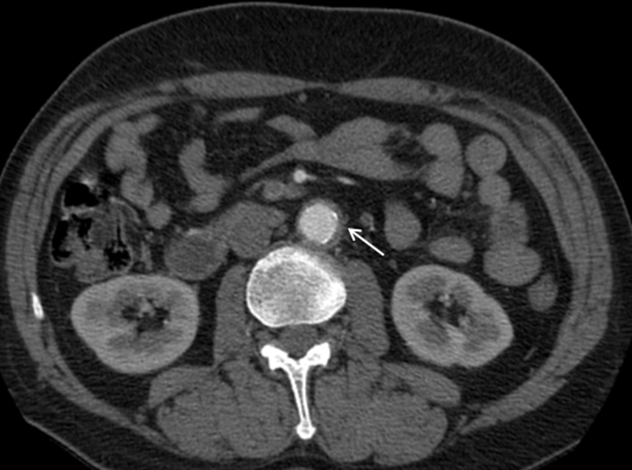

Figure 1: Abdominal computed tomography scan in axial section after injection of contrast agent showing a circumferential and regular parietal thickening of the subrenal abdominal aorta related to aortitis (white arrow).

Bone biopsy was not performed due to technical limitations. The diagnosis of multifocal tuberculosis was considered the most probable.Anti-tuberculous therapy was initiated. High doseof corticosteroids was added 15 days after, seeing the presence of macular edema. A favorable response was noted with notably an improvement in visual acuity to 7/10. Repeat computed tomography scan was planned at 9 months. But the patient was lost to follow-up.
In April 2022, he presented with a one-month history of blurred vision and eye pain.Ophthalmologic examination revealed reduced visual acuity (4/10) and bilateral scleromalacia. He also reported bilateral, symmetric inflammatory arthralgias of large and small joints sparing distal interphalangeal joints and bilateral buttock pain evolving for one year. Clinical examination found positive squeeze tests in both hands and feet, and a three cm rheumatoid nodule on the extensor surface of the left elbow. Laboratory testing objected biological inflammation. Serologies for hepatitis C and B viruses and human immunodeficiency viruses were negative. QuantiFERON-TB and Mycobacterium tuberculosis testing in sputum and urine were negative.Musculoskeletal ultrasound showed active synovitis in right metacarpophalangeal joints, left flexor tenosynovitis, and widespread erosions in metacarpophalangeal and interphalangeal joints proximal joints. Repeat computed tomographyscan showed bilateral sacroiliitis (Figure 2) and progression of aortitis into the thoracic aorta.

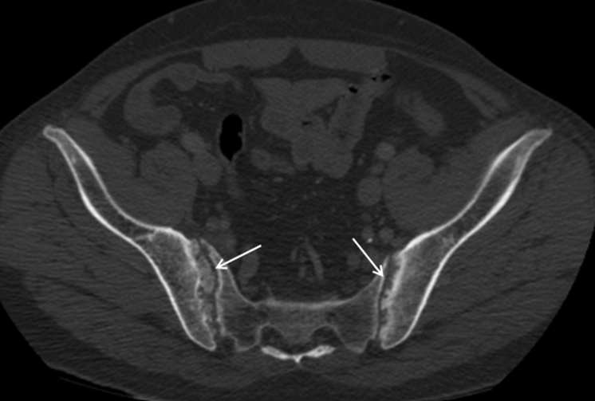

Figure 2: Computed tomography scan of the pelvis showing erosions with osteocondensation of the sacroiliac joint edges on the anterior and posterior sides, more marked on the right without narrowing of the joint space (white arrows).

Immunological testing revealed high tires of anti-cyclic citrullinated peptide antibodies (anti-CCP >250 U/mL), negative anti-neutrophil cytoplasmic antibodies and normal IgG4 levels. HLA-B27 typing was negative. Based on the 2010 ACR/EULAR criteria, a diagnosis of seropositive erosive RA was retained.Given the severity of ocular involvement, a multidisciplinary meeting between rheumatology, internal medicine, and ophthalmology specialists recommended pulse therapy with methylprednisolone (1 g/day for 3 days) followed by oral prednisone at 1 mg/kg/day. While awaiting approval for infliximab biotherapy from the National Health Insurance Fund, monthly cyclophosphamide pulses were initiated. Two months later, the patient presented a fatal myocardial infarction, following an abrupt discontinuation of his anti-anginal medications.

DISCUSSION
Beyond its typical presentation with peripheral joint involvement, RA can initially manifest with uncommon clinical features that obscure diagnosis, as illustrated by our observation in whichthe initial presentation was highly suggestive of multifocal tuberculosis.
Sacroiliitis is a hallmark of spondyloarthropathies. It has been described in certain systemic diseases, in the literature, notably lupus, sarcoidosis and Behçet's disease, independently of associated ankylosing spondylitis [3].
The reel frequency of sacroiliitis in RA seems to be uncertain. A Moroccan review found only seven cases of seropositive RA with radiographic sacroiliitis among 1000 patientswith RA over 22 years, corresponding to a frequency of 0.7%. In RA, sacroiliitis typically appears late, is erosive with geodes, and may not start in the inferior third of the sacro-iliite joint[4].In our case, associated spondylarthritis was ruled out based on the negative HLA-B27 status.
Aortitis involves inflammation of the aortic wall, leading to disorganization of arterial layers and wall thickening [5]. It may progress to stenosis or aneurysm formation with risk of rupture. In practice, diagnosis of aortitis relies on imaging: angio-computed tomography, angio-magnetic resonance imaging and Positron Emission Tomography scan [6]. Infectious causes of aortitis,especially tuberculosis, syphilisand infections by Salmonella or common pathogens such as Staphylococcus and Streptococcus, must be excluded first. Inflammatory causes include Takayasu arteritis, giant cell arteritis, and Behçet’s disease. RA rarely causes aortitis; in one autopsy series of 188 RA patients, only 10 cases of aortitis (0.05%) were found [7]. Aortitis typically complicates seropositive, destructive, and erosive RA [5], as seen in our patient. It is well known that RA is the most common inflammatory cause of scleritis. However, necrotizing scleritis or perforating scleromalacia, is found almost exclusively in advanced PR, for which it constitutes a criterion of severity [8]. In our case, the initial improvement in ocular symptoms was likely due to corticosteroid therapy. Delayed RA diagnosis led to subsequent scleromalacia, extended aortitis and bilateral sacroiliitis.

CONCLUSION
RA is the most frequent inflammatory cause of scleritis and should be considered even in complex cases with atypical extra-articular features, as demonstrated by this case presentation.

REFERENCES
1. Aletaha D, Neogi T, Silman A.J, Funovits J, Felson D.T, Bingham C.O. et al. Rheumatoid arthritis classification criteria: An American College of Rheumatology/European League Against Rheumatism collaborative initiative. 2010.
2. Fabiana Assunta Figus, Matteo Piga, Irene Azzolin, Rebecca McConnell, Annamaria Iagnocco. Rheumatoid arthritis: Extra-articular manifestations and comorbidities. Autoimmun Rev. 2021 Apr;20(4):102776. doi: 10.1016/j.autrev.2021.102776.
3. Akasbi LN, Ouazzani FZ, Kadi N, Mansouri N, Tahiri L, Harzy T. Sacroiliac joint involvement in rheumatology. Annals of medicine and therapeutics amether. January 2010; Volume 2, No. 1: 9-13.
4. Alaoui F.Z, AL Haloui H, Echchilali K, Benamour S. Sacroiliac involvement in rheumatoid arthritis (7 cases). Rev Maroc Chir Orthop Traumato 2006; 27: 22-24.
5. Fekih Y, Aydi Z, Daoud F, Rachdi I, Baili L, Ben Dhaou B et al. Aortitis in rheumatoid arthritis. Rev Med Int. 2016 (37): 179–180.
6. Espitiaa O, Toquet C, Jamet B, Serfaty J. M, Agard C. Aortitis. Rev MedInt.2024;45: 767–75.
7. Rousselin C, Pontana F, Puecha P, Lambert M. Differential diagnosis of inflammatory aortitis. Rev Med Int. 2016;37:256–63.
8. Gaelle C, Eric G, Luca S. Corneoscleral involvement in inflammatory rheumatism. Revue du Rhumatisme. July 2019;86, Issue 4:350–7.

