Original Research Article
Assessing Groundwater Vulnerability Using a GIS-Based SINTACS Model in Bapatla District, Andhra Pradesh, India

Abstract:
The necessity of groundwater in semi-arid regions like Bapatla District, Andhra Pradesh emerges from its role in supporting agricultural activities, together with industrial operations and household needs. The continuing viability of the ecosystem faces serious threats from increasing pollution linked to human activities. The evaluation of groundwater vulnerability plays a critical role in managing resources effectively while preventing pollution. This research employs the SINTACS model which functions as a GIS overlay and index method to evaluate inherent groundwater vulnerability by analysing seven hydrogeological factors: Slope (S) Infiltration (I) Net recharge (N) Soil media (T) Aquifer media (A) Hydraulic conductivity (C) and Saturation zone depth (S).
Bapatla District's intricate hydrogeological features comprising coastal aquifers alongside deltaic plains and hard rock formations render it susceptible to contamination from agricultural, industrial, and urban sources. The SINTACS model adjusted for specific local conditions integrates spatial data obtained from multiple sources including the Geological Survey of India (GSI) Water Resources Information System (WRIS) and remote sensing (DEM). The evaluation assigns scores and weights to each parameter based on its influence on contaminant transport which results in a composite vulnerability index. The groundwater vulnerability map produced for the district designates areas into low moderate high and very high vulnerability zones which enables specific conservation actions.
This study pinpoints zones requiring immediate surveillance and protective measures to support sustainable land-use planning together with groundwater management. Policymakers in Bapatla District can secure long-term water resources through the GIS-based SINTACS method which provides an economically viable and scalable solution.
Keywords: Groundwater vulnerability, SINTACS model, GIS, Contamination risk.

- INTRODUCTION
Groundwater is an important natural resource, especially in semi-arid and arid areas, as a main source of industrial, irrigation, and drinking water. Nonetheless, this precious resource is continuously endangered by anthropogenic processes that release different contaminants into the subsurface, resulting in groundwater quality decline and a great risk to human health and ecosystems (Foster et al., 1987; Mishra et al., 2023 and Fusco et al, 2024).
Groundwater vulnerability mapping is an important process towards sustainable management and conservation of this precious resource. It focuses on assessing the inherent vulnerability of the groundwater resources to contamination from processes operating at or near the land surface (Vrba & Zaporozec, 1994). The spatial distribution of groundwater vulnerability is important for land use planning, protection zones and the realisation of successful pollution prevention and mitigation measures.
Different methods have been established to evaluate groundwater vulnerability, which are generally classified as overlay and index methods, statistical methods, and process-based modelling (Civita, 1990a). Overlay and index approaches, e.g., DRASTIC (Aller et al., 1987) and SINTACS (Civita & De Maio, 1997), have become popular because they are relatively easy to apply, based on easily available hydrogeological data, and capable of generating spatially explicit vulnerability maps through Geographic Information Systems (GIS) (Kumar et al., 2013; Sahu et al., 2022). The SINTACS model, a Slope, Infiltration, Net recharge, Type of soil, Aquifer media, Conductivity (hydraulic), and Saturation zone depth (water table depth) acronym, is a parametric system specially created to evaluate intrinsic groundwater vulnerability to contamination (Civita & De Maio, 1997).
It takes into account seven hydrogeological parameters that affect the movement and attenuation of contaminants in the subsurface. Each parameter is grouped into ranges, given a rating dependent on its contribution to vulnerability, and weighted based on its relative significance in the particular hydrogeological context (Kumar et al., 2013; Al Kuisi et al., 2006). The SINTACS vulnerability index is determined by summing the ratings and weights of the seven parameters to provide a quantitative evaluation of groundwater vulnerability over a research area (Kumar et al., 2012). Bapatla District in Andhra Pradesh, India, is an agriculturally significant area that depends heavily on groundwater for irrigation and other domestic and industrial purposes (CGWB, 2024). The hydrogeology of the area is dominated by a complex interaction of coastal aquifers, deltaic plains, and underlying hard rocks (CGWB, 2024).
Agricultural activities such as the intensive application of fertilizers and pesticides, combined with industrial and urban activities, potentially compromise the quality of underlying groundwater resources (Venkata Subbaiah et al., 2022; Sudhakar et al., 2014). Knowing the spatial distribution of groundwater vulnerability in Bapatla District is hence important in designing sustainable water resource management plans and safeguarding the aquifers from pollution. This research seeks to evaluate the intrinsic groundwater vulnerability of Bapatla District, Andhra Pradesh, through the SINTACS model coupled with GIS. By examining the spatial pattern of the seven SINTACS parameters – depth to water table, net recharge, unsaturated zone characteristics, soil media, aquifer media, hydraulic conductivity, and topographic slope – and assigning suitable ratings and weights according to the region-specific hydrogeological conditions, this study prepare a groundwater vulnerability map for the district.
This map will outline regions of differing vulnerability levels, from low to high, which will be important information for water resource management stakeholders, land-use planners, and environmental protectors in Bapatla District. The conclusions drawn in this research will advance knowledge about the groundwater resources of the area and help in implementing measures tailored to protect this vital resource for current and future generations. Use of the SINTACS model in Bapatla District is beneficial in a number of ways. The flexibility of the model to allocate weights depending upon varying hydrogeological conditions allows it to fit the varied conditions found within the district, including coastal, deltaic, and hard rock environments (Civita, 1990a).
GIS application enables spatial analysis of the different SINTACS parameters and thus the production of a spatially continuous and detailed vulnerability map (Neshat et al., 2014). The visualisation of vulnerability areas is easier to interpret by decision-makers and the public than in purely numerical estimates (Baghapour et al., 2016). In addition, the SINTACS model has been extensively used and validated in different hydrogeological environments worldwide, with a solid framework for vulnerability assessment (Al Kuisi et al., 2006; Kumar et al., 2013; Kapelj et al., 2013). Nevertheless, there is a need to recognise the intrinsic limitations of overlay and index models such as SINTACS. These models are based on subjective ratings of parameters and weightage assignments, which can add uncertainty to the evaluation (Ducci, 2010).
The quality and spatial resolution of the input data also directly affect the accuracy of the vulnerability map (Rahman, 2008). Furthermore, intrinsic vulnerability evaluations do not necessarily consider the individual properties of pollutants or the true risk of contamination, which necessitates additional analysis that includes land-use and contaminant source data (Stigter et al., 2006). Notwithstanding these constraints, the SINTACS model is a useful initial assessment of the relative vulnerability of groundwater resources to contamination and is an essential tool for directing subsequent investigation and management strategies. The groundwater vulnerability map produced in this study can have several significant uses in Bapatla District. It can be used as a criterion for prioritizing places for groundwater quality monitoring and conservation actions (Sudhakar et al., 2014). The model-identified high vulnerability areas may be declared as sensitive areas for which more restrictions on possible polluting activities are instituted. The map may also be incorporated into land-use planning p3rocedures to inform the placement of new development and infrastructure in regions with lower groundwater vulnerability (Sudhakar et al., 2014).
In addition, the vulnerability can be used to inform the design of specific agricultural best management practices to reduce agrochemical leaching into the groundwater (Matham et al., 2024). Through a spatially explicit groundwater vulnerability understanding, the present study will support a better-informed and sustainable management of the valuable groundwater resources of Bapatla District, Andhra Pradesh.
- MATERIALS AND METHODS
  - Data used
Sl. No. | Data | Layers | Sources
1 | Groundwater Level | Water Table Depth (S) | WRIS
2 | Rainfall | Effective Infiltration (I) | https://www.city-facts.com/
3 | Lithology | Unsaturated Zone (N) | GSI
4 | Soil | Soil Media (T) | https://apsac.ap.gov.in/dashboard-staging/ap-geoportal/
5 | Geology | Aquifer Media (A) | GSI
6 | Rainfall Recharge | Hydraulic Conductivity Zone (C) | https://www.city-facts.com/
7 | DEM | Topographic Slope (S) | Earth Explorer
Table: 1 Datasets used for analysis
  - Methodology
Depth to Water Table (S)
Groundwater Level
Rainfall
Digital Elevation
Rainfall Recharge
Geology
Soil
Lithology
Topographic Slope (S)
Hydraulic Conductivity (C)
Aquifer Media (A)
Soil Media (T)
Unsaturated Zone (N)
Effective Infiltration (I)
Fluoride
Groundwater Vulnerability
SINTACS Model
Validation

Fig: 1 The Methodology of cyclone vulnerability mapping
- STUDY AREA
Bapatla District is situated along Andhra Pradesh's southern coastline, which is a south-eastern state in India, well-known for its diverse landscapes and highly productive agricultural regions. The district lies between latitudes 15°40'N and 16°15'N, together with longitudes 80°00'E and 80°50'E, which puts it in a warm and humid climate zone influenced by the Bay of Bengal and local landforms. The district's agricultural seasons and water management practices are still very dependent on its location, which is near the Bay of Bengal, which is a major source of water, but at the same time, it brings the place monsoons and flooding, as well as sometimes the arrival of cyclones.
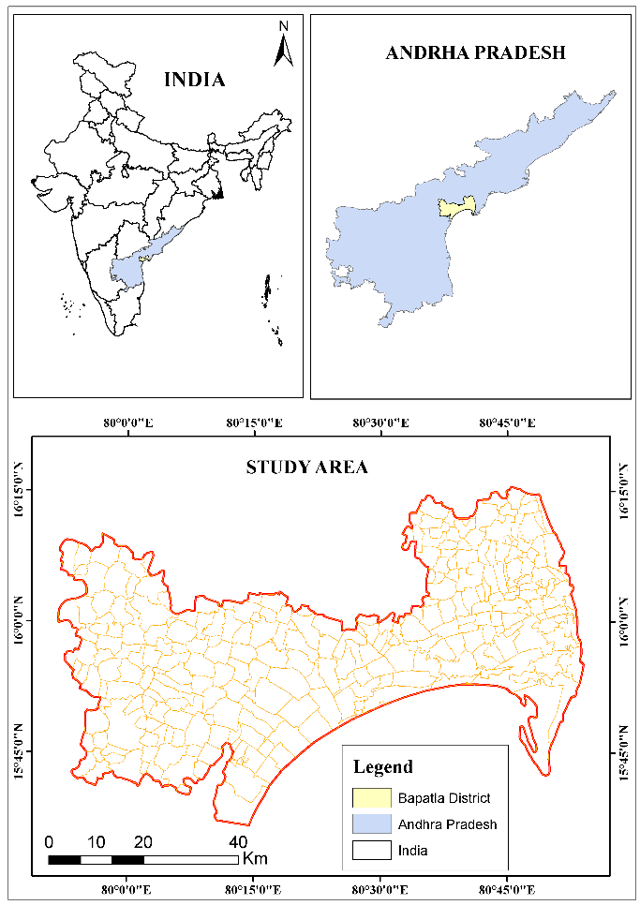
Fig: 2 Location map of the Study area
The district's western and central parts are composed of ancient, high-grade metamorphic rocks such as Migmatite Gneiss and Charnockite, which reveal extensive local cooling and pressure histories. The east and south of the coast areas are, generally, sedimentary rock areas, which are very much in line with the current geological picture. Geological structure, along with rivers and marine activity, colours the landscape here, which is made of hills, deltaic plains, and coastal plains as its main features. The land surface becomes more diverse due to not only man's interventions, like quarrying, but also natural formations such as sand sheets. Black Cotton soil and sandy loamy soils are the dominant soils in the Bapatla district. Black cotton soil covers almost 70% of the region, whereas sandy loamy soil covers about 30%. Both soils are generally fertile.
The climate change trajectory in Bapatla may be that it results in not only warmer temperatures but also rainfall pattern that has been changed, and therefore, there may be intense droughts and unseasonal monsoons. Besides, the continuation of the process of rising sea levels will probably intensify coastal erosion and saline intrusion, which in turn will become an issue for agricultural production and water for drinking. The expected alterations will be problematic to the agricultural output and will also limit the availability of groundwater and at the same time increase the danger of floods and storms for coastal communities. The district has different rainfall amounts; the eastern and north western areas get the highest, and the central west receives the least. The western and south-western regions of the district have shallower groundwater levels because hydraulic conductivity increases where lineaments run alongside drainage networks.
- RESULTS AND DISCUSSION
  - Input parameters generation
    - Depth to Water Table (S): The groundwater level map of Bapatla District has shown the spatial heterogeneity of depth to the water table. The western and south-western parts generally have shallower groundwater and are more accessible, while the eastern and south-eastern coastal parts of the district have deeper groundwater levels. The importance of the data lies in the fact that they are important indicators of how much water is exploitable from the area, to what extent there can be environmental issues such as waterlogging, and appropriate planning towards sustainable management and development of groundwater resources within the district. Further study by integrating these data with geologic, geomorphologic and land use data provides a more detailed hydrogeological regime of the Bapatla District.
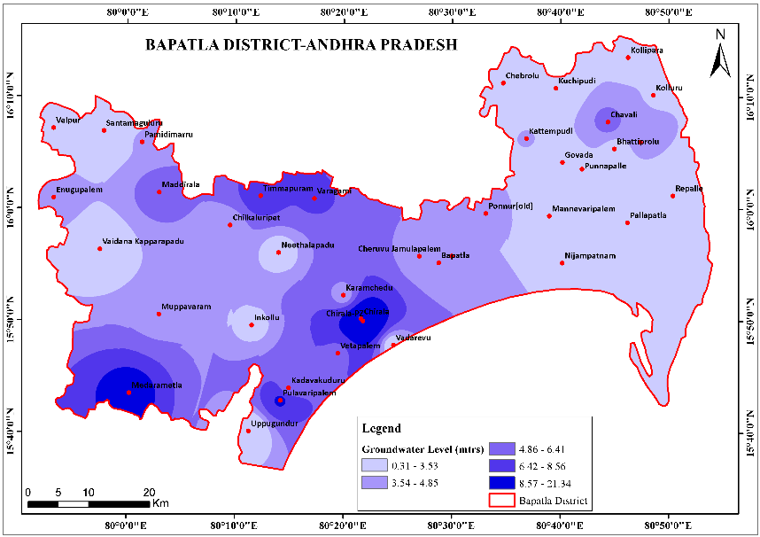
Fig: 3 Depth to Water Table
    - Effective Infiltration (I): The Rainfall Map of the Bapatla District demonstrates how spatial variability in annual rainfall is massive. The highest is in the east and north-east, and the lowest falls in a pocket area in the central-west district. This uneven distribution has serious implications for the agriculture, water resource management and environment of the district. Understanding these patterns is essential for sustainable development planning and solving future water problems in different locations of Bapatla. Integrating this information with other environmental and socio-economic data would provide more comprehensive information for the region. The effective Infiltration data calculated using the following formula proposed by Barzegar et al. (2021)R=P×Cr​
P = Total rainfall (mm/year)
Cr​ = Recharge coefficient (dimensionless, typically 0.1–0.3 depending on soil type)
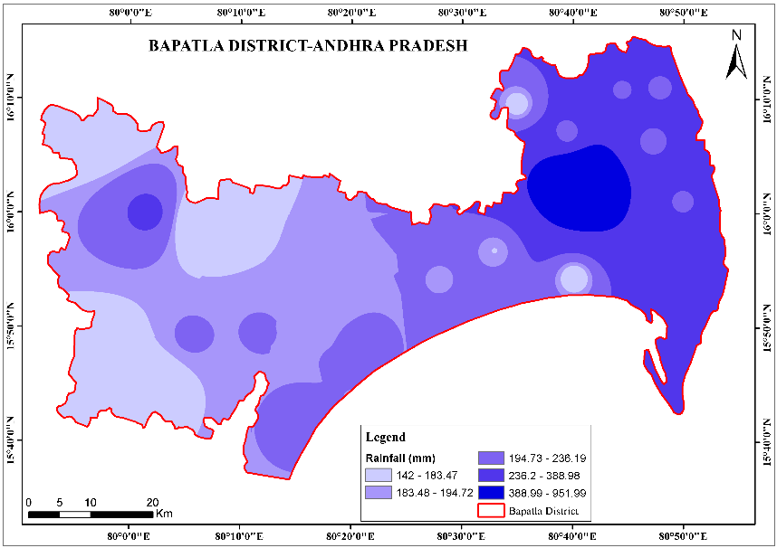
Fig: 4 Effective Infiltration
    - Unsaturated zone (N): The Bapatla District Unsaturated zone map describes a very complicated geological terrain, where the old metamorphic rocks and the intrusive igneous rocks are associated with the younger sedimentary rocks, and with the recent coastal deposits. This level of geological diversity has a great impact on the hydrogeology, mineral resources, parent material and landscape evolution of the region. Measures the actual water infiltrating into the subsurface data using the following formula by Javadi et al. (2021):I=R−ET−Roff
ET = Evapotranspiration (mm/year)
Roff= Surface runoff (mm/year)
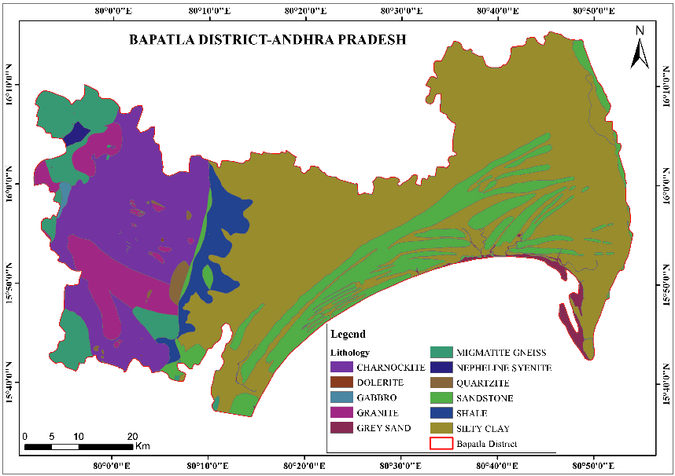
Fig: 5 Unsaturated Zone
    - Soil Media (T): The soil map of Bapatla District is diverse and complex, showing a very wide range of soils in association with supporting the various crops and land use systems. The Deep Black Clay Soil and Clay Red Soil have been the dominant soil types for the region. These soils are very suitable for growing cotton, groundnut and pulses as they can retain moisture and are fertile. The Black Soil and Loamy Soil are not only the main soil types in the district but are also found in plenty, thus raising the productivity of the district in the field of agriculture. The Eastern seaboard and South regions have been developed over a combination of Gravelly Clay Soils and Sandy Soils, which are sets of soils that are indicative of marine and fluvial processes additionally and also identify land that may be erodible or that may have drainage problems. Apart from that, water bodies and patches of Gravelly Red Soil and Gravelly Clay Red Soil with local hydrological and topographical differences were also observed. This soil complex mosaic demonstrates the requirement of soil-specific land use practices and sustainable farming systems intended to ensure long-term productivity and ecological sustainability of the district.
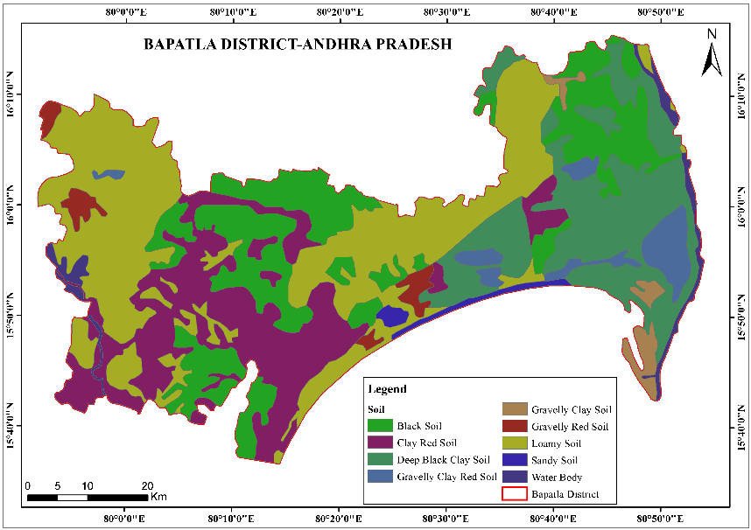
Fig: 6 Soil Media
    - Aquifer Media (A): Bapatla District in the state of Andhra Pradesh is dominated by fertile and diverse geological formations of fluvial origin and ancient crystalline basement rocks. The eastern part of the district is mostly mantled by fluvial sediments and shows evidence of recent active depositional features, most likely related to riverine and marine systems, implying the significance of agriculture and water resources. However, in the western part, older litho units prevail (charnockitary gneiss, granite gneiss, migmatite gneiss, peninsular gneiss, and Upper Gondwana Groups of rocks). These rock units show a complex tectonometamorphic history and stress the district's position within the stable Indian Shield. The lithological diversity not only gives clues about the geological history of the area but also signifies the importance of studying the geology of the area in resource management, environmental planning, and sustainable development of the district.
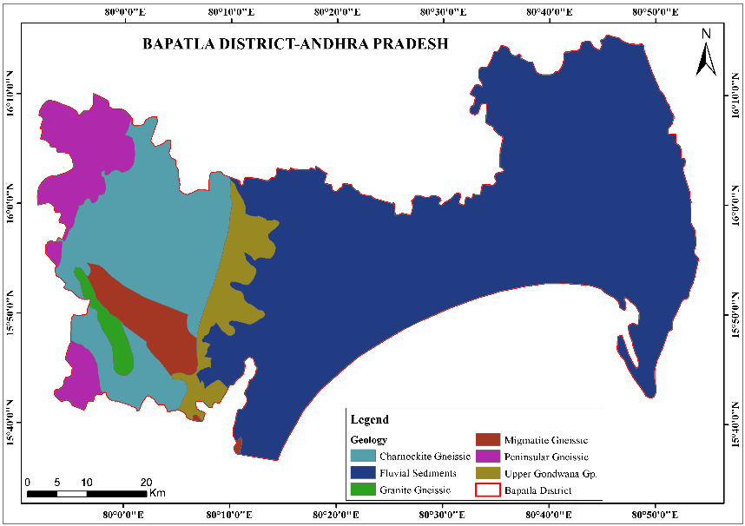
Fig: 7 Aquifer Media
    - Hydraulic Conductivity Zone (C): The hydraulic conductivity map of Bapatla District indicates that the water transmitting ability below the subsurface is highly variable in space. The western and south-western areas are generally more highly conductive, indicating the potential for greater groundwater flows, and the eastern and south-eastern coastlines have lower conductivities. For sustainable development, protection and management of groundwater in the district, knowledge of its spatial distribution is required. Using this in combination with other available information, such as groundwater levels, geology, and land use will offer a better understanding of the hydrogeological system in the Bapatla District. Ability of the aquifer to transmit water. Formula (Darcy’s Law) Boufekane & Saighi (2022):
C=Q/A-i ​
Q = Flow rate (m³/s),
AA = Cross-sectional area (m²),
ii = Hydraulic gradient.
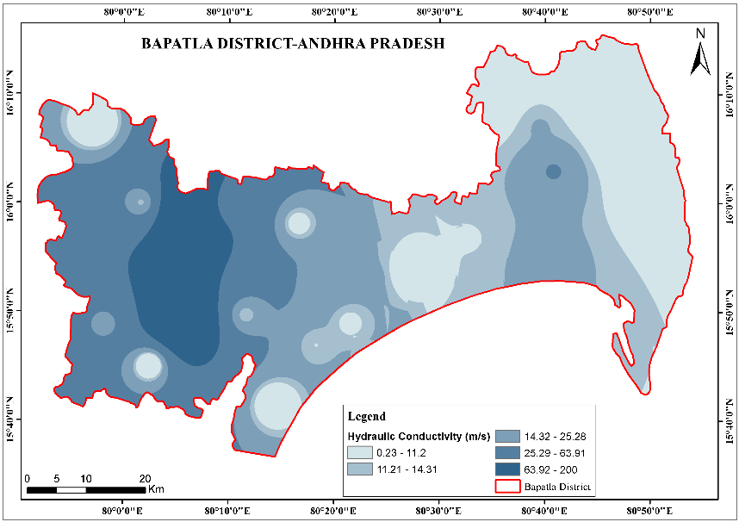
Fig: 8 Hydraulic Conductivity Zone
    - Topographic Slope (S): The slope map of Bapatla District, Andhra Pradesh, shows that the district is predominantly flat to gently undulating, with the majority of the district falling under the 0 to 2.92° slope category. These rolling plains, marked as green colours, are best suited for agriculture, building infrastructure and spreading out settlements. Some scattered patches, especially in the west of the district, have slopes more than 9.35° up to 20° to more, shown in yellow to red. They may also indicate the positions of peaks such as hillocks or rocky outcrops, which may not be suitable for intensive cropping, but might have other ecological or geological roles. Most areas in the catchment itself are generally well-suited for mechanised agriculture or agroforestry development, requiring little more than slope restrictions to be observed.
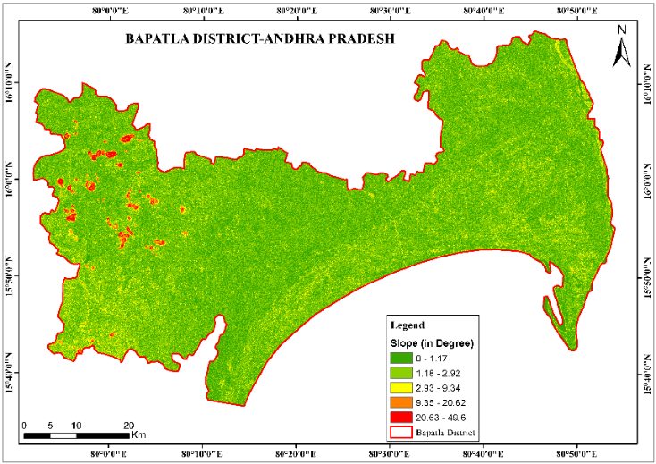
Fig: 9 Topography
The SINTACS groundwater vulnerability map of the Bapatla District, Andhra Pradesh, is a spatial depiction of the susceptibility of the area to contamination based on hydrogeological and environmental conditions. The map differentiates vulnerability into four classes: Very Low, Low, Medium, and High, enabling clear visual examination of the most vulnerable areas. The eastern and central regions of the district have Predominantly Medium to High vulnerability, probably because of conditions such as shallow water tables, permeable soils, and high recharge rates from rainfall or irrigation. These regions are of most concern because they overlap with agriculture, where excessive fertilizer application and pesticide runoff readily percolate and taint groundwater.

    - Final SINTACS Index Formula
SINTACS=∑ (Wi​×Pi)
WiWi​ = Weight for parameter ii (varies by study),
PiPi​ = Normalised parameter score (1–10).
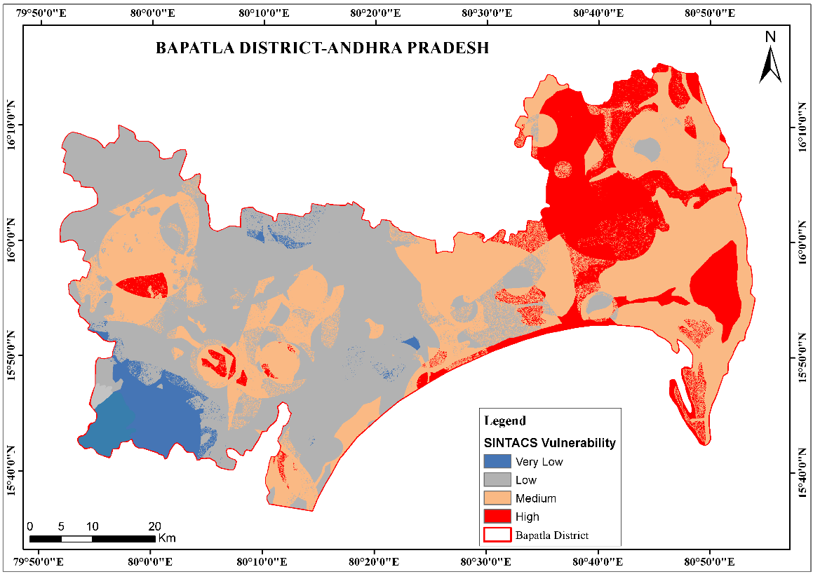
Fig: 10 SINTACS Vulnerability Index
While examining this map, one important factor that should not be ignored is the potential impact of seasonal changes. For instance, a recharge caused by the monsoon could temporarily make certain regions more vulnerable. These local geological heterogeneities may not be represented in the model because its accuracy is also influenced by the resolution of the input data. There is a suggestion that further studies could take advantage of higher-resolution datasets or even employ the SINTACS model in combination with other evaluation tools such as DRASTIC or GALDIT. The SINTACS map, highlighting priority conservation areas and sustainable development techniques, is still a big step towards the Bapatla District's clean water resource management, as it is the key to protecting water supplies to future generations.
On the other hand, the map also indicates the fact that locations in the district's west and north-west show Low to Very Low vulnerability. This can be attributed to the fact that these aquifers are deeper in those parts of the district, or there are less permeable geological structures or topography with steeper slopes that make infiltration slower. Such places can become a natural barrier to the pollution threats and, consequently, they become more resistant to pollution caused by human activities. However, more confirmation is required by utilising water quality data in drilled wells so that it can be certain whether these vulnerability ranks are consistent with the actual concentration of various contaminants, such as nitrate, chloride, or heavy metals, in wells and boreholes.

Sl. No. | Vulnerable Level | Area (sq. km) | %
1 | Very Low Vulnerable | 195.38 | 4.97
2 | Low Vulnerable | 1539.80 | 39.15
3 | Medium Vulnerable | 1547.96 | 39.36
4 | High Vulnerable | 649.64 | 16.52
 |  | 3932.78 | 100
Table: 2 Area-wise Risk level in square kilometres.
The SINTACS method of modelling evaluates groundwater vulnerability levels in Andhra Pradesh's Bapatla District. The entire district is divided into four different sensitivity classes. Very Low, Low, Medium, and High classes are used to specify areas with different levels of vulnerability. According to the report of this district, the low vulnerable category is 1539.80 square kilometres. This is equivalent to average protection from naturally occurring pollutants. The intermediate vulnerable class was found to be the majority, which covers 1,547.96 square kilometres (or 39.36%). It is almost as large as the low vulnerable area, but something seems off here. The evidence of signs of intermediate vulnerability in certain districts because agricultural activities (intensive farming) and industrial waste disposal could affect those aquifers.
The highly vulnerable class accounts for 649.64 square kilometres, which is 16.52% of the total area of Bapatla District, and is especially vulnerable to pollution from several human sources. In some environmentally sensitive regions globally, pollution risks call for somewhat hurried protective actions and quite careful monitoring. The very low category class is only 195.38 square kilometres in size and represents 4.97% of the total area. These are mainly areas with a very high level of natural protection against contamination, primarily due to geologic formations that act as a shield or deep aquifers, which are hardly accessible for mining. Most of the Bapatla District is rated as low and medium-vulnerable, covering more than 78%; a smaller part is classed as highly vulnerable. Stratification helps to precisely manage groundwater, therefore allocating resources effectively and protecting water quality, mostly in at-risk zones, quite efficiently. The surface water/groundwater sustainable resource planning area's sub aquifer water quality preliminary assessment presents the SINTACS groundwater pollution potential map, which is quite consistent with the study area topography and human activities' marked areas.

- VALIDATION
It is quite evident that a comparison of the observed fluoride concentrations with the SINTACS map classes representing various levels of vulnerability is the most revealing way to figure out the extent to which the map can be used for the identification of the fluoride-polluted groundwater in the Bapatla District, Andhra Pradesh. The essential idea that goes behind the fluoride locations is that the sources of fluoride in these areas are still within the limits of the standards. This excellent agreement very clearly shows that the SINTACS model is still functioning in these parts, as the indicative vulnerability classes are the same as the measured fluoride concentrations.
The scatter plot illustrating the relationship between the potential vulnerability and the observed fluoride concentrations shows a correlation coefficient, R = 0.1058, which is a very weak strength of the relationship, hence a very weak influence between the variables. Thus, the graph suggests that some points scattered along the line may fit the hypothesis of the model, but in the main, it is highly likely that the SINTACS method will have minimal predictive power for this area. As an example, the model would not be able to fully depict the local hydrogeological conditions or the anthropogenic factors and thus, it would be the main factors that are responsible for the presented differences among the reasons.
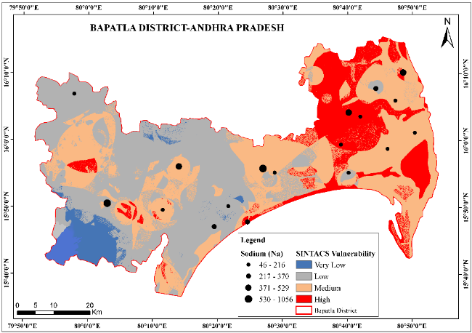
Fig: 11 SINTACS Vulnerability Index model with Validation Graph (Fluoride)
In addition to this, the cleanliness and purity of the map are also supported by the fact that the fluoride levels detected in the samples were low. However, on the other hand, the weak correlation in the validation graph also hints to the fact that the undertaking will require further studies and maybe change the model to be more precise in forecasting the Bapatla District.
- CONCLUSION
The SINTACS map of groundwater vulnerability in Bapatla District, Andhra Pradesh, features the contamination potential of the region due to hydrogeological features and is thus highly significant for groundwater conservation. The map identifies various geographical patterns in the district and assigns the vulnerability to four categories, namely: Very Low, Low, Medium and High. The regions with high susceptibility may be fully described as those areas which have very thin water tables, soil with high permeability, and very high recharge rates and, therefore, are more sensitive to contamination coming from surface sources, such as industrial effluent discharge or agriculture. If the pollution of groundwater in the region is to be controlled, then these places undoubtedly should be at the top of the list in terms of the implementation of the necessary protective measures, such as the reduction of the consumption of fertilisers, proper disposal of wastewater, and land use planning.
Places referred to as having a low to very low vulnerability are, in all probability, those places that have steep slopes, less permeable geological bodies, or deeper aquifers, which indicate that the penetration of contaminants will be very difficult. They can be a form of protection for the sustainable use of groundwater resources in the long run, but at the same time, they have to be subject to regular monitoring. An area adjacent to the transitional boundary of the medium-vulnerability zone is probably a place that can be protected mildly, especially if the human activities that are being considered occur in the same place. The vulnerability class map of Bapatla District is a decent sketch of the local hydrogeological and topographical conditions, which are the core factors for the contamination of groundwater in the district. It also shows that the district is mainly driven by hydrogeological and topographical conditions.
It visually depicts the risk of contamination of groundwater in the district due to the local hydrogeological and topographical conditions, which constitute the main factors of the contamination. The map is very useful for politicians, environmental planners, and scholars, since they can use it to target those specific places where they need to carry out actions to protect the water sources. The model could become more accurate if various studies use better resolution data, do field checking with groundwater quality data, and alter the recharge methods according to climate change. In short, the vulnerability map based on the SINTACS method gives the outline for Bapatla District to be able to carry out groundwater management that is consistent with the local water conservation measures and, therefore, still have water in that area for the future.

References
- Al Kuisi, M., El Naqa, A., & Hammouri, N. (2006). Vulnerability mapping of shallow groundwater aquifer using SINTACS model in Jordan Valley in Jordan. Environmental Geology, 50(5), 651–667.
- Aller, L., Bennett, T., Lehr, J. H., Petty, R. J., & Hackett, G. (1987). DRASTIC: A standardized system for evaluating ground-water pollution potential using hydrogeologic settings. EPA/600/2-87/035.
- Baghapour, M. A., Nazari Samani, A., Shahidi, A., & Arabi, S. (2016). Groundwater vulnerability assessment using a modified DRASTIC model in GIS environment: A case study of Rafsanjani plain, Iran. Environmental Earth Sciences, 75(11), 967.
- CGWB. (2024). Aquifer mapping for sustainable management of ground water resources in Bapatla district, Andhra Pradesh state. Central Ground Water Board, Southern Region.
- Civita, M. (1990a). The concept of groundwater vulnerability. In G. Matthess, K. P. Seiler, & F. H. Frimmel (Eds.), Contaminated Soil '88 (pp. 31–48). Springer Netherlands.
- Civita, M., & De Maio, M. (1997). Assessing and mapping groundwater vulnerability to contamination: The Italian approach. Environmental Geology, 32(3), 215–227.
- Ducci, D. (2010). Aquifer Vulnerability Assessment Methods: The Non-Independence of Parameters Problem. Journal of Water Resource and Protection, 2(4), 298–308.
- Foster, S. S. D., Hirata, R., Gomes, D., D’Elia, M., & Paris, M. (1987). Groundwater contamination: A guide to hydrogeologic risk assessment. International Hydrology Programme.
- Fusco, F., Allocca, V., Bancheri, M., Basile, A., Calcaterra, D., Coppola, A., & De Vita, P. (2024). A multi-method approach for assessing groundwater vulnerability of shallow aquifers in the Marchfeld region (Austria). Journal of Hydrology: Regional Studies, 54, 101865.
- Javadi et al. (2021). A new hybrid framework for groundwater vulnerability assessment. Environmental Earth Sciences, 80(5), 1-18.
- Kapelj, S., Loborec, J., & Kapelj, J. (2013). Assessment of aquifer intrinsic vulnerability by the SINTACS method. Geologia Croatica, 66(2), 119–128.
- Kumar, S., Tirumalaivasan, D., Nisha, R., & Mathew, S. (2013). Groundwater vulnerability using SINTACS model. Geomatics, Natural Hazards and Risk, 4(4), 339–354.
- Matham, P. K., Pattanayak, S., Kolagani, N., & Shankari, U. (2024). Rainfed Agriculture and Use of Groundwater: Winners and Losers-A Review of Literature of Experiences in India. Current Agriculture Research Journal, 12(2).
- Mishra, R. K., Mentha, S. S., Misra, Y., & Dwivedi, N. (2023). Emerging pollutants of severe environmental concern in water and wastewater: A comprehensive review on current developments and future research. Water-Energy Nexus, 6, 74-95.
- Neshat, A., Pradhan, B., & Dadras, M. (2014). Groundwater vulnerability assessment using an improved DRASTIC method in GIS. Resources, Conservation and Recycling, 86, 74–86.
- Rahman, A. (2008). Groundwater vulnerability assessment using DRASTIC model under GIS environment in a hard rock terrain of southern India. Environmental Geology, 56(6), 1127–1135.
- Sahu, I., Prasad, A. D., & Ahmad, I. (2022). Comparison of GIS-Based Intrinsic Groundwater Vulnerability Assessment Methods: DRASTIC and SINTACS. Nature Environment and Pollution Technology, 21(5), 2249–2258.
- Satheesh Kumar, D., Thirumalaivasan, D., Nisha Radhakrishnan, & Samson Mathew. (2012). Groundwater vulnerability assessment using SINTACS model. Applied Water Science, 4(4), 339–354.
- Stigter, T. Y., Ribeiro, L., & Carvalho Dill, A. M. (2006). Evaluation of an intrinsic and a specific vulnerability assessment method in comparison with ground water salinization and nitrate contamination levels in two agri. regions in South Portugal. Environmental Geology, 49(1), 79–99.
- Sudhakar, G., Swarnalatha, G., & Venkataratnamma, Z. (2014). Vishnuvardhan. Determination of water quality index for groundwater of Bapatla Mandal, Guntur District, Andhra Pradesh, India. International Journal of Engineering Research and Technology, 3(3), 77-80.
- Transforming Rainfed Agriculture with Groundwater Collectivisation. (2025, January 9). https://welllabs.org/transforming-rainfed-agriculture-with-groundwater-collectivisation/.
- Venkata Subbaiah, P., Anny Mrudhula, K., & Kaledhonkar, M. J. (2022). Groundwater Quality Assessment of Shallow Coastal Aquifer in Guntur District of Andhra Pradesh. International Journal of Plant & Soil Science, 34(11), 74–88.
- Vrba, J., & Zaporozec, A. (1994). Guidebook on mapping groundwater vulnerability. International Association of Hydrogeologists.

