Original Research Article
Hydro-Climatic Variability and Its Implications on Soil and Water Security in Kenya’s Tana Delta

Abstract
The Tana Delta in coastal Kenya is a vital ecological and livelihood zone increasingly threatened by hydro-climatic variability. This study examined rainfall and temperature trends, their influence on soil–water systems, and implications for community resilience. A mixed-methods design combined household surveys (n=382), focus group discussions, key informant interviews, meteorological records (1990–2020), and remote sensing techniques, including the Normalized Difference Vegetation Index, the Normalized Difference Water Index, and Geographic Information Systems.
Results revealed significant declines in rainfall (p<0.05) and rising temperatures averaging +1.2 °C over three decades. Remote sensing detected a 21% loss of wetlands (2017–2023), concentrated in Kipini and Ozi, driven by agricultural expansion and vegetation decline. Communities reported increased reliance on boreholes, rivers, and canals, though many water sources are increasingly saline. Soil degradation and reduced moisture retention have intensified water scarcity, undermining agriculture, pastoralism, and fishing. Household surveys confirmed that 76% of respondents experienced declining crop yields, 64% reported livestock losses, and 58% noted reduced fish catches.
These findings demonstrate that hydro-climatic variability has significantly undermined soil and water security in the Tana Delta. Effective adaptation strategies—such as wetland restoration, salinity management, and climate-smart agriculture—are urgently needed to sustain livelihoods and ecosystem services. Strengthening community-based water governance will also be critical in enhancing resilience to future climate stresses.
Keywords: Tana Delta, hydro-climatic variability, soil and water security, livelihoods, wetland loss, climate adaptation
Introduction
Climate change ranks among the most pressing global challenges of the 21st century, exerting profound impacts on hydrological cycles, soil systems, and ecosystem stability (Intergovernmental Panel on Climate Change [IPCC], 2022). Altered rainfall regimes, temperature extremes, and the increasing frequency of droughts and floods have disrupted the balance between water availability and soil health (IPCC, 2021; Ndehedehe, 2023). These disruptions are particularly critical in deltaic ecosystems, where intricate interactions among water, soil, and biodiversity sustain agricultural production and rural livelihoods (Nicholls & Cazenave, 2010). Hydro-climatic variability in these systems threatens not only food security but also the ecological integrity of wetlands that provide vital ecosystem services (Mitsch & Gosselink, 2015; Erwin, 2009).
Historically, seasonal flooding in river deltas replenished soil fertility and supported agricultural systems. For instance, annual Nile floods deposited nutrient-rich sediments vital for Egyptian agriculture (Said, 1993; Stanley & Warne, 1993), Mekong Delta floods sustained rice cultivation in Vietnam (Mekong River Commission [MRC], 2010), and seasonal inundations in Kenya’s Tana Delta enhanced grazing and recession farming (Hamerlynck et al., 2012). However, this natural regulation is increasingly disrupted by irregular precipitation, prolonged droughts, and intense flood events concentrated in short periods, leading to soil-water insecurity for communities dependent on rain-fed agriculture and pastoralism. These extremes amplify livelihood vulnerability, triggering crop failures during droughts and livestock losses during flash floods (IPCC, 2022; Ndehedehe, 2023).
The Tana Delta exemplifies this fragility. Spanning about 130,000 hectares, the delta sustains agriculture, pastoralism, and fisheries for over 300,000 people and is recognized as a Ramsar wetland of international importance (Ramsar Secretariat, 2021). Over the past three decades, rainfall variability and altered river flows attributed to climate shifts in the Horn of Africa have intensified, causing recurrent droughts and floods that accelerate soil erosion, nutrient depletion, salinization, and compaction. These processes reduce land productivity and exacerbate food insecurity (IPCC, 2022; Government of Kenya [GoK], 2018). Additional anthropogenic pressures, including upstream dam construction (e.g., High Grand Falls Dam), irrigation expansion for commercial agriculture, and wetland conversion to settlements, further compound soil and water stress (GoK, 2021; United Nations Environment Programme [UNEP], 2015).
Despite the strategic role of soil–water security in sustaining deltaic resilience, integrated studies linking hydro-climatic variability to soil degradation and water scarcity remain scarce in East African contexts (Conway & Schipper, 2011; Niang et al., 2014; IPCC, 2022). Existing research on the Tana Delta has predominantly focused on biodiversity conservation, land-use conflicts, and hydropower development (Hamerlynck et al., 2012; Maingi & Marsh, 2006), while relatively little attention has been paid to the interconnected dynamics of climate variability, soil health, and water security at community scales. This knowledge gap limits the design of effective adaptation strategies because current interventions often address either water availability or soil fertility but fail to consider their interdependence (Rockström et al., 2010; Bossio et al., 2010).
This study addresses this gap by analyzing hydro-climatic variability and its implications for soil and water security in the Tana Delta, Kenya. Specifically, it (i) examines historical rainfall and temperature trends over the past three decades, (ii) evaluates changes in surface water and wetlands using remote sensing indices, and (iii) assesses the implications of these changes for soil quality and community livelihoods.
.

2. Materials and Methods

2.1 Study Area
The research was conducted in the Tana River Delta, which is located in Tana River County, Kenya, between latitudes 2°15′S and 4°30′S and longitudes 39°15′E and 40°30′E. The delta is an ecologically sensitive and socio-economically important landscape, supporting pastoralism, crop farming, and fisheries. It experiences a bimodal rainfall pattern with long rains in (April–June) and short rains in (October–December) and an average annual rainfall ranging from 500 mm to 1,200 mm. Mean temperatures vary between 23°C and 30°C. The area is highly vulnerable to hydro-climatic variability, including droughts and floods, which have significantly affected the soil and water resources and consequently the local livelihoods.
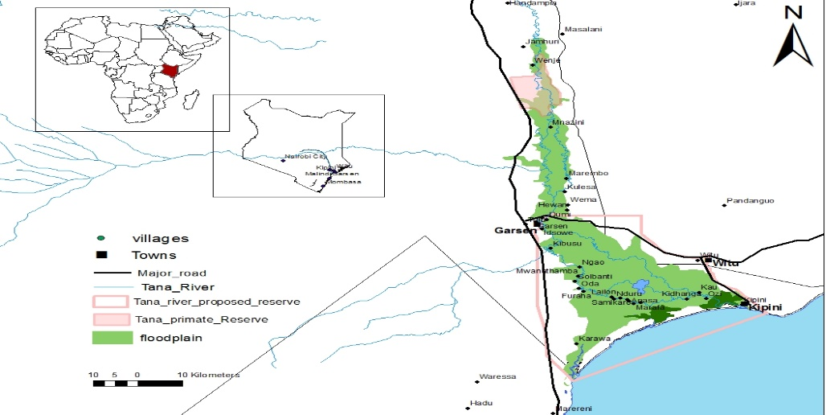
Figure 1: Map of the Tana Delta, Kenya, showing key study sites.

2.2 Research Design
Hydro-climatic variability, soil health and water security are intricate, interrelated phenomena that requires a comprehensive research design. Thus in this study, a mixed-method approach which integrated quantitative methods such as remote sensing, GIS and hydrological data analysis with qualitative methods, household surveys and interviews provided a holistic understanding of these complex systems (Pienaah et al., 2025; Goswami et al., 2023; Tekleab et al., 2014). This integration the researchers to capture both physical measurements of environmental changes and the social responses of communities thus ensuring that the data analyses reflects real-world interactions between ecological processes and human livelihoods.
2 Data Sources and Collection
2.3.1 Hydro-Climatic Data
Historical rainfall and temperature records spanning 30 years (1993–2023) were obtained from the Kenya Meteorological Department and validated against satellite datasets, namely the Climate Hazards Group InfraRed Precipitation with Station data (CHIRPS) and the Moderate Resolution Imaging Spectroradiometer (MODIS). The use of long-term ground-based observations ensures accurate detection of local rainfall and temperature trends, while satellite products provide spatially continuous coverage to fill gaps in areas with limited meteorological stations (Funk et al., 2015; Hijmans, 2020). The Standardized Precipitation Index (SPI) was then applied to quantify drought severity and frequency.

2.3.2 Remote Sensing and GIS Analysis
Landsat imagery was used to assess land cover and hydrological changes, capitalizing on its long-term consistency and medium resolution (Roy et al., 2014). Vegetation and hydrological indices, specifically the Normalized Difference Vegetation Index (NDVI; Gao, 1996) and the Normalized Difference Water Index (NDWI; McFeeters, 1996), were applied to monitor vegetation health and surface water dynamics.
Image preprocessing included atmospheric correction, mosaicking, and radiometric normalization (Lu et al., 2016). Land cover maps were generated using supervised classification (Maximum Likelihood Classifier), and accuracy was validated with ground-truth data and confusion matrices (Congalton & Green, 2009; Lillesand et al., 2015). These steps allowed reliable quantification of land and wetland changes across time and zones in the delta

2.3.3 Water Security Assessment
Household surveys were conducted across ecological and settlement zones (floodplain, deltaic wetland, and uplands), ensuring stratified representation. Households were randomly sampled using updated village lists. The survey captured both quantitative measures of water access and reliability, and qualitative insights into coping strategies and perceptions (Jepson et al., 2017; Fraser et al., 2013).
Focus group discussions (FGDs) and key informant interviews (KIIs) provided additional contextual understanding, validating household responses and exploring adaptive behaviors. GIS-based spatial analysis was applied to locate water sources relative to households and infrastructure, highlighting vulnerable areas (Srinivasan et al., 2017). Integrating household, qualitative, and spatial data improved the robustness of water security assessments and informed recommendations for climate-resilient management strategies (UN-Water, 2021).
The table 1 below provides the narrative of the sampled households for each village across the Tana Delta
Table 1: Household Survey Sample Framework
No. | Village Name | Geographical Zone | Estimated Households | Proportion (%) | Sampled Households
1 | Mnazini | Upper Section | 911 | 10.3 % | 39
2 | Marembo | Upper Section | 1200 | 13.6 % | 52
3 | Kulesa | Upper Section | 500 | 5.7 % | 22
4 | Wema | Upper Section | 400 | 4.5 % | 17
5 | Hewani | Upper Section | 300 | 3.4 % | 13
6 | Idsowe | Central Part | 1061 | 12 % | 46
7 | Danisa | Central Part | 200 | 2.3 % | 9
8 | Ghalili | Central Part | 160 | 1.8 % | 7
9 | Kibusu | Central Part | 619 | 7.0 % | 27
10 | Ngao | Central Part | 440 | 5.0 % | 19
11 | Mandingo | Lower Segment | 166 | 1.9 % | 7
12 | Semikaro | Lower Segment | 446 | 5.1 % | 19
13 | Ozi | Lower Segment | 249 | 2.8 % | 11
14 | Kipini | Lower Segment | 2165 | 24.6 % | 94
 | Total |  | 8817 | 100.0 % | 382

2.4 Data Analysis
2.4.1 Hydro-Climatic Data Analysis
Rainfall and temperature records were analyzed for long-term variability and extremes. SPI values quantified drought severity and frequency (McKee et al., 1993; Guttman, 1999). Temperature anomalies highlighted warming trends. Trend detection was conducted using the non-parametric Mann–Kendall test and linear regression (Hamed, 2008). Together, these methods provided robust insights into hydro-climatic variability.
2.4.2 Remote Sensing and GIS Analysis
Landsat imagery (1995, 2005, 2023) was processed in Google Earth Engine and ArcGIS to map land cover and wetland change. NDVI and NDWI were computed to assess vegetation health and water extent (Gao, 1996; McFeeters, 1996). Supervised classification produced land cover maps validated through ground truthing and confusion matrices (Lillesand et al., 2015; Congalton & Green, 2009). Zonal statistics enabled comparison across upper, middle, and lower delta zones.
2.4.3 Water Security Data Analysis
Survey data were analyzed in SPSS v26 using descriptive statistics to summarize water access, reliability, and usage patterns (Jepson et al., 2017; Fraser et al., 2013). Qualitative data from FGDs and KIIs were thematically analyzed (Creswell & Plano Clark, 2018). GIS mapping of water sources identified hotspots of scarcity and vulnerability (Srinivasan et al., 2017).
2.4.4 Integrated Analysis
Integrated analysis combined hydro-climatic trends, remote sensing outputs, and water security results. For instance, rainfall variability and NDWI-derived wetland changes were linked with household-level water shortages. Cross-comparison across ecological zones revealed how environmental stressors translated into household water insecurity and livelihood impacts. This integrative approach highlighted pathways of vulnerability and resilience in the Tana Delta system.

3. Results

3.1 Historical Rainfall and Temperature Trends
Analysis of 30 years of rainfall and temperature data revealed significant hydro-climatic variability in the Tana Delta. Mean annual rainfall declined by approximately 245 mm, from 1,125 mm (1995–1999 average) to 880 mm (2020–2023 average). The Standardized Precipitation Index (SPI) confirmed an increase in the frequency of drought episodes, with four severe droughts occurring after 2000 compared to only two in the preceding decade. Shortened wet seasons and erratic onset of rains contributed to agricultural uncertainty.
Temperature analyses indicated a gradual warming trend of 0.8–1.2 °C over three decades. Temperature anomalies showed persistent warming since 2010, amplifying evapotranspiration rates and reducing soil water retention. The combined rainfall decline and warming have intensified soil-water stress, reducing recharge in floodplains and accelerating desiccation of surface soils. The declining rainfall reliability and rising temperatures observed above have coincided with progressive wetland shrinkage and vegetation stress across the Tana Delta The results are illustrated in the figure 2 below.

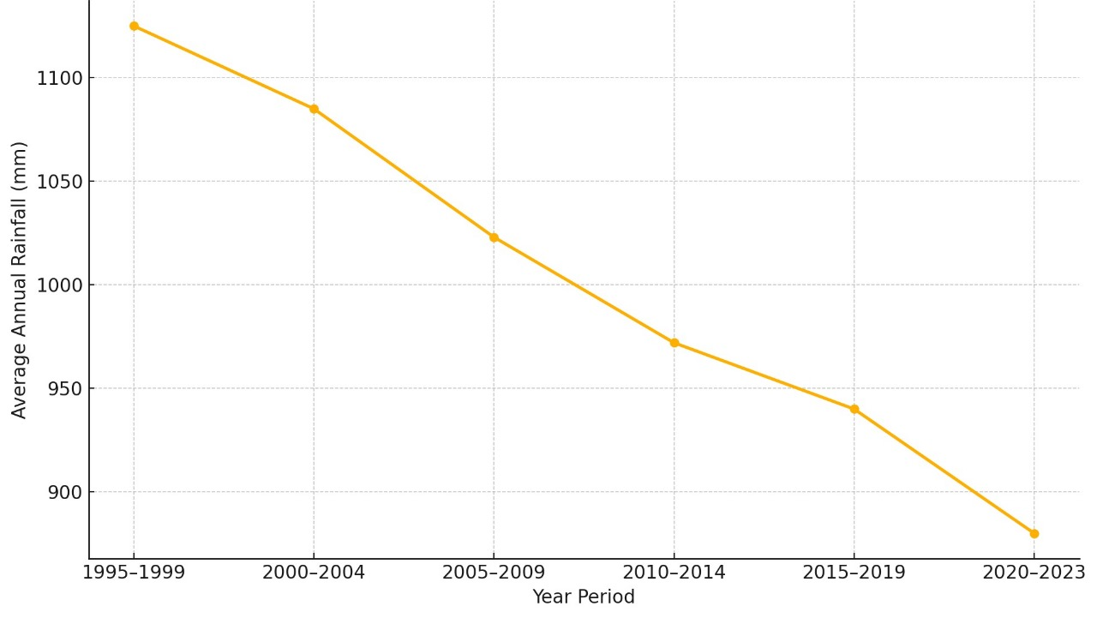
Figure 2: Average Annual Rainfall Trends in the Tana Delta (1995–2023
3.2 Wetland Dynamics and Land Cover Change
Remote sensing and GIS analyses revealed major changes in water and vegetation cover. NDWI results showed a 21% reduction in wetland extent between 2017 and 2023, with the most pronounced losses around Kipini and Ozi. NDVI trends indicated declining vegetation health in wetland and grazing areas, reflecting reduced soil moisture and increasing ecological stress.
Land cover maps demonstrated a 17% expansion of agricultural land over the same period, coinciding with the conversion of wetland and grazing areas. Field observations confirmed these trends, with visible salinity patches and soil cracking in Kipini and Mnazini. The decline in wetlands was linked to reduced groundwater recharge and diminished surface water buffering, intensifying seasonal water scarcity.. These dynamics are comprehensively illustrated in Figure 3 below.
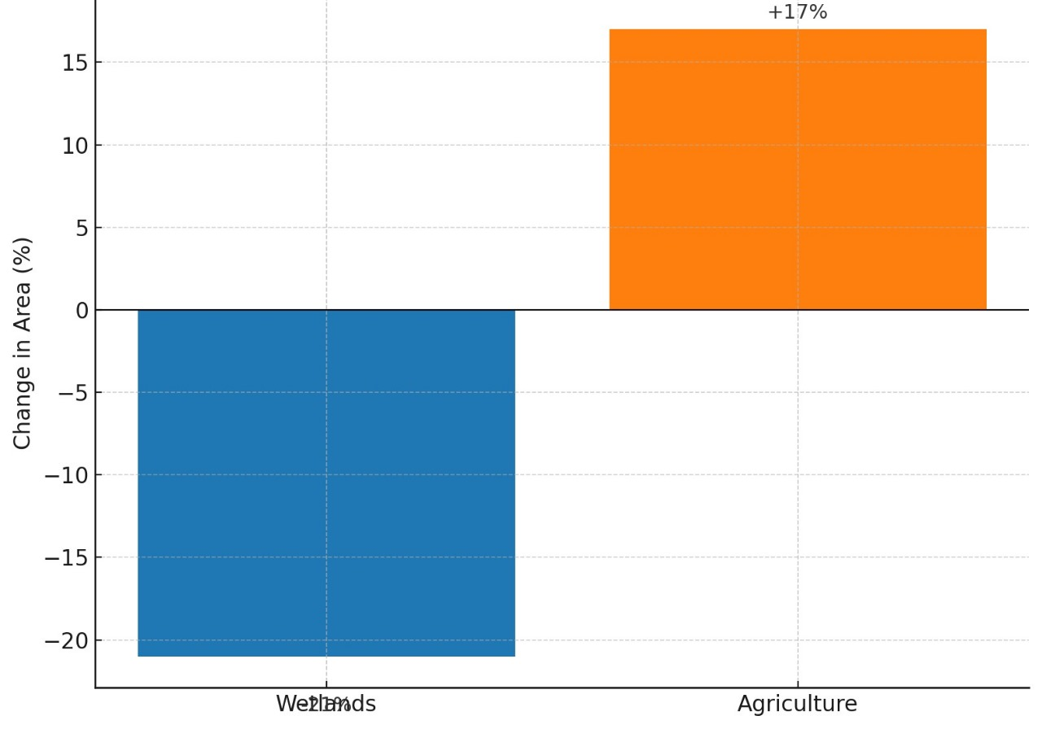
Figure 3: Land Cover Change in the Tana Delta (2017–2023)
3.3 Soil and Livelihood Implications of Hydro-Climatic and Land Cover Changes
Household surveys (n = 382) across upper, middle, and lower delta zones revealed a pronounced shift in water source dependency and corresponding impacts on soil quality and livelihoods.
42.1 % of households rely on river water, though only 28.5 % consider it safe due to turbidity and agrochemical runoff.
21.7 % depend on boreholes, of which 68.2 % report safety concerns related to salinity and metallic taste.
15.3 % use shallow wells, 11.8 % use seasonal streams, and 9.1 % use swamps or oxbow lakes, with declining perceived safety across all.
Participants in Kipini reported that borehole water had become increasingly saline, noting that “the water we now fetch tastes bitter and leaves white stains on our cooking pots” (FGD, Kipini). A Garsen group added that “even river water is not clean anymore; after the rains, it turns brown and smells of chemicals” (FGD, Garsen).
(Table 2: Household Water Sources, Perceived Safety, and Main Concerns.)
Soil Quality Effects:
Groundwater reliance has increased the use of saline irrigation water, accelerating soil salinization and reducing soil moisture retention and crop productivity. Field observations recorded cracked soils, salt crusts, and loss of organic matter, particularly in Mnazini and Kipini.
A Mnazini farmer observed that “our farms used to stay wet after the floods, but now the soil dries and cracks before the maize matures” (FGD, Mnazini). In Kipini, several respondents attributed declining yields to saline irrigation, explaining that “even when we water the crops, they wither because the soil has become salty” (FGD, Kipini).
Livelihood Disruptions:
Farming: 76 % of respondents reported reduced yields, especially in maize and rice, linked to erratic rainfall and saline soils.
Pastoralism: 64 % reported livestock losses as grazing lands degraded due to diminished floodplain inundation.
Fisheries: 58 % noted reduced catches due to shrinking wetlands and saline intrusion in estuarine zones.
FGDs also highlighted how reduced flood cycles disrupted traditional grazing and fishing patterns. A herder in Garsen lamented, “we now walk longer distances with our animals because the grass no longer grows near the river” (FGD, Garsen). A fisher in Kipini similarly explained, “fish used to breed in flooded ponds; now those ponds are dry most of the year” (FGD, Kipini).
FGDs and KIIs revealed adaptive strategies—such as borehole use, canal irrigation, and crop diversification but participants emphasized that these measures remain inadequate. One participant summarized, “we are trying new crops and wells, but the water keeps changing, and we lose more each year” (FGD, Mnazini).
The integrated GIS mapping confirmed hotspots of soil and water insecurity in lower delta settlements such as Kipini and Ozi, while upper delta areas retained better river access.
This section addresses the third gap by empirically linking hydro-climatic variability to soil degradation and livelihood vulnerability, integrating remote sensing and social data. See the narratives in the table 2 below.
Table 2. Household Water Sources, Perceived Safety, and Main Concerns
Water Source | % of Households Using Source | % Who Perceive the Water as Safe | Main Concerns
River Water | 42.1% | 28.5% | Turbidity, contamination, agrochemical runoff
Boreholes | 21.7% | 68.2% | Salinity, metallic taste
Shallow Wells | 15.3% (estimated) | 35.0% (estimated) | Contamination from nearby latrines, shallow depth
Seasonal Streams | 11.8% (estimated) | 22.5% (estimated) | Seasonal availability, waterborne diseases
Oxbow Lakes & Swamps | 9.1% (estimated) | 18.0% (estimated) | Stagnation, mosquito breeding, livestock contamination

Soil quality impacts: Increased reliance on boreholes introduced saline irrigation water, accelerating soil salinization and reducing crop productivity. Cracked soils and salt patches were commonly observed in Mnazini and Kipini.
Livelihood disruptions:
- Crop farming: Declining soil moisture and saline water led to recurrent crop failures, particularly maize and rice.
- Pastoralism: Grazing lands degraded due to reduced floodplain inundation, forcing livestock herders to travel longer distances.
- Fisheries: Oxbow lakes and swamps shrank, reducing fish availability and household fishing incomes.
FGDs highlighted these cascading impacts. For example, a participant from Mnazini noted: “The river water is no longer enough, our farms dry up, and even boreholes give salty water that damages crops.” A key informant from Kipini added: “Livestock have fewer pastures as floodplains dry faster; animals must move far to graze.”
Integrated analysis demonstrated a clear linkage: hydro-climatic variability → wetland loss and surface water decline → soil salinity and reduced moisture → livelihood vulnerability. GIS hotspot mapping showed that lower delta settlements such as Kipini and Ozi were the most affected, while upper delta areas retained relatively better access to river water.as illustrated in Figure 4 below.

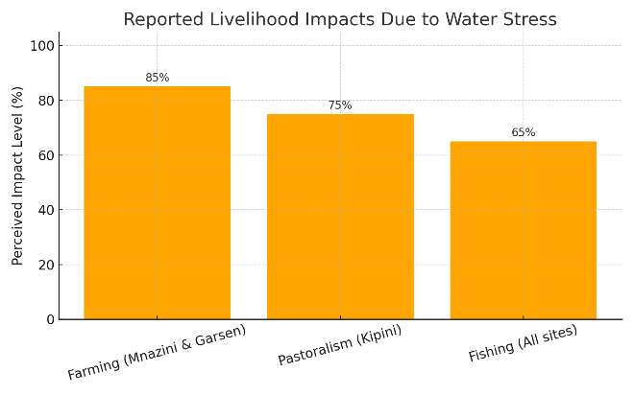
Figure 4: Reported Livelihood Impact due water stress

4. Discussion
This discussion interprets the results of the study in line with its three objectives, namely: (1) to analyze historical rainfall and temperature trends; (2) to examine wetland and land cover dynamics using remote sensing and GIS; and (3) to assess the implications of hydro-climatic and land cover changes on soil quality and community livelihoods in the Tana Delta.

4.1 Historical Rainfall and Temperature Trends
The results indicate a consistent decline in rainfall and a rise in temperature over the past three decades, signifying progressive hydro-climatic stress in the Tana Delta. The decrease in mean annual rainfall by approximately 245 mm, combined with a temperature rise of 0.8–1.2°C, confirms a trend toward increasing aridity. This finding aligns with regional studies that have documented similar patterns of declining precipitation and rising temperatures in arid and semi-arid zones of Kenya (Ongoma et al., 2018; Opiyo et al., 2021). The increased frequency of droughts and shortened wet seasons mirror broader East African climate dynamics influenced by the Indian Ocean Dipole and global warming effects (Gebrechorkos et al., 2020).
The consequences of these climatic changes are significant. Reduced rainfall reliability has decreased river recharge and floodplain inundation, leading to hydrological imbalance. The observed warming amplifies evapotranspiration rates, depleting soil moisture and accelerating desiccation, particularly in sandy and saline-prone soils typical of the lower delta. These findings substantiate the hypothesis that hydro-climatic variability is intensifying, undermining the resilience of both natural and human systems in the delta. The observed trends thus form the environmental foundation upon which subsequent ecosystem degradation and livelihood vulnerabilities manifest.

4.2 Wetland Dynamics and Land Cover Change
Remote sensing analyses demonstrated substantial loss of wetland cover (21%) and expansion of agricultural land (17%) between 2017 and 2023, largely concentrated in Kipini and Ozi. These transformations reveal a pattern of anthropogenic encroachment exacerbated by climatic stressors. Comparable trends have been reported in other Kenyan deltas, such as the Athi-Galana-Sabaki and Ewaso Nyiro, where recurrent droughts and population pressure have intensified wetland conversion (Mutie et al., 2021).
The observed decline in the NDWI and NDVI values suggests both hydrological and vegetative stress, consistent with reduced soil moisture and shrinking surface water bodies. Such conditions compromise the ecological buffering capacity of wetlands, which traditionally modulate floods and droughts (Mitsch & Gosselink, 2015). The conversion of wetland ecosystems into farmland, though partly adaptive, has disrupted hydrological connectivity and increased salinization risks. The field evidence of cracked soils, salt crusts, and vegetation dieback in Mnazini and Kipini reinforces this process of land degradation.
The findings highlight a feedback loop where climatic stress accelerates wetland loss, and the consequent reduction in wetland functions amplifies vulnerability to further hydro-climatic extremes. This dynamic aligns with the theory of ecological disequilibrium in deltaic systems, where human-induced pressures interact with climate variability to destabilize ecosystem resilience (Turner et al., 2020).

4.3 Soil and Livelihood Implications of Hydro-Climatic and Land Cover Changes
The combined climatic and land cover shifts have profoundly affected soil conditions and household livelihoods in the Tana Delta. The survey results revealed an increasing reliance on boreholes and shallow wells, many of which are saline, leading to secondary soil salinization and declining productivity. This corresponds with previous studies in coastal Kenya, which identified salinity as a major constraint to agricultural sustainability under changing hydrological regimes (Kitheka et al., 2018). The field and FGD evidence—such as reports of “bitter” borehole water and cracked farm soils—illustrates how water scarcity directly undermines soil fertility and crop yields.
The decline in agricultural productivity (reported by 76% of households) and the degradation of grazing lands (reported by 64%) point to an intensifying livelihood crisis. As floodplain systems dry and wetlands contract, traditional livelihood systems farming, pastoralism, and fishing are increasingly constrained. The observation that fish breeding ponds are now dry most of the year underscores a collapse of ecological services once sustained by flood cycles. These results confirm the hypothesis that hydro-climatic variability and environmental degradation have reduced the adaptive capacity of local livelihoods.
The spatial differentiation observed across zones further supports the integrative perspective: upper delta areas maintain relative stability due to perennial river flow, while lower delta settlements like Kipini and Ozi face compounded water and soil stress. This spatial disparity underscores the importance of localized adaptation strategies that account for geomorphological and hydrological differences within the delta.
Overall, the findings emphasize that climate-induced changes in water and soil systems are not isolated environmental phenomena but deeply intertwined with socio-economic well-being. The adaptive strategies noted borehole use, canal irrigation, and crop diversification—are reactive rather than transformative, highlighting the need for long-term resilience planning that integrates ecological restoration, water governance, and livelihood diversification.

Conclusion
The findings from this study collectively demonstrate that the Tana Delta is undergoing significant hydro-climatic transformation, manifested through declining rainfall, rising temperatures, and intensifying drought frequency. These changes have disrupted the region’s hydrological balance, reduced wetland extent, and altered soil characteristics particularly through increased salinization and loss of soil moisture. The long-term implication is a shift toward greater aridity and ecological stress across the deltaic system.
Wetland and land cover analyses revealed that climatic stressors are compounded by human-induced pressures such as agricultural expansion and unsustainable water extraction. The observed 21% reduction in wetland area and the 17% increase in farmland between 2017 and 2023 indicate that adaptive land use practices are inadvertently accelerating environmental degradation. As wetlands lose their capacity to buffer floods and sustain soil fertility, communities become increasingly exposed to climate shocks.
At the household level, the rising dependency on saline groundwater and the decline in surface water quality have contributed to soil degradation and declining productivity. Livelihood systems that depend on the natural floodplain farming, pastoralism, and fishing—have been severely impacted. The results from Kipini, Garsen, and Mnazini demonstrate that lower delta settlements face the most acute water and soil insecurity, while upper delta zones retain relative hydrological stability due to perennial river flow.
Recommendations
Based on the study findings, the following recommendations are proposed to enhance climate resilience, restore ecosystem integrity, and improve livelihoods in the Tana Delta:
- Strengthen Integrated Water Resource Management (IWRM):
Establish a basin-wide water management framework that coordinates surface and groundwater use across upper, middle, and lower delta zones. This should include community-based monitoring of water quality, controlled abstraction, and equitable allocation during dry seasons.
- Wetland Restoration and Protection:
Implement large-scale wetland rehabilitation programs targeting degraded areas in Kipini, Ozi, and Mnazini. Restoring natural flood cycles through controlled releases from upstream reservoirs and reforestation of riparian buffers can enhance hydrological balance and ecosystem services.
- Promote Climate-Smart Agriculture:
Introduce salt-tolerant crop varieties, improve soil fertility through organic amendments, and encourage rainwater harvesting and drip irrigation to mitigate soil salinization. Training farmers in climate-resilient agronomic practices will help maintain productivity under changing hydro-climatic conditions.
- Enhance Livelihood Diversification:
Support alternative income-generating activities such as aquaculture, apiculture, eco-tourism, and handicrafts to reduce overdependence on climate-sensitive sectors. Targeted livelihood diversification will strengthen household resilience to climate shocks.
- Improve Water Infrastructure and Quality Monitoring:
Invest in borehole desalination technologies and community water treatment systems to address salinity and contamination concerns. Regular testing of water sources for chemical and microbial safety should be institutionalized through local water committees.
- Strengthen Early Warning and Climate Information Systems:
Expand meteorological data collection stations and ensure real-time dissemination of rainfall forecasts, drought alerts, and flood warnings to local communities. Integrating indigenous knowledge with scientific forecasting can improve community preparedness.
- Enhance Governance and Policy Coordination:
Strengthen coordination among the National Environment Management Authority (NEMA), Water Resources Authority (WRA), and County Government of Tana River to align climate adaptation, land-use planning, and disaster risk reduction policies.
- Promote Community Participation and Capacity Building:
Engage local communities, particularly women and youth, in resource management committees and training programs on sustainable land and water practices. Their inclusion ensures ownership, compliance, and long-term success of adaptation measures.
- Support Research and Continuous Monitoring:
Establish a long-term ecological monitoring framework using remote sensing and GIS tools to track hydrological, soil, and vegetation changes. Collaborative research with universities and development partners can provide data for adaptive management.
- Develop a Delta Resilience Strategy:
Formulate a Tana Delta Resilience Strategy that integrates ecosystem-based adaptation, sustainable land use, and climate-smart development planning. This should serve as a blueprint for guiding future interventions and donor investments.
Collectively, these recommendations aim to balance environmental conservation with socio-economic development, ensuring that the Tana Delta remains ecologically functional and socially resilient in the face of climate change

References
[1] Bossio D, Geheb K, Critchley W. Managing water by managing land: Addressing land degradation to improve water productivity and rural livelihoods. Agric Water Manag. 2010;97(4):536–42. https://doi.org/10.1016/j.agwat.2009.09.008
[2] Conway D, Schipper ELF. Adaptation to climate change in Africa: Challenges and opportunities identified from Ethiopia. Glob Environ Change. 2011;21(1):227–37. https://doi.org/10.1016/j.gloenvcha.2010.07.013
[3] Erwin KL. Wetlands and global climate change: The role of wetland restoration in a changing world. Wetl Ecol Manag. 2009;17(1):71–84. https://doi.org/10.1007/s11273-008-9119-1
[4] Food and Agriculture Organization of the United Nations (FAO). The state of the world’s land and water resources for food and agriculture – Systems at breaking point. Rome: FAO; 2021. Available from: https://www.fao.org/3/cb9910en/cb9910en.pdf
[5] Government of Kenya (GoK). Tana River County Integrated Development Plan 2018–2022. Nairobi: Government Printers; 2018.
[6] Government of Kenya (GoK). National Water Resources Authority: Annual report. Nairobi: Government Printers; 2021.
[7] Hamerlynck O, Duvail S, Nyingi D, Paul JL, Leauthaud C, Morand P. The communal forest of the Tana Delta, Kenya: A socio-ecological system under threat. For Policy Econ. 2012;13(6):488–97. https://doi.org/10.1016/j.forpol.2011.06.001
[8] Intergovernmental Panel on Climate Change (IPCC). Climate Change 2021: The Physical Science Basis. Cambridge: Cambridge University Press; 2021. Available from: https://www.ipcc.ch/report/ar6/wg1/
[9] Intergovernmental Panel on Climate Change (IPCC). Climate Change 2022: Impacts, Adaptation and Vulnerability. Cambridge: Cambridge University Press; 2022.
[10] Intergovernmental Panel on Climate Change (IPCC). Synthesis report of the IPCC Sixth Assessment Report (AR6). Geneva: IPCC; 2023. Available from: https://www.ipcc.ch/ar6/
[11] Maingi JK, Marsh SE. Composition, structure, and regeneration patterns in a gallery forest along the Tana River near Bura, Kenya. For Ecol Manage. 2006;236(2–3):211–28. https://doi.org/10.1016/j.foreco.2006.09.016
[12] Mekong River Commission (MRC). State of the Basin Report 2010. Vientiane: MRC Secretariat; 2010.
[13] Mitsch WJ, Gosselink JG. Wetlands. 5th ed. Hoboken, NJ: Wiley; 2015.
[14] Niang I, Ruppel OC, Abdrabo MA, Essel A, Lennard C, Padgham J, Urquhart P. Africa. In: Barros VR, et al., editors. Climate Change 2014: Impacts, Adaptation, and Vulnerability. Cambridge: Cambridge University Press; 2014. p. 1199–1265.
[15] Nicholls RJ, Cazenave A. Sea-level rise and its impact on coastal zones. Science. 2010;328(5985):1517–20. https://doi.org/10.1126/science.1185782
[16] Ndehedehe CE. Hydro-climatic extremes in the Anthropocene. Cham: Springer International Publishing; 2023. (If available, include DOI: e.g. 10.1007/978-3-031-37727-3 or appropriate)
[17] Ramsar Convention Secretariat. The Ramsar convention manual: A guide to the Convention on Wetlands. 6th ed. Gland: Ramsar Secretariat; 2018.
[18] Ramsar Secretariat. The list of wetlands of international importance. Gland: Ramsar Convention Secretariat; 2021.
[19] Republic of Kenya. Kenya Meteorological Department climate data archives (1990–2023). Nairobi: Ministry of Environment and Forestry; 2023.
[20] Rockström J, Falkenmark M, Karlberg L, Hoff H, Rost S, Gerten D. Future water availability for global food production: The potential of green water for increasing resilience to global change. Water Resour Res. 2010;46(W00F12). https://doi.org/10.1029/2009WR008803
[21] Said R. The River Nile: Geology, hydrology and utilization. Oxford: Pergamon Press; 1993.
[22] Seto KC, Reenberg A. Rethinking global land use in an urban era. Cambridge, MA: MIT Press; 2014.
[23] Stanley DJ, Warne AG. Nile delta: Recent geological evolution and human impact. Science. 1993;260(5108):628–34. https://doi.org/10.1126/science.260.5108.628
[24] Syvitski JPM, Vörösmarty CJ, Kettner AJ, Green P. Impact of humans on the flux of terrestrial sediment to the global coastal ocean. Science. 2005;308(5720):376–80. https://doi.org/10.1126/science.1109454
[25] UN Water. Policy brief on climate change and water. Geneva: United Nations; 2020. Available from: https://www.unwater.org/publications/un-water-policy-brief-on-climate-change-and-water/
[26] United Nations Environment Programme (UNEP). Kenya wetlands atlas. Nairobi: UNEP; 2015.
[27] United Nations Environment Programme (UNEP). State of the environment and outlook report for Kenya 2022. Nairobi: UNEP; 2022.

