Impact of sand-bar movements on livelihood and income in River Aie in Assam, India

ABSTRACT

Showcasing the complexity of understanding interdisciplinarity the study dwells into the learnings from spatial science and from the agrarian change and rural development domain which suggests that in rural economies people are dependent on various livelihood strategies and there is a tendency of formation of class differentiation which include the rich, middle and poor peasants but the assumption was that with the start of capitalism these middle peasants would disappear, which didn’t take place. The study is based on GIS in order to track and map the morphological dynamics of the river and understand the livelihood practices that are present in and around these lands in the rural sandbars. These middle peasants also fall under the category of the poor often. These rural poor continued to be landowners of small landholdings. Based on these classifications these group falls under both wage laborers as well as petty commodity producers who has some amount of land but use family labor thus, meaning the livelihoods are actually a complex combination of both the wage labors and the self-employment.

Keywords: Charlands, Livelihood, River morphology, Socio-economy

1. INTRODUCTION

The Indus-Ganga-Brahmaputra-Meghna plains of the Indian subcontinent form an important part of the ecological process of char making. Sandbars or Chars are a crucial component of alluvial river systems because these rivers have an abundance of sediment and a varied capacity to transport it (Muktadir et al. 2024). Sandbars are important for ecology and provide habitat for wildlife (Arjun et al. 2023). Chars are formed when rivers carry along with them silts and other sediments while flowing from the young Himalayan mountains through the plains throughout the year and form into destructive torrents changing its character during the monsoon (Lahiri-Dutt 2014). While talking about these processes, the important thing that needs to be noted is the different characteristics of tropical areas where seasonality and ferocity of the flow of a river is very much distinct than that of the temperate ones. During this process the coarser and heavier sediments are deposited first and then the finer sediments are carried out along the way finally reaching the sea. These sediments are stored in the floodplains and channels and these storage forms the char lands. These sand bars or river islands or chars are usually found in three forms, in the form of islands in the middle of the river or in the form of bars attached to the river banks. These sand bars are three main types which include type one which is sandbars with sandy loam soil with sufficient silt, formed by erosion and located by the banks. Type two includes sandbars with no silt and are sandy in nature. The type three sandbars include the upstream north type and the downstream south type where the south types are sandbars that emerge due to alluvial deposits and the north types are basically parts of river beds that are dried up. The south types are more permanent in nature than the north type (Permaculture news 2014). The morphology of a river is an important feature of a river channel as it indicates the type of processes that are present in the river. The rivers have complex dynamics controlled by different processes and regimes (Leopold et al. 1964). Formation of chars occur when the river’s channel is in a braided form. Braided channel of a river occurs when the flow of sediments exceeds the capacity of the river to transport. Other factors include the elevation through which the river flows as higher the elevation the velocity of the river is high and as it reaches the plains, there is a decline in elevation hence, declining the velocity of the river in the plain increasing the deposit of sediments (Patel 2010; Lahiri-Dutt 2014). The distinctive geomorphic characteristics of wandering rivers differentiate them from other river systems (Zhang et al. 2025). An increase in flow of the river due to runoff or flood results in widening of the river channel due to bank erosion and decreased flow might as well result in short-term widening of the river channel thus, decreasing the ability of the river to carry sediment resulting in the increase of sand bar areas (Nath 2020). River plays an important role and these geomorphic processes have a great impact on the physical environment. Of these are the impacts of flood and bank erosion which not only impacts upon the physical environment but also the socio-economic condition of the area (Nath 2020). Livelihoods of a large number of people living on or around these chars are supported by these chars (Masoom and Khatoniar 2025). The research suggests that the vulnerability of people living on river sandbars varies significantly depending on how close they are to the mainland (Sarker et al. 2003). It is indeed interesting to note that in these unstable changing environments, distinct types of subcultures are born, quite different from the cultures that is found on the mainland (Lahiri-Dutt 2014). Land use landcover change happens to be one of the significant physical changes that occurs because of flood and riverbank erosion. Destruction of flood plain and vegetation cover being the major effects. Some of the socio-economic problems that are faced are of land loss and displacement of the people along with other assets whereas the impacts vary from place to place (Nath 2020).

In the northeastern part of India, (Mahanta 2017) the two main rivers, the Brahmaputra and the Barak are joined by numerous small and large tributaries in the country. The banks of the river Brahmaputra are said to be extremely unstable because of frequent changing flows influenced by the southwest monsoon. The braided characteristic features of this river form numerous big and small sand bars or chars differing in size and permanency.

In Assam, these sandbars play an important role in the economy by contributing significantly to the social and economic life of the region (Hoque and Hazarika 2020). Nearly half of the population based on riverine habitats face the problems of flood and erosion (Nath 2020). These sandbars or Chapori as known in the local language, cover land of about 3.60 lakhs hectare and about 24.90 lakhs of population in the Brahmaputra riverine areas. There have not been much systematic plans to remove the backwardness of the char areas because of their unique physical complexities constantly under threat of flood and erosion during the wet seasons. Some of these issues include infrastructural developments like roads, electricity, education, health facilities as well as proper drinking water or proper delivery systems for their livelihoods. Around 80% of the population that live in chars are below poverty line (DIRCAD 2025). This study would aim to understand the dynamics of the river Aie through channel deposits that falls under the north bank tributaries of river Brahmaputra and then we would try to see how these lands are used by the people and finally would evaluate the socio-economic conditions of the people, how they are affected.

Chars or sand bars or river islands are temporary pieces of sandy lands that rise from the river beds when the water level goes down and likely to disappear with the change in the river i.e., these lands are created and destroyed by the river’s actions itself. A sandbar is a natural river structure that helps stabilize river channels. It works by decreasing the river’s flow velocity and increasing the diversification of flow distribution, which prevents erosion and maintains the rivers shape (Maryono et al. 2023). These chars look like islands but are very different from islands. Usually called as Chars in Bengali, they are called by other names like diaras in the middle Ganga plains of Bihar and Uttar Pradesh. They are known as kuccha, wet and fragile lands in place of the permanent lands in Indus plain in Pakistan. These are fine, sandy or silty alluvium deposits that make more expansive chars. As the chars are evolved from water, they are used in many ways like place building whereas, more importantly from evolving from making homes to building livelihoods. The unstable conditions give rise to different forms of cultures from those in the mainland (Lahiri-Dutt 2014, Nath 2020). Chars are dynamic landscapes created by the rivers on which a number of people are dependent upon in one way or the other (Sarker et al. 2003). Because of being unstable these areas have lacked behind in many ways than their mainland counterparts. They are more vulnerable to the morphological changes that take place with time and thus need to be emphasized and studied in-depth in order to understand the challenges that are present and overcome the challenges with favorable solutions.

To truly understand the complex interrelation ship between sandbar and people, farming patterns and how they affect society, the environment, and the economy needs to be considered (Talukdar et al. 2021). The main objective of this research is to analyze the changing dynamics of the river and how these lands are used by the people dependent on them and how the dynamics affect them. The research questions are- To what extent is there a difference in the channel deposits over time and change in the position and its amount of shift? To what extent is there a relationship of sandbar dynamics and the land cover and land-use practiced by people on it? What is the effect of sand bar dynamics on the socio-economic conditions of the people?

2. methodology

Methods

In order to understand the geomorphologic dynamics of the river, Google Earth imagery, GIS geospatial application techniques have been used, under which the change in the channel deposits of ten years has been captured with an interval of around three years gap along with the changes in the study area as well as the land-use and land-cover of the area. The study area was selected by first searching for water bodies and viewing it in the google earth application. The next step was to visit the place on foot and observe if such phenomenon was actually taking place. The steps included first image survey and collection after which the images were georeferenced using GIS and then digitized. The next steps included collection of geo data base for sandbars and the river banks. Finally, the change in the study area was calculated, analyzed and compared.

Both primary and secondary data have been used for conducting this research which included both qualitative and quantitative data. The primary data being the first-hand information was collected from the field. The field survey included firstly Google Earth exploration followed by pilot survey through which the site was decided and based on the literature a semi-structured questionnaire for the socio-economic purpose was made. It included both quantitative as well as qualitative questions. There was a use of mixed methods which included semi-structured interviews based on the questionnaire. The survey was open to respondents of all sex and also included people of all age groups. The questionnaire included both closed ended as well as open-ended questions of both qualitative and quantitative types. The interviews continued with people approaching themselves to the spot out of curiosity and then taking a form of group discussions along with interview. This further took the shape of snow ball sampling where the interviewed people introduced to the other similar people of their village. The secondary data included already available data online which included journal articles, book chapters etc. all the sources collected were selected based on the relevance of the research problem.

Study area

The study site (Figure 1) of Aie river and Nepalpara village in the middle of the river falls under the coordinates of latitude 26.57 degrees and longitude 90.57 degrees under the Chirang district of Assam. The community that lives in this village belongs to the Muslim community. The district shares an international boundary with Bhutan on the North. Aie river originates from the Black mountains of Bhutan which flows through the district and falls into the mighty river Brahmaputra. The district is characterized by different landforms that include inselbergs which are in the form of separated hillocks in the alluvial plains. The alluvial plains comprise both of older alluvium and newer alluvium. The soil type of this area is basically sandy to sandy loam with alluvial deposits. The climate of this region is sub-tropical warm and humid during summers and dry to cool during the winter. The average annual rainfall of this area is 1900 mm of which it is in the monsoon that accounts 75% of the rainfall. Aie river is one of the major perennial rivers of this area forming one of the northern tributaries of river Brahmaputra. The river is fairly wide and has a braided course forming large islands of sandbars on its bed including deposition of silts and debris that is carried from the upstream. During the monsoon, sudden flood flow from the hills cause havoc to the people dwelling in and around the river (DCO 2011). According to the Census of India 2011, the village Nepalpara comes under Sidli Tehsil of district Chirang. The total population of the village is around 1006 people which consists of around 195 households (DCO 2011). The sex ratio of the village is 504 males and 502 females.

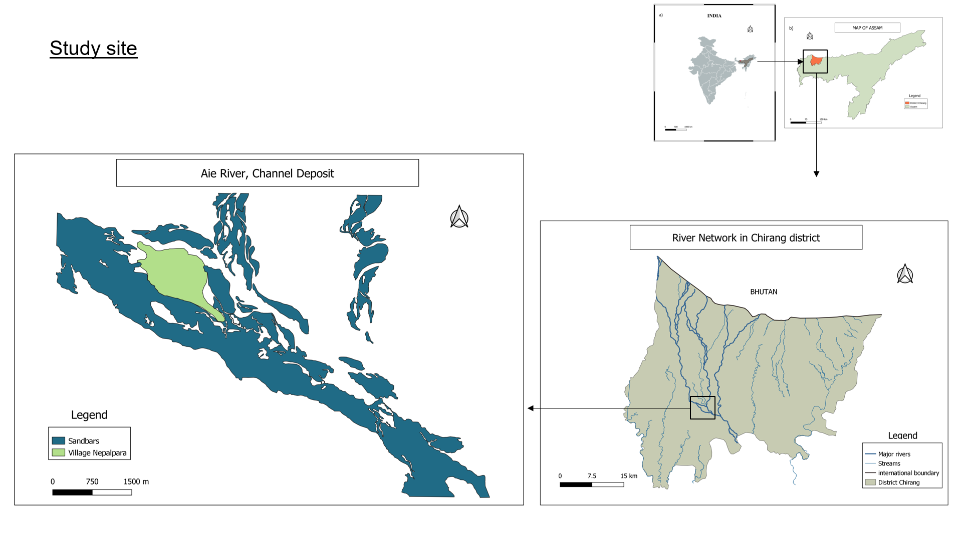
Figure 1. Study area showing the Aie river deposits and the village Nepalpara

3. results

Morphological changes in the study area

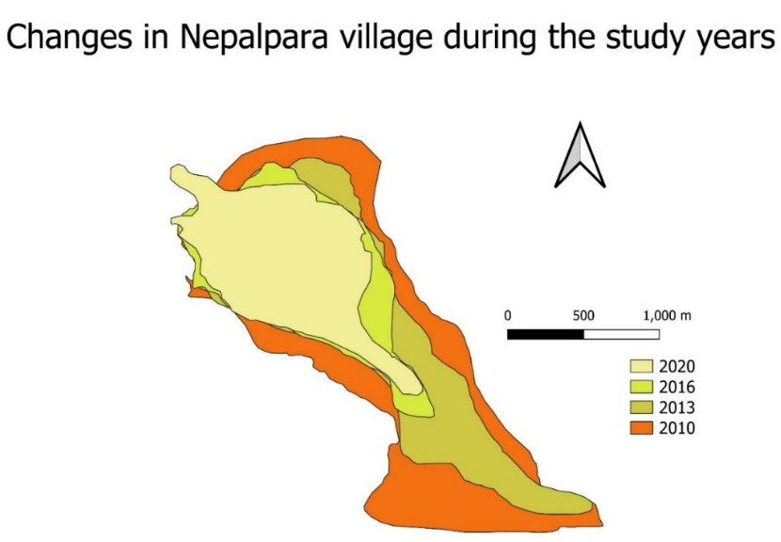
Figure 2. Morphological changes, oldest baseline data of 2010 of the study area, 2013 data showing village detached from mainland, 2016 showing decrease in village area and increased sediment, 2020 showing a stability

The sediments that are brought by the river over time keeps on changing and form varieties of morphological features that are emerging and disappearing with time. From the figure 2 we can see that the village land is connected to the mainland area and there are some number of deposits of sediments. From the area that was measured in the initial year was 3.07 sq km for the village Nepalpara and 3.24 sq km for the sandbar deposits. On the next map (Figure 3) we can see that there has been a decrease in the size of the village area from the initial area to 2.1 sq km and on the other hand an increase in the area mostly on the right side of the sandbar from the initial to 4.7 sq km. In this map we can also see that the village has been separated from the mainland. We can see that there has been further increase in the area of the sandbar deposits almost on all sides from the initial area to 6.55 sq km more than double and a further decrease in the size of the area of village to 1.26 sq km. There can be seen to have a stability in the morphology of the river after the year 2016 to 2020 as there has been a slight decline in the area of the sandbar and a much lower decrease in the village area in comparison to the other years. These sediments are accumulated up to several kilometers in size characterized by braided channels. The comparisons of these 10 years show a fluctuating change experienced in the study area.

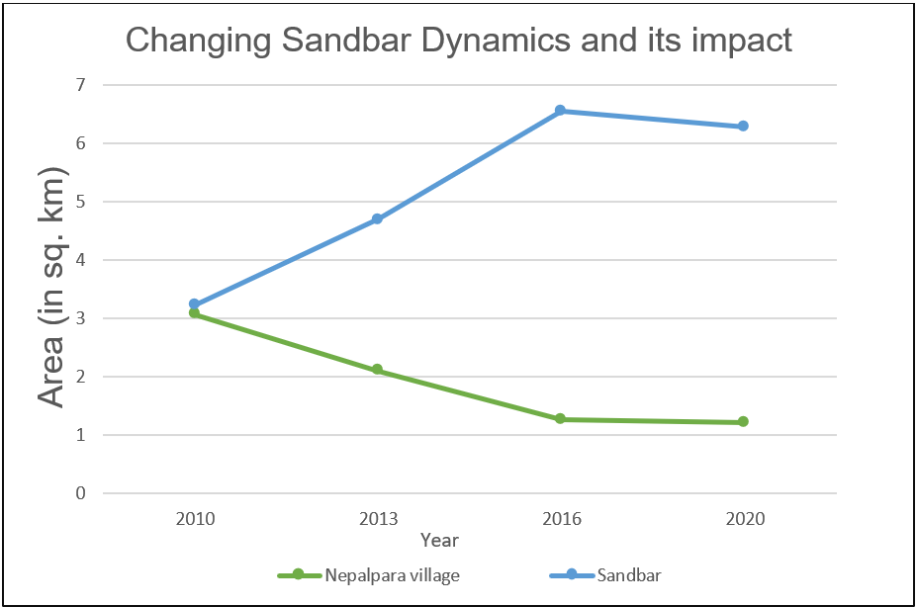

Figure 3. Line graph showing the pattern of change of the sandbars and its impact on the village, and data below

Socio-economic status

The sex ratio of the village showed (Figure 4) almost equal number of males and females where, 51% of the people in the households were female followed by 49% of the being male in the households. This matches the Census data of 2011 as an update over a decade later.

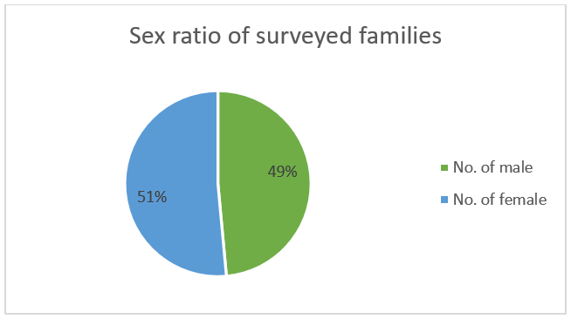
Figure 4. Sex ratio of the village

From the survey of the village Nepalpara we can see the character of the socio-economic condition of the area. When we look at the size of the households surveyed, maximum of the families had a family size of 4 to 5 members followed by equal number of people having family size of 3 or less family members and 6 to 7 family members. Only one family accounted for a family of 8 members.

Table 1. Socio-economic status of Nepalpara village, 2020



From the table1 we can see that almost all the households surveyed were involved in farming as their main source of income occupation followed by one person being a boatman. The other sources of income of the households in Nepalpara village include equal number of wage labors who practiced farming. Two of the households who were involved in farming as well as were wage labor also had one small shop each as additional income. On thing to be noted is that the boatman was only involved in boatman activities even in its additional source of income.

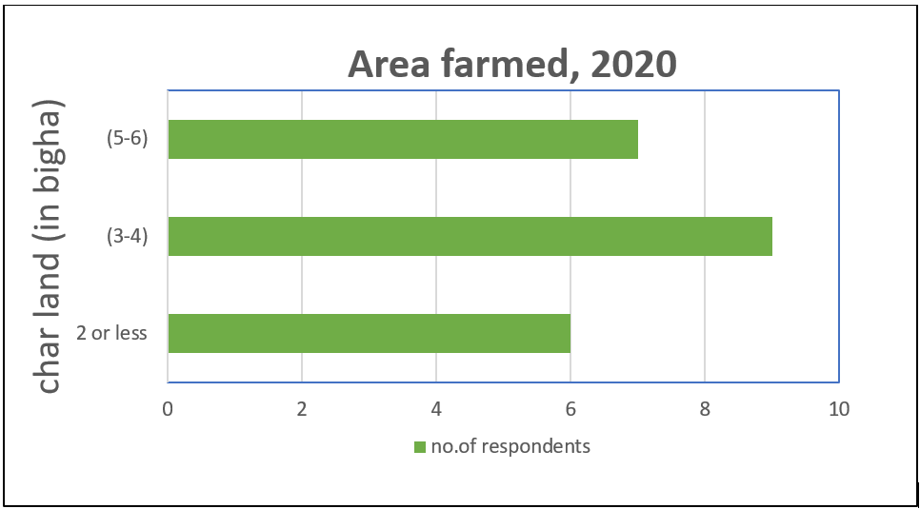
Figure 5. Char landholdings of the households, 2020

From the surveyed households, maximum number of households for this year had cultivated around 3 to 4 bigha of land (Figure 5) followed by people who had cultivated around 5 to 6 bigha of lands. The least number of people had cultivated char land area of 2 or less.

Table 2. Estimated input and output from watermelon cultivation per bigha




In order to estimate the income of the households from watermelon cultivation the cost of inputs have been calculated according to the size of the char lands cultivated (Table 2). The inputs include cost of 50 gm of seed for one bigha is Rupees 1300/- which accounts for 250 holes in one bigha. The other inputs include bamboos or nets for fencing the cultivated land which costs around Rs. 800/- per bigha followed by cow dung which in this case was fulfilled by their cattle without any expense and followed by the use of fertilizers like urea which cost for around Rs 2000/- per bigha of land. The estimated input cost for 1 bigha of land thus cost up to Rs 4100/- and the maximum in this case Rs 24000/- for 6 bighas of land.

The estimated output income of the households accounted for Rs 75000/- for 1 bigha of land which involved the factors like number of fruits produced in one plant i.e., around 4- 5 fruits, the selling price of watermelon costs about Rs 10/- per kg of which Rs 60/- per fruit if we see the average weight of a watermelon (Drake 1954). Thus, the maximum income of a household in this case is around 4.3 lakhs (Figure 6). Whereas, it should be noted that it is the estimated income from watermelon harvest earned after six months of continuous work.

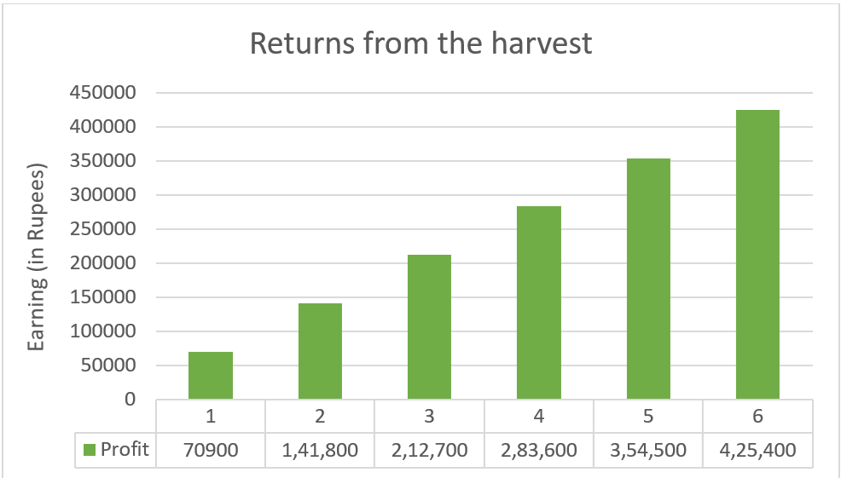
Figure 6. Earnings from water melon harvest

3. Discussions and conclusion

The primary factors making people who live on sandbars vulnerable are their strategies for adapting to their environment and their limited access to food and health services. Natural events like riverbank erosion and frequent flooding, as well as social issues such as a lack of jobs and basic public services are other major causes of vulnerability (Sarker et al. 2003). The sandbars or the char lands of the river Aie is very dynamic in nature as could be found from the combination of data collected. Like as observed by Patel (2010), the dynamic surfaces of the river Aie keep shifting because of the transportation of sediments and deposition on the river banks brought by the river which take place mostly during the monsoon season every year. The above study shows the evidence of shifting char lands with increase and decreases in depositions which might have various included concerns about manmade constructions like dams and embankments for different purposes which only resulted in increased deposits of sediments and silts by the river with rise in the formation of chars or sandbars which had a significant impact on the local flora and fauna of the area. Many villages like the village Nepalpara have been affected by the erosion of the river resulting in loss of their initial lands and being pushed back, also leading to circumstances where there are people now living in their neighbor’s lands. Similarly like in the case of Langton (2013) villagers of Nepalpara had mentioned about reduction in the flow of the river Aie during the winter running almost dry. These could have a relation with the construction of dams upstream like the Kurichu dam in Bhutan with a capacity of 60 MW in the upper part of Aie river resulting in the reduction of flow in the river during the winters (Gupta and Bhimwal 2020) and flashfloods during the monsoon because of the sudden release of water from the floodgates resulting in the submerging of areas in western Assam of which Chirang is one of the affected districts (Kalita 2019). While flood control is one of the reasons such structures are made whereas, these have further worsened the situation and the people continue suffering every year. Some of the techniques that the villagers of Nepalpara practiced in order to stop their land from eroding was use of traditional bamboo fences (see fig. 8) which couldn’t stop the flow of the river during monsoon. The risk of flooding on sandbars requires the frequent evacuation of residents whenever a massive flood event takes place (Chakrabartty 2025).

Sandbars differ from one another as well as differing in the use of these chars i.e., human use of these lands also differ from area to area to one river system to another (Lahiri-Dutt 2014). These sandbars offer reliable and sufficient income by supporting farming and agricultural activities (Talukdar et al. 2021). In this study, the people of Nepalpara are majorly dependent on char land farming which seems to have changed in the year 2020 as before that majority of the people were involved in different types of wage labors works in nearby towns, labor in oil and gas refinery nearby in the town etc. and only seven families used to practice this cropping. The earlier practitioners say this change has occurred because of the profit that others saw coming from these crops while earlier hesitant whereas, it is to be remembered that even those who were involved in this practice were occasional wage laborers along with farming. The main crop includes watermelon (Figure 7) as the major crop along with other crops like bitter melon, cucumber, bottle gourd etc. grown in less quantities. The people from this village do continuous hard work for six months from October to May and are thus seasonal farmers and the rest of the monsoonal period because of flood they are forced to stay in their village.

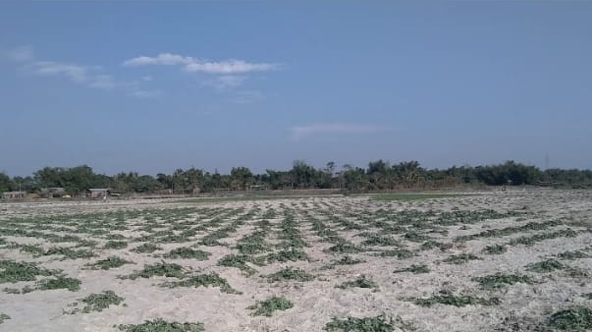
Figure 7. Watermelon cultivation in char lands of Nepalpara

These chars often show the existence of complex powerplays (Lahiri-Dutt 2014) resulting in ownership and dispute over lands in some of the cases where the richer ones are mostly better off and get control over these lands. Whereas, in the case of Nepalpara, in order to understand this class differentiation comprising of the capitalist farmer, middle farmer and the poor farmers as mentioned by (Bernstein 2010), the villagers that were surveyed were found to own small landholdings and used family labor and thus alternated between working as wage labors as well as petty commodity producers. Along with this even the land holdings as mentioned earlier might change each year along with their incomes as like the complex unstable habitats, their conditions keep changing. Inhabitants of char areas in Assam primarily rely on agriculture, but the sector’s outdated practices and farmers’ limited knowledge prevent them from maintaining these activities (Masoom and Khatoniar 2025). The Char dwellers have always found out new ways of building their assets and livelihoods.

Natural events like riverbank erosion and frequent flooding, along with social issues such as unemployment and a lack of basic public services, are the main reasons for the vulnerability of people living on river sandbars. To help them, policymakers need to create both short-and long-term strategies specifically for these communities to reduce their vulnerability and build their resilience (Sarker et al. 2019). Thus, more study is needed to understand the complex livelihoods of these petty commodity producers in their complex habitats. The changing river dynamics from bringing on sediments to transporting and deposition of these materials along with emerging and disappearing of these lands with the change in seasons to shaping the lands of the people living around these lands or on these lands through erosion has a big role to play in shaping the livelihood strategies and the socio-economic conditions of these char dwellers. In order to protect these habitats ecologically and socially, favorable efforts should be brought into effect. Efforts like creation of basic services like health, proper drinking water, education etc. The water from the river has not only created havoc for the people but has also given rise to new strategies of livelihood. Taking the example of Bangladesh’s positive outcome from the sandbar cropping techniques for the poor people where it has not only lifted the financial condition but has also led to empowerment of the women, thus, it is necessary to give importance and support the people practicing the same on a smaller scale in India which would enhance their skills as well as lift their socio-economic quality of life.

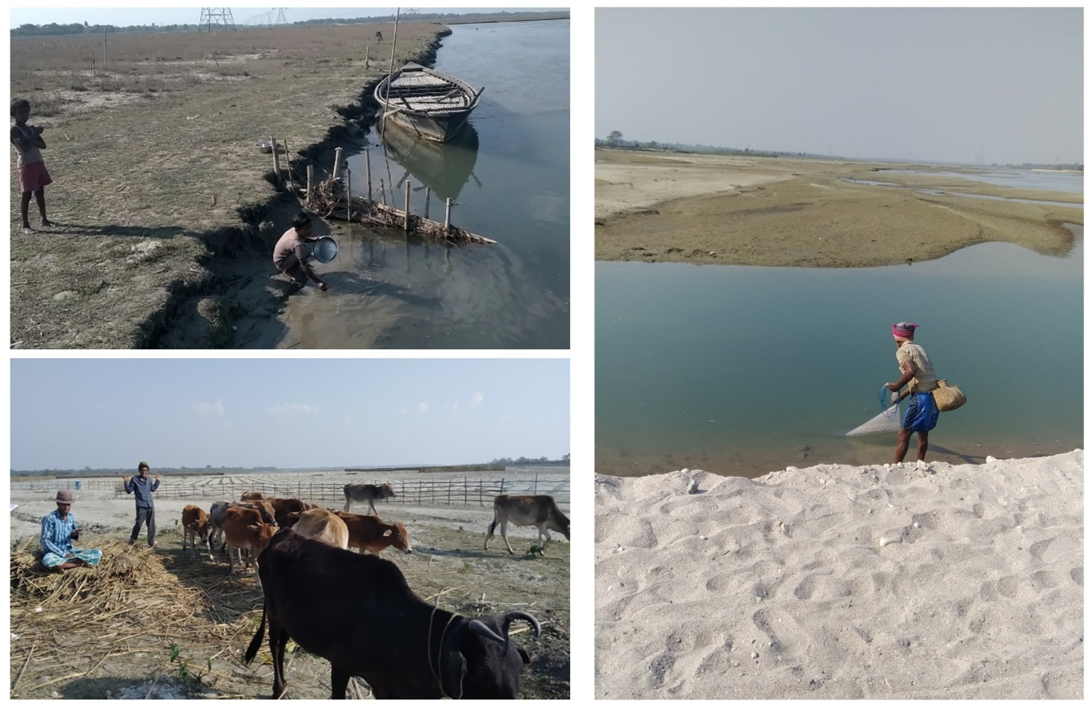
Figure 8. Bamboo fencing for erosion prevention (Top left), Cattle grazing on sandbars (Bottom left), and Fishing by villager (Right)

REFERENCES

Shampa, Muktadir, H. M., Nejhum, I. J., Islam, A. K. M. S., Rahman, M. M., & Islam, G. M. T. (2024). The Impact of Sandbars on Bank Protection Structures in Low-Land Reaches: Case of Ganges and Brahmaputra-Jamuna. Water, 16(17), 2523. https://doi.org/10.3390/w16172523
Arjun, M.S., Panda, B.P. & Arun, P.R. (2023). Sand Mining as a Contemporary threat to Sandbar Nesting Birds: a Review. Contemp. Probl. Ecol. 16, 189–204 (2023). https://doi.org/10.1134/S1995425523020038
Lahiri-Dutt, K. (2014). Islands that float within rivers, Shima: The International Journal of Research into Island Cultures, 8(2), 22-38
Permaculture news (2014). Sandbar cropping in Bangladesh, https://www.permaculturenews.org/2014/04/25/sandbar-cropping-bangladesh/
Leopold, L.B., Wolman, M.G., Miller, J.P. (1964) Fluvial processes in geomorphology, W. H. Freeman & Company, San Francisco, California. 544 p.
Patel, P. P. (2010). The shifting “charlands” of the Godavari at Rajahmundry. Indian Journal of Spatial Science, 1(1), 1–17.
Zhang, X., Chen, Y., Li, L., Zhang, L. (2025) Study on the influence of revetment on the evolution law of river channel morphology in the wandering section of Tarim river. Sci Rep 15, 16355. https://doi.org/10.1038/s41598-025-00723-x
Nath, S.R. (2020). Assessment of adaptation strategies to flooding impacts: a case study in Sipajhar development block of Darrang district, Assam, International Journal of Advanced Research in Engineering and Technology (IJARET), 11(8), 399-409, DOI: 10.34218/IJARET.11.8.2020.040
Masoom, S., Khatoniar, R. (2025). Agriculture: Source Of Livelihood In The Char Areas Of Assam, IOSR Journal Of Economics and Finance (IOSR-JEF), 16(3), 47-52
Sarker, M. H., Huque, I., Alam, M., & Koudstaal, R. (2003). Rivers, chars and char dwellers of Bangladesh. International Journal of River Basin Management, 1(1), 61–80. https://doi.org/10.1080/15715124.2003.9635193
Mahanta, C (2017). North-East India Rivers Profile (Brahmaputra Basin), South Asia Network on Dams, Rivers and People (SANDRP), Delhi, https://sandrp.in/2017/06/13/north-east-india-rivers-profile-brahmaputra-basin/
Hoque, D., Hazarika, C. (2020) An Empirical Analysis of Income and Livelihood Pattern in Sandbar Areas along the River Brahmaputra, International Journal of Social Science and Humanity, 10(2), 35-41, doi: 10.18178/ijssh.2020.V10.1010
Directorate of Char Areas Development (DIRCAD) (2025). Welfare of Minorities and Development, Government of Assam, https://dircad.assam.gov.in/about-us/history-0, 2 Sept 2025
Maryono, A., Darmayanti, A., Basyarudin, A.S., Sembada, P.T.S. (2023). Geometric Characteristics of Sandbars Case Study of Progo River, Proceedings of the 3rd International Conference on Smart and Innovative Agriculture (ICoSIA 2022), Advances in Biological Sciences Research, 10.2991/978-94-6463-122-7_22
Talukdar, G., Sarma, A.K., Bhattacharjya, R.K. (2021). Sediment analysis and modelling based approach for optimal allocation of riverine sandbar for socio economic benefits, 173, 106415, https://doi.org/10.1016/j.ecoleng.2021.106415.
Directorate of Census Operations (DCO) (2011). District Census Handbook, Chirang, Village and Town Wise Primary Census Abstract (PCA), Series – 19, Part XII – B.
Drake, L.S. (1954). A Method of Showing Farmers How to Estimate Gross Income and Marginal Value Products, Journal of Farm Economics, 36(1), 66-77
Langton, N. (2013). Political Economy Analysis of the Teesta River Basin. Asia Foundation.
Gupta, J. Bhimwal, K. (2020). India: Dams and embankments worsen floods in Assam, India Climate Dialogue, Prevention Web, UNDRR, https://www.preventionweb.net/news/view/73366
Kalita, P. (2019). Assam braces for Worse as Bhutan releases dam water, The Times of India, https://timesofindia.indiatimes.com/city/guwahati/assam-braces-for-worse-as-bhutan-releases-dam-water/articleshow/70388510.cms
Chakrabartty, S.K. (2025). People beyond the border in the sandbars of Damodar River: understanding the people’s management in a changing landscape, India, International journal of river basin management, 23(2), 273-284, https://doi.org/10.1080/15715124.2023.2289942
Bernstein H. (2010) Class dynamics of agrarian change, Agrarian change and peasant studies, Fernwood Publishing ISBN: 9781552663493, Pp 154
Sarker, M.N.I., Wu, M., Alam, G.M.M., Shouse, R.C. (2019) Livelihood Vulnerability of Riverine-Island Dwellers in the Face of Natural Disasters in Bangladesh, Sustainability, 11(6), 1623; https://doi.org/10.3390/su11061623

