Review Article

Amatoxin Poisoning: An Updated Review

Abstract:
Amatoxin-containing mushrooms—principally from the genera Amanita, Lepiota, and Galerina—cause the majority of fatal mushroom poisonings worldwide due to their potent inhibition of RNA polymerase II and the resultant hepatocellular necrosis. Characterized by a delayed onset of symptoms, amatoxin poisoning frequently leads to acute liver and renal failure, with mortality ranging from 10% to 30% without liver transplantation. This review catalogs relevant mushroom species, explores molecular and physiological mechanisms of toxicity, delineates diagnostic tools (e.g., HPLC, urine detection, Meixner test), and outlines management strategies—including activated charcoal, penicillin, N-acetylcysteine (NAC), silymarin/silibinin (Legalon® SIL), and supportive care—with the role of liver transplantation in severe cases. Advances in rapid detection methods, like portable test strips, are also discussed. The aim is to enhance early recognition and improve treatment outcomes.
Keywords: amatoxins • Amanita phalloides • RNA polymerase II • silibinin • mushroom poisoning • hepatotoxicity • Meixner test
…………………………………………………………………………………………………….

Introduction:

Mushrooms that contain amatoxins are responsible for the majority of fatal mushroom poisonings due to their delayed onset of liver cell damage. Reports indicate a rising trend in amatoxin-related poisonings globally, as young adults often confuse toxic mushrooms for hallucinogenic varieties, immigrants misidentify toxic mushrooms as safe ones from their home regions, and accidentally consume poisonous mushrooms while in nature. Amatoxins are mainly generated by three types of mushrooms: Amanita, Lepiota, and Galerina. Epidemiological studies show that the majority of mushroom poisonings result from unidentified mushrooms, with the deadliest cases linked to those containing amatoxins. Among these, species from the Amanita genus are responsible for more fatalities than other amatoxi specifically amanita phalloides accounts for the majority of deaths. Amatoxins are a group of highly toxic peptides a phalloides is responsible for 90–95% of human fatalities and has the highest toxin content. However, the content of these toxins is variable between species and even within a given species . This species is mainly predominant in Europe, especially in Central and Western Europe. The concentration of amatoxins in mushrooms, increases during the first stages of the mushroom’s development and then decreases during the mature stage. This review aims to catalog mushroom species containing amatoxins and provide a diagnostic framework for earlier recognition. Furthermore, it discusses a treatment strategies for amatoxin poisoning. ^{1.2}

Methods:

To achieve the goals of this review article, various Internet search engines such as PubMed, Medline, Google, Google Scholar, and Cochrane were utilized with specific keywords as a science and medical subject headings. The aim was to locate peer-reviewed scientific literature regarding amatoxin-containing mushroom poisonings and their mechanisms, diagnosis and treatments up to 2025. The keywords used included mushrooms, poisonous, amatoxin-containing, amatoxins, and beta, alpha-amanitin. For the first objective, which was to identify mushroom species that contain amatoxins. The second objective to study the mechanisms of amatoxin in human, and the third objective involved presenting a toxidromic approach for earlier diagnosis and treatment strategies. This included epidemiological and toxicological studies, as well as comparative analyses of different treatments and their results. Articles addressing poisonings from mushrooms that do not contain amatoxins were excluded from the review.

Amatoxin-Containing Mushroom Species:

The amatoxins are a collective group of oligopeptides found in 3 genera of mushrooms: Amanita, Lepiota, and Galerina. The amatoxins include at least 9 different toxins: α, β, γ, and ε-amanitins, amanullin, amanullinic acid, amaninamide, amanin, and proamanullin. The amatoxins are selective inhibitors of RNA polymerases, which are critical enzymes required for the synthesis of messenger RNA and micro RNAs. Among the amatoxins, α-amatoxin is considered the most hepatotoxic. The estimated median lethal dose of α amanitin in humans is 0.1 mg per kg, or about 7 to 8 mg of toxin in adults. All amatoxins are thermally stable and are not inactivated by boiling, cooking, drying, steaming, or freezing.⁵ The liver is the main target organ for ingested amatoxins and the first organ to receive absorbed amatoxins from the gastrointestinal tract via the portal venous circulation. Without messenger RNA, protein synthesis stops in the liver, and cellular-level metabolism is halted.⁶ Because amatoxins inactivate both RNA polymerase II (α-amanitin) and slightly RNA polymerase III (β-amanitin), the protein synthesis–dependent regenerative capacity of the liver is disrupted; the liver cannot repair the lysis it sustains; and centrilobular and periportal hemorrhagic hepatic necrosis ensues. Subsequently, there is a rapid rise in hepatic damage biomarkers, principally the serum transaminases, and coagulopathies result from deficiencies in hepatic clotting factors. As liver function fails, tubulointerstitial nephropathy follows and precipitates a hepatorenal syndrome that is rapidly fatal without liver transplantation. ^{1,3}

Epidemiology of Amatoxin-Containing Mushroom Poisoning:

Amatoxin-containing species occur worldwide in; Africa, America, Asia, Europe, and Oceania. Given the few reports of the amatoxin syndrome from the African, Asian, and Oceanian continents, Amanita poisoning occurs because most people are not able to tell which mushrooms species are safe for consumption when foraging. According to a reported by the National Poison Data System (NPDS) from 1999 to 2016. Over the last 18 years, 133 700 cases (7428/year) of mushroom exposure, mostly by ingestion, have been reported. Cases are most frequently unintentional (83%); cause no or only minor harm (86%); and in children <6 years old (62%). Approximately 704 (39/year) exposures have resulted in major harm. 25 (2.9/year) fatalities have been reported, mostly from cyclopeptide (68–89%) producing mushrooms ingested by older adults unintentionally. In summary, all national reports in the United States and Europe have confirmed that most mushroom poisonings are caused by unknown mushrooms, and most fatal mushroom poisonings are caused by amatoxin-containing mushrooms, which are responsible for 90 to 95% of all human fatalities. Amanita mushroom poisonings, including A phalloides poisonings, are rare but are associated with lateappearing (46 hours) symptoms, longer hospital lengths of stay, and greater likelihood of acute liver injury and failure. ⁴

- Amatoxin-Containing Mushroom Species:

The amatoxins are a collective group of oligopeptides found in 3 genera of mushrooms: Amanita, Lepiota, and Galerina. The amatoxins include at least 9 different toxins: α, β, γ, and ε-amanitins, amanullin, amanullinic acid, amaninamide, amanin, and proamanullin. ⁵

Amanita Species:

The genus Amanita contains about 600 species with 9 known poisonous species containing amatoxins, but contain 2 other classes of toxins (phallotoxins and virotoxins), which are considered nontoxic. Although Lepiota mushrooms have the greatest number of amatoxinproducing species, mushroom species in the genus Amanita especially (A phalloides, the death cap ) are responsible for most fatalities (Figure 1) followed by A virosa and A verna. Amanita mushrooms have a sweet smell and taste and a white spore print. The most common edible species are Agaricus species and Amanita lanei. ^{4,5}

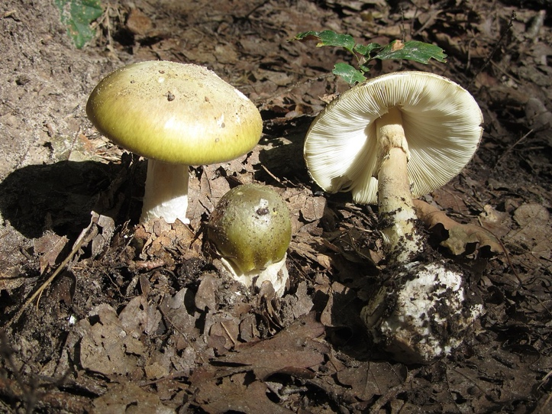
Figure 1. Amanita phalloides. Source: Wikimedia Commons, authorized for reproduction under the GNU Free Documentation License. Photographer: Archenzo.

Lepiota Species

The genus Lepiota contains about 400 species of mushrooms distributed worldwide. Several Lepiota species have caused fatalities after ingestion, including Lepiota brunneoincarnata most commonly (Figure 2). Lepiota mushrooms have a white-to-cream-colored spore print and a rubbery, unpleasant smell. Amatoxin-containing Lepiota mushrooms can be both pancreatotoxic and hepatotoxic. Unlike Amanita poisoning survivors, who typically recover normal liver function, Lepiota poisoning survivors may face later complications like chronic active hepatitis and mixed polyneuropathy. ⁵

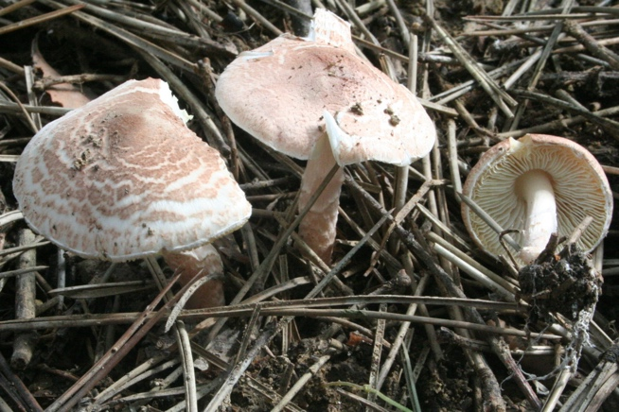

Figure 2. Lepiota brunneoincarnata. Source: Wikimedia Commons, permission granted to copy under

Galerina Species :

The genus Galerina contains about 300 species distributed worldwide, with 8 known poisonous species. Galerina mushrooms are light yellow-bronze to light brown in color and have cinnamon-brown spore prints. Galerina mushrooms have a pleasant smell, described as aromatic and fruity, and taste like fresh cucumbers. The acute liver insufficiency will progress to acute liver and hepatorenal failure in cases in which supportive therapy fails and will require liver transplantation.^{5,6}
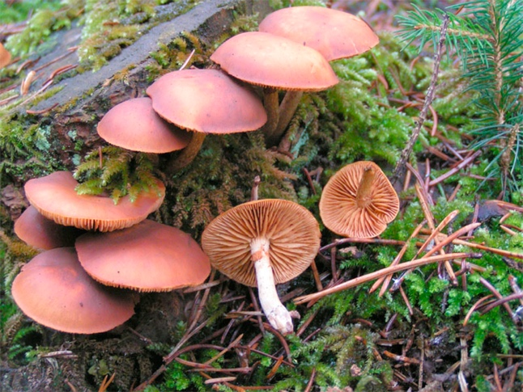
Figure 3. Galerina marginata. Source: Wikimedia Commons, permission granted to copy under the GNU Free Documentation License. Photographer: Eric Steinert.

Structure of Amatoxin:

Structurally, the amatoxins comprise the amino acid sequences Ile-Trp-Gly-Ile-Gly-Cys-Asn-Pro (α-amanitin) or Ile-Trp-Gly-Ile-Gly-Cys-Asp-Pro (β-amanitin), cyclized by head-to-tail peptide bonds and also a cross-bridge between the Trp and Cys residues. Further diversity among the amatoxins arises from differences in hydroxylations of the side chains, which include 4-hydroxyPro, γ,δ-dihydroxyIle, and 6-hydroxyTrp. ⁷

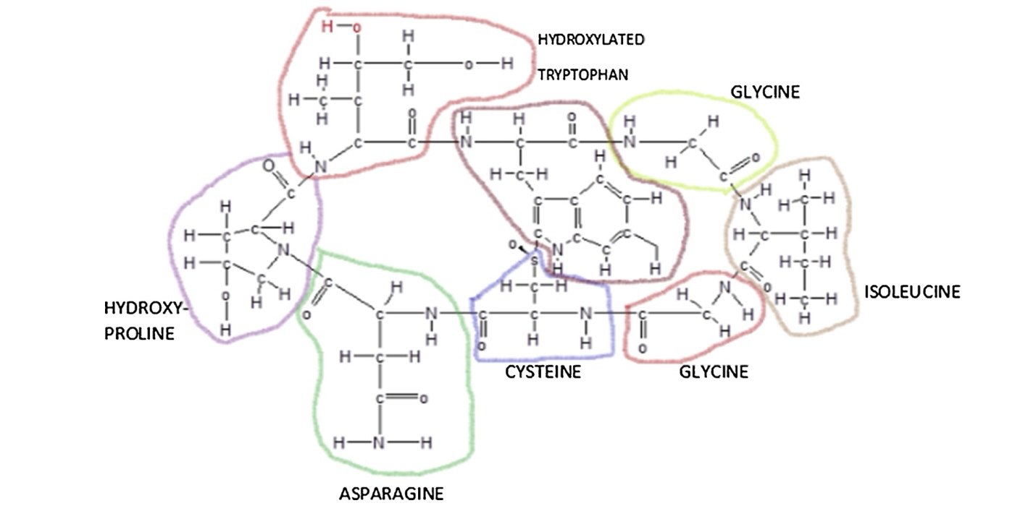
Image 1 Structural arrangement of selected amino acids in a polypeptide chain

Chemical and physical properties :

Amatoxins were first identified by Heinrich Wieland and Rudolf Hallermayer in 1941, with their structure being characterized by Wieland and his team in the 1950s and 1960s. The toxicological research does not provide clarity on the differences between neutral and acidic amatoxins. The distinction arises from the amino acid at position 7: asparagine (Asn) in neutral amatoxins and aspartic acid (Asp) in acidic amatoxins. Therefore, those with Asp, like β-amanitin and ε-amanitin, are classified as acidic, while those with Asn, such as α-amanitin and γ-amanitin, fall under neutral amatoxins. The chemical structures of the most abundant and essential amatoxins, α- and β-amanitin, have been elucidated and confirmed by X-ray crystallography. The molecules differ only in their number of hydroxyl groups and the presence or absence of an amide group at the aspartic acid side, position 7. ^{8,9}

Solubility:

The hydroxyl groups of the side chains are responsible for the high hydrophilicity of the molecule and to a certain degree, for its interaction with RNA polymerase. Hence, amatoxins in the pure state form white crystals containing about 10% crystal-bound water, and they are soluble in water, methanol, and other polar organic solvents, [e.g., ethanol] and insoluble in ether, chloroform, and other organic solvents . Amatoxins have high heat stability, and this property, combined with their solubility in water, make them exceptionally toxic as they are not destroyed by cooking, even at high temperatures like 250ºC-280ºC, drying, steaming, or freezing. When frozen at − 25ºC and after storage for 7–8 months, A. phalloides still produces fatal hepatotoxicity when ingested. Furthermore, these toxins resist enzymes and acid degradation, making them resistant to intestinal inactivation and detoxification processes. However, according to Barceloux et al., amatoxins decomposed slowly when stored in open, aqueous solutions or after prolonged exposure to sun or neon light.⁸

Lipophilic characteristics:

The lipophilic properties of amanitins are in ascending order β-amanitin < amanin < ε-amanitin < α-amanitin < amanin amide < γ-amanitin < amanullinic acid < amanullin < proamanullin. Proamanullin is a more lipophilic amatoxin than α-amanitin due to the loss of two hydroxyl groups at R1 and R2, position 3 dihydroxy-Ile, and the loss of another hydroxyl group at R5, position 2 hydroxy-Pro. In summary, the higher number of hydroxyl groups decreases in the lipophilic characteristics of amanitins. ⁹

Extraction of Amatoxin:

Extracting amatoxins is a complex process that requires a deep understanding of chemistry and mycology, as well as strict adherence to safety protocols due to their high toxicity. Over the years, the extraction procedure of amatoxins, mainly α-amanitin, focuses on the extraction of only the polar cyclopeptides by incubating macerated mushroom tissue for 12–24 h . The results of these studies showed differences in the levels of α-amanitin for Amanita sp. Several factors may be responsible for this variability of results, such as climate, topography, soil characteristics, different tissues of the mushroom fruiting body, the various growth stages, he collection site (mainly soil characteristics), and the age of the collected species also affect the amount of toxins. Thus, using mushrooms as samples requires knowledge of the total composition of the toxins, their distribution in the mushroom body tissues (cap, gills, ring, stipe, bulb and volva). The higher amatoxin content, mainly α-amanitin, β-amanitin, and γ-amanitin, is found in the ring, gills and cap, while in the volva we have a richer phallotoxin content. The amatoxin content is relatively high during the maturation period and varies between different species and also within a given species . Before amatoxin extraction, all mushroom samples were pre-treated in at least one of the following processes: washing, freeze- drying , grinding and ultrasonication . This pre-treatment of the sample has the main objective of increasing the efficiency of the extractive process . ^{10,11}

Main Steps for Amatoxin Extraction:

1. Sample Collection:Collect fresh samples of mushrooms known to contain amatoxins, such as the death cap mushroom. 2. Homogenization: Grind the mushroom tissue into a fine powder to increase the surface area for extraction. 3. Solvent Extraction: In general, and for mushroom samples, aqueous-methanolic solutions with the added mineral or organic acid (e. g., hydrochloric or formic acid) are the most commonly reported solvent mixture for amatoxin extraction. 4. Filtration: Filter the mixture to remove solid particles, retaining the liquid containing the dissolved amatoxins. 5. Concentration: Evaporate the solvent under reduced pressure or using a rotary evaporator to concentrate the extract. 6. Purification: Further purify the extract using techniques like liquid chromatography to isolate the amatoxins. 7.Analysis: Analyze the purified compounds using methods such as High-Performance Liquid Chromatography (HPLC) or Mass Spectrometry for Identification and Quantification (MSIQ). ¹²

Detecting the Amatoxins in Mushrooms and Poisoned Patients:

The time between mushroom ingestion and the onset of symptoms, alongside the type of systemic involvement (such as neurological or gastrointestinal issues), can aid in identifying the type of mushroom poisoning. The diagnosis can be confirmed by detecting α-amanitin in urine through various methods including radioimmunoassay (RIA), and high-performance liquid chromatography (HPLC). If a sample of the consumed mushroom is available, the Meixner test can be conducted. This test relies on the creation of a blue product from an acid-catalyzed reaction between amatoxins and the biopolymer lignin. Lignin remains in lower-grade cellulose paper like newsprint, which is used in the test: juice from fresh mushroom tissue is expressed onto newspaper, left to dry, and then treated with hydrochloric acid. A positive result is indicated by the appearance of a blue color. Although the Meixner test is effective at detecting high levels of alpha-amanitin, it does not differentiate between alpha-amanitin and other mushroom indoles. ^{11.14}

- Mechanisms of toxicity induced by amatoxins:

The main toxicity mechanism of amatoxin is by inhibiting RNA polymerase II, causing disruption of transcription and prolongation of mRNA. The decline of mRNA levels leads to the decrease of protein synthesis and, ultimately, to cell death and cause liver failure over 48 hours.
Other mechanisms have been suggested and include the formation of reactive oxygen species (ROS), leading to oxidative stress-related damage. Generation of ROS may also be induced by
increase of superoxide dismutase (SOD) activity and inhibition of catalase activity. Amatoxins may act synergistically with tumor necrosis factor (TNF) to induce apoptosis.
Though the underlying mechanisms are not yet known. Amatoxin-induced apoptosis may also be caused by the translocation of p53 to the mitochondria, causing alteration of mitochondrial membrane permeability through the formation of complexes with protective proteins (Bcl-xL and Bcl-2). These changes result in the release of cytochrome c into the cytosol and activation of the intrinsic pathway of apoptosis. Question marks indicate that the mechanisms remain unknown. ¹⁵

Pathophysiology:

After consuming poisonous mushrooms, symptoms usually show up between six to 24 hours later. This delay allows the body to fully absorb the toxins and complicates the diagnosis due to the potential absence of leftover specimens for proper identification. Initial symptoms including; nausea, vomiting, stomach cramps, and diarrhea. Severe cases may involve intense vomiting, severe cramping, and bloody diarrhea. Following a temporary period of seeming recovery lasting about 24 hours, the liver and kidneys may start to fail, often leading to coma, lasting damage to the liver and kidneys, and sometimes death.The onset of symptoms develops over three phases: ¹⁶

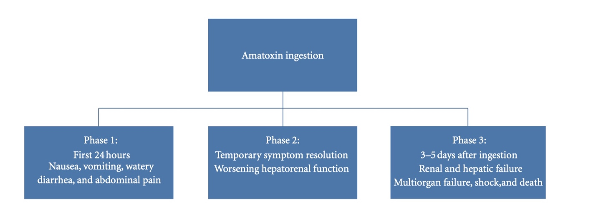
Figure 4: Phases of amatoxin ingestion.

Patients may also bleed out due to the destruction of clotting factors in their blood, and relapses may happen multiple times. The severity of toxicity depends on the concentration of amatoxins in mushrooms that influenced by factors such as growing conditions, seasonal changes, and humidity. As a result, it's challenging to accurately predict toxicity based solely on the number of mushrooms ingested. Estimates suggest that the lethal dose of amatoxins for humans is approximately 0.1 mg/kg of body weight, equating to around 7 to 8 mg of toxin, which may be found in a single mushroom. ^{16, 17, 18}

Treatment Strategies For Amatoxincontaining Mushroom Poisonings And Outcomes

There are no antidotes or specific treatments for amatoxin-containing mushroom poisonings. Without liver transplantation, a case fatality rate of 10 to 30% occurs after amatoxin-containing mushroom poisoning with acute liver failure. In addition to intravenous rehydration, general management strategies for amatoxin poisoning include both gastrointestinal absorptive techniques (eg, multidose activated charcoal to disrupt enterohepatic circulation of amatoxins) and extracorporeal removal techniques (eg, charcoal hemoperfusion, molecular absorbent recirculating systems, and fractionated plasma absorption and separation systems). The drug treatment strategies for amatoxin poisoning are all nonspecific and anecdotal. ¹⁹ The most commonly administered drug treatments alone and in combination at present include intravenous benzylpenicillin, n-acetylcysteine, cimetidine, and silymarin. Benzylpenicillin is presumed to block the hepatic uptake of α-amanitin by inhibiting its transporter protein, but this has not been confirmed in experimental animals or humans. N-acetylcysteine is a glutathione precursor, an antioxidant, and a free radical scavenger. Cimetidine is a known inhibitor of the hepatic microsomal cytochrome P450 system. Cimetidine’s enzymeinhibiting effects have been presumed to limit the metabolism of amatoxins to toxic metabolites, but this mechanism has also not been confirmed in hepatotoxic mushroom poisoning. Silymarin is an antioxidant and free radical scavenger that maintains hepatic glutathione levels and is presumed to offer hepatoprotective effects similar to n-acetylcysteine. A meta-analysis study pooled outcome data from 452 patients with A phalloides poisoning treated with silibinin Their results demonstrated significant differences in mortality in patients treated with silibinin and patients receiving supportive care without silibinin (mortality 9.8% with silibinin vs 18.3% with standard treatment). The authors concluded that silymarin has a favorable safety profile and could play a role in the treatment of A phalloides poisoning. ^{20,21}

Conclusions :

Descriptive epidemiological analyses have now confirmed that most fatal mushroom poisonings worldwide are caused by amatoxin-containing mushrooms. Although Amanita species cause most fatal mushroom poisonings, Lepiota species now cause more fatal cases after ingestion in the United States. Amatoxin poisoning is responsible for 90% of deaths from mushroom ingestions, with a fatality rate of up to 25%.Amatoxin inhibits mRNA, leading to tissue injury in the intestinal mucosa, liver, and kidneys.Clinical presentation occurs in three phases: initial gastrointestinal symptoms, temporary resolution followed by hepato-renal dysfunction, and finally, multi-organ failure. Diagnosis involves laboratory evaluation, including liver function tests and urine analysis for alpha-amanitin.Treatment is primarily supportive, including GI decontamination, and medical therapies like milk thistle. Liver transplant is often necessary for survival in severe cases. Prognosis is poor in patients with low mean arterial pressure, hepatic encephalopathy, hemorrhage, oliguria, and hypoglycemia.The King's College criteria are used to determine the need for liver transplant. Early predictors of fatal outcome include diarrhea onset less than eight hours after ingestion and a prothrombin index below 10% for four or more days after ingestion.

References:
- Garcia J, Costa VM, Carvalho A, Baptista P, de Pinho PG, de Lourdes Bastos M, et al. Amanita phalloides poisoning: Mechanisms of toxicity and treatment. Food Chem Toxicol. 2015;86:41-55. doi:10.1016/j.fct.2015.09.008
- Poucheret P, Fons F, Doré JC, Michelot D, Rapior S. Amatoxin poisoning treatment decision-making: Pharmaco-therapeutic clinical strategy assessment using multidimensional multivariate statistic analysis. Toxicon. 2010;55(7):1338-45. doi:10.1016/j.toxicon.2009.08.001
- Karlson-Stiber C, Persson H. Cytotoxic fungi – An overview. Toxicon. 2003;42(4):339-49. doi:10.1016/S0041-0101(03)00240-8
- Tuğcan MO, Akpınar AA. Mushroom poisoning: An updated review. Turkish Journal of Emergency Medicine. 2025 Jan 1;25(1):10-6.
- Diaz JH. Amatoxincontaining mushroom poisonings: Species, toxidromes, treatments, and outcomes. Wilderness Environ Med 2018;29:111-8.
- Ward J, Kapadia K, Brush E, Salhanick SD. Amatoxin poisoning: Case reports and review. J Emerg Med. 2013;44(1):116-21. doi:10.1016/j.jemermed.2012.05.016
- Mengs U, Pohl RT, Mitchell T. Legalon® SIL: The antidote of choice in patients with acute hepatotoxicity from amatoxin poisoning. Curr Pharm Biotechnol. 2012;13(10):1964-70. doi:10.2174/138920112802273353
- Jaeger A, Jehl F, Flesch F, Sauder P, Kopferschmitt J. Kinetics of amatoxins in human poisoning: Therapeutic implications. J Toxicol Clin Toxicol. 1993;31(1):63-80. doi:10.3109/15563659309000386
- Ganzert M, Felgenhauer N, Zilker T. Indication of liver transplantation following amatoxin intoxication. J Hepatol. 2005;42(2):202-9. doi:10.1016/j.jhep.2004.10.019
- Enjalbert F, Rapior S, Nouguier-Segueur C, Guillon S, Amouroux N, Cabot C. Treatment of amatoxin poisoning: 20-year retrospective analysis. J Toxicol Clin Toxicol. 2002;40(6):715-57. doi:10.1081/CLT-120014646
- Faulstich H. Mushroom poisoning by Amanita phalloides: From therapy to prevention. Toxicon. 1980;18(4):319-25. doi:10.1016/0041-0101(80)90149-9
- Ganzert M, Felgenhauer N, Schuster T, Eyer F, Gourdin C, Zilker T. Amatoxin poisoning—comparison of silibinin with a combination of silibinin and penicillin. Dtsch Med Wochenschr. 2008;133(44):2261-7. doi:10.1055/s-0028-1091268 Technical University of Munich Medscape Reference
- Hruby K, Csomos G, Fuhrmann M, Thaler H. Chemotherapy of Amanita phalloides poisoning with intravenous silibinin. Arch Toxicol. 1983;53(2):127-33. SAGE Journals
- Sahin A, Arici MA, Yilmaz Y, et al. A comparison of the effectiveness of silibinin and resveratrol in preventing α-amanitin-induced hepatotoxicity. Basic Clin Pharmacol Toxicol. 2018;122(6):633-42. doi:10.1111/bcpt.12954 Wiley Online Library
- Del Rio-Camero M, Sabaté M, Carbonell G, et al. Potential value of urinary amatoxin quantification in patients with hepatotoxic mushroom poisoning. Clin Toxicol (Phila). 2019;57(8):722-729. doi:10.1080/15563650.2018.1514384 PubMed
- Garcia J, Costa VM, Carvalho A, et al. Legalon® SIL: the antidote of choice in patients with acute hepatotoxicity from amatoxin poisoning. Food Chem Toxicol. 2012;50(2):488-92. doi:10.1016/j.fct.2011.11.056 PubMed
- Bantz D, Tuchmann-Durebex C, Schnyder O, et al. Protection by silibinin against Amanita phalloides intoxication in beagles. Vet Hum Toxicol. 1984;26(5):373-7. PubMed
- Rodríguez C, Rivière O, Sánchez-Valle M, et al. Amanita phalloides-associated liver failure: molecular mechanisms and management. Int J Mol Sci. 2024;25(23):13028. doi:10.3390/ijms252313028 MDPI
- Creppy EE, Goumenou M, Lefebvre PA. Silibinin and acute poisoning with Amanita phalloides. J Toxicol Clin Toxicol. 1997;35(5):499-503. PubMed
- Poucheret P, Fons F, Doré JC, et al. Amatoxin poisoning treatment decision-making: pharmaco-therapeutic clinical strategy assessment using multidimensional multivariate statistic analysis. Toxicon. 2010;55(7):1338-45. doi:10.1016/j.toxicon.2009.08.001 PubMed
- Khan A, Müller A, Drechsel A, et al. Assessment of α-amanitin toxicity and effects of silibinin and penicillin in different in vitro models. Toxicol Lett. 2020;323:30-38. doi:10.1016/j.toxlet.2020.05.017 PubMed

