Community Structure of Macrozoobenthos as a Bioindicator of Water Quality in Situ Sipatahunan, West Java, Indonesia

.
ABSTRACT

This study aimed to determine the water quality of Situ Sipatahunan based on the macrozoobenthic community structure as a bioindicator. The research was conducted from May 19 to June 20, 2025, using a survey method with purposive sampling for data collection. The observational data were analyzed descriptively and comparatively. The results revealed 4 classes and 11 species of macrozoobenthos, with the highest abundance found in Pomacea canaliculata (41 ind/m²; 63%). Water quality status in Situ Sipatahunan, based on macrozoobenthos, was classified as lightly to moderately polluted. This was indicated by the evenness index values ranging from 0.53 to 0.80, suggesting that the population at each station was in an unstable to relatively stable condition, with overall moderate evenness of the macrozoobenthic community. The Family Biotic Index (FBI) ranged between 4.11 and 4.69, also indicating light to moderate pollution levels. Accordingly, Situ Sipatahunan can be categorized as being polluted by certain organic materials.patients. These predictors, however, need further work to validate reliability.

Keywords: FBI index, Macrozoobentos, Organic Pollution FBI index, Water Quality, Situ Sipatahunan

1. INTRODUCTION
Situ Sipatahunan is an artificial lake located in Baleendah District, West Java, Indonesia, covering an area of 10 hectares, with an elevation of 700 meters above sea level and an average depth of 8 meters. The lake functions as a water source for agricultural land, aquaculture activities, fishing, and as a temporary reservoir during the rainy season to reduce the risk of downstream flooding, as well as a habitat for various flora and fauna. In addition, the lake is utilized by the surrounding community as a water source for daily needs, including both domestic and non-domestic purposes. Situ Sipatahunan serves as one of the drinking water sources that can be supplied to the community in Baleendah District (Zaqi, 2020).
However, Situ Sipatahunan, which is located in a densely populated area and surrounded by agricultural land, is at risk of receiving pollutant inputs such as household waste and agricultural fertilizer runoff. The accumulation of organic matter in the waters can decrease dissolved oxygen (DO) levels. In addition, residential activities and the conversion of agricultural land exert further pressure on the environment, particularly on water quality. Pollution from domestic waste, agriculture, and other anthropogenic activities may introduce organic and inorganic compounds as well as pathogenic microorganisms that disrupt the balance of the aquatic ecosystem. One of the methods to evaluate the ecological impacts of pollution is biomonitoring, conducted through the analysis of macrozoobenthos community structure as a bioindicator of water quality.
Biomonitoring is the utilization of organisms to monitor and assess/detect environmental conditions (Rosyadi & Ali, 2020). Biomonitoring of water quality in Situ Sipatahunan can be conducted using macrozoobenthos. According to Ramadhan et al. (2024), water quality influences the growth of aquatic biota, particularly macrozoobenthos. Macrozoobenthos are organisms that live within the substrate or attach to the surface of the waterbed (Rijaluddin et al. 2017). They are also widely used as indicators of water quality because of their high sensitivity to environmental changes in aquatic ecosystems (Vinda et al. 2018). Tolerant macrozoobenthos species tend to dominate polluted waters, whereas sensitive species decline or even disappear.
In recent years, studies on water quality in Situ Sipatahunan have been conducted by Supriyatna et al. (2023), who examined zooplankton abundance, and by Azkiya (2023), who investigated phytoplankton diversity. The findings of both studies indicated that the water quality in Situ Sipatahunan falls into the lightly polluted category. However, research on the macrozoobenthos community structure in Situ Sipatahunan has not yet been carried out. The analysis of macrozoobenthos community structure aims to provide a comprehensive overview of the aquatic ecosystem condition, while also serving as a basis for identifying various factors influencing water quality, including pollution levels, temperature, dissolved oxygen concentration, sediment characteristics, and biotic aspects such as abundance, composition, evenness, and biodiversity. The significance of this study lies in efforts to preserve Situ Sipatahunan as a sustainable natural resource. By understanding the condition of the macrozoobenthos community and water quality, it is expected that strategies or actions can be developed to prevent further water quality degradation in Situ Sipatahunan.

2. Research methods
2.1 Time and Location of Research
Sampling was conducted in Situ Sipatahunan, Baleendah District, Bandung Regency, West Java, Indonesia. Field sampling was carried out every 14 days over a two-month period from May to June 2025. Laboratory analyses were conducted at the Aquatic Resources Laboratory, Faculty of Fisheries and Marine Sciences, Universitas Padjadjaran.
2.2 Sampling Stations and Depth
The determination of sampling points considered environmental factors and land use around Situ Sipatahunan, Baleendah Subdistrict, Bandung Regency. The research map and a more detailed description of the sampling points are presented in Figure 1 and Table 1.
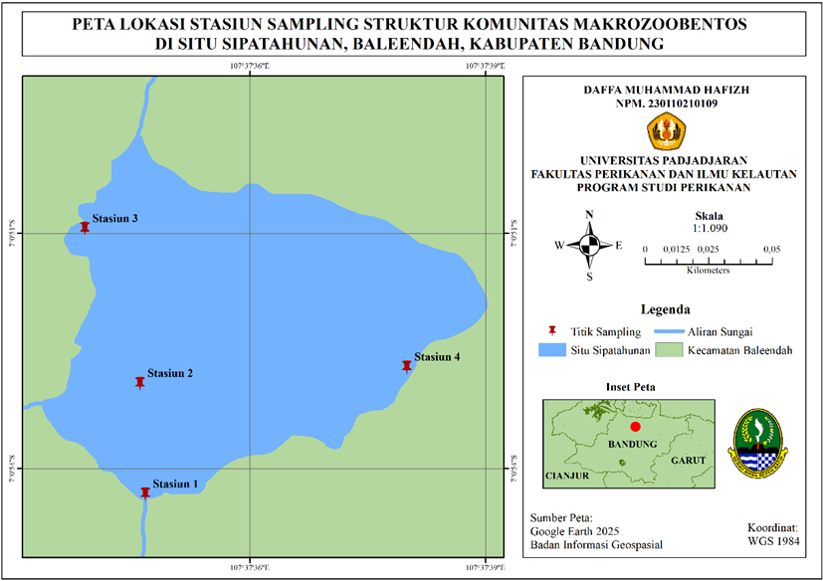
Figure 1. Location of Research Station
Table 1. Description of the research location based on environmental characteristics
Station | Location | Coodinate Point | Description
1 | Inlet zone | 7° 0'54.34"S  107°37'34.67"E | a calm-water area that is occasionally used as a source of clean water for washing
2 | Midlet zone | 7° 0'52.87"S  107°37'34.38"E | The midwater zone, often used as a target fishing area, with a depth of approximately 1 meter
3 | Antropogenic zone | 7° 0'50.95"S  107°37'33.90"E | located near residential areas, characterized by the presence of solid waste, and frequently used for bathing and dishwashing
4 | Low antropogenic activity zone | 7° 0'52.72"S  107°37'38.16"E | an area distant from human activities and pollution sources, although small amounts of waste are still present

2.3 Parameters Measured and Data Analysis
This study used a survey method with purposive sampling at four stations determined based on the level of human activities and the ecological conditions of the waters. Water quality parameters measured included temperature (thermometer), pH (pH meter), dissolved oxygen/DO (DO meter) measured in situ, and Biochemical Oxygen Demand (BOD) analyzed ex situ in the laboratory. Sediment analysis was conducted using the dry sieving method to determine substrate fractions (gravel, sand, silt).
Macrozoobenthos samples were collected using an Ekman Grab (20 × 20 cm) in deeper waters. The samples were then separated from the substrate using a sieve, preserved in 4% formalin, and subsequently identified in the laboratory. The number of individuals per species was recorded and used to analyze the structure of the macrozoobenthos community.

Table 2. Physical and Chemical Parameters
Parameter | Unit | Tool | Method | Location
1. Physical
Temperature | °C | Thermometer | Potentiometric | Direct
2. Chemical
pH | - | pH meter | Potentiometric | Direct
BOD | Mg/L | Winkler bottle | Titrimetric | Laboratory
DO | Mg/L | DO meter | Potentiometric | Direct

2.4 Data Analysis
The observational data from this study were processed using Microsoft Excel and analyzed with a descriptive-comparative method. Water quality results were then compared with the Class II water quality standards in accordance with Government Regulation (PP) No. 22 of 2021. Macrozoobenthos community data were analyzed based on species composition and abundance, the Shannon-Wiener diversity index (H’), evenness index (E), and dominance index (C). The pollution status of the waters was determined using the Family Biotic Index (FBI) according to Hilsenhoff (1988).

3. results and discussion
3.1 Physical and Chemical Water Quality Factors
Water temperature in Situ Sipatahunan ranged from 26.8–27.4°C with a deviation of 0.33–1.53°C. Station 2 recorded the highest temperature as it was located in the mid-zone directly exposed to sunlight, while Station 4 had the lowest temperature due to shading by vegetation. Temperature variation among stations was influenced by light intensity, vegetation cover, and site conditions (Gayosia & Basri, 2015). This temperature range remains within the optimum tolerance for macrozoobenthos, 25–30°C (Ruswahyuni, 2010), thus supporting the survival of benthic organisms.
The pH of the waters in Situ Sipatahunan ranged from 7.3–7.7, with the lowest average at Station 1 (7.3 ± 0.39) and the highest at Station 3 (7.7 ± 0.22). This variation was influenced by anthropogenic activities, particularly at Station 3 which receives domestic waste inputs, thereby increasing the organic and inorganic content of the waters. This finding is consistent with Yuliasti (2011), who reported that waste inputs can elevate pH values. The observed pH range remains within the optimum tolerance for macrozoobenthos, 7–8.5 (Effendi, 2003).
BOD values in Situ Sipatahunan ranged from 5.21–7.34 mg/L, with the highest average at Station 3 (7.34 ± 2.56 mg/L) and the lowest at Station 2 (5.21 ± 2.92 mg/L). The elevated BOD at station 3 reflects high organic matter input from domestic activities, particularly household waste discharged directly into the water body. Most BOD values exceeded the Class II water quality standard set by Government Regulation No. 22/2021 (>3 mg/L), with values at Stations 3 and 4 reaching more than twice the permissible limit. These findings suggest that water quality in several parts of Situ Sipatahunan has declined due to organic pollution, which may negatively impact aquatic biota (Sukmabuana, 2016).
Dissolved oxygen (DO) concentration in Situ Sipatahunan ranged from 5.77–6.77 mg/L, with the lowest value at Station 3 (5.77 ± 0.13 mg/L) and the highest at Station 4 (6.77 ± 1.0 mg/L). The low DO at Station 3 was associated with high BOD values, indicating organic matter input from domestic activities, including household wastewater and plastic waste. Elevated organic loads enhance microbial decomposition activity, which consumes oxygen and reduces DO levels.. Despite inter-station variation, DO concentrations across all sites remained above 5 mg/L, the minimum threshold considered ideal to support aquatic life (Anggraini et al. 2015).
Table 3. Result of Physical and Chemical Water Quality Analysis
Parameters | Location |  |  |  | Quality  Standards
Parameters | 1 | 2 | 3 | 4 | Quality  Standards
Temperature (°C) | 27.1 ± 1.5 | 27.4 ± 1.2 | 27.2 ± 0.4 | 26.8 ± 0.3 | Dev 3
pH | 7.3 ± 0.3 | 7.5 ± 0.1 | 7.7 ± 0.22 | 7.4 ± 0.3 | 7 – 8.5
BOD (mg/L) | 5.4 ± 2.4 | 5.2 ± 2.9 | 7.3 ± 2.4 | 7.2 ± 2.9 | > 3
DO (mg/L) | 6.4± 0.9 | 6.7 ± 0.6 | 5.7 ± 0.9 | 6.7 ± 1 | > 5
Source : Indonesian Government Regulation of the Republic of Indonesia No. 22 of 2021

3.2 Sediment Fraction
Sediment fraction analysis revealed differences in substrate composition among stations. Stations 1 (inlet) and 2 (midlet) were dominated by mud, while Stations 3 and 4 contained higher proportions of sand and gravel, with sand fractions exceeding 40%.Fine sandy substrates tend to be less favorable for aquatic organisms due to anaerobic decomposition processes that may produce toxic compounds (Ulfah et al. 2012). The highest macrozoobenthos abundance in Situ Sipatahunan was found in the class Gastropoda. This finding is consistent with Susanti (2018), who noted that gastropods generally prefer mixed mud–sand substrates, which provide more suitable conditions for their life activities..

3.3 Composition and Abudance of Makrozoobentos
The identification results revealed 11 macrozoobenthos species from four sampling stations in Situ Sipatahunan, namely Pomacea canaliculata, Pila ampullacea, Filopaludina javanica, Palaemon macrodactylus, Lymnaeidae rubingosa, Sinanodonta woodiana, Melanoides tuberculata, Tarebia granifera, Lingunia nasuta, and Melanoides plicaria. The community was dominated by P. canaliculata (63.8%), followed by T. granifera (13.5%) and F. javanica (7.2%). Species with high tolerance to environmental conditions, such as P. canaliculata, tend to dominate waters under organic pollution pressure (Ratih et al. 2016).

Table 4. Macrozoobenthos Abundance and Diversity
Class | Identified species | Abudace at each station (ind/m²)
Class | Identified species | 1 | 2 | 3 | 4
Gastropoda | Pomacea canaliculata | 29 | 1 | 1 | 18
Gastropoda | Pila ampulacea | 5 | 0 | 0 | 0
Gastropoda | Filopaludina javanica | 2 | 0 | 9 | 2
Gastropoda | Lymnaeidae rubingosa | 2 | 0 | 0 | 0
Gastropoda | Melanoides tuberculata | 0 | 3 | 0 | 0
Gastropoda | Tarebia granifera | 1 | 6 | 0 | 4
Gastropoda | Melanoides plicaria | 0 | 3 | 0 | 2
Bivalvia | Sinanodonta woodiana | 0 | 1 | 0 | 0
Bivalvia | Corbicula javanica | 0 | 1 | 0 | 0
Malacostraca | Palaemon macrodactylus | 1 | 0 | 0 | 0
Total Macrozoobenthos |  | 40 | 15 | 10 | 26

Macrozoobenthos abundance varied among stations, with the highest recorded at Station 1 (40 ind/m²), characterized by mud–sand substrates rich in organic matter, and the lowest at Station 3 (10 ind/m²), dominated by gravel substrates with the highest BOD (7.34 mg/L). This condition restricted the presence of sensitive species, leaving only tolerant organisms such as P. canaliculata and F. javanica. Overall, the class Gastropoda dominated the macrozoobenthos community across the study area. This finding is consistent with previous studies showing that gastropods prefer muddy substrates with high organic content (Chusna et al. 2017), and their abundance can serve as an indicator of organic pollution (Lutfi et al. 2020).
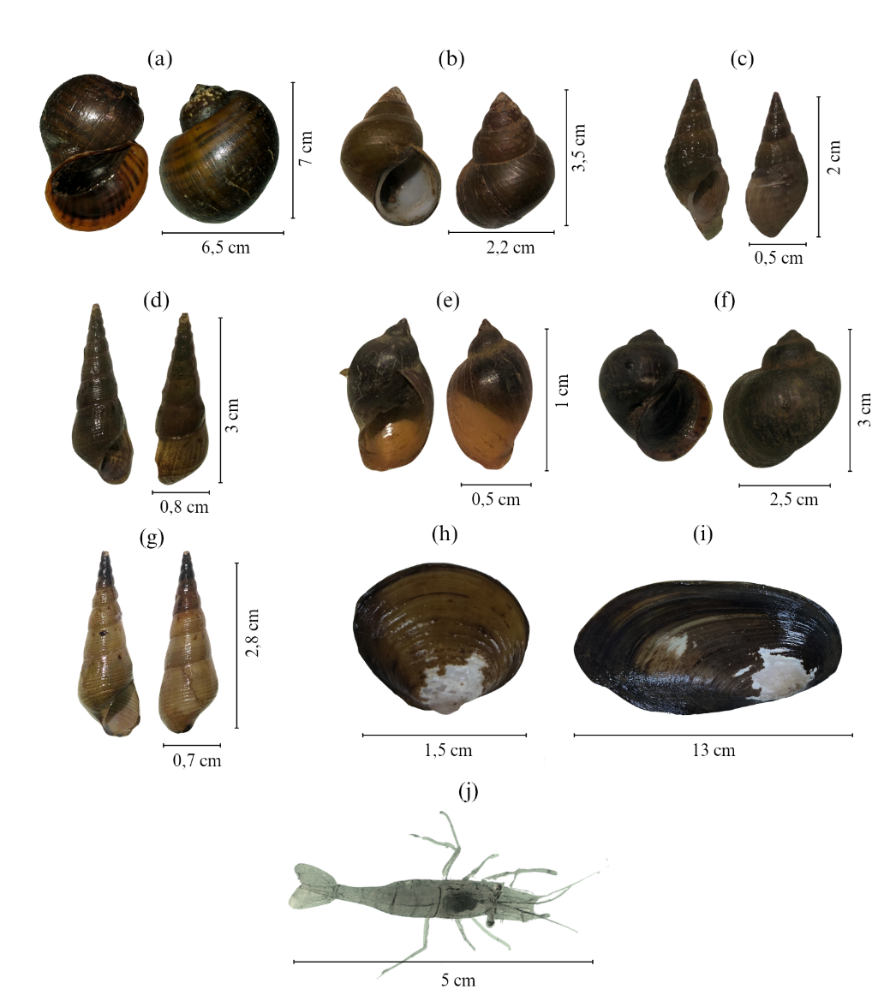
Figure 2. . a) Pomacea canaliculata, b) Filopaludina javanica,
c) Tarebia granifera, d) Melanoides tuberculata, e) Lymnaeidae rubingosa,
f) Pila ampulacea, g) Melanoides plicaria, h) Corbicula javanica
i) Sinandonta woodiana, j) Palaemon macrodactylus

3.4 Diversity Index (H'), Evenness Index (E), and Dominance Index (C)
The macrozoobenthos diversity index (H’) in Situ Sipatahunan ranged from 0.58–0.94, indicating low to moderate diversity levels. The highest value was recorded at Station 1 (0.94), while the lowest was at Station 3 (0.58). According to the Shannon-Wiener criteria, H’ < 1 indicates low diversity, 1 < H’ < 3 moderate, and H’ > 3 high. Ecological stress was strongly associated with anthropogenic activities, particularly at Station 3, which is adjacent to residential areas and receives inputs from domestic and agricultural waste as well as inorganic pollutants such as plastics, diapers, and styrofoam. Such inputs potentially lower DO levels and disrupt macrozoobenthos productivity (Munandar et al. 2016).
The evenness index (E) ranged from 0.53–0.80. The highest value was found at Station 2 (0.80), reflecting a relatively stable community with an even distribution of individuals, while the lowest was at Station 3 (0.53), indicating an unstable condition due to dominance by pollution-tolerant species. At Stations 1, 3, and 4, E values fell within the “unstable” category (0.50 < E < 0.75), highlighting imbalanced species distribution and ecological stress. According to Odum (1993), communities with E values close to 1.00 represent stable ecosystems with balanced individual distribution. Hence, most macrozoobenthos communities in Situ Sipatahunan remain imbalanced, especially in the anthropogenic zone, while Station 2 is relatively more stable.
The dominance index (C) ranged from 0.25–0.72, classified as low to moderate. Stations 2 and 3 (showed low dominance, while stations 1 (inlet) and 4 (minimal anthropogenic activity) showed moderate dominance. These differences were influenced by habitat zones, where littoral areas (stations 1 and 4) provide better light and nutrient availability, thereby supporting higher benthic diversity (Muhammad, 2019). Pomacea canaliculata dominated several stations, particularly 1, 3, and 4. High dominance indicates low species richness and uneven distribution (Munandar et al. 2016). At Station 3, dominance was driven by organic pollution from anthropogenic activities and coarse gravel substrates, which restricted sensitive species. P. canaliculata, as an invasive species with broad environmental tolerance (Bunga et al. 2018), proliferated rapidly and dominated the community. The high abundance of gastropods also indicates organic pollution in the aquatic ecosystem (Wulansari & Kuntjoro, 2018).
Table 5. Results of index analysis
Parameters | Location
Parameters | 1 | 2 | 3 | 4
H’ | 0.94 | 0.88 | 0.58 | 0.90
E | 0.68 | 0.80 | 0.53 | 0.56
C | 0.58 | 0.25 | 0.46 | 0.72
FBI | 4.11 | 4.38 | 4.69 | 4.59

3.5 Family Biotic Index (FBI)
The Family Biotic Index (FBI) values in Situ Sipatahunan ranged from 4.11–4.69, indicating water conditions from slightly to moderately polluted by organic matter. The lowest value was recorded at station 1 (4.11; lightly polluted), while the highest was at station 3 (4.69; moderately polluted), which also experienced the greatest anthropogenic pressure. Overall, water quality across the four stations was still considered good, although inter-station differences indicated varying levels of organic pollution influenced by domestic activities and local environmental conditions.
The dominance of tolerant species such as Pomacea canaliculata (tolerance value 4), Filopaludina javanica (tolerance value 6), and Tarebia granifera supports these findings. P. canaliculata is recognized as a facultative organism capable of surviving in waters ranging from lightly to moderately polluted (Sulaeman et al. 2020). Moreover, P. canaliculata, F. javanica, and T. granifera were found at nearly all stations, demonstrating their high adaptive capacity in both soft (muddy) and hard (gravelly) substrates (Athifah et al. 2019)

4. Conclusion
Total of 11 macrozoobenthos species were identified in Situ Sipatahunan, dominated by Pomacea canaliculata, Tarebia granifera, and Filopaludina javanica. Water quality parameters (temperature, pH, DO, and sediment fractions) were generally within the optimum range for macrozoobenthos survival, although variations were observed due to anthropogenic inputs, particularly at Station 3. Biological indices revealed low to moderate diversity and evenness, with dominance by tolerant species, while the Family Biotic Index (FBI) indicated that the waters were slightly to moderately polluted by organic matter. These findings demonstrate that anthropogenic activities, especially domestic waste, strongly influence water quality and benthic community structure, with gastropods such as P. canaliculata serving as reliable indicators of organic pollution.

References

Anggraini, N., Simartmata, H. A., & Sihotang, C. (2015). Dissolved Oxygen Concentration from the Water around the Floating Cage Fish Culture Area and from the Area with No Cage, in the DAM site of the Koto Panjang Reservoir. Doctoral Dissertation, Riau University.
Athifah, A., Putri, M. N., Wahyudi, S. I., & Rohyani, I. S. (2019). Mollusc Diversity as a Bioindicator of Water Quality in the Kebon Kongok Landfill Area, West Lombok. Journal of Tropical Biology, 19(1), 54–60.
Azkiya, R. (2023). Analysis of Water Quality Based on Phytoplankton Diversity in Situ Sipatahunan, Baleendah, West Java [UIN Sunan Gunung Djati]. https://digilib.uinsgd.ac.id/73752/.
Chusna, R. R. R., Rudiyanti, S., & Suryanti, S. (2017). The Relationship of Dominant Substrate to Gastropods Abundance in the Mangrove Forest of Kulonprogo, Yogyakarta. SAINTEK PERIKANAN: Indonesian Journal of Fisheries Science and Technology, 13(1), 19.
Effendi, H. (2003). Water Quality Review. Yogyakarta: PT. Kanisius.
Gayosia, A., & Basri, H. (2015). Water quality due to human activities in the freshwater lake catchment area of ​​Central Aceh Regency. Journal of Land Resource Management, 4(1), 543.
Hilsenhoff, W.L.. (1988). Rapid Field Assessment of Organic Pollution with a Family-Level Biotic Index. Journal of the North American Benthological Society, 7(1): 65-68.
Lutfi, M., Nurruhwati, I., Hasan, Z., & Herawati, H. (2020). Macrozoobenthos Spatial Distribution as an Indicator of Cikeruh River Pollution in Sumedang Regency, West Java. Asian Journal of Fisheries and Aquatic Research, 6(2), 18–26.
Mochamad Zaqi S, (2020) The Concept of Utilizing Sipatahunan Lake as a Drinking Water Source in Baleendah District, Bandung Regency. Undergraduate thesis, Universitas Pasundan. Anas, P., Jubaedah, I., & Sudinno, D. (2017). Water Quality and Waste Load of Floating Net Cages in Jatiluhur Reservoir, West Java. Journal of Fisheries and Marine Extension, 11(1), 35-47.
Munandar, A., Ali, M. S., & Karina, S. (2016). Macrozoobenthos Community Structure in the Kuala Rigaih Estuary, Setia Bakti District, Aceh Jaya Regency. Scientific Journal of Marine and Fisheries Students, Unsyiah, 1(3), 331–336.
Odum, E.P. (1993). Fundamentals of Ecology. Translated by Tjahjono Samingan. Third Edition. Yogyakarta: Gadjah Mada University Press.
Government Regulation of the Republic of Indonesia Number 22 of 2021.
Ratih, I., Prihanta, W., & Susetyarini, R. E. (2016). Inventory of Macrobenthic Diversity in the Brantas River Basin, Ngoro District, Mojokerto as a Learning Resource for Biology for Senior High School Grade X Students. JPBI (Indonesian Journal of Biology Education), 1(2), 158–168
Rijaluddin, A. F., Wijayanti, F., & Haryadi, J. (2017). Macrobenthic Community Structure in Situ Gintung, Situ Bungur, and Situ Kuru, East Ciputat. Journal of Environmental Technology, 18(2), 139. https://doi.org/10.29122/jtl.v18i2.1613 Heriyanto, H., Hasan, Z., Yustiati, A., & Nurruhwati, I. (2018). The Impact of Floating Net Cage Cultivation on Primary Productivity in the Darma Reservoir, Kuningan Regency, West Java. Journal of Fisheries and Marine Affairs Vol. IX No. 27, 33.
Rosyadi, H. I., & Ali, M. (2020). Biomonitoring of Macrobenthos as an Indicator of River Water Quality. Jurnal Envirotek, 12(1), 11–18.
Ruswahyuni, (2010). Population and Diversity of Macrobenthos in Closed and Open Waters in Awur Bay, Jepara. Scientific Journal of Fisheries and Marine Sciences. Vol. 2(1): 11–20.
Sukmabuana, P. (2016). Absorption of Cs-134 in Water by Catfish (Clarias sp.). Proceedings of the National Seminar on Nuclear Energy Technology, 713–720.
Sulaeman, D., Nurruhwati, I., Hasan, Z., & Hamdani, H. (2020). Spatial Distribution of Macrozoobenthos as Bioindicators of Organic Material Pollution in the Citanduy River, Cisayong, Tasikmalaya Region, West Java, Indonesia. Asian Journal of Fisheries and Aquatic Research, 9(1), 32–42.
Supriyatna, A. A., Mustahiq Akbar, R. T., & Azizah, A. N. (2023). Zooplankton Diversity as a Bioindicator of Water Quality in Sipatahunan Baleendah Lake, Bandung Regency, West Java. Al-Nafis: Journal of Biology and Biology Education, 3(2), 77. https://doi.org/10.46339/al-nafis.v3i2.1151.
Susanti, R. (2018). Gastropod Community Structure in the Mangrove Forest of Lalang Village, Sungai Apit District, Siak Regency. University of Riau. Pekanbaru
Ulfah, Y., Widianingsih, & Zainuri, M. (2012). Macrobenthic Community Structure in the Waters of Morosari, Bedono Village, Sayung District, Demak. Journal of Marine Research, 1(2), 188–196.
Vinda, G., Pelealu, E., Koneri, R., & Butarbutar, R. R. (2018). Abundance and Diversity of Macrobenthos in the Tunan Waterfall River, Talawaan, North Minahasa, North Sulawesi. Scientific Science, 18(2), 97–102. Ismail, I., Melani, W. R., & Apriadi, T. Water Fertility Level in the Waters of Kampung Madong, Kampung Bugis Subdistrict, Tanjungpinang City. Ju

