Original Research Article
Climate-Induced Water Resource Variability and Livelihood Adaptation in Kenya’s Tana Delta
Abstract
The Tana Delta region of Kenya is increasingly vulnerable to climate-induced hydro-climatic variability, posing significant risks to water security and livelihoods dependent on farming, pastoralism, and fishing. Despite growing evidence of climate change impacts in East Africa, few empirical studies integrate hydro-climatic trends, water resource dynamics, and adaptive livelihood responses at the deltaic ecosystem scale. This study addresses this gap by analyzing 30 years of historical rainfall and temperature data, Normalized Difference Water Index (NDWI) from satellite imagery, and hydrological records to assess spatiotemporal water variability. Household surveys (n = 382), focus group discussions, and key informant interviews were also conducted to examine community adaptation strategies. Results indicate a 245 mm decline in mean annual rainfall and a 0.8–1.2 °C rise in temperature over three decades, leading to seasonal flow variability, shrinking wetlands, and increased salinity intrusion. NDWI analysis reveals a progressive decline in surface water bodies, particularly during long dry seasons. Livelihoods have been severely affected, with rain-fed agriculture and livestock herding experiencing frequent losses, and fishing communities facing reduced fish stocks. Adaptation measures include livelihood diversification, water harvesting, and small-scale irrigation; however, these remain constrained by limited resources and policy gaps. Enhancing water governance, restoring wetlands, and supporting climate-resilient livelihoods are critical for sustaining the Tana Delta’s socio-ecological systems under changing climatic conditions.
Keywords: Climate change; water variability; livelihoods; adaptation strategies; Tana Delta; Kenya
Highlights
- Water resources in the Tana Delta have declined by 24% over three decades
- Key livelihoods farming, fishing, pastoralism are increasingly water-stressed
- Adaptation strategies include diversification, but resilience is still weak
- Climate-smart water management and wetland restoration are urgently needed
1 Introduction
Deltaic ecosystems are among the most productive yet ecologically fragile environments, where the stability of water resources is critical for sustaining human livelihoods. Globally, these systems face mounting pressure from climate-induced variability, land-use change, and population growth, resulting in heightened exposure to hydrological instability and environmental stress (FAO, 2021; Nicholls et al., 2020).
The Tana Delta in Kenya exemplifies these challenges (Maithya et al., 2022). It is one of the country’s most biodiverse and agriculturally significant wetland systems, supporting farming, fishing, pastoralism, and other water-dependent livelihoods (GoK, 2018). However, the delta has experienced pronounced hydro-climatic changes over the past three decades (Hamerlynck & Duvail, 2003; GoK, 2018). Remote sensing data reveal significant shifts in wetland extent and quality, with some zones experiencing long-term surface water decline while others maintain relative stability (Duvail et al., 2012; Mati et al., 2010). These changes have far-reaching implications for food security, income stability, and social well-being, especially in rural communities that rely heavily on seasonal and spatial water availability (Omondi et al., 2022). Furthermore, uneven infrastructure development, governance, and access to alternative water sources have created spatial disparities in vulnerability across the delta’s upper, middle, and lower zones (Duvail et al., 2012; GoK, 2018).
Despite growing literature on climate change impacts in East African deltas (Awuor et al., 2015; Onyango et al., 2020), limited empirical work explicitly links hydrological variability to livelihood adaptation strategies in the Tana Delta (Mati et al., 2010; Omondi et al., 2022). Previous studies often address water variability and livelihood impacts as separate issues, overlooking the integrated socio-ecological dynamics of the delta (Hirji & Davis, 2009; Kitheka, 2013).

Study Objectives
To address this gap, the study pursues three specific objectives:
- To quantify the spatial and seasonal patterns of water resource variability in the Tana Delta from 1995 to 2023 using remote sensing and climatic data.
- To assess the impacts of water variability on major livelihood activities, specifically farming, fishing, and pastoralism.
- To document household strategies for coping with and adapting to hydrological changes, drawing from surveys, interviews, and focus group discussions.
By explicitly linking climate-driven water resource variability with livelihood adaptation, this study provides evidence-based insights for climate-resilient water management, policy planning, and sustainable livelihoods in deltaic ecosystems vulnerable to climate change.

2. Materials and Methods
2.1 Study Area
The Tana Delta, located along Kenya’s coast, spans approximately 130,000 hectares and consists of riverine forests, floodplains, mangroves, and estuarine wetlands. For the purpose of this study, the delta was divided into three ecological and administrative zones, each represented by a key settlement:
- Upper Tana Delta (Mnazini): Characterized by perennial river systems, farmlands, and mixed agro-pastoral livelihoods.
- Middle Tana Delta (Garsen): A transitional floodplain zone with seasonal flooding, borehole dependence, and mixed farming.
- Lower Tana Delta (Kipini): A coastal-mangrove environment influenced by saline intrusion, tidal creeks, and fishing-based livelihoods.
This zonal division allowed the study to capture spatial variability in water resources, ecosystem characteristics, and community adaptation strategies. See figure 1 below illustrating the map of Tana Delta.
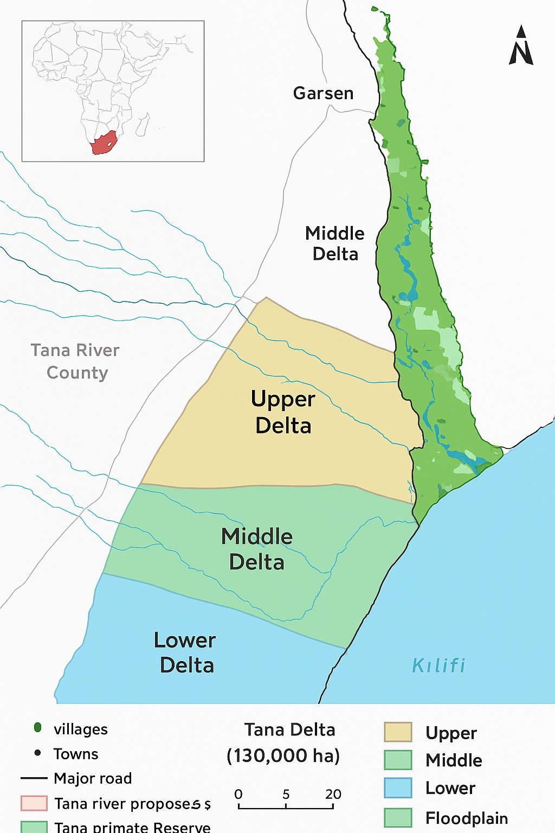
Figure 1: A Map of Tana Delta

2.2 Research Design
The study adopted a mixed-methods research design integrating quantitative and qualitative approaches. Primary data were collected through household surveys, focus group discussions (FGDs), and key informant interviews (KIIs), while secondary data included satellite imagery and climatic records. A total of 382 households were surveyed across the Tana Delta, complemented by FGDs in three representative towns Mnazini (Upper Delta), Garsen (Middle Delta), and Kipini (Lower Delta) and KIIs with community leaders, government officers, and technical experts.

2.3 Hydro-Climatic and Remote Sensing Analysis
To assess long-term climatic trends, 30-year rainfall and temperature data (1993–2023) were obtained from the Kenya Meteorological Department and analyzed for variability and trends using linear regression and time-series analysis.
Surface water and vegetation dynamics were analyzed using Landsat imagery (30 m resolution) covering the period 1995–2023. Two spectral indices were applied:
- Normalized Difference Water Index (NDWI) — used to detect and quantify changes in surface water extent.
- Normalized Difference Vegetation Index (NDVI) — used to assess vegetation greenness and photosynthetic activity as a proxy for soil moisture and ecosystem health.
Images were processed using ArcGIS and QGIS to map spatiotemporal variations in water and vegetation cover. Seasonal patterns were assessed for the long rains (March–May) and short rains (October–December). Data were aggregated by delta zones (Upper, Middle, and Lower) to evaluate hydro-climatic variability and spatial distribution.

2.4 Household Surveys
A structured questionnaire was administered to 382 households selected through a stratified random sampling approach. The sampling frame was based on Kenya National Bureau of Statistics (KNBS, 2009) census data, which provided village-level household estimates across the delta. Stratification ensured proportional representation of communities in the Upper, Central, and Lower Delta zones.
The sample size was computed using Cochran’s (1977) formula for large populations at a 95% confidence level and ±5% margin of error, adjusted for non-responses. Within each selected village, households were randomly chosen in proportion to population size.

2.5 Focus Group Discussions (FGDs) and Key Informant Interviews (KIIs)
FGDs were used to explore community perspectives on water access, climate impacts, and adaptation strategies. Three FGDs were conducted in Mnazini (Upper Delta), Garsen (Middle Delta), and Kipini (Lower Delta). Participants were purposively selected and stratified by gender, age, and livelihood type following Krueger and Casey (2015) and Morgan (1998). A semi-structured discussion guide allowed flexibility for emergent themes (Bryman, 2016; Ming’ate, 2014). Sessions were audio-recorded, transcribed, and analyzed thematically.
KIIs were held with community leaders, water officers, county environment officials, and NGO representatives to validate FGD findings and provide expert context. Interviews followed semi-structured protocols and were analyzed thematically (Patton, 2015).

2.6 Data Analysis
Quantitative data from household surveys were coded and analyzed using SPSS (version 25) for descriptive statistics, including frequencies, percentages, and cross-tabulations.
Qualitative data from FGDs and KIIs were analyzed thematically in NVivo, following Braun and Clarke’s (2006) framework to identify key themes on water variability, adaptation, and livelihood impacts.
Remote sensing indices (NDWI and NDVI) were analyzed for temporal and spatial trends, and visualized in ArcGIS to produce thematic maps that linked climatic variability with livelihood dynamics.

2.7 Ethical Considerations
The study obtained ethical approval from the Kenyatta University Ethics Review Committee (Approval 11/July/2025). Informed consent was obtained from all participants, and confidentiality and anonymity were strictly maintained.

2.8 Data Availability
The datasets generated and analyzed during this study are available from the corresponding author on reasonable request

3 Results
3.1 Spatial and Seasonal Patterns of Water Resource Variability
This section corresponds directly to Objective 1:
“To quantify the spatial and seasonal patterns of water resource variability in the Tana Delta from 1995 to 2023 using remote sensing and climatic data.
3.1.1 Rainfall and Temperature Trends (1995–2023)
Analysis of 30-year climatic data from the Kenya Meteorological Department (KMD) and Tana River hydrological stations revealed significant spatiotemporal variability in rainfall and temperature across the Tana Delta. Mean annual rainfall ranged from 350 mm to 900 mm, exhibiting a bimodal distribution with long rains (March–May) and short rains (October–December). Rainfall reliability has declined over time, with prolonged dry spells and irregular onset/cessation.
Trend analysis indicates a total annual rainfall decline of approximately 8–12% between the baseline period (1993–2002) and 2013–2023. Drought-prone periods occurred during 2000–2009 and 2017–2023, while extreme rainfall events in 1997–1998 and 2011–2012, linked to El Niño, caused flooding and wetland expansion.
Temperature analysis shows a warming trend of ~1.2°C over the study period, with minimum temperatures rising faster than maxima. Increased evapotranspiration has reduced soil moisture and accelerated drying of shallow water bodies, intensifying hydrological stress in deltaic systems.
These climatic changes provided the background for remote sensing analyses using NDWI and NDVI to assess surface water and vegetation dynamics. The results are illustrated in the figure 2 below.
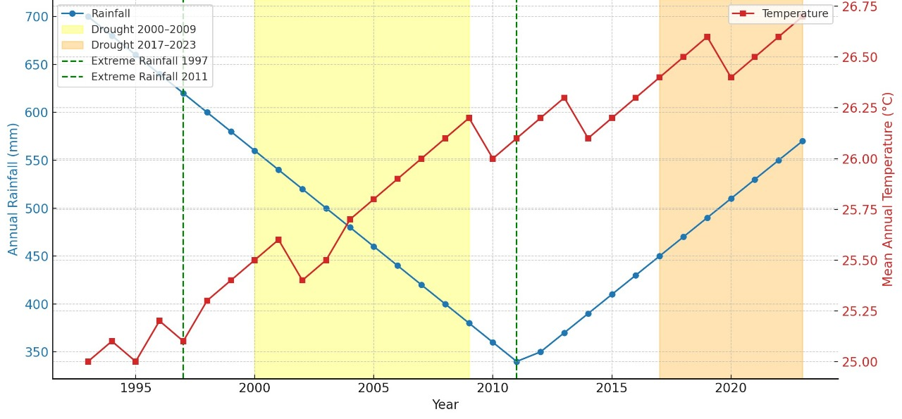
Figure 2: Trends in Annual Rainfall and Temperature in the Tana Delta (1993–2023)

3.1.2 Remote Sensing Analysis of NDWI and NDVI (1995–2023)
Remote sensing analyses using the Normalized Difference Water Index (NDWI) and Normalized Difference Vegetation Index (NDVI) were conducted on Landsat imagery (30 m resolution) for comparable seasonal periods.
- Overall trends: NDWI indicated a 21% decline in surface water extent, while NDVI showed a 17% reduction in vegetation greenness. Spatial patterns reflect strong correlations with declining rainfall and rising temperatures, particularly in mid- and downstream regions.
Upper Delta (Mnazini Zone): Surface water coverage remained ~70% across seasons. High NDVI during long rains indicates robust vegetation and soil moisture, with minor short-rain fluctuations. Hydrological stability is supported by proximity to perennial river channels and limited saline intrusion.
Middle Delta (Garsen Zone): NDWI declined 30–45%, reflecting reduced river discharge and irregular flooding. Vegetation stress is observed with NDVI declines, and communities increasingly rely on boreholes and seasonal pans, indicating high water insecurity.
Lower Delta (Kipini Zone): Mangrove and estuarine zones showed ~50% NDWI persistence due to tidal influence, whereas inland areas declined 35–40% from saline intrusion and reduced freshwater recharge. NDVI also declined, reflecting soil salinization and limited freshwater availability.

Summary of Spatial and Seasonal Variability
Table 1 summarizes surface water stability, seasonal variations, and dominant water sources across the three deltaic zones. The analysis demonstrates that the Middle Delta faces the greatest hydrological stress, while the Upper Delta remains comparatively resilient due to sustained river inflow and less saline intrusion.

Table 1: Patterns of Surface Water Variation by Season and Location (1995–2023)
Delta Zone | NDWI Water Persistence (%) | NDVI Vegetation Stability (%) | Dominant Water Sources | Seasonal Characteristics
Upper Delta (Mnazini) | ~70 | ~75 | River channels, piped supply, shallow wells | Stable during long and short rains; minor seasonal variability
Middle Delta (Garsen) | 55 → 30 (−45%) | 65 → 50 (−23%) | Boreholes, river abstraction, seasonal pans | High variability; flooding in long rains, poor recovery in short rains
Lower Delta (Kipini) | 60 → 35 (−40%) | 58 → 42 (−28%) | Tidal creeks, shallow wells, brackish boreholes | Coastal stability; inland decline due to saline intrusion and recharge loss

3.1.3 Integration of Hydro-Climatic and Remote Sensing Findings
Declining rainfall reliability, rising temperatures, and NDWI/NDVI trends collectively demonstrate progressive hydro-climatic transformation across the Tana Delta.
- Upper Delta: Most hydrologically stable due to perennial Tana River flow.
- Middle Delta: Highest stress with recurrent flooding followed by severe dry-season water scarcity.
- Lower Delta: Localized coastal stability but inland desiccation from saline intrusion and reduced upstream inflows.
Hydro-climatic variability is spatially uneven, threatening grazing, fishing, and irrigation. NDWI and NDVI trends correlate with a 245 mm rainfall reduction over 30 years, indicating climate-driven water loss, amplified by anthropogenic pressures (deforestation, overgrazing, unsustainable abstraction).
3.2 Impacts of Water Variability on Major Livelihood Activities (Objective 2)
This section addresses Objective 2: “To assess the impacts of water variability on major livelihood activities, specifically farming, fishing, and pastoralism.”
Findings reveal that hydro-climatic variability, expressed through declining rainfall, fluctuating river flows, and shrinking wetlands, has had profound implications for the three main livelihood systems that sustain communities in the Tana Delta.

3.2.1 Farming Livelihood Impacts
Farming in the Tana Delta remains predominantly rain-fed and thus highly sensitive to water fluctuations. Household survey data show that crop production forms the primary livelihood for 37 % of households, concentrated in floodplains traditionally supported by seasonal inundation. However, the reliability of this system has declined due to erratic rainfall, diminishing flood frequency, and reduced soil moisture.
Analysis of NDWI and NDVI time series from 1995–2023 indicates a progressive reduction in floodplain water coverage, corresponding with observed decreases in crop yields. Field data and interviews confirm that formerly productive areas near the Tana River are now prone to delayed floods or complete dry spells, while inland zones experience prolonged droughts. Irrigated farming represents less than 10 % of household practices and remains constrained by deteriorating canal infrastructure and low river discharge during dry seasons.
Spatial mapping shows a gradual shift in agricultural hotspots toward residual-moisture zones, where communities rely on shallow wells and small water pans. To sustain their livelihoods, farmers increasingly supplement crop production with petty trade, charcoal production, and motorbike transport (Figure 3). These trends reflect early adaptation through livelihood diversification, though often driven by necessity rather than planned resilience building.

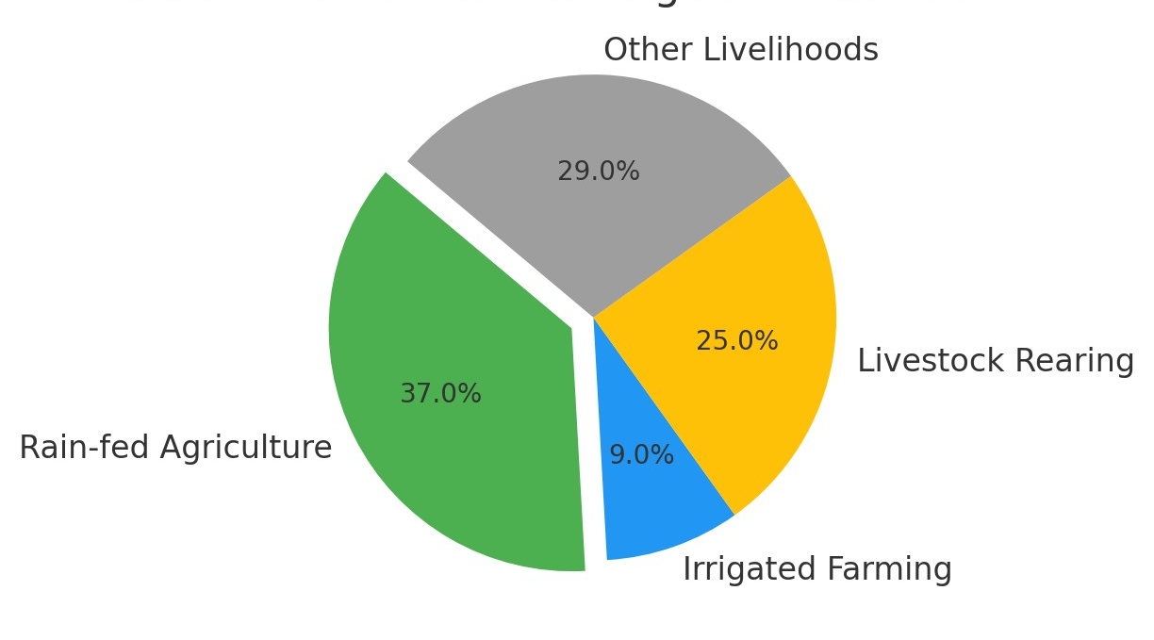

Figure 3: Spatial distribution of farming and supplementary livelihoods under water-stress conditions in the Tana Delta.

3.2.2 Fishing Livelihood Impacts
Fishing supports approximately 37 % of households and is deeply linked to surface-water dynamics. Seasonal flooding and freshwater inflows historically sustained estuarine and floodplain fisheries, especially during long rains when nutrient mixing enhanced productivity.
NDWI analysis from 1995–2023 shows a marked reduction in inundated floodplain areas, shortening breeding seasons and causing fish stock declines. In the lower delta, saline intrusion and sedimentation have further reduced freshwater fish habitats. Estuarine fishing, practiced by 22 % of households, now faces declining catches and increased operating costs as fishermen travel further offshore.
Focus-group discussions indicate that reduced freshwater discharge has altered traditional fishing calendars, forcing shifts toward mangrove harvesting, small-scale trading, and aquaculture initiatives. These adjustments illustrate evolving adaptive responses to water scarcity but remain constrained by limited capital and weak institutional support for sustainable fisheries management. See figure 4 below narrating on the above results.

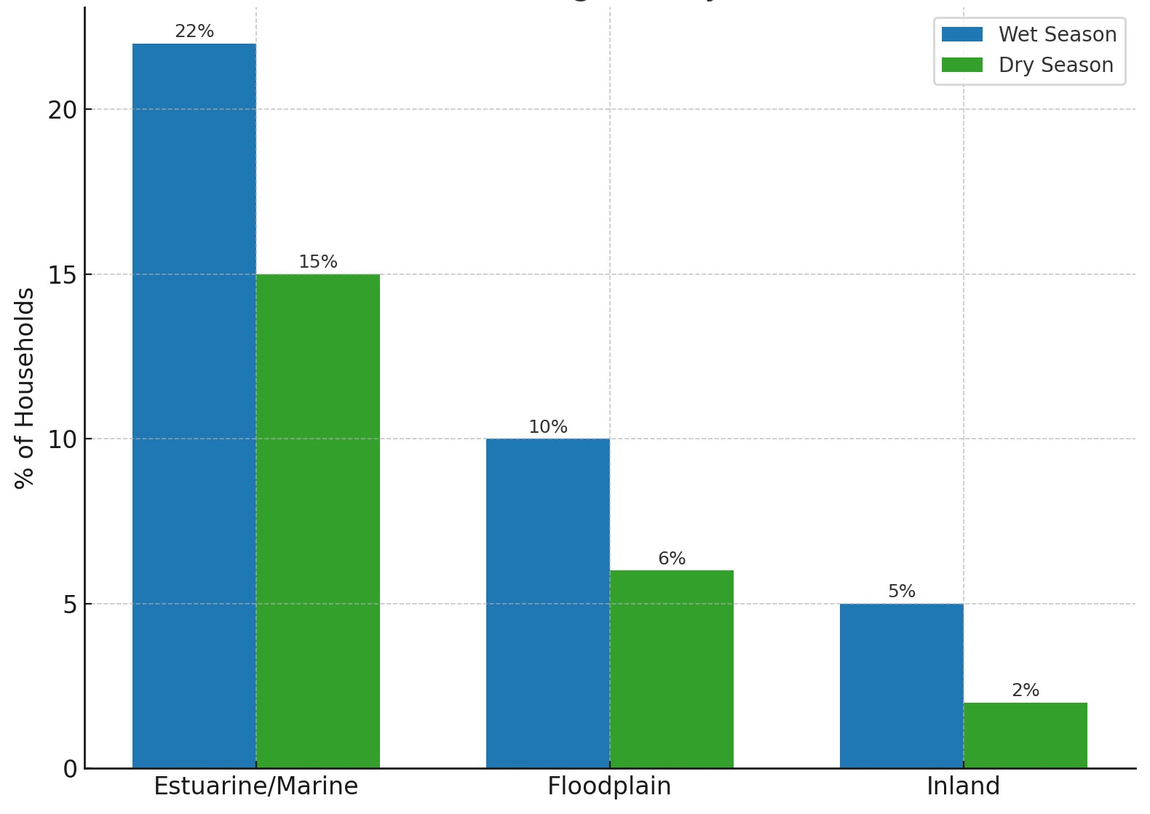

Figure 4: Seasonal distribution of fishing activities in the Tana Delta and their dependence on water availability

3.2.3 Pastoralist Livelihood Impacts
Pastoralism accounts for roughly 22 % of household livelihoods, primarily in the inland and upper-delta zones. Livestock systems are acutely affected by water scarcity, as grazing patterns and herd mobility depend on seasonal water availability.
Survey data reveal significant reductions in pasture quality and water-point reliability, particularly after the drought years of 2010–2011 and 2016–2017. Remote-sensing analysis confirms widespread rangeland degradation, with NDVI values indicating declining vegetation greenness and expansion of bare ground.
During prolonged dry spells, herders migrate toward riverine or coastal areas in search of pasture and water, often triggering resource-use conflicts with farmers and fisherfolk. Livestock losses especially of cattle and goats have become common, leading some households to sell animals and transition into mixed or non-livestock livelihoods such as charcoal burning, petty trade, or boda-boda transport (Figure 5 below give the findings). These patterns reflect adaptive transformation under persistent hydro-climatic stress, though often at the cost of ecosystem degradation and reduced livelihood security.
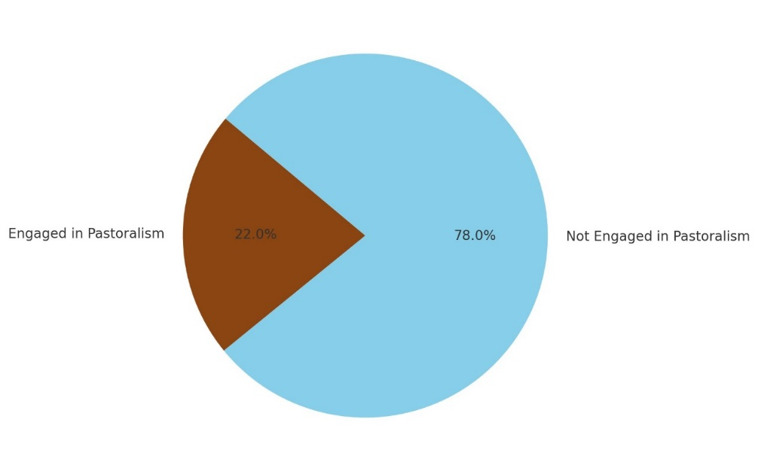
Figure 5: Proportion of households engaged in pastoralism compared with other water-dependent livelihoods
3.2.4 Livelihood Diversification as an Adaptation Strategy
Livelihood diversification has emerged as a critical adaptation mechanism in response to climate-induced water resource variability and the declining reliability of traditional, water-dependent livelihoods in the Tana Delta. Farming (36%), pastoralism (21%), and fishing remain dominant activities; however, their viability is increasingly undermined by erratic rainfall, prolonged droughts, saline water intrusion, and reduced river flows associated with hydro-climatic variability.
Survey results and focus group discussions reveal that households are supplementing these core livelihoods with alternative income-generating activities such as petty trade (17%), casual labor (14%), charcoal production (11%), and small-scale businesses (9%). These strategies aim to reduce dependency on unstable water-based systems. For example, in Mnazini and Garsen, recurrent crop failure and livestock mortality have forced households to adopt informal labor and small-scale trading, while in Kipini, siltation of river channels and rough sea conditions have driven shifts toward mangrove harvesting and residual moisture farming.
This diversification reflects a proactive adaptation pathway, enhancing livelihood resilience to hydrological stress. However, certain measures, such as charcoal production, pose environmental risks, potentially creating negative feedback loops that exacerbate ecosystem degradation and undermine long-term adaptation.
Qualitative evidence from FGDs and KIIs provides further insights into household-level adaptation:
- A female farmer in Garsen stated:
“We can no longer rely solely on the rains. Some years our fields remain dry even when the long rains start. We have started selling small goods and working for neighbors to survive.”
- A male pastoralist in Mnazini explained:
“The river water is more unpredictable now. We move our cattle to different areas and sometimes rely on boreholes, but these are limited.”
- A community leader in Kipini noted:
“Fish are fewer in the estuary during the dry season. Many have started small fish ponds and rely on mangrove crabs to supplement income.”
These insights confirm that households adopt flexible, context-specific adaptation strategies, combining traditional water-dependent livelihoods with alternative income sources. The findings are illustrated in Figure 6, which presents the spatiotemporal patterns of water resource variability and associated livelihood effects.

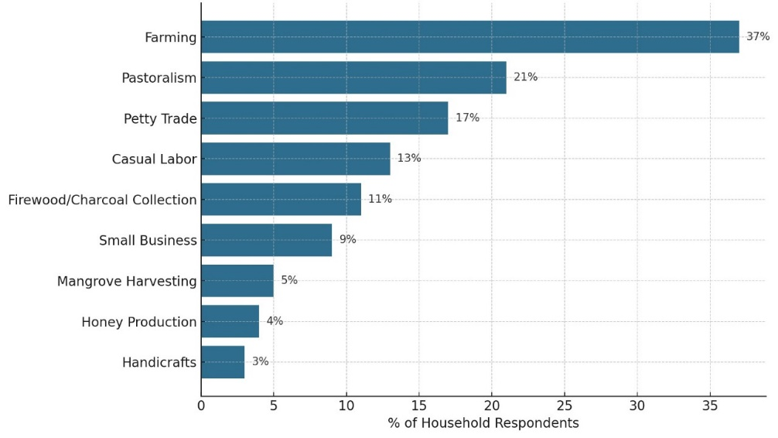

Figure 6: Distribution of primary and supplementary livelihood strategies in the Tana Delta under water stress conditions
3.2.5 Coping Mechanisms During Food Insecurity
Figure 7 illustrates that climate-induced water variability has severe implications for household food security in the Tana Delta. Survey findings indicate that farming-dependent households are the most affected, with 60% reporting food insecurity, followed by pastoralist households (58%). Other water-sensitive activities, including casual labor (54%), charcoal production (52%), and mangrove harvesting (50%), also exhibit high vulnerability. Households engaged in diversified income sources, such as petty trade (48%), honey production (45%), and small businesses (43%), likewise report notable exposure to food insecurity.
Insights from focus group discussions reinforce these patterns, linking food shortages to declining river flows, saline boreholes, and increasingly erratic rainfall. In Mnazini, participants identified crop failures caused by drought and flooding as primary drivers of hunger. In Garsen, respondents highlighted borehole salinity and shifting river channels as major challenges, while in Kipini, fishing households, though slightly less food insecure, reported that unpredictable rains and limited irrigation infrastructure remain critical constraints to stable food production.
These findings in the 7 below demonstrate that households dependent on water-based livelihoods bear the greatest burden of food insecurity, prompting coping strategies such as temporary migration, engagement in informal labor, and dietary adjustments. However, these measures provide only short-term relief, emphasizing the urgent need for climate-resilient water management and adaptive livelihood strategies to secure food systems in the Tana Delta.
- In Garsen, participants highlighted that borehole salinity and shifting river channels exacerbate food insecurity.
- In Mnazini, crop failures caused by drought and delayed floods were cited as primary drivers of hunger.
- In Kipini, fishing households reported that unpredictable rains and lack of irrigation infrastructure constrain stable food production.
Coping strategies include temporary migration to areas with better water access, engagement in casual labor, petty trade, and adjustments in diet to rely on stored or wild foods.

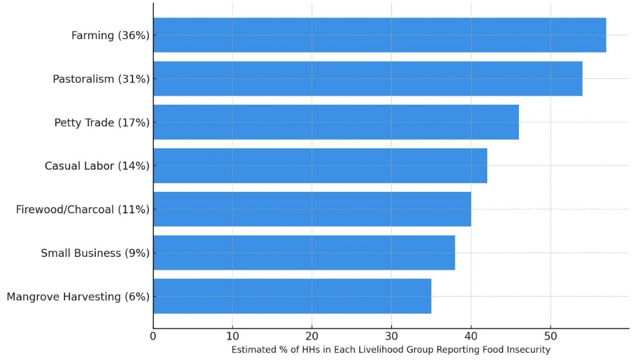

Figure 7: Food insecurity patterns linked to water stress across major livelihood systems in the Tana Delta

3.3 Adaptation Insights and Institutional Perspectives

3.3.1 Insights from Key Informants
KIIs provided institutional perspectives:
- Government support for small-scale irrigation and borehole maintenance is limited.
- Weak enforcement of water allocation rules leads to conflicts among farmers, pastoralists, and fishers.
- Climate-smart initiatives such as drought-tolerant crops, mangrove restoration, and community-based water governance are needed to enhance adaptive capacity.

3.3.2 Summary of Adaptation and Coping
Integration of survey, FGD, and KII data indicates:
- Households diversify livelihoods to reduce dependency on unstable water sources.
- Adaptation is mostly reactive, shaped by necessity rather than planned resilience.
- Food security remains highly vulnerable to hydro-climatic variability.
- Institutional support and water governance are critical enablers for sustainable adaptation.

4. Discussion
The findings of this study reveal that climate-induced hydrological variability is a critical driver of livelihood vulnerability and adaptation dynamics in the Tana Delta, consistent with global literature on climate–livelihood linkages in deltaic systems (IPCC, 2022; Conway et al., 2021). Over the past three decades, remote sensing data indicate substantial spatial and seasonal variation in surface water availability, with the middle and lower delta zones experiencing the most pronounced decline due to reduced rainfall reliability, saline intrusion, and diminished river recharge. These patterns are consistent with projections for East African river basins under climate change scenarios, which predict intensified drought and increased saline intrusion in low-lying deltas (Niang et al., 2014).

4.1 Water Variability and Livelihood Sensitivity
The strong dependence of farming, fishing, and pastoral systems on water availability underscores the climate sensitivity of rural livelihoods in the Tana Delta. The decline in floodplain inundation and reduced soil moisture has severely undermined rain-fed agriculture, historically the backbone of household food production. Similar findings have been reported in other African deltas, where unpredictable rainfall and declining river flows threaten agricultural sustainability (Amisah et al., 2020). Likewise, fishing systems face dual stressors of altered river discharge and estuarine siltation, which shorten breeding seasons and reduce fish productivity. Pastoralism, while adaptive in mobility, is constrained by shrinking grazing lands and intensified resource competition, leading to livestock losses during recurrent droughts. These patterns reinforce the concept of double exposure, where communities simultaneously face climatic and socio-economic stressors, limiting their adaptive capacity (Leichenko & O’Brien, 2008).

4.2 Adaptation Pathways and Livelihood Diversification
The emergence of livelihood diversification as a dominant adaptation strategy reflects household efforts to spread risk and reduce dependence on increasingly unreliable water-based activities. Engagement in petty trade, casual labor, and small-scale businesses provides short-term buffers against climate shocks, aligning with adaptation theories that emphasize flexibility and income heterogeneity (Ellis, 2000). However, the reliance on environmentally degrading practices such as charcoal production poses a paradox: while offering immediate economic relief, it accelerates ecosystem degradation, thereby undermining long-term resilience. This highlights the need for sustainable diversification strategies that complement, rather than compromise, natural resource systems.

4.3 Food Security Implications and Coping Mechanisms
The study confirms that household food security remains tightly coupled to hydrological stability (Maithya et al, 2020). Farming and pastoral households report the highest levels of food insecurity, followed by those engaged in water-sensitive informal activities. Coping mechanisms such as temporary migration, informal labor, and dietary adjustments offer short-term relief but lack sustainability, echoing findings from similar studies in African floodplains (Adger et al., 2011). This calls for systemic interventions, including improved irrigation infrastructure, saline water management, and integrated water governance, to enhance resilience across multiple livelihood systems.

5. Conclusion
This study demonstrates that climate-induced water resource variability is a central determinant of livelihood vulnerability and adaptive responses in Kenya’s Tana Delta. Over the past three decades, significant spatial and seasonal fluctuations in surface water availability driven by erratic rainfall, saline intrusion, and reduced river recharge have altered the ecological and socio-economic fabric of the region. These hydrological changes have undermined the viability of water-dependent livelihoods, particularly farming, fishing, and pastoralism, which remain the backbone of household subsistence and income generation.
The analysis underscores that adaptation in the Tana Delta is increasingly shaped by livelihood diversification, as households seek to buffer against climate shocks by engaging in petty trade, casual labor, and other non-traditional income sources. While these strategies enhance short-term resilience, reliance on unsustainable practices such as charcoal production introduces new environmental risks, reinforcing the need for integrated and ecologically sound adaptation measures.
Furthermore, the strong link between hydrological stability and food security highlights the urgency of systemic interventions to safeguard water resources and strengthen community resilience. Investments in climate-resilient infrastructure such as small-scale irrigation, saline water management, and floodplain restoration combined with participatory water governance and sustainable livelihood options, are critical for long-term adaptation.
Ultimately, the findings emphasize that addressing climate-induced water variability in the Tana Delta requires a multi-dimensional approach that integrates water resource management, ecosystem conservation, and livelihood support. Such strategies will be essential to secure both human well-being and ecological sustainability in the face of escalating climate risks.

Recommendations
Based on the findings and conclusion of this study, the following recommendations are proposed to address climate-induced water resource variability and enhance livelihood adaptation in Kenya’s Tana Delta:

6.1 Strengthen Climate-Resilient Water Infrastructure
- Invest in small-scale irrigation systems to reduce dependence on rain-fed agriculture and stabilize crop production.
- Develop and maintain saline water management solutions, such as desalination and salt-tolerant crop introduction, to counter saline intrusion in the lower delta.
- Promote rainwater harvesting and groundwater recharge initiatives to buffer against prolonged droughts.

6.2 Enhance Integrated Water Governance
- Establish community-based water resource management committees to ensure equitable allocation and minimize conflicts during water scarcity.
- Implement participatory planning frameworks that integrate local knowledge with scientific data for adaptive decision-making.
- Strengthen enforcement of water abstraction and land-use regulations to prevent over-exploitation and ecosystem degradation.

6.3 Promote Sustainable Livelihood Diversification
- Support climate-smart agriculture (e.g., drought-resistant crops, conservation farming) to improve resilience of farming systems.
- Facilitate access to microfinance and skills training for alternative livelihoods such as eco-tourism, aquaculture, and small enterprises.
- Discourage environmentally degrading practices like charcoal production by promoting renewable energy options and afforestation programs.

6.4 Improve Food Security and Social Safety Nets
- Develop early warning systems for drought and flooding to help communities plan for shocks.
- Expand social protection programs (e.g., food assistance, cash transfers) during extreme climate events to reduce vulnerability.
- Support community grain banks and cooperative storage facilities to manage seasonal food shortages.

6.5 Invest in Research and Climate Information Services
- Enhance hydrological monitoring systems using remote sensing and ground-based data to track water trends in real time.
- Provide localized climate advisories to farmers, fishers, and pastoralists to guide seasonal planning.
- Promote collaborative research on ecosystem restoration, particularly floodplain and mangrove rehabilitation, to sustain water-regulating functions.

References
[1] Gao BC. NDWI A normalized difference water index for remote sensing of vegetation liquid water from space. Remote Sens Environ. 1996;58(3):257–266.
[2] McFeeters SK. The use of the normalized difference water index (NDWI) in the delineation of open water features. Int J Remote Sens. 1996;17(7):1425–1432.
[3] Rokni K, Ahmad A, Selamat A, Hazini S. Water feature extraction and change detection using multitemporal Landsat imagery. Remote Sens. 2014;6(5):4173–4189.
[4] Hirji R, Davis R. Environmental flows in water resources policies, plans and projects: Findings and recommendations. World Bank Publ. 2009.
[5] Government of Kenya. Tana River County Integrated Development Plan (2018–2022). Govt. of Kenya Publ. 2018.
[6] Hamerlynck O, Duvail S. The ecology and management of the Tana River Delta: Kenya. IUCN Publ. 2003.
[7] Duvail S, Hamerlynck O, et al. Land and water dynamics in the Tana Delta, Kenya: The impact of flooding on livelihoods and the environment. Wetl Ecol Manag. 2012;20(2):101–120.
[8] Kitheka JU. Dynamics of the Tana River coastal delta ecosystem, Kenya: The role of flow variability in the retention and exchange of nutrients. J Ecol Nat Environ. 2013;5(6):118–134.
[9] Mati BM, Mutie S, Gadain H, Home P, Mtalo F. Land use changes in response to changes in climate and water availability: A case study of the Tana River Basin, Kenya. J Hydrol. 2010;393(3–4):318–326.
[10] Nicholls RJ, et al. Integrating coastal climate change adaptation into development policy and planning in the context of Africa. Environ Sci Policy. 2020;103:29–41.
[11] Awuor CB, Orindi VA, Adwera AO. Climate change and coastal cities: Building adaptive capacity for resilience to climate change in Kenya. Environ Urban. 2015;20(1):231–242.
[12] Omondi P, et al. Climate change impacts on water resources and livelihoods in East African river basins: Evidence and adaptation strategies. Clim Change. 2022;170(3–4):25–43.
[13] Onyango EA, et al. Climate variability and food security in East Africa: Building resilience in farming systems. Clim Risk Manag. 2020;30:100245.
[14] Maithya J, Ming’ate F, Letema S. A review on ecosystem services and their threats in the conservation of Nyando Wetland, Kisumu County, Kenya. Tanzan J Sci. 2020;46(3):711–722.
[15] Maithya JK, Ming’ate FL, Letema SC. The impact of wetland utilisation on provisioning ecosystem services in Nyando Wetland, Kenya. J Environ Assess Policy Manag. 2022;24(1):2250023.
[16] Ming’ate FLM. Combining ethnography and case study research designs in studying forestry co-management approaches. J Hum Soc Sci Res. 2014;3(2):67–79.
[17] Food and Agriculture Organization of the United Nations. The state of the world’s land and water resources for food and agriculture. FAO Publ. 2021.
[18] Bryman A. Social Research Methods. 5th ed. Oxford Univ. Press; 2016.
[19] Creswell JW, Creswell JD. Research Design: Qualitative, Quantitative, and Mixed Methods Approaches. 5th ed. SAGE Publ.; 2018.
[20] Kothari CR. Research Methodology: Methods and Techniques. 2nd ed. New Age Int. Publ.; 2004.
[21] Krueger RA, Casey MA. Focus Groups: A Practical Guide for Applied Research. 5th ed. SAGE Publ.; 2015.
[22] Morgan DL. Planning Focus Groups. SAGE Publ.; 1998.
[23] Patton MQ. Qualitative Research & Evaluation Methods. 4th ed. SAGE Publ.; 2015.

